Table of contents

Table of contents

Modernization Journey

Executive Summary
Federal agency IT architecture has evolved through four historical eras — stark mainframe centralization, distributed decentralization, security-driven complexity, and cloud-forced fragmentation — without ever replacing the single source of truth the mainframe originally provided. The result: regional identity domains that never reconciled, duplicate payments, records that cannot be traced to an authoritative source, and a session-based authentication model (Kerberos/Active Directory) that breaks under the physics of distance and the security architecture layered on top of it.
This is not a technology gap. It is an architecture gap, and it is well understood: commercial industries — banking, healthcare, manufacturing — hit and solved this same problem between roughly 2014 and 2022. The physics is fixed: bandwidth does not reduce latency, and no amount of infrastructure spend changes the propagation floor of light through fiber. What changes the outcome is architecture — separating the system of record from the in-path enforcer, making the network application-aware rather than packet-aware, replacing session-based identity with token-based identity, governing infrastructure actively rather than assessing it periodically, and reducing the number of synchronous round-trips an application makes to its data, including at the mainframe boundary itself.
FedRAMP’s 20x Consolidated Rules, phasing in through 2026 and mandatory January 1, 2027, convert this from an architectural preference into a compliance deadline: continuous, machine-readable evidence replaces periodic assessment, and agencies that have not made this transition will not be able to produce it. The path forward is five principles, each traced to a specific NIST, OMB, CISA, or FedRAMP requirement — this is vendor-neutral, product-neutral guidance, not a pitch for any specific platform. Concrete next steps are laid out in the Call to Action at the end of this document.
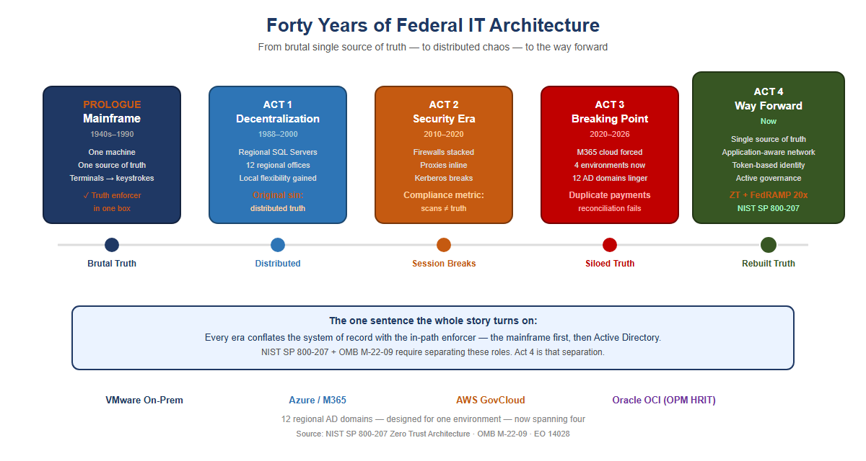{width=“5.833333333333333in” | height=“3.111111111111111in”} | | Figure 1: Forty years of federal IT architecture in one view — from the mainframe’s stark single source of truth, through | decentralization, the security era, and the breaking point, to the | way forward |

Prologue — The Mainframe Era (1940s–1990s)
Your agency’s entire operation ran on mainframes. IBM systems, mostly. One massive computer in a locked room. Everything happened there: all the data, all the logic, all the state.
Users didn’t have computers. They had terminals — green screens, keyboards. A terminal was a dumb device that sent keystrokes to the mainframe and received screen refreshes back. Text-based, synchronous, simple.
The model was starkly elegant: one source of truth. The mainframe was the truth. When you asked “how many people received benefits this month,” there was one answer, and it came from one place. No ambiguity. No regional variations. No hidden discrepancies.
Security was implicit. If you weren’t sitting at a terminal physically connected to that mainframe room, you couldn’t access anything. The network was the security perimeter. Control physical access, and you controlled everything.
And crucially: the machine that held the truth was the same machine that enforced access to it. Truth and enforcement lived in one box. Remember that; it is the seed of everything that follows.
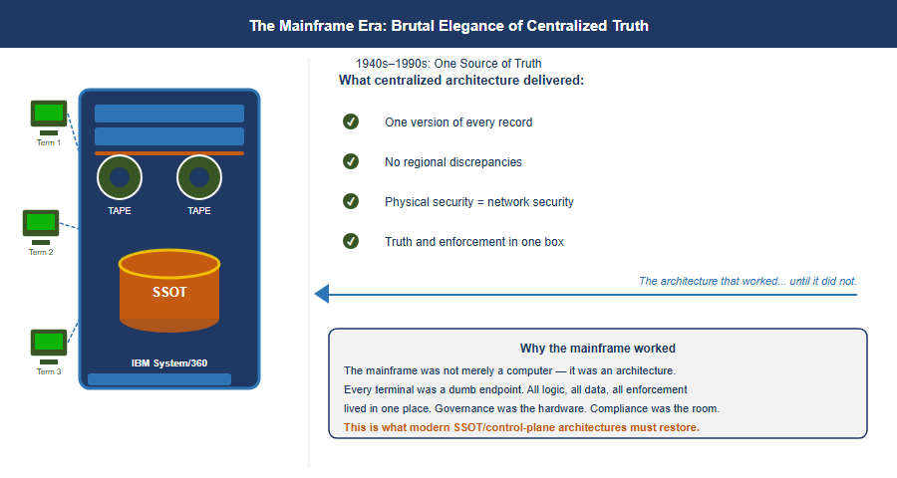{width=“5.833333333333333in” | height=“3.111111111111111in”} | | Figure 2: The Mainframe Era: stark elegance of centralized truth — | an IBM System/360 with three terminals wired to a single SSOT | database cylinder, plus the four benefits centralized architecture | delivered |

Act 1 — The Great Decentralization (Late 1980s–2000)
By the late 1980s, the entire world was rejecting the mainframe model — not because mainframes stopped working, but because the economics broke and the technology changed.
Minicomputers had already proven you didn’t need one godlike machine. Then PCs arrived. Networks got faster. The vision became irresistible: put a SQL Server in every region. Put applications in every office. Spread programming expertise to the edges. Let local teams build solutions for their local problems — because they understood those problems better than Washington ever could.
For your agency, this was revolutionary. Twelve regional offices could each have their own database administrators, their own application developers, their own tools tailored to how their states and territories worked.
But here is where the architecture broke.
With the mainframe, there was one source of truth. One database. One version of the record. The moment you put SQL Servers in twelve regions, you lost that. Now California had its own database. Massachusetts had its own. New York had its own. And they didn’t always talk to each other — or they did, but inconsistently. Regional systems evolved their own schemas, their own business logic, their own definitions of what a “benefit” even meant.
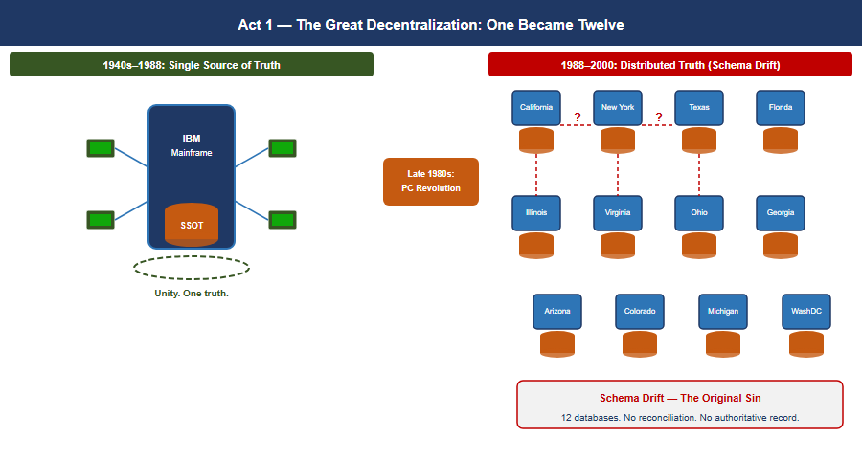{width=“5.833333333333333in” | height=“3.111111111111111in”} | | Figure 3: Act 1 — The Great Decentralization: one mainframe became | twelve regional databases, with schema drift appearing between | adjacent silos and the original sin of distributed truth called out | below |
The vision of distributed intelligence was real and good. But it came at a cost: distributed truth. And nobody replaced the single source of truth that the mainframe had given you.
That became the original sin — the moment the architecture started to drift. The regional variations that seemed like flexibility in 1993 would calcify into incompatible silos by 2020.

Act 2 — When Security Ate the Architecture (2010–2020)
Around 2010, your agency started consolidating compute. Simultaneously — and this is the critical inflection — cybersecurity became a board-level imperative. Not just “have a firewall.” Defense-in-depth. Layered security. Multiple inspection points.
But here is the problem: the tools chosen to enforce security were fundamentally incompatible with the session-based client-server model your entire infrastructure depended on.
Load balancers became inline proxies. Intrusion detection systems were inserted into the traffic path. Multiple NAT sessions. Firewalls stacked on firewalls. Every packet from a field office to a regional data center had to traverse security devices designed to break sessions — to inspect, decrypt, re-encrypt, verify, block.
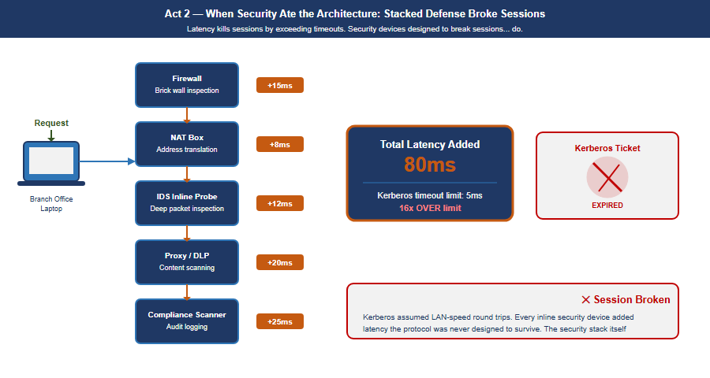{width=“5.833333333333333in” | height=“3.111111111111111in”} | | Figure 4: Act 2 — When Security Ate the Architecture: a | branch-office request traverses five stacked security devices | (firewall, NAT, IDS, proxy/DLP, compliance scanner), each adding | latency, arriving at 80ms total against a 5ms Kerberos timeout, with | the expired ticket and broken session called out on the right |
Active Directory Kerberos tickets have a lifespan — a default TGT lives ten hours with seven-day renewal, and service tickets 600 minutes. They are not bound to a network path. Windows KILE ships ClientIpAddresses = 0, so client addresses are not written into the ticket at all, and Microsoft’s stated reason is verbatim “because of Dynamic Host Configuration Protocol and network address translation issues” — tolerating a changed source address is a design property of the deployed protocol. Where RFC 4120’s optional caddr field is populated, it carries addresses the client supplies in the AS-REQ rather than the source IP the KDC observes, and the check is performed by the application server (KRB_AP_ERR_BADADDR), not by the KDC on a TGS-REQ. SNAT at a PoP writes nothing into a ticket, and Kerberos FAST (RFC 6113) is pre-authentication armouring, unrelated to source-IP binding.
What distance actually costs is narrower, and the argument is stronger for being stated correctly: the DC-dependent operations. Initial TGT acquisition at logon, SYSVOL/GPO retrieval, password changes, and hybrid Entra join registration all require reaching a domain controller, and Microsoft documents the last of these as needing line-of-sight to an on-premises DC. Stack enough inline latency in front of those and logons crawl, GPO processing stalls, and the estate feels exactly the pain this paper describes — without any ticket being invalidated by NAT.
The physics that cannot be negotiated: Portland to Washington is approximately 4,500 km in a straight line. Actual fiber routing adds roughly 20%, bringing the real fiber distance to approximately 5,400 km. At 200,000 km/second — the speed of light through glass fiber — that distance sets an unavoidable propagation floor of 27 ms one-way, 54 ms round-trip minimum, before any queue delay, security inspection, or application processing. Active Directory has no millisecond latency requirement — the widely-quoted five-minute Kerberos figure is clock-skew tolerance, not a latency budget — but the DC-dependent operations are the ones that feel this distance: initial TGT acquisition at logon, SYSVOL/GPO retrieval, password changes, and hybrid Entra join registration, each of which Microsoft documents as requiring line-of-sight to an on-premises domain controller. No amount of bandwidth changes this. Bandwidth is volume. Latency is distance. You cannot buy your way out of geography.

Asymmetric routing: the second session killer
Latency kills sessions by exceeding protocol timeouts. A second mechanism, equally destructive and entirely independent of latency, operated simultaneously: asymmetric routing. It occurs when the outbound path of a session and the return path traverse different physical or logical routes through stateful network devices. A stateful firewall maintains a session table keyed on the five-tuple. When a SYN packet arrives, the device creates an entry expecting the SYN-ACK to return through it. When the SYN-ACK returns via a different path, that second device sees a SYN-ACK with no corresponding session entry — it drops it as unsolicited. The TCP three-way handshake never completes.
Asymmetric routing vs. latency: independent killers that compound. Latency kills sessions by exceeding protocol timeouts. Asymmetric routing kills sessions by preventing TCP from completing its three-way handshake at all — even with perfect, sub-millisecond latency on both paths. In environments where both conditions exist simultaneously — the federal standard — they compound.
How SD-WAN overlay eliminates asymmetric routing: The SD-WAN overlay tunnel is established between two edge devices as a single logical connection. Inside the tunnel, individual packets may physically traverse any available path. But at the application layer, both directions of every session enter and exit the same SD-WAN edge device. The stateful inspection happens at the tunnel endpoint, which sees both directions. Asymmetric physical routing below the tunnel is structurally removed.

Act 3 — The Breaking Point (2020–2026)
Then M365 happened. Microsoft forced the issue. Your agency migrated to Microsoft 365 — Exchange Online, Teams, SharePoint. Suddenly your email and collaboration lived in Azure, managed by Microsoft, unreachable by your session-based authentication model.
And here is the critical moment: the agency still had twelve regional Active Directory domains. Still had the OU tree structure designed for when compute lived regionally. Still had MPLS circuits connecting field offices to regional data centers that were increasingly just logical boundaries, not physical anchors.
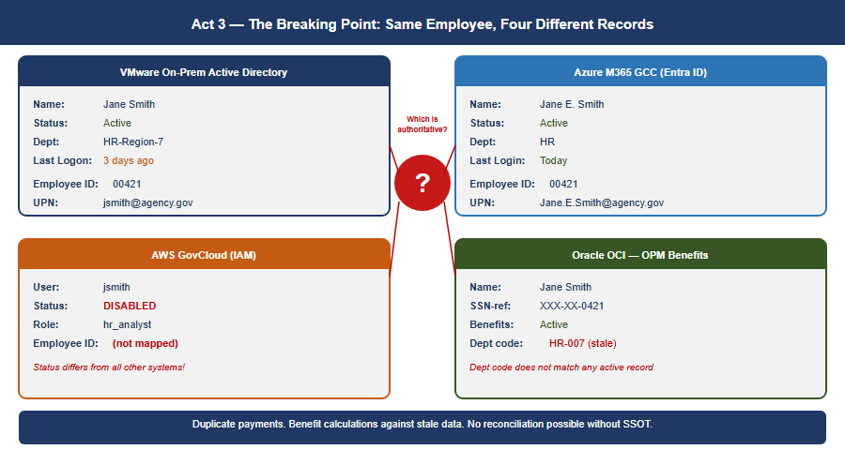{width=“5.833333333333333in” | height=“3.111111111111111in”} | | Figure 5: Act 3 — The Breaking Point: the same employee, Jane | Smith, shows four contradictory records across VMware on-prem AD, | Azure M365 GCC, AWS GovCloud IAM, and Oracle OCI OPM Benefits, | converging on a red question mark asking which is authoritative |
Now a field office in Portland authenticates to a regional DC physically in Washington. An application running on VMware queries a service in AWS. Email lives in Azure. The session-based contract — the assumption that client and server are talking synchronously over a trusted link — is fracturing across three environments and an upcoming fourth.
The hard realization. The bulk of mission compute still runs on VMware on-premises. Red Hat workloads are moving to AWS GovCloud. Email and collaboration are in Azure. OPM HRIT on Oracle OCI is the next boundary arriving. Identity is still in twelve regional AD domains designed for a world where all four of those environments were the same room. The infrastructure could do things but could not verify them across that boundary. With program integrity now a national imperative, that is no longer acceptable.
Meanwhile, the regional variations that started in Act 1 had calcified into institutional silos. California’s benefit calculation differed from Massachusetts’s. Regional databases had evolved incompatible schemas. And because single source of truth had never been restored, nobody could see the discrepancies. The fragmentation that made the system agile in 1995 had become the hiding place for systemic error — duplicate payments across states, records that should have been closed years ago, reconciliations nobody could complete.

The Physics Argument Decision Makers Have Not Heard
When a decision maker hears “the MPLS hairpin is causing latency problems,” the response is almost always: “add a Direct Internet Access circuit at the branch.” DIA eliminates the geographic hairpin. That improvement is real.
And then leadership will conclude that the network problem is solved. It is not. DIA is a pipe. It is a better-positioned pipe than the MPLS circuit it supplements, but it is still a single, unintelligent pipe with no visibility into what is happening on it, no ability to respond when it degrades, and no way to know whether it is actually the best available path to your destination.
{width=“5.833333333333333in” | height=“3.013888888888889in”} | | Figure 6: Physics the network cannot escape: terrestrial fiber at | 200,000 km/s and 27ms one-way propagation versus LEO satellite at the vacuum speed of light, with a one-way latency comparison bar chart | across MPLS, DIA, 5G MEC, and Starlink paths, and the 5G | architectural advantage explained on the right |

Why satellite latency is no longer what you remember
The satellite internet that federal IT professionals evaluated and rejected for decades was geostationary (GEO) — satellites parked at 35,786 km altitude. The physics are unforgiving: approximately 238 ms of one-way propagation delay. No enterprise application tolerates this gracefully. That ruling does not apply to LEO.
Starlink and similar Low Earth Orbit constellations operate at approximately 550 km altitude. Current practical end-to-end latency: 20–40 ms and improving. That places LEO satellite in the same competitive range as broadband DIA circuits.
The vacuum advantage: Light travels through optical fiber at approximately 200,000 km/second — two-thirds the speed of light in vacuum, due to the refractive index of glass. Light travels through the vacuum of space at 299,792 km/second. For the same physical path length, a signal through space arrives 50% sooner than a signal through fiber. This is not a technology gap that better fiber will close. It is physics.
For the longest domestic paths — Pacific Northwest to mid-Atlantic — the terrestrial fiber route may traverse 4,000 km or more of physical cable. The LEO vacuum path traverses 550 km up, geometrically direct inter-satellite laser link hops through space, and 550 km down at propagation speed 50% higher than fiber. Under the right conditions the satellite path is not a compromise — it is the physics-optimal path.

5G: lower latency through architecture, not just physics
5G reduces latency through two distinct mechanisms.
The radio mechanism: 5G’s shorter radio frame duration (0.125 ms slot time versus 1 ms in LTE) reduces the fundamental waiting time. Practical mid-band sub-6 GHz 5G achieves 5–10 ms across the air interface.
The architectural mechanism: 5G’s Control and User Plane Separation (CUPS) and Multi-access Edge Computing (MEC) allow traffic to break out of the carrier’s network locally — at the cell tower or a nearby edge node — rather than backhauling to a central core. This is particularly significant for federal field offices in locations where broadband ISP options are limited.

What Application-Aware Networking Actually Means
The phrase “application-aware networking” appears in policy documents and vendor briefings without ever being explained in plain terms. Here is the plain version.
Your current network sees a packet. Specifically, it sees: source IP address, destination IP address, source port, destination port, protocol. It has no idea who sent the packet, what application it belongs to, whether the user is who they claim to be, whether the device is managed and compliant, or whether the data being accessed is the data policy says they should access. It sees a packet. It checks a rule. It allows or denies.
Application-aware networking sees a transaction. Specifically, it sees: a specific employee, on a managed government laptop that passed compliance check this morning, running Microsoft Teams, requesting a SharePoint document classified as internal, from an office location that is consistent with their normal work pattern, at a time of day that is expected, to access a file that their role and organizational attributes authorize them to access. The network enforces policy against the full context of the transaction — not against a packet.
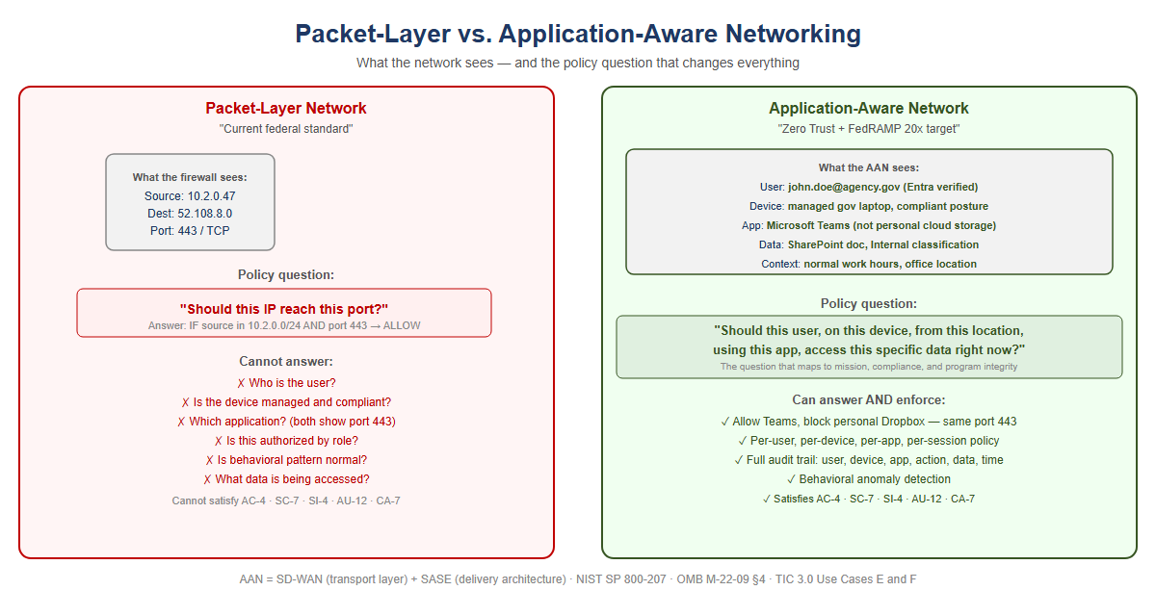{width=“5.833333333333333in” | height=“3.111111111111111in”} | | Figure 7: Packet-layer network versus application-aware network: the | packet-layer side can only answer ‘should this IP reach this port?’ | and lists six questions it cannot answer, while the application-aware side answers the full transaction-context policy question and lists | what it can enforce |

What SD-WAN overlay does with new transports
The overlay treats 5G and LEO satellite exactly the same way it treats MPLS and broadband DIA: as transports to probe continuously, measure precisely, and steer traffic across based on what is performing best for each application class at each moment. The agency does not need to decide in advance that Starlink is better than DIA for Teams calls. The overlay makes that determination empirically, in real time, and changes it when conditions change.

SD-WAN Active-Active Multipath
An SD-WAN overlay runs continuous, simultaneous probes on every available transport using sub-second probe intervals. The probes measure three things on each path independently: latency, jitter, and packet loss. When a path degrades, the overlay knows within seconds.
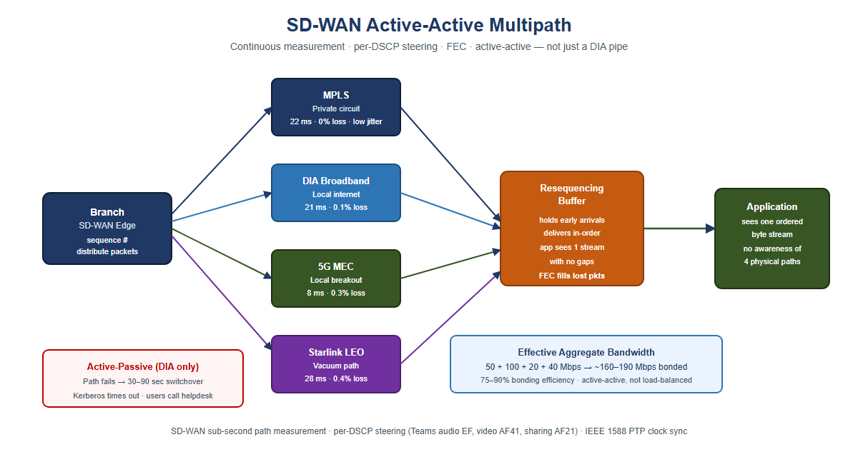{width=“5.833333333333333in” | height=“3.111111111111111in”} | | Figure 8: SD-WAN active-active multipath: a branch edge distributes | sequenced packets across MPLS, DIA broadband, 5G MEC, and Starlink | LEO simultaneously into a resequencing buffer with FEC, delivering | one ordered byte stream to the application, versus an active-passive | DIA-only fallback with a 30-90 second switchover |

Forward Error Correction: recovering toward the physics floor
Forward Error Correction (FEC) sends redundant data alongside the primary transmission. The receiver can reconstruct a lost packet from the redundant data without any retransmission. The application experiences only the propagation delay — the physics floor — with no retransmission penalty. FEC does not make the signal travel faster. It removes the latency tax that lossy paths impose on top of the physics minimum.

Active-active vs. active-passive: the failover that is not a failover
Traditional WAN design is active-passive: MPLS is the primary circuit, DIA broadband is the standby. During switchover — typically 30–90 seconds — authentication sessions time out. VPN tunnels drop. Users re-authenticate.
Active-active multipath carries traffic on all available paths simultaneously, all the time. When a path fails or degrades, the remaining paths absorb its load within milliseconds. A Kerberos ticket exchange that is mid-flight when a path fails is retransmitted automatically. Under active-passive failover, the client times out after several seconds — this is the “logon takes 45 seconds” symptom field offices report. Under active-active multipath, the request was already distributed across multiple paths. The user experiences a 50 ms pause rather than a 30-second timeout.

Why “DIA to M365 will solve it” is half the answer
Capability DIA Circuit O Overlay | nly SD-WAN Intelligent
Eliminates MPLS Yes Yes geographic hairpin to cloud
Visibility into path Non quality (latency, per-tr jitter, loss) | e Continuous, ansport
Responds to path None Su degradation before users notice | b-second reweighting
Splits a single One path conversation across with multiple paths simultaneously | only Active-active mult resequencing | ipath
Aggregates bandwidth One from all transports of a | path only Bonded capaci ll paths | ty = sum
Routes audio, video, Non and data streams of one call to different paths | e Per-stream application steering
Fails over within 30–90 milliseconds without swi dropping sessions | second Seamless — all tchover already active | paths
Uses 5G local breakout N when faster than in mult wireline | one Measured and include ipath pool | d
Uses LEO satellite None vacuum path when faster than fiber | Measured and included in multipath pool
Applies FEC to recover N toward physics minimum on lossy paths | one Per-transport FEC
Provides audit trail of path decisions (TIC 3.0 / AU-12) | None Every decision is a logged event

What the commercial world figured out — and when
Current Federal Wh Practice Moved On | en Commercial What | Replaced It Why
MPLS for all 2014- branch broadband + connectivity local | -2018 SD-WAN on Co LTE flexibility, breakout | st,
Central internet 2 breakout through b DC through DC | 016–2019 Local in reakout at branch | ternet Cloud apps do need to go | not
VPN as primary 201 remote access repl per-network trust | 9–2021 ZTNA / SAS aces | E overlay Per-app ac | cess
Windows DNS / 2017 per-site DNS (Info servers surface | –2020 Unified DDI Blox, BlueCat) sec | DNS became a urity control
DHCP as invisible per-site utility a evidence authorita device inventory | 2017–2020 IPAM as nd compliance requ tive | inventory Zero Trus ires | t
Network-layer 2018 firewall as enforc primary security Z | –2022 Application ement (SASE, usefu TNA) or intent | -layer Packets carry l identity | no
Session-based 2015 application 2.0 / authentication tok stateless | –2019 Token-based OIDC) across WAN; ens are | (OAuth Sessions bre | ak
This is not a forecast. Every item in this table is a completed transition in the commercial sector. The federal government is executing these transitions now, under compliance mandates — Zero Trust Executive Order, TIC 3.0, FedRAMP 20x — that commercial enterprises were not subject to. That makes the federal transition harder, not easier. The path is known. The delay has a cost.

Why Direct Internet Access Alone Does Not Satisfy NIST Controls
When agencies present DIA as a modernization achievement, they have solved a connectivity problem. They have not solved a compliance problem. DIA is a transit service — a pipe to the internet. It satisfies exactly one federal requirement: it provides network connectivity to internet-hosted services. Every security control governing what traverses that connectivity must be applied by a separate control stack. The pipe itself contributes nothing to compliance.
NIST Control What It Req | uires What Provides It
AC-4 Information Flow Ap Enforcement enforcement the destination application, not just the destination IP | plication-layer CASB in identifying | SASE stack
SC-7 Boundary Applicatio Protection inspection; d on port 443, exfiltration in DNS | n-layer SWG / FWaaS in S etect C2 stack | ASE
SC-8 Transmission Networ Confidentiality and encr Integrity nothing | k-layer SD-WAN IPsec tun yption DIA alone encrypt | nel — s
SI-3 Malware Protection inspection at in SASE st appropriate locations | Inline malware SWG with ack | SSL inspection
SI-4 System Monitoring A telemetry — user, tele device, app, data, behavioral pattern | pplication-layer AAN app metry | lication
AU-2 / AU-12 Audit User Events / Audit Record ac Generation performed act data type C — not just IP flows | Z on device D Applicatio cessed application A, lo ion V on | n-layer gging via AAN
CA-7 Continuous Per-sess Monitoring verified, dev posture, access consistent with policy — machine-readable | ion: identity AAN and SA ice | SE stack
The precise relationship: DIA enables compliance; AAN and SASE achieve it. DIA provides the connectivity that makes cloud-hosted services reachable without the MPLS hairpin. It is necessary. It is not sufficient. When an agency presents “we have DIA” as a compliance achievement, the correct technical response is: you have the pipe. Where is the control stack?

Act 4 — The Way Forward: Application-Aware Modernization
You can’t fix this by patching the old model. You can’t bolt Zero Trust onto a Kerberos-in-MPLS architecture. You can’t add more proxies. The only way forward is to rebuild the foundation around one structural move and five principles that follow from it.
The structural move is the one sentence this whole story turns on. Active Directory conflated the directory (truth) with the domain controller (the in-path enforcer). NIST SP 800-207 and OMB M-22-09 require the modern architecture to keep these separate: the governance layer holds and reconciles authoritative state, while identity providers, enforcement points, and data platforms remain the runtime data planes.
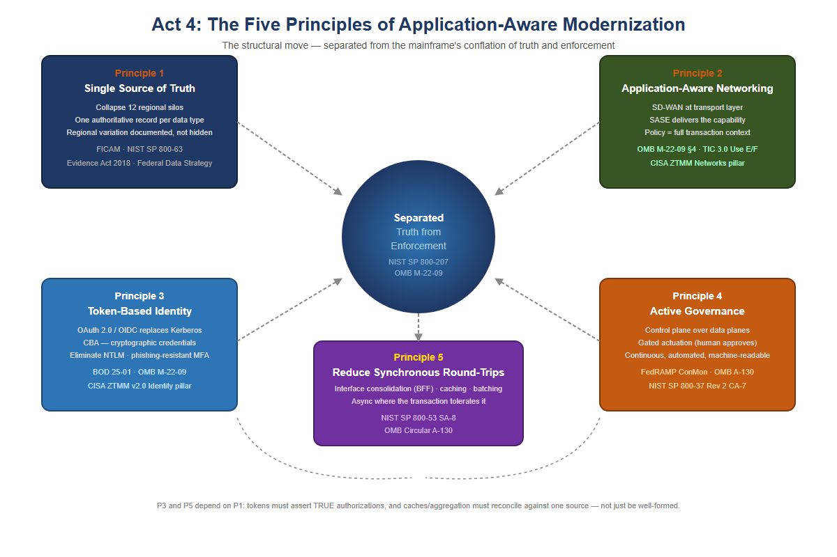{width=“5.833333333333333in” | height=“3.888888888888889in”} | | Figure 9: Act 4: the five principles of application-aware | modernization, arranged around a central hub reading ‘Separated: | Truth from Enforcement’ — Single Source of Truth, Application-Aware | Networking, Token-Based Identity, Control-Plane Governance, and Reduce Synchronous Round-Trips |

Principle 1 — Restore a Single Source of Truth
Every data type the federal government manages must have one authoritative source. Not twelve regional databases with eventual consistency. Not caches that drift. One source, cryptographically verifiable, auditable: you must know where every piece of data came from, who accessed it, when, and why.
For your agency, that means collapsing the twelve regional silos into a unified model — not by erasing regional autonomy, but by making it transparent. If California’s benefit calculation differs from Massachusetts’s, that difference is documented, auditable, and traceable back to policy, not hidden in schema variation.
The Federal Identity, Credential, and Access Management (FICAM) Architecture and NIST SP 800-63 require that every governed object carry a complete, authoritative set of identity attributes derived from authoritative sources such as HR systems and device management platforms. The Evidence Act (2018) and the Federal Data Strategy mandate that those attributes trace back to a single authoritative system of record for each data type, with a documented data lineage from source to decision.
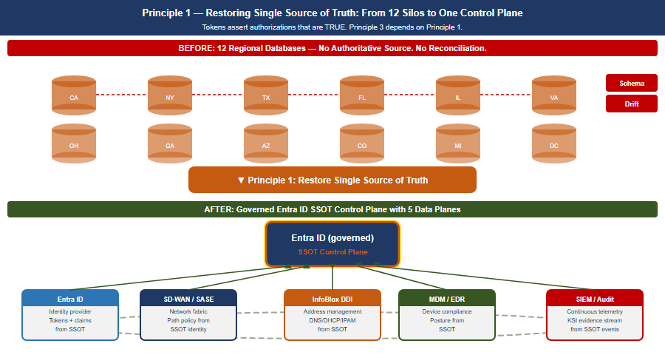{width=“5.833333333333333in” | height=“3.111111111111111in”} | | Figure 10: Principle 1 — SSOT Restoration: twelve regional silos | with schema drift and duplicate/name-collision arrows collapse into a governed Entra ID SSOT control plane with five data planes (identity, network, DDI, device, SIEM) |

Principle 2 — Application-Aware Networking and Cybersecurity
You can’t enforce security at the network layer anymore. The network is the Internet now. The only way to know whether a transaction is legitimate is to understand what the application is doing: Is this user authorized to access this data? Is the data being accessed the data policy says they should access? Is the request from a compliant device, from a location that makes sense?
That is application-aware networking. NIST SP 800-207’s seven zero trust tenets require exactly this: all communication secured regardless of network location; access determined per-session with least privilege; integrity and behavior monitored continuously. OMB M-22-09 §4 requires agencies to implement network visibility and traffic inspection that operates at the application layer, not the IP/port layer. TIC 3.0 publishes four use cases — Traditional TIC, Branch Office (v1.0, April 2021), Remote User (v2.2, July 2025) and Cloud (v1.2, July 2025). The Branch Office and Remote User cases describe application-layer visibility at the policy enforcement point, but TIC 3.0 is guidance rather than a mandate and prescribes no specific product class.
Application-Aware Networking framework alignment:
- SD-WAN is AAN at the transport layer. SD-WAN achieves application awareness through DPI or FQDN/signature-based identification, then applies per-application path selection dynamically based on real-time path quality measurement. SD-WAN alone does not enforce access control based on user identity or device posture. That requires SASE.
- SASE is the delivery architecture that completes AAN. SASE converges SD-WAN with cloud-delivered security services — CASB, FWaaS, ZTNA, SWG — at the network edge. It brings user identity (from the IdP via SAML/OIDC), device posture (from MDM/EDR), application identity (from DPI), and data classification (from CASB) into a single enforcement point distributed geographically near the user.
- CISA ZTMM maps AAN to the Networks pillar maturity progression. Traditional: all decisions at IP/port layer, no application visibility. Initial: basic application identification. Advanced: application-aware routing and enforcement — the FedRAMP ConMon standard posture. Optimal: fully dynamic, identity-driven, application-aware policy with continuous behavioral monitoring.

Principle 3 — Move From Session-Based to Token-Based Identity
Active Directory Kerberos assumes clients and servers are in the same room. Tokens assume they are strangers on the Internet.
A token is a cryptographically signed assertion: this user is who they claim to be; this device is compliant; this request is authorized; timestamp now; signature here. The server doesn’t need to trust the network or call back to a domain controller — it just verifies the signature.
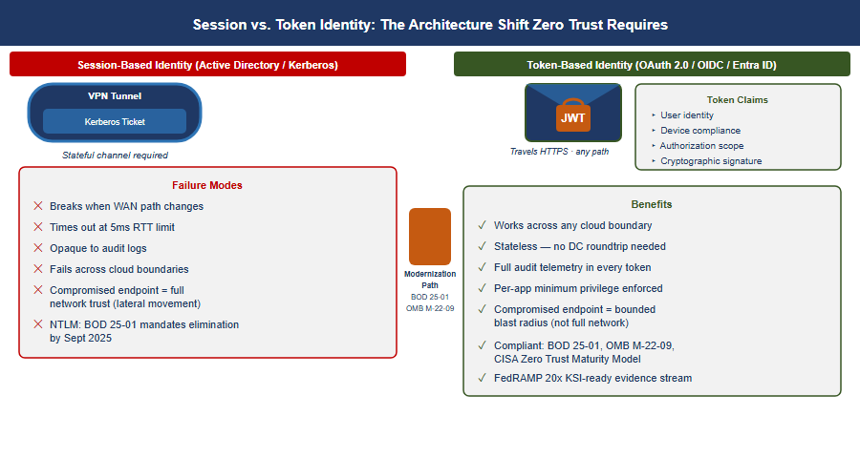{width=“5.833333333333333in” | height=“3.111111111111111in”} | | Figure 11: Principle 3 — Token vs Session: session-based Kerberos | requires a stateful channel and lists six failure modes, while OAuth | 2.0/OIDC token-based identity travels HTTPS over any path and lists | seven benefits, joined by a Modernization Path arrow |
Entra ID, Conditional Access, and device-compliance policies are the token-based equivalents of what AD used to do. BOD 25-01 mandates SCuBA secure configuration baselines for Microsoft 365 that require modern authentication throughout. OMB M-22-09 requires phishing-resistant MFA government-wide. The CISA Zero Trust Maturity Model v2.0 Identity pillar at Advanced and Optimal levels requires Certificate-Based Authentication (CBA) as the primary mechanism. NTLM has no zero-trust story: every NTLM event is opaque to telemetry, invisible to audit logs, and must be eliminated.
Tokens only work if the authoritative identity model is correct. If you don’t know what a user is actually authorized to do — if that is still encoded in twelve regional OU trees with no authoritative HR-derived source — tokens won’t save you. You will just be signing broken authorizations very efficiently. That is why Principle 3 depends on Principle 1: the token must assert an authorization that is true rather than merely well-formed.

FedRAMP 20x Consolidated Rules — What Modernization Must Achieve
FedRAMP published its Consolidated Rules for 2026 on June 25, 2026, establishing the most significant shift in federal cloud authorization since FedRAMP’s inception. The core change: periodic evidence assembly is replaced by continuously-verified, machine-readable Key Security Indicators (KSIs) enforced by infrastructure-as-code.
For agencies on the mainframe-to-AAN modernization path, this is not a compliance burden — it is the confirmation that the architectural direction is correct.
FedRAMP 20x Requirement What the Mod Provides | ern Architecture
Continuous, automated KSI SD-WAN pro verification second; SASE logs every DDI logs every DNS query | bes every transport every session;
Machine-readable evidence format SD- (JSON) structured exports, InfoBlox — all native JSON | WAN telemetry APIs, SIEM WAPI
Infrastructure-as-code guardrails Te policy, GitOps for network config — guardrails enforced at commit | rraform for DDI, IaC for SASE
No manual evidence assembly for The assessments observation IS the evide a report prepared for an assessor | control plane’s continuous nce — not
Automated KSI: all DNS encrypted or integrity-protected Grid Members | DNSSEC on all zones; DoH/DoT on
Automated KSI: no CIDR overlap Terra between environments overlapping all time | form InfoBlox provider blocks ocation at request
Automated KSI: every workload has SC machine identity at IP provisioning | EP/EST auto-enrollment triggered
Key dates all agencies must track:
- July 28, 2026: FedRAMP Ready submissions cease — no new Ready pathway submissions accepted
- August 3, 2026: Class A pipeline opens
- August 31, 2026: Class B and C pipelines open
- January 1, 2027: Consolidated Rules mandatory for all certified systems — all ConMon evidence must meet machine-readable KSI format
- June 11, 2027: No new Rev5 certifications accepted
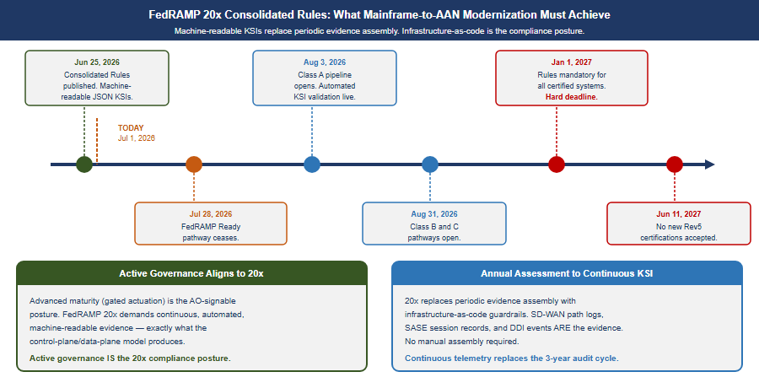{width=“5.833333333333333in” | height=“2.9814807524059495in”} | | Figure 12: FedRAMP 20x timeline from Consolidated Rules publication | through the Class A/B/C pipeline openings to the January 2027 | mandatory deadline, alongside how control-plane governance already aligns to continuous, machine-readable evidence |

Principle 4 — Govern Actively: The Control Plane Over the Data Plane
A governance substrate that embodies these principles is not a passive registry that records desired state and reports divergence. It is an active reconciliation control plane: it holds desired state, observes actual state, classifies drift, and reconciles toward intent — while identity providers, network fabrics, endpoint management platforms, DDI systems, and SIEM platforms remain the data planes that authenticate, route, resolve, and store at runtime.
CISA ZT Stage Governance Practice | Posture What This Means | in
Traditional Record and o documented; actual state collected manually. No automated detection or correction. | bserve only Desired stat | e
Initial Observe and advi drift from policy. Corrective actions generated and surfaced to operators. No automated writes. | se Automated detection o | f
Advanced Gated act generates a corrective action; a human approves before it executes. Dry-run required before production. Federal ConMon standard posture. | uation** **Governance fr | amework
Optimal Autonomous withi guardrails closes the lo human intervention for enumerated low-blast-radius operation classes. High-blast-radius operations remain gated permanently. | n Governance framework op without

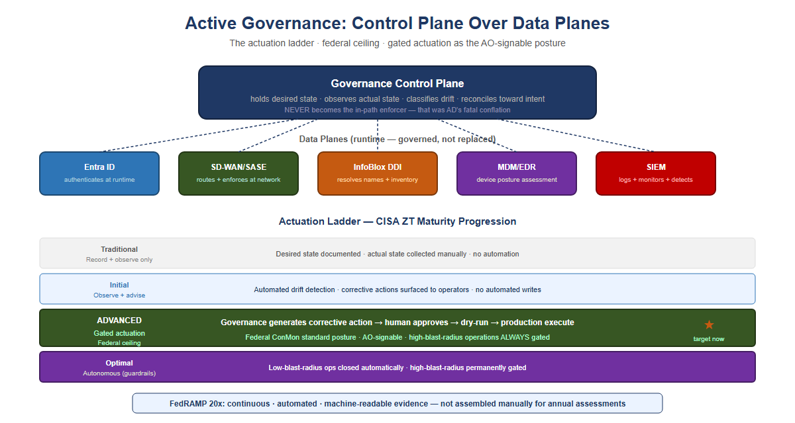{width=“5.833333333333333in” | height=“3.111111111111111in”} | | Figure 13: Control-plane governance and the actuation ladder — | a governance control plane over five data planes (Entra ID, | SD-WAN/SASE, InfoBlox DDI, MDM/EDR, SIEM), plus the CISA ZT maturity | progression from Traditional through Optimal with the federal L3 | gated-actuation ceiling marked as the target now |
What this means for authorizing officials: FedRAMP continuous monitoring and OMB M-22-09 expect agencies to operate at Advanced maturity as the production standard. Advanced maturity — gated actuation, where the governance framework generates a corrective action and a human approves before it executes — is the posture an Authorizing Official can sign. High-blast-radius operations — tenant-wide role changes, network policy updates that touch thousands of endpoints — remain gated permanently regardless of overall maturity level.

Principle 5 — Reduce Synchronous Round-Trip Count at the Application Layer
Every application that depends on frequent synchronous communication with an authoritative data store must reduce the number of network round trips a single business transaction requires, before that application is separated from its data across a distance that imposes a meaningful propagation floor. Where round-trip reduction has not been demonstrated through transaction profiling and performance validation, the application’s compute should remain co-located with its authoritative data.
Principles 1 through 4 govern truth, transport, session survival, and identity. None of them touch application design. A well-architected SD-WAN overlay carrying token-authenticated traffic over active-active multipath still incurs the physics floor once per synchronous call. Only reducing the number of calls — or converting them to a pattern that tolerates distance — actually shrinks the latency budget a transaction consumes.
Round-trip reduction is an application and integration-architecture discipline, not a network purchase:
Technique Mechanism Effe Exposure | ct on Latency
Interface consolidation (BFF) replaces N fine-gr calls 1× floor per transaction | One aggregated call Redu ained count from N× floo | ces round-trip r to
Async / event-driven Pro processing on a synchron critical path | ducer does not block Rem ous reply from the user- | oves floor exposure facing
Edge caching Serve repea (read-through) a local c hits | t reads from Eliminates ache trip entirely for c | the round ache
Batching Multiple operat travel in one exchange a operations | ions Amortizes the floor cross many logical
Connection pooling Hands once, reused many times round trip | hake cost paid Removes r latency, not the data | epeated setup
Stateless transaction Ps conversion sessions beco calls forces sequential trips | eudo-conversational Remo me atomic server affinit round | ves multi-step y that
Principle 5 depends on Principle 1 the same way Principle 3 does: a cache or aggregation layer is only safe to build once there is one authoritative source to cache from and reconcile against. Principle 2’s application-layer visibility (DPI, SASE telemetry) is the natural place to measure round-trip count and transaction chattiness in production, giving Principle 5 an evidence base rather than a guess. Principle 4’s gated actuation should treat “has this workload’s round-trip count been profiled and reduced” as a required check before approving separation of an application from its authoritative data store.

Mainframe Access Modernization: A Token-Based Implementation Path
This section describes an implementation pattern that is already mature and productized — not an open feasibility question. It does not assume knowledge of a specific z/OS estate’s current subsystem versions or RACF configuration; validating configuration against the actual environment is the first implementation step, not an afterthought.

Current state
Mainframe access is natively governed by RACF (Resource Access Control Facility) through the System Authorization Facility (SAF) interface. Interactive access is typically session-bound — 3270 terminal emulation, or z/OS’s own Kerberos implementation (Network Authentication Service) — and CICS/IMS transactions execute within a region that expects a resolved RACF identity for the duration of the unit of work. None of this is token-based in the OAuth/OIDC sense: it is credential- or ticket-based, and tied to an active session in the same way Kerberos in Principle 3 is tied to a domain controller.

How the gateway bridges to RACF
Token-based access to mainframe transactions is not a hypothetical — IBM has shipped it for a decade. z/OS Connect (Enterprise Edition) has validated OAuth 2.0 / OIDC tokens against CICS, IMS, and batch assets since the mid-2010s, and RACF PassTicket itself dates to the 1990s. Commercial banks — exactly the customer base with the least tolerance for standing still — adopted this pattern years ago under PSD2 and open-banking mandates that required OAuth-fronted core banking APIs. The federal gap here is not a technology gap; it is the same adoption lag documented throughout this whitepaper.
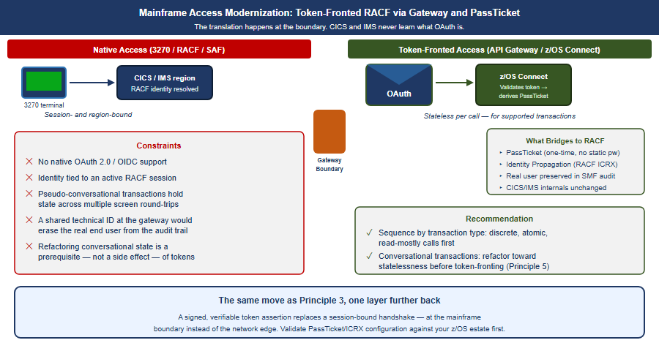{width=“5.833333333333333in” | height=“3.111111111111111in”} | | Figure 14: Mainframe access modernization: native 3270/RACF/SAF | access on the left versus token-fronted access through an API | gateway/z/OS Connect on the right, bridging to RACF via PassTicket | and Identity Propagation |
The established pattern: an API gateway or z/OS Connect (EE) layer exposes CICS, IMS, or batch assets as REST/JSON services and terminates an OAuth 2.0 / OIDC token issued by the enterprise identity provider (e.g., Entra ID). The gateway validates the token’s signature and claims, then derives a RACF PassTicket — a one-time, algorithmically generated credential (from a shared secret, user ID, application ID, and timestamp) — to authenticate to RACF without storing or transmitting a static password. z/OS Identity Propagation (RACF distributed identity filters / ICRX) maps the external token’s subject into the RACF audit and authorization context, so the transaction is authorized and logged against the real end user rather than a shared technical service ID. This is architecturally the same move as Principle 3 — a signed, verifiable assertion replaces a session-bound handshake — applied one layer further back, at the mainframe boundary instead of the network edge.

What does not change internally
CICS and IMS do not natively understand OAuth tokens, and the underlying transaction engine remains region- and session-bound. Token-based access is a translation at the boundary, not a replacement of the mainframe’s internal security model. Pseudo-conversational transactions that hold state across multiple screen interactions are the harder case: they were designed around a persistent session, and converting them to a stateless, per-request token model is itself a round-trip-reduction and refactoring exercise — the same work Principle 5 already calls for. In practice, token-based mainframe access and round-trip reduction are not two separate modernization tracks; they are the same gateway and the same refactoring effort viewed from two angles.

Recommendation
Treat mainframe token-based access as a byproduct of Principle 5’s interface-consolidation work, not a separate initiative. The same API/gateway layer built to aggregate chatty synchronous calls is the natural point to terminate tokens and bridge to RACF via PassTicket and Identity Propagation. Sequence the work by transaction type: discrete, atomic, read-mostly transactions are the near-term candidates for token-fronted access; pseudo-conversational, multi-step transactions should be refactored toward statelessness first, which is exactly the round-trip reduction Principle 5 already requires. Validate PassTicket and Identity Propagation configuration against the specific z/OS estate before committing a modernization timeline — this assessment is general; the environment’s current CICS/IMS versions, RACF class configuration, and API gateway posture will determine the actual sequencing.

Federal Framework Alignment
The following table maps each concept in this narrative to the federal mandate, standard, or policy that requires or validates it.
Concept / Narrative Fede Claim | ral Mandate Standard / R | eference
Separate truth from EO 1 runtime enforcement OMB | 4028 (May 2021), NIST SP M-22-09 (Zero Trust tene | 800-207 §2 ts)
Single source of truth E for identity and data Fe | vidence Act (2018), NIST deral Data Strategy CM-8 | SP 800-53 Rev 5 , SI-12
Authoritative identity F attributes from HR / M-2 authoritative sources Gu 2025) | ICAM Architecture, OMB N 2-09 Digital Identity idelines (31 Jul | IST SP 800-63 Rev 4
Application-aware OMB M- networking; 14028 3.0 Br per-transaction policy R enforcement | 22-09 §4, EO NIST SP 800 anch Office and emote User use cases | -207, TIC
Phishing-resistant MFA B / Certificate-Based pill Authentication (Advanced | OD 25-01, OMB M-22-09 CI ar /Optimal) | SA ZTMM v2.0 Identity
Eliminate NTLM; move to token-based identity bas | BOD 25-01 (M365 SCuBA CI elines) pillar | SA ZTMM v2.0 Identity
Device compliance as OMB input to access pillar decisions | M-22-09 §3 CISA ZTMM v2 | .0 Devices
SD-WAN local internet TI breakout; eliminate Inte MPLS hairpin | C 3.0 (Trusted CISA ZTMM rnet Connections) pillar | v2.0 Networks
SASE / ZTNA as access OM model replacing VPN ZTMM | B M-22-09 §4, TIC 3.0 NI Networks pillar | ST SP 800-207, CISA
Unified DNS as security control (DNSSEC, RPZ, SC threat blocking) | FedRAMP Moderate NIST SP -20/21 SC-20, SC-21 | 800-53 Rev 5
IP address inventory as compliance evidence CM-8 (CM-8) | FedRAMP Moderate NIST SP | 800-53 Rev 5
Audit provenance: every transaction traceable AU to authorized source | FedRAMP Moderate NIST SP -2/12 AU-2, AU-12 | 800-53 Rev 5
Continuous monitoring; F automated KSI Consolidat enforcement 25, 2026); O A-130 | edRAMP 20x NIST SP 800-3 ed Rules (Jun CA-7; FedR MB Circular mandatory Ja | 7 Rev 2 AMP 20x KSIs; n 1, 2027
Gated actuation as FedRA standard governance M-22 posture (Advanced Orches maturity) | MP ConMon, OMB CISA ZTMM -09 Automation and tration pillar | v2.0
Machine-readable KSI Fed evidence; no manual Cons evidence assembly Class open Aug 3/31, 2026 stru | RAMP 20x FedRAMP 20x JSO olidated Rules — evide A/B/C pipelines GitHub-p ctured rules | N nce format; ublished
Reduce synchronous OMB C round-trip count before separating an practice); application from Princip authoritative data | ircular A-130 NIST SP 80 (sound engineering SA-8 EO 14028 Privacy Engine les) | 0-53 Rev 5 (Security and ering
Bridge mainframe OMB M-2 RACF/SAF access to authe token-based identity 25- via API gateway and PassTicket | 2-09 (modern NIST SP 800 ntication); BOD ZTMM v2. 01 pillar | -207; CISA 0 Identity

Call to Action
This whitepaper describes a well-worn commercial transition your agency has not yet completed, under a federal compliance deadline that is no longer negotiable. The following steps convert the five principles into an execution plan.
None of this requires a specific vendor decision on day one. It requires an inventory, an owner, and a date. The architecture described in this whitepaper is not aspirational — it is what the commercial sector already runs, and what federal compliance now requires.

Appendix — Narrative provenance: this arc mapped to FMP canon
Everything above this appendix is vendor- and product-neutral — it cites only NIST, OMB, CISA and FedRAMP, and the argument stands without anything below. This appendix is separable: it exists for readers who want to know where Act 4’s claims come from in the FMP substrate, and it can be dropped when the paper is handed to an audience that is not evaluating a platform.
The same arc also circulates as the compliance series Vol I Book 05, which carries the federal control-closure framing (NIST 800-53, FedRAMP 20x KSI, TIC 3.0) and the SD-WAN / INR implementation appendix. That book names no automation engine at all — the the compliance series series is adoptable on its own — so this appendix is the canonical home of the mapping below. The modernization pillar’s curated entry points for the arc are collected at the OrgMod hub.
Acts 1–3 are the agency’s lived history and are not canon claims. Act 4 is anchored — here is the line-by-line provenance, including where earlier framings were corrected to match canon.
Narrative claim Canon an | chor Reconciliation note
Separate truth from the runtime enforcement; AD conflated directory + DC | program decision §1 Verbatim doctrine; the spine of Act 4.
Application-aware the pr networking; token-bound per-call transport by ac “Session is no longer a canonical concept.” | ogram decision Proposed (amended by the program decision); generalized cepted the program decision.
Vendor products (SD-WAN platform, cloud Book_17 on-ramp) sdwan-fabric Azure Policy, ISE/ClearPass/Entra RADIUS. Specific platforms are illustrative, incorporated as providers. | the program decision §2, Softened: canon names a neutral slot,
Session→token identity; CBA replaces Kerberos th Cloud Kerberos trust. | the program decision, Canonical. NTLM e program decision elimination + CBA +
Control-plane governance L0–L4 ladder; federal o L3 ceiling | ; the program decision §3–4 Verbatim; the keystone f the way forward.
Restore single source th of truth / provenance th accountability / integrity**. Program-integrity stakes are the agency’s real-world motivation, not an FMP canon claim. | e program decision, Canonical, framed as e program decision **governance /

