Book_01 — The Authentication Inheritance Problem
  - SQL Server Identity Transformation — Narrative Series
Table of Contents

Book_01 — The Authentication Inheritance Problem
SQL Server’s Windows Authentication was an act of good engineering, not negligence. This book makes the case for replacement without making the case that what came before was foolish — a precise account of what Windows Authentication is, why it worked, and why it must now end.
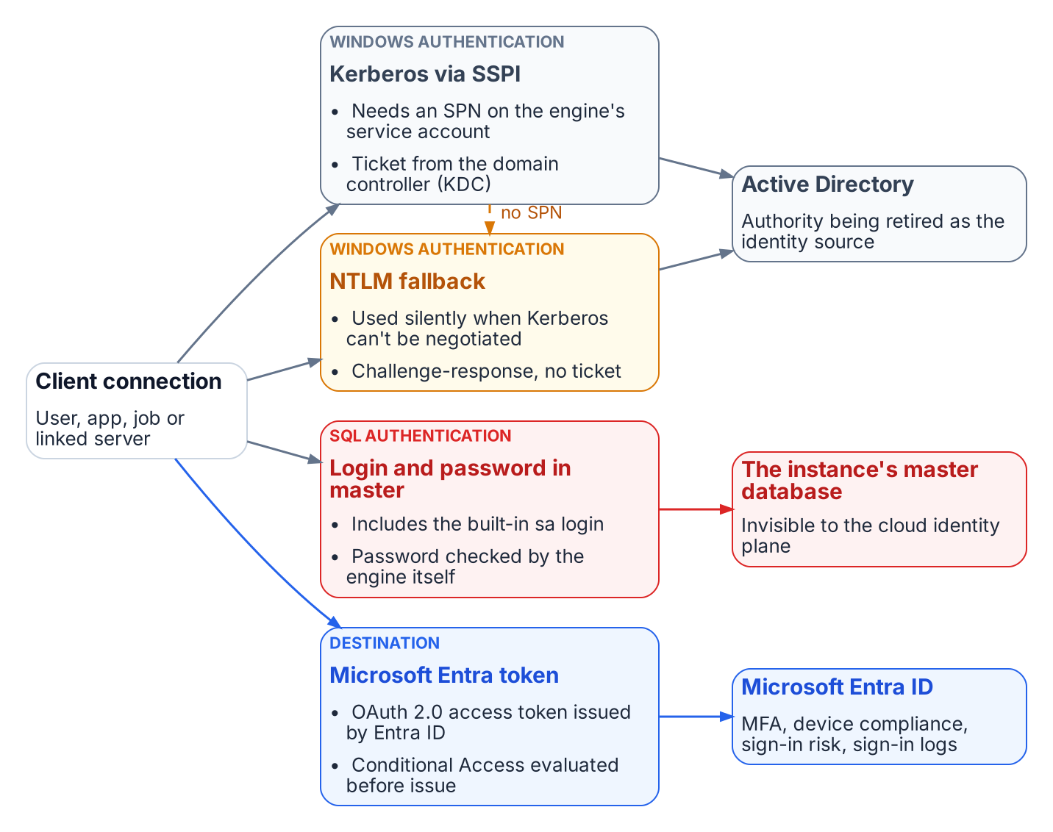
The four ways a connection authenticates to SQL Server today, and which authority each depends on.
Place in the dependency chain: Why the chain exists (before step 1).

Authoritative references
Checked 19 October 2026.
- Microsoft Entra authentication for SQL Server overview
- Microsoft Entra cloud-first identity guidance
- Retiring NTLM: frequently asked questions (Microsoft Tech Community)
- OMB M-22-09, Federal Zero Trust Strategy
- Memo 22-09 identity requirements overview

Chapter 1 — What Windows Authentication Actually Is
The inheritance, named precisely, before the case for replacing it.

In this chapter
How SQL Server delegates authentication to the Windows security subsystem through Kerberos and SSPI, why a missing SPN silently drops a connection to NTLM, what the service account and the sa account each contribute to the picture, and why this whole architecture was genuinely good engineering for the world it was designed for.

The Kerberos Foundation
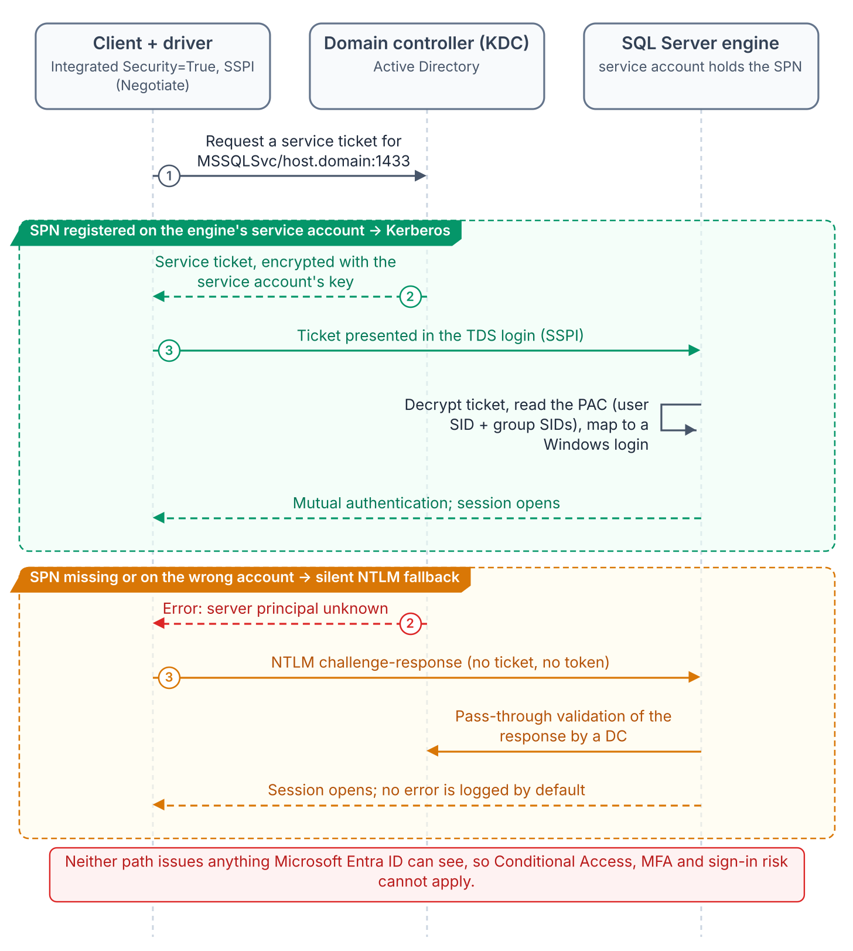
A Windows-integrated connection: SSPI negotiates Kerberos when the SPN resolves, and silently falls back to NTLM when it doesn’t.
In Windows Authentication mode, SQL Server delegates authentication entirely to the Windows security subsystem, with no password verification or token model of its own. With Integrated Security=True, the driver hands off to the Security Support Provider Interface (SSPI), which, if Kerberos is negotiable, requests a service ticket from the domain controller’s Key Distribution Center (KDC) for the instance’s Service Principal Name (SPN). The engine validates the ticket with the service account’s key and maps the principal to a login. No password crosses the network, none sits in configuration files, and authentication is mutual. This is good security architecture, and it deserves saying plainly before explaining why it must be replaced.
The SPN, MSSQLSvc/hostname.domain.com:port, is registered on the engine’s service account, binding that account’s long-term key to the service name. Without it the KDC cannot issue a ticket, and SSPI silently falls back to NTLM.
That silent fallback is the most consequential fault in the inheritance. It is invisible to applications and absent from the default error log, so environments confident they run Kerberos are running NTLM on a significant fraction of connections. Only measurement reveals the fraction; the authentication audit is the instrument, and most federal environments have not run it.

The NTLM Fallback
NTLM was Windows’ original network protocol. When Windows 2000 made Kerberos preferred, NTLM stayed as the fallback where Kerberos could not be negotiated: untrusted domains, non-domain-joined clients, unreachable KDCs. SQL Server inherited that order unchanged, and for a perimeter-defended, fully domain-joined network it was adequate.
It does not scale to zero trust, which this program’s FedRAMP Moderate boundary now requires. NTLM’s challenge-response happens entirely inside the connection negotiation and issues no token or assertion a third party can validate. Conditional Access, which lives in the Azure identity plane outside the connection path, has nothing to observe, evaluate, or deny.

The Service Account
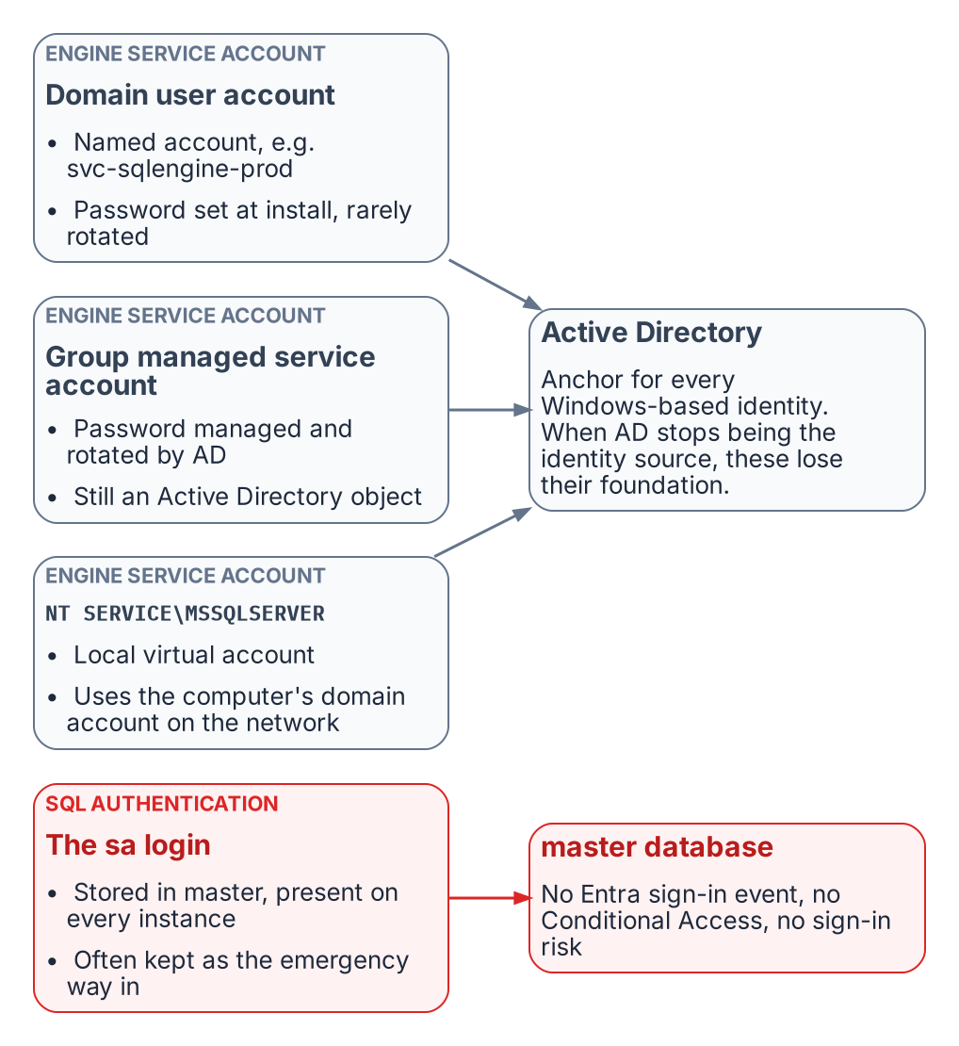
The identities the engine has historically run under, and where each one is anchored.
The engine’s service account is the identity it presents on the network: to file shares, linked servers, and monitoring sinks. Federal estates use three forms:
- a domain service account such as svc-sqlengine-prod, with a password set at installation and rarely changed;
- a group managed service account (gMSA), whose password AD rotates every 30 days and no human knows; better hygiene, but still AD-anchored;
- the NT SERVICE\MSSQLSERVER virtual account, which authenticates on the network as the domain-joined computer account.
In every case AD is the engine’s identity authority. When the program removes AD as the authoritative source, the engine needs a new identity in Microsoft Entra ID — on SQL Server 2025, the system-assigned managed identity that Arc provides for the host; on SQL Server 2022, an app registration whose certificate is kept in Azure Key Vault. That identity sits alongside the Windows account the service runs as rather than replacing it; the transition is the subject of Book 04.

The sa Account
SQL Authentication stores credentials in master instead of AD, and sa is its built-in administrator on every instance. Well-governed estates disable or rename it; many federal estates keep it active as an emergency path in case AD fails, often with its installation-time password.
SQL Authentication is invisible to the Azure identity plane: no Entra sign-in event, no Conditional Access, no Defender for Identity signal, no risk assessment. An active sa is the most dangerous entry point on the instance. Its handling is one of the decisions the SQL Server engine-authentication decision formalizes.

Why This Was Correct
Taken together, SSPI-negotiated Kerberos, SPNs, NTLM fallback, AD service accounts, and SQL Authentication as a local fallback form a coherent, defensible architecture. In a fully domain-joined world it was centrally managed, non-repudiable at the ticket level, resistant to credential theft in transit, and needed nothing beyond the domain controllers already in place. It was not a compromise. The problem is that its world (every machine domain-joined, the perimeter as the boundary, no cloud identity plane) no longer exists.
What Book 01 establishes — Chapter 1
- SQL Server Windows Authentication delegates to the Windows security subsystem: Kerberos through SSPI when an SPN is registered, silent NTLM fallback when it is not.
- The engine’s process identity and the sa account are anchored to authorities — Active Directory and master — that the program removes or that the Azure identity plane can’t see.
- None of this was a mistake; it was correct engineering for a fully domain-joined world that no longer exists.

Chapter 2 — Why the Inheritance Must End
Three drivers, each as well-reasoned as the original design, and their dependency structure.

In this chapter
The three forces that now require replacing Windows Authentication for SQL Server — the NTLM elimination the program has committed to, with its 2027-04-01 backstop, the zero-trust requirement that puts the Azure identity plane in the authentication path, and the service-account credential problem created by the broader directory modernization — and why their dependency structure dictates the order of the entire series.
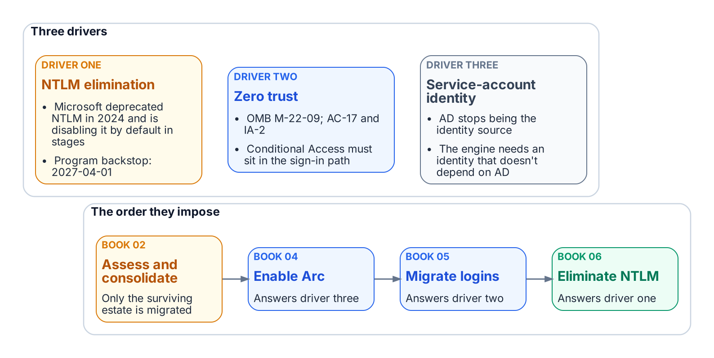
Three drivers end the inheritance, and their dependencies set the order of the series.
The reasons for replacement are as well-reasoned as the original design. NTLM elimination, Conditional Access in the authentication path for all human access, and the end of the domain-joined world are not preferences. They follow from Microsoft’s deprecation of NTLM, the transformation inventory, and OMB M-22-09 (the Federal Zero Trust Strategy), operationalized in this boundary as phishing-resistant MFA and Conditional Access (AC-17, IA-2).

Driver One — The NTLM Elimination Commitment
The first driver is a decision this program has made and recorded: the Kerberos/NTLM-elimination program, accepted 2026-05-13, commits the program to eliminating NTLM. The external driver is real but gradual: Microsoft formally deprecated NTLM in June 2024 and is disabling it by default — not removing it — across successive Windows releases, from enhanced auditing in Windows Server 2025 / Windows 11 24H2, to the BlockNTLMv1SSO enforcement default arriving via Windows Update in October 2026, to network NTLM off by default in the next major Windows Server release (~2027/2028). Microsoft has not published a fixed calendar date for that final step; the program’s 2027-04-01 backstop is its own planning anchor, set to finish ahead of it, not a vendor deadline. Both NTLM variants are eliminated, on different timelines. NTLMv1 goes first: Phase B blocks it through the LAN Manager Authentication Level policy as soon as the Phase A assessment completes (targeted 2026-Q3), so any connection still needing LM or NTLMv1 fails before the engine evaluates the login. Book 06 covers the detail.
NTLMv2 has a firm backstop: on 2027-04-01 the enforcement phase disables NTLM at the LSA layer across the estate. Any SQL Server connection still relying on it, through a missing SPN, a client that cannot negotiate Kerberos, a trust boundary, or an unjoined host, will fail inside the host’s security subsystem before the engine sees it. 2027-04-01 is not the migration’s completion date; it is the date by which consolidation, Arc deployment, login migration, and connection-string migration must already be complete.

Driver Two — The Zero-Trust Requirement
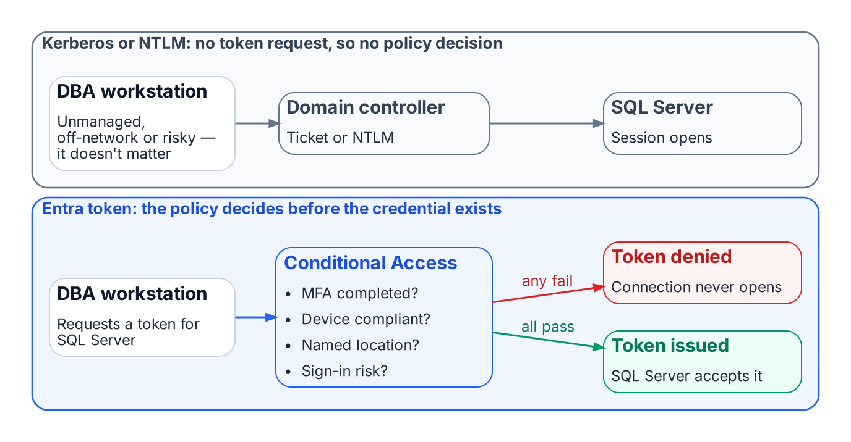
Conditional Access can evaluate an Entra token request; it never sees a Kerberos or NTLM exchange.
The M-22-09 zero-trust posture for this FedRAMP Moderate boundary cannot be implemented without the Azure identity plane in the SQL Server authentication path. Conditional Access enforces device compliance, named locations, MFA, and sign-in risk by intercepting token issuance. Kerberos and NTLM involve no token request, so a DBA on an unmanaged device, outside named locations, or with elevated risk cannot be blocked.
With Entra ID authentication, every token request is evaluated first. Missing MFA, a non-compliant device, or elevated risk (an anonymous IP, an account flagged by Entra ID Protection) means no token, or a remediation challenge, and no connection. The policy has real leverage because the token it controls is the credential SQL Server accepts.

Driver Three — The Service Account Credential Problem
The transformation inventory removes Active Directory as the authoritative identity source. The AD service accounts and gMSAs that authorize the engine on the network then lose their governance foundation, so the engine needs a new identity first.
On-premises, that identity arrives through Azure Arc: the server’s managed identity, which SQL Server 2025 uses directly, or on SQL Server 2022 an app registration certificate the Arc agent fetches from Key Vault with that identity. (Microsoft also documents an Arc-free, certificate-only app-registration setup.) Arc is therefore a prerequisite, not an enhancement. It does not change the Windows account the service runs as.
The order follows from these dependencies, preceded by Book 02’s consolidation decision: assess and consolidate, enable Arc, migrate logins, then eliminate NTLM. That order is the architecture of this series.
What Book 01 establishes — Chapter 2
- Three independent drivers end the Windows Authentication inheritance: the Kerberos/NTLM-elimination program and its 2027-04-01 backstop, the M-22-09 zero-trust posture, and the engine’s need for an identity that outlives AD.
- The zero-trust posture works only when the Entra identity plane is in the authentication path.
- The drivers’ dependencies set the order of the books: inventory and rationalize, audit, enable the identity substrate, move principals and applications, retire protocols, then demonstrate the posture.

Microsoft Learn, Register a Service Principal Name for Kerberos connections.
Microsoft Learn, Change server authentication mode.
Microsoft Learn, What is Microsoft Entra ID Protection?.
Microsoft Learn, What is Conditional Access?.
Microsoft Learn, Group Managed Service Accounts overview.
Microsoft Learn, Managed identity overview — SQL Server enabled by Azure Arc.
Microsoft Learn, Set up Microsoft Entra authentication with app registration — SQL Server enabled by Azure Arc.
Microsoft Learn, What is Conditional Access?.
Office of Management and Budget, M-22-09, Moving the U.S. Government Toward Zero Trust Cybersecurity Principles.
Microsoft Learn, Features removed or no longer developed in Windows Server.
Microsoft Learn, Register a Service Principal Name for Kerberos connections.
Microsoft Learn, What is Microsoft Entra ID Protection?.
Microsoft Learn, Group Managed Service Accounts overview.
Microsoft Learn, Azure Arc-enabled servers overview.
Microsoft Learn, Managed identity overview — SQL Server enabled by Azure Arc.
Microsoft Learn, Set up Microsoft Entra authentication with app registration — SQL Server enabled by Azure Arc.

