Book_02 — The Estate Itself
  - SQL Server Identity Transformation — Narrative Series
Table of Contents

Book_02 — The Estate Itself
You do not migrate the estate in the shape you discover it. After twenty years across an Active Directory forest, the SQL Server estate is larger and more tangled than any team’s mental model of it — and a significant fraction of it should not survive the transformation at all. This book establishes the consolidation assessment that classifies every instance retain, consolidate, or retire before any login is touched.
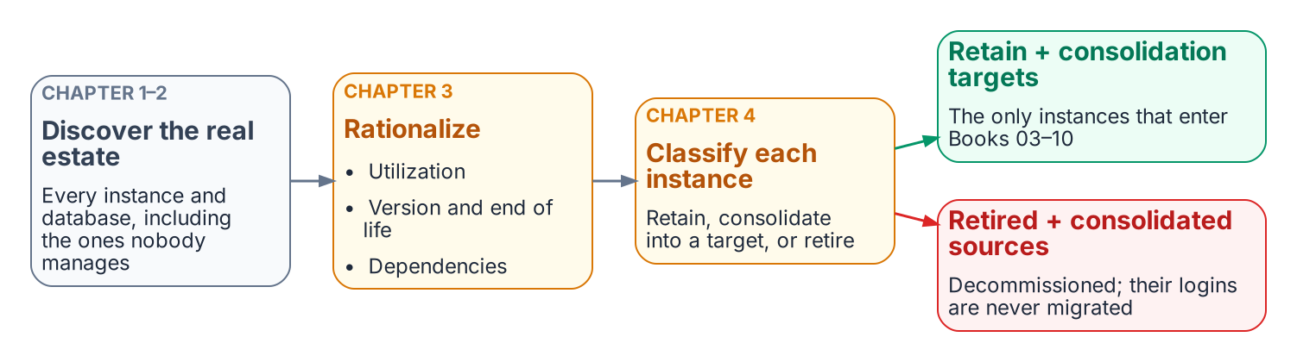
The estate is measured and reduced before any login moves.
Place in the dependency chain: Steps 1–2 — Inventory and Rationalize.

Authoritative references
Checked 19 October 2026.
- End of support options — SQL Server
- SQL Server enabled by Azure Arc — overview
- Migrate SQL Server Windows users and groups to SQL Managed Instance using T-SQL
- Microsoft Entra cloud-first identity guidance

Chapter 1 — The Shape of Twenty Years
Why the estate you must transform is not the estate anyone remembers building.

In this chapter
The three forms of sprawl that accumulate in a SQL Server estate over two decades across an Active Directory forest — instance sprawl, database sprawl, and forest entanglement — and why an authentication transformation that begins before this sprawl is assessed will migrate the authentication of servers that should not survive the transformation at all.
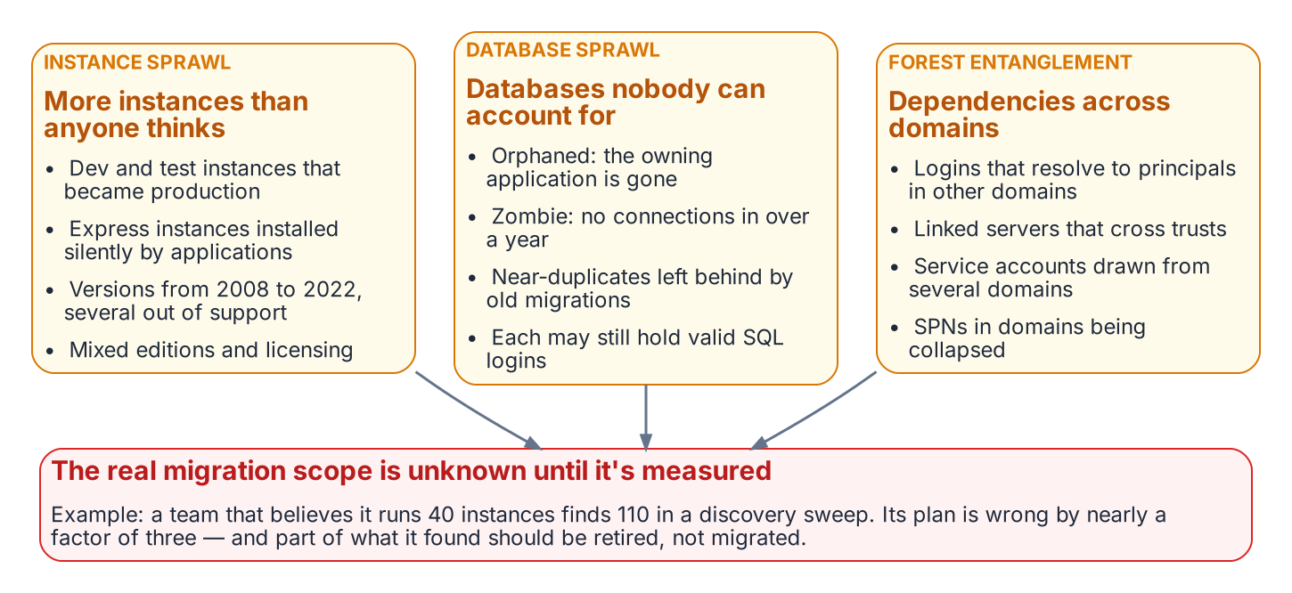
Instance sprawl, database sprawl and forest entanglement overlap, and together they set the scope of the transformation.
The previous book named the inheritance and the three drivers that require ending it. This book confronts a precondition that most authentication narratives skip entirely: you cannot migrate the authentication of an estate you have not first measured and rationalized. After twenty years across an Active Directory forest, the SQL Server estate is larger, older, and more entangled than any single team’s mental model of it — and a meaningful fraction of it should not survive the transformation in its current shape.
The order matters because effort is finite and the 2027-04-01 deadline is fixed. Migrating the logins of an instance to Entra ID, only to retire that instance three months later, is wasted work measured against a deadline that does not move. The SQL Server engine-authentication decision makes the sequencing normative: the consolidation assessment classifies every instance retain, consolidate, or retire before any login is touched.

Instance Sprawl
A SQL Server estate does not grow by design. It grows by accretion. A development instance becomes a production instance because a project shipped and nobody rebuilt it on the production tier. A test instance set up for a vendor evaluation is never decommissioned. An application installer silently provisions a SQL Server Express instance on an application server, and that instance accumulates real data for years without ever appearing on a DBA team’s inventory.
The result, in a mature federal environment, is a population of instances spanning every SQL Server version released across two decades — 2008, 2012, 2014, 2016, 2017, 2019, and 2022 — in every edition, from Express on a workstation to Enterprise on a clustered host. Several of those versions are out of support and receive no security updates. The licensing posture is equally heterogeneous: a mix of Standard and Enterprise cores, some covered by Software Assurance and some not, with no single authority that can state how many cores the estate actually consumes.
Instance sprawl is the first thing the assessment must quantify, because the count of instances — and especially the count of unknown instances — determines the true scope of the transformation. In an illustrative example, an estate that the DBA team believes contains forty instances and the discovery sweep reveals to contain a hundred and ten is not forty instances behind schedule; it is operating on a scope estimate that is wrong by a factor of nearly three.

Database Sprawl
Beneath the instances lies a second layer of accretion: the databases themselves. An instance that has run for fifteen years carries databases nobody can confidently account for. Some are orphaned — the application that created them has been decommissioned, but the database was never dropped because no one was certain it was safe to do so. Some are zombies — they have received no connection in over a year, yet they consume storage, appear in backup jobs, and lengthen every maintenance window. Some are near-duplicates, the residue of a migration that copied a database to a new name and never removed the original.
Database sprawl matters to the authentication transformation for a specific reason. Every database is a potential source of logins, and every login is a unit of migration work. A zombie database may map a long-forgotten SQL Authentication service account that still has a valid password and still appears, to a discovery script, as an active credential requiring migration. The fastest way to reduce the migration surface is not to migrate faster — it is to retire the databases and instances that should not be migrated at all.
Zombie detection is therefore not a housekeeping nicety; it is migration-scope reduction. To take an illustrative example, a database with no connections in four hundred days, no recent backups consumed for a restore, and an owning application that the application portfolio lists as retired is a database whose logins should never enter the migration pipeline.

Forest Entanglement
The third form of sprawl is the one that makes the SQL Server transformation genuinely harder than a single-domain migration: the estate is entangled with the Active Directory forest it grew up in. Instances are spread across multiple domains connected by trusts. Logins on one instance resolve to security principals in a different domain. Linked-server definitions form a web of cross-instance dependencies that crosses domain boundaries, and the service accounts running the engine processes are drawn from several domains with no consistent naming or governance.
This entanglement is precisely what the directory modernization removes the foundation for. When Active Directory ceases to be the authoritative identity source, every cross-domain login, every SPN registered in a domain that is being collapsed, and every shared service account becomes a dependency that must be resolved — not merely re-pointed. Consolidation is the moment when that resolution is cheapest, because collapsing many instances into fewer modern targets is also the moment to collapse the cross-domain identity sprawl into Entra-backed identity.
The shape of twenty years, then, is three overlapping problems: too many instances, too many databases, and too many forest-spanning dependencies between them. The chapters that follow describe how to measure each, and how to turn the measurement into the retain / consolidate / retire decision that gates everything in Books 03 through 10.
What Book 02 establishes — Chapter 1
- A twenty-year estate has three overlapping forms of sprawl: instances, databases, and forest entanglement.
- Sprawl inflates the migration surface, because much of the estate should be retired or consolidated rather than migrated.
- The authentication transformation doesn’t begin until the sprawl is assessed.

Chapter 2 — The Estate Inventory
Finding the instances and databases that no inventory already records.

In this chapter
What a complete estate inventory must capture before consolidation can begin, the discovery instruments that find the instances no one remembers — network and Active Directory sweeps, the SPN registration trail, and Microsoft’s migration-assessment tooling — and why estate discovery is a broader exercise than the authentication audit that Book 03 describes.
A consolidation assessment begins with an inventory, and the defining characteristic of a twenty-year estate is that the inventory does not already exist in complete form. The instances a DBA team manages deliberately are known. The instances that matter most to the assessment are the ones nobody is managing — and those must be discovered, not retrieved from a list.
This is the point at which estate discovery diverges from the authentication audit of Book 03. The authentication-audit script measures the authentication posture of instances that are already known: their login types, their authentication mode, their SPN status, their Arc eligibility. Estate discovery runs earlier and casts wider. Its job is to establish the denominator — the complete set of instances and databases that exist — so that the authentication audit has something complete to measure.

What the Inventory Must Capture
An estate inventory sufficient to drive a consolidation decision captures, for every instance it can find, a consistent set of facts. The version, edition, and build number establish the support and licensing posture. The host operating system version establishes the Arc and upgrade envelope. The domain-join state and the owning domain establish the forest-entanglement picture. The service-account identity and its source domain establish the credential dependencies. And, for every database on the instance, the size, the last-access timestamp, the recovery model, and the owning application establish the utilization and zombie picture that Chapter 3 turns into a rationalization decision.
The inventory is not a point-in-time spreadsheet. Like the authentication audit it precedes, it is designed to be re-run, because instances appear and disappear across a multi-month assessment, and the consolidation plan must track a moving estate rather than a single snapshot.

Discovery Instruments
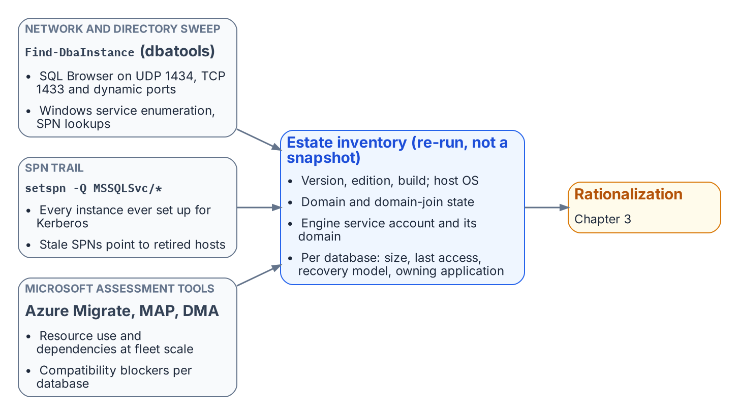
Three independent discovery instruments feed one re-runnable estate inventory.
No single instrument finds every instance, because instances hide in different ways. A complete sweep combines several, each blind to what the others surface.
A network and directory sweep finds instances by listening for them. The SQL Server Browser service responds on UDP 1434, instances listen on TCP 1433 and dynamic ports, and Active Directory itself records instances indirectly. The open-source PowerShell module dbatools provides Find-DbaInstance, which combines these signals — service-principal-name lookups, SQL Browser responses, port scans, and Windows service enumeration — into a single discovery pass across a network range or an Active Directory domain. It is the most direct way to surface instances that no inventory records.
The SPN registration trail is a second, independent signal. Because every instance that successfully negotiates Kerberos must register an MSSQLSvc service principal name, a forest-wide query for those SPNs (setspn -Q MSSQLSvc/*, or the equivalent directory query) enumerates every instance that was ever configured for Kerberos — including instances on hosts that are otherwise off the radar. The SPN trail also feeds directly into the authentication audit, because a registered SPN that points at a decommissioned host, or an instance generating Kerberos traffic with no corresponding SPN, are both findings the later books act on.
Microsoft’s migration-assessment tooling is the third instrument, and it captures what the first two cannot: workload and dependency data. Azure Migrate, with its dependency-analysis capability, and the Microsoft Assessment and Planning (MAP) Toolkit, enumerate instances and their resource consumption at fleet scale. The Data Migration Assistant (DMA) assesses individual databases for compatibility and feature blockers against a target version. These instruments are pedagogically useful here for what they reveal about the estate, independent of any decision to use Azure as a migration target — the dependency map and the version-compatibility findings are inputs to the consolidation decision regardless of where the consolidated estate ultimately lands.

Why a Canonical Estate-Discovery Spec Does Not Yet Exist
The discovery instruments named above are real and well-understood, but they are not yet bound into a canonical discovery specification the way the authentication-audit script, the application-audit script, and the certificate-audit script bind the authentication, application, and certificate audits. The SQL Server engine-authentication decision names this as an explicit gap: the estate-consolidation inventory that produces the retain / consolidate / retire classification has no discovery script of its own. Authoring that instrument — a discovery script whose output feeds the same compliance-monitoring pipeline as the authentication audit — is identified in the implementation plan as Phase 0, the prerequisite to everything the later books describe.
Until that specification exists, the consolidation assessment is conducted with the general-purpose instruments above and recorded as a deliberate program artifact rather than a canonical telemetry record. Naming the gap is itself part of the assessment’s value: an estate transformation that proceeds on an incomplete inventory will discover its missing instances at the worst possible moment, which is exactly the failure mode the discipline of this book exists to prevent.
What Book 02 establishes — Chapter 2
- Inventory comes first: the estate doesn’t already know what it has.
- Discovery combines a network and directory sweep, the MSSQLSvc SPN trail, and Microsoft’s assessment tooling, because each misses what the others find.
- No canonical discovery script exists yet; the engine-authentication decision names authoring it as Phase 0.

Chapter 3 — Rationalization: Utilization, Versions, and Dependencies
Turning a complete inventory into a defensible judgment about what each instance is worth.

In this chapter
The three analytical lenses that convert a raw inventory into a rationalization judgment — utilization and zombie detection, version and end-of-life posture, and dependency mapping — and why the dependency map in particular determines which instances can be consolidated and which are load-bearing in ways that are invisible until they are mapped.
An inventory establishes what exists. Rationalization establishes what each item is worth keeping. The assessment applies three lenses to every instance and every database the inventory surfaced, and the combined picture drives the retain / consolidate / retire decision that Chapter 4 formalizes.

Utilization and Zombie Detection
The first lens is utilization. An instance consumes CPU, memory, storage, and a licensing entitlement whether or not anyone is using it, and a twenty-year estate contains instances that consume all four while serving no current workload.
Utilization analysis rightsizes the survivors and identifies the candidates for retirement. For each instance, the assessment captures sustained and peak resource consumption, connection counts, and the workload profile — read-heavy reporting, transactional, batch, or idle. For each database, it captures the last-access timestamp, the recent query workload, and the backup-restore history.
A database with no connections in over a year, no restores consumed, and a retired owning application is a zombie, and zombies are the cleanest retirement candidates in the estate. Retiring them is the single most effective way to reduce the authentication migration surface, because every login they carry — including long-forgotten SQL Authentication service accounts with still-valid passwords — is removed from the migration pipeline before it ever enters it.
Utilization data also rightsizes the consolidation targets. In an illustrative example, an instance running at four percent of a sixteen-core Enterprise license is not a retain candidate at its current size; it is a consolidation source whose workload belongs on a shared modern target, freeing the license and the host.

Version and End-of-Life Posture
The second lens is version posture, and it interacts directly with the authentication transformation. The FROM EXTERNAL PROVIDER login syntax that the entire transformation depends upon requires SQL Server 2022. An instance on any earlier version — 2019, 2017, 2016, or the out-of-support 2012 and 2008 — cannot accept Entra ID logins regardless of any other change, a constraint Book 03 formalizes as the Category 3 classification.
This makes version posture a primary input to the consolidation decision rather than a secondary one. An out-of-support instance on SQL Server 2012 is simultaneously a security-update liability, a licensing question, and an instance that cannot be migrated to Entra ID authentication without an engine upgrade. For most such instances, the right answer is not “upgrade in place to 2022 and then migrate” — it is “consolidate the surviving workload onto a modern target and retire the old engine.” The version lens and the utilization lens converge on the same conclusion for the bulk of the aged estate: collapse it onto fewer modern instances rather than carrying each old engine forward.
The licensing posture rides alongside the version posture. Consolidation that reduces the instance count also reduces the core-license consumption, and an estate that can state its true core count before consolidation can quantify the licensing dividend that consolidation produces.

Dependency Mapping
The third lens is the one that most often overturns a naive consolidation plan: dependency mapping. An instance that appears idle by connection count may be the silent target of a linked-server chain, a replication topology, an SSIS package, or a cross-database query that runs once a quarter and matters enormously when it runs.
Dependency mapping traces these relationships before any instance is moved. Linked-server definitions (sys.servers, sys.linked_logins) reveal the cross-instance — and frequently cross-domain — web that forest entanglement produced. Application-to-database mapping, drawn from connection telemetry and the application portfolio, reveals which databases are load-bearing for which systems. The SQL Server Agent job inventory, the replication configuration, and the SSIS/SSRS/SSAS footprint reveal the integration surface that a consolidation must preserve. Azure Migrate’s dependency analysis and the Data Migration Assistant’s compatibility findings supplement the in-engine views with workload-level dependency and feature-blocker data.
The dependency map is also the bridge to Book 08. The upstream applications that consume SQL Server — many of them LDAP-bound — are precisely the systems whose dependencies the map records, and the application-chain migration of Book 08 acts on the same relationships the rationalization lens surfaces here. An instance cannot be classified retire if a load-bearing application still depends on it, and the dependency map is what makes that judgment defensible rather than hopeful.

The Combined Picture
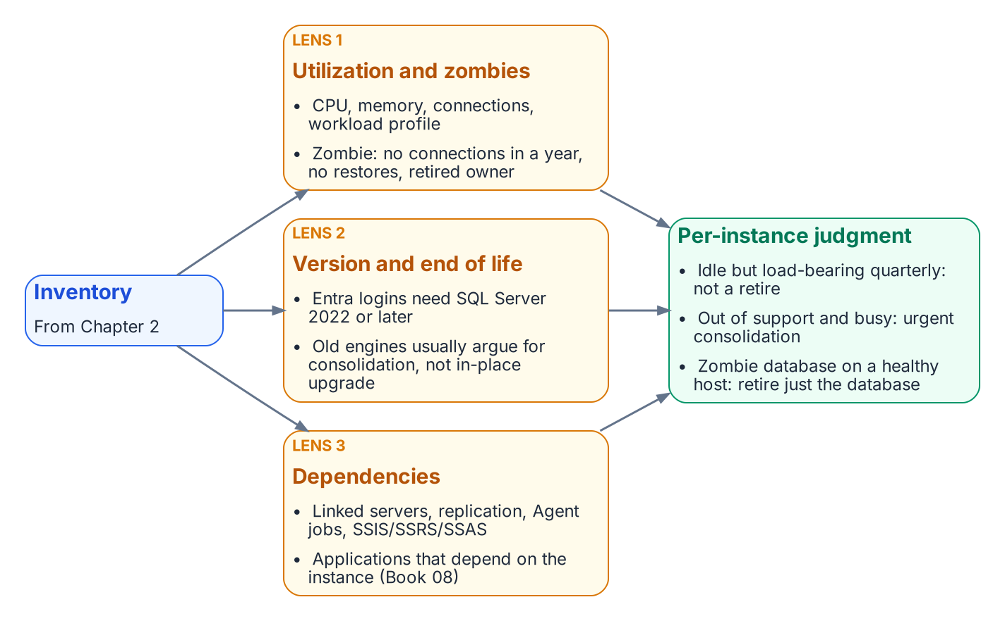
Utilization, version posture and dependencies, applied together, produce a defensible judgment per instance and per database.
No single lens produces the rationalization decision. An instance that is lightly utilized but load-bearing for a quarterly process is not a retirement candidate. An out-of-support instance with heavy utilization is an urgent consolidation target, not a leave-alone. A zombie database on an otherwise healthy instance is a local retirement that shrinks the migration surface without touching the host. The three lenses together produce, for each instance and each database, a defensible judgment — and that judgment is the input to the decision Chapter 4 records.
What Book 02 establishes — Chapter 3
- Rationalization applies three lenses — utilization, version and end-of-life posture, and dependencies — to every inventoried instance.
- Idle instances and zombie databases are retired, which shrinks the migration surface.
- The three lenses together produce the per-instance retain, consolidate or retire judgment.

Chapter 4 — The Retain, Consolidate, Retire Decision
The gate that determines which instances enter the authentication migration at all.

In this chapter
How the three rationalization lenses resolve into a single per-instance classification — retain, consolidate-into-target, or retire — the target-state options that absorb consolidated workloads, the constraints that prevent consolidation, and why this decision is the moment to collapse the forest-spanning identity sprawl into Entra-backed identity.
The assessment now resolves to a decision. Every instance the inventory surfaced and the rationalization lenses evaluated is assigned one of three classifications, and that classification governs whether the instance enters the authentication migration that Books 03 through 10 describe. The SQL Server engine-authentication decision makes the classification a normative prerequisite: engine-layer authentication migration is performed only on instances classified retain or on the consolidation targets that absorb consolidated workloads. Instances classified retire or consolidate-into-target (source) are not migrated — they are decommissioned or collapsed.

The Three Classifications
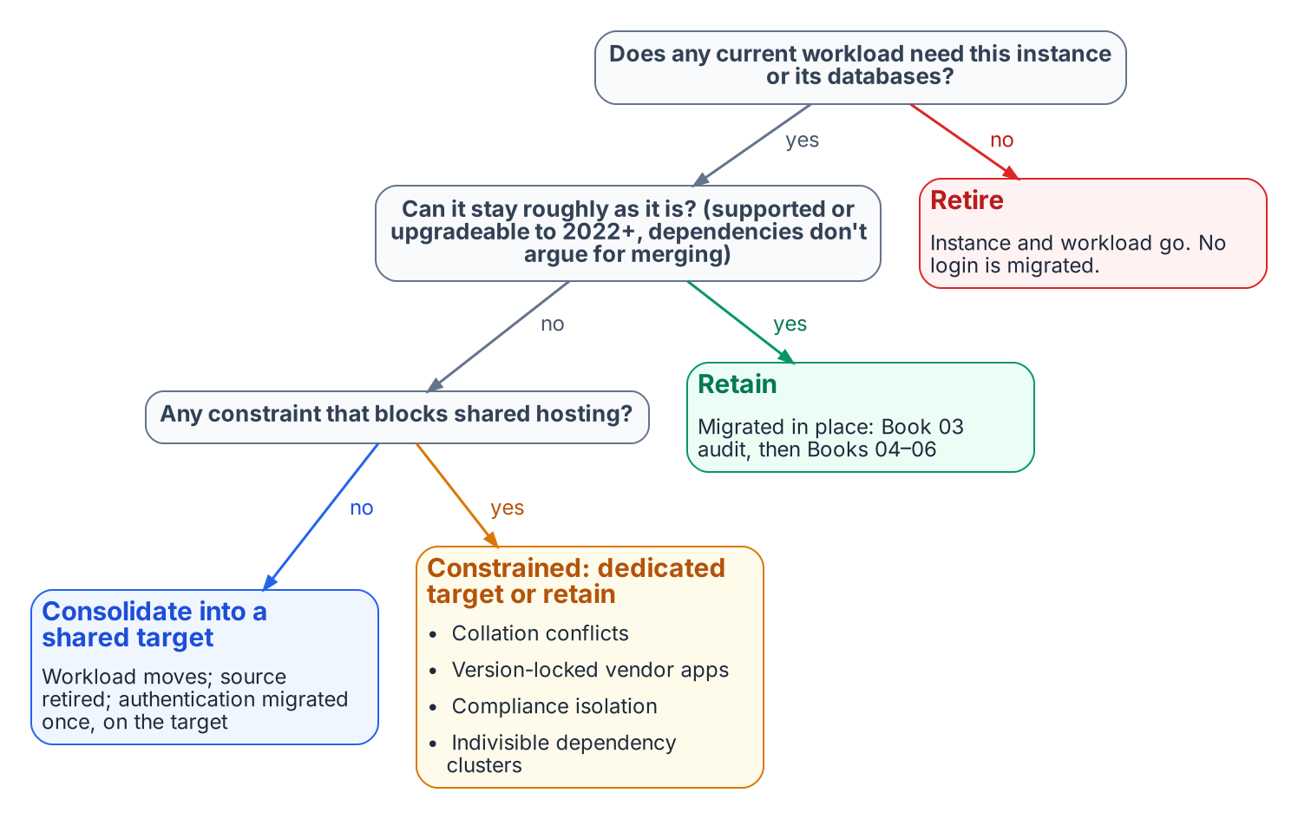
Retain, consolidate or retire: the classification that gates the authentication work.
A retain instance survives the transformation roughly in place. It carries current, load-bearing workload; it is on a supported version or has a clear in-place upgrade path to SQL Server 2022; and its dependencies do not argue for collapsing it into something larger. A retain instance proceeds directly into the Book 03 authentication audit and the Arc-eligibility classification.
A consolidate-into-target instance does not survive as an instance, but its workload does. The databases it carries are migrated onto a modern consolidation target, and the source instance is then retired. This is the classification for the large middle of an aged estate: lightly utilized instances, out-of-support engines whose workload is still needed, and instances whose only real function is to host one or two databases that belong on a shared platform. The migration work for these instances happens at the database-and-workload level; the authentication migration is performed on the target, not the source.
A retire instance does not survive at all, and neither does its workload. Zombie instances, instances whose every database is a zombie, and instances whose owning applications are decommissioned are retired outright. No login on a retire instance ever enters the migration pipeline — which is the entire point of running this assessment before the migration rather than after it.

Target-State Options
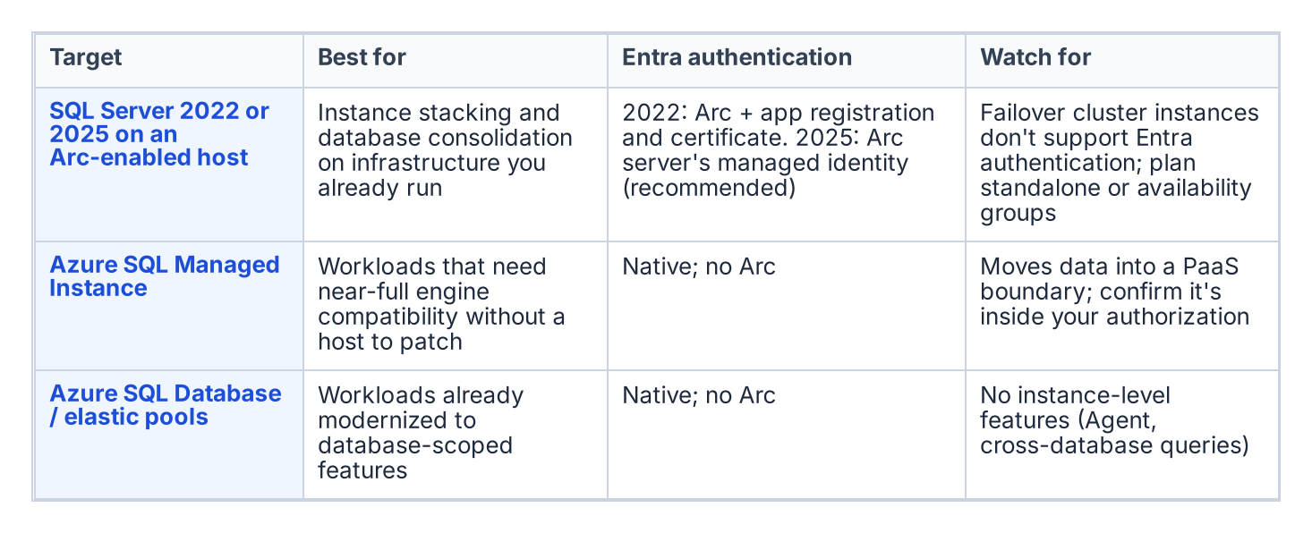
Consolidation targets, and what each one means for authentication.
A consolidation target is the platform that absorbs consolidated workloads, and the assessment chooses among a small set of options based on the workload profile and the program’s boundary posture. Collapsing many instances onto fewer modern SQL Server 2022 instances — through instance stacking or database consolidation onto a shared engine — is the most direct path and keeps the workload on infrastructure the program already operates. Azure SQL Managed Instance offers a near-full-compatibility platform-as-a-service target for workloads that can move to a managed surface, eliminating the host and much of the patching burden. Azure SQL Database and elastic pools suit workloads that have been modernized to the database-scoped feature set.
The target choice interacts with the rest of the series. A consolidation onto SQL Server 2022 on an Arc-enabled host is exactly the Category 1 starting position that Book 03 describes and Book 05 migrates. A consolidation onto Azure SQL Managed Instance changes the authentication story in detail — the Managed Instance is natively Entra-integrated — but not in principle, because the destination is still Entra ID-only authentication. The point of naming the target during the assessment is that the authentication migration is then performed once, on the target, in its final shape, rather than twice.

What Cannot Be Consolidated
Not every instance that looks like a consolidation candidate can actually be consolidated, and the assessment must record the constraints honestly. Collation conflicts between databases that must coexist on a shared instance can block stacking. Version-locked vendor applications that certify only against a specific SQL Server version cannot be moved to a newer engine without losing vendor support. Compliance-isolation requirements — a database whose data classification mandates physical or logical separation — can prevent co-residency regardless of technical compatibility. And cross-database or cross-instance dependencies that the dependency map surfaced can make two instances a single indivisible unit that must move together or not at all.
Each of these constraints converts an apparent consolidate candidate into either a constrained-consolidation case (move it, but onto a dedicated rather than shared target) or a retain case (leave it in place and migrate its authentication where it sits). Recording the constraint is what makes the consolidation plan executable rather than aspirational.

The Identity Dividend
Consolidation and the authentication transformation are mutually reinforcing, and the assessment is the moment to realize the connection. Collapsing many instances across multiple domains into fewer modern targets is also the moment to collapse the forest-spanning identity sprawl that Chapter 1 described. The cross-domain logins, the orphaned SPNs registered in domains being decommissioned, and the shared service accounts drawn from several domains do not need to be re-pointed instance by instance if the instances carrying them are being retired or consolidated. They are resolved once, at the target, into Entra-backed identity.
This is why the consolidation decision gates the authentication migration rather than running alongside it. The retain instances and the consolidation targets are the surface on which Books 03 through 10 operate; everything classified retire or consolidate-source falls away before that work begins, and the forest entanglement falls away with it. The SQL Server engine-authentication decision records this ordering as the governing constraint: assess and consolidate first, so the authentication transformation is spent only on the estate that survives.
What Book 02 establishes — Chapter 4
- Every instance is classified retain, consolidate-into-target or retire, and only retained instances and consolidation targets enter the migration.
- Targets are chosen during the assessment, so authentication is migrated once, in its final shape.
- Consolidation is the moment to collapse forest-spanning identity sprawl, which is why the assessment gates everything that follows.

Microsoft Learn, Register a Service Principal Name for Kerberos connections.
Microsoft Learn, CREATE LOGIN (Transact-SQL).
Microsoft Learn, Microsoft Entra authentication for SQL Server overview.

