Book_04 — Arc as the Identity Bridge
  - SQL Server Identity Transformation — Narrative Series
Table of Contents

Book_04 — Arc as the Identity Bridge
Without Arc, the SQL Server engine has no cloud-native identity; without that identity, there is nothing to anchor the instance’s Entra identity — the managed identity on SQL Server 2025, or the app registration certificate the Arc agent installs on SQL Server 2022 — and no mechanism to accept Entra ID-issued tokens. This book explains exactly what Arc does and does not change — and why SQL engine Entra auth (Layer 1) must not be blocked on the domain unjoin that OS-level Entra login (Layer 2) requires.
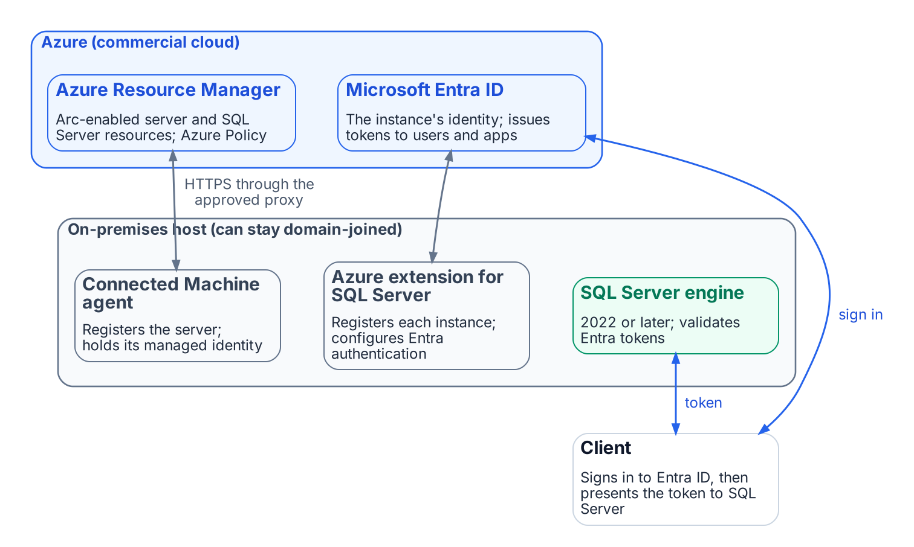
What Azure Arc connects: the on-premises host, Azure Resource Manager and Microsoft Entra ID.
Place in the dependency chain: Step 4 — Enable identity substrate.

Authoritative references
Checked 19 October 2026.
- Prerequisites — SQL Server enabled by Azure Arc
- Connected Machine agent network requirements
- Access Azure resources with managed identity on Azure Arc-enabled servers
- Set up Microsoft Entra authentication with app registration (SQL Server 2022)
- Set up managed identity and Microsoft Entra authentication (SQL Server 2025)
- Managed identity overview — SQL Server enabled by Azure Arc
- Enable Microsoft Entra authentication for SQL Server on Windows without Azure Arc

Chapter 1 — What Arc Provides to SQL Server
Arc is not an end state — it is the bridge that gives the SQL Server engine a cloud-native identity.

In this chapter
What the Connected Machine agent and its managed identity establish; which Entra identity the instance uses on SQL Server 2022 and 2025; the two-layer distinction between SQL-engine Entra authentication and OS-level Entra login; why Arc’s managed identity beats a gMSA, a vaulted secret, or certificate-based authentication; and what Arc deliberately does not change.
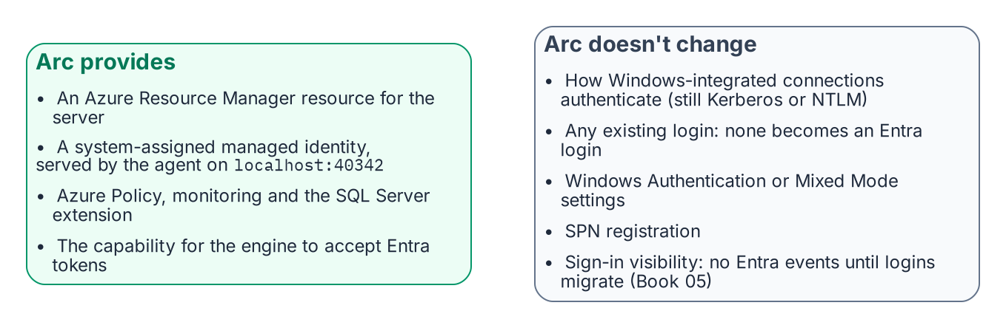
What installing Arc changes, and what it deliberately doesn’t.
Arc is usually introduced as a management capability: on-premises servers in the Azure portal, under Azure Policy and Azure Resource Manager. For this transformation it matters more because it gives the server, and through it the SQL Server engine, a cloud-native identity. Without that identity the engine cannot authenticate to Key Vault, forward logs to Azure Monitor, or accept Entra ID tokens from clients. Arc is the enablement layer for everything that follows.

The Arc Agent and the ARM Resource Identity
Installing the Azure Connected Machine agent gives the server a first-class ARM resource of type Microsoft.HybridCompute/machines, with a resource ID, subscription, and resource group. That resource makes the server visible in the portal and addressable by Azure Policy and ARM, and it is the basis for the system-assigned managed identity: an Entra ID service principal created at registration and deleted at deregistration.
The identity’s private key sits in the Arc agent’s local certificate store, is rotated automatically every 90 days, and is never seen by an administrator. A process requests a token from the agent’s local identity endpoint, the Hybrid Instance Metadata Service (HIMDS) at http://localhost:40342/metadata/identity/oauth2/token (not the Azure VM address 169.254.169.254), and the agent returns a token for any Azure resource the identity has been granted. The endpoint first issues a challenge that only members of the local Administrators or Hybrid Agent Extension Applications group can complete, so not every process on the host can obtain a token.

The Two-Layer Distinction
Arc enables two architecturally independent Entra ID capabilities for SQL Server. Confusing them is the most common sequencing error in this transformation.
Layer 1 is SQL Server engine Entra authentication, the subject of this series. With the Azure extension for SQL Server on an Arc-enabled server running SQL Server 2022 or later, the engine accepts Entra ID OAuth 2.0 access tokens for CREATE LOGIN ... FROM EXTERNAL PROVIDER logins and validates them against Entra ID. It needs the registered Arc agent, SQL Server 2022 or later, the Azure extension for SQL Server, and Entra authentication configured on the instance (Chapter 2). It does not need domain unjoin or Windows Server 2025: a domain-joined Windows Server 2019 host running SQL Server 2022 is fully capable of Layer 1 today.
Layer 2 is OS-level Entra login through the AADLoginForWindows extension, which lets administrators RDP with Entra credentials. It belongs to the server infrastructure transformation, requires domain unjoin and Windows Server 2025 with Desktop Experience, and is more disruptive: unjoin affects every AD-dependent service on the host, plus DNS, Group Policy, and certificate enrollment.
Do not block Layer 1 on domain unjoin, a Layer 2 prerequisite. Layer 1 proceeds on domain-joined servers and should finish before Layer 2 begins. Say this explicitly to every DBA and infrastructure team; incorrect sequencing assumptions are the most common cause of unnecessary delay.

The Managed Identity and the Service Account
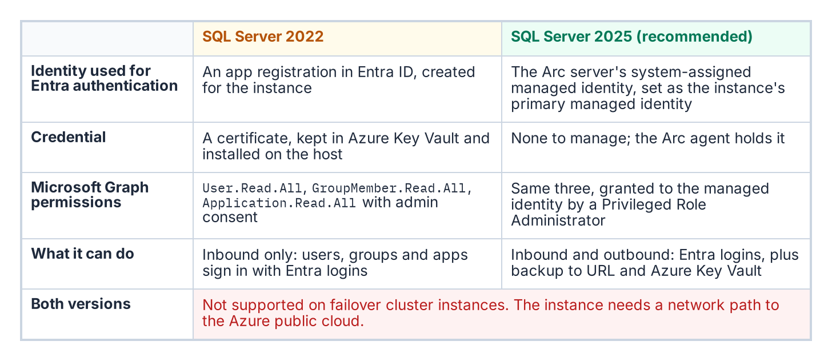
Where an Arc-enabled instance’s Entra identity comes from in SQL Server 2022 and in SQL Server 2025.
What the instance uses as its Entra identity depends on the version. On SQL Server 2025, the server’s system-assigned managed identity is set as the instance’s primary managed identity and serves both inbound Entra authentication and outbound connections to Azure services such as backup to URL and Azure Key Vault. On SQL Server 2022, the instance uses an Entra app registration whose certificate is kept in Azure Key Vault; the Arc agent retrieves that certificate with the server’s managed identity and installs it on the host. An app registration covers inbound Entra authentication only and cannot make outbound connections.
On both versions, agent-side work (retrieving certificates from Key Vault, log forwarding through the Azure Monitor agent, the extension’s own operations) authenticates with the server’s managed identity, not stored credentials.
None of this replaces the Windows account the service runs as (NT SERVICE\MSSQLSERVER, a gMSA, or a domain account), which still presents the computer or domain identity for Windows networking on a domain-joined host. What changes is the identity Entra ID and Azure see: the managed identity (2025) or the app registration (2022) instead of an AD service account. On SQL Server 2025 there is no credential to manage; on 2022 the one credential is the app registration’s Key Vault certificate, which needs a named renewal owner and, per Microsoft, a validity of at most 12 months.

Why Arc and Not the Alternatives
Every alternative either re-anchors on the directory the program is retiring or reintroduces the stored credential it exists to eliminate.
- A gMSA or domain service account works only while AD is authoritative. Book 01’s third driver removes AD as the authority for this boundary; a gMSA can stay the Windows logon account while the domain exists, but it cannot be the engine’s Entra identity.
- A service principal with a client secret, on disk or in Key Vault, reintroduces a rotatable credential and a bootstrap problem: the engine must authenticate to the vault first, so a root credential lands on the server anyway.
- Certificate-based authentication is the program’s interim posture, authorized for the pre-2022 exception long tail that cannot reach Kerberos or Entra OAuth before the 2027-04-01 block. It still needs certificate lifecycle management, hence the ADCS-to-Microsoft Cloud PKI dependency the transformation inventory still classifies as “Not Yet Defined.” It is a bridge, not a destination.
The Arc managed identity is the only option that is both cloud-native and credential-free for the operator: its certificate rotates automatically, no human sees it, and its lifecycle is bound to the ARM resource rather than to AD. SQL Server 2025 uses it directly. SQL Server 2022 still authenticates through an app registration certificate, but the Arc agent fetches it from Key Vault with the managed identity, so no root credential is placed on the server by hand.

What Arc Does Not Do
Arc’s effect is often overstated in both directions. A domain-joined client using Integrated Security=True against an Arc-enabled instance still negotiates Kerberos or NTLM exactly as described in Book 01, and Arc alone produces no Entra sign-in events for SQL Server connections. Arc converts no login to the External Provider type, disables neither Windows Authentication nor Mixed Mode, and leaves SPN registration untouched. It provides the capability without activating it; the login migration in Book 05 is what changes authentication behavior. Arc is a necessary prerequisite, not the transformation itself.
What Book 04 establishes — Chapter 1
- Arc gives the server an ARM identity and a system-assigned managed identity whose tokens come from the local endpoint (localhost:40342); the instance’s Entra identity is an app registration and Key Vault certificate on SQL Server 2022 and the managed identity on SQL Server 2025.
- Layer 1 (SQL-engine Entra authentication) is independent of Layer 2 (OS-level Entra login) and must never be blocked on it.
- Arc provides the capability but doesn’t activate it, and it doesn’t replace the Windows account the service runs as; of the alternatives, it is the only one both credential-free and independent of AD.

Chapter 2 — Arc Deployment Sequencing for SQL Server Hosts
The ordered prerequisites that turn a domain-joined SQL Server host into an Arc-enabled, identity-ready instance.

In this chapter
The connectivity prerequisites that Arc enrollment demands inside a GCC-Moderate boundary, why the Azure extension for SQL Server is a distinct installation with its own version validation, the version-specific step that enables Microsoft Entra authentication on the instance, and the checks — a token from the Arc agent’s local endpoint and a test Entra login — that confirm the identity is genuinely available before any login migration begins.
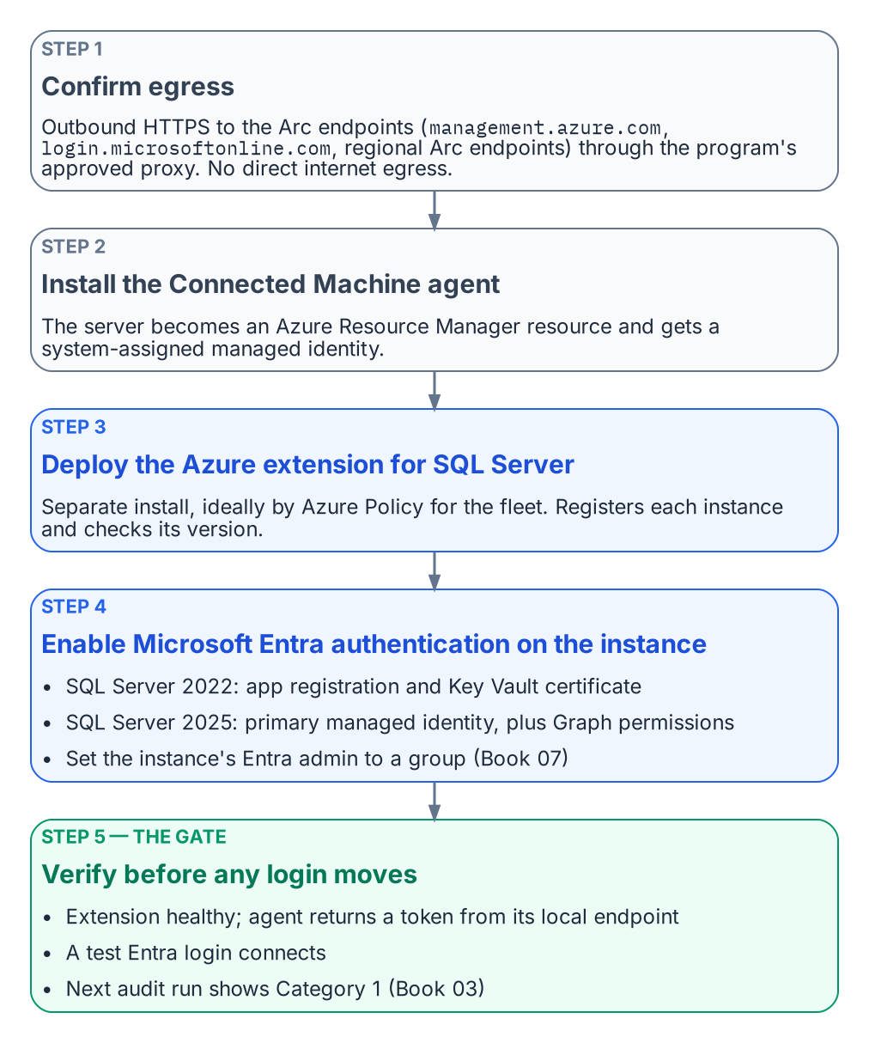
The ordered steps that make a host identity-ready.
Arc deployment is a sequence, not a single act. Each step has a prerequisite that the prior step satisfies, and skipping ahead produces failures that are easy to misdiagnose as migration problems when they are in fact enrollment problems. The order is connectivity first, then the Connected Machine agent, then the SQL Server extension, then Entra authentication on the instance, then a verification that the identity is actually present and answering.

Prerequisites for Arc Enrollment
The Connected Machine agent requires outbound HTTPS connectivity from the server to the Azure Arc endpoints — management.azure.com, login.microsoftonline.com, and the Arc-specific regional endpoints. In a GCC-Moderate boundary, this connectivity must be routed through the program’s approved network egress path.
Direct internet egress from a production SQL Server host is not acceptable under the boundary’s network posture. The Arc agent supports proxy configuration for HTTPS traffic, and the proxy address must be provided at installation time. The instance’s own Entra authentication traffic does not use the Arc agent’s proxy setting: SQL Server connects to Entra ID directly, so a host that needs a proxy also needs the machine-level WinHTTP proxy set (netsh winhttp set proxy).
Connectivity verification — confirming that the server can reach all required Arc endpoints through the approved proxy — is the first prerequisite check before Arc deployment begins. An agent that cannot reach its endpoints will fail to register its ARM resource, and without that resource there is no Managed Identity to verify later.

The Azure Extension for SQL Server
The Azure extension for SQL Server is a distinct installation from the Connected Machine agent and must be deployed after the agent is enrolled. It is installed via Azure Policy assignment — the recommended approach for fleet-wide deployment — or via the Azure portal or CLI for individual servers.
The extension performs additional validation at installation time. It verifies the SQL Server version, where 2022 or later is required for Entra auth capability; it registers the SQL Server instance with the Arc SQL resource plane; and it is the component that later applies the instance’s Entra authentication configuration.
The authentication-audit script Arc-eligibility classification — Category 1 versus Category 2 versus Category 3 — is the primary input for prioritizing Arc deployment across the estate. Category 2 instances are the immediate deployment targets, and the audit’s login inventory and NTLM risk signals within Category 2 are used to order those deployments by remediation urgency.

Enabling Microsoft Entra Authentication on the Instance
Installing the extension does not by itself switch on Entra authentication. That is a separate, version-specific step. On SQL Server 2022, the instance uses an Entra app registration: register the application, grant it the Microsoft Graph read permissions the setup tutorial lists with admin consent, create its certificate in Azure Key Vault, and give the Arc server’s managed identity read access to that certificate so the Arc agent can install it on the host. On SQL Server 2025, the recommended path is to set the Arc server’s system-assigned managed identity as the instance’s primary managed identity and grant that identity User.Read.All, GroupMember.Read.All and Application.Read.All, which only a Privileged Role Administrator can do. On both versions, set the instance’s Entra admin to a group (Book 07). Neither version supports Entra authentication on failover cluster instances, and both need a network path to the Azure public cloud.

Verification of Managed Identity Availability
After the Connected Machine agent is installed and the Azure extension for SQL Server is deployed, the program must verify that the system-assigned Managed Identity is available, and that Entra authentication works on the instance, before proceeding to the login migration. This verification is not optional — it is the gate between enrollment and migration.
The first check calls the Arc agent’s local identity endpoint (HIMDS) on the server — http://localhost:40342/metadata/identity/oauth2/token?api-version=2019-11-01&resource=https://management.azure.com/ — not the Azure VM metadata address 169.254.169.254. The endpoint first returns a challenge that only a local administrator or a member of the Hybrid Agent Extension Applications group can answer; the check confirms that the Arc agent then returns a valid access token. The second check is a test Entra login that connects to the instance. The third is the next audit run, which should classify the instance as Category 1 (Book 03).
A successful token response confirms three things at once: that the Managed Identity is enrolled in Entra ID, that the Arc agent is functioning, and that the server’s ARM resource is in a healthy state. A failed token response at this stage requires Arc troubleshooting before the SQL Server migration can proceed.
The authentication-audit script’s Arc-eligibility classification is updated on each run to reflect the current Managed Identity availability state, so the per-instance compliance record for the instance reflects this verification outcome in near-real-time.
What Book 04 establishes — Chapter 2
- Enrollment runs in a strict order: egress connectivity, the Connected Machine agent, the SQL extension, then Entra authentication on the instance.
- Verification — a token from the local endpoint, a test Entra login, and Category 1 on the next audit — is the gate for login migration.
- A failed verification is an enrollment problem, resolved before migration starts.

Microsoft Learn, Microsoft Entra authentication for SQL Server overview.
Microsoft Learn, Managed identity overview — SQL Server enabled by Azure Arc.
Microsoft Learn, Set up Microsoft Entra authentication with app registration — SQL Server enabled by Azure Arc.
Microsoft Learn, Group Managed Service Accounts overview.
Microsoft Learn, Azure Arc-enabled servers overview.
Microsoft Learn, Access Azure resources with managed identity on Azure Arc-enabled servers.
Microsoft Learn, Overview — SQL Server enabled by Azure Arc.
Microsoft Learn, Microsoft Entra authentication for SQL Server overview.
Microsoft Learn, CREATE LOGIN (Transact-SQL).
Microsoft Learn, Sign in to an Azure Arc-enabled server using Microsoft Entra ID.
Microsoft Learn, Managed identity overview — SQL Server enabled by Azure Arc.
Microsoft Learn, Set up Microsoft Entra authentication with app registration — SQL Server enabled by Azure Arc.
Microsoft Learn, Microsoft Cloud PKI for Microsoft Intune.
Microsoft Learn, Change server authentication mode.
Microsoft Learn, Overview — SQL Server enabled by Azure Arc.
Microsoft Learn, Azure Arc-enabled servers overview.
Microsoft Learn, Microsoft Entra authentication for SQL Server overview.
Microsoft Learn, Managed identity overview — SQL Server enabled by Azure Arc.
Microsoft Learn, Set up managed identity and Microsoft Entra authentication for SQL Server enabled by Azure Arc.
Microsoft Learn, Access Azure resources with managed identity on Azure Arc-enabled servers.
Microsoft Learn, Set up Microsoft Entra authentication with app registration — SQL Server enabled by Azure Arc.

