Book_05 — The Login Migration: Windows Principals to Entra Logins
  - SQL Server Identity Transformation — Narrative Series
Table of Contents

Book_05 — The Login Migration: Windows Principals to Entra Logins
Everything in Books 01 through 04 is prerequisite; everything in Books 06 through 09 is consequence. This book is the migration itself — performed only on the instances Book 02 classified retain or target, using the three-phase parallel-run pattern that the SQL Server engine-authentication decision makes normative.
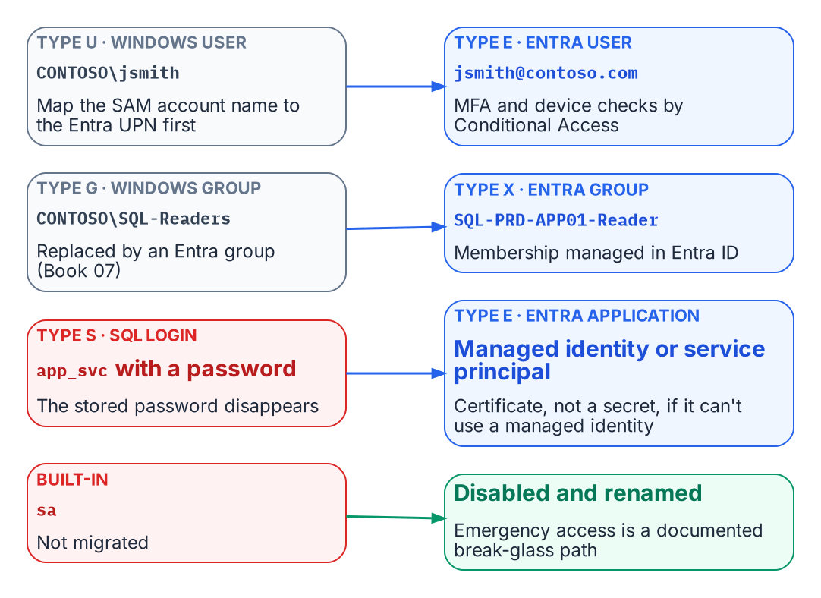
Every legacy login type maps to an Entra principal.
Place in the dependency chain: Steps 5 and 7 — Introduce Entra principals, then remove legacy principals.

Authoritative references
Checked 19 October 2026.
- CREATE LOGIN (Transact-SQL)
- sys.server_principals (Transact-SQL)
- Disable SQL Authentication — SQL Server enabled by Azure Arc
- Change server authentication mode
- What is Conditional Access?

Chapter 1 — Three Principal Types — User, Group, Service Principal
The moment the engine stops accepting Kerberos and NTLM and starts accepting Entra-issued tokens.

In this chapter
The FROM EXTERNAL PROVIDER syntax that creates type-E logins validated by token at connect time, the three principal types those logins map to — Entra user, Entra security group, and Entra service principal — and the three-phase parallel-run pattern that creates and validates the new logins before disabling the old ones.
This is the technical heart of the series: the engine stops accepting Kerberos tickets and NTLM exchanges and starts accepting Entra ID OAuth 2.0 access tokens carrying claims about identity, group membership, device compliance, and MFA. Books 01–04 are prerequisite; Books 06–10 are consequence. The SQL Server engine-authentication decision records the canonical sequence this chapter follows.

The FROM EXTERNAL PROVIDER Syntax
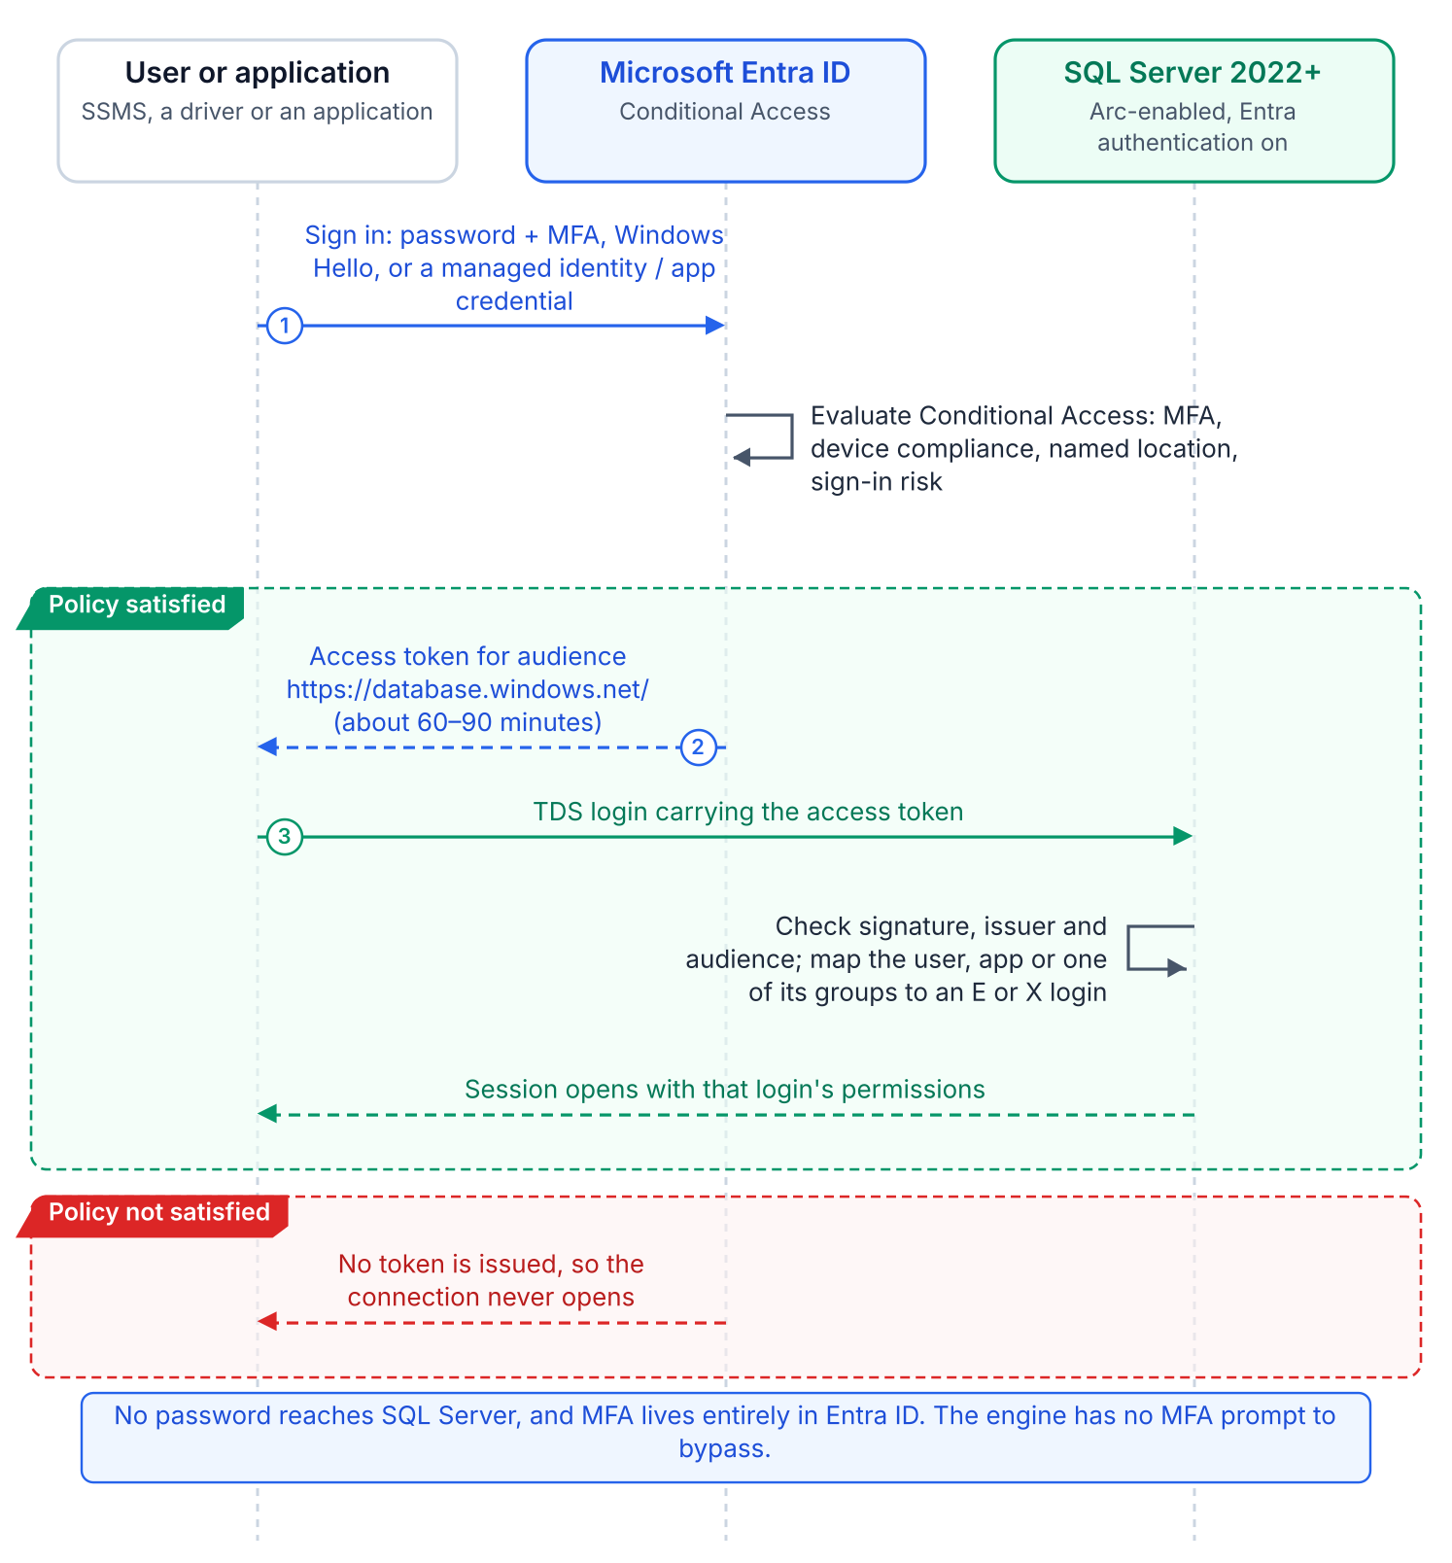
A connection with an Entra login: the client gets a token for the SQL audience and the engine validates it.
SQL Server 2022’s CREATE LOGIN [principal] FROM EXTERNAL PROVIDER maps an Entra principal (a user’s UPN, a group’s display name, or an application’s name) to a login with no Active Directory involvement. The login is stored in master as a passwordless external principal. At connection time the client presents an access token for the SQL Server resource audience; the engine validates its signature, maps the claims to the login, and, if the login is enabled, applies its permissions and database roles.
The syntax requires the Azure extension for SQL Server, which configures the instance’s Entra identity (an app registration on 2022, the managed identity on 2025) and token validation, and registration with the Arc SQL resource plane. CREATE LOGIN looks the principal up through Microsoft Graph, which is why the instance’s identity needs Graph read permissions. Verify that each principal exists before creating its login, to avoid orphaned logins that map to deleted or renamed principals.

Type 1 — Entra User Login
For human DBAs and developers, a CREATE LOGIN [DOMAIN\username] FROM WINDOWS login gets a type-E counterpart for the same person’s UPN: CREATE LOGIN [username@tenant.onmicrosoft.com] FROM EXTERNAL PROVIDER. UPNs can differ from SAM account names where UPN synchronization was never standardized, so the audit captures the UPN-to-SAMAccountName mapping for every Windows login first. The user then signs in with password plus MFA, FIDO2, or Windows Hello for Business, as Conditional Access requires.
The engine has no MFA logic. Conditional Access enforces MFA, device compliance, Named Locations, and sign-in risk before the token is issued; if they fail, no token is issued and the connection never opens. There is no SQL-level MFA prompt and no SQL-level bypass. None of these controls apply to Windows Authentication or NTLM connections.

Type 2 — Entra Group Login
A SQL Server login can be created for an Entra ID security group rather than an individual user: CREATE LOGIN [GroupDisplayName] FROM EXTERNAL PROVIDER. When a user whose Entra access token includes a claim asserting membership in the named group connects to SQL Server, the engine maps the group claim to the group login and grants the user the permissions associated with that login.
It is the familiar AD group pattern, with group claims in place of SID resolution and Kerberos PAC membership. Group logins appear in sys.server_principals as type X (EXTERNAL_GROUP), distinct from type E. When the group is a dynamic group whose rule reads HR-sourced attributes, users gain and lose SQL Server access as HR updates them, with no CREATE USER or DROP USER. Book 07 covers designing and governing those groups.

Type 3 — Entra Service Principal Login
ETL pipelines, reporting services, API backends, and monitoring agents replace their SQL Authentication account (a type-S login with a stored password) with a service principal login: CREATE LOGIN [ApplicationDisplayName] FROM EXTERNAL PROVIDER. This removes passwords from connection strings, configuration files, logs, and repositories, along with their rotation.
Preferably the application uses a managed identity and holds no credential. On an Arc-enabled server, DefaultAzureCredential in Azure.Identity finds the server’s managed identity at the agent’s local endpoint (localhost:40342), provided the process account is in the local Hybrid Agent Extension Applications group. Azure VMs, Container Instances, and App Service use their platform managed identity. Where a credential is unavoidable, use a client certificate stored in Key Vault, never a client secret or a file.

The Parallel-Run Migration Pattern
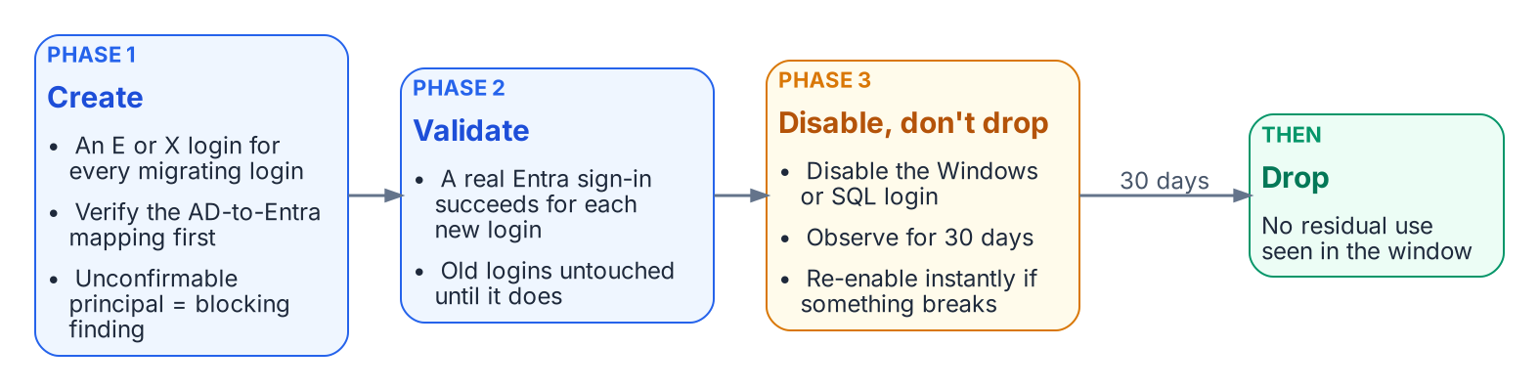
The required three-phase parallel run for production.
No Windows login is dropped until its Entra equivalent is validated. The engine-authentication decision makes this three-phase parallel run required for production:
- Create. For every migrating Windows login, user or group, create the FROM EXTERNAL PROVIDER login for the corresponding Entra principal. Verify each mapping first; a principal with no confirmed Entra equivalent is a blocking finding. This mapping, built from the authentication audit’s AD inventory and Entra’s UPN and group data, is the most labor-intensive step.
- Validate. Test each new login with the principal’s real Entra credential before any legacy login is touched.
- Disable, observe, drop. Disable (do not drop) the legacy Windows and SQL Authentication logins, monitor for 30 days to confirm nothing depends on them, then drop them.
Non-production instances may shorten the observation window with documented owner sign-off, but create→validate→disable→observe→drop is the canonical sequence. Other platforms document the same side-by-side premise: Google’s Cloud SQL for SQL Server lets Entra ID authentication be enabled without disabling existing Active Directory authentication during a phased migration. The next chapter records four further decisions around it.
What Book 05 establishes — Chapter 1
- FROM EXTERNAL PROVIDER creates passwordless logins for Entra users and applications (type E) and groups (type X), authenticated by Entra-issued tokens.
- MFA and other sign-in conditions are enforced by Conditional Access in the Entra plane, not by the engine.
- Migration is the parallel run: create, validate, disable (not drop) the legacy login, observe for 30 days, then drop.

Chapter 2 — What the Engine-Authentication Decision Settles
The five governance positions that turn the migration pattern into enforceable canon.

In this chapter
The five decisions the engine-authentication decision records — that consolidation gates auth migration, that the parallel-run sequence is required, that SQL Authentication is eliminated and sa disabled and renamed, that pre-2022 instances are upgrade-or-except with a Certificate-Based Authentication interim posture, and that the per-instance compliance record is the closure artifact.
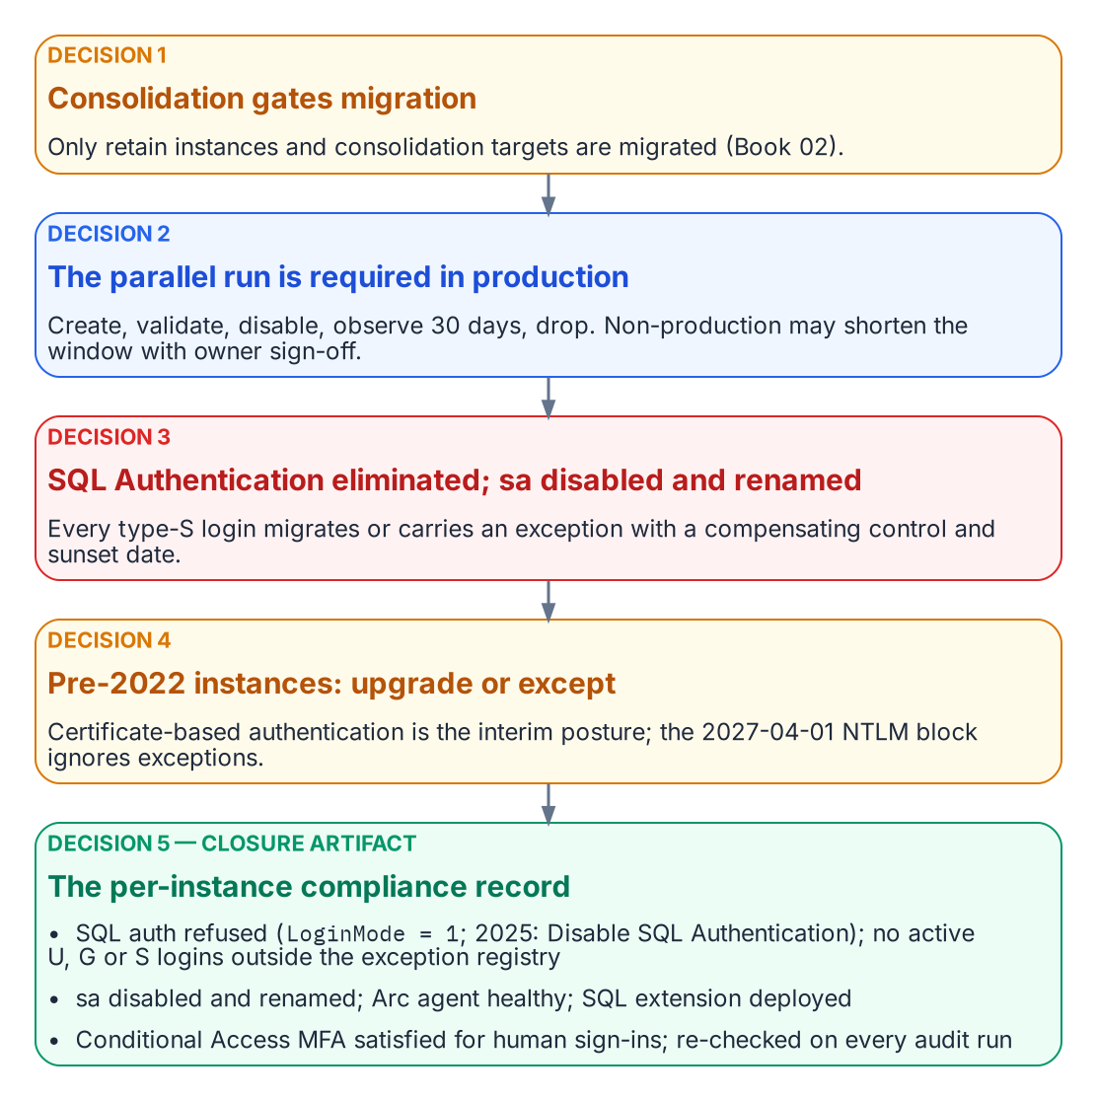
The five positions of the engine-authentication decision, in operational order, ending in the closure record.
Chapter 1’s pattern covers the engineering case, Windows logins migrated through FROM EXTERNAL PROVIDER, but leaves governance positions that need a decision, not a narrative. The SQL Server engine-authentication decision (currently proposed) is the engine-layer companion to the Kerberos/NTLM-elimination program (protocol layer) and the Arc non-domain-join requirement (server and OS layer). It answers all five positions, in operational order.

Decision 1 — Consolidation Precedes and Gates Auth Migration
Established in Book 02
Every instance is classified retain, consolidate-into-target, or retire before any migration work; Arc-eligibility Categories 1–3 are layered on top.
The decision makes that assessment the normative prerequisite for this book. Only retain instances and consolidation targets are migrated; migrating logins on instances about to be retired or collapsed is wasted effort. Consolidating into fewer SQL Server 2022 or later targets, Azure SQL Managed Instance, or Arc-enabled SQL is also the natural moment to retire cross-domain login sprawl, orphaned SPNs, and shared service accounts.

Decision 2 — The Parallel-Run Sequence Is Required
On every retain or target instance, Windows logins (type U users, type G groups) and SQL Authentication logins (type S) migrate to Entra external-provider logins through Chapter 1’s parallel run, which is required for production. The letters are the values of sys.server_principals.type, not mnemonics: S SQL login, U Windows login, G Windows group, E external (Entra) login. There is no type W — a discovery query written against one returns zero rows and reports a clean instance, which is how a typo becomes a false attestation of closure.
Non-production instances may compress the 30-day observation window only with documented owner sign-off. Disable-and-observe keeps every cutover reversible inside the window, so a wrong mapping locks no one out.

Decision 3 — SQL Authentication Eliminated; sa Disabled and Renamed
Every active type-S login on a retain or target instance migrates to a service-principal or managed-identity login, or carries a documented exception with a named compensating control and a sunset date. Open-ended retention is not an option: SQL Authentication is invisible to Conditional Access and Defender for Identity.
sa is disabled and renamed on every production instance. Any retained emergency recovery is a documented, monitored break-glass procedure, not an active sa. An enabled sa with a non-rotated password is the authentication audit’s highest-priority finding.

Decision 4 — Pre-2022 Instances Are Upgrade-or-Except
External-provider logins require SQL Server 2022 or later with the Azure extension on an Arc-enabled host, so a pre-2022 Category 3 instance cannot accept them regardless of Arc status. A Category 3 retain instance either upgrades and follows the Category 2-to-1 pathway or files a sunset-dated exception, though most Category 3 instances should be retire or consolidation candidates. An exception records the reason, the compensating control (for example, an identity-protection product that applies MFA or block policies to Kerberos and NTLM at the domain controller), the maximum duration, and acknowledgement that the 2027-04-01 NTLM block is network-level and ignores engine-layer exceptions.
Connections that cannot reach Kerberos or Entra OAuth by that date use Certificate-Based Authentication, the authorized interim posture, which makes the ADCS-to-Cloud-PKI transformation (Not Yet Defined in the transformation inventory) a hard dependency for the exception long tail.

Decision 5 — The Per-Instance Compliance Record Is the Closure Artifact
An instance is closed when its compliance record simultaneously shows SQL authentication refused (LoginMode = 1; on SQL Server 2025, Disable SQL Authentication as well), zero active type-S logins outside the exception registry, zero active type-U or type-G logins, sa disabled and renamed, the Arc Connected Machine agent enrolled and healthy, the Azure extension for SQL Server deployed with Entra authentication configured, and — for human principals — Conditional Access MFA enforcement satisfied for SQL Server resource sign-ins over a defined validation period.
“Done” becomes a queryable posture instead of a claim. Because no engine setting blocks Windows authentication, the record evidences the Entra-exclusive posture rather than reading a mode switch (Book 09). Closure is continuously verified: the authentication audit runs on a schedule, and drift (LoginMode reverting, a new type-S, U, or G login, the Arc agent going offline) is a violation that triggers remediation.
What Book 05 establishes — Chapter 2
- Consolidation gates migration, and the parallel run is required in production.
- SQL Authentication is eliminated and sa disabled and renamed; pre-2022 instances upgrade or carry a sunset-dated exception.
- The per-instance compliance record is the continuously re-verified closure artifact.

Microsoft Learn, CREATE LOGIN (Transact-SQL).
Microsoft Learn, Overview — SQL Server enabled by Azure Arc.
Microsoft Learn, Microsoft Entra authentication for SQL Server overview.
Microsoft Learn, Managed identity overview — SQL Server enabled by Azure Arc.
Microsoft Learn, What is Conditional Access?.
Microsoft Learn, What is Microsoft Entra ID Protection?.
Microsoft Learn, sys.server_principals (Transact-SQL).
Microsoft Learn, Manage rules for dynamic membership groups in Microsoft Entra ID.
Microsoft Learn, Access Azure resources with managed identity on Azure Arc-enabled servers.
Third-party source (Google Cloud documentation), Integration with Microsoft Entra ID — Cloud SQL for SQL Server, “Migration from Microsoft Active Directory.”
Microsoft Learn, CREATE LOGIN (Transact-SQL).
Microsoft Learn, sys.server_principals (Transact-SQL).
Microsoft Learn, What is Conditional Access?.
Microsoft Learn, Overview — SQL Server enabled by Azure Arc.
Third-party source (vendor case study), Silverfort, Customer case study: preventing NTLM-based lateral movement with Silverfort. Cited as an example of the control category, not an endorsement.
Microsoft Learn, Change server authentication mode.
Microsoft Learn, Azure Arc-enabled servers overview.
Microsoft Learn, Disable SQL Authentication — SQL Server enabled by Azure Arc.

