Book_06 — Eliminating NTLM at the SQL Layer
  - SQL Server Identity Transformation — Narrative Series
Table of Contents

Book_06 — Eliminating NTLM at the SQL Layer
SQL Server is one of the most common sources of NTLM traffic in a federal environment, and the reasons are more varied than most DBA teams expect. This book traces the Kerberos/NTLM-elimination program’s three phases — assess, block-where-safe, eliminate — as they apply to the SQL Server workload, against the program’s hard 2027-04-01 network-level block.
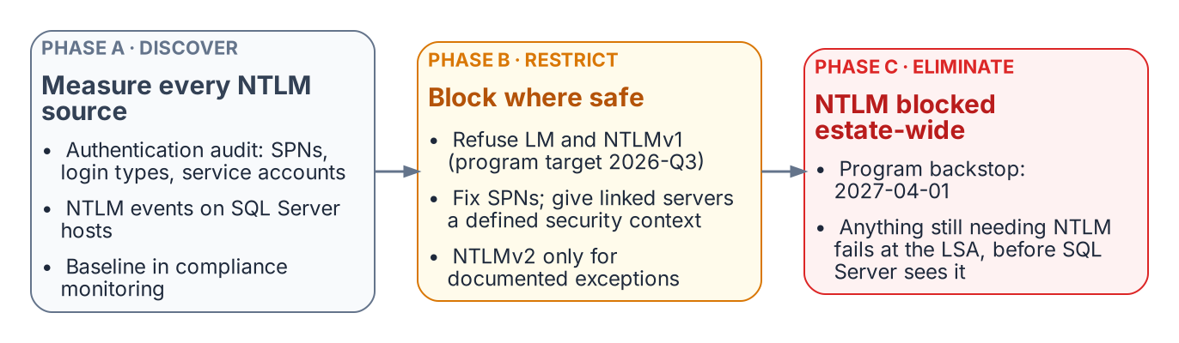
The three phases of the program’s NTLM elimination, applied to SQL Server.
Place in the dependency chain: Step 8 — Enforce protocol retirement.

Authoritative references
Checked 19 October 2026.
- Retiring NTLM: frequently asked questions (Microsoft Tech Community)
- Features removed or no longer developed in Windows Server
- Overview of NTLM auditing enhancements in Windows 11, version 24H2, Windows Server 2019, and later versions (Microsoft Support)
- Register a Service Principal Name for Kerberos connections
- sys.dm_exec_connections (Transact-SQL)
- Linked server for SQL Server with Microsoft Entra authentication
- Kerberos constrained delegation overview

Chapter 1 — NTLMv1, NTLMv2, and the Patterns That Generate NTLM
NTLM is a protocol, not a setting — so eliminating it means naming every connection pattern that produces it.

In this chapter
Why NTLMv1 is blocked early (Phase B, targeted 2026-Q3) while NTLMv2 has a phased 2027-04-01 deadline, and the four SQL Server connection patterns that generate NTLM: a missing or incorrect SPN, an unreachable KDC, linked-server passthrough, and non-domain-joined application hosts.
No single switch or Group Policy change removes NTLM from SQL Server connections. Eliminating it means finding every connection pattern that generates it, and there are more than most database teams expect. Beyond Book 01’s missing-SPN case there are cross-site connections, linked-server passthrough, and hosts already moved to a non-domain-joined state, each with its own root cause and fix.

NTLMv1: Blocked First, in Phase B
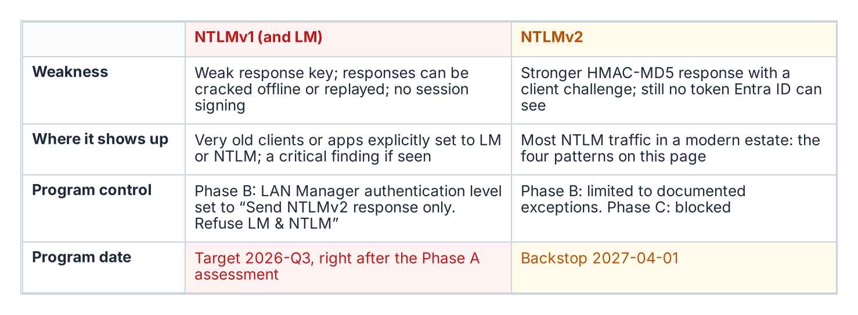
The two NTLM variants and their different timelines.
NTLMv1 uses an MD4 hash of the password as its response key. A captured response can be attacked offline or replayed to authenticate as the victim (pass-the-hash), and with no session signing, traffic can be modified in transit.
The Kerberos/NTLM-elimination program blocks NTLMv1 in its Phase B “block-where-safe” stage, by default as soon as the Phase A assessment completes (targeted 2026-Q3), by setting “Network Security: LAN Manager Authentication Level” to “Send NTLMv2 response only; refuse LM and NTLM.” The Local Security Authority then negotiates only NTLMv2. This is slightly ahead of Microsoft, whose October 2026 Windows Update flips the BlockNTLMv1SSO default from Audit to Enforce on devices without an explicit policy; the program’s Group Policy makes the block deterministic.
Windows Server 2016 and later with default settings generate no NTLMv1; it surfaces only with Windows 7-era clients or applications explicitly configured for LM or NTLM. NTLMv1 found by the authentication audit or Phase A traffic analysis is a critical finding requiring immediate remediation, not a routine migration item.

NTLMv2: The 2027-04-01 Deadline
NTLMv2 uses HMAC-MD5, adds a client challenge against replay, and supports signing; it is what most SQL Server NTLM traffic in a modern federal environment uses. Phase B restricts it to documented exception groups; Phase C disables it at the 2027-04-01 hard cutover, the program’s own backstop. That is a program decision, not a Microsoft deadline: Microsoft’s stated target is to disable NTLM by default — not remove it — in the next major release of Windows Server and client, subject to change, with re-enablement possible at least initially. SQL Server NTLMv2 connections must be migrated either to Kerberos as an interim posture — using Cloud Kerberos trust per the elimination program — or to Entra ID OAuth 2.0 authentication as the final destination, before that date.

Pattern One: Missing or Incorrect SPN
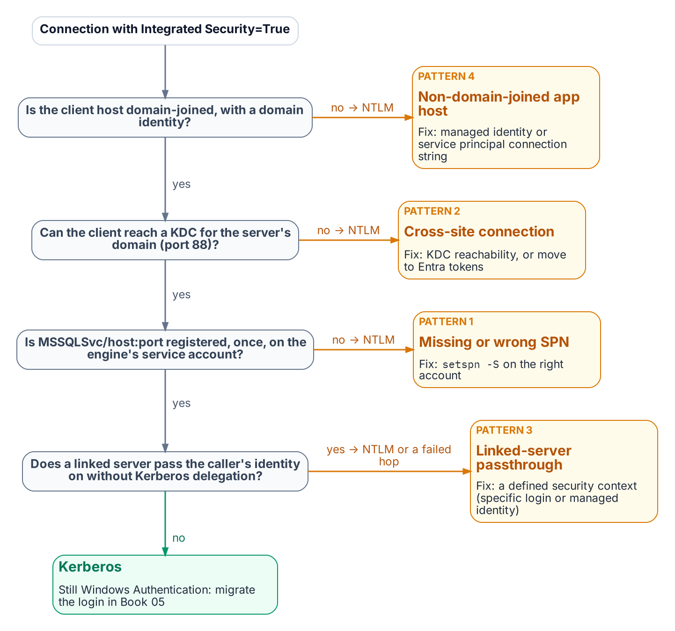
The checks Negotiate makes before it settles for NTLM, and the connection pattern behind each failure.
Established in Book 01
When no valid SPN is registered on the engine’s service account, SSPI cannot negotiate Kerberos and falls back to NTLM.
This is the most common cause of NTLM fallback. The SPN takes the form MSSQLSvc/hostname.domain.com:port (named instances also MSSQLSvc/hostname.domain.com:instancename) on the account the engine runs under. A service-account change without an SPN update leaves the SPN on the wrong account, with the same result. The fix is setspn -S MSSQLSvc/hostname.domain.com:port serviceaccount; the authentication audit captures SPN status per instance, and each gap can be fixed independently of the login migration.

Pattern Two: Cross-Site Connections
Connections that cross AD sites, domains, or forests can generate NTLM when Kerberos cannot complete. Kerberos requires the client to obtain a service ticket from a domain controller (KDC) for the domain that holds the server’s service account — any DC of that domain, not one in a particular site. Across forests it also needs a forest trust with name-suffix routing for the SPN; without a trust, neither Kerberos nor NTLM can authenticate an account from the other forest.
If the client cannot reach or locate a DC for that domain — port 88 blocked, or DNS that doesn’t resolve it — Negotiate falls back to NTLM where a trust lets the server validate the account, and the connection fails where it doesn’t. This is common in distributed federal networks.
Detect it in Phase A output by correlating source and destination sites. Cross-site NTLM usually means DC reachability or DNS from the source site, but a missing SPN or trust gap looks the same, so confirm with klist or the client’s Kerberos events before changing firewall rules. The remediation is to restore Kerberos — DC reachability on UDP and TCP port 88 and working DNS from every client site, a correct SPN, and, across forests, a trust — or to move the connection to Entra ID tokens, which need no KDC at all. Cloud Kerberos trust, which the Kerberos/NTLM-elimination program deploys for Windows Hello for Business sign-in, is not a fix for this pattern: the partial ticket Entra ID issues must still be exchanged with an on-premises domain controller, and the service ticket for the SQL Server SPN still comes from one.

Pattern Three: Linked-Server Passthrough Authentication
Linked-server definitions in SQL Server — which allow one instance to query another using OPENQUERY or four-part name syntax — frequently use Windows passthrough (self-mapping, @useself = 'TRUE') as the mechanism for the linked-server connection. In the passthrough model, the originating instance impersonates the connecting client’s Windows identity and tries to present that identity to the target SQL Server — a second hop.
NTLM cannot make that second hop: an instance that authenticated the client with NTLM holds no credential it can forward, so the connection to the target fails, typically as Login failed for user 'NT AUTHORITY\ANONYMOUS LOGON'. Passthrough needs Kerberos delegation: the client should reach the first instance with Kerberos, and the first instance’s service account must be trusted for (preferably constrained) delegation to the target’s SPN. In practice the pattern shows up as NTLM on the client’s first hop or as a failed second hop; it is not a working NTLM path to keep.
Linked-server NTLM often looks like “internal” traffic and escapes standard connection audits; find it through sys.linked_logins, sys.servers, and inter-instance traffic analysis. Each passthrough definition is migrated during the restriction phase to a defined security context: a specific mapped login, a managed identity (SQL Server 2025 on an Arc-enabled host, linking to a target with Entra authentication), or, where the caller’s own identity must reach the target, Kerberos constrained delegation.

Pattern Four: Non-Domain-Joined Application Hosts
An application on a host unjoined under the Arc non-domain-join requirement has no Kerberos TGT, so a connection string still using Windows Integrated Security falls back to NTLM with local credentials: a new NTLM source the unjoin created. The pattern grows as server unjoin progresses, which is why connection strings should move to managed identity before or alongside application-host unjoin. A host on managed identity generates no NTLM and satisfies both programs.
What Book 06 establishes — Chapter 1
- NTLM is a protocol, not a setting; no single switch removes it from SQL Server connections.
- NTLMv1 is blocked early; NTLMv2 is restricted to exception groups, then blocked at the program’s 2027-04-01 cutover.
- Four patterns generate NTLM at the SQL layer — missing SPNs, unreachable KDCs, linked-server passthrough, and non-domain-joined hosts — and each must be found before it can be fixed.

Chapter 2 — The Three Phases of NTLM Elimination for SQL Server
Discover, restrict, eliminate — the same phase structure the Kerberos/NTLM-elimination program applies program-wide, applied specifically to SQL Server workloads.

In this chapter
How the Kerberos/NTLM-elimination program’s three-phase structure applies to SQL Server: Phase A discovery using the authentication-audit script alongside Windows event-log NTLM analysis, Phase B restriction that converts NTLM connections to Kerberos and migrates the remaining patterns, and Phase C elimination at the 2027-04-01 domain-wide block — and why an instance migrated to Entra ID logins is immune to that block because it was never generating NTLM in the first place.
The Kerberos/NTLM-elimination program structures NTLM elimination into three phases — discover, restrict, eliminate — and this chapter applies that structure specifically to SQL Server workloads. The phases are sequential and the final one is a hard backstop: the domain-wide NTLM block takes effect no later than 2027-04-01, the date the elimination program sets for the program.
After that date, any SQL Server connection that requires NTLM will fail at the LSA layer — inside the host’s Windows security subsystem, where the Local Security Authority (LSA) enforces the policy. The SQL Server engine will not receive an authenticated connection; the NTLM exchange is rejected by the LSA before the engine evaluates the login. SQL Server NTLM elimination is therefore not decoupled from the broader elimination program timeline. Every NTLM-generating connection pattern must be resolved before the elimination phase, not after.

Phase A — Discovery
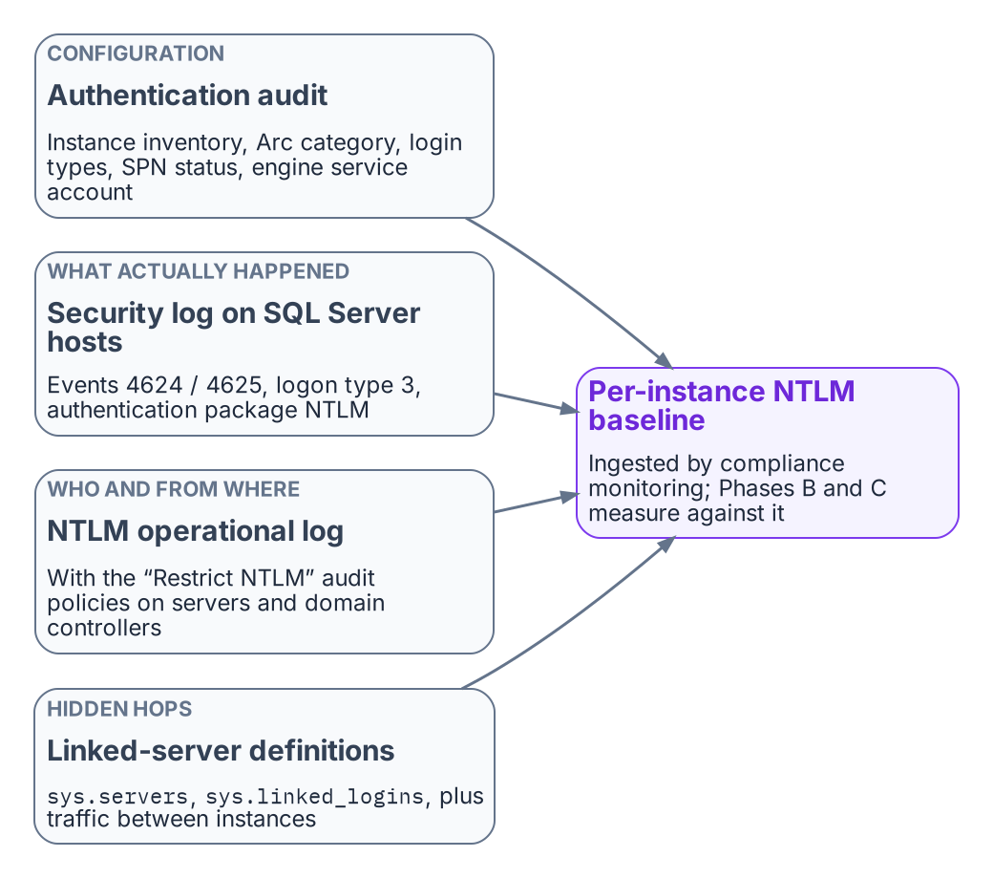
The evidence Phase A combines into the NTLM baseline.
The discovery phase is the elimination program’s first phase, and for SQL Server its primary instrument is the authentication-audit script. The Phase A output for SQL Server includes the full instance inventory with Arc-eligibility classifications, the login-type inventory, the SPN registration status for every instance, and the service-account identity for each engine process.
Network-traffic analysis supplements the script output by capturing actual NTLM authentication events in the Windows event log. The relevant events are Event IDs 4624 and 4625 — logon success and failure — with logon type 3, the network logon type, and authentication package NTLM, filtered to events where the target server is a SQL Server host.
The combination of the audit-script output and the event-log analysis produces a complete picture of NTLM-generating SQL Server connection patterns across the estate. That Phase A output is ingested by the compliance-monitoring pipeline as the baseline record from which all subsequent phases measure progress.

Phase B — Restriction
The restriction phase applies controls that reduce NTLM traffic without eliminating it entirely. The restrictions create pressure on connection patterns to migrate while preserving operational continuity. The primary Phase B control for SQL Server is NTLMv1 blocking, combined with Kerberos remediation for the missing-SPN cases.
SPN registration is corrected for all instances with missing or incorrect SPNs, converting those connections from NTLM to Kerberos. Cross-site connection patterns are fixed by restoring DC reachability (port 88 and DNS) and, across forests, a trust, or by moving the connection to Entra ID tokens; Cloud Kerberos trust, which the Kerberos/NTLM-elimination program also deploys, does not remove the need for DC reachability, because its tickets are still exchanged with on-premises domain controllers. Linked-server definitions using passthrough authentication are migrated to defined security contexts. Application connection strings on recently domain-unjoined hosts are migrated to Managed Identity or service-principal authentication.
After Phase B, the only remaining NTLM-generating SQL Server connections should be those that require the elimination program’s enforcement phase’s hard block to remove. These are typically applications that cannot be modified before the 2027-04-01 block date set in the elimination program, which become exception cases requiring formal exception documentation per the elimination program.

Phase C — Elimination
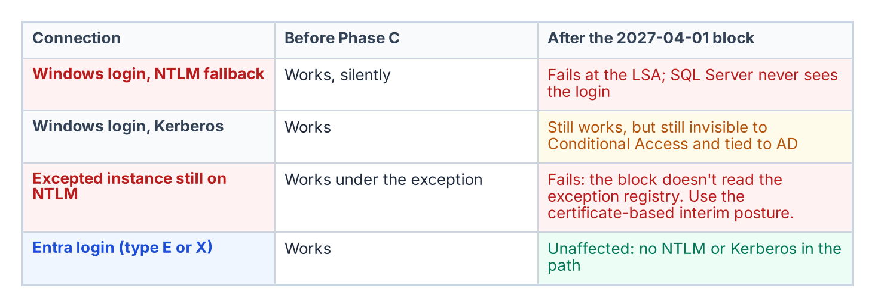
What the Phase C block does to each kind of connection.
The elimination phase disables NTLM across the estate. Group Policy pushed domain-wide restricts NTLM authentication at the LSA layer on every host, and any connection that cannot negotiate an alternative protocol fails. For SQL Server, Phase C is only safe to implement after the login migration of Book 05 has been completed for every instance in the estate.
An instance whose connections have been migrated to Entra ID OAuth 2.0 tokens generates no NTLM traffic at all. The SQL Server engine does not use NTLM or Kerberos for type-E login connections. An instance that has completed the login migration is therefore immune to Phase C — it was not generating NTLM before the block, and it is not affected by the block after.
The sequencing imperative is clear: complete the SQL Server login migration before Phase C is applied. The 2027-04-01 backstop is the Phase C application date, and the SQL Server login migration must be complete before that date for every production instance in the estate.
Unresolved: what happens to the long tail on 2027-04-01
Known fact. Microsoft’s own plan is to disable NTLM by default in the next major Windows release, subject to change; 2027-04-01 is this program’s date, not Microsoft’s (Chapter 1).
Dependency. Pre-2022 instances and deferred applications that can’t reach Kerberos or Entra tokens by then rely on the certificate-based interim posture, which needs a replacement CA issuing before ADCS is retired (Book 10).
Unresolved decision. Whether the Phase C date holds for instances whose interim posture isn’t in place, or whether they get dated exceptions with network-level isolation.
Owner and artifact. The Kerberos/NTLM-elimination program, recorded as an amendment to its enforcement-phase decision and reflected in the exception registry.
What Book 06 establishes — Chapter 2
- Discovery baselines every NTLM-generating pattern from the audit and Windows NTLM logon events.
- Restriction blocks NTLMv1, repairs SPNs and Kerberos reachability, and migrates linked-server security contexts and connection strings.
- Elimination applies the domain-wide block; instances already on Entra logins are unaffected because they don’t use NTLM.

Microsoft Learn, Linked server for SQL Server with Microsoft Entra authentication.
Microsoft Learn, Features removed or no longer developed in Windows Server.
Microsoft Learn, Register a Service Principal Name for Kerberos connections.
Microsoft Tech Community, Retiring NTLM: frequently asked questions.
Microsoft Learn, Windows Hello for Business cloud Kerberos trust deployment guide.
Microsoft Learn, Kerberos constrained delegation overview.
Microsoft Learn, Managed identity overview — SQL Server enabled by Azure Arc.
Microsoft Learn, Features removed or no longer developed in Windows Server.
Microsoft Learn, Register a Service Principal Name for Kerberos connections.
Microsoft Learn, Windows Hello for Business cloud Kerberos trust deployment guide.
Microsoft Learn, Linked server for SQL Server with Microsoft Entra authentication.

