Book_09 — The Transformed Posture: Continuous Governance and the 2027 Milestone
  - SQL Server Identity Transformation — Narrative Series
Table of Contents

Book_09 — The Transformed Posture: Continuous Governance and the 2027 Milestone
A transformation that achieves a completed state and then stops monitoring is a transformation that will regress. The transformed posture is not a permanent state achieved by a one-time action — it is an ongoing condition maintained by continuous monitoring, automated drift detection, and a governance process that treats regression as a compliance violation.
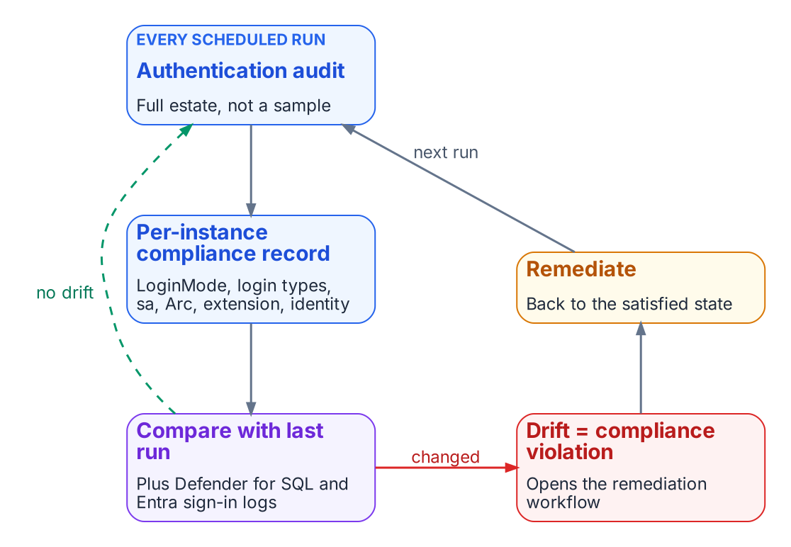
The transformed posture is a loop that never stops.
Place in the dependency chain: Step 9 — Demonstrate sustained posture.

Authoritative references
Checked 19 October 2026.
- Disable SQL Authentication — SQL Server enabled by Azure Arc
- sys.dm_exec_connections (Transact-SQL)
- Sign-in logs in Microsoft Entra ID
- Microsoft Defender for SQL servers on machines overview
- SQL Server Audit (Database Engine)
- CISA Zero Trust Maturity Model, Version 2.0

Chapter 1 — The Closure Condition for the SQL Server Authentication Transformation
Transformations do not complete — they achieve a posture, and a posture is something you keep proving.

In this chapter
The five conditions that must be simultaneously satisfied for the SQL Server authentication transformation to be closed across the estate, why the continuous audit rather than a one-time scan is the verification instrument, how the per-instance compliance record captures the satisfying state, what drift detection looks for, and how behavioral telemetry — Defender for SQL threat alerts, Entra ID sign-in logs, and host authentication logs — adds a layer on top of the structural monitoring.
A transformation that achieves a completed state and then stops monitoring is a transformation that will regress. A SQL Server instance brought to the Entra-exclusive operational posture can be reconfigured to Mixed Mode by any administrator with sufficient permission. New SQL Authentication logins can be created. New Windows logins can be created if the instance remains domain-joined. The transformed posture is not a permanent state achieved through a one-time action — it is an ongoing condition maintained by continuous monitoring, automated drift detection, and a governance process that treats regression as a compliance violation rather than an operational preference.

The Five Closure Conditions
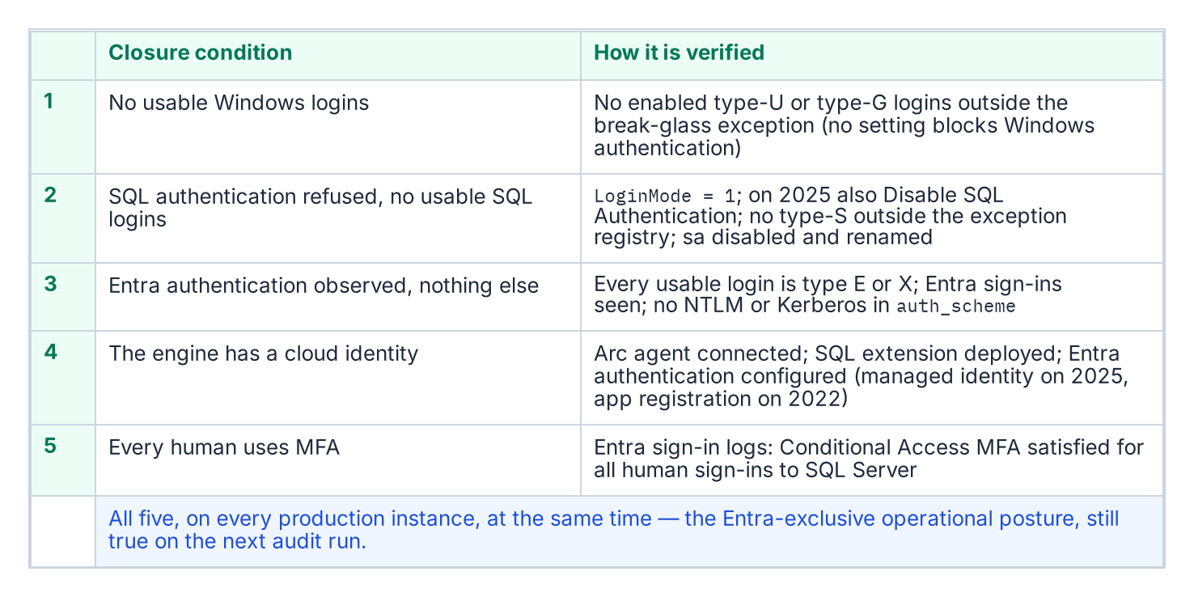
The five closure conditions, and the check that proves each one.
The transformation inventory defines the SQL Server authentication transformation as complete when five conditions are simultaneously satisfied across all production SQL Server instances in the estate. None of the five is a single engine setting, and the series calls the combined state the Entra-exclusive operational posture: an evidenced condition, not a mode. SQL Server has no setting that turns Windows authentication off. Entra authentication works alongside whichever authentication mode the instance uses, and even SQL Server 2025’s Disable SQL Authentication setting leaves the instance accepting “Microsoft Entra authentication and Windows authentication.” LoginMode = 1 (Windows Authentication mode) therefore proves only that SQL logins are refused, not that Windows logins are gone.
The first condition is that no usable Windows-backed principal remains. A query of sys.server_principals shows zero type-U and type-G logins that are enabled and hold CONNECT SQL, other than a documented break-glass group recorded in the exception registry.[^b09c01-principals]
The second condition is that SQL Authentication is eliminated. No SQL Authentication logins — type-S logins — exist on any production instance other than those carrying documented exception status, and the sa account is disabled on every instance. SQL logins are refused: SERVERPROPERTY('IsIntegratedSecurityOnly') = 1 (Windows Authentication mode, LoginMode = 1), and on SQL Server 2025 also SERVERPROPERTY('IsExternalAuthenticationOnly') = 1 once Disable SQL Authentication is on. The operational verification is that evidence plus a sys.server_principals query for type-S logins, cross-referenced against the exception registry the program maintains. The third condition is that Entra authentication is observed working and nothing else is: every usable login is type E or X, Entra sign-in logs show connections to the instance, and sys.dm_exec_connections.auth_scheme shows no NTLM or KERBEROS connections over the validation period.[^b09c01-auth-scheme]
The fourth condition is that the engine has a cloud identity. The Arc Connected Machine agent is connected, the Azure extension for SQL Server is deployed, and Microsoft Entra authentication is configured on every production instance — with the managed identity on SQL Server 2025, or an app registration on SQL Server 2022.[^b09c01-arc-servers][^b09c01-arc-sql][^b09c01-mi-2025] The fifth condition is that every human principal authenticates with MFA enforced by Conditional Access.[^b09c01-ca] This is verified through Entra ID sign-in logs and Conditional Access policy reports — every sign-in event for a SQL Server resource should show MFA satisfied and Conditional Access grant controls met.

The Continuous Audit as the Verification Instrument
The authentication-audit script in continuous monitoring mode — running on a recurring schedule against the full estate rather than as a point-in-time scan — is the primary instrument for verifying that all five closure conditions remain satisfied over time. The per-instance compliance record, updated on each audit run, is the structured evidence artifact that captures the current state of each condition for each instance. The SQL Server engine-authentication decision defines the field set that record carries.
A per-instance compliance record that shows SQL authentication refused, zero usable type-S logins, zero usable type-U and type-G logins outside the break-glass exception, zero Windows-authenticated connections over the validation period, the sa account disabled and renamed, the Arc agent enrolled, the SQL extension deployed, and Entra authentication configured is a record that satisfies all five closure conditions for that instance. When all production instances carry satisfying compliance records, the SQL Server authentication transformation is verifiably closed for the estate. The continuous audit ensures closure is not a point-in-time claim — it is an ongoing verification.

Drift Detection
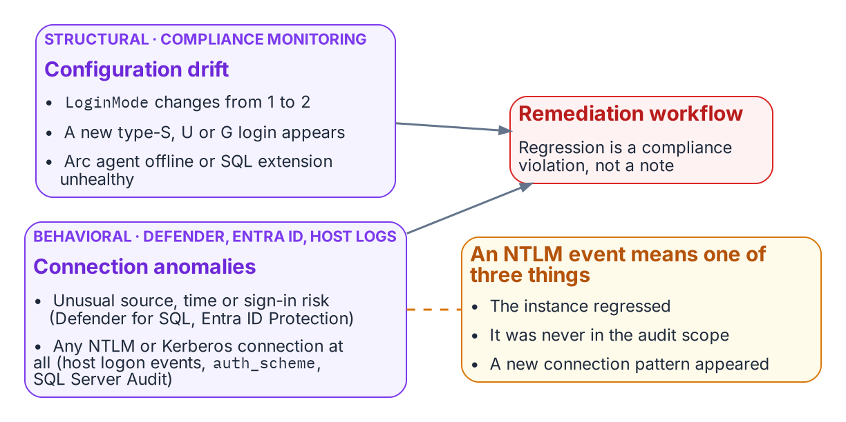
Structural drift detection and behavioral telemetry feed one remediation workflow.
Drift detection in the compliance-monitoring pipeline identifies conditions that would constitute regression before they become compliance violations. A drift event for SQL Server authentication takes one of several forms. An instance whose LoginMode value changes from 1 to 2 — Windows Authentication Only to Mixed Mode — indicates that someone has enabled Mixed Mode without authorization. A new type-S login appearing in sys.server_principals that was not present on the previous audit run indicates that a SQL Authentication login has been created.
A new type-U or type-G login appearing on an instance that was previously in the Entra-exclusive posture is the same class of regression for Windows-backed identity. And an Arc agent going offline, or the SQL extension becoming unavailable, would leave the instance’s Entra identity unmanaged: certificate renewal on SQL Server 2022 and managed-identity tokens on SQL Server 2025 both depend on the agent. Each drift event triggers the program’s remediation workflow. The SQL Server engine-authentication decision records these same events — LoginMode reverting to Mixed Mode, a new type-S/U/G login appearing, the Arc agent going offline — as compliance violations, not advisory signals.
The 2027-04-01 NTLM elimination backstop is not a migration completion date in the continuous-compliance monitoring context — it is the date by which the records for all production instances must have been in the satisfied state continuously for a sufficient validation period. Migration activity should conclude well before the 2027-04-01 block date set by the elimination program’s enforcement phase; the final months before it are the continuous-audit validation period, not the migration period.

Behavioral Telemetry: Defender for SQL, Entra ID, and Host Logs
Behavioral telemetry complements the continuous-compliance monitoring. The compliance monitoring tracks the configuration state of each instance — is the LoginMode correct, are the login types correct. The behavioral layer watches the connections themselves, and it draws on three sources with distinct jobs. Microsoft Defender for SQL servers on machines, enabled through Defender for Cloud on the Arc-enabled host, raises threat alerts — sign-ins from an unusual location or an unfamiliar principal, brute-force attempts, potential SQL injection — and runs vulnerability assessment; it is an alerting service, not an audit log of every authentication. Entra ID sign-in logs record every token issued for SQL Server, with its risk and Conditional Access result. The authentication protocol itself is recorded on the host: Windows Security log logon events (4624 and 4625) name the authentication package, the NTLM operational log records NTLM use, sys.dm_exec_connections.auth_scheme shows NTLM or KERBEROS for each live Windows connection, and SQL Server Audit records successful and failed logins.[^b09c01-sqlaudit] The Azure Monitor agent forwards those Windows logs, including SQL Server Audit written to the Security log, to a Log Analytics workspace, where the alert queries run.
In the transformed posture, the baseline is Entra-authenticated connections only. Every Entra-authenticated connection rests on a token that Entra ID issued, and each token issuance is recorded in the sign-in logs (a client can reuse a cached token across connections); an anomalous connection — from an unusual source IP, at an unusual time, with an elevated sign-in risk signal — is surfaced by Defender for SQL and by Entra ID Protection.[^b09c01-idp] Any NTLM- or Kerberos-authenticated connection to an instance, visible in auth_scheme, SQL Server Audit and the host’s logon events, should be zero in the transformed posture and raises an immediate alert from Log Analytics.
An NTLM event means one of three things: an instance has regressed to Mixed Mode, which the compliance monitoring should already have detected; an instance was not included in the original audit scope, a discovery gap; or a novel connection pattern has appeared that the migration plan did not anticipate. All three require investigation. The combination of continuous-compliance structural monitoring and behavioral monitoring from these sources is the two-layer governance instrument that maintains the transformed posture continuously after the migration is complete.
What Book 09 establishes — Chapter 1
- Closure is the Entra-exclusive operational posture: five evidenced conditions holding at once on every production instance.
- The scheduled audit is the instrument, and the per-instance compliance record is the evidence.
- Drift detection catches regression, and behavioral telemetry adds a layer over the structural checks.
[^b09c01-principals]: Microsoft Learn, sys.server_principals (Transact-SQL).
Microsoft Learn, Manage emergency access admin accounts. [^b09c01-auth-scheme]: Microsoft Learn, sys.dm_exec_connections (Transact-SQL). [^b09c01-mi-2025]: Microsoft Learn, Managed identity overview — SQL Server enabled by Azure Arc. [^b09c01-arc-sql]: Microsoft Learn, Overview — SQL Server enabled by Azure Arc. [^b09c01-arc-servers]: Microsoft Learn, Azure Arc-enabled servers overview. [^b09c01-ca]: Microsoft Learn, What is Conditional Access?. [^b09c01-sqlaudit]: Microsoft Learn, SQL Server Audit (Database Engine). [^b09c01-idp]: Microsoft Learn, What is Microsoft Entra ID Protection?.

Chapter 2 — The 2027 Milestone: What Done Looks Like
The evidence is not a binder you assemble — it is the live output of the monitoring you never turn off.

In this chapter
The six evidence artifact sets that close the SQL Server authentication transformation — and why each is a live output of the continuous monitoring infrastructure rather than a point-in-time document — followed by the correct reading of 2027-04-01: not a migration completion date, but the date the network block is applied, which means the migration must already be complete and the final months reserved for validation.
The evidence artifacts required to close the SQL Server authentication transformation in the transformation inventory are not a collection of documents produced at a single point in time — they are the live outputs of the continuous monitoring infrastructure described in Chapter 1. A closure claim is only as strong as the monitoring that keeps producing the evidence after the claim is made. This chapter names the artifacts, then places the program’s 2027-04-01 NTLM backstop in its proper operational context.

The Evidence Artifacts as Live Outputs
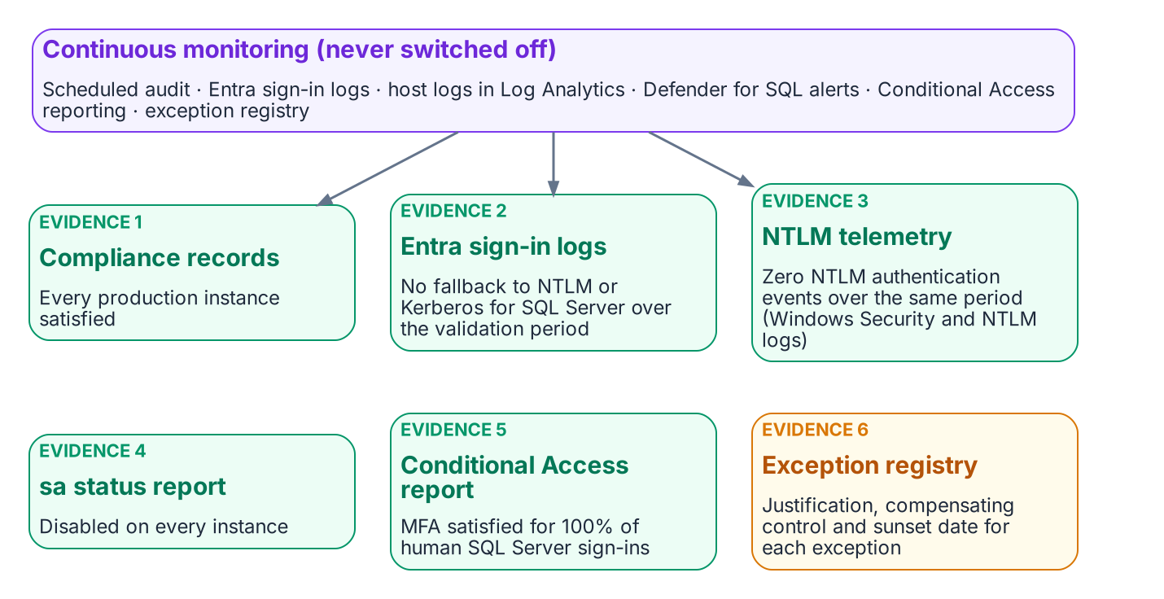
The six evidence sets are live outputs of continuous monitoring.
The closure claim for the SQL Server authentication transformation must be supported by six artifact sets, and each is a continuously regenerated output rather than a static deliverable. The first is the per-instance compliance record set: a record for every production SQL Server instance in the estate, each showing the Entra-exclusive operational posture — SQL authentication refused, zero usable SQL Authentication logins, zero active Windows-backed logins, the Arc agent enrolled and healthy, and the SQL extension deployed. The SQL Server engine-authentication decision defines the field set these records carry, and the continuous audit keeps them current rather than freezing them at the moment of the claim.
The second is the Entra ID sign-in log set, showing zero failed token requests attributable to NTLM or Kerberos fallback for SQL Server resource audience tokens over a defined validation period preceding the closure claim. The third is the NTLM telemetry — the Windows Security and NTLM operational logs from SQL Server hosts, collected in Log Analytics — showing zero NTLM authentication events over that same validation period — the behavioral confirmation that complements the structural compliance view. These two artifacts together demonstrate that the transformed posture holds not only in configuration but in observed connection behavior.
The fourth is the sa account status report, showing the sa account disabled on all instances. The fifth is the Conditional Access policy compliance report, showing MFA enforcement satisfied for one hundred percent of SQL Server resource sign-ins by human principals over the validation period. The sixth is the exception registry, showing every currently excepted instance with documented justification, a sunset date, and its own compliance tracking record. When all six artifact sets are simultaneously satisfying, and the monitoring infrastructure confirms they have been satisfying for the validation period, the SQL Server authentication transformation is closed. That is what done looks like — not a checkbox, but a demonstrated, continuously verified, evidence-backed posture.

2027-04-01: A Consequence, Not a Completion Date
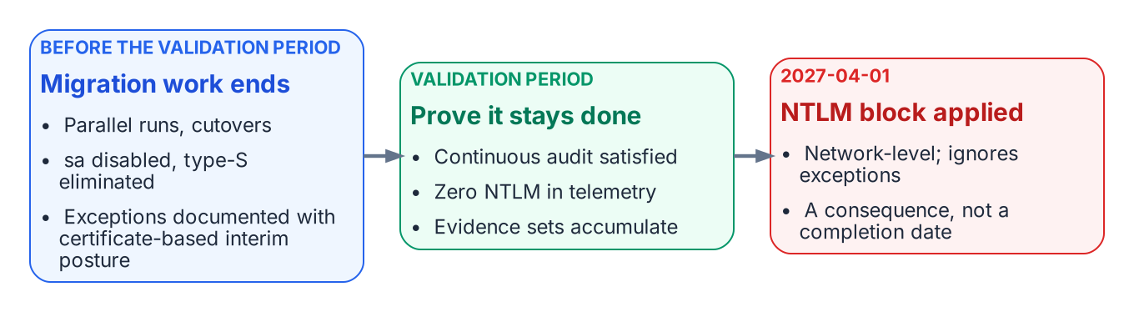
2027-04-01 is when the block lands, so migration ends well before it and the last stretch is validation.
The 2027-04-01 NTLM elimination deadline is the single most misread date in the program. It is widely treated as the date by which the migration must complete. It is not. It is the date on which the network-level NTLM block is applied. The block does not distinguish a compliant instance from an excepted one — it does not honor engine-layer exception status at all. The difference between “migration complete by 2027-04-01” and “migration must be complete before 2027-04-01, and 2027-04-01 is when the block is applied” is not a semantic distinction. It is the difference between a deadline and a consequence.
Read as a consequence, the date reorganizes the schedule. If 2027-04-01 is when connections that still depend on NTLM stop working, then the migration must have already concluded by then, with enough margin for the continuous audit to have confirmed the satisfying posture across a full validation period. Migration activity — the three-phase parallel-run, the cutover, the sa disablement, the type-S elimination — should finish well before the deadline. The final months are reserved for validation, not for migration, because a posture confirmed only on the last day before the block is a posture nobody has had time to prove.
This reading also gives the exception long-tail its proper weight. An instance that cannot reach Kerberos or Entra OAuth before the block must carry a documented exception with Certificate-Based Authentication as the authorized interim posture, and that exception’s sunset date must be reconciled against the block rather than against any softer internal milestone. The block is network-level and fixed; the program’s schedule must bend to it, not the other way around. When the migration is complete, the audit has validated the posture continuously, and the six artifact sets are live and satisfying, the 2027-04-01 block arrives as a non-event — which is exactly what done is supposed to feel like.
What Book 09 establishes — Chapter 2
- Six evidence sets close the transformation, and each is a live output of continuous monitoring.
- They must hold across a defined validation period, not be assembled once.
- 2027-04-01 is the network-block date, not the migration finish line: migration finishes earlier, so the block arrives as a non-event.

Microsoft Learn, Microsoft Defender for SQL servers on machines overview.
Microsoft Learn, Sign-in logs in Microsoft Entra ID.
Microsoft Learn, Change server authentication mode.
Microsoft Learn, Disable SQL Authentication — SQL Server enabled by Azure Arc (SQL Server 2025 on Windows).
Microsoft Learn, Sign-in logs in Microsoft Entra ID.
Microsoft Learn, What is Conditional Access?.

