Architecture Series
  - Modernization Workbook — Word edition
Table of Contents

Architecture Series
Published architecture narratives under the pseudonymous byline per docs governance. Each explainer targets 2–4 pages of readable prose and one or two canonical diagrams. The series is the bridge between the Executive Briefs and the deeper technical specifications.

Pages in this section
Status badges follow the Whitepapers status conventions.
Slug | Topic | Status | Canon anchor
six-plane-architecture | The six-plane FMP reference model | Draft | docs/docs/01_UnifiedArchitecture.qmd
three-layer-rule-model | Rule layering: canon, policy, runtime | Draft | src/fmp/rules/
boundary-impact-model | Authorization boundary and impact scoring | Draft | docs/docs/gcc-boundary-solution-architecture.qmd
drift-engine | How drift is detected and remediated | Draft | docs/docs/16_DriftDetectionStandard.qmd
evidence-chain | Certificate-anchored evidence propagation | Draft | docs/docs/15_ProvenanceProfile.qmd

Boundary Impact Model
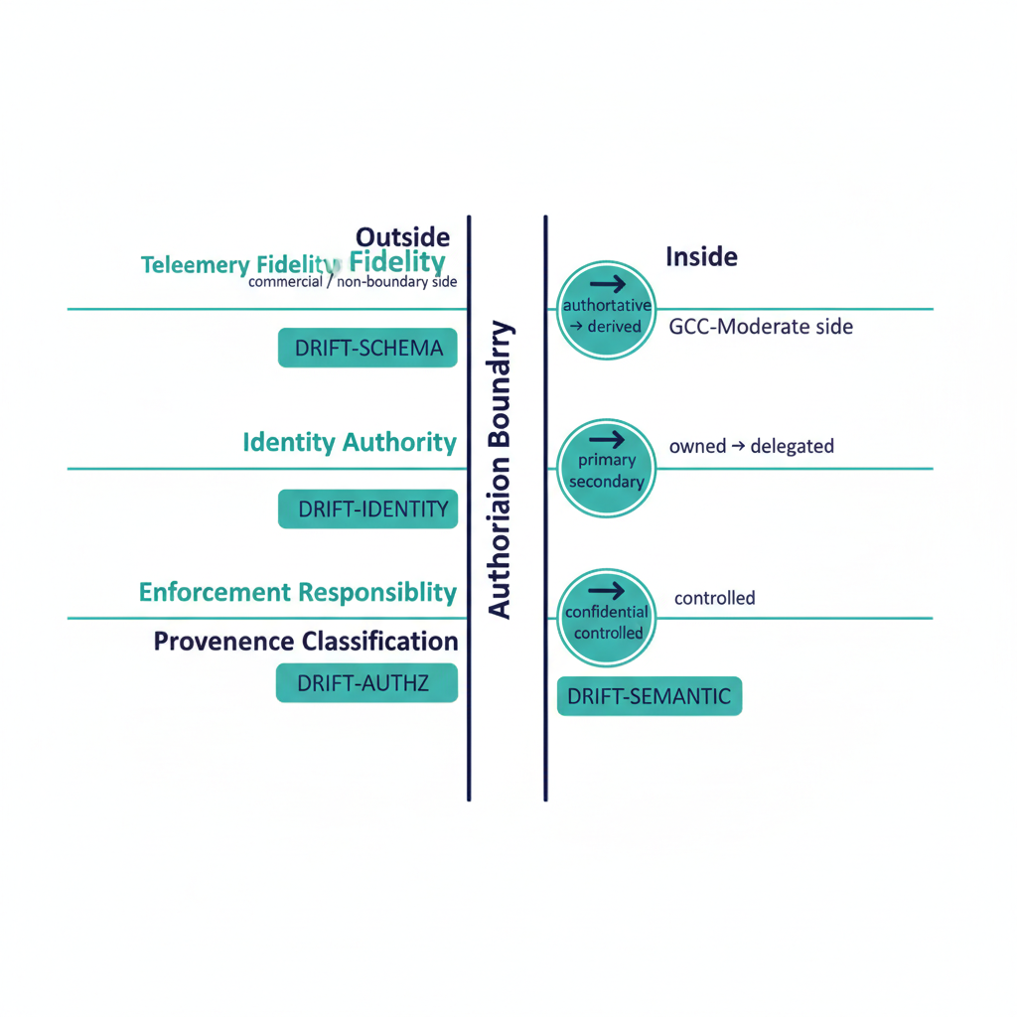
Illustration: four impact dimensions crossing an authorization boundary.
The boundary impact model is FMP’s architectural treatment of what happens when authorization boundaries cut across the substrate — most notably the GCC-Moderate boundary that constrains telemetry, identity, and enforcement surfaces inside Microsoft 365 GCC-Moderate tenants.

Canon-anchor note
The original ROADMAP cited docs/docs/authorization-boundary.qmd, which does not exist. This page anchors instead on the existing GCC-Moderate boundary canon (gcc-boundary-problem-statement.qmd, gcc-boundary-solution-architecture.qmd, drift-detection-boundary-amendment.qmd) and the customer-facing leaf B.1 GCC-Moderate Boundary Model. A canon-change ADR may later promote a generalized authorization-boundary canon document; until then, this model is GCC-Moderate-anchored.
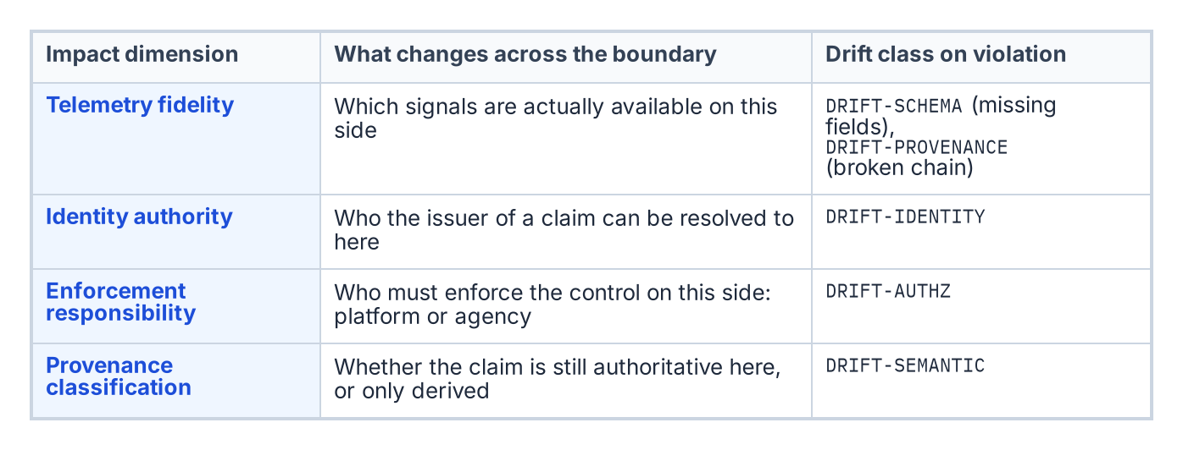
The four impact dimensions of a boundary and the drift class each raises when violated.

What the model captures
A boundary in FMP is not just a network or tenant edge — it is any surface across which:
- Telemetry fidelity changes (e.g. commercial → GCC-Moderate causes silent loss of Endpoint Analytics, Device Health Attestation, etc.).
- Identity authority changes (e.g. a federated trust crosses from one IdP’s namespace to another).
- Enforcement responsibility changes (e.g. a control that was platform- enforced becomes agency-enforced, or vice versa).
- Provenance classification changes (e.g. a claim that was authoritative from system X becomes derived after crossing the boundary).
Each of these axes contributes an impact dimension that the model quantifies independently.

The four impact dimensions
Dimension | Question | Drift class on violation
Telemetry fidelity | What signals are actually available on this side of the boundary? | DRIFT-SCHEMA (missing fields), DRIFT-PROVENANCE (broken chain)
Identity authority | Who can the issuer of a claim be resolved to here? | DRIFT-IDENTITY
Enforcement responsibility | Who must enforce this control on this side? | DRIFT-AUTHZ (out-of-envelope action)
Provenance classification | Is the claim still authoritative on this side, or only derived? | DRIFT-SEMANTIC
The model deliberately maps onto the Drift Engine’s five-class taxonomy. Boundary crossings are the most common source of multi-class drift, and treating boundary modeling as a drift problem (rather than a separate compliance concern) keeps both surfaces in one operational language.

The invisible-boundary problem (worked example)
The structural example for this model is the GCC-Moderate invisible boundary, documented in gcc-boundary-problem-statement.qmd:
Microsoft 365 GCC-Moderate provides the same nominal product set as M365 commercial, but the FedRAMP Moderate authorization boundary materially constrains the outbound telemetry that drives many of the platform’s higher-order analytics. Features appear available in administrative portals, are described in commercial documentation, and may be referenced in SSPs and migration plans, but silently produce no data, emit no errors, and have no documented resolution path in the GCC-Moderate context.
Mapped onto the four-dimension model:
- Telemetry fidelity: Endpoint Analytics, Device Health Attestation, Locations / Network Fence, ARC Server Monitoring, and Expedited Updates are unavailable in GCC-Moderate despite UI presence. The boundary silently attenuates telemetry.
- Identity authority: federated trusts from commercial IdPs cross into GCC-Moderate scope; resolution rules differ on each side.
- Enforcement responsibility: controls that commercial customers consume as platform features (e.g. some ZT analytics) become agency responsibility in GCC-Moderate.
- Provenance classification: an authoritative claim sourced from a commercial-only telemetry path is derived (or absent) in GCC-Moderate.
Treating these as a single boundary impact rather than four unrelated issues is what allows the B.1 GCC-Moderate Boundary Model leaf to produce a single coherent SSP narrative instead of four disjoint ones.
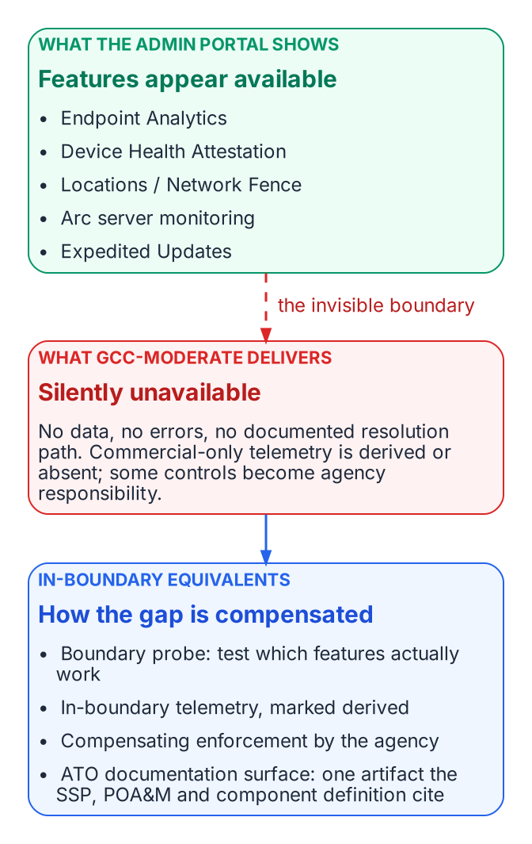
The GCC-Moderate invisible boundary: features that look available, what actually arrives, and the four compensations.

How FMP compensates: in-boundary equivalents
Per gcc-boundary-solution-architecture.qmd, FMP addresses each impact dimension through in-boundary mechanisms rather than waiting for Microsoft to fix the platform:
- Boundary probe — programmatically tests which features actually function on each side, producing a structured capability disposition instead of a portal screenshot.
- In-boundary telemetry — adapters that operate inside the GCC-Moderate boundary and emit canonical claims with explicit source_classification: derived when they substitute for an unavailable commercial signal.
- Compensating enforcement — agency-side enforcement adapters for controls that platform features cannot provide, with their evidence flowing through the same Evidence Chain.
- ATO documentation surface — the boundary impact is captured as a first-class artifact that the SSP, POA&M, and Component Definition all reference, rather than as a series of footnotes.

Why this is an architectural concern, not a compliance concern
Two reasons the boundary impact model lives in the Architecture Series and not in the Compliance section:
- It changes the topology of the substrate. A boundary crossing redefines which plane is authoritative for which claim. That is a structural property of the architecture, not a control mapping.
- It is the same problem on every boundary. GCC-Moderate is the worked example, but identity-federation boundaries, classified-network boundaries, and agency-to-agency boundaries all instantiate the same four-dimension model. Solving it once architecturally is cheaper than re-solving it per compliance regime.

What this means for an ATO package
An FMP-anchored ATO package treats every authorization boundary as a named, modeled, drift-monitored surface:
- The boundary itself appears in the SSP, with disposition data per the four impact dimensions.
- Compensating mechanisms are documented per impact dimension, not as generic mitigations.
- Drift findings cite the boundary they crossed (e.g. DRIFT-PROVENANCE @ gcc-moderate-edge), making remediation scope explicit.
This is what makes the GCC-Moderate boundary tractable: the substrate treats the boundary itself as a first-class governed object, not as an implicit assumption embedded in every control narrative.

Change Control and Provenance Doctrine
Every operational change travels an authorized path that originates from a single source of truth and closes with evidence

The five-clause path
Every operational change in the estate — every Move, Add, Change, Deletion, and Reset (MACD-R) — travels five clauses, and an operation that skips one is unauthorized by construction:
- It originates with the single source of truth. Work is created by divergence between the source of truth and the estate — a joiner in the HR system of record, a control gap against the compliance baseline, a migration wave in the modernization plan. A task with no single-source-of-truth origin is an ad-hoc assertion: nothing authoritative asked for it, so nothing authoritative can attest it.
- It carries an authoritative authorization in the path. The approval resolves from the authority model, not from whoever is nearby: the owner and approver derive from the same source of truth that originated the work, and any pre-authorized lanes are standing authorizations — recorded grants with scope and expiry, never the absence of approval.
- It executes under least privilege, elevated just-in-time. The executing actor — human or automation — activates a time-boxed, scoped role at execution and holds no standing privilege. The activation record is part of the operation’s evidence, binding who could act to what was done.
- It closes with provenance. No closure counts unless it carries its proof. The closing update carries the verification payload that justified it — the probe result, the posture query, the re-test output — with a timestamp and the identity of the checking mechanism. A closure record without a verification payload does not validate.
- It emits verified, secured evidence — automatically. The closure record, integrity-protected and carrying its lineage (originating record, authorization, just-in-time activation, verification payload), flows into the continuous-monitoring stream with no human assembly. Evidence a person compiles arrives late and unverifiable; evidence the lifecycle emits arrives continuously and carries its own chain of custody.
The five clauses are one chain: single-source-of-truth-originated → authoritatively authorized → least-privilege executed → provenance-closed → evidence-emitted back to the reporting plane.

Closure Provenance Doctrine
No closure counts unless it carries its proof.
A remediation task, a daily operational check, a plan-of-action milestone, or a control test closed by a human clicking “complete” — with no machine-readable verification attached to the closing record — is prose, not evidence. It asserts that work happened; it proves nothing an assessor can consume.

Three requirements
- Every closure carries provenance. The closing update carries the verification payload that justified it, with a timestamp and the identity of the checking mechanism. The close is the contract: a closure record without a verification payload does not validate.
- Human-only closure is an exception state, not a path. It remains possible — operations need an escape hatch — but it is visibly flagged, counted separately, and never silently aggregated into control tests, continuous-monitoring evidence, or service-level attainment. An attestation pipeline that cannot distinguish probe-backed closures from attested-only ones attests fiction.
- Reports are derivations, never compilations. Every report in the coordination plane — continuous-monitoring roll-ups, plan-of-action aging, patch service-level attainment, evidence feeds — is derived from the closure stream by a generator that can be re-run and diffed. A report that cannot be regenerated from closure records is an artifact of effort, not of state.

Non-human class sources of truth
The non-human classes that a modernization moves have designated sources of truth of their own:
- Devices originate in the asset-lifecycle registry. Device-management enrollment is enforcement, not truth.
- Declared infrastructure originates in the infrastructure-as-code repository.
- Every item migrated must carry a human owner resolvable in the HR source of truth. An ownerless item is an orphan finding before it is a migration candidate.

Application at migration scale
A migration wave is a batch of Moves originated by the modernization plan’s source of truth, each executed under a just-in-time role and each emitting per-object closure evidence. This is how a migration stays an audited operation instead of a weekend of standing administrative rights.

Cleaned extraction for project use. No internal branding or document identifiers.

Continuous Monitoring Strategy
Objectives and cadence for ongoing evidence collection after modernization.

Purpose
Modernization does not end at cutover. Continuous monitoring detects drift, confirms controls remain effective, and supplies evidence for residual risk reviews and compliance reporting.

Objectives
- Detect configuration and attribute drift within a defined window.
- Confirm that Conditional Access, compliance policies, and governance attributes remain effective.
- Provide evidence for residual risk acceptance and control assessments.
- Alert on high-severity findings before they become incidents.

Cadence
Signal type | Collection frequency | Review frequency
Critical drift findings | Continuous or hourly | Immediate
Compliance and Conditional Access hits | Daily | Weekly
Attribute and group membership changes | Daily | Weekly
Residual risk register | — | Monthly or on change
Full control assessment | — | Quarterly

Evidence retention
Retain findings, approvals, and verification results long enough to support audit and incident review. Evidence is immutable once written.

Cleaned extraction for project use.

Delegation Matrix
Principles for scoping administrative authority.

Purpose
Delegation defines who may perform which actions on which scope of objects. In a modernized environment the scope is expressed by governed attributes rather than by OU.

Principles
Principle | Implication
Least privilege | Role is limited to the minimum actions required
Scoped by attribute | Scope is an attribute value or combination, not a manual group
Time-bound where possible | Standing access is the exception
Recorded | Every delegation has an owner, a scope, and a review date
Separated | Requestor and approver are different people for high-privilege actions

Example scopes
Scope | Typical roles | Review cadence
Single department | Help desk, local admin | Quarterly
Division or region | Tier-2 operations | Quarterly
Privileged roles | Identity admins | Monthly or on change
Break-glass | Emergency only | Continuous monitoring

Bottom line
Delegation is auditable when the scope is a governed attribute and the assignment is recorded. Manual group membership as the sole scope mechanism loses that auditability.

Cleaned extraction for project use.

Drift Engine
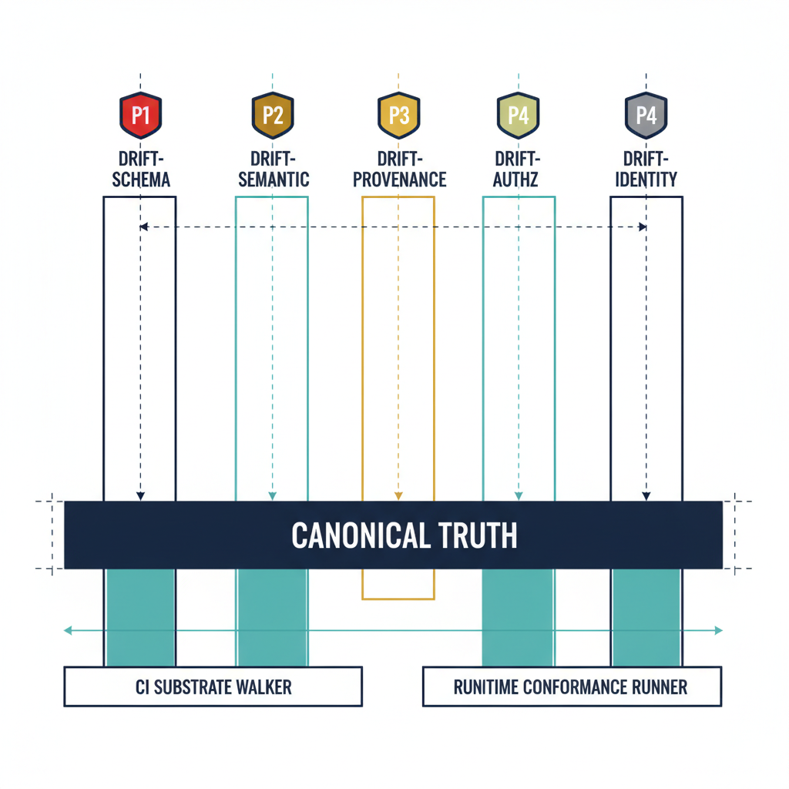
Illustration: the five drift classes rising from canonical truth.
FMP treats drift as a first-class operational signal, not as an exception. The Drift Engine is the substrate-wide subsystem that classifies, prioritizes, and remediates the gap between declared canonical state and observed runtime reality.
The companion executive brief is Drift Engine Overview. This page is the architectural depth: how the engine is structured, what it catches today, and what is reserved for runtime maturity.
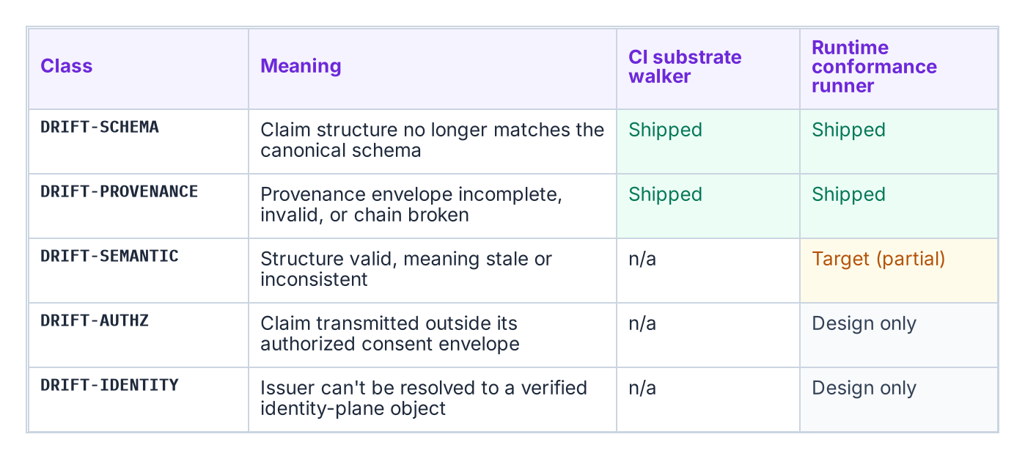
The five drift classes, what each means, and where detection ships today.

Five-class taxonomy
FMP defines exactly five drift classes, declared in 16_DriftDetectionStandard.qmd §2:
Class | Meaning | Detection surface
DRIFT-SCHEMA | Claim structure no longer matches canonical schema | CI substrate walker
DRIFT-SEMANTIC | Structure valid, meaning stale or inconsistent | Runtime conformance runner
DRIFT-PROVENANCE | Provenance envelope incomplete, invalid, or chain broken | CI substrate walker + runtime
DRIFT-AUTHZ | Claim transmitted outside authorized consent envelope | Runtime conformance runner
DRIFT-IDENTITY | Issuer cannot be resolved to a verified identity-plane object | Runtime conformance runner
Five is the right number because each class corresponds to a distinct failure mode that requires a distinct remediation contract. Collapsing them (e.g. calling everything “configuration drift”) loses the ability to assign severity and SLA deterministically.

Severity model
Every drift finding carries a severity, also canonically defined:
Severity | When | Auto-remediate? | SLA
P1 (critical) | Active-use claim with provenance or identity drift | No — halt + alert | Immediate
P2 (high) | Live schema or semantic drift | Yes, if deterministic | 1 hour
P3 (medium) | Drift in dormant or historical claim | Yes | 24 hours
P4 (low) | Style or metadata drift, no semantic impact | Yes | 72 hours
Severity is computed deterministically from the drift class plus the liveness of the affected claim — it is not a judgment call.
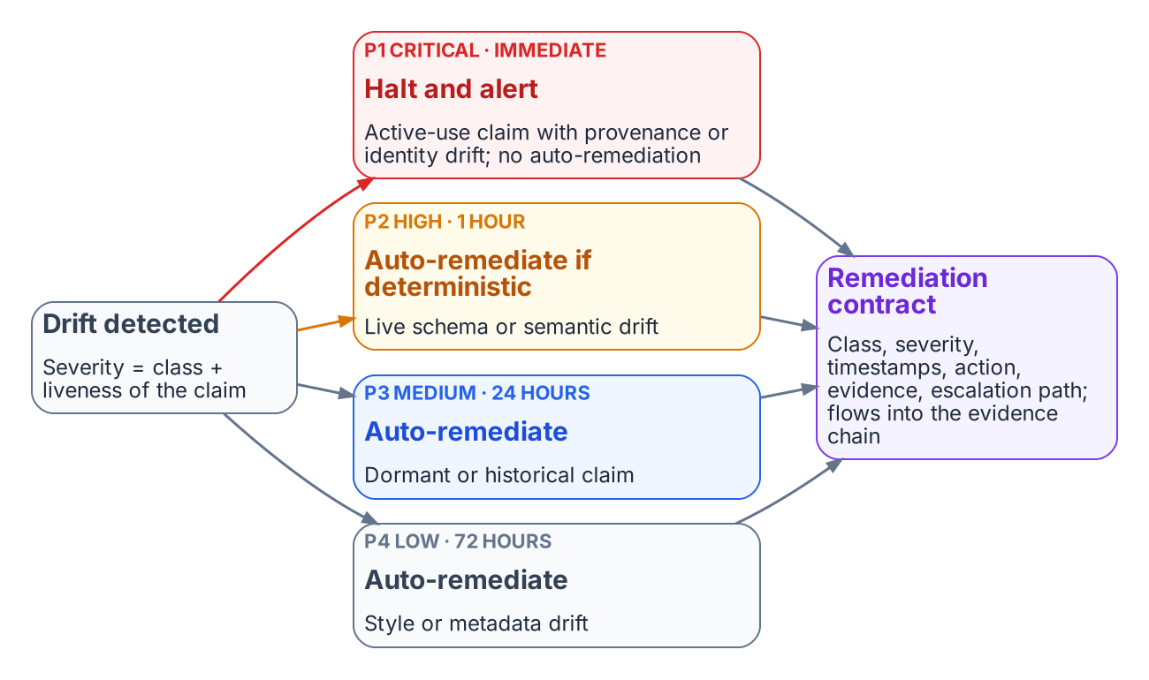
Severity follows from class and liveness; each severity has a fixed path, and every path emits a remediation contract.

Detection surfaces

CI substrate walker (shipped today)
fmp substrate walk and fmp substrate drift (source) emit two drift classes on every PR via substrate-drift.yml:
- DRIFT-SCHEMA — verifies module paths declared in substrate-manifest.yaml (FMP_200) actually exist in the tree.
- DRIFT-PROVENANCE — verifies that every registry document referenced from a manifest, ADR, or registry resolves to a real canon artifact.
fmp substrate drift is the CI-friendly entry point: exit code 0 = clean, non-zero = drift detected. The full structured report is available via fmp substrate walk --json.

Runtime conformance runner (target / partial)
The runtime detection surface — semantic, authorization, identity — is defined in canon and partially implemented. Adapters that pass the runtime conformance runner emit a remediation contract for every drift event:
remediation_contract:
drift_class: "DRIFT-*"
severity: "P1|P2|P3|P4"
detection_timestamp: ISO8601
detected_by: "{adapter_id | workflow_id}"
auto_remediated: true | false
remediation_action: "halt | fix | flag | log"
remediation_timestamp: ISO8601
remediation_evidence: "{commit_sha | audit_record_id}"
escalation_path: "Canon Steward | Architecture Lead | CISO"
Source: 16_DriftDetectionStandard.qmd §4.
The Drift Fabric view ties the detection surfaces above into a single pipeline — canonical state read, delta comparison, classification, and the HIGH/CRITICAL escalation arrow into the Governance Plane:
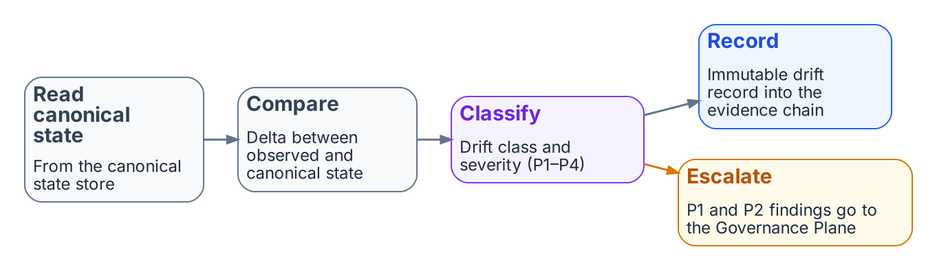
The drift pipeline: read canonical state, compare, classify, record, and escalate critical and high findings.

Maturity matrix
Drift class | CI surface | Runtime surface
DRIFT-SCHEMA | SHIPPED | SHIPPED
DRIFT-PROVENANCE | SHIPPED | SHIPPED
DRIFT-SEMANTIC | n/a | TARGET (partial)
DRIFT-AUTHZ | n/a | DESIGN-ONLY
DRIFT-IDENTITY | n/a | DESIGN-ONLY
For an authoritative shipped-vs-target snapshot, see Substrate Status.

Why this is different from a config-drift tool
Three properties distinguish the FMP Drift Engine from generic configuration-drift tooling:
- Canon-anchored, not snapshot-anchored. Drift is measured against a numbered canon document with a version, not against an arbitrary “last-known-good” snapshot. Reproducibility is built in: the same canon version always yields the same expected state.
- Five-class taxonomy with deterministic severity. Operators do not triage drift findings; severity is a pure function of class plus liveness. This collapses the “is this serious?” debate into “did the classifier run correctly?”
- Remediation contracts are first-class evidence. Every remediation — auto or human — emits an evidence record that flows back through the Evidence Chain into OSCAL artifacts. There is no parallel “drift log” disconnected from the SSP.

What this means for an ATO package
A drift finding in an FMP-anchored system carries:
- A canonical class (DRIFT-*) traceable to FMP_200 / canon-numbered drift standard.
- A severity computed deterministically.
- A remediation contract with timestamps, action, and signed evidence.
- An escalation path that lands at a named role, not a generic distribution list.
3PAOs assessing such a system can verify the drift posture by running fmp substrate walk themselves rather than trusting a snapshot — the engine is designed for independent re-execution.

Evidence Chain
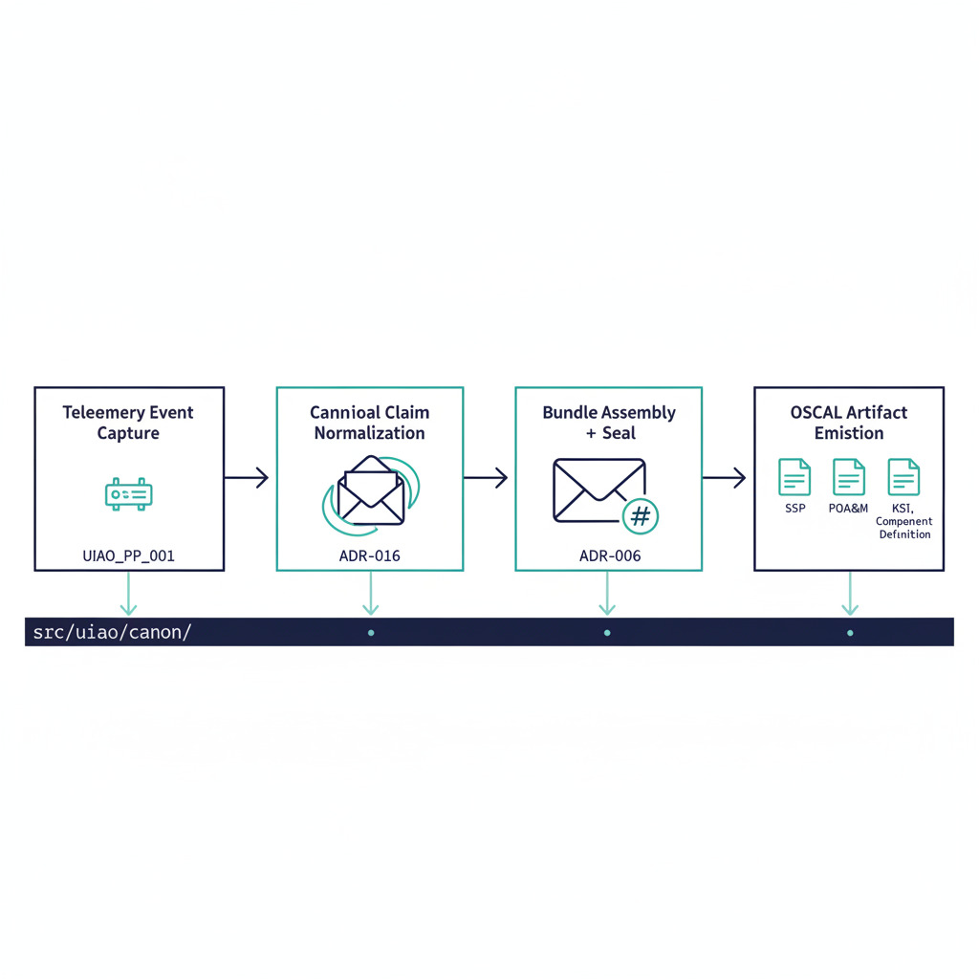
Illustration: telemetry becoming OSCAL artifacts in four stages.
FMP’s evidence chain is the architectural mechanism that turns runtime telemetry into assessor-ready compliance artifacts with traceable provenance at every step. The chain is deterministic: same inputs, same canon version, same evidence bundle.
The companion executive brief is Evidence Fabric Overview. This page is the architectural depth — the four-stage pipeline, the provenance envelope, and the determinism guarantees.
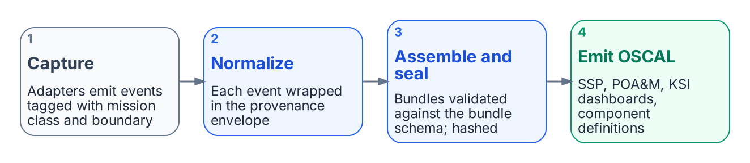
The evidence chain in four stages, from telemetry to OSCAL artifacts.

Four-stage pipeline
Stage-by-stage responsibility:
- Telemetry event capture — adapters at the system boundary emit structured events. Each adapter declares its mission-class and boundary so the captured event carries authoritative source classification from the moment of emission.
- Canonical claim normalization — every event is wrapped in the provenance envelope defined in 15_ProvenanceProfile.qmd §3. This is the chain’s structural backbone (see below).
- Evidence bundle assembly + sealing — claims are grouped into bundles per the program decision (assemble → seal → submit → close). Bundles are validated against evidence-bundle.schema.json which enforces hash-bearing provenance at item and bundle scope.
- OSCAL artifact emission — sealed bundles feed the OSCAL pipeline that emits SSP, POA&M, KSI dashboards, and Component Definitions, with every field traceable back to the originating claim.
The Truth Fabric view of stages 1–2 is the canonical claim-intake pipeline that turns adapter-signed events into the Canonical State Store the rest of the chain reads from:
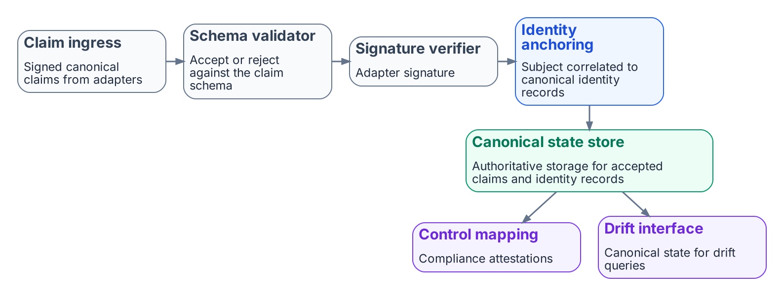
Claim intake (stages 1–2): signed claims are validated, verified and identity-anchored into the canonical state store.

Provenance envelope
Every claim emitted into the chain carries this envelope, verbatim from canon:
provenance:
claim_id: "urn:fmp:claim:{domain}:{claim_type}:{uuid}"
issuer_identity: "{entra_object_id | agency_issuer_id}"
source_system: "{system_name}:{version}"
source_classification: "authoritative | derived | synthesized"
extraction_timestamp: ISO8601
extraction_method: "api | batch | stream | manual"
transformation_chain:
- step: 1
transform: "{transform_name}"
applied_by: "{adapter_id}"
applied_at: ISO8601
lineage_hash: "{SHA-256 of source record at extraction}"
schema_version: "1.0"
signature: "{mTLS certificate thumbprint}"
Three properties of this envelope matter for assessor review:
- source_classification is canonical. A claim is authoritative, derived, or synthesized — and a 3PAO can verify the classification by re-executing the adapter. There is no “trust me” classification.
- transformation_chain is append-only. Once a step is recorded and signed, it cannot be removed or reordered. Re-execution that would produce a different chain is itself a DRIFT-PROVENANCE finding.
- lineage_hash is per-claim. Every claim hashes its source record at extraction time. The bundle hash is computed over those hashes, giving a tamper-evident tree.
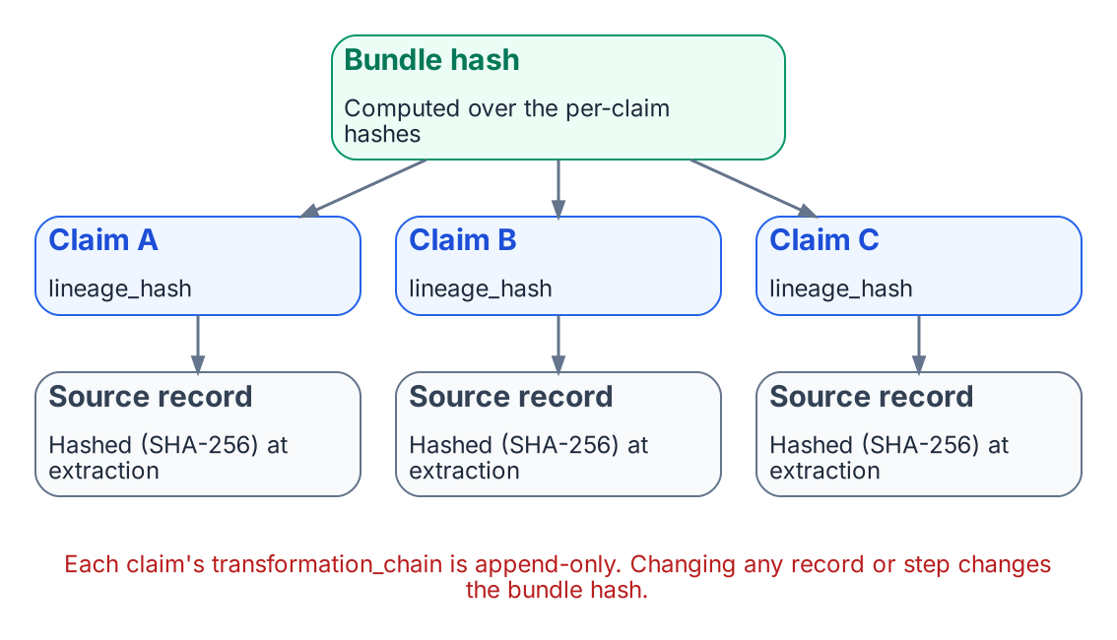
Per-claim lineage hashes roll up into the bundle hash, so a change anywhere breaks it.

Determinism guarantees (the program decision)
Per the program decision, the evidence chain is built for deterministic regeneration. Concretely:
- No silent drops. Every input event is either accepted, rejected with reason, or queued — never silently lost.
- Append-only writes. Evidence storage is immutable; updates are new records that supersede prior ones with explicit provenance.
- Ordered records. Replays produce identical ordering, not “best-effort” ordering.
- Idempotent ingestion. Re-ingesting the same source record twice yields the same canonical claim, not a duplicate.
The operational consequence: the same canon version processing the same input bundle always produces a byte-identical evidence bundle. A 3PAO can re-run the assembly months later and verify the bundle hash matches the original, without coordinating with the original adapter operator.
The Evidence Fabric view of stages 3–4 shows the write-side pipeline with the two-tier storage that backs deterministic regeneration — adapter-signed events flow through countersignature and hash-chain anchoring into Active (≤ 90 days) and Archive (3–7 year) storage tiers, both readable by the Correlation Engine that serves diff and re-run queries:
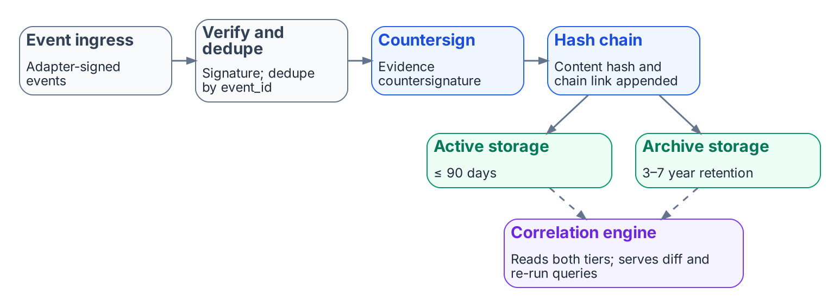
The write side (stages 3–4): countersigned, hash-chained events in two storage tiers.

What ships today
Capability | Maturity
Provenance envelope schema (FMP_PP_001 v1.0) | SHIPPED
Evidence bundle schema + lifecycle (the program decision) | SHIPPED
OSCAL SSP / POA&M / KSI / Component Def generators | SHIPPED
Deterministic regeneration (the program decision properties) | SHIPPED for canon-anchored generators
Continuous event-time capture across all adapters | TARGET
Cryptographic signing with agency-issued certs | DESIGN-ONLY (envelope reserves the field)
The event-time capture chain is design-defined but not fully wired in current production flow. The structural pieces — provenance envelope, bundle schema, lifecycle, OSCAL emission — all ship today; end-to-end continuous capture across every adapter is target-state.

What this means for an ATO package
An FMP-anchored evidence bundle gives a 3PAO four properties they cannot get from a screenshot-based evidence package:
- Independent re-execution. The bundle can be regenerated from canon and source data without the original operator’s involvement.
- Per-claim source classification. Authoritative claims are distinguished from derived claims at the field level, not in narrative prose.
- Tamper-evident lineage. The hash tree binds every claim to a source record; modification anywhere in the chain breaks the bundle hash.
- Drift-coupled. A DRIFT-PROVENANCE finding from the Drift Engine directly identifies the affected claim(s) in the evidence bundle, so remediation is scoped, not rebuild-the-whole-package.
This is what “canon-anchored evidence” means in practice — and is the operational basis for treating FMP evidence as deterministically reviewable rather than periodically attested.

Gap Closure Register
Structure for tracking residual risk and closure actions.

Purpose
A living register of gaps that remain after a modernization wave or control implementation. Each entry records the gap, its residual risk, the owner, the planned closure action, and the evidence required to close it.

Entry fields
Field | Content
Gap ID | Unique identifier
Description | What is missing or incomplete
Residual risk | Impact and likelihood if left open
Owner | Accountable party
Planned action | How the gap will be closed
Evidence required | What will prove closure
Target date | When closure is expected
Status | Open, in progress, closed, accepted

Operating rules
- No gap is closed without evidence.
- Accepted residual risk requires explicit approval and a review date.
- The register is reviewed on a defined cadence.
- Closed items remain in the register for audit.

Bottom line
The register makes residual risk visible and actionable. It prevents gaps from being forgotten after the project phase that created them ends.

Cleaned extraction for project use.

Governance Platform Coverage and Gap Doctrine
Model for determining what a governance platform covers and what remains a gap.

Purpose
Not every control or process is delivered by a single platform. This document defines how to classify coverage and how to treat gaps so that residual risk is explicit.

Coverage classification
Classification | Meaning
Covered | The platform enforces the control and produces evidence
Partial | The platform supports the control but evidence or enforcement is incomplete
Gap | The control is required but not delivered by the platform
Out of scope | The control is not required for this boundary or workload

Gap treatment
- Record the gap in the Gap Closure Register.
- Assign an owner and a residual risk rating.
- Decide: close by configuration, close by compensating control, or accept with approval.
- Define the evidence that will prove the decision was executed.
- Review on the continuous monitoring cadence.

Bottom line
Coverage is not binary. Explicit classification and gap treatment prevent silent residual risk.

Cleaned extraction for project use.

GPO-to-Cloud Governance Gaps
What enterprises lose in control and governance when Group Policy moves to Intune and Entra ID.

Why this matters
Most large organizations understand the benefits of moving from Group Policy to Intune and Entra ID: cloud scale, remote device management, modern security baselines, and less on-premises infrastructure. Far fewer internalize the governance and control trade-offs until they are deep in the migration or already living with the post-migration operating model.
This document names the capabilities that are commonly lost or significantly weakened in the GPO-to-cloud shift.

The short answer
Partially, at best. The benefits of Intune and Entra ID are well advertised. The governance cost is not. It tends to surface unevenly, and usually after the targeting model has already changed.
The net effect is a shift from hierarchical, structure-driven governance (OU tree + GPO links + inheritance) to attribute-driven, intent-based governance (dynamic groups, assignment filters, Settings Catalog). That shift is more flexible on paper and much harder to govern consistently at scale without a strong canonical model underneath it.

What is lost
Governance capability | GPO / OU model | Cloud model | Consequence
Deterministic targeting | OU + GPO link + inheritance | Dynamic group or filter | “Why does this device have this policy?” becomes hard to answer
Single source of truth for applicability | OU membership | Multiple group and filter rules | Policy rationale fragments
Drift detection | GPO refresh and RSOP | No native continuous comparison | Configuration drift accumulates silently
Delegation with audit | OU ACLs and GPO ownership | Role assignments and group ownership | Change attribution weakens
Legacy setting triage | GPO setting inventory | Manual or tool-assisted mapping | High-risk settings can be missed or copied literally
Portability | On-premises structure | Cloud-specific groups and filters | Governance does not travel with the workload

How the migration actually progresses
In large and regulated environments the move is rarely a clean lift-and-shift. It is a multi-year transformation that changes the fundamental nature of policy governance from hierarchical and on-premises to dynamic and cloud-native. Many organizations discover that they need additional governance architecture — not just more licenses or a basic IGA tool — to avoid losing critical control and visibility.

Bottom line
Large organizations are not uniformly aware of the full governance and control implications until they are deep in migration or already post-migration. The migration is progressing, but it is rarely a clean lift-and-shift.

Cleaned extraction for project use. No internal branding or document identifiers.

Identity and Directory Transformation Inventory
Structured assessment artifact for planning the move from Active Directory to a hybrid or cloud-native identity model.

Purpose
Capture the current identity and directory estate in a form that supports transformation planning. The inventory answers what exists, what depends on it, and what must be decided before any object is moved or retired.

Inventory categories
Category | Key questions
Forest and domains | Functional levels, trusts, sites, domain controllers
Users | Count, privileged, service, stale, external
Groups | Count, nested, privileged, dynamic vs static
Computers | Domain-joined, OS distribution, last logon
Authentication | NTLM usage, Kerberos delegation, certificate-based
Applications | Apps that require AD, LDAP, or Kerberos
Group Policy | Count, high-risk settings, link structure
DNS and PKI | Zones, CAs, templates, issued certificates
Dependencies | Systems that will break if a DC, GPO, or trust is removed

Output
A decision-ready inventory that feeds:
- Identity transformation sequencing
- GPO sunset planning
- Application remediation
- Residual risk acceptance

Cleaned extraction for project use.

Intune-First Asset Onboarding
Net-new devices enter governance from day zero.

Purpose
Devices procured after the modernization decision should receive their governance attributes and management enrollment at the earliest practical moment — ideally before a user signs in. This document describes a five-phase process that stamps governance intent at procurement time and carries it through enrollment.

Priority order for attribute assignment
- Procurement record — The organization decided to buy the asset for a specific purpose and location.
- Vendor or program carrier — The supplier or enrollment program carries the intended attributes.
- User derivation — Fallback when no procurement record exists (for example, BYOD or historical inventory).
- Unpositioned — Explicit marker when no source can supply a value. No enrolled device should carry an empty governance attribute.
Procurement-first ordering provides determinism (the attribute reflects the purchase decision, not the technician who powered the device on), auditability (chain of custody from purchase order to production), and pre-user-logon coverage (shared and self-deploying devices are stamped correctly with no user present).

Five phases
Phase | Owner | Outcome
1 — Procure | Procurement / asset management | Asset record created with intended governance attributes
2 — Carrier | Vendor or enrollment program | Attributes available to the enrollment process
3 — Validate | Governance / identity | Attributes checked against the canonical model
4 — Enroll | Endpoint management | Device enrolled in Intune with attributes stamped
5 — Verify | Operations | Device appears in the correct dynamic groups and policies; residual risk recorded if any

Devices without a procurement record
Devices that pre-date the process or arrive outside normal procurement fall through to user derivation or the unpositioned marker. These surface as findings for governance review — either by retroactively filing a record, reclassifying the asset, or quarantining it for disposition.

Bottom line
Every enrolled device carries a governance attribute, even if that attribute is an explicit “unpositioned” marker. That invariant keeps dynamic group membership and drift detection deterministic from day zero.

Cleaned extraction for project use.

Single Source of Truth (SSOT)
The authoritative origin for every identity, addressing, enforcement, telemetry, and governance claim
The single source of truth is the authoritative origin for every identity, addressing, enforcement, telemetry, and governance object handled by the modernization framework. All other representations are provenance-anchored pointers, not copies.
It is the foundation of governed operations, the root of the provenance chain, and the baseline against which every drift class is evaluated.

Scope
This document defines what the single source of truth is, where it lives, and how runtime systems are allowed to consume it. It does not enumerate every artifact — that inventory lives in the project’s document registry.

Topology
The authoritative layout places governance artifacts in a version-controlled repository:
Surface | Role
Governance documents | Single source of truth — policies, plans, evidence
Schemas | Schema authority
Rules | Consumer rules and validation logic
The repository is the single source of truth. Runtime systems read from it; they do not write to it except through a governed change process.

Consumer rule
Runtime code must resolve governance artifacts through a stable, package-relative mechanism. This guarantees:
- Artifacts are addressable from any working directory inside the installed system.
- Artifacts survive installation and deployment.
- Artifacts are read-only at runtime — the only writers are the governed change process (reviewed pull request) and explicitly designated tooling.
Hardcoded absolute paths and sibling-checkout fallbacks are forbidden outside test fixtures.

Provenance chain
Every artifact the system produces cites the governance document and version it was derived from:
- Derived artifacts (reports, exports, evidence packets) carry a provenance block with source, version, derived_at, and derived_by.
- Documents classified as derived require provenance; documents classified as authoritative origins do not derive from anything and are leaves of the chain.
- Cryptographic anchoring uses a content hash over the claim content.

Drift baseline
Drift is evaluated against the single source of truth:
Class | Means
Schema drift | Declared structure or registry-cited document does not exist
Semantic drift | Content changed in a way that weakens a policy invariant
Provenance drift | A document cites a path that does not resolve
Authorization drift | Role assignments, delegation scopes, or privilege claims diverge from the authoritative source
Identity drift | Identity objects cannot be reconciled to the authoritative organizational attributes
Single-source-of-truth contention | A write is directed at a demoted instance after the single-source-of-truth roster has been ratified
Severities range from critical to low. A continuous-integration gate fires on any critical finding against the authoritative content.

Change process
Every modification to the authoritative repository must:
- Update the document registry.
- For doctrinal changes (supersession, retirement, scope shift), add a reviewed decision record.
- Pass governance review before merge.
Direct commits without a reviewed decision record are a governance drift signal.

Why it matters
Without a single source of truth, every system holds a slightly different copy of the same claim. Over time those copies diverge, and no one can say which is authoritative. With a single source of truth, every other system holds a pointer that can be validated, refreshed, or retired. Drift becomes detectable. Provenance becomes reconstructible. Auditors can ask “what was the authoritative value on this date?” and receive a machine-readable answer.

Cleaned extraction for project use. No internal branding or document identifiers.

Three-Layer Rule Model
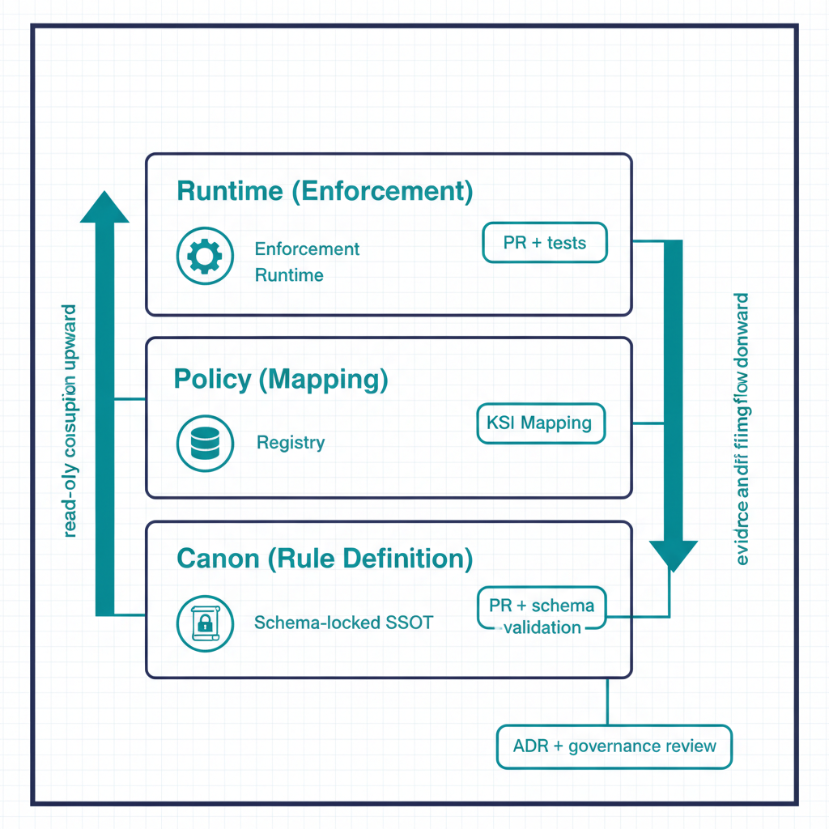
Illustration: the canon, policy and runtime layers as a stack.
FMP separates rule authoring into three distinct layers so that policy intent, evaluation logic, and runtime enforcement can be reasoned about, versioned, and drift-detected independently. Mixing them — the typical “policy-as-config” failure mode — collapses three different change boundaries into one and loses the ability to assess each layer for its own risk profile.
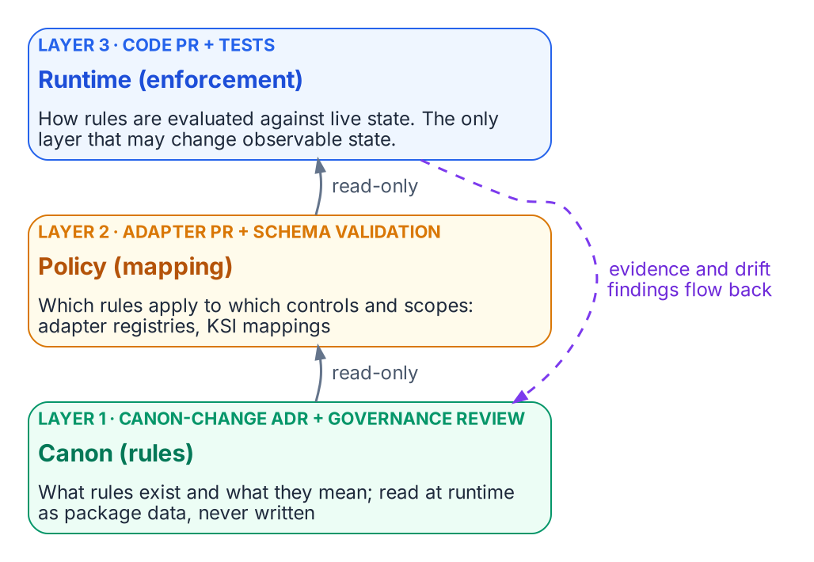
Canon, policy and runtime: each layer has its own change boundary, and the lower layers are read-only to the runtime.

The three layers
Layer | Lives in | Authoritative for | Change boundary
Canon (rule layer) | src/fmp/rules/ | What rules exist and what they mean | Canon-change ADR + governance review
Policy (mapping layer) | src/fmp/canon/<adapter>-registry.yaml, KSI mappings | Which rules apply to which controls / scopes | Adapter PR + schema validation
Runtime (enforcement layer) | Adapter code under src/fmp/adapters/ and enforcement runtime under src/fmp/enforcement/ | How rules are evaluated against live state | Code PR + tests
Each layer has its own change cadence, its own review surface, and its own drift class. This is the architectural reason FMP’s drift engine can distinguish a meaning drift (canon layer changed unexpectedly) from a mapping drift (policy points at a retired rule) from an enforcement drift (runtime code disagrees with canon).

Layer 1 — Canon
The canon layer is the single source of truth for rule existence and semantics. It lives under src/fmp/rules/ and is shipped as package data inside the installable fmp distribution. Canon is read at runtime via importlib.resources per the Canon Consumer rule — never from filesystem paths, never written to.
A canon rule declares:
- Rule identifier (stable, versioned).
- Semantic statement in human-readable form.
- Schema constraints that any concrete instance must satisfy.
- Provenance — the canon document and ADR that authored it.
What canon does not declare: which adapters apply it, which controls it maps to, or how it is enforced at runtime. Those belong to layers 2 and 3.

Layer 2 — Policy
The policy layer is the mapping between canon rules and operational scope. It lives in canon-adjacent registries:
- adapter-registry.yaml — conformance adapter mappings.
- modernization-registry.yaml — modernization adapter mappings.
- KSI mapping files under src/fmp/rules/ksi/ — Key Security Indicator to canon-rule bindings.
A policy entry says: “Adapter X (or KSI Y) applies canon rule R within scope S.” Schema validation in schema-validation.yml enforces that every policy entry references a canon rule that actually exists. A dangling policy entry — referencing a retired rule, a renamed scope, or a non-existent adapter — is a DRIFT-PROVENANCE finding, not a runtime crash.
Policy changes are higher-cadence than canon changes: an adapter author can add or retire a mapping in a normal PR without invoking the canon-change process. The schema gates ensure mappings stay consistent.

Layer 3 — Runtime
The runtime layer is the evaluation logic that actually consumes canon rules and policy mappings against live state. It lives in two places:
- Adapter code under src/fmp/adapters/<adapter>/ — each adapter implements the conformance contract for its mission-class and emits drift findings + evidence per the Evidence Chain.
- Enforcement runtime under src/fmp/enforcement/ — library-only today (FMP_111). Policies are Python callables; there is no CLI surface for the enforcement runtime, by design — see cli-reference.qmd §4.1.
The runtime layer is the only layer allowed to mutate observable state. Canon and policy are read-only at runtime; only the runtime layer can act.

How drift maps onto the layers
The five-class drift taxonomy aligns with the three layers in a way that matters operationally:
Drift class | Layer where the mismatch lives
DRIFT-SCHEMA | Canon — declared schema vs. actual claim structure
DRIFT-SEMANTIC | Canon ↔ Runtime — meaning has shifted between layers
DRIFT-PROVENANCE | Policy — a mapping references a rule that no longer resolves
DRIFT-AUTHZ | Runtime — an adapter emitted outside its consent envelope
DRIFT-IDENTITY | Runtime — issuer cannot be resolved
This alignment is why FMP can attribute a drift finding to a specific review surface: DRIFT-PROVENANCE findings are policy-layer concerns, auto-resolvable in many cases; DRIFT-SEMANTIC findings cross from canon into runtime and require both governance review and code change.

Why three layers and not two
A common simplification is to fold “policy” into “canon” — declare mappings inside the canon document itself. FMP rejects this because:
- Cadence mismatch. Canon changes require ADRs and governance review. Mapping changes do not. Folding mappings into canon either slows mapping work to canon cadence or weakens canon’s review discipline.
- Blast radius. A bad mapping is recoverable by a registry edit. A bad canon edit is recoverable only through ADR supersession. Different blast radii deserve different change boundaries.
- Drift attribution. The drift engine can tell a 3PAO whether a finding represents a meaning shift or a mapping mistake. That distinction is lost if both live in the same artifact.
The same logic argues against folding “runtime” into “policy” — runtime must execute, mutate, and emit, which policy must not.

What this means for an ATO package
Three operational properties for a 3PAO:
- Per-layer evidence trails. Canon changes carry an ADR; policy changes carry a schema-validated registry diff; runtime changes carry tests and remediation contracts. The package shows three distinct evidence surfaces, not one.
- Independent reviewability. A reviewer can challenge “is this rule’s meaning correct?” (canon) separately from “is this mapping right?” (policy) separately from “does the code do what canon says?” (runtime).
- Targeted remediation. When drift is found, only the affected layer is rebuilt — canon, mapping, or code. The other two layers’ evidence remains valid.

Where Data Lives — Devices and Azure Resources
Data location taxonomy for devices and Azure resources under a governed model.

Purpose
Extends the identity data-location model to devices and Azure resources. For each object type, identify the authoritative origin, the derived pointers, and the systems that must not be treated as sources of truth.

Devices
Claim | Authoritative origin | Derived pointers
Ownership / purpose | Procurement or asset record | Intune device category, dynamic group membership
Compliance state | Intune compliance policy evaluation | Conditional Access signal
Location / site | Procurement or assignment record | Named location, dynamic group
Management authority | Intune enrollment | Azure Arc (servers)

Azure resources
Claim | Authoritative origin | Derived pointers
Subscription / resource group purpose | Governance assignment | Tags, policy assignment
Owner | Governance record | Tag or role assignment
Environment (prod/non-prod) | Governance assignment | Tag, policy, Conditional Access named location
Compliance scope | Governance boundary | Azure Policy assignment, regulatory tags

Rule
No device or Azure resource should carry an empty governance attribute when enrolled or created under the governed path. Derived values (tags, group membership, policy assignment) must be explainable from the authoritative origin.

Cleaned extraction for project use.

Architecture Series
Conceptual explainers for the modernization governance model
Each explainer targets readable prose and one or two diagrams. The series is the bridge between the Executive Briefs and the deeper technical specifications.

Contents
Document | Focus
Six-Plane Architecture | The six control planes and their governance roles
Three-Layer Rule Model | Separating canon, policy, and runtime rule layers
Drift Engine | How drift is detected and remediated
Evidence Chain | Certificate-anchored evidence propagation

Cleaned extraction for project use. No internal branding or document identifiers.

Drift Engine
How drift is detected and remediated
Drift is treated as a first-class operational signal, not as an exception. The Drift Engine classifies, prioritizes, and remediates the gap between declared authoritative state and observed runtime reality.

Five-class taxonomy
Class | Meaning | Detection surface
Schema | Claim structure no longer matches authoritative schema | Continuous integration
Semantic | Structure valid, meaning stale or inconsistent | Runtime
Provenance | Provenance envelope incomplete, invalid, or chain broken | Continuous integration + runtime
Authorization | Claim transmitted outside authorized envelope | Runtime
Identity | Issuer cannot be resolved to a verified identity object | Runtime
Five is the right number because each class corresponds to a distinct failure mode that requires a distinct remediation contract. Collapsing them loses the ability to assign severity and service-level agreement deterministically.

Severity model
Severity | When | Auto-remediate? | SLA
P1 (critical) | Active-use claim with provenance or identity drift | No — halt + alert | Immediate
P2 (high) | Live schema or semantic drift | Yes, if deterministic | 1 hour
P3 (medium) | Drift in dormant or historical claim | Yes | 24 hours
P4 (low) | Style or metadata drift, no semantic impact | Yes | 72 hours
Severity is computed deterministically from the drift class plus the liveness of the affected claim — it is not a judgment call.

Detection surfaces

Continuous integration (shipped)
Verifies that declared structures exist and that every referenced document resolves to a real artifact.

Runtime (target / partial)
Semantic, authorization, and identity detection. Every drift event emits a remediation contract:
remediation_contract:
drift_class: "DRIFT-*"
severity: "P1|P2|P3|P4"
detection_timestamp: ISO8601
auto_remediated: true | false
remediation_action: "halt | fix | flag | log"
remediation_evidence: "{commit | audit_record}"
escalation_path: "named role"

Why this is different from a config-drift tool
- Authoritative-origin-anchored, not snapshot-anchored. Drift is measured against a versioned document, not against an arbitrary “last-known-good” snapshot. The same version always yields the same expected state.
- Five-class taxonomy with deterministic severity. Operators do not triage drift findings; severity is a pure function of class plus liveness.
- Remediation contracts are first-class evidence. Every remediation emits an evidence record that flows into the authorization artifacts. There is no parallel “drift log” disconnected from the package.

What this means for an authorization package
A drift finding carries a canonical class, a severity computed deterministically, a remediation contract with timestamps and signed evidence, and an escalation path that lands at a named role. Reviewers can re-execute the detection rather than trust a snapshot.

Cleaned extraction for project use. No internal branding or document identifiers.

Six-Plane Architecture
The six control planes and their governance roles
The modernization control surface decomposes into six control planes. Each plane is authoritative for its domain, and all six operate as a single deterministic system.
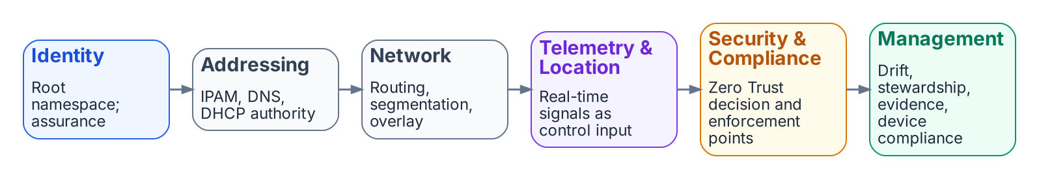
The six control planes, in the order authority flows between them.

The six planes
Plane | Role
Identity | Root namespace and assurance engine
Network | Routing, segmentation, and overlay transport
Addressing | Deterministic IPAM and DNS/DHCP authority
Telemetry & Location | Real-time signals for routing, security, and compliance
Security & Compliance | Zero Trust enforcement and authorization alignment
Management | Governance, drift detection, configuration management, device compliance

Why six planes
The decomposition is not arbitrary. Each plane corresponds to a distinct authority boundary: a single source of truth, a single set of authoritative schemas, and a single class of drift findings. The six-plane cut is the smallest decomposition that:
- Names every authoritative source an authorizing official needs to evaluate during review.
- Maps cleanly to operational roles — every mission-class lands inside exactly one plane.
- Avoids the “everything is identity” overload that collapses addressing, telemetry, and management into the identity plane and loses the ability to drift-detect them independently.

Plane-by-plane summary

Identity plane
Root namespace. Every actor — human, service principal, device, workload — is named here exactly once. Assurance levels are anchored on this plane. Downstream planes consume identity claims; they do not mint them.

Network plane
Routing, segmentation, and overlay transport. Owns the path-level decisions that flow from identity context (who) and addressing (where). Replaces perimeter logic with an identity-driven overlay.

Addressing plane
Deterministic IPAM/DNS/DHCP. Names are derived from identity and policy, not assigned by a parallel administrative process. Addressing is computed from the identity plane, not maintained as an independent source.

Telemetry & Location plane
Real-time signal carrier. Every component emits telemetry in canonical claim form. Telemetry is treated as control input, not as after-the-fact reporting: drift findings, evidence claims, and policy decisions all originate as telemetry events.

Security & Compliance plane
Zero Trust enforcement and authorization alignment. Holds the policy decision points and policy enforcement points that consume identity, addressing, and telemetry to evaluate access.

Management plane
Governance and configuration management. Where the system is run from: drift detection, stewardship, evidence regeneration, device compliance reporting.

How the planes interact
Cross-plane interaction is deterministic and one-directional at the authoritative level: identity feeds addressing feeds network feeds telemetry feeds security-and-compliance feeds management. Cycles exist only at runtime (for example, management drift findings trigger identity re-evaluation), and every cycle is mediated by an explicit artifact, never by ad-hoc coupling.
This means every plane has exactly one authoritative input, and any deviation surfaces as a drift finding rather than as silent inconsistency.

What this means for an authorization package
An authorizing official can expect: - A per-plane control narrative rather than a perimeter-centric one. - Citations for every policy intent. - Drift findings scoped per plane — identity drift, addressing drift, telemetry drift each carry their own evidence trail rather than collapsing into a single “system drift” line item.

Cleaned extraction for project use. No internal branding or document identifiers.

Three-Layer Rule Model
Separating authoritative rules, policy mappings, and runtime enforcement
Rule authoring is separated into three distinct layers so that policy intent, evaluation logic, and runtime enforcement can be reasoned about, versioned, and drift-detected independently. Mixing them — the typical “policy-as-config” failure mode — collapses three different change boundaries into one and loses the ability to assess each layer for its own risk profile.
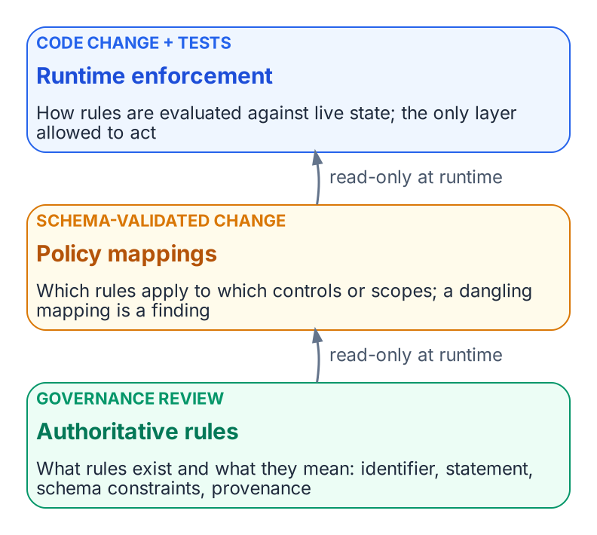
Authoritative rules, policy mappings and runtime enforcement, each with its own change boundary.

The three layers
Layer | Authoritative for | Change boundary
Authoritative rules | What rules exist and what they mean | Governance review
Policy mappings | Which rules apply to which controls or scopes | Schema-validated change
Runtime enforcement | How rules are evaluated against live state | Code change + tests
Each layer has its own change cadence, its own review surface, and its own drift class.

Layer 1 — Authoritative rules
The single source of truth for rule existence and semantics. A rule declares: - A stable, versioned identifier. - A semantic statement in human-readable form. - Schema constraints that any concrete instance must satisfy. - Provenance — the document that authored it.
What this layer does not declare: which components apply it, which controls it maps to, or how it is enforced at runtime. Those belong to the other layers.

Layer 2 — Policy mappings
The mapping between authoritative rules and operational scope. A policy entry says: “Component X applies rule R within scope S.” Schema validation ensures that every policy entry references a rule that actually exists. A dangling policy entry is a provenance finding, not a runtime crash.
Policy changes are higher-cadence than rule changes: a mapping can be added or retired without invoking the full governance-review process. The schema gates ensure mappings stay consistent.

Layer 3 — Runtime enforcement
The evaluation logic that consumes rules and policy mappings against live state. The runtime layer is the only layer allowed to mutate observable state. Authoritative rules and policy mappings are read-only at runtime; only the runtime layer can act.

How drift maps onto the layers
Drift class | Layer where the mismatch lives
Schema | Authoritative rules — declared schema vs. actual claim structure
Semantic | Authoritative rules ↔ Runtime — meaning has shifted between layers
Provenance | Policy — a mapping references a rule that no longer resolves
Authorization | Runtime — a component emitted outside its authorized envelope
Identity | Runtime — issuer cannot be resolved

Why three layers and not two
- Cadence mismatch. Rule changes require governance review. Mapping changes do not. Folding mappings into the rule layer either slows mapping work or weakens review discipline.
- Blast radius. A bad mapping is recoverable by a registry edit. A bad rule edit is recoverable only through formal supersession.
- Drift attribution. The drift engine can tell a reviewer whether a finding represents a meaning shift or a mapping mistake. That distinction is lost if both live in the same artifact.

What this means for an authorization package
- Per-layer evidence trails. Rule changes carry a review record; policy changes carry a schema-validated diff; runtime changes carry tests and remediation contracts.
- Independent reviewability. A reviewer can challenge “is this rule’s meaning correct?” separately from “is this mapping right?” separately from “does the code do what the rule says?”
- Targeted remediation. When drift is found, only the affected layer is rebuilt.

Cleaned extraction for project use. No internal branding or document identifiers.

Eight Core Concepts
These concepts are universal — not specific to any single compliance regime. They form the architectural foundation for governance, including directory migration.
# | Core Concept | Definition
1 | Single source of truth | Every claim has one authoritative origin. All other representations are pointers, not copies.
2 | Conversation as atomic unit | Every interaction binds identity, certificates, addressing, path, quality of service, and telemetry.
3 | Identity as root namespace | Every address, certificate, subnet, policy, and telemetry event derives from identity.
4 | Deterministic addressing | Addressing is identity-derived and policy-driven.
5 | Certificate-anchored overlay | Mutual TLS anchors tunnels, services, and trust relationships.
6 | Telemetry as control | Telemetry is a real-time control input, not passive reporting.
7 | Embedded governance | Governance is executed through orchestrated workflows, not manual tickets.
8 | User experience first | The migration is invisible to end users if governance was done right.

Alignment to Directory Migration
Each adapter interface references the core concepts it implements:
- IP Address Management Adapter → Concepts 1 (single source of truth) and 4 (deterministic addressing)
- PKI Adapter → Concept 5 (certificate-anchored overlay)
- RADIUS Adapter → Concepts 3 (identity as root namespace) and 5
- LDAP Proxy Adapter → Concept 3 (identity as root namespace)
- Directory Synchronization Engine Adapter → Concept 1 (single source of truth) — retirement means the single source of truth moves to the cloud identity platform
- Device Management Adapter → Concept 7 (embedded governance)
- NTP Adapter → Concept 5 (certificate-anchored overlay — Kerberos dependency)
- Distributed File System Adapter → Concept 8 (user experience first — path names must not break)

Cleaned extraction for project use.

