Chapter 06 — The Canonical Workforce Identity Model
  - Book 03 — HR-Driven Identity: from the HR system of record to Entra ID
Table of Contents
Chapter 06 — The Canonical Workforce Identity Model
In this chapter
The standard-attribute layer
Contractors and vendors: the population HRIT doesn’t cover
Design rules
The schema
Writers
How other pages use this schema
Continue the book

Chapter 06 — The Canonical Workforce Identity Model
OPM’s standard attributes are the contract. Native attributes first. A small, coded set of extension attributes for access. Nothing hand-edited.

In this chapter
The standard-attribute layer: why OPM’s data standards, not vendor fields, are the contract for federal employees. Contractors and vendors, whom HRIT doesn’t cover: where to source them, and how to split authority among those sources. The design rules behind the schema. The implementation crosswalk, which every other page on this site links to instead of repeating. Why three extension attributes, and why they hold codes. How the hire and leave dates reach Entra ID from each landing zone. Who is allowed to write any of it.

The standard-attribute layer
The schema below names Oracle fields because Oracle Fusion Cloud HCM is the Core HCM platform. But the durable contract is one level up: OPM’s standard personnel data. Every agency on the platform records the same data elements with the same codes and meanings, defined by OPM’s data standards (formerly published as the Guide to Data Standards, now maintained in OPM’s online metadata repository), and every personnel action carries a nature-of-action code from the same standards (Chapter 08). For federal employees, mapping identity to the standard rather than to vendor fields means one crosswalk serves every employee population, survives the next vendor change, and can be reused by any agency on the platform. The standard stops at federal employees, though; contractors and vendors are covered in the next section.
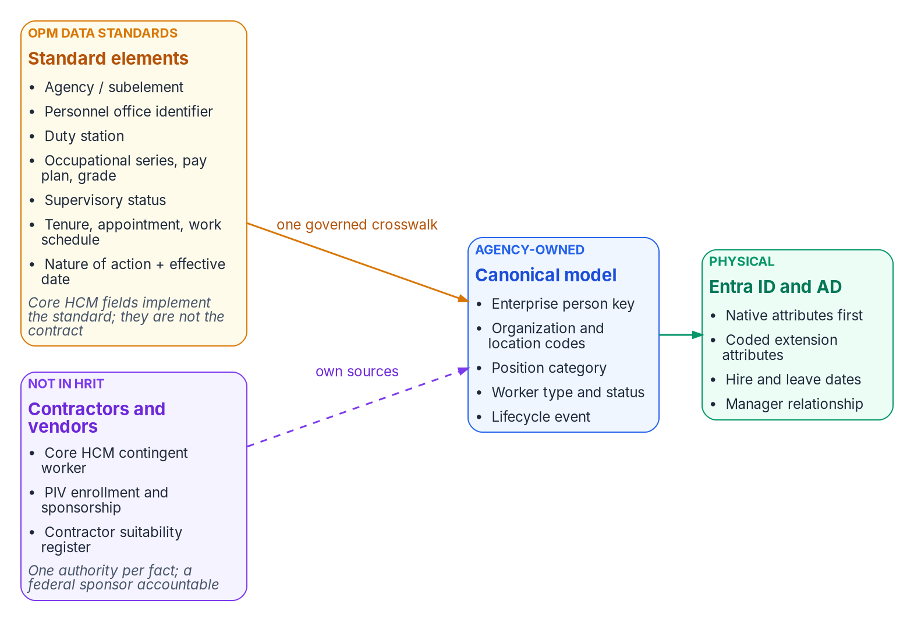
The standard-attribute layer: OPM standard data elements are the contract; one governed crosswalk maps them into the canonical model; Entra ID and Active Directory receive coded projections.
OPM standard data elements and what identity does with them
OPM standard data element | Identity use | Lands as (crosswalk below)
Agency / subelement | Legal employer and component scope | companyName; organization code
Personnel office identifier | Servicing HR office; delegated administration scope | Administrative-unit rule input
Duty station | Location of record; location-based scoping; physical-access integration | Location code; usageLocation source
Occupational series, pay plan, grade | Position category for role-eligible access packages | Position category code
Supervisory status | Approver and reviewer eligibility; manager-chain integrity | Supervisor group; manager checks
Tenure, type of appointment, work schedule | Worker type and its lifecycle profile (pre-hire window, license, retention) | employeeType; worker-type code
Nature of action + effective date | Lifecycle trigger: joiner, mover, conversion, leave, return, leaver, correction | Hire and leave dates; account state
Confirm each element’s current name, values and how Core HCM exposes it against OPM’s current standards at engagement time (Chapter 12, verification register). OPM requires that the coded blocks of the SF-50 use only codes listed in the EHRI Data Standards, which is what makes them dependable as access inputs. Where an access decision needs a code that a standard element supplies, the code is the standard’s — not a locally invented list.

Contractors and vendors: the population HRIT doesn’t cover
OPM’s data standards and nature-of-action codes describe federal employees. Federal HR 2.0 moves federal employees. Contractors and vendors — often a large share of an agency’s accounts, and the share most likely to be orphaned — are in neither. In most agencies they are tracked today in contracting officer’s representative (COR) spreadsheets: a sponsor, a contract or task order, a start date and an end date that nobody is obliged to keep current. A spreadsheet can’t be a source of authority, so these workers need one, mapped into the same canonical model as employees.
Where contractors and vendors can be sourced from
Option | What it gives | What it lacks
Core HCM Contingent Worker (best fit) | Oracle Fusion Cloud HCM treats contractors as a full worker type, the contingent worker: a person record, an assignment, a place in the organization and a lifecycle much like an employee’s, with add, renew and convert actions and the same interfaces | No vendor-management system and no non-employee governance layer: sponsorship, contract linkage and end-date attestation still need an owner and a process. Confirm that the agency’s Core HCM configuration will record contingent workers
PIV credential and sponsorship system | Sponsorship, adjudication, the sponsoring office and an expiry already exist for every badged contractor: FIPS 201-3 requires a background investigation and favorable adjudication before issuance, and caps a PIV card’s validity at six years | Covers only people who get a PIV credential; vendors and short-term workers without one need another path
Contractor suitability register | Many agencies already keep one, under personnel security or contracting: each contractor tied to the agency contract they work on, with the suitability determination and its date. It is often the only existing record that links a person to a contract under agency authority | Often records the vetting decision, not the end of the engagement. Owner, interface and update timing vary, and a register keyed by hand from COR spreadsheets inherits their lag
A non-employee lifecycle service (complement) | Sponsor workflows, contract and vendor records, periodic attestation | A third source to integrate and govern; usually layered on one of the two options above rather than replacing them
Whichever source the agency chooses, the rules are the same:
- One model. Contractors map into the same canonical model, with worker type set to contractor and their own enterprise person key (Chapter 04). In the proposed canonical model, conversion between contractor and employee creates a new affiliation for the same person, joining the two sources on that key, so a converting person never gets a second identity.
- Different triggers. Contractors have no SF-50. Their joiner and leaver events are the contract or sponsorship start and end dates, and a sponsor’s withdrawal is a leaver event (Chapter 08).
- Map what applies. Organization code, duty station and sponsor (as manager) carry over; employee-only elements such as pay plan and grade don’t. Add a contract or task-order reference so access can be scoped to the contract and reviewed with it.
- Expiry is enforced, not trusted. An end date that passes without renewal ends access on that date, whatever the spreadsheet says.

One fact, one authority
No single option is complete. The contingent worker record has no contract or vetting data, the PIV system manages a card rather than an identity, and a suitability register may not know when an engagement ends. So don’t pick one: give each fact identity needs one authoritative source, and hang the whole record on an accountable federal sponsor.
One authority per contractor fact
Fact identity needs | Authority
Existence and contract link | The contractor suitability register, or the Core HCM contingent worker record once it is configured
End of engagement | The contract record. Confirm the register carries end dates; if it doesn’t, the sponsor attests them
Suitability | The contractor suitability register
Identity proofing and credential status | The PIV enrollment and card management system, whose identity proofing and registration FIPS 201-3 sets at IAL3
Accountable sponsor | The COR or another federal employee, mastered in HR
Organization placement | Derived from the sponsor, so it follows accountability; an explicit override needs a justification
Person key | The enterprise person key (Chapter 04). Where the agency already issues it to contractors with their PIV credential, as an agency-wide “Mainframe PIN” often is, contractors are keyed exactly like employees
A contractor’s access ends at the earliest of: the contract end date passing; suitability withdrawn; the PIV credential revoked; the sponsor leaving with no one taking over within a short grace period (for example 14 days); or the sponsor missing a periodic recertification (for example every 180 days). The last two close the gap that free-text sponsor fields leave open, because the sponsor is a live reference into HR, not a name on a form. Reconcile in both directions: a badge with no contractor record, and a contractor record with no badge, are both drift findings (Chapter 11).

Before a register becomes an authority
Settle six things with the register’s owner first. The first two decide whether it can be the leaver signal at all.
- Owner. Contracting or personnel security? The owner has to accept identity as a named consumer, just as HR does.
- Content. Does it hold contract end dates and departures, or only the suitability decision? A register with only the decision is a vetting source, not a lifecycle source.
- Freshness. How fast is a departure recorded?
- Privacy basis. Which system-of-records notice covers the register, and what is the basis for disclosing it to identity systems? Within the agency that maintains it, that is normally the Privacy Act’s need-to-know provision; a routine use is needed only if the records leave the agency, for example to a shared-service provider (Chapter 04, Appendix B). The privacy office decides.
- Join key. Does it record the enterprise person key? If it does, the register, PIV enrollment and the directories join on one key. If not, the first job is a crosswalk to it.
- Coverage. Who isn’t in it: short-term, remote or vendor-support staff without a PIV credential? They still need a sponsor-only path.

Sequence: start with what already exists
- Read only. Reconcile the register and PIV enrollment against the contractor accounts in AD and Entra ID, joined on the enterprise person key. Report orphans and expired engagements, and write nothing to any directory. This measures the problem before anyone is asked to change a process.
- Before Core HCM. The register plus sponsor attestation become the contractor source. Ship the leaver trigger first, then the joiner.
- At Core HCM go-live. Decide whether to configure the contingent worker type. If the agency adopts it, it holds the person and the assignment, and the register stays the authority for the contract and suitability. Either way the identity pipeline doesn’t change: it reads one canonical record, whatever the source.

Design rules
- Use a native Entra attribute wherever one exists. employeeId, department, jobTitle, companyName, manager, employeeType, employeeHireDate, employeeLeaveDateTime and employeeOrgData already mean what the HR record means. Other Microsoft features (the org chart, Lifecycle Workflows, access-package approvals) read them directly.
- Add an extension attribute only where access needs a value a rule can’t read natively. Rules for dynamic membership support a fixed list of user properties. That list includes department, companyName, jobTitle, employeeId, employeeHireDate (preview), userType and accountEnabled, plus extensionAttribute1–15 and directory extension properties. It doesn’t include employeeType, employeeOrgData or manager (direct-reports groups use a separate rule form). Three attributes cover the gap.
- Put codes in access attributes, never display strings. An organization code changes only when the business fact changes; a display name changes whenever someone retypes it.
- Use the same carrier in both landing zones. extensionAttribute1–15 exist in on-premises AD and in Entra ID. For synced users, AD is the source and the Entra values are read-only; for cloud-only users they can be set when the user is created or updated. A rule written against user.extensionAttribute10 works the same for a hybrid user and a cloud-mastered one, which matters during the years of coexistence.
- Don’t build an organizational hierarchy into attributes. The reporting line is the manager relationship; organizational placement is department, employeeOrgData and one organization code. There’s no encoded path, tree or composite key to maintain.

The schema
The target crosswalk for the governed workforce identity model
Canonical field | Oracle HCM source | SCIM attribute | On-premises AD | Entra ID | Rule can read it | Used for
Person number | workers.PersonNumber | externalId | employeeID | employeeId | Yes | Source correlation key, subject to the enterprise identifier decision in Chapter 04 (where the agency already has an enterprise ID, such as a Mainframe PIN, employeeId carries that instead and PersonNumber maps to it)
Employment active | Assignment status | active | accountDisabled | accountEnabled | Yes | Joiner and leaver state
Given name / surname | workers.names | name.givenName / name.familyName | givenName / sn | givenName / surname | Yes | Display, UPN rules
Display name | workers.DisplayName | displayName | cn | displayName | Yes | Display only, never access
Department | Department name | enterprise department | department | department | Yes | Display, address book, coarse scoping
Division | Business unit | enterprise division | division | employeeOrgData.division | No | Reporting, profile card
Cost center | Cost center | enterprise costCenter | — | employeeOrgData.costCenter | No | Chargeback, reporting
Legal employer | Legal employer | enterprise organization | company | companyName | Yes | Agency or component
Manager | Manager’s person number | enterprise manager | manager (DN) | manager | Direct-reports rule only | Supervisory chain, approvals, reviewers
Job title | JobName | title | title | jobTitle | Yes | Display; not an access input
Worker type | Worker type / person type | custom extension workerType | employeeType | employeeType | No | Employee, contractor, intern, volunteer
Hire date | Effective start date | custom extension HireDate | extensionAttribute2 | employeeHireDate | Yes (preview) | Joiner workflow trigger
Leave date | Termination effective date | custom extension TermDate | extensionAttribute3 | employeeLeaveDateTime | No | Leaver workflow trigger
Work country | Work address country | addresses[type eq "work"].country | co | country | Yes | Address; source for the usageLocation expression that licensing needs
Organization code | Department ID (code) | custom extension orgCode | extensionAttribute10 | extensionAttribute10 | Yes | Access targeting
Worker type code | Worker type (code) | custom extension workerTypeCode | extensionAttribute11 | extensionAttribute11 | Yes | Access targeting; mirrors employeeType
Position category | Job family or position category (code) | custom extension positionCategory | extensionAttribute12 | extensionAttribute12 | Yes | Access targeting
Notes on the table:
- The SCIM mappings for both landing zones follow the example worksheets in Microsoft’s Oracle HCM integration guide, which also maps a custom JobCode to extensionAttribute1 in both AD and Entra ID. Custom attributes are added to the provisioning app’s schema as SCIM schema extensions and then mapped. For attributes with no AD equivalent, the same guide says to use extensionAttribute1–15 or extend the AD schema.
- Neither date has a native AD attribute. For AD-landed users, Microsoft’s Oracle HCM worksheet writes HireDate and TermDate to extensionAttribute2 and extensionAttribute3; a sync rule then maps each one to employeeHireDate or employeeLeaveDateTime in Entra ID. The AD attribute must be a string, and the value must be converted to the format Entra expects, usually with a date-format expression. Inbound provisioning, Entra Connect cloud sync and Entra Connect Sync all support both target attributes.
- The choice of extensionAttribute10–12 for access codes is this workbook’s proposed implementation choice, not a Microsoft default. Before Phase 1 closes, confirm that each one is in the provisioning app’s target attribute list and isn’t already used. Exchange calls extensionAttribute1–15 custom attributes 1–15.
- Rules can’t use multi-value extension properties. All three access attributes hold one code.

Writers
A dynamic membership rule moves the access decision to whoever can write the attribute it reads. Microsoft’s guidance is to check write permissions for every attribute a rule uses, in Entra ID and in any source directory, and to restrict self-service write access to attributes used in security-sensitive groups. For this schema that means:
- The only writer of every field above is the provisioning service: the API-driven inbound app for cloud-mastered users, the provisioning agent plus Entra Connect for AD-mastered ones.
- Remove help-desk, self-service and Exchange-admin write paths to extensionAttribute10–12 and to the two date carriers. In AD, review the ACLs on the target OUs; in Exchange, the custom-attribute cmdlets are a write path.
- Any write by another principal is a drift event (Chapter 11).

How other pages use this schema
The SQL Server Identity Transformation series, Book 07 applies the same attribute-to-access discipline to SQL Server logins and database roles. Book 02, Chapter 09 — Building the Entra ID Target and the Conditional Access library link here rather than carrying their own attribute map.

Continue the book
← Previous: Chapter 05 — Provisioning Services · Book index · Next: Chapter 07 — Who Owns Workforce Identity →

U.S. Office of Personnel Management, “Data Policy & Guidance” (data standards and the metadata repository that replaced the PDF Guide to Data Standards), https://www.opm.gov/policy-data-oversight/data-analysis-documentation/data-policy-guidance/ (accessed Oct 20, 2026).
U.S. Office of Personnel Management, Federal Workforce Data, “EHRI Data Standards,” https://data.opm.gov/data-standards/ehri-data-standards (accessed Oct 20, 2026).
U.S. Office of Personnel Management, Guide to Processing Personnel Actions, October 2026 edition, https://www.opm.gov/policy-data-oversight/data-analysis-documentation/personnel-documentation/processing-personnel-actions/guide_to_processing_personnel_actions.pdf (accessed Oct 20, 2026).
U.S. Office of Personnel Management, Guide to Processing Personnel Actions, October 2026 edition, https://www.opm.gov/policy-data-oversight/data-analysis-documentation/personnel-documentation/processing-personnel-actions/guide_to_processing_personnel_actions.pdf (accessed Oct 20, 2026).
Oracle, REST API for Oracle Fusion Cloud HCM, “Create a worker work relationship” (WorkerType values Employee (E), Contingent Worker (C), Pending Worker (P), Nonworker (N)), https://docs.oracle.com/en/cloud/saas/human-resources/farws/op-workers-workersuniqid-child-workrelationships-post.html (accessed Oct 20, 2026).
Oracle, Oracle Fusion Cloud HCM, “How You Convert Pending Workers” (Add Contingent Worker, Add Contingent Work Relationship and Renew Contingent Worker actions), https://docs.oracle.com/en/cloud/saas/human-resources/fawhr/how-you-convert-pending-workers.html (accessed Oct 20, 2026).
Oracle, Oracle Fusion Cloud Human Resources 26B What’s New, “New Redwood Process to Change Worker Type” (contingent worker to employee in one transaction), https://docs.oracle.com/en/cloud/saas/readiness/hcm/26b/hure-26b/26B-hr-wn-f43513.htm (accessed Oct 20, 2026).
National Institute of Standards and Technology, FIPS 201-3, Personal Identity Verification (PIV) of Federal Employees and Contractors, January 2022 (background investigation and adjudication before issuance; identity proofing and registration meet IAL3; card validity of no more than six years), https://nvlpubs.nist.gov/nistpubs/FIPS/NIST.FIPS.201-3.pdf (accessed Oct 20, 2026).
National Institute of Standards and Technology, FIPS 201-3, Personal Identity Verification (PIV) of Federal Employees and Contractors, January 2022 (background investigation and adjudication before issuance; identity proofing and registration meet IAL3; card validity of no more than six years), https://nvlpubs.nist.gov/nistpubs/FIPS/NIST.FIPS.201-3.pdf (accessed Oct 20, 2026).
Microsoft Learn, “Manage rules for dynamic membership groups in Microsoft Entra ID” (supported properties; extension attributes and custom extension properties; security consideration on attribute write permissions), https://learn.microsoft.com/en-us/entra/identity/users/groups-dynamic-membership (accessed Oct 20, 2026).
Microsoft Graph, “onPremisesExtensionAttributes resource type,” https://learn.microsoft.com/en-us/graph/api/resources/onpremisesextensionattributes (accessed Oct 20, 2026).
Microsoft Learn, “Configure Oracle Human Capital Management (HCM) for automatic user provisioning,” https://learn.microsoft.com/en-us/entra/identity/saas-apps/oracle-hcm-provisioning-tutorial (accessed Oct 20, 2026).
Microsoft Learn, “Extend API-driven provisioning to sync custom attributes,” https://learn.microsoft.com/en-us/entra/identity/app-provisioning/inbound-provisioning-api-custom-attributes (accessed Oct 20, 2026).
Microsoft Learn, “Configure Oracle Human Capital Management (HCM) for automatic user provisioning,” https://learn.microsoft.com/en-us/entra/identity/saas-apps/oracle-hcm-provisioning-tutorial (accessed Oct 20, 2026).
Microsoft Learn, “Configure Oracle Human Capital Management (HCM) for automatic user provisioning,” https://learn.microsoft.com/en-us/entra/identity/saas-apps/oracle-hcm-provisioning-tutorial (accessed Oct 20, 2026).
Microsoft Learn, “How to synchronize attributes for Lifecycle Workflows,” https://learn.microsoft.com/en-us/entra/id-governance/how-to-lifecycle-workflow-sync-attributes (accessed Oct 20, 2026).
Microsoft Graph, “onPremisesExtensionAttributes resource type,” https://learn.microsoft.com/en-us/graph/api/resources/onpremisesextensionattributes (accessed Oct 20, 2026).
Microsoft Learn, “Manage rules for dynamic membership groups in Microsoft Entra ID” (supported properties; extension attributes and custom extension properties; security consideration on attribute write permissions), https://learn.microsoft.com/en-us/entra/identity/users/groups-dynamic-membership (accessed Oct 20, 2026).
Microsoft Learn, “Manage rules for dynamic membership groups in Microsoft Entra ID” (supported properties; extension attributes and custom extension properties; security consideration on attribute write permissions), https://learn.microsoft.com/en-us/entra/identity/users/groups-dynamic-membership (accessed Oct 20, 2026).

