Book 05 — Devices & Endpoints
  - Group Policy to Intune and Azure Arc — Modernization Workbook, combined edition
Table of Contents
Book 05 — Devices & Endpoints: Group Policy to Intune and Azure Arc
Status — draft book
Why, what, who, how
Reading paths
Where this book sits in the workbook
Chapter 01 — Why Group Policy Can’t Come to the Cloud
In this chapter
Governance that came free with the domain
What Group Policy did implicitly
Why none of it carries over
The governance gaps this opens
How the move actually goes
The Why in five sentences
What this chapter establishes
Continue the book
Chapter 02 — The Hybrid Join Trap
In this chapter
A program that turns out to be a switch
How the fleet converts itself
What Microsoft recommends now
The loss ledger
What hybrid join never covers
The governed path
What to do first
What this chapter establishes
Continue the book
Chapter 03 — Where Device and Server Data Lives
In this chapter
The rule
Which system owns which fact
What each Microsoft record is authoritative for
How the records correlate
A read-only correlation pass
Illustrative, not tested against a production tenant
What this chapter establishes
Continue the book
Chapter 04 — Intune-First Onboarding
In this chapter
Scope: net-new devices only
What Intune-first means
Why the doctrine exists
The five pillars
Where the organizational assignment comes from
The five-phase process
Windows: Autopilot or Autopilot device preparation
Illustrative, not tested against a production tenant
The compliance and configuration baseline
Other platforms
The three exception paths
Devices without a procurement record
Validation, drift classes and evidence
What this chapter establishes
Continue the book
Chapter 05 — The Governed, Manual and Retrofit Paths
In this chapter
One end state, three ways to reach it
What every path shares
The shared runbook
Illustrative, not tested against a production estate
Arc servers run non-domain-joined in the target
Never put an onboarding secret in plain text in a startup script
Group Policy and Intune: Group Policy wins by default
Conditional Access can’t block on-premises NTLM
The manual path
The governed path
The retrofit path
How to choose
Key risks on every path
Continue the book
Chapter 06 — Who Owns the Endpoint
In this chapter
Where the roles come from
Decision rights and work are different things
The roles
The responsibility matrix
Three role systems, one access model
What changes from Group Policy, in one table
Continue the book
Chapter 07 — The GPO Sunset Program
In this chapter
The program at a glance
Step 1: Inventory and parse
Step 2: Classify each setting
Step 3: Crosswalk
Step 4: Decide and record
Step 5: Sequence by population
Coexistence: who wins
Freezing and unlinking GPOs
The end state
Methodology principles
Continue the book
Chapter 08 — GPO to Intune Policy Migration
In this chapter
The seven phases at working level
Policy architecture
Compliance policies
Configuration profiles (settings catalog)
Folder Redirection to a file share doesn’t move by itself
Endpoint security policies
Exclusion hygiene
App protection policies
The translation reference and CSP paths
Dynamic group and filter templates
Illustrative, not tested against a production tenant
Microsoft Graph templates
Continue the book
Chapter 09 — Servers Under Azure Arc
In this chapter
What Arc changes and what it doesn’t
Arc servers run non-domain-joined in the target
Before you onboard
Illustrative, not tested against a production estate
Onboarding
Never put an onboarding secret in plain text in a startup script
The day-one baseline
Extended Security Updates
Microsoft Entra ID sign-in
Rollback
The manual and governed server paths
Monitoring the server estate
What this chapter establishes
Continue the book
Chapter 10 — Operating and Evidencing the Fleet
In this chapter
Compliance and the Conditional Access hand-off
Configuration status and conflicts
Windows updates
Microsoft Defender for Endpoint
Device inventory reconciliation
Illustrative, not tested against a production tenant
Retirement and wipe
Drift detection and alerting
Reporting and the evidence an assessor reads
GCC (Moderate) boundary facts
Where to go next
Continue the book
Appendix A — GPO to Intune Crosswalk
In this appendix
How to use this appendix
Category crosswalk
Setting reference: 50 common GPO settings
CSP paths behind key settings
Workload comparison: Group Policy, Configuration Manager and Intune
Limits that shape the crosswalk
Continue the book

Book 05 — Devices & Endpoints: Group Policy to Intune and Azure Arc

Status — draft book
This book consolidates the workbook’s device and server modernization pages (the Group Policy sunset guides, the Intune policy migration guide, Intune-first onboarding, the Intune and Azure Arc path guides, the hybrid-join whitepaper and their short companion pages) into one ordered book. Every external claim was checked against a primary source on October 20, 2026 and carries a footnote. The earlier pages are kept in the repository’s archive/b05-devices/ folder, and their old addresses forward to the chapters that replaced them.
15-minute presentation: the Why / What / Who / How deck and its narrated, self-running version are in the repository under presentations/b05-devices/.
For twenty years Group Policy did a great deal of governance without anyone writing it down. Where a computer sat in the OU tree decided which settings it got, in which order, and which ones won. Moving devices to Entra ID and Intune removes that machinery. Nothing in the cloud reads the OU tree, and Intune applies policy by assignment, not by precedence. So the settings, the targeting and the exceptions all have to be stated again on purpose. Servers follow a different road: Intune doesn’t manage Windows Server, so servers come under governance through Azure Arc and Azure Policy. This book is the plan for both, and for the hybrid-join shortcut that looks like progress but isn’t an end state.

Why, what, who, how
 | Question | Chapters
Why | Why can’t Group Policy come to the cloud, and why isn’t hybrid join the answer? | 01, 02
What | What is authoritative for devices and servers, how new devices start governed, and which path each estate takes | 03, 04, 05
Who | Who decides and who does the work for the endpoint | 06
How | Sunset Group Policy, migrate the policy, bring servers under Arc, and run and evidence the fleet | 07, 08, 09, 10
Appendix: A — GPO to Intune crosswalk

Reading paths
- Executives (20 minutes): Chapters 01, 02 and 06, or the 15-minute presentation.
- Architects: Chapters 01–06, then 09.
- Endpoint and server engineers: Chapters 03–05, then 07–10 with Appendix A at hand.

Where this book sits in the workbook
This is Book 05 of the Modernization Workbook. It builds on Book 02 — Identity & Directory for the directory migration, and hands device compliance to Book 04 — Access & Privilege, where Conditional Access decides what a compliant device may reach. The Endpoint & Device Modernization project (plan) delivers it, and the Client-Server to Hybrid-Cloud chapters on policy and compute tell the same story at the level of the whole estate.

Chapter 01 — Why Group Policy Can’t Come to the Cloud
Group Policy governed devices by where they sat in the directory, and a device that isn’t in the directory has nowhere to sit.

In this chapter
What Group Policy did for a domain-joined fleet without anyone having to ask: placement-based targeting, inheritance, loopback, filtering, scripts, drive maps and preferences, refresh and troubleshooting. Why none of that machinery exists on a device that is joined to Microsoft Entra ID and managed by Intune, and what Intune offers in its place. The governance gaps the move opens, and why they have to be rebuilt deliberately rather than migrated.

Governance that came free with the domain
For more than two decades, a Windows device joined to an Active Directory domain received its configuration from Group Policy. Nobody had to design the governance model for that configuration. It came with the directory. A computer object sat in an organizational unit (OU), Group Policy Objects (GPOs) were linked to that OU and its parents, and the device applied them in a fixed order every time it started and every 90 minutes after that. Ask “why does this machine have this setting?” and the answer was its position in the tree.
That model doesn’t survive the move to cloud-native endpoints. Microsoft’s own planning guidance says it plainly: traditional policy enforcement using Group Policy isn’t possible with cloud-native endpoints, which are joined to Microsoft Entra ID and not to an on-premises domain. An Entra-joined device has no computer object in an OU, no domain controller to read GPOs from, and no SYSVOL share. Intune can deliver most of the same settings, but it delivers them through a different targeting model, on a different schedule, with different conflict rules and different evidence.
The settings are the easy part. The hard part is everything Group Policy did implicitly around them.
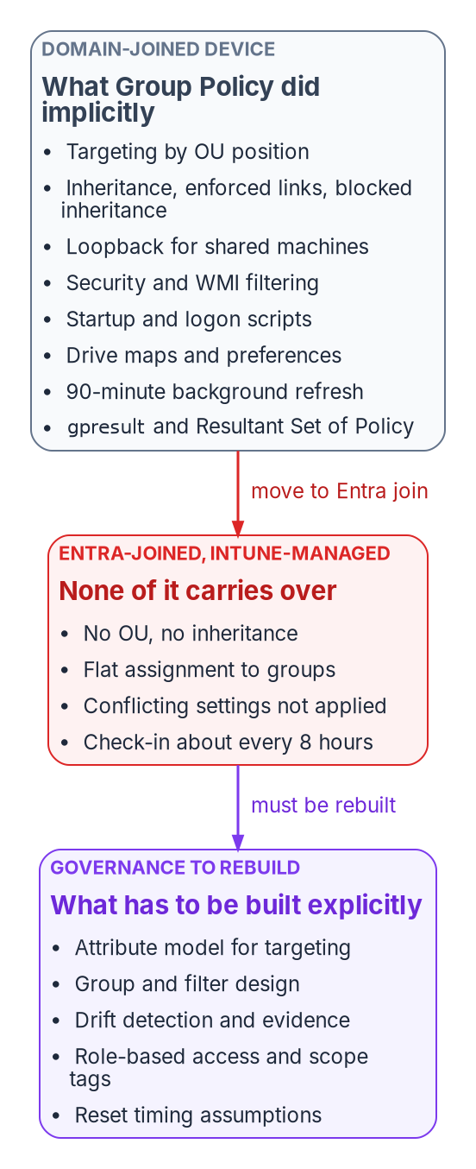
Group Policy carried governance implicitly through placement in the directory; an Entra-joined, Intune-managed device has none of that machinery, so each function has to be rebuilt explicitly.

What Group Policy did implicitly
Each of the mechanisms below did a governance job. Most organizations never wrote those jobs down, because the directory did them.
Mechanism | What it did | The governance job it did silently
OU linking and processing order | GPOs apply in order: local, site, domain, then OUs from parent to child; each later policy can override an earlier one, and the container closest to the object wins | The directory tree was the targeting model, and the answer to “why does this device have this setting?”
Inheritance, enforced links, block inheritance | Settings are inherited and cumulative down the tree. A link marked enforced can’t be overridden by lower OUs, and blocking inheritance on an OU stops higher policy except enforced links | Mandatory baselines at the top, local exceptions lower down, with precedence that could be reasoned about
Link order | When several GPOs link to one container, the link with the lowest link order wins by default | Deterministic tie-breaking without a conflict report
Loopback processing | Applies user settings based on the computer a person signs in to, in merge or replace mode; intended for kiosks, classrooms, labs and Remote Desktop servers | Shared and special-purpose machines behaved the same for everyone
Security filtering | A GPO applies only to principals granted both Read and Apply Group Policy | Targeting by group membership on top of placement
WMI filters | A query evaluated on the computer at processing time; the GPO applies only if it returns true. One filter per GPO | Targeting by hardware, OS version or local state
Startup, shutdown, logon and logoff scripts | Scripts run at startup and shutdown and at user logon and logoff | Recurring, event-driven local enforcement and remediation
Group Policy Preferences, including drive maps | Preference extensions process items top to bottom, with item-level targeting; one GPO can hold many drive map items | User environment, mapped drives, printers, registry and file items, each with its own targeting
Refresh | Computer policy at startup, user policy at logon, then a background refresh every 90 minutes plus a random offset of up to 30 minutes | A known, short bound on how stale a device could be
Modeling and Results (RSoP, gpresult) | Simulates or reports the winning GPO for each setting, with precedence detail | An auditable explanation of the effective configuration
GPMC delegation | Linking a GPO, changing link order and blocking inheritance require modify rights on the site, domain or OU; by default only Domain Admins and Enterprise Admins have them | Change authority scoped to the same tree that scoped the policy
Read down the right-hand column and a pattern appears. Group Policy wasn’t only a settings engine. It was a targeting model, a precedence model, a delegation model, a timing guarantee and an evidence source, all derived from one structure: the OU tree. Book 02 makes the same argument for identity as a whole, that Active Directory governs by placement and Entra ID governs by attributes (Chapter 02 of Book 02). For devices the consequence is concrete, because every device setting in the fleet was routed through that placement.

Why none of it carries over

There is no tree to sit in
Intune doesn’t apply policy in local-site-domain-OU order. Policies are assigned to users and groups, and Microsoft describes the change as a shift in thinking that requires the users and groups to be in order first. There is no hierarchy, so there is no inheritance, no enforced link and no blocked inheritance. Precedence by position is gone, and nothing replaces it automatically.
The conflict rules change with it. When two Intune configuration policies set the same setting to different values, the conflict is shown in Intune and must be resolved manually; the setting can fail to apply. In Microsoft’s GPO-to-settings-catalog walkthrough, the rule is stated directly: if two configuration profiles conflict, the setting isn’t applied. Compliance policies follow a different rule, where the most restrictive value applies, and compliance settings take precedence over the same setting in a configuration policy. Endpoint security policies, security baselines and settings catalog policies have equal priority; none outranks the others.
That is a different failure mode from Group Policy. A GPO conflict resolved silently in favor of the closer container. An Intune conflict surfaces as a status, and the device may end up with neither value until someone fixes the assignment.
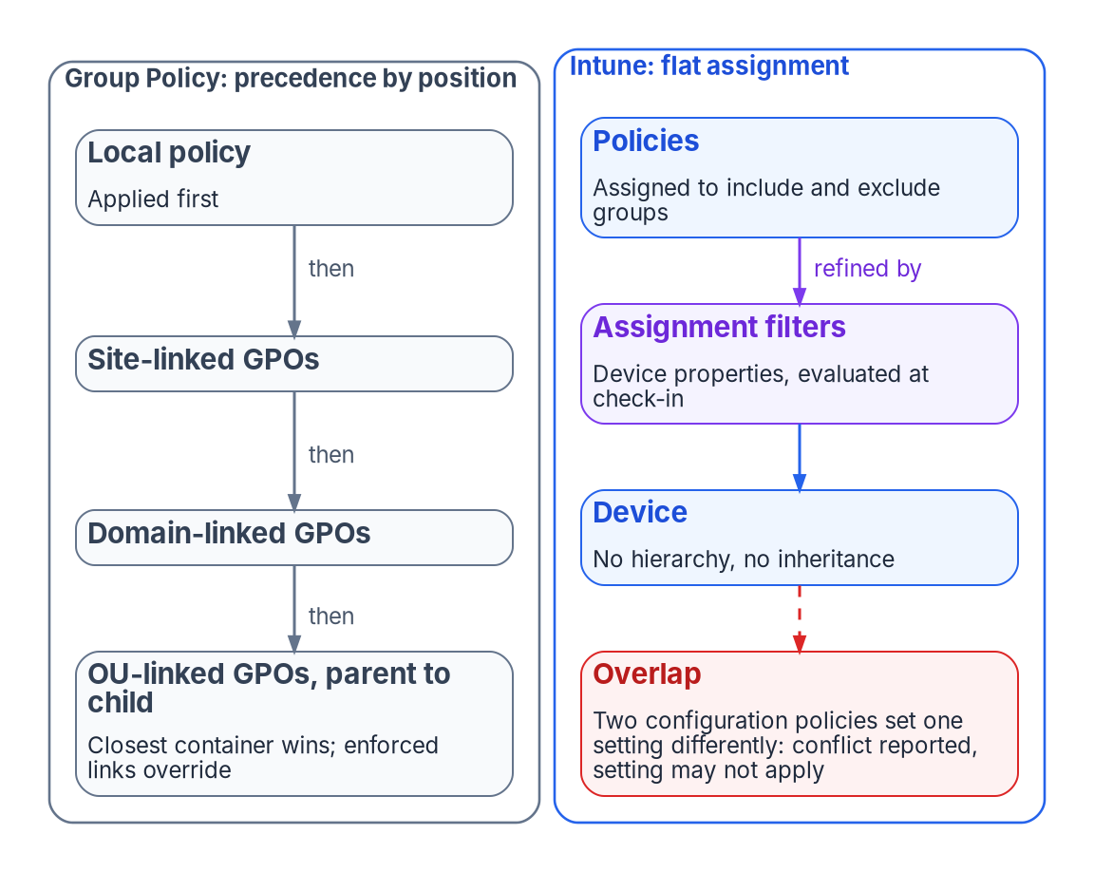
Group Policy resolves overlapping settings by position in the tree; Intune has no hierarchy, so overlapping configuration settings become conflicts that someone must resolve.

The nearest equivalents, and what is different about them
Group Policy mechanism | Nearest Intune mechanism | What is different
OU linking and inheritance | Assignment to included and excluded Entra groups | Flat; no precedence by position. Microsoft advises using the smallest group scope and refining with filters
Security filtering | Group include and exclude | Close in intent. Dynamic device groups need processing time before members appear
WMI filters | Assignment filters | Evaluated against device properties at enrollment and check-in, not by an arbitrary local query. Up to 200 filters per tenant, each up to 3,072 characters
Loopback | Assigning user-scope settings to device groups | Settings assigned to a device group apply to any user who signs in to that device; there is no merge or replace mode to choose
ADMX-backed Administrative Templates | Settings catalog; custom ADMX import | Built-in templates are in the settings catalog. Custom ADMX import is in public preview and doesn’t support the combo box setting type
Startup and logon scripts | Platform scripts; Remediations | A platform script runs once and doesn’t run again unless the script or policy changes; scripts time out after 30 minutes. Remediations rerun on a schedule, every 24 hours by default
Drive maps | None built in | Microsoft states cloud-native scenarios have no built-in solution for mapped network drives and recommends moving users to Teams, SharePoint and OneDrive, with scripts as a fallback
Background refresh every 90 to 120 minutes | Change-based notifications plus maintenance sync | Maintenance check-in is about every 8 hours, and a device gets at most one maintenance sync every 6.5 hours; change notifications can arrive immediately or take a few hours
RSoP and gpresult | Per-setting status reports; MDM diagnostic report | Reported from the service after check-in. Reports can lag the device’s actual state
GPMC delegation per OU | Intune role-based access control and scope tags | Scope is a tag attached to objects, not a position in a tree. Imported GPOs themselves are visible only to admins who share the scope tag chosen at import
None of these is a bad replacement. Several are better: assignment filters don’t depend on group membership processing, and a conflict that is reported is easier to fix than one that resolves invisibly. But every row moves a decision that Group Policy made from structure into a decision someone now has to make, document and keep current.

Group Policy analytics measures the gap; it doesn’t close it
Microsoft’s on-ramp is Group Policy analytics in Intune. It imports GPO exports as XML, shows which settings have an MDM equivalent as an “MDM Support” percentage, flags deprecated and unsupported settings, and can migrate supported settings into a settings catalog policy. It parses the Policy, PassportForWork, BitLocker, Firewall and AppLocker CSPs and Group Policy Preferences. Each XML file must be under 4 MB, and the tool supports non-ADMX settings only in English, so a non-English GPO produces an inaccurate MDM Support percentage.
The Migrate step is, in Microsoft’s words, best effort. AppLocker and firewall rule settings can’t be migrated this way and belong in endpoint security policy. Some settings map to a different setting with a similar effect, some fail, and conflicting values across GPOs must be resolved before the policy can be created.
The workbook’s source pages quoted a typical figure of 30 to 60 percent of settings with a direct Intune equivalent. Microsoft publishes no such figure, and the percentage depends entirely on what is in a given estate’s GPOs. The Federal Modernization Program doesn’t quote a number: run Group Policy analytics against the estate’s own exports and read the result. The program’s GPO triage script (Invoke-GpoMigrationTriage.ps1, used in Chapter 07) classifies every live GPO onto a target plane, Intune for workstations and Azure Arc for servers, so the unmappable surface is named early rather than discovered late.
Microsoft’s guidance also argues against translating at all. Migrating existing Group Policy settings to MDM isn’t the preferred approach; the intent shouldn’t be to lift and shift. Identify the mandatory settings, compare those against MDM, and treat the gaps as blockers to resolve. The program’s name for this is regenerate, not copy: the GPO-to-Intune mapping is a semantic translation reference that answers “what is the closest equivalent of this setting?”, and the replacement policy is written for the modern control plane rather than copied setting by setting. Chapter 08 and Appendix A carry the mapping.

Running both is not a safe middle ground
A hybrid-joined device can take policy from GPOs, from Intune, or from both. Microsoft notes the combination is possible but adds administrative overhead and complexity. It also adds precedence rules that nobody sees. Since Windows 10 version 1709, when the same policy is configured through Group Policy and MDM, Group Policy takes precedence. The MDMWinsOverGP setting reverses that, but only for policies in the Policy CSP. For equivalent settings defined in other CSPs, such as Defender, Microsoft warns there is a race condition and no guarantee which one wins. Windows Hello for Business is one of those exceptions: it is configured through the PassportForWork CSP, and mixing GPO and CSP settings for it leaves the CSP settings unapplied until the Group Policy settings are cleared.
The source pages described the coexistence period as “last writer wins.” For a GPO and an MDM policy on the same hybrid device, the reality is worse than that: Group Policy wins by default, MDM wins where MDMWinsOverGP applies, and outside the Policy CSP the result is a race. For two Intune policies the description is simply wrong; the conflict is reported and the setting may not apply. The practical rule is the same in every case: document each overlapping setting before Intune policy reaches production, and retire the GPO copy as soon as Intune owns the setting.
Configuration Manager estates have one more layer. Co-management moves seven workloads, individually or together, from Configuration Manager to Intune: compliance policies, Windows Update policies, resource access policies, Endpoint Protection, device configuration, Office Click-to-Run apps and client apps. Switching device configuration also moves resource access and Endpoint Protection. The workload slider decides which authority owns each area, and it is a second place where “who controls this setting?” has to be answered explicitly.

The governance gaps this opens
None of the gaps below is a reason to stay on Group Policy. They are the governance surface that has to be re-created intentionally on the cloud side rather than assumed. The analysis is the program’s own.
Gap | Under Group Policy | Under Intune and Entra ID by default | What has to be built
Targeting rationale | OU position, GPO links and inheritance explained every setting | Many groups, filters and assignments; the “why” is spread across rules | A canonical attribute model that groups and filters derive from, so targeting is reproducible
One source of truth for applicability | OU membership | Group membership and filter rules, often maintained by hand | Groups generated from authoritative attributes, not spreadsheets
Coverage of legacy and complex settings | The full ADMX and Preferences surface | The supported subset, plus scripts and custom profiles | A per-setting decision: regenerate, replace with a modern control, accept the loss, or hold a temporary GPO island
Visibility and drift | RSoP and gpresult, near-immediate | Per-setting status after check-in; no native cross-plane comparison | Continuous comparison of declared against observed state, with drift raised as findings
Delegation and audit | OU-scoped rights to create, edit and link GPOs | Intune roles and scope tags, a different shape | A delegation model mapped from the old OU boundaries, so scope is canonical rather than rebuilt admin by admin
Enforcement timing | 90 to 120 minute refresh, cached, offline-capable | Check-in about every 8 hours plus change notifications | Operations and incident runbooks reset to the new timing
Portability | Governance lived in the on-premises structure | Groups and filters are tenant-specific | Governance held as declared state that can be re-applied, not only as portal configuration
The organizations that feel these gaps first and hardest are the ones trying to keep or improve deterministic, auditable governance through the transition, which describes most regulated environments. They tend to discover the cost after the targeting model has already changed underneath them. Delegation without OUs is covered for identity in Chapter 05 of Book 02; the same structure carries device administration, and Chapter 06 assigns who owns it. Device compliance as an access signal, the point where device governance meets Conditional Access, belongs to Book 04.

How the move actually goes
In the program’s experience, progress is real but slow and uneven, especially for large and regulated estates. The pattern it plans for is this:
- Phased and multi-year. Estates with hundreds or thousands of GPOs, legacy applications and intricate OU structures move in waves, with recurring weekly or monthly migration work rather than a cutover. GPO rationalization and cleanup usually come before migration, not after.
- A long co-management or hybrid period. Many organizations stay there longer than planned, because unmapped settings, application dependencies and testing load accumulate.
- Predictable blockers. Testing burden, conflicts during coexistence, the skills shift from GPO administration to endpoint management, and the targeting-model change described above.
- Slower still in federal environments. Compliance validation, government-cloud considerations and the need for auditable governance throughout the transition push many agencies to build a governance layer on top of the Microsoft surfaces rather than rely on the native defaults alone.
The migration is rarely a lift-and-shift. It changes the nature of policy governance from hierarchical and on-premises to attribute-driven and cloud-native. Organizations that plan only for licenses and tools tend to find they also need governance architecture to keep control and visibility. The rest of this book is that architecture: where device data lives (Chapter 03), how new devices are onboarded under governance from day one (Chapter 04), and how the existing fleet’s GPOs are retired (Chapter 07). The policy view of the same transition is also in the Client-Server to Hybrid-Cloud series, Chapter 05 — Policy Transformation.

The Why in five sentences
Group Policy governed devices by their position in the OU tree, and that position quietly supplied targeting, precedence, delegation, timing and evidence. An Entra-joined, Intune-managed device has no position: policy is assigned flatly to groups, overlapping settings become conflicts, and devices check in about every eight hours. Intune can deliver most settings, but Microsoft itself advises against copying GPOs and offers no built-in answer for some of them, such as mapped drives. Every governance job the tree did implicitly has to be rebuilt explicitly, starting with an attribute model that targeting can derive from. Organizations that treat the move as a settings migration discover the governance loss after the targeting model has already changed.

What this chapter establishes
- Group Policy’s value was never only its settings. It was a governance model derived from OU placement.
- Cloud-native endpoints can’t use Group Policy, and Intune replaces placement with flat assignment, reported conflicts and a slower check-in cycle.
- Group Policy analytics measures how many settings have an MDM equivalent in a given estate; it doesn’t close the governance gap, and Microsoft recommends rebuilding from requirements rather than migrating GPOs.
- Running GPO and MDM on the same setting is a race, so coexistence needs a written list of overlaps and a retirement date for each.
- The gaps in targeting, coverage, drift visibility, delegation, timing and portability must be rebuilt on purpose. Chapter 02 shows what happens when the fleet’s device identity is changed without doing so.

Continue the book
Book index · Next: Chapter 02 — The Hybrid Join Trap →

Chapter 02 — The Hybrid Join Trap
The mechanism that converts a whole fleet to hybrid join needs almost no governance, which is exactly why the governance gets skipped.

In this chapter
Why a control scored as a multi-quarter program, “all sign-in activity comes from managed devices,” can be satisfied on paper by a near-effortless tenant switch. How the switch works, step by step. What Microsoft now recommends for new and existing devices, and why hybrid join is a waypoint rather than an end state. The loss ledger an ungoverned flip runs up, what hybrid join never covers, and the governed path that reaches the same end state with every change owned and evidenced.

A program that turns out to be a switch
A common Zero Trust baseline control reads, in full, “All sign-in activity comes from managed devices.” In practice it is satisfied by Conditional Access policy that grants access only from a device that is marked compliant by Intune or is Microsoft Entra hybrid joined. Microsoft publishes exactly that policy as a template, with the grant controls “Require device to be marked as compliant” and “Require Microsoft Entra hybrid joined device” and the instruction to create it in report-only mode first.
Assessments usually score the control as a multi-quarter program, gated on device inventory, device management and join maturity. What makes it a program isn’t the toggle. It is the twenty years of Active Directory entanglement the toggle sits on. Converting the domain-joined Windows fleet to hybrid join, the step that makes the Conditional Access control satisfiable for that fleet, is at the mechanism level close to a single tenant-wide switch. The trap is treating the switch as if it were the program.
The illustration used in this chapter is a fleet of 50,000 domain-joined Windows devices. The number is a framing device, not a real engagement; the mechanism is the same at 5,000 or 500,000.

How the fleet converts itself
Microsoft’s configuration path for hybrid join has few steps, and none of them is per device.
- Synchronize the computer objects. The synchronization service is almost certainly already syncing users. Extend its scope to the OUs that hold the computer objects, and don’t exclude the default device attributes. Microsoft Entra Connect (version 1.1.819.0 or later) has a wizard for the whole configuration. Microsoft Entra Cloud Sync can also synchronize computer objects for hybrid join, though it doesn’t configure federation.
- Publish the service connection point (SCP). The SCP is an object in each forest’s configuration naming context that carries two keywords: the tenant ID and a verified domain name. It must exist in every forest that contains domain-joined computers. Entra Connect writes it for each forest, using enterprise administrator credentials for that forest. The alternative, which Microsoft documents for targeted rollouts, is a GPO that writes the same two values (TenantId and TenantName) into each computer’s registry under HKLM\SOFTWARE\Microsoft\Windows\CurrentVersion\CDJ\AAD, linked to the OUs in the rollout population.
- Let the devices register themselves. On every Windows 10 or later domain-joined computer, the built-in Automatic Device Join task runs on domain join and at user sign-in and retries every hour. It reads the SCP over LDAP, and in a managed (non-federated) domain it writes a self-signed certificate to the computer object’s userCertificate attribute. On the next sync cycle the sync service carries that certificate to Microsoft Entra ID, a device object is created, and the task completes registration and installs a device certificate. Until registration completes, the synced object shows as Pending.
- Users get cloud single sign-on. At the next Windows sign-in on a hybrid-joined device, the user receives a Primary Refresh Token (PRT), the token behind single sign-on to Entra-protected resources.
That is the whole mechanism. One synchronization scope change, one SCP per forest or one GPO, and the estate starts changing state on its own schedule. There is no per-device approval, no ownership check, no check of where the device sits in the organization and no reconciliation step anywhere in the path. The program’s design position is that this effortlessness is the hazard. The control’s intent, that every sign-in comes from a known, owned and managed device, gets turned into 50,000 state changes that nobody can later attribute.
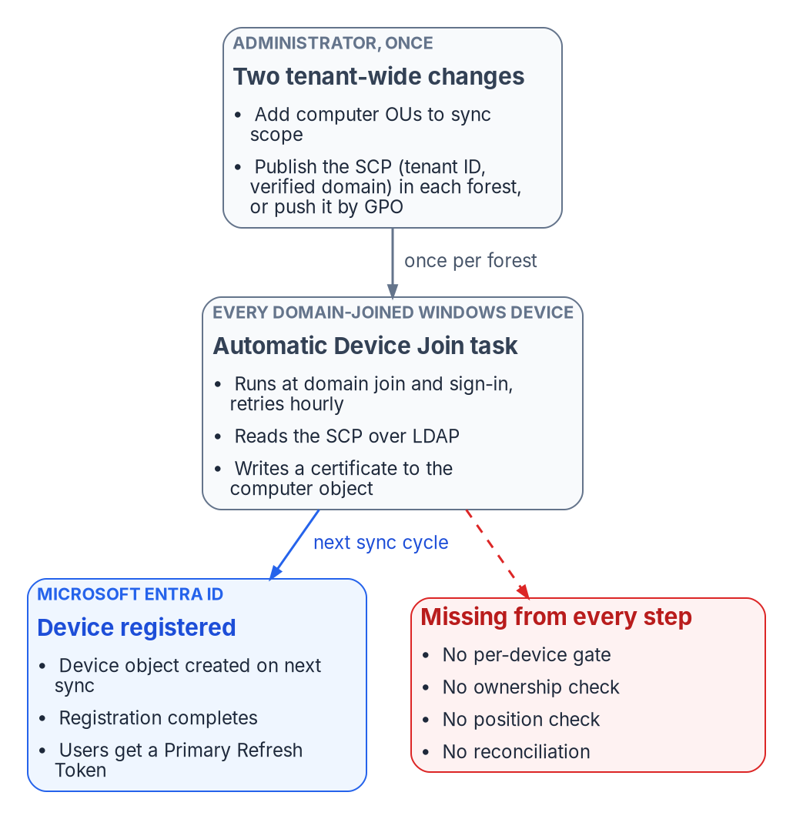
The ungoverned flip: a sync-scope change and one SCP per forest are enough for every domain-joined Windows device to register itself; nothing in the path checks ownership, position or approval.
Microsoft doesn’t recommend flipping the whole estate at once. Its own guidance is a targeted deployment first, with a pilot group drawn from varying roles and profiles, so that issues the plan didn’t anticipate surface before the whole organization is enabled. The ungoverned path is what happens when that advice is skipped, or when the SCP is published for one reason and every device in the forest starts registering as a side effect.

What Microsoft recommends now
Microsoft’s guidance on join type is explicit and has two halves.
Device situation | Microsoft’s recommendation | Why
New, refurbished, refreshed or reset Windows devices | Microsoft Entra join, as the default | Modern management and authentication are built into Windows; hybrid join for new devices is typically not recommended and may not get the modern features
Existing devices already joined to an on-premises domain | Microsoft Entra hybrid join | Gives the device a cloud identity with minimal impact on the user
Long-term or end-state device identity | Not hybrid join | Hybrid join shouldn’t be long term or the end goal; organizations not otherwise restricted should be moving, or planning to move, to Entra join
The same direction appears elsewhere. Windows Autopilot documentation says Microsoft recommends deploying new devices as cloud-native with Entra join, and that deploying new devices as hybrid joined, including through Autopilot, isn’t recommended. Entra ID’s device planning guidance calls Entra join the first choice for new devices and notes that Entra-joined devices can still single sign-on to on-premises file, print and application servers when they are on the organization’s network.
Two facts make hybrid join sticky once it is in place. There is no Microsoft-supported path to convert an existing domain-joined or hybrid-joined device to Entra join without resetting Windows, and Autopilot Reset doesn’t support hybrid-joined devices, so the reset is a full wipe. Microsoft therefore recommends moving at a complementary event, such as a hardware refresh, an OS upgrade or a troubleshooting rebuild. Hybrid join also inherits the domain’s dependencies. Hybrid-joined devices need periodic line of sight to a domain controller; without it, device and user password changes and TPM resets break, and Microsoft warns the devices become unusable. If the organization is moving away from an on-premises domain, it has to move away from hybrid join too.
That is the trap in full. Hybrid join is Microsoft’s recommended waypoint for devices that already exist. Done as an ungoverned switch, it becomes the destination by default: the fleet keeps every on-premises dependency, adds a second and third system of record, and has no plan for the refresh events that would carry it to Entra join.
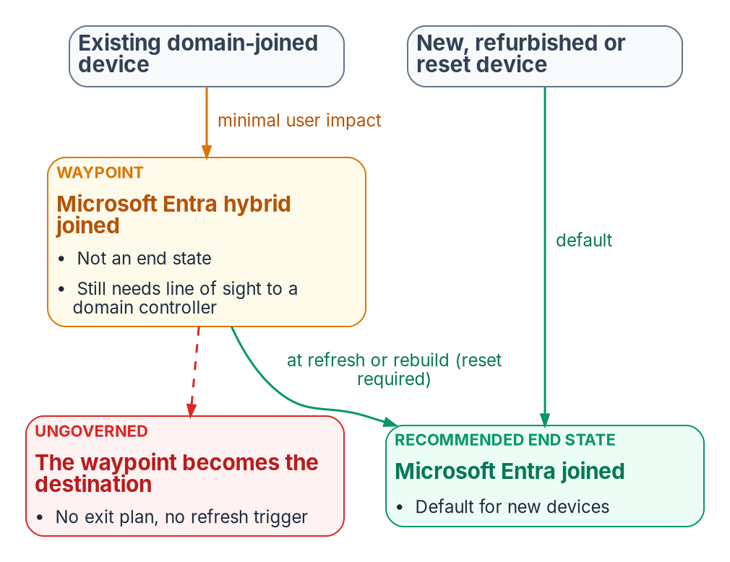
Microsoft’s join guidance: new and reset devices go straight to Entra join; existing domain-joined devices can take hybrid join as a waypoint and move to Entra join at the next reset event.

The loss ledger
Classic Active Directory was a creaky governance system, but it was one. A computer object lived in an OU, had a delegated administration lineage, and was visible in the same console that governed everything else. An ungoverned hybrid-join flip keeps the connectivity benefit, cloud single sign-on and Conditional Access eligibility, and quietly discards the governance underneath. It also splits one machine’s truth across three systems of record: Active Directory holds the computer object, Entra ID holds the device object and its tokens, and Intune holds compliance state. Nothing reconciles them by default.
What classic Active Directory provided | What an ungoverned flip loses | What governed reconciliation restores
Ownership: each computer object sat in an OU with a delegated admin lineage | New cloud device objects appear with no mapping to an owner or an organizational position; “who owns this device, and in which part of the organization?” is unanswerable at scale | Every governed device carries organizational attributes, and ownership and scope are derived from them
One object per machine | Duplicate and phantom records. A domain-joined device whose user once added a work account is also Entra registered, and the dual state can produce nondeterministic Conditional Access evaluation on older Windows builds. Moving a computer object out of sync scope deletes its Entra device; moving it back creates a new Pending object that won’t complete registration until the device re-registers | Divergence between the three records is detected and resolved against the authoritative source
Scoped, gradual rollout: Group Policy applied per OU, in waves | Enforcing “require compliant or hybrid joined device” before registration has finished fleet-wide locks users out. Microsoft’s own template is created in report-only mode and excludes emergency-access accounts for this reason | Device-state change is treated as a high-blast-radius operation: report-only baking, then gated enforcement with a human approver
Provenance: changes were at least logged in one directory | Each of 50,000 state changes happens with no signed, attributable record of why and under whose authority | Each plan, apply and reconcile step emits signed evidence; an unattributable state is itself a finding
Lifecycle: a join and leave process, however imperfect | Hybrid-joined devices are supposed to follow the on-premises stale-device policy, and deleting one only in Entra ID resynchronizes it as a new Pending object. Without a policy, retired machines linger and inflate the “managed” count | Lifecycle reconciled against the authoritative source; stale objects surface for review rather than accumulating
A single console of record | Three planes, three consoles, no reconciliation. Deleting a device object also deletes the BitLocker recovery keys stored on it | The control plane reconciles all three; Entra ID and Intune remain the planes that authenticate and enforce
An explicit line-of-sight assumption | The dependency on reaching a domain controller is left implicit; remote and VPN-only users fail on password change and TPM reset until devices become unusable | The dependency is recorded as a known limit and drives the target state, Entra join, instead of being discovered as an outage
The pattern across every row is the same. The ungoverned flip keeps the runtime benefit and spends the truth-and-accountability layer. The ownership, provenance and reconciliation rows are the program’s analysis; the duplicate, lockout, lifecycle and line-of-sight rows are documented Microsoft behavior.

What hybrid join never covers
Even a flawless hybrid-join rollout doesn’t by itself satisfy “all sign-in activity comes from managed devices.” Hybrid join applies to domain-joined Windows: Windows 11 and Windows 10 (except Home editions) and Windows Server 2016, 2019 and 2022. Domain controllers can’t be hybrid joined, and Server Core supports no device registration at all. The control’s denominator is much larger:
- macOS, iOS, Android and Linux need Entra join (supported for macOS 13 or newer and for current Ubuntu and Red Hat Enterprise Linux LTS releases), registration, or Intune enrollment with a compliance policy, not hybrid join.
- Personal devices, contractors and guests are never hybrid joinable.
- Servers, virtual desktops, shared kiosks and service accounts each need their own posture decision; servers are the subject of Chapter 09.
The population an assessment is really probing is the slice that a Windows-only flip makes invisible behind a green checkmark. The program’s answer is to make endpoint onboarding a governed, Intune-first discipline across every platform (Chapter 04), so the uncovered surface shows up as a gap. The Conditional Access side of the control, including compliance as an access signal, is in Book 04, and Windows Hello for Business on the device is in Chapter 10 of Book 02.

The governed path
The governed path reaches the identical technical outcome: devices hybrid joined, Conditional Access enforcing managed-device sign-in. The difference is that the bulk state change runs through an active reconciliation control plane instead of being left to the provider to apply unattended. The control plane holds desired state, observes actual state, classifies drift and reconciles toward intent; Entra ID and Intune remain the planes that authenticate and enforce at runtime. This is the program’s design, described in full in Chapter 05.
- Address before you actuate. Every device to be converted carries organizational attributes that express its position, so the rollout can be scoped, sequenced and audited in the same terms as every other plane, not by guessing from OU names.
- Cap the blast radius by class. “Tenant-wide device-state change” and “Conditional Access enforcement change” are high-blast-radius operation classes that stay gated on human approval. One wrong Conditional Access toggle touching 50,000 devices is the case the ceiling exists for.
Rung | Name | Behavior for this operation class
L0 | Record | Desired state (hybrid-join target, Conditional Access intent) recorded in the authoritative source
L1 | Observe | Actual join state collected per device and drift detected; read-only
L2 | Advise | Wave plan and report-only Conditional Access change set generated and surfaced; no writes
L3 | Gated actuation | A human approves each wave, and the control plane executes it through the provider API. The default ceiling for high-blast-radius classes
L4 | Autonomous | Not permitted for this class; permanently capped
- Run each wave through plan and apply, not ad hoc scripts. The plan step compares declared target state with observed state and returns a list of operations without making a single API call. Apply in dry-run mode evaluates every operation and records it as would-send; nothing reaches the provider. Promotion out of dry-run is a separate, explicit call that an operator makes per wave after review, and certain operation classes always require human sign-off.
- Bake the enforcement. Conditional Access runs in report-only mode first. Report-only policies are evaluated at sign-in but not enforced, and their results are logged in the sign-in logs, which gives the coverage data: before any wave moves to enforcement, “registered and compliant” coverage is reconciled against the attribute-scoped target population, so the lockout failure mode can’t happen silently.
- Reconcile duplicates and lifecycle. Phantom, dual-state and stale device objects are classified as drift and resolved against the authoritative source rather than left to inflate the managed-device count.
- Produce evidence an authorizing official can sign. Every wave produces signed plan, apply and reconcile evidence. The accreditation sentence isn’t “it enforces managed-device sign-in” but “this operation class is gated, with a dry-run record and a rollback.” Chapter 10 covers the evidence.
- Cover the whole denominator. Non-Windows, personal and guest surfaces go through Intune-first onboarding, so the control is satisfied for its real population and not only for the Windows slice.
- Plan the exit from the waypoint. Each hybrid-joined device carries a target of Entra join and a trigger event, such as its refresh date, so the waypoint doesn’t become the destination.
The end state matches the ungoverned flip. The difference is that each of the 50,000 changes is owned, addressable, attributable, reversible and accredited. The loss ledger is paid down instead of run up.

What to do first
- Find out whether the ungoverned path is already live: whether an SCP exists in any forest’s configuration partition or is pushed by GPO, whether computer OUs are in sync scope, and since when.
- Run the fleet against the loss ledger, duplicates, stale objects, unowned devices and line-of-sight users, before any Conditional Access policy enforces managed-device sign-in.
- Name the wave owner who holds the plan, the approvals and the rollback. Chapter 06 sets out who that is.
- Run the first wave in report-only mode, scoped by organizational attributes, and gate the move to enforcement on coverage data.

What this chapter establishes
- Hybrid join of an existing domain-joined fleet is close to a tenant-wide switch: a sync-scope change and an SCP, after which devices register themselves with no per-device gate.
- Microsoft recommends Entra join for new and reset devices and hybrid join only as a low-impact step for existing domain-joined devices, never as the end state; converting a hybrid-joined device later requires a reset.
- Taken ungoverned, the flip keeps the runtime benefit and spends ownership, single-record integrity, staged rollout, provenance, lifecycle and the explicit domain-controller dependency.
- Hybrid join covers only domain-joined Windows, so a managed-device control needs Intune-first onboarding for everything else.
- The governed path reaches the same end state with every change owned, gated and evidenced. The What part of this book starts with where that evidence and the device data live, in Chapter 03.

Continue the book
← Previous: Chapter 01 — Why Group Policy Can’t Come to the Cloud · Book index · Next: Chapter 03 — Where Device and Server Data Lives →

Chapter 03 — Where Device and Server Data Lives
A device in the cloud isn’t one record but six, and governance holds only when each fact has exactly one place where it’s true.

In this chapter
The authority map for devices and servers: which system owns each fact, which systems hold only derived copies, and which must never be treated as a source of truth. What each Microsoft record (Entra ID device object, Intune managed device, Windows Autopilot registration, Azure Arc machine resource, Defender for Endpoint machine) is actually authoritative for. The keys that tie the records together, the places they break, and a read-only script that correlates them.
In an Active Directory estate a computer had one record that mattered. The computer object sat in an OU, the OU decided which Group Policy Objects applied, and the domain controller was both the directory and the enforcer (Chapter 01). After modernization the same laptop is described by a procurement record, a Windows Autopilot registration, a Microsoft Entra ID device object, an Intune managed-device record and a Defender for Endpoint machine entry. A server adds an Azure Arc resource in Azure Resource Manager. Each record is maintained by a different service on a different schedule, and most of them can be edited by someone.
That’s manageable only if the program decides, fact by fact, where the truth lives. This chapter extends the identity data-location model in Book 02 (Chapter 03 of Book 02) to devices and Azure resources. For each kind of fact it names the authoritative origin, the derived pointers that copy it, and the systems that must not be treated as the source.
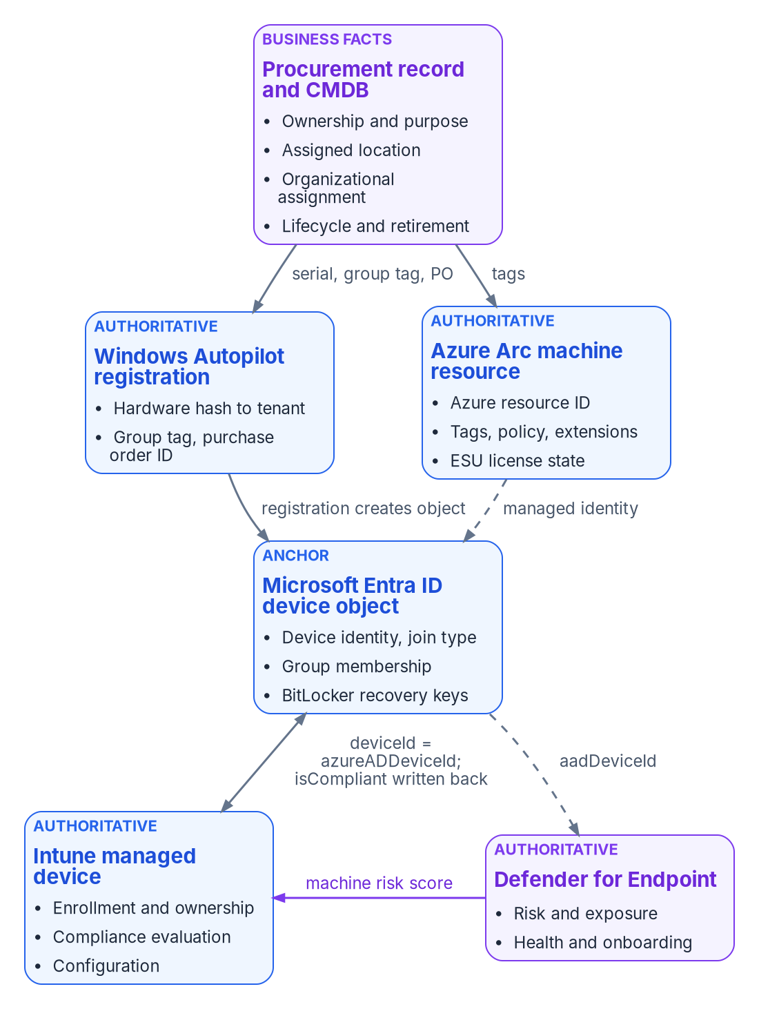
Each fact about a device has one authoritative origin; the other records carry derived pointers that must be explainable from it.

The rule
Two sentences carry the whole model, and both are the program’s design position.
- No device or Azure resource carries an empty governance attribute once it’s enrolled or created on the governed path. If no source can supply a value, the attribute carries an explicit “unpositioned” marker (Chapter 04).
- Every derived value (a tag, a group membership, a policy assignment, a device category) must be explainable from its authoritative origin. If a derived value can’t be traced back, it’s drift, and it’s corrected at the origin, not at the copy.
The second rule is the one that breaks most often. An Intune administrator renames a device category to fix a report. A server owner edits a tag in the portal. An analyst moves a device into a static group “for now.” Each edit makes a derived pointer disagree with the record it was supposed to reflect, and nothing in the platform flags it. Detecting that disagreement is the job of the drift loop described in Chapter 10.

Which system owns which fact
The authority map below covers devices. Procurement and the asset record are authoritative for business facts, the decisions the organization made when it bought the device. Microsoft’s services are authoritative for technical state, what the device actually is and does.
Claim | Authoritative origin | Derived pointers | Not a source of truth
Ownership and purpose | Procurement or asset record | Intune device category; ownership type; dynamic group membership | Whoever enrolled the device
Assigned location or site | Procurement or assignment record | Named location; dynamic group; Autopilot group tag | The IP address the device last reported
Organizational assignment | Procurement record, validated against the organizational registry | Autopilot group tag; Entra ID extension attribute; Arc tag | The primary user’s department
Device identity and join type | Microsoft Entra ID device object | Intune azureADDeviceId; Defender aadDeviceId | The device’s host name
Management authority (endpoints) | Intune enrollment | Entra ID isManaged, managementType | Configuration Manager collections
Management authority (servers) | Azure Arc onboarding into Azure Resource Manager | Arc machine tags; policy assignments | Active Directory OU placement
Compliance state | Intune compliance policy evaluation | Entra ID isCompliant, read by Conditional Access | A spreadsheet or a manual attestation
Threat and exposure state | Defender for Endpoint | Intune compliance (through the machine risk score) | The antivirus console’s last scan date
The source page this chapter replaces listed Azure Arc as a derived pointer of Intune enrollment. That’s corrected above: Arc is the management authority for servers in its own right. Intune’s supported platforms don’t include Windows Server, and an Arc server is a resource in Azure Resource Manager, not an Intune record. The one overlap is Defender security settings management, which lets Intune endpoint security policies reach servers onboarded to Defender for Endpoint without Intune enrollment (Chapter 09).
Azure resources follow the same pattern. The governance record, not the portal, is authoritative.
Claim | Authoritative origin | Derived pointers
Subscription or resource group purpose | Governance assignment | Tags; policy assignment
Owner | Governance record | Owner tag; role assignment
Environment (production or non-production) | Governance assignment | Environment tag; policy; Conditional Access named location
Compliance scope | Governance boundary | Azure Policy assignment; regulatory tags

What each Microsoft record is authoritative for

The Microsoft Entra ID device object
A device identity is a directory object, like a user or a group. There are three ways to get one: Microsoft Entra registration (personal and mobile devices), Microsoft Entra join (organization-owned Windows devices) and Microsoft Entra hybrid join. Microsoft describes hybrid join as an interim step on the road to Entra join. Device identities are what device-based Conditional Access and Intune management build on.
The object is authoritative for identity and trust, and it holds a few things nothing else holds.
- deviceId is set by the Device Registration Service when the device registers. It’s the key every other Microsoft record uses to point at the device.
- trustType records the join type: Workplace for registered, AzureAd for Entra joined, ServerAd for hybrid joined.
- isCompliant and isManaged can be written only by Intune (or, for Windows, an approved MDM app). Conditional Access reads compliance from here, but this object doesn’t evaluate it. It reports what Intune decided.
- extensionAttributes 1 to 15 are mastered in the cloud for devices and can be set when the object is created or updated. They’re the natural place for a cloud-native organizational attribute.
- approximateLastSignInDateTime is the activity timestamp used to find stale devices.
The object also holds the device’s BitLocker recovery keys. Deleting a device object deletes its keys, and a deleted device can’t be recovered. Microsoft’s cleanup guidance is to retire the device in Intune first, disable the object for a grace period, back up any keys you might need, and only then delete. It also says not to delete system-managed devices such as Autopilot objects, because a deleted Autopilot device can’t be reprovisioned the same way. Read the deletion order as a governance rule: the Entra ID object is the last record to go, not the first.

The Intune managed-device record
Intune is authoritative for management state: whether the device is enrolled, how (deviceEnrollmentType), whether it’s corporate or personal (managedDeviceOwnerType), its primary user, the configuration it has received and its compliance state (complianceState). Each record carries its own Intune ID, the Entra ID device’s identifier in azureADDeviceId, and the hardware serialNumber.
Compliance is evaluated here and projected to Entra ID. Two tenant-wide settings decide whether that projection can be trusted. By default, a device with no compliance policy assigned is marked compliant; Microsoft recommends changing Mark devices with no compliance policy assigned as to Not compliant when you use Conditional Access. And a device that doesn’t report within the compliance status validity period (30 days by default) is treated as noncompliant. The first setting is a governance decision, not a technical default. Leave it at Compliant and an unmanaged gap reads as a green checkmark.

The Windows Autopilot registration
An Autopilot registration binds a device’s hardware hash to a tenant. The hash identifies the device by manufacturer, model, serial number, drive serial number and other attributes. Registration is ideally done by the OEM, reseller or distributor at purchase. When a device is registered, Autopilot automatically creates a Microsoft Entra object for it, which the deployment process needs to identify the device before anyone signs in.
Registration isn’t enrollment. A registered device may not exist in Intune at all until it runs through Autopilot the first time and a licensed user signs in. The registration record carries the fields procurement cares about: serialNumber, groupTag, purchaseOrderIdentifier, manufacturer and model, plus managedDeviceId once the device enrolls. Its azureActiveDirectoryDeviceId property is marked in the Microsoft Graph PowerShell reference as “to be deprecated,” so don’t build a new correlation on it.
The registration is the first place a procurement decision becomes machine-readable. The group tag Intune stores on the registration appears on the Entra ID device object as an [OrderID] physical ID, which a dynamic group rule can match. Chapter 04 builds the onboarding process around that chain.
Windows Autopilot device preparation, the re-architected version, doesn’t require registration at all. Devices onboarded that way have no registration record, so the procurement link has to be carried another way (corporate identifiers, device association or the procurement mapping table). Chapter 04 covers the choice.

The Azure Arc machine resource
When a server connects to Azure Arc, it becomes a resource of type Microsoft.HybridCompute/machines with an Azure resource ID, inside a resource group alongside native Azure resources. Azure Resource Manager is authoritative for that resource: its tags, role assignments, policy assignments, extensions and ESU license state.
The Connected Machine agent reports instance metadata to the resource, including the operating system, computer name, FQDN, the Active Directory domain name if the server is joined, BIOS UUID, manufacturer, model, serial number, SMBIOS asset tag, IP addresses and Windows licensing and Extended Security Update eligibility. From Azure it receives the resource’s region, virtual machine ID, tags, managed identity certificate, machine configuration assignments and extension requests. Azure is the source of truth for the agent: the only way to tell it to do something is to act on the server’s Azure representation.
Each Arc server is also associated with a Microsoft Entra object, its system-assigned managed identity, and that object counts against the directory’s object quota. The agent sends a heartbeat every five minutes. The resource shows Disconnected within 15 to 30 minutes of missed heartbeats, and a server disconnected for 45 days can become Expired, at which point it can’t be managed until an administrator disconnects and reconnects it. So an Arc resource’s status is evidence of management, and an expired resource is a finding.

The Defender for Endpoint machine
Defender for Endpoint is authoritative for threat and exposure: risk score, exposure level, health status, onboarding status, device value and machine tags. Its machine record has its own ID and carries the Entra ID device ID in aadDeviceId, but only when the machine is Entra joined. Hybrid-joined, workgroup and unmanaged machines need another join key.
Defender’s view reaches access decisions through Intune. A Windows compliance policy can require the device to be at or under a machine risk score of Clear, Low, Medium or High, and a device above the threshold is marked noncompliant. The chain is Defender (risk), then Intune (compliance), then Entra ID (isCompliant), then Conditional Access. The access policy side of that chain is in Book 04.

The procurement record and the CMDB
No Microsoft service is authoritative for why the organization bought a device, who it’s assigned to, where it’s meant to be, or when it should be retired. Those facts come from procurement, and the program treats the procurement record, and the configuration management database it feeds, as their origin. Procurement is the first governance step (Chapter 04): the organizational assignment is captured on the purchase order, not inferred later from whoever powered the device on.
The CMDB is a source of truth for business facts and a consumer for technical ones. It shouldn’t be where anyone decides a device is compliant or managed; it should import those states from Intune, Arc and Defender and flag the records where they disagree with its own.

How the records correlate
Correlation is where most device inventories fail. The same physical device can appear in every system with a different primary key. The table shows the keys and how far you can trust each one.
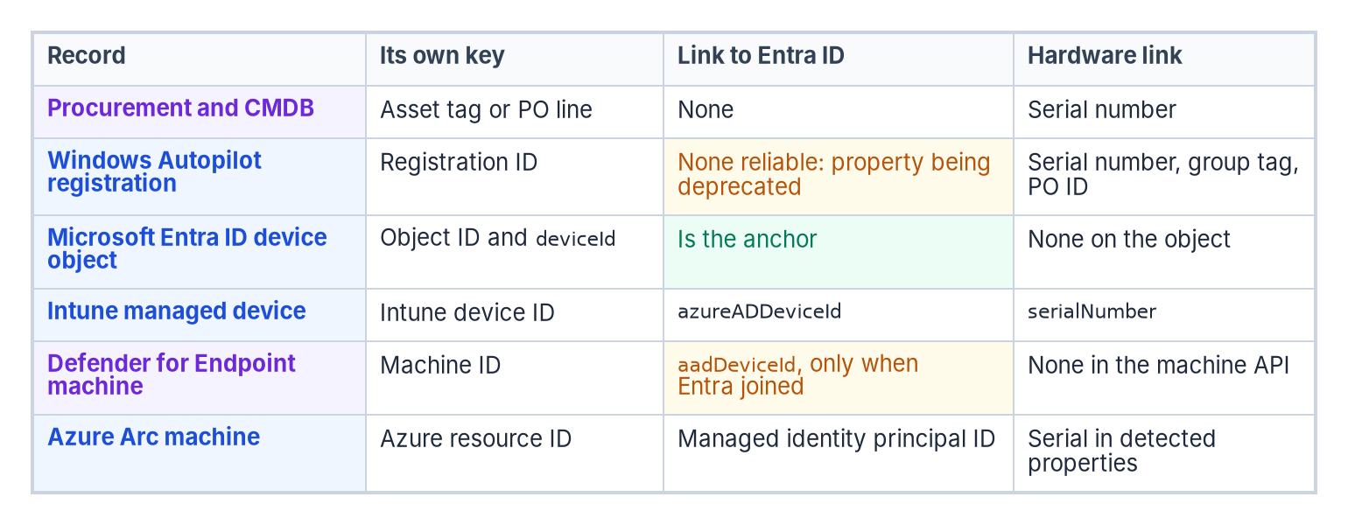
The keys that link each record: the Entra ID device ID ties the Microsoft records together, and the serial number ties them to procurement.
Record | Its own key | Link to Entra ID | Hardware link
Procurement and CMDB | Asset tag or purchase order line | None | Serial number
Windows Autopilot registration | Registration ID | None reliable; the Entra device ID property is being deprecated | serialNumber, plus groupTag and purchaseOrderIdentifier
Microsoft Entra ID device object | Object id; deviceId | Is the anchor | None on the object
Intune managed device | Intune device id | azureADDeviceId | serialNumber
Defender for Endpoint machine | Machine id | aadDeviceId, only when Entra joined | None in the machine resource
Azure Arc machine | Azure resource ID | Managed identity principal ID | Serial number in the agent’s detected properties
Three rules follow from the table, and they’re the program’s correlation design.
- Join Microsoft records on the Entra ID device ID. It’s set once at registration and every Microsoft record that knows about Entra ID points at it.
- Join to procurement on the serial number. It’s the only key that exists before the device is powered on, and it’s what an OEM or reseller registration carries.
- Expect identifiers to change at lifecycle events. A reimage, an OS reinstall or a broken hybrid join can leave duplicate device objects or objects in the Pending state. When Linux devices update to version 2.0.2 or later of the Microsoft Identity Broker, Intune re-registers and re-enrolls them with new Intune and Entra ID device IDs, and Microsoft tells administrators to review assignments and group memberships that depend on device IDs. The serial number survives these events; the device ID doesn’t.
Arc servers are the exception to rule 1. A workgroup Arc server has no Entra ID device object unless you enable Entra ID sign-in, which Entra-joins it through an extension (Chapter 09). Join Arc servers on the Azure resource ID and the serial number. Defender security settings management also creates an Entra ID device object for a server that doesn’t already have one, so a server can acquire a device object without being Entra joined in the usual sense. Account for that in any stale-device rule.

A read-only correlation pass
The script below pulls the Entra ID, Intune and Autopilot records and an Arc inventory, joins them on the keys above, and reports the records that don’t line up. It writes nothing back to any service.

Illustrative, not tested against a production tenant
These commands are examples. They haven’t been run against a production tenant or subscription. Read each one, run it in a test scope first, and review the output before acting on it. The script only reads. It needs the read-only Microsoft Graph scopes shown and Reader on the Arc resource groups.
# Read-only. Requires Microsoft.Graph and Az.ConnectedMachine modules.
Connect-MgGraph -Scopes 'Device.Read.All',
'DeviceManagementManagedDevices.Read.All',
'DeviceManagementServiceConfig.Read.All'
$entra = Get-MgDevice -All
$intune = Get-MgDeviceManagementManagedDevice -All
$autopilot = Get-MgDeviceManagementWindowsAutopilotDeviceIdentity -All
# Index the Entra ID objects by deviceId, the anchor key
$entraById = @{}
foreach ($d in $entra) { $entraById[$d.DeviceId] = $d }
# Index the Autopilot registrations by serial number, the procurement key
$apBySerial = @{}
foreach ($a in $autopilot) { $apBySerial[$a.SerialNumber] = $a }
# 1. Intune records whose Entra ID object is missing
$orphanIntune = $intune | Where-Object {
-not $_.AzureAdDeviceId -or -not $entraById.ContainsKey($_.AzureAdDeviceId)
}
# 2. Corporate Windows devices enrolled without an Autopilot registration
$noRegistration = $intune | Where-Object {
$_.OperatingSystem -eq 'Windows' -and
$_.ManagedDeviceOwnerType -eq 'company' -and
-not $apBySerial.ContainsKey($_.SerialNumber)
}
# 3. Registrations with no group tag (no procurement attribute carried)
$untagged = $autopilot | Where-Object { [string]::IsNullOrWhiteSpace($_.GroupTag) }
# 4. Arc servers that aren't connected, with their tags for owner follow-up
Connect-AzAccount
$arc = Get-AzConnectedMachine
$arcNotConnected = $arc | Where-Object { $_.Status -ne 'Connected' } |
Select-Object Name, ResourceGroupName, Status, LastStatusChange, DomainName, Tags
$orphanIntune | Select-Object DeviceName, Id, AzureAdDeviceId, SerialNumber |
Export-Csv .\intune-without-entra.csv -NoTypeInformation
$noRegistration | Select-Object DeviceName, SerialNumber, EnrolledDateTime, DeviceEnrollmentType |
Export-Csv .\enrolled-without-registration.csv -NoTypeInformation
$untagged | Select-Object SerialNumber, Model, PurchaseOrderIdentifier |
Export-Csv .\registration-without-grouptag.csv -NoTypeInformation
$arcNotConnected | Export-Csv .\arc-not-connected.csv -NoTypeInformation
Each output file maps to a governance finding. Enrolled-without-registration is the vector the program calls DRIFT-ENROLLMENT-VECTOR, and registration-without-group-tag is DRIFT-VENDOR-PROGRAM-CARRIER (Chapter 04). Compare the serial numbers against a CMDB export to find the fifth class, DRIFT-PROCUREMENT-RECORD-ABSENT. A disconnected or expired Arc server is a management gap on the server side. Don’t delete anything this script reports until the owner has confirmed it; deletion order matters, as described above.

What this chapter establishes
- Every fact about a device has one authoritative origin. Procurement owns the business facts; Entra ID, Intune, Autopilot, Arc and Defender each own a slice of the technical state.
- Derived pointers (tags, groups, categories, compliance flags) must be explainable from their origin, and drift is fixed at the origin.
- The Entra ID device ID ties the Microsoft records together, the serial number ties them to procurement, and Arc servers join on the Azure resource ID.
- Identifiers change at lifecycle events, and the Entra ID object, which holds the BitLocker keys, is the last record to delete.
Chapter 04 uses this map to stamp governance attributes on net-new devices before a user ever signs in.

Continue the book
← Previous: Chapter 02 — The Hybrid Join Trap · Book index · Next: Chapter 04 — Intune-First Onboarding →

Chapter 04 — Intune-First Onboarding
Migration brings an existing device under governance; Intune-first refuses to let an ungoverned device exist in the first place.

In this chapter
The doctrine for devices that have never been on the network: what Intune-first means, its five pillars and three exception paths, and the five-phase process that carries an organizational assignment from the purchase order to a validated, compliant device. The Windows mechanics in detail (Windows Autopilot versus Autopilot device preparation, registration and group tags, enrollment restrictions, naming, the Enrollment Status Page, and the compliance and configuration baseline), then the other platforms, and the drift classes that catch a device that slipped through.

Scope: net-new devices only
This chapter covers devices the organization buys after the modernization decision. Replacing Group Policy on the existing fleet is a different program, with different stakeholders and a different timeline: the GPO Sunset Program in Chapter 07 and Chapter 08. The program reserves the phrase “Intune-first” for this net-new doctrine and doesn’t use it for the GPO replacement work. Servers follow the same doctrine through Azure Arc, and their mechanics are in Chapter 09.

What Intune-first means
A net-new asset (a laptop just unboxed, a phone just issued, a server just racked) is governed from the moment it first powers on: by Intune for endpoints, and by Azure Arc into the same governance plane for servers. There is no intermediate state where the device:
- joins on-premises Active Directory and waits for a future migration;
- is provisioned by Configuration Manager and co-managed later;
- runs without an organizational assignment;
- enters production without a compliance evaluation; or
- skips the procurement-side step that records its organizational position.
That’s the inverse of the directory migration path in Book 02 (Chapter 04 of Book 02). Migration takes a device that already exists and brings it under governance. Intune-first refuses the existence of an ungoverned device.
It’s also where Microsoft points new hardware. Microsoft describes hybrid join as an interim step on the road to Entra join, and its join guidance makes Entra join the default for new, refurbished or reset Windows devices (Chapter 02).

Why the doctrine exists
The program already had a mature canon for migrating AD-joined endpoints into Entra ID and Intune. It had no operating doctrine for devices bought new. Without one, net-new acquisition followed an implicit pattern with three failure modes:
- Organizational assignment was missed at procurement. Devices ended up wherever a runtime script that derived position from the user placed them, not where procurement intended.
- Platforms were handled inconsistently. Windows had Autopilot; macOS, iOS, Android and servers each had bespoke handling.
- Co-management crept in. Net-new Windows endpoints sometimes went into Configuration Manager co-management because it was convenient. Each one was a future migration ticket and a present compliance gap.

The five pillars
These are the program’s doctrine, not Microsoft requirements.
# | Pillar | What it asserts
1 | No ungoverned device, ever | Every asset is governance-enrolled before it moves to production use. Quarantine (/UNPOSITIONED) is the safety valve, not the steady state.
2 | Procurement is the first governance step | The organizational assignment is set when the purchase order is issued, not when the device arrives. Procurement systems feed the governance pipeline the way HR systems feed user provisioning.
3 | Zero-touch only | Manual enrollment is a controlled exception that needs written justification, compensating controls, a finite duration and an audit entry.
4 | One management plane per asset; no co-management for new assets | Intune for endpoints. Azure Arc with Azure Policy machine configuration for servers. No greenfield Configuration Manager, no greenfield Group Policy, no greenfield hybrid join.
5 | Quarantine on failure; never silently degrade | An onboarding failure produces a quarantine entry and a governance ticket, never a production device running in a degraded state.
Pillar 4 is corrected from the source, which paired Arc with the Intune Settings Catalog for servers. Intune’s supported platforms don’t include Windows Server, so the Settings Catalog doesn’t reach a server. Server configuration is set by Azure Policy machine configuration, and Intune endpoint security policies reach servers only through Defender for Endpoint security settings management (Chapter 09).

Where the organizational assignment comes from
Every enrolled device carries a governance attribute. The program fills it from the first source that can supply one, in this order:
- The procurement record. The organization decided to buy the asset for a specific purpose and place.
- The vendor or program carrier. The supplier or enrollment program carries the intended attributes, such as an Autopilot group tag or an Apple Business Manager assignment.
- User derivation. The fallback when no procurement record exists, such as personally owned devices or historical inventory.
- Unpositioned. An explicit marker when nothing can supply a value. No enrolled device carries an empty governance attribute.
Procurement-first ordering gives three properties. It’s deterministic: the attribute reflects the purchase decision, not the technician who powered the device on. It’s auditable: there’s a chain of custody from purchase order to production. And it covers devices with no user: shared and self-deploying devices are stamped correctly before anyone signs in. The unpositioned marker keeps dynamic group membership and drift detection deterministic from day zero, because a known “nowhere” is still a value a rule can match.

The five-phase process
Every net-new asset follows the same five phases, whatever the platform. What changes per platform is the vendor program used in phase 2 and the enrollment vector used in phase 4.
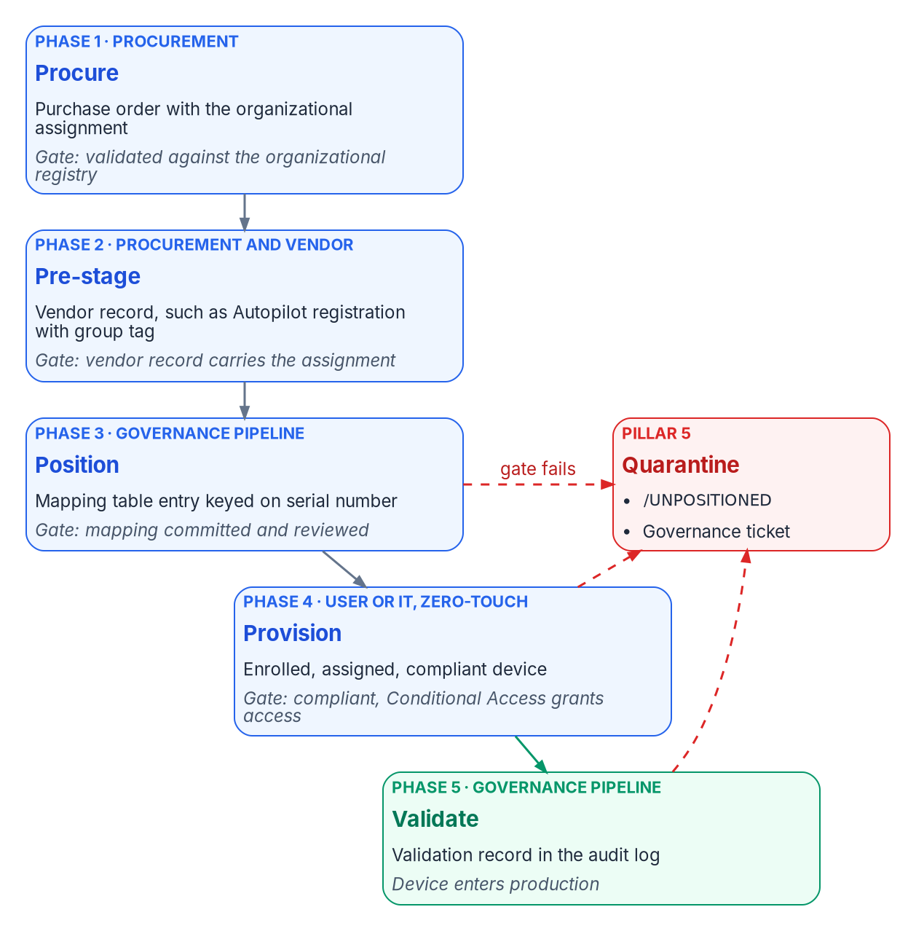
Five phases carry the organizational assignment from the purchase order to a validated device; a failure at any gate quarantines the device instead of degrading it.
Phase | Owner | Trigger | Output | Gate to the next phase
1. Procure | Procurement | Business request for an asset | Approved purchase order with the organizational assignment | Assignment validated against the organizational registry
2. Pre-stage | Procurement and vendor | Purchase order sent to the vendor | Vendor program record (Autopilot registration, Apple Business Manager assignment and so on) | The vendor record carries the organizational assignment
3. Position | Governance pipeline | Vendor confirms registration | Procurement-side mapping table entry, keyed on serial number | Mapping committed to the governance repository and reviewed
4. Provision | End user (zero-touch) or IT (assisted zero-touch) | Asset arrives at the recipient’s location | Enrolled, assigned, compliant device | Compliance policy returns Compliant; Conditional Access grants access
5. Validate | Governance pipeline | The device’s first compliance evaluation completes | Validation record in the governance audit log | All phase 5 checks pass; device leaves quarantine if it was in it
The program’s latency target is 14 calendar days from purchase order to production-governed for standard hardware, and 5 calendar days for expedited orders. The short twin of this page named the phases Procure, Carrier, Validate, Enroll and Verify; the table above is the fuller version, and the two describe the same flow.
The source also described a “pre-staged Entra ID device object placeholder” as a phase 3 output. For classic Autopilot that object isn’t something the pipeline creates: Autopilot creates it automatically when the device is registered. Phase 3’s job is to confirm that the registration exists, carries the right group tag, and matches the procurement record.

Procurement intake fields
Phase 1 is where the doctrine departs most from past practice. The organizational assignment is captured at purchase order time in structured fields:
- recipient_upn and recipient_org_attributes, resolved from Entra ID;
- asset_class (Windows endpoint, macOS endpoint, iOS tablet and so on);
- asset_assignment_type (personal, shared, kiosk, lab or service);
- asset_org_attributes and asset_orgnodeid, validated against the organizational registry; and
- vendor and vendor_program (Autopilot through the OEM or reseller, Apple Business Manager, Android zero-touch, Samsung Knox Mobile Enrollment, or Arc for servers).
The procurement system commits the order as a structured record in the governance repository and writes the organizational assignment to the vendor program in phase 2.

Windows: Autopilot or Autopilot device preparation
Microsoft now ships two Windows provisioning solutions. Windows Autopilot device preparation is a re-architecture of Windows Autopilot with a simpler configuration and near real-time reporting. Classic Windows Autopilot remains more feature-rich. The differences that matter for this doctrine:
Requirement | Autopilot device preparation | Windows Autopilot
Device registration required | No | Yes
Bind devices to the tenant before enrollment | Yes, through device association | Yes, through registration
Group tag on the registration | Not applicable (no registration) | Yes
Microsoft Entra join | Yes | Yes
Microsoft Entra hybrid join | No | Yes
User-driven | Yes | Yes
Pre-provisioned and self-deploying | No | Yes
Windows 10 | No | Yes
More than 10 apps or 10 PowerShell scripts during setup | No | Yes
Block the desktop until user-based configuration is applied | No | Yes
What admins configure | Device preparation policy, plus a device security group owned by the Intune Provisioning Client | Deployment profile, plus the Enrollment Status Page
GCC High and DoD | Yes | No

Which one, in a GCC tenant
The workbook assumes a Microsoft 365 GCC tenant. Intune doesn’t have a separate GCC instance; GCC uses the commercial Intune service, so both solutions are available. GCC High and DoD use a separate government instance in which classic Windows Autopilot isn’t available.
The program’s recommendation for a GCC tenant is classic Windows Autopilot, user-driven, with Microsoft Entra join, and OEM or reseller registration carrying a group tag, as the default for standard hardware. The reason is pillar 2. Classic Autopilot’s registration carries the procurement attribute (group tag and purchase order ID) from the vendor to the Entra ID device object before the device is powered on. Device preparation has no registration, so it has no carrier: devices are added to a device group at enrollment time, and the organizational assignment has to come from the procurement mapping table after enrollment.
Use device preparation where its advantages matter (a simpler policy, faster provisioning, mixing Win32 and line-of-business apps in one deployment, or a tenant that might later move to GCC High), and carry the attribute from the serial-number mapping table in phase 3. Don’t use either solution with hybrid join for new devices; that’s what pillar 4 forbids.
Device preparation requires Windows 11 version 24H2 or later, or version 23H2 or 22H2 with KB5035942 or later. Installation media dated April 2024 or later includes that update. It needs Microsoft Entra automatic enrollment configured, and the first user who signs in must be allowed to join devices to Entra ID. That last requirement is a governance point: on the device preparation path, the user’s own join permission is what brings the device in.

Registration and group tags
Registration binds the hardware hash to the tenant. The OEM, reseller or distributor should do it at purchase, which is also what makes it zero-touch. An OEM or reseller can register devices only after the organization’s Global Administrator authorizes it. Microsoft calls out that this one feature needs the Global Administrator role and recommends least-privileged roles everywhere else. Plan that consent as a one-time, recorded approval per supplier. Manual registration, harvesting the hash from a running device, is intended mainly for testing and evaluation.
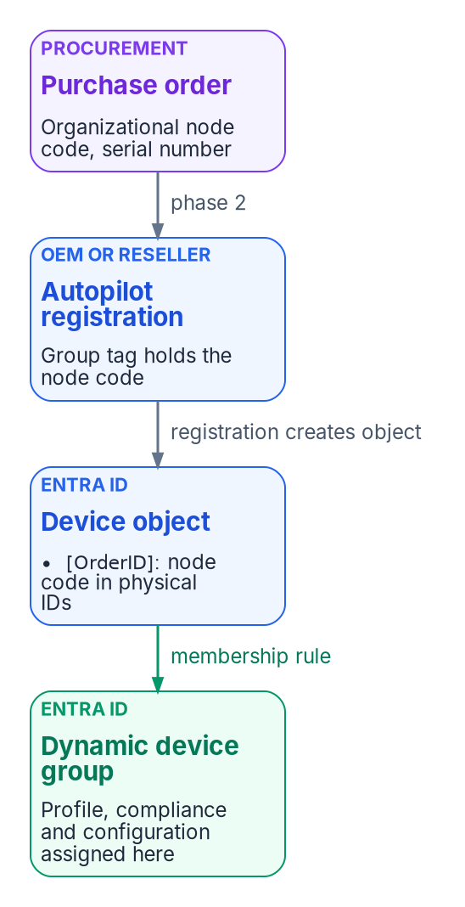
Classic Autopilot carries the procurement decision to the device’s configuration: the group tag on the registration becomes an OrderID on the Entra ID device, which a dynamic group matches.
The group tag Intune stores on the registration appears on the Entra ID device as an [OrderID] physical ID, and the purchase order ID appears as [PurchaseOrderId]. Dynamic groups match on them.

Illustrative, not tested against a production tenant
The rules and commands in this chapter are examples. Test each one in a non-production scope and check the resulting group membership before you assign policy to it.
All Windows Autopilot devices
(device.devicePhysicalIDs -any (_ -startsWith "[ZTDid]"))
Devices whose group tag is a given organizational node
(device.devicePhysicalIds -any _ -eq "[OrderID]:ORG-0420")
Devices bought on a given purchase order
(device.devicePhysicalIds -any _ -eq "[PurchaseOrderId]:76222342342")
The rule syntax is Microsoft’s; the ORG-0420 value is an example of an organizational node code. The program’s convention is that the group tag carries the organizational node identifier from the procurement record, never a free-text department name, so a reorganization changes the mapping table, not thousands of registrations. The Autopilot profile, compliance policies and configuration profiles are then assigned to those groups, which is how the procurement decision reaches the device’s configuration without anyone touching it.

Enrollment restrictions
Enrollment restrictions decide which devices may enroll at all. For Intune-first, the important one is the device platform restriction that blocks personally owned Windows devices. With it in place, Intune authorizes a Windows enrollment as corporate only through approved paths, and Windows Autopilot is one of them. Devices provisioned through device preparation are treated as corporate but blocked by a personal-device restriction unless they’re defined by corporate identifiers (serial number, manufacturer and model uploaded in advance) or bound to the tenant by device association.
That gives the doctrine its enforcement point. With personal Windows enrollment blocked, a device that wasn’t registered or pre-identified by procurement can’t enroll as corporate. It fails with an enrollment restriction error, which is exactly the pillar 5 behavior: quarantine, not silent degradation. Allow personal Windows enrollment only for the specific user groups that need it, which is also Microsoft’s advice.

Naming
Classic Autopilot profiles can apply a device name template. Names must be 15 characters or fewer, use letters, numbers and hyphens, and can’t be all numbers. The %SERIAL% macro inserts the hardware serial number and %RAND:x% inserts x random digits. The program’s convention is a short, fixed prefix for the asset class followed by %SERIAL%, truncated to fit 15 characters, because the serial number is the procurement join key (Chapter 03). Organizational position doesn’t go in the name. It goes in the group tag, where it can change without renaming the device.
In GCC High and DoD, renaming devices during device preparation based on organizational structure is still listed as a planned feature. Check device preparation’s current capabilities before you rely on it for naming.

The Enrollment Status Page
The Enrollment Status Page (ESP) shows provisioning progress and can block the device until required policies and apps are installed. It runs in two phases: device setup during the out-of-box experience, then account setup for the first user. The default ESP assigned to all devices doesn’t show app and profile progress; Microsoft recommends a custom ESP that does, because a user who signs in before the device is fully provisioned can cause problems. A tenant can hold up to 51 ESP profiles (the default plus 50).
For Intune-first, configure the ESP to block device use until the security-critical items are installed: the compliance-relevant configuration, Defender, BitLocker and any agent the validation phase checks for. Use the Selected blocking-apps list rather than All, so that a non-critical app’s failure doesn’t strand a device, and don’t let users bypass the ESP on an installation error for the security-critical list. The ESP list filters which assigned apps are tracked; it doesn’t itself assign them.
Device preparation doesn’t use the ESP. It applies only the apps and scripts selected in its policy during setup (up to 10 of each) and syncs policies assigned to the device group without tracking whether they’ve applied by the time the desktop appears. On that path, the validation phase, not the setup screen, is what confirms the device reached its baseline.

The compliance and configuration baseline
A net-new device should arrive at a known baseline before it’s used. The baseline has two halves.
Compliance, which decides access. Set the tenant-wide Mark devices with no compliance policy assigned as to Not compliant, so an unassigned device can’t pass Conditional Access by default; Microsoft recommends this whenever compliance feeds Conditional Access. A Windows compliance policy for net-new devices typically requires BitLocker, Secure Boot and code integrity under device health; firewall, TPM, antivirus and antispyware under system security; Microsoft Defender Antimalware with current security intelligence and real-time protection; and a minimum OS version. With Defender for Endpoint connected, add Require the device to be at or under the machine risk score. The access-policy side, Conditional Access requiring a compliant device, is in Book 04.
Configuration, which sets the device up. Start from Microsoft’s security baselines in Intune: the Security Baseline for Windows 10 and later (version 25H2 is the latest Windows baseline) and the Microsoft Defender for Endpoint baseline. Existing baseline profiles don’t update to a new version automatically, and different baselines can set the same setting to different defaults, so review overlaps before you deploy more than one. Then add BitLocker with recovery-key escrow to Entra ID, Windows Hello for Business (Chapter 10 of Book 02), firewall profiles and Windows LAPS. Because these devices never had Group Policy, there’s no GPO conflict to resolve; that’s the payoff of Intune-first, and Chapter 08 covers the existing fleet where there is one.

Other platforms
The five-phase process is platform-neutral. Each platform has its own vendor program and its own carrier for the organizational assignment.
Platform | Vendor program | Assignment carrier | Management state
Windows endpoint | Windows Autopilot (OEM or reseller registration) or Autopilot device preparation | Group tag; or the mapping table for device preparation | Microsoft Entra joined, Intune enrolled
Microsoft Surface | Surface registration through Microsoft or an authorized partner | Group tag; DFCI profile for firmware settings | Entra joined; firmware managed through DFCI
macOS | Apple Business Manager or Apple School Manager, Automated Device Enrollment | Assignment to the Intune enrollment profile | Supervised, ADE-enrolled
iOS and iPadOS | Apple Business Manager or Apple School Manager, Automated Device Enrollment | Assignment to the Intune enrollment profile | Supervised
Android | Android Enterprise zero-touch or Samsung Knox Mobile Enrollment | Enrollment profile or managed configuration | Fully managed (corporate-owned)
Linux workstation | Intune enrollment through the Microsoft Intune app | Mapping table | Intune managed
Server (Windows Server 2025, Linux) | Azure Arc onboarding | Azure resource tag on the Arc machine | Workgroup plus Arc; Entra ID sign-in on Windows Server 2025 (Chapter 09)
A few facts behind the table, current as of October 2026:
- Devices enrolled through an Apple device enrollment program, Windows Autopilot, Knox Mobile Enrollment, Android Enterprise corporate-owned methods and Google zero-touch are marked corporate-owned automatically.
- Intune supports Linux on Ubuntu Desktop 24.04 and 26.04 LTS and Red Hat Enterprise Linux 9 and 10.
- DFCI management for Surface works only with classic Autopilot; device preparation doesn’t support it. DFCI is in the planned list for GCC High and DoD.
The source’s Surface row named specific resellers and firmware security features; those are dropped as vendor positioning that the program doesn’t need to rely on.

The three exception paths
Doctrine carve-outs for cases that can’t follow the main path. Each needs written justification, a compensating control and an audit entry.
Path | Applies to | Why it’s permissible
A. User-driven enrollment for personal devices | Personally owned devices enrolled into a work profile or partition (iOS user enrollment, Android work profile, Windows registered) | Refusing to govern personal devices pushes users to unmanaged access through personal browsers. Governed at a lower assurance level is better than ungoverned.
B. Linux endpoint with an Arc fallback | Linux endpoints that can’t use Intune’s Linux management (developer workstations that need root, embedded Linux, air-gapped hosts) | Intune’s Linux support covers a limited set of distributions and desktop configurations; Arc with Azure Policy machine configuration is the substitute governance plane.
C. Pre-2025 Windows servers | Windows Server 2019 and 2022 hosts whose OS upgrade isn’t yet feasible | Entra ID sign-in for Arc-enabled Windows servers requires Windows Server 2025 or later with Desktop Experience. Arc-managed without Entra ID sign-in is an acceptable interim state.
Exception C is restated from the source, which cited a program decision. The underlying fact is Microsoft’s support boundary, footnoted above.

Devices without a procurement record
Devices that predate the process, or arrive outside normal procurement, fall through to user derivation or the unpositioned marker. They surface as findings for governance review, with three possible outcomes: file a procurement record retroactively, reclassify the asset, or quarantine it for disposition.

Validation, drift classes and evidence
Phase 5 runs platform-neutral and platform-specific checks. Failures quarantine the device under pillar 5. The doctrine adds five drift classes, which are the program’s own taxonomy:
Drift class | What it detects
DRIFT-PROCUREMENT-MISMATCH | The device’s organizational assignment differs from the procurement record
DRIFT-VENDOR-PROGRAM-CARRIER | The assignment in the vendor program record (Autopilot group tag, Apple assignment and so on) differs from the procurement record, or is missing
DRIFT-ENROLLMENT-VECTOR | The device enrolled through a non-zero-touch path without an exception grant
DRIFT-CO-MANAGEMENT-NEW | A net-new Windows endpoint landed in Configuration Manager co-management instead of Intune-first
DRIFT-PROCUREMENT-RECORD-ABSENT | A device enrolled in Intune with no matching procurement record
The keys these checks join on, and a read-only script that finds three of the five, are in Chapter 03. Each detection produces a signed evidence artifact in the governance repository. The program maps the evidence to the NIST SP 800-53 controls AC-2, AC-19, CM-2, CM-7, CM-8, IA-3, MA-2 and SC-15 for its FedRAMP Moderate boundary. That mapping is the program’s assertion for its own assessors, not a statement that these artifacts satisfy the controls by themselves. How the evidence is produced and presented is covered in Chapter 10.

What this chapter establishes
- A net-new device is governed from first power-on. There’s no domain join, co-management or unassigned state on the way.
- The organizational assignment is set at the purchase order and carried by the vendor program, with an explicit unpositioned marker when nothing can supply it.
- In a GCC tenant, classic Autopilot with Entra join and OEM or reseller registration is the default, because its registration carries the procurement attribute; device preparation needs the attribute carried by the mapping table.
- Blocking personal Windows enrollment turns an unregistered device into an enrollment failure, which is the doctrine’s quarantine in practice.
- Five drift classes catch the devices that slipped through, and they join on the keys from Chapter 03.
Chapter 05 takes up how the existing fleet reaches the same end state.

Continue the book
← Previous: Chapter 03 — Where Device and Server Data Lives · Book index · Next: Chapter 05 — The Governed, Manual and Retrofit Paths →

Chapter 05 — The Governed, Manual and Retrofit Paths
Every path ends at the same device configuration; what differs is who holds the decision record and whether anyone notices when the estate drifts back.

In this chapter
The three ways a workstation or server reaches the target state: the governed path, orchestrated by the program with evidence; the manual path, run by operators without an orchestration platform; and the retrofit path, which brings an estate that was already modernized by hand under governance. The chapter sets out the runbook all three share, what each path adds, what each one risks, and how to choose.
Chapter 04 described where a device should land: enrolled in Intune first, with Group Policy retired setting by setting rather than copied. This chapter is about how it gets there. The workbook’s sources described the journey as three separate kits, each with its own runbook, and they repeated most of the same steps. The steps are the same because the destination is the same. Servers are onboarded to Azure Arc, workstations are enrolled in Intune, NTLM is restricted after it has been measured, service principal names are clean, SQL Server is hardened, and Conditional Access is enforced. What changes from path to path is the binding between an organizational decision and the technical change that carries it out: who approved it, where that approval is recorded, and how anyone finds out when a device stops matching it.
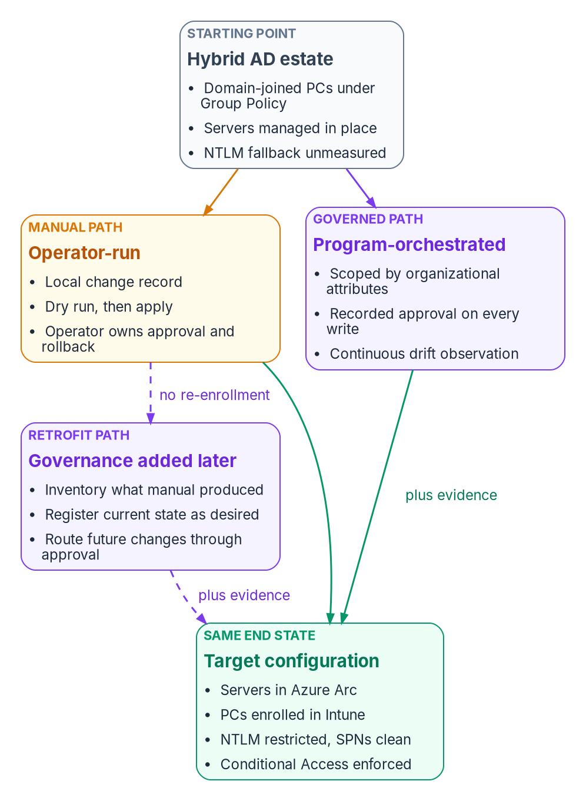
Three paths lead from the hybrid estate to the same target configuration; the governed and retrofit paths add evidence, and the retrofit path starts from the manual path’s output without re-enrollment.

One end state, three ways to reach it
The program is an active reconciliation control plane. It holds the desired state of each managed object, observes the actual state, classifies the difference as drift, and reconciles toward the desired state. It isn’t an inline runtime component and doesn’t replace any Microsoft service. That definition, which is the program’s own design, explains why the three paths can share a runbook. Microsoft’s services do the work in every path. The program only changes what happens around them.

The rule all three obey: the control plane governs, the data plane executes
Active Directory merged two jobs. The directory held the truth about users and computers, and the domain controller enforced it in the authentication path. The target keeps those jobs apart, and the program sits on the truth side. It governs: it holds desired state, observes, classifies and reconciles. The provider executes: it authenticates, authorizes, enrolls, evaluates policy and stores. A program adapter may call a provider’s management API to make a change. It must never sit inline in an authentication or request path. Onboarding a server calls the Azure management plane. Deploying a Conditional Access policy calls the Microsoft Graph policy API. Neither puts the program between a user and a sign-in.
The providers are incorporated, not replaced.
Provider (data plane) | What it does at runtime | What the program governs
Microsoft Entra ID | Authenticates and enforces Conditional Access | Desired Conditional Access and identity state; drift against it
Microsoft Intune | Enrolls devices and enforces device policy | Desired profile and compliance state; observed posture
Azure Policy and Azure Arc | Evaluates machine configuration on servers | Desired server baseline; compliance reconciliation
Active Directory | Issues Kerberos tickets and holds SPNs | Desired NTLM and SPN state; audit and repair plan
The program doesn’t reimplement any of these functions. It compares their state against the desired state and emits evidence.

Terms used in this chapter
The control plane is the reconciliation layer described above. Organizational attributes are the coded values every governed object carries, so that its state can be addressed in the same terms in Entra ID, Intune, Azure and Active Directory. Book 02, Chapter 05 explains why attributes, not organizational units, carry that meaning once the directory is flat. An actuation rung is the level of change an operation is allowed to make, described under the governed path below.

What every path shares

Four phases, observe first
Every path runs the same four phases in the same order. Nothing is restricted until it has been measured.
Phase | Kind of change | What runs | Why
1 — Observe | Read-only | NTLM audit, SPN inventory, SQL Server audit, Intune enrollment and posture, Group Policy overlap | You can’t safely restrict what you haven’t measured
2 — Onboard | State-changing | Arc onboarding and server baseline; Intune automatic enrollment | Attach the management planes
3 — Harden | State-changing | SPN repair, NTLM restriction, Conditional Access baseline | Close the identity gaps, only after Phase 1 is signed off
4 — Watch | Read-only | Conditional Access drift, compliance and cross-domain status | Keep the estate from drifting back
The endpoint project plan follows the same sequence, with a Phase 0 for charter and alignment in front of it (endpoint and device project plan).

Rules that hold on every path
- Observe before you change anything. Budget at least two weeks for assessment before any production change. Starting Arc onboarding or Intune enrollment without the inventory and the NTLM audit is the program’s most common cause of failed modernization: authentication failures, policy conflicts and application outages.
- Treat every first run as a dry run. Preview each state-changing step before you apply it. Microsoft’s own cleanup script for stale Arc resources follows the same pattern, with a -WhatIf pass before the real one.
- Deploy Conditional Access in report-only mode first. Report-only policies are evaluated at sign-in and their results logged, but they aren’t enforced. Promote a policy to enforcement as a separate change.
- Exclude emergency access accounts before enforcing. Microsoft recommends at least two cloud-only emergency access accounts, excluded from Conditional Access policies that block or restrict sign-in. Report-only policies don’t need the exclusion.
- Domain unjoin is a separate decision. Onboarding attaches a management plane. It doesn’t remove the domain join, and it shouldn’t be allowed to imply that decision. Chapter 02 explains what goes wrong when hybrid join is treated as the destination.
- Document overlapping settings before Intune enforces them. Group Policy and Intune targeting the same setting is the conflict described under the runbook below.
- Cover the whole denominator. Non-Windows, personally owned, guest, kiosk and server classes are in scope, even when a wave defers them.

Prerequisites: licensing and roles
Confirm licensing against the agency’s own agreements before starting. As of October 2026:
Need | What provides it
Workstation management | Microsoft Intune Plan 1, the base service, usually obtained through a Microsoft 365 bundle such as E3 or E5
Enforcing compliance through Conditional Access | Intune plus Microsoft Entra ID P1 or P2
Risk-based Conditional Access | Microsoft Entra ID P2, for sign-in risk conditions from ID Protection
Endpoint detection on workstations | Microsoft Defender for Endpoint, included in Microsoft 365 E5
Server management plane | Azure Arc’s control-plane functions (tags, Resource Graph, Azure RBAC, templates and extensions) at no extra cost; services used on Arc servers are billed separately
Server configuration, update and change tracking | Included for Windows Server with active Software Assurance or pay-as-you-go licensing after attestation; otherwise purchased per server
Server and SQL Server threat protection | Defender for Servers Plan 2 and Defender for SQL Servers on Machines; on-premises servers must be onboarded to Arc
The source runbooks put “Intune Administrator through PIM” on the endpoint line. Microsoft now advises against using the Intune Administrator role for day-to-day work, because it grants global read and write across Intune. Use a least-privileged built-in Intune role or a custom role instead. The least-privileged roles for each workstream are:
Work | Role
Onboarding servers to Arc | Azure Connected Machine Onboarding, scoped to the target resource group, held by a dedicated service principal
Managing Arc servers after onboarding | Azure Connected Machine Resource Administrator
Intune policy and enrollment | Intune RBAC roles such as Policy and Profile Manager or Endpoint Security Manager
Conditional Access | Conditional Access Administrator
Directory synchronization | Hybrid Identity Administrator
SPN work | Delegated administration on the service-account OUs in Active Directory
Chapter 06 maps these roles to teams.

The shared runbook
The steps below are the technical end state all three paths produce. The manual path runs them by hand. The governed path runs the same steps with an approval reference on every change. The retrofit path finds them already done. Later chapters go deeper: Chapter 08 on moving policy, Chapter 09 on servers, and Chapter 10 on monitoring and evidence.

Illustrative, not tested against a production estate
The commands in this chapter are examples. They haven’t been run against a production forest or tenant. Read each one, run it first in a test scope, and review the output before you apply anything that changes state.

Phase 1: baseline the estate
The baseline is read-only. It covers four inventories: NTLM use over the last 30 days, every SPN with duplicates and stale owners flagged, the SQL Server hardening posture, and Intune enrollment status. To find NTLMv1 use, Microsoft’s method is to enable logon success auditing on domain controllers and read the NTLM version recorded in Event ID 4624. The Restrict NTLM audit policies log the NTLM requests that a later deny setting would block, in the NTLM operational log. For SPNs, setspn lists and searches registrations:
# SPNs registered on one service account
setspn -L CONTOSO\svc-app
# Which account owns a given SPN (single forest); use -X to search for duplicates
setspn -Q HTTP/app.contoso.com
setspn -X
Searching for duplicates across a forest can take a long time and a lot of memory.

Phase 2: onboard servers to Azure Arc
Azure Arc extends the Azure control plane to servers outside Azure. The Connected Machine agent communicates outbound to Azure Arc over TCP 443, and all its connections are outbound unless the documentation says otherwise. Each onboarded server becomes a Microsoft.HybridCompute/machines resource that Azure Policy machine configuration can target, and Azure RBAC, tags and extensions apply to it like any other resource. Each server also gets a system-assigned managed identity, which applications on the server can use to reach Azure resources without stored credentials.

Arc servers run non-domain-joined in the target
In the program’s target architecture, Arc-enabled servers carry an Entra-backed machine identity and run without a domain join. Onboarding attaches the management plane. It doesn’t remove the domain join for you. Plan the unjoin as a separately sequenced decision.
At-scale onboarding uses a service principal that holds the Azure Connected Machine Onboarding role, scoped to the target landing zone. That role can create and read Arc server resources but can’t manage extensions or delete servers, and Microsoft recommends assigning it only to the onboarding service principal. The credential is needed only when azcmagent connect runs. If it expires afterward, the server stays connected.

Never put an onboarding secret in plain text in a startup script
The source runbook warned that a service principal secret in a Group Policy startup script is readable by every domain-authenticated user through SYSVOL. Treat it that way. Microsoft’s guidance for scripted onboarding is to prefer certificates over secrets, because certificates can be controlled with Conditional Access, to keep parameters in a configuration file instead of on the command line, and to clean the file up afterward. Microsoft’s Group Policy onboarding method encrypts that configuration file so only computer accounts can decrypt it. Rotate the credential regularly and keep it in the onboarding role only.
The server baseline comes next. Azure machine configuration, formerly Azure Policy Guest Configuration, audits and can set operating-system settings on Arc servers. Azure Policy includes a built-in definition that checks Windows machines against the Azure compute security baseline. With Defender for Servers Plan 2 enabled, Defender for Cloud assesses server configuration against the Windows and Linux compute baselines in the Microsoft cloud security benchmark.
Tag every server consistently, because tags drive policy scope, cost reporting and operational queries: Environment, Workload, Criticality, Owner, CostCenter, PatchGroup and an onboarding date. On the governed path the same taxonomy carries the organizational attributes. Tags are stored in plain text, so don’t put sensitive information in them.

Phase 2: enroll the existing workstation fleet in Intune
For a fleet that is already domain-joined and synchronized to Entra ID, Group Policy–triggered automatic enrollment of Microsoft Entra hybrid joined devices is the lowest-friction route. It needs no reimage and no user interaction. Microsoft recommends it for hybrid joined fleets that aren’t managed with Configuration Manager. For new hardware, Microsoft recommends Windows Autopilot with Microsoft Entra join rather than hybrid join. The enrollment policy is Computer Configuration > Administrative Templates > Windows Components > MDM > Enable automatic MDM enrollment using default Microsoft Entra credentials, linked to the workstation OU and filtered by a security group. On a client, confirm hybrid join before you troubleshoot enrollment:
dsregcmd /status
# Device State should show:
# AzureAdJoined : YES
# DomainJoined : YES
Those two values mean the device is both domain-joined and Entra-joined, which is what Group Policy enrollment requires.
Deploy configuration in priority order: the security baseline, BitLocker with recovery-key escrow to Entra ID, Windows Hello for Business, Defender Antivirus, firewall profiles and Windows LAPS. Intune’s LAPS policy can back the local administrator account up to Entra ID or to Active Directory, and can rotate the password on a schedule. Book 02, Chapter 10 covers Windows Hello for Business as part of phishing-resistant sign-in. Then attach a compliance policy: minimum OS version, BitLocker, Secure Boot, code integrity, Defender real-time protection and current signatures, firewall, TPM and health attestation. A device that fails it can be blocked by Conditional Access. Every compliance policy includes a Mark device noncompliant action. You can schedule it from 0 to 365 days to give users a grace period before Conditional Access takes effect. Book 04 owns the Conditional Access side of that decision.

Group Policy and Intune: Group Policy wins by default
The source runbook described a Group Policy and Intune overlap as “last writer wins.” Microsoft documents something more specific, and more dangerous. When the same policy is set in both Group Policy and MDM, Group Policy takes precedence. The MDMWinsOverGP setting reverses that, but only for settings in the Policy CSP. It doesn’t cover settings defined in other CSPs, such as the Defender CSP. For those, configuring both channels creates a race condition with no guaranteed winner. Windows Hello for Business policy lives in the PassportForWork CSP. If Group Policy and Intune both configure it, the conflicting Intune settings aren’t applied until the Group Policy settings are cleared. So document every overlapping setting before Intune enforces anything in production, and retire the Group Policy copy once Intune owns the setting. Chapter 08 sets out that retirement sequence.

Phase 3: restrict NTLM in stages
NTLM is deprecated in all its versions. Microsoft says calls to it should move to Negotiate, which tries Kerberos first. NTLMv1 is removed starting with Windows 11, version 24H2 and Windows Server 2025. Book 02, Chapter 03 sets out the full deprecation schedule. The destination is Kerberos for everything that stays on premises, and token-based protocols for everything that moves.
Restricting NTLM too early breaks legacy web applications, file access by IP address or without an SPN, and some third-party products. Enforce restrictions only after a 14 to 30 day audit shows no remaining dependencies, and only after application owners sign off.
The source runbook’s staging table was wrong in one important way. It treated LAN Manager authentication level 5 as “block all NTLM.” Level 5 makes domain controllers refuse LM and NTLMv1, but they still accept NTLMv2. Level 4 refuses only LM. NTLM is blocked by the Restrict NTLM policies. Network security: Restrict NTLM: NTLM authentication in this domain controls the domain controller, Incoming NTLM traffic controls servers, and Outgoing NTLM traffic to remote servers controls clients. Exception lists exist for the domain controller and the client roles. The corrected staging is:
Stage | LAN Manager authentication level | Restrict NTLM policies
1 — Audit | 3 or higher on clients (send NTLMv2 only) | Audit NTLM authentication in this domain and audit incoming NTLM traffic: enabled for all accounts
2 — Refuse legacy variants | 5 on domain controllers (refuse LM and NTLMv1; accept NTLMv2 only) | Deny for domain accounts, with the audited exceptions in the server exception list
3 — Block NTLM | 5 | Deny all; remove the exceptions as each dependency is retired
On Windows 11 24H2 and Windows Server 2025, NTLMv1 is already gone, so Stage 2 mostly matters for older systems in the estate.

Conditional Access can’t block on-premises NTLM
NTLM is controlled at the Local Security Authority and through these Windows policies, which Group Policy or Intune can deliver. The LAN Manager level and the Restrict NTLM settings are both in the Policy CSP. Conditional Access blocks legacy authentication to cloud applications. A Kerberos or NTLM exchange between a client and a domain controller never reaches it.

Phase 3: repair SPNs before enforcing Kerberos
Kerberos needs a correct, unique SPN for each service. A missing SPN is the silent failure. If the client’s security layer can’t find the SPN in Active Directory, Kerberos isn’t attempted and the connection falls back to NTLM, which usually succeeds. A duplicate SPN makes Kerberos fail outright. The KDC returns KDC_ERR_PRINCIPAL_NOT_UNIQUE, and each SPN must be unique in the forest. An SPN left on the old account after a service-account change has to be moved, so that each SPN has exactly one owner. The source runbook said a duplicate falls back to NTLM silently. In fact, the missing SPN is the quiet case and the duplicate is the loud one. Both need fixing before NTLM is restricted, because stage 3 turns the quiet case into an outage.
Validate each repair. Purge the client’s ticket cache, connect again, and confirm the session used Kerberos. For SQL Server, sys.dm_exec_connections reports the authentication scheme:
klist purge
SELECT auth_scheme, net_transport
FROM sys.dm_exec_connections
WHERE session_id = @@SPID;
-- KERBEROS is the expected result; NTLM means the SPN is still missing or misplaced

Phase 3: harden SQL Server
The hardening audit reports the authentication mode (Windows authentication only is the goal), the server configuration options that should be off (xp_cmdshell, OLE Automation procedures, CLR, cross-database ownership chaining, Database Mail XPs and similar), and the status of the sa account. Then onboard the SQL Server hosts to Arc and enable Defender for SQL Servers on Machines. Replacing Windows and SQL authentication with Entra ID for SQL Server 2022 and later is a separate engine-level transformation. The SQL Server Identity Transformation narrative covers it.

Phase 3: Conditional Access baseline
The baseline creates the core policies: block legacy authentication, require MFA, require a compliant device, and require MFA for administrators and for the Azure management plane. Create them in report-only mode, measure the impact in the sign-in logs and the insights workbook, and then enforce each one as a separate change. Before anything is enforced, exclude the emergency access group from every policy that blocks or restricts sign-in.
The source runbook described emergency accounts as protected by “long unique passwords.” Microsoft’s current guidance is different. Emergency access accounts should be cloud-only accounts in the .onmicrosoft.com domain. They should use phishing-resistant methods, such as FIDO2 passkeys or certificate-based authentication, that are different from normal admin accounts. They should be monitored with alerts on every sign-in and validated at least every 90 days. Book 04 designs the full policy set.

Phase 4: watch
Send Arc heartbeat, Intune compliance, Active Directory audit and Defender alerts to a Log Analytics workspace with defined alert rules. Capture a Conditional Access baseline on the first run, then compare against it on a schedule. A cross-domain status report shows which domains have fresh evidence and the headline pass and attention counts. It is the weekly status page on the manual path and the evidence feed on the governed path. Chapter 10 describes it.

Rollback
Define rollback criteria before you begin. Each domain has a back-out:
- Intune: retire or unenroll the device and re-apply the Group Policy baseline.
- Arc: remove the extensions first, because uninstalling the agent doesn’t remove them. Then run azcmagent disconnect, which deletes the Azure resource and resets the local agent, and uninstall the agent.
- Conditional Access: keep policies in report-only until they’re validated. The emergency access accounts are the recovery path.
- NTLM: if a missed dependency surfaces, relax the Restrict NTLM deny setting back to audit, or add a scoped exception, until the owner fixes it. That is the setting that blocks. Lower the LAN Manager level only if the dependency is on NTLMv1. This is why the audit gate exists.

What you must configure
Every deployment has local values to set before anything runs: tenant ID, subscription ID, resource group, region and cloud environment (Azure commercial or Azure Government), the workstation OU distinguished name, the emergency access group ID and the SQL Server instance list. Run each step as a dry run before you remove the guards.

The manual path
The manual path is for an agency that is modernizing without an orchestration platform. That can happen because of how the agency is organized, because it acquired the estate, because the timeline is compressed, or because it has no budget for one yet. Every step is self-contained and is meant to be run by qualified staff with no outside advisory dependency.
The manual path isn’t the ungoverned path. Because no control plane checks each decision as it happens, the operator owns the change record, the approval and the rollback. Write the accepted risks into a change record before you start.
 | Manual path
Needs | The licensing and roles above, a local change-control process, operators who can read every script before running it
Produces | The full target configuration on the Microsoft surface; a change record per step; read-only drift and status reports run on a schedule
Doesn’t produce | An approval reference bound to each change, or continuous drift classification. Evidence is assembled when an auditor asks for it
Main risks | Drift found by incident, not by observation; approvals that live in a ticket nobody links to the device; the NTLM and Conditional Access cutovers done on one operator’s judgment
Best for | Small estates, pilots, and agencies that need to start before a control plane exists
If you expect to add governance later, the manual path is designed for it. Don’t re-image or re-enroll devices just so you can add governance later. The retrofit path below exists so that you never have to.

The governed path
The governed path reaches the same end state as the manual path. The same steps run. What governance adds is the binding from organizational intent to each technical change.
- Address before you actuate. Organizational attributes must be present on every device before any policy targets it. Scope is derived from attributes, not from an OU or a hand-built group.
- Cap the blast radius. High-blast-radius classes, such as privileged access workstations, servers and kiosks, stay gated on human approval.
- Plan, then apply with a dry run. No change is applied without a preview of its impact.
- Report-only first. Enforcement is measured before it’s switched on.
- Reconcile duplicates and lifecycle. One object per machine. Orphaned and phantom device objects are findings, not leftover state.
- Emit evidence an authorizing official can sign. Every bulk change produces a provenance record.
- Cover the whole denominator. No platform or ownership class is quietly left out.

The actuation ladder
Every governed operation declares a rung. The rung is a property of the operation, not a global switch. The program’s federal default write ceiling is L3: a human approves, and the program executes through the provider’s API. Autonomous L4 actuation is refused inside the boundary. The ladder and the ceiling are the program’s design. Raising the ceiling takes deliberate configuration outside the kit, and a tightened boundary can lower it, for example to L1 so that only observers run.
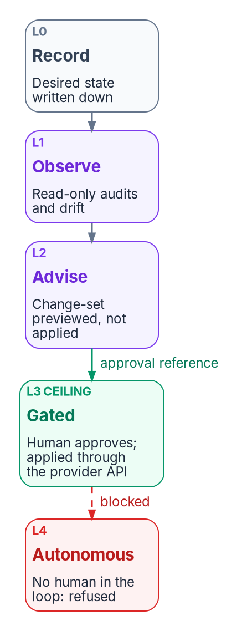
The actuation ladder runs from recording desired state to gated change; autonomous change is above the program’s federal ceiling and refused.
Rung | Name | Meaning | In this book’s runbook
L0 | Record | Desired state recorded, nothing observed yet | The modernization desired-state table
L1 | Observe | Actual state collected and drift detected, read-only | NTLM, SPN, SQL Server and Intune audits; the drift report
L2 | Advise | Corrective change-set generated and shown | The dry-run previews
L3 | Gated | A human approves; the program applies the change through the provider API | Every state-changing step, carrying an approval reference
L4 | Autonomous | The loop closes without a human | Above the ceiling; refused
The approval check refuses any write above the ceiling, refuses a gated write that has no approval reference, and logs every decision. Microsoft provides a native second-approver gate for part of the endpoint surface. Intune Multi Admin Approval can require a second administrator to approve changes to app deployments, compliance policies, settings catalog policies, scripts, role assignments, and the wipe, retire and delete device actions. The person who requests a change can’t approve it, not even a Global Administrator or Intune Administrator. The gate also applies to automation that calls Microsoft Graph. Where it covers a workload, the program records the Multi Admin Approval request as the L3 approval instead of building a parallel one.

The reconciliation loop
The governed path runs the modernization domains through the program’s drift-detection loop, not as one-shot scripts. The loop has six phases: snapshot, compare, classify, alert, remediate and verify. It runs as a dry run by default, and high-blast-radius operations are gated for governance review. The read-only audits from Phase 1 and Phase 4 are the snapshot, compare and classify steps for each domain. Remediate and verify are the gated L3 write: the same step, run again with an approval reference once a human approves the change-set. The kit’s governed invocation looks like this:
Import-Module .\lib\IntuneArcModernization.psm1
# Observe (L1): identical to the manual path
.\scripts\Get-NtlmAudit.ps1 -DaysBack 30 -OutputPath .\artifacts\ntlm-audit.csv
# Gated actuation (L3): an approval reference is required; a write without one is refused
.\scripts\Invoke-ArcOnboarding.ps1 -SubscriptionId $sub -ResourceGroup rg-arc-servers `
-Location eastus -ApprovalRef 'CR0012345' -WhatIf
.\scripts\Set-NtlmRestriction.ps1 -Level 5 -ApprovalRef 'CR0012346' -WhatIf
# Verify (L1)
.\scripts\Get-ModernizationDriftReport.ps1 -ArtifactPath .\artifacts
These are the program’s companion kit scripts, not Microsoft cmdlets, and the kit isn’t published with this workbook. Read the block as the shape of a governed run: observe, preview, approve, apply, verify.

Mapping the source’s model to the program’s terms
One source draft described the governed path as five products. The concepts exist, but as machinery the program already names. This book uses the program’s terms.
Source draft term | The program’s term
Policy engine | Desired state plus plan, apply and reconcile adapters
Identity registry | The identity control-plane slot
Attestation service | The drift-detection loop, six phases, dry run by default
Audit ledger | The provenance-anchored evidence pipeline: every artifact cites the desired-state record and version it derives from
Access orchestrator | Enforcement adapters bound to a control-plane slot

What the governed path adds, and what it evidences
Over the manual end state, the governed path delivers:
- every modernized resource traceable to a recorded approval;
- no Conditional Access change outside a gated, logged workflow;
- continuous, exportable evidence, anchored to provenance instead of assembled at audit time;
- drift caught and classified by the loop instead of discovered by an incident.
FedRAMP’s Consolidated Rules for 2026 express security outcomes as 46 Key Security Indicators in 10 themes. Initial certification under the rules began on July 4, 2026, and ongoing certification follows them from January 1, 2027. The indicators are written for cloud service offerings. The program uses them as a vocabulary for the evidence it produces. The mapping below is the program’s own claim about a bounded slice of the catalog.
Key Security Indicator | Evidenced on the governed path by
KSI-IAM-APM, Adopting Passwordless Methods | The Conditional Access baseline and phishing-resistant sign-in
KSI-IAM-ELP, Ensuring Least Privilege | Attribute-scoped assignment instead of tenant-wide assignment
KSI-SVC-ACM, Automating Configuration Management | Machine configuration baselines on Arc servers
KSI-CNA-EIS, Enforcing Intended State | Conditional Access drift comparison against the captured baseline
KSI-CMT-LMC, Logging Changes | The approval reference attached to every state-changing run
KSI-MLA-EVC, Evaluating Configurations | The cross-domain drift report against the baseline
Don’t cite this path for recovery planning (KSI-RPL), supply chain risk (KSI-SCR), cybersecurity education (KSI-CED) or incident response (KSI-INR). That evidence comes from contingency-plan reviews, software bill of materials and vulnerability disclosure tooling, training records and response playbooks, not from the endpoint surface. The manual path produces the same Microsoft configuration but no approval chain, so it doesn’t evidence KSI-CMT-LMC. That gap is the reason the governed path exists.
The kit’s scope is also deliberately bounded. It enforces MFA and compliant devices through Conditional Access at the Entra ID P1 level, and it includes Defender for Servers Plan 2 and Defender for SQL. Risk-based Conditional Access, PIV-only enforcement, FIPS-validated cryptography and extended log retention are handled through separate controls and other chapters, not by this path.

Rolling back the governed path
Roll back in two layers. The operational back-outs are the same as the shared runbook’s. The governance seam has its own:
- Approval enforcement: lower the approval check to record-only (an L1 ceiling). Gated writes stop, and the observers keep running.
- Loop suspension: stop the scheduled compare and drift-report runs. The provider state isn’t affected.
Rolling back the seam never requires re-onboarding, re-enrollment, or undoing any Intune, Arc or Conditional Access work, because the provider always owns the operational state.

The retrofit path
The retrofit path starts where the manual path finished. Servers are in Arc, workstations are in Intune, legacy protocols are restricted and Conditional Access is enforced, and now governance is required. The retrofit adopts that estate into the governed path without redoing any of the Intune or Arc work.
It works because the manual path already produced what the control plane needs: Arc tags, enrollment state, Conditional Access policies and the audit artifacts from each phase. The retrofit reads those artifacts, derives the governance attributes from structure that already exists, and attaches the observation and approval loop.
- Inventory what the manual path produced: tags, enrollment status, policy assignments and audit files.
- Derive governance attributes from the existing tags, OUs or groups.
- Stamp the derived attributes onto the objects that already exist.
- Register the current state as the desired state.
- Turn on continuous observation and drift detection.
- Route all future changes through the approval process.
 | Retrofit path
Needs | The manual path’s artifacts, intact; owners who can confirm that the current state is the intended state before step 4
Produces | The governed path’s evidence from the day observation starts, with no re-imaging, re-onboarding or re-enrollment
Main risks | Step 4 blesses whatever is there, so drift accumulated before the retrofit becomes desired state unless someone reviews it; attributes derived from old OUs can carry old structure forward
Best for | Estates modernized by hand that now need an authorizing official’s signature
Adding governance after the fact isn’t a migration. It turns on the observation and approval seam that the manual path left available.

When the estate can’t leave the domain yet
An earlier version of these guides also used “retrofit” for a different case: devices that can’t be treated as new and can’t be unjoined in the current wave. This book keeps the word for adding governance after the fact. The domain-bound case is a constraint that can apply on any of the three paths, and it has its own rules:
- Arc onboarding and Intune enrollment attach the management plane without a domain unjoin.
- Policy is applied through the management plane. Group Policy stays only where Intune or machine configuration can’t yet own the setting.
- Group Policy and Intune conflicts are documented before they’re hit, and the overlapping settings are retired in a later wave.
- NTLM and SPN work proceeds in parallel but is sequenced after the management plane is attached.
- Domain unjoin is scheduled on its own, as described in Chapter 02.

How to choose
The three paths aren’t competing products. They’re three answers to one question: who holds the decision record, and when does that start?
If the estate… | Use | Because
Is small or a pilot, and no control plane exists yet | Manual | It starts now, and nothing in it forecloses governance later
Is larger than a few hundred devices, or an authorizing official must sign the change | Governed | The approval and drift evidence is what the signature rests on
Was already modernized by hand and now needs governance | Retrofit | It adds the evidence without touching the devices
Must stay domain-joined for this wave | Any of the three, with the domain-bound rules above | The constraint is about sequencing, not governance
The paths share the observe-before-change rule and the evidence requirement. The manual path is where operators learn the runbook. The governed path is the production path for large estates. The retrofit path makes sure the first choice is never wasted.

Key risks on every path
- Restricting NTLM before the audit window closes breaks legacy applications.
- Onboarding secrets left in plain text in startup scripts expose a credential that can register servers into your subscription.
- Enforcing Conditional Access without the emergency access exclusion locks out recovery.
- Treating domain unjoin as a side effect of onboarding instead of a sequenced decision.
- Incomplete attribute population lets devices fall outside policy scope, which the endpoint charter lists as a key risk (endpoint and device project charter).

Continue the book
← Previous: Chapter 04 — Intune-First Onboarding · Book index · Next: Chapter 06 — Who Owns the Endpoint →

Chapter 06 — Who Owns the Endpoint
Group Policy let whoever could edit a GPO decide what every computer in an OU would do; Intune and Arc split that power across three role systems, so ownership has to be assigned on purpose or it will be assigned by accident.

In this chapter
The people who decide, do and advise on the endpoint: endpoint engineering, server infrastructure, security operations, the identity team, application owners and packaging, the help desk, end users, and the CISO, ISSO and authorizing official. A responsibility matrix covers baselines, compliance policy, application deployment, update rings, exceptions and retirement. A role map shows which Entra, Intune and Azure roles each team needs, and why there are three role systems instead of one.
In an Active Directory estate, ownership of the endpoint was rarely written down. Whoever had edit rights on a Group Policy Object, and could link it to an OU, decided what every computer under that OU would do at its next refresh. Usually that was the same small team that ran the domain controllers. A security setting, a drive mapping and a software installation all travelled the same way, approved by the same people, often with no record beyond the GPO’s version number. Chapter 01 explains why that policy plane can’t come to the cloud. This chapter deals with what replaces the people side of it.
The replacement isn’t one console. Workstations are governed in Intune, servers in Azure through Arc and Azure Policy, and device identity and access in Microsoft Entra ID. Each has its own role system, its own audit log and its own idea of scope. The decisions that one GPO editor used to make now belong to several teams, and some of them carry risk that only the authorizing official can accept. Book 02, Chapter 06 covers ownership of the identity migration as a whole, including the Risk Management Framework definitions of the authorizing official, CISO, ISSO and system owner. This chapter applies the same model to devices and servers. The roles, the matrix and the role map below are the program’s recommended model. Adapt them to the agency’s governance, but keep one decider per row.
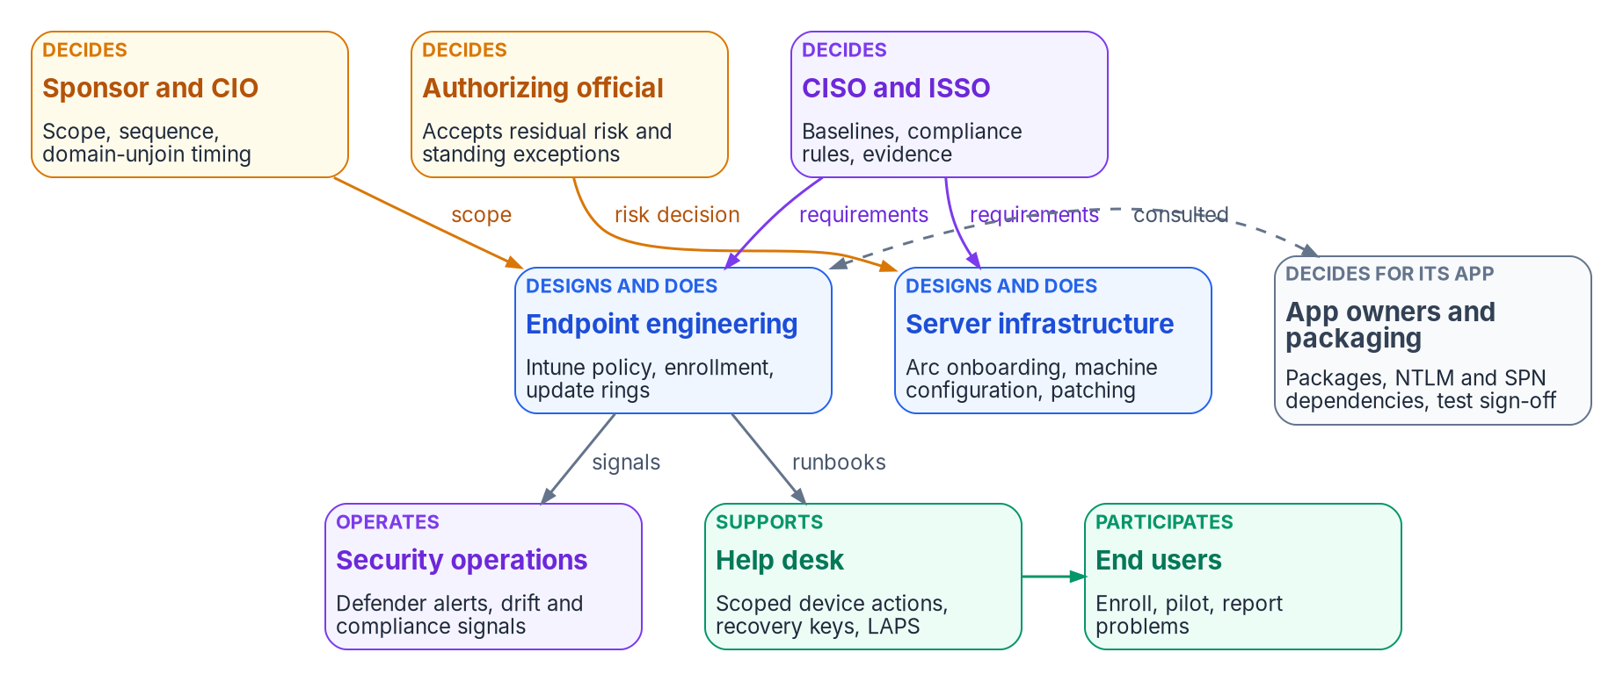
Who decides, who designs and does, and who operates and supports the endpoint.

Where the roles come from
The endpoint project charter sets the starting point. It names a project sponsor and a project lead, both still to be appointed, and four domain leads: device identity, Group Policy sunset, Conditional Access and NTLM (endpoint and device project charter). Those four domains are workstreams, not teams. Each one cuts across the teams below. Device identity needs the identity team and endpoint engineering. Group Policy sunset needs endpoint engineering, server infrastructure and the security office. Conditional Access is owned by the identity team under the CISO’s requirements. NTLM restriction can’t proceed without application owners. The program’s model gives each domain lead the job of driving the workstream and keeping its evidence. The decisions inside the workstream go to the deciders named in the matrix.
Chapter 05 supplies the other input: the path. On the manual path, the operator who runs a step also holds its change record. On the governed path, a recorded approval sits between the person who proposes a change and the change itself. The roles below are the same on both paths. What changes is whether the approval is recorded where the change happens.

Decision rights and work are different things
The program separates three kinds of involvement, as Book 02 does. A role decides when it is accountable for the outcome and can say no. A role does the work when it builds, configures or runs the thing. A role is consulted when the decision can’t be made well without its input, even though the decision isn’t its to make.
The split matters more for devices than for almost anything else, because Group Policy trained a generation of administrators to treat the ability to change something as the right to decide it. In Intune that habit is how an endpoint engineer ends up setting the agency’s risk posture by default. Setting a compliance grace period to 30 days is a risk decision. So is leaving a Group Policy setting in place alongside an Intune policy, or exempting a kiosk class from BitLocker. Each one is made in a console, by someone who may not know that a decision is being made.

The roles
The sponsor and CIO set scope, funding and sequence. In the program’s model they decide when the domain-unjoin waves happen, because unjoining ends the fallback every other team relies on, and they break ties between the endpoint and server teams. The charter treats domain unjoin as a separately sequenced decision outside the initial phase, and so does this book (Chapter 02).
The CISO and ISSO decide the control requirements the fleet has to meet. Those are the security baselines, the compliance rules a device must pass before Conditional Access trusts it, the update cadence for security patches, and the evidence an assessor will read. The ISSO assembles that evidence, tracks findings to closure, and is consulted on every change that alters a control.
The authorizing official accepts residual risk. For the endpoint, that means every standing exception: a device class excluded from a compliance rule, an application allowed to keep NTLM past the cutoff, a server that can’t take the baseline, a deferral longer than the agency’s policy allows. A temporary exception that nobody has reviewed in a year has become a risk acceptance. The program routes it to the authorizing official on a schedule, not just once.
Endpoint engineering designs and builds workstation management. It owns Intune configuration profiles and the settings catalog, compliance policies, enrollment (Group Policy–triggered for the existing fleet, Autopilot for new hardware), update rings, and the Group Policy retirement sequence in Chapter 08. Like identity engineering in Book 02, it’s the team most likely to be over-trusted, because it holds the roles that can change every device at once. The program’s answer is to give it least-privileged Intune roles and put a second approver in front of its high-impact changes, not to slow it down.
Server infrastructure owns the server side: Arc onboarding, tags, Azure machine configuration baselines, patching through Azure Update Manager or the agency’s existing tooling, and the decision record for each server’s eventual domain unjoin, which the sponsor schedules. It also owns the onboarding service principal. Microsoft makes the customer responsible for managing RBAC on Arc resources, rotating onboarding credentials and keeping the agent and extensions current.
Security operations receives what the fleet emits. That includes Defender for Endpoint alerts on workstations, Defender for Servers alerts on Arc servers, compliance state changes, and the drift findings from the program’s loop. Defender for Servers Plan 1 and Plan 2 both provide the capabilities of Defender for Endpoint Plan 2, including endpoint detection and response. Security operations is consulted on the baselines and on exceptions, because it’s the team that finds out when an exception gets used.
The identity team owns the Entra ID side of the device: device registration and hybrid join, Windows Hello for Business, Windows LAPS enablement in the tenant, and the Conditional Access policies that consume compliance state. Book 02 covers its migration-wide work, and Book 04 covers the access policy design. In this book it’s the team that turns a compliant device into an access decision.
Application owners and packaging decide for their applications. Packaging builds and tests the Intune app packages and the detection rules. Application owners know which of their applications still need NTLM, depend on an SPN, or depend on a Group Policy setting nobody else remembers. They’re the only people who can sign off a test result or accept a cutover window for their own application. The charter puts redesign of application packaging and software distribution out of scope for the initial phase. Application owners are in scope from day one anyway, because the NTLM audit and the Group Policy overlap inventory both end at their door.
The help desk supports users through enrollment and carries out device actions on request: retire, wipe, sync, BitLocker key recovery and local administrator password recovery. Intune’s built-in Help Desk Operator role can retire and wipe devices and run remote tasks, and Entra’s Helpdesk Administrator role can read LAPS metadata but not the password itself. In the program’s model, the help desk’s identity verification procedure before a wipe or a key release is a CISO decision, not a help desk decision.
End users enroll their devices, join pilot waves and report what breaks. As in Book 02, the program treats enrollment completion rates and help desk ticket volume as go/no-go inputs for each wave.

The responsibility matrix
D = decides (accountable) · R = does the work · C = consulted · blank = informed at most.
Decision or work item | Sponsor / CIO | CISO / ISSO | AO | Endpoint eng. | Server infra. | SecOps | Identity | App owners / packaging | Help desk | Users
Path choice: manual, governed or retrofit (Chapter 05) | D | C | C | C | C
Security baselines for workstations |  | D |  | R |  | C | C | C
Security baselines for servers (machine configuration) |  | D |  |  | R | C |  | C
Compliance policy rules and grace period |  | D |  | R |  | C | C |  | C
Conditional Access use of compliance state (Book 04) |  | D | C | C |  | C | R
Application deployment: packaging, assignment, supersedence |  | C |  | R |  |  |  | D, R |  | C
Update rings and deferral periods |  | D |  | R | R | C |  | C
Pausing a workstation ring after a bad update |  | C |  | D, R |  | C |  | C | C
Pausing server patching after a bad update |  | C |  |  | D, R | C |  | C
Group Policy setting retirement, per setting class (Chapter 08) |  | C |  | D, R | R |  | C | C
NTLM restriction stages, per application |  | C | C | R | R | C | C | D
Exceptions: temporary, with an end date |  | D |  | R | R | C |  | C
Exceptions: standing, or past the agency’s limit | C | C | D | R | R | C |  | C
Device retirement: retire, wipe, then directory cleanup |  | C |  | D, R |  |  | R |  | R | C
Server retirement: extensions, Arc disconnect, stale resources |  | C |  |  | D, R |  |  | C
Domain-unjoin wave timing (Chapter 02) | D | C | C | R | R |  | C | C | C
Help desk verification before wipe or key release |  | D |  | C |  | C | C |  | R
Drift findings and compliance evidence (Chapter 10) |  | D | C | R | R | R
Pilot and wave go/no-go | C | C |  | D | C | C | C | C | C | C
Three rows need comment. The update ring row splits deciding from doing, but the two pause rows don’t. Pausing a quality update ring is an operational emergency stop, so the team that runs the ring decides it and tells the security office. That is the scenario Microsoft’s update guidance describes: a problem shows up in the pilot ring and the administrator pauses the rollout. The application deployment row gives the decision to the application owner, not the endpoint team, because the endpoint team can push a package but can’t judge whether it works. The exception rows split on time. A temporary exception with an end date is a control decision the CISO can make. One that has no end date, or has outlived the agency’s limit, is a risk acceptance, and only the authorizing official can make it.

Notes on the rows that Microsoft’s tooling shapes
Compliance and its grace period. Every Intune compliance policy has a Mark device noncompliant action that defaults to zero days. The schedule can be set from 0 to 365 days, and Conditional Access acts on the device as soon as it’s marked noncompliant. Optional actions can email the user, lock the device, or add it to a retire list. An administrator must still retire a device on that list explicitly. The grace period is the security office’s decision because it sets how long a device that fails policy keeps access.
Update rings. Update ring policies in Intune set deferral periods, deadlines, restart behavior and notifications, and are commonly used to stage test, pilot and production rings. If devices are managed by Windows Autopatch, the service may create and maintain the rings itself, and Microsoft says administrators typically shouldn’t assign custom rings to those devices. Decide which model the agency uses before assigning ownership, because under Autopatch, endpoint engineering configures the Autopatch groups, not the rings.
Retirement. Device retirement is a sequence that spans three systems, and the order matters. Retire or wipe the device in Intune first. Retire removes company data and unenrolls the device but keeps personal content. Wipe resets the device to factory settings. Then clean up the Entra ID object. Microsoft’s guidance is to disable it for a grace period before deleting it, because deletion can’t be undone. Deleting the device also deletes its BitLocker recovery keys and its Entra-backed LAPS password, so back up any keys you may still need. For hybrid joined devices running Windows 10 or later, disable or delete the object in on-premises Active Directory and let sync carry the change. Deleting only the Entra object brings it back from sync as a new object in the Pending state. Retiring a server is a separate sequence. Remove the extensions, disconnect the agent, which deletes the Azure resource, and uninstall it. Servers decommissioned without that sequence leave stale Arc resources in the Disconnected state.

Three role systems, one access model
Decision rights don’t change what a console lets someone do. Roles do, and for the endpoint there are three separate role systems.
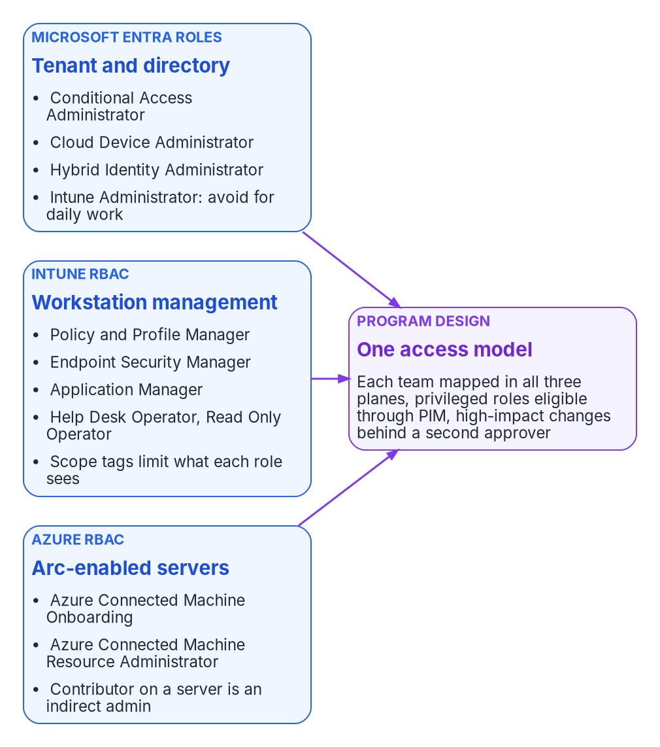
Endpoint permissions are granted in three separate role systems, which the program maps to one access model.
Microsoft Entra roles govern the tenant and the directory. The Intune Administrator role is a privileged Entra role with global read and write across Intune. Microsoft advises against using it, or Global Administrator, for routine Intune administration. Cloud Device Administrator can enable, disable and delete devices in Entra ID and read BitLocker keys, and nothing else on the device. Conditional Access Administrator manages Conditional Access.
Intune RBAC governs workstation management. Its built-in roles include Application Manager, Policy and Profile Manager, Endpoint Security Manager, Help Desk Operator, Read Only Operator and Intune Role Administrator. Intune Role Administrator is the only Intune role that can assign permissions to administrators. Scope tags limit which objects an administrator can see. Intune has supported unlicensed administrators since June 2021, but accounts created before that change, and administrators in nested groups, still need a license.
Azure RBAC governs Arc-enabled servers. Azure Connected Machine Onboarding can create and read Arc server resources but can’t manage extensions or delete servers. Azure Connected Machine Resource Administrator can read, modify, re-onboard and delete them. Microsoft warns that extensions can run arbitrary scripts in a privileged context, so anyone with Contributor on an Arc server resource should be treated as an indirect administrator of the server. That warning changes who should hold Contributor on server resource groups. In AD terms it’s the same as local administrator.
The program maps each team to the least-privileged role in each system it touches, makes privileged Entra roles eligible through Privileged Identity Management instead of permanent, and puts a second approver in front of high-impact changes.
Team | Microsoft Entra | Intune RBAC | Azure RBAC (Arc)
Endpoint engineering | None routinely; Intune Administrator only through PIM for tenant-level tasks | Policy and Profile Manager; Application Manager for app work | None
Server infrastructure | None routinely | None | Azure Connected Machine Resource Administrator on server resource groups; Onboarding role held only by the onboarding service principal
Security office and SecOps | Security Reader | Endpoint Security Manager for baselines and endpoint security policy; Read Only Operator for review | Reader, plus Defender for Cloud roles
Identity team | Conditional Access Administrator; Cloud Device Administrator for device lifecycle; Hybrid Identity Administrator for sync | Read Only Operator | None
Application packaging | None | Application Manager | None
Help desk | Helpdesk Administrator scoped to an administrative unit (LAPS metadata only) | Help Desk Operator, limited by scope tags | None
ISSO and assessors | Global Reader or Security Reader | Read Only Operator | Reader
Access to the local administrator password needs its own decision. In Entra ID, Cloud Device Administrator and Intune Administrator can read backed-up LAPS passwords by default. Helpdesk Administrator, Security Administrator and Security Reader can read only the metadata. A custom role can grant password read on its own if the agency has Entra ID P1 or P2. If the help desk needs to release local administrator passwords, give it a custom role with that one permission, not Cloud Device Administrator.

The second approver
Intune Multi Admin Approval lets an agency require a second administrator to approve changes to protected resources before Intune applies them. Protected resources can include app deployments, compliance policies, settings catalog policies, scripts, role assignments, and the wipe, retire and delete device actions. The requester can’t approve their own request. Changes submitted by a Global Administrator or Intune Administrator still need a different approver. Approvers must be in a security group that is directly assigned to an Intune role. In the program’s model, the security office owns the approver groups and endpoint engineering submits the requests. On the governed path, the approval becomes the L3 approval reference described in Chapter 05. On the manual path, it’s the cheapest way to get a recorded second pair of eyes without an orchestration platform.

What changes from Group Policy, in one table
Group Policy habit | What replaces it
Whoever can edit and link a GPO decides for the whole OU | Deciders by row in the matrix; doers hold least-privileged roles in three systems
Domain Admins can change anything, including every computer | Intune Administrator and Global Administrator kept out of daily work; privileged roles eligible, not permanent
Local administrator on a server is the server’s admin | Contributor on the Arc resource is also an admin, because extensions run with privilege
An exception is a GPO filtered away from one group | An exception is a record with an owner and an end date, reviewed by the CISO or accepted by the AO
Change history is the GPO version number | Intune and Azure audit logs, Multi Admin Approval records, and on the governed path the approval reference
Retirement is deleting the computer object | Retire or wipe, then disable, then delete, with key backup checked first

Continue the book
← Previous: Chapter 05 — The Governed, Manual and Retrofit Paths · Book index · Next: Chapter 07 — The GPO Sunset Program →

Chapter 07 — The GPO Sunset Program
The goal is to retire the legacy policy surface, not to reproduce it; the program is measured by GPOs retired with evidence, not by settings copied.

In this chapter
How the Federal Modernization Program runs the Group Policy sunset on the existing fleet: the seven steps from inventory to retirement, what Group Policy analytics can and can’t tell you, how each setting is classified and given a disposition, and how the work is sequenced by population. The coexistence rules that decide which policy wins while GPOs and Intune both touch a device, how GPOs are frozen, unlinked and retired, what the end state looks like, and the principles behind every step. The setting-by-setting mechanics belong to Chapter 08; the crosswalk is Appendix A.
Three related but distinct efforts touch Intune during modernization, and the program keeps them apart:
- Intune-first onboarding gives net-new devices their governance at procurement time, so they never depend on Group Policy at all. Chapter 04 covers it.
- The GPO sunset, this chapter, is the existing-fleet program. It replaces Group Policy Objects on endpoints that are already deployed and ends when those GPOs are formally retired.
- Regenerate, not copy is the philosophy that governs how replacement policies are authored. It isn’t a separate program. The Client-Server to Hybrid-Cloud series sets it out in Chapter 05, Policy Transformation.
The sunset sits between the other two. It inherits devices that onboarding never touched and applies the regenerate-not-copy philosophy to them, one population at a time. Chapter 01 explains why the work can’t be a migration in the literal sense. Microsoft’s own guidance for cloud-native Windows says the same: lifting and shifting existing Group Policy settings isn’t the preferred approach, and trying to assess every GPO and every setting is time-consuming and likely impractical. The guidance is to identify the mandatory settings, compare them with the available MDM settings, and treat the gaps as blockers. The program turns that advice into a repeatable sequence.
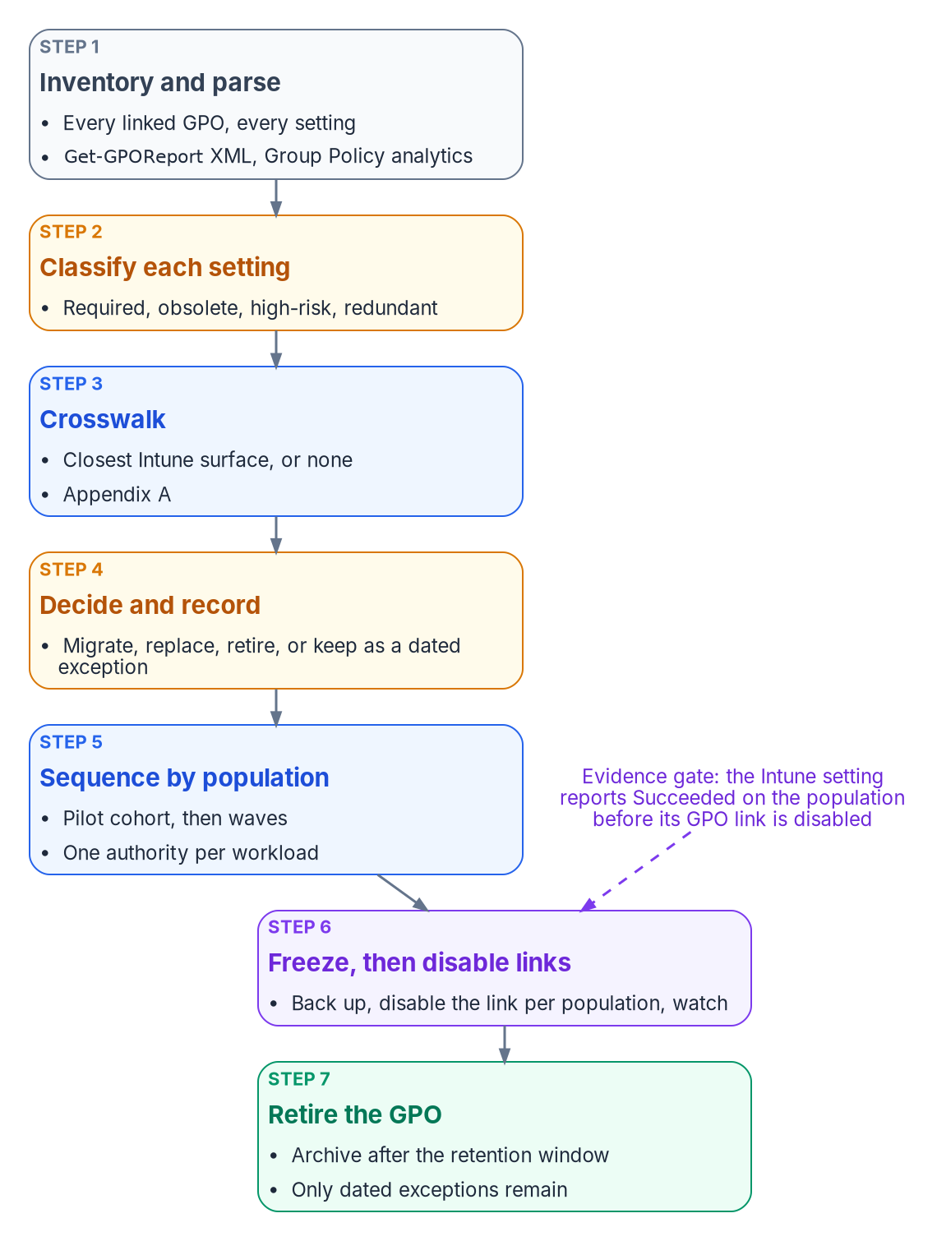
The GPO sunset pipeline: seven steps from inventory to retirement, with an evidence gate before any link is disabled.

The program at a glance
The program’s reference sequence has seven phases. Each one ends on an exit condition, and the next phase doesn’t start until that condition is met.
Phase | Focus | Exit condition
1 | Inventory and classify | Complete GPO and setting inventory; high-risk and obsolete settings identified
2 | Coexistence planning | Authority for each workload (Configuration Manager or Intune) decided; conflict risks documented
3 | Baseline policy authoring | Compliance, configuration and endpoint security baselines written for the target state, under regenerate-not-copy
4 | Pilot | A representative cohort receives the Intune policies while its GPOs are still linked; conflicts measured
5 | Workload cutover | Authority for each workload moves to Intune; the matching GPO links are disabled for that population
6 | Verification and residual cleanup | Residual GPO settings confirmed absent or deliberately retained; evidence collected
7 | Formal retirement | GPO objects retired, or retained only for documented exceptions; program closed
An earlier, illustrative version of the same seven-phase shape is worth keeping in mind because it names the GPO-level decision explicitly: inventory and assess; classify each GPO as retire, regenerate or retain temporarily; author replacements under regenerate-not-copy; pilot on a controlled cohort; expand with continuous validation; run a monitored coexistence period; and retire each GPO once the device-management policy owns its settings. That version described coexistence as “last writer wins.” It isn’t, as the coexistence rules below show: for settings in the Policy CSP, Group Policy wins unless MDMWinsOverGP is set; outside the Policy CSP, the outcome is a race with no guaranteed winner. Neither is something to monitor and accept.
For a large fleet the program runs for months, not weeks. The timeline depends on the size of the inventory, the co-management state of the fleet, and the number of exceptions. Chapter 08 breaks the phases into their technical tasks and durations. This chapter stays at the program level: the steps every phase draws on, and the rules that keep them honest.

Step 1: Inventory and parse
Nothing is translated or retired until it is inventoried. The parse extracts every setting from every linked GPO and records, at a minimum, the GPO name, the link path, the setting path, and the current value. Record the targeting as well, because it’s the part that doesn’t survive the move: security filtering, WMI filters, and whether the GPO is linked at all.
Get-GPOReport produces that raw material. It reports, for each GPO, its details, links, security filtering, WMI filtering, delegation, and computer and user configuration, in XML or HTML, for one GPO or for every GPO in the domain.
The PowerShell in this chapter is illustrative. It hasn’t been tested against a production forest. Review it, and run it first against a lab domain, before using it in production.
# Read-only. One XML report per GPO, which is the shape Group Policy analytics imports.
Import-Module GroupPolicy
$exportPath = 'C:\GPOInventory'
New-Item -ItemType Directory -Path $exportPath -Force | Out-Null
Get-GPO -All | ForEach-Object {
$file = Join-Path $exportPath ("{0}.xml" -f $_.Id)
Get-GPOReport -Guid $_.Id -ReportType Xml -Path $file
}
# Flag any report too large for a single Group Policy analytics import (4 MB per GPO).
Get-ChildItem $exportPath -Filter *.xml |
Where-Object Length -gt 4MB |
Select-Object Name, @{ Name = 'SizeMB'; Expression = { [math]::Round($_.Length / 1MB, 2) } }
The program’s GPO triage script, Invoke-GpoMigrationTriage.ps1, works on the same inventory. It sorts every live GPO onto a target plane, Intune for workstation-scope policy and Azure Arc for server-scope policy, using two classifiers run side by side (the operating systems predominant in the linked OUs, and the OU names), so that disagreements between them surface instead of hiding behind one guess. Server-scope GPOs leave this program for Chapter 09.

What Group Policy analytics adds
Group Policy analytics in Intune imports those XML exports and shows, for each GPO, the share of its settings that have a matching setting available to MDM providers, any settings it can’t analyze, whether the GPO is linked to an OU, and when it was last imported. Drilling into a GPO shows each setting with its category, value, user or device scope, minimum Windows build, the configuration service provider (CSP) behind it, and its OMA-URI path. The migration readiness report sorts every setting into Ready for migration, Not supported or Deprecated.
The tool has limits the program has to plan around:
- Size and encoding. A single GPO export can’t be larger than 4 MB, and files without proper Unicode encoding fail to import.
- What it parses. It reads the Policy, PassportForWork, BitLocker, Firewall and AppLocker CSPs and Group Policy preferences. Settings outside those appear as unknown settings.
- Language. Only non-ADMX settings in English are supported. A GPO with settings in another language produces an inaccurate MDM support percentage.
- Visibility. An imported GPO carries the scope tags chosen at import, or the Default tag. Administrators without one of those tags can’t see the import or migrate it.
- Freshness. Microsoft updates the mapping over time, and imported GPOs pick up the changes without being reimported. After you add or remove imports, the readiness report can take about 20 minutes to refresh.
Group Policy analytics can also create a settings catalog policy directly from an imported GPO. Microsoft describes that migration as best effort. Some settings move to a different setting with a similar effect, some fail and are reported in notifications, and firewall rules and AppLocker settings can’t be migrated this way at all; they belong in Endpoint security. When several imported GPOs set the same setting to different values, the migration stops and asks you to pick one. The program treats that last behavior as a useful by-product: it surfaces the GPO-on-GPO conflicts that OU precedence used to hide.
The program uses the readiness report as evidence that an equivalent exists, never as evidence that a setting is needed. A high MDM support percentage on a GPO full of obsolete settings is still a GPO full of obsolete settings. Microsoft’s own tip on the migrate feature is not to include all Group Policy settings without reviewing them.

Step 2: Classify each setting
Every setting in the inventory gets one tag.
Tag | Meaning | Typical action
Required | Still needed in the target operating model | Translate to a modern control
Obsolete | No longer relevant: an old Windows version, a retired product, a network assumption that no longer holds | Retire
High-risk | Weakens security or creates an operational hazard | Retire, or replace with a stronger control
Redundant | Already enforced by another control, another GPO, or a Windows default | Retire
A required setting then gets a disposition. The program asks four questions, in order, and the first “yes” decides where the setting lands:
- Is it still required in the target operating model? If not, retire it. Group Policy accumulated settings that existed only because Group Policy could set them.
- Does a native Intune equivalent exist? Most do, either in the settings catalog or in an Endpoint security policy.
- Does a cloud-native pattern remove the need for it? Folder redirection becomes OneDrive Known Folder Move; mapped printers become Universal Print; WSUS targeting becomes update rings. The pattern replaces the need, not the setting.
- Can a script enforce it and prove it? If so, it becomes a Remediation, and it is reviewed later for a native replacement.
A setting that fails all four becomes a dated exception, with an owner, a reason and a review date. Its GPO stays linked for that population and no other. For every disposition, also decide whether the control is a configuration (set it), a compliance requirement (evaluate it and feed Conditional Access), or both, and record what evidence will prove the control is in effect. Compliance policies evaluate the state that the configuration policies produce; they don’t replace them. Conditional Access and device-compliance-based access belong to Book 04.
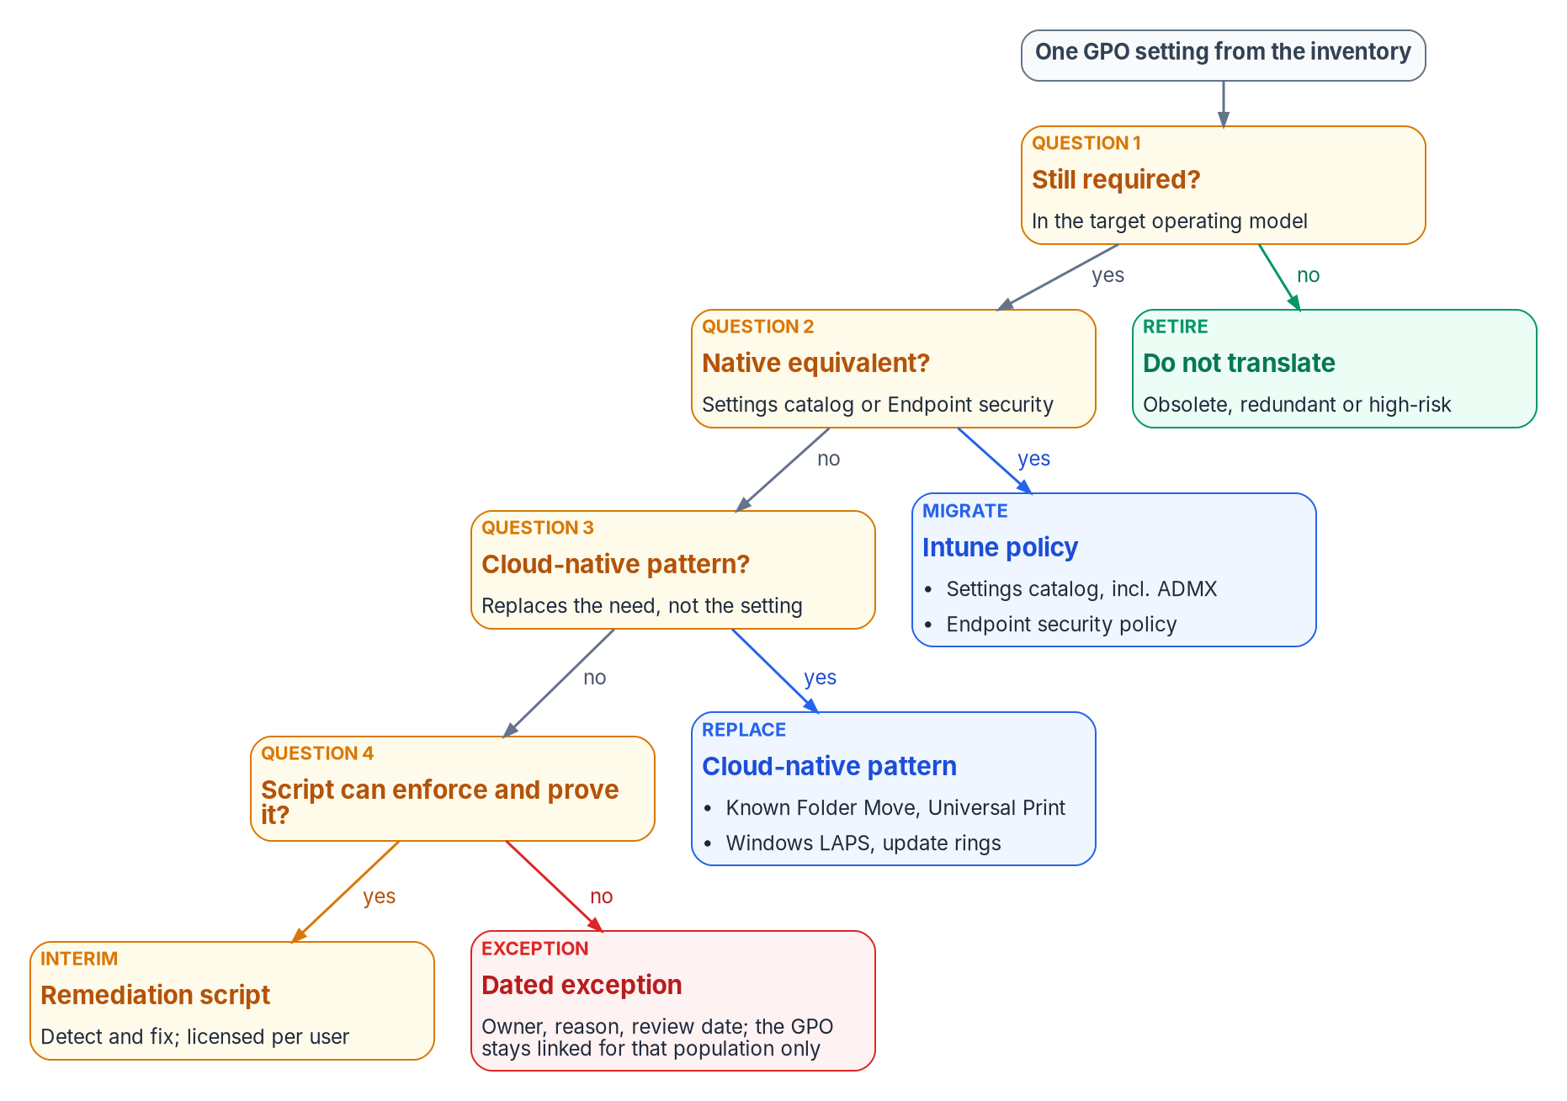
The disposition of one GPO setting: four questions, asked in order, decide where it lands.

The landing zones
The four questions send a required setting to one of four Intune surfaces.
Landing zone | What goes there | What to know
Settings catalog | Most Administrative Template (ADMX) and security settings | Lists thousands of Windows settings generated from the Windows CSPs, including built-in ADMX settings that need no OMA-URI. The older Administrative Templates profile type has been deprecated and read-only since the 2412 release.
Imported ADMX | Third-party and custom templates not built in | Public preview. At most 20 ADMX files of 1 MB or less, one ADML file per ADMX, en-us only, dependencies imported first.
Endpoint security | Antivirus, disk encryption, firewall, attack surface reduction, account protection (including Windows LAPS), EDR | Purpose-built security policies. Microsoft’s best practice is to manage a given setting through Endpoint security policies or security baselines, not both.
Remediations and platform scripts | Logic no CSP exposes | Remediations need users licensed for Windows Enterprise E3 or E5, Windows Education A3 or A5, or Windows VDA, and the tenant allows up to 200 script packages. Platform scripts run once per assignment, time out after 30 minutes, and rerun only when the script or policy changes.
Appendix A maps each Group Policy area to its landing zone, with the limits that apply.

Step 3: Crosswalk
The crosswalk answers one question per required setting: what is the closest Intune surface? It is a semantic translation reference, a lookup, not a prescription to reproduce every GPO setting one for one. It tells engineers where a control lands, not what value it should carry. The value comes from current policy intent: the compliance baseline, the persona model, the Conditional Access strategy and attribute-scoped targeting. Porting old values and OU-filter targeting into Intune reproduces old drift on a new surface.
Two crosswalk facts shape the plan more than any single row:
- The targeting model changes. On-premises policy is applied in local, site, domain and OU order, with later layers overwriting earlier ones. Intune has no hierarchy; policies apply to the groups they are assigned to. Every GPO link becomes an assignment (see the assignment strategy under Step 5).
- Some areas move to different CSPs. A GPO setting and its Intune equivalent can sit in different CSPs, and that decides how they behave during coexistence (see below).

Step 4: Decide and record
The output of the first three steps is a decision record per GPO and per setting. Each record holds the setting, its tag, its disposition (migrate, replace, retire, or exception), the target Intune policy and assignment, the evidence method, and an owner. The records feed the migration work in Chapter 08 and the access-policy work in Book 04. They are also what a reviewer reads when a setting goes missing after cutover: the record shows whether it was retired on purpose.
Each replacement policy carries four things: its target population, expressed as dynamic groups or filters derived from the attribute model; a setting table with intended values; the GPO settings it replaces; and how it will be verified.

Step 5: Sequence by population
The program moves populations, not settings. A pilot cohort, representative across tiers, regions and departments, receives the Intune policies while its GPOs are still linked. Then the program expands in waves. Within the work, high-risk and high-dependency settings are dealt with before broad rollout, so the riskiest changes are proven on the smallest population.

Assignment strategy
Populations are defined by attributes, not by OU placement. Every replacement policy is assigned through three layers:
- Include groups: dynamic device groups that match the policy’s intended tier, environment and role, built from the program’s attribute model.
- Exclude groups: break-glass groups for emergency override, and staging groups during a phased rollout.
- Assignment filters: rules on device properties, applied on top of the group assignment in include or exclude mode, and evaluated when the device enrolls or checks in.
Two Microsoft details shape the choice between them. Dynamic device group membership takes processing time before devices appear in the group, so for time-sensitive targeting Microsoft suggests assignment filters, which evaluate at check-in without waiting for membership. And filters can’t replace groups everywhere: Conditional Access and licensing need Entra group membership. A tenant can hold up to 200 assignment filters.

One authority per workload
Where Configuration Manager still manages the fleet, co-management is the mechanism for moving authority one workload at a time. Co-management supports seven workloads: compliance policies, Windows Update policies, resource access policies, Endpoint Protection, device configuration, Office Click-to-Run apps, and client apps. None has to move, and until a workload is switched, Configuration Manager keeps managing it. Each workload’s slider has three positions: Configuration Manager, Pilot Intune (only the devices in that workload’s pilot collection), and Intune (every co-managed device).
Workload | Starting point (GPO and Configuration Manager) | Pilot | End state
Compliance policies | Configuration Manager | Pilot Intune | Intune
Device configuration | Configuration Manager | Pilot Intune | Intune
Endpoint Protection | Configuration Manager | Pilot Intune | Intune
Windows Update policies | Configuration Manager | Pilot Intune | Intune
Four co-management facts change how the program sequences this:
- Device configuration carries two other workloads. Switching it also moves resource access and Endpoint Protection. A settings catalog policy is controlled by the device configuration slider regardless of what it contains.
- Resource access is gone as a separate workload. Configuration Manager stopped supporting its company resource access features and this workload in version 2203, and from version 2403 the slider is mandated to Intune.
- Pilot doesn’t clean up. With Pilot Intune selected for Endpoint Protection or device configuration, Intune deploys policies but doesn’t remove them on unassignment; removal needs the workload switched fully to Intune. Plan rollback on that basis.
- Exceptions can stay with Configuration Manager. After device configuration moves to Intune, a Configuration Manager configuration baseline can still be deployed to co-managed devices for a setting Intune doesn’t offer, if it is marked to apply even for co-managed clients. That is a legitimate home for a dated exception.

Coexistence: who wins
While a population has both GPOs and Intune policies, three conflict systems are in play. Chapter 01 explains why running both isn’t a safe middle ground; these are the rules the program plans against.
Conflict | What happens | Program rule
Compliance policy vs. compliance policy | The most restrictive setting applies. | Acceptable; verify the intended value
Compliance policy vs. configuration policy | The compliance policy’s setting takes precedence. | Keep compliance thresholds aligned with configured values
Configuration vs. configuration (settings catalog, Endpoint security, security baselines, templates) | All policy types have equal priority. The conflict is reported, and the setting might fail to apply until it is resolved manually. | Each setting is owned by exactly one Intune policy
GPO vs. MDM, settings in the Policy CSP | Group Policy keeps winning unless MDMWinsOverGP is set to 1. With it set, an MDM policy that has a Group Policy equivalent blocks the GP setting. | Set it where the population is in transition; remove the GPO copy as Intune takes the setting
GPO vs. MDM, settings in other CSPs | MDMWinsOverGP doesn’t apply, for example to the Defender CSP; Microsoft warns of a race condition with no guarantee which one wins. Windows Hello for Business, in the PassportForWork CSP, shouldn’t be configured through both at all. | Never configure these in both places; unlink first or exclude the population
GPO vs. MDM, Windows Update | Microsoft recommends IgnoreWindowsUpdateGroupPolicies over MDMWinsOverGP for update conflicts. It applies to Windows 11, version 24H2 with KB5101684 and later. | Use it on eligible builds; on older builds, unlink the update GPO when the workload moves
Configuration Manager vs. Intune | The co-management slider sets one authority per workload. | Never deploy Intune policies for a workload still on Configuration Manager
Two corrections to earlier program material are worth stating. Configuration profiles don’t resolve conflicts by “last write wins,” and Endpoint security policies don’t automatically take precedence over configuration profiles. Both are equal sources, and a conflict is a fault to fix, not a rule to rely on.

Freezing and unlinking GPOs
Disabling a GPO link is the moment the program changes production behavior, so it is gated.
- Freeze. Once a GPO is inventoried, its settings are under change control. Nobody adds settings to a GPO that is scheduled for retirement; new requirements go to Intune.
- Back up. Backup-GPO backs up one GPO or every GPO in a domain to an existing backup directory, and the GPMC restores from it.
- Prove the replacement. The Intune policy that owns each setting reports success on the target population, and the pilot showed no conflicts.
- Disable the link, not the GPO. Set-GPLink -LinkEnabled No turns off one link while leaving the GPO and its other links in place, so the change is scoped to one population and reverses with one command.
- Watch, then retire. After a retention window with no regressions, the GPO is archived and removed. The program’s reference plan disables rather than deletes, keeps the GPO for 90 days as a rollback safety net, and only then archives and deletes it. That window is a program design choice, sized to the fleet’s patch and refresh cycle.
# Back up, then disable one GPO link for one population's OU. Reversible with -LinkEnabled Yes.
$gpoName = 'FMP-Legacy-Workstation-Baseline'
$target = 'OU=Pilot-Workstations,DC=example,DC=gov'
Backup-GPO -Name $gpoName -Path '\\fileserver\GPOBackups' -Comment 'Pre-unlink, GPO sunset wave 1'
Set-GPLink -Name $gpoName -Target $target -LinkEnabled No
Unlinking doesn’t always undo what a GPO did. Group Policy preferences don’t remove their settings when a GPO stops applying, unless the item was configured with Remove this item when it is no longer applied. Drive maps, registry items, local users and groups, and scheduled tasks delivered as preferences stay on the device after the link is gone. Co-management has a matching trap: Intune doesn’t revert settings when policy is unassigned while the device configuration workload is still on Configuration Manager. So the decision record for every preference item states what clears it: an Intune policy that takes over the value, or a Remediation that removes it.

The end state
The program is done when:
- No GPO in scope is linked to an OU containing migrated devices. Devices that are Entra joined and not domain joined receive no domain GPOs at all. Hybrid-joined devices still process whatever remains linked to their OU, which is one reason Chapter 02 treats hybrid join as a trap rather than a destination.
- Every required setting has exactly one owner, an Intune policy, and that policy reports per-setting status.
- Every remaining GPO link is a dated exception in the register, with an owner and a review date.
- Every retired GPO has a backup and a decision record that explains its retirement.
- The workload sliders are at Intune, or Configuration Manager has been retired from the endpoint fleet.
Group Policy doesn’t vanish from the estate on that day. Domain controllers and servers that stay domain joined keep their GPOs until the server program moves them; Chapter 09 covers servers under Azure Arc. Chapter 10 covers how the fleet is evidenced once Intune is the authority.

Methodology principles
These principles govern every step above.
- Regenerate, don’t copy. The crosswalk says where a control lands. Current policy intent says what it should be.
- Retire before you translate. Obsolete, redundant and high-risk settings are retired, not carried forward. A smaller surface is the point of the program.
- One authority per setting. At any moment, each setting on each device has exactly one owner: a GPO, a Configuration Manager workload, or one Intune policy. Overlap is a defect.
- Target by attribute, not by placement. Assignments use dynamic groups and filters derived from the attribute model, never a reconstruction of the OU tree.
- Evidence before unlink. A GPO link is disabled only after the replacement reports success on that population.
- Disable before delete. Links are disabled, GPOs are backed up and retained, and deletion comes last.
- Exceptions expire. A setting with no modern home is an exception with an owner and a review date, not a permanent GPO.
- Measure the retired surface. Success is GPOs and links retired with evidence, not the number of settings migrated.

Continue the book
← Previous: Chapter 06 — Who Owns the Endpoint · Book index · Next: Chapter 08 — GPO to Intune Policy Migration →

Chapter 08 — GPO to Intune Policy Migration
A policy template is a starting position for a decision, not a copy of the GPO it replaces; every setting in it has to earn its place, its owner and its evidence.

In this chapter
The working detail of the GPO sunset that Chapter 07 runs as a program: the seven phases broken into tasks, durations, exit gates, rings, tests and rollback steps. Then the program’s policy library for the existing Windows fleet: how policies are typed, targeted and tagged, the five compliance policies, six configuration profiles, six endpoint security policies and two app protection policies, with the GPO paths they replace. The chapter closes with dynamic group and filter templates and Microsoft Graph templates for creating the policies as code; the setting-level crosswalk and CSP paths are in Appendix A.
Chapter 07 sets the rules: inventory before anything moves, one authority per setting, evidence before a GPO link is disabled, and disable before delete. This chapter is what an endpoint engineer works from inside those rules. It assumes the decision records from Chapter 07 exist, because a template is only applied to a setting that has been classified as required.
The scope is the existing Windows fleet: corporate-owned workstations, privileged access workstations and kiosks, plus personal devices that reach organizational data through app protection only. Two scope facts changed since the source material was written:
- Windows 10 is out of support. It reached end of support on October 14, 2025. Intune still treats it as an allowed version, so devices can enroll and use eligible features, but Microsoft no longer guarantees that functionality works. The templates below set Windows 11 as the floor; any Windows 10 device left in the fleet is an exception with an upgrade date.
- Windows Server doesn’t enroll in Intune. Intune manages Windows 11 client editions, not Windows Server; Microsoft describes Defender for Endpoint security settings management as the way to extend Intune endpoint security policy to devices that can’t enroll, and lists Windows Server 2025 among them. The source’s server compliance policy is therefore recast below as a server baseline that Chapter 09 carries through Azure Arc and Defender.
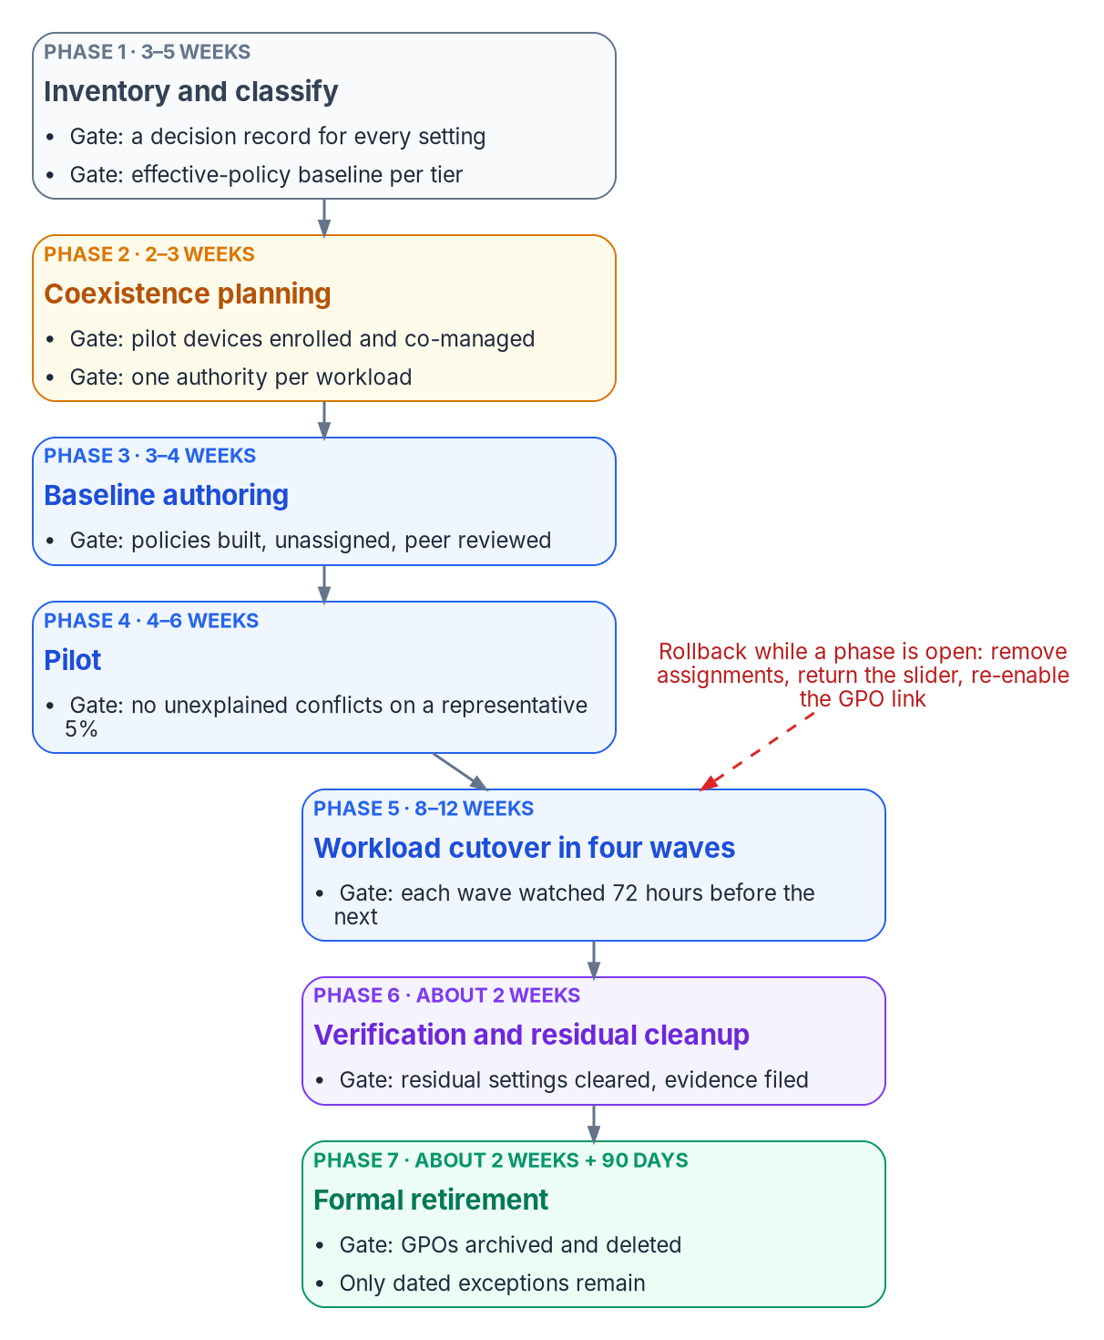
The seven phases of the migration, each closed by an exit gate, with the rollback that applies while the phase is open.

The seven phases at working level
The phases are the program’s seven from Chapter 07. The tasks, durations and gates come from the program’s reference plan for a large fleet. Durations are planning estimates for a fleet with an existing Configuration Manager estate; a fleet without one skips most of Phase 2.
Phase | Working tasks | Typical duration | Risk | Exit gate | Rollback while open
1. Inventory and classify | Export every GPO, import into Group Policy analytics, classify settings, capture the effective-policy baseline per tier | 3–5 weeks | Low (read-only) | A decision record for every setting; a baseline per device tier | None needed; delete Group Policy analytics imports if wanted
2. Coexistence planning | Enable co-management for the pilot collection, set workload sliders to Pilot Intune, decide MDMWinsOverGP per population | 2–3 weeks | Medium | Pilot devices enrolled, syncing, and still receiving the workloads not yet switched | Slider back to Configuration Manager; remove devices from the pilot collection
3. Baseline authoring | Build the policies in this chapter unassigned, in audit mode where one exists; create groups and scope tags; peer review | 3–4 weeks | Low (nothing assigned) | Every required setting owned by exactly one policy; review signed off | Delete the unassigned policies
4. Pilot | Assign to a representative cohort of about 5% with extended grace periods; GPOs stay linked | 4–6 weeks | Medium | No unexplained conflicts; application and user tests pass against the Phase 1 baseline | Remove the pilot assignments; GPOs keep applying
5. Workload cutover | Four waves by workload, each watched for 72 hours before the next | 8–12 weeks | Medium to high | Each wave’s settings report success on its population; GPO links for that workload disabled | Slider back for the affected workload; re-enable the GPO links
6. Verification and residual cleanup | Disable remaining links for migrated populations, clear tattooed preference items, collect evidence | About 2 weeks | Low if Phases 4–5 held | No migrated device processes an in-scope GPO; evidence filed | Re-enable the link for the affected population
7. Formal retirement | Disable GPOs, keep them 90 days, then back up, archive and delete; close the exception register | About 2 weeks of work, plus the 90-day window | Low | GPOs archived and deleted; only dated exceptions remain | Restore from backup and re-link
On those estimates the program reaches Phase 7 in roughly 34 weeks, with the last deletions about three months later. Phases 2 and 3 can overlap, because authoring doesn’t depend on co-management being live.

Phase 1: inventory and classify
- Export every GPO as XML and catalog its links, security filtering, WMI filters and settings. Chapter 07 gives the read-only export script; Get-GPOReport -All -ReportType Xml is the shape Group Policy analytics imports.
- Find GPO-on-GPO conflicts: the same setting written by more than one GPO at different OU levels. These are the conflicts OU precedence hid, and each needs a decision before Intune can own the setting.
- Import the XML into Devices > Group Policy analytics. For each GPO the report shows how many settings have an MDM equivalent and, per setting, the CSP and OMA-URI behind it. Use it to find the landing zone, never to decide whether a setting is still needed.
- Classify each setting using the four tags from Chapter 07 (required, obsolete, high-risk, redundant), and record what kind of equivalent exists: a direct Intune setting, a partial one that needs adapting, none (a custom OMA-URI, a Remediation or an exception), or deprecated in the cloud-native model.
- Capture the baseline: the effective policy per device tier, taken with gpresult on a sample of devices in each tier. Phases 4 and 5 test against it.

Phase 2: coexistence planning
Where Configuration Manager manages the fleet, enable co-management for a pilot collection and set the workloads you plan to move first to Pilot Intune. Confirm each pilot device’s join state and that it has synced with Intune recently, and confirm that the workloads still on Configuration Manager keep applying. Before switching any workload, the matching Intune policy must already be built, because a co-managed device synchronizes MDM policy as soon as the workload moves.
This is also where the program decides, per population, whether to set MDMWinsOverGP for the transition, and which settings must never be configured through both channels. Chapter 07 has the full rule set; it isn’t repeated here.

Phase 3: baseline authoring
Build every policy in this chapter, but assign none of them.
- Create attack surface reduction rules and controlled folder access in audit mode.
- Apply scope tags so delegated administrators see only their policies.
- Create the dynamic groups and filters from the templates later in this chapter.
- Peer review each policy against its decision records. The review checks two things: that every setting traces to a required setting in a decision record, and that no setting appears in two policies.

Phase 4: pilot
The pilot cohort is about 5% of the fleet, chosen to be representative across tiers, regions and departments.
- Assign the compliance policies to the pilot groups with a longer grace period than production; the program uses 7 days instead of 1. The grace period is the schedule on the Mark device noncompliant action, set in days from 0 to 365.
- Assign the configuration profiles and endpoint security policies to the same groups.
- Leave the GPOs linked. The pilot measures conflicts; it doesn’t remove them.
- Compare each device’s gpresult report with the Intune per-setting status for the same device. A setting that shows Conflict or Error in Intune, or a value in gpresult that differs from the Intune value, is a finding.
- Test the line-of-business applications and the user experience against the Phase 1 baseline, and log every issue and exception.

Phase 5: workload cutover in waves
Each wave moves one workload for the whole population, in rings: the pilot cohort first (already done in Phase 4), then about a quarter of the population, then the rest. The ring sizes are a program design choice; what matters is that each ring is watched before the next starts.
Wave | Weeks | Workload | Work
1 | 1–3 | Compliance policies | Move the compliance slider to Intune; assign CP-001 to CP-005 to production groups
2 | 4–6 | Endpoint Protection | Move the Endpoint Protection slider; assign ES-001 to ES-006; disable the matching GPO links per population
3 | 7–9 | Device configuration | Move the device configuration slider; assign SC-001, SC-003 to SC-005, SC-009 and SC-010; disable the matching GPO links per population
4 | 10–12 | Windows Update policies | Move the Windows Update slider; assign the update rings (Chapter 10); stop WSUS for migrated devices
The source plan moved device configuration before Endpoint Protection. That order doesn’t work on co-managed devices: switching the device configuration workload also moves Endpoint Protection and resource access, so the two can’t be separated once device configuration moves. Endpoint Protection goes first, on its own slider, and device configuration follows. After each wave, validate, watch for 72 hours, and only then start the next.

Phase 6: verification and residual cleanup
Disable the remaining GPO links for migrated populations, one population at a time, with the link procedure in Chapter 07. Then deal with what unlinking leaves behind: Group Policy preference items that weren’t set to remove themselves stay on the device, so each one needs an Intune setting that takes over the value or a Remediation that clears it.
The source plan also blocked inheritance on migrated OUs. The program doesn’t: blocking inheritance stops every higher-level GPO, including domain-level policy that hybrid-joined devices and exceptions still need, and it hides the remaining links rather than retiring them. Disabling specific links keeps the change scoped and reversible.

Phase 7: formal retirement
Disable each GPO object rather than deleting it and keep it for 90 days as a rollback net. After 90 days without a regression, back it up, archive the backup, and delete the GPO from Active Directory. Update the program’s documentation so Intune is recorded as the authority for every migrated setting, and close the exception register with an owner and review date on every entry that remains.

Testing at each gate
Gate | Test | Pass condition
Phase 1 | Group Policy analytics import and decision records | Every in-scope GPO imported; every setting tagged and given a disposition
Phase 3 | Peer review; a test ring of lab devices | No setting in two policies; lab devices report Succeeded for every setting
Phase 4 | gpresult against Intune per-setting status; application test scripts; user feedback | No unexplained Conflict or Error; no application regressions against the baseline
Phase 5, each wave | Per-setting status for the wave’s policies; help desk ticket volume | Success on the ring’s population; no rise in tickets attributable to the change during the 72-hour watch
Phase 6 | Device-side check that no in-scope GPO applies; preference-item inventory | No migrated device processes an in-scope GPO; every preference item cleared or owned
Phase 7 | Backup verification before deletion | Backup restores in a test domain or a GPMC restore test

Rollback
Rollback is defined for every phase before the phase starts. Three facts shape it:
- Pilot doesn’t clean up. With Pilot Intune selected for Endpoint Protection or device configuration, Intune deploys policies but doesn’t remove them when they are unassigned; removal needs the workload switched fully to Intune. Rolling a pilot back means reassigning a policy that sets the old value, not just removing the assignment.
- Moving a workload back has side effects. Microsoft notes that switching a workload back to Configuration Manager can leave some state behind; for example, Windows and Office stay at the later versions Intune installed.
- Disabled links come back with one command. Because Phase 5 and Phase 6 disable links rather than delete GPOs, the GPO path is restored by re-enabling the link for the affected population.

Policy architecture

Policy types
Policy type | Purpose | ID prefix | Where in the Intune admin center
Compliance policy | Defines the minimum security posture; Conditional Access consumes the result | CP-xxx | Devices > Compliance
Configuration profile (settings catalog) | Delivers device settings; replaces ADMX-backed GPO settings and many preferences | SC-xxx | Devices > Configuration
Endpoint security policy | Security-focused policy for antivirus, firewall, disk encryption, EDR, attack surface reduction and account protection | ES-xxx | Endpoint security > category
App protection policy | Protects organizational data inside managed apps, including on personal devices that aren’t enrolled | AP-xxx | Apps > App protection policies
App configuration policy | Pushes app-specific key and value settings to managed apps | AC-xxx | Apps > App configuration policies
Conflicts between these types follow Microsoft’s rules, not the ones in the source material. A compliance policy’s setting takes precedence over the same setting in a configuration policy, and between compliance policies the most restrictive value applies. Between configuration policies of any kind (settings catalog, endpoint security, security baselines) there is no precedence: the conflict is reported and must be resolved by hand, and the setting may not apply until it is. The source’s “last write wins” for profiles and “endpoint security wins over profiles” were both wrong. The program’s rule is the one in Chapter 07: each setting has exactly one owning policy.

The device attribute schema
Every policy is assigned to dynamic device groups built from attributes, which replaces OU-linked GPO scoping. Microsoft Entra dynamic membership rules for devices can use extensionAttribute1 through extensionAttribute15, but those values must be written to the Entra device object first, through Microsoft Graph. They aren’t the same attributes as the user extension attributes in Book 02, Appendix C; a device object has its own set.
The source material used two numberings for the same attributes. The program standardizes on the one its rules actually use:
Device attribute | Meaning | Example values
extensionAttribute1 | Region | EAST, WEST, CENTRAL
extensionAttribute3 | Department or function | Governance, Engineering, Finance
extensionAttribute11 | Security tier | Tier0, Tier1, Tier2
extensionAttribute12 | Device role | Kiosk, SharedDevice, Dedicated
extensionAttribute13 | Environment | Production, Staging, Dev
The values are written by the program’s provisioning process when a device is registered (see Chapter 04) and corrected by reconciliation in Chapter 10. A device with no tier value falls into no tier group, which is why the tenant-wide compliance setting in Chapter 10 marks unassigned devices as noncompliant.

Assignment strategy
- Include groups. Dynamic device groups that match the policy’s tier, environment and role.
- Exclude groups. Break-glass exclusion groups for emergency override, and staging groups during a phased rollout.
- Assignment filters. A second layer applied at assignment time. Filters can’t read device extension attributes. They work on Intune device properties such as deviceName, deviceOwnership, deviceTrustType, enrollmentProfileName, manufacturer, model, operatingSystemSKU and operatingSystemVersion. The source’s filters on extensionAttribute11 and extensionAttribute13 would not evaluate; attribute targeting belongs in the group rule, and filters handle hardware, ownership, join type and OS.
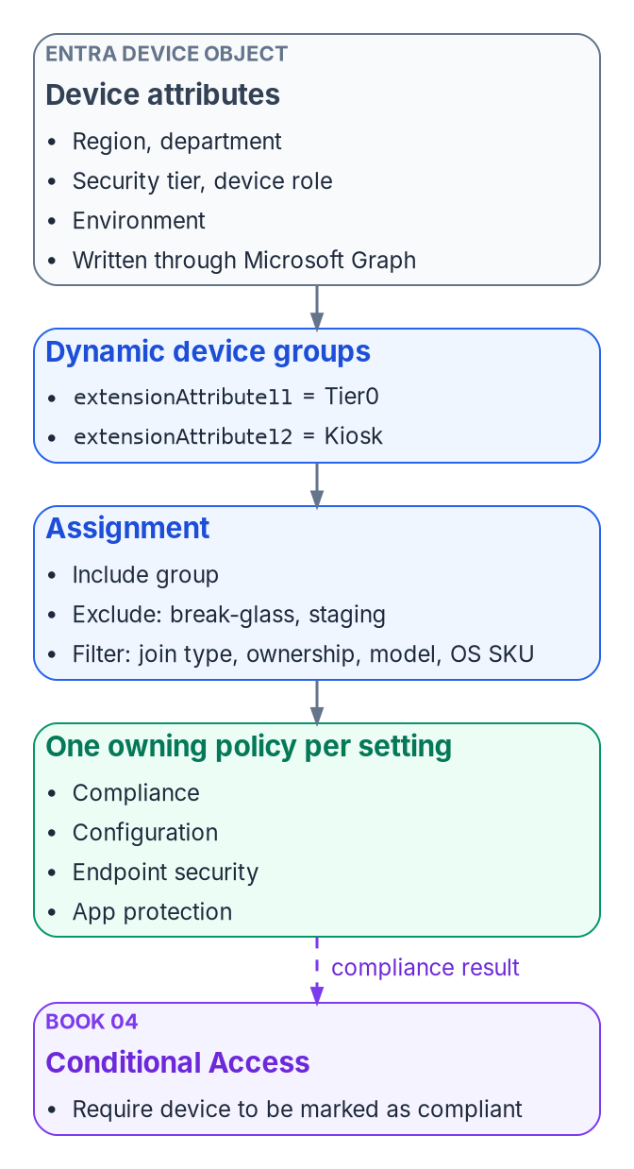
How a policy reaches a device: attributes drive dynamic groups, assignments add exclusions and filters, and the compliance result flows to Conditional Access.

Scope tags
Scope tags partition the admin center for delegated administration. Each policy carries one or more:
Scope tag | Covers | Assigned to
FMP-Global | Baseline policies for every device | CP-001, SC-001, ES-001 to ES-004
FMP-Tier0 | Privileged access workstation policies | CP-002, SC-009, ES-005, ES-006
FMP-Region-East | Region-specific variants | Region-scoped configuration profiles
FMP-Kiosk | Kiosk and shared devices | CP-005, SC-010

Choosing the authority per workload
Chapter 07 covers how the co-management sliders work. Which authority each workload should end with depends on the device and how it is used:
Criterion | Keep with Configuration Manager for now | Move to Intune
Device type | Servers, legacy Windows, on-premises kiosks | Windows 11 workstations, remote devices
Management model | On-premises, domain joined, managed network | Cloud native, Entra joined, or hybrid joined in transition
Connectivity | Always on the corporate network or VPN | Internet connected on any network
User type | On-site, manufacturing, lab | Remote, hybrid and mobile workers
Application complexity | Complex task sequences and multi-step installs | Standard apps, Win32-wrapped apps, Microsoft Store and Winget
The program’s recommended end state per workload, and the reference timing over a 12-month program:
Workload | Recommended authority | Months 1–3 | Months 4–6 | Months 7–9 | Months 10–12
Office Click-to-Run apps | Intune; usually the first to move | Move | Complete | — | —
Compliance policies | Intune; native Conditional Access integration | Build and pilot | Move | Complete | —
Endpoint Protection | Intune; one security surface | Build | Pilot | Move | Complete
Device configuration | Intune; settings catalog and OMA-URI | Build | Pilot | Move | Complete
Windows Update policies | Intune; no WSUS infrastructure | — | Build and pilot | Move | Retire WSUS
Resource access (Wi-Fi, VPN, certificates) | Intune; needs the certificate connector | — | Build | Pilot | Move
Client apps | Phased; complex apps may stay in Configuration Manager at first | — | — | Pilot | Phased move
Resource access is no longer a separate decision on current Configuration Manager versions, where its slider is fixed to Intune; Chapter 07 has the detail.

Compliance policies
Compliance policies define the minimum posture a device must meet before Conditional Access grants it access. Book 04 owns the Conditional Access policies that consume them. Three Microsoft facts shape every template in this section:
- Schedules are in days. Every noncompliance action is scheduled in days from 0 to 365, not hours. The source’s “24 hours” and “72 hours” are 1 and 3 days.
- Windows supports fewer actions. On Windows, the actions are Mark device noncompliant, Send email to end user and Add device to retire list. Remote lock and push notifications aren’t available for Windows. Adding a device to the retire list doesn’t retire it; an administrator has to retire it from that list. There is no separate “block access” action: blocking is what Conditional Access does with a noncompliant device.
- Health attestation settings are measured at boot. BitLocker, Secure Boot and code integrity are evaluated through Device Health Attestation, so a newly encrypted device needs a restart before it reports compliant.

CP-001: Windows workstation baseline
Platform: Windows 11 · Target: all corporate workstations · Group: devices where extensionAttribute11 is Tier0, Tier1 or Tier2. GPO equivalent: an aggregate of Security Settings, BitLocker, Defender and system health GPOs.
Category | Setting | Value | GPO equivalent
Device health | Require BitLocker | Require | Computer Configuration > Administrative Templates > Windows Components > BitLocker Drive Encryption
Device health | Require Secure Boot to be enabled | Require | None (UEFI firmware setting)
Device health | Require code integrity | Require | Computer Configuration > Administrative Templates > System > Device Guard
Device properties | Minimum OS version | 10.0.26100 (Windows 11, version 24H2) | None (WSUS or update policy decided the version)
System security | Firewall | Require | Computer Configuration > Windows Settings > Security Settings > Windows Defender Firewall
System security | Trusted Platform Module (TPM) | Require | None (hardware)
Defender | Antivirus | Require | Computer Configuration > Administrative Templates > Windows Components > Microsoft Defender Antivirus
Defender | Antispyware | Require | Same as antivirus
Defender | Real-time protection | Require | Microsoft Defender Antivirus > Real-time Protection
Defender | Microsoft Defender Antimalware security intelligence up to date | Require | Signature updates through WSUS or Configuration Manager
Password | Require a password to unlock | Require | Computer Configuration > Windows Settings > Security Settings > Account Policies > Password Policy
Password | Minimum password length | 14 | Account Policies > Password Policy
Password | Password type | Alphanumeric | Account Policies > Password Policy (complexity)
The minimum OS version is a correction. The source set Windows 10 22H2 and Windows 11 23H2. As of October 2026, Windows 11, version 23H2 Enterprise and Education receive updates only until November 10, 2026, and version 24H2 (build 26100) Enterprise and Education until October 12, 2027; version 25H2 is build 26200. The program sets 24H2 as the floor and raises it each year as versions leave servicing.
Action | Schedule | Notes
Mark device noncompliant | 1 day | The grace period before Conditional Access blocks access
Send email to end user | 1 day | Remediation steps and help desk contact, from a message template
Add device to retire list | 30 days | An administrator reviews the list and retires devices from it

CP-002: Tier 0 privileged access workstation (strict)
Platform: Windows 11 · Target: privileged access workstations · Group: extensionAttribute11 equals Tier0. All CP-001 requirements apply, with no grace period and these additions:
Category | Setting | Value | GPO equivalent
Device properties | Minimum OS version | 10.0.26200 (Windows 11, version 25H2) | None
Defender for Endpoint | Require the device to be at or under the machine risk score | Clear | None
Device health | Require BitLocker, Secure Boot and code integrity | Require (as CP-001) | As CP-001
The source listed Credential Guard, network inspection and cloud-delivered protection as compliance settings. Windows compliance policy doesn’t evaluate those; they are configuration, set in ES-006 and ES-001, and checked by the drift comparison in Chapter 10. The machine risk score replaces them as the compliance signal from Defender, which Microsoft lists among the Windows compliance settings.
Action | Schedule
Mark device noncompliant | 0 days (immediate)
Send email to the user, with the security team as additional recipients | 0 days
Add device to retire list | 7 days

CP-003: Tier 2 standard workstation
Platform: Windows 11 · Target: standard end-user workstations · Group: extensionAttribute11 equals Tier2.
Category | Setting | Value | Notes
Device properties | Minimum OS version | 10.0.26100 (Windows 11, version 24H2) | The source allowed Windows 10 21H2 for older hardware; that version is long out of support
Device health | Require BitLocker | Require | The source made BitLocker optional for personal devices; personal devices don’t receive this policy, they get AP-002
Defender | Antivirus | Require | —
Password | Minimum password length | 12 | Reduced from 14 for usability; a program decision
Password | Password type | Alphanumeric | —
System security | Firewall | Require | —
System security | TPM | Require | —

Action | Schedule
Mark device noncompliant | 3 days
Send email to end user | 3 days
Add device to retire list | 30 days

CP-004: server baseline (moved to Chapter 09)
The source defined CP-004 as an Intune compliance policy for Windows Server 2025 reached through Azure Arc. That can’t be built: Windows Server doesn’t enroll in Intune, and Intune compliance policies apply only to enrolled devices. The intent survives as a server baseline, delivered and evaluated through the server toolchain in Chapter 09:
Requirement | Value | Delivered through
OS version | Windows Server 2025 (build 26100) | Server inventory under Azure Arc
Defender | Microsoft Defender for Servers Plan 2 | Defender for Cloud; endpoint security policy through Defender for Endpoint security settings management
Firewall | On, all profiles | Endpoint security firewall policy through security settings management
Secure Boot | On | Machine configuration baseline (Chapter 09)
Noncompliance | Server admin team notified after 1 day; no automatic retirement | Alerting in Chapter 10
Security settings management has a licensing catch for servers: if the tenant’s only Defender for Endpoint entitlement comes through Defender for Servers, the feature isn’t available; at least one Defender for Endpoint user license must be active.

CP-005: kiosk and shared devices
Platform: Windows 11 · Target: kiosk and shared devices · Group: extensionAttribute12 equals Kiosk.
Category | Setting | Value
Device properties | Minimum OS version | 10.0.26100 (Windows 11, version 24H2)
Defender | Antivirus | Require
Defender | Real-time protection | Require
System security | Firewall | Require
The source’s “shared device mode” setting isn’t a Windows compliance setting; shared and kiosk behavior is configuration, set in a kiosk or shared multi-user device profile. Its “block access” action doesn’t exist either; marking the device noncompliant is what lets Conditional Access block it. Kiosks aren’t added to the retire list, because they are managed assets that get repaired, not retired.
Action | Schedule | Notes
Mark device noncompliant | 2 days | Grace for maintenance windows
Send email to the device owner group | 2 days | Kiosks have no individual user

Compliance summary
Setting | CP-001 baseline | CP-002 Tier 0 | CP-003 Tier 2 | Server baseline (Ch 09) | CP-005 kiosk
Minimum OS | Windows 11 24H2 | Windows 11 25H2 | Windows 11 24H2 | Windows Server 2025 | Windows 11 24H2
BitLocker | Require | Require | Require | Chapter 09 | —
Defender risk score | — | Clear | — | Defender for Servers | —
Password length | 14 | 14 | 12 | Chapter 09 | —
Grace period | 1 day | 0 days | 3 days | 1 day (alert) | 2 days
Retire list | 30 days | 7 days | 30 days | No | No

Configuration profiles (settings catalog)
Settings catalog profiles replace ADMX-backed Group Policy with cloud-delivered configuration. Each profile below maps the GPO paths to the settings that replace them. All are assigned to all corporate devices unless the profile says otherwise.
The source library also defined four settings catalog profiles for security settings: SC-002 (Defender Antivirus), SC-006 (BitLocker), SC-007 (Windows Firewall) and SC-008 (Windows LAPS). Each duplicated an Endpoint security policy that configured the same settings, and Microsoft’s guidance is to manage a given setting through one method, because duplicates across policy types conflict. The program moved their settings into ES-001, ES-002, ES-003 and ES-006, and retired the four IDs rather than reusing them. Appendix A maps the GPO settings to the Endpoint security IDs accordingly.

SC-001: Windows security baseline
Group: devices where extensionAttribute11 is Tier0, Tier1 or Tier2.

Account lockout
GPO path | GPO setting | Settings catalog | Value
Computer Configuration > Windows Settings > Security Settings > Account Policies > Account Lockout Policy | Account lockout threshold | Device Lock > Account Lockout Policy | 10 invalid attempts
Same | Account lockout duration | Device Lock > Account Lockout Policy | 15 minutes
Same | Reset account lockout counter after | Device Lock > Account Lockout Policy | 15 minutes
The three values travel as one string in the DeviceLock AccountLockoutPolicy setting, for example AccountLockoutDuration:15, AccountLockoutThreshold:10, ResetAccountLockoutCounterAfter:15, and the setting needs Windows 11, version 22H2 with KB5053657 or version 24H2 and later. The source mapped the threshold to DeviceLock/MaxDevicePasswordFailedAttempts, which is a different control. On an Entra-joined device this policy governs local accounts; sign-in lockout for Entra accounts is governed in Entra ID, which Book 02 covers.

Audit policy
GPO path | GPO setting | Settings catalog | Value
Computer Configuration > Windows Settings > Security Settings > Advanced Audit Policy Configuration > Logon/Logoff | Audit Logon | Auditing > Account Logon Logoff Audit Logon | Success and Failure
Same > Object Access | Audit File System | Auditing > Object Access Audit File System | Success and Failure
Same > Policy Change | Audit Policy Change | Auditing > Policy Change Audit Policy Change | Success and Failure
Same > Privilege Use | Audit Sensitive Privilege Use | Auditing > Privilege Use Audit Sensitive Privilege Use | Success and Failure

User rights assignment
GPO path | GPO setting | Settings catalog | Value
Computer Configuration > Windows Settings > Security Settings > Local Policies > User Rights Assignment | Deny log on locally | User Rights > Deny Local Log On | Guests
Same | Deny log on through Remote Desktop Services | User Rights > Deny Remote Desktop Services Log On | Guests, local accounts

Security options
GPO path | GPO setting | Settings catalog | Value
Computer Configuration > Windows Settings > Security Settings > Local Policies > Security Options | Interactive logon: Don’t display last signed-in | Local Policies Security Options > Interactive Logon Do Not Display Last Signed In | Enabled
Same | Interactive logon: Message text for users attempting to log on | Local Policies Security Options > Interactive Logon Message Text For Users Attempting To Log On | The organization’s approved system use notice
Same | Interactive logon: Message title for users attempting to log on | Local Policies Security Options > Interactive Logon Message Title For Users Attempting To Log On | NOTICE
The logon banner text is the organization’s approved notice. The source’s sample text is a placeholder, not approved wording.

SC-003: Microsoft Edge
Replaces GPO-delivered Internet Explorer and legacy Edge settings. The Internet Explorer 11 desktop application isn’t present on Windows 11; sites that still need it open in Edge’s IE mode, which Microsoft supports through at least 2029.
Settings catalog | Setting | Value | GPO equivalent
Microsoft Edge > Startup, home page and new tab page | Home page URL | The organization’s portal URL | Computer Configuration > Administrative Templates > Microsoft Edge > Startup, home page and new tab page
Same | Action to take on startup | Open a list of URLs | Same
Microsoft Edge > SmartScreen settings | Configure Microsoft Defender SmartScreen | Enabled | Microsoft Edge > SmartScreen settings
Same | Prevent bypassing Microsoft Defender SmartScreen prompts for sites | Enabled | Same
Microsoft Edge > Password manager and protection | Enable saving passwords to the password manager | Disabled | Microsoft Edge > Password manager and protection
Microsoft Edge > Extensions | Control which extensions cannot be installed | * (block all not allowed) | Microsoft Edge > Extensions
Same | Allow specific extensions to be installed | Organization-approved extension IDs | Same
Microsoft Edge > Proxy server | Proxy settings | System proxy or PAC file URL | Microsoft Edge > Proxy server
Microsoft Edge | Allow download restrictions | Block dangerous downloads | Microsoft Edge
Microsoft Edge | Configure Internet Explorer integration | Internet Explorer mode, with the enterprise site list | Internet Explorer settings (retired)

SC-004: OneDrive
Replaces GPO Folder Redirection and logon-script drive maps with OneDrive Known Folder Move and Files On-Demand.
Settings catalog | Setting | Value | GPO equivalent
OneDrive | Silently move Windows known folders to OneDrive | Enabled, with the tenant ID | Computer Configuration > Administrative Templates > OneDrive
OneDrive | Known folders: Desktop, Documents, Pictures | Move | User Configuration > Windows Settings > Folder Redirection
OneDrive | Prompt users to move Windows known folders to OneDrive | Enabled | None
OneDrive | Use OneDrive Files On-Demand | Enabled | None (new capability)
OneDrive | Limit the sync app upload rate to a percentage of throughput | 70% during the move, then off | None
OneDrive | Prevent users from syncing personal OneDrive accounts | Enabled | Computer Configuration > Administrative Templates > OneDrive

Folder Redirection to a file share doesn’t move by itself
The source said Known Folder Move would carry redirected folders from the network share into OneDrive. It doesn’t. Known Folder Move doesn’t work while Windows Folder Redirection still points Documents, Pictures or Desktop somewhere other than OneDrive. Where the folders are redirected to a network share, Microsoft’s sequence is: copy the share contents into each user’s OneDrive with Migration Manager, disable the Folder Redirection policy while leaving the content on the share, then enable Known Folder Move, which merges with the copied folders. Microsoft also recommends moving no more than 1,000 existing devices a day, and 4,000 a week, with the silent policy. Provision OneDrive storage before the move. Replace net use drive-map logon scripts with SharePoint libraries and OneDrive shortcuts.

SC-005: Windows updates
Replaces WSUS-targeting GPOs with Windows Update client policies (the current name for what the source called Windows Update for Business policies), delivered as an Intune update ring.
GPO equivalent: Computer Configuration > Administrative Templates > Windows Components > Windows Update.
Setting | Value | Notes
Quality update deferral period (days) | 7 | Range 0–30
Feature update deferral period (days) | 0 | A feature update policy pins the version instead; the source’s 30-day deferral applies only without one
Windows drivers | Allow | Driver approvals in Chapter 10
Delivery Optimization download mode | 1 (HTTP blended with peering behind the same NAT)
Active hours | 07:00 to 19:00 | —
Use deadline settings | Allow | —
Deadline for quality updates (days) | 7 | Range 2–30
Deadline for feature updates (days) | 14 | Range 2–30
Grace period (days) | 2 | Range 0–7; replaces the source’s separate 48-hour auto-restart setting
Chapter 10 sets these per ring and covers Windows Autopatch, which can create and maintain the rings itself.

SC-009: Remote Desktop
Group: extensionAttribute11 equals Tier0 or Tier1. GPO equivalent: Computer Configuration > Administrative Templates > Windows Components > Remote Desktop Services.
Settings catalog | Setting | Value
Remote Desktop Services > Connections | Allow users to connect remotely | Enabled
Remote Desktop Services > Security | Require user authentication for remote connections by using Network Level Authentication | Enabled
Remote Desktop Services > Security | Set client connection encryption level | High
Remote Desktop Services > Session Time Limits | Set time limit for active but idle sessions | 15 minutes
Same | Set time limit for active sessions | 4 hours
Same | End session when time limits are reached | Enabled
User Rights | Allow log on through Remote Desktop Services | FMP-RDP-Users group

SC-010: user experience
Replaces GPO Start layout, wallpaper and lock screen policies.
Settings catalog | Setting | Value | GPO equivalent
Start | Start layout | A layout pinning line-of-business apps, Microsoft 365 apps and Edge | Computer Configuration > Administrative Templates > Start Menu and Taskbar > Start Layout
Personalization | Desktop image | Organization wallpaper, staged by a Win32 app | User Configuration > Administrative Templates > Desktop > Desktop Wallpaper
Personalization | Lock screen image | Organization lock screen | Computer Configuration > Administrative Templates > Control Panel > Personalization
Start | Taskbar pinned apps | Edge, Outlook, Teams, File Explorer | Start Menu and Taskbar
Experience | Windows Spotlight | Disabled | User Configuration > Administrative Templates > Windows Components > Cloud Content
Experience | Allow Windows consumer features | Block | Computer Configuration > Administrative Templates > Windows Components > Cloud Content
Windows 11 limits how much of Start and the taskbar MDM can customize, and Microsoft documents the supported CSPs separately for each; test the layout on the pilot ring.

Endpoint security policies
Endpoint security policies live under Endpoint security in the Intune admin center. They are security-focused profiles, but they aren’t a higher-priority source: they have the same standing as configuration profiles when the two conflict. In the program’s library they own every Defender, BitLocker, firewall, account protection and LAPS setting.

ES-001: antivirus
Replaces the Microsoft Defender Antivirus GPOs, and absorbs the source’s SC-002 profile.
Setting | Value | GPO path | Notes
Real-time protection | On | Computer Configuration > Administrative Templates > Windows Components > Microsoft Defender Antivirus > Real-time Protection | Compliance (CP-001) checks it; ES-001 sets it
Cloud-delivered protection | On | Same > MAPS | —
Cloud block level | High | Same > MAPS | Values: Default, High, High plus, Zero tolerance
Cloud extended timeout | 50 seconds | Same > MAPS | Adds up to 50 seconds to the normal 10-second check, so 50 is the maximum
Submit samples consent | Send safe samples automatically | Same > MAPS | See below
PUA protection | On | Microsoft Defender Antivirus | —
Network protection | Enabled (block mode) | Microsoft Defender Exploit Guard > Network Protection | —
Controlled folder access | Audit mode, then enabled in phases | Microsoft Defender Exploit Guard > Controlled Folder Access | —
Tamper protection (Windows Security experience profile) | On | None | Needs devices onboarded to Defender for Endpoint (Plan 1 or 2)
Full scan | Sunday, 02:00 | Microsoft Defender Antivirus > Scan | —
Quick scan | Daily, 12:00 | Same | —
Process exclusions | Line-of-business executables | Microsoft Defender Antivirus > Exclusions | Organization-specific; maintained list
Path exclusions | Line-of-business data directories | Same | Keep to a minimum
Extension exclusions | Only as required by line-of-business apps | Same | Justify each one
The source table said “send all samples automatically” while its JSON sent the value for safe samples. The program uses safe samples (value 1). Sending all samples (value 3) can upload documents that contain organizational data, so it is an explicit decision for the data owner.
Tamper protection through Intune needs the device onboarded to Defender for Endpoint, and Microsoft doesn’t support managing it this way on co-managed devices. On a co-managed device it waits until the Endpoint Protection workload has moved.

Exclusion hygiene
Every antivirus exclusion widens the attack surface. Record the business reason for each exclusion, review the list quarterly, and remove exclusions for retired applications. Never exclude common executable and script types (.exe, .dll, .ps1, .bat, .cmd).

ES-002: disk encryption
Replaces the BitLocker Drive Encryption GPOs (Computer Configuration > Administrative Templates > Windows Components > BitLocker Drive Encryption), and absorbs the source’s SC-006 profile.
Setting | Value | Notes
Require device encryption | Required | —
Encryption method, operating system and fixed drives | XTS-AES 256-bit | —
Startup authentication | TPM only for standard and kiosk devices; TPM with PIN for Tier 0 | Two policies, one per group
Minimum startup PIN length | 6 digits (Tier 0 policy only) | —
Removable drives | Deny write access to drives not protected by BitLocker | —
Recovery key escrow | Microsoft Entra ID, required before encryption | Keys stored on the device object
Recovery password rotation | Refresh on Entra-joined devices | A new recovery password after each use
Silent encryption | On, standard and kiosk policy only | —
Reporting | Devices > Monitor > Encryption report | —
The source combined silent encryption with a required TPM and PIN for every device. Those can’t coexist: silent BitLocker requires that devices don’t need a TPM startup PIN or startup key, because both need user interaction. The program splits them. Standard and kiosk devices encrypt silently with TPM-only protectors; Tier 0 devices, which are provisioned by hand, use TPM plus PIN. The two groups get separate disk encryption policies, so the settings never conflict on one device.
With silent encryption, recovery keys go to Entra ID automatically, which needs the device to be Entra joined. Chapter 10 covers the operational catch: deleting a device object in Entra ID deletes its recovery keys.

ES-003: firewall
Replaces the Windows Defender Firewall with Advanced Security GPOs (Computer Configuration > Windows Settings > Security Settings), and absorbs the source’s SC-007 profile and the firewall rows of its SC-001 baseline.
Profile | State | Inbound default | Outbound default | Log dropped packets | Log successful connections
Domain | On | Block | Allow | Yes | Yes
Private | On | Block | Allow | Yes | No
Public | On | Block | Block | Yes | Yes
The source’s two profiles disagreed on the public profile’s outbound default (Allow in SC-001, Block in SC-007). With one owner the question has one answer; the program blocks outbound on public networks and allows the management and line-of-business rules it needs.
Rule | Protocol | Port | Source | Action | Profile
WinRM (HTTP) | TCP | 5985 | Tier 0 management subnet | Allow | Domain
WinRM (HTTPS) | TCP | 5986 | Tier 0 management subnet | Allow | Domain
RDP | TCP | 3389 | Tier 0 privileged access workstation subnet only | Allow | Domain
ICMP echo request | ICMPv4 | — | Management subnet | Allow | Domain
Line-of-business applications | Per application | Per application | Per application | Allow | As required
On an Entra-joined device that isn’t domain joined, the domain profile doesn’t apply, so the management rules need a private-profile equivalent scoped to the same source subnets. Group Policy analytics can’t migrate firewall rules; they are built here by hand.

ES-004: endpoint detection and response
Setting | Value | Notes
Microsoft Defender for Endpoint client configuration package type | Auto from connector | Needs the Intune–Defender for Endpoint connection
Sample sharing | All | Matches the program’s Defender data-handling decision
The source listed four more settings for this policy. Telemetry reporting frequency is deprecated and has no effect on new devices. Automated investigation level, live response and web content filtering aren’t EDR policy settings in Intune; they are configured in the Microsoft Defender portal, and Chapter 10 sets them there.

ES-005: attack surface reduction
Deployment: all rules in audit mode for 30 days, then block after confirming no business-critical impact.
Rule GUID | Rule | Phase 1 | Phase 2
56a863a9-875e-4185-98a7-b882c64b5ce5 | Block abuse of exploited vulnerable signed drivers | Audit | Block
e6db77e5-3df2-4cf1-b95a-636979351e5b | Block persistence through WMI event subscription | Audit | Block
be9ba2d9-53ea-4cdc-84e5-9b1eeee46550 | Block executable content from email client and webmail | Audit | Block
d4f940ab-401b-4efc-aadc-ad5f3c50688a | Block all Office applications from creating child processes | Audit | Block
d3e037e1-3eb8-44c8-a917-57927947596d | Block JavaScript or VBScript from launching downloaded executable content | Audit | Block
5beb7efe-fd9a-4556-801d-275e5ffc04cc | Block execution of potentially obfuscated scripts | Audit | Block
92e97fa1-2edf-4476-bdd6-9dd0b4dddc7b | Block Win32 API calls from Office macros | Audit | Block
9e6c4e1f-7d60-472f-ba1a-a39ef669e4b2 | Block credential stealing from the Windows local security authority subsystem | Audit, or straight to block | Block
d1e49aac-8f56-4280-b9ba-993a6d77406c | Block process creations originating from PSExec and WMI commands | Audit | Block, except where Configuration Manager manages the device
b2b3f03d-6a65-4f7b-a9c7-1c7ef74a9ba4 | Block untrusted and unsigned processes that run from USB | Audit | Block
3b576869-a4ec-4529-8536-b80a7769e899 | Block Office applications from creating executable content | Audit | Block
75668c1f-73b5-4cf0-bb93-3ecf5cb7cc84 | Block Office applications from injecting code into other processes | Audit | Block
7674ba52-37eb-4a4f-a9a1-f0f9a1619a2c | Block Adobe Reader from creating child processes | Audit | Block
c1db55ab-c21a-4637-bb3f-a12568109d35 | Use advanced protection against ransomware | Audit | Block
The source’s twelve GUIDs are correct. The program adds the first two, which Microsoft classes as standard protection rules alongside the LSASS rule. Microsoft’s rule reference adds four rollout notes: the PSExec and WMI rule shouldn’t be enabled on devices Configuration Manager manages, because its client depends on WMI; the LSASS rule adds nothing where LSA protection and Credential Guard are on; the LSASS rule produces a large volume of audit events that are almost all safe to ignore, so you can skip audit for it and start blocking on a small set of devices; and the ransomware and obfuscated-script rules need cloud-delivered protection.

ES-006: account protection
Absorbs the source’s SC-008 Windows LAPS profile.
Setting | Value | Target
Credential Guard | Enabled with UEFI lock | Tier 0 (extensionAttribute11 equals Tier0)
Credential Guard | Enabled without lock | Tier 1 and Tier 2
Windows Hello for Business | Required | All devices
Windows Hello for Business minimum PIN length | 6 | All devices
Biometrics | Allowed | All devices
Credential Guard needs Windows Enterprise or Education; it isn’t available on Windows Pro. From Windows 11, version 22H2 it is on by default, without UEFI lock, on devices that meet the license and hardware requirements and haven’t been configured to disable it. The Tier 0 policy adds the UEFI lock, which means it can’t be turned off remotely afterward. Windows Hello for Business must be configured through Intune or Group Policy, never both; Chapter 07 explains why. Book 02, Chapter 10 covers Windows Hello for Business as part of phishing-resistant sign-in.

Windows LAPS (local admin password solution profile)
Replaces the LAPS GPO (Computer Configuration > Administrative Templates > System > LAPS).
Setting | Value
Backup directory | Microsoft Entra ID (Entra-joined devices); Active Directory for hybrid-joined devices still in transition
Password complexity | Large letters, small letters, numbers and special characters
Password length | 24 characters
Password age (days) | 30
Post-authentication actions | Reset the password and sign out the managed account
Post-authentication reset delay (hours) | 8
Administrator account name | Default (built-in Administrator)
The post-authentication delay can be 0 to 24 hours, where 0 turns the actions off; 24 is the default. The program shortens it from the source’s 24 to 8 so a disclosed password doesn’t outlive a working day. Intune manages Windows LAPS through endpoint security account protection policy and can back passwords up to Entra ID or Active Directory; on Windows 11, version 24H2 and later, automatic account management can also randomize the managed account’s name. The source listed Windows Server 2025 as a target; servers don’t enroll, so server LAPS stays with the server toolchain in Chapter 09.

App protection policies

AP-001: Microsoft 365 apps on iOS and Android
Type: app protection policy · Target: Outlook, Teams, OneDrive, SharePoint, Word, Excel, PowerPoint and Edge on iOS and Android.
The source wrote AP-001 for Windows with enrollment. That doesn’t exist: on Windows, app protection applies to Microsoft Edge only, and only on devices that aren’t MDM enrolled or Entra joined; if a device is managed, Windows MAM enrollment is blocked. Enrolled Windows devices get their data protection from the configuration and compliance policies above. AP-001 therefore targets the mobile Microsoft 365 apps.
Category | Setting | Value
Data transfer | Send org data to other apps | Policy-managed apps
Data transfer | Receive data from other apps | Policy-managed apps
Data transfer | Save copies of org data | Block
Data transfer | Allow user to save copies to selected services | OneDrive for work or school, SharePoint
Data transfer | Restrict cut, copy and paste between other apps | Policy-managed apps with paste in
Data transfer | Screen capture and Google Assistant (Android) | Block
Encryption | Encrypt org data | Require
Conditional launch | Minimum OS version | The current major version minus one

AP-002: Edge on personal Windows devices, and BYOD mobile
Type: app protection policy without enrollment · Target: Microsoft Edge on personal Windows devices, and the AP-001 apps on personal iOS and Android devices.
Category | Setting | Value
Access (mobile) | PIN for access | Require, 6 digits
Access (mobile) | Biometrics instead of PIN | Allow
Conditional launch | Offline grace period | 90 days, then wipe org data
Conditional launch | Jailbroken or rooted devices | Block access
Conditional launch | Maximum PIN attempts | 5, then wipe org data
Conditional launch | Minimum app version | The latest version minus one
Health checks (Windows) | Maximum allowed device threat level | Set from the Windows Security Center connector
Data transfer | Same as AP-001 | —
A Conditional Access policy that requires an app protection policy makes these protections mandatory; Book 04 owns it.

The translation reference and CSP paths
The setting-level lookup card that accompanied this library (fifty common GPO settings, each with its closest Intune surface and the program policy that owns it) and the CSP paths behind the key settings are in Appendix A, with the policy IDs used in this chapter. The appendix is a reference, not a prescription: it says where a required setting lands, and the regenerate-not-copy philosophy in Client-Server to Hybrid-Cloud, Chapter 05 decides its value.
Three corrections from the source carry through both documents. Account lockout maps to the DeviceLock AccountLockoutPolicy setting, not MaxDevicePasswordFailedAttempts. Logon auditing sits under Audit/AccountLogonLogoff_AuditLogon, not an AccountLogon_ path. And the Defender, BitLocker, firewall and LAPS rows map to the Endpoint security policies ES-001, ES-002, ES-003 and ES-006, not to settings catalog profiles. For a setting with no surface at all, a custom OMA-URI profile delivers it by CSP path; Intune doesn’t validate a custom payload, so record its owner like any other policy.

Dynamic group and filter templates

Illustrative, not tested against a production tenant
The scripts and payloads in this chapter are illustrative. They haven’t been tested against a production tenant. Review every name, rule and value, and run them first against a test tenant.
The groups below use the device attribute schema. GCC (Moderate) tenants use the worldwide Microsoft Graph endpoint, https://graph.microsoft.com; GCC High uses https://graph.microsoft.us and DoD https://dod-graph.microsoft.us. Intune in GCC is the same service instance as commercial Intune, so the admin center is intune.microsoft.com.

Writing a device attribute
Dynamic rules can only match values that exist on the device object, so the provisioning process writes them first.
# Requires Device.ReadWrite.All. $deviceObjectId is the Entra device object ID, not the device ID.
Connect-MgGraph -Scopes 'Device.ReadWrite.All'
$params = @{
extensionAttributes = @{
extensionAttribute11 = 'Tier0'
extensionAttribute13 = 'Production'
}
}
Update-MgDevice -DeviceId $deviceObjectId -BodyParameter $params

Tier groups
Connect-MgGraph -Scopes 'Group.ReadWrite.All'
$tiers = @(
@{ Name = 'FMP-Devices-Tier0'; Value = 'Tier0'; Description = 'Tier 0 privileged access workstations' }
@{ Name = 'FMP-Devices-Tier1'; Value = 'Tier1'; Description = 'Tier 1 devices' }
@{ Name = 'FMP-Devices-Tier2'; Value = 'Tier2'; Description = 'Tier 2 standard end-user workstations' }
)
foreach ($tier in $tiers) {
New-MgGroup -DisplayName $tier.Name `
-Description $tier.Description `
-MailEnabled:$false `
-MailNickname ($tier.Name.ToLower()) `
-SecurityEnabled:$true `
-GroupTypes @('DynamicMembership') `
-MembershipRule "(device.extensionAttribute11 -eq `"$($tier.Value)`")" `
-MembershipRuleProcessingState 'On'
}
The source labeled the Tier 1 group “Azure Arc–enrolled servers.” Servers don’t appear in Intune device groups as enrolled devices; Tier 1 here means client devices in Tier 1, and Chapter 09 groups servers through Azure Arc.

Environment, role, region and department groups
$groups = @(
@{ Name = 'FMP-Devices-Production'; Rule = '(device.extensionAttribute13 -eq "Production")'; Description = 'Production environment devices' }
@{ Name = 'FMP-Devices-Staging'; Rule = '(device.extensionAttribute13 -eq "Staging")'; Description = 'Staging environment devices' }
@{ Name = 'FMP-Devices-Dev'; Rule = '(device.extensionAttribute13 -eq "Dev")'; Description = 'Development environment devices' }
@{ Name = 'FMP-Devices-Kiosk'; Rule = '(device.extensionAttribute12 -eq "Kiosk")'; Description = 'Kiosk and shared devices' }
@{ Name = 'FMP-Devices-Region-East'; Rule = '(device.extensionAttribute1 -eq "EAST")'; Description = 'Devices in the East region' }
@{ Name = 'FMP-Devices-Dept-Governance'; Rule = '(device.extensionAttribute3 -eq "Governance")'; Description = 'Devices assigned to the Governance department' }
)
foreach ($g in $groups) {
New-MgGroup -DisplayName $g.Name `
-Description $g.Description `
-MailEnabled:$false `
-MailNickname ($g.Name.ToLower()) `
-SecurityEnabled:$true `
-GroupTypes @('DynamicMembership') `
-MembershipRule $g.Rule `
-MembershipRuleProcessingState 'On'
}
The source’s region rule matched EASTUS while its schema listed East. A rule only works if it matches the value provisioning writes, so the program fixes one spelling per value in the schema and uses it everywhere.

The same group through the Graph REST API
POST https://graph.microsoft.com/v1.0/groups
Content-Type: application/json
{
"displayName": "FMP-Devices-Tier0",
"description": "Tier 0 privileged access workstations",
"mailEnabled": false,
"mailNickname": "fmp-devices-tier0",
"securityEnabled": true,
"groupTypes": ["DynamicMembership"],
"membershipRule": "(device.extensionAttribute11 -eq \"Tier0\")",
"membershipRuleProcessingState": "On"
}

Assignment filter examples
Filters use Intune device properties, not extension attributes.
// Only Entra-joined devices (excludes hybrid joined during transition)
(device.deviceTrustType -eq "Azure AD joined")
// Only corporate-owned devices
(device.deviceOwnership -eq "Corporate")
// Kiosks provisioned with the kiosk Autopilot profile
(device.enrollmentProfileName -startsWith "FMP-Kiosk")
// Enterprise editions only, for policies that need Windows Enterprise features
(device.operatingSystemSKU -in ["Enterprise", "EnterpriseN"])
The deviceTrustType values in an Intune filter are the Intune ones (Azure AD joined, Hybrid Azure AD joined, Azure AD registered), not the Entra dynamic-rule values (AzureAD, ServerAD, Workplace).

Microsoft Graph templates
These payloads create the policies as code. They are where the source needed the most correction.
- Compliance policies are in v1.0, but most Windows settings aren’t. The v1.0 windows10CompliancePolicy resource carries password, OS version and health attestation settings (BitLocker, Secure Boot, code integrity, storage encryption). The firewall, TPM, Defender, antivirus, antispyware, real-time protection and signature settings exist only on the beta resource. The source posted all of them to v1.0. The program uses beta for compliance policies and accepts that beta APIs change more often.
- Every compliance policy needs a scheduled action. scheduledActionsForRule is required when creating a per-platform compliance policy. Each action’s actionType is one of noAction, notification, block, retire, wipe, removeResourceAccessProfiles or pushNotification, with a grace period in hours. In Graph, block with a grace period is the API form of the portal’s Mark device noncompliant schedule, which is why the API counts in hours while the portal counts in days.
- Settings catalog and endpoint security policies are beta only. deviceManagement/configurationPolicies is a beta API. The source’s endpoint security example used deviceManagement/intents, the older template-based API, which is also beta only; current endpoint security policies are settings catalog policies created through configurationPolicies with a template reference. The source’s intents example is not carried.

CP-001 as a compliance policy
POST https://graph.microsoft.com/beta/deviceManagement/deviceCompliancePolicies
Content-Type: application/json
{
"@odata.type": "#microsoft.graph.windows10CompliancePolicy",
"displayName": "FMP-CP-001-Workstation-Baseline",
"description": "Windows workstation baseline compliance",
"passwordRequired": true,
"passwordMinimumLength": 14,
"passwordRequiredType": "alphanumeric",
"passwordMinutesOfInactivityBeforeLock": 15,
"osMinimumVersion": "10.0.26100",
"secureBootEnabled": true,
"codeIntegrityEnabled": true,
"bitLockerEnabled": true,
"tpmRequired": true,
"activeFirewallRequired": true,
"defenderEnabled": true,
"antivirusRequired": true,
"antiSpywareRequired": true,
"signatureOutOfDate": true,
"rtpEnabled": true,
"scheduledActionsForRule": [
{
"ruleName": "PasswordRequired",
"scheduledActionConfigurations": [
{ "actionType": "block", "gracePeriodHours": 24, "notificationTemplateId": "", "notificationMessageCCList": [] },
{ "actionType": "notification", "gracePeriodHours": 24, "notificationTemplateId": "<message template ID>" },
{ "actionType": "retire", "gracePeriodHours": 720 }
]
}
]
}
The source set the minimum OS to 10.0.19045 (Windows 10 22H2); it is 10.0.26100 here. The retire action at 720 hours is the API form of adding the device to the retire list after 30 days. The notification action needs the ID of a notification message template created first.

ES-001’s Defender settings as a configuration policy
POST https://graph.microsoft.com/beta/deviceManagement/configurationPolicies
Content-Type: application/json
{
"name": "FMP-ES-001-Defender-Antivirus",
"description": "Microsoft Defender Antivirus configuration",
"platforms": "windows10",
"technologies": "mdm",
"settings": [
{
"settingInstance": {
"@odata.type": "#microsoft.graph.deviceManagementConfigurationChoiceSettingInstance",
"settingDefinitionId": "device_vendor_msft_policy_config_defender_allowrealtimemonitoring",
"choiceSettingValue": { "value": "device_vendor_msft_policy_config_defender_allowrealtimemonitoring_1" }
}
},
{
"settingInstance": {
"@odata.type": "#microsoft.graph.deviceManagementConfigurationChoiceSettingInstance",
"settingDefinitionId": "device_vendor_msft_policy_config_defender_cloudblocklevel",
"choiceSettingValue": { "value": "device_vendor_msft_policy_config_defender_cloudblocklevel_2" }
}
},
{
"settingInstance": {
"@odata.type": "#microsoft.graph.deviceManagementConfigurationSimpleSettingInstance",
"settingDefinitionId": "device_vendor_msft_policy_config_defender_cloudextendedtimeout",
"simpleSettingValue": {
"@odata.type": "#microsoft.graph.deviceManagementConfigurationIntegerSettingValue",
"value": 50
}
}
},
{
"settingInstance": {
"@odata.type": "#microsoft.graph.deviceManagementConfigurationChoiceSettingInstance",
"settingDefinitionId": "device_vendor_msft_policy_config_defender_submitsamplesconsent",
"choiceSettingValue": { "value": "device_vendor_msft_policy_config_defender_submitsamplesconsent_1" }
}
},
{
"settingInstance": {
"@odata.type": "#microsoft.graph.deviceManagementConfigurationChoiceSettingInstance",
"settingDefinitionId": "device_vendor_msft_policy_config_defender_puaprotection",
"choiceSettingValue": { "value": "device_vendor_msft_policy_config_defender_puaprotection_1" }
}
}
]
}
The suffixes follow the CSP values: cloud block level 2 is High, sample consent 1 is send safe samples, PUA protection 1 is on. The same configurationPolicies API creates settings catalog profiles and Endpoint security policies; an Endpoint security antivirus policy also carries a templateReference naming the antivirus template, so ES-001 itself is easiest to build in the admin center and export. Export a policy built in the admin center and compare before relying on any setting definition ID; the IDs come from the settings catalog, not from documentation.

Creating policies with the Graph PowerShell SDK
# GCC (Moderate) uses the default global environment; GCC High would add -Environment USGov.
Connect-MgGraph -Scopes 'DeviceManagementConfiguration.ReadWrite.All'
$complianceBody = @{
'@odata.type' = '#microsoft.graph.windows10CompliancePolicy'
displayName = 'FMP-CP-001-Workstation-Baseline'
description = 'Windows workstation baseline compliance'
passwordRequired = $true
passwordMinimumLength = 14
osMinimumVersion = '10.0.26100'
secureBootEnabled = $true
codeIntegrityEnabled = $true
bitLockerEnabled = $true
tpmRequired = $true
activeFirewallRequired = $true
defenderEnabled = $true
scheduledActionsForRule = @(
@{
ruleName = 'PasswordRequired'
scheduledActionConfigurations = @(
@{ actionType = 'block'; gracePeriodHours = 24 }
)
}
)
}
# Beta cmdlet, because tpmRequired, activeFirewallRequired and defenderEnabled are beta-only properties.
New-MgBetaDeviceManagementDeviceCompliancePolicy -BodyParameter $complianceBody
The source’s script created a compliance policy without the required scheduled action, and created an empty windows10GeneralConfiguration profile as “SC-001.” That profile type is the older device restrictions template; SC-001 is a settings catalog policy and is created through configurationPolicies, as in the ES-001 example.

Continue the book
← Previous: Chapter 07 — The GPO Sunset Program · Book index · Next: Chapter 09 — Servers Under Azure Arc →

Chapter 09 — Servers Under Azure Arc
Azure Arc gives a server an address in the cloud control plane; everything that makes the server governed is what you then attach to that address, and the domain join stays until you decide to remove it.

In this chapter
The server how-to: what Azure Arc does and doesn’t change, how to prepare the network, roles and tags, how to onboard with a least-privileged service principal, and the day-one baseline of Azure Policy machine configuration, Azure Update Manager and Defender for Servers. Extended Security Updates for Windows Server 2012 and 2016 and SQL Server, Microsoft Entra ID sign-in where it’s supported, rollback, and how the manual and governed server paths differ. The three-path comparison is in Chapter 05; this chapter goes deeper on the server half.
Group Policy reached servers the same way it reached workstations: through OU placement in the domain (Chapter 01). Intune doesn’t take over that job for servers, because Intune’s supported platforms don’t include Windows Server. The cloud equivalent is Azure Arc. A server outside Azure runs the Azure Connected Machine agent and appears in Azure as a resource with an Azure resource ID, in a resource group, managed the way native Azure virtual machines are. Azure Policy, role-based access control, tags, extensions, update management and Defender for Cloud then apply to it.
That’s the management plane. It isn’t the identity plane, and onboarding doesn’t change how the server authenticates users or whether it’s joined to a domain. Keep the two separate in every plan.
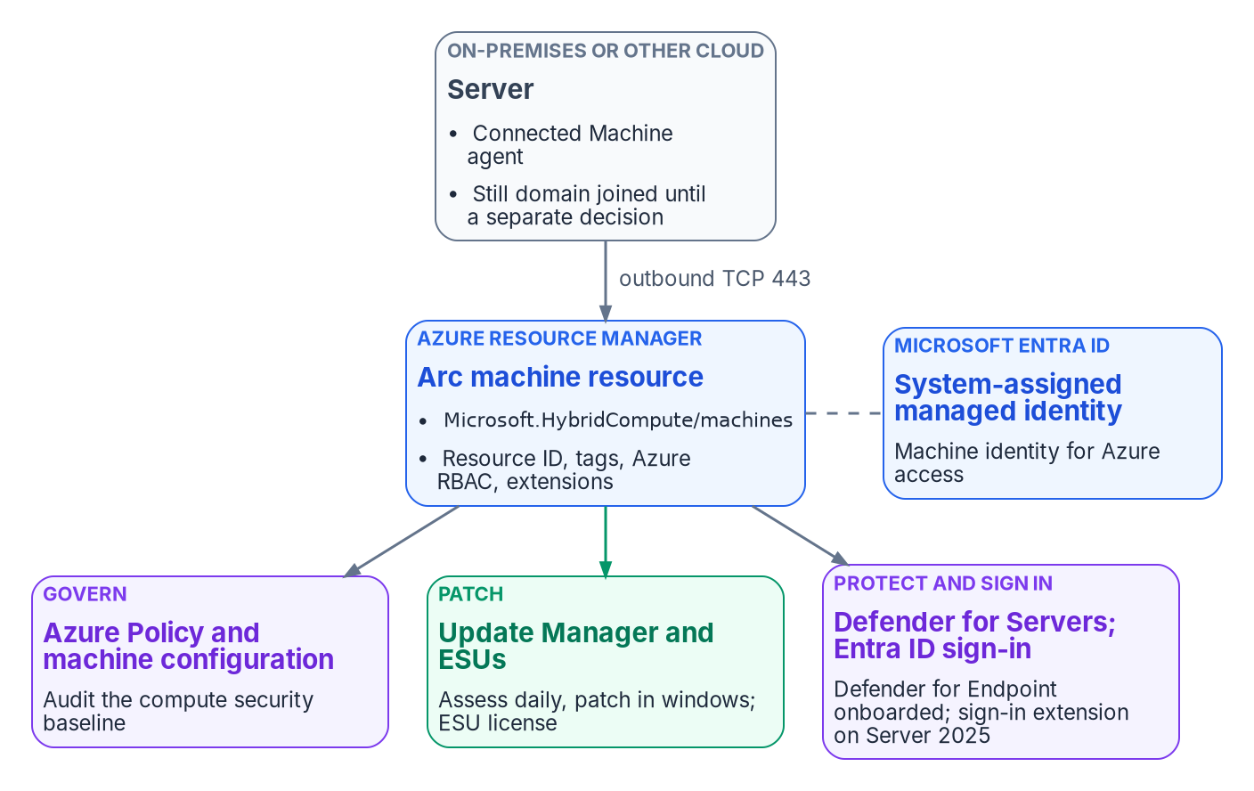
Arc gives the server an Azure resource and a managed identity; governance, patching, protection and sign-in attach to that resource.

What Arc changes and what it doesn’t
Arc changes | Arc doesn’t change
The server gets an Azure resource ID and can be placed in a resource group with other Azure resources | The server’s domain membership; onboarding doesn’t unjoin it
Azure RBAC, tags and Azure Policy apply to it | How users and services authenticate to it, unless you enable Entra ID sign-in
The server gets a system-assigned managed identity in Microsoft Entra ID | The workload; an Arc outage impairs management only, not the workload
Extensions can be installed from Azure, and run with full privileges on the server | Where the server runs; Arc isn’t a migration to Azure
Two properties shape the operating model.
- Azure is the source of truth for the agent. The only way to tell the agent to do something is to act on the server’s Azure representation, which means RBAC and Azure Policy are evaluated before any change reaches the server.
- Connection state is evidence. The agent sends a heartbeat every five minutes. A server that stops sending shows Disconnected within 15 to 30 minutes. A server disconnected for 45 days can become Expired, and it can’t be managed until an administrator disconnects and reconnects it. The managed identity’s credential is valid for up to 90 days and renews every 45.

Arc servers run non-domain-joined in the target
In the program’s target architecture, Arc-enabled servers carry an Entra-backed machine identity and run without a domain join. Onboarding attaches the management plane. It doesn’t remove the domain join for you. Plan the unjoin as a separately sequenced decision for each workload, after its authentication dependencies are known; the Kerberos and NTLM work that precedes it is in Chapter 05 and Book 02 (Chapter 04 of Book 02).

Before you onboard

Plan cost by service, not by connection
Chapter 05 sets out what Arc’s control plane costs and which services on Arc servers are billed separately. For servers, the decision that changes the bill most is whether the Windows Server licenses carry active Software Assurance or are subscription or pay-as-you-go licenses. If they do, Windows Server Management enabled by Azure Arc provides Azure Update Manager, Change Tracking and Inventory, and Azure Machine Configuration for Windows Server 2012 and later at no extra cost beyond networking, storage and log ingestion, plus Windows Admin Center in Azure and other services for Windows Server 2016 and later.
The benefit isn’t automatic. You have to attest each Arc server’s licensing, or enroll it in Windows Server pay-as-you-go; Azure doesn’t infer eligibility from the connection. Make attestation a step in the onboarding runbook, and record who attested and on what license evidence.

Roles
Use the narrowest built-in roles, and remember what extensions can do.
Role | Holder | What it allows
Azure Connected Machine Onboarding | The onboarding service principal only | Read and create Arc server resources. Can’t delete servers or manage extensions.
Azure Connected Machine Resource Administrator | The server operations team | Read, modify, re-onboard and delete machines, extensions, licenses and private link scopes
Virtual Machine Administrator Login and Virtual Machine User Login | People who sign in to servers with Entra ID | Administrator or standard sign-in; Owner and Contributor don’t confer sign-in
Extensions can run arbitrary scripts with full privileges on the server, so Microsoft says to treat any Contributor on the Arc resource as an indirect administrator of the server. The Cloud Adoption Framework goes further and warns that Contributor, Owner and Azure Connected Machine Resource Administrator can effectively delegate root access through extension deployment. Scope those roles to the resource groups a team owns, hold them through Privileged Identity Management where possible, and don’t grant subscription-wide Contributor to anyone who doesn’t administer every server in it. Chapter 06 maps roles to teams.

Network
The Connected Machine agent communicates outbound to Azure Arc over TCP 443. No inbound rule is needed. Allow the service tags AzureActiveDirectory, AzureTrafficManager, AzureResourceManager, AzureArcInfrastructure, Storage and, as of April 2026, AzureFrontDoor.Frontend. A proxy is supported but doesn’t add security, because the traffic is already encrypted; an Azure Arc private link scope keeps the traffic off public networks instead. Before onboarding a site, run the agent’s own check from a representative server.

Illustrative, not tested against a production estate
The commands in this chapter are examples. They haven’t been run against a production estate or subscription. Read each one, run it first in a test scope, and review the output before you apply anything that changes state.
# Network readiness for the target region (add --cloud AzureUSGovernment for Azure Government)
azcmagent check --location "eastus"
# Include SQL Server enabled by Azure Arc endpoints if the server hosts SQL Server
azcmagent check --location "eastus" --extensions sql
The --cloud values are AzureCloud, AzureUSGovernment and AzureChinaCloud. This workbook assumes a commercial Azure subscription in the same directory as the GCC tenant; if your servers are onboarded to Azure Government, use the US Government endpoints and service tags throughout.

Resource groups and tags
Create a dedicated resource group for Arc-enabled servers, or one per owning team, so RBAC and policy can be scoped without touching other resources. Apply one tag taxonomy at connection time: Environment, Workload, Criticality, Owner, CostCenter, PatchGroup and ArcOnboardedDate. Tags drive policy scope, Update Manager’s dynamic scoping, cost reporting and operational queries. On the governed path the same taxonomy carries the organizational attributes from the procurement or asset record (Chapter 03).
Two cautions. Tags are stored in plain text, so don’t put sensitive information in them. And a server with SQL Server installed connects its instances to Arc automatically, deploying an extension and applying new roles to SQL Server. To opt a server out, add the tag ArcSQLServerExtensionDeployment with the value Disabled when you connect it.

Images and cloning
You can install the agent package into a golden image, but don’t connect the image. A connected image gives every clone the same Azure resource ID, and the clones show up as disconnected or receive 429 errors. The fix for a clone is azcmagent disconnect --force-local-only followed by a fresh azcmagent connect.

Onboarding
Onboarding runs in waves. Each wave creates its credential, connects a defined set of servers, attaches the baseline on the same change, verifies, and closes by removing what onboarding needed.
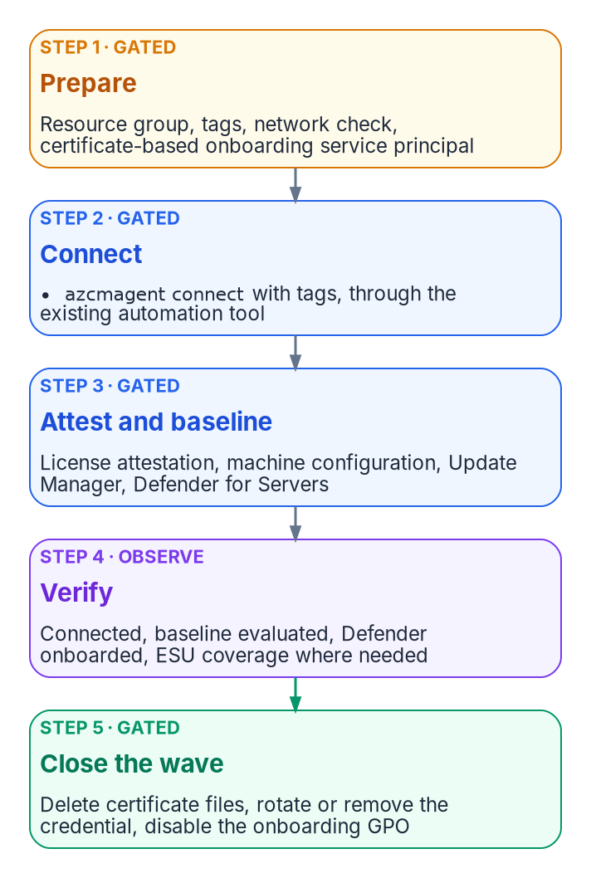
One onboarding wave: the credential exists only for the wave, the baseline is attached on the same change, and the wave closes by removing what onboarding needed.

Choose a method
Microsoft supports these methods:
Method | Operating systems | Scale
Script generated in the Azure portal | Windows and Linux | A few servers, interactively
PowerShell | Windows and Linux | Interactive or at scale
Service principal with the installation script | Windows and Linux | At scale, non-interactively
Ansible (Ansible Core or Ansible Automation Platform) | Windows and Linux | At scale
Azure Arc-enabled VMware vSphere | Windows and Linux VMs on vCenter | At scale; needs VMware Tools
Multicloud connector | Windows and Linux on AWS | At scale
Windows Admin Center; Azure Arc setup | Windows Server | Interactive
Configuration Manager scripts or custom task sequence | Windows Server | At scale
Group Policy | Domain-joined Windows Server | At scale
The program’s recommendation: onboard fleets with a dedicated service principal that authenticates with a certificate, deployed through the automation tool the server team already runs (Configuration Manager, Ansible or Group Policy). Use the interactive script only for a handful of servers or a pilot. Whichever tool you use, the same least-privilege rules apply.

Create the onboarding service principal
The service principal exists only to connect machines. Microsoft describes it as used only during onboarding and for no other purpose, and the credential is needed only when azcmagent connect runs. If it expires or is deleted afterward, the server stays connected. So keep its lifetime short and its scope small.
# Azure CLI. Scope the onboarding role to the target resource group, not the subscription,
# and create a certificate credential instead of a client secret.
az ad sp create-for-rbac `
--name "sp-arc-onboarding-rg-arc-servers" `
--role "Azure Connected Machine Onboarding" `
--scopes "/subscriptions/<subscription-id>/resourceGroups/rg-arc-servers" `
--create-cert
Microsoft recommends certificates over secrets for onboarding service principals, because a certificate credential can be controlled with Conditional Access. If you must use a secret, note that the examples Microsoft publishes create one that’s valid for a year; set a shorter lifetime, rotate it after each onboarding wave and delete it when the wave closes. Creating the service principal needs permission to register applications (or the Application Administrator or Cloud Application Administrator role), and assigning the Arc role needs Owner or User Access Administrator on the scope. Do that once, as a recorded change, then hand the credential to the automation tool.
A stolen onboarding credential lets an attacker connect servers outside your organization into your subscription. Private endpoints restrict Arc access to your network and close that path.

Protect the credential in the deployment
The onboarding script carries the credential. Microsoft’s guidance is to use the automation tool’s own secret protection if it has one, and otherwise to move the parameters into a dedicated configuration file so the secret isn’t parsed or logged on the command line, and to delete the file afterward.

Never put an onboarding secret in plain text in a startup script
A service principal secret in a hand-built Group Policy startup script is readable by every domain-authenticated user through SYSVOL. Don’t build one. Microsoft’s Group Policy onboarding method is different: it places the agent and configuration on a remote share and encrypts the configuration file so only computer accounts can decrypt it. That still means any computer account in the domain can, so scope the GPO to the target OU, rotate the credential after the wave, and disable the GPO once the servers have connected, which Microsoft also tells you to do so the scheduled task doesn’t run again.

Connect
On each server, the agent connects with the service principal and the resource’s tags. With a certificate credential:
# Run elevated on the server after installing the agent (or from the generated script)
azcmagent connect `
--service-principal-id "<app-id>" `
--service-principal-cert "C:\onboarding\sp-arc-onboarding.pem" `
--tenant-id "<tenant-id>" `
--subscription-id "<subscription-id>" `
--resource-group "rg-arc-servers" `
--location "eastus" `
--cloud "AzureCloud" `
--tags "Environment=Production,Workload=FileServices,Criticality=High,Owner=infra-team,CostCenter=CC1234,PatchGroup=Wave2,ArcOnboardedDate=2026-10-20"
# Confirm the connection and agent state
azcmagent show
The agent accepts PFX or PEM files that hold both keys, or on Windows a certificate in the machine store by thumbprint (--service-principal-cert-thumbprint). Password-protected certificate files aren’t supported. Remove the certificate file from the server when the connect completes. The resource name defaults to the host name and can’t be changed later without disconnecting and reconnecting, so settle naming conflicts before the wave.

Lock down what the agent will accept
For sensitive servers, the agent has local controls that can’t be changed from Azure, only on the server itself. You can restrict which extensions may install, disable remote connections, or disable machine configuration. Microsoft intends these for servers such as domain controllers, servers that handle payment data, and servers under strict change control. By default, scripts run through the Custom Script Extension or Run Command execute as Local System or root; if you don’t plan to use them, block them.
# Add the Azure Monitor agent extension to the allowlist (--add appends; without it the list is replaced)
azcmagent config set extensions.allowlist "Microsoft.Azure.Monitor/AzureMonitorWindowsAgent" --add
# Disable all remote access to the machine through Arc
azcmagent config set incomingconnections.enabled false
The example commands are Microsoft’s. Decide the allowlist per server class in advance and record it with the onboarding change; the local setting will override anything the cloud side tries later.

The day-one baseline
A connected server is addressable, not yet governed. Attach three things on the same change.

Azure Policy and machine configuration
Azure machine configuration, formerly Azure Policy Guest Configuration, extends Azure Policy inside the operating system. It uses Desired State Configuration to audit or set OS settings and reports compliance per machine. Unlike Group Policy, it’s scoped by Azure resource scope (subscription, resource group or individual machine), not by OU. The Connected Machine agent includes the machine configuration service natively, so there’s no extension to deploy on Arc servers.
The Windows and Linux audit baselines are built-in definitions: Windows machines should meet requirements of the Azure compute security baseline and Linux machines should meet requirements for the Azure compute security baseline. Both can be customized, and a CIS benchmark definition for Linux is in preview. Deploy the machine configuration prerequisite initiative to the scope first. Assign the baselines to the Arc resource groups as policy-as-code, version the customized baseline JSON in the governance repository, and treat noncompliance as a finding, not as a failed deployment.
If a server disconnects, its guest assignments are stored locally for 14 days and reapplied when it reconnects within that window. After 14 days they’re deleted and not reassigned. A long disconnection therefore removes the baseline evaluation, which is one more reason the connection state is monitored.

Azure Update Manager
Update Manager assesses and deploys operating system updates for Windows and Linux servers across Azure, on-premises and other clouds. It assesses machines every 24 hours when periodic assessment is enabled, supports scheduled patching in maintenance windows, and can group machines by subscription, location, resource group or tags through dynamic scoping, which is where the PatchGroup tag earns its keep.
Update Manager is charged per Arc server per month, prorated daily, on days the server is connected and has an update operation or schedule. It isn’t charged when the server is enabled for Extended Security Updates through Arc, when Defender for Servers Plan 2 is enabled on the subscription (unless through a security connector), or when the Windows Server license has active Software Assurance, a subscription license or pay-as-you-go through Arc. Windows Server 2025 hotpatching is also delivered through Arc and isn’t subject to the Windows Server Management licensing rules.

Defender for Servers
Defender for Servers has two paid plans. Plan 1 centers on endpoint detection and response through the Defender for Endpoint integration. Plan 2 adds agentless scanning, regulatory compliance assessment, premium Defender Vulnerability Management, OS configuration assessment against the Microsoft cloud security benchmark, update assessment, file integrity monitoring and a data ingestion benefit. Defender for Cloud onboards the Defender for Endpoint extension automatically to supported Arc-enabled machines, and Microsoft recommends Plan 2 for most organizations. The program’s FedRAMP Moderate scope uses Plan 2, plus Defender for SQL on Arc-connected SQL Server hosts.
Onboard on-premises servers as Arc machines rather than installing the Defender for Endpoint agent directly. With direct installation only Plan 1 functionality is available, plus the premium vulnerability management features under Plan 2. Two related limits matter to the endpoint team. If your only Defender for Endpoint entitlement comes through Defender for Servers, Defender for Endpoint security settings management isn’t available; you need at least one Defender for Endpoint user license. And security settings management, which lets Intune endpoint security policies configure Defender on servers that aren’t enrolled in Intune, supports Windows Server 2012 R2 and later but not Server Core 2016 and earlier.

Extended Security Updates
Arc is also how many organizations keep end-of-support servers patched while they migrate. As of today, October 20, 2026, the dates are:
Product | Status | Arc ESU detail
Windows Server 2012 and 2012 R2 | ESU period ended October 13, 2026 | That month’s update was the last. Arc ESU licenses deactivated at midnight UTC on October 14, 2026.
Windows Server 2016 | End of support January 12, 2027 | ESUs for up to three years, through 2030. Configurable in the portal since August 3, 2026; billing begins January 13, 2027; agent 1.62 or later.
SQL Server 2014 | ESU year 3 | ESUs available until July 2027
SQL Server 2016 | ESU year 1 (from July 14, 2026) | ESUs available until July 17, 2029
Any Windows Server 2012 or 2012 R2 host still running now receives no further security updates through any channel. Treat it as a red finding: migrate or upgrade it, or isolate it and record the risk acceptance. Windows Server 2016 hosts should be connected and enrolled before January 12, 2027 if they won’t be upgraded in time.
ESUs through Arc are billed monthly through Azure, need no product keys on the server, and show coverage per server in the portal. Purchasing them needs Software Assurance through a volume licensing program, unless the servers are licensed through SPLA or a server subscription. Don’t use Arc to deliver ESUs to VDI virtual machines; use Multiple Activation Keys instead. A server connected only for ESUs can run with a reduced endpoint list, and its extension allowlist can be set to Allow/None so the extension manager runs for billing without allowing any extension to install.

Microsoft Entra ID sign-in

Windows Server 2025
Arc-enabled Windows servers can use Microsoft Entra ID as their sign-in authority for Remote Desktop, with Azure RBAC deciding who may sign in. The requirements, all from Microsoft’s documentation:
- Windows Server 2025 or later with Desktop Experience, or Windows 11 24H2 or later. Server 2019 and 2022 aren’t supported, which is exception C in Chapter 04.
- Available in Azure Global and Azure Government.
- A system-assigned managed identity on the Arc server, then the AADLoginForWindows extension (publisher Microsoft.Azure.ActiveDirectory). The extension’s settings must include an mdmId property, which can be an empty string.
- Installing the extension Microsoft Entra joins the server. The scenario is for servers that won’t be joined to Active Directory or Entra Domain Services; if a server must stay domain-joined, uninstall the extension and use hybrid join instead.
- Users need the Virtual Machine Administrator Login or Virtual Machine User Login role. Making a user a local administrator directly isn’t supported. Only member users of the same tenant can sign in, not guests.
- The client device must be Entra joined, hybrid joined or Entra registered to the same directory.
- Conditional Access isn’t supported with the Entra join extension on Arc-enabled servers.
The last point corrects an assumption in the source material, which treated Entra ID sign-in on Arc servers as bringing them under the same Conditional Access as workstations. It doesn’t. The control you get is Azure RBAC on who may sign in, plus Entra ID’s credential and authentication policies, plus Azure Policy to require the extension and flag unapproved local accounts. Hold the sign-in roles through Privileged Identity Management so that standing access isn’t the default.
# Install the Entra ID sign-in extension on an Arc-enabled Windows Server 2025 machine
az connectedmachine extension create `
--machine-name "fs01" --resource-group "rg-arc-servers" --location "eastus" `
--name "AADLogin" --publisher "Microsoft.Azure.ActiveDirectory" `
--type "AADLoginForWindows" --settings '{\"mdmId\": \"\"}'
# Grant sign-in through a group, at resource-group scope
az role assignment create `
--assignee "<server-admins-group-object-id>" `
--role "Virtual Machine Administrator Login" `
--scope "/subscriptions/<subscription-id>/resourceGroups/rg-arc-servers"
# On the server, confirm the join
dsregcmd /status # expect AzureAdJoined : YES
The az connectedmachine extension create form with these publisher and type names follows Microsoft’s examples; check the quoting of the --settings JSON in your shell before running it. The Entra join itself is recorded in the *User Device Registrationevent log, and the extension’s log is under C:\WindowsAzure\Logs\Plugins\Microsoft.Azure.ActiveDirectory.AADLoginForWindows.

Linux
For Linux, SSH through Arc lets you connect without a public IP address or open inbound ports. Install the AADSSHLoginForLinux extension (which installs the aadsshlogin packages) and assign the same two Virtual Machine login roles; Owner or Contributor alone doesn’t grant Entra ID sign-in. Microsoft recommends assigning the login roles at management group, subscription or resource group scope rather than per machine, to stay under role-assignment limits, and holding them through Privileged Identity Management. Supported distributions include recent releases of Red Hat Enterprise Linux, Ubuntu, Debian, SUSE Linux Enterprise Server, Oracle Linux, Rocky and AlmaLinux, in Azure Global and Azure Government.

Rollback
Define rollback before the wave. For Arc, the order matters:
- Remove the extensions. Uninstalling the agent doesn’t remove extensions, and leftover extensions aren’t recognized if the server reconnects.
- Disconnect. azcmagent disconnect deletes the Arc resource in Azure and resets the local agent. It needs an account that can delete the resource, which the onboarding role can’t do; use the Azure Connected Machine Resource Administrator role. If the resource is already gone, use azcmagent disconnect --force-local-only to clean up locally.
- Uninstall the agent. Configuration, log and policy folders remain on the server afterward.
If a server was Entra joined through the sign-in extension, uninstall that extension first; that’s what disconnects it from Entra ID. Rolling back Arc doesn’t touch the server’s domain membership or its workload.

The manual and governed server paths
Both paths produce the same server configuration. Chapter 05 describes the paths in general and the actuation ladder (L0 record, L1 observe, L2 advise, L3 gated, L4 autonomous, refused). For servers, the operations land on the ladder like this:
Rung | Server operations | Manual path | Governed path
L1 Observe | azcmagent check, azcmagent show, Arc inventory, policy compliance, Update Manager assessment, ESU coverage | Operator runs and files the output | Scheduled; results compared with the desired state in canon
L2 Advise | Proposed tags, policy assignments, extension allowlists, patch schedules | Reviewed in the change record | Generated change-set surfaced for approval
L3 Gated | Create the service principal, azcmagent connect, assign machine configuration, enable Defender for Servers, enroll ESUs, install the Entra ID sign-in extension, disconnect | Operator approves under local change control; first run is a dry run | Runs only with a recorded approval reference
L4 Autonomous | Any of the above with no human approval | Not applicable | Refused at the federal L3 ceiling
On the manual path, the operator owns the change record, the approval and the rollback. The program’s companion kit wraps the onboarding and baseline steps in two scripts, Invoke-ArcOnboarding.ps1 (creates the least-privileged service principal, installs and connects the agent, and validates registration) and Set-ArcPolicyBaseline.ps1 (assigns the Windows security-baseline machine configuration and enables Defender for Servers Plan 2). Both honor -WhatIf, and both must be configured for subscription, resource group, location and cloud before use. They’re the program’s tooling, not Microsoft cmdlets.
On the governed path, the same scripts run with -ApprovalRef on every state-changing call, and the approval check refuses a gated write that has no approval reference or that’s declared above the L3 ceiling. Every Arc resource is then traceable to an approval, and the policy baseline is evidence of automated configuration management rather than a one-time setup. Rolling back the governance layer (lowering the ceiling to record-only, or stopping the scheduled observers) doesn’t require re-onboarding any server, because the operational state is held by Azure, not by the program. The evidence this produces, and the FedRAMP 20x indicators it supports, are in Chapter 10.

Monitoring the server estate
- Alert on connection state. Set up Resource Health alerts for disconnection, and investigate any server that misses heartbeats for more than 15 minutes.
- Keep the agent current. Microsoft supports only Connected Machine agent versions released within the last year; automatic agent upgrade is in preview.
- Watch the three baselines together: machine configuration compliance, Update Manager compliance and Defender for Cloud recommendations. A server that’s connected but failing all three is addressable, not governed.
- Track ESU coverage and end-of-support dates as a standing report until the last Windows Server 2016 and SQL Server 2014 host is gone.
Chapter 10 brings the server and workstation signals together. The compute side of the same transition, from the application’s point of view, is in the Client-Server to Hybrid-Cloud series, Chapter 07 — Compute Transformation.

What this chapter establishes
- Arc attaches the management plane: an Azure resource ID, RBAC, tags, policy and extensions. It doesn’t change domain membership or authentication by itself.
- Onboard with a dedicated, certificate-based service principal holding only the onboarding role on the target resource group, and remove the credential when the wave closes.
- A connected server is governed only once machine configuration, Update Manager and Defender for Servers are attached and their results are watched.
- Windows Server 2012 left ESU coverage on October 13, 2026; Windows Server 2016 needs Arc ESU enrollment before January 12, 2027 if it can’t be upgraded.
- Entra ID sign-in is available on Windows Server 2025 with Desktop Experience and on Linux. It Entra-joins the Windows server and doesn’t bring Conditional Access with it.

Continue the book
← Previous: Chapter 08 — GPO to Intune Policy Migration · Book index · Next: Chapter 10 — Operating and Evidencing the Fleet →

Chapter 10 — Operating and Evidencing the Fleet
Once the GPOs are gone, the fleet’s state is no longer explained by where a device sits; it has to be proved, continuously, from records the services already keep.

In this chapter
How the Federal Modernization Program runs the fleet after the GPO sunset. Compliance and how its result reaches Conditional Access; Windows update rings, update policies and Windows Autopatch; Microsoft Defender for Endpoint; reconciling the device inventories that Intune, Entra ID and Defender each keep; retiring and wiping devices without losing recovery keys; drift detection and alerting; and the evidence an assessor reads for the configuration management and flaw remediation controls, with the boundary facts for a GCC (Moderate) tenant.
Group Policy answered “why is this setting here?” with the device’s position in the directory. Chapter 01 explained why that answer doesn’t survive the move to Intune. In the run state the program replaces it with three records that together say what each device should be, what it is, and who changed what: the policy library from Chapter 08, the status Intune and Defender report per device, and the audit log of every change. Operating the fleet means keeping those three records in agreement. Evidencing the fleet means handing an assessor the same records, not a document written for the audit.
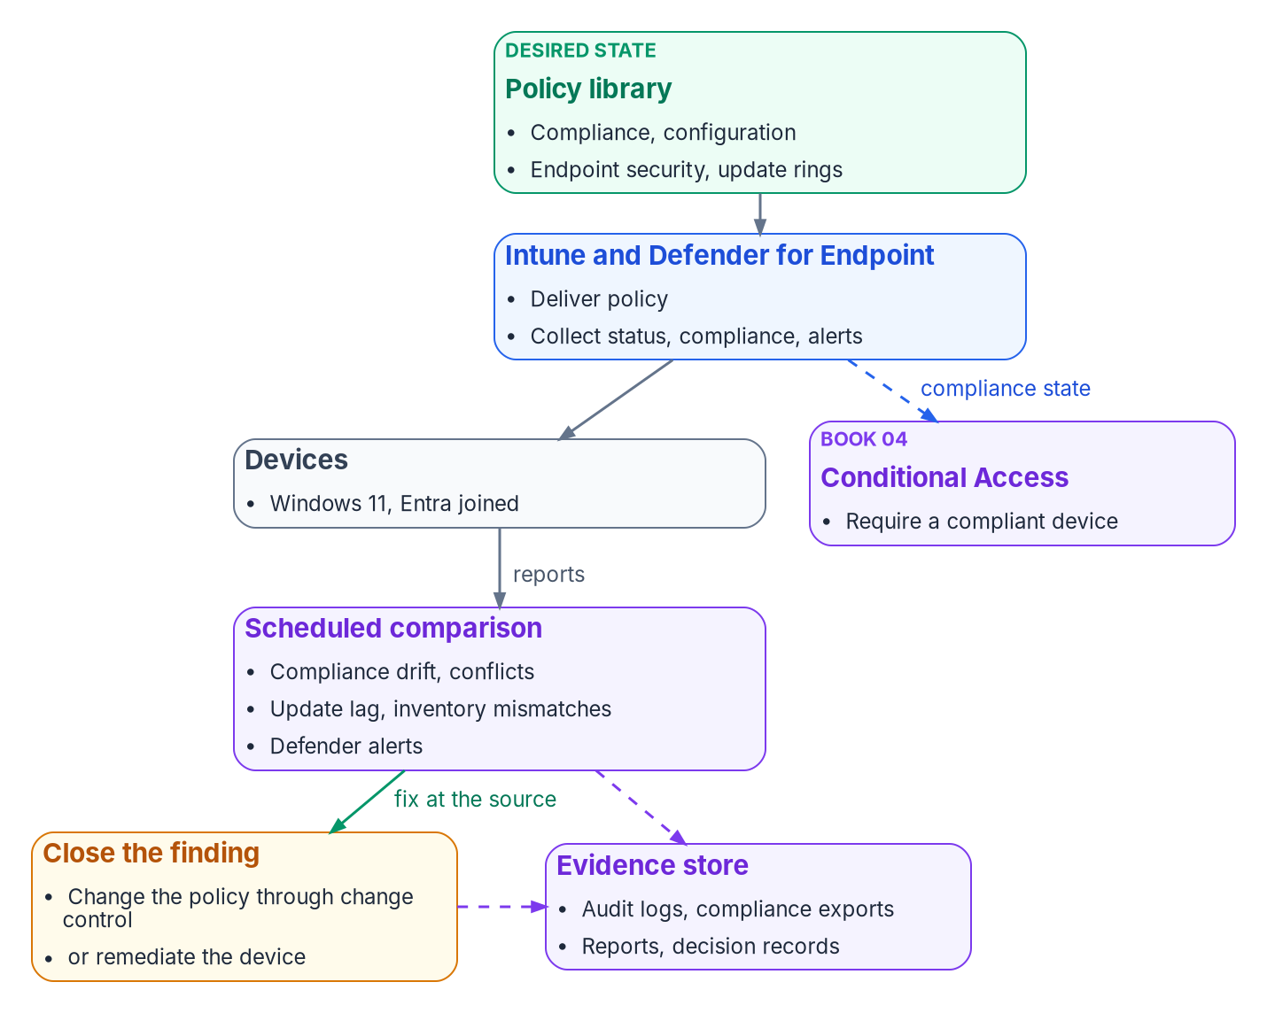
The run-state loop: policy is assigned, devices report, the program compares, findings close at the policy or the device, and every step leaves evidence.

Compliance and the Conditional Access hand-off
The compliance policies in Chapter 08 decide whether a device is compliant. Conditional Access decides what a noncompliant device can reach. Book 04 owns that second decision: the policies that use the Require device to be marked as compliant grant control, their report-only rollout, and their exclusions. This book’s side of the hand-off is making sure the compliance signal is accurate. The grant control works only for devices registered in Entra ID and enrolled in Intune.

Tenant-wide compliance settings
Two tenant settings sit above every compliance policy, under Endpoint security > Device compliance > Compliance policy settings:
Setting | Default | Program value | Why
Mark devices with no compliance policy assigned as | Compliant | Not compliant | A device that falls outside every group (a missing tier attribute, for example) must not pass Conditional Access by default; Microsoft recommends this when compliance feeds Conditional Access
Compliance status validity period (days) | 30 | 14 | A device that hasn’t reported within the period is treated as noncompliant; the range is 1 to 120 days
The 14-day validity period is a program choice: short enough that a device left in a drawer loses access before its posture is stale by a whole patch cycle, long enough not to catch staff on leave.

Reading compliance status
The device compliance dashboard groups devices as Compliant, In grace period, Not evaluated and Not compliant. In grace period means noncompliant, but inside the grace period set on the policy’s Mark device noncompliant action. Not evaluated is the initial state of a newly enrolled device and also covers devices that haven’t checked in since a policy changed. A compliance setting that returns Error leaves the device’s existing compliance status in place for up to seven days, after which the device becomes noncompliant, or enters its grace period. The program reviews Not evaluated and Error weekly, because both hide devices from the noncompliant count.

Defender risk as a compliance signal
The Windows compliance policy can require a device to be at or under a Defender for Endpoint machine risk score. The program sets it on Tier 0 (CP-002 in Chapter 08), so a Defender detection on a privileged access workstation becomes a compliance failure and, through Conditional Access, a loss of access.

Configuration status and conflicts
Each configuration profile and endpoint security policy reports per device and per setting. Succeeded means the setting on the device matches the policy; Error means it failed to apply; Conflict means another policy sets the same setting to a different value, or an update is still pending. A device that hasn’t checked in since assignment simply hasn’t reported yet. A conflict is a defect in the library, not a state to live with: between configuration policies of any type there is no precedence, and the setting may not apply until the conflict is resolved.
Conflict | How it shows | Resolution
Compliance vs. compliance | The device’s compliance details name the policy that flagged it | The most restrictive value applies; confirm it is the intended one
Configuration vs. configuration | Conflict in the device configuration status | Move the setting into the one policy that owns it; adjust assignments
Endpoint security vs. configuration profile | Conflict or Error on both | Same as above; the source’s claim that Endpoint security wins was wrong
GPO vs. Intune (a population still in transition) | gpresult on the device differs from the Intune value | Remove the GPO copy; Chapter 07 has the coexistence rules

Windows updates

The update policy surfaces
Intune manages Windows updates through several policy types, all built on the Windows Update client policies (the current name for what was called Windows Update for Business):
Policy | What it controls
Update ring | Deferral periods, deadlines, restart behavior and the user experience for a group of devices
Feature update policy | Pins devices to a Windows version, such as Windows 11, version 25H2, until the policy changes
Quality update policy | Targets monthly cumulative updates; supports expediting a critical update and hotpatch updates that install without a restart
Driver update policy | Approves driver and firmware updates from Windows Update, manually or automatically

The program’s rings
Rings stage each month’s quality update across the fleet. The ring names follow Windows Autopatch’s (Test, First, Fast, Broad); the values are the program’s design, built from the SC-005 template in Chapter 08:
Ring | Population | Quality deferral (days) | Quality deadline (days) | Grace period (days)
Test | Endpoint engineering lab devices | 0 | 2 | 1
First | Pilot cohort, about 5% | 1 | 3 | 2
Fast | About a quarter of the fleet | 3 | 5 | 2
Broad | Everyone else | 7 | 7 | 2
Update rings allow a quality deferral of 0 to 30 days, deadlines of 2 to 30 days and a grace period of 0 to 7 days. With these values a quality update reaches every online device within about 16 days of release, and an update that breaks the Test or First ring can be paused before it reaches Broad. The feature update deferral is 0 in every ring, because a feature update policy pins the version.

Windows Autopatch
Windows Autopatch automates update ring management, sequencing and reporting for Windows, Microsoft 365 Apps, Edge and Teams. It is available with Windows Enterprise E3 or E5 (including through Microsoft 365 F3, E3 or E5), Education A3 or A5, Enterprise VDA, and Microsoft 365 Business Premium. For government tenants, it is included for GCC customers with Microsoft 365 G3 GCC or G5 GCC, and isn’t supported in GCC High or DoD. Devices must be Entra joined or hybrid joined, and co-managed devices need the Windows Update policies and device configuration workloads set to Intune or Pilot Intune. When Autopatch manages a device, it creates and maintains the update rings; administrators shouldn’t assign their own rings to those devices.
The program’s position: use Autopatch where the license allows, and keep the ring table above as the specification Autopatch’s groups are configured to. Either way, the ring values are what the assessor reads for SI-2.

Version currency
Feature update policies hold the fleet on a supported Windows version. As of October 2026, Windows 11 versions and their end of updates for Enterprise and Education editions are:
Version | Build | End of updates (Enterprise, Education)
26H2 | 26300 | 2029-10-09
25H2 | 26200 | 2028-10-10
24H2 | 26100 | 2027-10-12
23H2 | 22631 | 2026-11-10
Version 26H1 (build 28000) ships only on new devices that came to market in 2026 and isn’t offered as an in-place update. Any 23H2 device left in the fleet loses updates on November 10, 2026, so the program’s feature update policy targets 25H2 now and the compliance floor (24H2) rises each year.

Microsoft Defender for Endpoint
Devices onboard to Defender for Endpoint through the EDR policy (ES-004 in Chapter 08), which uses the onboarding package Intune receives over the Intune–Defender connection. Intune’s EDR Onboarding Status report shows which devices are onboarded and the health of their sensors; the Defender portal’s device inventory confirms it.
In a GCC tenant, Defender for Endpoint for US Government customers runs in the Azure US Government environment with some feature differences from commercial; the GCC portal is security.microsoft.com, and desktop licensing comes from offers such as Microsoft 365 GCC G5, Microsoft 365 G5 Security GCC, or standalone Defender for Endpoint GCC. Defender for Endpoint security settings management, which is how Intune endpoint security policy reaches servers, is supported in GCC.
The settings the source put in the EDR policy, and that live in the Defender portal instead, are part of the program’s Defender configuration:
Setting | Program value | Where
Automated investigation and remediation | Full, automatic remediation, for workstation device groups | Defender portal device groups
Live response | On, with the role limited to Tier 0 analysts | Defender portal advanced features and roles
Web content filtering | On, with the organization’s category policy | Defender portal
Tamper protection | On | Intune antivirus policy (ES-001); needs onboarding first
Attack surface reduction runs the audit-then-block cadence in ES-005. During the audit month, the program reviews each rule’s audit events in Defender and records an exclusion or a decision before the rule moves to block.
Servers are in Defender too, but not in Intune: Intune doesn’t manage Windows Server, so Chapter 09 covers how servers are configured through Azure Policy machine configuration and reached by Intune only through security settings management.

Device inventory reconciliation
Three services keep their own device inventory, and they disagree in predictable ways:
Inventory | What it holds | Key | Typical mismatch
Intune managed devices | Enrolled devices, compliance, OS version, encryption, last check-in | Intune device ID, with the Entra device ID as a reference | Devices that stopped checking in; cleanup rules hide them
Entra ID device objects | Joined and registered devices, extension attributes, BitLocker recovery keys | Entra device ID | Stale objects left by reimaging, broken hybrid trust, or devices never enrolled
Defender for Endpoint device inventory | Onboarded devices, sensor health, risk | Defender machine ID, with the Entra device ID | Devices onboarded but not enrolled, or enrolled but never onboarded
The program reconciles them weekly on the Entra device ID. Every enrolled device must have an Entra object with its tier, role and environment attributes set, and a healthy Defender sensor. Every Entra object for a corporate Windows device must have an Intune enrollment. A device missing from any one is a finding. The same comparison is the program’s evidence for CM-8’s requirement that the inventory include every component and contain no duplicates.

Stale records
- Intune cleanup rules hide devices that haven’t checked in for a set number of days, from 30 to 270, per platform. They don’t wipe or retire anything, and a hidden device reappears if it checks in before its device certificate expires. Hidden devices aren’t removed from Entra ID. The program sets 90 days for Windows.
- Entra ID stale devices are found by approximateLastSignInDateTime, which isn’t updated on every sign-in; Microsoft advises not treating anything newer than about 21 days as stale, and disabling a device for a grace period before deleting it. Hybrid-joined devices are disabled or deleted in Active Directory and the change syncs; deleting one only in Entra ID brings it back as a new pending object.
- BitLocker keys go with the device object. Deleting an Entra device deletes the recovery keys stored on it, with no way to recover them. The program exports keys for any device it deletes, into the key escrow record set, before the delete runs.

Illustrative, not tested against a production tenant
The scripts and queries in this chapter are illustrative and haven’t been tested against a production tenant. Review them, and run them first against a test tenant. They read inventory; none of them changes a device.
# Read-only. Joins Intune managed devices to Entra device objects on the Entra device ID.
Connect-MgGraph -Scopes 'DeviceManagementManagedDevices.Read.All', 'Device.Read.All'
$intune = Get-MgDeviceManagementManagedDevice -All |
Where-Object { $_.OperatingSystem -eq 'Windows' } |
Select-Object DeviceName, AzureAdDeviceId, ComplianceState, OSVersion, LastSyncDateTime, SerialNumber
$entra = Get-MgDevice -All -Property Id, DeviceId, DisplayName, OperatingSystem, TrustType,
ApproximateLastSignInDateTime, AccountEnabled, ExtensionAttributes |
Where-Object { $_.OperatingSystem -eq 'Windows' }
$entraById = @{}
foreach ($d in $entra) { $entraById[$d.DeviceId] = $d }
$findings = foreach ($m in $intune) {
$e = $entraById[$m.AzureAdDeviceId]
if (-not $e) {
[pscustomobject]@{ Device = $m.DeviceName; Finding = 'Enrolled, no Entra object' }
}
elseif (-not $e.ExtensionAttributes.ExtensionAttribute11) {
[pscustomobject]@{ Device = $m.DeviceName; Finding = 'No security tier attribute' }
}
}
$enrolledIds = $intune.AzureAdDeviceId
$findings += $entra | Where-Object { $_.DeviceId -notin $enrolledIds -and $_.AccountEnabled } |
ForEach-Object { [pscustomobject]@{ Device = $_.DisplayName; Finding = 'Entra object, not enrolled' } }
$findings | Sort-Object Finding, Device | Export-Csv .\inventory-findings.csv -NoTypeInformation

Retirement and wipe
A device leaves the fleet through a fixed sequence, because the order decides what can still be recovered.
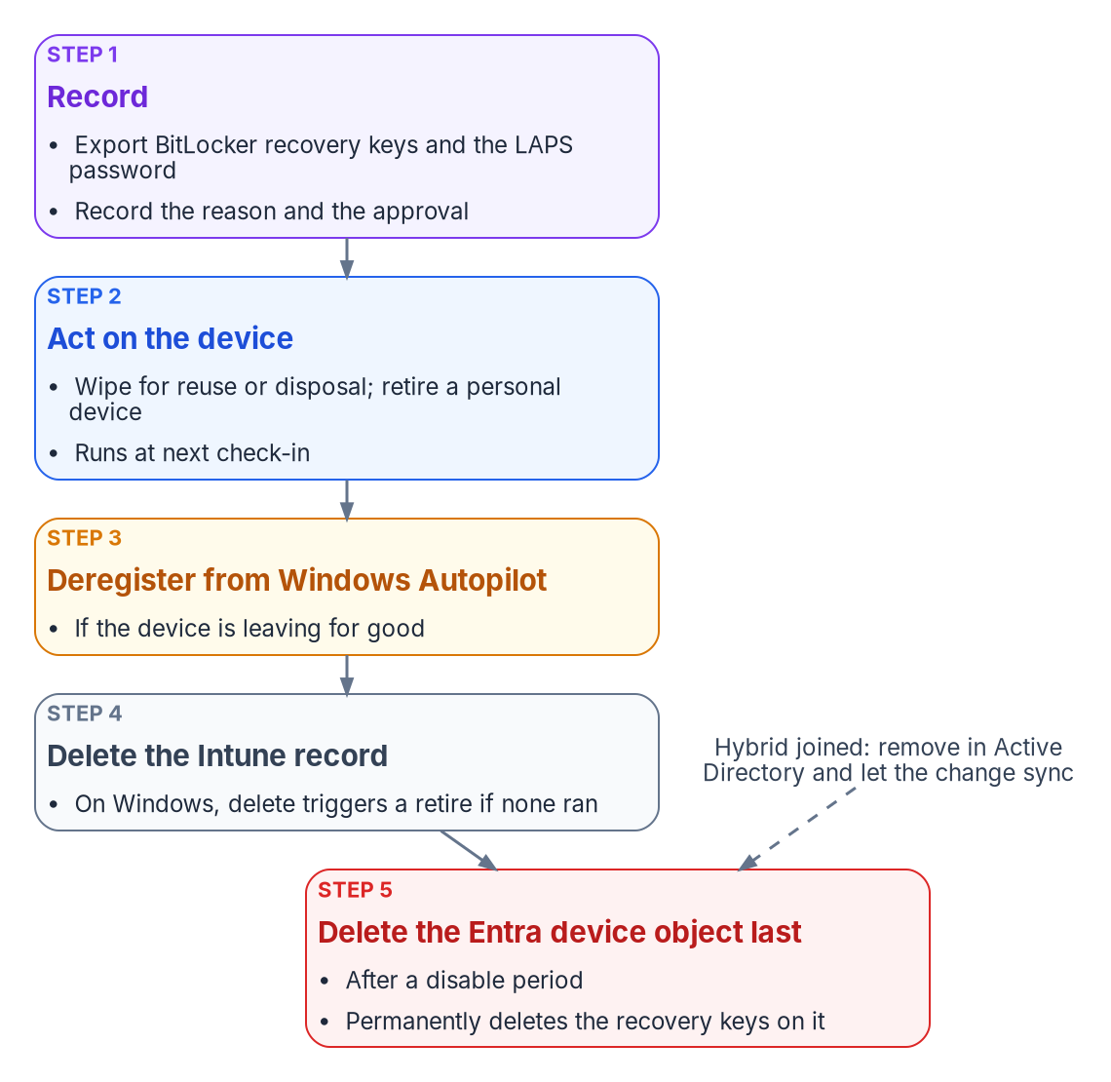
Retiring a corporate Windows device: back up what only the device object holds, act on the device, then remove the records in order.
Action | What it does on Windows | When the program uses it
Retire | Removes company apps, settings, Wi-Fi, VPN and certificate profiles and Intune-provisioned mail; keeps personal data; unjoins an Entra-joined device and removes its Entra record unless it’s registered in Autopilot | Personally owned devices; devices leaving one user for another outside a rebuild
Wipe | Factory reset; options keep the enrollment state and user account, or continue the wipe through power loss and overwrite free space | Corporate devices being reused or disposed of; lost or stolen devices (the power-loss option)
Delete | Removes the device from Intune; on Windows it always triggers a retire | After the device action has completed, or for a device that will never check in again
Add to retire list (compliance action) | Queues a noncompliant device for an administrator to retire; retires nothing by itself | CP-001 to CP-003 after 7 or 30 days
Four facts shape the sequence:
- Retiring or deleting the Intune object of a BitLocker-protected Entra-joined device suspends BitLocker by removing key protectors, as a safeguard against unrecoverable encryption. Back up the recovery key and the local administrator credentials first.
- The power-loss wipe option can leave some devices unable to start, so the program reserves it for corporate devices where data destruction outweighs reuse.
- Actions run at next check-in. Until then the device still shows in the admin center; a retire or wipe that stays Pending on a device that has been reset can be cleared by deleting the record.
- Daily limits apply. A tenant can submit up to 1,000 retire actions and 1,000 delete actions a day, counting bulk and Graph requests. A mass refresh is planned in daily batches.
The Entra device object is deleted last, after a disable period, and only after its recovery keys are exported (see Stale records). Windows Autopilot devices can’t be deleted from Entra ID until they are deleted from Intune.

Drift detection and alerting
Drift is a difference between the policy library and a device’s reported state that the policy should have prevented: BitLocker off, tamper protection off, an OS below the floor, a setting stuck in Conflict. The program detects it with the same loop Chapter 05 describes for the governed path (snapshot, compare, classify, alert, remediate, verify), applied to the Intune and Defender records:
- Scheduled export. A daily export of compliance, configuration and inventory status through Microsoft Graph and Intune diagnostic settings.
- Baseline comparison. Current values against the template values in Chapter 08.
- Classification and alerting. Each difference is classified (policy gap, device fault, conflict, inventory mismatch) and alerted by severity.
- Remediation. A device sync or a Remediation script on the affected devices, or a policy change through change control when the library itself is wrong. On the governed path, every remediating write carries an approval reference.

What Log Analytics receives, and when
Intune’s diagnostic settings send four log categories to a Log Analytics workspace: audit logs, operational logs (enrollment and noncompliance), device compliance organizational logs, and the IntuneDevices inventory. Audit and operational logs are sent immediately. Compliance organizational logs and IntuneDevices are exported once every 24 hours and can take up to 48 hours to arrive; Microsoft says not to rely on a fixed delivery time. Two consequences: these tables are for trends and evidence, not for minute-level alerts; and per-setting configuration status isn’t among them, so the configuration part of the comparison comes from Microsoft Graph reports, not from Log Analytics.
The source’s three queries needed rework. Its compliance query hard-coded state strings, its failed-deployment query joined on a DeviceId column that IntuneOperationalLogs doesn’t have, and its conflict query looked for configuration conflicts in a table that records enrollment and noncompliance. The program uses these instead:
// Compliance trend over 30 days, by state, from the daily organizational export.
IntuneDeviceComplianceOrg
| where TimeGenerated > ago(30d)
| summarize Devices = dcount(DeviceId) by ComplianceState, bin(TimeGenerated, 1d)
| order by TimeGenerated asc
// Windows devices below the program's OS floor or not reporting encryption, from the latest inventory export.
IntuneDevices
| where TimeGenerated > ago(2d) and OS == "Windows"
| summarize arg_max(TimeGenerated, *) by DeviceId
| extend Build = toint(split(OSVersion, ".")[2])
| where Build < 26100 or EncryptionStatusString != "True"
| project DeviceName, OSVersion, EncryptionStatusString, LastContact, JoinType, ReferenceId
// Every Intune change in the last 7 days, for the change record (CM-3, CM-6(d)).
IntuneAuditLogs
| where TimeGenerated > ago(7d)
| project TimeGenerated, OperationName, Identity, ResultType, Properties
| order by TimeGenerated desc
The table columns used are documented for IntuneDeviceComplianceOrg, IntuneDevices and IntuneAuditLogs. Check the actual values of EncryptionStatusString in your workspace before relying on the second query; the schema documents the column, not its values.

Alerts
Alert | Threshold | Source | Action
Noncompliant devices | More than 10% of managed devices | Compliance export (daily) | Endpoint team; incident in the service management tool
Tier 0 noncompliance | Any device | Graph query of Tier 0 compliance state, hourly | Security team, immediately
Policy deployment failure | More than 5 devices failing the same policy | Graph configuration status, daily | Endpoint team
Tamper protection off, or a Defender tampering alert | Any device | Defender for Endpoint alerts | Security incident; investigate immediately
BitLocker not encrypted | Noncompliant for more than 2 days | Compliance export | Help desk ticket for the device’s user
Inventory mismatch | Any finding from the weekly reconciliation | Reconciliation script | Endpoint team; device owner
The source alerted on Tier 0 noncompliance from the daily compliance export. With up to 48 hours of export latency, that alert would arrive two days late. Tier 0 is polled from Graph instead, and Conditional Access blocks the device in the meantime because CP-002 has no grace period.

Reporting and the evidence an assessor reads
The program’s evidence is the records the services keep, exported on a schedule and retained. An assessor reading the configuration management and flaw remediation controls for the fleet sees these artifacts. Control wording below is from NIST SP 800-53 Revision 5, release 5.2.0, the release FedRAMP’s 2026 control catalog uses; FedRAMP adds no parameter values of its own to CM-2, CM-6, CM-7, CM-8 or SI-2.
Control | What it asks | Evidence the program hands over | Produced by
CM-2 Baseline Configuration | Develop, document and maintain under configuration control a current baseline configuration, and review it on a schedule, when circumstances require, and when components are installed or upgraded | The policy library (Chapter 08) exported as JSON from Graph, under version control, with its review history; the Windows version and update policy | Graph export; repository history
CM-6 Configuration Settings | Establish settings in the most restrictive mode consistent with operations, implement them, approve deviations, and monitor and control changes | Per-setting status reports; the exception register with approvals; Intune audit logs of every policy change | Intune reports and Graph; IntuneAuditLogs; exception register
CM-7 Least Functionality | Provide only mission-essential capabilities and prohibit or restrict named functions, ports, protocols, software and services | Attack surface reduction rules in block, firewall policy with its rule set, Edge extension allow list, consumer features off; ASR audit-to-block decisions | ES-003, ES-005, SC-003, SC-010 status; Defender ASR reports
CM-8 System Component Inventory | Keep an inventory that reflects the system, includes every component, has no duplicates or components of other systems, and is reviewed on a schedule | The weekly reconciliation of Intune, Entra ID and Defender inventories, with findings and their closure | Reconciliation output; IntuneDevices export
SI-2 Flaw Remediation | Identify, report and correct flaws; test updates before installation; install security updates within a defined period of release; tie flaw remediation into configuration management | The ring table with its deferrals and deadlines; quality update compliance per ring; the Test and First ring results that gate Broad; expedite records | Update ring and quality update reports; Autopatch reports
Two notes on the update evidence in a GCC tenant. Windows Update for Business reports, the Log Analytics–based update reporting service, doesn’t meet US Government Community Cloud compliance requirements, so the program uses Intune’s own Windows update reports and Autopatch reports for SI-2 evidence. And SI-2’s “within a defined period” is the organization’s parameter; the ring table above is what sets it, so the assessor reads the ring deadlines, not a separate statement.
The source mapped the policy library to a wider set of controls. The program keeps that mapping as its own claim of where each control is implemented on the endpoint surface:
Control | Implemented by (Chapter 08 IDs)
AC-7 Unsuccessful Logon Attempts | SC-001 account lockout (local accounts)
AC-8 System Use Notification | SC-001 logon banner
AC-11 Device Lock | CP-001 password and inactivity requirements
AU-2 Event Logging | SC-001 audit policy
IA-2 Identification and Authentication | ES-006 Windows Hello for Business
IA-5 Authenticator Management | CP-001 password rules; ES-006 Windows LAPS rotation
SC-7 Boundary Protection | ES-003 firewall
SC-13 Cryptographic Protection | ES-002 BitLocker XTS-AES 256
SC-28 Protection of Information at Rest | ES-002 BitLocker; AP-001 app data encryption
SI-3 Malicious Code Protection | ES-001 antivirus and tamper protection
SI-4 System Monitoring | ES-004 Defender for Endpoint
The source also mapped SI-16 (memory protection) to Credential Guard and code integrity, and AU-3 (content of audit records) to EDR telemetry. The program doesn’t carry those two mappings until its assessor agrees the features meet the control’s parameters; they are recorded as candidates, not claims.

FedRAMP 20x Key Security Indicators
FedRAMP’s Consolidated Rules for 2026 express security outcomes as 46 Key Security Indicators in 10 themes. Initial certification under the rules began on July 4, 2026, and ongoing certification follows them from January 1, 2027. The indicators are written for cloud service offerings, not for an agency’s endpoint fleet. The program uses them as a vocabulary for the evidence this chapter produces; the mapping below is the program’s own claim, carried from the intune-arc governed-path material and checked against FedRAMP’s indicator pages.
Key Security Indicator | Evidenced on the endpoint surface by
KSI-IAM-APM, Adopting Passwordless Methods | Windows Hello for Business (ES-006) and the phishing-resistant sign-in in Book 02
KSI-IAM-ELP, Ensuring Least Privilege | Attribute-scoped assignment instead of tenant-wide assignment; scope tags
KSI-SVC-ACM, Automating Configuration Management | The policy library assigned by dynamic group, with the drift comparison
KSI-CNA-EIS, Enforcing Intended State | The scheduled comparison and remediation loop
KSI-CMT-LMC, Logging Changes | IntuneAuditLogs, and the approval reference on governed-path changes
KSI-MLA-EVC, Evaluating Configurations | The drift report against the Chapter 08 baseline
KSI-PIY-GIV, Generating Inventories | The weekly inventory reconciliation
KSI-CNA-EIS is optional for Class B and Class C. Don’t cite this surface for recovery planning, supply chain risk, cybersecurity education or incident response; that evidence comes from elsewhere. Chapter 05 explains why the manual path, which produces the same configuration without an approval chain, doesn’t evidence KSI-CMT-LMC for changes the program makes.

GCC (Moderate) boundary facts
The source’s boundary table described Intune and Entra ID in a GCC (Moderate) tenant as a separate government instance. For Intune that’s wrong, and it changes where data and endpoints live:
Topic | Fact for a GCC (Moderate) tenant | Program implementation
Intune service instance | GCC uses the same Intune instance as commercial; only GCC High and DoD use the separate government instance | Admin center intune.microsoft.com
Microsoft Graph | GCC uses the worldwide endpoints, graph.microsoft.com and portal.azure.com; GCC High uses graph.microsoft.us | All Graph calls in Chapters 08 and 10 use graph.microsoft.com
Defender for Endpoint | Offered to GCC as Defender for Endpoint for US Government, built in Azure US Government; GCC portal security.microsoft.com | ES-004 onboards to the tenant’s GCC instance
Conditional Access | The compliance result feeds Entra ID Conditional Access in the same tenant | Book 04
BitLocker keys and LAPS passwords | Stored on the device object in the tenant’s Entra ID | Exported before any device delete
Update reporting | Windows Update for Business reports doesn’t meet GCC compliance requirements | Intune and Autopatch update reports
Windows Autopatch | Included for GCC with Microsoft 365 G3 or G5 GCC; not supported in GCC High or DoD | Used where licensed
Feature availability | Intune documents feature differences for GCC High and DoD; GCC follows commercial | Re-check the service description before relying on a new feature

Where to go next
- Book 02 — Identity & Directory, for the identities these devices authenticate: Chapter 04 treats devices as one of the migration’s hidden adapters, and Chapter 10 covers Windows Hello for Business and phishing-resistant sign-in.
- Book 04 — Access & Privilege, for the Conditional Access policies that consume device compliance, and for the privileged access model that Tier 0 devices serve.
- The Endpoint & Device Modernization project plan, which tracks this work as Observe, Onboard, Harden and Watch; this chapter is its Watch phase.

Continue the book
← Previous: Chapter 09 — Servers Under Azure Arc · Book index · Next: Appendix A — GPO to Intune Crosswalk →

Appendix A — GPO to Intune Crosswalk
A crosswalk tells you where a control lands in Intune; it doesn’t tell you what the control should be.

In this appendix
The category crosswalk: each Group Policy area, the Intune mechanism that replaces it, and the notes and limits that apply. The program’s 50-row setting reference for the most commonly deployed GPO settings, corrected against current Microsoft documentation. The CSP paths behind the program’s key settings, and the workload-by-workload comparison of Group Policy, Configuration Manager and Intune.

How to use this appendix
This is a semantic translation reference. Engineers use it to answer “what is the closest Intune surface for this GPO setting?” It isn’t a prescription to recreate every GPO setting, and it isn’t authority for what a setting’s value should be in the new system. The disposition of each setting comes first, through the four questions in Chapter 07; the values come from current policy intent, under the regenerate-not-copy philosophy of Policy Transformation. The step-by-step migration is in Chapter 08.
The mechanisms named in the tables are:
- Settings catalog: the Intune profile type that lists the Windows settings generated from the Windows configuration service providers (CSPs), including built-in Administrative Template (ADMX) settings.
- Imported ADMX: custom or third-party ADMX and ADML files imported into Intune (public preview).
- Endpoint security: the purpose-built Intune policies for antivirus, disk encryption, firewall, attack surface reduction, account protection and EDR.
- Remediations and platform scripts: PowerShell delivered by the Intune management extension.
- Custom OMA-URI: a custom profile that writes a CSP path directly, for a setting no other surface exposes.

Category crosswalk
GPO area | Intune mechanism | Notes and limits
Account policies: password | Settings catalog (Device Lock); compliance policy to evaluate | Compliance evaluates the resulting state; it doesn’t configure it. For Entra ID accounts the password policy lives in Entra ID, not on the device.
Account policies: lockout | Settings catalog (Device Lock, AccountLockoutPolicy) | Needs Windows 11, version 22H2 with KB5053657, or version 24H2 and later. Applies to local accounts on the device. Entra ID sign-ins are governed by smart lockout, which by default locks after ten failed attempts in Azure Public tenants and three in Azure US Government tenants; customizing it needs Entra ID P1.
Advanced audit policy | Settings catalog (Audit) | One Policy CSP setting per subcategory, for example AccountLogonLogoff_AuditLogon.
User rights assignment | Settings catalog (User Rights) | Policy CSP UserRights, for example DenyLocalLogOn and DenyRemoteDesktopServicesLogOn.
Security options | Settings catalog (Local Policies Security Options) | A logon message title or text breaks Windows Autopilot pre-provisioning. Plan the legal banner around the provisioning method.
Windows Defender Firewall | Endpoint security: firewall | Group Policy analytics can’t migrate firewall rules; it directs them to Endpoint security.
BitLocker | Endpoint security: disk encryption (BitLocker CSP) | Managing BitLocker through the CSP beyond enabling it with RequireDeviceEncryption needs Windows Enterprise E3 or E5 (or A3 or A5) licenses. Settings are enforced only when encryption starts. Recovery passwords go to Entra ID for Entra-joined devices, and to both AD and Entra ID for hybrid-joined devices.
Microsoft Defender Antivirus | Endpoint security: antivirus | MDMWinsOverGP doesn’t apply to the Defender CSP; remove the Defender GPO settings rather than overriding them. Exclusion settings merge across antivirus policies; most other settings conflict.
Exploit Guard and attack surface reduction rules | Endpoint security: attack surface reduction | ASR rules use the Policy CSP. Group Policy wins over MDM by default unless MDMWinsOverGP is set to 1, so don’t configure the same rule in both.
AppLocker and application control | Endpoint security: application control | Group Policy analytics can’t migrate AppLocker settings; it directs them to Endpoint security.
Device Guard and Credential Guard | Settings catalog or Endpoint security: account protection | Credential Guard is a Windows Enterprise feature, not available on Windows Pro.
Windows Hello for Business | Endpoint security: account protection, or settings catalog | PassportForWork CSP. Configure it through Group Policy or CSP, never both; MDMWinsOverGP doesn’t cover it. See Book 02, Chapter 10.
Microsoft LAPS and Windows LAPS | Endpoint security: account protection (Windows LAPS) | Backs up to Entra ID or AD, not both. Entra-joined devices need LAPS enabled in Entra ID device settings. The CSP-based policy takes precedence over legacy LAPS.
Windows Update and WSUS targeting | Update rings, feature update and quality update policies | WSUS is deprecated: no new features, still supported. Update rings use the Update Policy CSP. If you use feature update policies, Microsoft recommends removing feature update deferrals from update rings.
Delivery Optimization | Settings catalog (Delivery Optimization) | Policy CSP DeliveryOptimization.
Diagnostic data | Settings catalog (System, AllowTelemetry) | Windows Update for Business reports need at least Required (Basic) diagnostic data, and don’t meet US Government Community (GCC) compliance requirements. Plan update reporting for a GCC tenant on Intune’s own Windows Update reports.
Microsoft Edge | Settings catalog (Microsoft Edge) | Edge and Google Chrome settings are built in; no ADMX import needed.
Internet Explorer | Retire; Edge IE mode where a site still needs it | The IE11 desktop application is retired and permanently disabled on many Windows 10 versions; IE mode is supported through at least 2029.
Folder redirection | Replace: OneDrive Known Folder Move (settings catalog, OneDrive) | Moves Desktop, Documents and Pictures. Microsoft recommends pacing silent moves on existing devices at no more than 1,000 devices a day and 4,000 a week.
Drive maps (Group Policy preferences) | Replace: OneDrive, SharePoint and Teams; scripts only if needed | Cloud-native Windows has no built-in mapped-drive solution.
Printers (Group Policy preferences) | Replace: Universal Print printer provisioning (settings catalog) | Uses the UniversalPrint CSP.
Point and Print restrictions | Settings catalog (Printers) | Policy CSP Printers PointAndPrintRestrictions, ADMX-backed.
Desktop wallpaper and lock screen image | Settings catalog (Personalization) | Personalization CSP. Microsoft’s pages differ on edition support: the configuration guide lists Windows Pro support through Intune, while the CSP reference lists Enterprise and Education. Test on your editions.
Start layout | Settings catalog (Start, ConfigureStartPins) | Windows 11 takes a LayoutModification.json pin list.
Consumer experiences and Windows experience customization | Settings catalog (Experience) | Windows experience customization is an Enterprise feature, not available on Windows Pro.
Remote Desktop Services | Settings catalog (Remote Desktop Services ADMX) | Check each setting’s MDM support in Group Policy analytics.
Power management | Settings catalog (Power) | Device-type dependent.
Startup, shutdown, logon and logoff scripts | Platform scripts or Remediations; Win32 apps for installs | Platform scripts run once per assignment and time out after 30 minutes. Remediations need Windows Enterprise E3 or E5, Education A3 or A5, or VDA licenses.
Software installation | Win32, MSI, MSIX, Microsoft Store and WinGet apps | The client apps co-management workload moves application management.
Group Policy preferences: registry, files, local users and groups, scheduled tasks | Settings catalog where a CSP exists; otherwise Remediations | Preferences don’t remove their settings when the GPO stops applying, unless configured to. Plan explicit cleanup.
Wi-Fi, VPN and certificates | Intune configuration profiles; certificate profiles with a SCEP or PKCS connector | Managed by Intune once the device configuration workload moves. For the PKI side, see Book 02, Chapter 04.
Group Policy infrastructure: slow-link detection, “always wait for the network” | Retire | Exist only to manage Group Policy processing on a domain network.
Third-party and custom ADMX | Imported ADMX | At most 20 ADMX files of 1 MB or less, one en-us ADML per ADMX, dependencies imported first.
Anything else with no MDM support | Custom OMA-URI, Remediation, or dated exception | Group Policy analytics shows the OMA-URI path where one exists.

Setting reference: 50 common GPO settings
The program’s lookup card for the most commonly deployed GPO settings in enterprise environments. The program policy IDs refer to the Federal Modernization Program’s Intune policy template library (CP compliance, SC settings catalog, ES Endpoint security), covered in Chapter 08. The surfaces are corrected against current Microsoft documentation; where a correction changes the source row, the note says so.
# | GPO path | GPO setting | Intune surface | Intune setting | Program ID | Notes
1 | Computer > Windows Settings > Security Settings > Account Policies | Minimum password length | Settings catalog; compliance to evaluate | Device Lock: minimum password length | CP-001 | Compliance evaluates; configuration sets
2 | Computer > Windows Settings > Security Settings > Account Policies | Password must meet complexity requirements | Settings catalog; compliance to evaluate | Device Lock: password complexity | CP-001 | —
3 | Computer > Windows Settings > Security Settings > Account Policies | Account lockout threshold | Settings catalog | Device Lock: Account Lockout Policy | SC-001 | Windows 11 22H2 with KB5053657, or 24H2+
4 | Computer > Windows Settings > Security Settings > Account Policies | Account lockout duration | Settings catalog | Device Lock: Account Lockout Policy | SC-001 | Same setting as row 3
5 | Computer > Admin Templates > Windows Components > BitLocker | Choose drive encryption method | Endpoint security: disk encryption | Encryption method by drive type | ES-002 | Licensed per user beyond enabling encryption
6 | Computer > Admin Templates > Windows Components > BitLocker > OS Drives | Require additional authentication at startup | Endpoint security: disk encryption | System drives require startup authentication (TPM+PIN) | ES-002 | Source mapped to SC-006
7 | Computer > Admin Templates > Windows Components > Defender | Turn on real-time protection | Endpoint security: antivirus; compliance to evaluate | Real-time protection | CP-001 / ES-001 | —
8 | Computer > Admin Templates > Windows Components > Defender > MAPS | Cloud-delivered protection level | Endpoint security: antivirus | Cloud block level | ES-001 | Requires MAPS enabled
9 | Computer > Admin Templates > Windows Components > Defender > Exploit Guard | Attack surface reduction rules | Endpoint security: attack surface reduction | ASR rules | ES-005 | Program set: 12 rules
10 | Computer > Windows Settings > Security Settings > Windows Firewall | Domain profile: firewall state | Endpoint security: firewall | Enable firewall (domain) | ES-003 | Firewall rules can’t be migrated by Group Policy analytics
11 | Computer > Windows Settings > Security Settings > Windows Firewall | Public profile: firewall state | Endpoint security: firewall | Enable firewall (public) | ES-003 | —
12 | Computer > Admin Templates > Windows Components > Windows Update | Configure Automatic Updates | Update ring | Automatic update behavior | SC-005 | Replaces WSUS targeting
13 | Computer > Admin Templates > Windows Components > Windows Update | Defer feature updates | Update ring, or feature update policy | Feature update deferral (days) | SC-005 | Set to 0 when a feature update policy controls the version
14 | Computer > Admin Templates > Windows Components > Windows Update | Defer quality updates | Update ring | Quality update deferral (days) | SC-005 | 0 to 30 days
15 | Computer > Admin Templates > Windows Components > Windows Update | Specify intranet Microsoft update service location | Retire | None: devices update from Windows Update | SC-005 | WSUS is deprecated
16 | User > Windows Settings > Folder Redirection > Desktop | Redirect Desktop | Replace: settings catalog (OneDrive) | Silently move Windows known folders: Desktop | SC-004 | Known Folder Move
17 | User > Windows Settings > Folder Redirection > Documents | Redirect Documents | Replace: settings catalog (OneDrive) | Silently move Windows known folders: Documents | SC-004 | Known Folder Move
18 | Computer > Admin Templates > Microsoft Edge | Configure the home page URL | Settings catalog | Home page URL | SC-003 | —
19 | Computer > Admin Templates > Microsoft Edge > SmartScreen | Configure Microsoft Defender SmartScreen | Settings catalog | SmartScreen enabled | SC-003 | —
20 | Computer > Admin Templates > Microsoft Edge > Extensions | Control which extensions cannot be installed | Settings catalog | Extension install blocklist | SC-003 | —
21 | Computer > Admin Templates > OneDrive | Silently move Windows known folders to OneDrive | Settings catalog (OneDrive) | Silently move Windows known folders to OneDrive | SC-004 | Pace existing devices
22 | Computer > Admin Templates > OneDrive | Prevent users from syncing personal OneDrive accounts | Settings catalog (OneDrive) | Prevent users from syncing personal OneDrive accounts | SC-004 | User-scoped setting
23 | Computer > Admin Templates > System > Device Guard | Turn on Virtualization Based Security | Settings catalog or Endpoint security: account protection | Credential Guard | ES-006 | Enterprise edition; Tier 0 only. Source mapped to compliance
24 | Computer > Admin Templates > Remote Desktop Services | Allow users to connect remotely | Settings catalog | Allow users to connect remotely | SC-009 | —
25 | Computer > Admin Templates > Remote Desktop Services | Require Network Level Authentication | Settings catalog | Require user authentication by using NLA | SC-009 | —
26 | Computer > Admin Templates > Remote Desktop Services | Set time limit for idle sessions | Settings catalog | Idle session time limit | SC-009 | —
27 | Computer > Windows Settings > Security Settings > Local Policies | Interactive logon: Do not display last user name | Settings catalog | Interactive Logon Do Not Display Last Signed In | SC-001 | —
28 | Computer > Windows Settings > Security Settings > Local Policies | Interactive logon: Message text | Settings catalog | Interactive Logon Message Text For Users Attempting To Log On | SC-001 | Legal banner; breaks Autopilot pre-provisioning
29 | Computer > Windows Settings > Security Settings > Advanced Audit | Audit Logon | Settings catalog (Audit) | Account Logon Logoff: Audit Logon | SC-001 | —
30 | Computer > Windows Settings > Security Settings > Advanced Audit | Audit Policy Change | Settings catalog (Audit) | Policy Change: Audit Policy Change | SC-001 | —
31 | Computer > Windows Settings > Security Settings > User Rights | Deny log on locally | Settings catalog (User Rights) | Deny Local Log On | SC-001 | —
32 | Computer > Windows Settings > Security Settings > User Rights | Deny log on through Remote Desktop Services | Settings catalog (User Rights) | Deny Remote Desktop Services Log On | SC-001 | —
33 | User > Admin Templates > Desktop | Desktop wallpaper | Settings catalog (Personalization) | Desktop Image Url | SC-010 | Test edition support
34 | Computer > Admin Templates > Control Panel > Personalization | Force a specific default lock screen image | Settings catalog (Personalization) | Lock Screen Image Url | SC-010 | Test edition support
35 | Computer > Admin Templates > Start Menu and Taskbar | Start layout | Settings catalog (Start) | Configure Start Pins | SC-010 | Windows 11 JSON pin list
36 | Computer > Admin Templates > Windows Components > Cloud Content | Turn off Microsoft consumer experiences | Settings catalog (Experience) | Allow Windows consumer features | SC-010 | Enterprise and Education
37 | Computer > Admin Templates > Windows Components > Defender > Network Inspection System | Turn on protocol recognition | Endpoint security: antivirus | Allow intrusion prevention system | ES-001 | Source mapped to compliance
38 | Computer > Admin Templates > Network > DNS Client | DNS suffix search list | Check Group Policy analytics | DNS suffix search list | — | Custom OMA-URI or script if no MDM support
39 | Computer > Admin Templates > System > Logon | Always wait for the network at computer startup and logon | Retire | — | — | Exists for domain logon processing
40 | Computer > Admin Templates > System > Group Policy | Configure Group Policy slow link detection | Retire | — | — | No Group Policy processing on cloud-native devices
41 | Computer > Admin Templates > Windows Components > Internet Explorer | All Internet Explorer settings | Retire; Edge IE mode if needed | Edge IE mode site list | SC-003 | IE11 desktop app retired
42 | Computer > Admin Templates > Printers | Point and Print Restrictions | Settings catalog (Printers) | Point and Print Restrictions | — | PrintNightmare mitigation
43 | Computer > Admin Templates > System > Power Management | Sleep and hibernate settings | Settings catalog (Power) | Various | — | Device-type dependent
44 | Computer > Windows Settings > Scripts | Startup and shutdown scripts | Platform scripts, Remediations or Win32 apps | — | — | Scripts and remediations node
45 | User > Windows Settings > Scripts | Logon scripts (drive mappings) | Replace: OneDrive, SharePoint, Teams | Known Folder Move; SharePoint library sync | SC-004 | No built-in mapped-drive solution
46 | Computer > Admin Templates > Windows Components > Delivery Optimization | Download mode | Settings catalog (Delivery Optimization) | DO Download Mode | SC-005 | —
47 | Computer > Admin Templates > Windows Components > Data Collection | Allow diagnostic data | Settings catalog (System) | Allow Telemetry | — | Required (Basic) minimum for update reports
48 | Computer > Admin Templates > Windows Components > Microsoft Defender Exploit Guard > Network Protection | Prevent users and apps from accessing dangerous websites | Endpoint security: antivirus or attack surface reduction | Enable network protection | ES-001 | Source mapped to SC-002
49 | Computer > Admin Templates > Windows Components > Microsoft Defender Antivirus | Configure detection for potentially unwanted applications | Endpoint security: antivirus | PUA protection | ES-001 | Source mapped to SC-002
50 | Computer > Admin Templates > System > LAPS | Windows LAPS password settings | Endpoint security: account protection | Windows LAPS | ES-006 | Back up to Entra ID; source mapped to SC-008
Rows 7, 8, 48 and 49 were mapped in the source to a settings catalog Defender profile (SC-002). The program keeps antivirus settings in one Endpoint security antivirus policy, because Microsoft’s best practice is to manage a given setting through one method, and duplicate settings across policy types conflict. Where the program’s library still holds an SC-002 profile, retire its overlapping settings when ES-001 is assigned.

CSP paths behind key settings
The OMA-URI paths behind the program’s key settings, for verification on a device and for any custom profile. Group Policy analytics shows the same mapping per setting.
Area | Setting | CSP path
Device Lock | Account lockout (threshold, duration, reset counter) | ./Device/Vendor/MSFT/Policy/Config/DeviceLock/AccountLockoutPolicy
Audit | Audit Logon | ./Device/Vendor/MSFT/Policy/Config/Audit/AccountLogonLogoff_AuditLogon
Audit | Audit File System | ./Device/Vendor/MSFT/Policy/Config/Audit/ObjectAccess_AuditFileSystem
Audit | Audit Policy Change | ./Device/Vendor/MSFT/Policy/Config/Audit/PolicyChange_AuditPolicyChange
Audit | Audit Sensitive Privilege Use | ./Device/Vendor/MSFT/Policy/Config/Audit/PrivilegeUse_AuditSensitivePrivilegeUse
Security options | Do not display last signed-in user | ./Device/Vendor/MSFT/Policy/Config/LocalPoliciesSecurityOptions/InteractiveLogon_DoNotDisplayLastSignedIn
Security options | Logon message text | ./Device/Vendor/MSFT/Policy/Config/LocalPoliciesSecurityOptions/InteractiveLogon_MessageTextForUsersAttemptingToLogOn
User rights | Deny log on through Remote Desktop Services | ./Device/Vendor/MSFT/Policy/Config/UserRights/DenyRemoteDesktopServicesLogOn
Defender | Real-time protection | ./Device/Vendor/MSFT/Policy/Config/Defender/AllowRealtimeMonitoring
Defender | Cloud protection level | ./Device/Vendor/MSFT/Policy/Config/Defender/CloudBlockLevel
Defender | Extended cloud check | ./Device/Vendor/MSFT/Policy/Config/Defender/CloudExtendedTimeout
Defender | Sample submission | ./Device/Vendor/MSFT/Policy/Config/Defender/SubmitSamplesConsent
Defender | PUA protection | ./Device/Vendor/MSFT/Policy/Config/Defender/PUAProtection
Defender | Network protection | ./Device/Vendor/MSFT/Policy/Config/Defender/EnableNetworkProtection
Defender | Controlled folder access | ./Device/Vendor/MSFT/Policy/Config/Defender/EnableControlledFolderAccess
Defender | ASR rules | ./Device/Vendor/MSFT/Policy/Config/Defender/AttackSurfaceReductionRules
Update | Feature update deferral | ./Device/Vendor/MSFT/Policy/Config/Update/DeferFeatureUpdatesPeriodInDays
Update | Quality update deferral | ./Device/Vendor/MSFT/Policy/Config/Update/DeferQualityUpdatesPeriodInDays
Update | Ignore Windows Update Group Policies | ./Device/Vendor/MSFT/Policy/Config/Update/IgnoreWindowsUpdateGroupPolicies
Delivery Optimization | Download mode | ./Device/Vendor/MSFT/Policy/Config/DeliveryOptimization/DODownloadMode
System | Diagnostic data level | ./Vendor/MSFT/Policy/Config/System/AllowTelemetry
BitLocker | Require encryption | ./Device/Vendor/MSFT/BitLocker/RequireDeviceEncryption
BitLocker | Encryption method by drive type | ./Device/Vendor/MSFT/BitLocker/EncryptionMethodByDriveType
BitLocker | OS drive recovery options | ./Device/Vendor/MSFT/BitLocker/SystemDrivesRecoveryOptions
Windows LAPS | Backup directory, password age, complexity, length, post-authentication actions | ./Device/Vendor/MSFT/LAPS/Policies/ followed by BackupDirectory, PasswordAgeDays, PasswordComplexity, PasswordLength, PostAuthenticationActions
Policy conflict | MDM wins over Group Policy | ./Device/Vendor/MSFT/Policy/Config/ControlPolicyConflict/MDMWinsOverGP
Start | Start pins | ./Device/Vendor/MSFT/Policy/Config/Start/ConfigureStartPins
Personalization | Lock screen and desktop images | ./Vendor/MSFT/Personalization/LockScreenImageUrl, ./Vendor/MSFT/Personalization/DesktopImageUrl
The source mapped account lockout threshold to DeviceLock/MaxDevicePasswordFailedAttempts, which is a device-lock password setting, not the account lockout policy; and it mapped Audit Logon to an Audit/AccountLogon_ path, where the Logon subcategory sits under AccountLogonLogoff_. Both are corrected above.
A custom OMA-URI profile, for a setting no other surface exposes, takes a name, a description naming the GPO setting it replaces, the OMA-URI (./Device/Vendor/MSFT/Policy/Config/<Area>/<Setting> for Policy CSP settings), a data type (integer, string, Boolean or Base64), and the value. ADMX-backed Policy CSP settings need the SyncML string format with <enabled/> and <data id=… value=…/> elements rather than a plain value.

Workload comparison: Group Policy, Configuration Manager and Intune
Workload | Group Policy (on-premises) | Configuration Manager | Intune | Program recommendation
Compliance policies | No native equivalent; scripts and configuration baselines | Compliance settings (configuration baselines) | Device compliance policies, consumed by Conditional Access | Intune
Device configuration | ADMX-backed GPO settings | Configuration items and baselines | Settings catalog (including ADMX), imported ADMX, custom OMA-URI | Intune
Endpoint Protection | Defender, firewall and BitLocker GPO settings | Endpoint Protection workload | Endpoint security policies | Intune
Windows Update | WSUS targeting through GPO | Software update point with WSUS | Update rings, feature and quality update policies | Intune; retire WSUS for migrated devices
Resource access (Wi-Fi, VPN, certificates) | GPO with NPS and AD CS templates | No longer supported from version 2203 | Configuration profiles; certificate profiles with a SCEP or PKCS connector | Intune; moves with device configuration
Client apps | GPO software installation | Application management, task sequences | Win32, MSI, MSIX, Microsoft Store and WinGet apps | Phased; complex packages may stay in Configuration Manager at first
Office Click-to-Run apps | Not applicable | Microsoft 365 Apps deployment | Microsoft 365 Apps assignment | Intune; a common first workload
Co-management supports these seven workloads; the resource access workload is no longer supported from Configuration Manager version 2203, and its policies are managed by Intune when the device configuration workload moves.

Limits that shape the crosswalk
Limit | Effect on the plan
Group Policy analytics imports GPO exports of 4 MB or less with proper Unicode encoding, and reads only non-ADMX settings in English accurately. | Split oversized GPOs before import; treat non-English results as unreliable
Group Policy analytics migration is best effort, and can’t migrate firewall rules or AppLocker. | Review every migrated setting; build firewall and application control in Endpoint security
ADMX import is in preview: 20 files, 1 MB each, en-us only. | Prefer built-in settings catalog ADMX; import only what’s missing
MDMWinsOverGP covers only the Policy CSP. | Defender, Windows Hello for Business and other CSPs need the GPO removed, not overridden
Configuration policies of every type have equal priority; conflicts may leave a setting unapplied. | Each setting has one owning policy
Remediations need Windows Enterprise E3 or E5, Education A3 or A5, or VDA licenses. | Confirm licensing before relying on Remediations for exceptions
BitLocker CSP management beyond RequireDeviceEncryption needs Enterprise E3 or E5 (or A3 or A5) licenses. | Confirm licensing for the disk encryption policy
Some settings depend on edition: Credential Guard and Windows experience customization need Enterprise. | Edition is part of the device’s target state
Windows Update for Business reports don’t meet GCC compliance requirements. | Use Intune’s Windows Update reports in a GCC tenant

Continue the book
← Previous: Chapter 10 — Operating and Evidencing the Fleet · Book index

Microsoft Learn, “High level planning guide to move to cloud-native endpoints,” section “Review your endpoint and user workloads,” https://learn.microsoft.com/intune/solutions/cloud-native-endpoints/planning-guide (accessed Oct 20, 2026).
Microsoft Learn, “Group Policy processing,” https://learn.microsoft.com/en-us/windows-server/identity/ad-ds/manage/group-policy/group-policy-processing (accessed Oct 20, 2026).
Microsoft Learn, “Group Policy processing,” https://learn.microsoft.com/en-us/windows-server/identity/ad-ds/manage/group-policy/group-policy-processing (accessed Oct 20, 2026).
Microsoft Learn, “Group Policy processing,” https://learn.microsoft.com/en-us/windows-server/identity/ad-ds/manage/group-policy/group-policy-processing (accessed Oct 20, 2026).
Microsoft Learn, “Group Policy processing,” https://learn.microsoft.com/en-us/windows-server/identity/ad-ds/manage/group-policy/group-policy-processing (accessed Oct 20, 2026).
Microsoft Learn, “Group Policy scope,” section “GPO filtering,” https://learn.microsoft.com/windows-server/identity/ad-ds/manage/group-policy/group-policy-scope (accessed Oct 20, 2026).
Microsoft Learn, “Group Policy processing,” https://learn.microsoft.com/en-us/windows-server/identity/ad-ds/manage/group-policy/group-policy-processing (accessed Oct 20, 2026).
Microsoft Learn, “Group Policy processing,” https://learn.microsoft.com/en-us/windows-server/identity/ad-ds/manage/group-policy/group-policy-processing (accessed Oct 20, 2026).
Microsoft Learn, “Group Policy processing,” https://learn.microsoft.com/en-us/windows-server/identity/ad-ds/manage/group-policy/group-policy-processing (accessed Oct 20, 2026).
Microsoft Learn, “Group Policy processing,” https://learn.microsoft.com/en-us/windows-server/identity/ad-ds/manage/group-policy/group-policy-processing (accessed Oct 20, 2026).
Microsoft Learn, “Group Policy Modeling and Group Policy Results,” https://learn.microsoft.com/windows-server/identity/ad-ds/manage/group-policy/group-policy-modeling-results (accessed Oct 20, 2026).
Microsoft Learn, “Group Policy Management Console,” section “Prerequisites,” https://learn.microsoft.com/windows-server/identity/ad-ds/manage/group-policy/group-policy-management-console (accessed Oct 20, 2026).
Microsoft Learn, “Known issues and limitations with cloud-native endpoints,” section “Group Policy Objects might not apply,” https://learn.microsoft.com/intune/solutions/cloud-native-endpoints/troubleshoot (accessed Oct 20, 2026).
Microsoft Learn, “Common questions, answers, and scenarios with policies and profiles in Microsoft Intune,” sections “Policy refresh intervals” and “Conflicts,” https://learn.microsoft.com/intune/device-configuration/troubleshoot-device-profiles (accessed Oct 20, 2026).
Microsoft Learn, “Walkthrough - Create an Intune settings catalog policy and compare with on-premises ADMX,” section “Create groups, and add users,” https://learn.microsoft.com/intune/device-configuration/settings-catalog/tutorial-group-policy-migration (accessed Oct 20, 2026).
Microsoft Learn, “Common questions, answers, and scenarios with policies and profiles in Microsoft Intune,” sections “Policy refresh intervals” and “Conflicts,” https://learn.microsoft.com/intune/device-configuration/troubleshoot-device-profiles (accessed Oct 20, 2026).
Microsoft Learn, “Manage device security with endpoint security policies in Microsoft Intune,” section “Manage policy conflicts,” https://learn.microsoft.com/intune/device-configuration/endpoint-security/manage-policies (accessed Oct 20, 2026).
Microsoft Learn, “Assign policies in Microsoft Intune,” section “Exclude groups from a policy assignment,” https://learn.microsoft.com/intune/device-configuration/assign-device-profile (accessed Oct 20, 2026).
Microsoft Learn, “Assign policies in Microsoft Intune,” section “Exclude groups from a policy assignment,” https://learn.microsoft.com/intune/device-configuration/assign-device-profile (accessed Oct 20, 2026).
Microsoft Learn, “Use assignment filters to assign your apps, policies, and profiles in Microsoft Intune,” https://learn.microsoft.com/intune/fundamentals/filters/overview (accessed Oct 20, 2026).
Microsoft Learn, “Import custom ADMX and ADML administrative templates into Microsoft Intune (public preview),” https://learn.microsoft.com/intune/device-configuration/settings-catalog/import-custom-admx-templates (accessed Oct 20, 2026).
Microsoft Learn, “Import custom ADMX and ADML administrative templates into Microsoft Intune (public preview),” https://learn.microsoft.com/intune/device-configuration/settings-catalog/import-custom-admx-templates (accessed Oct 20, 2026).
Microsoft Learn, “Use PowerShell scripts on Windows devices in Intune,” section “Before you begin,” https://learn.microsoft.com/intune/device-management/tools/run-powershell-scripts-windows (accessed Oct 20, 2026).
Microsoft Learn, “Remediations,” section “Create and deploy custom script packages,” https://learn.microsoft.com/intune/device-management/tools/deploy-remediations (accessed Oct 20, 2026).
Microsoft Learn, “Tutorial: Set up cloud-native Windows endpoints with Microsoft Intune,” Phase 4, sections “Apply customizations and review your on-premises configuration” and “Mapping Network Drives and Printers,” https://learn.microsoft.com/intune/solutions/cloud-native-endpoints/tutorial-cloud-native-setup (accessed Oct 20, 2026).
Microsoft Learn, “Common questions, answers, and scenarios with policies and profiles in Microsoft Intune,” sections “Policy refresh intervals” and “Conflicts,” https://learn.microsoft.com/intune/device-configuration/troubleshoot-device-profiles (accessed Oct 20, 2026).
Microsoft Learn, “Common questions, answers, and scenarios with policies and profiles in Microsoft Intune,” sections “Policy refresh intervals” and “Conflicts,” https://learn.microsoft.com/intune/device-configuration/troubleshoot-device-profiles (accessed Oct 20, 2026).
Microsoft Learn, “Import and analyze your on-premises GPOs using Group Policy analytics in Microsoft Intune,” https://learn.microsoft.com/intune/device-configuration/import-group-policy-analytics (accessed Oct 20, 2026).
Microsoft Learn, “Import and analyze your on-premises GPOs using Group Policy analytics in Microsoft Intune,” https://learn.microsoft.com/intune/device-configuration/import-group-policy-analytics (accessed Oct 20, 2026).
Microsoft Learn, “Import and analyze your on-premises GPOs using Group Policy analytics in Microsoft Intune,” https://learn.microsoft.com/intune/device-configuration/import-group-policy-analytics (accessed Oct 20, 2026).
Microsoft Learn, “Create a Settings Catalog policy using your imported GPOs in Microsoft Intune,” section “What you need to know,” https://learn.microsoft.com/intune/device-configuration/migrate-group-policy (accessed Oct 20, 2026).
Microsoft Learn, “Tutorial: Set up cloud-native Windows endpoints with Microsoft Intune,” Phase 4, sections “Apply customizations and review your on-premises configuration” and “Mapping Network Drives and Printers,” https://learn.microsoft.com/intune/solutions/cloud-native-endpoints/tutorial-cloud-native-setup (accessed Oct 20, 2026).
Microsoft Learn, “Microsoft Entra joined vs. Hybrid Microsoft Entra joined in cloud-native endpoints,” section “Common questions, answers, and scenarios,” https://learn.microsoft.com/intune/solutions/cloud-native-endpoints/entra-join-types (accessed Oct 20, 2026).
Microsoft Learn, “Enroll a Windows device automatically using Group Policy,” https://learn.microsoft.com/windows/client-management/enroll-a-windows-10-device-automatically-using-group-policy (accessed Oct 20, 2026).
Microsoft Learn, “Policy CSP - ControlPolicyConflict,” section “MDMWinsOverGP,” https://learn.microsoft.com/windows/client-management/mdm/policy-csp-controlpolicyconflict (accessed Oct 20, 2026).
Microsoft Learn, “Configure Windows Hello for Business,” section “Policy conflicts from multiple policy sources,” https://learn.microsoft.com/windows/security/identity-protection/hello-for-business/configure (accessed Oct 20, 2026).
Microsoft Learn, “Co-management workloads,” https://learn.microsoft.com/intune/configmgr/comanage/workloads (accessed Oct 20, 2026).
Microsoft Learn, “Require a compliant device, Microsoft Entra hybrid joined device, or multifactor authentication for all users,” https://learn.microsoft.com/entra/identity/conditional-access/policy-alt-all-users-compliant-hybrid-or-mfa (accessed Oct 20, 2026).
Microsoft Learn, “Configure Microsoft Entra hybrid join,” https://learn.microsoft.com/en-us/entra/identity/devices/how-to-hybrid-join (accessed Oct 20, 2026).
Microsoft Learn, “Configure Microsoft Entra hybrid join,” https://learn.microsoft.com/en-us/entra/identity/devices/how-to-hybrid-join (accessed Oct 20, 2026).
Microsoft Learn, “Microsoft Entra hybrid joined devices,” https://learn.microsoft.com/entra/identity/devices/concept-hybrid-join (accessed Oct 20, 2026).
Microsoft Learn, “Configure Microsoft Entra hybrid join manually,” section “Configure a service connection point,” https://learn.microsoft.com/entra/identity/devices/hybrid-join-manual (accessed Oct 20, 2026).
Microsoft Learn, “Configure Microsoft Entra hybrid join,” https://learn.microsoft.com/en-us/entra/identity/devices/how-to-hybrid-join (accessed Oct 20, 2026).
Microsoft Learn, “Microsoft Entra hybrid join targeted deployment,” https://learn.microsoft.com/en-us/entra/identity/devices/hybrid-join-control (accessed Oct 20, 2026).
Microsoft Learn, “How it works: Device registration,” section “Microsoft Entra hybrid joined in Managed environments,” https://learn.microsoft.com/entra/identity/devices/device-registration-how-it-works (accessed Oct 20, 2026).
Microsoft Learn, “Microsoft Entra hybrid join targeted deployment,” https://learn.microsoft.com/en-us/entra/identity/devices/hybrid-join-control (accessed Oct 20, 2026).
Microsoft Learn, “Understanding Primary Refresh Token (PRT),” section “How is a PRT issued?,” https://learn.microsoft.com/entra/identity/devices/concept-primary-refresh-token (accessed Oct 20, 2026).
Microsoft Learn, “Plan your Microsoft Entra hybrid join implementation,” https://learn.microsoft.com/en-us/entra/identity/devices/hybrid-join-plan (accessed Oct 20, 2026).
Microsoft Learn, “Microsoft Entra joined vs. Hybrid Microsoft Entra joined in cloud-native endpoints,” section “Which option is right for your organization,” https://learn.microsoft.com/intune/solutions/cloud-native-endpoints/entra-join-types (accessed Oct 20, 2026).
Microsoft Learn, “Deploy Microsoft Entra hybrid joined devices by using Intune and Windows Autopilot,” https://learn.microsoft.com/autopilot/windows-autopilot-hybrid (accessed Oct 20, 2026).
Microsoft Learn, “Plan your Microsoft Entra device deployment,” section “Microsoft Entra join,” https://learn.microsoft.com/entra/identity/devices/plan-device-deployment (accessed Oct 20, 2026).
Microsoft Learn, “Microsoft Entra joined vs. Hybrid Microsoft Entra joined in cloud-native endpoints,” section “Which option is right for your organization,” https://learn.microsoft.com/intune/solutions/cloud-native-endpoints/entra-join-types (accessed Oct 20, 2026).
Microsoft Learn, “Plan your Microsoft Entra hybrid join implementation,” https://learn.microsoft.com/en-us/entra/identity/devices/hybrid-join-plan (accessed Oct 20, 2026).
Microsoft Learn, “Microsoft Entra joined vs. Hybrid Microsoft Entra joined in cloud-native endpoints,” section “Which option is right for your organization,” https://learn.microsoft.com/intune/solutions/cloud-native-endpoints/entra-join-types (accessed Oct 20, 2026).
Microsoft Learn, “Microsoft Entra device management FAQ,” section “Microsoft Entra hybrid join FAQ,” https://learn.microsoft.com/entra/identity/devices/faq (accessed Oct 20, 2026).
Microsoft Learn, “Pending devices in Microsoft Entra ID,” https://learn.microsoft.com/troubleshoot/entra/entra-id/dir-dmns-obj/pending-devices (accessed Oct 20, 2026).
Microsoft Learn, “Require a compliant device, Microsoft Entra hybrid joined device, or multifactor authentication for all users,” https://learn.microsoft.com/entra/identity/conditional-access/policy-alt-all-users-compliant-hybrid-or-mfa (accessed Oct 20, 2026).
Microsoft Learn, “How To: Manage stale devices in Microsoft Entra ID,” https://learn.microsoft.com/entra/identity/devices/manage-stale-devices (accessed Oct 20, 2026).
Microsoft Learn, “How To: Manage stale devices in Microsoft Entra ID,” https://learn.microsoft.com/entra/identity/devices/manage-stale-devices (accessed Oct 20, 2026).
Microsoft Learn, “Plan your Microsoft Entra hybrid join implementation,” https://learn.microsoft.com/en-us/entra/identity/devices/hybrid-join-plan (accessed Oct 20, 2026).
Microsoft Learn, “Microsoft Entra hybrid joined devices,” https://learn.microsoft.com/entra/identity/devices/concept-hybrid-join (accessed Oct 20, 2026).
Microsoft Learn, “Plan your Microsoft Entra hybrid join implementation,” https://learn.microsoft.com/en-us/entra/identity/devices/hybrid-join-plan (accessed Oct 20, 2026).
Microsoft Learn, “Microsoft Entra joined devices,” https://learn.microsoft.com/entra/identity/devices/concept-directory-join (accessed Oct 20, 2026).
Microsoft Learn, “Analyze Conditional Access policy impact,” section “Overview,” https://learn.microsoft.com/entra/identity/conditional-access/concept-conditional-access-report-only (accessed Oct 20, 2026).
Microsoft Learn, “Supported operating systems and browsers in Intune,” https://learn.microsoft.com/intune/fundamentals/ref-supported-platforms (accessed Oct 20, 2026).
Microsoft Learn, “Learn how to use Intune endpoint security policies to manage Microsoft Defender for Endpoint on devices that are not enrolled with Intune,” https://learn.microsoft.com/intune/device-security/microsoft-defender/security-settings-management (accessed Oct 20, 2026).
Microsoft Learn, “What is a device identity?,” https://learn.microsoft.com/entra/identity/devices/overview (accessed Oct 20, 2026).
Microsoft Learn, “device resource type” (Microsoft Graph v1.0), https://learn.microsoft.com/graph/api/resources/device?view=graph-rest-1.0 (accessed Oct 20, 2026).
Microsoft Learn, “How To: Manage stale devices in Microsoft Entra ID,” https://learn.microsoft.com/entra/identity/devices/manage-stale-devices (accessed Oct 20, 2026).
Microsoft Learn, “managedDevice resource type” (Microsoft Graph v1.0), https://learn.microsoft.com/graph/api/resources/intune-devices-manageddevice?view=graph-rest-1.0 (accessed Oct 20, 2026).
Microsoft Learn, “Use compliance policies to set rules for devices you manage with Intune,” compliance policy settings, https://learn.microsoft.com/intune/device-security/compliance/overview#compliance-policy-settings (accessed Oct 20, 2026).
Microsoft Learn, “Windows Autopilot registration overview,” https://learn.microsoft.com/autopilot/registration-overview (accessed Oct 20, 2026).
Microsoft Learn, “Windows Autopilot registration overview,” https://learn.microsoft.com/autopilot/registration-overview (accessed Oct 20, 2026).
Microsoft Learn, “New-MgDeviceManagementWindowsAutopilotDeviceIdentity” (windowsAutopilotDeviceIdentity properties), https://learn.microsoft.com/powershell/module/microsoft.graph.devicemanagement.enrollment/new-mgdevicemanagementwindowsautopilotdeviceidentity?view=graph-powershell-1.0 (accessed Oct 20, 2026).
Microsoft Learn, “Manage rules for dynamic membership groups in Microsoft Entra ID,” rules for devices, https://learn.microsoft.com/entra/identity/users/groups-dynamic-membership#rules-for-devices (accessed Oct 20, 2026).
Microsoft Learn, “Compare Windows Autopilot device preparation and Windows Autopilot,” https://learn.microsoft.com/autopilot/device-preparation/compare (accessed Oct 20, 2026).
Microsoft Learn, “What is Azure Arc-enabled servers?,” https://learn.microsoft.com/azure/azure-arc/servers/overview (accessed Oct 20, 2026).
Microsoft Learn, “Overview of Azure Connected Machine agent,” instance metadata, https://learn.microsoft.com/azure/azure-arc/servers/agent-overview#instance-metadata (accessed Oct 20, 2026).
Microsoft Learn, “Security overview for Azure Arc-enabled servers,” https://learn.microsoft.com/azure/azure-arc/servers/security-overview (accessed Oct 20, 2026).
Microsoft Learn, “Plan and deploy Azure Arc-enabled servers,” prerequisites and service limits, https://learn.microsoft.com/azure/azure-arc/servers/plan-at-scale-deployment#prerequisites (accessed Oct 20, 2026).
Microsoft Learn, “What is Azure Arc-enabled servers?,” https://learn.microsoft.com/azure/azure-arc/servers/overview (accessed Oct 20, 2026).
Microsoft Learn, “Machine resource type” (Defender for Endpoint API), https://learn.microsoft.com/defender-endpoint/api/machine (accessed Oct 20, 2026).
Microsoft Learn, “Device compliance settings for Windows in Intune,” Microsoft Defender for Endpoint rules, https://learn.microsoft.com/intune/device-security/compliance/ref-windows-settings#microsoft-defender-for-endpoint (accessed Oct 20, 2026).
Microsoft Learn, “New-MgDeviceManagementWindowsAutopilotDeviceIdentity” (windowsAutopilotDeviceIdentity properties), https://learn.microsoft.com/powershell/module/microsoft.graph.devicemanagement.enrollment/new-mgdevicemanagementwindowsautopilotdeviceidentity?view=graph-powershell-1.0 (accessed Oct 20, 2026).
Microsoft Learn, “managedDevice resource type” (Microsoft Graph v1.0), https://learn.microsoft.com/graph/api/resources/intune-devices-manageddevice?view=graph-rest-1.0 (accessed Oct 20, 2026).
Microsoft Learn, “Machine resource type” (Defender for Endpoint API), https://learn.microsoft.com/defender-endpoint/api/machine (accessed Oct 20, 2026).
Microsoft Learn, “Overview of Azure Connected Machine agent,” instance metadata, https://learn.microsoft.com/azure/azure-arc/servers/agent-overview#instance-metadata (accessed Oct 20, 2026).
Microsoft Learn, “How To: Manage stale devices in Microsoft Entra ID,” https://learn.microsoft.com/entra/identity/devices/manage-stale-devices (accessed Oct 20, 2026).
Microsoft Learn, “Deployment guide: Manage Linux devices in Microsoft Intune,” step 4, https://learn.microsoft.com/intune/fundamentals/platform-guide-linux#step-4-enroll-devices (accessed Oct 20, 2026).
Microsoft Learn, “Learn how to use Intune endpoint security policies to manage Microsoft Defender for Endpoint on devices that are not enrolled with Intune,” https://learn.microsoft.com/intune/device-security/microsoft-defender/security-settings-management (accessed Oct 20, 2026).
Microsoft Learn, “What is a device identity?,” https://learn.microsoft.com/entra/identity/devices/overview (accessed Oct 20, 2026).
Microsoft Learn, “Supported operating systems and browsers in Intune,” https://learn.microsoft.com/intune/fundamentals/ref-supported-platforms (accessed Oct 20, 2026).
Microsoft Learn, “Learn how to use Intune endpoint security policies to manage Microsoft Defender for Endpoint on devices that are not enrolled with Intune,” https://learn.microsoft.com/intune/device-security/microsoft-defender/security-settings-management (accessed Oct 20, 2026).
Microsoft Learn, “Windows Autopilot registration overview,” https://learn.microsoft.com/autopilot/registration-overview (accessed Oct 20, 2026).
Microsoft Learn, “Windows Autopilot device preparation FAQ,” https://learn.microsoft.com/autopilot/device-preparation/faq (accessed Oct 20, 2026).
Microsoft Learn, “Compare Windows Autopilot device preparation and Windows Autopilot,” https://learn.microsoft.com/autopilot/device-preparation/compare (accessed Oct 20, 2026).
Microsoft Learn, “Microsoft Intune Government Service overview,” https://learn.microsoft.com/intune/fundamentals/government-service (accessed Oct 20, 2026).
Microsoft Learn, “Overview of Windows Autopilot device preparation,” https://learn.microsoft.com/autopilot/device-preparation/overview (accessed Oct 20, 2026).
Microsoft Learn, “Windows Autopilot device preparation requirements,” https://learn.microsoft.com/autopilot/device-preparation/requirements (accessed Oct 20, 2026).
Microsoft Learn, “OEM registration,” https://learn.microsoft.com/autopilot/oem-registration (accessed Oct 20, 2026).
Microsoft Learn, “Manual registration overview,” https://learn.microsoft.com/autopilot/manual-registration (accessed Oct 20, 2026).
Microsoft Learn, “Windows Autopilot for HoloLens 2,” create a device group (group tag maps to the OrderID attribute), https://learn.microsoft.com/hololens/hololens2-autopilot#configuring-autopilot-for-hololens-2 (accessed Oct 20, 2026).
Microsoft Learn, “Manage rules for dynamic membership groups in Microsoft Entra ID,” rules for devices, https://learn.microsoft.com/entra/identity/users/groups-dynamic-membership#rules-for-devices (accessed Oct 20, 2026).
Microsoft Learn, “What are enrollment restrictions?,” https://learn.microsoft.com/intune/device-enrollment/restrictions (accessed Oct 20, 2026).
Microsoft Learn, “Identify devices as corporate-owned,” https://learn.microsoft.com/intune/device-enrollment/add-corporate-identifiers (accessed Oct 20, 2026).
Microsoft Learn, “Unblock Windows ‘Set up for work or school’ enrollment,” https://learn.microsoft.com/troubleshoot/mem/intune/device-enrollment/troubleshoot-windows-work-school (accessed Oct 20, 2026).
Microsoft Learn, “User-driven Microsoft Entra join: Create and assign user-driven Microsoft Entra join Windows Autopilot profile,” https://learn.microsoft.com/autopilot/tutorial/user-driven/azure-ad-join-autopilot-profile (accessed Oct 20, 2026).
Microsoft Learn, “Microsoft Intune Government Service overview,” https://learn.microsoft.com/intune/fundamentals/government-service (accessed Oct 20, 2026).
Microsoft Learn, “User-driven Microsoft Entra join: Configure and assign the Enrollment Status Page (ESP),” https://learn.microsoft.com/autopilot/tutorial/user-driven/azure-ad-join-esp (accessed Oct 20, 2026).
Microsoft Learn, “Set up the Enrollment Status Page,” https://learn.microsoft.com/intune/device-enrollment/windows/setup-status-page (accessed Oct 20, 2026).
Microsoft Learn, “Set up the Enrollment Status Page,” https://learn.microsoft.com/intune/device-enrollment/windows/setup-status-page (accessed Oct 20, 2026).
Microsoft Learn, “Overview of Windows Autopilot device preparation,” https://learn.microsoft.com/autopilot/device-preparation/overview (accessed Oct 20, 2026).
Microsoft Learn, “Use compliance policies to set rules for devices you manage with Intune,” compliance policy settings, https://learn.microsoft.com/intune/device-security/compliance/overview#compliance-policy-settings (accessed Oct 20, 2026).
Microsoft Learn, “Device management and application management in Microsoft 365 Business Premium,” create device compliance policies, https://learn.microsoft.com/microsoft-365/admin/security-and-compliance/m365bp-devices-enrollment?view=o365-worldwide (accessed Oct 20, 2026).
Microsoft Learn, “Device compliance settings for Windows in Intune,” Microsoft Defender for Endpoint rules, https://learn.microsoft.com/intune/device-security/compliance/ref-windows-settings#microsoft-defender-for-endpoint (accessed Oct 20, 2026).
Microsoft Learn, “Use security baselines to help secure Windows devices you manage with Microsoft Intune,” https://learn.microsoft.com/intune/device-security/security-baselines/overview (accessed Oct 20, 2026).
Microsoft Learn, “Identify devices as corporate-owned,” https://learn.microsoft.com/intune/device-enrollment/add-corporate-identifiers (accessed Oct 20, 2026).
Microsoft Learn, “Supported operating systems and browsers in Intune,” https://learn.microsoft.com/intune/fundamentals/ref-supported-platforms (accessed Oct 20, 2026).
Microsoft Learn, “Compare Windows Autopilot device preparation and Windows Autopilot,” https://learn.microsoft.com/autopilot/device-preparation/compare (accessed Oct 20, 2026).
Microsoft Learn, “Microsoft Intune Government Service overview,” https://learn.microsoft.com/intune/fundamentals/government-service (accessed Oct 20, 2026).
Microsoft Learn, “Supported operating systems and browsers in Intune,” https://learn.microsoft.com/intune/fundamentals/ref-supported-platforms (accessed Oct 20, 2026).
Microsoft Learn, “Sign in to an Azure Arc-enabled server using Microsoft Entra ID and Azure Roles Based Access Control,” https://learn.microsoft.com/entra/identity/devices/howto-arc-sign-in-windows (accessed Oct 20, 2026).
National Institute of Standards and Technology, SP 800-53 Rev. 5, Security and Privacy Controls for Information Systems and Organizations, September 2020 (updated December 10, 2020), https://csrc.nist.gov/pubs/sp/800/53/r5/upd1/final (accessed Oct 20, 2026).
Microsoft Learn, “Uninstall the Azure Connected Machine agent from Arc-enabled servers,” https://learn.microsoft.com/azure/azure-arc/servers/uninstall-agent (accessed Oct 20, 2026).
Microsoft Learn, “Analyze Conditional Access policy impact,” https://learn.microsoft.com/entra/identity/conditional-access/concept-conditional-access-report-only (accessed Oct 20, 2026).
Microsoft Learn, “Manage emergency access accounts in Microsoft Entra ID,” https://learn.microsoft.com/entra/identity/role-based-access-control/security-emergency-access (accessed Oct 20, 2026).
Microsoft Learn, “Microsoft Intune licensing,” https://learn.microsoft.com/intune/fundamentals/licensing (accessed Oct 20, 2026).
Microsoft Learn, “Microsoft Intune planning guide,” Step 3, “Determine costs and licensing,” https://learn.microsoft.com/intune/fundamentals/planning-guide (accessed Oct 20, 2026).
Microsoft Learn, “Require multifactor authentication for elevated sign-in risk,” https://learn.microsoft.com/entra/identity/conditional-access/policy-risk-based-sign-in (accessed Oct 20, 2026).
Microsoft Learn, “Microsoft Intune planning guide,” Step 3, “Determine costs and licensing,” https://learn.microsoft.com/intune/fundamentals/planning-guide (accessed Oct 20, 2026).
Microsoft Learn, “Azure Arc overview,” section “Pricing,” https://learn.microsoft.com/azure/azure-arc/overview (accessed Oct 20, 2026).
Microsoft Learn, “Windows Server Management enabled by Azure Arc,” https://learn.microsoft.com/azure/azure-arc/servers/windows-server-management-overview (accessed Oct 20, 2026).
Microsoft Learn, “Protect your servers with Defender for Servers,” https://learn.microsoft.com/azure/defender-for-cloud/tutorial-enable-servers-plan (accessed Oct 20, 2026).
Microsoft Learn, “Enable Defender for SQL Servers on Machines,” https://learn.microsoft.com/azure/defender-for-cloud/defender-for-sql-usage (accessed Oct 20, 2026).
Microsoft Learn, “Role-based access control (RBAC) with Microsoft Intune,” https://learn.microsoft.com/intune/fundamentals/role-based-access-control/overview (accessed Oct 20, 2026).
Microsoft Learn, “Identity and authorization” (Azure Arc-enabled servers security), section “RBAC roles,” https://learn.microsoft.com/azure/azure-arc/servers/security-identity-authorization (accessed Oct 20, 2026).
Microsoft Learn, “Identity and authorization” (Azure Arc-enabled servers security), section “RBAC roles,” https://learn.microsoft.com/azure/azure-arc/servers/security-identity-authorization (accessed Oct 20, 2026).
Microsoft Learn, “Role-based access control (RBAC) with Microsoft Intune,” https://learn.microsoft.com/intune/fundamentals/role-based-access-control/overview (accessed Oct 20, 2026).
Microsoft Learn, “Microsoft Entra built-in roles,” https://learn.microsoft.com/entra/identity/role-based-access-control/permissions-reference (accessed Oct 20, 2026).
Microsoft Learn, “Microsoft Entra built-in roles,” https://learn.microsoft.com/entra/identity/role-based-access-control/permissions-reference (accessed Oct 20, 2026).
Microsoft Learn, “Audit use of NTLMv1 on a Windows Server-based domain controller,” https://learn.microsoft.com/troubleshoot/windows-server/windows-security/audit-domain-controller-ntlmv1 (accessed Oct 20, 2026).
Microsoft Learn, “Policy CSP - LocalPoliciesSecurityOptions,” entries NetworkSecurity_LANManagerAuthenticationLevel and NetworkSecurity_RestrictNTLM_*, https://learn.microsoft.com/windows/client-management/mdm/policy-csp-localpoliciessecurityoptions (accessed Oct 20, 2026).
Microsoft Learn, “Kerberos generates KDC_ERR_S_PRINCIPAL_UNKNOWN or KDC_ERR_PRINCIPAL_NOT_UNIQUE error,” https://learn.microsoft.com/troubleshoot/windows-server/windows-security/kerberos-error-kdc-err-s-principal-unknown-or-not-unique (accessed Oct 20, 2026).
Microsoft Learn, “Connected Machine agent network requirements,” https://learn.microsoft.com/azure/azure-arc/servers/network-requirements (accessed Oct 20, 2026).
Microsoft Learn, “Azure Machine Configuration prerequisites,” section “Assigning policies to machines outside of Azure,” https://learn.microsoft.com/azure/governance/machine-configuration/overview/02-setup-prerequisites (accessed Oct 20, 2026).
Microsoft Learn, “Azure Arc overview,” section “Pricing,” https://learn.microsoft.com/azure/azure-arc/overview (accessed Oct 20, 2026).
Microsoft Learn, “Identity and access management with Azure Arc-enabled servers,” https://learn.microsoft.com/azure/azure-arc/servers/cloud-native/identity-access (accessed Oct 20, 2026).
Microsoft Learn, “Connect machines at scale using Group Policy,” https://learn.microsoft.com/azure/azure-arc/servers/onboard-group-policy-powershell (accessed Oct 20, 2026).
Microsoft Learn, “Identity and authorization” (Azure Arc-enabled servers security), section “RBAC roles,” https://learn.microsoft.com/azure/azure-arc/servers/security-identity-authorization (accessed Oct 20, 2026).
Microsoft Learn, “Planning and deployment guidance” (Azure Arc-enabled servers security), sections “Onboarding credential” and “Protecting secrets in onboarding script,” https://learn.microsoft.com/azure/azure-arc/servers/security-onboarding (accessed Oct 20, 2026).
Microsoft Learn, “Planning and deployment guidance” (Azure Arc-enabled servers security), sections “Onboarding credential” and “Protecting secrets in onboarding script,” https://learn.microsoft.com/azure/azure-arc/servers/security-onboarding (accessed Oct 20, 2026).
Microsoft Learn, “Cloud-native governance and policy with Azure Arc-enabled servers,” https://learn.microsoft.com/azure/azure-arc/servers/cloud-native/governance-policy (accessed Oct 20, 2026).
Microsoft Learn, “Azure Policy built-in definitions for Azure Arc-enabled servers,” https://learn.microsoft.com/azure/azure-arc/servers/policy-reference (accessed Oct 20, 2026).
Microsoft Learn, “Install the Azure machine configuration extension” (Defender for Cloud), https://learn.microsoft.com/azure/defender-for-cloud/security-baseline-guest-configuration (accessed Oct 20, 2026).
Microsoft Learn, “Planning and deployment guidance” (Azure Arc-enabled servers security), sections “Onboarding credential” and “Protecting secrets in onboarding script,” https://learn.microsoft.com/azure/azure-arc/servers/security-onboarding (accessed Oct 20, 2026).
Microsoft Learn, “Step 5 – Enroll devices in Microsoft Intune,” section “Enrollment for Windows,” https://learn.microsoft.com/intune/device-enrollment/enroll-devices (accessed Oct 20, 2026).
Microsoft Learn, “Enroll a Windows device automatically using Group Policy,” https://learn.microsoft.com/windows/client-management/enroll-a-windows-10-device-automatically-using-group-policy (accessed Oct 20, 2026).
Microsoft Learn, “Troubleshooting Windows 10 Group Policy-based auto-enrollment in Intune,” https://learn.microsoft.com/troubleshoot/mem/intune/device-enrollment/troubleshoot-windows-auto-enrollment (accessed Oct 20, 2026).
Microsoft Learn, “Microsoft Intune support for Windows LAPS,” https://learn.microsoft.com/intune/device-security/laps/overview (accessed Oct 20, 2026).
Microsoft Learn, “Configure actions for noncompliant devices in Intune,” https://learn.microsoft.com/intune/device-security/compliance/configure-noncompliance-actions (accessed Oct 20, 2026).
Microsoft Learn, “Enroll a Windows device automatically using Group Policy,” https://learn.microsoft.com/windows/client-management/enroll-a-windows-10-device-automatically-using-group-policy (accessed Oct 20, 2026).
Microsoft Learn, “Policy CSP - ControlPolicyConflict,” entry MDMWinsOverGP, https://learn.microsoft.com/windows/client-management/mdm/policy-csp-controlpolicyconflict (accessed Oct 20, 2026).
Microsoft Learn, “Configure Windows Hello for Business,” section “Policy conflicts from multiple policy sources,” https://learn.microsoft.com/windows/security/identity-protection/hello-for-business/configure (accessed Oct 20, 2026).
Microsoft Learn, “Deprecated features for Windows client,” entry NTLM (deprecation announced June 2024; NTLMv1 removed starting in Windows 11, version 24H2 and Windows Server 2025), https://learn.microsoft.com/windows/whats-new/deprecated-features (accessed Oct 20, 2026).
Microsoft Learn, “How to enable NTLM 2 authentication,” section “More information” (LMCompatibilityLevel levels 0–5), https://learn.microsoft.com/troubleshoot/windows-client/windows-security/enable-ntlm-2-authentication (accessed Oct 20, 2026).
Microsoft Learn, “Status code 0x32 and you can’t join a domain,” section “More information” (the seven NTLM security policies), https://learn.microsoft.com/troubleshoot/windows-server/active-directory/status-code-0x32-cannot-join-domain (accessed Oct 20, 2026).
Microsoft Learn, “Policy CSP - LocalPoliciesSecurityOptions,” entries NetworkSecurity_LANManagerAuthenticationLevel and NetworkSecurity_RestrictNTLM_*, https://learn.microsoft.com/windows/client-management/mdm/policy-csp-localpoliciessecurityoptions (accessed Oct 20, 2026).
Microsoft Learn, “‘Cannot generate SSPI context’ error when using Windows authentication to connect to SQL Server,” section “Frequently asked questions,” https://learn.microsoft.com/troubleshoot/sql/database-engine/connect/cannot-generate-sspi-context-error (accessed Oct 20, 2026).
Microsoft Learn, “Kerberos generates KDC_ERR_S_PRINCIPAL_UNKNOWN or KDC_ERR_PRINCIPAL_NOT_UNIQUE error,” https://learn.microsoft.com/troubleshoot/windows-server/windows-security/kerberos-error-kdc-err-s-principal-unknown-or-not-unique (accessed Oct 20, 2026).
Microsoft Learn, “Troubleshoot SQL Server Kerberos and authentication failures with gMSAs,” https://learn.microsoft.com/troubleshoot/sql/database-engine/startup-shutdown/gmsa-kerberos-authentication-failures (accessed Oct 20, 2026).
Microsoft Learn, “Register a Service Principal Name for Kerberos connections,” https://learn.microsoft.com/sql/database-engine/configure-windows/register-a-service-principal-name-for-kerberos-connections (accessed Oct 20, 2026).
Microsoft Learn, “Enable Defender for SQL Servers on Machines,” https://learn.microsoft.com/azure/defender-for-cloud/defender-for-sql-usage (accessed Oct 20, 2026).
Microsoft Learn, “Analyze Conditional Access policy impact,” https://learn.microsoft.com/entra/identity/conditional-access/concept-conditional-access-report-only (accessed Oct 20, 2026).
Microsoft Learn, “Manage emergency access accounts in Microsoft Entra ID,” https://learn.microsoft.com/entra/identity/role-based-access-control/security-emergency-access (accessed Oct 20, 2026).
Microsoft Learn, “Uninstall the Azure Connected Machine agent from Arc-enabled servers,” https://learn.microsoft.com/azure/azure-arc/servers/uninstall-agent (accessed Oct 20, 2026).
Microsoft Learn, “Use access policies to require multi admin approval,” https://learn.microsoft.com/intune/fundamentals/role-based-access-control/multi-admin-approval (accessed Oct 20, 2026).
FedRAMP, “Key Security Indicators,” FedRAMP Consolidated Rules for 2026, https://www.fedramp.gov/2026/reference/20x/b/key-security-indicators/ (accessed Oct 20, 2026).
FedRAMP, “FedRAMP Certification,” FedRAMP Consolidated Rules for 2026, section “Effective Date(s) & Overall Applicability for 20x,” https://www.fedramp.gov/2026/providers/20x/rules/fedramp-certification/ (accessed Oct 20, 2026).
Microsoft Learn, “Security overview for Azure Arc-enabled servers,” section “Responsibilities,” https://learn.microsoft.com/azure/azure-arc/servers/security-overview (accessed Oct 20, 2026).
Microsoft Learn, “Common questions about Defender for Servers,” section “Defender for Endpoint integration,” https://learn.microsoft.com/azure/defender-for-cloud/faq-defender-for-servers (accessed Oct 20, 2026).
Microsoft Learn, “Built-in role permissions for Microsoft Intune,” https://learn.microsoft.com/intune/fundamentals/role-based-access-control/ref-built-in-roles (accessed Oct 20, 2026).
Microsoft Learn, “Windows Local Administrator Password Solution in Microsoft Entra ID,” https://learn.microsoft.com/entra/identity/devices/howto-manage-local-admin-passwords (accessed Oct 20, 2026).
Microsoft Learn, “Walkthrough: Use CSPs and MDMs to configure Windows Update client policies,” section “Manage Windows Update offerings,” https://learn.microsoft.com/windows/deployment/update/waas-wufb-csp-mdm (accessed Oct 20, 2026).
Microsoft Learn, “Configure actions for noncompliant devices in Intune,” https://learn.microsoft.com/intune/device-security/compliance/configure-noncompliance-actions (accessed Oct 20, 2026).
Microsoft Learn, “Manage Windows Update ring policies,” https://learn.microsoft.com/intune/device-updates/windows/manage-update-rings (accessed Oct 20, 2026).
Microsoft Learn, “Manage Windows Update ring policies,” https://learn.microsoft.com/intune/device-updates/windows/manage-update-rings (accessed Oct 20, 2026).
Microsoft Learn, “Device action: retire,” https://learn.microsoft.com/intune/device-management/actions/retire (accessed Oct 20, 2026).
Microsoft Learn, “Wipe devices with Microsoft Intune,” https://learn.microsoft.com/intune/device-management/actions/wipe (accessed Oct 20, 2026).
Microsoft Learn, “How To: Manage stale devices in Microsoft Entra ID,” https://learn.microsoft.com/entra/identity/devices/manage-stale-devices (accessed Oct 20, 2026).
Microsoft Learn, “Windows Local Administrator Password Solution in Microsoft Entra ID,” https://learn.microsoft.com/entra/identity/devices/howto-manage-local-admin-passwords (accessed Oct 20, 2026).
Microsoft Learn, “Uninstall the Azure Connected Machine agent from Arc-enabled servers,” https://learn.microsoft.com/azure/azure-arc/servers/uninstall-agent (accessed Oct 20, 2026).
Microsoft Learn, “Role-based access control (RBAC) with Microsoft Intune,” https://learn.microsoft.com/intune/fundamentals/role-based-access-control/overview (accessed Oct 20, 2026).
Microsoft Learn, “Microsoft Entra built-in roles,” https://learn.microsoft.com/entra/identity/role-based-access-control/permissions-reference (accessed Oct 20, 2026).
Microsoft Learn, “Microsoft Entra built-in roles,” https://learn.microsoft.com/entra/identity/role-based-access-control/permissions-reference (accessed Oct 20, 2026).
Microsoft Learn, “Role-based access control (RBAC) with Microsoft Intune,” https://learn.microsoft.com/intune/fundamentals/role-based-access-control/overview (accessed Oct 20, 2026).
Microsoft Learn, “Permissions, scope tags, and approvals for deployments in Microsoft Intune,” section “Scope tags,” https://learn.microsoft.com/intune/device-management/deployments/rbac-scope-tags (accessed Oct 20, 2026).
Microsoft Learn, “Role-based access control (RBAC) with Microsoft Intune,” https://learn.microsoft.com/intune/fundamentals/role-based-access-control/overview (accessed Oct 20, 2026).
Microsoft Learn, “Identity and authorization” (Azure Arc-enabled servers security), section “RBAC roles,” https://learn.microsoft.com/azure/azure-arc/servers/security-identity-authorization (accessed Oct 20, 2026).
Microsoft Learn, “Identity and authorization” (Azure Arc-enabled servers security), section “RBAC roles,” https://learn.microsoft.com/azure/azure-arc/servers/security-identity-authorization (accessed Oct 20, 2026).
Microsoft Learn, “Built-in role permissions for Microsoft Intune,” https://learn.microsoft.com/intune/fundamentals/role-based-access-control/ref-built-in-roles (accessed Oct 20, 2026).
Microsoft Learn, “Microsoft Entra built-in roles,” https://learn.microsoft.com/entra/identity/role-based-access-control/permissions-reference (accessed Oct 20, 2026).
Microsoft Learn, “Windows Local Administrator Password Solution in Microsoft Entra ID,” https://learn.microsoft.com/entra/identity/devices/howto-manage-local-admin-passwords (accessed Oct 20, 2026).
Microsoft Learn, “Use access policies to require multi admin approval,” https://learn.microsoft.com/intune/fundamentals/role-based-access-control/multi-admin-approval (accessed Oct 20, 2026).
Microsoft Learn, “Use access policies to require multi admin approval,” https://learn.microsoft.com/intune/fundamentals/role-based-access-control/multi-admin-approval (accessed Oct 20, 2026).
Microsoft Learn, “Tutorial: Set up cloud-native Windows endpoints with Microsoft Intune,” section “Phase 4 – Apply customizations and review your on-premises configuration,” https://learn.microsoft.com/intune/solutions/cloud-native-endpoints/tutorial-cloud-native-setup (accessed Oct 20, 2026).
Microsoft Learn, “Get-GPOReport,” GroupPolicy module, https://learn.microsoft.com/powershell/module/grouppolicy/get-gporeport?view=windowsserver2025-ps (accessed Oct 20, 2026).
Microsoft Learn, “Import and analyze your on-premises GPOs using Group Policy analytics in Microsoft Intune,” https://learn.microsoft.com/intune/device-configuration/import-group-policy-analytics (accessed Oct 20, 2026).
Microsoft Learn, “Import and analyze your on-premises GPOs using Group Policy analytics in Microsoft Intune,” https://learn.microsoft.com/intune/device-configuration/import-group-policy-analytics (accessed Oct 20, 2026).
Microsoft Learn, “Import and analyze your on-premises GPOs using Group Policy analytics in Microsoft Intune,” https://learn.microsoft.com/intune/device-configuration/import-group-policy-analytics (accessed Oct 20, 2026).
Microsoft Learn, “Import and analyze your on-premises GPOs using Group Policy analytics in Microsoft Intune,” https://learn.microsoft.com/intune/device-configuration/import-group-policy-analytics (accessed Oct 20, 2026).
Microsoft Learn, “Import and analyze your on-premises GPOs using Group Policy analytics in Microsoft Intune,” https://learn.microsoft.com/intune/device-configuration/import-group-policy-analytics (accessed Oct 20, 2026).
Microsoft Learn, “Import and analyze your on-premises GPOs using Group Policy analytics in Microsoft Intune,” https://learn.microsoft.com/intune/device-configuration/import-group-policy-analytics (accessed Oct 20, 2026).
Microsoft Learn, “Import and analyze your on-premises GPOs using Group Policy analytics in Microsoft Intune,” https://learn.microsoft.com/intune/device-configuration/import-group-policy-analytics (accessed Oct 20, 2026).
Microsoft Learn, “Create a Settings Catalog policy using your imported GPOs in Microsoft Intune,” sections “What you need to know” and “Conflicting settings are detected early,” https://learn.microsoft.com/intune/device-configuration/migrate-group-policy (accessed Oct 20, 2026).
Microsoft Learn, “Create a Settings Catalog policy using your imported GPOs in Microsoft Intune,” sections “What you need to know” and “Conflicting settings are detected early,” https://learn.microsoft.com/intune/device-configuration/migrate-group-policy (accessed Oct 20, 2026).
Microsoft Learn, “Manage endpoint security in Microsoft Intune,” sections “Choose the right policy type” and “Avoid policy conflicts,” https://learn.microsoft.com/intune/device-security/endpoint-security-policies (accessed Oct 20, 2026).
Microsoft Learn, “Use the Intune settings catalog to configure settings,” https://learn.microsoft.com/intune/device-configuration/settings-catalog/ (accessed Oct 20, 2026).
Microsoft Learn, “Configure ADMX settings using the settings catalog in Microsoft Intune,” https://learn.microsoft.com/intune/device-configuration/settings-catalog/configure-admx-templates-windows (accessed Oct 20, 2026).
Microsoft Learn, “Configure ADMX settings using the settings catalog in Microsoft Intune,” https://learn.microsoft.com/intune/device-configuration/settings-catalog/configure-admx-templates-windows (accessed Oct 20, 2026).
Microsoft Learn, “Import custom ADMX and ADML administrative templates into Microsoft Intune (public preview),” section “What you need to know,” https://learn.microsoft.com/intune/device-configuration/settings-catalog/import-custom-admx-templates (accessed Oct 20, 2026).
Microsoft Learn, “Manage endpoint security in Microsoft Intune,” sections “Choose the right policy type” and “Avoid policy conflicts,” https://learn.microsoft.com/intune/device-security/endpoint-security-policies (accessed Oct 20, 2026).
Microsoft Learn, “Remediations,” section “Prerequisites,” https://learn.microsoft.com/intune/device-management/tools/deploy-remediations (accessed Oct 20, 2026).
Microsoft Learn, “Use PowerShell Scripts on Windows Devices in Intune,” section “Before you begin,” https://learn.microsoft.com/intune/device-management/tools/run-powershell-scripts-windows (accessed Oct 20, 2026).
Microsoft Learn, “Walkthrough - Create an Intune settings catalog policy and compare with on-premises ADMX,” section “Create groups, and add users,” https://learn.microsoft.com/intune/device-configuration/settings-catalog/tutorial-group-policy-migration (accessed Oct 20, 2026).
Microsoft Learn, “Use assignment filters to assign your apps, policies, and profiles in Microsoft Intune,” sections “How assignment filters work” and “Restrictions,” https://learn.microsoft.com/intune/fundamentals/filters/overview (accessed Oct 20, 2026).
Microsoft Learn, “Assign policies in Microsoft Intune,” section “Exclude groups from a policy assignment,” https://learn.microsoft.com/intune/device-configuration/assign-device-profile (accessed Oct 20, 2026).
Microsoft Learn, “Choose the right targeting method in Microsoft Intune,” section “Assignment filters,” https://learn.microsoft.com/intune/fundamentals/choose-targeting-method (accessed Oct 20, 2026).
Microsoft Learn, “Use assignment filters to assign your apps, policies, and profiles in Microsoft Intune,” sections “How assignment filters work” and “Restrictions,” https://learn.microsoft.com/intune/fundamentals/filters/overview (accessed Oct 20, 2026).
Microsoft Learn, “Co-management workloads,” https://learn.microsoft.com/intune/configmgr/comanage/workloads (accessed Oct 20, 2026).
Microsoft Learn, “How to switch Configuration Manager workloads to Intune,” section “Switch workloads,” https://learn.microsoft.com/intune/configmgr/comanage/how-to-switch-workloads (accessed Oct 20, 2026).
Microsoft Learn, “Co-management workloads,” https://learn.microsoft.com/intune/configmgr/comanage/workloads (accessed Oct 20, 2026).
Microsoft Learn, “Co-management workloads,” https://learn.microsoft.com/intune/configmgr/comanage/workloads (accessed Oct 20, 2026).
Microsoft Learn, “How to switch Configuration Manager workloads to Intune,” section “Switch workloads,” https://learn.microsoft.com/intune/configmgr/comanage/how-to-switch-workloads (accessed Oct 20, 2026).
Microsoft Learn, “Co-management workloads,” https://learn.microsoft.com/intune/configmgr/comanage/workloads (accessed Oct 20, 2026).
Microsoft Learn, “Common questions, answers, and scenarios with policies and profiles in Microsoft Intune,” section “Conflicts,” https://learn.microsoft.com/intune/device-configuration/troubleshoot-device-profiles (accessed Oct 20, 2026).
Microsoft Learn, “Common questions, answers, and scenarios with policies and profiles in Microsoft Intune,” section “Conflicts,” https://learn.microsoft.com/intune/device-configuration/troubleshoot-device-profiles (accessed Oct 20, 2026).
Microsoft Learn, “Manage device security with endpoint security policies in Microsoft Intune,” section “Manage policy conflicts,” https://learn.microsoft.com/intune/device-configuration/endpoint-security/manage-policies (accessed Oct 20, 2026).
Microsoft Learn, “Common questions, answers, and scenarios with policies and profiles in Microsoft Intune,” section “Conflicts,” https://learn.microsoft.com/intune/device-configuration/troubleshoot-device-profiles (accessed Oct 20, 2026).
Microsoft Learn, “Policy CSP - ControlPolicyConflict,” section “MDMWinsOverGP,” https://learn.microsoft.com/windows/client-management/mdm/policy-csp-controlpolicyconflict (accessed Oct 20, 2026).
Microsoft Learn, “Policy CSP - ControlPolicyConflict,” section “MDMWinsOverGP,” https://learn.microsoft.com/windows/client-management/mdm/policy-csp-controlpolicyconflict (accessed Oct 20, 2026).
Microsoft Learn, “Configure Windows Hello for Business,” section “Policy conflicts from multiple policy sources,” https://learn.microsoft.com/windows/security/identity-protection/hello-for-business/configure (accessed Oct 20, 2026).
Microsoft Learn, “Policy CSP - Update,” section “IgnoreWindowsUpdateGroupPolicies,” https://learn.microsoft.com/windows/client-management/mdm/policy-csp-update (accessed Oct 20, 2026).
Microsoft Learn, “Co-management workloads,” https://learn.microsoft.com/intune/configmgr/comanage/workloads (accessed Oct 20, 2026).
Microsoft Learn, “Backup-GPO,” GroupPolicy module, https://learn.microsoft.com/powershell/module/grouppolicy/backup-gpo?view=windowsserver2025-ps (accessed Oct 20, 2026).
Microsoft Learn, “Set-GPLink,” GroupPolicy module, https://learn.microsoft.com/powershell/module/grouppolicy/set-gplink?view=windowsserver2025-ps (accessed Oct 20, 2026).
Microsoft Learn, “Group Policy preferences,” section “Common configurations,” https://learn.microsoft.com/windows-server/identity/ad-ds/manage/group-policy/group-policy-preferences (accessed Oct 20, 2026).
Microsoft Learn, “Troubleshoot co-management workloads,” section “Common issues,” https://learn.microsoft.com/troubleshoot/mem/intune/comanage-configmgr/troubleshoot-co-management-workloads (accessed Oct 20, 2026).
Microsoft Learn, “App and device properties, operators, and rule editing when creating assignment filters in Microsoft Intune,” note on Windows 10 end of support, https://learn.microsoft.com/intune/fundamentals/filters/ref-device-properties (accessed Oct 20, 2026).
Microsoft Learn, “Supported operating systems and browsers in Intune,” https://learn.microsoft.com/intune/fundamentals/ref-supported-platforms (accessed Oct 20, 2026).
Microsoft Learn, “Learn how to use Intune endpoint security policies to manage Microsoft Defender for Endpoint on devices that are not enrolled with Intune,” sections “Prerequisites” and “Licensing and subscriptions,” https://learn.microsoft.com/intune/device-security/microsoft-defender/security-settings-management (accessed Oct 20, 2026).
Microsoft Learn, “Import and analyze your on-premises GPOs using Group Policy analytics in Microsoft Intune,” https://learn.microsoft.com/intune/device-configuration/import-group-policy-analytics (accessed Oct 20, 2026).
Microsoft Learn, “Import and analyze your on-premises GPOs using Group Policy analytics in Microsoft Intune,” https://learn.microsoft.com/intune/device-configuration/import-group-policy-analytics (accessed Oct 20, 2026).
Microsoft Learn, “How to switch Configuration Manager workloads to Intune,” section “Switch workloads,” https://learn.microsoft.com/intune/configmgr/comanage/how-to-switch-workloads (accessed Oct 20, 2026).
Microsoft Learn, “Configure actions for noncompliant devices in Intune,” sections “Available actions for noncompliance” and “Add actions for noncompliance,” https://learn.microsoft.com/intune/device-security/compliance/configure-noncompliance-actions (accessed Oct 20, 2026).
Microsoft Learn, “Co-management workloads,” section “Device configuration,” https://learn.microsoft.com/intune/configmgr/comanage/workloads (accessed Oct 20, 2026).
Microsoft Learn, “How to switch Configuration Manager workloads to Intune,” section “Switch workloads,” https://learn.microsoft.com/intune/configmgr/comanage/how-to-switch-workloads (accessed Oct 20, 2026).
Microsoft Learn, “Co-management workloads,” section “Device configuration,” https://learn.microsoft.com/intune/configmgr/comanage/workloads (accessed Oct 20, 2026).
Microsoft Learn, “Common questions, answers, and scenarios with policies and profiles in Microsoft Intune,” section “Conflicts,” https://learn.microsoft.com/intune/device-configuration/troubleshoot-device-profiles (accessed Oct 20, 2026).
Microsoft Learn, “Manage endpoint security in Microsoft Intune,” sections “Choose the right policy type” and “Avoid policy conflicts,” https://learn.microsoft.com/intune/device-security/endpoint-security-policies (accessed Oct 20, 2026).
Microsoft Learn, “Manage rules for dynamic membership groups in Microsoft Entra ID,” section “Rules for devices,” https://learn.microsoft.com/entra/identity/users/groups-dynamic-membership (accessed Oct 20, 2026).
Microsoft Learn, “App and device properties, operators, and rule editing when creating assignment filters in Microsoft Intune,” section “Managed device properties,” https://learn.microsoft.com/intune/fundamentals/filters/ref-device-properties (accessed Oct 20, 2026).
Microsoft Learn, “Configure actions for noncompliant devices in Intune,” sections “Available actions for noncompliance” and “Add actions for noncompliance,” https://learn.microsoft.com/intune/device-security/compliance/configure-noncompliance-actions (accessed Oct 20, 2026).
Microsoft Learn, “Configure actions for noncompliant devices in Intune,” sections “Available actions for noncompliance” and “Add actions for noncompliance,” https://learn.microsoft.com/intune/device-security/compliance/configure-noncompliance-actions (accessed Oct 20, 2026).
Microsoft Learn, “Device compliance settings for Windows in Intune,” sections “Device health,” “System security” and “Microsoft Defender for Endpoint,” https://learn.microsoft.com/intune/device-security/compliance/ref-windows-settings (accessed Oct 20, 2026).
Microsoft Learn, “Windows 11 release information,” section “Windows 11 current versions by servicing option,” https://learn.microsoft.com/windows/release-health/windows11-release-information (accessed Oct 20, 2026).
Microsoft Learn, “Device compliance settings for Windows in Intune,” sections “Device health,” “System security” and “Microsoft Defender for Endpoint,” https://learn.microsoft.com/intune/device-security/compliance/ref-windows-settings (accessed Oct 20, 2026).
Microsoft Learn, “Supported operating systems and browsers in Intune,” https://learn.microsoft.com/intune/fundamentals/ref-supported-platforms (accessed Oct 20, 2026).
Microsoft Learn, “Learn how to use Intune endpoint security policies to manage Microsoft Defender for Endpoint on devices that are not enrolled with Intune,” sections “Prerequisites” and “Licensing and subscriptions,” https://learn.microsoft.com/intune/device-security/microsoft-defender/security-settings-management (accessed Oct 20, 2026).
Microsoft Learn, “Learn how to use Intune endpoint security policies to manage Microsoft Defender for Endpoint on devices that are not enrolled with Intune,” sections “Prerequisites” and “Licensing and subscriptions,” https://learn.microsoft.com/intune/device-security/microsoft-defender/security-settings-management (accessed Oct 20, 2026).
Microsoft Learn, “Manage endpoint security in Microsoft Intune,” sections “Choose the right policy type” and “Avoid policy conflicts,” https://learn.microsoft.com/intune/device-security/endpoint-security-policies (accessed Oct 20, 2026).
Microsoft Learn, “Policy CSP - DeviceLock,” section “AccountLockoutPolicy,” https://learn.microsoft.com/windows/client-management/mdm/policy-csp-devicelock (accessed Oct 20, 2026).
Microsoft Learn, “Lifecycle FAQ - Internet Explorer and Microsoft Edge,” https://learn.microsoft.com/lifecycle/faq/internet-explorer-microsoft-edge; and “Essential Eight user application hardening,” section “Internet Explorer 11 is disabled or removed,” https://learn.microsoft.com/compliance/anz/e8-app-harden (both accessed Oct 20, 2026).
Microsoft Learn, “Redirect and move Windows known folders to OneDrive,” sections “About the Known Folder Move policies” and “Transition from the Windows Folder Redirection Group Policy objects,” https://learn.microsoft.com/sharepoint/redirect-known-folders (accessed Oct 20, 2026).
Microsoft Learn, “Update rings policy settings,” https://learn.microsoft.com/intune/device-updates/windows/ref-update-ring-settings (accessed Oct 20, 2026).
Microsoft Learn, “Policy CSP - DeliveryOptimization,” section “DODownloadMode,” https://learn.microsoft.com/windows/client-management/mdm/policy-csp-deliveryoptimization (accessed Oct 20, 2026).
Microsoft Learn, “Update rings policy settings,” https://learn.microsoft.com/intune/device-updates/windows/ref-update-ring-settings (accessed Oct 20, 2026).
Microsoft Learn, “Supported operating systems and browsers in Intune,” https://learn.microsoft.com/intune/fundamentals/ref-supported-platforms (accessed Oct 20, 2026).
Microsoft Learn, “Manage endpoint security in Microsoft Intune,” sections “Choose the right policy type” and “Avoid policy conflicts,” https://learn.microsoft.com/intune/device-security/endpoint-security-policies (accessed Oct 20, 2026).
Microsoft Learn, “Policy CSP - Defender,” sections “CloudBlockLevel,” “CloudExtendedTimeout,” “PUAProtection” and “SubmitSamplesConsent,” https://learn.microsoft.com/windows/client-management/mdm/policy-csp-defender (accessed Oct 20, 2026).
Microsoft Learn, “Policy CSP - Defender,” sections “CloudBlockLevel,” “CloudExtendedTimeout,” “PUAProtection” and “SubmitSamplesConsent,” https://learn.microsoft.com/windows/client-management/mdm/policy-csp-defender (accessed Oct 20, 2026).
Microsoft Learn, “Antivirus policy for endpoint security in Microsoft Intune,” section “Prerequisites for antivirus policy,” https://learn.microsoft.com/intune/device-configuration/endpoint-security/antivirus; and “Tamper protection overview,” section “Requirements for tamper protection,” https://learn.microsoft.com/defender-endpoint/tamper-protection-overview (both accessed Oct 20, 2026).
Microsoft Learn, “Policy CSP - Defender,” sections “CloudBlockLevel,” “CloudExtendedTimeout,” “PUAProtection” and “SubmitSamplesConsent,” https://learn.microsoft.com/windows/client-management/mdm/policy-csp-defender (accessed Oct 20, 2026).
Microsoft Learn, “Antivirus policy for endpoint security in Microsoft Intune,” section “Prerequisites for antivirus policy,” https://learn.microsoft.com/intune/device-configuration/endpoint-security/antivirus; and “Tamper protection overview,” section “Requirements for tamper protection,” https://learn.microsoft.com/defender-endpoint/tamper-protection-overview (both accessed Oct 20, 2026).
Microsoft Learn, “Encrypt Windows devices with BitLocker using Intune,” sections “Configure silent BitLocker encryption” and “Troubleshooting,” https://learn.microsoft.com/intune/device-configuration/endpoint-security/encrypt-bitlocker-windows (accessed Oct 20, 2026).
Microsoft Learn, “Encrypt Windows devices with BitLocker using Intune,” sections “Configure silent BitLocker encryption” and “Troubleshooting,” https://learn.microsoft.com/intune/device-configuration/endpoint-security/encrypt-bitlocker-windows (accessed Oct 20, 2026).
Microsoft Learn, “Create a Settings Catalog policy using your imported GPOs in Microsoft Intune,” https://learn.microsoft.com/intune/device-configuration/migrate-group-policy (accessed Oct 20, 2026).
Microsoft Learn, “Configure Microsoft Defender for Endpoint with Intune and onboard devices,” section “Onboard devices,” https://learn.microsoft.com/intune/device-security/microsoft-defender/configure-integration (accessed Oct 20, 2026).
Microsoft Learn, “Attack surface reduction (ASR) rules reference,” https://learn.microsoft.com/defender-endpoint/attack-surface-reduction-rules-reference (accessed Oct 20, 2026).
Microsoft Learn, “Attack surface reduction (ASR) rules reference,” https://learn.microsoft.com/defender-endpoint/attack-surface-reduction-rules-reference (accessed Oct 20, 2026).
Microsoft Learn, “Windows Commercial Licensing overview,” section “Use a Windows Pro device with the Windows Enterprise user subscription license,” https://learn.microsoft.com/windows/whats-new/windows-licensing (accessed Oct 20, 2026).
Microsoft Learn, “Credential Guard overview,” section “Default enablement,” https://learn.microsoft.com/windows/security/identity-protection/credential-guard/ (accessed Oct 20, 2026).
Microsoft Learn, “Configure policy settings for Windows LAPS,” sections “PostAuthenticationResetDelay” and “PostAuthenticationActions,” https://learn.microsoft.com/windows-server/identity/laps/laps-management-policy-settings (accessed Oct 20, 2026).
Microsoft Learn, “Microsoft Intune support for Windows LAPS,” https://learn.microsoft.com/intune/device-security/laps/overview (accessed Oct 20, 2026).
Microsoft Learn, “App protection policy settings for Windows,” https://learn.microsoft.com/intune/app-management/protection/ref-settings-windows (accessed Oct 20, 2026).
Microsoft Learn, “Policy CSP - DeviceLock,” section “AccountLockoutPolicy,” https://learn.microsoft.com/windows/client-management/mdm/policy-csp-devicelock (accessed Oct 20, 2026).
Microsoft Learn, “Policy CSP - Audit,” https://learn.microsoft.com/windows/client-management/mdm/policy-csp-audit (accessed Oct 20, 2026).
Microsoft Learn, “Common questions, answers, and scenarios with policies and profiles in Microsoft Intune,” section “Conflicts,” https://learn.microsoft.com/intune/device-configuration/troubleshoot-device-profiles (accessed Oct 20, 2026).
Microsoft Learn, “Microsoft Graph national cloud deployments,” section “Microsoft Graph and Graph Explorer service root endpoints,” https://learn.microsoft.com/graph/deployments (accessed Oct 20, 2026).
Microsoft Learn, “Microsoft Intune for US Government GCC High and DoD service description,” section “Intune commercial and government instances,” https://learn.microsoft.com/intune/fundamentals/government-service (accessed Oct 20, 2026).
Microsoft Learn, “App and device properties, operators, and rule editing when creating assignment filters in Microsoft Intune,” section “Managed device properties,” https://learn.microsoft.com/intune/fundamentals/filters/ref-device-properties (accessed Oct 20, 2026).
Microsoft Learn, “App and device properties, operators, and rule editing when creating assignment filters in Microsoft Intune,” section “Managed device properties,” https://learn.microsoft.com/intune/fundamentals/filters/ref-device-properties (accessed Oct 20, 2026).
Microsoft Learn, “Manage rules for dynamic membership groups in Microsoft Entra ID,” section “Rules for devices,” https://learn.microsoft.com/entra/identity/users/groups-dynamic-membership (accessed Oct 20, 2026).
Microsoft Learn, “windows10CompliancePolicy resource type” (Microsoft Graph v1.0), https://learn.microsoft.com/graph/api/resources/intune-deviceconfig-windows10compliancepolicy?view=graph-rest-1.0 (accessed Oct 20, 2026).
Microsoft Learn, “windows10CompliancePolicy resource type” (Microsoft Graph beta), https://learn.microsoft.com/graph/api/resources/intune-deviceconfig-windows10compliancepolicy?view=graph-rest-beta (accessed Oct 20, 2026).
Microsoft Learn, “windows10CompliancePolicy resource type” (Microsoft Graph v1.0), https://learn.microsoft.com/graph/api/resources/intune-deviceconfig-windows10compliancepolicy?view=graph-rest-1.0 (accessed Oct 20, 2026).
Microsoft Learn, “deviceComplianceActionItem resource type” (Microsoft Graph v1.0), https://learn.microsoft.com/graph/api/resources/intune-deviceconfig-devicecomplianceactionitem?view=graph-rest-1.0 (accessed Oct 20, 2026).
Microsoft Learn, “Create deviceManagementConfigurationPolicy” (Microsoft Graph beta), https://learn.microsoft.com/graph/api/intune-deviceconfigv2-devicemanagementconfigurationpolicy-create?view=graph-rest-beta (accessed Oct 20, 2026).
Microsoft Learn, “deviceManagementIntent resource type” (Microsoft Graph beta; no v1.0 version), https://learn.microsoft.com/graph/api/resources/intune-deviceintent-devicemanagementintent?view=graph-rest-beta (accessed Oct 20, 2026).
Microsoft Learn, “Policy CSP - Defender,” sections “CloudBlockLevel,” “CloudExtendedTimeout,” “PUAProtection” and “SubmitSamplesConsent,” https://learn.microsoft.com/windows/client-management/mdm/policy-csp-defender (accessed Oct 20, 2026).
Microsoft Learn, “Create deviceManagementConfigurationPolicy” (Microsoft Graph beta), https://learn.microsoft.com/graph/api/intune-deviceconfigv2-devicemanagementconfigurationpolicy-create?view=graph-rest-beta (accessed Oct 20, 2026).
Microsoft Learn, “Supported operating systems and browsers in Intune,” https://learn.microsoft.com/intune/fundamentals/ref-supported-platforms (accessed Oct 20, 2026).
Microsoft Learn, “What is Azure Arc-enabled servers?,” https://learn.microsoft.com/azure/azure-arc/servers/overview (accessed Oct 20, 2026).
Microsoft Learn, “What is Azure Arc-enabled servers?,” https://learn.microsoft.com/azure/azure-arc/servers/overview (accessed Oct 20, 2026).
Microsoft Learn, “Identity and access management with Azure Arc-enabled servers,” system-assigned managed identity, https://learn.microsoft.com/azure/azure-arc/servers/cloud-native/identity-access#system-assigned-managed-identity (accessed Oct 20, 2026).
Microsoft Learn, “Overview of Azure Connected Machine agent,” https://learn.microsoft.com/azure/azure-arc/servers/agent-overview (accessed Oct 20, 2026).
Microsoft Learn, “Identity and authorization” (Azure Arc-enabled servers security), RBAC roles, https://learn.microsoft.com/azure/azure-arc/servers/security-identity-authorization#rbac-roles (accessed Oct 20, 2026).
Microsoft Learn, “Security overview for Azure Arc-enabled servers,” https://learn.microsoft.com/azure/azure-arc/servers/security-overview (accessed Oct 20, 2026).
Microsoft Learn, “What is Azure Arc-enabled servers?,” https://learn.microsoft.com/azure/azure-arc/servers/overview (accessed Oct 20, 2026).
Microsoft Learn, “Windows Server Management enabled by Azure Arc,” https://learn.microsoft.com/azure/azure-arc/servers/windows-server-management-overview (accessed Oct 20, 2026).
Microsoft Learn, “Windows Server Management enabled by Azure Arc,” https://learn.microsoft.com/azure/azure-arc/servers/windows-server-management-overview (accessed Oct 20, 2026).
Microsoft Learn, “Identity and authorization” (Azure Arc-enabled servers security), RBAC roles, https://learn.microsoft.com/azure/azure-arc/servers/security-identity-authorization#rbac-roles (accessed Oct 20, 2026).
Microsoft Learn, “Identity and authorization” (Azure Arc-enabled servers security), RBAC roles, https://learn.microsoft.com/azure/azure-arc/servers/security-identity-authorization#rbac-roles (accessed Oct 20, 2026).
Microsoft Learn, “Sign in to an Azure Arc-enabled server using Microsoft Entra ID and Azure Roles Based Access Control,” https://learn.microsoft.com/entra/identity/devices/howto-arc-sign-in-windows (accessed Oct 20, 2026).
Microsoft Learn, “Identity and authorization” (Azure Arc-enabled servers security), RBAC roles, https://learn.microsoft.com/azure/azure-arc/servers/security-identity-authorization#rbac-roles (accessed Oct 20, 2026).
Microsoft Learn, Cloud Adoption Framework, “Identity and access management for Azure Arc-enabled servers,” https://learn.microsoft.com/azure/cloud-adoption-framework/scenarios/hybrid/arc-enabled-servers/eslz-identity-and-access-management (accessed Oct 20, 2026).
Microsoft Learn, “Azure Arc network requirements,” Azure Arc-enabled servers, https://learn.microsoft.com/azure/azure-arc/network-requirements-consolidated#azure-arc-enabled-servers (accessed Oct 20, 2026).
Microsoft Learn, “CLI reference for azcmagent check,” https://learn.microsoft.com/azure/azure-arc/servers/azcmagent-check (accessed Oct 20, 2026).
Microsoft Learn, Cloud Adoption Framework, “Automation disciplines for Azure Arc-enabled servers,” https://learn.microsoft.com/azure/cloud-adoption-framework/scenarios/hybrid/arc-enabled-servers/eslz-automation-arc-server (accessed Oct 20, 2026).
Microsoft Learn, “Planning and deployment guidance” (Azure Arc-enabled servers security), onboarding credential and protecting secrets, https://learn.microsoft.com/azure/azure-arc/servers/security-onboarding (accessed Oct 20, 2026).
Microsoft Learn, “Azure Connected Machine agent deployment options,” https://learn.microsoft.com/azure/azure-arc/servers/deployment-options (accessed Oct 20, 2026).
Microsoft Learn, “Overview of Azure Connected Machine agent,” https://learn.microsoft.com/azure/azure-arc/servers/agent-overview (accessed Oct 20, 2026).
Microsoft Learn, “Azure Connected Machine agent deployment options,” https://learn.microsoft.com/azure/azure-arc/servers/deployment-options (accessed Oct 20, 2026).
Microsoft Learn, “Connect hybrid machines to Azure at scale,” https://learn.microsoft.com/azure/azure-arc/servers/onboard-service-principal (accessed Oct 20, 2026).
Microsoft Learn, “Planning and deployment guidance” (Azure Arc-enabled servers security), onboarding credential and protecting secrets, https://learn.microsoft.com/azure/azure-arc/servers/security-onboarding (accessed Oct 20, 2026).
Microsoft Learn, “Planning and deployment guidance” (Azure Arc-enabled servers security), onboarding credential and protecting secrets, https://learn.microsoft.com/azure/azure-arc/servers/security-onboarding (accessed Oct 20, 2026).
Microsoft Learn, “Connect hybrid machines to Azure at scale,” https://learn.microsoft.com/azure/azure-arc/servers/onboard-service-principal (accessed Oct 20, 2026).
Microsoft Learn, “Connect hybrid machines to Azure at scale,” https://learn.microsoft.com/azure/azure-arc/servers/onboard-service-principal (accessed Oct 20, 2026).
Microsoft Learn, “Planning and deployment guidance” (Azure Arc-enabled servers security), onboarding credential and protecting secrets, https://learn.microsoft.com/azure/azure-arc/servers/security-onboarding (accessed Oct 20, 2026).
Microsoft Learn, “Planning and deployment guidance” (Azure Arc-enabled servers security), onboarding credential and protecting secrets, https://learn.microsoft.com/azure/azure-arc/servers/security-onboarding (accessed Oct 20, 2026).
Microsoft Learn, “Planning and deployment guidance” (Azure Arc-enabled servers security), onboarding credential and protecting secrets, https://learn.microsoft.com/azure/azure-arc/servers/security-onboarding (accessed Oct 20, 2026).
Microsoft Learn, “Connect machines at scale using Group Policy,” https://learn.microsoft.com/azure/azure-arc/servers/onboard-group-policy-powershell (accessed Oct 20, 2026).
Microsoft Learn, “azcmagent connect,” https://learn.microsoft.com/azure/azure-arc/servers/azcmagent-connect (accessed Oct 20, 2026).
Microsoft Learn, “azcmagent connect,” https://learn.microsoft.com/azure/azure-arc/servers/azcmagent-connect (accessed Oct 20, 2026).
Microsoft Learn, “Extensions security for Azure Arc-enabled servers,” https://learn.microsoft.com/azure/azure-arc/servers/security-extensions (accessed Oct 20, 2026).
Microsoft Learn, “azcmagent config,” https://learn.microsoft.com/azure/azure-arc/servers/azcmagent-config (accessed Oct 20, 2026).
Microsoft Learn, “Cloud-native governance and policy with Azure Arc-enabled servers,” Azure machine configuration, https://learn.microsoft.com/azure/azure-arc/servers/cloud-native/governance-policy#azure-machine-configuration (accessed Oct 20, 2026).
Microsoft Learn, “Overview of Azure Connected Machine agent,” https://learn.microsoft.com/azure/azure-arc/servers/agent-overview (accessed Oct 20, 2026).
Microsoft Learn, “Deploy a Security Baseline Policy Assignment” (Azure Machine Configuration), https://learn.microsoft.com/azure/governance/machine-configuration/how-to/assign-security-baselines/deploy-a-baseline-policy-assignment (accessed Oct 20, 2026).
Microsoft Learn, “Overview of Azure Connected Machine agent,” https://learn.microsoft.com/azure/azure-arc/servers/agent-overview (accessed Oct 20, 2026).
Microsoft Learn, “Azure Update Manager frequently asked questions,” https://learn.microsoft.com/azure/update-manager/update-manager-faq (accessed Oct 20, 2026).
Microsoft Learn, “Azure Update Manager frequently asked questions,” https://learn.microsoft.com/azure/update-manager/update-manager-faq (accessed Oct 20, 2026).
Microsoft Learn, “Windows Server Management enabled by Azure Arc,” https://learn.microsoft.com/azure/azure-arc/servers/windows-server-management-overview (accessed Oct 20, 2026).
Microsoft Learn, “Select a Defender for Servers plan and deployment scope,” https://learn.microsoft.com/azure/defender-for-cloud/plan-defender-for-servers-select-plan (accessed Oct 20, 2026).
Microsoft Learn, “Onboard servers to Microsoft Defender,” server plans, https://learn.microsoft.com/defender-endpoint/onboard-server#server-plans (accessed Oct 20, 2026).
Microsoft Learn, “Protect your servers with Defender for Servers,” prerequisites, https://learn.microsoft.com/azure/defender-for-cloud/tutorial-enable-servers-plan#prerequisites (accessed Oct 20, 2026).
Microsoft Learn, “Learn how to use Intune endpoint security policies to manage Microsoft Defender for Endpoint on devices that are not enrolled with Intune,” https://learn.microsoft.com/intune/device-security/microsoft-defender/security-settings-management (accessed Oct 20, 2026).
Microsoft Learn, “Learn how to use Intune endpoint security policies to manage Microsoft Defender for Endpoint on devices that are not enrolled with Intune,” https://learn.microsoft.com/intune/device-security/microsoft-defender/security-settings-management (accessed Oct 20, 2026).
Microsoft Learn, “Prepare to deliver Extended Security Updates for Windows Server,” https://learn.microsoft.com/azure/azure-arc/servers/prepare-extended-security-updates (accessed Oct 20, 2026).
Microsoft Learn, “Prepare to deliver Extended Security Updates for Windows Server,” https://learn.microsoft.com/azure/azure-arc/servers/prepare-extended-security-updates (accessed Oct 20, 2026).
Microsoft Learn, “Extended Security Updates: Frequently asked questions” (SQL Server), https://learn.microsoft.com/sql/sql-server/end-of-support/extended-security-updates-frequently-asked-questions (accessed Oct 20, 2026).
Microsoft Learn, “Extended Security Updates: Frequently asked questions” (SQL Server), https://learn.microsoft.com/sql/sql-server/end-of-support/extended-security-updates-frequently-asked-questions (accessed Oct 20, 2026).
Microsoft Learn, “Prepare to deliver Extended Security Updates for Windows Server,” https://learn.microsoft.com/azure/azure-arc/servers/prepare-extended-security-updates (accessed Oct 20, 2026).
Microsoft Learn, “Prepare to deliver Extended Security Updates for Windows Server,” https://learn.microsoft.com/azure/azure-arc/servers/prepare-extended-security-updates (accessed Oct 20, 2026).
Microsoft Learn, “Archive for What’s new with Azure Connected Machine agent,” version 1.35, https://learn.microsoft.com/azure/azure-arc/servers/agent-release-notes-archive#version-135---october-2023 (accessed Oct 20, 2026).
Microsoft Learn, “Sign in to an Azure Arc-enabled server using Microsoft Entra ID and Azure Roles Based Access Control,” https://learn.microsoft.com/entra/identity/devices/howto-arc-sign-in-windows (accessed Oct 20, 2026).
Microsoft Learn, “Sign in to an Azure Arc-enabled server using Microsoft Entra ID and Azure Roles Based Access Control,” https://learn.microsoft.com/entra/identity/devices/howto-arc-sign-in-windows (accessed Oct 20, 2026).
Microsoft Learn, “SSH access to Azure Arc-enabled servers,” https://learn.microsoft.com/azure/azure-arc/servers/ssh-arc-overview (accessed Oct 20, 2026).
Microsoft Learn, “Sign in to an Azure Arc-enabled server using Microsoft Entra ID and Azure Roles Based Access Control,” https://learn.microsoft.com/entra/identity/devices/howto-arc-sign-in-windows (accessed Oct 20, 2026).
Microsoft Learn, “SSH access to Azure Arc-enabled servers,” https://learn.microsoft.com/azure/azure-arc/servers/ssh-arc-overview (accessed Oct 20, 2026).
Microsoft Learn, “Sign in to a Linux virtual machine in Azure by using Microsoft Entra ID and OpenSSH,” supported distributions, https://learn.microsoft.com/entra/identity/devices/howto-vm-sign-in-azure-ad-linux#supported-linux-distributions-and-azure-regions (accessed Oct 20, 2026).
Microsoft Learn, “Uninstall the Azure Connected Machine agent from Arc-enabled servers,” https://learn.microsoft.com/azure/azure-arc/servers/uninstall-agent (accessed Oct 20, 2026).
Microsoft Learn, “azcmagent disconnect,” https://learn.microsoft.com/azure/azure-arc/servers/azcmagent-disconnect (accessed Oct 20, 2026).
Microsoft Learn, “Overview of Azure Connected Machine agent,” https://learn.microsoft.com/azure/azure-arc/servers/agent-overview (accessed Oct 20, 2026).
Microsoft Learn, “Sign in to an Azure Arc-enabled server using Microsoft Entra ID and Azure Roles Based Access Control,” https://learn.microsoft.com/entra/identity/devices/howto-arc-sign-in-windows (accessed Oct 20, 2026).
Microsoft Learn, “Overview of Azure Connected Machine agent,” https://learn.microsoft.com/azure/azure-arc/servers/agent-overview (accessed Oct 20, 2026).
Microsoft Learn, “Overview of Azure Connected Machine agent,” https://learn.microsoft.com/azure/azure-arc/servers/agent-overview (accessed Oct 20, 2026).
Microsoft Learn, “Conditional Access: Grant,” section “Require device to be marked as compliant,” https://learn.microsoft.com/entra/identity/conditional-access/concept-conditional-access-grant (accessed Oct 20, 2026).
Microsoft Learn, “Use compliance policies to set rules for devices you manage with Intune,” section “Compliance policy settings,” https://learn.microsoft.com/intune/device-security/compliance/overview (accessed Oct 20, 2026).
Microsoft Learn, “Monitor results of your Intune device compliance policies,” sections “Device compliance dashboard” and “Device behavior with a compliance setting in Error state,” https://learn.microsoft.com/intune/device-security/compliance/monitor-policy (accessed Oct 20, 2026).
Microsoft Learn, “Monitor results of your Intune device compliance policies,” sections “Device compliance dashboard” and “Device behavior with a compliance setting in Error state,” https://learn.microsoft.com/intune/device-security/compliance/monitor-policy (accessed Oct 20, 2026).
Microsoft Learn, “Device compliance settings for Windows in Intune,” section “Microsoft Defender for Endpoint,” https://learn.microsoft.com/intune/device-security/compliance/ref-windows-settings (accessed Oct 20, 2026).
Microsoft Learn, “Monitor security baselines and profiles in Microsoft Intune,” section “View settings from profiles that apply to a device,” https://learn.microsoft.com/intune/device-security/security-baselines/monitor-baselines (accessed Oct 20, 2026).
Microsoft Learn, “Common questions, answers, and scenarios with policies and profiles in Microsoft Intune,” section “Conflicts,” https://learn.microsoft.com/intune/device-configuration/troubleshoot-device-profiles (accessed Oct 20, 2026).
Microsoft Learn, “Common questions, answers, and scenarios with policies and profiles in Microsoft Intune,” section “Conflicts,” https://learn.microsoft.com/intune/device-configuration/troubleshoot-device-profiles (accessed Oct 20, 2026).
Microsoft Learn, “Windows update management overview,” section “Windows update management capabilities,” https://learn.microsoft.com/intune/device-updates/windows/ (accessed Oct 20, 2026).
Microsoft Learn, “Essential Eight patch operating systems,” section “Windows Autopatch,” https://learn.microsoft.com/compliance/anz/e8-patch-os (accessed Oct 20, 2026).
Microsoft Learn, “Update rings policy settings,” https://learn.microsoft.com/intune/device-updates/windows/ref-update-ring-settings (accessed Oct 20, 2026).
Microsoft Learn, “Prerequisites” (Windows Autopatch), sections “Licenses and entitlements” and “Configuration Manager co-management requirements,” https://learn.microsoft.com/windows/deployment/windows-autopatch/prepare/windows-autopatch-prerequisites (accessed Oct 20, 2026).
Microsoft Learn, “Frequently Asked Questions about Windows Autopatch,” section “General,” https://learn.microsoft.com/windows/deployment/windows-autopatch/overview/windows-autopatch-faq (accessed Oct 20, 2026).
Microsoft Learn, “Prerequisites” (Windows Autopatch), sections “Licenses and entitlements” and “Configuration Manager co-management requirements,” https://learn.microsoft.com/windows/deployment/windows-autopatch/prepare/windows-autopatch-prerequisites (accessed Oct 20, 2026).
Microsoft Learn, “Manage Windows Update ring policies,” https://learn.microsoft.com/intune/device-updates/windows/manage-update-rings (accessed Oct 20, 2026).
Microsoft Learn, “Windows 11 release information,” section “Windows 11 current versions by servicing option,” https://learn.microsoft.com/windows/release-health/windows11-release-information (accessed Oct 20, 2026).
Microsoft Learn, “Windows 11 release information,” section “Windows 11 current versions by servicing option,” https://learn.microsoft.com/windows/release-health/windows11-release-information (accessed Oct 20, 2026).
Microsoft Learn, “Deploy endpoint detection and response policy with Intune,” sections “Deploy EDR policy” and “Monitor and validate EDR deployment,” https://learn.microsoft.com/intune/device-configuration/endpoint-security/deploy-edr (accessed Oct 20, 2026).
Microsoft Learn, “Microsoft Defender for Endpoint for US Government customers,” sections “Licensing requirements” and “Portal URLs,” https://learn.microsoft.com/defender-endpoint/gov (accessed Oct 20, 2026).
Microsoft Learn, “Microsoft Intune for US Government GCC High and DoD service description,” sections “Intune commercial and government instances” and “Feature differences in Intune GCC High and DoD,” https://learn.microsoft.com/intune/fundamentals/government-service (accessed Oct 20, 2026).
Microsoft Learn, “Antivirus policy for endpoint security in Microsoft Intune,” section “Prerequisites for antivirus policy,” https://learn.microsoft.com/intune/device-configuration/endpoint-security/antivirus (accessed Oct 20, 2026).
Microsoft Learn, “Device cleanup rules,” https://learn.microsoft.com/intune/governance/configure-cleanup-rules (accessed Oct 20, 2026).
Microsoft Learn, “How To: Manage stale devices in Microsoft Entra ID,” https://learn.microsoft.com/entra/identity/devices/manage-stale-devices (accessed Oct 20, 2026).
Microsoft Learn, “How To: Manage stale devices in Microsoft Entra ID,” https://learn.microsoft.com/entra/identity/devices/manage-stale-devices (accessed Oct 20, 2026).
Microsoft Learn, “How To: Manage stale devices in Microsoft Entra ID,” https://learn.microsoft.com/entra/identity/devices/manage-stale-devices (accessed Oct 20, 2026).
Microsoft Learn, “Device action: retire,” sections “Before retiring or deleting a Microsoft Entra joined device” and “User experience,” https://learn.microsoft.com/intune/device-management/actions/retire (accessed Oct 20, 2026).
Microsoft Learn, “Wipe devices with Microsoft Intune,” section “How to wipe a device from the Intune admin center,” https://learn.microsoft.com/intune/device-management/actions/wipe (accessed Oct 20, 2026).
Microsoft Learn, “Device action: delete,” section “Delete action behavior by platform,” https://learn.microsoft.com/intune/device-management/actions/delete (accessed Oct 20, 2026).
Microsoft Learn, “Device action: retire,” sections “Before retiring or deleting a Microsoft Entra joined device” and “User experience,” https://learn.microsoft.com/intune/device-management/actions/retire (accessed Oct 20, 2026).
Microsoft Learn, “Wipe devices with Microsoft Intune,” section “How to wipe a device from the Intune admin center,” https://learn.microsoft.com/intune/device-management/actions/wipe (accessed Oct 20, 2026).
Microsoft Learn, “Device action: retire,” sections “Before retiring or deleting a Microsoft Entra joined device” and “User experience,” https://learn.microsoft.com/intune/device-management/actions/retire (accessed Oct 20, 2026).
Microsoft Learn, “Device action: retire,” sections “Before retiring or deleting a Microsoft Entra joined device” and “User experience,” https://learn.microsoft.com/intune/device-management/actions/retire (accessed Oct 20, 2026).
Microsoft Learn, “Device action: delete,” section “Delete action behavior by platform,” https://learn.microsoft.com/intune/device-management/actions/delete (accessed Oct 20, 2026).
Microsoft Learn, “Manage devices” (Microsoft Entra PowerShell), section “Delete a Microsoft Entra device,” https://learn.microsoft.com/powershell/entra-powershell/manage-devices?view=entra-powershell (accessed Oct 20, 2026).
Microsoft Learn, “Send Intune log data to Azure Storage, Event Hubs, or Log Analytics,” sections “Send logs to Azure monitor” and “Frequently asked questions,” https://learn.microsoft.com/intune/governance/integrate-azure-monitor (accessed Oct 20, 2026).
Microsoft Learn, “IntuneOperationalLogs” (Azure Monitor table reference), https://learn.microsoft.com/azure/azure-monitor/reference/tables/intuneoperationallogs (accessed Oct 20, 2026).
Microsoft Learn, “IntuneDeviceComplianceOrg” (Azure Monitor table reference), https://learn.microsoft.com/azure/azure-monitor/reference/tables/intunedevicecomplianceorg (accessed Oct 20, 2026).
Microsoft Learn, “IntuneDevices” (Azure Monitor table reference), https://learn.microsoft.com/azure/azure-monitor/reference/tables/intunedevices (accessed Oct 20, 2026).
Microsoft Learn, “IntuneAuditLogs” (Azure Monitor table reference), https://learn.microsoft.com/azure/azure-monitor/reference/tables/intuneauditlogs (accessed Oct 20, 2026).
National Institute of Standards and Technology, SP 800-53 Rev. 5, Security and Privacy Controls for Information Systems and Organizations, September 2020 (updated December 10, 2020; release 5.2.0, August 27, 2025), https://csrc.nist.gov/pubs/sp/800/53/r5/upd1/final; control text from the NIST OSCAL catalog, release 5.2.0, https://github.com/usnistgov/oscal-content/tree/main/nist.gov/SP800-53/rev5 (both accessed Oct 20, 2026).
FedRAMP, “Configuration Management” (NIST SP 800-53 Rev. 5 controls, catalog release 5.2.0), FedRAMP Consolidated Rules for 2026, https://fedramp.gov/2026/reference/controls/configuration-management/ (accessed Oct 20, 2026).
FedRAMP, “System and Information Integrity” (NIST SP 800-53 Rev. 5 controls, catalog release 5.2.0), FedRAMP Consolidated Rules for 2026, https://fedramp.gov/2026/reference/controls/system-and-information-integrity/ (accessed Oct 20, 2026).
Microsoft Learn, “Windows Update for Business reports overview,” section “Limitations,” https://learn.microsoft.com/windows/deployment/update/wufb-reports-overview (accessed Oct 20, 2026).
FedRAMP, “Key Security Indicators,” FedRAMP Consolidated Rules for 2026, https://www.fedramp.gov/2026/reference/20x/b/key-security-indicators/ (accessed Oct 20, 2026).
FedRAMP, “FedRAMP Certification,” FedRAMP Consolidated Rules for 2026, section “Effective Date(s) & Overall Applicability for 20x,” https://www.fedramp.gov/2026/providers/20x/rules/fedramp-certification/ (accessed Oct 20, 2026).
FedRAMP, “Service Configuration” (Key Security Indicators), https://fedramp.gov/2026/providers/20x/key-security-indicators/service-configuration/ (accessed Oct 20, 2026).
FedRAMP, “Change Management” (Key Security Indicators), https://fedramp.gov/2026/providers/20x/key-security-indicators/change-management/ (accessed Oct 20, 2026).
FedRAMP, “Monitoring, Logging, and Auditing” (Key Security Indicators), https://fedramp.gov/2026/providers/20x/key-security-indicators/monitoring-logging-and-auditing/ (accessed Oct 20, 2026).
FedRAMP, “Policy and Inventory” (Key Security Indicators), https://fedramp.gov/2026/providers/20x/key-security-indicators/policy-and-inventory/ (accessed Oct 20, 2026).
FedRAMP, “Cloud Native Architecture” (Key Security Indicators), https://fedramp.gov/2026/providers/20x/key-security-indicators/cloud-native-architecture/ (accessed Oct 20, 2026).
FedRAMP, “Identity and Access Management” (Key Security Indicators), https://fedramp.gov/2026/providers/20x/key-security-indicators/identity-and-access-management/ (accessed Oct 20, 2026).
FedRAMP, “Cloud Native Architecture” (Key Security Indicators), https://fedramp.gov/2026/providers/20x/key-security-indicators/cloud-native-architecture/ (accessed Oct 20, 2026).
Microsoft Learn, “Microsoft Intune for US Government GCC High and DoD service description,” sections “Intune commercial and government instances” and “Feature differences in Intune GCC High and DoD,” https://learn.microsoft.com/intune/fundamentals/government-service (accessed Oct 20, 2026).
Microsoft Learn, “Microsoft Graph national cloud deployments,” section “Microsoft Graph and Graph Explorer service root endpoints,” https://learn.microsoft.com/graph/deployments (accessed Oct 20, 2026).
Microsoft Learn, “Microsoft Defender for Endpoint for US Government customers,” sections “Licensing requirements” and “Portal URLs,” https://learn.microsoft.com/defender-endpoint/gov (accessed Oct 20, 2026).
Microsoft Learn, “Windows Update for Business reports overview,” section “Limitations,” https://learn.microsoft.com/windows/deployment/update/wufb-reports-overview (accessed Oct 20, 2026).
Microsoft Learn, “Frequently Asked Questions about Windows Autopatch,” section “General,” https://learn.microsoft.com/windows/deployment/windows-autopatch/overview/windows-autopatch-faq (accessed Oct 20, 2026).
Microsoft Learn, “Use the Intune settings catalog to configure settings,” https://learn.microsoft.com/intune/device-configuration/settings-catalog/ (accessed Oct 20, 2026).
Microsoft Learn, “Import custom ADMX and ADML administrative templates into Microsoft Intune (public preview),” section “What you need to know,” https://learn.microsoft.com/intune/device-configuration/settings-catalog/import-custom-admx-templates (accessed Oct 20, 2026).
Microsoft Learn, “Manage endpoint security in Microsoft Intune,” sections “Choose the right policy type” and “Avoid policy conflicts,” https://learn.microsoft.com/intune/device-security/endpoint-security-policies (accessed Oct 20, 2026).
Microsoft Learn, “Remediations,” section “Prerequisites,” https://learn.microsoft.com/intune/device-management/tools/deploy-remediations (accessed Oct 20, 2026).
Microsoft Learn, “Use PowerShell Scripts on Windows Devices in Intune,” https://learn.microsoft.com/intune/device-management/tools/run-powershell-scripts-windows (accessed Oct 20, 2026).
Microsoft Learn, “Manage endpoint security in Microsoft Intune,” sections “Choose the right policy type” and “Avoid policy conflicts,” https://learn.microsoft.com/intune/device-security/endpoint-security-policies (accessed Oct 20, 2026).
Microsoft Learn, “Policy CSP - DeviceLock,” section “AccountLockoutPolicy,” https://learn.microsoft.com/windows/client-management/mdm/policy-csp-devicelock (accessed Oct 20, 2026).
Microsoft Learn, “Protect user accounts from attacks with Microsoft Entra smart lockout,” https://learn.microsoft.com/entra/identity/authentication/howto-password-smart-lockout (accessed Oct 20, 2026).
Microsoft Learn, “Policy CSP - Audit,” https://learn.microsoft.com/windows/client-management/mdm/policy-csp-audit (accessed Oct 20, 2026).
Microsoft Learn, “Policy CSP - UserRights,” https://learn.microsoft.com/windows/client-management/mdm/policy-csp-userrights (accessed Oct 20, 2026).
Microsoft Learn, “Policy CSP - LocalPoliciesSecurityOptions,” sections “InteractiveLogon_MessageTextForUsersAttemptingToLogOn” and “InteractiveLogon_MessageTitleForUsersAttemptingToLogOn,” https://learn.microsoft.com/windows/client-management/mdm/policy-csp-localpoliciessecurityoptions (accessed Oct 20, 2026).
Microsoft Learn, “Create a Settings Catalog policy using your imported GPOs in Microsoft Intune,” section “What you need to know,” https://learn.microsoft.com/intune/device-configuration/migrate-group-policy (accessed Oct 20, 2026).
Microsoft Learn, “BitLocker CSP,” https://learn.microsoft.com/windows/client-management/mdm/bitlocker-csp (accessed Oct 20, 2026).
Microsoft Learn, “Defender CSP,” https://learn.microsoft.com/windows/client-management/mdm/defender-csp (accessed Oct 20, 2026).
Microsoft Learn, “Antivirus policy for endpoint security in Microsoft Intune,” section “Policy merge for settings,” https://learn.microsoft.com/intune/device-configuration/endpoint-security/antivirus (accessed Oct 20, 2026).
Microsoft Learn, “Configure attack surface reduction (ASR) rules and exclusions,” section “How policy conflicts are handled,” https://learn.microsoft.com/defender-endpoint/attack-surface-reduction-rules-configure (accessed Oct 20, 2026).
Microsoft Learn, “Create a Settings Catalog policy using your imported GPOs in Microsoft Intune,” section “What you need to know,” https://learn.microsoft.com/intune/device-configuration/migrate-group-policy (accessed Oct 20, 2026).
Microsoft Learn, “Windows Commercial Licensing overview,” section “Use a Windows Pro device with the Windows Enterprise user subscription license,” https://learn.microsoft.com/windows/whats-new/windows-licensing (accessed Oct 20, 2026).
Microsoft Learn, “Configure Windows Hello for Business,” section “Policy conflicts from multiple policy sources,” https://learn.microsoft.com/windows/security/identity-protection/hello-for-business/configure (accessed Oct 20, 2026).
Microsoft Learn, “Microsoft Intune support for Windows LAPS,” https://learn.microsoft.com/intune/device-security/laps/overview (accessed Oct 20, 2026).
Microsoft Learn, “Windows Server Update Services (WSUS) overview,” https://learn.microsoft.com/windows-server/administration/windows-server-update-services/get-started/windows-server-update-services-wsus (accessed Oct 20, 2026).
Microsoft Learn, “Troubleshoot Update rings for Windows 10 and Windows 11 in Microsoft Intune,” section “What Windows Update ring policies do,” https://learn.microsoft.com/troubleshoot/mem/intune/device-protection/troubleshoot-update-rings (accessed Oct 20, 2026).
Microsoft Learn, “Configure Windows feature update policies,” section “Move from update ring deferrals to feature update policies,” https://learn.microsoft.com/intune/device-updates/windows/configure-feature-update-policy (accessed Oct 20, 2026).
Microsoft Learn, “Configuring Microsoft Intune devices for Windows Update for Business reports,” https://learn.microsoft.com/windows/deployment/update/wufb-reports-configuration-intune; and “Enable Windows Update for Business reports,” https://learn.microsoft.com/windows/deployment/update/wufb-reports-enable (both accessed Oct 20, 2026).
Microsoft Learn, “Tasks you can complete using the Settings Catalog in Intune,” section “Configure Microsoft Edge and Google Chrome,” https://learn.microsoft.com/intune/device-configuration/settings-catalog/common-tasks (accessed Oct 20, 2026).
Microsoft Learn, “Lifecycle FAQ - Internet Explorer and Microsoft Edge,” https://learn.microsoft.com/lifecycle/faq/internet-explorer-microsoft-edge (accessed Oct 20, 2026).
Microsoft Learn, “Redirect and move Windows known folders to OneDrive,” section “About the Known Folder Move policies,” https://learn.microsoft.com/sharepoint/redirect-known-folders (accessed Oct 20, 2026).
Microsoft Learn, “Tutorial: Set up cloud-native Windows endpoints with Microsoft Intune,” section “Mapping Network Drives and Printers,” https://learn.microsoft.com/intune/solutions/cloud-native-endpoints/tutorial-cloud-native-setup (accessed Oct 20, 2026).
Microsoft Learn, “Create a Universal Print policy in Microsoft Intune,” https://learn.microsoft.com/intune/device-configuration/settings-catalog/configure-universal-print (accessed Oct 20, 2026).
Microsoft Learn, “Policy CSP - Printers,” section “PointAndPrintRestrictions,” https://learn.microsoft.com/windows/client-management/mdm/policy-csp-printers (accessed Oct 20, 2026).
Microsoft Learn, “Configure the desktop and lock screen backgrounds,” https://learn.microsoft.com/windows/configuration/background/ (accessed Oct 20, 2026).
Microsoft Learn, “Personalization CSP,” https://learn.microsoft.com/windows/client-management/mdm/personalization-csp (accessed Oct 20, 2026).
Microsoft Learn, “Policy CSP - Start,” section “ConfigureStartPins,” https://learn.microsoft.com/windows/client-management/mdm/policy-csp-start (accessed Oct 20, 2026).
Microsoft Learn, “Windows Commercial Licensing overview,” section “Use a Windows Pro device with the Windows Enterprise user subscription license,” https://learn.microsoft.com/windows/whats-new/windows-licensing (accessed Oct 20, 2026).
Microsoft Learn, “Use PowerShell Scripts on Windows Devices in Intune,” https://learn.microsoft.com/intune/device-management/tools/run-powershell-scripts-windows (accessed Oct 20, 2026).
Microsoft Learn, “Remediations,” section “Prerequisites,” https://learn.microsoft.com/intune/device-management/tools/deploy-remediations (accessed Oct 20, 2026).
Microsoft Learn, “Group Policy preferences,” section “Common configurations,” https://learn.microsoft.com/windows-server/identity/ad-ds/manage/group-policy/group-policy-preferences (accessed Oct 20, 2026).
Microsoft Learn, “Co-management workloads,” sections “Resource access policies” and “Device configuration,” https://learn.microsoft.com/intune/configmgr/comanage/workloads (accessed Oct 20, 2026).
Microsoft Learn, “Import custom ADMX and ADML administrative templates into Microsoft Intune (public preview),” section “What you need to know,” https://learn.microsoft.com/intune/device-configuration/settings-catalog/import-custom-admx-templates (accessed Oct 20, 2026).
Microsoft Learn, “Import and analyze your on-premises GPOs using Group Policy analytics in Microsoft Intune,” https://learn.microsoft.com/intune/device-configuration/import-group-policy-analytics (accessed Oct 20, 2026).
Microsoft Learn, “Manage endpoint security in Microsoft Intune,” sections “Choose the right policy type” and “Avoid policy conflicts,” https://learn.microsoft.com/intune/device-security/endpoint-security-policies (accessed Oct 20, 2026).
Microsoft Learn, “Import and analyze your on-premises GPOs using Group Policy analytics in Microsoft Intune,” https://learn.microsoft.com/intune/device-configuration/import-group-policy-analytics (accessed Oct 20, 2026).
Microsoft Learn, “Policy CSP - DeviceLock,” section “AccountLockoutPolicy,” https://learn.microsoft.com/windows/client-management/mdm/policy-csp-devicelock (accessed Oct 20, 2026).
Microsoft Learn, “Policy CSP - Audit,” https://learn.microsoft.com/windows/client-management/mdm/policy-csp-audit (accessed Oct 20, 2026).
Microsoft Learn, “Policy CSP - Audit,” https://learn.microsoft.com/windows/client-management/mdm/policy-csp-audit (accessed Oct 20, 2026).
Microsoft Learn, “Policy CSP - Audit,” https://learn.microsoft.com/windows/client-management/mdm/policy-csp-audit (accessed Oct 20, 2026).
Microsoft Learn, “Policy CSP - Audit,” https://learn.microsoft.com/windows/client-management/mdm/policy-csp-audit (accessed Oct 20, 2026).
Microsoft Learn, “Policy CSP - LocalPoliciesSecurityOptions,” sections “InteractiveLogon_MessageTextForUsersAttemptingToLogOn” and “InteractiveLogon_MessageTitleForUsersAttemptingToLogOn,” https://learn.microsoft.com/windows/client-management/mdm/policy-csp-localpoliciessecurityoptions (accessed Oct 20, 2026).
Microsoft Learn, “Policy CSP - UserRights,” https://learn.microsoft.com/windows/client-management/mdm/policy-csp-userrights (accessed Oct 20, 2026).
Microsoft Learn, “Policies in Policy CSP supported by group policy,” section “Defender,” https://learn.microsoft.com/windows/client-management/mdm/policies-in-policy-csp-supported-by-group-policy (accessed Oct 20, 2026).
Microsoft Learn, “Policy CSP - Defender,” sections “CloudBlockLevel” and “CloudExtendedTimeout,” https://learn.microsoft.com/windows/client-management/mdm/policy-csp-defender (accessed Oct 20, 2026).
Microsoft Learn, “Policy CSP - Defender,” sections “CloudBlockLevel” and “CloudExtendedTimeout,” https://learn.microsoft.com/windows/client-management/mdm/policy-csp-defender (accessed Oct 20, 2026).
Microsoft Learn, “Policies in Policy CSP supported by group policy,” section “Defender,” https://learn.microsoft.com/windows/client-management/mdm/policies-in-policy-csp-supported-by-group-policy (accessed Oct 20, 2026).
Microsoft Learn, “Policies in Policy CSP supported by group policy,” section “Defender,” https://learn.microsoft.com/windows/client-management/mdm/policies-in-policy-csp-supported-by-group-policy (accessed Oct 20, 2026).
Microsoft Learn, “Policies in Policy CSP supported by group policy,” section “Defender,” https://learn.microsoft.com/windows/client-management/mdm/policies-in-policy-csp-supported-by-group-policy (accessed Oct 20, 2026).
Microsoft Learn, “Policies in Policy CSP supported by group policy,” section “Defender,” https://learn.microsoft.com/windows/client-management/mdm/policies-in-policy-csp-supported-by-group-policy (accessed Oct 20, 2026).
Microsoft Learn, “Policies in Policy CSP supported by group policy,” section “Defender,” https://learn.microsoft.com/windows/client-management/mdm/policies-in-policy-csp-supported-by-group-policy (accessed Oct 20, 2026).
Microsoft Learn, “Policy CSP - Update,” https://learn.microsoft.com/windows/client-management/mdm/policy-csp-update (accessed Oct 20, 2026).
Microsoft Learn, “Policy CSP - Update,” https://learn.microsoft.com/windows/client-management/mdm/policy-csp-update (accessed Oct 20, 2026).
Microsoft Learn, “Policy CSP - Update,” https://learn.microsoft.com/windows/client-management/mdm/policy-csp-update (accessed Oct 20, 2026).
Microsoft Learn, “Configuring Microsoft Intune devices for Windows Update for Business reports,” https://learn.microsoft.com/windows/deployment/update/wufb-reports-configuration-intune; and “Enable Windows Update for Business reports,” https://learn.microsoft.com/windows/deployment/update/wufb-reports-enable (both accessed Oct 20, 2026).
Microsoft Learn, “BitLocker CSP,” https://learn.microsoft.com/windows/client-management/mdm/bitlocker-csp (accessed Oct 20, 2026).
Microsoft Learn, “BitLocker CSP,” https://learn.microsoft.com/windows/client-management/mdm/bitlocker-csp (accessed Oct 20, 2026).
Microsoft Learn, “BitLocker CSP,” https://learn.microsoft.com/windows/client-management/mdm/bitlocker-csp (accessed Oct 20, 2026).
Microsoft Learn, “Get started with Windows LAPS and Microsoft Entra ID,” section “Policies that apply to Microsoft Entra mode,” https://learn.microsoft.com/windows-server/identity/laps/laps-scenarios-azure-active-directory (accessed Oct 20, 2026).
Microsoft Learn, “Policy CSP - ControlPolicyConflict,” section “MDMWinsOverGP,” https://learn.microsoft.com/windows/client-management/mdm/policy-csp-controlpolicyconflict (accessed Oct 20, 2026).
Microsoft Learn, “Policy CSP - Start,” section “ConfigureStartPins,” https://learn.microsoft.com/windows/client-management/mdm/policy-csp-start (accessed Oct 20, 2026).
Microsoft Learn, “Personalization CSP,” https://learn.microsoft.com/windows/client-management/mdm/personalization-csp (accessed Oct 20, 2026).
Microsoft Learn, “BitLocker CSP,” https://learn.microsoft.com/windows/client-management/mdm/bitlocker-csp (accessed Oct 20, 2026).
Microsoft Learn, “Co-management workloads,” sections “Resource access policies” and “Device configuration,” https://learn.microsoft.com/intune/configmgr/comanage/workloads (accessed Oct 20, 2026).
Microsoft Learn, “Import and analyze your on-premises GPOs using Group Policy analytics in Microsoft Intune,” https://learn.microsoft.com/intune/device-configuration/import-group-policy-analytics (accessed Oct 20, 2026).
Microsoft Learn, “Create a Settings Catalog policy using your imported GPOs in Microsoft Intune,” section “What you need to know,” https://learn.microsoft.com/intune/device-configuration/migrate-group-policy (accessed Oct 20, 2026).
Microsoft Learn, “Import custom ADMX and ADML administrative templates into Microsoft Intune (public preview),” section “What you need to know,” https://learn.microsoft.com/intune/device-configuration/settings-catalog/import-custom-admx-templates (accessed Oct 20, 2026).
Microsoft Learn, “Policy CSP - ControlPolicyConflict,” section “MDMWinsOverGP,” https://learn.microsoft.com/windows/client-management/mdm/policy-csp-controlpolicyconflict (accessed Oct 20, 2026).
Microsoft Learn, “Manage endpoint security in Microsoft Intune,” sections “Choose the right policy type” and “Avoid policy conflicts,” https://learn.microsoft.com/intune/device-security/endpoint-security-policies (accessed Oct 20, 2026).
Microsoft Learn, “Remediations,” section “Prerequisites,” https://learn.microsoft.com/intune/device-management/tools/deploy-remediations (accessed Oct 20, 2026).
Microsoft Learn, “BitLocker CSP,” https://learn.microsoft.com/windows/client-management/mdm/bitlocker-csp (accessed Oct 20, 2026).
Microsoft Learn, “Windows Commercial Licensing overview,” section “Use a Windows Pro device with the Windows Enterprise user subscription license,” https://learn.microsoft.com/windows/whats-new/windows-licensing (accessed Oct 20, 2026).
Microsoft Learn, “Configuring Microsoft Intune devices for Windows Update for Business reports,” https://learn.microsoft.com/windows/deployment/update/wufb-reports-configuration-intune; and “Enable Windows Update for Business reports,” https://learn.microsoft.com/windows/deployment/update/wufb-reports-enable (both accessed Oct 20, 2026).

