Book 06 — Data Platform: SQL Server Identity
  - From Windows Authentication to cloud identity — Modernization Workbook, combined edition
Table of Contents
Book 06 — Data Platform: SQL Server Identity
Status — draft book
Why, what, who, how
The destination
Reading paths
Where this book sits in the workbook
Chapter 01 — What Windows Authentication Actually Is
In this chapter
Why the database is where legacy authentication hides
The case in one paragraph
The Kerberos foundation
The NTLM fallback
The service account
The sa account
Why this was correct
Continue the book
Chapter 02 — Why the Inheritance Must End
In this chapter
Driver one: the NTLM elimination commitment
What is actually due in 2027
Driver two: the zero-trust requirement
Driver three: the service account credential problem
Continue the book
Chapter 03 — The Shape of Twenty Years
In this chapter
You don’t migrate the estate in the shape you discover it
Instance sprawl
Database sprawl
Forest entanglement
Continue the book
Chapter 04 — The Estate Inventory
In this chapter
What the inventory must capture
Discovery instruments
The Phase 0 discovery instrument
Continue the book
Chapter 05 — Rationalization: Utilization, Versions and Dependencies
In this chapter
Utilization and zombie detection
Version and end-of-life posture
Dependency mapping
The combined picture
Continue the book
Chapter 06 — The Retain, Consolidate, Retire Decision
In this chapter
The three classifications
Target-state options
What can’t be consolidated
The identity dividend
Continue the book
Chapter 07 — The Authentication Audit
In this chapter
Scope of the enumeration
Authentication-mode configuration
Login type classification
Service-account identity and SPN registration
The Arc-eligibility output
The compliance-monitoring telemetry sink
Continue the book
Chapter 08 — Reading the Audit: Classification and Triage
In this chapter
Interpreting Category 1: Entra-auth-ready
Interpreting Category 2: Arc-eligible but not enabled
Interpreting Category 3: version upgrade required
The SQL engine versus OS Entra sign-in distinction
Continue the book
Chapter 09 — What Arc Provides to SQL Server
In this chapter
The Arc agent and the ARM resource identity
The two-layer distinction
The managed identity and the service account
Why Arc and not the alternatives
What it costs and where it’s available
What Arc doesn’t do
Continue the book
Chapter 10 — Arc Deployment Sequencing for SQL Server Hosts
In this chapter
Prerequisites for Arc enrollment
The Azure extension for SQL Server
Enabling Microsoft Entra authentication on the instance
Verification of managed identity availability
Continue the book
Chapter 11 — Three Principal Types: User, Group, Service Principal
In this chapter
The FROM EXTERNAL PROVIDER syntax
Type 1: Entra user login
Type 2: Entra group login
Type 3: Entra service principal login
The parallel-run migration pattern
Continue the book
Chapter 12 — What the Engine-Authentication Decision Settles
In this chapter
Decision 1: consolidation precedes and gates authentication migration
Decision 2: the parallel-run sequence is required
Decision 3: SQL Authentication eliminated; sa disabled and renamed
Decision 4: pre-2022 instances are upgrade-or-except
Decision 5: the per-instance compliance record is the closure artifact
Continue the book
Chapter 13 — Who Owns the Data Platform
In this chapter
Where the roles come from
The roles
The responsibility matrix
Permissions for each team
Ownership in practice
Continue the book
Chapter 14 — NTLMv1, NTLMv2 and the Patterns That Generate NTLM
In this chapter
Where this part of the book starts
Where Microsoft stands on NTLM
NTLMv1: blocked first, in Phase B
NTLMv2: the program’s 2027-04-01 backstop
Pattern One: missing or incorrect SPN
Pattern Two: cross-site connections
Pattern Three: linked-server passthrough authentication
Pattern Four: non-domain-joined application hosts
Continue the book
Chapter 15 — The Three Phases of NTLM Elimination for SQL Server
In this chapter
Phase A — discovery
Phase B — restriction
Phase C — elimination
Continue the book
Chapter 16 — Groups, Roles and How Membership Reaches the Engine
In this chapter
Where this part of the book goes next
How an Entra group becomes SQL Server access
One group, one role
Flat by design
When a change takes effect
Migrating the four AD group patterns
Conditional Access as the outer perimeter
Continue the book
Chapter 17 — Dynamic Membership, Delegation and Privileged Access
In this chapter
The attribute is the access control
Choosing the attributes
Writing, naming and testing rules
Scoped delegation with administrative units
Privileged access belongs in PIM, not in a rule
Access reviews
Break-glass
Monitoring
FedRAMP Moderate in the commercial cloud
Continue the book
Chapter 18 — The Four-Class Pattern Applied to SQL-Consuming Applications
In this chapter
Where this part of the book goes next
Two axes: user sign-in and the database connection
Class 1 — App Proxy: can’t be modernized directly
Class 2 — SAML: federated identity but not OIDC
Class 3 — OIDC: the preferred destination
Class 4 — Entra Domain Services: last resort
The application-audit script as the classification tool
Continue the book
Chapter 19 — Connection String Migration: The Last Mile
In this chapter
The connection-string change
Entra options by driver
The gate conditions
The Azure.Identity library and DefaultAzureCredential
Continue the book
Chapter 20 — The Closure Condition
In this chapter
The transformed posture, Chapters 20–21
The five closure conditions
The continuous audit as the verification instrument
Drift detection
Behavioral telemetry: Defender for SQL, Entra ID and host logs
What this chapter establishes
Continue the book
Chapter 21 — What Done Looks Like
In this chapter
The evidence artifacts as live outputs
What is due in 2027, and what isn’t
2027-04-01: a consequence, not a completion date
What this chapter establishes
Continue the book
Chapter 22 — Where SQL Server Touches AD CS
In this chapter
A “Not Yet Defined” gap: analytical, not normative
SQL Server TLS certificates
Certificate-mapped SQL Server logins
Certificate-based sign-in as the NTLM interim posture
The sequencing dependency
What this chapter establishes
Continue the book
Chapter 23 — Epilogue: The Platform Question
In this chapter
An epilogue, not another migration step
The fragmentation cost
Three destinations
Decision framework
Decision sequence
Continue the book
Runbook R01 — Prerequisites & Using This Companion
In this runbook
What the runbooks automate
Step 1 — Install the toolchain
Illustrative, not tested against your estate
Step 2 — The evidence model
Step 3 — The safety model
Production safety
Step 4 — The offline snapshot pattern
Step 5 — The run order
Provenance
Safety
Continue the book
Runbook R02 — Estate Discovery & the Consolidation Gate
In this runbook
The Phase 0 instrument
Why this runbook runs before everything else
Step 1 — Build the estate inventory (read-only)
Illustrative, not tested against your estate
Step 2 — Apply the three rationalization lenses (read-only)
Step 3 — The retain / consolidate / retire decision (the gate)
Consolidation execution is review-required
Feeding the rest of the series
Safety
Continue the book
Runbook R03 — The Authentication Audit
In this runbook
Start here: the audit is the foundation
The primary script: Spec3-D1.8-Get-SQLServerAuthAudit.ps1
Illustrative, not tested against your estate
The supporting discovery family
Known defects in the input handoff
Failure modes
Feeding continuous-monitoring closure
Safety
Continue the book
Runbook R04 — Arc Deployment & the Managed Identity
In this runbook
Automation status: shipped, review-required for the mutating step
Why Arc comes before login migration
SQL Server version matters
Prerequisites (GCC-Moderate)
Step 1 — Enroll the host
Illustrative, not tested against your estate
Step 2 — Validate the managed-identity token
Step 3 — The Azure extension for SQL Server
Step 4 — Turn on Entra authentication for the instance
Verification checklist
Failure modes
Rollback
Continue the book
Runbook R05 — Login Migration & Parallel-Run Validation
In this runbook
Automation status and production safety
Preconditions
Step 1 — Generate the login statements (dry run first)
Illustrative, not tested against your estate
Step 2 — Create the Entra database users beside the Windows users
Step 3 — The parallel run
Step 4 — Cutover
Rollback
The sa account
Continue the book
Runbook R06 — NTLM Detection & Remediation
In this runbook
The shape of the problem
Phase 1 — Detection (read-only)
Illustrative, not tested against production
Known defect in the D1.5-to-D1.7 handoff
Phase 2 — Remediation (review-required patterns)
These change production
Verification and rollback
Continue the book
Runbook R07 — Groups, Administrative Units & the Conditional Access Perimeter
In this runbook
The two phases
Phase 1 — Inventory (read-only, script-backed)
Illustrative, not tested against production
Phase 2 — Provision (review-required)
These change production identity
Verification and rollback
The perimeter dividend
Continue the book
Runbook R08 — The Application Chain & Connection-String Migration
In this runbook
The chain has two tracks
Phase 1 — Inventory the LDAP-bind dependency (read-only, script-backed)
Illustrative, not tested against production
The four-class triage
Phase 2 — Connection-string migration (review-required, the last mile)
The simplest change, the most gated
Verification and rollback
Continue the book
Runbook R09 — Continuous Monitoring & the CCM-BIR Closure Record
In this runbook
Closure is a continuously verified posture
Step 1 — Run Spec3-D1.8 in continuous-monitoring mode (read-only)
Illustrative, not tested against production
Step 2 — Assemble the per-instance closure record
Step 3 — Detect drift as a compliance violation
Step 4 — The behavioral layer
The six live evidence sets
Reading the 2027-04-01 date correctly
Safety
Continue the book
Runbook R10 — Certificate Discovery for SQL Server’s ADCS Dependencies
In this runbook
Why discovery comes long before any decommission date
Step 1 — Run the certificate audit (read-only)
Illustrative, not tested against production
Step 2 — Map the audit to SQL Server’s three dependencies
Step 3 — Order the CA-migration dependencies
The sequencing finding
Safety
Continue the book
Appendix A — Requirements Mapping
In this appendix
Compliance-enabling, not a compliance claim
The four frameworks
Mapping by part
Controls outside the Moderate baseline
Notes on the mapping
Continue the book
Appendix B — Security-Approval (ATO) Kit
In this appendix
Supports an authorization decision; doesn’t make one
Boundary
Outbound endpoints
FedRAMP audit scope of each leveraged service
Graph permissions for each machine identity
Token folder and BULK permissions
Break-glass design
Licensing bill of materials
Continue the book
Appendix C — Applicability
In this appendix
Platform facts as of October 20, 2026
Where the book applies as written
Where it does not apply as written
Alternatives
Fallback protections for out-of-scope servers
Continue the book

Book 06 — Data Platform: SQL Server Identity

Status — draft book
This book is the former SQL Server Identity Transformation narrative series and its Implementation Companion, combined into one ordered book that reads Why / What / Who / How, with a new chapter on who owns the data platform. Every external claim was checked against a primary source on October 20, 2026 and carries a footnote. The previous pages are kept in the repository’s archive/b06-data-platform/ folder, and their old addresses forward here. The old Word download names still work.
15-minute presentation: the Why / What / Who / How deck and its narrated, self-running version are in the repository under presentations/b06-data-platform/.
Every SQL Server instance that was joined to the domain inherited Windows Authentication: Kerberos when the service principal name is right, NTLM silently when it isn’t, and SQL logins wherever an application couldn’t do either. That inheritance is why the database is where legacy authentication hides longest. Nothing in Entra ID sees a Kerberos or NTLM session, so Conditional Access, phishing-resistant authentication and the audit trail never reach it. This book moves the estate to cloud identity for SQL Server 2022 and later: an Entra identity for each instance through Azure Arc, Entra logins for people, groups and applications, NTLM eliminated, and a closure condition that proves it. It starts with the estate itself, because consolidating before migrating is cheaper than migrating what should have been retired.
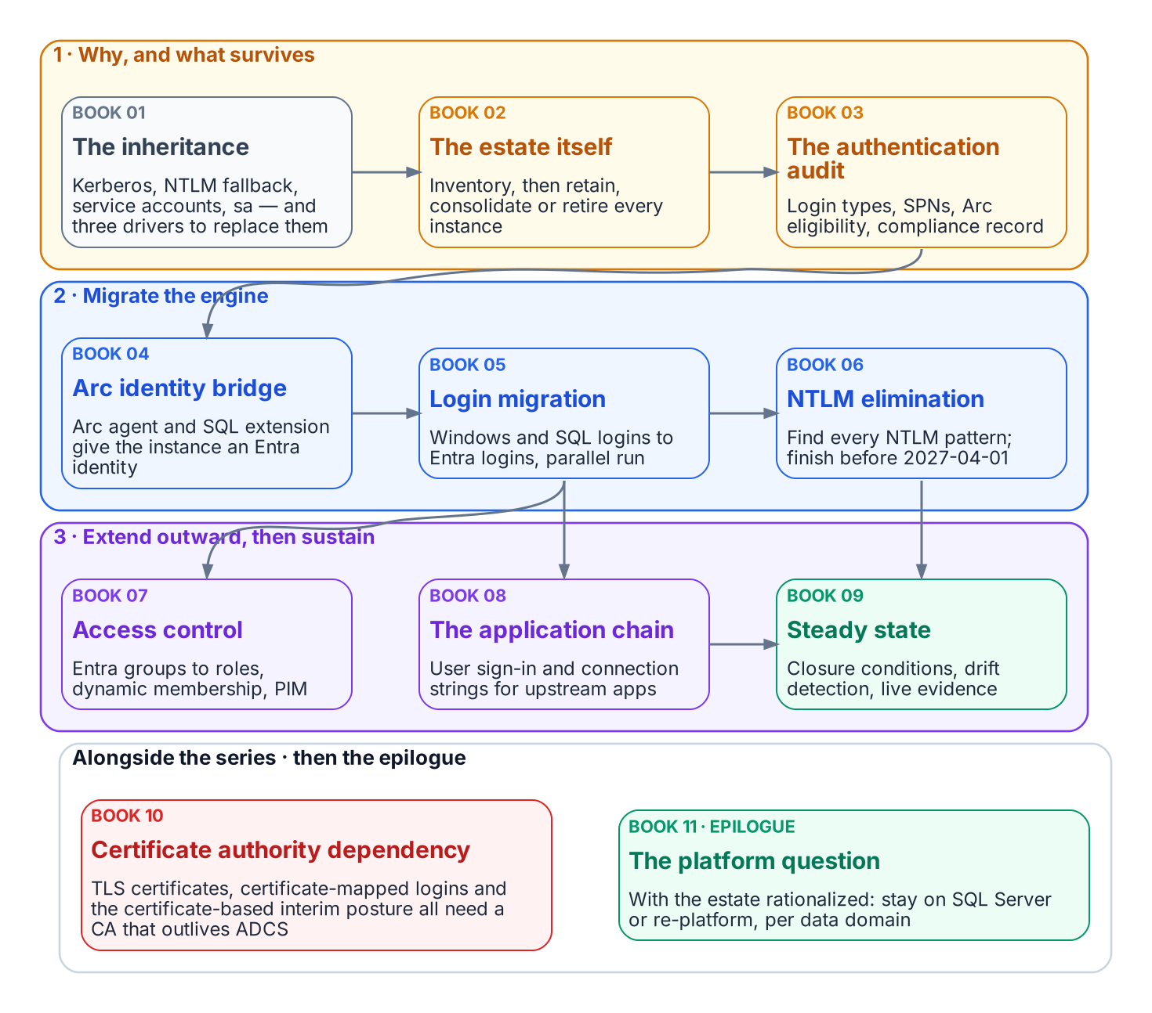
The book’s chapters in the order they depend on each other.

Why, what, who, how
 | Question | Chapters
Why | What Windows Authentication really is, why it must end, and what the estate looks like | 01–06
What | What is actually authenticating, the Arc identity bridge, and the principals that replace Windows logins | 07–12
Who | Who decides and who does the work for the data platform | 13
How | NTLM elimination, access control, the application chain, closure, the certificate dependency and the platform question | 14–23
How — runbooks | Step-by-step implementation, one runbook per stage | R01–R10
Appendices: A — Requirements mapping · B — Security-approval (ATO) kit · C — Applicability

The destination
Windows Authentication and SQL Authentication are eliminated for SQL Server 2022 and later and replaced with Microsoft Entra authentication: OAuth 2.0 tokens, an Entra identity for each instance (the Arc managed identity on SQL Server 2025, an app registration on SQL Server 2022), and multifactor authentication for every human principal. Versions that can’t use Entra authentication reach the closed state only by upgrade or retirement.
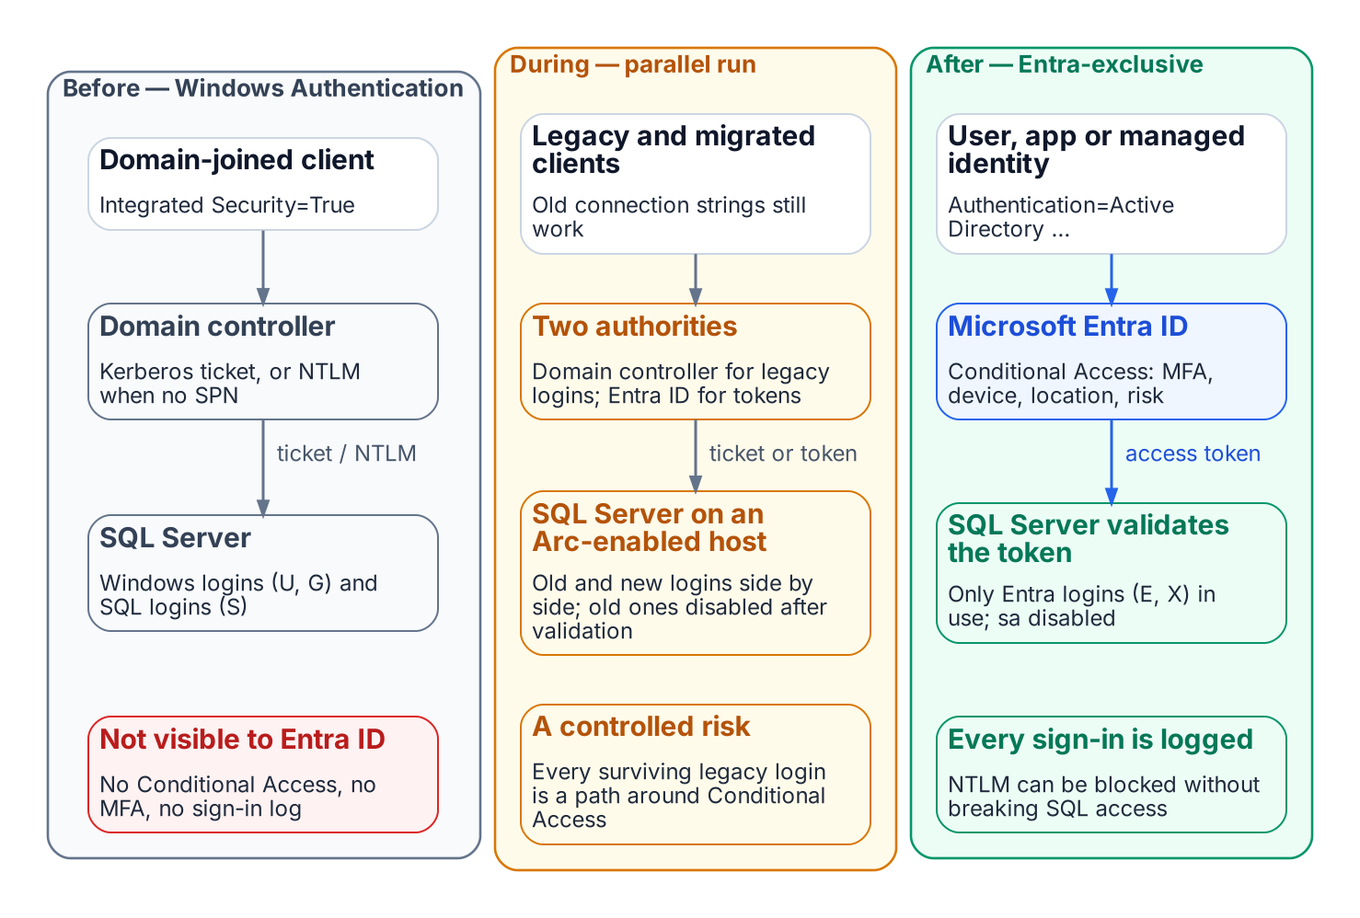
How a connection authenticates before, during and after the transformation.

Reading paths
- Executives (20 minutes): Chapters 01, 02, 06 and 13, or the 15-minute presentation.
- Architects: Chapters 01–13, then 20–23 and Appendix C first if the estate differs from the book’s assumptions.
- DBAs and engineers: each narrative stage with its runbook: Chapters 03–06 with R02, 07–08 with R03, 09–10 with R04, 11–12 with R05, 14–15 with R06, 16–17 with R07, 18–19 with R08, 20–21 with R09, 22 with R10.

Where this book sits in the workbook
This is Book 06 of the Modernization Workbook. It depends on Book 02 — Identity & Directory for the directory migration, Book 03 — HR-Driven Identity for the attributes that drive dynamic group access, Book 04 — Access & Privilege for Conditional Access and PIM, and Book 05 — Devices & Endpoints for bringing servers under Azure Arc. The Federal Compliance books on SQL Server authentication modernization, the SQL Server implementation guide and database consolidation carry the compliance treatment, and the Data Platform Identity Transformation project (plan) delivers it.

Chapter 01 — What Windows Authentication Actually Is
The inheritance, named precisely, before the case for replacing it.

In this chapter
Why the database is where legacy authentication hides, and what that inheritance is. How SQL Server hands authentication to the Windows security subsystem through Kerberos and SSPI, why a missing SPN silently drops a connection to NTLM, what the engine’s service account and the sa login each contribute, and why this architecture was good engineering for the world it was designed for.

Why the database is where legacy authentication hides
Every identity program eventually reaches the database, and the database is where it finds the most Windows authentication still in use. A SQL Server instance doesn’t check passwords for Windows logins; it trusts whatever the Windows security subsystem tells it, and Windows Authentication can’t be turned off. The protocol a connection actually used, Kerberos or NTLM, is visible only from inside the engine, one session at a time. The dependencies sit in connection strings, service accounts, linked servers and the built-in sa login. None of them shows up on an identity dashboard, and none of them produces a sign-in that Microsoft Entra ID can evaluate. So when the Federal Modernization Program retires NTLM, puts Conditional Access in the authentication path and stops treating Active Directory as the identity source, the database is where those changes break things last and hardest. This book finds that inheritance, measures it, shrinks the estate that carries it, and moves what survives to Microsoft Entra ID.

The case in one paragraph
SQL Server’s Windows Authentication was good engineering, not negligence. The case for replacing it doesn’t depend on calling what came before foolish. It depends on a precise account of what Windows Authentication is, why it worked, and why the world it was built for no longer exists. Today a connection reaches SQL Server in one of four ways, and only one of them, a Microsoft Entra token, is anchored in an identity plane that can enforce MFA, device compliance and sign-in risk.
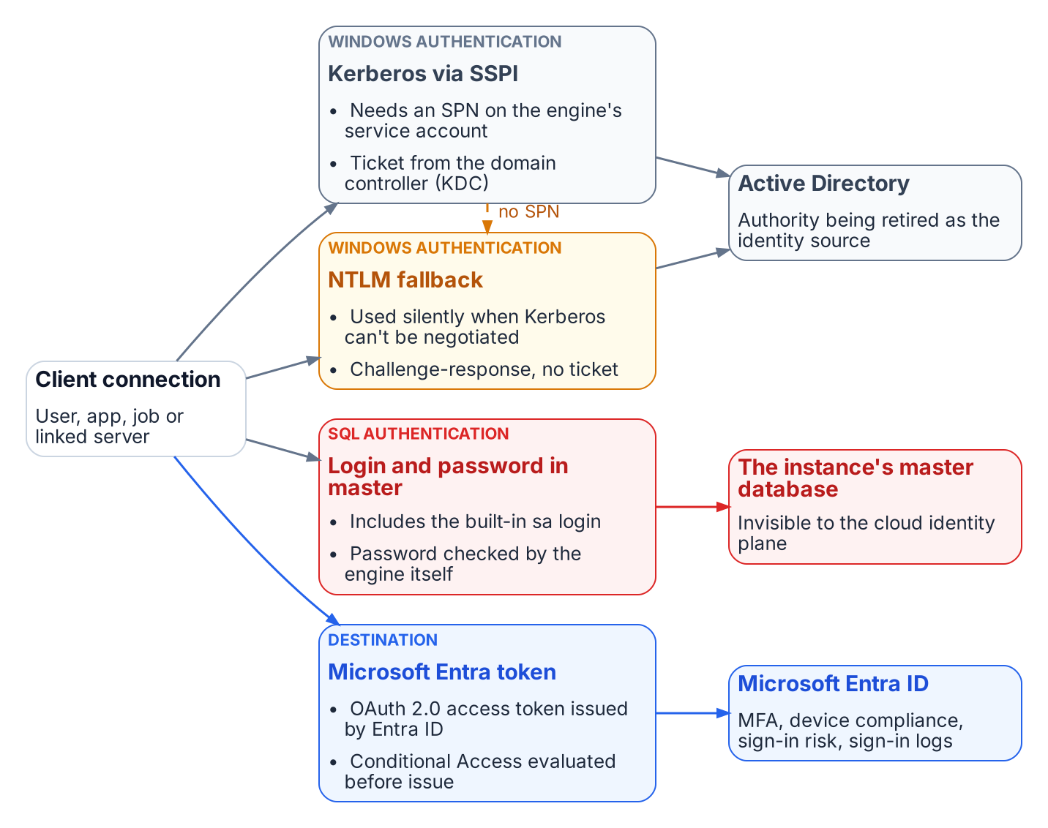
The four ways a connection authenticates to SQL Server today, and which authority each depends on.

The Kerberos foundation
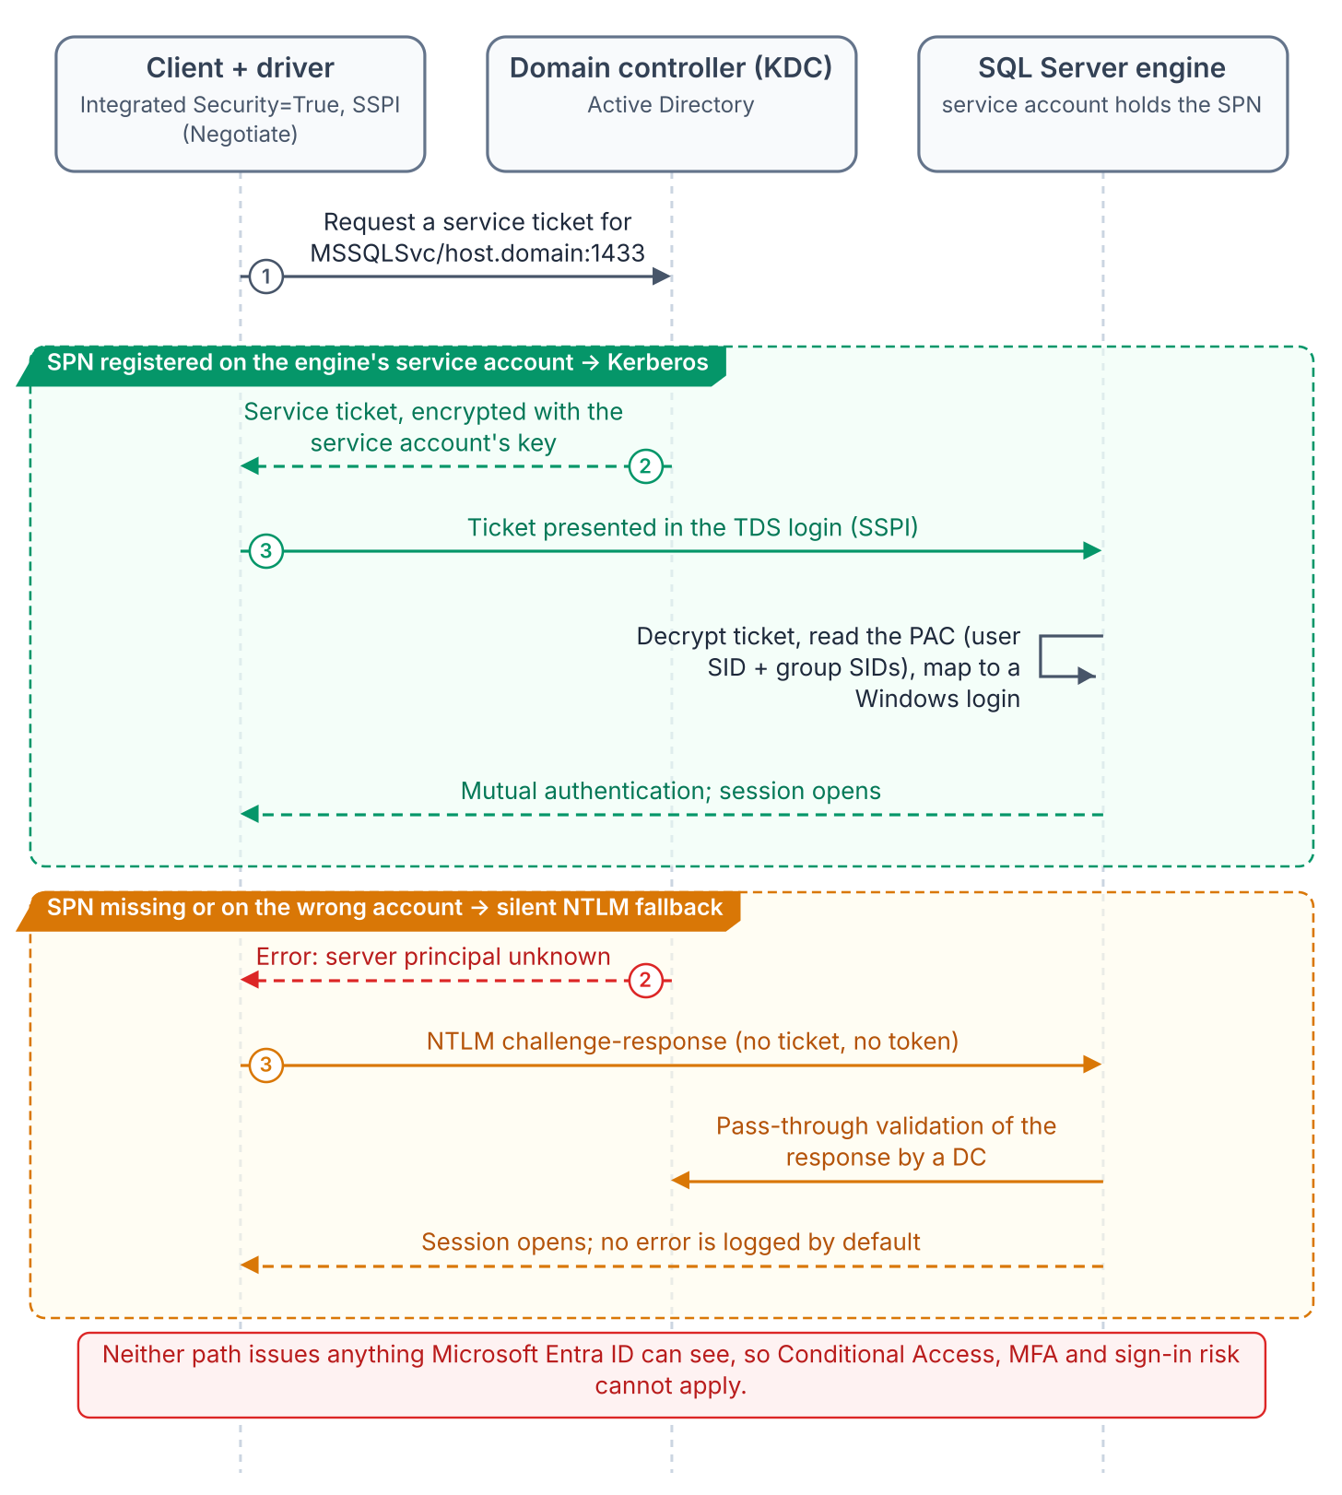
A Windows-integrated connection: SSPI negotiates Kerberos when the SPN resolves, and silently falls back to NTLM when it doesn’t.
When a user connects with a Windows account, SQL Server doesn’t ask for the password or validate the identity itself. It relies on the Windows principal token, so the identity is confirmed by Windows. With Integrated Security=True, the driver hands off to the Security Support Provider Interface (SSPI). SSPI lets an application obtain an authenticated connection without knowing which protocol is underneath, and its Negotiate package picks Kerberos unless one of the systems involved can’t use it. To use Kerberos, the client asks the Key Distribution Center (KDC) on a domain controller for a service ticket to the instance’s Service Principal Name (SPN). The engine validates the ticket with the service account’s key and maps the principal to a login. No password crosses the network, none sits in a configuration file, and Kerberos authenticates the server to the client as well as the client to the server. This is good security architecture, and it deserves saying plainly before explaining why it has to be replaced.
The SPN for a TCP connection takes the form MSSQLSvc/<FQDN>:<port>, and once registered it maps to the Windows account that started the SQL Server service. If the SPN was never registered, or the registration failed, Windows can’t work out which account the SPN belongs to, and Kerberos isn’t used. When the client can’t get a ticket, authentication uses NTLM instead. Microsoft’s own table of authentication defaults shows the full picture. When the SPN maps to the correct account, remote connections use Kerberos and local connections use NTLM. When the SPN lookup fails, both local and remote connections use NTLM. When the SPN maps to the wrong account, authentication fails outright.
That silent fallback is the most consequential fault in the inheritance. The application gets a working connection either way. The engine logs a failed SPN registration at startup, but it doesn’t log which protocol each connection negotiated. The only way to see that is to query the auth_scheme column of sys.dm_exec_connections, session by session. An environment confident that it runs Kerberos can be running NTLM on a large share of its connections, and only measurement shows how large. The authentication audit in Chapter 07 is the program’s instrument for that measurement.

The NTLM fallback
The NTLM family of protocols, which includes LAN Manager and NTLM versions 1 and 2, is Windows’ older challenge-response authentication. Kerberos has been the default Windows authentication protocol since Windows 2000. NTLM stayed on as the fallback for the cases Kerberos can’t handle: workgroup machines, resources reached by IP address rather than host name, computers in untrusted domains, and clients that can’t reach a KDC. SQL Server inherited that order unchanged. On a perimeter-defended network where every machine was domain-joined, that was enough.
It isn’t enough for zero trust, which the program’s FedRAMP Moderate boundary requires. NTLM’s challenge and response happen entirely inside the connection negotiation, between the client, the server and a domain controller. No token or assertion is issued that a third party can evaluate. Conditional Access is enforced in Microsoft Entra ID, outside that path, when a sign-in requests access, so it has nothing to observe, evaluate or deny. The same is true of Microsoft Entra ID Protection’s sign-in risk, which is calculated during Entra sign-ins.

The service account
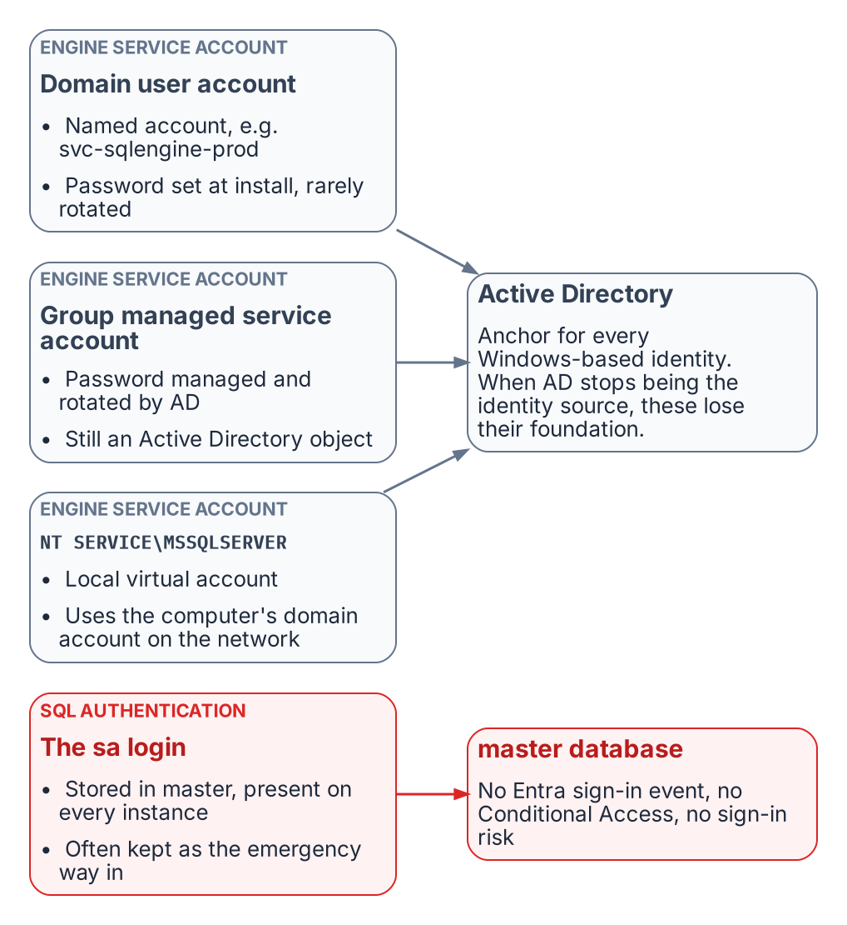
The identities the engine has historically run under, and where each one is anchored.
The engine’s service account is the identity the engine presents on the network: to file shares, to linked servers, to monitoring sinks. Federal estates typically use one of three forms:
- A domain user account such as svc-sqlengine-prod. Its password is set by an administrator and has to be rotated by hand, which in practice often means rarely.
- A group managed service account (gMSA). The domain controller computes and manages its password and rotates it every 30 days by default, and no administrator needs to know it. That’s better hygiene, but it’s still an Active Directory object.
- The virtual account NT SERVICE\MSSQLSERVER, which setup uses by default. It’s a managed local account that reaches network resources with the computer account’s credentials, <domain_name>\<computer_name>$.
In every case, Active Directory is the engine’s identity authority. When the program stops treating AD as the authoritative source, the engine needs an identity in Microsoft Entra ID. On SQL Server 2025, that’s the system-assigned managed identity Azure Arc creates for the host, which Microsoft recommends for Entra authentication on 2025. On SQL Server 2022, it’s an app registration whose certificate is kept in Azure Key Vault and downloaded to the host by the Arc agent. That Entra identity sits alongside the Windows account the service runs as; it doesn’t replace it. Chapters 09–10 cover the transition.

The sa account
SQL Server Authentication stores logins and passwords in SQL Server itself rather than in AD, and sa is its built-in system administrator on every instance. When setup chooses Windows Authentication mode, sa is created but disabled. Microsoft’s guidance is not to enable it unless an application requires it, because it’s well known and often targeted. A common pattern in long-lived estates is the opposite: sa stays enabled as an emergency way in if AD fails, sometimes with the password set at installation.
SQL Server Authentication is invisible to the Microsoft identity plane. The password is checked by the engine, not by a domain controller or by Entra ID, so there’s no Entra sign-in event, no Conditional Access, no sign-in risk, and no domain controller traffic for Microsoft Defender for Identity to watch. An enabled sa is the most dangerous entry point on the instance. How it’s handled is one of the questions the SQL Server engine-authentication decision settles (Chapter 12).

Why this was correct
Taken together, SSPI-negotiated Kerberos, SPNs, NTLM fallback, AD service accounts and SQL Authentication as a local fallback form a coherent, defensible architecture. In a fully domain-joined world it was centrally managed, it authenticated both ends of the connection, it kept credentials off the wire, and it needed nothing beyond the domain controllers already in place. It wasn’t a compromise. The problem is that its world, with every machine domain-joined, the perimeter as the boundary and no cloud identity plane, no longer exists.
What this chapter establishes
- The database is where legacy authentication hides: its Windows Authentication is invisible to the Entra identity plane and can’t be switched off.
- SQL Server Windows Authentication delegates to the Windows security subsystem: Kerberos through SSPI when a correct SPN is registered, silent NTLM fallback when it isn’t.
- The engine’s process identity and the sa login are anchored to authorities, Active Directory and the instance itself, that the program is retiring or that the Microsoft identity plane can’t see.
- None of this was a mistake. It was correct engineering for a fully domain-joined world that no longer exists.

Continue the book
← Previous: Book 06 index · Book index · Next: Chapter 02 — Why the Inheritance Must End →

Chapter 02 — Why the Inheritance Must End
Three drivers, each as well-reasoned as the original design, and their dependency structure.

In this chapter
The three forces that now require replacing Windows Authentication for SQL Server: the NTLM elimination the program has committed to, with its 2027-04-01 backstop; the zero-trust requirement that puts the Microsoft Entra identity plane in the authentication path; and the service-account credential problem the broader directory modernization creates. What is and isn’t externally due in 2027, and why the drivers’ dependencies dictate the order of the whole book.
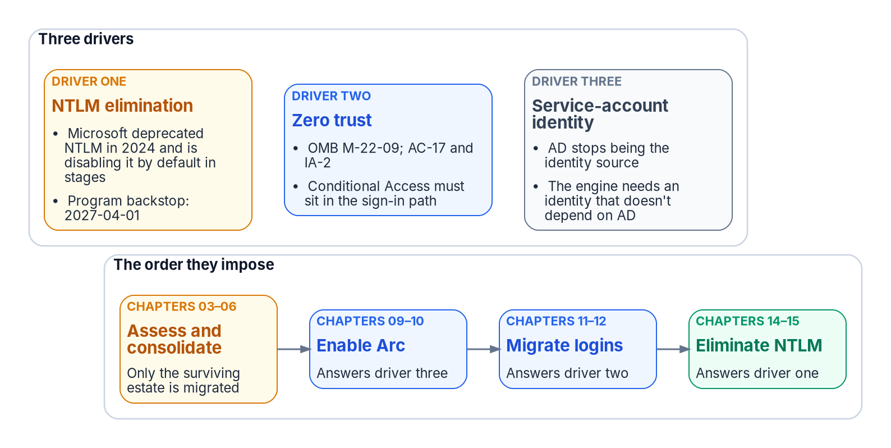
Three drivers end the inheritance, and their dependencies set the order of the book.
The reasons for replacement are as well-reasoned as the original design. NTLM elimination, Conditional Access in the authentication path for all human access, and the end of the domain-joined world aren’t preferences. They follow from Microsoft’s deprecation of NTLM, from the transformation inventory, and from OMB M-22-09, the Federal Zero Trust Strategy. M-22-09 requires phishing-resistant MFA for agency staff, contractors and partners, enforced at the application layer rather than the network layer, and at least one device-level signal alongside identity when authorizing access. The program operationalizes that in its boundary through Conditional Access and phishing-resistant MFA, mapped to the NIST SP 800-53 controls AC-17 (remote access) and IA-2 (identification and authentication).

Driver one: the NTLM elimination commitment
The first driver is a decision the program has made and recorded. The Kerberos/NTLM-elimination program, accepted 2026-05-13, commits the program to eliminating NTLM.
The external driver is real but gradual. Microsoft deprecated all versions of NTLM, including LANMAN, NTLMv1 and NTLMv2, in June 2024. NTLMv1 is already removed from Windows Server 2025 and Windows 11, version 24H2; NTLMv2 still works there but is deprecated and will be removed from Windows Server in a future release. Microsoft’s stated next step is to disable network NTLM by default, not remove it, in the next major release of Windows Server and client. That target is subject to change, and administrators will be able to re-enable NTLM by policy, at least at first. Interim milestones come first: enhanced NTLM auditing, already available on Windows Server 2025 and Windows 11, versions 24H2 and 25H2; IAKerb and the local KDC; and blocking policies. In-market versions of Windows and Windows Server keep supporting NTLM. One related change arrives through Windows Update in October 2026: the internal default of the BlockNTLMv1SSO setting moves from Audit to Enforce. It applies to Windows 11 and Windows Server 2025 devices that don’t have Credential Guard enabled and haven’t set the value. It blocks only NTLMv1-derived credentials used for single sign-on, such as MS-CHAPv2 for Wi-Fi, Ethernet and VPN, and doesn’t touch SQL Server’s NTLM traffic.
Microsoft hasn’t published a calendar date for disabling NTLM by default. The program’s 2027-04-01 backstop is its own planning anchor, set to finish ahead of that step. It isn’t a vendor deadline.
Both NTLM variants are eliminated, on different timelines. NTLMv1 goes first. Hosts older than Windows Server 2025 can still negotiate it, so Phase B blocks it through the “Network security: LAN Manager authentication level” policy (the LmCompatibilityLevel setting) as soon as the Phase A assessment completes, a step the program targeted for 2026-Q3. At the strictest level, domain controllers refuse LM and NTLMv1 responses and accept only NTLMv2. Any connection that still needs LM or NTLMv1 then fails before the engine evaluates the login. Chapters 14–15 cover the detail.
NTLMv2 has a firm backstop: on 2027-04-01 the program’s enforcement phase disables NTLM at the LSA layer across the estate. Any SQL Server connection still relying on it, whether through a missing SPN, a client that can’t negotiate Kerberos, a trust boundary or an unjoined host, will fail inside the host’s security subsystem before the engine sees it. 2027-04-01 isn’t the migration’s completion date. It’s the date by which consolidation, Arc deployment, login migration and connection-string migration must already be complete.

What is actually due in 2027
Nothing in Microsoft’s NTLM roadmap or in M-22-09 falls due on 2027-04-01; that date is the program’s. Three external lifecycle dates in 2027 do bear on the SQL Server estate, and they reinforce the order this book sets:
- Windows Server 2016 leaves extended support on January 12, 2027.
- SQL Server 2014 reaches the end of its third and final Extended Security Update year in July 2027; SQL Server 2016’s first ESU year also ends then.
- SQL Server 2017 leaves extended support on October 12, 2027.
None of these versions can accept Microsoft Entra logins, which need SQL Server 2022 or later. Hosts and engines on them are candidates for the consolidation in Chapters 03–06, not for in-place migration.

Driver two: the zero-trust requirement
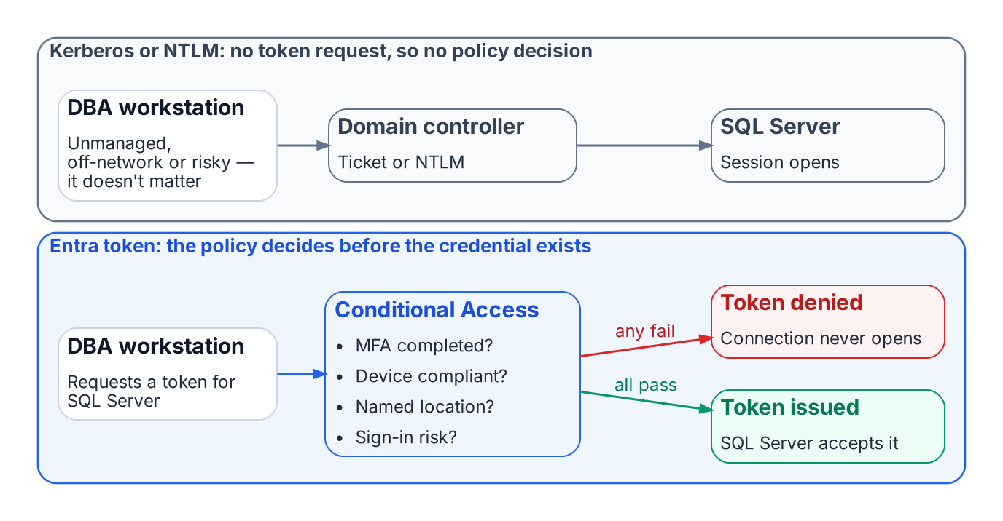
Conditional Access can evaluate an Entra token request; it never sees a Kerberos or NTLM exchange.
The M-22-09 zero-trust posture for this FedRAMP Moderate boundary can’t be implemented without the Microsoft Entra identity plane in the SQL Server authentication path. Conditional Access brings together signals such as user, location, device state and real-time sign-in risk, and enforces its decision when the sign-in asks for access: block, or grant only after MFA, a compliant device or another control is satisfied. Kerberos and NTLM involve no Entra sign-in at all, so a DBA on an unmanaged device, outside named locations or with elevated risk can’t be blocked by policy.
With Microsoft Entra authentication, every token request is evaluated first. Missing MFA, a non-compliant device or elevated risk, such as a sign-in from an anonymous IP address that Microsoft Entra ID Protection flags, means no token or a remediation challenge, and no connection. Risk-based policies need Microsoft Entra ID P2. The policy has real leverage because the token it controls is the credential SQL Server accepts.

Driver three: the service account credential problem
The transformation inventory removes Active Directory as the authoritative identity source. The AD service accounts and gMSAs that authorize the engine on the network then lose their governance foundation, so the engine needs a new identity first. Microsoft’s own cloud-first guidance makes the same point from the other direction: inventory every application that authenticates against AD with Kerberos, NTLM or LDAP before moving its users and groups, because those dependencies break when AD stops being the source.
On premises, that identity arrives through Azure Arc. SQL Server 2025 uses the Arc server’s managed identity directly. SQL Server 2022 uses an app registration certificate that the Arc agent fetches from Key Vault with that identity. Microsoft also documents an Arc-free, certificate-only app-registration setup for SQL Server 2022 and later. Arc is therefore a prerequisite, not an enhancement. It doesn’t change the Windows account the service runs as.
The order follows from these dependencies, preceded by the consolidation decision of Chapters 03–06: assess and consolidate, enable Arc, migrate logins, then eliminate NTLM. That order is the architecture of this book.
What this chapter establishes
- Three independent drivers end the Windows Authentication inheritance: the Kerberos/NTLM-elimination program and its 2027-04-01 backstop, the M-22-09 zero-trust posture, and the engine’s need for an identity that outlives AD.
- 2027-04-01 is the program’s date, not Microsoft’s; Microsoft has set no date for disabling NTLM by default, while several SQL Server and Windows Server lifecycle dates do fall in 2027.
- The zero-trust posture works only when the Entra identity plane is in the authentication path.
- The drivers’ dependencies set the order of the book: inventory and rationalize, audit, enable the identity substrate, move principals and applications, retire protocols, then demonstrate the posture.

Continue the book
← Previous: Chapter 01 — What Windows Authentication Actually Is · Book index · Next: Chapter 03 — The Shape of Twenty Years →

Chapter 03 — The Shape of Twenty Years
Why the estate you must transform is not the estate anyone remembers building.

In this chapter
The three forms of sprawl that accumulate in a SQL Server estate over two decades across an Active Directory forest: instance sprawl, database sprawl and forest entanglement. Why an authentication transformation that begins before this sprawl is assessed will migrate the authentication of servers that shouldn’t survive the transformation at all.

You don’t migrate the estate in the shape you discover it
After twenty years across an Active Directory forest, the SQL Server estate is larger and more tangled than any team’s mental model of it, and a significant fraction of it shouldn’t survive the transformation at all. Chapters 03 through 06 set out the consolidation assessment that classifies every instance retain, consolidate or retire before any login is touched: this chapter describes the sprawl, Chapter 04 finds it, Chapter 05 judges it, and Chapter 06 records the decision. That decision gates every chapter that follows.
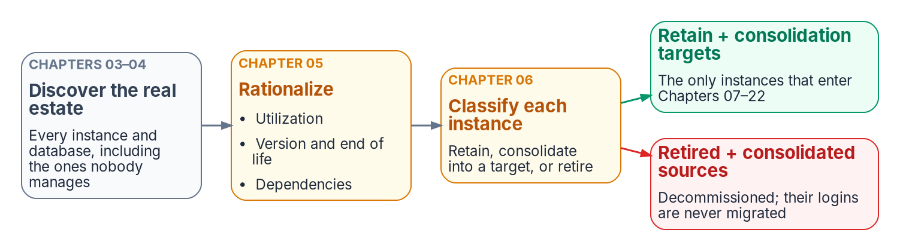
The estate is measured and reduced before any login moves.
Chapters 01–02 named the inheritance and the three drivers that require ending it. This chapter confronts a precondition that most authentication narratives skip entirely: you can’t migrate the authentication of an estate you haven’t first measured and rationalized. After twenty years across an Active Directory forest, the SQL Server estate is larger, older and more entangled than any single team’s mental model of it, and a meaningful fraction of it shouldn’t survive the transformation in its current shape.
The order matters because effort is finite and the program’s 2027-04-01 backstop is fixed. Migrating the logins of an instance to Microsoft Entra ID, only to retire that instance three months later, is wasted work measured against a date the program has committed not to move. The SQL Server engine-authentication decision makes the sequencing normative: the consolidation assessment classifies every instance retain, consolidate or retire before any login is touched.
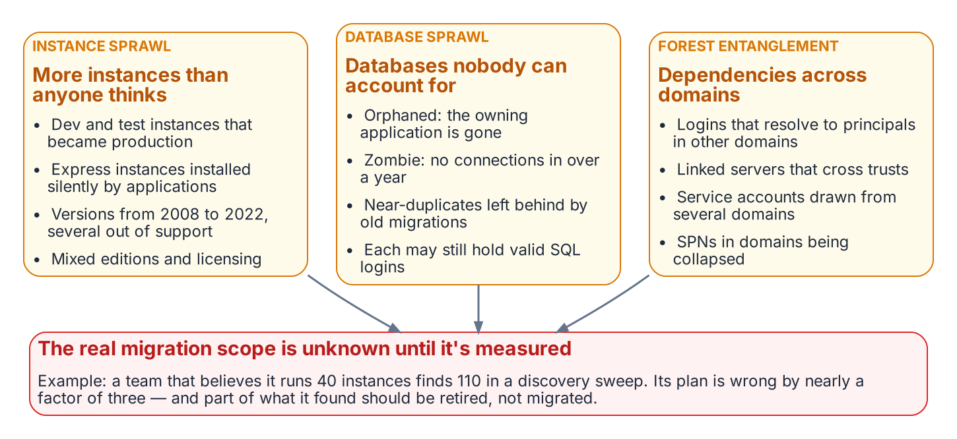
Instance sprawl, database sprawl and forest entanglement overlap, and together they set the scope of the transformation.

Instance sprawl
A SQL Server estate doesn’t grow by design. It grows by accretion. A development instance becomes a production instance because a project shipped and nobody rebuilt it on the production tier. A test instance set up for a vendor evaluation is never decommissioned. An application installer silently provisions a SQL Server Express instance on an application server, and that instance accumulates real data for years without ever appearing on a DBA team’s inventory.
The result, in a mature federal environment, is a population of instances spanning the SQL Server versions released across two decades, 2008, 2012, 2014, 2016, 2017, 2019 and 2022, with SQL Server 2025 now arriving as well, in every edition from Express on a workstation to Enterprise on a clustered host. Several of those versions are out of support. SQL Server 2008 R2, 2012 and 2014 have left extended support, and SQL Server 2016 left it on July 14, 2026. Those engines now get security updates only through a paid Extended Security Update subscription, where one is still offered, and the subscription runs for at most three years past end of support. SQL Server 2017 follows on October 12, 2027. The licensing posture is equally mixed: Standard and Enterprise cores, some covered by Software Assurance and some not, with no single authority that can state how many cores the estate actually consumes.
Instance sprawl is the first thing the assessment must quantify, because the count of instances, and especially the count of unknown instances, sets the true scope of the transformation. In an illustrative example, an estate that the DBA team believes contains forty instances and the discovery sweep shows to contain a hundred and ten isn’t forty instances behind schedule. It’s working from a scope estimate that’s wrong by a factor of nearly three.

Database sprawl
Beneath the instances lies a second layer of accretion: the databases themselves. An instance that has run for fifteen years carries databases nobody can confidently account for. Some are orphaned: the application that created them has been decommissioned, but the database was never dropped because no one was certain it was safe to do so. Some are zombies: they’ve received no connection in over a year, yet they consume storage, appear in backup jobs and lengthen every maintenance window. Some are near-duplicates, the residue of a migration that copied a database to a new name and never removed the original.
Database sprawl matters to the authentication transformation for a specific reason. Every database is a potential source of logins, and every login is a unit of migration work. A zombie database may map a long-forgotten SQL Authentication service account that still has a valid password and still appears, to a discovery script, as an active credential requiring migration. The fastest way to reduce the migration surface isn’t to migrate faster. It’s to retire the databases and instances that shouldn’t be migrated at all.
Zombie detection is therefore not a housekeeping nicety; it’s migration-scope reduction. To take an illustrative example, a database with no connections in four hundred days, no recent backups consumed for a restore, and an owning application that the application portfolio lists as retired is a database whose logins should never enter the migration pipeline.

Forest entanglement
The third form of sprawl is the one that makes the SQL Server transformation genuinely harder than a single-domain migration: the estate is entangled with the Active Directory forest it grew up in. Instances are spread across multiple domains connected by trusts. Logins on one instance resolve to security principals in a different domain. Linked-server definitions form a web of cross-instance dependencies that crosses domain boundaries, and the service accounts running the engine processes are drawn from several domains with no consistent naming or governance.
This entanglement is precisely what the directory modernization removes the foundation for. When Active Directory stops being the authoritative identity source, every cross-domain login, every SPN registered in a domain that’s being collapsed, and every shared service account becomes a dependency that must be resolved, not merely re-pointed. Consolidation is the moment when that resolution is cheapest, because collapsing many instances into fewer modern targets is also the moment to collapse the cross-domain identity sprawl into Entra-backed identity.
The shape of twenty years, then, is three overlapping problems: too many instances, too many databases, and too many forest-spanning dependencies between them. The chapters that follow describe how to measure each, and how to turn the measurement into the retain / consolidate / retire decision that gates everything in Chapters 07 through 22.
What this chapter establishes
- A twenty-year estate has three overlapping forms of sprawl: instances, databases and forest entanglement.
- Sprawl inflates the migration surface, because much of the estate should be retired or consolidated rather than migrated.
- The authentication transformation doesn’t begin until the sprawl is assessed.

Continue the book
← Previous: Chapter 02 — Why the Inheritance Must End · Book index · Next: Chapter 04 — The Estate Inventory →

Chapter 04 — The Estate Inventory
Finding the instances and databases that no inventory already records.

In this chapter
What a complete estate inventory must capture before consolidation can begin. The discovery instruments that find the instances no one remembers: network and Active Directory sweeps, the SPN registration trail, and Microsoft’s assessment tooling. Why estate discovery is a broader exercise than the authentication audit of Chapters 07–08, and how the program closed the gap its engine-authentication decision named.
A consolidation assessment begins with an inventory, and the defining characteristic of a twenty-year estate is that the inventory doesn’t already exist in complete form. The instances a DBA team manages deliberately are known. The instances that matter most to the assessment are the ones nobody is managing, and those must be discovered, not retrieved from a list. Microsoft’s own guidance for moving identity off Active Directory starts the same way: begin with an inventory before changing anything.
This is the point at which estate discovery diverges from the authentication audit of Chapters 07–08. The authentication-audit script measures the authentication posture of instances that are already known: their login types, their authentication mode, their SPN status, their Arc eligibility. Estate discovery runs earlier and casts wider. Its job is to establish the denominator, the complete set of instances and databases that exist, so that the authentication audit has something complete to measure.

What the inventory must capture
An estate inventory sufficient to drive a consolidation decision captures, for every instance it can find, a consistent set of facts. The version, edition and build number establish the support and licensing posture. The host operating system version establishes the Arc and upgrade envelope. The domain-join state and the owning domain establish the forest-entanglement picture. The service-account identity and its source domain establish the credential dependencies. And, for every database on the instance, the size, the last-access timestamp, the recovery model and the owning application establish the utilization and zombie picture that Chapter 05 turns into a rationalization decision.
The inventory isn’t a point-in-time spreadsheet. Like the authentication audit it precedes, it’s designed to be re-run, because instances appear and disappear across a multi-month assessment, and the consolidation plan must track a moving estate rather than a single snapshot.

Discovery instruments
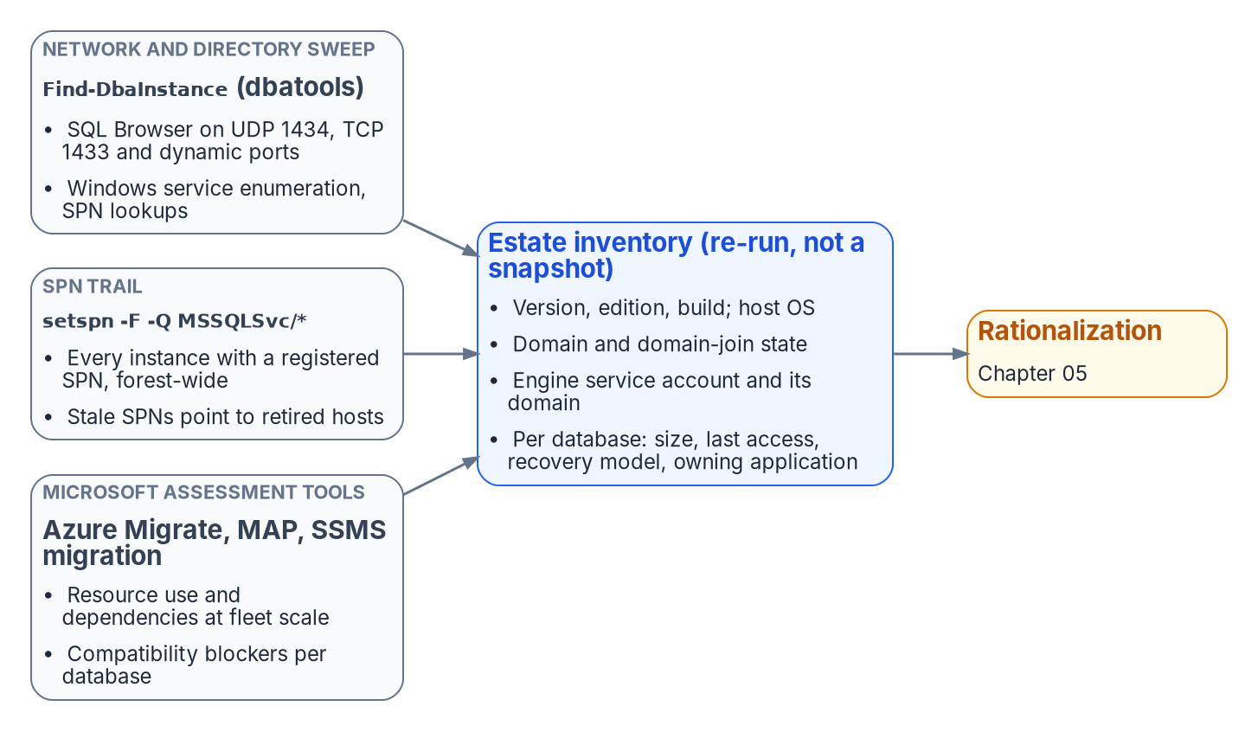
Three independent discovery instruments feed one re-runnable estate inventory.
No single instrument finds every instance, because instances hide in different ways. A complete sweep combines several, each blind to what the others surface.
A network and directory sweep finds instances by listening for them. The default instance listens on TCP 1433; named instances, including SQL Server Express, use dynamic ports by default; and the SQL Server Browser service answers on UDP 1434 with the port for each named instance. Active Directory records instances indirectly, through their SPNs. The open-source PowerShell module dbatools provides Find-DbaInstance, which combines these signals in one discovery pass across a network range or an Active Directory domain. It can find candidate hosts from AD SPN records, Active Directory computer objects, the Browser broadcast or IP ranges, and then confirm each one with Browser queries, Windows service enumeration, SPN lookups, TCP port tests and, optionally, a SQL connection. It’s the most direct way to surface instances that no inventory records. It’s a community tool, not a Microsoft product, so it goes through the program’s normal software approval before it runs.
The SPN registration trail is a second, independent signal. An instance that negotiates Kerberos has an MSSQLSvc service principal name registered for it, whether the engine registered it at startup or an administrator did it by hand. A forest-wide query for those SPNs, setspn -T <forest-root-domain> -F -Q MSSQLSvc/* or the equivalent directory query, enumerates every instance that was ever registered for Kerberos, including instances on hosts that are otherwise off the radar. It doesn’t find instances whose SPN registration failed, which is exactly why it complements the network sweep. The SPN trail also feeds directly into the authentication audit: a registered SPN that points at a decommissioned host, and an instance generating Kerberos traffic with no corresponding SPN, are both findings the later chapters act on.
Microsoft’s assessment tooling is the third instrument, and it captures what the first two can’t: workload and dependency data. Azure Migrate discovers SQL Server instances and databases across VMware, Hyper-V and physical servers, collects their configuration and performance data, and with agentless dependency analysis maps the TCP connections between servers so that interdependent servers can be grouped and moved together. The Microsoft Assessment and Planning (MAP) Toolkit, which Microsoft still lists for the discovery phase, inventories the wider infrastructure. For per-database compatibility and feature blockers against a target version, the SQL Server migration component in SQL Server Management Studio now does the job the Data Migration Assistant (DMA) used to; DMA was retired on July 16, 2025. SQL Server instances connected to Azure Arc also get a migration readiness assessment produced automatically. These instruments are useful here for what they reveal about the estate, independent of any decision to use Azure as a migration target. The dependency map and the version-compatibility findings are inputs to the consolidation decision wherever the consolidated estate ultimately lands.

The Phase 0 discovery instrument
The discovery instruments named above are real and well understood, but on their own they aren’t bound into a single discovery specification the way the authentication-audit script, the application-audit script and the certificate-audit script bind the authentication, application and certificate audits. The SQL Server engine-authentication decision named this as an explicit gap: the estate-consolidation inventory that produces the retain / consolidate / retire classification had no discovery instrument of its own. The implementation plan identified authoring one, with output that feeds the same compliance-monitoring pipeline as the authentication audit, as Phase 0, the prerequisite to everything the later chapters describe.
The program has since closed that gap. New-FMPEstateInventory fuses the instance enumeration from the authentication-audit family, the MSSQLSvc SPN trail and the broader sweep into one deduplicated inventory and applies the retain / consolidate / retire gate. Runbook R02 documents how to run it. The general-purpose instruments above remain the sources it consumes, so an assessment can still be done with them alone; it’s then recorded as a deliberate program artifact rather than a fused inventory. Naming the gap was itself part of the assessment’s value. An estate transformation that proceeds on an incomplete inventory discovers its missing instances at the worst possible moment, which is exactly the failure this part of the book exists to prevent.
What this chapter establishes
- Inventory comes first: the estate doesn’t already know what it has.
- Discovery combines a network and directory sweep, the MSSQLSvc SPN trail and Microsoft’s assessment tooling, because each misses what the others find.
- The engine-authentication decision named the missing discovery instrument as Phase 0; New-FMPEstateInventory (Runbook R02) now fills it.

Continue the book
← Previous: Chapter 03 — The Shape of Twenty Years · Book index · Next: Chapter 05 — Rationalization: Utilization, Versions and Dependencies →

Chapter 05 — Rationalization: Utilization, Versions and Dependencies
Turning a complete inventory into a defensible judgment about what each instance is worth.

In this chapter
The three analytical lenses that convert a raw inventory into a rationalization judgment: utilization and zombie detection, version and end-of-life posture, and dependency mapping. Why the dependency map in particular decides which instances can be consolidated and which are load-bearing in ways that stay invisible until they’re mapped.
An inventory establishes what exists. Rationalization establishes what each item is worth keeping. The assessment applies three lenses to every instance and every database the inventory surfaced, and the combined picture drives the retain / consolidate / retire decision that Chapter 06 formalizes.

Utilization and zombie detection
The first lens is utilization. An instance consumes CPU, memory, storage and a licensing entitlement whether or not anyone is using it, and a twenty-year estate contains instances that consume all four while serving no current workload.
Utilization analysis rightsizes the survivors and identifies the candidates for retirement. For each instance, the assessment captures sustained and peak resource consumption, connection counts and the workload profile: read-heavy reporting, transactional, batch or idle. For each database, it captures the last-access timestamp, the recent query workload and the backup-restore history. Azure Migrate collects much of this for discovered SQL Server instances and databases, refreshing configuration data daily and performance data every 30 seconds.
A database with no connections in over a year, no restores consumed and a retired owning application is a zombie, and zombies are the cleanest retirement candidates in the estate. Retiring them is the single most effective way to reduce the authentication migration surface, because every login they carry, including long-forgotten SQL Authentication service accounts with still-valid passwords, is removed from the migration pipeline before it ever enters it.
Utilization data also rightsizes the consolidation targets. In an illustrative example, an instance running at four percent of a sixteen-core Enterprise license isn’t a retain candidate at its current size. It’s a consolidation source whose workload belongs on a shared modern target, freeing the license and the host.

Version and end-of-life posture
The second lens is version posture, and it interacts directly with the authentication transformation. The FROM EXTERNAL PROVIDER login syntax that the whole transformation depends on, which maps a login to a Microsoft Entra principal, is available only on SQL Server 2022 and later. An instance on any earlier version, whether 2019 or 2017, or the out-of-support 2016, 2014, 2012 and 2008 releases, can’t accept Entra ID logins regardless of any other change. Chapters 07–08 formalize that constraint as the Category 3 classification.
This makes version posture a primary input to the consolidation decision rather than a secondary one. An out-of-support instance on SQL Server 2012 is at once a security-update liability, since its last Extended Security Update year ended in July 2025, a licensing question, and an instance that can’t move to Entra ID authentication without an engine upgrade. The upgrade paths narrow the options further. SQL Server 2012 and later can be upgraded in place to SQL Server 2022, but SQL Server 2008 and 2008 R2 need a side-by-side upgrade or a migration. SQL Server 2025 accepts in-place upgrades only from SQL Server 2014 SP3 and later. For most such instances, the right answer isn’t “upgrade in place to 2022 or 2025 and then migrate.” It’s “consolidate the surviving workload onto a modern target and retire the old engine.” The version lens and the utilization lens reach the same conclusion for most of the aged estate: collapse it onto fewer modern instances rather than carrying each old engine forward.
The licensing posture rides alongside the version posture. Consolidation that reduces the instance count also reduces core-license consumption, and an estate that can state its true core count before consolidation can quantify the licensing dividend consolidation produces.

Dependency mapping
The third lens is the one that most often overturns a naive consolidation plan: dependency mapping. An instance that appears idle by connection count may be the silent target of a linked-server chain, a replication topology, an SSIS package, or a cross-database query that runs once a quarter and matters enormously when it runs.
Dependency mapping traces these relationships before any instance is moved. Linked-server definitions in sys.servers and the login mappings in sys.linked_logins reveal the cross-instance, and frequently cross-domain, web that forest entanglement produced. Application-to-database mapping, drawn from connection telemetry and the application portfolio, shows which databases are load-bearing for which systems. The SQL Server Agent job inventory, the replication configuration and the SSIS, SSRS and SSAS footprint show the integration surface a consolidation must preserve. Azure Migrate’s agentless dependency analysis adds server-to-server connection data, and the SSMS migration component adds compatibility and feature-blocker findings, supplementing the in-engine views.
The dependency map is also the bridge to Chapters 18–19. The upstream applications that consume SQL Server, many of them LDAP-bound, are precisely the systems whose dependencies the map records, and the application-chain migration of those chapters acts on the same relationships the rationalization lens surfaces here. An instance can’t be classified retire if a load-bearing application still depends on it, and the dependency map is what makes that judgment defensible rather than hopeful.

The combined picture
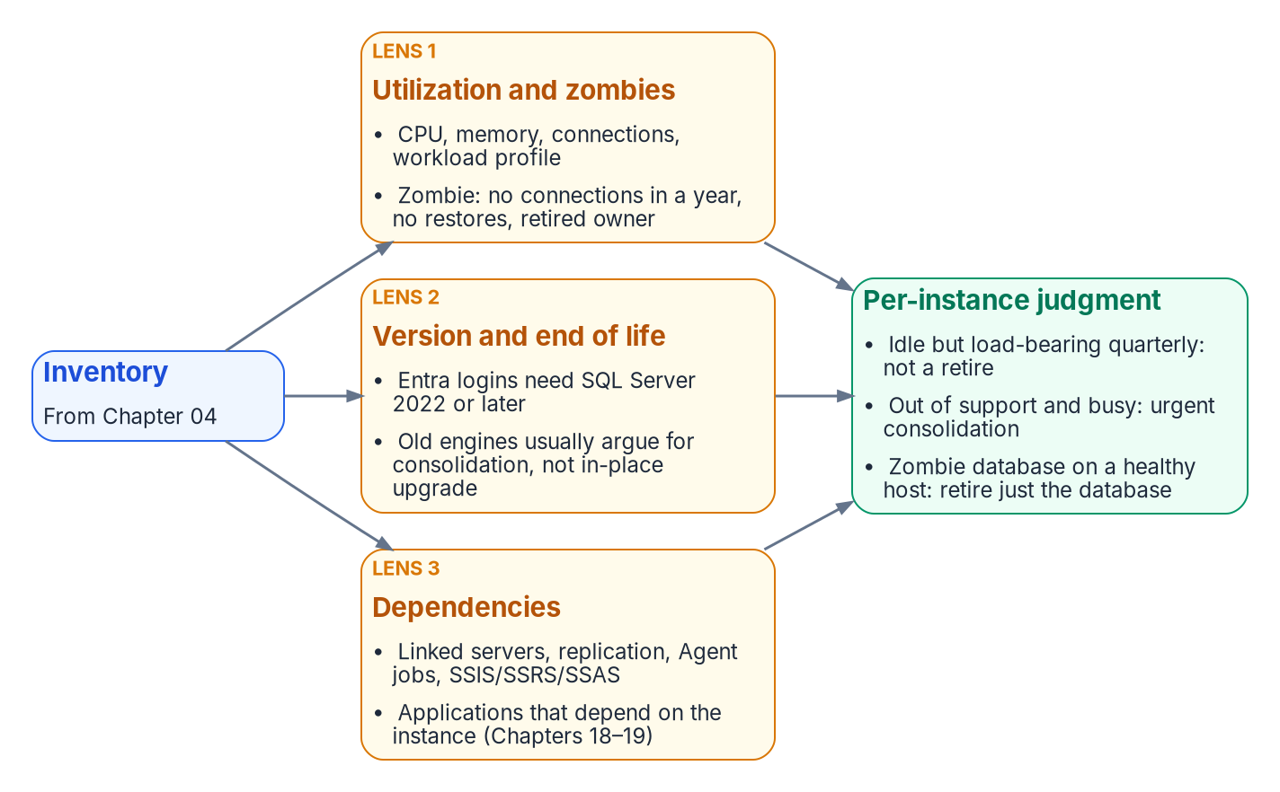
Utilization, version posture and dependencies, applied together, produce a defensible judgment per instance and per database.
No single lens produces the rationalization decision. An instance that’s lightly used but load-bearing for a quarterly process isn’t a retirement candidate. An out-of-support instance with heavy utilization is an urgent consolidation target, not one to leave alone. A zombie database on an otherwise healthy instance is a local retirement that shrinks the migration surface without touching the host. Together, the three lenses produce a defensible judgment for each instance and each database, and that judgment is the input to the decision Chapter 06 records.
What this chapter establishes
- Rationalization applies three lenses, utilization, version and end-of-life posture, and dependencies, to every inventoried instance.
- Idle instances and zombie databases are retired, which shrinks the migration surface.
- Entra logins need SQL Server 2022 or later, so version posture is a primary input, and old engines usually argue for consolidation over in-place upgrade.
- The three lenses together produce the per-instance retain, consolidate or retire judgment.

Continue the book
← Previous: Chapter 04 — The Estate Inventory · Book index · Next: Chapter 06 — The Retain, Consolidate, Retire Decision →

Chapter 06 — The Retain, Consolidate, Retire Decision
The gate that determines which instances enter the authentication migration at all.

In this chapter
How the three rationalization lenses resolve into a single per-instance classification: retain, consolidate-into-target or retire. The target-state options that absorb consolidated workloads, the constraints that prevent consolidation, and why this decision is the moment to collapse the forest-spanning identity sprawl into Entra-backed identity.
The assessment now resolves to a decision. Every instance the inventory surfaced and the rationalization lenses evaluated is assigned one of three classifications, and that classification governs whether the instance enters the authentication migration that Chapters 07 through 22 describe. The SQL Server engine-authentication decision makes the classification a normative prerequisite: engine-layer authentication migration is performed only on instances classified retain or on the consolidation targets that absorb consolidated workloads. Instances classified retire or consolidate-into-target (source) aren’t migrated; they’re decommissioned or collapsed.

The three classifications
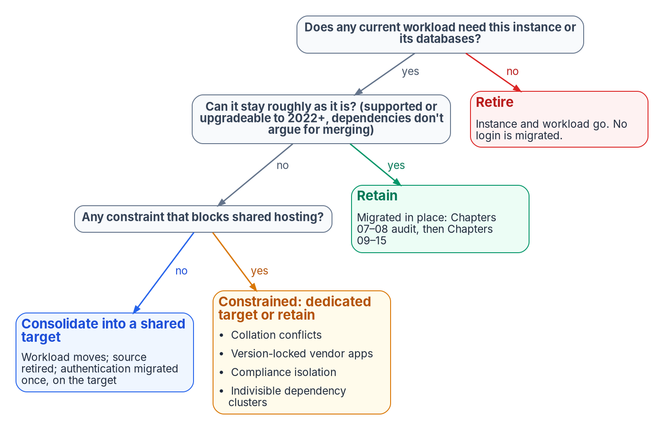
Retain, consolidate or retire: the classification that gates the authentication work.
A retain instance survives the transformation roughly in place. It carries current, load-bearing workload; it’s on a supported version or has a clear in-place upgrade path to SQL Server 2022 or later; and its dependencies don’t argue for collapsing it into something larger. A retain instance goes straight into the authentication audit and Arc-eligibility classification of Chapters 07–08.
A consolidate-into-target instance doesn’t survive as an instance, but its workload does. The databases it carries are migrated onto a modern consolidation target, and the source instance is then retired. This is the classification for the large middle of an aged estate: lightly used instances, out-of-support engines whose workload is still needed, and instances whose only real function is to host one or two databases that belong on a shared platform. The migration work for these instances happens at the database and workload level; the authentication migration is performed on the target, not the source.
A retire instance doesn’t survive at all, and neither does its workload. Zombie instances, instances whose every database is a zombie, and instances whose owning applications are decommissioned are retired outright. No login on a retire instance ever enters the migration pipeline, which is the whole point of running this assessment before the migration rather than after it.

Target-state options
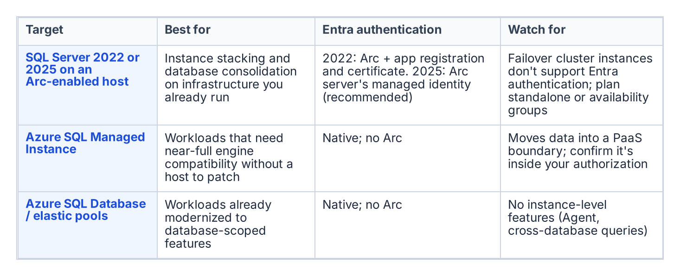
Consolidation targets, and what each one means for authentication.
A consolidation target is the platform that absorbs consolidated workloads, and the assessment chooses among a small set of options based on the workload profile and the program’s boundary posture.
- Fewer, modern SQL Server 2022 or 2025 instances on Arc-enabled hosts, through instance stacking or database consolidation onto a shared engine. This is the most direct path, and it keeps the workload on infrastructure the program already operates. Microsoft Entra authentication isn’t supported on failover cluster instances, so consolidation targets that need Entra logins are standalone instances or Always On availability groups.
- Azure SQL Managed Instance, a platform-as-a-service target that closely matches the features of an on-premises instance, including cross-database queries and SQL Server Agent jobs, and removes the host and most of the patching burden. It has documented T-SQL differences and a 32 TB combined storage limit.
- Azure SQL Database and elastic pools, for workloads already modernized to the database-scoped feature set. Applications that use cross-database queries, linked servers or SQL Server Agent jobs may need changes.
The target choice interacts with the rest of the book. A consolidation onto SQL Server 2022 on an Arc-enabled host is exactly the Category 1 starting position that Chapters 07–08 describe and Chapters 11–12 migrate. A consolidation onto Azure SQL Managed Instance changes the authentication story in detail but not in principle. Managed Instance supports Microsoft Entra authentication natively, and Microsoft Entra-only authentication can be enabled on it, which stops every SQL authentication login from connecting. The destination is still Entra ID-only authentication. The point of naming the target during the assessment is that the authentication migration is then performed once, on the target, in its final shape, rather than twice.

What can’t be consolidated
Not every instance that looks like a consolidation candidate can actually be consolidated, and the assessment must record the constraints honestly:
- Collation conflicts between databases that must coexist on a shared instance can block stacking.
- Version-locked vendor applications that are certified only against a specific SQL Server version can’t move to a newer engine without losing vendor support.
- Compliance isolation: a database whose data classification mandates physical or logical separation can be barred from co-residency regardless of technical compatibility.
- Indivisible dependencies: cross-database or cross-instance dependencies that the dependency map surfaced can make two instances a single unit that must move together or not at all.
Each of these constraints converts an apparent consolidation candidate into either a constrained-consolidation case (move it, but onto a dedicated rather than shared target) or a retain case (leave it in place and migrate its authentication where it sits). Recording the constraint is what makes the consolidation plan executable rather than aspirational.

The identity dividend
Consolidation and the authentication transformation reinforce each other, and the assessment is the moment to realize the connection. Collapsing many instances across multiple domains into fewer modern targets is also the moment to collapse the forest-spanning identity sprawl that Chapter 03 described. The cross-domain logins, the orphaned SPNs registered in domains being decommissioned, and the shared service accounts drawn from several domains don’t need to be re-pointed instance by instance if the instances carrying them are being retired or consolidated. They’re resolved once, at the target, into Entra-backed identity.
This is why the consolidation decision gates the authentication migration rather than running alongside it. The retain instances and the consolidation targets are the surface on which Chapters 07 through 22 operate. Everything classified retire or consolidate-source falls away before that work begins, and the forest entanglement falls away with it. The SQL Server engine-authentication decision records this ordering as the governing constraint: assess and consolidate first, so the authentication transformation is spent only on the estate that survives. Runbook R02 is the procedure that applies the gate.
What this chapter establishes
- Every instance is classified retain, consolidate-into-target or retire, and only retained instances and consolidation targets enter the migration.
- Targets are chosen during the assessment, so authentication is migrated once, in its final shape.
- Consolidation is the moment to collapse forest-spanning identity sprawl, which is why the assessment gates everything that follows.

Continue the book
← Previous: Chapter 05 — Rationalization: Utilization, Versions and Dependencies · Book index · Next: Chapter 07 — The Authentication Audit →

Chapter 07 — The Authentication Audit
No migration survives contact with an estate it hasn’t measured, so the audit turns every surviving instance into a structured, drift-aware authentication record.

In this chapter
What the authentication-audit script enumerates across the surviving estate, how it reads the authentication-mode configuration and classifies every login by type, how it captures the engine service-account identity and SPN registration, the three-category Arc-eligibility classification that drives migration sequencing, and why the script’s output feeds the compliance-monitoring pipeline rather than a spreadsheet.
Chapters 03 through 06 measured the estate to decide what survives. This chapter and the next measure the authentication posture of what remains. The authentication-audit script is the instrument, the Arc-eligibility classification is its most consequential output, and the per-instance compliance record, not a spreadsheet, is its deliverable. In the program’s dependency chain this is step 3: audit the survivors. The hands-on procedure is in Runbook R03.
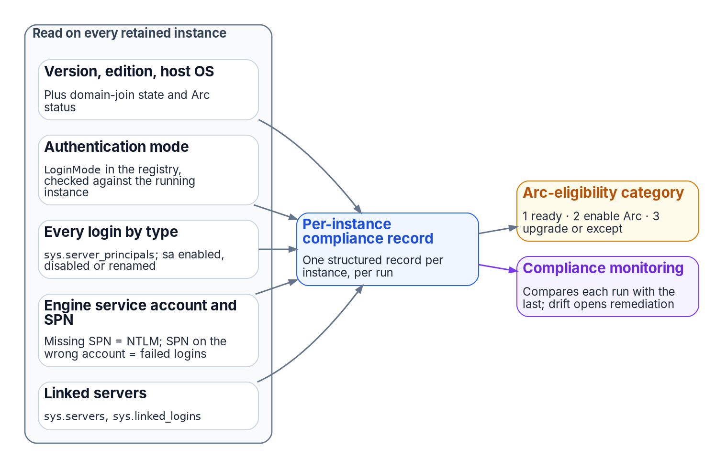
What the authentication audit reads on each instance, and where its output goes.
The audit runs only on the instances Chapter 06 classified as retain or consolidation target. The rationalization decision has already removed the zombies and retirees from scope before a single line of enumeration runs.

Scope of the enumeration
The authentication-audit script performs a structured enumeration of the SQL Server estate across all hosts in the program’s management scope. For each host it identifies every SQL Server instance, named instances and the default instance, along with the version, edition and build number.
The host operating system version is captured because it determines the Arc capability envelope. The Connected Machine agent runs on Windows Server 2012 through 2025, though new agent versions for 2012 and 2012 R2 end in November 2026. SQL Server enabled by Azure Arc needs Windows Server 2016 or later, and Microsoft Entra authentication for the engine needs SQL Server 2022 or later, set up through an app registration on SQL Server 2022 or the server’s managed identity on SQL Server 2025. The program sets its own floor one step higher, at Windows Server 2019, because Windows Server 2016 reaches end of support on January 12, 2027. None of those hosts supports the AADLoginForWindows OS-level Entra sign-in extension, which needs Windows Server 2025 with Desktop Experience; Windows Server 2025 supports both capabilities.
That distinction matters for migration sequencing, and the audit captures it explicitly. The domain-join status of the host is recorded alongside it: a host already migrated to a non-domain-joined state under the Arc non-domain-join requirement occupies a different starting position than a domain-joined host, and the per-instance output must reflect that.
Arc-enablement status (whether the Connected Machine agent is installed and the system-assigned managed identity is available) is the single most consequential classification output for migration prioritization.

Authentication-mode configuration
For each instance the script reads the authentication-mode configuration. SQL Server supports two modes: Windows Authentication mode and mixed mode. In Windows Authentication mode, SQL Authentication logins are rejected at the connection level: no SQL Authentication credential is accepted regardless of whether a matching login exists in master. In mixed mode, both Windows Authentication and SQL Authentication are accepted. Windows Authentication is always available and can’t be disabled in either mode, and Microsoft Entra authentication, once configured, works alongside both.
The mode is stored in the Windows registry as the LoginMode value under the instance’s key, HKLM\SOFTWARE\Microsoft\Microsoft SQL Server\MSSQL<version>.<InstanceID>\MSSQLServer (for example MSSQL16.MSSQLSERVER for a default SQL Server 2022 instance): a value of 1 indicates Windows Authentication mode, and 2 indicates mixed mode. The audit reads this value directly and cross-references it against the running instance with SERVERPROPERTY('IsIntegratedSecurityOnly'), which returns 1 in Windows Authentication mode. A change of mode takes effect only after the service restarts, so the registry and the running configuration can disagree after a reconfiguration without a restart. Any discrepancy is flagged as an anomaly requiring resolution before the migration can proceed. On SQL Server 2025 enabled by Azure Arc the audit also reads SERVERPROPERTY('IsExternalAuthenticationOnly'), which returns 1 when the instance’s Disable SQL Authentication setting is on.

Login type classification
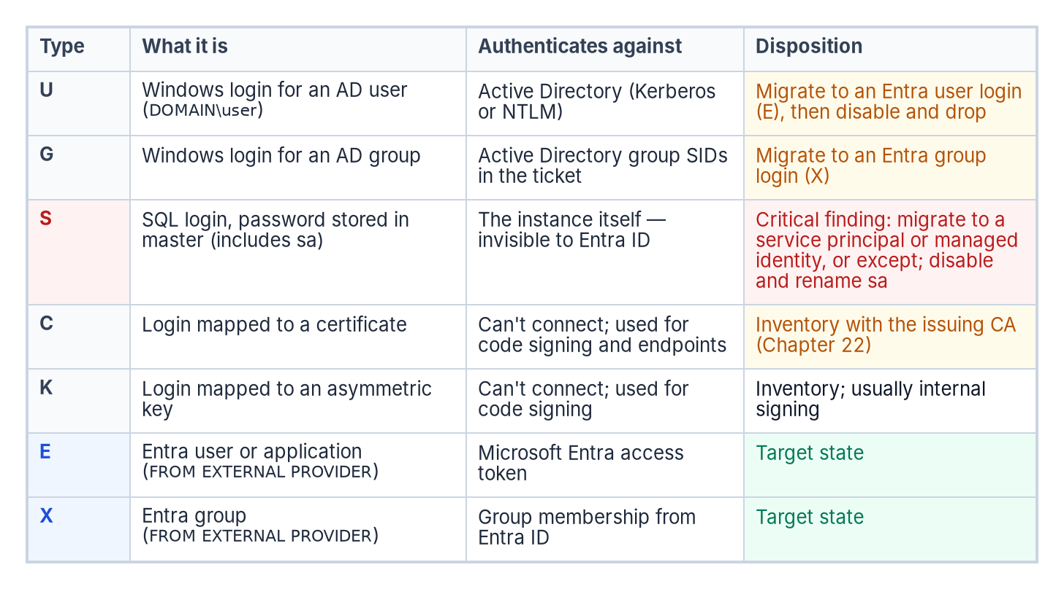
The login types the audit classifies, by sys.server_principals type, and what happens to each.
The script connects to each instance and queries the sys.server_principals system view to enumerate all logins. Each login is classified by type: Windows logins for individual AD user accounts (type U, whose SID matches the Windows SID); Windows logins for AD security groups (type G); SQL Authentication logins with credentials stored in master (type S); certificate-mapped logins (type C); and asymmetric key-mapped logins (type K). Entra logins already present appear as type E (a user or application) or X (a group).
The count and identity of each type is reported per instance. The presence of active SQL Authentication logins (type S) is a critical finding, because these logins are invisible to the Azure identity plane.
Such logins must be either migrated to Entra ID equivalents, the FROM EXTERNAL PROVIDER logins created in Chapter 11, or formally excepted with documented justification before the SQL Server authentication transformation can be declared closed.
The sa account’s status is separately flagged: enabled, disabled or renamed. An enabled sa account with a non-rotated password is the highest-priority remediation finding in the audit output.

Service-account identity and SPN registration
The script captures the identity of the Windows service account running the SQL Server engine process, the MSSQLSERVER service or its named-instance equivalent, by querying the service configuration. This identifies whether the engine runs as a domain service account, a group managed service account (gMSA), the NT SERVICE\MSSQLSERVER virtual account, or another identity.
It then queries Active Directory, using Get-ADServiceAccount and setspn or their equivalents, to determine whether the correct SPN is registered for the service account and the instance endpoint.
The SPN check is one of the most operationally valuable outputs of the audit. When the client can’t obtain a Kerberos ticket for the instance’s SPN, authentication uses NTLM, and the misconfiguration isn’t visible without deliberately querying AD for it.
Microsoft’s own table of outcomes makes the two failure modes distinct. If the SPN is missing or its lookup fails, local and remote connections both use NTLM. If the SPN is registered on the wrong account, authentication fails outright. And even with a correct SPN, local connections use NTLM; only remote connections use Kerberos. An instance with a missing SPN is therefore generating NTLM traffic for every remote connection that expects Kerberos, and in most cases the application teams generating those connections don’t know it. The audit can confirm the result per session, because sys.dm_exec_connections reports auth_scheme as KERBEROS or NTLM.

The Arc-eligibility output
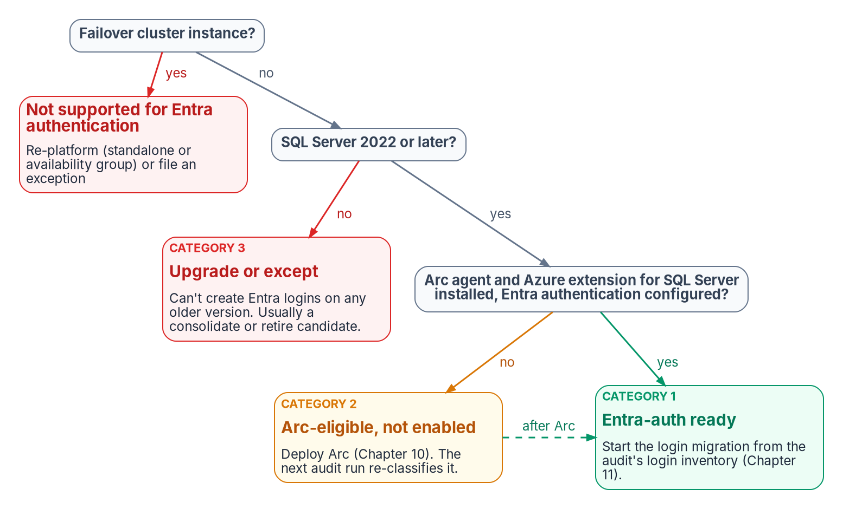
How the audit assigns each instance an Arc-eligibility category.
The most consequential output of the audit is the Arc-eligibility classification it assigns to every instance. The program delivers Entra authentication through Azure Arc (Chapter 09 explains why, and the manual alternative Microsoft also documents), so the categories are framed around Arc. Every instance falls into one of three.
Category 1 is Arc-eligible and Entra-auth-ready today: the server is already running the Connected Machine agent, the Azure extension for SQL Server has been deployed, the system-assigned managed identity is available, Entra authentication is configured on the instance, and the SQL Server version is 2022 or later. A Category 1 instance can have its Entra ID logins created and its login migration begun immediately. It requires no further infrastructure work before Chapter 11’s migration pattern can be applied.
Category 2 is Arc-eligible but not yet enabled: the host meets all the prerequisites for Arc enablement (the program’s Windows Server floor, network connectivity to the Azure Arc endpoints, SQL Server 2022 or later) but the Connected Machine agent hasn’t been installed or Entra authentication hasn’t been configured. A Category 2 instance requires Arc deployment as the prerequisite action before login migration can begin.
Category 3 is not yet Arc-eligible. Either the SQL Server version is pre-2022 (2019, 2017 or earlier), which means the engine can’t accept FROM EXTERNAL PROVIDER logins regardless of Arc status, or the host has a configuration that prevents enrollment. One configuration is a hard stop before the version question: Microsoft Entra authentication isn’t supported on SQL Server failover cluster instances, so an FCI must be re-platformed as a standalone instance or an availability group, or carry an exception.
A Category 3 instance requires a SQL Server version upgrade as the gate before any Entra-auth migration can occur, and that upgrade timeline must be factored into the overall program sequencing against the program’s 2027-04-01 NTLM backstop. That date is the program’s own planning anchor, not a Microsoft deadline (Chapter 02).

The compliance-monitoring telemetry sink
The audit script’s output is not a standalone deliverable. It is the input to the compliance-monitoring pipeline, and that is the architectural characteristic that distinguishes the authentication-audit script from a conventional discovery script.
The continuous-compliance monitoring system is the program-level tracking system for SQL Server authentication state at the instance level. Each time the audit runs (and it is designed to run continuously, on a schedule, against the full estate) it produces a structured per-instance compliance record that the compliance-monitoring pipeline ingests.
That pipeline computes the current authentication posture of the instance, compares it to the previous record, and flags any drift: a new SQL Authentication login that appeared since the last scan, an instance that has reverted from Windows Authentication mode back to mixed mode, a new linked-server definition that relies on Windows passthrough rather than an Entra credential.
Drift events are not informational. They are compliance violations that trigger the program’s remediation workflow. The required output is a per-instance compliance record, not a spreadsheet delivered to a program manager.
What this chapter establishes
- The audit enumerates the surviving estate: version and OS, domain join, authentication mode, login types, and service-account and SPN posture.
- Every instance gets an Arc-eligibility category: Entra-ready (1), Arc-eligible but not enabled (2), or upgrade required (3); failover cluster instances are outside Entra authentication altogether.
- The output is a per-instance compliance record that re-runs as a drift-aware baseline, not a one-off spreadsheet.

Continue the book
← Previous: Chapter 06 — The Retain, Consolidate, Retire Decision · Book index · Next: Chapter 08 — Reading the Audit: Classification and Triage →

Chapter 08 — Reading the Audit: Classification and Triage
A per-instance category becomes a defensible migration order once one distinction is understood: the engine and the operating system move to Entra ID on separate tracks.

In this chapter
How to interpret each of the three Arc-eligibility categories the audit assigns, how the audit output should drive triage and prioritization within each category, and the architectural distinction between SQL Server engine Entra authentication and server OS Entra sign-in: the Layer 1 versus Layer 2 separation that lets engine migration proceed on a host that is still domain-joined.
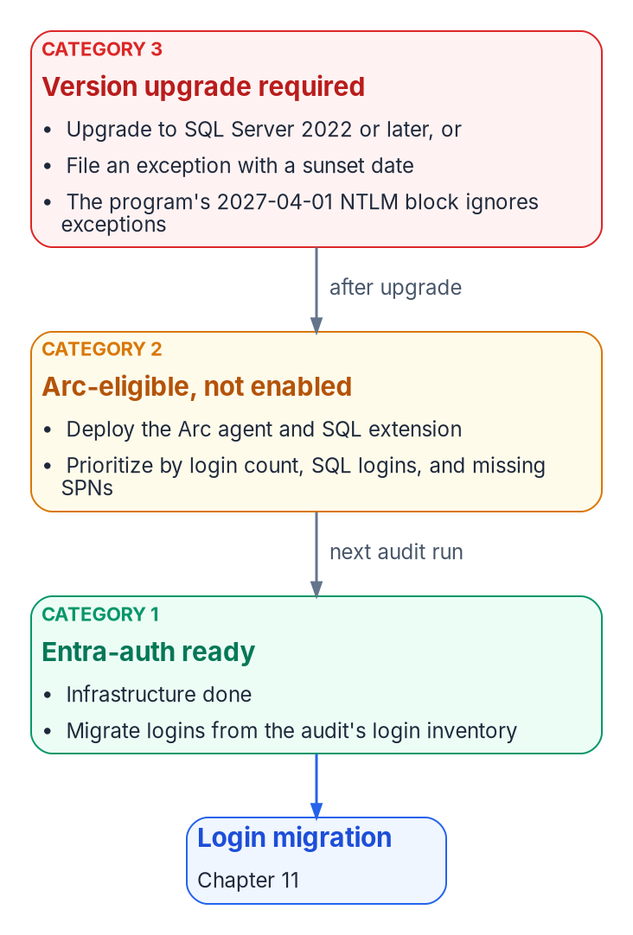
The triage action for each category, and the path from Category 3 and 2 to Category 1.

Interpreting Category 1: Entra-auth-ready
A Category 1 classification is the program’s best starting position. It means the infrastructure prerequisites for Entra ID authentication are already in place: the Arc agent is running, the Azure extension for SQL Server is deployed, Entra authentication is configured on the instance, and the engine is running SQL Server 2022 or later.
The managed identity for the server is available, and the extension has registered the instance as a SQL Server enabled by Azure Arc resource. Nothing in the infrastructure stack remains to be built.
The migration work for a Category 1 instance therefore begins with the login inventory from the audit: how many Windows logins exist, which AD groups are mapped to SQL Server roles, and whether any SQL Authentication logins need to be addressed before or alongside the Windows login migration. The specific migration steps are in Chapter 11.
The point here is that the audit has done its job for a Category 1 instance when it delivers a precise login inventory. The infrastructure work is already done, and the migration can proceed without any further prerequisites.

Interpreting Category 2: Arc-eligible but not enabled
A Category 2 instance requires an Arc deployment action before login migration can begin. The audit output for such an instance should be used to prioritize that deployment.
Instances with a large number of Windows logins, active SQL Authentication logins, or missing SPN registrations, and therefore NTLM-generating connections, are higher priority for Arc deployment than instances with simple, well-configured Windows Authentication.
The Arc deployment itself is not a SQL Server change. It is a server-level action that installs the Connected Machine agent; when the agent connects a server that has SQL Server installed, Azure Arc installs the Azure extension for SQL Server automatically. Chapter 10 describes the deployment sequence in detail, including the separate step that turns on Entra authentication for the instance.
Once Arc deployment is complete and Entra authentication is configured on the instance, the instance re-classifies from Category 2 to Category 1 on the next audit run, and the login migration can begin.

Interpreting Category 3: version upgrade required
A Category 3 instance is the most operationally complex. A pre-2022 instance can’t accept FROM EXTERNAL PROVIDER logins regardless of any other configuration change.
Microsoft Entra authentication for on-premises SQL Server was introduced in SQL Server 2022; earlier versions don’t support it at all, with or without Arc.
A Category 3 instance therefore has two possible paths: upgrade the SQL Server engine to 2022 or later and then proceed through the Category 2 pathway, or document a formal exception with a sunset date for the instance. Failover cluster instances belong with Category 3 even on a current version, because Microsoft Entra authentication isn’t supported on them; the paths there are re-platforming to a standalone instance or availability group, or an exception.
Given the program’s 2027-04-01 NTLM backstop, a Category 3 instance that can’t be upgraded before that date will face NTLM failure regardless of exception status. The program’s block is applied in the operating system’s security layer, not in the engine, so it doesn’t distinguish between instances that are excepted from the transformation and instances that aren’t. The date and the block are the program’s own decision; Microsoft has deprecated NTLM and plans to disable it by default in a future Windows release, but hasn’t published a date for that step (Chapter 02).
The version-upgrade timeline for Category 3 instances must be integrated into the SQL Server engine-authentication migration plan as an explicit dependency.

The SQL engine versus OS Entra sign-in distinction
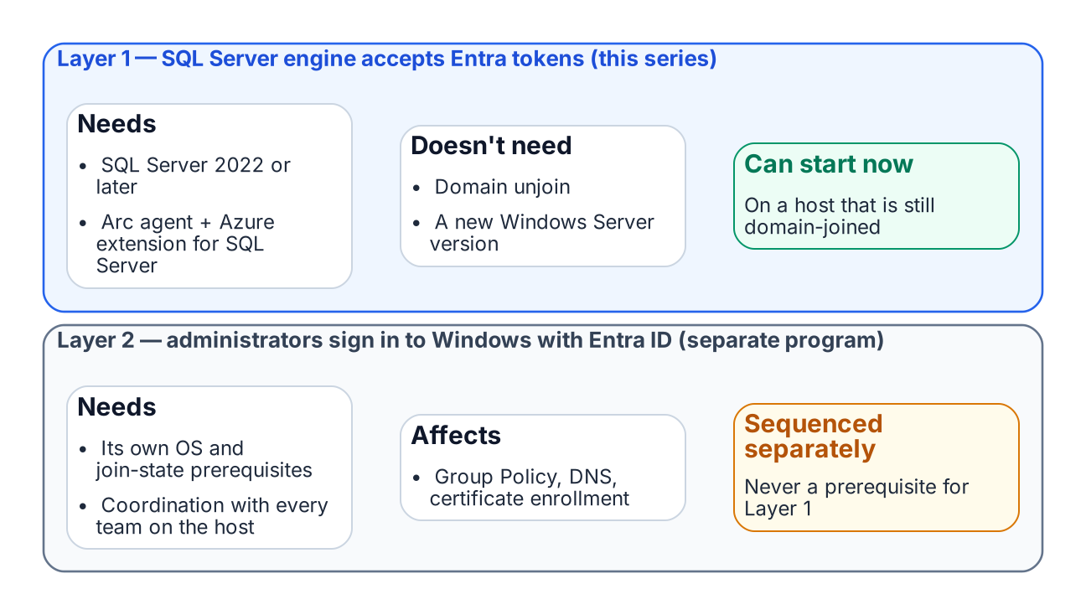
SQL engine Entra authentication and OS-level Entra sign-in are independent tracks.
One of the most important clarifications the audit output must carry, and that the teams reading it must internalize, is the architectural distinction between SQL Server engine Entra authentication and server OS Entra ID sign-in. These are two separate capabilities with separate prerequisites, and confusing them is the most common misunderstanding this program will encounter.
SQL Server engine Entra authentication, Layer 1 and the capability described in this book, requires SQL Server 2022 or later on an instance that isn’t a failover cluster instance, plus (on the program’s path) the Arc Connected Machine agent and the Azure extension for SQL Server. It doesn’t require the server to be domain-unjoined, and it doesn’t require Windows Server 2025.
A domain-joined Windows Server 2019 host running SQL Server 2022 with Arc installed can have Entra ID-backed SQL Server logins today, while the server itself remains domain-joined and continues to authenticate OS-level users via Kerberos to the domain controller.
Server OS Entra ID sign-in, Layer 2 and the ability for administrators to sign in over Remote Desktop with Entra ID credentials instead of domain credentials, is a separate transformation governed by the Arc non-domain-join requirement. It needs Windows Server 2025 with Desktop Experience, and installing its extension Entra-joins the server, which Microsoft intends only for machines that aren’t joined to another domain such as on-premises AD.
The two capabilities are related (both are part of the SQL Server authentication transformation) but they are sequenced independently, and the SQL Server engine migration can and should proceed first.
This sequencing point must be explicit in every instance of audit output that classifies a server as “not yet domain-unjoined.” The correct interpretation is not “SQL Server migration blocked” but “OS-level Entra sign-in not yet available; SQL engine migration can proceed.”
What this chapter establishes
- Category 1 migrates now; Category 2 gets Arc and becomes Category 1; Category 3 upgrades or carries a dated exception, and failover cluster instances re-platform or carry one.
- SQL-engine Entra authentication (Layer 1) needs SQL Server 2022 or later and, on the program’s path, Arc and the SQL extension.
- Layer 1 proceeds on domain-joined hosts and never waits for OS-level Entra sign-in (Layer 2).

Continue the book
← Previous: Chapter 07 — The Authentication Audit · Book index · Next: Chapter 09 — What Arc Provides to SQL Server →

Chapter 09 — What Arc Provides to SQL Server
Arc isn’t an end state; it’s the bridge that gives the SQL Server engine a cloud-native identity.

In this chapter
What the Connected Machine agent and its managed identity establish; which Entra identity the instance uses on SQL Server 2022 and 2025; the two-layer distinction between SQL-engine Entra authentication and OS-level Entra sign-in; why Arc’s managed identity beats a gMSA, a vaulted secret, certificate-based authentication or Microsoft’s manual non-Arc setup; what using Arc for this costs and where it’s available; and what Arc deliberately doesn’t change.
Without Arc, the program’s SQL Server engine has no cloud-native identity. Without that identity there’s nothing to anchor the instance’s Entra identity (the managed identity on SQL Server 2025, or the app registration certificate the Arc agent installs on SQL Server 2022), and no managed mechanism to accept Entra ID-issued tokens. This chapter and the next explain exactly what Arc does and doesn’t change, and why SQL engine Entra authentication (Layer 1) must not be blocked on the domain unjoin that OS-level Entra sign-in (Layer 2) requires. In the program’s dependency chain this is step 4: enable the identity substrate. The hands-on procedure is in Runbook R04; the server-wide view of Arc, which this chapter stays consistent with, is Book 05, Chapter 09.
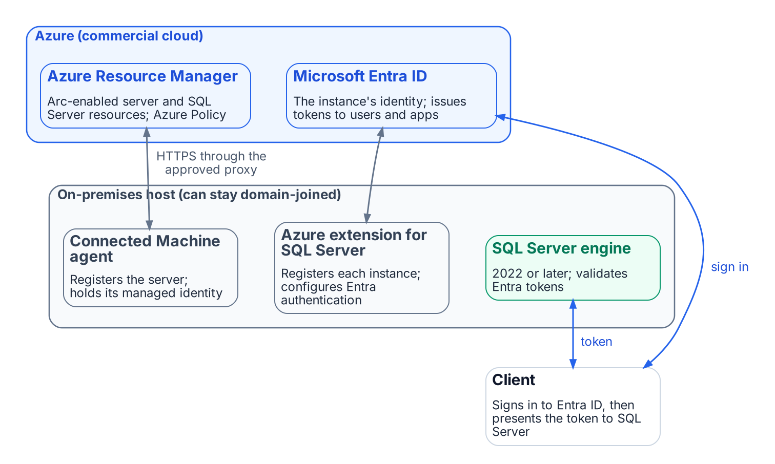
What Azure Arc connects: the on-premises host, Azure Resource Manager and Microsoft Entra ID.
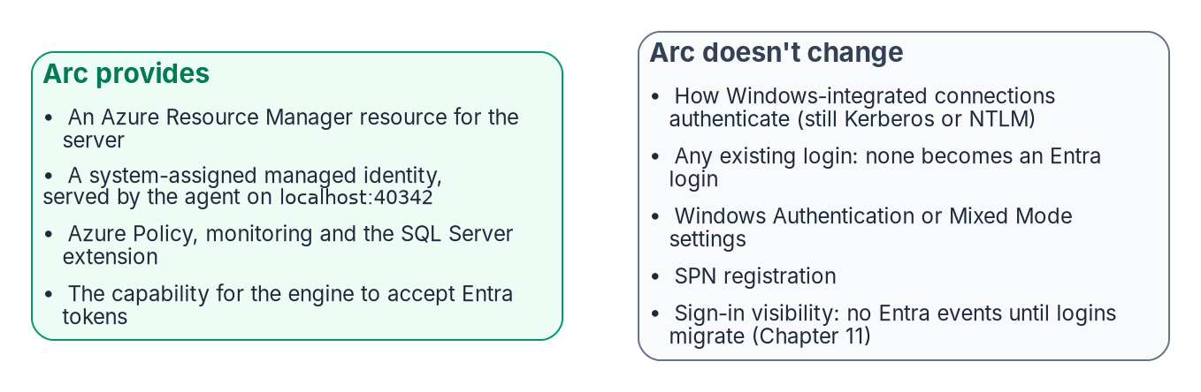
What installing Arc changes, and what it deliberately doesn’t.
Arc is usually introduced as a management capability: on-premises servers in the Azure portal, under Azure Policy and Azure Resource Manager. For this transformation it matters more because it gives the server, and through it the SQL Server engine, a cloud-native identity. On the program’s path, without that identity the engine can’t authenticate to Key Vault, can’t have its Entra configuration managed from Azure, and has no credential-free way to accept Entra ID tokens from clients. Arc is the enablement layer for everything that follows.

The Arc agent and the ARM resource identity
Installing the Azure Connected Machine agent gives the server a first-class Azure Resource Manager (ARM) resource of type Microsoft.HybridCompute/machines, with a resource ID, subscription and resource group. That resource makes the server visible in the portal and addressable by Azure Policy and ARM, and it’s the basis for the system-assigned managed identity: a service principal that ARM creates in Microsoft Entra ID for the server, in the tenant the subscription trusts.
The agent manages the identity’s credential entirely. The certificate behind it is valid for 90 days, and the agent renews it when 45 or fewer days remain, as long as the server stays connected; a server offline long enough for the certificate to expire becomes Expired and has to be disconnected and reconnected with an onboarding credential. No administrator handles the credential. A process requests a token from the agent’s local identity endpoint, the Hybrid Instance Metadata Service (HIMDS) at http://localhost:40342/metadata/identity/oauth2/token (not the Azure VM address 169.254.169.254), and the agent returns a token for any Azure resource the identity has been granted. Before it returns a token, the endpoint issues a challenge that only members of the local Administrators or Hybrid Agent Extension Applications group can complete, so not every process on the host can obtain one.

The two-layer distinction
Arc enables two architecturally independent Entra ID capabilities for SQL Server. Confusing them is the most common sequencing error in this transformation.
Layer 1 is SQL Server engine Entra authentication, the subject of this book. With the Azure extension for SQL Server on an Arc-enabled server running SQL Server 2022 or later, the engine accepts Entra ID access tokens for CREATE LOGIN ... FROM EXTERNAL PROVIDER logins and validates them against Entra ID. It needs the registered Arc agent, SQL Server 2022 or later, the Azure extension for SQL Server, Entra authentication configured on the instance (Chapter 10), and an instance that isn’t a failover cluster instance. It doesn’t need domain unjoin or Windows Server 2025: a domain-joined Windows Server 2019 host running SQL Server 2022 is fully capable of Layer 1 today.
Layer 2 is OS-level Entra sign-in through the AADLoginForWindows extension, which lets administrators sign in over Remote Desktop with Entra credentials, authorized by Azure role assignments. It belongs to the server infrastructure transformation, needs Windows Server 2025 with Desktop Experience, and Entra-joins the server, which Microsoft intends only for machines that aren’t joined to another domain. That makes it more disruptive: unjoin affects every AD-dependent service on the host, plus DNS, Group Policy and certificate enrollment. Conditional Access isn’t supported for servers joined this way, so Layer 2 brings Azure RBAC on who may sign in, not the workstation Conditional Access perimeter.
Don’t block Layer 1 on domain unjoin, a Layer 2 prerequisite. Layer 1 proceeds on domain-joined servers and should finish before Layer 2 begins. Say this explicitly to every DBA and infrastructure team; incorrect sequencing assumptions are the most common cause of unnecessary delay.

The managed identity and the service account
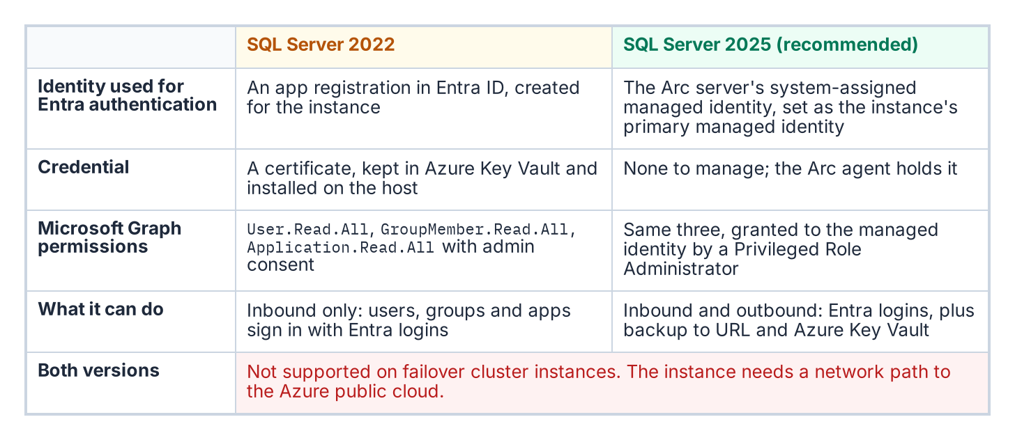
Where an Arc-enabled instance’s Entra identity comes from in SQL Server 2022 and in SQL Server 2025.
What the instance uses as its Entra identity depends on the version. On SQL Server 2025, the server’s system-assigned managed identity is set as the instance’s primary managed identity and serves both inbound Entra authentication and outbound connections to Azure services such as backup to URL and Azure Key Vault; only system-assigned identities are supported, and only on Windows. On SQL Server 2022, the instance uses an Entra app registration whose certificate is kept in Azure Key Vault; the Arc agent downloads that certificate to the host, after the server’s managed identity has been granted access to it. An app registration covers inbound Entra authentication only and can’t make outbound connections.
On both versions, agent-side work (retrieving certificates from Key Vault, the extension’s own operations) authenticates with the server’s managed identity, not stored credentials.
None of this replaces the Windows account the service runs as (NT SERVICE\MSSQLSERVER, a gMSA or a domain account), which still presents the computer or domain identity for Windows networking on a domain-joined host. What changes is the identity Entra ID and Azure see: the managed identity (2025) or the app registration (2022) instead of an AD service account. On SQL Server 2025 there’s no credential to manage. On 2022 the one credential is the app registration’s Key Vault certificate, which needs a named renewal owner: Microsoft recommends a validity of at most 12 months, and the certificates created for this setup aren’t rotated automatically.

Why Arc and not the alternatives
Every alternative either re-anchors on the directory the program is retiring or reintroduces the stored credential it exists to eliminate.
- A gMSA or domain service account works only while AD is authoritative. Chapter 02’s third driver removes AD as the authority for this boundary; a gMSA can stay the Windows logon account while the domain exists, but it can’t be the engine’s Entra identity.
- A service principal with a client secret, on disk or in Key Vault, reintroduces a rotatable credential and a bootstrap problem: the engine must authenticate to the vault first, so a root credential lands on the server anyway.
- Microsoft’s manual, non-Arc setup for SQL Server 2022 and later on Windows is real and supported: a certificate imported into the machine store, an app registration with Graph permissions, and registry values under the instance’s FederatedAuthentication key. It works on a host with no Arc agent, but it has no managed identity, no Azure-side configuration or inventory of the setting, and a certificate whose lifecycle is entirely manual. It’s an option for a host that can’t run the agent, not the program’s path.
- Certificate-based authentication is the program’s interim posture, authorized for the pre-2022 exception long tail that can’t reach Kerberos or Entra authentication before the program’s 2027-04-01 backstop. It still needs certificate lifecycle management, hence the AD CS-to-Microsoft Cloud PKI dependency the transformation inventory still classifies as “Not Yet Defined.” Part of the reason is that Cloud PKI issues certificates to Intune-managed devices, and Intune doesn’t manage Windows Server (Book 05, Chapter 09). It’s a bridge, not a destination.
The Arc managed identity is the only option that is both cloud-native and credential-free for the operator: the agent renews its certificate automatically, no human sees it, and its lifecycle is bound to the ARM resource rather than to AD. SQL Server 2025 uses it directly. SQL Server 2022 still authenticates through an app registration certificate, but the Arc agent fetches it from Key Vault with the managed identity, so no root credential is placed on the server by hand.

What it costs and where it’s available
Using Arc for this purpose doesn’t depend on the SQL Server license type. Microsoft lists connecting to Arc, inventory, Microsoft Entra authentication and Defender for Cloud as available to license-only customers as well as those with Software Assurance, a SQL Server subscription or pay-as-you-go; features such as best practices assessment, automatic updates and monitoring need Software Assurance, a subscription or pay-as-you-go. Availability isn’t the same as price: Defender for Cloud plans are paid services in their own right. Book 05, Chapter 09 covers the server-side costs, Extended Security Updates and the Windows Server Management benefit.
Two placement constraints matter for a federal boundary. First, SQL Server enabled by Azure Arc in the US Government Virginia region currently supports only onboarding, inventory, licensing and billing, failover cluster instance management and ESU licenses; Microsoft Entra authentication isn’t in that list. The program therefore assumes, as Book 05 does, a commercial Azure subscription in the same directory as the GCC tenant. Second, SQL Server needs access to the Azure public cloud to use Microsoft Entra authentication.

What Arc doesn’t do
Arc’s effect is often overstated in both directions. A domain-joined client using Integrated Security=True against an Arc-enabled instance still negotiates Kerberos or NTLM exactly as described in Chapter 01, and Arc alone produces no Entra sign-in events for SQL Server connections. Arc converts no login to the external-provider type, disables neither Windows Authentication nor mixed mode, and leaves SPN registration untouched. Installing the extension doesn’t even turn Entra authentication on: that setting is off by default and is configured per instance. Arc provides the capability without activating it; the login migration in Chapter 11 is what changes authentication behavior. Arc is a necessary prerequisite, not the transformation itself.
What this chapter establishes
- Arc gives the server an ARM identity and a system-assigned managed identity whose tokens come from the local endpoint (localhost:40342); the instance’s Entra identity is an app registration and Key Vault certificate on SQL Server 2022 and the managed identity on SQL Server 2025.
- Layer 1 (SQL-engine Entra authentication) is independent of Layer 2 (OS-level Entra sign-in) and must never be blocked on it.
- Arc provides the capability but doesn’t activate it, and it doesn’t replace the Windows account the service runs as; of the alternatives, it’s the only one both credential-free and independent of AD. Entra authentication through Arc is available under every SQL Server license type, but not yet in the US Government Virginia region.

Continue the book
← Previous: Chapter 08 — Reading the Audit: Classification and Triage · Book index · Next: Chapter 10 — Arc Deployment Sequencing for SQL Server Hosts →

Chapter 10 — Arc Deployment Sequencing for SQL Server Hosts
Each step satisfies the next one’s prerequisite, so a host becomes identity-ready only in order, and only after it proves it.

In this chapter
The connectivity prerequisites that Arc enrollment demands inside a GCC-Moderate boundary, how the Azure extension for SQL Server arrives and what it checks, the version-specific step that turns on Microsoft Entra authentication for the instance, and the checks (a token from the Arc agent’s local endpoint and a test Entra login) that confirm the identity is genuinely available before any login migration begins. The hands-on procedure is in Runbook R04.
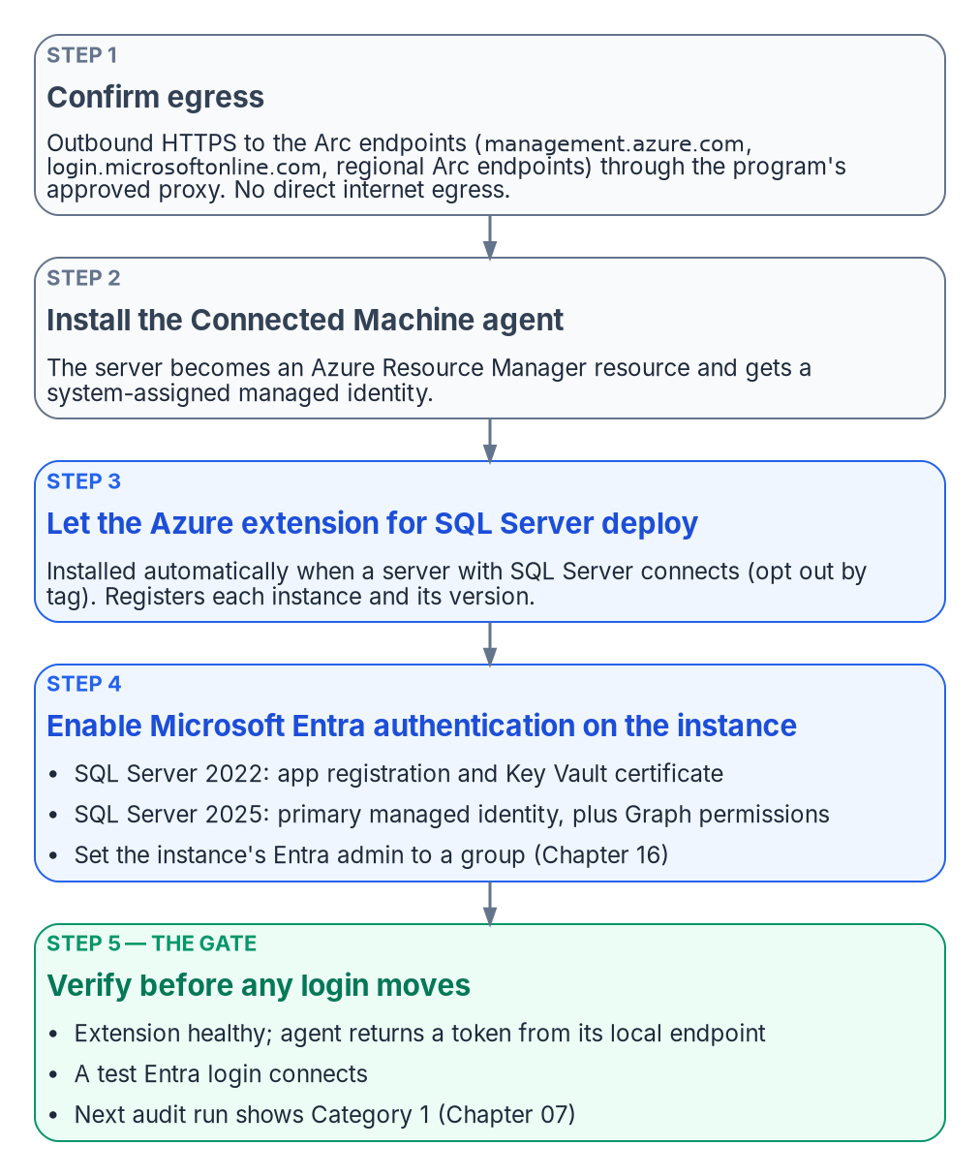
The ordered steps that make a host identity-ready.
Arc deployment is a sequence, not a single act. Each step has a prerequisite that the prior step satisfies, and skipping ahead produces failures that are easy to misdiagnose as migration problems when they’re in fact enrollment problems. The order is connectivity first, then the Connected Machine agent, then the Azure extension for SQL Server, then Entra authentication on the instance, then a verification that the identity is actually present and answering. The server-wide onboarding detail (least-privilege onboarding service principals, tags, extension allowlists, rollback) is in Book 05, Chapter 09; this chapter covers what’s specific to SQL Server hosts.

Prerequisites for Arc enrollment
The Connected Machine agent communicates outbound to Azure over TCP 443; no inbound rule is needed. On top of the agent’s own endpoints and service tags (listed in Book 05), a SQL Server host needs four more groups of destinations:
Purpose | Destinations
Azure Arc data processing service (inventory and usage upload) | *.<region>.arcdataservices.com, or *.<region>.arcdataservices.azure.us in US Government Virginia
Extension installation | aka.ms and *.web.core.windows.net
Microsoft Entra authentication, if a firewall filters URLs | login.microsoftonline.com, login.microsoft.com, enterpriseregistration.windows.net, graph.microsoft.com, and the Key Vault (<name>.vault.azure.net) when certificates are used
Resource providers registered in the subscription | Microsoft.HybridCompute and Microsoft.AzureArcData
In a GCC-Moderate boundary this connectivity must be routed through the program’s approved network egress path; direct internet egress from a production SQL Server host isn’t acceptable under the boundary’s network posture. The Arc agent supports an HTTPS proxy, set with azcmagent config set proxy.url. Two proxy details catch SQL Server hosts specifically. The instance’s own Entra authentication traffic doesn’t use the Arc agent’s proxy setting: SQL Server connects to Entra ID directly, so a host that needs a proxy also needs the machine-level WinHTTP proxy set with netsh winhttp set proxy. And if the machine has a system-level HTTPS_PROXY environment variable, localhost and 127.0.0.1 must be excluded with NO_PROXY, or requests to the local Arc identity endpoint go to the proxy. An Azure Arc private link scope can keep agent traffic off public networks (Book 05), but Private Link isn’t supported for the data processing service endpoint.
Connectivity verification (confirming that the server can reach all required endpoints through the approved proxy) is the first prerequisite check before Arc deployment begins. The agent’s own check covers the SQL Server endpoints when run as azcmagent check --extensions sql (Book 05, Chapter 09). An agent that can’t reach its endpoints will fail to register its ARM resource, and without that resource there’s no managed identity to verify later.

The Azure extension for SQL Server
The Azure extension for SQL Server is a distinct component from the Connected Machine agent, but it usually doesn’t need a separate installation: when a server connected to Azure Arc has SQL Server installed, Arc installs the extension automatically and creates the SQL Server instance resources in Azure. Automatic connection can be managed at scale, and an individual server can be connected interactively if the extension didn’t deploy. To keep a server out (for example, a host that isn’t in this wave), tag it ArcSQLServerExtensionDeployment with the value Disabled when you connect it (Book 05, Chapter 09). Only extension versions released within the last 12 months are supported, so enable the extension’s automatic updates.
The extension registers every instance of SQL Server 2014 or later, so it isn’t what enforces the 2022 floor for Entra authentication; the audit’s Arc-eligibility classification is. The extension does have its own preconditions, which hardened SQL Server builds sometimes break:
- The SQL Server service account must be a member of the sysadmin fixed server role, which it is by default.
- The extension’s deployer connects as NT AUTHORITY\SYSTEM with Windows authentication, so that login must exist, be enabled and hold CONNECT SQL. Hardening baselines that remove it make the extension fail to provision.
- On Windows, the host needs .NET Framework 4.7.2 or later.
The authentication-audit script’s Arc-eligibility classification (Category 1 versus Category 2 versus Category 3) is the primary input for prioritizing Arc deployment across the estate. Category 2 instances are the immediate deployment targets, and the audit’s login inventory and NTLM risk signals within Category 2 are used to order those deployments by remediation urgency.

Enabling Microsoft Entra authentication on the instance
Installing the extension doesn’t by itself switch on Entra authentication; the setting is disabled by default and configured per instance. That’s a separate, version-specific step:
 | SQL Server 2022 | SQL Server 2025 (recommended path)
Instance’s Entra identity | An Entra app registration with a certificate in Azure Key Vault | The Arc server’s system-assigned managed identity, set as the instance’s primary managed identity
Microsoft Graph permissions | Directory.Read.All, or Application.Read.All, Group.Read.All and User.Read.All, with admin consent | User.Read.All, GroupMember.Read.All and Application.Read.All as app roles on the managed identity
Who can grant them | Privileged Role Administrator or higher | Privileged Role Administrator or higher
Credential to manage | The Key Vault certificate: unique common name, validity of at most 12 months, not rotated automatically | None
Key Vault access | The Arc server’s managed identity gets Key Vault Certificate User and Key Vault Secrets User, or Get and List access policies | Not needed for authentication
For SQL Server 2022, the portal can also create the certificate and app registration for you (“service-managed” options) when you set the Entra admin; admin consent for the Graph permissions still has to be granted afterward, or creating Entra logins fails with error 37455. For SQL Server 2025, enable the primary managed identity from the portal rather than by editing the registry. Because the Graph permissions are app roles, they’re assigned to each server’s managed identity individually; Microsoft notes that adding identities to a role-assignable group holding Directory Readers is simpler at scale but grants far broader read access, and doesn’t recommend it where least privilege is required.
The Entra admin you set becomes a sysadmin on the instance. Changing the admin later doesn’t remove the previous admin’s login, so drop it deliberately. The program sets the instance’s Entra admin to a group (Chapter 16).
Three limits apply on both versions. Neither supports Entra authentication on failover cluster instances; both need a network path to the Azure public cloud; and connections authenticated by Entra ID are always encrypted, so the instance needs a TLS certificate its clients trust, or clients must be set to trust the server certificate. On SQL Server 2025, Microsoft also advises against disabling Entra authentication once it’s enabled.

Verification of managed identity availability
After the Connected Machine agent is installed and the Azure extension for SQL Server is deployed, the program must verify that the system-assigned managed identity is available, and that Entra authentication works on the instance, before proceeding to the login migration. This verification isn’t optional; it’s the gate between enrollment and migration.
The first check calls the Arc agent’s local identity endpoint (HIMDS) on the server, http://localhost:40342/metadata/identity/oauth2/token?api-version=2020-06-01&resource=https://management.azure.com/, not the Azure VM metadata address 169.254.169.254. The endpoint first returns a challenge that only a local administrator or a member of the Hybrid Agent Extension Applications group can answer; the check confirms that the agent then returns a valid access token. The second check is a test Entra login that connects to the instance. The third is the next audit run, which should classify the instance as Category 1 (Chapter 07).
A successful token response confirms three things at once: that the managed identity exists in Entra ID, that the Arc agent is functioning, and that the server’s ARM resource is in a healthy state. A failed token response at this stage requires Arc troubleshooting before the SQL Server migration can proceed.
The authentication-audit script’s Arc-eligibility classification is updated on each run to reflect the current managed-identity state, so the per-instance compliance record reflects this verification outcome in near real time.
What this chapter establishes
- Enrollment runs in a strict order: egress connectivity, the Connected Machine agent, the SQL extension (deployed automatically), then Entra authentication configured per instance.
- SQL Server 2022 and 2025 enable Entra authentication differently, and both need Graph permissions that only a Privileged Role Administrator can grant.
- Verification (a token from the local endpoint, a test Entra login, and Category 1 on the next audit) is the gate for login migration; a failed verification is an enrollment problem, resolved before migration starts.

Continue the book
← Previous: Chapter 09 — What Arc Provides to SQL Server · Book index · Next: Chapter 11 — Three Principal Types: User, Group, Service Principal →

Chapter 11 — Three Principal Types: User, Group, Service Principal
This is the moment the engine stops accepting Kerberos and NTLM and starts accepting Entra-issued tokens.

In this chapter
The FROM EXTERNAL PROVIDER syntax that creates type-E and type-X logins validated by token at connect time, the three principal types those logins map to (Entra user, Entra security group and Entra service principal), and the three-phase parallel-run pattern that creates and validates the new logins before disabling the old ones.
Everything in Chapters 01 through 10 is prerequisite; everything in Chapters 14 through 22 is consequence. This chapter and the next are the migration itself, performed only on the instances Chapter 06 classified retain or consolidation target, using the three-phase parallel-run pattern that the SQL Server engine-authentication decision makes normative. In the program’s dependency chain they are steps 5 and 7: introduce Entra principals, then remove legacy principals. The hands-on procedure is in Runbook R05.
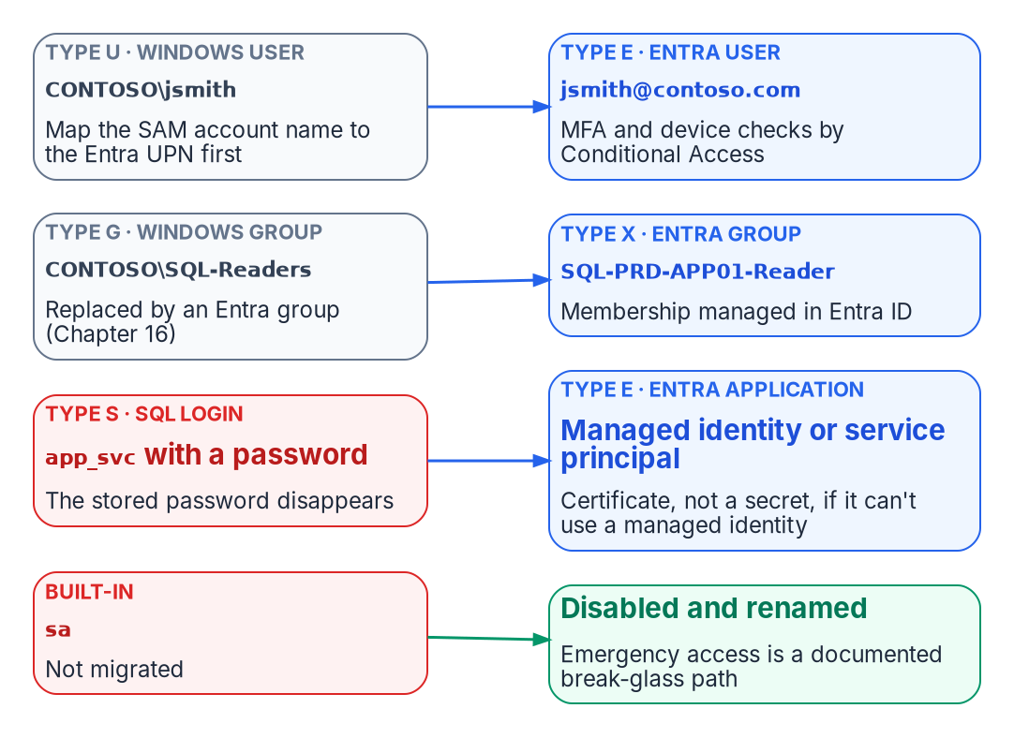
Every legacy login type maps to an Entra principal.
This is the technical heart of the book: the engine stops accepting Kerberos tickets and NTLM exchanges and starts accepting Entra ID OAuth 2.0 access tokens, which Entra ID issues only after its sign-in conditions (identity, group membership, device compliance, MFA) are met. The SQL Server engine-authentication decision records the canonical sequence this chapter follows.

The FROM EXTERNAL PROVIDER syntax
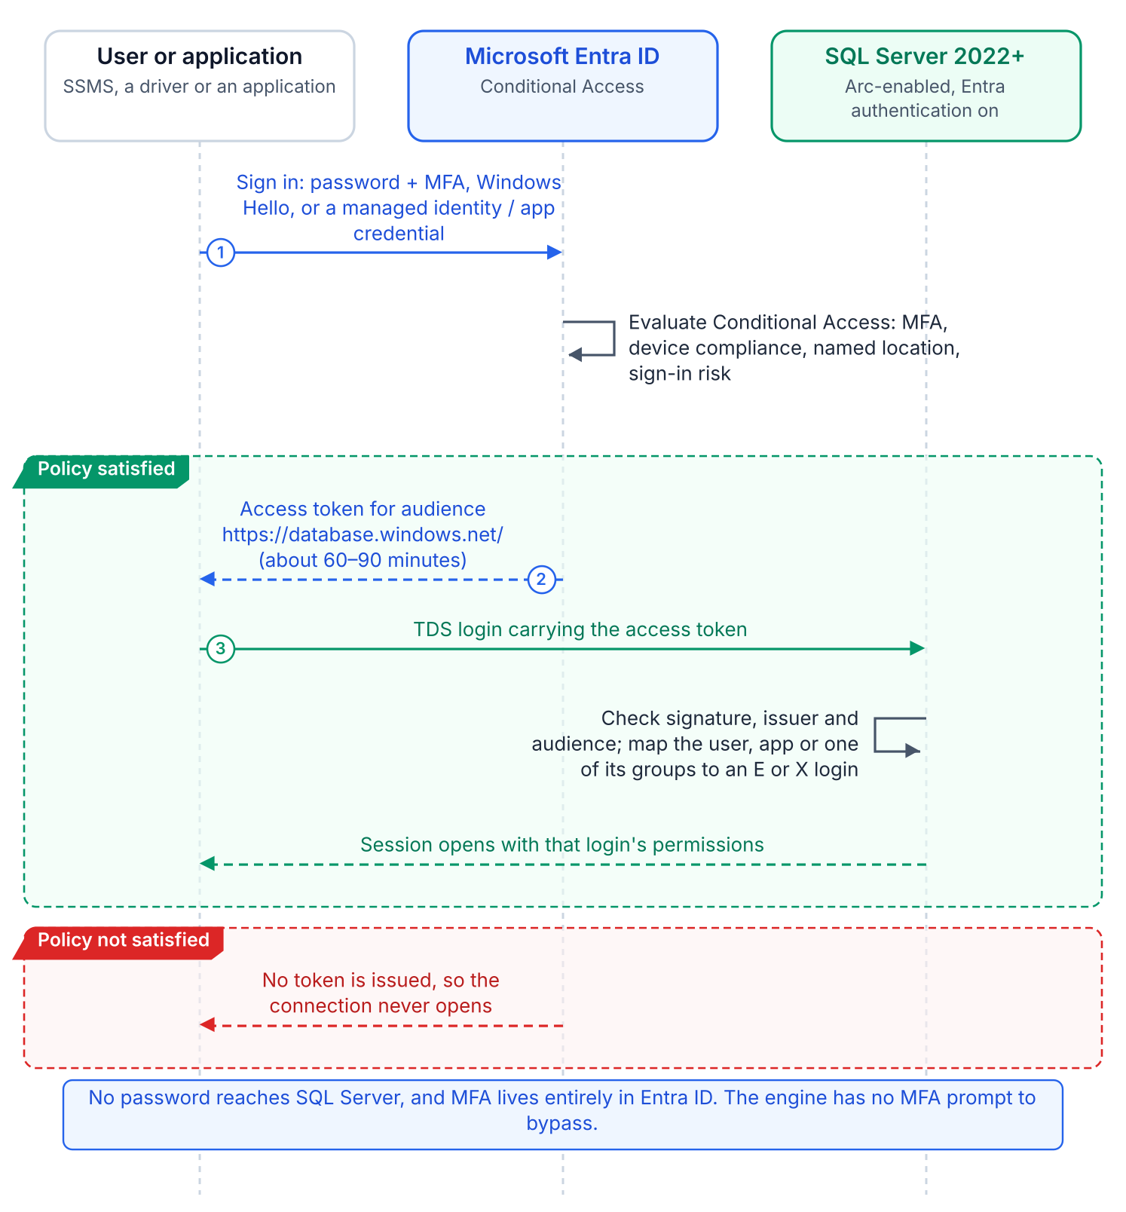
A connection with an Entra login: the client gets a token for the SQL audience and the engine validates it.
SQL Server 2022’s CREATE LOGIN [principal] FROM EXTERNAL PROVIDER maps an Entra principal to a login with no Active Directory involvement. For a user the name is the user principal name (UPN); for a group or an application it’s the object’s display name, and it must match an existing principal in the tenant the instance is enabled with. The login is stored in master as a passwordless external principal whose SID is the binary form of the Entra object ID (or, for an application, its client ID). At connection time the client presents an access token whose audience is https://database.windows.net/; the engine validates it, maps the identity to the login, and, if the login is enabled, applies its permissions and database roles.
The syntax requires Entra authentication to be configured on the instance (an app registration on 2022, the primary managed identity on 2025), which on the program’s path the Azure extension for SQL Server does. CREATE LOGIN looks the principal up through Microsoft Graph, which is why the instance’s identity needs Graph read permissions; without admin consent for them, login creation fails. Verify that each principal exists before creating its login, to avoid orphaned logins that map to deleted or renamed principals. On SQL Server 2025, WITH OBJECT_ID pins a login to a specific object ID, which resolves display names that aren’t unique.
Two client-side facts shape everything after this. Connections authenticated by Entra ID are always encrypted, so clients must trust the instance’s TLS certificate. And the drivers and tools must support the Entra authentication methods: default, password, integrated, interactive with MFA, service principal, managed identity and access token.

Type 1: Entra user login
For human DBAs and developers, a CREATE LOGIN [DOMAIN\username] FROM WINDOWS login gets a type-E counterpart for the same person’s UPN: CREATE LOGIN [username@tenant.onmicrosoft.com] FROM EXTERNAL PROVIDER. UPNs can differ from SAM account names where UPN synchronization was never standardized, so the audit captures the UPN-to-SAMAccountName mapping for every Windows login first. The user then signs in with whatever Entra authentication method Conditional Access requires, with one exception: FIDO2 security keys aren’t currently supported for Entra authentication to SQL Server on Arc-enabled machines.
The engine has no MFA logic. Conditional Access enforces MFA, device compliance, named locations and sign-in risk before the token is issued; if they fail, no token is issued and the connection never opens. There’s no SQL-level MFA prompt and no SQL-level bypass. Microsoft’s guidance for Azure SQL targets these policies at the Azure SQL Database enterprise application, the resource behind the https://database.windows.net/ audience; Conditional Access needs at least Microsoft Entra ID P1 (sign-in risk conditions need ID Protection, a P2 feature), and these policies apply to users, not to programmatic connections by service principals or managed identities. Service principals can be targeted only through Conditional Access for workload identities, a separately licensed capability. None of these controls apply to Windows Authentication or NTLM connections.

Type 2: Entra group login
A SQL Server login can be created for an Entra ID security group rather than an individual user: CREATE LOGIN [GroupDisplayName] FROM EXTERNAL PROVIDER. When a member of that group connects with an Entra token, the engine maps the user to the group login and grants the permissions associated with it.
It’s the familiar AD group pattern, with Entra group membership in place of SID resolution and Kerberos PAC membership. Group logins appear in sys.server_principals as type X (EXTERNAL_GROUP), distinct from type E. When the group is a dynamic membership group whose rule reads HR-sourced attributes, Entra ID adds and removes members as those attributes change, so users gain and lose SQL Server access with no CREATE USER or DROP USER. Dynamic membership needs Microsoft Entra ID P1 for each unique member, and the access is only as strong as the write controls on the attributes the rule reads. Chapter 16 and Chapter 17 cover designing and governing those groups.

Type 3: Entra service principal login
ETL pipelines, reporting services, API backends and monitoring agents replace their SQL Authentication account (a type-S login with a stored password) with a login for an Entra application: CREATE LOGIN [ApplicationDisplayName] FROM EXTERNAL PROVIDER. This removes passwords from connection strings, configuration files, logs and repositories, along with their rotation.
Preferably the application uses a managed identity and holds no credential. On an Arc-enabled server, ManagedIdentityCredential in the Azure Identity library supports the server’s managed identity at the agent’s local endpoint (localhost:40342); DefaultAzureCredential tries it too, but Microsoft recommends a specific credential rather than DefaultAzureCredential in production. The process account must be in the local Hybrid Agent Extension Applications group (or Administrators) to obtain the token. Remember what that identity is: the Arc identity belongs to the server, so every process permitted to read it presents the same principal. One login per server is the honest unit of attribution, not one per application. Azure VMs, Container Instances and App Service use their platform managed identity. Where a credential is unavoidable, use a client certificate stored in Key Vault, never a client secret or a file.

The parallel-run migration pattern
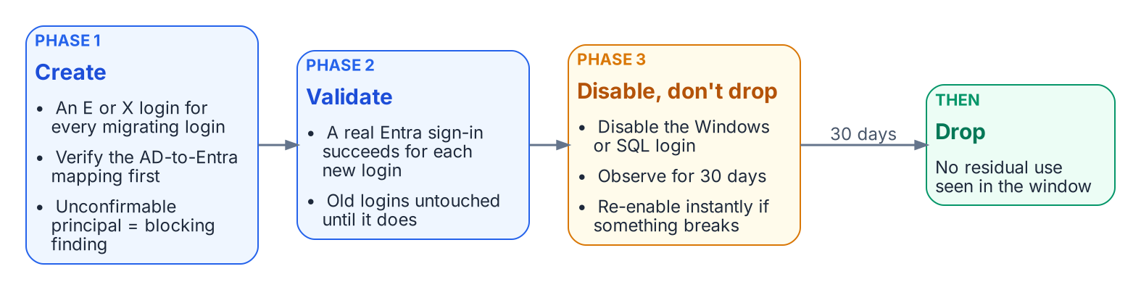
The required three-phase parallel run for production.
No Windows login is dropped until its Entra equivalent is validated. The engine-authentication decision makes this three-phase parallel run required for production:
- Create. For every migrating Windows login, user or group, create the FROM EXTERNAL PROVIDER login for the corresponding Entra principal. Verify each mapping first; a principal with no confirmed Entra equivalent is a blocking finding. This mapping, built from the authentication audit’s AD inventory and Entra’s UPN and group data, is the most labor-intensive step.
- Validate. Test each new login with the principal’s real Entra credential before any legacy login is touched.
- Disable, observe, drop. Disable (don’t drop) the legacy Windows and SQL Authentication logins, monitor for 30 days to confirm nothing depends on them, then drop them.
Observation needs evidence, not silence. Login metadata tells you what exists; only auditing tells you what’s used. Microsoft’s own migration sequence for retiring SQL authentication uses SQL Server Audit with the SUCCESSFUL_LOGIN_GROUP action group to see which logins still connect, and checks for password-based contained database users too. On SQL Server 2025 enabled by Azure Arc, the end state can then be enforced: the Disable SQL Authentication setting blocks new SQL-authentication logins (including sa) without a restart, is reversible from the portal, and requires the primary managed identity.
Non-production instances may shorten the observation window with documented owner sign-off, but create→validate→disable→observe→drop is the canonical sequence. Other platforms document the same side-by-side premise: Google’s Cloud SQL for SQL Server lets Entra ID authentication be enabled without disabling existing Active Directory authentication during a phased migration. Chapter 12 records the decisions around it.
What this chapter establishes
- FROM EXTERNAL PROVIDER creates passwordless logins for Entra users and applications (type E) and groups (type X), authenticated by Entra-issued tokens.
- MFA and other sign-in conditions are enforced by Conditional Access in the Entra plane, for users only, not by the engine; FIDO2 isn’t yet supported for SQL Server on Arc.
- Migration is the parallel run: create, validate, disable (not drop) the legacy login, observe for 30 days with audit evidence, then drop.

Continue the book
← Previous: Chapter 10 — Arc Deployment Sequencing for SQL Server Hosts · Book index · Next: Chapter 12 — What the Engine-Authentication Decision Settles →

Chapter 12 — What the Engine-Authentication Decision Settles
Five governance positions turn the migration pattern into enforceable canon.

In this chapter
The five decisions the engine-authentication decision records: that consolidation gates authentication migration, that the parallel-run sequence is required, that SQL Authentication is eliminated and sa disabled and renamed, that pre-2022 instances are upgrade-or-except with a certificate-based authentication interim posture, and that the per-instance compliance record is the closure artifact.
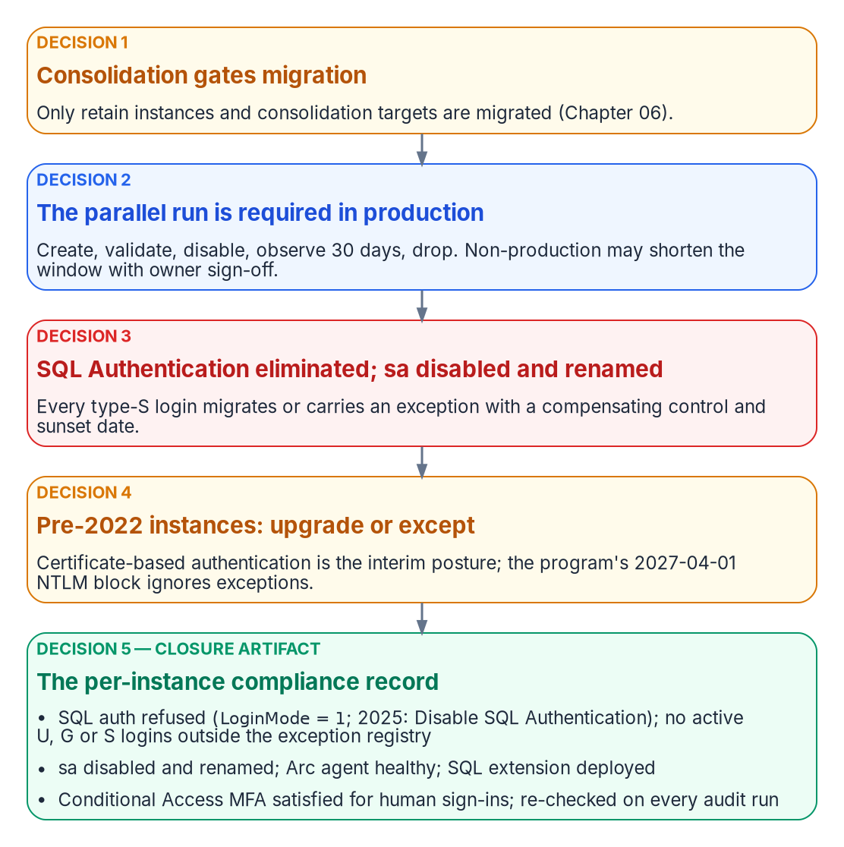
The five positions of the engine-authentication decision, in operational order, ending in the closure record.
Chapter 11’s pattern covers the engineering case, Windows logins migrated through FROM EXTERNAL PROVIDER, but leaves governance positions that need a decision, not a narrative. The SQL Server engine-authentication decision (currently proposed) is the engine-layer companion to the Kerberos/NTLM-elimination program (protocol layer) and the Arc non-domain-join requirement (server and OS layer). It answers all five positions, in operational order.

Decision 1: consolidation precedes and gates authentication migration
Established in Chapter 06
Every instance is classified retain, consolidate-into-target or retire before any migration work; Arc-eligibility Categories 1–3 (Chapter 07) are layered on top.
The decision makes that assessment the normative prerequisite for this part of the book. Only retain instances and consolidation targets are migrated; migrating logins on instances about to be retired or collapsed is wasted effort. Consolidating into fewer SQL Server 2022 or later targets, Azure SQL Managed Instance, or Arc-enabled SQL Server is also the natural moment to retire cross-domain login sprawl, orphaned SPNs and shared service accounts.

Decision 2: the parallel-run sequence is required
On every retain or target instance, Windows logins (type U users, type G groups) and SQL Authentication logins (type S) migrate to Entra external-provider logins through Chapter 11’s parallel run, which is required for production. The letters are the values of sys.server_principals.type, not mnemonics: S SQL login, U Windows login, G Windows group, E external (Entra) login or application, X external (Entra) group. There’s no type W: a discovery query written against one returns zero rows and reports a clean instance, which is how a typo becomes a false attestation of closure.
Non-production instances may compress the 30-day observation window only with documented owner sign-off. Disable-and-observe keeps every cutover reversible inside the window, so a wrong mapping locks no one out.

Decision 3: SQL Authentication eliminated; sa disabled and renamed
Every active type-S login on a retain or target instance migrates to a service-principal or managed-identity login, or carries a documented exception with a named compensating control and a sunset date. Open-ended retention isn’t an option. A SQL Authentication login is checked against a password in master and never reaches Microsoft Entra ID or a domain controller, so Conditional Access can’t evaluate it and Microsoft Defender for Identity, whose sensors run on domain controllers and other identity servers, never sees it.
sa is disabled and renamed on every production instance. Any retained emergency recovery is a documented, monitored break-glass procedure, not an active sa. An enabled sa with a non-rotated password is the authentication audit’s highest-priority finding. On SQL Server 2025 enabled by Azure Arc, the Disable SQL Authentication setting closes the door for sa and every other SQL login together.

Decision 4: pre-2022 instances are upgrade-or-except
External-provider logins require SQL Server 2022 or later; on the program’s path, that means the Azure extension for SQL Server on an Arc-enabled host. A pre-2022 Category 3 instance can’t accept them regardless of Arc status, and neither can a failover cluster instance on any version. A Category 3 retain instance either upgrades and follows the Category 2-to-1 pathway or files a sunset-dated exception, though most Category 3 instances should be retire or consolidation candidates. An exception records the reason, the compensating control (for example, an identity-protection product that applies MFA or block policies to NTLM authentication), the maximum duration, and acknowledgement that the program’s 2027-04-01 NTLM block is applied in the operating system’s security layer and ignores engine-layer exceptions. That date is the program’s own backstop, not a Microsoft deadline (Chapter 02).
Connections that can’t reach Kerberos or Entra authentication by that date use certificate-based authentication, the authorized interim posture, which makes the AD CS-to-Cloud-PKI transformation (Not Yet Defined in the transformation inventory) a hard dependency for the exception long tail (Chapter 09, Chapter 22).

Decision 5: the per-instance compliance record is the closure artifact
An instance is closed when its compliance record simultaneously shows:
- SQL authentication refused: LoginMode = 1 (SERVERPROPERTY('IsIntegratedSecurityOnly') = 1), and on SQL Server 2025 the Disable SQL Authentication setting on (SERVERPROPERTY('IsExternalAuthenticationOnly') = 1)
- zero active type-S logins outside the exception registry, and zero active type-U or type-G logins
- sa disabled and renamed
- the Arc Connected Machine agent connected and healthy, and the Azure extension for SQL Server deployed with Entra authentication configured
- for human principals, Conditional Access MFA enforcement satisfied for SQL Server resource sign-ins over a defined validation period
“Done” becomes a queryable posture instead of a claim. Because Windows Authentication is always available and no engine setting disables it, the record evidences the Entra-exclusive posture through the absence of Windows logins rather than by reading a mode switch (Chapter 20). Closure is continuously verified: the authentication audit runs on a schedule, and drift (LoginMode reverting, a new type-S, U or G login, the Arc agent going offline) is a violation that triggers remediation.
What this chapter establishes
- Consolidation gates migration, and the parallel run is required in production.
- SQL Authentication is eliminated and sa disabled and renamed; pre-2022 instances and failover cluster instances upgrade, re-platform or carry a sunset-dated exception.
- The per-instance compliance record is the continuously re-verified closure artifact.

Continue the book
← Previous: Chapter 11 — Three Principal Types: User, Group, Service Principal · Book index · Next: Chapter 13 — Who Owns the Data Platform →

Chapter 13 — Who Owns the Data Platform
Under Windows authentication the DBA team owned database access almost by default; once the engine trusts Entra ID, access is decided in five places, so the program has to say who decides what.

In this chapter
The people behind the SQL Server identity transformation: the data platform team, application owners and their developers, the identity team, server infrastructure, the CISO, ISSO and authorizing official, the CIO and data leadership, and the help desk. Where the Data Platform project charter fits. A decide, do and consult matrix for the decisions this book asks for, from consolidation verdicts to closure sign-off. The SQL Server, Entra and Azure permissions each team needs, and why several of them sit outside the DBA team on purpose.
For twenty years a SQL Server estate could run on an informal ownership model. The DBA team mapped Active Directory groups to logins, someone in the directory team decided who was in those groups, and the application team kept a service account password in a configuration file. Nobody had to write down who decided what, because the decisions were small and the people making them sat close together.
Chapters 01 to 12 take that model apart. The consolidation verdict in Chapter 06 decides which instances deserve to survive. The Arc deployment in Chapter 10 puts a server-level agent and an Azure resource in front of the engine. The login migration in Chapter 11 moves the proof of membership from Kerberos tickets to Entra tokens. And the governance positions in Chapter 12 turn SQL authentication, sa and the pre-2022 long tail into decisions that need a named owner. Each of those steps hands part of database access to a team that isn’t the DBA team.
Book 02, Chapter 06 sets out the general model for the identity migration: the Risk Management Framework roles, the rule of one decider per decision, and the Entra roles for each team. Book 05, Chapter 06 applies it to workstations and Arc-enabled servers. This chapter applies the same model to the data platform and doesn’t repeat what those chapters say. The roles, the matrix and the permission map below are the program’s recommended model. Adapt them to the agency’s governance, but keep one decider per row.
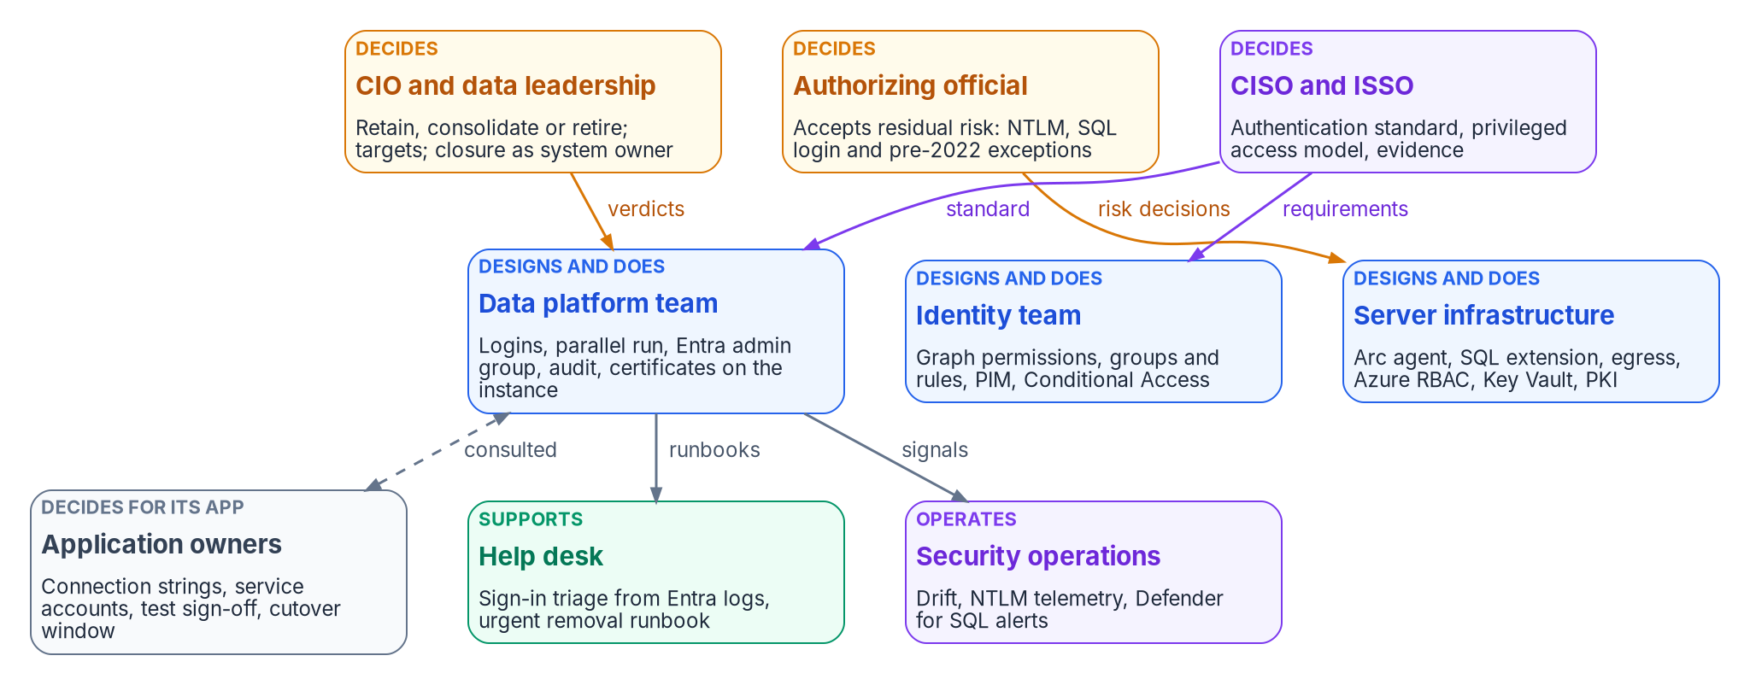
Who decides, who designs and does, and who supports the SQL Server identity transformation.

Where the roles come from
The Data Platform project charter is the starting point. It names a project sponsor and a project lead, both still to be appointed, and four domain leads: Database Authentication, Application-Tier Identity, Secrets Lifecycle and Evidence. As in the endpoint project, those domains are workstreams, not teams, and each one cuts across the teams below. Database Authentication needs the data platform team, the identity team and server infrastructure. Application-Tier Identity can’t move without application owners. Secrets Lifecycle spans Key Vault, the SQL Server 2022 app-registration certificate and the TLS certificates in Chapter 22. Evidence belongs to the ISSO’s package. The program’s model gives each domain lead the job of driving the workstream and keeping its evidence. The decisions inside the workstream go to the deciders named in the matrix.
The charter also draws two boundaries that this book has to respect. Its initial phase excludes full database consolidation or platform replacement, and application code changes beyond authentication configuration. This book still asks for a retain, consolidate or retire verdict on every instance, because Chapter 06 makes that verdict the gate for everything else. The program reads the two together this way: the verdict is in scope, while executing a large consolidation, or re-platforming a data domain as Chapter 23 describes, needs its own funding decision. Likewise, a connection-string change is in scope, but an application in the code-change column of Chapter 18 needs its owner to fund the change or carry a dated exception.
NIST’s Risk Management Framework defines the accountable roles this chapter leans on. The authorizing official is the only organizational official who can accept security and privacy risk, and approves plans of action and milestones. The system owner is responsible for a system’s procurement, development, integration, modification, operation, maintenance and disposal, and decides who has access to it in coordination with the information owner. The information owner or steward governs the information itself and gives the system owner its security requirements. The system security officer keeps the system’s security posture in place day to day and advises on its controls. The same publication tells organizations to avoid conflicts of interest when one person holds several of these roles. That matters on a data platform, where the person who wants an exception and the person who can grant it are often a desk apart.

The roles

The data platform team
The DBAs and the wider data platform team own the engine and everything inside it. In this transformation they run the estate discovery and the authentication audit (Chapters 04 and 07), build the login mapping, create the external-provider logins, run the parallel run and the 30-day observation window, and disable and later drop the legacy logins (Chapter 11, Runbook R05). They repair SPNs and linked-server security contexts during NTLM restriction (Chapters 14 and 15), and they keep the scheduled audit running so the closure record stays current (Chapter 20).
What they no longer own outright is who gets in. The instance’s Microsoft Entra administrator is granted sysadmin on the instance, and changing the administrator in the Azure portal doesn’t remove the previous one, which stays a sysadmin until a DBA drops that login by hand. The program’s model makes the Entra administrator a group (Chapter 17) and gives the data platform team the duty to drop the old administrator login whenever it changes. Membership of that group is a privileged access decision under the CISO’s model, not a DBA decision.
The engine also offers narrower tools than sysadmin for the team’s own work. Any Entra principal with ALTER ANY LOGIN or ALTER ANY USER can create Entra logins or users. SQL Server 2022 added fixed server roles built for least privilege: ##MS_LoginManager## can create, delete and modify logins but can’t grant permissions, and the reader roles such as ##MS_ServerSecurityStateReader## and ##MS_DefinitionReader## give read access to security state and metadata. Microsoft says to treat securityadmin as equivalent to sysadmin, and warns that ##MS_SecurityDefinitionReader## can view password hashes for SQL logins. The program’s model gives the people who run the parallel run ##MS_LoginManager## and the reader roles they need, and keeps sysadmin in the PIM-governed group.

Application owners and their developers
Application owners decide for their own applications. They know which service accounts, connection strings, linked servers and hard-coded group names an application depends on, and they’re the only people who can accept a test result or a cutover window for it. In this book they own the application audit results and the two-axis placement in Chapter 18, and the connection-string change in Chapter 19. Their developers make that change and prove it in a non-production environment whose Arc and SQL extension configuration matches production.
Two things are easy to miss. First, data owners are a separate role from application owners even when the same person holds both. A data owner decides who should be able to read a ledger. An application owner decides when the ledger application’s connection string changes. Chapter 17 gives the data owner the job of confirming that each dynamic rule still describes the intended population. Second, an application owner who can’t move by the program’s dates doesn’t decide to stay on NTLM or SQL authentication. Staying is a risk acceptance, so it goes to the authorizing official as an exception.

The identity team
The identity team owns the Entra side of the engine’s identity, and several of its steps can’t be done by anyone else. On SQL Server 2025, the Arc server’s managed identity needs the Microsoft Graph application permissions User.Read.All, GroupMember.Read.All and Application.Read.All, assigned directly to each managed identity, and only a Privileged Role Administrator or higher can grant them. On SQL Server 2022, the app registration’s Graph permissions need admin consent, which also requires a Privileged Role Administrator or higher. Privileged Role Administrator can manage assignments for every Entra role, including Global Administrator. The program’s model keeps it with a small, named group in the identity team, eligible through PIM, and never with the data platform team.
The identity team also builds the groups and dynamic rules of Chapters 16 and 17, the administrative units that scope DBA delegation, the PIM for Groups settings for privileged SQL access, and the Conditional Access policies that sit in front of every token. PIM for Groups lets an administrator require MFA, justification and approval to activate a membership, and limit how long it lasts. Every user eligible for a PIM-managed group needs a Microsoft Entra ID P2 or Microsoft Entra ID Governance license. Managing membership of a role-assignable group in PIM needs a role such as Privileged Role Administrator, while Groups Administrator or Identity Governance Administrator is enough for groups that aren’t role-assignable, and PIM doesn’t support groups in restricted management administrative units. In NIST terms the identity team is a common control provider: it implements, assesses and monitors controls that the database systems inherit, and documents them for the systems’ security plans.

Server infrastructure
Server infrastructure owns the host and the Azure resources around it. It confirms egress, installs the Connected Machine agent, deploys the Azure extension for SQL Server and owns the onboarding service principal (Chapter 10, Runbook R04). Book 05, Chapter 09 covers Arc for servers in general, and this book stays consistent with it.
Azure role assignments on these resources are now part of SQL Server security. Microsoft recommends giving the Azure Connected Machine Onboarding role only to the service principal that onboards machines, and warns that anyone with Contributor on an Arc server resource can deploy extensions that run arbitrary scripts with privilege, so should be treated as an indirect administrator of the server. Connecting SQL Server to Arc needs Onboarding or Contributor, Azure Connected Machine Resource Administrator and Reader on the resource group. On SQL Server 2025, Owner and Contributor on the SQL Server resource can turn SQL authentication off or back on from the portal, with the same permissions that set the instance’s Entra administrator. Microsoft points out that this Azure RBAC path is how you recover if you lose data-plane access. In the program’s model, whoever holds those Azure roles holds a SQL Server privilege, so the assignments go through the same review as sysadmin.
The host itself carries privilege too. The agent’s token endpoint answers only local administrators and members of the Hybrid agent extension applications group. On SQL Server 2025, Microsoft says to treat the ADMINISTER BULK OPERATIONS and ADMINISTER DATABASE BULK OPERATIONS permissions as equivalent to sysadmin, because OPENROWSET BULK can read the agent’s tokens folder. For SQL Server 2022, infrastructure owns the Key Vault that holds the instance’s certificate. The Arc machine needs the Key Vault Certificate User and Key Vault Secrets User roles on it, and Microsoft recommends a certificate validity of at most 12 months. The program’s model puts the renewal date for that certificate, the TLS certificates and any ADCS-issued certificate behind a type-C login on one calendar that infrastructure owns and the data platform team checks (Chapter 22).

Security, the ISSO and the authorizing official
The CISO’s organization decides the standard every instance has to meet: SQL authentication refused, sa disabled and renamed, the privileged access model for sysadmin and the Entra administrator, the Conditional Access requirements for SQL Server sign-ins, and the break-glass design in Appendix B. Security operations receives the drift events, NTLM telemetry and Defender for SQL alerts of Chapter 20.
The ISSO assembles the evidence and runs the exception registry. That includes the per-instance compliance records, the six artifact sets of Chapter 21, every SQL-login, NTLM and pre-2022 exception with its compensating control and sunset date, and the requirements mapping in Appendix A. The ISSO is consulted on every design decision that changes a control.
The authorizing official accepts the risks the program can’t remove yet. In this book that means each NTLM exception, each SQL authentication login kept past its migration, each pre-2022 instance on the certificate-based interim posture, and the leveraged cloud services described in Appendix B. The 2027-04-01 date in Chapter 15 is the program’s own NTLM backstop, not a Microsoft deadline. The open question there, whether an instance without its interim posture gets a dated exception with network isolation, belongs to the Kerberos/NTLM-elimination program and its exception registry, and each exception it grants still reaches the authorizing official.

The CIO and data leadership
The CIO and data leadership own the platform question. They decide each instance’s retain, consolidate or retire verdict, the consolidation targets, whether a pre-2022 retain instance is upgraded or retired, and, later, the per-domain platform choice of Chapter 23. In NIST’s terms they usually hold the system owner role for the data platform, and so they’re the ones who declare an instance or the estate closed, on the ISSO’s evidence. A mission or business owner can also serve as the authorizing official, and in that case the program’s model still records the two decisions separately.

The help desk
The help desk sees the change first. A user whose token request is refused by Conditional Access gets a failed connection and calls the help desk, not the DBA team. The program’s model gives help desk staff read access to Entra sign-in logs so they can see the Conditional Access result for a SQL Server sign-in. Reports Reader is the least-privileged Entra role that can read the audit and sign-in logs. The help desk also runs its part of the urgent removal path in Chapter 16: disabling the Entra account and revoking sessions while the data platform team ends the user’s SQL Server sessions.
The help desk’s own Entra roles need limits. Helpdesk Administrator can reset passwords for non-administrators, and Microsoft notes that changing a user’s password can mean assuming that user’s identity and permissions. It can’t change the credentials of members or owners of a role-assignable group. That’s one more reason the program puts privileged SQL access in cloud-only, role-assignable groups (Chapter 17): it keeps help desk credential resets away from the people who hold sysadmin.

The responsibility matrix
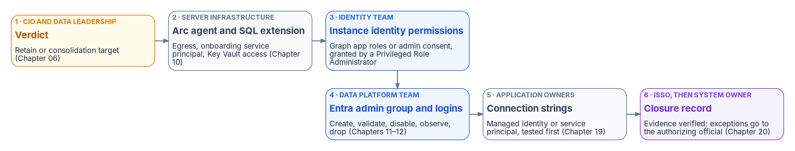
The hand-offs one instance passes through, from verdict to closure, and who owns each step.
No single team can take an instance from verdict to closure on its own, as the figure shows. The matrix assigns the decisions along that path.
D = decides (accountable) · R = does the work · C = consulted · blank = informed at most.
Decision or work item | CIO / data leadership | AO | CISO | ISSO | Data platform | Identity | Infrastructure | App and data owners | Help desk
Retain, consolidate or retire verdict per instance (Chapter 06) | D |  |  | C | R |  | C | C
Consolidation target for each consolidated workload (Chapter 06) | D |  | C |  | R | C | R | C
Upgrade or retire a pre-2022 retain instance (Chapter 08) | D | C |  | C | R |  | R | C
Dated exception for a pre-2022 instance, with its interim posture (Chapter 12) | C | D | C | R | R |  | C | C
Arc onboarding order and the onboarding service principal (Chapter 10) |  |  | C | C | C |  | D, R
Graph permissions or admin consent for the instance’s Entra identity (Chapter 10) |  |  | C |  | C | D, R | C
Authentication standard: SQL authentication refused, sa disabled and renamed (Chapter 12) |  | C | D | C | R |  |  | C
Authentication mode per instance, applied against the standard |  |  |  | C | D, R |  | R | C
Keeping a SQL authentication login past migration (Chapter 12) |  | D | C | R | C |  |  | C
Privileged access model: Entra admin group, PIM for Groups settings, break-glass (Chapter 17, Appendix B) |  | C | D | C | R | R | C
Group design and dynamic rules for each database role (Chapters 16–17) |  |  | C | C | C | R |  | D
Login migration window and legacy-login disable per instance (Chapter 11) |  |  |  | C | D, R | C |  | C | C
Shortening the 30-day observation window in non-production (Chapter 12) | D |  |  | C | R |  |  | C
Connection-string cutover per application (Chapter 19) |  |  |  |  | C | C | C | D, R | C
SPN and linked-server remediation (Chapters 14–15) |  |  | C |  | D, R |  | R | C
NTLM exception for a connection that can’t move in time (Chapter 15) | C | D | C | R | C |  | C | C
TLS and app-registration certificate renewal per instance (Chapter 22) |  |  |  | C | R |  | D, R
Replacement CA and the ADCS decommission date (Chapter 22) | D | C | C | C | C | C | R
Urgent access removal procedure (Chapter 16) |  |  | D | C | R | R |  |  | R
Drift response and remediation (Chapter 20) |  |  | D | C | R | R | R | C
Closure sign-off per instance and for the estate (Chapters 20–21) | D | C | C | R | R |  |  | C
Four rows need comment.
The authentication standard and the per-instance mode are separate rows on purpose. The CISO decides the standard once, and the data platform team applies it instance by instance. An instance that can’t meet the standard doesn’t get a local decision to stay in Mixed Mode. It gets an exception row, decided by the authorizing official.
Group design sits with the app and data owners because, in NIST’s model, the system owner decides who has access in coordination with the information owner. The identity team writes the rule. The data owner says whether it describes the right people. That split also follows the principle in Chapter 17 that the attribute writer controls access, so neither team can change a SQL Server grant alone.
Shortening the observation window in non-production sits with data leadership as the system owner, because Chapter 12 allows it only with documented owner sign-off. The data platform team proposes it and can’t approve its own proposal.
Closure sign-off sits with data leadership, not the authorizing official, because closure is a claim about the system’s state, made by the system owner on the ISSO’s evidence. The authorizing official is consulted because the exception registry that comes with every closure claim is a list of risks the authorizing official has accepted. A closure claim that arrives with new exceptions needs those exceptions accepted first.

Permissions for each team
Decision rights don’t change what a console lets someone do. Permissions do, and on this platform they live in three places: SQL Server, Microsoft Entra ID and Azure RBAC. The program maps each team to the narrowest permission that does its work, makes the privileged ones eligible through PIM, and reviews the Azure and SQL Server assignments with the same cadence as the Entra ones.
Team | SQL Server | Microsoft Entra ID | Azure RBAC
Data platform (daily work) | ##MS_LoginManager## and reader roles such as ##MS_ServerSecurityStateReader## | Reports Reader for sign-in evidence | Reader on SQL Server resources
Data platform (privileged) | Member of the instance’s Entra admin group, which holds sysadmin, through PIM for Groups | None routinely | Contributor on the SQL Server resource only where the team manages its Entra settings, and reviewed as a SQL privilege
Identity team | None routinely | Groups Administrator scoped to an administrative unit; Privileged Role Administrator for a small named group, eligible only | None
Server infrastructure | None routinely | None routinely | Azure Connected Machine Resource Administrator on server resource groups; Onboarding role held only by the onboarding service principal
ISSO, assessors | ##MS_ServerSecurityStateReader## and ##MS_DefinitionReader##, not ##MS_SecurityDefinitionReader## | Reports Reader or Security Reader | Reader
Help desk | None | Reports Reader; Helpdesk Administrator scoped to an administrative unit | None
Two consequences follow. First, Azure RBAC on Arc and SQL Server resources is a database control, because Contributor on the server can run privileged extensions and Contributor on the SQL Server resource can switch SQL authentication back on. Second, the narrowest SQL Server roles exist only on SQL Server 2022 and later. That’s one more reason the pre-2022 long tail is an exception to retire, not a steady state.

Ownership in practice
Under Windows authentication, a database grant had one owner because it had one plumbing. In the target, one connection depends on an Entra group the identity team built, a rule the data owner approved, a managed identity whose Graph permissions a Privileged Role Administrator granted, an Arc agent infrastructure keeps healthy, a login the DBAs created and a connection string the application team changed. If any of those owners is missing, the gap shows up as drift in the closure record, or as a help desk call nobody can resolve. That’s why the program names the owner of each step before the first login moves, and why Chapter 14 starts the How part with the NTLM patterns, whose fixes need almost every team in this chapter.

Continue the book
← Previous: Chapter 12 — What the Engine-Authentication Decision Settles · Book index · Next: Chapter 14 — NTLMv1, NTLMv2 and the Patterns That Generate NTLM →

Chapter 14 — NTLMv1, NTLMv2 and the Patterns That Generate NTLM
NTLM is a protocol, not a setting, so removing it means naming every connection pattern that produces it.

In this chapter
Why NTLMv1 is blocked early in the program while NTLMv2 runs to the program’s 2027-04-01 backstop, and how both dates relate to what Microsoft has actually announced. Then the four SQL Server connection patterns that generate NTLM: a missing SPN, an unreachable domain controller, linked-server passthrough, and application hosts that are no longer domain-joined.

Where this part of the book starts
SQL Server is one of the most common sources of NTLM traffic in a large Windows estate, and the reasons are more varied than most database teams expect. Chapters 14 and 15 apply the Kerberos/NTLM-elimination program’s three phases (assess, block where safe, eliminate) to the SQL Server workload, against the program’s own network-level backstop of 2027-04-01. In the program’s dependency chain this is step 8, enforcing protocol retirement. The working procedure is Runbook R06.
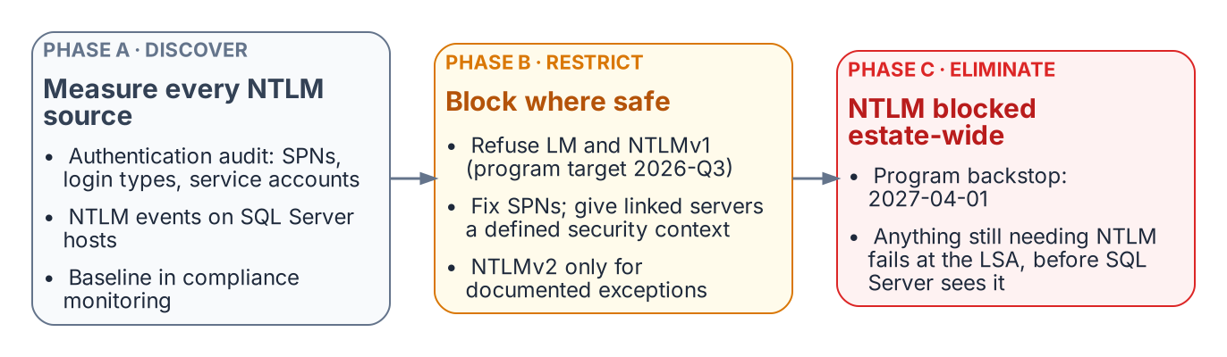
The three phases of the program’s NTLM elimination, applied to SQL Server.
No single switch or Group Policy change removes NTLM from SQL Server connections. Eliminating it means finding every connection pattern that generates it, and there are more than most database teams expect. Beyond the missing-SPN case from Chapter 01 there are cross-site connections, linked-server passthrough, and hosts already moved to a non-domain-joined state, each with its own root cause and fix.

Where Microsoft stands on NTLM
The program’s dates are its own, so it helps to state Microsoft’s first:
- All versions of NTLM are deprecated. In June 2024 Microsoft announced that LANMAN, NTLMv1 and NTLMv2 are no longer under active feature development. Its guidance is to replace calls to NTLM with calls to Negotiate, which tries Kerberos first.
- NTLMv1 is removed starting with Windows 11, version 24H2 and Windows Server 2025. NTLMv2 still works on Windows Server 2025 but will be removed in a future release.
- NTLMv1-derived credentials for single sign-on are blocked by default starting with the October 2026 security update (released October 13, 2026) on Windows 11, versions 24H2 through 26H2, and Windows Server 2025, on devices where Credential Guard is off. The change targets single sign-on paths such as MS-CHAPv2 Wi-Fi and VPN, not NTLMv1 network authentication in general, and a BlockNtlmv1SSO registry value can temporarily return a device to audit.
- Network NTLM is to be off by default in the next major release of Windows Server and its client. Microsoft published a three-phase plan on January 29, 2026: enhanced NTLM auditing first, then new tooling such as IAKerb and local KDC in the second half of 2026, then NTLM disabled by default. Microsoft says the timelines are subject to change.
None of these is a deadline for SQL Server. The 2027-04-01 date belongs to the program.

NTLMv1: blocked first, in Phase B
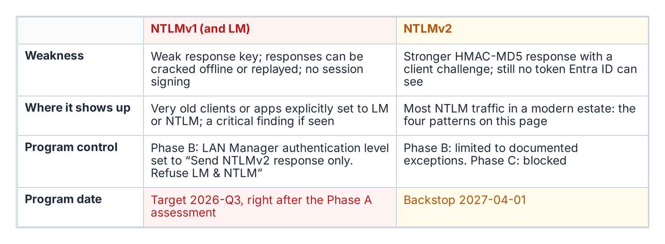
The two NTLM variants and their different timelines.
NTLMv1 and LM are the variants Microsoft says are vulnerable to widely published attacks for obtaining user passwords; its long-standing recommendation is to enforce NTLMv2 and reduce or eliminate NTLMv1 and LM. A captured NTLMv1 exchange can be attacked offline, and the hash it proves can be replayed (pass-the-hash).
The program blocks NTLMv1 in its Phase B “block where safe” stage, by default as soon as the Phase A assessment completes (targeted 2026-Q3). It does this by setting Network security: LAN Manager authentication level to Send NTLMv2 response only. Refuse LM & NTLM (level 5). At that level clients send only NTLMv2, and domain controllers refuse LM and NTLMv1 responses but still accept NTLMv2. Level 5 is therefore the NTLMv1 block, not an NTLM block; refusing NTLM itself is the job of the Restrict NTLM policies in Chapter 15.
The program’s Group Policy is a different control from Microsoft’s October 2026 change. Microsoft’s change blocks NTLMv1-derived credentials from being used for single sign-on on devices without Credential Guard; the program’s LAN Manager setting stops NTLMv1 responses from being sent or accepted on every host it reaches, including older systems Microsoft’s change doesn’t cover. On Windows 11, version 24H2 and Windows Server 2025, NTLMv1 is already removed, so the setting matters most on older hosts and clients still in the estate.
NTLMv1 found by the authentication audit or Phase A traffic analysis is a critical finding requiring immediate remediation, not a routine migration item. On a domain controller with logon success auditing on, Event ID 4624 records the NTLM version in its Package Name (NTLM only) field. Microsoft cautions that the field reports NTLM V1 for anonymous logons and for any session without NTLMv2 key material, so filter those out before raising a finding.

NTLMv2: the program’s 2027-04-01 backstop
NTLMv2 is what most SQL Server NTLM traffic in a modern estate uses. Phase B restricts it to documented exception groups; Phase C disables it at the 2027-04-01 hard cutover, the program’s own backstop. That is a program decision, not a Microsoft deadline: Microsoft’s stated plan is to disable network NTLM by default, not remove it, in the next major Windows release, subject to change. SQL Server NTLMv2 connections must move before that date either to Kerberos, as an interim posture, or to Entra ID OAuth 2.0 authentication, the final destination.
Cloud Kerberos trust, which the Kerberos/NTLM-elimination program deploys for Windows Hello for Business, helps the interim posture on Entra-joined clients: the client gets a partial ticket-granting ticket from Entra ID and exchanges it with an on-premises domain controller for a full one, which it then uses for resources such as SQL Server. It doesn’t remove the domain controller from the path, which matters for Pattern Two below.

Pattern One: missing or incorrect SPN
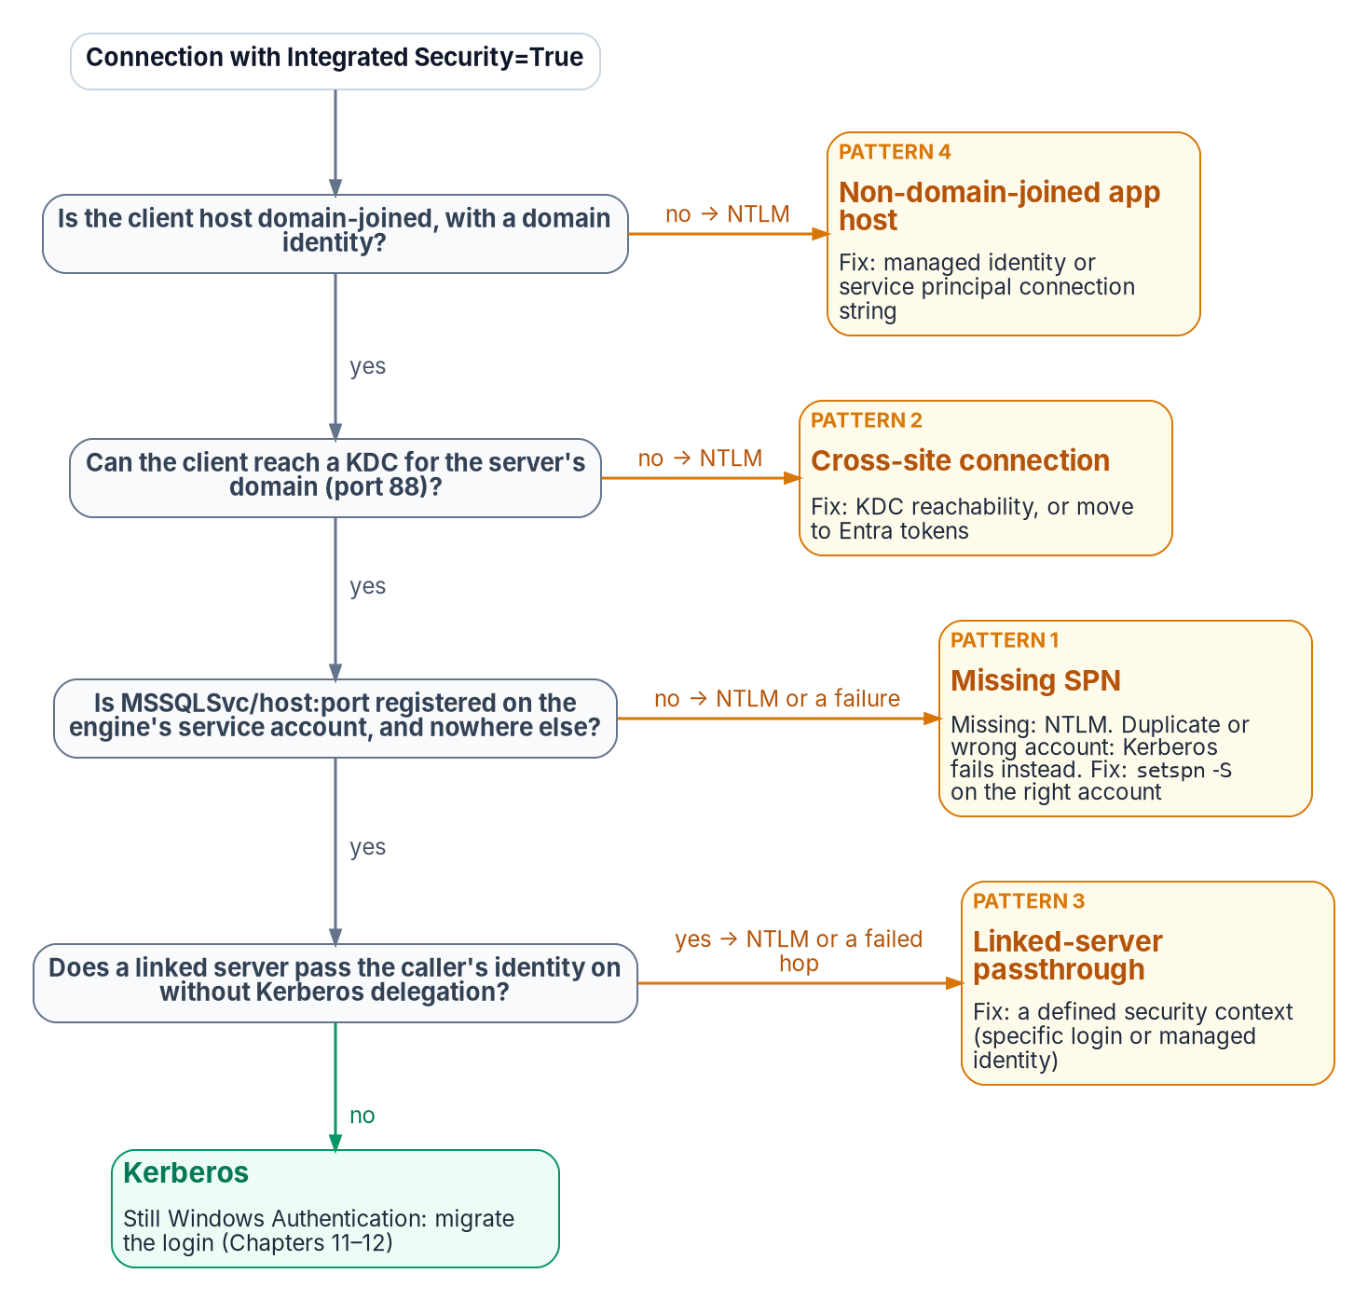
The checks Negotiate makes before it settles for NTLM, and the connection pattern behind each failure.
Established in Chapter 01
When no valid SPN is registered for the engine’s service account, SSPI can’t negotiate Kerberos and falls back to NTLM.
This is the most common cause of NTLM fallback. The SPN takes the form MSSQLSvc/<FQDN>:<port> for TCP connections, or MSSQLSvc/<FQDN>:<instancename> for a named instance over other protocols, registered on the account the engine runs under. If the driver can’t obtain a ticket for the SPN it builds, authentication uses NTLM. The fix is setspn -S MSSQLSvc/<FQDN>:<port> <domain>\<account>, which checks for duplicates before adding. The authentication audit captures SPN status per instance, and each gap can be fixed independently of the login migration.
Two neighbors of this pattern behave differently, and the difference matters for triage:
- An SPN on the wrong account doesn’t fall back. It fails. Microsoft’s table of authentication defaults is explicit: an SPN that maps to an incorrect account makes authentication fail, typically with Cannot generate SSPI context. A service-account change without an SPN move produces this, not silent NTLM.
- A duplicate SPN also breaks Kerberos. SPNs must be unique in the forest; when more than one account holds the requested SPN, the KDC returns KDC_ERR_PRINCIPAL_NOT_UNIQUE. Find duplicates with setspn -Q <SPN> (or setspn -X across trusted forests) and remove the extra registration.
Even with a correct SPN, Microsoft’s defaults table shows that local connections use NTLM and only remote connections use Kerberos. An application on the same host as the instance is an NTLM source that SPN repair won’t touch; it belongs with Pattern Four. Some older client components also force NTLM: the legacy SQLOLEDB provider and the legacy SQL Server ODBC driver that ship with Windows support only NTLM over named pipes. Microsoft’s fix is TCP, or a current driver such as MSOLEDBSQL or ODBC Driver 17 or later.

Pattern Two: cross-site connections
Connections that cross AD sites, domains or forests can generate NTLM when Kerberos can’t complete. To use Kerberos with SQL Server, the client and server must be in the same domain or in trusted domains, and the client must obtain a service ticket from a domain controller of the domain that holds the server’s service account (any domain controller of that domain, not one in a particular site). Across forests that also needs a forest trust with name-suffix routing for the SPN; without a trust, neither Kerberos nor NTLM can authenticate an account from the other forest.
If the client can’t reach or locate a domain controller for that domain (port 88 blocked, or DNS that doesn’t resolve it), Negotiate falls back to NTLM where a trust lets the server validate the account, and the connection fails where it doesn’t. This is common in large, distributed networks. Microsoft names valid DNS on client and server as the key factor in Kerberos success, and lists SQL Server aliases and HOSTS file entries as common causes of an unexpected SPN, and so of NTLM.
Detect it in Phase A output by correlating source and destination sites. Cross-site NTLM usually means domain controller reachability or DNS from the source site, but a missing SPN or trust gap looks the same, so confirm with klist or the client’s Kerberos events before changing firewall rules. The remediation is to restore Kerberos (domain controller reachability on UDP and TCP port 88 and working DNS from every client site, a correct SPN and, across forests, a trust) or to move the connection to Entra ID tokens, which need no domain controller at all. Cloud Kerberos trust isn’t a fix for this pattern: the partial ticket Entra ID issues must still be exchanged with an on-premises domain controller, and the service ticket for the SQL Server SPN still comes from one.

Pattern Three: linked-server passthrough authentication
Linked-server definitions, which let one instance query another with OPENQUERY or four-part names, often use Windows passthrough (self-mapping, @useself = 'TRUE', the Be made using the login’s current security context option). The originating instance then tries to present the connecting client’s Windows identity to the target instance: a second hop.
NTLM can’t make that hop. Microsoft states that a double hop fails if NTLM credentials are used and needs Kerberos; the typical symptom is Login failed for user 'NT AUTHORITY\ANONYMOUS LOGON'. Passthrough needs Kerberos delegation: the client must reach the first instance with Kerberos, and the first instance’s service account must be trusted for delegation to the target’s SPN, preferably constrained or resource-based constrained delegation. Unconstrained delegation is also blocked on any client where Credential Guard is on. In practice the pattern shows up as NTLM on the client’s first hop or as a failed second hop; it isn’t a working NTLM path to keep.
Linked-server NTLM often looks like internal traffic and escapes standard connection audits. Find it through sys.servers, sys.linked_logins and inter-instance traffic analysis. Each passthrough definition is migrated during the restriction phase to a defined security context:
- a specific mapped login;
- on SQL Server 2022 and later with Entra authentication configured on both instances, an Entra identity in the linked-server provider string;
- on SQL Server 2025, a managed identity (Authentication=ActiveDirectoryMSI with the MSOLEDBSQL provider), with a login for the source server created on the target FROM EXTERNAL PROVIDER; or
- where the caller’s own identity must reach the target, Kerberos constrained delegation.
Avoid the password option for Entra linked servers: the Entra username-and-password flow is deprecated in Microsoft’s SQL drivers and is incompatible with mandatory multifactor authentication.

Pattern Four: non-domain-joined application hosts
In the program’s target architecture, Arc-enabled servers run without a domain join (see Book 05, Chapter 09). An application on an unjoined host has no Kerberos ticket-granting ticket, so a connection string still using Windows Integrated Security falls back to NTLM with local credentials, or fails outright: a new NTLM source the unjoin created. The pattern grows as server unjoin progresses, which is why connection strings should move to managed identity before or alongside application-host unjoin (Chapter 19). A host on managed identity generates no NTLM and satisfies both programs.
What this chapter establishes
- NTLM is a protocol, not a setting; no single switch removes it from SQL Server connections. Microsoft has deprecated every version and removed NTLMv1 from current Windows, but the 2027-04-01 date is the program’s.
- NTLMv1 is blocked early with LAN Manager level 5, which still accepts NTLMv2; NTLMv2 is restricted to exception groups, then blocked at the program’s 2027-04-01 cutover.
- Four patterns generate NTLM at the SQL layer (missing SPNs, unreachable domain controllers, linked-server passthrough and non-domain-joined or same-host clients), and each must be found before it can be fixed. Duplicate or misplaced SPNs fail rather than fall back.

Continue the book
← Previous: Chapter 13 — Who Owns the Data Platform · Book index · Next: Chapter 15 — The Three Phases of NTLM Elimination for SQL Server →

Chapter 15 — The Three Phases of NTLM Elimination for SQL Server
Discover, restrict, eliminate: the phase structure the Kerberos/NTLM-elimination program applies everywhere, applied to SQL Server workloads.

In this chapter
How the program’s three phases apply to SQL Server. Phase A discovery uses the authentication audit alongside Windows NTLM logging. Phase B restriction converts NTLM connections to Kerberos and migrates the remaining patterns. Phase C elimination applies the domain-wide block on the program’s 2027-04-01 backstop. An instance whose logins have moved to Entra ID isn’t affected by that block, because it isn’t using NTLM in the first place.
The Kerberos/NTLM-elimination program structures NTLM elimination into three phases (discover, restrict, eliminate), and this chapter applies that structure to SQL Server workloads. The phases are sequential and the final one is a hard backstop: the program sets the domain-wide NTLM block to take effect no later than 2027-04-01. That date is the program’s decision. Microsoft has deprecated NTLM and plans to disable network NTLM by default in the next major Windows release, but it hasn’t set a removal date for NTLMv2 (Chapter 14).
After that date, any SQL Server connection that needs NTLM fails inside the Windows security subsystem, where the Local Security Authority (LSA) enforces the policy. Windows Authentication in SQL Server is delegated to that subsystem, so the engine never receives an authenticated connection to evaluate. SQL Server NTLM elimination therefore can’t be decoupled from the broader program timeline. Every NTLM-generating connection pattern must be resolved before the elimination phase, not after.

Phase A — discovery
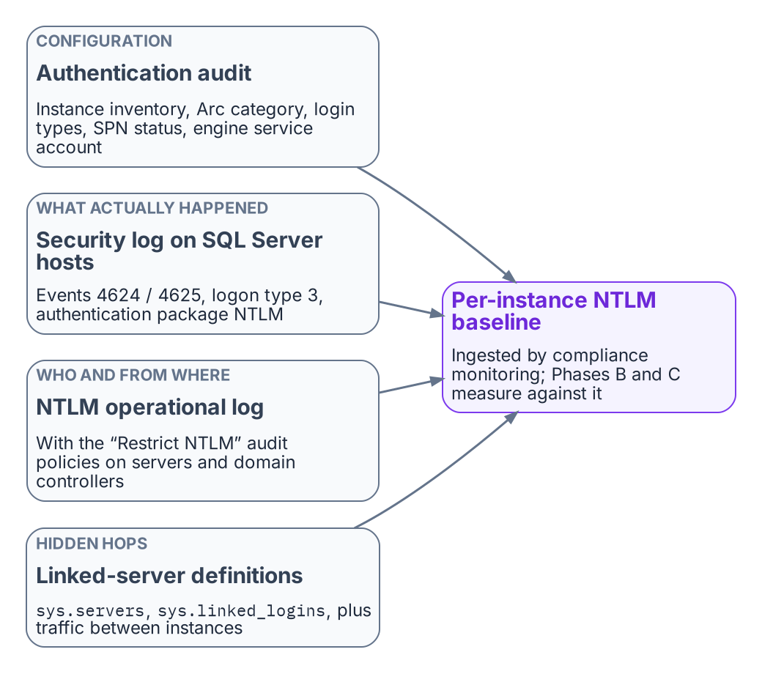
The evidence Phase A combines into the NTLM baseline.
Discovery is the program’s first phase, and for SQL Server its primary instrument is the authentication audit (Chapter 07). The Phase A output for SQL Server includes the full instance inventory with Arc-eligibility classifications, the login-type inventory, the SPN registration status for every instance, and the service-account identity for each engine process.
Windows logging supplements the audit by recording what actually happened on the wire. Four sources matter:
- The Security log on SQL Server hosts. Event ID 4624 (successful logon) and 4625 (failed logon) with logon type 3, the network logon type, and authentication package NTLM, filtered to SQL Server hosts. On domain controllers, 4624 also carries the NTLM version; ignore the NTLMv1 value on anonymous logons, which Microsoft says is reported for any session without NTLMv2 key material.
- Per-connection proof from the engine. sys.dm_exec_connections returns auth_scheme (NTLM, KERBEROS or SQL) for each live connection, which ties a host-level event to a specific instance and login.
- The Restrict NTLM audit policies. Network security: Restrict NTLM: Audit Incoming NTLM Traffic on servers, Audit NTLM authentication in this domain on domain controllers, and Outgoing NTLM traffic to remote servers set to Audit all on clients log the requests a later deny setting would block, in the Applications and Services Logs > Microsoft > Windows > NTLM > Operational log. On domain controllers, event 8004 records the server each NTLM request was for.
- Enhanced NTLM logging. Windows 11, version 24H2 and later and Windows Server 2025 add events in the same operational log that say who used NTLM, from where, and why Kerberos wasn’t used (4020 to 4023 on clients and servers; 4030 to 4033 on domain controllers), with warning-level variants for downgrades such as NTLMv1. Windows Server 2022 and 2019 get the same logging with the October 13, 2026 updates or later.
The combination of the audit output and the event analysis produces a complete picture of NTLM-generating SQL Server connection patterns across the estate. The compliance-monitoring pipeline ingests that Phase A output as the baseline from which all later phases measure progress.

Phase B — restriction
Restriction applies controls that reduce NTLM traffic without eliminating it, creating pressure on connection patterns to migrate while keeping operations running. The primary Phase B control for SQL Server is the NTLMv1 block (LAN Manager authentication level 5), combined with Kerberos remediation for the missing-SPN cases. Level 5 refuses LM and NTLMv1 on domain controllers but still accepts NTLMv2, so it doesn’t restrict NTLMv2 by itself.
The work in this phase, pattern by pattern:
- Missing SPNs. SPN registration is corrected for every instance with a missing SPN, converting those connections from NTLM to Kerberos. Duplicate and wrong-account SPNs, which fail rather than fall back, are cleaned up in the same pass.
- Cross-site connections. Fixed by restoring domain controller reachability (port 88 and DNS) and, across forests, a trust, or by moving the connection to Entra ID tokens. Cloud Kerberos trust, which the program also deploys, doesn’t remove the need for domain controller reachability: its partial tickets are still exchanged with on-premises domain controllers.
- Linked servers. Definitions using passthrough authentication move to defined security contexts.
- Unjoined hosts. Application connection strings on recently domain-unjoined hosts move to managed identity or service-principal authentication (Chapter 19).
NTLMv2 restriction uses the Restrict NTLM deny settings, staged from the Phase A audit settings: Outgoing NTLM traffic to remote servers on clients, Incoming NTLM traffic on servers and NTLM authentication in this domain on domain controllers. Only two roles have exception lists: Add remote server exceptions for NTLM authentication on the client and Add server exceptions in this domain on the domain controller. There’s no exception list for the server role. That is the same staging Book 05, Chapter 05 uses for servers generally. The SQL-specific part is the exception content: the excepted instances, fed from the Phase A baseline, go into the domain controller and client lists, and an instance that must keep accepting NTLM can’t have Incoming NTLM traffic set to deny. If a missed dependency surfaces, relax the deny setting back to audit or add a scoped exception until the owner fixes it.
After Phase B, the only remaining NTLM-generating SQL Server connections should be those that need the enforcement phase’s hard block to remove. These are typically applications that can’t be modified before the program’s 2027-04-01 block date, which become exception cases with formal exception documentation under the program.

Phase C — elimination
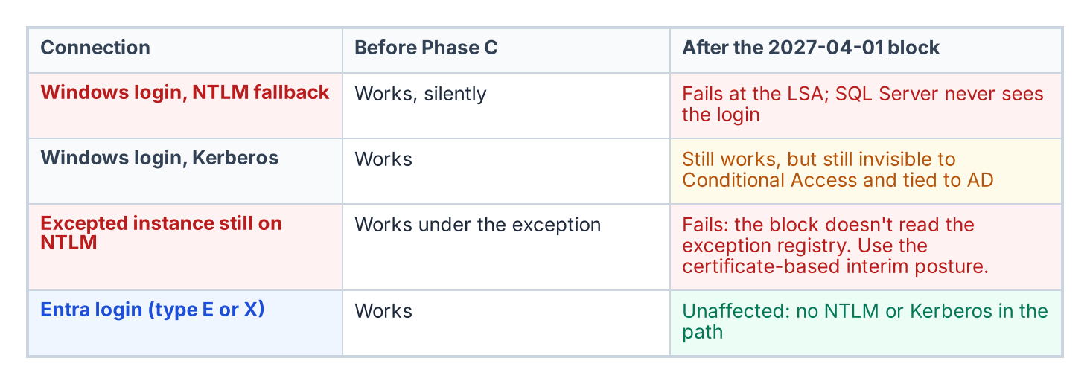
What the Phase C block does to each kind of connection.
The elimination phase disables NTLM across the estate. Group Policy pushed domain-wide sets the Restrict NTLM policies to deny on every host, and any connection that can’t negotiate an alternative protocol fails at the LSA. Windows 11, version 24H2 and later also offer NTLM blocking policies in the NTLM policy CSP, including one that blocks all outbound NTLM except listed targets. For SQL Server, Phase C is only safe after the login migration in Chapters 11–12 is complete for every instance in the estate.
An instance whose connections use Entra ID OAuth 2.0 tokens generates no NTLM traffic. A Microsoft Entra login (type E or X) authenticates with a token issued by Entra ID, not through Kerberos or NTLM; the existing SQL and Windows authentication modes are a separate path. An instance that has completed the login migration is therefore immune to Phase C: it wasn’t generating NTLM before the block, and it isn’t affected by the block after.
The sequencing imperative follows: complete the SQL Server login migration before Phase C is applied. The 2027-04-01 backstop is the Phase C date, and the login migration must be complete before it for every production instance.
Unresolved: what happens to the long tail on 2027-04-01
Known fact. Microsoft’s plan is to disable network NTLM by default in the next major Windows release, subject to change; 2027-04-01 is this program’s date, not Microsoft’s (Chapter 14).
Dependency. Pre-2022 instances, which can’t use Entra authentication at all, and deferred applications that can’t reach Kerberos or Entra tokens by then rely on the certificate-based interim posture, which needs a replacement CA issuing before AD CS is retired (Chapter 22).
Unresolved decision. Whether the Phase C date holds for instances whose interim posture isn’t in place, or whether they get dated exceptions with network-level isolation.
Owner and artifact. The Kerberos/NTLM-elimination program, recorded as an amendment to its enforcement-phase decision and reflected in the exception registry.
What this chapter establishes
- Discovery baselines every NTLM-generating pattern from the audit, auth_scheme, the Security log, and the NTLM operational log fed by the Restrict NTLM audit policies and enhanced NTLM logging.
- Restriction blocks NTLMv1, repairs SPNs and Kerberos reachability, moves linked-server security contexts and connection strings, and stages the Restrict NTLM deny settings with audited exceptions.
- Elimination applies the domain-wide block; instances already on Entra logins are unaffected because they don’t use NTLM.

Continue the book
← Previous: Chapter 14 — NTLMv1, NTLMv2 and the Patterns That Generate NTLM · Book index · Next: Chapter 16 — Groups, Roles and How Membership Reaches the Engine →

Chapter 16 — Groups, Roles and How Membership Reaches the Engine
Group-based authorization survives the migration. Its plumbing, its timing and its outer boundary don’t.

In this chapter
How an Entra security group becomes a SQL Server login and a database role member. Why each group should grant exactly one role, and why the group model should stay flat. When a membership change actually takes effect at the engine. How the four kinds of AD group found in a SQL Server estate migrate. Why Conditional Access becomes the outer perimeter for people once every login is Entra-backed, and what covers application identities instead.

Where this part of the book goes next
The migration moves SQL Server’s groups from Active Directory to Microsoft Entra ID, but it keeps group-based authorization. What changes is who maintains the groups and how. A group that maps to a single database role can keep itself current from HR-sourced attributes, which removes the helpdesk ticket. That only works if the attributes are trustworthy, the rules are tested, delegation is scoped and privileged access is just in time. Chapters 16 and 17 cover that design and the governance it needs; in the program’s dependency chain this is step 5, introducing Entra principals. The working procedure is Runbook R07.
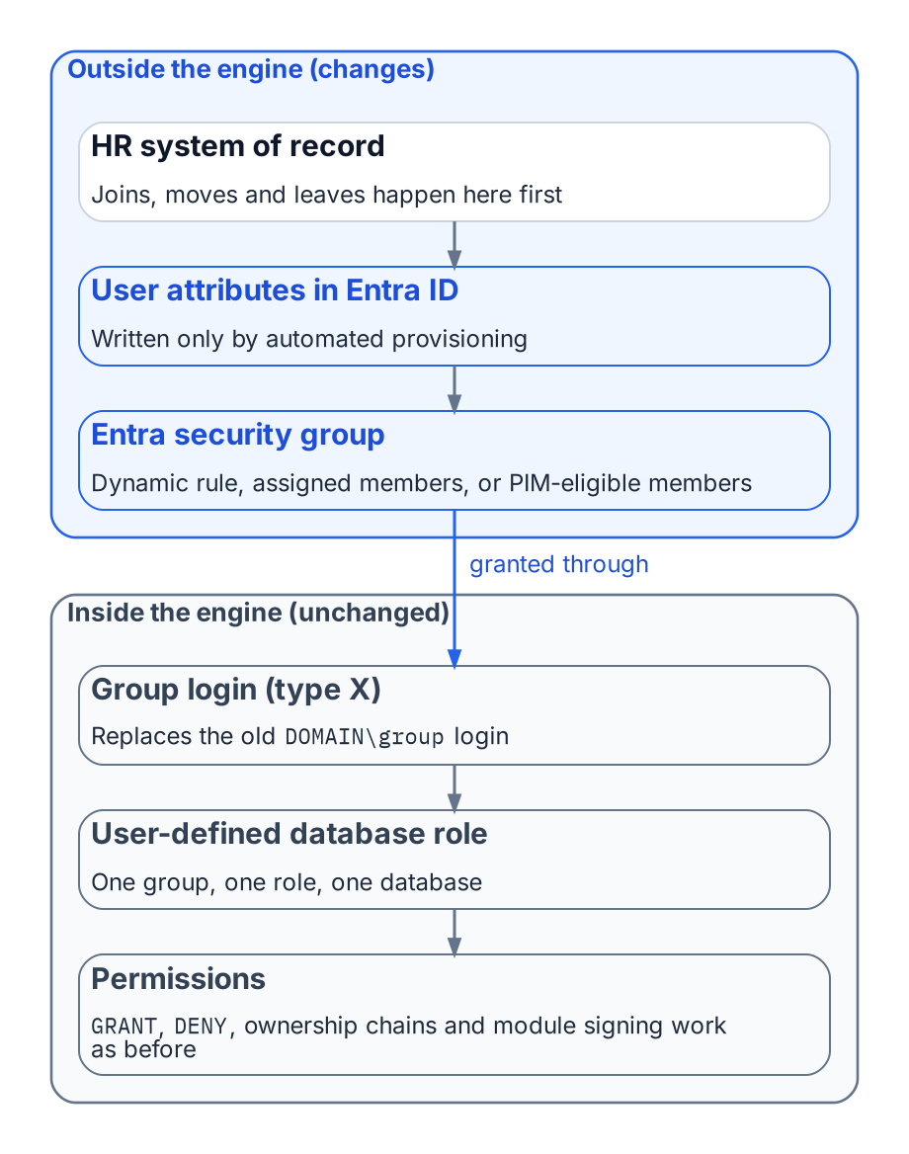
The directory half of SQL Server access moves to Entra ID; the engine half barely changes.
SQL Server’s access model has two halves: roles and permissions inside the engine, and the directory outside it that decides group membership. For twenty years the outside half was Active Directory: a DBA mapped DOMAIN\SQL-Reporting-Readers to a login and role, and whoever controlled that AD group controlled access.
The transformation replaces the outside half and leaves the inside nearly untouched. Roles, GRANT and DENY, ownership chains and module signing work as before. What changes is the principal (an Entra group), the proof of membership (an Entra token, not a Kerberos ticket) and when a membership change takes effect.

How an Entra group becomes SQL Server access
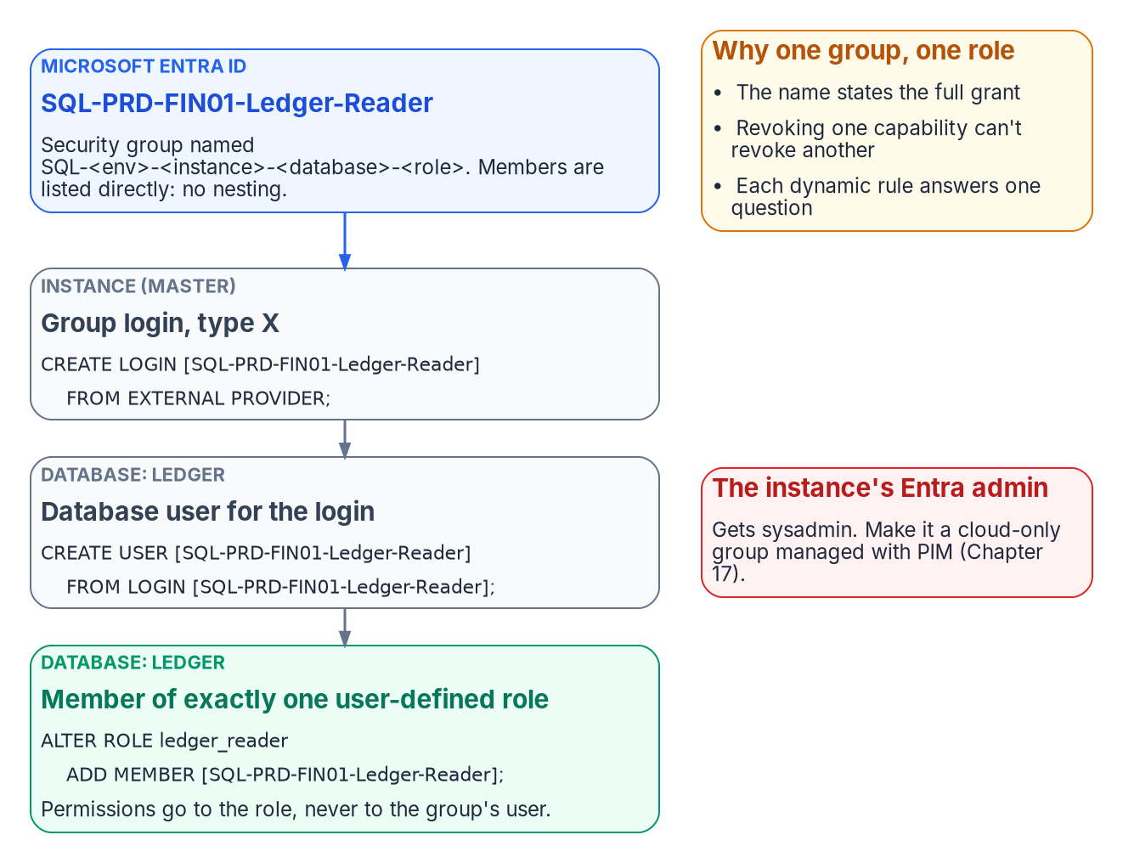
How one Entra group becomes exactly one database role.
Established in Chapters 11–12
CREATE LOGIN … FROM EXTERNAL PROVIDER creates logins for Entra users and applications (type E, EXTERNAL_LOGIN) and for Entra groups (type X, EXTERNAL_GROUP).
A group enters SQL Server as an AD group did: as a server login created from the group’s name, then a database user (CREATE USER … FROM LOGIN) added to a role. For users the principal name is the user principal name; for groups and applications it’s the name of the Entra object. The continuous audit in Chapter 20 must count type X as well as type E (SELECT * FROM sys.server_principals WHERE type IN ('E','X')), because group logins are where most access should live.
The instance’s Microsoft Entra administrator, chosen when Entra authentication is set up through Azure Arc, becomes sysadmin on the instance. In any sizable estate it should be a group (Chapter 17). On SQL Server 2025, the instance’s managed identity needs the Microsoft Graph application permissions User.Read.All, GroupMember.Read.All and Application.Read.All, assigned directly to each identity; only a Privileged Role Administrator or higher can grant them. That is an identity-team step, not a DBA step. Microsoft mentions the Directory Readers role as an alternative for many machines but doesn’t recommend it where least privilege is required. Every Entra connection to SQL Server also requires an encrypted connection, so the instance needs a TLS certificate its clients trust.
The T-SQL below is illustrative and hasn’t been tested against a production instance. Review it, and run it first in a non-production environment.
-- Instance level: one login per Entra group
CREATE LOGIN [SQL-PRD-FIN01-Ledger-Reader] FROM EXTERNAL PROVIDER;
-- Database level: the group becomes a member of exactly one role
USE Ledger;
CREATE USER [SQL-PRD-FIN01-Ledger-Reader] FROM LOGIN [SQL-PRD-FIN01-Ledger-Reader];
ALTER ROLE ledger_reader ADD MEMBER [SQL-PRD-FIN01-Ledger-Reader];
Runbook R07 carries the full procedure. Authorization inside the engine isn’t redesigned; only the principal changes.

One group, one role
The most consequential design decision in this part of the book is the simplest: each Entra group grants exactly one role, on one database, in one environment. A user who reads the ledger and runs the month-end job belongs to two groups.
The rule pays off three ways. The group name fully states what it grants, so an access review can be answered without opening SQL Server Management Studio. Revoking one capability never revokes another. And dynamic membership becomes tractable: “who should read the ledger?” can be written as a rule; “whoever this legacy group happened to include” can’t.
Permissions go to user-defined database roles, never directly to group users, and db_owner and sysadmin are kept for the few who need them. Every legacy group mapped to db_owner “because the application needed it” is a finding to resolve before its replacement is created.

Flat by design
AD estates are full of nested groups. Don’t rebuild that tree in Entra ID; the platform’s constraints point to a flat model.
- Dynamic groups can’t contain groups. A dynamic rule selects users or devices by attribute, never other groups.
- The memberOf operator is ending. It was the preview workaround for building a dynamic group from other groups. Microsoft has announced that its public preview ends on November 3, 2026. After that date, groups that use it stop updating and stay in their last known state, and Microsoft says to remove or replace every use before then.
- Role-assignable groups can’t nest. These are the groups with the strongest protection against privilege escalation, and a group can’t be added as a member of one.
- Group claims are capped. Applications that read group membership straight from the token get at most 200 groups in a JWT (150 in a SAML assertion), counting nested groups; above that they receive an overage indicator and must query Microsoft Graph instead.
- Nested-group evaluation isn’t documented for SQL Server. Microsoft’s SQL Server documentation doesn’t describe how nested Entra group membership is evaluated for an on-premises instance’s group logins. This is the program’s reading of the documentation, not a Microsoft statement.
Nesting builds on behavior that is unsupported, ending or undocumented. A flat model costs a few more groups and gives up nothing: each role-mapped group lists members directly, by rule or assignment, and several populations needing one role share one rule. Where a nested chain is unavoidable, test it on the target instance version first.

When a change takes effect
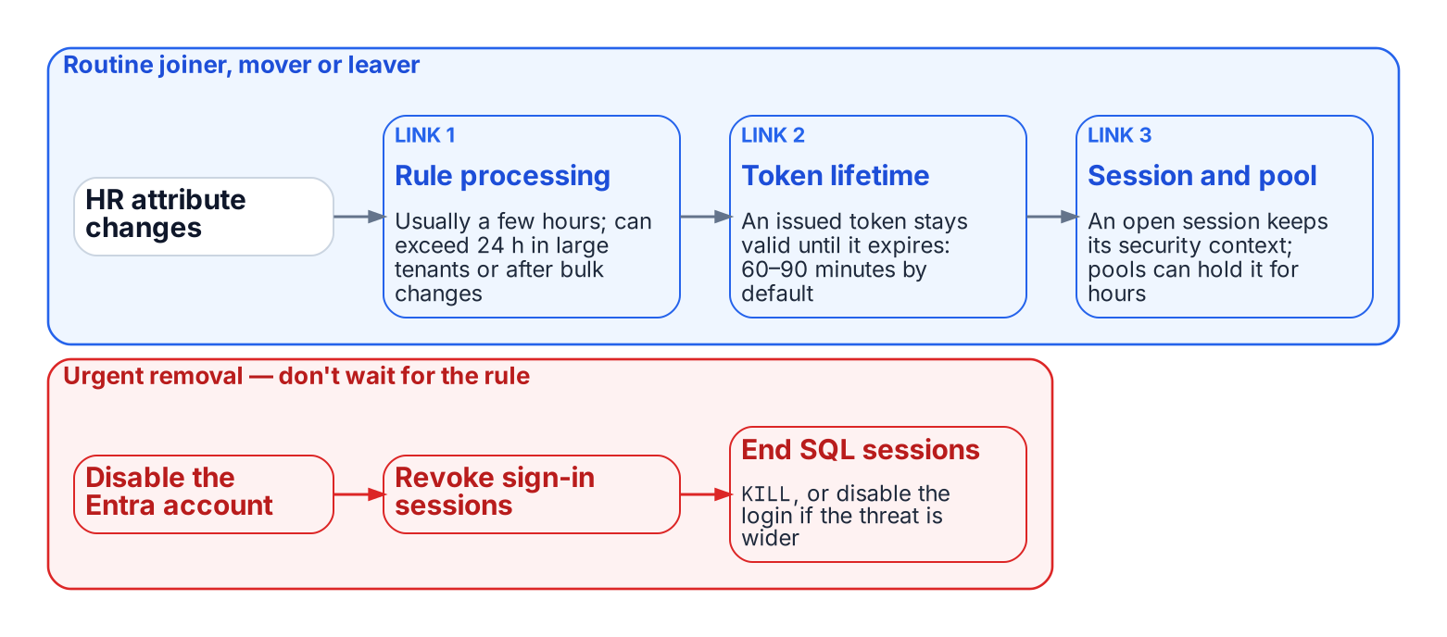
The chain between an HR change and the engine, and the urgent path that doesn’t wait for it.
Under Windows Authentication a membership change arrived with the next Kerberos ticket, usually the next logon. The Entra chain is longer:
- Rule processing. A dynamic group is recalculated when a relevant attribute changes. Microsoft documents that changes are usually processed within a few hours, but that processing can take more than 24 hours depending on tenant size, the number of changes, rule complexity and operator choice.
- Token lifetime. An access token already issued to the user stays valid until it expires. By default that’s a random value between 60 and 90 minutes.
- Session and pool lifetime. An open SQL Server session keeps the security context it was established with. A connection pool can keep that session open for hours.
That latency is acceptable for routine joiners, movers and leavers, and often beats the ticket queue it replaces. Urgent removal doesn’t wait for a rule. Disable the Entra account and revoke the user’s sessions, which Microsoft lists as the two Entra steps for revoking access; then end the user’s SQL Server sessions (KILL, or disable the individual or group login if the threat is broader). Microsoft also notes that an access token already issued can outlive the revocation for up to its lifetime, which is why the SQL step is needed. Write this path into the operations runbook before the first dynamic group grants production access.

Migrating the four AD group patterns
Groups in a long-lived SQL Server estate fall into four patterns:
- Organization-derived access groups, kept in step with the org chart by hand, become dynamic groups whose rules read HR-maintained attributes such as department, companyName, jobTitle, an extensionAttribute, or a directory extension property (Chapter 17).
- Explicit role-assignment groups such as PROD-SQL-SYSADMIN reflect specific people given a specific permission, so no rule should define them. They become flattened assigned groups managed by a delegated administrator or, for privileged roles, PIM (Chapter 17).
- Distribution lists for SQL Server Agent notifications become mail-only groups; the operator address is updated and no login is created.
- Mail-enabled security groups split into a mail-only group and an assigned security group, with the pairing recorded in both descriptions and the migration record.

Conditional Access as the outer perimeter
Once every login is Entra-backed, every user connection needs a token, and every user token request passes Conditional Access. Conditional Access is Microsoft’s policy engine for those requests: a policy can block a sign-in or require multifactor authentication, a compliant device or a particular location, and it can act on sign-in risk from Microsoft Entra ID Protection. A non-compliant device, a sign-in outside named locations or a high-risk sign-in is refused a token, so the connection never opens.
Application identities are a different case. Conditional Access policies scoped to users don’t block service principals. Conditional Access for workload identities covers only single-tenant service principals registered in the tenant, needs Workload ID Premium licenses, and doesn’t cover managed identities at all. For managed identities the perimeter is who can request the host’s token, Azure role assignments and access reviews, which Chapter 19 and Chapter 17 cover.
None of this reaches a Windows or SQL-authenticated login, so for people the perimeter is binary: one surviving Windows login bypasses every policy. Privileged-access workstations, bastions, segmentation and vaulting are legitimate interim controls, but none evaluates identity, device and risk per connection. Chapter 12 therefore treats each surviving legacy login as a documented, sunset-dated exception.
What this chapter establishes
- An Entra group reaches SQL Server as a type X login and grants exactly one role, on one database, in one environment.
- The group model stays flat, and membership changes reach the engine only after rule processing, token expiry and session turnover, so urgent removal needs its own runbook.
- Each kind of AD group maps to a specific Entra replacement. Conditional Access then sits in front of every user login; managed identities need other controls.

Continue the book
← Previous: Chapter 15 — The Three Phases of NTLM Elimination for SQL Server · Book index · Next: Chapter 17 — Dynamic Membership, Delegation and Privileged Access →

Chapter 17 — Dynamic Membership, Delegation and Privileged Access
A dynamic group is a policy that executes itself. It’s only as trustworthy as the data it reads and the people who can change it.

In this chapter
Why the attribute a rule reads is itself an access control. Which user attributes Entra dynamic rules can use, and where those values should come from. How to write, name, test and change rules safely within Microsoft’s processing limits. How administrative units scope DBA delegation, and where restricted management collides with governance tooling. Why privileged SQL Server access belongs in PIM for Groups rather than in a dynamic rule. How access reviews, break-glass and monitoring close the loop. What a FedRAMP Moderate system in the commercial cloud can adopt as written, and why preview features stay out of production.
Chapter 16 turned the organization-derived groups of the old estate into dynamic groups, whose membership Entra ID recomputes from a rule such as user.department -eq "Finance" whenever attributes change. No ticket, no DBA action. This chapter covers what has to be true for that to be safe. Book 03 covers the HR attribute pipeline itself, and Book 04 covers PIM and Conditional Access for the whole tenant; this chapter applies both to SQL Server.

The attribute is the access control
Principle: the attribute writer controls access
The person or process that can write the attribute a dynamic rule reads controls access to everything that rule grants. Write access to an access-driving attribute is therefore a privileged permission, governed and reviewed like any other.
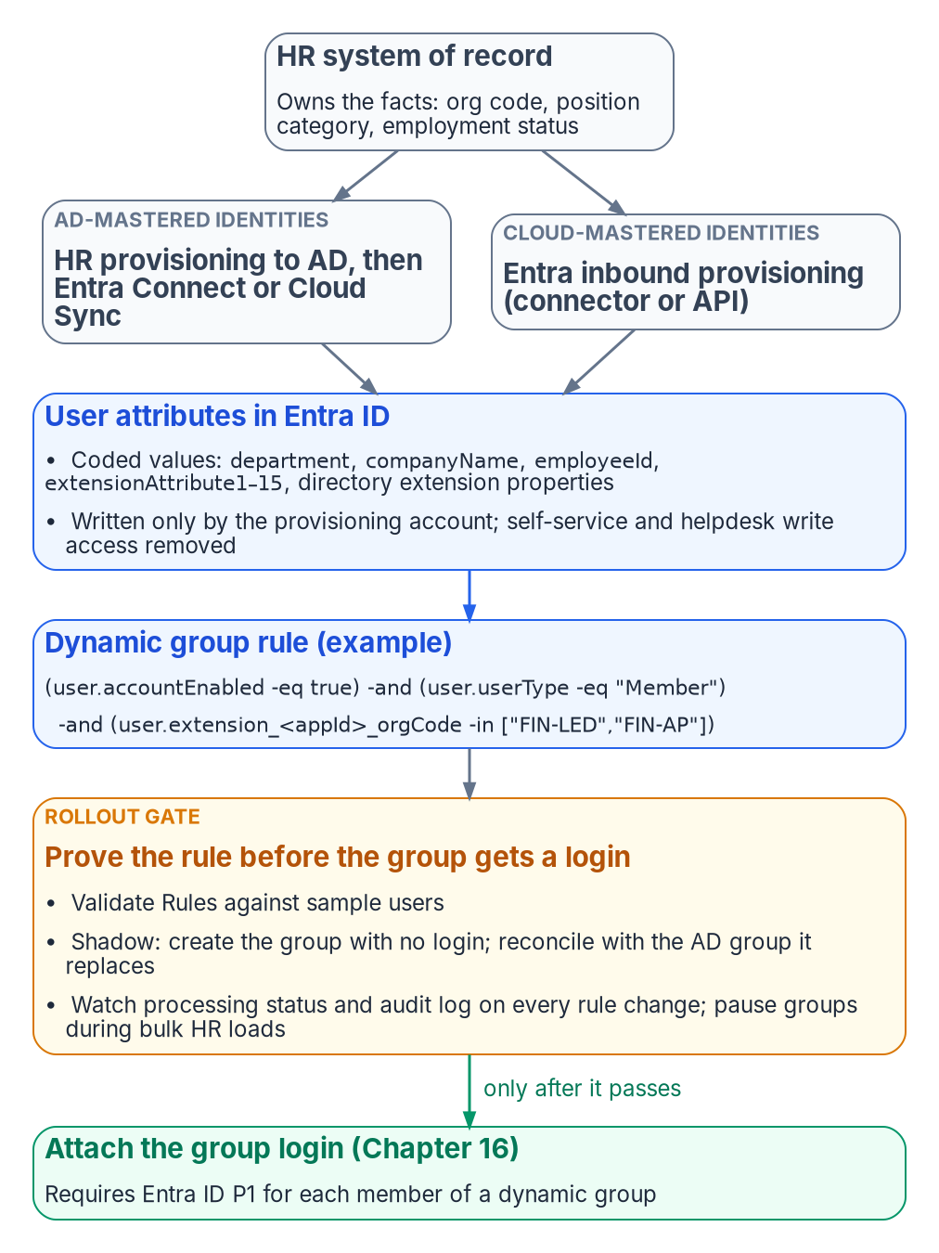
HR-sourced attributes drive dynamic membership, and no group grants access until its rule is proven.
Under assigned membership, whoever can add a member controls access; under dynamic membership, whoever can write the attribute does. Microsoft’s dynamic-group guidance says to review who can write an attribute in Entra ID and in any source directory that syncs it, especially on-premises attributes that users can edit on their own objects (SELF write), and to restrict self-service write access to attributes used in security-sensitive groups.
The single source of truth for access-driving attributes is therefore the HR system of record, which knows when someone joins, moves or leaves and has the governance to make those changes defensible. The path from HR to the directory is automated and one-way:
- For identities still mastered in Active Directory, HR-driven provisioning populates AD, and Microsoft Entra Connect or Cloud Sync carries the values into Entra ID.
- For cloud-mastered identities, Entra ID’s inbound provisioning writes them directly. There are built-in integrations for cloud HR applications such as Workday and SuccessFactors, and API-driven inbound provisioning brings identities from any system of record that can produce a feed.
Either way, a provisioning service account writes the attribute, and self-service and helpdesk write access to it is removed.

Choosing the attributes
Entra dynamic rules can read a fixed set of user properties. Microsoft’s current list includes department, companyName, jobTitle, employeeId, employeeHireDate (preview), userType, accountEnabled, and location fields such as city, country and usageLocation. Rules can also use the fifteen extensionAttribute1–extensionAttribute15 values, which are commonly synced from on-premises AD, and custom extension properties (directory extension properties, user.extension_<appId>_<name>), which can be synced from AD or created through Microsoft Graph. Two cautions apply. First, not every attribute on the user object is usable: employeeType, for example, isn’t in the supported-properties list at the time of writing, so check that list before designing around any attribute. Second, multi-value extension properties aren’t supported in rules.
Good rule inputs are HR-owned codes that change only when the business fact changes: an organization code in a directory extension property, not a display string someone will eventually retype. Publish a small, documented set of HR-sourced access attributes (organization code, position category, employment status) and write rules only against those:
The rule below is illustrative: <appId> and the codes are placeholders for the agency’s own extension properties and code lists. Validate any rule before it governs access, as described below.
(user.accountEnabled -eq true) -and (user.userType -eq "Member")
-and (user.extension_<appId>_orgCode -in ["FIN-LED","FIN-AP"])
-and (user.extension_<appId>_positionCategory -eq "Analyst")
A rule body can’t exceed 3,072 characters, and a tenant can have at most 15,000 dynamic membership groups. Prefer -eq, -startsWith and -in over -match, -contains and chains of -or; Microsoft says such rules process faster, and they review more easily. Every access rule excludes disabled accounts and guests explicitly, as above.
Dynamic membership needs a Microsoft Entra ID P1 license for each unique user who is a member of one or more dynamic groups; licenses needn’t be assigned to those users, but the tenant must hold enough to cover them. Most agency tenants have P1 through their Microsoft 365 or Enterprise Mobility + Security licensing; confirm the count before rollout.

Writing, naming and testing rules
Two practices keep a dynamic group from becoming an untested access grant.
The first is naming and ownership. Entra’s group naming policy applies only to Microsoft 365 groups, so the convention for SQL Server access groups is enforced by the provisioning automation or a review gate. A pattern such as SQL-<env>-<instance or app>-<database>-<role> carries Chapter 16’s one-group-one-role meaning. Each description records the rule’s business intent, the owning team and the last change record; each group has at least two named owners.
The second is testing before granting. A rule should be proven before its group is attached to a SQL Server login:
- Validate. The Validate Rules tab in the Entra admin center evaluates a rule against up to 20 chosen users or devices at a time and shows, expression by expression, why each one is or isn’t a member.
- Shadow. Create the group first with no login attached. Once processing reports Update complete, compare its membership with the legacy AD group it replaces, and explain every difference before the login is created.
- Watch processing. For a rule change on a group that’s already live, check the group’s processing status and its audit-log entries for the additions and removals the change caused. A rule change removes existing members who no longer match.
- Pause bulk changes. For HR reorganizations or bulk attribute loads (Microsoft’s examples are changes to more than 500 groups or more than 20,000 membership changes), Microsoft recommends pausing nonessential dynamic groups, waiting at least 24 hours for processing to catch up, then resuming in phases.
The rollout gate for the whole pattern follows from this. No dynamic group grants production access until the access attributes are populated and verified for a pilot cohort, and its rule has been validated, shadowed and reconciled against the group it replaces.

Scoped delegation with administrative units
Someone still has to manage the assigned groups and the dynamic groups’ owners and descriptions, and tenant-wide Groups Administrator for a DBA lead would just move the privilege concentration. Administrative units solve this: Groups Administrator assigned at administrative-unit scope manages only the groups in that unit, including their names and membership, but not the users inside them. The scoped administrator needs P1; members of a regular administrative unit need only Free. Draw one administrative unit per DBA team, application portfolio or data owner, so a team’s authority matches its accountability.
Restricted management administrative units go further. Only administrators assigned at the unit’s scope can modify its objects; tenant-scoped administrators, Global Administrators included, can’t unless they assign themselves to that scope, which is an audited event. That is attractive for protecting access groups, but it has costs that matter here:
- Groups and users in a restricted management administrative unit can’t be managed with PIM, entitlement management, lifecycle workflows or access reviews.
- Among groups, restricted management units accept only security groups; Microsoft 365, mail-enabled security and distribution groups can’t be members.
- The setting must be chosen when the unit is created and can’t be changed afterward, and a tenant can have at most 100 such units.
Use regular administrative units for groups that need governance tooling; reserve restricted management for cases where tamper-resistance outweighs reviewability. Dynamic membership for administrative units is available in the global Azure cloud but not in specialized clouds such as Azure Government, needs P1 for each dynamic member, and selects users or devices, not groups. Access groups are therefore added to an administrative unit explicitly or by automation.

Privileged access belongs in PIM, not in a rule
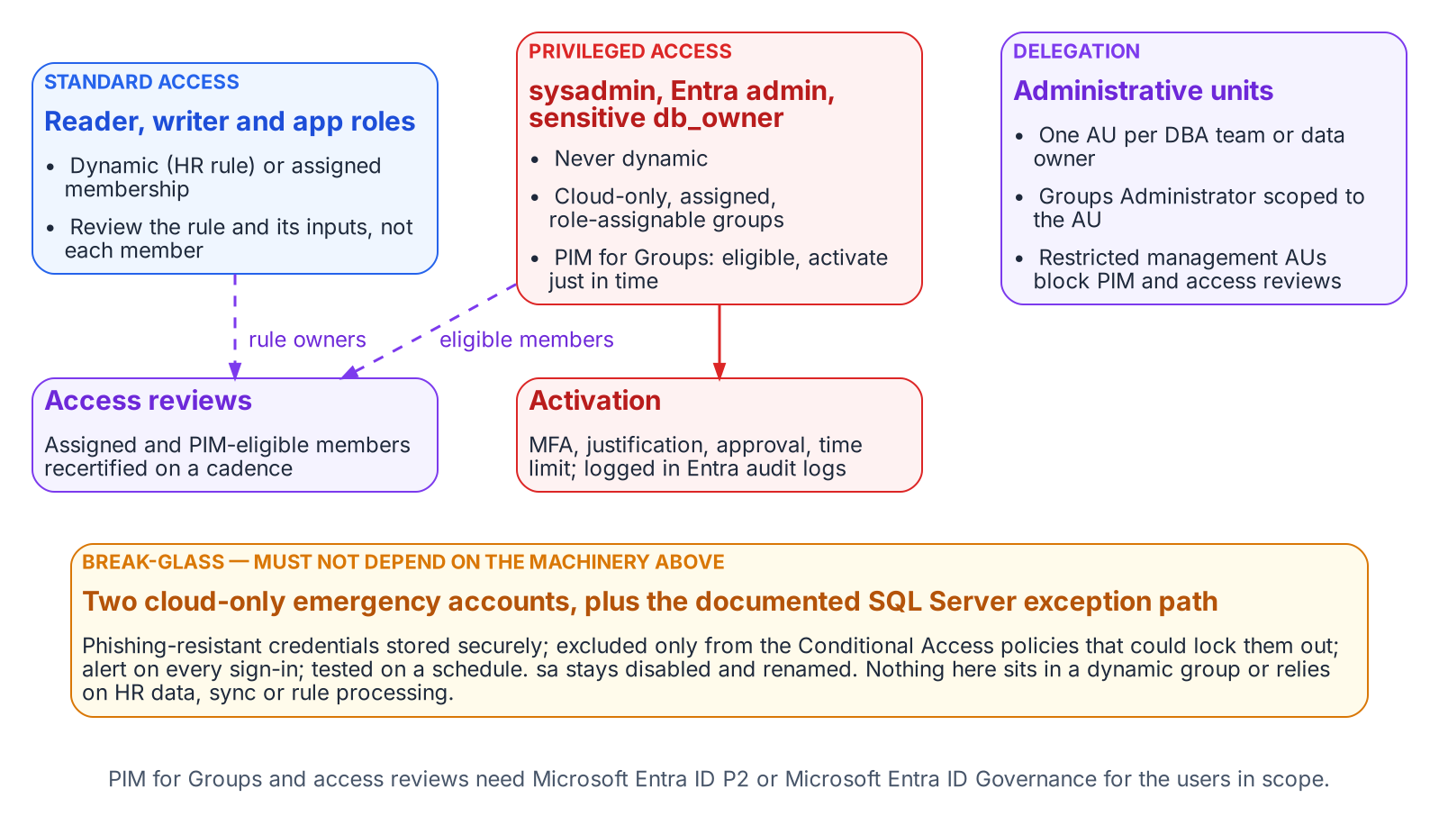
Which groups may be dynamic, which belong in PIM, how delegation is scoped, and the break-glass path that bypasses all of it.
Groups mapped to sysadmin, the instance’s Entra administrator and db_owner on sensitive databases are never dynamic. Microsoft makes the same judgment for directory roles: role-assignable groups must have assigned membership, which Microsoft notes already removes the attribute-write risk. The SQL Server equivalent is PIM for Groups: DBAs are eligible, not standing, members, and each logged activation is time-bound and requires MFA and, where policy demands, approval and justification. This is the same just-in-time model Book 04 applies to directory and Azure roles.
PIM for Groups can be enabled for any security or Microsoft 365 group except dynamic membership groups and groups synchronized from on-premises, so privileged groups are cloud-only and assigned by construction. Making them role-assignable as well adds protection: only a Privileged Authentication Administrator or higher can change the credentials, reset MFA or modify sensitive attributes of their members and owners, and a tenant can have at most 500 role-assignable groups. Every user eligible for membership or ownership through PIM for Groups needs a Microsoft Entra ID P2 or Microsoft Entra ID Governance license, as do approvers and reviewers. Access reviews are an Entra ID Governance feature for the member users who review or are reviewed; the review capabilities that were generally available in P2 still operate under P2, but Microsoft is adding no new governance features to P2.

Access reviews
A dynamic group’s membership can’t be edited by hand, and Microsoft confirms that access review decisions don’t change membership in dynamic groups. A member-by-member review therefore has no remediation path. Review the rule and its inputs instead: on a fixed cadence the data owner confirms the rule still expresses the intended population, and the identity team confirms its attributes are still HR-sourced and write-protected.
For assigned groups and PIM eligible assignments, use Entra access reviews. A recurring review can be set to remove access when reviewers don’t respond and to apply results automatically, and its results are the AC-2 evidence an assessor will ask for. Microsoft warns that combining Remove access for non-responses with auto-apply can revoke everyone’s access if reviewers fail to respond, so pair it with fallback reviewers.

Break-glass
Two kinds of break-glass access are needed, and they must not depend on the machinery they exist to bypass. At the tenant level, Microsoft’s guidance for emergency access accounts applies:
- at least two cloud-only accounts on the .onmicrosoft.com domain, with phishing-resistant credentials (passkeys or certificate-based authentication) different from normal admin accounts, stored securely in separate locations;
- excluded from the Conditional Access policies that block or restrict sign-in;
- alerting on every sign-in and audit event;
- validated at least every 90 days.
At the SQL Server level, Chapter 12’s position stands. The built-in sa is disabled and renamed, and any retained emergency path is a documented exception with its own monitoring. Neither emergency path may sit in a dynamic group or rely on HR data, Entra Connect or rule processing being healthy.

Monitoring
The access model is now spread across HR, the provisioning service, Entra ID and the engine, so monitoring has to cover each hand-off:
- Entra audit logs record rule edits, membership additions and removals, PIM activations, and administrative-unit and role-assignment changes, including changes to restricted management units. A change to the rule of any SQL Server access group should raise an alert.
- Entra sign-in logs show every token issued for SQL Server and the Conditional Access result for each policy that applied.
- SQL Server Audit records successful and failed logins (SUCCESSFUL_LOGIN_GROUP, FAILED_LOGIN_GROUP) and changes to server and database role membership (SERVER_ROLE_MEMBER_CHANGE_GROUP, DATABASE_ROLE_MEMBER_CHANGE_GROUP). Write the audit to the Windows Security log or a file, not the Application log, which any authenticated user can write.
The continuous audit described in Chapter 20 should reconcile all three. Every type E and type X principal on an instance must map to a known user, application or group. Every group must follow the naming convention and have an owner. No privileged role may have a standing member that PIM doesn’t account for.

FedRAMP Moderate in the commercial cloud
The series assumes Microsoft’s commercial cloud (Entra ID at login.microsoftonline.com, Azure public US regions) under an agency authorization at FedRAMP Moderate.
What the cloud authorization covers. Azure’s public cloud holds a FedRAMP High P-ATO for its US regions. The Moderate baseline is a subset of the High baseline, so a Moderate system can draw on High-authorized services; whether it inherits them is the agency’s call. The public-cloud audit-scope list includes the services this chapter relies on:
- Microsoft Entra ID (Free, P1 and P2), Microsoft Entra ID Governance, the Microsoft Entra provisioning service and Microsoft Entra multifactor authentication
- Microsoft Graph
- Azure Arc-enabled servers and Azure Arc-enabled SQL Server
- Azure Monitor (including Log Analytics) and Microsoft Sentinel
The list names services, not features; confirm dynamic groups, administrative units, PIM for Groups and access reviews against the agency’s boundary and Microsoft’s FedRAMP package, which agencies request through the FedRAMP Marketplace with a .gov or .mil address. The SQL Server hosts and Arc agent are part of the agency’s own system, and a third-party HR system has its own authorization. As Microsoft’s Entra FedRAMP guidance says, Azure provides the capability to meet the controls; completing the configuration is the customer’s responsibility.
Keep previews out of the production access path. Entra ID previews are offered under the preview terms in Microsoft’s Product Terms for online services; public previews may have limited support, normal service level agreements don’t apply, and a preview can be cancelled before it reaches general availability. Microsoft describes the memberOf operator, for example, as a preview not intended for production use. For a Moderate system, that rules out:
- the memberOf dynamic-rule operator (a preview that ends on November 3, 2026; see Chapter 16);
- preview user properties in membership rules, such as employeeHireDate;
- any PIM, access-review or provisioning capability that the Entra admin center or Microsoft Learn still marks as preview.
Check for the preview label at adoption and again at the rollout gate.
What is in scope as recommended. The generally available pieces of this design are delivered by services on the High list:
- Entra group logins and Entra authentication for SQL Server through Azure Arc. Microsoft notes that the SQL Server instance needs access to the Azure public cloud for this.
- Dynamic security groups built on supported properties and directory extension attributes
- Regular and restricted management administrative units, including dynamic administrative-unit membership for users in the global cloud
- PIM for Groups and access reviews, licensed through P2 or Entra ID Governance
- Emergency access accounts and Log Analytics monitoring
Treat any feature not verifiable at feature level as unconfirmed until the agency’s ATO documentation says otherwise.
What this chapter establishes
- Whoever can write the attribute a rule reads controls access, so only HR-driven provisioning writes access attributes.
- Rules are validated, shadowed against the groups they replace and piloted; privileged groups are assigned, cloud-only and governed by PIM for Groups and access reviews.
- Only generally available features sit in the production access path, and break-glass paths depend on none of this machinery.

Continue the book
← Previous: Chapter 16 — Groups, Roles and How Membership Reaches the Engine · Book index · Next: Chapter 18 — The Four-Class Pattern Applied to SQL-Consuming Applications →

Chapter 18 — The Four-Class Pattern Applied to SQL-Consuming Applications
The application is the other half of the authentication chain, and it has its own AD dependency to remove.

In this chapter
Why SQL Server’s authentication transformation is incomplete until the upstream applications that consume it are addressed. How the LDAP-dependent-application migration plan’s four-class taxonomy sorts those applications by modernization capability. What each class means for both the user sign-in track and the SQL connection track. How the application-audit script produces the per-application classification data that drives the triage.

Where this part of the book goes next
An upstream application that has moved its user sign-in to Entra ID but still uses a SQL Authentication service account to reach the database hasn’t finished its transformation. Chapters 18 and 19 treat the application chain as one authentication path, not as independent layers: the four-class pattern for the application (this chapter) and the connection-string change that ends it (Chapter 19). In the program’s dependency chain this is step 6, moving applications. The working procedure is Runbook R08.
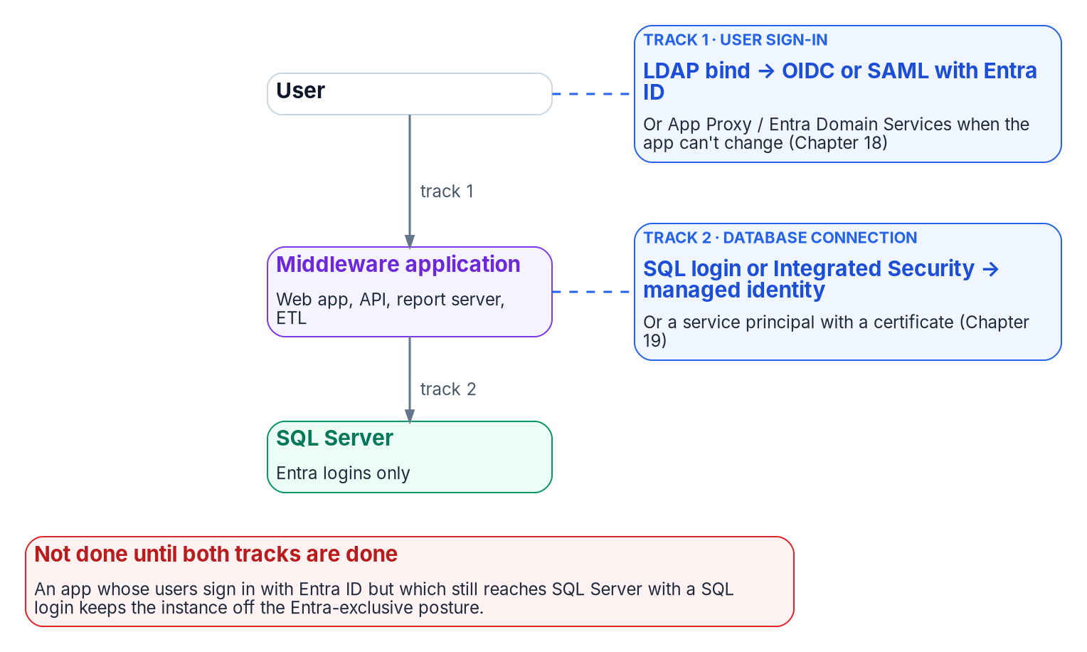
The application chain has two authentication tracks, and both must leave Active Directory.
SQL Server doesn’t exist in isolation. In any estate of meaningful size it is the data layer downstream of a middleware tier: web application servers, API back ends, reporting services, ETL pipelines and legacy integration systems. Those applications carry their own authentication architecture, and in many agency environments that architecture includes LDAP binding: the application binds to Active Directory as a directory authority, queries group membership or user attributes, and treats AD as its authorization source.
The AD dependency that must be removed from SQL Server’s authentication layer must also be removed from those upstream applications, and the removals must be coordinated. An application that has moved its user sign-in to Entra ID OpenID Connect but still uses a SQL Authentication service account to reach SQL Server hasn’t completed its transformation. The application chain is one authentication path (user to application to database), not a set of independent layers.
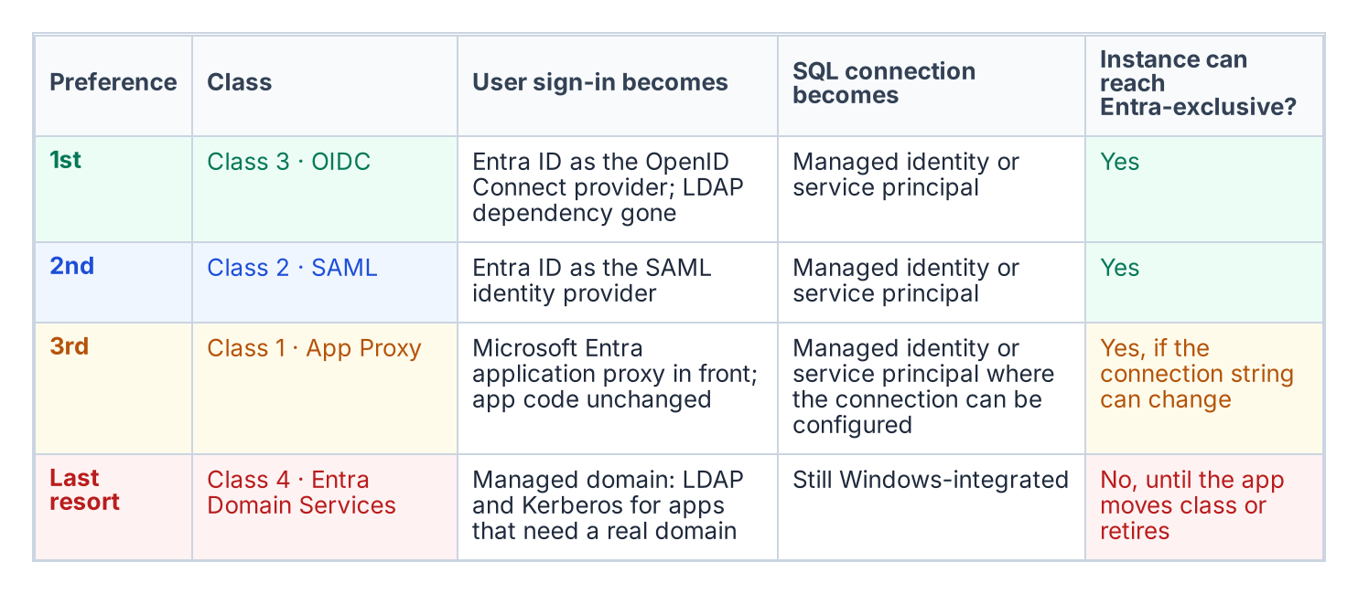
The four application classes in preference order, with what each means for user sign-in and the SQL connection.
The program’s LDAP-dependent-application migration plan, accepted 2026-05-13, provides the four-class taxonomy for sorting upstream applications by modernization capability, in a strict preference order: Class 3 (OIDC) first, then Class 2 (SAML), then Class 1 (App Proxy), then Class 4 (Entra Domain Services) as the last resort. The class numbers are the plan’s identifiers, not its ranking. The order matches Microsoft’s own guidance, which recommends OpenID Connect for new application development and describes Domain Services as a transitional capability for workloads that can’t use modern authentication. The application-audit script (Get-LDAPBindAccountInventory.ps1) is the discovery instrument that produces the per-application classification data this chapter depends on.

Two axes: user sign-in and the database connection
The four classes describe only one axis: how users authenticate to the application. The SQL connection is a second, independent axis, and an application’s place on it is set by evidence, not by its class:
- Driver version and Entra modes. Does the application’s database driver, at the version deployed, support the Entra authentication mode it needs? Each Microsoft driver family added Entra modes in specific releases (Chapter 19).
- Token acquisition and refresh. Can it be configured to use a managed identity or service principal, or must its code acquire a token and refresh it before expiry?
- Connection pooling. Does pooling keep working when connections use per-identity tokens? In Microsoft.Data.SqlClient, for example, a token passed through the AccessToken property is part of the pool key, and the driver can’t renew it.
- Vendor support. For commercial software, does the vendor support Entra authentication to SQL Server, and in which release?
- Client platform. Does the operating system or runtime the application runs on offer an Entra-capable driver?
These answers place each application in one of four database-axis columns: A, configuration only (connection-string change); B, code change; C, vendor-dependent; D, no Entra path today. Reading the two axes together gives the outcome for the host instance:
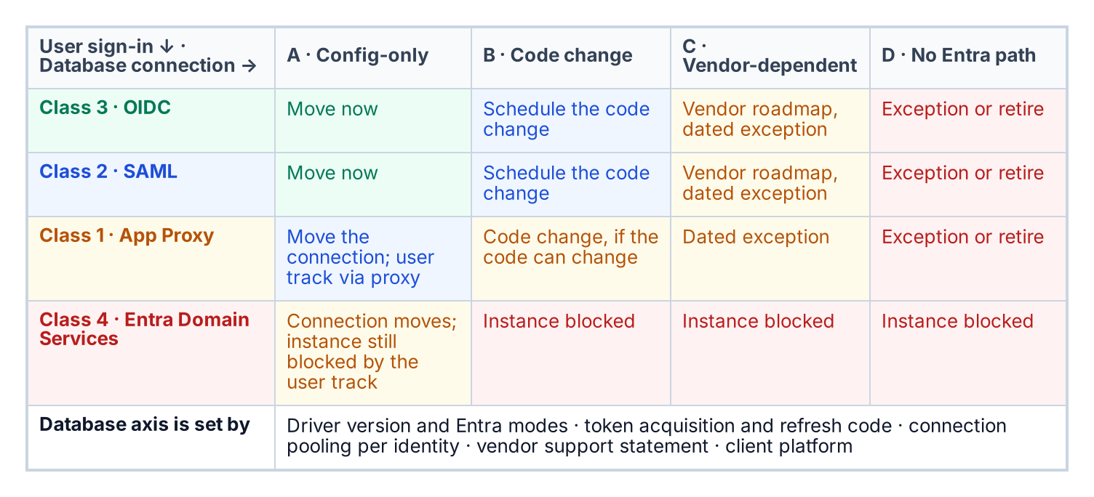
Where an application lands on both axes, and what that means for its host instance.
The application audit collects the user-axis data; the database-axis data comes from the driver inventory, the code owner and the vendor. Every cell outside A carries an owner, an effort band and a dated exception in the exception registry.

Class 1 — App Proxy: can’t be modernized directly
Class 1 applications can’t change their authentication mechanism. They bind to LDAP for user authentication, and the dependency is architectural: embedded in unmaintainable code, supplied by a vendor with no modern option, or frozen by a certification that prevents code modification. For SQL Server, Class 1 applications typically connect with an AD service-account credential stored in a connection string or configuration file.
The Class 1 pattern has two independent tracks. The user track puts Microsoft Entra application proxy in front of the application. Application proxy publishes an on-premises web application through an external URL, preauthenticates users with Entra ID (so Conditional Access applies), and then signs in to the application on the user’s behalf with one of its single sign-on methods: Kerberos constrained delegation for integrated Windows authentication, header-based, password-based or SAML. The application itself isn’t modified, which is the point of the class, but its own AD dependency stays behind the proxy: Kerberos delegation needs connector servers joined to the application’s domain or a trusting one, and an application that validates passwords by LDAP bind still does. Application proxy publishes web applications, web APIs, applications behind Remote Desktop Gateway and rich clients built on the Microsoft Authentication Library, so the program treats a thick-client LDAP application outside those categories as Class 4 or a retirement candidate, not Class 1.
The SQL connection track moves the application’s database credential from a SQL Authentication service account or Integrated Security to a managed identity or service principal: a change in the connection string or configuration, not in code, and independent of the user track. Both tracks must complete before the application’s part of the SQL Server transformation is done.

Class 2 — SAML: federated identity but not OIDC
Class 2 applications support SAML federation but not OIDC. SAML 2.0 is a mature, XML-based federation standard that enterprises have used widely for more than a decade, and many enterprise applications supported it before they supported OIDC. For Class 2 applications, Entra ID becomes the SAML identity provider. The user’s sign-in is modernized (they authenticate to Entra ID, Entra ID evaluates Conditional Access and issues a signed SAML assertion, and the application validates the assertion and grants access), but the protocol is SAML, not OIDC.
The SQL connection track for Class 2 follows the same pattern as Class 1: the connection string moves from SQL Authentication or Windows Integrated Security to managed identity or service-principal authentication. The two tracks are separate and can be sequenced independently. The plan places Class 2 second because SAML removes the LDAP dependency rather than proxying through it, but below OIDC because Microsoft provides no libraries for building SAML applications and recommends OIDC for new development.

Class 3 — OIDC: the preferred destination
Class 3 is the preferred destination. An OIDC-capable application can move fully to Entra ID as its identity provider, removing the LDAP dependency. The application redirects the user to the Entra ID authorization endpoint, the user signs in with Entra credentials, Entra ID evaluates Conditional Access and issues an ID token (and, where the application calls APIs, an access token), and the application uses the claims in those tokens for identity and authorization. No LDAP bind occurs, and no AD query occurs.
The application’s SQL Server connection also uses a managed identity or service principal, with no stored credential. The end-to-end chain is direct: the user signs in to Entra ID with OIDC, the application uses its managed identity to obtain a token for the SQL connection, SQL Server validates the Entra token (through the Entra configuration that Azure Arc sets up for the instance), and the connection is established. There is no AD in this path, no LDAP, no NTLM or Kerberos, and no stored credential. This is the target architecture.

Class 4 — Entra Domain Services: last resort
Class 4 applications can’t be moved to any modern authentication protocol. They need real LDAP and Kerberos from a domain: not a proxy or a federation, but an AD-compatible domain with DNS SRV records, LDAP on port 389 and Kerberos on port 88. For these applications, Microsoft Entra Domain Services provides a managed domain (two Microsoft-managed domain controllers per replica set) that offers domain join, Group Policy, LDAP, and Kerberos and NTLM authentication, backed by a one-way synchronization of users, groups and credential hashes from Entra ID. The plan places Class 4 last because it preserves the AD dependency rather than removing it, and Microsoft itself positions Domain Services as transitional rather than as a replacement for cloud-native identity.
For SQL Server, Class 4 has a specific consequence. An instance hosting databases for a Class 4 application can’t complete the full transformation until that application moves to a higher class or is retired. An instance that still accepts Windows Authentication logins because a Class 4 application can’t use Entra ID authentication is blocked from the Entra-exclusive posture the transformation requires. Class 4 applications are inventoried against their SQL Server dependencies, and each instance with a Class 4 upstream application carries a documented exception with a sunset date. Domain Services’ NTLM is still NTLM, so these connections also fall under the Phase C block in Chapter 15 unless they negotiate Kerberos.

The application-audit script as the classification tool
The application-audit script (Get-LDAPBindAccountInventory.ps1) produces the per-application classification data the four-class triage needs. For each application in its enumeration scope, the script captures the LDAP bind account (the AD service account used for directory queries) and the SQL Server connection target (the instance and database the application connects to).
It also captures the authentication mechanism for that SQL connection (Windows Integrated Security, SQL Authentication, or an already-migrated managed identity or service principal) and the signals that map to each class: SAML metadata URLs, OIDC discovery-endpoint registration, or vendor documentation indicating modernization capability. The output is a per-application record with a recommended class and the detection signals that support it.
That record is the input to the migration plan’s triage and to the instance-level migration planning in Chapters 11–12. The two audit scripts must be correlated: the authentication audit (Chapter 07) enumerates SQL Server instances, and the application audit enumerates the upstream applications. Only when both are joined does each instance show its full authentication chain: every application that depends on it, and the class each one falls into.
What this chapter establishes
- The transformation is incomplete until each application chain (user to application to database) is addressed.
- Each application is placed on two axes: how users authenticate to it, and how it authenticates to the database.
- The application audit supplies the data for both axes, and an application stuck on Entra Domain Services keeps its host instance off the Entra-exclusive posture.

Continue the book
← Previous: Chapter 17 — Dynamic Membership, Delegation and Privileged Access · Book index · Next: Chapter 19 — Connection String Migration: The Last Mile →

Chapter 19 — Connection String Migration: The Last Mile
The simplest change in the entire program, and the most gate-controlled.

In this chapter
The connection-string change that ends the application-chain migration: from Integrated Security or SQL Authentication to Entra ID authentication keywords. The Entra options in each Microsoft driver family. The gate conditions that must hold before the change can be made. How the Azure.Identity library’s DefaultAzureCredential chain lets a .NET application use one credential code path across production and development, and why production should name its credential explicitly.
The final step in the application-chain migration is the SQL Server connection-string change. It’s the moment the engine sees an Entra ID identity in the application connection rather than a SQL Authentication credential or a Windows Integrated Security token. Technically it’s the simplest step in the entire migration. Operationally it’s the most gate-controlled, and the two facts together are why it’s treated as a distinct step rather than folded into the work before it.

The connection-string change
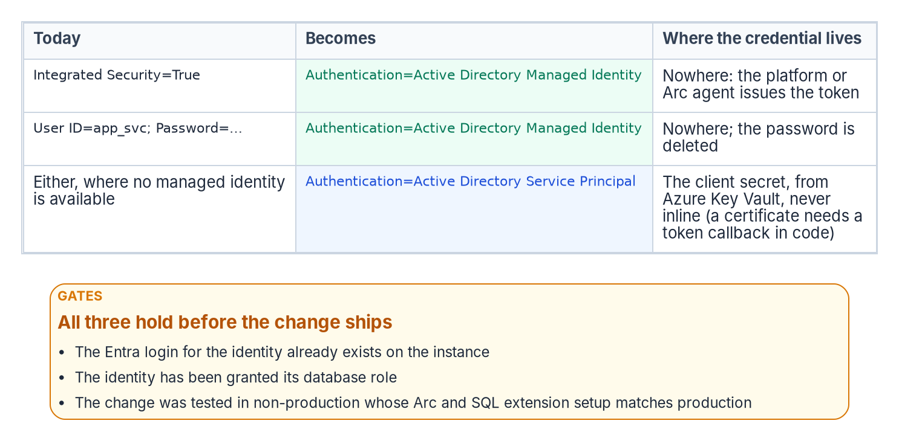
The connection-string change and the three gates in front of it.
The connection strings below are illustrative and haven’t been tested against a production instance. Review them against the driver version you deploy, and test them in a non-production environment first.
For an application using Windows Integrated Security, the connection string changes to use Entra ID authentication. For an application running on an Arc-enabled server with the server’s system-assigned managed identity, using Microsoft.Data.SqlClient:
Before: Data Source=sqlserver;Initial Catalog=database;Integrated Security=True
After: Data Source=sqlserver;Initial Catalog=database;Authentication=Active Directory Managed Identity;Encrypt=True
The keyword tells the driver to acquire a token from the host’s managed identity rather than negotiate a Windows credential; for a system-assigned identity no User ID is needed. On an Arc-enabled server, that identity is the server’s own, and tokens come from the Arc agent’s local identity endpoint (http://localhost:40342). Only local Administrators and members of the local Hybrid agent extension applications group can complete the agent’s challenge and obtain a token, so the application’s process account must be added to that group. Two consequences follow. Every application on the host that is allowed to request the token authenticates as the same identity, so the server identity’s SQL login and role grants have to be sized for everything permitted to run there. And membership of that group is a privileged permission: Microsoft’s guidance is to limit it.
For an application using a service principal, Microsoft.Data.SqlClient uses Authentication=Active Directory Service Principal, with the application’s client ID as User ID and its client secret as Password. The program stores the secret in Azure Key Vault and injects it at runtime, never inline in configuration. Where a certificate is required instead of a secret, the application acquires the token itself (for example with ClientCertificateCredential) and hands it to the driver through AccessTokenCallback, because the connection-string service-principal mode itself takes a secret. For SQL Authentication connections (User ID=serviceaccount;Password=…), moving to a managed identity or service principal removes the password from the connection string entirely. In every case the stored SQL credential goes, which is the point: the connection no longer carries a credential the identity plane can’t see.

Entra options by driver
The same change looks different in each Microsoft driver family, and the version deployed decides which modes exist. The application audit’s driver inventory (Chapter 18) is checked against this table:
Driver | Managed identity | Service principal | Credential chain | Notes
Microsoft.Data.SqlClient (.NET) | Authentication=Active Directory Managed Identity (or Active Directory MSI), from 2.1 | Active Directory Service Principal, from 2.0 | Active Directory Default, from 3.0 | From 7.0, the Entra modes need the separate Microsoft.Data.SqlClient.Extensions.Azure package at a matching version
ODBC Driver 17 and 18 | Authentication=ActiveDirectoryMsi, from 17.3.1.1 | ActiveDirectoryServicePrincipal (UID = client ID, PWD = secret), from 17.7 | None | An application-acquired token can be passed through SQL_COPT_SS_ACCESS_TOKEN
OLE DB Driver (MSOLEDBSQL) | Authentication=ActiveDirectoryMSI, from 18.3 | ActiveDirectoryServicePrincipal, from 18.5 | None | Microsoft’s driver page describes 18.3 managed identity from an Azure VM; SQL Server 2025’s linked-server guidance uses it on Arc-enabled hosts
JDBC (mssql-jdbc) | authentication=ActiveDirectoryManagedIdentity, from 12.2 (ActiveDirectoryMSI from 7.2); Azure Arc listed as a supported host from 12.2 | ActiveDirectoryServicePrincipal; ActiveDirectoryServicePrincipalCertificate from 12.4 | ActiveDirectoryDefault, from 12.2 | Needs the azure-identity (and, for some modes, msal4j) libraries at the versions Microsoft lists
In every family the Entra username-and-password mode (Active Directory Password, ActiveDirectoryPassword) is deprecated: it uses the resource-owner password flow, which can’t satisfy multifactor authentication. It isn’t a migration target. For drivers whose documentation doesn’t list Arc as a managed-identity host, the gate-three test below is where that support is proved.

The gate conditions
The change is the simplest step technically, but it can’t be made on demand. Three conditions must hold first.
- The Entra login exists. The FROM EXTERNAL PROVIDER login covered in Chapter 11 must already exist on the target instance, because a connection string that names an Entra identity with no corresponding login fails at connection time. For an application, the login is created from the name of the Entra application or, for a managed identity, the server’s identity.
- The role is granted. The application’s service principal or managed identity must hold the right database role, so that authentication succeeds and authorization follows (Chapter 16). A token doesn’t grant database permissions by itself.
- The change is tested in a production-equivalent environment. Token acquisition and validation depend on the Arc agent, the Azure extension for SQL Server and the instance’s Entra configuration being present and correct, and Entra connections require an encrypted connection with a server certificate the client trusts. A connection-string change that works on a developer’s laptop but has never been exercised against a production-equivalent Arc, extension and certificate stack isn’t a tested change.
Only when all three gates hold is the production cutover safe to perform.

The Azure.Identity library and DefaultAzureCredential
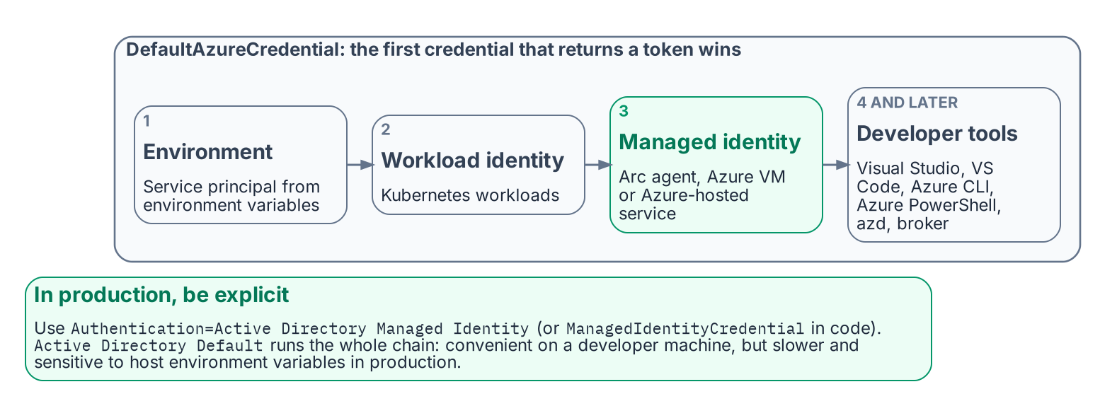
The order in which DefaultAzureCredential tries credentials, and what to use in production.
For .NET applications, a large share of most agency application estates, the Azure.Identity library provides DefaultAzureCredential, a preconfigured, ordered credential chain. It tries environment-variable service-principal credentials first, then workload identity, then managed identity, and then developer-tool credentials: Visual Studio, Visual Studio Code (with the Azure.Identity.Broker package), Azure CLI, Azure PowerShell, Azure Developer CLI and the broker. Interactive browser sign-in is in the chain but off by default. On an Arc-enabled server the managed identity step reaches the Arc agent’s local endpoint; on an Azure VM it reaches the Azure Instance Metadata Service.
The value of the chain is that one credential code path works unchanged across environments. In production the application resolves its managed identity; in a developer’s environment it resolves the developer’s Visual Studio or Azure CLI sign-in; no code differs between them. The SQL connection uses Authentication=Active Directory Default, available in Microsoft.Data.SqlClient 3.0 and later, which runs the chain with interactive browser sign-in disabled; or the application sets AccessTokenCallback (5.2 and later) with a credential of its choice, which lets the driver renew tokens for pooled connections.
Active Directory Default is convenient in development. In production, Microsoft recommends naming the credential explicitly (Authentication=Active Directory Managed Identity, or ManagedIdentityCredential in code), because walking the whole chain is slower and harder to debug, and its result can change if someone sets environment variables on the host. Setting the AZURE_TOKEN_CREDENTIALS environment variable to prod, or to a single credential name, narrows the chain where code can’t change. The result is that the connection-string change is a net reduction in complexity for .NET applications: one keyword replaces an entire credential-management system. This is the workload-identity model from Chapter 11: the application authenticates as itself through a managed identity, with no human credential and no stored secret anywhere in the path.
What this chapter establishes
- The connection-string change replaces Integrated Security or SQL Authentication with an Entra authentication mode, and the stored credential disappears; on an Arc host, who can request the server’s token becomes the control to govern.
- Each driver family supports managed identity and service principals from a specific version; Entra password authentication is deprecated everywhere.
- The change is gated on an existing Entra login, the right database role and a tested change in a production-equivalent environment. In production, name a specific mode such as Active Directory Managed Identity; Active Directory Default walks a credential chain.

Continue the book
← Previous: Chapter 18 — The Four-Class Pattern Applied to SQL-Consuming Applications · Book index · Next: Chapter 20 — The Closure Condition →

Chapter 20 — The Closure Condition
Transformations do not complete — they achieve a posture, and a posture is something you keep proving.

In this chapter
The five conditions that must hold at the same time for the SQL Server authentication transformation to be closed across the estate, why the continuous audit rather than a one-time scan is the verification instrument, how the per-instance compliance record captures the satisfying state, what drift detection looks for, and how behavioral telemetry (Defender for SQL threat alerts, Entra ID sign-in logs and host authentication logs) adds a layer on top of the structural monitoring.

The transformed posture, Chapters 20–21
A transformation that achieves a completed state and then stops monitoring is a transformation that will regress. The transformed posture is not a permanent state achieved by a one-time action; it is an ongoing condition maintained by continuous monitoring, automated drift detection, and a governance process that treats regression as a compliance violation. This chapter defines the closure conditions and how they are monitored. Chapter 21 names the evidence that proves them and puts the program’s 2027-04-01 NTLM backstop in context. The commands are in Runbook R09.
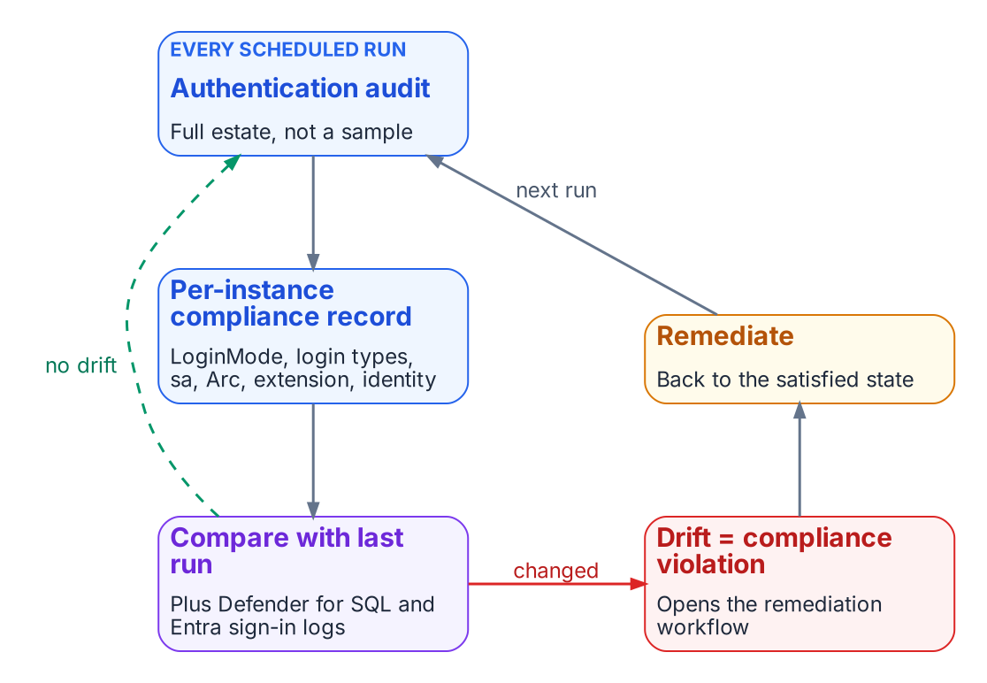
The transformed posture is a loop that never stops.
A transformation that achieves a completed state and then stops monitoring is a transformation that will regress. A SQL Server instance brought to the Entra-exclusive operational posture can be reconfigured to Mixed Mode by any administrator with sufficient permission; the change takes effect when the service restarts. New SQL Authentication logins can be created. New Windows logins can be created if the instance remains domain-joined. The transformed posture is not a permanent state achieved through a one-time action. It is an ongoing condition maintained by continuous monitoring, automated drift detection, and a governance process that treats regression as a compliance violation rather than an operational preference.

The five closure conditions
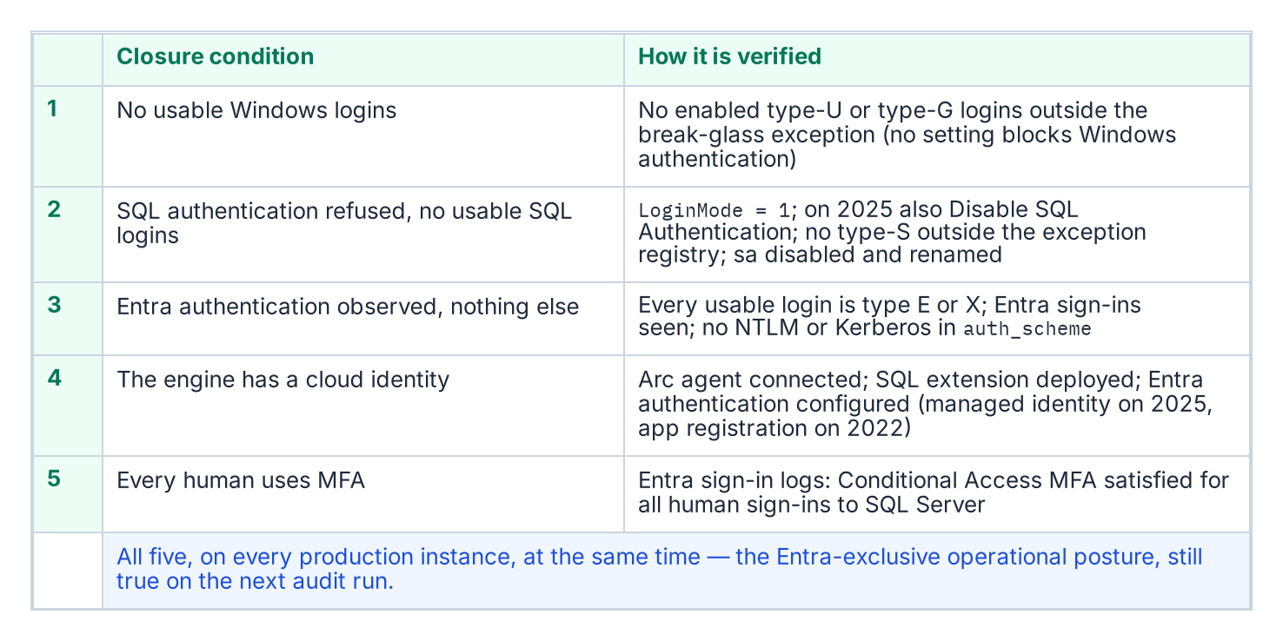
The five closure conditions, and the check that proves each one.
The transformation inventory defines the SQL Server authentication transformation as complete when five conditions are satisfied at the same time across all production SQL Server instances in the estate. None of the five is a single engine setting, and the series calls the combined state the Entra-exclusive operational posture: an evidenced condition, not a mode. SQL Server has no setting that turns Windows authentication off. Entra authentication works alongside whichever authentication mode the instance uses, and even SQL Server 2025’s Disable SQL Authentication setting leaves the instance accepting “Microsoft Entra authentication and Windows authentication.” LoginMode = 1 (Windows Authentication mode) therefore proves only that SQL logins are refused, not that Windows logins are gone.
The first condition is that no usable Windows-backed principal remains. A query of sys.server_principals shows zero type-U (Windows login) and type-G (Windows group) logins that are enabled and hold CONNECT SQL, other than a documented break-glass group recorded in the exception registry.
The second condition is that SQL Authentication is eliminated. No SQL Authentication logins (type-S logins) exist on any production instance other than those carrying documented exception status, and the sa account is disabled on every instance. SQL logins are refused: SERVERPROPERTY('IsIntegratedSecurityOnly') = 1 (Windows Authentication mode, LoginMode = 1), and on SQL Server 2025 also SERVERPROPERTY('IsExternalAuthenticationOnly') = 1 once Disable SQL Authentication is on. Disabling SQL authentication blocks new SQL-authenticated sign-ins, including sa, but leaves the logins and their permissions defined and doesn’t end sessions already connected, so the login census still matters. The operational verification is that evidence plus a sys.server_principals query for type-S logins, cross-referenced against the exception registry the program maintains.
The third condition is that Entra authentication is observed working and nothing else is: every usable login is type E (a Microsoft Entra user or application) or type X (a Microsoft Entra group), Entra sign-in logs show the expected principals obtaining tokens for SQL Server, SQL Server Audit records their logins on the instance, and sys.dm_exec_connections.auth_scheme shows no NTLM or KERBEROS connections over the validation period. Two details shape how that evidence is read. The token’s audience, https://database.windows.net/, is the same for every SQL Server and Azure SQL resource, so a sign-in log entry shows that a principal obtained a SQL token and under which Conditional Access result, not which instance it then connected to; the per-instance proof is the instance’s own audit. And connections made on the host itself always report NTLM, because local connections use NTLM regardless of Kerberos configuration, so the audit must separate local administrative sessions from remote ones rather than read every NTLM row as a regression.
The fourth condition is that the engine has a cloud identity. The Arc Connected Machine agent is connected, the Azure extension for SQL Server is deployed, and Microsoft Entra authentication is configured on every production instance: with the managed identity on SQL Server 2025, or an app registration and a Key Vault certificate on SQL Server 2022. Microsoft Entra authentication is available on SQL Server 2022 and later, not on earlier versions, and isn’t supported on failover cluster instances, so a production failover cluster instance can’t meet this condition as built: it needs a re-architecture (for example, to an availability group) or a documented exception.
The fifth condition is that every human principal authenticates with MFA enforced by Conditional Access. This is verified through Entra ID sign-in logs and Conditional Access policy reports: every sign-in event for the SQL Server resource should show MFA satisfied and the Conditional Access grant controls met. Conditional Access applies to users, not to service principals and managed identities, so application identities are governed by the controls of Chapter 18, not by this condition. Plan the phishing-resistant method with one limit in mind: Microsoft states that Entra authentication to SQL Server on Arc machines with the FIDO2 method isn’t currently supported.

The continuous audit as the verification instrument
The authentication-audit script of Chapter 07, in continuous monitoring mode, running on a recurring schedule against the full estate rather than as a point-in-time scan, is the primary instrument for verifying that all five closure conditions remain satisfied over time. The per-instance compliance record, updated on each audit run, is the structured evidence artifact that captures the current state of each condition for each instance. The SQL Server engine-authentication decision (Chapter 12) defines the field set that record carries; Runbook R09 shows how a scheduled run is projected onto it.
A per-instance compliance record that shows SQL authentication refused, zero usable type-S logins, zero usable type-U and type-G logins outside the break-glass exception, zero remote Windows-authenticated connections over the validation period, the sa account disabled and renamed, the Arc agent enrolled, the SQL extension deployed, and Entra authentication configured is a record that satisfies the structural closure conditions for that instance; the fifth condition is joined in from the Entra sign-in logs and Conditional Access reports. When all production instances carry satisfying compliance records, the SQL Server authentication transformation is verifiably closed for the estate. The continuous audit ensures closure is not a point-in-time claim. It is an ongoing verification.

Drift detection
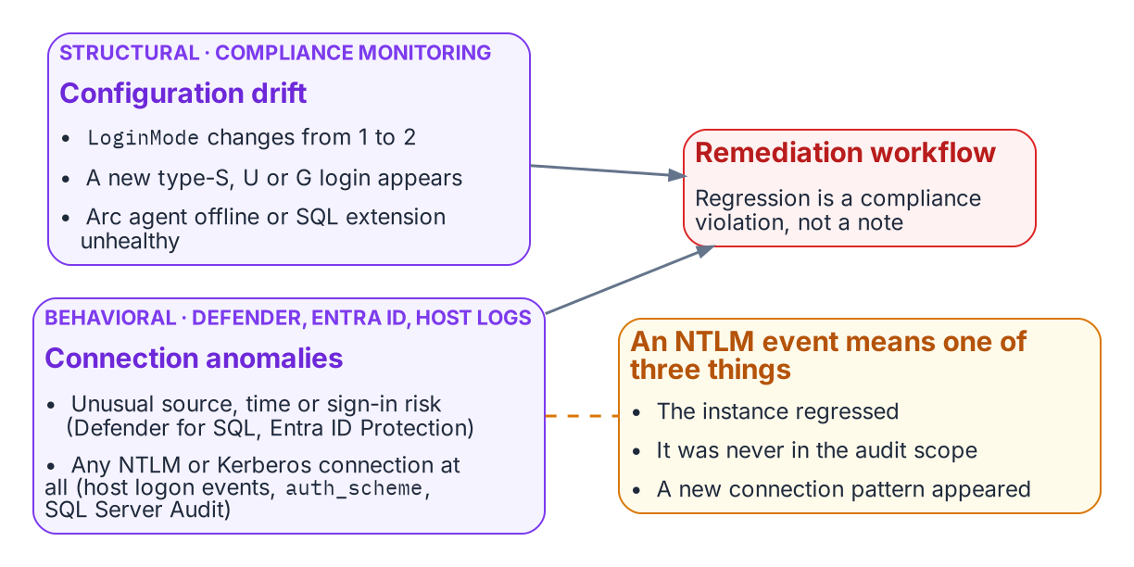
Structural drift detection and behavioral telemetry feed one remediation workflow.
Drift detection in the compliance-monitoring pipeline identifies conditions that would constitute regression before they become compliance violations. A drift event for SQL Server authentication takes one of several forms. An instance whose LoginMode value changes from 1 to 2 (Windows Authentication mode to Mixed Mode) indicates that someone has enabled Mixed Mode without authorization. Because the mode change takes effect only at the next service restart, compare the configured value with the running one, SERVERPROPERTY('IsIntegratedSecurityOnly'): a configured change not yet in effect is drift caught before it is live. A new type-S login appearing in sys.server_principals that was not present on the previous audit run indicates that a SQL Authentication login has been created.
A new type-U or type-G login appearing on an instance that was previously in the Entra-exclusive posture is the same class of regression for Windows-backed identity. And an Arc agent going offline, or the SQL extension becoming unavailable, would leave the instance’s Entra identity unmanaged: on SQL Server 2022 the agent delivers the Entra certificate from Key Vault to the host, and on SQL Server 2025 the managed identity is the Arc server’s own. Each drift event triggers the program’s remediation workflow. The SQL Server engine-authentication decision records these same events (LoginMode reverting to Mixed Mode, a new type-S, type-U or type-G login appearing, the Arc agent going offline) as compliance violations, not advisory signals.
The 2027-04-01 NTLM backstop is the program’s own date, set by its Kerberos/NTLM-elimination program for the enforcement phase; it is not a Microsoft or federal deadline (Chapter 21 sets out what external dates do fall in 2027). In the continuous-compliance monitoring context it is not a migration completion date. It is the date by which the records for all production instances must have been in the satisfied state continuously for a sufficient validation period. Migration activity should conclude well before the 2027-04-01 block date set by the elimination program’s enforcement phase; the final months before it are the continuous-audit validation period, not the migration period.

Behavioral telemetry: Defender for SQL, Entra ID and host logs
Behavioral telemetry complements the continuous-compliance monitoring. The compliance monitoring tracks the configuration state of each instance: is the LoginMode correct, are the login types correct. The behavioral layer watches the connections themselves, and it draws on three sources with distinct jobs.
- Microsoft Defender for SQL servers on machines, enabled through Defender for Cloud on the Arc-enabled host, raises threat alerts and runs vulnerability assessment. Its alerts include sign-ins from an unusual location, from a principal not seen in 60 days and from a suspicious IP, suspected brute-force attacks, and potential SQL injection. It is an alerting service, not an audit log of every authentication.
- Entra ID sign-in logs record every token Entra ID issues for SQL Server, with its risk and Conditional Access result.
- The host records the authentication protocol itself. Windows Security log logon events (4624 and 4625) name the authentication package and the NTLM version; the NTLM operational log records NTLM audit and block events; sys.dm_exec_connections.auth_scheme shows NTLM or KERBEROS for each live Windows connection; and SQL Server Audit records successful and failed logins.
The Azure Monitor agent forwards those Windows logs to a Log Analytics workspace through a data collection rule, with XPath filters that select the events, including SQL Server Audit written to the Security log. The alert queries run there.
In the transformed posture, the baseline is Entra-authenticated connections only. Every Entra-authenticated connection rests on a token that Entra ID issued, and each token issuance is recorded in the sign-in logs (a client can reuse a cached token across connections). An anomalous connection (from an unusual source IP, at an unusual time, with an elevated sign-in risk signal) is surfaced by Defender for SQL and by Entra ID Protection. Any NTLM- or Kerberos-authenticated remote connection to an instance, visible in auth_scheme, SQL Server Audit and the host’s logon events, should be zero in the transformed posture and raises an immediate alert from Log Analytics.
An NTLM event means one of three things: an instance has regressed to Mixed Mode or acquired a new Windows login, which the compliance monitoring should already have detected; an instance was not included in the original audit scope, a discovery gap; or a novel connection pattern has appeared that the migration plan did not anticipate. All three require investigation. The combination of continuous-compliance structural monitoring and behavioral monitoring from these sources is the two-layer governance instrument that maintains the transformed posture continuously after the migration is complete.

What this chapter establishes
- Closure is the Entra-exclusive operational posture: five evidenced conditions holding at once on every production instance.
- The scheduled audit is the instrument, and the per-instance compliance record is the evidence; the per-instance proof of Entra sign-in comes from the instance’s own audit, because the token audience is shared.
- Drift detection catches regression, and behavioral telemetry adds a layer over the structural checks.
- 2027-04-01 is the program’s own backstop, and the months before it are for validation, not migration.

Continue the book
← Previous: Chapter 19 — Connection String Migration: The Last Mile · Book index · Next: Chapter 21 — What Done Looks Like →

Chapter 21 — What Done Looks Like
The evidence is not a binder you assemble — it is the live output of the monitoring you never turn off.

In this chapter
The six evidence artifact sets that close the SQL Server authentication transformation, and why each is a live output of the continuous monitoring infrastructure rather than a point-in-time document. Then the correct reading of 2027-04-01: what is and isn’t externally due in 2027, and why the program’s own backstop is the date the block is applied, which means the migration must already be complete and the final months reserved for validation.
The evidence artifacts required to close the SQL Server authentication transformation in the transformation inventory are not a collection of documents produced at a single point in time. They are the live outputs of the continuous monitoring infrastructure described in Chapter 20. A closure claim is only as strong as the monitoring that keeps producing the evidence after the claim is made. This chapter names the artifacts, then places the program’s 2027-04-01 NTLM backstop in its proper operational context.

The evidence artifacts as live outputs
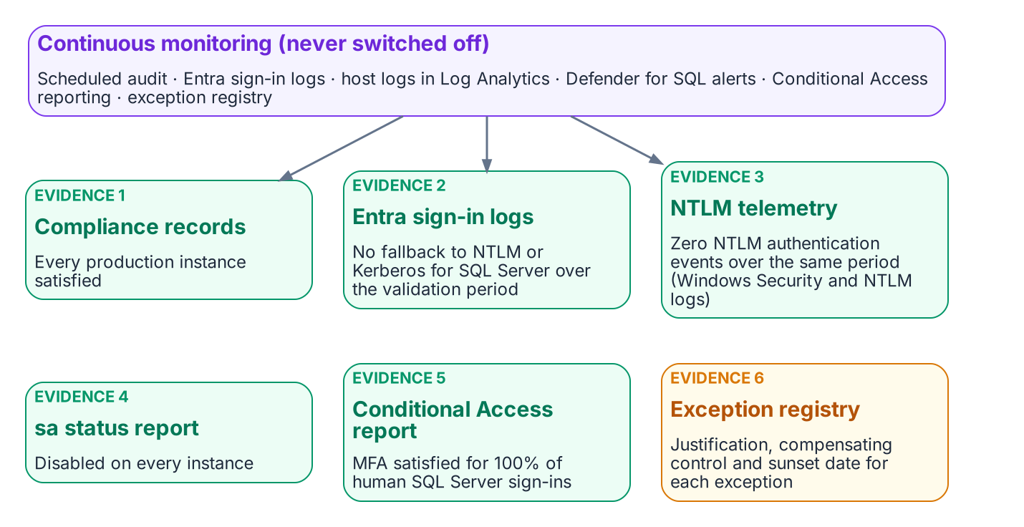
The six evidence sets are live outputs of continuous monitoring.
The closure claim for the SQL Server authentication transformation must be supported by six artifact sets, and each is a continuously regenerated output rather than a static deliverable.
The first is the per-instance compliance record set: a record for every production SQL Server instance in the estate, each showing the Entra-exclusive operational posture: SQL authentication refused, zero usable SQL Authentication logins, zero active Windows-backed logins, the Arc agent enrolled and healthy, and the SQL extension deployed. The SQL Server engine-authentication decision (Chapter 12) defines the field set these records carry, and the continuous audit keeps them current rather than freezing them at the moment of the claim.
The second is the Entra ID sign-in log set for the SQL Server resource over a defined validation period preceding the closure claim: every expected human and application principal obtaining tokens, with the Conditional Access result of each sign-in. Sign-in logs record what Entra ID issued; they can’t show a connection that bypassed Entra ID, and because every SQL Server shares the token audience https://database.windows.net/, they don’t name the instance a token was then used against. The third set fills that gap: the NTLM telemetry (the Windows Security and NTLM operational logs from SQL Server hosts, collected in Log Analytics) together with auth_scheme and SQL Server Audit, showing zero remote NTLM- and Kerberos-authenticated connections over that same validation period. It is the behavioral confirmation that complements the structural compliance view. These two artifacts together demonstrate that the transformed posture holds not only in configuration but in observed connection behavior.
The fourth is the sa account status report, showing the sa account disabled on all instances. The fifth is the Conditional Access policy compliance report, showing MFA enforcement satisfied for one hundred percent of SQL Server resource sign-ins by human principals over the validation period. The sixth is the exception registry, showing every currently excepted instance with documented justification, a sunset date, and its own compliance tracking record.
When all six artifact sets are satisfying at the same time, and the monitoring infrastructure confirms they have been satisfying for the validation period, the SQL Server authentication transformation is closed. That is what done looks like: not a checkbox, but a demonstrated, continuously verified, evidence-backed posture.
The same sets serve the agency’s own authorization. An agency’s on-premises SQL Server estate is part of the agency’s system, authorized by the agency’s authorizing official under the Risk Management Framework, not by FedRAMP, which covers the cloud services the design leverages. Continuous monitoring is a control in its own right (CA-7), and these live evidence sets are the kind of output a system-level continuous monitoring strategy names. Appendix A maps them to controls, and Appendix B collects the boundary facts an assessor will ask for.

What is due in 2027, and what isn’t
The series has called 2027-04-01 “the 2027 milestone.” Before reading it, separate what the outside world requires from what the program decided.
- No external NTLM deadline falls in 2027. Microsoft deprecated all NTLM versions in June 2024 and removed NTLMv1 starting in Windows 11, version 24H2 and Windows Server 2025. Its January 2026 roadmap has three phases: enhanced NTLM auditing, available now; fixes for the common causes of NTLM fallback, due in the second half of 2026 for Windows Server 2025 and Windows 11, version 24H2 and later; and network NTLM disabled by default “in the next major Windows Server release and associated Windows client releases,” with re-enablement through policy. Microsoft gives no calendar date for that last phase, and says the timelines “are subject to change.” Until then NTLM is deprecated, which means it remains available.
- No federal 2027 deadline drives this work. OMB M-22-09 set its zero trust goals for the end of fiscal year 2024; its identity actions (centralized identity integrated into applications, phishing-resistant MFA enforced at the application layer, a device-level signal in authorization) are the destination this series builds, not a dated 2027 requirement.
- The 2027 dates that do touch a SQL Server estate are support dates. Windows Server 2016 reaches the end of extended support on January 12, 2027. SQL Server 2014’s third and final year of Extended Security Updates ends on July 12, 2027, and SQL Server 2017 reaches the end of support on October 12, 2027. An instance on any of these that is still in the estate past its date runs without security updates, which is a finding in its own right and a reason the retain, consolidate or retire decision of Chapter 06 comes first. SQL Server 2014 and 2017 also can’t use Microsoft Entra authentication at all, so they can reach the closed posture only by upgrade or retirement.
2027-04-01 is therefore a program decision: the Phase C date the Kerberos/NTLM-elimination program sets for disabling NTLM across the estate (Chapter 15), chosen to finish ahead of Microsoft’s default change rather than wait for it. Everything that follows reads it as such.

2027-04-01: a consequence, not a completion date
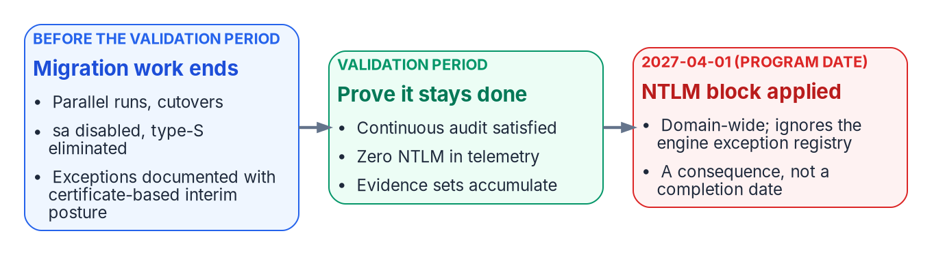
2027-04-01 is when the block lands, so migration ends well before it and the last stretch is validation.
The 2027-04-01 NTLM backstop is the single most misread date in the program. It is widely treated as the date by which the migration must complete. It is not. It is the date on which the program’s domain-wide NTLM block is applied. The block is enforced by Windows itself, through the Restrict NTLM policies on clients, servers and domain controllers. Those policies honor only their own exception lists: remote-server exceptions on the client and server exceptions on the domain controller. They don’t distinguish a compliant SQL Server instance from one the program has excepted, and they don’t read the engine-layer exception registry at all. Keeping NTLM alive for a server is a separate, deliberate entry in those Windows lists, not a consequence of an engine exception. The difference between “migration complete by 2027-04-01” and “migration must be complete before 2027-04-01, and 2027-04-01 is when the block is applied” is not a semantic distinction. It is the difference between a deadline and a consequence.
Read as a consequence, the date reorganizes the schedule. If 2027-04-01 is when connections that still depend on NTLM stop working, then the migration must have already concluded by then, with enough margin for the continuous audit to have confirmed the satisfying posture across a full validation period. Migration activity (the parallel run of Runbook R05, the cutover, the sa disablement, the type-S elimination) should finish well before the date. The final months are reserved for validation, not for migration, because a posture confirmed only on the last day before the block is a posture nobody has had time to prove.
This reading also gives the exception long tail its proper weight. An instance that can’t reach Kerberos or Entra OAuth before the block must carry a documented exception with Certificate-Based Authentication as the authorized interim posture (Chapter 22), and that exception’s sunset date must be reconciled against the block rather than against any softer internal milestone. Because the certificate secures only the user’s sign-in, an excepted connection survives the block only if it then negotiates Kerberos. The program has fixed the block date; the schedule must bend to it, not the other way around. When the migration is complete, the audit has validated the posture continuously, and the six artifact sets are live and satisfying, the 2027-04-01 block arrives as a non-event, which is exactly what done is supposed to feel like.

What this chapter establishes
- Six evidence sets close the transformation, and each is a live output of continuous monitoring.
- They must hold across a defined validation period, not be assembled once.
- Nothing external requires NTLM to be gone in 2027; 2027-04-01 is the program’s own block date, and the 2027 dates that are external are SQL Server and Windows Server support dates.
- Migration finishes before the block, so the block arrives as a non-event.

Continue the book
← Previous: Chapter 20 — The Closure Condition · Book index · Next: Chapter 22 — Where SQL Server Touches AD CS →

Chapter 22 — Where SQL Server Touches AD CS
The certificate dependencies a decommission plan cannot see, named before any decommission plan exists.

In this chapter
The three distinct SQL Server capabilities that can depend on certificates issued by Active Directory Certificate Services (AD CS): TLS encryption of client connections, certificate-mapped logins used for signing and endpoints, and certificate-based sign-in as the authorized NTLM-replacement interim posture. Why each one breaks if AD CS is decommissioned before it is migrated, what Microsoft Cloud PKI can and can’t replace, and why this chapter documents a transformation for which no normative architecture decision has yet been authored.

A “Not Yet Defined” gap: analytical, not normative
The transformation inventory classifies the move from AD CS to Microsoft Cloud PKI as “Not Yet Defined.” Most SQL Server transformation documents ignore the certificate infrastructure, but this series can’t be complete without it. This chapter identifies the dependencies, names the gap, and describes what the as-yet-unwritten AD CS migration architecture decision must address. Get-CertBasedAuthAudit.ps1 is the discovery instrument (Runbook R10). Don’t cite this chapter as normative governance for AD CS migration decisions.
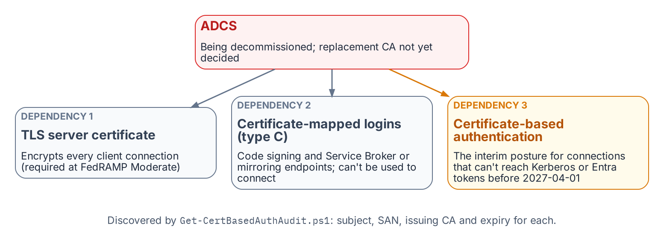
The three places SQL Server depends on AD CS-issued certificates.
The transformation inventory identifies the Active Directory Certificate Services to Microsoft Cloud PKI transformation as “Not Yet Defined.” As the series opening established, that label means the destination may be known but the normative canon governing how to reach it has not been authored. For most of this series, the missing record has been the substrate architecture decision; for this chapter, the gap is more fundamental still. No architecture decision record governs the certificate authority transformation at all.
There is no architecture decision to point to. The transformation is identified as necessary in the transformation inventory and the discovery instrument exists, but the normative decision about the replacement CA, the enrollment mechanism, and the sequencing of the AD CS decommission has not been made. This chapter is therefore analytical and motivational rather than prescriptive. It documents why the certificate gap matters specifically for SQL Server, and it cites no normative AD CS migration architecture decision because none exists.
It matters specifically because SQL Server has certificate dependencies that are not visible to most of the teams that will plan the AD CS decommission. Three distinct capabilities can depend on AD CS-issued certificates: TLS encryption of client connections, certificate-mapped SQL Server logins (used for code signing and endpoints, not to connect), and certificate-based sign-in as the authorized NTLM replacement for connections that can’t reach Kerberos or Entra OAuth before the program’s backstop. Get-CertBasedAuthAudit.ps1 is the instrument for discovering them.
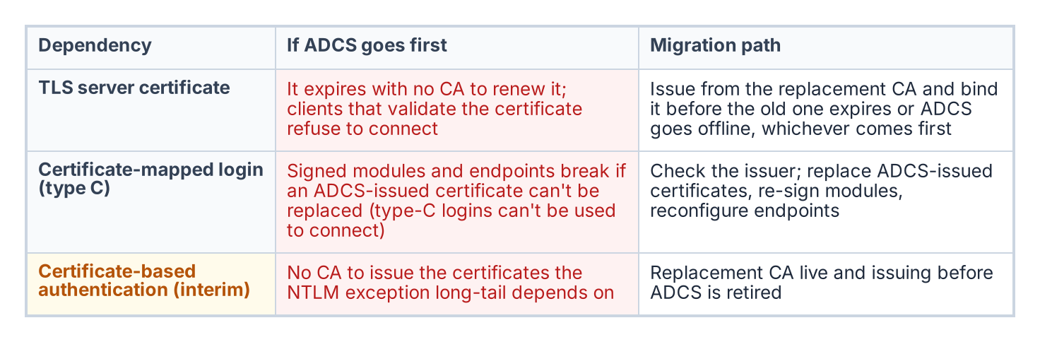
What fails if AD CS goes away before each dependency is moved, and the migration path for each.

SQL Server TLS certificates
The first and most commonly recognized SQL Server certificate dependency is the TLS certificate the engine presents for encryption of client connections. When SQL Server is configured to encrypt connections, it presents a server certificate to connecting clients as part of the TLS handshake. The transformation makes that certificate more important, not less. Connections authenticated by Microsoft Entra ID are always encrypted, so the Entra target of this series depends on a server certificate the client trusts; without one, Entra logins fail with an untrusted-chain error unless the client is told to trust the server certificate, which defeats the point. For the agency’s own system, encryption in transit is also a control, not a preference: SC-8 (Transmission Confidentiality and Integrity) and its enhancement SC-8(1) (Cryptographic Protection) are both in the SP 800-53 Rev. 5 Moderate baseline the agency’s authorizing official assesses the system against.
In many environments that certificate is issued by the organization’s AD CS infrastructure. The administrator submitted a request to the AD CS certification authority, the CA issued a certificate carrying the SQL Server’s host name in the Subject Alternative Name, and the certificate was installed in the computer’s certificate store and bound through SQL Server Configuration Manager. Microsoft documents the requirements the certificate must meet: the Server Authentication enhanced key usage, a KeySpec of AT_KEYEXCHANGE (which means a legacy cryptographic service provider, not a key storage provider), and a Subject Alternative Name covering every name clients use, including availability group listener names. Microsoft also documents the AD CS enrollment route, with the warning that a template using a key storage provider produces a certificate SQL Server can’t use. The certificate has an expiration date.
When AD CS is decommissioned, that certificate will not be renewed automatically: there is no CA left to issue the renewal. SQL Server checks a certificate’s validity only when it is configured, and keeps running if the certificate expires afterward; but clients that check validity on each connection, such as Power BI, raise an error when the instance presents an expired certificate, and Microsoft recommends against using one. Clients configured to validate the server certificate, which is the correct security posture, are the ones that break. The encryption that SC-8 requires becomes the thing that breaks the connection.
The certificate-audit script captures the TLS certificate for every instance in scope: the subject, the SAN, the issuing CA, and the expiration date. Any instance whose TLS certificate is AD CS-issued is a dependency the migration plan must address. The replacement certificate must come from the new CA and must be installed and bound before the AD CS-issued certificate expires or before AD CS goes offline, whichever comes first.
Which new CA is an open question, and Microsoft Cloud PKI doesn’t answer it for servers. Cloud PKI, licensed as an add-on to Intune Plan 1 or Plan 2, issues certificates only through SCEP to devices enrolled in Intune. Intune’s supported platforms don’t include Windows Server, so a SQL Server host can’t receive its TLS certificate from Cloud PKI directly. Cloud PKI can still anchor its issuing CA to an existing private root (“bring your own CA”), which lets workstation and server certificates share a trust anchor, but the server-certificate issuer is a separate choice the unwritten decision has to make. The same applies to the government cloud question: Cloud PKI is available in GCC High but not in DoD environments.

Certificate-mapped SQL Server logins
The second dependency is less commonly known. SQL Server supports a login type, the type-C login, created from a certificate in master with CREATE LOGIN [name] FROM CERTIFICATE [cert_name]; type-K logins are the same arrangement with an asymmetric key. Neither is a way to connect: Microsoft documents that logins created from certificates or asymmetric keys “are used only for code signing” and “can’t be used to connect to SQL Server.” They carry permissions for signed modules, and certificates of the same kind secure Service Broker and database mirroring endpoints.
Certificate-mapped logins are uncommon in standard deployments, but they appear in specific scenarios: module signing that grants a stored procedure permissions its caller lacks, and Service Broker or mirroring endpoint security. Each is the kind of arrangement that survives quietly across an estate for years without anyone documenting it.
Most such certificates are created inside SQL Server rather than issued by AD CS (CREATE CERTIFICATE can generate a self-signed certificate and its key), so the first question is the issuer. Where an AD CS-issued certificate backs a type-C login or an endpoint, replacing it means issuing a new certificate, re-signing the modules or reconfiguring the endpoints, and moving the login’s permissions, before AD CS is retired. Type-C logins are not migrated to Entra logins, because nothing connects with them. The certificate-audit script captures every certificate-mapped login and the issuing CA of its associated certificate, providing the inventory the migration needs.

Certificate-based sign-in as the NTLM interim posture
The third dependency is the most consequential for the NTLM elimination timeline. The Kerberos/NTLM-elimination program designates certificate-based authentication (CBA) as the authorized replacement for NTLM connections that can’t be migrated to Kerberos or Entra ID OAuth 2.0 tokens within the required timeline. Here CBA means certificate-based sign-in by the user, with a smart card or PIV credential, rather than a password. SQL Server itself has no client-certificate login, so for a pre-2022 instance the certificate secures the user’s sign-in to Active Directory, and the SQL Server connection that follows still authenticates with Windows authentication. It avoids NTLM only where that connection can use Kerberos.
For connections that can’t reach Entra ID authentication before the program’s 2027-04-01 NTLM backstop (Category 3 instances still on versions before SQL Server 2022, or applications still in the deferred class), CBA is the authorized interim posture. Certificate sign-in removes the password from the user’s side, and the program accepts it as the interim posture provided the connection itself then negotiates Kerberos rather than NTLM, which still depends on the SPN and KDC fixes of Chapters 14–15. It is the bridge that keeps an un-migratable connection compliant.
The problem is that certificate sign-in to Active Directory depends on a CA in two places, and AD CS usually sits in at least one of them.
- The user’s certificate. For federal workforce users this is normally the PIV authentication certificate, issued through the agency’s card management system by a CA operating under the Federal PKI Common Policy, not by the agency’s own AD CS (Book 03, Chapter 09). Whatever the issuer, Active Directory must list it in the forest’s NTAuth store before it will accept the certificate for smart card logon. Where AD CS issues smart card or virtual smart card certificates to users who have no PIV card, those certificates are a direct AD CS dependency.
- The domain controllers’ certificates. Each domain controller that authenticates smart card users must hold a domain controller certificate, and when a Microsoft Enterprise CA is installed in the forest, the domain controllers enroll for that certificate automatically. In most forests, that is where smart card logon quietly depends on AD CS even when every user certificate comes from the PIV issuer.
If the plan is to rely on certificate sign-in for connections that can’t yet reach Entra authentication, and AD CS is being decommissioned, a replacement issuer for the domain controller certificates (and for any non-PIV user certificates) must already be in place and trusted in NTAuth before AD CS goes offline. The interim posture has its own certificate dependency, and that dependency points at the same authority the program intends to remove.
On the target path the picture is different. Microsoft Entra certificate-based authentication is a relying party, not a CA: it authenticates X.509 certificates against the organization’s PKI, configured as trusted CAs in the tenant, and for PIV holders that PKI is the Federal PKI issuer, not AD CS. It is one of the phishing-resistant methods by which users meet the MFA condition of Chapter 20 once their connections use Entra tokens.

The sequencing dependency
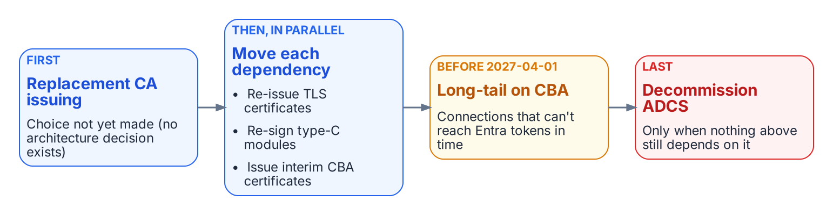
The order the AD CS migration must respect.
The three dependencies converge on a single sequencing question. TLS certificates must be re-issued before they expire; AD CS-issued certificates behind type-C logins and endpoints must be replaced and their modules re-signed; and CBA, the very mechanism the Kerberos/NTLM-elimination program relies on to cover connections that can’t meet the backstop, must have its domain controller and user certificates issued by a CA that will still exist after AD CS is retired.
If the AD CS decommission timeline runs earlier than the replacement-CA and CBA-deployment timeline, the program loses the interim posture the Kerberos/NTLM-elimination program depends on at precisely the moment it is most needed: connections that could not migrate to Entra authentication in time would have no compliant fallback. The sequencing of the AD CS decommission against the 2027-04-01 NTLM backstop is therefore a critical dependency, and it is one the as-yet-unwritten AD CS migration architecture decision must explicitly address before any decommission date is set. The forest-wide view of the same problem, with the other services that ride on AD CS, is in Book 02, Chapter 04.

What this chapter establishes
- SQL Server can depend on AD CS in three places: the TLS server certificate, certificates behind type-C logins and endpoints, and the certificate-based interim posture, where the dependency is usually the domain controller certificates rather than the PIV card.
- Microsoft Cloud PKI issues only to Intune-enrolled devices, which excludes Windows Server, so the server-certificate issuer is a separate decision.
- Get-CertBasedAuthAudit.ps1 discovers all three dependencies.
- The sequencing of the AD CS decommission against the program’s 2027-04-01 backstop is a dependency the as-yet-unwritten AD CS migration decision must resolve.

Continue the book
← Previous: Chapter 21 — What Done Looks Like · Book index · Next: Chapter 23 — Epilogue: The Platform Question →

Chapter 23 — Epilogue: The Platform Question
The authentication move is forced; the platform choice isn’t, so it comes afterward, one data domain at a time.

In this chapter
What to do with the rationalized estate once its authentication has moved to Microsoft Entra ID. The cost of fragmentation, the three candidate destinations for a retained data domain, the ten dimensions on which to score them, and why the platform decision follows the authentication move instead of preceding it.

An epilogue, not another migration step
Chapters 01–22 are the SQL Server identity transformation. This epilogue starts where they end: with a rationalized estate whose authentication has moved to Microsoft Entra ID. Nothing in Chapters 01–22 depends on it, and the Data Platform project charter leaves full consolidation and platform replacement out of its initial phase.

The fragmentation cost
The authentication transformation produces a rationalized estate. The platform question asks what to do with that estate. Twenty years of accretion have produced overlapping instances, duplicated data domains, and no single authoritative source for any given subject. The goal is fewer authoritative platforms: one authoritative database per data domain.

Three destinations
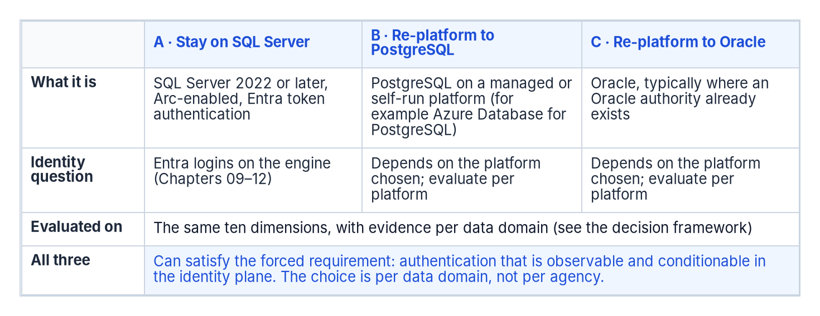
The three candidate destinations for a retained data domain.
Every retained data domain ends at one of three candidate destinations: stay on SQL Server, re-platform to PostgreSQL, or re-platform to Oracle. Each can satisfy the forced requirement, authentication that is observable and conditionable in the identity plane. SQL Server 2022 and later accept Microsoft Entra logins, as Chapters 09–12 describe. Azure Database for PostgreSQL flexible server supports Microsoft Entra authentication with tokens, including group logins and managed identities. Oracle documents configuring Oracle Database so that Microsoft Entra ID users connect with single sign-on. Each platform’s own documentation, not this book, is the authority on how it does so, and the identity integration dimension below asks for that evidence per platform.
This epilogue doesn’t rank the three. Which one fits depends on the data domain, so the decision is made with a framework rather than a verdict.

Decision framework
Score each candidate destination for each data domain on the same dimensions, and record the evidence behind each score:
Dimension | Evidence required per data domain
Migration effort | Schema and code inventory (procedures, functions, triggers, jobs), conversion estimate, test scope
Application compatibility | Driver and connection-string support for every consuming application; vendor support statements
Operational maturity | Monitoring, patching, backup and runbook coverage the operating team already has for the platform
HA/DR fit | Required RPO and RTO against the platform’s supported HA and DR topologies
Identity integration | How the platform authenticates to the chosen identity plane, verified in its own documentation
Licensing exposure | Current and projected license cost from the agency’s own agreements
Portability | Dependence on platform-specific features; exit path
Data-domain consolidation opportunity | Which duplicate copies of the domain the move would retire
Required skills | Staff skills today, and the training or hiring the move needs
Switching cost | Parallel-run duration, dual-running cost, contract terms
Two data domains can reach different answers, and that is normal. The goal is fewer authoritative platforms, not a single vendor. In the program’s ownership model the CIO and data leadership make this decision per domain, with application and data owners consulted (Chapter 13).

Decision sequence
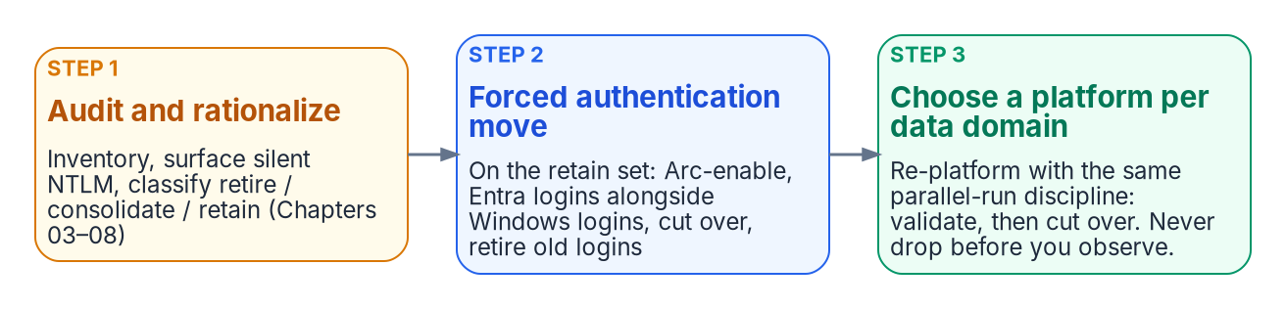
The platform decision comes after the forced authentication move.
- Audit and rationalize first (Chapters 03–08). Inventory every instance, surface silent NTLM fallback, and classify each instance retire, consolidate or retain.
- Do the forced authentication move on the retained set (Chapters 09–12 and 14–15): Arc-enable, stand up Entra logins alongside Windows logins, cut over, retire the old logins.
- Then make the platform choice per data domain. Re-platforming follows the same parallel-run discipline: establish the target, validate in parallel, cut over only after the validation window. Never drop before you observe.
The identity work isn’t lost when a domain moves. Microsoft documents, for example, how Windows users and groups in a database restored to Azure SQL Managed Instance are remapped to Microsoft Entra logins with ALTER USER … WITH LOGIN. The group design of Chapters 16–17 travels with the data, whatever platform the domain lands on.
What Chapter 23 establishes
- The authentication transformation produces the inventory that scopes the platform decision.
- The decision is made per data domain against a common set of dimensions and evidence, and two estates with two answers is normal.
- The goal is fewer authoritative platforms, not a single vendor.
In the book’s reading order this epilogue comes after the closure condition and the certificate dependencies (Chapters 20–22). The runbooks that follow are the executable counterpart to Chapters 01–22, starting with Runbook R01.

Continue the book
← Previous: Chapter 22 — Where SQL Server Touches AD CS · Book index · Next: Runbook R01 — Prerequisites & Using This Companion →

Runbook R01 — Prerequisites & Using This Companion
The narrative says why; the runbooks say what you install, what the evidence looks like, what is safe to run, and in what order.

In this runbook
The toolchain the later runbooks assume, the evidence envelope every function emits, the bright line between read-only functions and review-required ones, how to run the whole chain offline against captured snapshots, and the order in which Runbooks R02 to R10 run. Everything here is setup or orientation. It provisions nothing and changes no production state.
Pairs with: Chapter 01 — What Windows Authentication Actually Is and Chapter 02 — Why the Inheritance Must End. Those chapters open with the inheritance: why a twenty-year Windows-authentication estate exists and why it has to change. This runbook is their executable counterpart.

What the runbooks automate
The narrative chapters stay conceptual; the runbooks are the executable layer. Each later runbook documents the program’s real script behind its step, not a paraphrase. The automation lives in two places in the program’s repository: the read-only discovery Spec family under tools/discovery/, and the derivation and validation PowerShell modules under tools/powershell/. The tooling isn’t published with this workbook; the paths in the runbooks are relative to the root of the program’s repository, and the names follow the program’s FMP prefix.
Runbook | Program automation | Tier
R02 — Estate discovery | Spec3-D1.8 / Spec1-D1.5 / Find-DbaInstance, fused by New-FMPEstateInventory | read-only
R03 — Authentication audit | Spec3-D1.8-Get-SQLServerAuthAudit (plus the Spec*-D1.* family) | read-only
R04 — Arc and managed identity | Test-FMPArcAgentStatus, Test-FMPArcManagedIdentityToken, Test-FMPArcSqlExtension, Invoke-FMPArcOnboarding | validation read-only; onboarding review-required
R05 — Login migration | New-FMPEntraLoginMapping, New-FMPEntraLoginScript, Test-FMPLoginParallelRun | derive / dry-run
R06 — NTLM remediation | Spec3-D1.7 / Spec1-D1.5, New-FMPSpnRemediationPlan, Get-FMPNtlmGpoReport | audit-first
R07 — Groups and AUs | Export-FMPEntraGroups, New-FMPEntraGroupClassification, New-FMPGroupLoginScript | derive / dry-run
R08 — Application chain | Spec3-D1.9, New-FMPAppConnectionPlan | derive (connection-string change made in configuration)
R09 — Continuous monitoring | Spec3-D1.8 (scheduled), New-FMPClosureRecord, Compare-FMPClosureRun | read-only
R10 — Certificates | Spec3-D1.10, New-FMPSqlCertificatePlan, New-FMPPKIMigrationPlan | read-only / analytical
R01 has no script of its own: the conceptual opening has no executable layer. This runbook is the setup and orientation that the executable runbooks assume.

Step 1 — Install the toolchain
- PowerShell 7 or later is the runtime the modules target; the program’s Pester tests run under PowerShell 7.
- A Python interpreter with only the standard library (python3 on PATH) is the one external dependency. The modules call it to compute the canonical integrity seal with json and hashlib, byte-for-byte identical to the program’s canonical hash. The program’s Python package isn’t imported, so no editable install is needed to produce sealed evidence.
- The discovery Specs are plain PowerShell scripts under tools/discovery/; run them directly.
- The modules are imported from the repository root:

Illustrative, not tested against your estate
The commands in the runbooks are illustrative. They haven’t been tested against a production forest, tenant or SQL Server estate. Review every command and script, run it first in a test environment, and route anything that changes state through change control.
Import-Module ./tools/powershell/FMPSqlServerMigration # Runbooks R02, R04, R05, R06, R07, R08, R09, R10
Import-Module ./tools/powershell/FMPIdentityAssessment # Runbook R07 group and Conditional Access export
Import-Module ./tools/powershell/FMPPlanGenerators # Runbook R10 PKI sequencing
Live Azure and Microsoft Graph operations (Arc onboarding, Graph or Azure Resource Manager writes) also need the relevant command-line tools, azcmagent and the Azure CLI (az), and run only behind an explicit opt-in switch. Every function can be exercised offline without them.

Step 2 — The evidence model
Every derivation and validation function emits a provenance-sealed envelope, not loose output:
- schema and artifact_type name the artifact; data.records holds the rows; data also carries per-artifact summary counts.
- provenance records the producing module and version, a UTC timestamp, and a content_hash.
- The sealed data omits the timestamp, so identical inputs yield an identical content_hash. Artifacts are reproducible, and a broken or unattributed envelope is a DRIFT-PROVENANCE finding by definition.
Write each step’s envelope under a dated output directory and keep it under version control. That is what makes the scheduled runs in Runbook R09 comparable from one run to the next, and the whole chain auditable.

Step 3 — The safety model
The runbooks draw one bright line, and the code enforces it:
- Read-only and derivation functions run directly: discovery, audits, classifications, plans, closure records, comparisons. They read captured or live-read inputs and change nothing.
- State-changing functions are gated. They either declare SupportsShouldProcess and default to planning only (Invoke-FMPArcOnboarding plans the azcmagent connect command unless you pass -Execute and confirm), or they generate a reviewable script or plan and execute nothing (New-FMPEntraLoginScript, New-FMPGroupLoginScript). The login and group script generators have no -Server or -Execute parameter at all; they never open a SQL connection.
- No secrets are embedded. Tenant, subscription, cloud, endpoints and credentials are all parameters. The cloud-aware functions accept the two Azure cloud names the Arc agent uses for US workloads, AzureCloud and AzureUSGovernment, resolve the matching audience, and fail closed on an unknown cloud. A GCC-Moderate tenant is a Microsoft Entra tenant in the public (commercial) cloud, and an Azure Government subscription can’t be associated with a directory there, so the Arc resources that serve a GCC-Moderate tenant use AzureCloud; Runbook R04 explains why that matters for SQL Server.

Production safety
Anything that touches service accounts, SQL logins, SPNs, GPOs or the domain changes a production security posture. Run discovery and the audit first (they are safe), generate the plan or script, capture it, and route it through change control and security review before any enforcement. The discovery scripts are read-only; the remediation steps are not.

Step 4 — The offline snapshot pattern
Every function accepts captured input, a JSON or CSV snapshot of a live read, so the entire chain can be exercised and tested without touching a live estate. Capture once (the Spec* audits, the Export-FMP* exports, azcmagent show -j for the agent’s status as JSON, a captured managed-identity token response), then run the derivations against the captured files. The program’s Pester suite validates the modules the same way, fully offline.

Step 5 — The run order
The runbooks chain; later runbooks operate on the surviving set the earlier ones define:
- Runbook R02 establishes the denominator and the retain / consolidate / retire gate. Only retain instances and consolidation targets go on.
- Runbook R03 audits the surviving set’s authentication posture.
- Runbook R04 connects each retained host to Azure Arc and its Microsoft Entra identity; Runbook R05 migrates its logins to Entra ID with a parallel-run window.
- Runbook R06 eliminates the patterns that generate NTLM; Runbook R07 transforms the group and access layer and the Conditional Access perimeter.
- Runbook R08 removes the stored credential in the application chain, the last mile.
- Runbook R09 proves the posture and keeps it continuously; Runbook R10 discovers and sequences the certificate and AD CS dependencies that must not be decommissioned out from under SQL Server.

Provenance
The runbooks introduce no new doctrine. They are the operational rendering of decisions the narrative chapters already make, chiefly the consolidation gate before any login migration (Chapter 06) and Arc as the identity bridge for on-premises SQL Server (Chapter 09). Each runbook names the specific Spec script or function it documents.

Safety
This runbook installs and orients; it runs nothing against a live estate. The first action against production identity is in Runbook R04 (Arc) and Runbook R05 (logins), and only on the retain and target set that Runbook R02 defines.

Continue the book
← Previous: Chapter 23 — Epilogue: The Platform Question · Book index · Next: Runbook R02 — Estate Discovery & the Consolidation Gate →

Runbook R02 — Estate Discovery & the Consolidation Gate
Count everything first, decide what survives second, and spend the authentication migration only on what survives.

In this runbook
The Phase 0 discovery and rationalization runbook. It builds the estate inventory from three kinds of instrument, applies three rationalization lenses (utilization, version, dependencies), and classifies every instance retain, consolidate or retire. Discovery is read-only and runs first. The consolidation it leads to, database moves and instance retirement, is review-required and belongs to the program’s migration plan, not to this runbook.
Pairs with: Chapter 03 — The Shape of Twenty Years, Chapter 04 — The Estate Inventory, Chapter 05 — Rationalization and Chapter 06 — The Retain, Consolidate, Retire Decision. Those chapters explain why you assess and consolidate before you migrate; this runbook is how.

The Phase 0 instrument
Chapter 04 names the Phase 0 denominator as a gap: the authentication audit (Spec3-D1.8, Runbook R03) measures the authentication posture of instances that are already known, but estate discovery runs earlier and casts wider to establish the denominator. The program closes that gap with New-FMPEstateInventory (tools/powershell/FMPSqlServerMigration/ in the program’s repository), which fuses the discovery outputs into one deduplicated inventory and applies the retain / consolidate / retire gate. The individual instruments below remain the sources it consumes.

Why this runbook runs before everything else
Effort is finite, and the program’s 2027-04-01 NTLM backstop (Runbook R06, Runbook R09) doesn’t move. That date is the program’s own planning anchor, not a Microsoft deadline: Microsoft has deprecated NTLM, removed NTLMv1 from Windows Server 2025, and says NTLMv2 will be removed from Windows Server in a future release, without a published date (Chapter 02). Migrating the logins of an instance only to retire it three months later is wasted work measured against a fixed date. The program’s consolidation-gate decision makes the sequencing normative: classify every instance retain, consolidate into a target, or retire before any login is touched. Only retain instances and the consolidation targets enter the authentication migration that Runbooks R03 to R10 describe.
The deliverable of this runbook is one row per instance with that classification, justified by the three rationalization lenses. Everything downstream operates on the surviving set.

Step 1 — Build the estate inventory (read-only)
The defining property of a twenty-year estate is that the inventory doesn’t already exist in complete form. The instances that matter most are the ones nobody is managing, so they have to be discovered, not retrieved from a list. No single instrument finds every instance. Combine three, each blind to what the others surface.

1a — What the program’s discovery scripts give you
Two pieces of the sweep are backed by the program’s scripts in tools/discovery/:
- Spec3-D1.8-Get-SQLServerAuthAudit.ps1 finds instances from their MSSQLSvc SPNs (a live Active Directory query) and from an explicit -TargetServers list, then reads each host’s SQL Server services over CIM (Win32_Service) to record the engine, Agent, SSRS, SSIS and SSAS service accounts. It emits ServerName, InstanceName, Port, DiscoveryMethod and the service-account fields. SQLVersion, SQLVersionMajor, SQLEdition and AuthenticationMode are filled in only when the script connects to the instance (-QueryInstances); in discovery-only form they read Unknown. Run it here in its discovery-only form (no -QueryInstances) to seed the inventory; Runbook R03 is where you run the deep audit on the surviving set.
- Spec1-D1.5-Get-KerberosSPNInventory.ps1 gives the domain’s SPN trail, including every MSSQLSvc SPN: every instance registered for Kerberos, including hosts that are otherwise off the radar. Run it once per domain (it takes -DomainController and -SearchBase). Its Duplicates and Orphans arrays surface duplicate SPNs and SPNs registered on disabled objects or on objects with no logon in 180 days, typically decommissioned hosts. Both are consolidation-relevant findings.

Illustrative, not tested against your estate
The commands and queries in this runbook are illustrative. They haven’t been tested against a production forest or SQL Server estate. Review them, run them first in a test environment, and coordinate network sweeps with your security operations team before you run them.
# Read-only inventory seed from the audit script and the SPN trail.
# Each writes JSON and CSV named FMP_Spec<n>_D1.<n>_<name>_<domain>_<timestamp>.* under -OutputPath.
./Spec3-D1.8-Get-SQLServerAuthAudit.ps1 -OutputPath .\output # instances (no -QueryInstances)
./Spec1-D1.5-Get-KerberosSPNInventory.ps1 -OutputPath .\output # SPN trail for the current domain

1b — The broader sweep (the wider denominator)
The program’s scripts find instances that have an SPN or that you already name. They don’t find a SQL Server Express instance that an application installer dropped on an application server. Cast wider with the general-purpose instruments Chapter 04 names.
Find-DbaInstance from the open-source dbatools module scans only the computers you give it when you pass -ComputerName; to find hosts nobody listed, give it a discovery type instead. DomainServer finds every enabled Windows Server computer in Active Directory, DataSourceEnumeration uses the same UDP broadcast that SQL Server Management Studio uses, and IPRange sweeps subnets. The default scan types probe each candidate (TCP port, SQL Browser, SPN, service and DNS checks) without logging in to SQL Server.
# Network and directory sweep: surfaces instances no inventory records.
Find-DbaInstance -DiscoveryType DomainServer, DataSourceEnumeration |
Export-Csv .\output\estate-find-dbainstance.csv -NoTypeInformation
# Forest-wide SPN trail (an independent signal; cross-check against the Spec1-D1.5 output).
# -T * targets the current forest when combined with -F; without -F the query covers only the current domain.
setspn -T * -F -Q MSSQLSvc/* > .\output\estate-spn-trail.txt
The setspn query modifiers are -F (query at forest rather than domain level), -T (the target domain or forest, with * meaning the current one) and -Q (query for existing SPNs).
Microsoft’s migration-assessment tooling is the third instrument. Azure Migrate’s discovery and assessment tool and the migration assessment in SQL Server enabled by Azure Arc capture workload, dependency and compatibility data the first two can’t, and they’re useful here for what they reveal about the estate regardless of any decision to land on Azure. The Data Migration Assistant that older guidance names was retired on July 16, 2025, so don’t plan around it.

1c — Fuse the sources into one inventory: New-FMPEstateInventory
No single instrument finds every instance, and run side by side they double-count the ones they all see. New-FMPEstateInventory is the program’s Phase 0 instrument that fuses them. It reads the Spec3-D1.8 discovery output and, optionally, the Spec1-D1.5 SPN trail and a Find-DbaInstance export. It keys every instance on host and instance name, so the same instance seen by several instruments deduplicates, and it records a discovered_by set so coverage is auditable. It then applies a first-pass gate (Step 3) to each instance and emits a sealed, reproducible inventory envelope: the denominator the rest of the series operates on.
Import-Module ./tools/powershell/FMPSqlServerMigration
# Fuse the discovery outputs, classify, and emit the sealed estate inventory.
New-FMPEstateInventory `
-AuthAuditPath .\output\FMP_Spec3_D1.8_SQLServerAuthAudit_<domain>_<timestamp>.json `
-SpnInventoryPath .\output\FMP_Spec1_D1.5_SPNInventory_<domain>_<timestamp>.json `
-FindInstancePath .\output\estate-find-dbainstance.csv `
-OutputPath .\output\estate-inventory.json
The function is pure derivation over the read-only discovery output: it reads no live host or directory and changes nothing. Its classification counts (retain, consolidate, retire, review) and its denominator are the gate’s headline numbers. Know what the automated pass can and can’t see:
- It classifies on two signals only: the engine version and a last-access age in days. An instance with a last-access age at or above -ZombieThresholdDays (default 400) is classified retire; a pre-2022 engine is classified consolidate; a SQL Server 2022 or later engine is classified retain.
- An instance whose signal is insufficient lands in review, never silently in retain. Discovery-only Spec3-D1.8 output carries no version, so on its own almost every instance lands in review. Supply versions (from the R03 deep audit) and last-access ages (from Lens 1) to get a meaningful first pass.
- The dependency lens (Lens 3) and the choice of consolidation target are human judgment the function doesn’t make. Treat its output as a first pass that the architects confirm or override, with the reason recorded.

What the inventory must capture
For every instance: version, edition and build (support and licensing posture), host operating system (Arc and upgrade envelope), domain-join state and owning domain (the forest-entanglement picture), and the service-account identity and its source domain. For every database: size, last-access timestamp, recovery model and owning application (the utilization and zombie picture). Like the audit it precedes, the inventory is re-run, not snapshotted: instances appear and disappear across a multi-month assessment.

Step 2 — Apply the three rationalization lenses (read-only)
An inventory establishes what exists; rationalization establishes what each item is worth keeping. Apply three lenses to every instance and database, and combine them. No single lens decides.

Lens 1 — Utilization and zombie detection
Capture sustained and peak CPU, memory, storage and connection counts per instance; per database, the last-access timestamp, recent query workload and backup-restore history. A database with no connections in 400 or more days, no restores consumed and a retired owning application is a zombie: the cleanest retirement candidate, and the fastest way to shrink the migration surface. Every login it carries, including long-forgotten SQL-authenticated service accounts with valid passwords, leaves the pipeline before it enters it. Utilization also rightsizes survivors: an instance at 4% of a 16-core Enterprise license is a consolidation source, not a retain.
The index-usage DMV is a useful last-access signal, with one limit you must account for: its counters are initialized to empty whenever the Database Engine starts, and a database’s rows are removed when it’s detached or shut down (for example by AUTO_CLOSE). It can therefore show recent use, but it can’t prove 400 days of disuse unless the instance has been running that long. Read the engine start time alongside it, and take the long-horizon evidence from login auditing, backup history and the application portfolio.
-- How far back do the usage counters reach?
SELECT sqlserver_start_time FROM sys.dm_os_sys_info;
-- Per-database last-access signal since that time. A database with no row hasn't been
-- read or written through an index since the start time. Combine with backup history
-- and the application portfolio before judging.
SELECT DB_NAME(database_id) AS database_name,
MAX(last_user_seek) AS last_seek,
MAX(last_user_scan) AS last_scan,
MAX(last_user_lookup) AS last_lookup,
MAX(last_user_update) AS last_update
FROM sys.dm_db_index_usage_stats
GROUP BY database_id
ORDER BY database_name;

Lens 2 — Version and end-of-life posture
The CREATE LOGIN ... FROM EXTERNAL PROVIDER syntax the whole transformation depends on needs SQL Server 2022 (16.x) or later on premises. An earlier engine can’t accept Microsoft Entra logins, whatever else changes; Chapter 07 calls this Category 3. Read it off the R03 audit fields once the deep audit has run: SQLVersionMajor and the computed MigrationTarget already say “upgrade to SQL 2022 + Arc” for pre-2022 instances. For most aged instances the right answer isn’t “upgrade in place” but “consolidate the surviving workload onto a modern target and retire the old engine,” which also reclaims core licenses.
Two platform facts shape the target choice. On SQL Server 2025 the engine can use the Arc server’s system-assigned managed identity for Entra authentication, so a new consolidation target built on 2025 avoids the app registration and certificate that SQL Server 2022 needs (Runbook R04). And Entra authentication isn’t supported on SQL Server failover cluster instances, so a clustered workload consolidates onto a standalone instance or an availability group, or carries an exception.

Lens 3 — Dependency mapping
This is the lens that most often overturns a naive plan. An instance that looks idle by connection count may be the silent target of a linked-server chain, replication, an SSIS package or a quarterly cross-database query. Map these before moving anything:
-- Linked-server web (often cross-domain): the forest-entanglement signal.
-- SQL Server 2022 and later require VIEW SERVER SECURITY STATE to read sys.linked_logins.
SELECT s.name AS linked_server, s.data_source, s.product,
ll.uses_self_credential, ll.remote_name
FROM sys.servers AS s
LEFT JOIN sys.linked_logins AS ll ON ll.server_id = s.server_id
WHERE s.is_linked = 1;
uses_self_credential = 1 means the session passes its own credentials to the linked server; 0 means a stored remote login (remote_name) is used, with a password that SQL Server stores but doesn’t expose. Cross-reference the LinkedServers array from the Runbook R03 audit, the SQL Server Agent job inventory, the replication configuration and the SSIS, SSRS and SSAS footprint. Azure Migrate dependency analysis and the Arc migration assessment supplement the in-engine views. This lens is also the bridge to Runbook R08: the upstream LDAP-bound applications it surfaces are exactly what Spec3-D1.9 inventories there.

Step 3 — The retain / consolidate / retire decision (the gate)
The three lenses resolve to one classification per instance. The program’s consolidation-gate decision makes it the normative prerequisite: engine-layer authentication migration runs only on retain instances and on the consolidation targets that absorb consolidated workloads.
Classification | Meaning | Enters authentication migration?
retain | Load-bearing; supported version or a clear path to SQL Server 2022 or later; no dependency argues for collapse | Yes: proceeds to the R03 audit and Arc eligibility
consolidate into a target (source) | The workload migrates to a modern target, then the source is retired | No: the target is migrated, not the source
retire | Zombie, or the owning application is decommissioned | No: no login ever enters the pipeline
Target-state options for absorbing consolidated workloads: SQL Server 2022 or later on an Arc-enabled host (the Category 1 starting position that Runbook R03 audits and Runbook R05 migrates), Azure SQL Managed Instance, or Azure SQL Database and elastic pools, both of which support Microsoft Entra authentication natively. Choose the target during the assessment, so authentication is migrated once, in final shape, on the target, not twice.
Record the constraints honestly: collation conflicts, version-locked vendor applications, compliance-isolation requirements, failover cluster instances, and indivisible cross-instance dependency clusters each convert an apparent consolidation candidate into either constrained consolidation (a dedicated, not shared, target) or retain in place. Recording the constraint is what makes the plan executable rather than aspirational.

Consolidation execution is review-required
Discovery and rationalization are read-only. The execution they justify (moving databases, retiring instances, collapsing cross-domain identity into Entra-backed identity at the target) changes production. Sequence it through the program’s migration plan and change control; this runbook stops at the classified inventory that gates that work.

Feeding the rest of the series
The classified inventory is the surface that Runbooks R03 to R10 operate on. The forest-spanning identity sprawl (cross-domain logins, orphaned SPNs in collapsing domains, shared service accounts) is resolved once, at the target, rather than re-pointed instance by instance. That is why the program makes this decision the gate: the authentication transformation is spent only on the estate that survives.

Safety
Every script and query in this runbook reads; none changes a security posture. Spec3-D1.8 in discovery-only form and Spec1-D1.5 read Active Directory and host service configuration; Find-DbaInstance, setspn -Q and the DMV queries are inventory reads; and New-FMPEstateInventory derives over their captured output without touching anything live. Network sweeps do generate probe traffic that intrusion detection can flag, so schedule them with security operations. Changes to production security posture begin in Runbook R04 (Arc) and Runbook R05 (logins), and only on the retain and target set this runbook defines.

Continue the book
← Previous: Runbook R01 — Prerequisites & Using This Companion · Book index · Next: Runbook R03 — The Authentication Audit →

Runbook R03 — The Authentication Audit
The audit changes nothing, so run it first and run it often.

In this runbook
The audit script itself (prerequisites, parameters, invocations and output schema), how to read the readiness verdict it computes, the supporting discovery scripts and their run order, how the script degrades when something is missing, two input-format defects to work around, and how the audit output feeds continuous monitoring. Everything here is read-only.
Pairs with: Chapter 07 — The Authentication Audit and Chapter 08 — Reading the Audit: Classification and Triage. Those chapters explain why you audit before you migrate; this runbook is the actual scripts, their parameters and their output.

Start here: the audit is the foundation
Every later step (consolidation, Arc enablement, login migration, NTLM elimination) depends on knowing what you actually have. The audit produces that inventory. Run it first, keep its output under version control, and re-run it after every change to measure progress.
The scripts live in the program’s repository under tools/discovery/ as the Spec*-D1.* family, the Phase 1 deliverables of the program’s discovery specifications. They are plain PowerShell, emit JSON and CSV, and need no write access to anything.

The primary script: Spec3-D1.8-Get-SQLServerAuthAudit.ps1
The script discovers SQL Server instances and audits their authentication configuration for Microsoft Entra ID migration readiness.

Prerequisites
- The ActiveDirectory PowerShell module (RSAT), for the live MSSQLSvc SPN query and for the orphaned-login check.
- Remote CIM (WMI) access to each host, to read the SQL Server services and their accounts from Win32_Service.
- SQL Server permissions on each instance, only if -QueryInstances is set. The script connects with Windows integrated authentication through the .NET SqlClient provider and reads SERVERPROPERTY, sys.server_principals and sys.servers. It doesn’t need the SqlServer PowerShell module. Catalog views show only the metadata on securables the caller owns or has been granted some permission on, so an under-privileged audit account returns a partial login list without any error. Grant the audit account the narrowest server-level read permissions that let it see every login, and confirm the login count against a known instance.

Parameters
Parameter | Type | Default | Purpose
-OutputPath | string | .\output | Directory for JSON and CSV output
-D5InputFile | string | — | Path to the Spec1-D1.5 SPN-inventory JSON, used instead of the live SPN query (see the known defects below)
-D1InputFile | string | — | Path to a service-account scan JSON (ServiceAccounts[]), for cross-reference
-TargetServers | string[] | — | Explicit servers to add to the SPN-discovered set
-DomainController | string | — | Target a specific domain controller; automatic if omitted
-SearchBase | string | — | Optional Active Directory search base (DN)
-TestConnectivity | switch | off | Attempt a TCP connection to each discovered instance
-QueryInstances | switch | off | Connect to each instance to audit version, authentication mode, logins and linked servers (needs SQL Server permissions)

Usage

Illustrative, not tested against your estate
The invocations in this runbook are illustrative. They haven’t been tested against a production forest or SQL Server estate. Review them and run them first in a test environment.
# 1. Discovery only (SPNs and host services, no SQL connection): the safest first pass.
./Spec3-D1.8-Get-SQLServerAuthAudit.ps1 -OutputPath .\output
# 2. Add hosts that have no MSSQLSvc SPN (for example SQL Server Express on an application server).
./Spec3-D1.8-Get-SQLServerAuthAudit.ps1 -TargetServers (Get-Content .\hosts.txt) -OutputPath .\output
# 3. Deep audit: connects to each instance for version, authentication mode, logins and linked servers.
./Spec3-D1.8-Get-SQLServerAuthAudit.ps1 -QueryInstances -TestConnectivity -OutputPath .\output

Output schema
Three artifacts under -OutputPath, named FMP_Spec3_D1.8_SQLServerAuthAudit_<domain>_<timestamp>:
- ….json: { Metadata, Summary, InstanceAudits[] }. Each InstanceAudits entry carries ServerName, InstanceName, Port, DiscoveryMethod, SPNRegistration, ServiceAccountName, the SQLServiceAccount, SQLAgentAccount, SSRSAccount, SSISAccount and SSASAccount service identities, AuthenticationMode, SQLVersion, SQLVersionMajor, SQLEdition, TCPReachable, EntraIDReady, EntraIDBlockers[], MigrationTarget, MigrationComplexity, and the SQLLogins, WindowsLogins, OrphanedLogins and LinkedServers arrays.
- …_instances.csv: the flattened per-instance inventory (authentication mode, service accounts, login counts, orphaned logins, linked servers, readiness).
- …_logins.csv: per-login detail, with columns ServerName, InstanceName, LoginName, LoginType (SQL_LOGIN, WINDOWS_LOGIN or WINDOWS_GROUP), IsDisabled, IsSA, CreatedDate and PasswordLastSet (SQL logins only). It is written only when -QueryInstances returned logins.
Version, authentication mode, the login arrays and the linked servers come from the instance connection. In a discovery-only run they read Unknown or are empty, and EntraIDReady is false.

Reading the result: migration readiness
The script computes MigrationTarget and EntraIDBlockers for you:
- SQL Server 2022 or later (major version 16 or higher) gets “Enable Entra ID auth via Azure Arc.” It’s ready once Arc-connected and configured (Runbook R04). Microsoft Entra authentication for SQL Server on premises starts with SQL Server 2022.
- SQL Server 2019 and earlier gets “Upgrade to SQL 2022 + Arc, then Entra ID auth.” Version is the gate (Category 3 in Chapter 07).
- Blockers flagged in EntraIDBlockers: mixed-mode authentication, an enabled sa account, orphaned logins and linked servers. Each is a remediation item before cutover; logins are handled in Runbook R05.
The script doesn’t detect the one hard platform blocker: Microsoft Entra authentication isn’t supported on SQL Server failover cluster instances. Flag clustered instances from your cluster inventory and treat them as Category 3 until they’re re-platformed or excepted.

The supporting discovery family
Get-SQLServerAuthAudit is most useful when cross-referenced against the rest of the Spec family. These are the ones that matter for SQL Server:
Script | Spec | What it gives you | Used by
Spec1-D1.5-Get-KerberosSPNInventory.ps1 | D1.5 | Every SPN in the domain, including MSSQLSvc, with duplicates, orphans and a per-service-class migration target | the R02 inventory and Runbook R06
Spec3-D1.7-Get-SPNCollisionReport.ps1 | D1.7 | SPN collisions, which cause Kerberos authentication failures and push connections to NTLM | Runbook R06
Spec1-D1.4-Get-AuthenticationProtocolAudit.ps1 | D1.4 | Delegation (unconstrained, constrained, resource-based) and NTLM dependency indicators on computer objects | Runbook R06
Spec3-D1.10-Get-CertBasedAuthAudit.ps1 | D1.10 | Certificate-based authentication dependencies across the directory: the PKI inventory, machine and user certificates, smart-card-required accounts (Chapter 22) | Runbook R10
Spec3-D1.12-New-ServiceAccountOwnerMatrix.ps1 | D1.12 | The owner-to-service-account matrix and migration waves, built from whichever D1.x outputs you pass it (the D1.8 audit via -D8InputFile) | program planning
Run order for the SQL Server slice: D1.5 and D1.7, then D1.8, then D1.12 to assign owners and waves across everything.

Known defects in the input handoff
As reviewed for this edition, two script inputs don’t match what their producers emit. Work around them until the program’s scripts are reconciled:
- -D5InputFile on D1.8 and D1.7. Both scripts read the SPN inventory from an SPNInventory array (D1.8 also expects Hostname, RawSPN and AccountName fields), but Spec1-D1.5 writes its records to a top-level SPNs array with Host, SPN and SamAccountName fields. Passing the file therefore yields no SPN-discovered instances, and because the file replaces the live query, the live query doesn’t run either. Run D1.8 and D1.7 without -D5InputFile, so they query Active Directory directly, and use the D1.5 output for cross-checking.
- -D1InputFile on D1.8. The service-account scan it expects (Spec3-D1.1) isn’t among the program’s published discovery scripts yet. Leave the parameter unset, or supply a JSON file with a ServiceAccounts[] array keyed on SamAccountName.

Failure modes
The script degrades rather than crashing. Know what each state means:
- ActiveDirectory module absent: the SPN discovery is skipped, so only -TargetServers hosts are audited, and orphaned logins can’t be checked. Install RSAT for full coverage.
- Domain controller unreachable: the SPN query returns nothing; pass -DomainController to target a reachable one.
- CIM unreachable on a host: service-account fields stay Unknown for that host; check WinRM and DCOM access and the host firewall.
- SQL connection fails under -QueryInstances: the instance is recorded with AuthenticationMode set to Query Failed and an empty login inventory, rather than aborting the run. Check SQL Server permissions and the firewall.
- TCP timeout under -TestConnectivity: TCPReachable is Timeout (a three-second budget), as opposed to Yes or No. An instance that answers No is skipped by -QueryInstances.

Feeding continuous-monitoring closure
The audit JSON is the raw input for the continuous-monitoring evidence that Chapter 20 and Chapter 21 describe and Runbook R09 automates. Re-running it on a schedule turns “did we eliminate NTLM, mixed mode and the enabled sa account” into a live artifact you can compare run to run, rather than a one-time claim. Wire the JSON into the program’s continuous-monitoring ingestion (CCM-BIR in the program’s tooling) the same way the rest of the discovery pipeline feeds it.

Safety
This entire runbook is read-only. The discovery-only invocation (example 1) opens no SQL Server connection; it reads Active Directory and host service configuration. -QueryInstances runs read-only inventory queries. Nothing here changes a production security posture; that begins in Runbook R04 (Arc) and Runbook R05 (logins).

Continue the book
← Previous: Runbook R02 — Estate Discovery & the Consolidation Gate · Book index · Next: Runbook R04 — Arc Deployment & the Managed Identity →

Runbook R04 — Arc Deployment & the Managed Identity
An on-premises SQL Server host has no cloud identity of its own until Azure Arc gives it one, and every Entra login depends on that identity.

In this runbook
The prerequisites (the right Azure cloud for a GCC-Moderate tenant, network paths, roles and Graph permissions), enrolling the host with a certificate-based onboarding service principal, proving the host can mint a managed-identity token, the Azure extension for SQL Server, switching on Microsoft Entra authentication for the instance, a verification checklist, failure modes and the rollback order. Each step names the program function that automates or validates it.
Pairs with: Chapter 09 — What Arc Provides to SQL Server and Chapter 10 — Arc Deployment Sequencing for SQL Server Hosts. Those chapters explain why the Arc Connected Machine agent’s identity replaces AD-anchored service accounts; this runbook is the deployment. The general Arc server procedure (network readiness, the onboarding service principal, the day-one baseline and rollback) is in Book 05, Chapter 09; this runbook adds what is specific to SQL Server and stays consistent with it.

Automation status: shipped, review-required for the mutating step
The program’s Arc onboarding and validation helpers are in the FMPSqlServerMigration module (tools/powershell/FMPSqlServerMigration/ in the program’s repository). The validation helpers are read-only and run directly. The onboarding wrapper is idempotent and review-required: it plans the azcmagent connect command by default and executes only with -Execute plus confirmation, in a change window. The commands, validation steps and rollback below are the pattern; each step also names the function that automates it, and notes where the function needs correcting.

Why Arc comes before login migration
An on-premises SQL Server host has no cloud identity of its own. Connecting it to Azure Arc creates a system-assigned managed identity for the machine: a service principal in the Microsoft Entra tenant that the subscription trusts, with no secret anyone manages. That identity is what lets the instance take part in Entra authentication. No Arc, no machine identity; no machine identity, no Entra login (Runbook R05). Arc is a prerequisite, not an enhancement.

SQL Server version matters
How the engine uses the Arc identity depends on the version:
- SQL Server 2025 can use the Arc server’s system-assigned managed identity as its primary managed identity, both to authenticate inbound Entra logins and for outbound connections to Azure. Only system-assigned identities are supported, on Windows.
- SQL Server 2022 authenticates Entra logins with an app registration plus a certificate kept in Azure Key Vault. The Arc machine’s managed identity is what downloads that certificate from Key Vault to the host, so it still has to work, but it isn’t the identity the engine authenticates logins with.
Microsoft’s setup guides: SQL Server 2025 (managed identity) and SQL Server 2022 (app registration).

Prerequisites (GCC-Moderate)

The right Azure cloud
A GCC-Moderate Microsoft 365 tenant uses Microsoft Entra ID in the public (commercial) cloud, and an Azure Government subscription can’t be associated with a directory there. The Arc resources for a GCC-Moderate estate therefore live in a commercial Azure subscription associated with the same tenant, and the agent connects with --cloud AzureCloud. That is also the assumption Book 05, Chapter 09 makes.
It is the only arrangement that works for this runbook in any case. SQL Server enabled by Azure Arc in the US Government Virginia region supports onboarding, inventory, licensing, failover cluster instances and Extended Security Updates; Microsoft Entra authentication isn’t among the available features there, and the managed-identity setup states that SQL Server needs access to the Azure public cloud for Entra authentication. An estate whose servers are already onboarded to Azure Government for other reasons needs a second Arc registration plan for its SQL Server hosts, decided by the program before this runbook starts.

The host and the instance
- A supported Windows Server host running the SQL Server instance from the Runbook R03 audit, with MigrationTarget showing SQL Server 2022 or later. Older versions upgrade first.
- Not a failover cluster instance: Microsoft Entra authentication isn’t supported on FCIs.
- The NT AUTHORITY\SYSTEM login must be able to connect to the instance (an enabled login with CONNECT SQL), or the Azure extension for SQL Server can’t provision. Check this before onboarding on hardened instances that removed the login.
- A TLS certificate the clients trust. Connections authenticated by Entra ID are always encrypted; with a self-signed certificate, clients must set “trust server certificate.”

Network
- The Arc agent needs outbound TCP 443 to the Arc endpoints; Book 05, Chapter 09 lists the service tags and the azcmagent check pre-flight. If the site uses a proxy, set it for the agent with azcmagent config set proxy.url.
- The Azure extension for SQL Server also needs outbound 443 to the Arc data processing service, *.<region>.arcdataservices.com. If the machine has a system-level HTTPS_PROXY variable, exclude localhost and 127.0.0.1 with NO_PROXY so requests to the local Arc identity endpoint aren’t sent to the proxy.
- The Database Engine contacts Microsoft Entra ID directly for authentication and doesn’t use the Arc agent’s proxy. Either open the Entra endpoints Microsoft lists for direct access, or set the machine-level WinHTTP proxy (netsh winhttp set proxy). This path is easy to miss, because the agent shows Connected while Entra logins still fail.

Roles and permissions
- Onboarding: a dedicated onboarding service principal that authenticates with a certificate and holds only the Azure Connected Machine Onboarding role on the target resource group, created and handled as Book 05, Chapter 09 describes.
- Resource providers registered in the subscription: Microsoft.HybridCompute, Microsoft.GuestConfiguration, Microsoft.HybridConnectivity and, for SQL Server, Microsoft.AzureArcData.
- Configuring Entra authentication for the instance: the administrator needs Azure Connected Machine Onboarding (or Contributor), Azure Connected Machine Resource Administrator and Reader on the resource group.
- Microsoft Graph permissions for the identity the engine uses, granted by a Privileged Role Administrator or higher. On SQL Server 2025, assign the User.Read.All, GroupMember.Read.All and Application.Read.All application permissions directly to each machine’s managed identity; they can’t be granted through group membership. On SQL Server 2022, grant the app registration Directory.Read.All, or Application.Read.All, Group.Read.All and User.Read.All, with admin consent.
- Clock: tight time synchronization on the host. Token lifetimes are checked against the clock, and skew shows up as unexplained token failures.

Step 1 — Enroll the host

Illustrative, not tested against your estate
The commands in this runbook are illustrative. They haven’t been tested against a production tenant or SQL Server estate. Review them, run them first on a test host, and connect production hosts only in an approved change window.
# Run elevated on the SQL Server host after installing the Connected Machine agent.
# If the site uses a proxy, configure the agent first; azcmagent connect has no proxy flag.
azcmagent config set proxy.url "http://proxy.example.internal:8080"
# Connect with the certificate-based onboarding service principal (Book 05, Chapter 09).
azcmagent connect `
--service-principal-id "<app-id>" `
--service-principal-cert "C:\onboarding\sp-arc-onboarding.pem" `
--tenant-id "<tenant-guid>" `
--subscription-id "<subscription-guid>" `
--resource-group "rg-sql-arc" `
--location "eastus" `
--cloud "AzureCloud"
azcmagent show # expect Agent Status: Connected
# Delete the certificate file from the host once the connect completes.
# The Database Engine doesn't use the agent proxy for Entra authentication.
# Set the machine-level WinHTTP proxy only if the engine can't reach Entra ID directly.
netsh winhttp set proxy proxy-server="http://proxy.example.internal:8080"
--cloud accepts AzureCloud, AzureUSGovernment and AzureChinaCloud and must be used with --location; the certificate can be a PFX or PEM file holding both keys (not password-protected), or on Windows a certificate in the machine store by --service-principal-cert-thumbprint. Microsoft recommends a certificate over a secret for the onboarding service principal; if a secret is unavoidable, pass it in a configuration file (--config) rather than on the command line.
When a server with SQL Server installed connects to Arc, Azure installs the Azure extension for SQL Server automatically and creates the SQL Server resources, unless the machine, resource group or subscription carries the tag ArcSQLServerExtensionDeployment with the value Disabled. Decide before the wave whether you want automatic installation (Step 3).
Program automation. Invoke-FMPArcOnboarding wraps the connect idempotently. It skips when Test-FMPArcAgentStatus (which validates azcmagent show -j against the expected cloud and returns a sealed pass or fail record) already reports Connected, composes the azcmagent connect command from its parameters with no embedded secrets, and emits a sealed onboarding-plan record. It plans only, unless you pass -Execute and confirm the SupportsShouldProcess prompt. As reviewed for this edition, two things need correcting before you use it to execute: it appends --proxy-url when you pass -ProxyUrl, but azcmagent connect has no such flag (set the proxy with azcmagent config set proxy.url instead), and it takes no service-principal parameters, so the command it builds falls back to interactive sign-in. Use its plan output as the reviewable record and run the certificate-based command above.

Step 2 — Validate the managed-identity token
The Arc agent runs a local identity endpoint, published to processes on the host in the IDENTITY_ENDPOINT environment variable as http://localhost:40342/metadata/identity/oauth2/token. It isn’t the Azure VM endpoint at 169.254.169.254. Getting a token is a two-call challenge: the first request returns 401 with the path of a one-time challenge-token file under C:\ProgramData\AzureConnectedMachineAgent\Tokens\, and the caller proves it can read that folder by sending the file’s contents in an Authorization: Basic header on the second request. Only local Administrators and members of the Hybrid agent extension applications group can read the folder.
Confirm that the host can mint a token and that its audience is correct. For SQL Server on premises the data-plane audience is https://database.windows.net/, the same as in commercial Azure; https://database.usgovcloudapi.net/ is the audience for Azure SQL in Azure Government, not for an on-premises instance.
# PowerShell 7, run elevated (local Administrators or Hybrid agent extension applications).
$resource = 'https://database.windows.net/'
$endpoint = '{0}?resource={1}&api-version=2020-06-01' -f $env:IDENTITY_ENDPOINT, [uri]::EscapeDataString($resource)
# Call 1: expect 401 with WWW-Authenticate: Basic realm=<path to the challenge-token file>.
$challenge = Invoke-WebRequest -Uri $endpoint -Headers @{ Metadata = 'true' } -NoProxy -SkipHttpErrorCheck
$secretFile = ([string]$challenge.Headers['WWW-Authenticate'] -split 'Basic realm=')[1]
$secret = Get-Content -LiteralPath $secretFile -Raw
# Call 2: present the challenge token and receive the access token.
$resp = Invoke-RestMethod -Uri $endpoint -Headers @{ Metadata = 'true'; Authorization = "Basic $secret" } -NoProxy
# Decode the JWT payload (base64url) and check the claims.
$payload = $resp.access_token.Split('.')[1].Replace('-', '+').Replace('_', '/')
$payload += '=' * ((4 - $payload.Length % 4) % 4)
[Text.Encoding]::UTF8.GetString([Convert]::FromBase64String($payload)) | ConvertFrom-Json |
Select-Object aud, iss, oid, exp
The aud claim should equal the resource you asked for, exp should be in the future, and oid should match the principalId shown under Identity in the Arc machine’s JSON view in the Azure portal. Never print or log the token itself. What this proves: the agent’s identity endpoint is issuing tokens for the machine identity, which both versions depend on. On SQL Server 2025 the engine requests its own tokens from this same endpoint; on SQL Server 2022 the identity fetches the Entra certificate from Key Vault. A token for the wrong audience mints without error and is refused where it’s used, which is why the audience check matters.
Program automation. Test-FMPArcManagedIdentityToken decodes a token (claims inspection only, no signature trust), asserts that aud matches the cloud-correct SQL data-plane audience and that exp is in the future, and returns a sealed pass or fail record. Its default cloud, AzureCloud, resolves the right audience for an on-premises instance. As reviewed for this edition, its -Live mode queries 169.254.169.254 without the challenge step, which an Arc host doesn’t serve; capture the response with the commands above and validate it with -TokenSnapshotPath until the function is corrected.

Step 3 — The Azure extension for SQL Server
The Azure extension for SQL Server on the Arc-enabled host is what surfaces the instance to Azure and carries the Entra configuration to it. If automatic installation (Step 1) didn’t deploy it, install it from a management workstation:
# Azure CLI with the connectedmachine extension (az extension add --name connectedmachine).
az connectedmachine extension create `
--machine-name "<arc-machine-name>" `
--resource-group "rg-sql-arc" `
--location "eastus" `
--name "WindowsAgent.SqlServer" `
--type "WindowsAgent.SqlServer" `
--publisher "Microsoft.AzureData" `
--settings '{"SqlManagement":{"IsEnabled":true},"LicenseType":"<PAYG|Paid|LicenseOnly>","ExcludedSqlInstances":[]}'
# Confirm the provisioning state.
az connectedmachine extension show `
--machine-name "<arc-machine-name>" --resource-group "rg-sql-arc" `
--name "WindowsAgent.SqlServer" --query provisioningState -o tsv # expect Succeeded
These are the parameters and settings Microsoft documents for installing the extension on a server already connected to Arc; the license type is one of PAYG, Paid or LicenseOnly. Once installed, the extension finds every SQL Server instance on the machine and connects it to Arc, and it keeps detecting new instances. A manual installation tags the machine ArcSQLServerExtensionDeployment = Disabled. Use the latest extension version; the managed-identity setup requires it.
Program automation. Test-FMPArcSqlExtension confirms that the WindowsAgent.SqlServer extension’s provisioning state is Succeeded and reports any Entra-capability flag it finds, returning a sealed pass or fail record. It is read-only and validates either a captured extension document or a live az connectedmachine extension show (with -Live and -ResourceGroup).

Step 4 — Turn on Entra authentication for the instance
This is a configuration change on the instance; do it in the change window, on one pilot instance first.
- SQL Server 2025. On the SQL Server – Azure Arc resource, open Settings, then Microsoft Entra ID and Purview, and select Use a primary managed identity. Then grant the machine identity its three Graph permissions (Prerequisites). Microsoft documents a manual registry method as well and warns that it needs extreme caution; prefer the portal.
- SQL Server 2022. Register an application for the instance, grant its Graph permissions with admin consent, generate the certificate in Azure Key Vault and upload its public key to the app registration, give the Arc machine’s identity the Key Vault Certificate User and Key Vault Secrets User roles on the vault, and then use Set Admin on the Microsoft Entra ID and Purview page with the customer-managed certificate and app registration. Wait for Saved successfully before trying a login. The certificate needs a unique common name on the host.
Setting the Entra admin creates the first Entra login, a sysadmin, which is how Runbook R05 creates the rest.

Verification checklist
- azcmagent show reports Connected, with a resource ID in the expected commercial subscription and resource group.
- The identity endpoint returns a token whose aud is https://database.windows.net/, whose exp is in the future, and whose oid matches the machine’s principalId.
- The WindowsAgent.SqlServer extension shows Succeeded, and the instance appears as a SQL Server – Azure Arc resource.
- The Entra admin is set, and a test Entra principal can authenticate to the instance over an encrypted connection: the smoke test for Runbook R05.

Failure modes
- Agent egress blocked: azcmagent connect hangs or fails at the registration endpoint. Run azcmagent check and confirm the proxy allows the Arc endpoints.
- Agent connected, Entra logins fail: usually the engine’s own path to Entra ID. The engine doesn’t use the agent proxy; open the Entra endpoints or set the WinHTTP proxy.
- Extension won’t provision: check that NT AUTHORITY\SYSTEM can connect with CONNECT SQL, and read the agent and extension logs. A half-installed extension should be removed and reinstalled, not edited in place.
- Audience mismatch: the token mints but is refused at use. Request it again with the correct resource.
- Clock skew: token exp or nbf checks fail. Fix time synchronization first.
- Key Vault access missing (SQL Server 2022): the certificate never reaches the host. Check the machine identity’s Key Vault roles.
- “Extended call failed” on Save: the agent processes one configuration change at a time. Wait five minutes and try again.
- The new Entra admin isn’t listed in sys.server_principals: the admin change takes effect without a restart, but the view shows the new admin only after the instance restarts. A previous admin that was granted sysadmin stays until you drop it.

Rollback
Arc enrollment is reversible, and the order matters (Book 05, Chapter 09):
- Remove the extensions, including the Azure extension for SQL Server, and then the SQL Server – Azure Arc resource it created. Uninstalling the agent doesn’t remove extensions, and leftover extensions aren’t recognized if the server reconnects.
- az connectedmachine extension delete --machine-name "<arc-machine-name>" --resource-group "rg-sql-arc" `
--name "WindowsAgent.SqlServer" --publisher "Microsoft.AzureData"
az resource delete --resource-group "rg-sql-arc" `
--resource-type Microsoft.AzureArcData/SqlServerInstances --name "<full SQL instance name>"
- These are the commands Microsoft documents for disconnecting SQL Server instances from Arc.
- Disconnect. azcmagent disconnect deletes the Arc resource in Azure and resets the local agent. It needs an Azure account, from the same tenant as the subscription, that has permission to delete the resource; the onboarding role can’t, so Book 05, Chapter 09 uses the Azure Connected Machine Resource Administrator role. If the resource is already gone, azcmagent disconnect --force-local-only cleans up the local state. Disconnecting also deletes the machine’s managed identity; reconnecting creates a new identity and credential, so Graph permissions and Key Vault access granted to the old identity must be granted again.
- Uninstall the agent if the server is leaving Arc altogether.
Before Step 4, nothing in SQL Server depends on the machine identity, so rolling back has no effect on existing Windows-authenticated connections. After Step 4, treat Entra authentication as a one-way change on SQL Server 2025: Microsoft advises against disabling it once it’s enabled, and forcing it off by deleting registry entries can cause unpredictable behavior. Prove the pattern on a pilot instance before turning it on across a wave.

Continue the book
← Previous: Runbook R03 — The Authentication Audit · Book index · Next: Runbook R05 — Login Migration & Parallel-Run Validation →

Runbook R05 — Login Migration & Parallel-Run Validation
Add the Entra login beside the Windows one, watch both for thirty days, and disable rather than drop.

In this runbook
Generating the Entra logins from the audit (dry run first), creating Entra database users beside the existing Windows users, the 30-day parallel-run window and its exit criteria, cutover by disabling the superseded Windows logins, the rollback that disabling makes instant, and remediating an enabled sa account. Every step that runs T-SQL against an instance is review-required.
Pairs with: Chapter 11 — Three Principal Types: User, Group, Service Principal and Chapter 12 — What the Engine-Authentication Decision Settles. Those chapters explain why the migration is a parallel run rather than a big-bang cutover, under the program’s consolidation-gated, parallel-run decision; this runbook is the T-SQL and the validation that make it safe.

Automation status and production safety
The login-mapping and script-generation steps are in the program’s FMPSqlServerMigration module (tools/powershell/FMPSqlServerMigration/ in the program’s repository), and they’re deliberately non-executing. New-FMPEntraLoginMapping derives the mapping and New-FMPEntraLoginScript writes a reviewable .sql file; neither opens a SQL connection. Because the generated T-SQL runs CREATE LOGIN and related statements against production instances, every step stays review-required: generate the statements in a dry run, review them, execute them in a change window, and never disable or drop a Windows login until its Entra replacement is validated in parallel, which Test-FMPLoginParallelRun evaluates against the program’s exit criteria.

Preconditions
Don’t start until, per the earlier runbooks:
- The instance runs SQL Server 2022 or later, is Arc-connected with the Azure extension for SQL Server, has a validated managed-identity token, and has Entra authentication configured with an Entra admin set (Runbook R04).
- The estate has been consolidated: you’re migrating only instances that survive (Chapter 06; Runbook R02).
- You have the Runbook R03 …_logins.csv for the instance: the WINDOWS_LOGIN and WINDOWS_GROUP rows you must reproduce as Entra logins, plus the orphaned logins and the sa state to remediate.
- Clients trust the instance’s TLS certificate. Connections authenticated by Entra ID are always encrypted, and an untrusted certificate fails the login with a certificate-chain error.

Step 1 — Generate the login statements (dry run first)
Map each Windows login, or preferably the Entra group that should replace a set of them, to an external-provider login. Group-based logins are the target, because they remove per-user churn. Run the statements in master; any Entra account with ALTER ANY LOGIN can create Entra logins, otherwise a sysadmin must. For a user the name is the user principal name; for a group or an application it’s the name of the Entra object.

Illustrative, not tested against your estate
The T-SQL and PowerShell in this runbook are illustrative. They haven’t been tested against a production SQL Server estate or tenant. Review the generated scripts line by line, run them first on a pilot instance, and execute in production only in an approved change window.
USE master;
-- Per group (preferred): one Entra group login replaces many individual logins.
IF NOT EXISTS (SELECT 1 FROM sys.server_principals WHERE name = N'sql-app-readers')
CREATE LOGIN [sql-app-readers] FROM EXTERNAL PROVIDER;
-- Per user (only where a group isn't appropriate).
IF NOT EXISTS (SELECT 1 FROM sys.server_principals WHERE name = N'jdoe@contoso.com')
CREATE LOGIN [jdoe@contoso.com] FROM EXTERNAL PROVIDER;
-- Entra logins appear in sys.server_principals with type E (user or application) or X (group).
SELECT name, type, type_desc FROM sys.server_principals WHERE type IN ('E', 'X');
Generate these idempotently from the audit output and a reviewed mapping, rather than by hand:
# Dry run: emit reviewable T-SQL. Writes a .sql file; executes nothing.
# login-mapping.csv columns: WindowsLogin, EntraPrincipal
# (the UPN for a user, the Entra display name for a group or application).
$map = @{}
Import-Csv .\output\login-mapping.csv | ForEach-Object { $map[$_.WindowsLogin] = $_.EntraPrincipal }
$rows = Import-Csv .\output\FMP_Spec3_D1.8_SQLServerAuthAudit_<domain>_<timestamp>_logins.csv |
Where-Object { $_.LoginType -in 'WINDOWS_LOGIN', 'WINDOWS_GROUP' -and
$_.IsDisabled -eq 'False' -and
$_.LoginName -notmatch '^(NT SERVICE|NT AUTHORITY|BUILTIN)\\' }
$unresolved = $rows | Where-Object { -not $map.ContainsKey($_.LoginName) }
$principals = $rows | Where-Object { $map.ContainsKey($_.LoginName) } |
ForEach-Object { $map[$_.LoginName] } | Sort-Object -Unique
& {
'USE master;'
'GO'
foreach ($u in $unresolved) { "-- UNRESOLVED: $($u.LoginName) (map it, or record why it isn't migrated)" }
foreach ($name in $principals) {
$literal = $name.Replace("'", "''") # inside N'...'
$identifier = $name.Replace(']', ']]') # inside [...]
"IF NOT EXISTS (SELECT 1 FROM sys.server_principals WHERE name = N'$literal')"
" CREATE LOGIN [$identifier] FROM EXTERNAL PROVIDER;"
'GO'
}
} | Set-Content .\output\create-entra-logins.sql
The filter keeps enabled Windows users and groups and leaves out the built-in service and system principals, which aren’t migration targets. Several Windows logins usually map to one Entra group, so the script emits each Entra principal once.
Program automation. The Windows-login-to-Entra-principal mapping (the EntraPrincipal column) is the one piece of real judgment here. New-FMPEntraLoginMapping codifies it from the program’s identity reconciliation (the IdentityReconciliation envelope from FMPIdentityAssessment) rather than from a hand-built spreadsheet. It joins the R03 login audit to the reconciliation, maps only cleanly matched principals automatically, prefers a supplied Entra group map, and flags every unresolved login for review instead of silently dropping it. New-FMPEntraLoginScript then turns that mapping into the idempotent CREATE LOGIN ... FROM EXTERNAL PROVIDER file shown above: dry run only, no SQL connection, with unresolved entries written as commented-out to-do lines.

Step 2 — Create the Entra database users beside the Windows users
A server login grants nothing inside a database until a database user maps to it. Create an Entra user for each new login, in each database it needs, and give it the same role memberships and permissions the Windows user or group has. Leave the Windows user in place: both paths must work during the parallel run.
Don’t try to convert the existing Windows user with ALTER USER ... WITH LOGIN. On SQL Server that clause remaps SQL and Windows users only, and it can’t change the type of a user; the exception that turns a Windows user into a Microsoft Entra user applies only to Azure SQL Managed Instance. Even where a remap is possible, it would cut the Windows path over in one step and remove the parallel run.
USE [AppDb];
-- 1. Create the Entra user beside the existing Windows user or group.
IF NOT EXISTS (SELECT 1 FROM sys.database_principals WHERE name = N'sql-app-readers')
CREATE USER [sql-app-readers] FROM LOGIN [sql-app-readers];
-- 2. Read what the Windows principal has: role memberships...
SELECT r.name AS role_name
FROM sys.database_role_members AS rm
JOIN sys.database_principals AS r ON r.principal_id = rm.role_principal_id
JOIN sys.database_principals AS m ON m.principal_id = rm.member_principal_id
WHERE m.name = N'CONTOSO\AppReaders';
-- ...and explicit permissions.
SELECT class_desc, permission_name, state_desc,
CASE WHEN class = 1 THEN OBJECT_NAME(major_id) END AS object_name
FROM sys.database_permissions
WHERE grantee_principal_id = DATABASE_PRINCIPAL_ID(N'CONTOSO\AppReaders');
-- 3. Mirror them on the Entra user (one statement per role or permission found).
ALTER ROLE [db_datareader] ADD MEMBER [sql-app-readers];
CREATE USER [name] FROM LOGIN [name] is the documented form for an Entra user mapped to an Entra login on SQL Server. Mirror default schemas and object ownership as well where the Windows principal holds them, and generate the mirroring statements per database in the same dry-run file as Step 1, so the review covers both.

Step 3 — The parallel run
Keep the Windows logins enabled alongside the new Entra logins. Both work; nothing is removed. This is the parallel-run window the program’s decision requires, and it’s what makes the cutover reversible.
Observe which authentication scheme connections actually use, over a 30-day window. Querying these views needs VIEW SERVER STATE, or VIEW SERVER PERFORMANCE STATE on SQL Server 2022 and later.
-- Live: how are sessions authenticating right now?
SELECT s.original_login_name,
c.auth_scheme,
c.client_net_address,
COUNT(*) AS sessions
FROM sys.dm_exec_connections AS c
JOIN sys.dm_exec_sessions AS s ON s.session_id = c.session_id
GROUP BY s.original_login_name, c.auth_scheme, c.client_net_address
ORDER BY sessions DESC;
Read the auth_scheme column with two cautions. Connections made on the server itself always report NTLM, even when Kerberos is configured correctly, so judge Kerberos and NTLM only on connections from other hosts. And Microsoft documents the column only as the SQL Server or Windows authentication scheme of the connection, without listing the value an Entra-authenticated connection reports. Confirm on the pilot instance what your Entra test connections show before you encode it in the exit criteria.
A point-in-time query misses connections that come and go between samples. Capture successful logins for the whole window with SQL Server Audit, so you have a durable 30-day record. The SUCCESSFUL_LOGIN_GROUP action group records every successful login, including connections reused from a pool.
USE master;
CREATE SERVER AUDIT [FMP_LoginParallelRun]
TO FILE (FILEPATH = N'D:\SQLAudit\', MAXSIZE = 256 MB, MAX_ROLLOVER_FILES = 200);
CREATE SERVER AUDIT SPECIFICATION [FMP_LoginParallelRun_Spec]
FOR SERVER AUDIT [FMP_LoginParallelRun]
ADD (SUCCESSFUL_LOGIN_GROUP)
WITH (STATE = ON);
ALTER SERVER AUDIT [FMP_LoginParallelRun] WITH (STATE = ON);
Size the file target for the instance’s login rate (pooled logins are recorded too), restrict access to the audit folder, and read the files with sys.fn_get_audit_file. The exit criteria for the window:
- Every application and job that connected through a Windows login now also appears connecting through its Entra login.
- No NTLM rows remain for the instance from remote clients (cross-check Runbook R06).
- No connection is still arriving only on the legacy Windows login.
Program automation. Test-FMPLoginParallelRun evaluates a captured set of these observations (columns login_name, auth_scheme, sessions) against the exit criteria and returns a sealed cutover_ready verdict, with each login’s observed schemes and whether it still arrives only on NTLM or KERBEROS. It’s read-only: it reports readiness and never disables or drops a login. As reviewed for this edition, it counts a login as Entra-authenticated only when auth_scheme reads AAD, which Microsoft doesn’t document, and it counts every NTLM row, including local connections. Check both against the pilot before you rely on its verdict, and pre-filter local connections out of the observation file.

Step 4 — Cutover
Only after the observation window’s exit criteria are met:
-- Disable (don't drop) the superseded Windows login.
ALTER LOGIN [CONTOSO\jdoe] DISABLE;
Disable, observe for a further short tail, and only then consider dropping. Two things to check before you call a principal cut over. A principal often has more than one Windows path into the instance, such as an individual login and membership in one or more Windows group logins; cut over the group logins too, and confirm in the audit record that no Windows-authenticated logins remain for the principal. And disabling a login that is a sysadmin member also needs CONTROL SERVER. The narrative’s rule, that the date is a backstop and the migration must already be complete, applies here: the program’s 2027-04-01 NTLM backstop (Runbook R06) is a program planning date, not a Microsoft deadline (Chapter 02), and it assumes this cutover is finished well before it.

Rollback
Because the Windows logins are disabled, not dropped, rollback is immediate:
ALTER LOGIN [CONTOSO\jdoe] ENABLE;
The Windows database users from Step 2 are still in place, so re-enabling the login restores the old path in full. That is why nothing is dropped during the migration: keeping a disabled login costs almost nothing against the value of an instant rollback path.

The sa account
If the R03 audit flagged sa as enabled (EntraIDBlockers), remediate it here, independently of user migration. Confirm first that another sysadmin can sign in, such as the Entra admin set in Runbook R04. Then disable sa, and rename it if your standard requires it. It’s never a migration target; it’s a finding to close.
ALTER LOGIN [sa] DISABLE;
-- Optional, if your standard requires it:
-- ALTER LOGIN [sa] WITH NAME = [<new name>];
Closing the enabled sa account is one step toward Windows-only, then Entra-only, authentication. For instances connected to Arc, Microsoft added a portal option to disable SQL authentication, generally available since April 2026; use it, after the SQL logins themselves are migrated, to close mixed mode.

Continue the book
← Previous: Runbook R04 — Arc Deployment & the Managed Identity · Book index · Next: Runbook R06 — NTLM Detection & Remediation →

Runbook R06 — NTLM Detection & Remediation
You can’t remove NTLM you haven’t found, and most of what you find is a missing or misplaced name rather than a protocol choice.

In this runbook
The two-phase NTLM runbook for SQL Server. Phase 1 is detection: three read-only audits that map every MSSQLSvc service principal name (SPN), classify the collisions that force NTLM fallback, and find the delegation settings that shape what can move to Kerberos. Phase 2 is remediation: SPN registration and repair, linked-server fixes, and the phased Group Policy restriction, each review-required and run through change control.
Pairs with: Chapter 14 — NTLMv1, NTLMv2 and the Patterns That Generate NTLM and Chapter 15 — The Three Phases of NTLM Elimination for SQL Server. Those chapters explain why NTLM is a protocol you negotiate your way out of, not a switch you turn off. This page is the detect-then-remediate procedure. Detection is read-only and backed by the program’s discovery scripts. Remediation changes production (SPNs, linked servers and Group Policy) and is marked review-required throughout.

The shape of the problem
Windows Authentication to SQL Server tries Kerberos first. The client builds an SPN for the instance and asks the Key Distribution Center (KDC) for a ticket; if no ticket can be obtained, authentication falls back to NTLM. In practice that happens for four reasons: a missing or duplicated MSSQLSvc SPN, a client that can’t reach a KDC, a linked-server hop that needs delegation, or a host or client outside the domain. One more case surprises teams that measure NTLM: even with a correct SPN, a local connection on the SQL Server host itself uses NTLM, and only remote connections use Kerberos. And an SPN registered to the wrong account doesn’t fall back at all; authentication fails.
You can’t remediate what you haven’t detected, so this runbook has two phases: detect (run first, read-only), then remediate (review-required, audit first).

Phase 1 — Detection (read-only)

Illustrative, not tested against production
The commands and queries on this page are illustrative. They haven’t been tested against a production forest or instance. The three discovery scripts and the FMP* functions are the program’s own tooling; their parameters are documented here as the program defines them. Review every command, and run it first in a non-production environment.

Spec1-D1.5-Get-KerberosSPNInventory.ps1 — the SPN map
This script catalogs every SPN, flags duplicates and orphans, and assigns a migration target for each service class. For SQL Server the relevant service class is MSSQLSvc.
Parameter | Type | Default | Purpose
-OutputPath | string | .\output | Output directory
-DomainController | string | — | Target a specific domain controller
-SearchBase | string | — | Optional Active Directory search base (DN)
-ResolveDNS | switch | off | Resolve each SPN hostname (slow on large estates)
The source table also listed a -D4InputFile parameter for a Spec1-D1.4 cross-reference; the script has no such parameter, so it’s removed here. Delegation is reported per SPN from the account’s own attributes (HasDelegation).
The output is a *_SPNInventory_<domain>_<timestamp>.json file (Summary, SPNs[], Duplicates[], Orphans[]) plus *.csv and, when duplicates exist, *_duplicates.csv. Each SPN record includes IsOrphan, DaysSinceLogon, HasDelegation and a MigrationTarget; for MSSQLSvc the target is “Entra ID auth for SQL 2022+ via Arc”, because Microsoft Entra authentication starts with SQL Server 2022. A missing MSSQLSvc SPN is the most common silent-NTLM root cause in the program’s experience; a duplicate is the second.
The SPN formats SQL Server uses are MSSQLSvc/<FQDN>:<port> for TCP connections (default and named instances), and MSSQLSvc/<FQDN> or MSSQLSvc/<FQDN>:<instancename> for other protocols. When SQL Server starts it tries to register the TCP form itself, and this succeeds only if its service account has permission to write servicePrincipalName; virtual accounts and managed service accounts can. An inventory that shows no MSSQLSvc SPN for an instance running under a domain user account usually means that registration failed at startup, which SQL Server records as a warning in its error log.

Spec3-D1.7-Get-SPNCollisionReport.ps1 — what breaks Kerberos
This script consumes the D1.5 inventory (or queries Active Directory live) and classifies the collisions that force NTLM fallback.
Parameter | Type | Default | Purpose
-OutputPath | string | .\output | Output directory
-D5InputFile | string | — | An SPN-inventory JSON to read instead of querying Active Directory (see the defect note below)
-DomainController / -SearchBase | string | — | Live-query targeting
-ResolveDNS | switch | off | Detect DNS-alias collisions
-IncludeForestWide | switch | off | Cross-domain collisions across the forest
It detects five collision types (exact duplicate, case-insensitive, port-variant, cross-object-type, meaning the same SPN on a computer and a user object, and DNS alias) and emits *_collisions.csv plus a *_remediation.csv action plan. The case-insensitive class matters because Windows treats SPNs as case-insensitive, so two values that differ only in case are the same name to the KDC. Severity is CRITICAL when two or more enabled accounts hold the same SPN, or for a cross-object-type collision. Microsoft’s own tool reports the same condition: setspn -X searches for duplicate SPNs, and -F widens the search to the forest.

Known defect in the D1.5-to-D1.7 handoff
Spec3-D1.7 reads an SPNInventory[] array from the file given to -D5InputFile, but Spec1-D1.5 writes its records to a top-level SPNs[] array. Passing the D1.5 output therefore yields no SPNs, and because an input file was supplied, the live query is skipped. Until the program fixes the handoff, run D1.7 against Active Directory directly (omit -D5InputFile), as the detection pass below does. Runbook R03 records the same defect for Spec3-D1.8.

Spec1-D1.4-Get-AuthenticationProtocolAudit.ps1 — NTLM indicators and delegation
This script finds the delegation configurations (unconstrained, Kerberos constrained delegation and resource-based constrained delegation) and the NTLM-dependency indicators (Protected Users membership, Authentication Policies and Silos) that shape what can move to Kerberos. The output is a JSON file plus *_findings.csv and *_chains.csv, and each finding carries a Risk and a Remediation. It also accepts an optional -D1InputFile for cross-reference.
# Detection pass for SQL Server NTLM. Run in order; all three are read-only.
./Spec1-D1.5-Get-KerberosSPNInventory.ps1 -OutputPath .\output
./Spec3-D1.7-Get-SPNCollisionReport.ps1 -OutputPath .\output # live query; see the defect note above
./Spec1-D1.4-Get-AuthenticationProtocolAudit.ps1 -OutputPath .\output
# Microsoft's equivalent spot checks with setspn (also read-only)
setspn -L CONTOSO\svc-sql # SPNs registered on the service account
setspn -Q MSSQLSvc/sqlhost.contoso.gov:1433 # which account holds this SPN
setspn -X -F # duplicate SPNs across the forest
The setspn switches are Microsoft’s: -L lists, -Q queries, -X searches for duplicates and -F queries at forest level. To measure NTLM itself, rather than its causes, enable logon success auditing on domain controllers and read the NTLM version in Event ID 4624, and turn on the Restrict NTLM audit policies, which record would-be-blocked requests in the NTLM Operational log.

Phase 2 — Remediation (review-required patterns)

These change production
SPN edits, linked-server reconfiguration and Group Policy changes alter live authentication. Remediation planning is audit-first: New-FMPSpnRemediationPlan and Get-FMPNtlmGpoReport, in the program’s FMPSqlServerMigration module, emit reviewable plans and posture reports but enforce nothing. They run no setspn and set no Group Policy. The setspn and Group Policy patterns below are the actions, run in a change window after the plan is reviewed. Validate each in audit mode, capture the planned change, and route it through change control and security review before enforcement.

Register a missing MSSQLSvc SPN
Use -S, not -A. Microsoft’s guidance is that -S verifies no duplicate exists before it adds the SPN, so the registration is rejected if it would collide.
# FQDN form for a default instance on TCP 1433, registered to the account that runs the SQL Server service
setspn -S MSSQLSvc/sqlhost.contoso.gov:1433 CONTOSO\svc-sql
# Optional: the short-name form, only if clients connect by NetBIOS name
setspn -S MSSQLSvc/sqlhost:1433 CONTOSO\svc-sql
The FQDN form is the one Microsoft documents and the one the client drivers generate for TCP connections. The source runbook registered the short-name form as well. Keep it only where the inventory shows clients connecting by short name; it’s a program practice for those clients, not a Microsoft requirement.

Repair a collision
From the *_remediation.csv, remove the SPN from the disabled or wrong account, leaving exactly one enabled owner:
setspn -D MSSQLSvc/sqlhost.contoso.gov:1433 CONTOSO\old-or-disabled-account
A cross-object-type or two-or-more-enabled-account collision (severity CRITICAL) must be reduced to a single enabled owner before Kerberos will succeed. Microsoft’s troubleshooting sequence is the same: -L on the service account, -Q to find the current holder, -D to remove the misplaced registration.
New-FMPSpnRemediationPlan consumes the Spec3-D1.7 collision report and derives this minimal action set per collision: a setspn -D for each disabled or shadowing account, and, for a cross-object-type collision, a setspn -D of the user-object SPN plus a recommendation to move the service to a workload identity (a program design choice). It can scope to MSSQLSvc with -ServiceClassFilter and emit the setspn -S registration preview for a missing SPN. Every action carries mutating=true, requires_review=true and a command_preview. The plan is the deliverable; the function runs no setspn.

Linked-server passthrough
A linked server that passes the caller’s Windows identity to the next instance (“be made using the login’s current security context”, or Impersonate on a login mapping) is a double hop, and a double hop needs Kerberos delegation. Delegation isn’t required for a single hop, but it is for multiple hops, and delegation with linked servers requires Kerberos. So this pattern doesn’t quietly run on NTLM: when the first hop arrives over NTLM, the second hop fails with Login failed for user 'NT AUTHORITY\ANONYMOUS LOGON'. Correct SPNs are necessary but not sufficient; delegation must also be configured.
There are three remediation options, in the program’s order of preference:
- Move the linked server to Microsoft Entra authentication. On SQL Server 2022 and later, a linked server can authenticate with a Microsoft Entra password or an access token for an application; on SQL Server 2025, with a managed identity. This removes the Windows hop entirely.
- Keep Windows Authentication and make the hop Kerberos. Fix the SPNs on both instances and configure constrained delegation, or resource-based constrained delegation on the destination, for the service account of the first instance. Where Credential Guard is in use, constrained delegation is required, because Credential Guard blocks unconstrained delegation.
- Map to a defined remote login instead of impersonating. This removes the delegation requirement, but a mapping to a SQL Authentication login reintroduces a stored password, which the program is removing elsewhere. Use it only as a documented exception.
Afterward, re-run the Spec3-D1.8 instance audit from Runbook R03 and check its LinkedServers output.

Phased Group Policy restriction
NTLM elimination is sequenced, not a single cutover. Two different policy families do two different jobs, and the source runbook’s phases are restated here with that distinction:
- Phase B — refuse LM and NTLMv1. Set Network security: LAN Manager authentication level to Send NTLMv2 response only. Refuse LM & NTLM (level 5). On domain controllers, level 5 refuses LM and NTLMv1 and accepts only NTLMv2; it doesn’t block NTLMv2. This is the program’s own deterministic NTLMv1 block. It is separate from Microsoft’s change in the October 2026 security update, under which Windows 11 versions 24H2 to 26H2 and Windows Server 2025 restrict generating NTLMv1-derived credentials for single sign-on by default on devices without Credential Guard; that change mainly affects Wi-Fi, Ethernet and VPN connections that use MS-CHAPv2. NTLMv1 itself is already removed from Windows 11 version 24H2 and Windows Server 2025, so Phase B matters most for older systems.
- Phase B — restrict NTLMv2 to documented exceptions. NTLMv2 is restricted by the Restrict NTLM policies, not by the LAN Manager level. NTLM authentication in this domain controls the domain controller, Incoming NTLM traffic controls servers, and Outgoing NTLM traffic to remote servers controls clients. The source called the exceptions “exception groups”; they are actually server-name lists. Add server exceptions in this domain serves the domain controller and Add remote server exceptions for NTLM authentication serves clients, and there’s no exception list for the server role. A SQL Server host set to deny incoming NTLM therefore denies it to every client; the exceptions have to be expressed at the domain controller or on the client.
- Phase C — full block at the program’s 2027-04-01 backstop. That date is the program’s own planning date. It isn’t an external FedRAMP or Microsoft mandate; Microsoft describes NTLM as deprecated and still working, and its own timeline is covered in Chapter 14 and Chapter 15.
Get-FMPNtlmGpoReport, in the FMPSqlServerMigration module, reports each in-scope GPO’s NTLM-reduction posture against this phased plan. It classifies each GPO as unconfigured, below_target, phase_b_ntlmv2_only or phase_c_full_block from the LAN Manager authentication level and the Restrict NTLM settings, and it records 2027-04-01 explicitly as the program backstop, not an external mandate. It is read-only: it audits posture and never calls Set-GPRegistryValue or Set-GPO, so the phased enforcement stays a reviewed change.

Verification and rollback
- Verify Kerberos after SPN work. On a client, run klist purge, reconnect, and run klist to confirm that a MSSQLSvc ticket was issued; klist get MSSQLSvc/sqlhost.contoso.gov:1433 requests one directly. On the instance, SELECT auth_scheme FROM sys.dm_exec_connections WHERE session_id = @@SPID; returns KERBEROS for a Kerberos connection. Test from a remote client; a local connection reports NTLM by design.
- Re-run detection. Spec3-D1.7 should report zero CRITICAL collisions, and the Spec3-D1.8 audit (Runbook R03) should show no NTLM connections for the instance.
- Rollback. SPN changes are reversible (setspn -D, or re-add with -S). Group Policy changes revert by restoring the prior LAN Manager level and Restrict NTLM values. Because the Group Policy block is the last step, the earlier Kerberos fixes can be validated long before anything is refused.

Continue the book
← Previous: Runbook R05 — Login Migration & Parallel-Run Validation · Book index · Next: Runbook R07 — Groups, Administrative Units & the Conditional Access Perimeter →

Runbook R07 — Groups, Administrative Units & the Conditional Access Perimeter
The group model survives the move to Entra ID; what changes is who maintains the membership, who may administer it, and what boundary every sign-in has to cross.

In this runbook
The two-phase runbook for SQL Server’s access-control layer. Phase 1 inventories the Entra groups and Conditional Access policies read-only and classifies each migrating group into one of four types. Phase 2 provisions the DBA administrative unit first, then the dynamic and assigned groups inside it, then binds each access-bearing group to a SQL Server group login. Every Phase 2 step is review-required, dry-run first and routed through change control.
Pairs with: Chapter 16 — Groups, Roles and How Membership Reaches the Engine and Chapter 17 — Dynamic Membership, Delegation and Privileged Access. Those chapters explain why the group-based access model survives the migration while its lifecycle and outer boundary don’t. Inventory is read-only and script-backed. Provisioning groups, administrative units and SQL Server group logins changes production.

The two phases
Access-control transformation is inventory, then provision. Inventory the Active Directory groups that gate SQL Server access and the Entra objects that already exist (read-only, program scripts). Provision the Entra targets (attribute-based dynamic groups, assigned groups and the DBA administrative unit) and bind each access-bearing group to a SQL Server login created FROM EXTERNAL PROVIDER (review-required, no big-bang).

Phase 1 — Inventory (read-only, script-backed)

Export-FMPEntraGroups — the Entra group inventory
The program’s FMPIdentityAssessment module provides Export-FMPEntraGroups, which inventories Entra groups and their memberships into a sealed evidence envelope. It reads live through the Microsoft Graph PowerShell cmdlet Get-MgGroup, or replays a -SnapshotPath, so it can run offline against an export.
Parameter | Purpose
-TenantId | Target tenant (live mode)
-SnapshotPath | Replay a captured Graph export instead of querying live
-IncludeDynamic | Capture the membershipRule for dynamic groups (and flag them); without it dynamic groups are listed but the rule is omitted
-OutputPath | Where the sealed envelope is written
-Cloud / -GraphApiVersion / -GraphEndpoint | Cloud-aware endpoint resolution
The endpoint matters less than the name suggests for the program’s target. A Microsoft 365 GCC tenant keeps using the worldwide Graph endpoint, https://graph.microsoft.com; only GCC High and DoD use https://graph.microsoft.us and https://dod-graph.microsoft.us.
Each record carries id, display_name, is_dynamic, security_enabled, mail_enabled, membership_rule (when -IncludeDynamic is set and the group is dynamic), member_count and source_fields. These map to the Graph group properties the classification needs. securityEnabled and mailEnabled together distinguish the four types; groupTypes containing Unified marks a Microsoft 365 group, and containing DynamicMembership marks a dynamic group whose rule is in membershipRule.

Illustrative, not tested against production
The commands and T-SQL on this page are illustrative. They haven’t been tested against a production tenant or instance. The FMP* functions and the provisioning adapters are the program’s own tooling; their parameters are documented here as the program defines them. Review every command, and run it first in a non-production environment.
Import-Module FMPIdentityAssessment
# Live, with dynamic membership rules captured (read-only)
Export-FMPEntraGroups -TenantId <tenant-guid> -IncludeDynamic -OutputPath .\output
# Or offline against a captured snapshot
Export-FMPEntraGroups -SnapshotPath .\snapshots\groups.json -IncludeDynamic -OutputPath .\output

Export-FMPConditionalAccess — the perimeter inventory
The same module provides Export-FMPConditionalAccess, which reads live through Get-MgIdentityConditionalAccessPolicy or replays a -SnapshotPath, and emits each policy’s id, display_name and state. Use it to confirm the Conditional Access posture that becomes the SQL Server perimeter once every login is an Entra login. Two cautions. First, state alone shows whether a policy is on, off or report-only; whether it covers SQL Server sign-ins depends on its users and target resources, so review those conditions in the captured policy objects as well. Second, see The perimeter dividend for which principals Conditional Access reaches at all.

Mapping to the four-type taxonomy
Chapter 16 classifies every migrating Active Directory security group into one of four types (a program design taxonomy). The inventory flags drive the triage:
Type | Inventory signal | Entra target | SQL Server consequence
Type 1 — OU-derived | security-enabled, organizational naming | attribute-based dynamic security group | group login (type X)
Type 2 — explicit role assignment | security-enabled, no organizational derivation | flattened assigned security group | group login (type X)
Type 3 — distribution list | mail-enabled, security off | Microsoft 365 group (securityEnabled: false) | no SQL Server login; SQL Agent operator email only
Type 4 — mail-enabled security | security and mail enabled | split: Microsoft 365 group (mail) plus assigned security group (access), correlated by an extension attribute | group login on the security half only
The source table called each group login “type-E”. That’s corrected here: in sys.server_principals, a login for an Entra user or application is type E (EXTERNAL_LOGIN), and a login for an Entra group is type X (EXTERNAL_GROUP). The Type 4 split also follows a Graph constraint: Graph can create Microsoft 365 groups, dynamic groups and security groups, so the program provisions the mail and access halves as two objects rather than one mail-enabled security group.
New-FMPEntraGroupClassification, in the program’s FMPSqlServerMigration module, is the deterministic type-assignment pass over the envelope. It reads the Export-FMPEntraGroups output and assigns each group exactly one type from its observable shape (groupTypes, mail_enabled, security_enabled, membership_rule). It attaches each group’s target state, transformation, provisioning adapter and a becomes_sql_login flag, which is true for the access-backing types: assigned security, dynamic, and the access half of a mail-enabled split. A group with no usable signal lands in review rather than being mis-typed.
Import-Module FMPSqlServerMigration
New-FMPEntraGroupClassification -GroupExportPath .\output\entra-groups.json -OutputPath .\output\group-classification.json
It is read-only derivation over the reviewed export. It reads no live directory and writes only the sealed classification, which is the input both the provisioning adapters and the group-login emitter consume.

Phase 2 — Provision (review-required)

These change production identity
Creating Entra groups, dynamic membership rules, administrative units, scoped role assignments and SQL Server group logins all alter live access control. Provision through the program’s modernization adapters in dry-run (their default), review the planned writes, then apply through change control. Graph writes must go to the endpoint for the tenant’s cloud; for a GCC tenant that’s the worldwide endpoint.

Sequencing — the administrative unit comes first
The program makes administrative unit (AU) provisioning a prerequisite for migrating Type 2 explicit-role groups: a Type 2 group can be managed under least privilege only after the AU and its scoped role assignment exist. The order is fixed:
- Provision the DBA administrative unit, with restricted management turned on when the AU is created. The setting can’t be changed afterward.
- Establish the scoped role assignment for the DBA team lead: Groups Administrator scoped to that AU. The source named User Administrator. That role can also manage group membership at AU scope, but it adds user-management rights the DBA lead doesn’t need; Groups Administrator is the narrower built-in role that manages groups in the assigned AU. If the assignment is made to a group rather than a person, that group must be role-assignable, which means assigned membership, not dynamic. In the program’s design the assignment is eligible, not standing, and is activated through PIM (Book 04).
- Create the access groups inside the already-scoped boundary, add them to the AU explicitly (an AU can hold users and devices by rule, but groups only by explicit addition), and bind their SQL Server group logins.
Provisioning the AU before the groups it will hold avoids a transitional window in which new Entra groups exist but only a tenant-wide administrator can manage them, which is exactly the concentration of privilege the exercise removes.

Provision the DBA administrative unit (entra-admin-units)
The AU is provisioned through the program’s entra-admin-units modernization adapter (FMP_154) and aligned to the organizational boundary the DBA team owns, so the delegation boundary and the access boundary describe the same scope. AUs can’t be nested; a “division inside department” structure is a naming convention, not containment (Book 02, Chapter 05). The adapter enforces the program’s restricted-management invariant and its cross-reference integrity checks, which reject an AU whose referenced groups or attribute values don’t resolve. Run it dry-run first, review the planned AU and the scoped assignment, then apply.
Restricted management protects the AU’s members, but it isn’t absolute, and it has costs that shape this design:
- Tenant-scoped Global Administrators and Privileged Role Administrators can’t modify the groups inside, but they can manage the AU itself, including assigning a role over it to themselves. Those actions are recorded in the Entra audit logs, so the source’s phrase “a Global Admin cannot bypass the division-level delegation” is corrected to “can’t bypass it without an audited self-assignment.”
- Only users, devices and security groups can be members. The Microsoft 365 halves of Type 3 and Type 4 groups stay outside the AU (Book 02, Chapter 05).
- Users and groups in a restricted management AU can’t be managed by Microsoft Entra ID Governance features: PIM, entitlement management, lifecycle workflows and access reviews. A SQL Server access group placed inside one can’t be access-reviewed or made PIM-eligible as a group, so decide per group whether protection from tenant administrators or governance coverage matters more. Chapter 17 discusses the trade-off.
- A tenant can have at most 100 restricted management AUs.

Provision attribute-based dynamic groups (entra-dynamic-groups)
Type 1 (OU-derived) groups become dynamic security groups whose membershipRule references organizational attributes, provisioned through the program’s entra-dynamic-groups adapter (FMP_152). Attribute values are populated by the HR-synchronization pipeline, not maintained by hand (Book 03). Migrating a Type 1 group is therefore two things: confirm the attribute infrastructure is in place, and author the rule that expresses the original group’s organizational logic, for example (user.department -eq "Finance") -and (user.jobTitle -contains "DBA"). Both operators are supported in rules, but Microsoft recommends minimizing -contains and -match for processing efficiency, and a rule that uses -contains has to be entered in the text box rather than the rule builder. Dynamic membership needs a Microsoft Entra ID P1 license for every unique user who is a member of one or more dynamic groups. Validate the rule against the captured inventory before applying.
Type 2 (explicit-role) groups are flat assigned security groups: create the group, populate it from the Active Directory source members, and manage membership thereafter through the AU-scoped role assignment rather than a help desk ticket. Type 3 groups (distribution lists) become mail-only Microsoft 365 groups with no SQL Server login; only the SQL Agent operator’s notification address is repointed. Type 4 groups (mail-enabled security) split into the two-object pattern, correlated by an extension attribute recorded in the migration audit.

Bind the group to a SQL Server group login
Each access-bearing group (Types 1 and 2, and the security half of Type 4) is bound to a SQL Server login created FROM EXTERNAL PROVIDER. It’s the same mechanism Runbook R05 uses for individual principals, applied to the group, which is the preferred target because it removes per-user churn. SQL Server 2022 and later supports logins for Entra users, groups and applications with this syntax, and a database user created FROM LOGIN inherits from it.
-- Group login (review-required; preconditions per Runbook R05: SQL Server 2022 or later,
-- Microsoft Entra authentication configured through Azure Arc, validated token)
IF NOT EXISTS (SELECT 1 FROM sys.server_principals WHERE name = N'sql-app-readers')
CREATE LOGIN [sql-app-readers] FROM EXTERNAL PROVIDER; -- appears as type X, EXTERNAL_GROUP
GO
-- Map the database user and grant the role the Active Directory group previously held
USE [AppDb];
GO
CREATE USER [sql-app-readers] FOR LOGIN [sql-app-readers];
ALTER ROLE [db_datareader] ADD MEMBER [sql-app-readers];
GO
Microsoft Entra authentication on SQL Server can also be configured without Azure Arc, by hand, on Windows; the program requires the Arc path because it is the managed, repeatable one (Runbook R04). A display name that isn’t unique in the tenant makes CREATE LOGIN fail; the WITH OBJECT_ID extension resolves it.
New-FMPGroupLoginScript, in the FMPSqlServerMigration module, generates these statements from the classified inventory, idempotent and dry-run, the way Runbook R05 generates per-principal logins from the audit CSV. It emits a CREATE LOGIN ... FROM EXTERNAL PROVIDER only for groups whose becomes_sql_login flag is true; mail-only distribution or Unified groups and review groups appear as commented-out lines, so a distribution list can never become a SQL Server login. Like the R05 emitter it has no -Server or -Execute surface. It opens no SQL connection, and the script is the deliverable.
New-FMPGroupLoginScript -ClassificationPath .\output\group-classification.json -OutputPath .\output\create-group-logins.sql
The database-user mapping and role grant above (the USE [AppDb]; CREATE USER ...; ALTER ROLE ... block) stays a review-required, per-database step. Which database role each group inherits is a grant decision the emitter deliberately leaves to change control.

Verification and rollback
- Verify dynamic membership before binding any SQL Server login to it: confirm the expected principals appear in the dynamic group. A too-broad rule grants SQL Server access too broadly.
- Verify the AU boundary. The scoped role assignment can manage the groups inside the AU and is denied on groups outside it and on tenant-level settings.
- Verify the perimeter. A human sign-in from a non-compliant device or from outside the trusted named locations is denied a token. Re-run Export-FMPConditionalAccess and check that the enabled policies’ target resources include the SQL resource.
- Verify the logins. SELECT name, type, type_desc FROM sys.server_principals WHERE type IN ('E', 'X'); lists the Entra logins; group logins show X.
- Rollback. Entra groups, dynamic rules and AUs created by the adapters are reversible (delete the object or revert the rule); the SQL Server group login is reversible by DROP LOGIN once no user depends on it. Because the AU is restricted and provisioned first, the delegation can be validated long before any group lands inside it.

The perimeter dividend
Once every SQL Server login is backed by an Entra principal, Conditional Access becomes the outer perimeter for human SQL Server access: device compliance, named locations and sign-in risk are evaluated when the token is issued. A single surviving Windows-backed login is a path around all of it. That’s why the closure conditions in Chapter 20 and Runbook R09 include MFA through Conditional Access for every human principal, and why the group transformation is a precondition for the zero-trust posture rather than a relabeling.
Three facts bound the dividend:
- Which resource the policy targets. Tokens for SQL Server’s Entra authentication use the audience https://database.windows.net/, the same resource as Azure SQL, for which Microsoft documents Conditional Access against the Azure SQL Database enterprise application. Microsoft documents Conditional Access for Azure SQL Database, Azure SQL Managed Instance and Azure Synapse, not for SQL Server enabled by Azure Arc by name. That the same target governs Arc-enabled SQL Server sign-ins is the program’s working assumption, to be confirmed in the pilot. Policies that target all resources reach it either way; in the Book 04 Conditional Access library that includes CA006, CA007, CA018 and CA022.
- Which principals it reaches. Microsoft’s Azure SQL guidance notes that Conditional Access policies apply to users, not to programmatic connections such as service principals and managed identities. Application connections (Runbook R08) are protected by their credential type and by workload-identity controls (in Book 04, CA037 for high-risk service principals), not by device or MFA conditions.
- What it costs. Sign-in-risk conditions need Microsoft Entra ID P2 (Book 04 marks CA014 and CA019 as P2); compliance, location and MFA conditions need P1.

Continue the book
← Previous: Runbook R06 — NTLM Detection & Remediation · Book index · Next: Runbook R08 — The Application Chain & Connection-String Migration →

Runbook R08 — The Application Chain & Connection-String Migration
An application that signs its users in with Entra ID but reaches the database with a stored password has moved its front door and left the back door where it was.

In this runbook
The runbook for the SQL-connection track of every SQL-consuming application. Phase 1 inventories the accounts that bind to Active Directory over LDAP, then correlates them to the SQL Server instance audit and classifies each application into one of four classes. Phase 2 is the connection-string change that replaces a Windows or SQL Authentication credential with a Microsoft Entra authentication mode, gated by three conditions and made in a change window.
Pairs with: Chapter 18 — The Four-Class Pattern Applied to SQL-Consuming Applications and Chapter 19 — Connection String Migration: The Last Mile. Those chapters explain why an application that migrated its user sign-in to Entra ID but still reaches SQL Server with a stored service-account credential hasn’t finished. The LDAP-bind inventory is read-only and script-backed. The connection-string change touches production and is review-required: tested against a production-equivalent stack first, then cut over through change control.

The chain has two tracks
Every SQL-consuming application carries two independent migration tracks: the user-authentication track (how the user proves identity to the application) and the SQL-connection track (how the application proves identity to the database). This runbook is the SQL-connection track, the last mile, together with the application classification that decides how it is sequenced.

Phase 1 — Inventory the LDAP-bind dependency (read-only, script-backed)

Spec3-D1.9-Get-LDAPBindAccountInventory.ps1
This program discovery script finds the accounts performing LDAP binds against Active Directory, the hidden dependency layer that SPN-based discovery can’t see. It is read-only.
Parameter | Type | Default | Purpose
-OutputPath | string | .\output | JSON and CSV output directory
-DomainController | string | — | Target a specific domain controller for event-log queries; auto-discovery if omitted
-SearchBase | string | — | Optional Active Directory search base (DN)
-D1InputFile | string | — | A service-account scan JSON (the program’s planned Spec3-D1.1), for cross-reference and enrichment
-EventLogHours | int | 168 | Hours of event-log history to analyze (7 days)
-IncludeDCLogs | switch | off | Query domain controller event logs for LDAP bind evidence (Event ID 4624 with logon type 8 in the Security log; Event IDs 2887 and 2889 in the Directory Service log)
Two corrections to the source’s parameter table, from the script itself. It listed a -FirewallLogPath parameter for firewall or NetFlow discovery against domain controller ports 389, 636, 3268 and 3269; the script’s help text describes that method, but it has no such parameter and no implementation, so network-flow analysis is a manual step for now. And the Spec3-D1.1 service-account scan that -D1InputFile expects isn’t among the program’s published discovery scripts; supply a file of the shape the script reads, or omit the parameter.
The event IDs and ports carry specific meanings, and two corrections apply to the source’s description of them (the script itself reads the right logs):
- Event ID 4624 with logon type 8 (NetworkCleartext) in the Security log records a logon with a clear-text password, which is what an LDAP simple bind produces; Microsoft Defender for Identity reports logon type 8 as “LDAP Cleartext” (simple authentication).
- Event IDs 2887 and 2889 are in the Directory Service log, not the Security log. Event 2887 is a once-a-day summary of unsigned SASL binds and clear-text simple binds the domain controller permitted. Event 2889 records each such bind with the client’s IP address and the identity used, and it appears only after the 16 LDAP Interface Events diagnostic setting is raised to 2 (Basic). The source labeled 2887 “signing stats” and 2889 “unsigned bind”; that’s close, but 2889 covers clear-text simple binds as well as unsigned SASL binds. New Windows Server 2025 deployments require LDAP signing by default.
- Ports: 389 is LDAP, 636 is LDAP over TLS (LDAPS), and 3268 and 3269 are the global catalog and its TLS-protected port.
Discovery methods. The script combines account-attribute heuristics (password never expires and no SPN; name or description patterns such as ldap, bind, svc, app and connector; service-account OUs with no computer object), the domain controller event logs above, optional NetFlow or firewall parsing, and optional domain controller LDAP diagnostic logging, cross-referenced against the D1.1 service-account scan when one is supplied. NetFlow parsing is described in the script’s help but not implemented (see above).

Output schema
Under -OutputPath the script writes a *_LDAPBindAccountInventory*.json (a Summary plus the account array) and *_accounts.csv. Each account record carries SamAccountName, DistinguishedName, DisplayName, Description, Enabled, PasswordNeverExpires, PasswordAgeDays, DaysSinceLogon, DiscoveryMethod, LDAPBindConfidence (0–100), RiskClassification (Critical, High, Medium or Low), BindType (Simple, SASL or Anonymous; clear text or unsigned where event logs are available), BindSecurity, SourceApplication, MigrationTarget and RemediationPriority. The MigrationTarget points toward the program’s workload-identity destinations (API-driven provisioning through Microsoft Graph, a managed identity or a service principal), the same end state the SQL-connection track lands on.

Illustrative, not tested against production
The commands, connection strings and code on this page are illustrative. They haven’t been tested against a production forest, tenant or instance. The discovery script and the FMP* function are the program’s own tooling; their parameters are documented here as the program defines them. Review everything, and run it first in a non-production environment.
# Read-only LDAP-bind inventory: heuristics plus domain controller event logs over 30 days
./Spec3-D1.9-Get-LDAPBindAccountInventory.ps1 -IncludeDCLogs -EventLogHours 720 -OutputPath .\output
# Enriched with the service-account scan
./Spec3-D1.9-Get-LDAPBindAccountInventory.ps1 -D1InputFile .\output\service-account-scan.json -OutputPath .\output
The event-log pass finds per-client binds only if diagnostic logging was raised before the window you query; historical binds aren’t logged retroactively. Plan the 30-day window to start after the setting is changed, and set it back to 0 afterward, as Microsoft advises, to avoid a performance cost.

What D1.9 does and doesn’t give you
D1.9 inventories the LDAP-bind accounts with their risk and their Graph-migration target. It does not record which SQL Server instance or database each application connects to, and it doesn’t assign an application class. Both need correlation with the Spec3-D1.8 instance audit from Runbook R03 and with per-application modernization signals (SAML metadata URLs, OIDC discovery endpoints, vendor documentation).
New-FMPAppConnectionPlan, in the program’s FMPSqlServerMigration module, is the correlation-and-classification pass. It joins the D1.9 bind-account inventory to the Spec3-D1.8 instance audit, matching each bind account to the SQL Server login it maps to so the plan names the exact correlated_sql_instances. It then assigns each application a class, preferring the cleanest end state (OIDC, then SAML, then Application Proxy, then Domain Services), from a supplied -CapabilityMap of observable signals (oidc, saml, reverse_proxy, vendor_locked), falling back to the D1.9 MigrationTarget. For any application correlated to a SQL Server login it emits the connection-string transformation that removes the stored credential. Applications with no capability signal and no MigrationTarget land in review rather than being mis-classified.
Import-Module FMPSqlServerMigration
New-FMPAppConnectionPlan `
-LdapBindInventoryPath .\output\*LDAPBindAccountInventory*.json `
-AuthAuditPath .\output\sqlserver-auth-audit.json `
-CapabilityMap .\config\app-capabilities.json `
-OutputPath .\output\app-connection-plan.json
It is read-only derivation. Every record is marked mutating and requires_review, and the function changes nothing; the connection-string change itself (Phase 2) stays the gated, in-configuration step below.

The four-class triage
Chapter 18 classifies each SQL-consuming application into one of four classes, in strict preference order (the program’s LDAP-dependent-application migration plan). The SQL-connection track is the same for the first three classes; the user-authentication track differs.
Class | User-authentication track | SQL-connection track | Note
Class 3 — OIDC (preferred) | Entra ID as the OpenID Connect identity provider; full LDAP elimination | Managed identity or service principal | Target architecture: no Active Directory, no LDAP, no stored secret
Class 2 — SAML | Entra ID as the SAML identity provider | Managed identity or service principal | Eliminates LDAP; ranks below OIDC
Class 1 — Application Proxy | Microsoft Entra application proxy fronts the application, with no code change | Managed identity or service principal | Can’t modernize the application’s own authentication
Class 4 — Entra Domain Services (last resort) | A managed, Active Directory-compatible domain | Blocked; preserves the Active Directory protocol dependency | The host instance carries a documented exception with a sunset date
Microsoft Entra application proxy publishes on-premises web applications for remote users after Entra sign-in, without changes to the application; for integrated Windows authentication its connector uses Kerberos constrained delegation to the back end. Microsoft Entra Domain Services provides a managed domain with LDAP, Kerberos and NTLM, for legacy applications that can’t use modern authentication. That last point is why Class 4 blocks the SQL-connection track: the managed domain keeps Kerberos and NTLM in the chain.
The two tracks are independent and can be sequenced separately, but both must complete before the application’s part of the transformation is done. A Class 4 application on an instance forces that instance to keep accepting Windows Authentication, which blocks the Entra-exclusive closure posture defined in Chapter 20. Each such instance needs an exception with a sunset date reconciled against the program’s 2027-04-01 NTLM backstop (Runbook R09).

Phase 2 — Connection-string migration (review-required, the last mile)

The simplest change, the most gated
Technically the connection-string change is one keyword; operationally it’s the most gate-controlled step in the program. New-FMPAppConnectionPlan emits the per-application plan (which application, which instances, which target keyword), but the change itself is made in application configuration by deliberate choice. No script rewrites a production connection string. Three gate conditions must hold first, and the cutover runs in a change window.

The change
The stored credential disappears. Windows integrated security or SQL Authentication becomes a Microsoft Entra authentication mode:
# Before: the credential is invisible to the identity plane
Data Source=sqlhost.contoso.gov;Initial Catalog=AppDb;Integrated Security=True
Data Source=sqlhost.contoso.gov;Initial Catalog=AppDb;User ID=svc-app;Password=<stored>
# After: no stored secret on the host
Data Source=sqlhost.contoso.gov;Initial Catalog=AppDb;Encrypt=True;Authentication=Active Directory Managed Identity
# Service principal: User ID = client ID; the client secret comes from a Key Vault reference, never inline
Data Source=sqlhost.contoso.gov;Initial Catalog=AppDb;Encrypt=True;Authentication=Active Directory Service Principal;User ID=<client-id>;Password=<from Key Vault>
Data Source=sqlhost.contoso.gov;Initial Catalog=AppDb;Encrypt=True;Authentication=Active Directory Default
Four facts about these modes, from Microsoft’s Microsoft.Data.SqlClient documentation, correct or qualify the source:
- Versions. Active Directory Service Principal first shipped in SqlClient 2.0, Active Directory Managed Identity in 2.1, and Active Directory Default in 3.0. The source said Default arrived in 2.0. From SqlClient 7.0, the driver-provided Active Directory ... modes also need the Microsoft.Data.SqlClient.Extensions.Azure package at a matching version.
- Production preference. The source called Active Directory Default “preferred for new configurations.” Microsoft’s guidance is narrower: Default tries credential providers in sequence, which can slow the first connection, and the identity it selects can change when host configuration changes, so Microsoft recommends a specific mode in production, such as Active Directory Managed Identity. The program follows that: Managed Identity (or Service Principal) in production configuration; Default only where one configuration must also run on developer machines.
- Service principal credential. The built-in Service Principal mode takes the client ID as User ID and a client secret as Password. A certificate credential needs a token callback instead. Either way the secret comes from protected configuration such as a Key Vault reference, not from the connection string in source.
- Encryption. Setting Authentication turns on encryption and server-certificate validation by default, and every Entra-authenticated connection to SQL Server requires an encrypted connection. A server certificate the client doesn’t trust fails the connection; that dependency on the instance’s TLS certificate is the subject of Runbook R10.
For an application on an Arc-enabled host, Authentication=Active Directory Managed Identity makes the driver request a token for the machine’s system-assigned managed identity from the local Hybrid Instance Metadata Service (HIMDS) endpoint, http://localhost:40342, instead of negotiating a Windows credential. The source called this endpoint IMDS; on Arc it’s the agent’s HIMDS service, with one extra step: the caller has to read a challenge token from a protected folder, so the application’s process identity must be a local administrator or a member of the Hybrid agent extension applications group. Arc-enabled servers have a system-assigned identity only, so every application on the host that uses it authenticates to SQL Server as the same principal. Give each application its own service principal where the database grants differ.

The three gate conditions
All three must hold before cutover:
- The Entra login already exists on the target instance: the FROM EXTERNAL PROVIDER login from Runbook R05, or the group login from Runbook R07. A connection string naming an Entra identity with no corresponding login fails at connection time.
- The application’s managed identity or service principal holds the appropriate database role, so authentication succeeds and authorization follows. Obtaining a token doesn’t grant database permissions. On an Arc host, the application’s process identity must also be allowed to request the machine’s token (gate 2 includes the group membership above).
- The change has been tested in a non-production environment whose Arc and SQL Server extension configuration matches production, including a server certificate the client trusts. Token acquisition and validation depend on that infrastructure. A change that works against a laptop but was never exercised against a production-equivalent Arc and extension stack isn’t a tested change.

DefaultAzureCredential for .NET
For .NET applications, the Azure.Identity library’s DefaultAzureCredential tries an ordered chain of credentials. The source gave the order as managed identity first, then Azure CLI, Visual Studio and environment variables. Microsoft’s current order is the reverse at the top: environment credentials first, then workload identity, then managed identity, then developer-tool credentials such as Visual Studio and the Azure CLI; the interactive browser credential is excluded by default. The design point survives the correction. One credential code path can run on the Arc-enabled host (managed identity) and on a developer’s machine (Azure CLI), and Authentication=Active Directory Default in SqlClient 3.0 and later delegates to the same chain, realizing the program’s workload-identity model. For production, the cautions above apply: a specific credential, such as ManagedIdentityCredential, removes the discovery delay and the risk that an environment variable silently selects a different identity.
// Explicit form when the Authentication keyword can't be used
using Azure.Core;
using Azure.Identity;
using Microsoft.Data.SqlClient;
var credential = new DefaultAzureCredential(); // production: prefer new ManagedIdentityCredential(...)
AccessToken token = credential.GetToken(
new TokenRequestContext(new[] { "https://database.windows.net/.default" }));
using var conn = new SqlConnection("Data Source=sqlhost.contoso.gov;Initial Catalog=AppDb;Encrypt=True");
conn.AccessToken = token.Token;
conn.Open();
The data-plane audience matters, and the source had it wrong. It used https://database.usgovcloudapi.net/ and labeled it the GCC audience. Microsoft documents the audience for a token presented to SQL Server’s Entra authentication as https://database.windows.net/, and a Microsoft 365 GCC tenant’s Entra ID runs in the worldwide cloud, so GCC uses the worldwide endpoints. The Azure Government audience applies to tenants in GCC High or DoD, which are outside this book’s scope. As Runbook R04 notes for managed identity tokens, a token for the management plane is refused by the SQL data plane. One more caution from Microsoft: a token supplied through AccessToken can’t be renewed by the driver and becomes part of the connection-pool key, so pooled applications should use AccessTokenCallback (SqlClient 5.2 and later) instead.

Verification and rollback
- Verify the application now connects as its Entra principal and no longer over Windows Authentication. The sys.dm_exec_connections and sys.dm_exec_sessions join that Runbook R05 uses for the parallel-run window shows login_name and auth_scheme for each session. Confirm the application’s sessions log in under the Entra login and that no NTLM or KERBEROS rows remain for it. Microsoft documents auth_scheme as the SQL Server or Windows authentication scheme for the connection but doesn’t list the value it shows for an Entra connection; the source’s auth_scheme = AAD should be confirmed in the pilot before it’s used as a test.
- Rollback is the prior connection string. Keep the previous configuration and, as Runbook R05 does, keep the legacy login disabled, not dropped, so reverting is immediate. Cut over only after the gate conditions are met and the parallel observation is clean.

Continue the book
← Previous: Runbook R07 — Groups, Administrative Units & the Conditional Access Perimeter · Book index · Next: Runbook R09 — Continuous Monitoring & the CCM-BIR Closure Record →

Runbook R09 — Continuous Monitoring & the CCM-BIR Closure Record
Closure isn’t a day on the calendar; it’s a record that keeps coming back clean.

In this runbook
How to keep proving the transformed posture. The instance audit runs on a schedule; New-FMPClosureRecord projects each run onto the per-instance closure record (the program calls it the CCM-BIR record); Compare-FMPClosureRun turns the difference between two runs into drift events. The behavioral evidence (who connected, how) stays in Entra ID, SQL Server and the hosts and is joined, not copied. The chapter ends with the six evidence sets that close the transformation and the correct reading of the 2027-04-01 date.
Pairs with: Chapter 20 — The Closure Condition and Chapter 21 — What Done Looks Like. Those chapters explain that a transformation achieves a posture, not a completion. This page is how you keep proving it. The audit that produces the evidence is read-only, and so are the two derivations over it. The MFA and connection-behavior fields are reported as external joins to Entra sign-in logs and host telemetry by design: the structural record points at that telemetry rather than duplicating it.

Closure is a continuously verified posture
A migrated instance can be reconfigured to Mixed Mode by any administrator with sufficient permission, and new SQL Authentication or Windows logins can be created. The transformed posture is therefore not a state you reach and stop watching. It’s a condition maintained by continuous monitoring and by a governance process that treats regression as a compliance violation. The instrument is the same audit you’ve run since Runbook R03, now on a recurring schedule.

Step 1 — Run Spec3-D1.8 in continuous-monitoring mode (read-only)
Spec3-D1.8-Get-SQLServerAuthAudit.ps1 is both the discovery baseline and the closure-verification instrument; the program names it the producer of the per-instance posture record. Run its deep form (-QueryInstances) on a schedule against the retain and target estate from Runbook R02, keeping every run’s JSON under version control so successive runs can be compared.

Illustrative, not tested against production
The commands and queries on this page are illustrative. They haven’t been tested against a production estate. The audit script and the FMP* functions are the program’s own tooling; their parameters are documented here as the program defines them. Review each, and run it first in a non-production environment.
# Scheduled deep audit of the surviving estate (read-only inventory queries)
./Spec3-D1.8-Get-SQLServerAuthAudit.ps1 `
-TargetServers (Get-Content .\retain-and-target.txt) `
-QueryInstances -TestConnectivity `
-OutputPath .\output\$(Get-Date -Format yyyy-MM-dd)
The audit JSON’s InstanceAudits[] already carries the raw closure signals: AuthenticationMode (read from SERVERPROPERTY('IsIntegratedSecurityOnly'), so it reports the running mode as “Windows Authentication Only” or “Mixed Mode (Windows + SQL)”), the SQLLogins, WindowsLogins and OrphanedLogins arrays (login-type counts), the IsSA, IsDisabled and PasswordLastSet columns in the per-login *_logins.csv, and the service-identity and EntraIDReady fields (Arc and extension state). It’s the same output Runbook R03 documents. Continuous monitoring isn’t a different script, only a different cadence.

Step 2 — Assemble the per-instance closure record
The program’s closure specification defines the artifact. The SQL Server authentication transformation is closed for an instance when its record simultaneously shows all of the following. The left column is the program’s field set; the middle column states what the field proves, corrected where the source overstated it; the right column is where the evidence comes from.
Closure field | What it proves | Source
LoginMode = 1 (Windows Authentication mode) | SQL logins are refused. It doesn’t prove Windows logins are gone; SQL Server has no setting that turns Windows Authentication off. | AuthenticationMode
Zero active type-S logins outside the exception registry | No SQL Authentication principal can connect | SQLLogins (type S) cross-referenced to the exception registry
Zero active type-U and type-G logins | No usable Windows-backed principal remains | WindowsLogins array
Every type-E and type-X login maps to a known user, application or group | Entra principals are reconciled, not just present (Chapter 17) | Login census joined to the Entra inventory (Runbook R07)
sa disabled and renamed | The well-known SQL login can’t be used | IsSA and IsDisabled in *_logins.csv (the source called them sa and Disabled)
Arc Connected Machine agent connected | The host is reachable from the cloud control plane | Service-identity and Arc fields; azcmagent show reports Agent Status (Runbook R04)
Microsoft Entra authentication configured on the instance | The engine can validate Entra tokens: through the primary managed identity on SQL Server 2025, or an app registration on SQL Server 2022 | EntraIDReady plus extension state
MFA through Conditional Access for human SQL Server sign-ins over a validation period | Every human sign-in to the SQL resource met MFA | Entra sign-in logs and Conditional Access results (external join)
The source called the sixth row “Managed Identity active.” That holds only for SQL Server 2025: the managed identity setup for Entra authentication is supported on Arc-enabled SQL Server 2025 on Windows, while SQL Server 2022 uses an app registration for inbound Entra authentication. On SQL Server 2025 the record can also capture SERVERPROPERTY('IsExternalAuthenticationOnly') = 1, which shows the Disable SQL Authentication setting is on; that setting blocks every SQL login, including sa, and still accepts Entra and Windows authentication.
New-FMPClosureRecord, in the program’s FMPSqlServerMigration module, is the ingestion-and-projection step. It reads one scheduled D1.8 JSON and, per instance, projects it onto the field set: Windows Authentication mode, zero active type-S outside the exception registry, zero active type-U and type-G, sa disabled, Arc enrolled and healthy, Entra authentication configured. It emits a sealed closure record with a verdict (closed, closed_excepted or open) and the failing_fields for any open instance. An optional -ExceptionRegistryPath tolerates an excepted instance’s type-S login (verdict closed_excepted). The MFA field is reported as external: the record points at the Entra sign-in logs and the Export-FMPConditionalAccess output from Runbook R07 rather than asserting it from the structural audit.
Import-Module FMPSqlServerMigration
New-FMPClosureRecord `
-AuditPath .\output\2027-03-01\sqlserver-auth-audit.json `
-ExceptionRegistryPath .\config\sql-exception-registry.json `
-OutputPath .\output\2027-03-01\ccm-bir-closure.json

Step 3 — Detect drift as a compliance violation
The program records specific transitions as compliance violations, not advisory signals. The difference between two scheduled D1.8 runs surfaces each one:
- LoginMode changing 1 → 2 (Windows Authentication mode to mixed mode): mixed mode enabled without authorization. The new mode takes effect only when the service restarts, and the D1.8 audit reads the running mode, so a change made in the registry is invisible to the audit until that restart. If earlier warning matters, add a registry check of LoginMode alongside the audit.
- A new type-S login present this run but not last: a SQL Authentication login was created.
- A new type-U or type-G login on a previously Entra-only instance: Windows-backed identity was reintroduced.
- The Arc agent offline or the SQL Server extension unavailable: Entra token validation on the engine is at risk.
Compare-FMPClosureRun, in the FMPSqlServerMigration module, is the mechanical diff. It indexes a baseline and a current D1.8 run by instance and emits one event per regression (mixed_mode_enabled, new_sql_auth_login, new_windows_login, arc_agent_offline, each flagged violation = true), plus informational instance_appeared and instance_disappeared events. An appeared instance is a possible discovery gap; re-run Runbook R02. The envelope’s compliance_violation is true whenever any violation event is present.
Compare-FMPClosureRun `
-BaselinePath .\output\2027-02-01\sqlserver-auth-audit.json `
-CurrentPath .\output\2027-03-01\sqlserver-auth-audit.json `
-OutputPath .\output\2027-03-01\closure-drift.json
Each drift event triggers the program’s remediation workflow. Because the audit is read-only and the diff is mechanical, drift is caught at the next scheduled run rather than at incident time.

Step 4 — The behavioral layer
The closure record monitors the configuration state: is LoginMode correct, are the login types correct. The behavioral layer watches the connections. The source assigned that whole job to Microsoft Defender for SQL and said any NTLM or Kerberos event in Defender telemetry should be zero. That’s corrected here, consistent with Chapter 20, because the behavioral evidence comes from three sources with different jobs:
- Microsoft Defender for SQL servers on machines, enabled through Defender for Cloud on the Arc-enabled host, runs vulnerability assessment and raises threat alerts such as potential SQL injection, access from an unusual location, access from an unfamiliar principal or potentially harmful application, and brute force of SQL credentials. It’s an alerting service, not a log of every authentication and its protocol.
- Microsoft Entra sign-in logs record each token issued for the SQL resource, in four log types: interactive user, non-interactive user, service principal and managed identity sign-ins, each with its Conditional Access result. A client can reuse a cached token across connections, so a sign-in event isn’t one-to-one with a connection.
- The instance and the host record the authentication protocol itself. sys.dm_exec_connections.auth_scheme shows NTLM or KERBEROS for Windows-authenticated connections, Windows logon events name the authentication package, the NTLM Operational log records NTLM use when the Restrict NTLM audit policies are on (Runbook R06), and SQL Server Audit records successful and failed logins.
In the transformed posture the baseline is Entra-authenticated connections only, so any NTLM- or Kerberos-authenticated connection to an instance, visible in auth_scheme, SQL Server Audit or the host’s logon events, should be zero and is an immediate alert. An NTLM connection means one of three things, all requiring investigation: an instance regressed to Mixed Mode (the closure record should already have caught it), an instance was outside the original audit scope (a discovery gap; re-run Runbook R02), or a connection pattern the plan didn’t anticipate.
By design, the closure record keeps the behavioral layer as an external join rather than copying Defender alerts, Entra sign-in logs and host events into the structural record: New-FMPClosureRecord marks the MFA field external and points at that telemetry. Each layer stays authoritative in its own console, and the closure decision reads both. Collapsing them into one artifact would duplicate a source of truth, which the program’s single-source-of-truth principle forbids.

The six live evidence sets
Chapter 21 names six evidence sets that close the transformation. Each is a live output of the monitoring above, satisfied continuously across a validation period, not assembled once. Sets 2 and 3 are restated from the source, which asked Entra sign-in logs to show “zero failed token requests attributable to NTLM/Kerberos fallback” and Defender for SQL to show “zero NTLM events”; neither service records that.
- Closure records: one per production instance, all fields satisfied (Step 2).
- Entra sign-in logs: every sign-in to the SQL resource over the validation period is accounted for by a known user, service principal or managed identity, with the expected Conditional Access result.
- Protocol telemetry: zero NTLM- or Kerberos-authenticated connections over the same period, from auth_scheme sampling, SQL Server Audit and host logon events, with Defender for SQL alerts reviewed and closed (Step 4).
- sa-disabled report: sa disabled on all instances (from the D1.8 *_logins.csv).
- Conditional Access MFA report: MFA satisfied for 100% of human sign-ins to the SQL resource (Export-FMPConditionalAccess from Runbook R07, plus the sign-in logs).
- Exception registry: every excepted instance with its justification, sunset date and its own closure record.
When all six are satisfied at the same time, and the monitoring confirms they have been for the validation period, the transformation is closed.

Reading the 2027-04-01 date correctly
2027-04-01 is the date the program applies the network-level NTLM block, Phase C of its NTLM-elimination plan (Runbook R06). It is the program’s own date, not an external deadline: Microsoft lists NTLM as deprecated but still working, and nothing in Microsoft’s or the federal record falls due on that day. The external dates near it are product lifecycle dates. SQL Server 2017 reaches end of support on October 12, 2027; the first year of Extended Security Updates for SQL Server 2016 ends on July 13, 2027, and the third and final year for SQL Server 2014 ends on July 12, 2027. Those dates bear on the pre-2022 long tail below, because only SQL Server 2022 and later can take Entra logins at all.
The block is a consequence, not a migration completion date, and it doesn’t honor engine-level exception status. Read as a consequence, it reorganizes the schedule. Migration activity (the parallel run and cutover of Runbook R05, sa disablement, type-S elimination) must finish well before the block, and the final months are the continuous-audit validation period, not the migration period. A posture confirmed only on the last day before the block is one nobody has had time to prove.
The exception long tail (pre-2022 instances and deferred-class applications) must carry certificate-based authentication as the program’s authorized interim posture, with a sunset date reconciled against the block. As Chapter 22 explains, that means the user signs in to Active Directory with a smart card or PIV certificate and the SQL Server connection still uses Windows Authentication, so it avoids NTLM only where the connection then negotiates Kerberos. Its certificate dependency is the subject of Runbook R10. When the migration is done, the audit has validated the posture continuously, and the six evidence sets are live and satisfied, the block arrives as a non-event.

Safety
Everything in this runbook is read-only: scheduled Spec3-D1.8 runs in inventory mode, log reads and diffs. Continuous monitoring changes nothing on the instances it watches; its only outputs are evidence and drift events. A drift event is remediated through the relevant earlier runbook’s review-required procedure (Runbook R05 for logins, Runbook R06 for NTLM and SPNs), not here.

Continue the book
← Previous: Runbook R08 — The Application Chain & Connection-String Migration · Book index · Next: Runbook R10 — Certificate Discovery for SQL Server’s ADCS Dependencies →

Runbook R10 — Certificate Discovery for SQL Server’s ADCS Dependencies
Before anyone sets a date to switch off the certificate authority, someone has to find out what it is still signing.

In this runbook
A discovery-and-analysis runbook, not a provisioning one. Step 1 runs the program’s read-only Active Directory certificate audit and the in-engine reads it can’t reach. Step 2 maps the results onto SQL Server’s three dependencies on Active Directory Certificate Services (AD CS): the engine’s TLS certificate, certificates behind certificate-mapped logins and endpoints, and certificate-based sign-in as the NTLM-replacement interim posture. Step 3 orders the certificate authority (CA) migration. Everything here reads and plans; nothing issues, binds, revokes or decommissions.
Pairs with: Chapter 22 — Where SQL Server Touches AD CS. That chapter documents a gap the program has recorded as not yet defined: no program decision governs the move from AD CS to a cloud PKI. The replacement CA, the enrollment mechanism and the AD CS decommission sequence haven’t been decided. This runbook therefore runs the audit, names what breaks, and orders the CA-migration dependencies so that the decision, when it is written, is written against real data. Don’t cite it as governance for AD CS migration decisions.

Why discovery comes long before any decommission date
SQL Server has certificate dependencies that are invisible to most teams planning an AD CS decommission. If AD CS is removed before they are migrated, SQL Server capabilities fail. With no governing decision in place, the only safe move is to discover the dependencies and order them. That discovery is fully script-backed.

Step 1 — Run the certificate audit (read-only)

Spec3-D1.10-Get-CertBasedAuthAudit.ps1
This program discovery script inventories certificate-based authentication dependencies across the Active Directory environment. It is read-only.
Parameter | Type | Default | Purpose
-OutputPath | string | .\output | JSON and CSV output directory
-DomainController | string | — | Target a specific domain controller; auto-discovery if omitted
-SearchBase | string | — | Optional Active Directory search base (DN)
-D1InputFile | string | — | A service-account scan JSON (the program’s planned Spec3-D1.1, not yet published), for cross-reference
-IncludePKIAudit | switch | off | Run certutil -TCAInfo against the Enterprise CA
-IncludeTemplateAudit | switch | off | Enumerate all published certificate templates from Active Directory
It runs six analysis sections: PKI infrastructure inventory (Enterprise root and subordinate CAs, CRL and OCSP distribution points, NTAuth certificates, auto-enrollment GPOs), a machine-certificate audit, a user-certificate audit, service and application certificate dependencies (AD FS, LDAPS on domain controllers, RADIUS and NPS, web TLS client certificates), Entra ID certificate-based authentication readiness, and migration paths. LDAPS is a real AD CS dependency in its own right: a domain controller’s LDAPS certificate must carry the Server Authentication EKU and chain to a CA that both the domain controller and its clients trust.

Illustrative, not tested against production
The commands and queries on this page are illustrative. They haven’t been tested against a production forest, CA or instance. The audit script and the FMP* functions are the program’s own tooling; their parameters are documented here as the program defines them. Review each, and run it first in a non-production environment.
# Full read-only certificate audit, including PKI infrastructure and templates
# (needs certutil; the script's own guidance is to run the template audit with Enterprise Admin rights)
./Spec3-D1.10-Get-CertBasedAuthAudit.ps1 -IncludePKIAudit -IncludeTemplateAudit -OutputPath .\output

Output schema
Under -OutputPath the script writes FMP_Spec3_D1.10_CertBasedAuthAudit_<domain>_<timestamp>.json (summary, PKI infrastructure and the certificate arrays), plus *_machines.csv and *_users.csv. Machine records carry the userCertificate EKU set (Client Authentication, Server Authentication, IPsec, 802.1X), issuer, template and expiration. User records carry AuthenticationType; SmartCardRequired, from the SMARTCARD_REQUIRED flag (0x40000) in userAccountControl, which forces the user to sign in with a smart card; AltSecIdentityCount, the number of altSecurityIdentities values that bind certificates to the account; and a MigrationPath (smart card to Entra certificate-based authentication, FIDO2 or Windows Hello for Business). Template records (with -IncludeTemplateAudit) carry HasSmartCardLogon, true when the template includes the Smart Card Logon EKU; the source listed it among the user fields. The summary counts smart-card-required and certificate-based users and the smart-card-capable templates.
The altSecurityIdentities count matters twice. On the domain controller, strong certificate mapping under KB5014754 relies on non-reusable mapping types in that attribute; and Microsoft Entra Connect can synchronize those values to certificateUserIds for Entra certificate-based authentication, provided each account has 10 or fewer values, none longer than 1,024 characters and no duplicates.

What D1.10 does and doesn’t give you
D1.10 is an Active Directory-wide certificate audit: machine and user certificates, smart cards, PKI infrastructure, LDAPS on domain controllers. It captures the issuing CA for each certificate, which is exactly the signal needed to know what depends on AD CS. It does not reach into a SQL Server instance to find the engine’s TLS certificate or the certificates stored in master; those live in the host’s certificate store and in the instance, not in Active Directory.
New-FMPSqlCertificatePlan, in the program’s FMPSqlServerMigration module, is the SQL-specific extraction. It reads the D1.10 output and isolates the three dependency classes: tls_server_cert (scoped to SQL Server hosts with -SqlHostFilter), certificate_mapped_login, and cba_posture (readiness of the NTLM-replacement posture). It then derives the dependency-ordered CA-replacement sequence (roots before issuing CAs), the bridge for issuing certificate-based sign-in certificates. Every record is requires_review; the function is analytical and changes nothing.
Import-Module FMPSqlServerMigration
New-FMPSqlCertificatePlan -CertAuditPath .\output\*CertBasedAuthAudit*.json -SqlHostFilter 'SQL' -OutputPath .\output\sql-cert-plan.json
Reading the engine’s TLS certificate and the certificates inside the instance requires a connection to the instance, which this module deliberately never opens (the same no-connection rule as the emitters in Runbook R05 and Runbook R07). These stay a read-only, in-engine step. Capture their output and feed it in alongside the D1.10 audit:
-- 1. The engine's configured TLS certificate (thumbprint), read-only
SELECT registry_key, value_name, value_data
FROM sys.dm_server_registry
WHERE registry_key LIKE N'%SuperSocketNetLib%' AND value_name = N'Certificate';
-- 2. Certificate-mapped (type C) logins and the certificate behind each; run in master.
-- A login created FROM CERTIFICATE shares the certificate's SID.
USE master;
SELECT sp.name AS login_name, sp.type_desc,
c.name AS cert_name, c.issuer_name, c.subject, c.expiry_date, c.thumbprint
FROM sys.server_principals AS sp
JOIN sys.certificates AS c ON c.sid = sp.sid
WHERE sp.type = 'C';
-- 3. Database mirroring / availability group endpoints and how they authenticate
SELECT name, connection_auth_desc, is_encryption_enabled, encryption_algorithm_desc
FROM sys.database_mirroring_endpoints;
Three corrections to the source’s version of these reads:
- The join for type-C logins. The source joined sys.certificates.principal_id to sys.server_principals.principal_id. In sys.certificates, principal_id is the database principal that owns the certificate; the column that links a certificate to its login is sid, the login SID for the certificate. The query also adds issuer_name, which is the field that tells you whether the certificate came from AD CS at all.
- An empty registry value doesn’t mean no certificate. If no certificate is configured, SQL Server automatically uses one from the local computer store whose subject contains the machine’s FQDN, if its service account can read the private key; if none qualifies, it uses a self-generated certificate. So check the SQL Server error log at startup as well, which records the hash of the certificate it loaded for encryption.
- Endpoints are a third place certificates hide. Database mirroring and availability group endpoints authenticate either with Windows Authentication or with certificates, and connection_auth_desc shows which. An endpoint that reports NTLM or NEGOTIATE is also an NTLM source for Runbook R06.

Step 2 — Map the audit to SQL Server’s three dependencies
Chapter 22 names three SQL Server capabilities that can depend on AD CS-issued certificates. New-FMPSqlCertificatePlan classifies the D1.10 output (the issuing CA on every certificate) into these three, with the in-engine reads above supplying the detail.
Dependency | What it is | What breaks if AD CS is decommissioned first | Migration direction
TLS engine certificate | The server certificate the engine presents to encrypt connections. Transmission confidentiality with cryptographic protection (SC-8 and SC-8(1)) is in the NIST SP 800-53B moderate baseline, and every Microsoft Entra-authenticated connection to SQL Server requires encryption. | No CA is left to renew it. A certificate outside its validity period no longer meets SQL Server’s requirements, and clients that validate the server certificate refuse to connect. Encryption becomes the thing that breaks the connection. | A new CA issues and binds a replacement before the AD CS certificate expires or AD CS goes offline, and its root is distributed to every client.
Certificates behind certificate-mapped logins and endpoints | A login FROM CERTIFICATE used for code signing and permissions, or a certificate that authenticates a mirroring or availability group endpoint | Less than the source claimed; see the note below | If the certificate was issued by AD CS, replace it and re-sign the modules or re-create the endpoint certificate before the CA goes; most are self-signed by SQL Server and have no AD CS dependency.
Certificate-based sign-in as the NTLM-replacement interim posture | The program’s authorized fallback for connections that can’t reach Kerberos-only or Entra authentication before the deadline: the user signs in to Active Directory with a smart card or PIV certificate, and the SQL Server connection then negotiates Kerberos | The program loses its interim posture at the moment it is most needed | The replacement CA must be issuing sign-in certificates before AD CS retires
The second row is substantially corrected. The source described a certificate-mapped login as one where “the client presents a cert as the credential,” failing “when the backing cert expires,” with the preferred fix of replacing it with an Entra service-principal login. That isn’t how type-C logins work. Microsoft documents that logins created from certificates or asymmetric keys are used only for code signing and can’t be used to connect to SQL Server. SQL Server’s built-in signing and encryption functions don’t check certificate expiration either; Service Broker and backup encryption do. So an expiring certificate behind a type-C login doesn’t lock anyone out, and there’s no connection to move to an Entra login. The real AD CS dependency is narrower: a certificate that was imported from an AD CS-issued file (visible in issuer_name), whose renewal would require the old CA. Certificates that SQL Server generated itself with CREATE CERTIFICATE are self-signed and don’t depend on AD CS at all. The same is true of mirroring endpoint certificates, which Microsoft’s procedure creates locally on each instance. This matches Chapter 22, which describes type-C logins as “used for code signing and endpoints, not to connect.”

Step 3 — Order the CA-migration dependencies
CAs carry parent and child trust edges: an issuing CA depends on its root. The program’s New-FMPPKIMigrationPlan, in the FMPPlanGenerators module, derives a deterministic, dependency-ordered migration sequence from a PKI assessment envelope:
Parameter | Purpose
-AssessmentPath (required) | Path to the PKI assessment envelope (the CA inventory)
-OutputPath | Where the sealed plan envelope is written
It orders the CAs topologically (root before issuing) and flags cycles and cross-domain dependencies as blockers, the same cross-domain entanglement that Runbook R02 surfaces. The plan it emits is a sequence of migrate_ca steps plus a blocker list, sealed as a derived-from-assessment envelope.
Import-Module FMPPlanGenerators
New-FMPPKIMigrationPlan -AssessmentPath .\output\pki-assessment.json -OutputPath .\output
This plan is the CA-sequencing skeleton. It doesn’t choose the replacement CA or the enrollment mechanism; that is the decision the missing AD CS migration decision must make. One fact bears directly on that choice for this book. Microsoft Cloud PKI, a candidate cloud CA, issues end-entity certificates through SCEP to Intune-managed devices; Intune’s supported platforms don’t include Windows Server (Book 05, Chapter 09). A Cloud PKI design would therefore need another enrollment path for SQL Server hosts’ TLS certificates. That’s an observation for the decision, not a conclusion of this runbook.

The sequencing finding
The three dependencies converge on one question the audit makes concrete: does the AD CS decommission timeline run earlier than the replacement-CA and sign-in-certificate timeline? If it does, the program loses the certificate-based interim posture at precisely the moment connections that couldn’t reach Entra authentication need it. TLS certificates must be re-issued before they expire; AD CS-issued certificates behind type-C logins and endpoints must be replaced and their modules re-signed; and certificate-based sign-in must have a CA issuing its certificates before AD CS retires. The sequencing of AD CS decommission against the program’s 2027-04-01 NTLM backstop (Runbook R06, Runbook R09) is therefore a critical dependency. The central deliverable of this runbook is the discovered, ordered evidence that the AD CS migration decision must resolve before any decommission date is set.

Safety
This entire runbook is read-only. The D1.10 audit reads Active Directory and, with -IncludePKIAudit, the CA configuration; the in-engine queries are inventory reads; New-FMPSqlCertificatePlan and New-FMPPKIMigrationPlan derive plans from captured output. Nothing here issues, binds or revokes a certificate, and nothing decommissions a CA; those are governed actions awaiting the AD CS migration decision.

Continue the book
← Previous: Runbook R09 — Continuous Monitoring & the CCM-BIR Closure Record · Book index · Next: Appendix A — Requirements Mapping →

Appendix A — Requirements Mapping
A crosswalk tells an agency where the book’s evidence can be reused; it never tells the agency that a control is met.

In this appendix
The four federal frameworks the mapping uses, a table that maps each part of the book to the control it puts in place, the evidence it produces and the requirement that evidence helps an agency show, which mapped controls sit outside the SP 800-53B Moderate baseline, and notes on reading the mapping.

Compliance-enabling, not a compliance claim
This appendix maps the book’s controls and evidence to federal requirements so an agency can reuse them in its own system security plan. It does not claim that following the book satisfies any requirement, control or maturity stage. The agency’s SQL Server estate is part of the agency’s own system, authorized by the agency’s authorizing official under the Risk Management Framework, not by FedRAMP; FedRAMP covers the cloud services the design leverages (Appendix B). Control selection, tailoring, implementation statements and assessment belong to the agency and its assessors. Identifiers are from the sources’ current editions, checked October 20, 2026.

The four frameworks
- OMB M-22-09 sets the federal zero trust strategy’s identity actions: agencies must employ centralized identity management systems for agency users that can be integrated into applications and common platforms; must use strong MFA throughout the enterprise, enforced at the application layer and phishing-resistant for agency staff, contractors and partners; and must consider at least one device-level signal alongside identity information when authorizing users. Its goals were due by the end of fiscal year 2024.
- CISA Zero Trust Maturity Model v2.0 describes the identity pillar through four functions (Authentication, Identity Stores, Risk Assessments and Access Management) plus the cross-cutting Visibility and Analytics, Automation and Orchestration, and Governance capabilities, each at Traditional, Initial, Advanced and Optimal stages.
- NIST SP 800-207 states seven zero trust tenets, cited below by number: (1) all data sources and computing services are resources; (2) all communication is secured regardless of network location; (3) access is granted per session; (4) access is determined by dynamic policy; (5) the enterprise monitors the integrity and security posture of all assets; (6) authentication and authorization are dynamic and strictly enforced before access; (7) the enterprise collects information on the current state of assets, infrastructure and communications.
- NIST SP 800-53 Rev. 5 supplies the control identifiers (current release 5.2.0, August 27, 2025), and SP 800-53B supplies the baselines.

Mapping by part
Chapters | Control the chapters put in place | Evidence they produce | M-22-09 | CISA ZTMM v2 identity | SP 800-207 tenet | SP 800-53 Rev. 5
03–06 The Estate | Inventory every instance; retire, consolidate or retain each | Instance inventory with a disposition per instance | Enterprise identity applied to every system in scope | Identity Stores (know and reduce the stores); Governance | 1 | CM-8, PM-5
07–08 The Audit | Classify every login and measure NTLM fallback | Per-instance login census by sys.server_principals type; auth_scheme counts | Inventory of legacy authentication to retire | Authentication (Traditional baseline); Visibility and Analytics | 5, 7 | AC-2, AU-2, AU-12, CM-8
09–10 The Identity Bridge | A cloud identity for the engine: Arc managed identity (2025) or app registration and certificate (2022) | Arc and extension health; Graph permission grants per machine identity; local token test | Centrally managed identity integrated with the application | Identity Stores; Authentication (non-person entities) | 6 | IA-9, IA-5, AC-6
11–12 Login Migration | Entra logins replace Windows and SQL logins through create → validate → disable → observe → drop | Parallel-run record; disabled-then-dropped legacy logins; sa disabled and renamed; SQL authentication refused | Enterprise identity at the application; MFA at the application layer through Conditional Access | Authentication (Advanced with phishing-resistant MFA); Access Management | 3, 6 | AC-2, AC-2(3), IA-2, IA-2(1), IA-2(2), IA-5, CM-3
14–15 NTLM Elimination | SPN repair so connections negotiate Kerberos; restrict, then block, NTLM | auth_scheme trend to zero NTLM; NTLM audit events | Removes a legacy, replayable method on the way to phishing-resistant authentication | Authentication | 2, 6 | IA-2(8), CM-7, SC-23
16–17 Access Control | One Entra group, one role, one database, one environment; dynamic membership from HR attributes; write control on the attributes; PIM for Groups; access reviews | Group-to-role map; attribute write-permission evidence; review completions; PIM activation logs | Attribute- and role-based authorization | Access Management (Initial → Advanced → Optimal just-in-time); Automation and Orchestration; Governance | 4 | AC-2(1), AC-3, AC-3(13), AC-6, AC-6(7), AC-2(7), AC-16
18–19 The Application Chain | Each application authenticates users and connects to the database with Entra tokens, or carries a dated exception | Per-application class, owner and exception register | Enterprise identity integrated into applications | Authentication; Access Management | 3, 6 | IA-2, IA-9, AC-3, CA-3
20–21 Steady State | Entra-exclusive operational posture, re-evidenced on every audit run; drift alerts | Per-instance compliance record; drift events; sign-in logs; host NTLM telemetry | Continuous verification of the identity outcomes | Visibility and Analytics; Governance (Optimal) | 5, 7 | CA-7, AU-6, AU-12, AC-2(4), AC-6(9)
22 Certificate Authority | A replacement CA issuing before AD CS is retired; certificate inventory | Certificate inventory (subject, issuer, expiry) per instance | — | Identity (cross-cutting governance of credentials) | 2 | SC-17, SC-12, IA-5(2), SC-8, SC-8(1)
23 Epilogue | Per-data-domain platform decision | Decision record per data domain | — | Governance | 1 | PM-5, SA-9
Chapters 01–02 state the case and produce no control evidence of their own. Appendix C — Applicability decides which rows apply to an environment.

Controls outside the Moderate baseline
Five identifiers in the table are in neither the SP 800-53B Moderate nor the High baseline. An agency that wants to claim them selects them during tailoring; an agency that doesn’t can still use the evidence under the baseline controls in the same row.
Control | Title | In the Moderate baseline | In the High baseline
PM-5 | System Inventory | No (program management control) | No
IA-9 | Service Identification and Authentication | No | No
AC-2(7) | Privileged User Accounts | No | No
AC-3(13) | Attribute-based Access Control | No | No
AC-16 | Security and Privacy Attributes | No | No
Every other control in the table is in the Moderate baseline.

Notes on the mapping
- Mixed results are normal. An instance can meet one row and miss another; the per-instance compliance record of Chapter 20 is what shows which.
- MFA is a Conditional Access outcome, not an engine setting. SQL Server accepts the Entra token; whether the human behind it used phishing-resistant MFA is decided by Conditional Access policy and evidenced in Entra sign-in logs. Conditional Access applies to users, not to service principals or managed identities, and Microsoft states that FIDO2 isn’t currently supported for Entra authentication to SQL Server on Arc machines, so plan the phishing-resistant method (for example, certificate-based authentication with PIV) accordingly.
- IA-9 applies to the engine’s own identity. The Arc managed identity or app registration authenticates SQL Server to Microsoft Entra ID and Microsoft Graph; Appendix B — Security-Approval (ATO) Kit gives the permission justification.
- IA-2(8) and SC-23 carry the NTLM row. NTLM elimination removes a relayable, replayable method (IA-2(8), replay-resistant authentication) and moves sessions to mutually authenticated Kerberos or Entra tokens (SC-23, session authenticity); CM-7 covers prohibiting the protocol itself. SC-8 belongs to the certificate row, where the TLS server certificate protects data in transit.
- The 800-207 mapping is architectural. SQL Server acts as the enforcement point that accepts only tokens Entra ID issued under policy; the book doesn’t implement a full policy engine.

Continue the book
← Previous: Runbook R10 — Certificate Discovery for SQL Server’s AD CS Dependencies · Book index · Next: Appendix B — Security-Approval (ATO) Kit →

Appendix B — Security-Approval (ATO) Kit
The assessor’s questions are predictable; answering them from Microsoft’s own documentation, before they are asked, is most of the work of an authorization package.

In this appendix
What runs inside the agency boundary and what it reaches outside it, the outbound endpoints, the FedRAMP audit scope of each leveraged cloud service, the Microsoft Graph permissions each machine identity needs and why, the mitigation for the agent’s token folder, the break-glass design, and the licenses each capability in the book requires.

Supports an authorization decision; doesn’t make one
The SQL Server estate is part of the agency’s own system, and its authorization is a risk decision by the agency’s authorizing official under the Risk Management Framework. FedRAMP authorizes the cloud services the design leverages, not the agency’s system. The authorization boundary, the interconnection and leveraged-authorization language, and the risk decision belong to the authorizing official. This kit collects the facts an assessor will ask for. Platform facts were checked on October 20, 2026, and apply to Microsoft’s commercial cloud, including GCC-Moderate; SQL Server needs access to the Azure public cloud to use Microsoft Entra authentication. See Appendix C — Applicability for GCC High and DoD.

Boundary
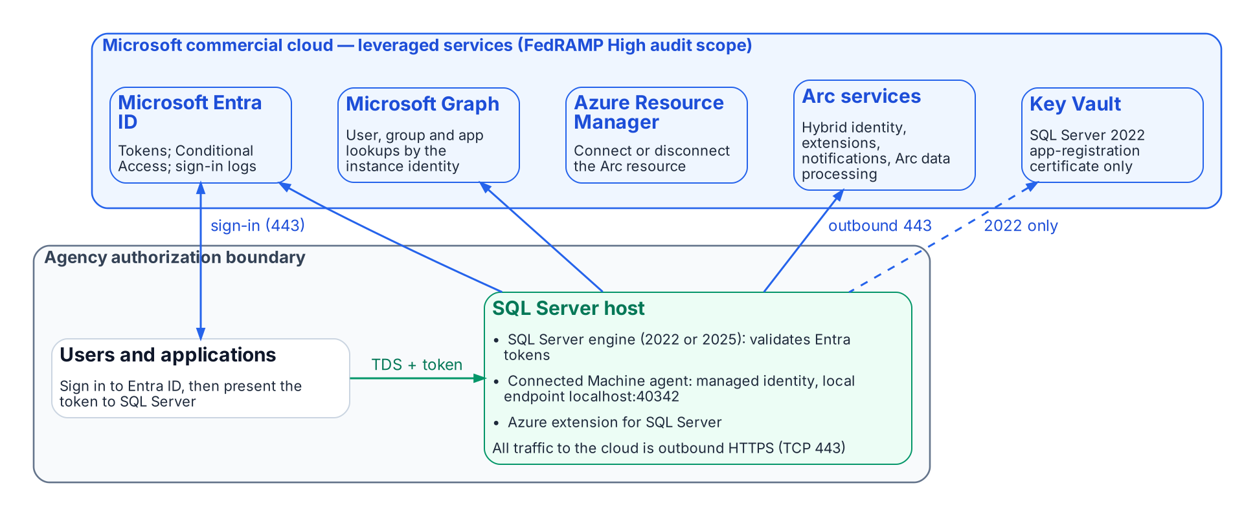
What runs inside the agency boundary and what it reaches outside it.
The SQL Server host stays inside the boundary. What changes is that it now depends on leveraged cloud services: Microsoft Entra ID for tokens, Microsoft Graph for lookups of users, groups and applications, and the Azure Arc services for the agent and the SQL extension. The Connected Machine agent communicates outbound to Azure Arc over TCP port 443. Azure Private Link can carry the Arc service traffic, but “network traffic to Microsoft Entra ID and Azure Resource Manager doesn’t traverse the Azure Arc private link scope and continues to use your default network route to the internet.” SQL Server itself connects directly to Microsoft Entra ID for authentication and doesn’t use the Arc agent’s proxy setting; if the host needs a proxy, Entra authentication uses the machine-level WinHTTP proxy.

Outbound endpoints
From Microsoft’s network requirements for the Connected Machine agent (Azure public cloud) and the prerequisites for SQL Server enabled by Azure Arc:
Endpoint | Purpose | When required
download.microsoft.com | Windows installation package | Installation only
login.microsoftonline.com | Global Microsoft Entra token endpoint (onboarding and fallback) | Always
*.login.microsoft.com | Regional Microsoft Entra token endpoints | Always
pas.windows.net | Microsoft Entra ID | Always
management.azure.com | Azure Resource Manager: create or delete the Arc server resource | Connect or disconnect only
*.his.arc.azure.com | Metadata and hybrid identity services | Always
*.guestconfiguration.azure.com | Extension management and guest configuration | Always
guestnotificationservice.azure.com, *.guestnotificationservice.azure.com | Notification service | Always
azgn*.servicebus.windows.net or *.servicebus.windows.net | Notification service | Always
*.<region>.arcdataservices.com | Arc data processing service for Arc-enabled SQL Server (TLS 1.2 or 1.3 only) | If Arc-enabled SQL Server is used
login.microsoftonline.com, login.microsoft.com, enterpriseregistration.windows.net, graph.microsoft.com, <key-vault-name>.vault.azure.net | Microsoft Entra authentication with Arc-enabled SQL Server; the Key Vault endpoint only where a certificate is used (SQL Server 2022) | If Microsoft Entra authentication is used
Use Microsoft’s pages, not this table, as the firewall source of truth: they list optional endpoints (Windows Admin Center, SSH, ESU certificates, license validation) and change over time.

FedRAMP audit scope of each leveraged service
Microsoft’s compliance-scope page lists each of these Azure public-cloud services as in scope for FedRAMP High (page dated September 21, 2026):
Service | Role in this design | FedRAMP High (Azure public)
Microsoft Entra ID (P1 + P2) and Microsoft Entra multifactor authentication | Tokens, Conditional Access, MFA, sign-in logs | ✅
Microsoft Entra ID Governance | PIM for Groups, access reviews (Chapters 16–17) | ✅
Microsoft Graph | Instance-identity lookups | ✅
Azure Arc-enabled servers | Connected Machine agent, managed identity | ✅
Azure Arc-enabled SQL Server | Azure extension for SQL Server | ✅
Azure Resource Manager | Arc resources | ✅
Key Vault | SQL Server 2022 certificate | ✅
Azure Monitor (incl. Log Analytics) | Telemetry (Chapters 20–21) | ✅
Microsoft Defender for Cloud | Defender for SQL (Chapters 20–21) | ✅
Microsoft Intune | Cloud PKI, an Intune add-on (Chapter 22) | ✅
An audit-scope listing is not the agency’s authorization. Leveraging a provider authorization still needs the agency’s own review of the package and of customer responsibilities, and the decision stays with the authorizing official.

Graph permissions for each machine identity

What is required
“Each system-assigned managed identity requires User.Read.All, GroupMember.Read.All, and Application.Read.All permissions to query Microsoft Graph.” They are application permissions (app roles) that “must be assigned directly to each managed identity” and “can’t be manually assigned to a Microsoft Entra security group.” Only a Privileged Role Administrator or higher can grant them. The SQL Server 2022 app-registration setup documents either Directory.Read.All or the narrower set Application.Read.All, Group.Read.All and User.Read.All; choose the narrower set.

Least-privilege justification
- User.Read.All resolves the Entra users that CREATE LOGIN … FROM EXTERNAL PROVIDER names and that connect.
- GroupMember.Read.All resolves group membership for type-X (group) logins, which is how Chapters 16–17 grant access.
- Application.Read.All resolves service principals and managed identities that connect as applications (Chapters 18–19).
- All three are read-only. None grants write access to the directory.

Why not Directory Readers
Microsoft offers assigning the Directory Readers role to a role-assignable group as an alternative for many machines, but notes that it “grants broad read access across all directory objects, significantly exceeding the three targeted Graph API permissions,” and that it “isn’t recommended for production environments where least-privilege access is required.” Grant the three app roles to each identity with a script, and review the grants with the rest of the access reviews.

Token folder and BULK permissions
Microsoft documents that “OPENROWSET BULK operations can also read the tokens folder C:\ProgramData\AzureConnectedMachineAgent\Tokens\,” and that the ADMINISTER BULK OPERATIONS and ADMINISTER DATABASE BULK OPERATIONS permissions “should be treated as equivalent to sysadmin.” The mitigation:
- Grant either permission only to principals that already hold sysadmin, and record any exception in the exception registry.
- Include both permissions in the audit’s privileged-permission report and in SQL Server Audit, alongside sysadmin membership.
- The agent’s local identity endpoint requires the caller to be in the local Administrators group or the Hybrid Agent Extension Applications group, so manage those memberships as privileged.

Break-glass design
Failure | Design
Entra ID or Graph unreachable | Entra logins can’t authenticate. Keep one documented break-glass path: a Windows group holding sysadmin, empty by default, in the exception registry, with every membership change and every login alerting.
Every sysadmin path lost | Microsoft documents starting the instance in single-user mode; any member of the computer’s local Administrators group can then connect as a member of sysadmin. That is why local Administrators membership on SQL hosts is itself privileged.
Tenant-side lockout | Follow Microsoft’s emergency-access account guidance for the Entra tenant.
Pressure to turn Entra authentication off | Microsoft states that once Entra authentication is enabled with a managed identity, disabling it isn’t advisable, and forcibly deleting registry entries can cause unpredictable behavior. Recover through the paths above instead.

Licensing bill of materials
List prices change and agreements differ, so this table names the license each capability needs, not its price.
Chapters | Capability | License | Source
03–08 | Arc inventory and the audit | SQL Server license; Arc’s client connection summary needs Software Assurance, a SQL Server subscription or pay-as-you-go
09–12 | Entra authentication on the engine | Available with “License only”: no Software Assurance or pay-as-you-go needed
09–10 | SQL Server 2022 certificate | Azure Key Vault (consumption)
11–12, 16–17, 20–21 | Conditional Access (MFA, device, location, risk) | Microsoft Entra ID P1
16–17 | Dynamic membership groups | Microsoft Entra ID P1 for each unique member
16–17 | PIM for Groups | Microsoft Entra ID P2, or a tier that includes it (Microsoft Entra ID Governance, Microsoft Entra Suite)
16–17 | Access reviews | Microsoft Entra ID Governance or Microsoft Entra Suite; some capabilities work with Microsoft Entra ID P2
20–21 | Defender for SQL servers on machines | A Microsoft Defender for Cloud plan
20–21 | Log Analytics | Azure Monitor (consumption) | —
22 | Microsoft Cloud PKI | A subscription in addition to Intune Plan 1 or Plan 2, standalone or in the Intune Suite; issues only to Intune-enrolled devices

Continue the book
← Previous: Appendix A — Requirements Mapping · Book index · Next: Appendix C — Applicability →

Appendix C — Applicability
Read this before Chapter 01: the engine-side steps depend on a cloud, a version and a topology that not every estate has.

In this appendix
The cloud, SQL Server version, operating system and topology the book assumes; the environments where it doesn’t apply as written and what still applies there; the Entra-without-Arc and re-platforming alternatives; and the protections an out-of-scope server still gets.

Platform facts as of October 20, 2026
SQL Server enabled by Azure Arc changes month to month. Every platform fact on this page was checked against Microsoft Learn on October 20, 2026. Recheck the linked pages before you rely on them.

Where the book applies as written
The engine-side steps (Chapters 09–12 and 20–21) depend on Microsoft Entra authentication in SQL Server itself. The book applies as written where all of these hold:
Dimension | In scope | Source
Cloud | Microsoft’s commercial cloud, including GCC-Moderate tenants. SQL Server needs access to the Azure public cloud to use Entra authentication.
SQL Server version | SQL Server 2022 (app registration and Key Vault certificate) and SQL Server 2025 (Arc managed identity, which Microsoft recommends for 2025 and later).
Operating system | Windows. The managed-identity setup is supported only for Arc-enabled SQL Server 2025 on Windows Server.
Topology | Standalone instances and Always On availability groups.

Where it does not apply as written
Environment | What Microsoft documents | What still applies
GCC High and DoD (Azure Government) | SQL Server enabled by Azure Arc in Azure Government runs only in US Government Virginia, only on Windows, and offers only onboarding, inventory, licensing and billing, failover-cluster-instance management and ESU licenses; “all other features are not currently available.” Entra authentication is not among them. Microsoft Cloud PKI is available in GCC High but not DoD. | Chapters 01–08 (the case, consolidation and the audit), Chapters 14–15 (Kerberos repair and NTLM restriction) and the Entra-side work of Chapters 16–17: dynamic groups, PIM, access reviews and entitlement management are available in Azure Government. Chapters 09–12 and 20–21 do not apply until the engine side is available there.
Air-gapped or disconnected networks | Entra authentication needs outbound reach to Entra ID and Microsoft Graph, with or without Arc. Microsoft’s cloud-first identity guidance says apps that must work without an internet connection need to stay on premises. | Consolidation (Chapters 03–06), the audit (Chapters 07–08) and Kerberos hardening (Chapters 14–15).
Failover cluster instances (FCIs) | Entra authentication is not supported for SQL Server failover cluster instances. Arc can still onboard them and show them in its inventory. | Move the databases to an availability group, or keep the FCI on Kerberos with the fallback protections below, tracked as a named exception class.
SQL Server 2019 and older | Entra authentication needs SQL Server 2022 or later. Arc doesn’t onboard SQL Server 2012 or older at all. | The upgrade is a prerequisite and belongs to the consolidation plan of Chapters 05–06. Until then, Kerberos hardening only.
SQL Server on Linux | Entra authentication is documented for SQL Server 2022 and later on Linux, but connecting SQL Server on Linux to Arc is still in preview. The managed-identity path and Disable SQL Authentication are Windows-only on SQL Server 2025. | Treat Linux instances as their own exception class and verify each feature on Microsoft Learn before planning.

Alternatives
Entra authentication without Azure Arc. Microsoft documents a manual setup for SQL Server 2022 and later on Windows. You obtain a certificate, install adal.dll from the Microsoft OLE DB Driver for SQL Server, register an application, grant it Microsoft Graph permissions with admin consent, upload the certificate, and set the FederatedAuthentication registry values. The host still needs network access to login.windows.net, login.microsoftonline.com, graph.microsoft.com, graph.windows.net and database.windows.net. It suits agencies that won’t install the Arc agent, but you take on certificate rotation and configuration drift yourself. Microsoft documents only commercial-cloud endpoints for this method, so the book makes no claim that it works in Azure Government.
Re-platforming. For a data domain whose instances fall out of scope, the platform question (Chapter 23) is a legitimate alternative. The identity question follows the data to any platform.

Fallback protections for out-of-scope servers
An instance that can’t reach Entra authentication still benefits from most of the book:
- Consolidate first. Retiring the instance removes the problem (Chapter 06).
- Turn SQL authentication off where you can. Use Windows Authentication mode (SERVERPROPERTY('IsIntegratedSecurityOnly') = 1), disable and rename sa, and give every remaining SQL login an owner and a sunset date.
- Make Kerberos work and measure it. Register SPNs so connections negotiate Kerberos instead of falling back to NTLM, and confirm with sys.dm_exec_connections.auth_scheme from a client, because local connections use NTLM even when the SPN is correct (Chapter 14).
- Retire the weakest protocols. NTLMv1 is removed in Windows Server 2025, and NTLMv2, LANMAN and RC4 for Kerberos are deprecated. Use the enhanced NTLM auditing in Windows 11 version 24H2 and Windows Server 2025, which Microsoft extended to Windows Server 2022 and 2019 with updates released on or after October 13, 2026, to find what still uses NTLM.
- Least privilege through AD groups. Apply the one-group, one-role discipline of Chapter 16 with AD groups and recurring reviews.
- Third-party MFA for Kerberos and NTLM. If the agency evaluates a product that adds MFA to these protocols at the domain controller, treat it as a compensating control recorded in the exception registry, not as a destination (Chapter 12).

Continue the book
← Previous: Appendix B — Security-Approval (ATO) Kit · Book index

Microsoft Learn, “Choose an authentication mode” (SQL Server), https://learn.microsoft.com/en-us/sql/relational-databases/security/choose-an-authentication-mode?view=sql-server-ver17 (accessed Oct 20, 2026). Windows Authentication “is always available and can’t be disabled”; SQL Server doesn’t ask for the password or perform the identity validation; sa is created disabled under Windows Authentication mode.
Microsoft Learn, “Register a Service Principal Name for Kerberos connections,” https://learn.microsoft.com/en-us/sql/database-engine/configure-windows/register-a-service-principal-name-for-kerberos-connections?view=sql-server-ver17 (accessed Oct 20, 2026). SPN formats; the SPN maps to the account that started the service; “If a security token can’t be obtained, authentication uses NTLM”; authentication-defaults table; failed SPN registration is recorded in the error log; auth_scheme in sys.dm_exec_connections.
Microsoft Learn, “Choose an authentication mode” (SQL Server), https://learn.microsoft.com/en-us/sql/relational-databases/security/choose-an-authentication-mode?view=sql-server-ver17 (accessed Oct 20, 2026). Windows Authentication “is always available and can’t be disabled”; SQL Server doesn’t ask for the password or perform the identity validation; sa is created disabled under Windows Authentication mode.
Microsoft Learn, “Security Support Provider Interface Architecture,” https://learn.microsoft.com/en-us/windows-server/security/windows-authentication/security-support-provider-interface-architecture (accessed Oct 20, 2026). “The Kerberos protocol has been the default authentication protocol since Windows 2000.”
Microsoft Learn, “Microsoft NTLM” (Win32 security), https://learn.microsoft.com/en-us/windows/win32/secauthn/microsoft-ntlm (accessed Oct 20, 2026). Negotiate selects Kerberos unless it can’t be used by one of the systems involved.
Microsoft Learn, “Kerberos authentication overview in Windows Server,” https://learn.microsoft.com/en-us/windows-server/security/kerberos/kerberos-authentication-overview (accessed Oct 20, 2026).
Microsoft Learn, “Kerberos v5 Protocol” (COM security), https://learn.microsoft.com/en-us/windows/win32/com/kerberos-v5-protocol (accessed Oct 20, 2026). “The Kerberos protocol requires mutual authentication.”
Microsoft Learn, “Register a Service Principal Name for Kerberos connections,” https://learn.microsoft.com/en-us/sql/database-engine/configure-windows/register-a-service-principal-name-for-kerberos-connections?view=sql-server-ver17 (accessed Oct 20, 2026). SPN formats; the SPN maps to the account that started the service; “If a security token can’t be obtained, authentication uses NTLM”; authentication-defaults table; failed SPN registration is recorded in the error log; auth_scheme in sys.dm_exec_connections.
Microsoft Learn, “Register a Service Principal Name for Kerberos connections,” https://learn.microsoft.com/en-us/sql/database-engine/configure-windows/register-a-service-principal-name-for-kerberos-connections?view=sql-server-ver17 (accessed Oct 20, 2026). SPN formats; the SPN maps to the account that started the service; “If a security token can’t be obtained, authentication uses NTLM”; authentication-defaults table; failed SPN registration is recorded in the error log; auth_scheme in sys.dm_exec_connections.
Microsoft Learn, “Register a Service Principal Name for Kerberos connections,” https://learn.microsoft.com/en-us/sql/database-engine/configure-windows/register-a-service-principal-name-for-kerberos-connections?view=sql-server-ver17 (accessed Oct 20, 2026). SPN formats; the SPN maps to the account that started the service; “If a security token can’t be obtained, authentication uses NTLM”; authentication-defaults table; failed SPN registration is recorded in the error log; auth_scheme in sys.dm_exec_connections.
Microsoft Learn, “Security Support Provider Interface Architecture,” https://learn.microsoft.com/en-us/windows-server/security/windows-authentication/security-support-provider-interface-architecture (accessed Oct 20, 2026). “The Kerberos protocol has been the default authentication protocol since Windows 2000.”
Microsoft Learn, “NTLM overview,” https://learn.microsoft.com/en-us/windows-server/security/kerberos/ntlm-overview (accessed Oct 20, 2026). The NTLM family includes LAN Manager v1 and v2 and NTLM v1 and v2; NTLM must be used for workgroup members; Kerberos is preferred in AD environments.
Microsoft Learn, “Passwords technical overview,” https://learn.microsoft.com/en-us/windows-server/security/kerberos/passwords-technical-overview (accessed Oct 20, 2026). Situations in which Kerberos can’t be used, including access by IP address and to computers in untrusted domains or outside the domain.
Microsoft Learn, “Kerberos SSP/AP,” https://learn.microsoft.com/en-us/windows/win32/secauthn/kerberos-ssp-ap (accessed Oct 20, 2026). “If a Kerberos KDC is not available, Windows uses MSV1_0 and pass-through authentication.”
Microsoft Learn, “Microsoft NTLM,” noninteractive authentication steps (client, server and domain controller), https://learn.microsoft.com/en-us/windows/win32/secauthn/microsoft-ntlm (accessed Oct 20, 2026).
Microsoft Learn, “What is Conditional Access?,” https://learn.microsoft.com/en-us/entra/identity/conditional-access/overview (accessed Oct 20, 2026). Conditional Access is Microsoft’s Zero Trust policy engine; policies are enforced after first-factor authentication completes.
Microsoft Learn, “What is Microsoft Entra ID Protection?,” https://learn.microsoft.com/en-us/entra/id-protection/overview-identity-protection (accessed Oct 20, 2026). “During each sign-in, ID Protection runs all real-time sign-in detections.”
Microsoft Learn, “Configure Windows service accounts and permissions” (SQL Server), https://learn.microsoft.com/en-us/sql/database-engine/configure-windows/configure-windows-service-accounts-and-permissions?view=sql-server-ver17 (accessed Oct 20, 2026). Virtual accounts NT SERVICE\<SERVICENAME> are the setup default and access the network with the computer account’s credentials; domain accounts require manual password management.
Microsoft Learn, “Service accounts” (Active Directory Domain Services), https://learn.microsoft.com/en-us/windows-server/identity/ad-ds/manage/understand-service-accounts (accessed Oct 20, 2026). The domain controller computes and manages the gMSA password; “The default interval is 30 days,” settable only at creation.
Microsoft Learn, “Configure Windows service accounts and permissions” (SQL Server), https://learn.microsoft.com/en-us/sql/database-engine/configure-windows/configure-windows-service-accounts-and-permissions?view=sql-server-ver17 (accessed Oct 20, 2026). Virtual accounts NT SERVICE\<SERVICENAME> are the setup default and access the network with the computer account’s credentials; domain accounts require manual password management.
Microsoft Learn, “Managed identity for SQL Server enabled by Azure Arc,” https://learn.microsoft.com/en-us/sql/sql-server/azure-arc/managed-identity?view=sql-server-ver17 (accessed Oct 20, 2026). Applies to SQL Server 2025; a system-assigned managed identity is created when the instance is connected to Arc; recommended for SQL Server 2025 and later.
Microsoft Learn, “Tutorial: Set up Microsoft Entra authentication for SQL Server enabled by Azure Arc,” https://learn.microsoft.com/en-us/sql/sql-server/azure-arc/entra-authentication-setup-tutorial?view=sql-server-ver17 (accessed Oct 20, 2026). SQL Server 2022 uses a certificate stored in Azure Key Vault that the Arc agent downloads to the host, with an app registration.
Microsoft Learn, “Choose an authentication mode” (SQL Server), https://learn.microsoft.com/en-us/sql/relational-databases/security/choose-an-authentication-mode?view=sql-server-ver17 (accessed Oct 20, 2026). Windows Authentication “is always available and can’t be disabled”; SQL Server doesn’t ask for the password or perform the identity validation; sa is created disabled under Windows Authentication mode.
Microsoft Learn, “Choose an authentication mode” (SQL Server), https://learn.microsoft.com/en-us/sql/relational-databases/security/choose-an-authentication-mode?view=sql-server-ver17 (accessed Oct 20, 2026). Windows Authentication “is always available and can’t be disabled”; SQL Server doesn’t ask for the password or perform the identity validation; sa is created disabled under Windows Authentication mode.
Microsoft Learn, “Change server authentication mode,” https://learn.microsoft.com/en-us/sql/database-engine/configure-windows/change-server-authentication-mode?view=sql-server-ver17 (accessed Oct 20, 2026).
Microsoft Learn, “What is Conditional Access?,” https://learn.microsoft.com/en-us/entra/identity/conditional-access/overview (accessed Oct 20, 2026). Common signals (user, IP location, device, application, real-time and calculated risk) and decisions (block, or grant with MFA, compliant device and other controls).
Office of Management and Budget, M-22-09, Moving the U.S. Government Toward Zero Trust Cybersecurity Principles, January 26, 2022, https://www.whitehouse.gov/wp-content/uploads/2022/01/M-22-09.pdf (accessed Oct 20, 2026). §III.A, Identity, actions 2 and 3: “MFA must be enforced at the application layer, instead of the network layer”; phishing-resistant MFA required for agency staff, contractors and partners; at least one device-level signal alongside identity information.
National Institute of Standards and Technology, SP 800-53 Rev. 5, Security and Privacy Controls for Information Systems and Organizations, AC-17 Remote Access and IA-2 Identification and Authentication (Organizational Users), https://nvlpubs.nist.gov/nistpubs/SpecialPublications/NIST.SP.800-53r5.pdf (accessed Oct 20, 2026). The mapping of the program’s controls to these identifiers is the program’s own.
Microsoft Learn, “Deprecated features for Windows client,” NTLM entry, https://learn.microsoft.com/en-us/windows/whats-new/deprecated-features (accessed Oct 20, 2026). “All versions of NTLM, including LANMAN, NTLMv1, and NTLMv2, are no longer under active feature development and are deprecated”; deprecation announced June 2024.
Microsoft Learn, “Features removed or no longer developed in Windows Server,” https://learn.microsoft.com/en-us/windows-server/get-started/removed-deprecated-features-windows-server (accessed Oct 20, 2026). Windows Server 2025: NTLMv1 removed; “NTLMv2 will continue to work but will be removed from Windows Server in a future release.”
Microsoft Windows IT Pro Blog, “Retiring NTLM: Frequently asked questions,” September 9, 2026, https://techcommunity.microsoft.com/blog/windows-itpro-blog/retiring-ntlm-frequently-asked-questions/4550522 (accessed Oct 20, 2026). “Our current target for default disablement is the next major release of Server and Client (subject to change)”; NTLM is being disabled by default, not removed; in-market versions continue to support NTLM; enhanced NTLM auditing on Windows 11 24H2/25H2 and Windows Server 2025.
Microsoft Support, “Upcoming changes to NTLMv1 in Windows 11, version 24H2 and Windows Server 2025” (KB5066470), https://support.microsoft.com/help/5066470 (accessed Oct 20, 2026). Audit mode since the August 2025 updates; Enforce becomes the internal default in October 2026 where the value isn’t set and Credential Guard is disabled; scope is NTLMv1-derived credentials for single sign-on (MS-CHAPv2).
Microsoft Learn, “How to enable NTLM 2 authentication,” https://learn.microsoft.com/en-us/troubleshoot/windows-client/windows-security/enable-ntlm-2-authentication (accessed Oct 20, 2026). LMCompatibilityLevel level 5: domain controllers refuse LM and NTLM responses and accept only NTLMv2.
Microsoft Learn, “Register a Service Principal Name for Kerberos connections,” https://learn.microsoft.com/en-us/sql/database-engine/configure-windows/register-a-service-principal-name-for-kerberos-connections?view=sql-server-ver17 (accessed Oct 20, 2026).
Microsoft Learn, “Windows Server 2016” (Microsoft Lifecycle), https://learn.microsoft.com/en-us/lifecycle/products/windows-server-2016 (accessed Oct 20, 2026). Extended support ends January 12, 2027 (listed as 1/13/2027 6:59:59 AM Pacific).
Microsoft Learn, “SQL Server 2014” (Microsoft Lifecycle), https://learn.microsoft.com/en-us/lifecycle/products/sql-server-2014 (accessed Oct 20, 2026). Extended support ended July 9, 2024; ESU Year 3 runs to July 2027.
Microsoft Learn, “SQL Server 2016” (Microsoft Lifecycle), https://learn.microsoft.com/en-us/lifecycle/products/sql-server-2016 (accessed Oct 20, 2026). Extended support ended July 14, 2026; ESU Year 1 runs to July 2027, Year 3 to July 2029.
Microsoft Learn, “SQL Server 2017” (Microsoft Lifecycle), https://learn.microsoft.com/en-us/lifecycle/products/sql-server-2017 (accessed Oct 20, 2026). Extended support ends October 12, 2027 (listed as 10/13/2027 6:59:59 AM Pacific).
Microsoft Learn, “Microsoft Entra authentication for SQL Server,” https://learn.microsoft.com/en-us/sql/relational-databases/security/authentication-access/azure-ad-authentication-sql-server-overview?view=sql-server-ver17 (accessed Oct 20, 2026). Applies to SQL Server 2022 and later; failover cluster instances aren’t supported.
Microsoft Learn, “What is Conditional Access?,” https://learn.microsoft.com/en-us/entra/identity/conditional-access/overview (accessed Oct 20, 2026). Common signals (user, IP location, device, application, real-time and calculated risk) and decisions (block, or grant with MFA, compliant device and other controls).
Microsoft Learn, “What is Microsoft Entra ID Protection?,” https://learn.microsoft.com/en-us/entra/id-protection/overview-identity-protection (accessed Oct 20, 2026). Detections include anonymous IP address usage; risk feeds Conditional Access.
Microsoft Learn, “Risk-based access policies,” https://learn.microsoft.com/en-us/entra/id-protection/concept-identity-protection-policies (accessed Oct 20, 2026). “Microsoft Entra ID P2 is required to use risk-based access policies.”
Microsoft Learn, “Service accounts” (Active Directory Domain Services), https://learn.microsoft.com/en-us/windows-server/identity/ad-ds/manage/understand-service-accounts (accessed Oct 20, 2026).
Microsoft Learn, “Microsoft Entra cloud-first identity guidance for IT architects,” https://learn.microsoft.com/en-us/entra/identity/hybrid/guidance-it-architects-source-of-authority (accessed Oct 20, 2026). “Always begin with an application inventory before initiating SOA transfer”; inventory all on-premises apps that use AD for authentication (Kerberos/NTLM or LDAP).
Microsoft Learn, “Azure Arc-enabled servers overview,” https://learn.microsoft.com/en-us/azure/azure-arc/servers/overview (accessed Oct 20, 2026).
Microsoft Learn, “Managed identity for SQL Server enabled by Azure Arc,” https://learn.microsoft.com/en-us/sql/sql-server/azure-arc/managed-identity?view=sql-server-ver17 (accessed Oct 20, 2026).
Microsoft Learn, “Tutorial: Set up Microsoft Entra authentication for SQL Server enabled by Azure Arc,” https://learn.microsoft.com/en-us/sql/sql-server/azure-arc/entra-authentication-setup-tutorial?view=sql-server-ver17 (accessed Oct 20, 2026).
Microsoft Learn, “Tutorial: Enable Microsoft Entra authentication for SQL Server on Windows without Azure Arc,” https://learn.microsoft.com/en-us/sql/relational-databases/security/authentication-access/microsoft-entra-authentication-sql-server-enable-without-arc?view=sql-server-ver17 (accessed Oct 20, 2026). Applies to SQL Server 2022 and later; certificate, app registration and registry configuration.
Microsoft Learn, “SQL Server end of support options,” https://learn.microsoft.com/en-us/sql/sql-server/end-of-support/sql-server-end-of-support-overview?view=sql-server-ver17 (accessed Oct 20, 2026). Lifecycle table; ESUs deliver Critical security updates for up to three years past end of support and require Software Assurance or subscription licenses. Earlier releases: Microsoft Learn, “Microsoft SQL Server 2008 R2,” https://learn.microsoft.com/en-us/lifecycle/products/microsoft-sql-server-2008-r2, and “Microsoft SQL Server 2012,” https://learn.microsoft.com/en-us/lifecycle/products/microsoft-sql-server-2012 (both accessed Oct 20, 2026); extended support ended July 9, 2019 and July 12, 2022, and their last ESU years ended in 2023 and July 2025.
Microsoft Learn, “SQL Server 2016” (Microsoft Lifecycle), https://learn.microsoft.com/en-us/lifecycle/products/sql-server-2016 (accessed Oct 20, 2026). Extended support ended July 14, 2026; ESU years run to July 2029. SQL Server 2014’s extended support ended July 9, 2024, and its ESU Year 3 runs to July 2027: “SQL Server 2014,” https://learn.microsoft.com/en-us/lifecycle/products/sql-server-2014 (accessed Oct 20, 2026).
Microsoft Learn, “SQL Server 2017” (Microsoft Lifecycle), https://learn.microsoft.com/en-us/lifecycle/products/sql-server-2017 (accessed Oct 20, 2026).
Microsoft Learn, “Microsoft Entra cloud-first identity guidance for IT architects,” https://learn.microsoft.com/en-us/entra/identity/hybrid/guidance-it-architects-source-of-authority (accessed Oct 20, 2026). “Always begin with an application inventory before initiating SOA transfer.”
Microsoft Learn, “SQL Server Browser service (Database Engine and SSAS),” https://learn.microsoft.com/en-us/sql/database-engine/configure-windows/sql-server-browser-service-database-engine-and-ssas?view=sql-server-ver17 (accessed Oct 20, 2026). TCP 1433 for the default instance; named instances and Express use dynamic ports by default; Browser claims UDP 1434. See also Microsoft Learn, “Configure the Windows Firewall to allow SQL Server access,” https://learn.microsoft.com/en-us/sql/sql-server/install/configure-the-windows-firewall-to-allow-sql-server-access?view=sql-server-ver17 (accessed Oct 20, 2026).
dbatools, “Find-DbaInstance,” https://dbatools.io/Find-DbaInstance.html (accessed Oct 20, 2026). Discovery types DomainSPN, Domain/DomainServer, DataSourceEnumeration and IPRange; scan types Browser, SQLService, SPN, TCPPort, DNSResolve, Ping and SqlConnect.
Microsoft Learn, “Register a Service Principal Name for Kerberos connections,” https://learn.microsoft.com/en-us/sql/database-engine/configure-windows/register-a-service-principal-name-for-kerberos-connections?view=sql-server-ver17 (accessed Oct 20, 2026). Automatic registration at startup when the service account has permission; otherwise manual registration with setspn.
Microsoft Learn, “Setspn,” https://learn.microsoft.com/en-us/previous-versions/windows/it-pro/windows-server-2012-R2-and-2012/cc731241(v=ws.11) (accessed Oct 20, 2026). -Q queries for SPNs; -F performs queries “at the forest, rather than domain level”; -T targets a domain or forest (example: setspn -T contoso -F -Q */daserver).
Microsoft Learn, “Discover installed software inventory, web apps, and database instances” (Azure Migrate), https://learn.microsoft.com/en-us/azure/migrate/how-to-discover-applications (accessed Oct 20, 2026). SQL Server instance and database discovery across VMware, Hyper-V and physical servers; configuration data refreshed every 24 hours and performance data every 30 seconds.
Microsoft Learn, “Dependency analysis” (Azure Migrate), https://learn.microsoft.com/en-us/azure/migrate/concepts-dependency-visualization (accessed Oct 20, 2026). Agentless analysis captures TCP connection data; supported in Azure Public Cloud and Azure Government; agent-based analysis is classic-view only.
Microsoft Learn, “Migrate from SQL Server: Pre-migration,” https://learn.microsoft.com/en-us/data-migration/sql-server/pre-migration (accessed Oct 20, 2026). Discover phase tools: Azure Migrate and the MAP Toolkit.
Microsoft Learn, “Overview of Data Migration Assistant,” https://learn.microsoft.com/en-us/sql/dma/dma-overview?view=sql-server-ver17 (accessed Oct 20, 2026). “Data Migration Assistant (DMA) is retired from July 16, 2025.”
Microsoft Learn, “Upgrade SQL Server using the migration component in SSMS,” https://learn.microsoft.com/en-us/ssms/migrate/upgrade-sql-server (accessed Oct 20, 2026). Finds compatibility issues (breaking changes, behavior changes, deprecated features) when upgrading to a later SQL Server version.
Microsoft Learn, “Migrate with the link - Azure SQL Managed Instance,” Assess and discover, https://learn.microsoft.com/en-us/azure/azure-sql/managed-instance/managed-instance-link-migrate?view=azuresql (accessed Oct 20, 2026). “SQL Server enabled by Azure Arc automatically produces an assessment for migration to Azure.”
Microsoft Learn, “Discover installed software inventory, web apps, and database instances” (Azure Migrate), https://learn.microsoft.com/en-us/azure/migrate/how-to-discover-applications (accessed Oct 20, 2026).
Microsoft Learn, “CREATE LOGIN (Transact-SQL),” FROM EXTERNAL PROVIDER argument, https://learn.microsoft.com/en-us/sql/t-sql/statements/create-login-transact-sql?view=sql-server-ver17 (accessed Oct 20, 2026). “Specifies that the login is mapped to a Microsoft Entra principal. This option is available for Arc-enabled SQL Server 2022 and later versions.”
Microsoft Learn, “Microsoft Entra authentication for SQL Server,” https://learn.microsoft.com/en-us/sql/relational-databases/security/authentication-access/azure-ad-authentication-sql-server-overview?view=sql-server-ver17 (accessed Oct 20, 2026). Applies to SQL Server 2022 and later; Microsoft also documents a setup without Arc.
Microsoft Learn, “SQL Server end of support options,” lifecycle dates, https://learn.microsoft.com/en-us/sql/sql-server/end-of-support/sql-server-end-of-support-overview?view=sql-server-ver17 (accessed Oct 20, 2026). SQL Server 2016’s extended support ended July 14, 2026: “SQL Server 2016,” https://learn.microsoft.com/en-us/lifecycle/products/sql-server-2016 (accessed Oct 20, 2026).
Microsoft Learn, “Microsoft SQL Server 2012” (Microsoft Lifecycle), https://learn.microsoft.com/en-us/lifecycle/products/microsoft-sql-server-2012 (accessed Oct 20, 2026). Extended support ended July 12, 2022; ESU Year 3 ended July 2025.
Microsoft Learn, “Upgrade SQL Server,” https://learn.microsoft.com/en-us/sql/database-engine/install-windows/upgrade-sql-server?view=sql-server-ver17 (accessed Oct 20, 2026). SQL Server 2012 through 2019 can be upgraded directly to SQL Server 2022; 2008 and 2008 R2 need a side-by-side upgrade or a migration.
Microsoft Learn, “Supported version and edition upgrades (SQL Server 2025),” https://learn.microsoft.com/en-us/sql/database-engine/install-windows/supported-version-and-edition-upgrades-2025?view=sql-server-ver17 (accessed Oct 20, 2026). Upgrade from SQL Server 2014 SP3 or later, 2016 SP3 or later, 2017, 2019 and 2022.
Microsoft Learn, “sys.linked_logins (Transact-SQL),” https://learn.microsoft.com/en-us/sql/relational-databases/system-catalog-views/sys-linked-logins-transact-sql?view=sql-server-ver17 (accessed Oct 20, 2026).
Microsoft Learn, “Dependency analysis” (Azure Migrate), https://learn.microsoft.com/en-us/azure/migrate/concepts-dependency-visualization (accessed Oct 20, 2026).
Microsoft Learn, “Upgrade SQL Server using the migration component in SSMS,” https://learn.microsoft.com/en-us/ssms/migrate/upgrade-sql-server (accessed Oct 20, 2026). The successor to the Data Migration Assistant, retired July 16, 2025 (Microsoft Learn, “Overview of Data Migration Assistant,” https://learn.microsoft.com/en-us/sql/dma/dma-overview?view=sql-server-ver17, accessed Oct 20, 2026).
Microsoft Learn, “Microsoft Entra authentication for SQL Server,” https://learn.microsoft.com/en-us/sql/relational-databases/security/authentication-access/azure-ad-authentication-sql-server-overview?view=sql-server-ver17 (accessed Oct 20, 2026). Supported for standalone instances and Always On availability groups; “SQL Server failover cluster instances do not currently support Microsoft Entra authentication.”
Microsoft Learn, “SQL Server end of support options,” https://learn.microsoft.com/en-us/sql/sql-server/end-of-support/sql-server-end-of-support-overview?view=sql-server-ver17 (accessed Oct 20, 2026). SQL Managed Instance “closely matches the features of an on-premises instance of SQL Server, such as cross-database queries, transactional replication publishing and distribution, SQL job scheduling, and CLR support,” with T-SQL differences and a 32 TB combined storage limit; Azure SQL Database applications using cross-database queries, linked servers or Agent jobs “might require changes.”
Microsoft Learn, “SQL Server end of support options,” https://learn.microsoft.com/en-us/sql/sql-server/end-of-support/sql-server-end-of-support-overview?view=sql-server-ver17 (accessed Oct 20, 2026). SQL Managed Instance “closely matches the features of an on-premises instance of SQL Server, such as cross-database queries, transactional replication publishing and distribution, SQL job scheduling, and CLR support,” with T-SQL differences and a 32 TB combined storage limit; Azure SQL Database applications using cross-database queries, linked servers or Agent jobs “might require changes.”
Microsoft Learn, “Microsoft Entra-only authentication with Azure SQL,” https://learn.microsoft.com/en-us/azure/azure-sql/database/authentication-azure-ad-only-authentication?view=azuresql (accessed Oct 20, 2026). Supported for Azure SQL Database and Azure SQL Managed Instance; disables SQL authentication, including for server administrators.
Microsoft Learn, “Connected Machine agent prerequisites,” supported operating systems, https://learn.microsoft.com/azure/azure-arc/servers/prerequisites#supported-operating-systems (accessed Oct 20, 2026).
Microsoft Learn, “Prerequisites — SQL Server enabled by Azure Arc,” supported configurations, https://learn.microsoft.com/sql/sql-server/azure-arc/prerequisites (accessed Oct 20, 2026).
Microsoft Learn, “Microsoft Entra authentication for SQL Server,” https://learn.microsoft.com/sql/relational-databases/security/authentication-access/azure-ad-authentication-sql-server-overview (accessed Oct 20, 2026).
Microsoft Learn, “Managed identity for SQL Server enabled by Azure Arc,” https://learn.microsoft.com/sql/sql-server/azure-arc/managed-identity (accessed Oct 20, 2026).
Microsoft Learn, “Ending Support in 2027,” https://learn.microsoft.com/lifecycle/end-of-support/end-of-support-2027 (accessed Oct 20, 2026).
Microsoft Learn, “Sign in to an Azure Arc-enabled server using Microsoft Entra ID and Azure Roles Based Access Control,” https://learn.microsoft.com/entra/identity/devices/howto-arc-sign-in-windows (accessed Oct 20, 2026).
Microsoft Learn, “Change server authentication mode,” https://learn.microsoft.com/sql/database-engine/configure-windows/change-server-authentication-mode (accessed Oct 20, 2026).
Microsoft Learn, “Choose an authentication mode,” https://learn.microsoft.com/sql/relational-databases/security/choose-an-authentication-mode (accessed Oct 20, 2026).
Microsoft Learn, “Microsoft Entra authentication for SQL Server,” https://learn.microsoft.com/sql/relational-databases/security/authentication-access/azure-ad-authentication-sql-server-overview (accessed Oct 20, 2026).
Microsoft Learn, “Change server authentication mode,” https://learn.microsoft.com/sql/database-engine/configure-windows/change-server-authentication-mode (accessed Oct 20, 2026).
Microsoft Learn, “Tutorial: Enable Microsoft Entra authentication for SQL Server on Windows without Azure Arc,” registry path format, https://learn.microsoft.com/sql/relational-databases/security/authentication-access/microsoft-entra-authentication-sql-server-enable-without-arc (accessed Oct 20, 2026).
Microsoft Learn, “Change server authentication mode,” https://learn.microsoft.com/sql/database-engine/configure-windows/change-server-authentication-mode (accessed Oct 20, 2026).
Microsoft Learn, “Disable SQL authentication for SQL Server enabled by Azure Arc,” https://learn.microsoft.com/sql/sql-server/azure-arc/disable-sql-authentication (accessed Oct 20, 2026).
Microsoft Learn, “sys.server_principals (Transact-SQL),” https://learn.microsoft.com/sql/relational-databases/system-catalog-views/sys-server-principals-transact-sql (accessed Oct 20, 2026).
Microsoft Learn, “CREATE LOGIN (Transact-SQL),” https://learn.microsoft.com/sql/t-sql/statements/create-login-transact-sql (accessed Oct 20, 2026).
Microsoft Learn, “Group Managed Service Accounts overview,” https://learn.microsoft.com/windows-server/identity/ad-ds/manage/group-managed-service-accounts/group-managed-service-accounts/group-managed-service-accounts-overview (accessed Oct 20, 2026).
Microsoft Learn, “Register a Service Principal Name for Kerberos connections,” https://learn.microsoft.com/sql/database-engine/configure-windows/register-a-service-principal-name-for-kerberos-connections (accessed Oct 20, 2026).
Microsoft Learn, “Register a Service Principal Name for Kerberos connections,” https://learn.microsoft.com/sql/database-engine/configure-windows/register-a-service-principal-name-for-kerberos-connections (accessed Oct 20, 2026).
Microsoft Learn, “Register a Service Principal Name for Kerberos connections,” https://learn.microsoft.com/sql/database-engine/configure-windows/register-a-service-principal-name-for-kerberos-connections (accessed Oct 20, 2026).
Microsoft Learn, “SQL Server enabled by Azure Arc” (overview), https://learn.microsoft.com/sql/sql-server/azure-arc/overview (accessed Oct 20, 2026).
Microsoft Learn, “Microsoft Entra authentication for SQL Server,” https://learn.microsoft.com/sql/relational-databases/security/authentication-access/azure-ad-authentication-sql-server-overview (accessed Oct 20, 2026).
Microsoft Learn, “Microsoft Entra authentication for SQL Server,” https://learn.microsoft.com/sql/relational-databases/security/authentication-access/azure-ad-authentication-sql-server-overview (accessed Oct 20, 2026).
Microsoft Learn, “Linked server for SQL Server with Microsoft Entra authentication,” https://learn.microsoft.com/sql/relational-databases/security/authentication-access/azure-ad-authentication-sql-server-linked-server (accessed Oct 20, 2026).
Microsoft Learn, “SQL Server enabled by Azure Arc” (overview), https://learn.microsoft.com/sql/sql-server/azure-arc/overview (accessed Oct 20, 2026).
Microsoft Learn, “Register a Service Principal Name for Kerberos connections,” https://learn.microsoft.com/sql/database-engine/configure-windows/register-a-service-principal-name-for-kerberos-connections (accessed Oct 20, 2026).
Microsoft Learn, “What is Azure Arc-enabled servers?,” https://learn.microsoft.com/azure/azure-arc/servers/overview (accessed Oct 20, 2026).
Microsoft Learn, “Deployment options for SQL Server enabled by Azure Arc,” https://learn.microsoft.com/sql/sql-server/azure-arc/deployment-options (accessed Oct 20, 2026).
Microsoft Learn, “CREATE LOGIN (Transact-SQL),” FROM EXTERNAL PROVIDER, https://learn.microsoft.com/sql/t-sql/statements/create-login-transact-sql (accessed Oct 20, 2026).
Microsoft Learn, “Microsoft Entra authentication for SQL Server,” https://learn.microsoft.com/sql/relational-databases/security/authentication-access/azure-ad-authentication-sql-server-overview (accessed Oct 20, 2026).
Microsoft Learn, “Microsoft Entra authentication for SQL Server,” https://learn.microsoft.com/sql/relational-databases/security/authentication-access/azure-ad-authentication-sql-server-overview (accessed Oct 20, 2026).
Microsoft Learn, “Features removed or no longer developed in Windows Server,” NTLM, https://learn.microsoft.com/windows-server/get-started/removed-deprecated-features-windows-server (accessed Oct 20, 2026); Microsoft Windows IT Pro Blog, “Advancing Windows security: Disabling NTLM by default,” January 29, 2026, https://techcommunity.microsoft.com/blog/windows-itpro-blog/advancing-windows-security-disabling-ntlm-by-default/4489526 (accessed Oct 20, 2026).
Microsoft Learn, “Microsoft Entra authentication for SQL Server,” https://learn.microsoft.com/sql/relational-databases/security/authentication-access/azure-ad-authentication-sql-server-overview (accessed Oct 20, 2026).
Microsoft Learn, “Sign in to an Azure Arc-enabled server using Microsoft Entra ID and Azure Roles Based Access Control,” https://learn.microsoft.com/entra/identity/devices/howto-arc-sign-in-windows (accessed Oct 20, 2026).
Microsoft Learn, “Microsoft Entra authentication for SQL Server,” https://learn.microsoft.com/sql/relational-databases/security/authentication-access/azure-ad-authentication-sql-server-overview (accessed Oct 20, 2026).
Microsoft Learn, “Managed identity for SQL Server enabled by Azure Arc,” https://learn.microsoft.com/sql/sql-server/azure-arc/managed-identity (accessed Oct 20, 2026).
Microsoft Learn, “Tutorial: Set up Microsoft Entra authentication for SQL Server enabled by Azure Arc,” https://learn.microsoft.com/sql/sql-server/azure-arc/entra-authentication-setup-tutorial (accessed Oct 20, 2026).
Microsoft Learn, “What is Azure Arc-enabled servers?,” https://learn.microsoft.com/azure/azure-arc/servers/overview (accessed Oct 20, 2026).
Microsoft Learn, “Access Azure resources by using managed identity on Azure Arc-enabled servers,” https://learn.microsoft.com/azure/azure-arc/servers/managed-identity-authentication (accessed Oct 20, 2026).
Microsoft Learn, “Identity and authorization” (Azure Arc-enabled servers security), Microsoft Entra ID managed identity, https://learn.microsoft.com/azure/azure-arc/servers/security-identity-authorization (accessed Oct 20, 2026).
Microsoft Learn, “Access Azure resources by using managed identity on Azure Arc-enabled servers,” https://learn.microsoft.com/azure/azure-arc/servers/managed-identity-authentication (accessed Oct 20, 2026).
Microsoft Learn, “SQL Server enabled by Azure Arc” (overview), feature availability and settings, https://learn.microsoft.com/sql/sql-server/azure-arc/overview (accessed Oct 20, 2026).
Microsoft Learn, “Microsoft Entra authentication for SQL Server,” https://learn.microsoft.com/sql/relational-databases/security/authentication-access/azure-ad-authentication-sql-server-overview (accessed Oct 20, 2026).
Microsoft Learn, “CREATE LOGIN (Transact-SQL),” https://learn.microsoft.com/sql/t-sql/statements/create-login-transact-sql (accessed Oct 20, 2026).
Microsoft Learn, “Sign in to an Azure Arc-enabled server using Microsoft Entra ID and Azure Roles Based Access Control,” https://learn.microsoft.com/entra/identity/devices/howto-arc-sign-in-windows (accessed Oct 20, 2026).
Microsoft Learn, “Sign in to an Azure Arc-enabled server using Microsoft Entra ID and Azure Roles Based Access Control,” https://learn.microsoft.com/entra/identity/devices/howto-arc-sign-in-windows (accessed Oct 20, 2026).
Microsoft Learn, “Managed identity for SQL Server enabled by Azure Arc,” https://learn.microsoft.com/sql/sql-server/azure-arc/managed-identity (accessed Oct 20, 2026).
Microsoft Learn, “Tutorial: Set up Microsoft Entra authentication for SQL Server enabled by Azure Arc,” https://learn.microsoft.com/sql/sql-server/azure-arc/entra-authentication-setup-tutorial (accessed Oct 20, 2026).
Microsoft Learn, “Managed identity for SQL Server enabled by Azure Arc,” https://learn.microsoft.com/sql/sql-server/azure-arc/managed-identity (accessed Oct 20, 2026).
Microsoft Learn, “Tutorial: Set up Microsoft Entra authentication for SQL Server enabled by Azure Arc,” https://learn.microsoft.com/sql/sql-server/azure-arc/entra-authentication-setup-tutorial (accessed Oct 20, 2026).
Microsoft Learn, “Tutorial: Using automation to set up the Microsoft Entra admin for SQL Server,” https://learn.microsoft.com/sql/relational-databases/security/authentication-access/azure-ad-authentication-sql-server-automation-setup-tutorial (accessed Oct 20, 2026).
Microsoft Learn, “Group Managed Service Accounts overview,” https://learn.microsoft.com/windows-server/identity/ad-ds/manage/group-managed-service-accounts/group-managed-service-accounts/group-managed-service-accounts-overview (accessed Oct 20, 2026).
Microsoft Learn, “Tutorial: Enable Microsoft Entra authentication for SQL Server on Windows without Azure Arc,” https://learn.microsoft.com/sql/relational-databases/security/authentication-access/microsoft-entra-authentication-sql-server-enable-without-arc (accessed Oct 20, 2026).
Microsoft Learn, “Overview of Microsoft Cloud PKI for Microsoft Intune,” https://learn.microsoft.com/intune/cloud-pki/ (accessed Oct 20, 2026).
Microsoft Learn, “SQL Server enabled by Azure Arc” (overview), feature availability and settings, https://learn.microsoft.com/sql/sql-server/azure-arc/overview (accessed Oct 20, 2026).
Microsoft Learn, “SQL Server enabled by Azure Arc in US Government,” available features, https://learn.microsoft.com/sql/sql-server/azure-arc/us-government-region (accessed Oct 20, 2026).
Microsoft Learn, “Managed identity for SQL Server enabled by Azure Arc,” https://learn.microsoft.com/sql/sql-server/azure-arc/managed-identity (accessed Oct 20, 2026).
Microsoft Learn, “Change server authentication mode,” https://learn.microsoft.com/sql/database-engine/configure-windows/change-server-authentication-mode (accessed Oct 20, 2026).
Microsoft Learn, “SQL Server enabled by Azure Arc” (overview), feature availability and settings, https://learn.microsoft.com/sql/sql-server/azure-arc/overview (accessed Oct 20, 2026).
Microsoft Learn, “What is Azure Arc-enabled servers?,” https://learn.microsoft.com/azure/azure-arc/servers/overview (accessed Oct 20, 2026).
Microsoft Learn, “SQL Server enabled by Azure Arc” (overview), architecture, supported versions and settings, https://learn.microsoft.com/sql/sql-server/azure-arc/overview (accessed Oct 20, 2026).
Microsoft Learn, “Prerequisites — SQL Server enabled by Azure Arc,” https://learn.microsoft.com/sql/sql-server/azure-arc/prerequisites (accessed Oct 20, 2026).
Microsoft Learn, “Tutorial: Set up Microsoft Entra authentication for SQL Server enabled by Azure Arc,” https://learn.microsoft.com/sql/sql-server/azure-arc/entra-authentication-setup-tutorial (accessed Oct 20, 2026).
Microsoft Learn, “Tutorial: Set up Microsoft Entra authentication for SQL Server enabled by Azure Arc,” https://learn.microsoft.com/sql/sql-server/azure-arc/entra-authentication-setup-tutorial (accessed Oct 20, 2026).
Microsoft Learn, “Prerequisites — SQL Server enabled by Azure Arc,” https://learn.microsoft.com/sql/sql-server/azure-arc/prerequisites (accessed Oct 20, 2026).
Microsoft Learn, “Prerequisites — SQL Server enabled by Azure Arc,” https://learn.microsoft.com/sql/sql-server/azure-arc/prerequisites (accessed Oct 20, 2026).
Microsoft Learn, “Deployment options for SQL Server enabled by Azure Arc,” https://learn.microsoft.com/sql/sql-server/azure-arc/deployment-options (accessed Oct 20, 2026).
Microsoft Learn, “Deployment options for SQL Server enabled by Azure Arc,” https://learn.microsoft.com/sql/sql-server/azure-arc/deployment-options (accessed Oct 20, 2026).
Microsoft Learn, “Prerequisites — SQL Server enabled by Azure Arc,” https://learn.microsoft.com/sql/sql-server/azure-arc/prerequisites (accessed Oct 20, 2026).
Microsoft Learn, “Deployment options for SQL Server enabled by Azure Arc,” https://learn.microsoft.com/sql/sql-server/azure-arc/deployment-options (accessed Oct 20, 2026).
Microsoft Learn, “SQL Server enabled by Azure Arc” (overview), architecture, supported versions and settings, https://learn.microsoft.com/sql/sql-server/azure-arc/overview (accessed Oct 20, 2026).
Microsoft Learn, “Prerequisites — SQL Server enabled by Azure Arc,” https://learn.microsoft.com/sql/sql-server/azure-arc/prerequisites (accessed Oct 20, 2026).
Microsoft Learn, “SQL Server enabled by Azure Arc” (overview), architecture, supported versions and settings, https://learn.microsoft.com/sql/sql-server/azure-arc/overview (accessed Oct 20, 2026).
Microsoft Learn, “Tutorial: Set up Microsoft Entra authentication for SQL Server enabled by Azure Arc,” https://learn.microsoft.com/sql/sql-server/azure-arc/entra-authentication-setup-tutorial (accessed Oct 20, 2026).
Microsoft Learn, “Set up managed identity and Microsoft Entra authentication for SQL Server enabled by Azure Arc,” https://learn.microsoft.com/sql/sql-server/azure-arc/microsoft-entra-authentication-with-managed-identity (accessed Oct 20, 2026).
Microsoft Learn, “Tutorial: Set up Microsoft Entra authentication for SQL Server enabled by Azure Arc,” https://learn.microsoft.com/sql/sql-server/azure-arc/entra-authentication-setup-tutorial (accessed Oct 20, 2026).
Microsoft Learn, “Set up managed identity and Microsoft Entra authentication for SQL Server enabled by Azure Arc,” https://learn.microsoft.com/sql/sql-server/azure-arc/microsoft-entra-authentication-with-managed-identity (accessed Oct 20, 2026).
Microsoft Learn, “Tutorial: Set up Microsoft Entra authentication for SQL Server enabled by Azure Arc,” https://learn.microsoft.com/sql/sql-server/azure-arc/entra-authentication-setup-tutorial (accessed Oct 20, 2026).
Microsoft Learn, “Set up managed identity and Microsoft Entra authentication for SQL Server enabled by Azure Arc,” https://learn.microsoft.com/sql/sql-server/azure-arc/microsoft-entra-authentication-with-managed-identity (accessed Oct 20, 2026).
Microsoft Learn, “Tutorial: Set up Microsoft Entra authentication for SQL Server enabled by Azure Arc,” https://learn.microsoft.com/sql/sql-server/azure-arc/entra-authentication-setup-tutorial (accessed Oct 20, 2026).
Microsoft Learn, “Tutorial: Using automation to set up the Microsoft Entra admin for SQL Server,” https://learn.microsoft.com/sql/relational-databases/security/authentication-access/azure-ad-authentication-sql-server-automation-setup-tutorial (accessed Oct 20, 2026).
Microsoft Learn, “Tutorial: Set up Microsoft Entra authentication for SQL Server enabled by Azure Arc,” https://learn.microsoft.com/sql/sql-server/azure-arc/entra-authentication-setup-tutorial (accessed Oct 20, 2026).
Microsoft Learn, “Tutorial: Using automation to set up the Microsoft Entra admin for SQL Server,” https://learn.microsoft.com/sql/relational-databases/security/authentication-access/azure-ad-authentication-sql-server-automation-setup-tutorial (accessed Oct 20, 2026).
Microsoft Learn, “Set up managed identity and Microsoft Entra authentication for SQL Server enabled by Azure Arc,” https://learn.microsoft.com/sql/sql-server/azure-arc/microsoft-entra-authentication-with-managed-identity (accessed Oct 20, 2026).
Microsoft Learn, “Tutorial: Set up Microsoft Entra authentication for SQL Server enabled by Azure Arc,” https://learn.microsoft.com/sql/sql-server/azure-arc/entra-authentication-setup-tutorial (accessed Oct 20, 2026).
Microsoft Learn, “Microsoft Entra authentication for SQL Server,” https://learn.microsoft.com/sql/relational-databases/security/authentication-access/azure-ad-authentication-sql-server-overview (accessed Oct 20, 2026).
Microsoft Learn, “Managed identity for SQL Server enabled by Azure Arc,” limitations, https://learn.microsoft.com/sql/sql-server/azure-arc/managed-identity (accessed Oct 20, 2026).
Microsoft Learn, “Tutorial: Set up Microsoft Entra authentication for SQL Server enabled by Azure Arc,” https://learn.microsoft.com/sql/sql-server/azure-arc/entra-authentication-setup-tutorial (accessed Oct 20, 2026).
Microsoft Learn, “Managed identity for SQL Server enabled by Azure Arc,” limitations, https://learn.microsoft.com/sql/sql-server/azure-arc/managed-identity (accessed Oct 20, 2026).
Microsoft Learn, “Access Azure resources by using managed identity on Azure Arc-enabled servers,” https://learn.microsoft.com/azure/azure-arc/servers/managed-identity-authentication (accessed Oct 20, 2026).
Microsoft Learn, “CREATE LOGIN (Transact-SQL),” https://learn.microsoft.com/sql/t-sql/statements/create-login-transact-sql (accessed Oct 20, 2026).
Microsoft Learn, “CREATE LOGIN (Transact-SQL),” https://learn.microsoft.com/sql/t-sql/statements/create-login-transact-sql (accessed Oct 20, 2026).
Microsoft Learn, “Tutorial: Set up Microsoft Entra authentication for SQL Server enabled by Azure Arc,” create logins and users, https://learn.microsoft.com/sql/sql-server/azure-arc/entra-authentication-setup-tutorial (accessed Oct 20, 2026).
Microsoft Learn, “sys.server_principals (Transact-SQL),” https://learn.microsoft.com/sql/relational-databases/system-catalog-views/sys-server-principals-transact-sql (accessed Oct 20, 2026).
Microsoft Learn, “Microsoft Entra authentication for SQL Server,” https://learn.microsoft.com/sql/relational-databases/security/authentication-access/azure-ad-authentication-sql-server-overview (accessed Oct 20, 2026).
Microsoft Learn, “SQL Server enabled by Azure Arc” (overview), https://learn.microsoft.com/sql/sql-server/azure-arc/overview (accessed Oct 20, 2026).
Microsoft Learn, “Microsoft Entra authentication for SQL Server,” https://learn.microsoft.com/sql/relational-databases/security/authentication-access/azure-ad-authentication-sql-server-overview (accessed Oct 20, 2026).
Microsoft Learn, “Managed identity for SQL Server enabled by Azure Arc,” limitations, https://learn.microsoft.com/sql/sql-server/azure-arc/managed-identity (accessed Oct 20, 2026).
Microsoft Learn, “Tutorial: Using automation to set up the Microsoft Entra admin for SQL Server,” grant admin consent, https://learn.microsoft.com/sql/relational-databases/security/authentication-access/azure-ad-authentication-sql-server-automation-setup-tutorial (accessed Oct 20, 2026).
Microsoft Learn, “CREATE LOGIN (Transact-SQL),” https://learn.microsoft.com/sql/t-sql/statements/create-login-transact-sql (accessed Oct 20, 2026).
Microsoft Learn, “Tutorial: Set up Microsoft Entra authentication for SQL Server enabled by Azure Arc,” create logins and users, https://learn.microsoft.com/sql/sql-server/azure-arc/entra-authentication-setup-tutorial (accessed Oct 20, 2026).
Microsoft Learn, “Microsoft Entra authentication for SQL Server,” https://learn.microsoft.com/sql/relational-databases/security/authentication-access/azure-ad-authentication-sql-server-overview (accessed Oct 20, 2026).
Microsoft Learn, “Managed identity for SQL Server enabled by Azure Arc,” limitations, https://learn.microsoft.com/sql/sql-server/azure-arc/managed-identity (accessed Oct 20, 2026).
Microsoft Learn, “What is Conditional Access?,” https://learn.microsoft.com/entra/identity/conditional-access/overview (accessed Oct 20, 2026).
Microsoft Learn, “What is Conditional Access?,” https://learn.microsoft.com/entra/identity/conditional-access/overview (accessed Oct 20, 2026).
Microsoft Learn, “What is Microsoft Entra ID Protection?,” https://learn.microsoft.com/entra/id-protection/overview-identity-protection (accessed Oct 20, 2026).
Microsoft Learn, “Conditional access” (Azure SQL Database, Azure SQL Managed Instance and Azure Synapse Analytics), https://learn.microsoft.com/azure/azure-sql/database/conditional-access-configure (accessed Oct 20, 2026).
Microsoft Learn, “What is Conditional Access?,” https://learn.microsoft.com/entra/identity/conditional-access/overview (accessed Oct 20, 2026).
Microsoft Learn, “What is Conditional Access?,” https://learn.microsoft.com/entra/identity/conditional-access/overview (accessed Oct 20, 2026).
Microsoft Learn, “Tutorial: Set up Microsoft Entra authentication for SQL Server enabled by Azure Arc,” create logins and users, https://learn.microsoft.com/sql/sql-server/azure-arc/entra-authentication-setup-tutorial (accessed Oct 20, 2026).
Microsoft Learn, “sys.server_principals (Transact-SQL),” https://learn.microsoft.com/sql/relational-databases/system-catalog-views/sys-server-principals-transact-sql (accessed Oct 20, 2026).
Microsoft Learn, “Manage rules for dynamic membership groups in Microsoft Entra ID,” considerations and license requirements, https://learn.microsoft.com/entra/identity/users/groups-dynamic-membership (accessed Oct 20, 2026).
Microsoft Learn, “Manage rules for dynamic membership groups in Microsoft Entra ID,” considerations and license requirements, https://learn.microsoft.com/entra/identity/users/groups-dynamic-membership (accessed Oct 20, 2026).
Microsoft Learn, “Azure Identity client library for .NET,” managed identity support, https://learn.microsoft.com/dotnet/api/overview/azure/identity-readme (accessed Oct 20, 2026).
Microsoft Learn, “DefaultAzureCredential Class,” https://learn.microsoft.com/dotnet/api/azure.identity.defaultazurecredential (accessed Oct 20, 2026).
Microsoft Learn, “Access Azure resources by using managed identity on Azure Arc-enabled servers,” https://learn.microsoft.com/azure/azure-arc/servers/managed-identity-authentication (accessed Oct 20, 2026).
Microsoft Learn, “Disable SQL authentication for SQL Server enabled by Azure Arc,” https://learn.microsoft.com/sql/sql-server/azure-arc/disable-sql-authentication (accessed Oct 20, 2026).
Microsoft Learn, “Disable SQL authentication for SQL Server enabled by Azure Arc,” https://learn.microsoft.com/sql/sql-server/azure-arc/disable-sql-authentication (accessed Oct 20, 2026).
Third-party source (Google Cloud documentation), “Integration with Microsoft Entra ID — Cloud SQL for SQL Server,” migration from Microsoft Active Directory, https://docs.cloud.google.com/sql/docs/sqlserver/integration-with-microsoft-entra-id (accessed Oct 20, 2026).
Microsoft Learn, “CREATE LOGIN (Transact-SQL),” https://learn.microsoft.com/sql/t-sql/statements/create-login-transact-sql (accessed Oct 20, 2026).
Microsoft Learn, “sys.server_principals (Transact-SQL),” https://learn.microsoft.com/sql/relational-databases/system-catalog-views/sys-server-principals-transact-sql (accessed Oct 20, 2026).
Microsoft Learn, “What is Conditional Access?,” https://learn.microsoft.com/entra/identity/conditional-access/overview (accessed Oct 20, 2026).
Microsoft Learn, “Microsoft Defender for Identity sensor v2.x prerequisites,” server requirements, https://learn.microsoft.com/defender-for-identity/deploy/prerequisites-sensor-version-2 (accessed Oct 20, 2026).
Microsoft Learn, “Disable SQL authentication for SQL Server enabled by Azure Arc,” https://learn.microsoft.com/sql/sql-server/azure-arc/disable-sql-authentication (accessed Oct 20, 2026).
Microsoft Learn, “Microsoft Entra authentication for SQL Server,” https://learn.microsoft.com/sql/relational-databases/security/authentication-access/azure-ad-authentication-sql-server-overview (accessed Oct 20, 2026).
Third-party source (vendor case study), Silverfort, “Customer case study: preventing NTLM-based lateral movement with Silverfort,” https://www.silverfort.com/blog/customer-case-study-preventing-ntlm-based-lateral-movement-with-silverfort/ (accessed Oct 20, 2026). Cited as an example of the control category, not an endorsement.
Microsoft Learn, “Change server authentication mode,” https://learn.microsoft.com/sql/database-engine/configure-windows/change-server-authentication-mode (accessed Oct 20, 2026).
Microsoft Learn, “Disable SQL authentication for SQL Server enabled by Azure Arc,” https://learn.microsoft.com/sql/sql-server/azure-arc/disable-sql-authentication (accessed Oct 20, 2026).
Microsoft Learn, “What is Azure Arc-enabled servers?,” agent status, https://learn.microsoft.com/azure/azure-arc/servers/overview (accessed Oct 20, 2026).
Microsoft Learn, “Choose an authentication mode,” https://learn.microsoft.com/sql/relational-databases/security/choose-an-authentication-mode (accessed Oct 20, 2026).
National Institute of Standards and Technology, SP 800-37 Rev. 2, Risk Management Framework for Information Systems and Organizations: A System Life Cycle Approach for Security and Privacy, Appendix D, December 2018, https://nvlpubs.nist.gov/nistpubs/SpecialPublications/NIST.SP.800-37r2.pdf (accessed Oct 20, 2026).
National Institute of Standards and Technology, SP 800-37 Rev. 2, Risk Management Framework for Information Systems and Organizations: A System Life Cycle Approach for Security and Privacy, Appendix D, December 2018, https://nvlpubs.nist.gov/nistpubs/SpecialPublications/NIST.SP.800-37r2.pdf (accessed Oct 20, 2026).
Microsoft Learn, “Set up Microsoft Entra authentication with app registration — SQL Server enabled by Azure Arc,” https://learn.microsoft.com/sql/sql-server/azure-arc/entra-authentication-setup-tutorial (accessed Oct 20, 2026).
Microsoft Learn, “Set up Microsoft Entra authentication with app registration — SQL Server enabled by Azure Arc,” https://learn.microsoft.com/sql/sql-server/azure-arc/entra-authentication-setup-tutorial (accessed Oct 20, 2026).
Microsoft Learn, “Server-level roles,” https://learn.microsoft.com/sql/relational-databases/security/authentication-access/server-level-roles (accessed Oct 20, 2026).
Microsoft Learn, “Set up managed identity and Microsoft Entra authentication for SQL Server enabled by Azure Arc,” https://learn.microsoft.com/sql/sql-server/azure-arc/microsoft-entra-authentication-with-managed-identity (accessed Oct 20, 2026).
Microsoft Learn, “Set up Microsoft Entra authentication with app registration — SQL Server enabled by Azure Arc,” https://learn.microsoft.com/sql/sql-server/azure-arc/entra-authentication-setup-tutorial (accessed Oct 20, 2026).
Microsoft Learn, “Microsoft Entra built-in roles,” sections “Privileged Role Administrator” and “Helpdesk Administrator,” https://learn.microsoft.com/entra/identity/role-based-access-control/permissions-reference (accessed Oct 20, 2026).
Microsoft Learn, “Privileged Identity Management (PIM) for Groups,” https://learn.microsoft.com/entra/id-governance/privileged-identity-management/concept-pim-for-groups (accessed Oct 20, 2026).
Microsoft Learn, “Assign eligibility for a group in Privileged Identity Management,” https://learn.microsoft.com/entra/id-governance/privileged-identity-management/groups-assign-member-owner (accessed Oct 20, 2026).
National Institute of Standards and Technology, SP 800-37 Rev. 2, Risk Management Framework for Information Systems and Organizations: A System Life Cycle Approach for Security and Privacy, Appendix D, December 2018, https://nvlpubs.nist.gov/nistpubs/SpecialPublications/NIST.SP.800-37r2.pdf (accessed Oct 20, 2026).
Microsoft Learn, “Identity and authorization — Azure Arc-enabled servers,” https://learn.microsoft.com/azure/azure-arc/servers/security-identity-authorization (accessed Oct 20, 2026).
Microsoft Learn, “Microsoft Entra authentication for SQL Server,” section “Remarks,” https://learn.microsoft.com/sql/relational-databases/security/authentication-access/azure-ad-authentication-sql-server-overview (accessed Oct 20, 2026).
Microsoft Learn, “Disable SQL authentication — SQL Server enabled by Azure Arc,” sections “Permissions” and “Prepare your environment,” https://learn.microsoft.com/sql/sql-server/azure-arc/disable-sql-authentication (accessed Oct 20, 2026).
Microsoft Learn, “Identity and authorization — Azure Arc-enabled servers,” https://learn.microsoft.com/azure/azure-arc/servers/security-identity-authorization (accessed Oct 20, 2026).
Microsoft Learn, “Managed identity for SQL Server enabled by Azure Arc,” section “Limitations,” https://learn.microsoft.com/sql/sql-server/azure-arc/managed-identity (accessed Oct 20, 2026).
Microsoft Learn, “Set up Microsoft Entra authentication with app registration — SQL Server enabled by Azure Arc,” https://learn.microsoft.com/sql/sql-server/azure-arc/entra-authentication-setup-tutorial (accessed Oct 20, 2026).
National Institute of Standards and Technology, SP 800-37 Rev. 2, Risk Management Framework for Information Systems and Organizations: A System Life Cycle Approach for Security and Privacy, Appendix D, December 2018, https://nvlpubs.nist.gov/nistpubs/SpecialPublications/NIST.SP.800-37r2.pdf (accessed Oct 20, 2026).
Microsoft Learn, “Least privileged roles by task in Microsoft Entra ID,” section “Monitoring and health — Audit and sign-in logs,” https://learn.microsoft.com/entra/identity/role-based-access-control/delegate-by-task (accessed Oct 20, 2026).
Microsoft Learn, “Microsoft Entra built-in roles,” sections “Privileged Role Administrator” and “Helpdesk Administrator,” https://learn.microsoft.com/entra/identity/role-based-access-control/permissions-reference (accessed Oct 20, 2026).
National Institute of Standards and Technology, SP 800-37 Rev. 2, Risk Management Framework for Information Systems and Organizations: A System Life Cycle Approach for Security and Privacy, Appendix D, December 2018, https://nvlpubs.nist.gov/nistpubs/SpecialPublications/NIST.SP.800-37r2.pdf (accessed Oct 20, 2026).
Microsoft Learn, “Server-level roles,” https://learn.microsoft.com/sql/relational-databases/security/authentication-access/server-level-roles (accessed Oct 20, 2026).
Microsoft Learn, “Least privileged roles by task in Microsoft Entra ID,” section “Monitoring and health — Audit and sign-in logs,” https://learn.microsoft.com/entra/identity/role-based-access-control/delegate-by-task (accessed Oct 20, 2026).
Microsoft Learn, “Set up Microsoft Entra authentication with app registration — SQL Server enabled by Azure Arc,” https://learn.microsoft.com/sql/sql-server/azure-arc/entra-authentication-setup-tutorial (accessed Oct 20, 2026).
Microsoft Learn, “Privileged Identity Management (PIM) for Groups,” https://learn.microsoft.com/entra/id-governance/privileged-identity-management/concept-pim-for-groups (accessed Oct 20, 2026).
Microsoft Learn, “Disable SQL authentication — SQL Server enabled by Azure Arc,” sections “Permissions” and “Prepare your environment,” https://learn.microsoft.com/sql/sql-server/azure-arc/disable-sql-authentication (accessed Oct 20, 2026).
Microsoft Learn, “Assign eligibility for a group in Privileged Identity Management,” https://learn.microsoft.com/entra/id-governance/privileged-identity-management/groups-assign-member-owner (accessed Oct 20, 2026).
Microsoft Learn, “Microsoft Entra built-in roles,” sections “Privileged Role Administrator” and “Helpdesk Administrator,” https://learn.microsoft.com/entra/identity/role-based-access-control/permissions-reference (accessed Oct 20, 2026).
Microsoft Learn, “Identity and authorization — Azure Arc-enabled servers,” https://learn.microsoft.com/azure/azure-arc/servers/security-identity-authorization (accessed Oct 20, 2026).
Microsoft Learn, “Server-level roles,” https://learn.microsoft.com/sql/relational-databases/security/authentication-access/server-level-roles (accessed Oct 20, 2026).
Microsoft Learn, “Least privileged roles by task in Microsoft Entra ID,” section “Monitoring and health — Audit and sign-in logs,” https://learn.microsoft.com/entra/identity/role-based-access-control/delegate-by-task (accessed Oct 20, 2026).
Microsoft Learn, “Least privileged roles by task in Microsoft Entra ID,” section “Monitoring and health — Audit and sign-in logs,” https://learn.microsoft.com/entra/identity/role-based-access-control/delegate-by-task (accessed Oct 20, 2026).
Microsoft Learn, “Microsoft Entra built-in roles,” sections “Privileged Role Administrator” and “Helpdesk Administrator,” https://learn.microsoft.com/entra/identity/role-based-access-control/permissions-reference (accessed Oct 20, 2026).
Microsoft Learn, “Deprecated features for Windows client,” entry NTLM (deprecation announced June 2024; update November 2024: NTLMv1 removed starting in Windows 11, version 24H2 and Windows Server 2025), https://learn.microsoft.com/windows/whats-new/deprecated-features (accessed Oct 20, 2026).
Microsoft Learn, “Deprecated features for Windows client,” entry NTLM (deprecation announced June 2024; update November 2024: NTLMv1 removed starting in Windows 11, version 24H2 and Windows Server 2025), https://learn.microsoft.com/windows/whats-new/deprecated-features (accessed Oct 20, 2026).
Microsoft Learn, “Features removed or no longer developed in Windows Server,” Windows Server 2025, entry NTLM, https://learn.microsoft.com/windows-server/get-started/removed-deprecated-features-windows-server (accessed Oct 20, 2026).
Microsoft Learn, “Windows message center,” entry “Take action: NTLMv1 hardening changes might affect network connections on devices without Credential Guard,” October 14, 2026, https://learn.microsoft.com/windows/release-health/windows-message-center (accessed Oct 20, 2026).
Microsoft Support, KB5066470, “NTLMv1 changes in Windows” (BlockNtlmv1SSO; enforcement by default from the October 13, 2026 updates; applies only where Credential Guard is disabled; events 4024 and 4025), https://support.microsoft.com/help/5066470 (accessed Oct 20, 2026).
Microsoft Windows IT Pro Blog, “Advancing Windows security: Disabling NTLM by default,” January 29, 2026, https://techcommunity.microsoft.com/blog/windows-itpro-blog/advancing-windows-security-disabling-ntlm-by-default/4489526 (accessed Oct 20, 2026).
Microsoft Learn, “How to enable NTLM 2 authentication,” section “More information” (LMCompatibilityLevel levels 0–5), https://learn.microsoft.com/troubleshoot/windows-client/windows-security/enable-ntlm-2-authentication (accessed Oct 20, 2026).
Microsoft, Security Advisory 973811, “Frequently asked questions,” https://learn.microsoft.com/security-updates/securityadvisories/2009/973811 (accessed Oct 20, 2026).
Microsoft Learn, “How to enable NTLM 2 authentication,” section “More information” (LMCompatibilityLevel levels 0–5), https://learn.microsoft.com/troubleshoot/windows-client/windows-security/enable-ntlm-2-authentication (accessed Oct 20, 2026).
Microsoft Learn, “Policy CSP - LocalPoliciesSecurityOptions,” entry NetworkSecurity_LANManagerAuthenticationLevel, https://learn.microsoft.com/windows/client-management/mdm/policy-csp-localpoliciessecurityoptions (accessed Oct 20, 2026).
Microsoft Support, KB5066470, “NTLMv1 changes in Windows” (BlockNtlmv1SSO; enforcement by default from the October 13, 2026 updates; applies only where Credential Guard is disabled; events 4024 and 4025), https://support.microsoft.com/help/5066470 (accessed Oct 20, 2026).
Microsoft Learn, “Deprecated features for Windows client,” entry NTLM (deprecation announced June 2024; update November 2024: NTLMv1 removed starting in Windows 11, version 24H2 and Windows Server 2025), https://learn.microsoft.com/windows/whats-new/deprecated-features (accessed Oct 20, 2026).
Microsoft Learn, “Audit use of NTLMv1 on a Windows Server-based domain controller,” https://learn.microsoft.com/troubleshoot/windows-server/windows-security/audit-domain-controller-ntlmv1 (accessed Oct 20, 2026).
Microsoft Windows IT Pro Blog, “Advancing Windows security: Disabling NTLM by default,” January 29, 2026, https://techcommunity.microsoft.com/blog/windows-itpro-blog/advancing-windows-security-disabling-ntlm-by-default/4489526 (accessed Oct 20, 2026).
Microsoft Learn, “Introduction to Microsoft Entra Kerberos,” section “Authentication flow,” https://learn.microsoft.com/entra/identity/authentication/kerberos (accessed Oct 20, 2026).
Microsoft Learn, “Register a Service Principal Name for Kerberos connections,” sections “The role of the SPN in authentication,” “SPN formats,” “Manual SPN registration” and “Authentication defaults,” https://learn.microsoft.com/sql/database-engine/configure-windows/register-a-service-principal-name-for-kerberos-connections (accessed Oct 20, 2026).
Microsoft Learn, “Register a Service Principal Name for Kerberos connections,” sections “The role of the SPN in authentication,” “SPN formats,” “Manual SPN registration” and “Authentication defaults,” https://learn.microsoft.com/sql/database-engine/configure-windows/register-a-service-principal-name-for-kerberos-connections (accessed Oct 20, 2026).
Microsoft Learn, “Register a Service Principal Name for Kerberos connections,” sections “The role of the SPN in authentication,” “SPN formats,” “Manual SPN registration” and “Authentication defaults,” https://learn.microsoft.com/sql/database-engine/configure-windows/register-a-service-principal-name-for-kerberos-connections (accessed Oct 20, 2026).
Microsoft Learn, “‘Cannot generate SSPI context’ error when using Windows authentication to connect to SQL Server,” sections “Frequently asked questions” and “Fix the error without Kerberos Configuration Manager,” https://learn.microsoft.com/troubleshoot/sql/database-engine/connect/cannot-generate-sspi-context-error (accessed Oct 20, 2026).
Microsoft Learn, “Kerberos generates KDC_ERR_S_PRINCIPAL_UNKNOWN or KDC_ERR_PRINCIPAL_NOT_UNIQUE error,” https://learn.microsoft.com/troubleshoot/windows-server/windows-security/kerberos-error-kdc-err-s-principal-unknown-or-not-unique (accessed Oct 20, 2026).
Microsoft Learn, “Register a Service Principal Name for Kerberos connections,” sections “The role of the SPN in authentication,” “SPN formats,” “Manual SPN registration” and “Authentication defaults,” https://learn.microsoft.com/sql/database-engine/configure-windows/register-a-service-principal-name-for-kerberos-connections (accessed Oct 20, 2026).
Microsoft Learn, “Consistent authentication issues in SQL Server” (legacy providers and named pipes; HOSTS file and aliases; NTLM double hop), https://learn.microsoft.com/troubleshoot/sql/database-engine/connect/consistent-authentication-connectivity-issues (accessed Oct 20, 2026).
Microsoft Learn, “Register a Service Principal Name for Kerberos connections,” sections “The role of the SPN in authentication,” “SPN formats,” “Manual SPN registration” and “Authentication defaults,” https://learn.microsoft.com/sql/database-engine/configure-windows/register-a-service-principal-name-for-kerberos-connections (accessed Oct 20, 2026).
Microsoft Learn, “‘Cannot generate SSPI context’ error when using Windows authentication to connect to SQL Server,” sections “Frequently asked questions” and “Fix the error without Kerberos Configuration Manager,” https://learn.microsoft.com/troubleshoot/sql/database-engine/connect/cannot-generate-sspi-context-error (accessed Oct 20, 2026).
Microsoft Learn, “Consistent authentication issues in SQL Server” (legacy providers and named pipes; HOSTS file and aliases; NTLM double hop), https://learn.microsoft.com/troubleshoot/sql/database-engine/connect/consistent-authentication-connectivity-issues (accessed Oct 20, 2026).
Microsoft Learn, “Introduction to Microsoft Entra Kerberos,” section “Authentication flow,” https://learn.microsoft.com/entra/identity/authentication/kerberos (accessed Oct 20, 2026).
Microsoft Learn, “Consistent authentication issues in SQL Server” (legacy providers and named pipes; HOSTS file and aliases; NTLM double hop), https://learn.microsoft.com/troubleshoot/sql/database-engine/connect/consistent-authentication-connectivity-issues (accessed Oct 20, 2026).
Microsoft Learn, “MSSQLSERVER_18456,” section “Login failed for user NT AUTHORITYLOGON,” https://learn.microsoft.com/sql/relational-databases/errors-events/mssqlserver-18456-database-engine-error (accessed Oct 20, 2026).
Microsoft Learn, “Kerberos Constrained Delegation Overview,” https://learn.microsoft.com/windows-server/security/kerberos/kerberos-constrained-delegation-overview (accessed Oct 20, 2026).
Microsoft Learn, “How Credential Guard works,” section “Credential Guard protection limits,” https://learn.microsoft.com/windows/security/identity-protection/credential-guard/how-it-works (accessed Oct 20, 2026).
Microsoft Learn, “Linked server for SQL Server with Microsoft Entra authentication,” https://learn.microsoft.com/sql/relational-databases/security/authentication-access/azure-ad-authentication-sql-server-linked-server (accessed Oct 20, 2026).
Microsoft Learn, “Configure managed identity for linked servers” (SQL Server 2025), https://learn.microsoft.com/sql/sql-server/azure-arc/managed-identity-support-linked-server (accessed Oct 20, 2026).
Microsoft Learn, “Microsoft Entra authentication with Microsoft.Data.SqlClient,” section “Replace deprecated password authentication,” https://learn.microsoft.com/sql/connect/ado-net/sql/azure-active-directory-authentication (accessed Oct 20, 2026).
Microsoft Learn, “Features removed or no longer developed in Windows Server,” Windows Server 2025, entry NTLM, https://learn.microsoft.com/windows-server/get-started/removed-deprecated-features-windows-server (accessed Oct 20, 2026).
Microsoft Learn, “Register a Service Principal Name for Kerberos connections,” section “The role of the SPN in authentication” (Windows Authentication is NTLM or Kerberos, negotiated by the Windows security layer), https://learn.microsoft.com/sql/database-engine/configure-windows/register-a-service-principal-name-for-kerberos-connections (accessed Oct 20, 2026).
Microsoft Learn, “Audit use of NTLMv1 on a Windows Server-based domain controller,” https://learn.microsoft.com/troubleshoot/windows-server/windows-security/audit-domain-controller-ntlmv1 (accessed Oct 20, 2026).
Microsoft Learn, “Register a Service Principal Name for Kerberos connections,” sections “Authentication defaults” and auth_scheme query, https://learn.microsoft.com/sql/database-engine/configure-windows/register-a-service-principal-name-for-kerberos-connections (accessed Oct 20, 2026).
Microsoft Learn, “Policy CSP - LocalPoliciesSecurityOptions,” entries NetworkSecurity_RestrictNTLM_AuditIncomingNTLMTraffic, NetworkSecurity_RestrictNTLM_IncomingNTLMTraffic and NetworkSecurity_RestrictNTLM_OutgoingNTLMTrafficToRemoteServers, https://learn.microsoft.com/windows/client-management/mdm/policy-csp-localpoliciessecurityoptions (accessed Oct 20, 2026).
Microsoft Learn, “Configure Windows event auditing” (Microsoft Defender for Identity), section “Configure NTLM auditing” (event 8004 on domain controllers), https://learn.microsoft.com/defender-for-identity/deploy/configure-windows-event-collection (accessed Oct 20, 2026).
Microsoft Support, “Overview of NTLM auditing enhancements in Windows 11, version 24H2, Windows Server 2019, and later versions,” https://support.microsoft.com/en-us/servicing/os/windows/2025/07/overview-of-ntlm-auditing-enhancements-in-windows-11-version-24h2-and-windows-server-2025 (accessed Oct 20, 2026).
Microsoft Learn, “How to enable NTLM 2 authentication,” section “More information” (LMCompatibilityLevel levels 0–5), https://learn.microsoft.com/troubleshoot/windows-client/windows-security/enable-ntlm-2-authentication (accessed Oct 20, 2026).
Microsoft Learn, “Register a Service Principal Name for Kerberos connections,” sections “Authentication defaults” and auth_scheme query, https://learn.microsoft.com/sql/database-engine/configure-windows/register-a-service-principal-name-for-kerberos-connections (accessed Oct 20, 2026).
Microsoft Learn, “How to enable NTLM 2 authentication,” section “More information” (LMCompatibilityLevel levels 0–5), https://learn.microsoft.com/troubleshoot/windows-client/windows-security/enable-ntlm-2-authentication (accessed Oct 20, 2026).
Microsoft Learn, “Register a Service Principal Name for Kerberos connections,” sections “Authentication defaults” and auth_scheme query, https://learn.microsoft.com/sql/database-engine/configure-windows/register-a-service-principal-name-for-kerberos-connections (accessed Oct 20, 2026).
Microsoft Learn, “Introduction to Microsoft Entra Kerberos,” section “Authentication flow,” https://learn.microsoft.com/entra/identity/authentication/kerberos (accessed Oct 20, 2026).
Microsoft Learn, “Linked server for SQL Server with Microsoft Entra authentication,” https://learn.microsoft.com/sql/relational-databases/security/authentication-access/azure-ad-authentication-sql-server-linked-server (accessed Oct 20, 2026).
Microsoft Learn, “Policy CSP - LocalPoliciesSecurityOptions,” entries NetworkSecurity_RestrictNTLM_AuditIncomingNTLMTraffic, NetworkSecurity_RestrictNTLM_IncomingNTLMTraffic and NetworkSecurity_RestrictNTLM_OutgoingNTLMTrafficToRemoteServers, https://learn.microsoft.com/windows/client-management/mdm/policy-csp-localpoliciessecurityoptions (accessed Oct 20, 2026).
Microsoft Learn, “Status code 0x32 and you can’t join a domain,” section “More information” (the seven NTLM security policies; exception lists for the client and domain controller roles only), https://learn.microsoft.com/troubleshoot/windows-server/active-directory/status-code-0x32-cannot-join-domain (accessed Oct 20, 2026).
Microsoft Learn, “Policy CSP - NTLM,” entry BlockAll (Windows 11, version 24H2 and later), https://learn.microsoft.com/windows/client-management/mdm/policy-csp-ntlm (accessed Oct 20, 2026).
Microsoft Learn, “Microsoft Entra authentication for SQL Server” (SQL Server 2022 and later; existing SQL and Windows authentication modes unchanged), https://learn.microsoft.com/sql/relational-databases/security/authentication-access/azure-ad-authentication-sql-server-overview (accessed Oct 20, 2026).
Microsoft Learn, “Microsoft Entra authentication for SQL Server” (SQL Server 2022 and later; existing SQL and Windows authentication modes unchanged), https://learn.microsoft.com/sql/relational-databases/security/authentication-access/azure-ad-authentication-sql-server-overview (accessed Oct 20, 2026).
Microsoft Learn, “Tutorial: Set up Microsoft Entra authentication for SQL Server enabled by Azure Arc,” section “Create logins and users,” https://learn.microsoft.com/sql/sql-server/azure-arc/entra-authentication-setup-tutorial (accessed Oct 20, 2026).
Microsoft Learn, “Tutorial: Set up Microsoft Entra authentication for SQL Server enabled by Azure Arc,” section “Create logins and users,” https://learn.microsoft.com/sql/sql-server/azure-arc/entra-authentication-setup-tutorial (accessed Oct 20, 2026).
Microsoft Learn, “Tutorial: Set up Microsoft Entra authentication for SQL Server enabled by Azure Arc,” section “Create logins and users,” https://learn.microsoft.com/sql/sql-server/azure-arc/entra-authentication-setup-tutorial (accessed Oct 20, 2026).
Microsoft Learn, “Set up managed identity and Microsoft Entra authentication for SQL Server enabled by Azure Arc,” section “Grant application permissions to the identity,” https://learn.microsoft.com/sql/sql-server/azure-arc/microsoft-entra-authentication-with-managed-identity (accessed Oct 20, 2026).
Microsoft Learn, “Set up managed identity and Microsoft Entra authentication for SQL Server enabled by Azure Arc,” section “Grant application permissions to the identity,” https://learn.microsoft.com/sql/sql-server/azure-arc/microsoft-entra-authentication-with-managed-identity (accessed Oct 20, 2026).
Microsoft Learn, “Tutorial: Set up Microsoft Entra authentication for SQL Server enabled by Azure Arc,” section “Create logins and users,” https://learn.microsoft.com/sql/sql-server/azure-arc/entra-authentication-setup-tutorial (accessed Oct 20, 2026).
Microsoft Learn, “What are access reviews?,” https://learn.microsoft.com/entra/id-governance/access-reviews-overview (accessed Oct 20, 2026).
Microsoft Learn, “Manage rules for dynamic membership groups in Microsoft Entra ID,” https://learn.microsoft.com/entra/identity/users/groups-dynamic-membership (accessed Oct 20, 2026).
Microsoft Learn, “Configure dynamic membership groups with the memberOf operator in the Entra Admin Center (preview),” https://learn.microsoft.com/entra/identity/users/groups-dynamic-rule-member-of (accessed Oct 20, 2026).
Microsoft Learn, “Use Microsoft Entra groups to manage role assignments,” section “How are role-assignable groups protected?,” https://learn.microsoft.com/entra/identity/role-based-access-control/groups-concept (accessed Oct 20, 2026).
Microsoft Learn, “Configure group claims for applications by using Microsoft Entra ID,” https://learn.microsoft.com/entra/identity/hybrid/connect/how-to-connect-fed-group-claims (accessed Oct 20, 2026).
Microsoft Learn, “Understand and manage dynamic group processing in Microsoft Entra ID,” https://learn.microsoft.com/entra/identity/users/manage-dynamic-group (accessed Oct 20, 2026).
Microsoft Learn, “Access tokens in the Microsoft identity platform,” section “Token lifetime,” https://learn.microsoft.com/entra/identity-platform/access-tokens (accessed Oct 20, 2026).
Microsoft Learn, “Revoke user access in Microsoft Entra ID,” https://learn.microsoft.com/entra/identity/users/users-revoke-access (accessed Oct 20, 2026).
Microsoft Learn, “Revoke user access in Microsoft Entra ID,” https://learn.microsoft.com/entra/identity/users/users-revoke-access (accessed Oct 20, 2026).
Microsoft Learn, “What is Conditional Access?,” https://learn.microsoft.com/entra/identity/conditional-access/overview (accessed Oct 20, 2026).
Microsoft Learn, “What is Microsoft Entra ID Protection?,” https://learn.microsoft.com/entra/id-protection/overview-identity-protection (accessed Oct 20, 2026).
Microsoft Learn, “Conditional Access for workload identities,” https://learn.microsoft.com/entra/identity/conditional-access/workload-identity (accessed Oct 20, 2026).
Microsoft Learn, “Manage rules for dynamic membership groups in Microsoft Entra ID” (supported properties; extension attributes and custom extension properties; attribute write-permission guidance; 3,072-character and 15,000-group limits; P1 licensing), https://learn.microsoft.com/entra/identity/users/groups-dynamic-membership (accessed Oct 20, 2026).
Microsoft Learn, “Cloud HR application to Microsoft Entra user provisioning,” https://learn.microsoft.com/entra/identity/app-provisioning/plan-cloud-hr-provision (accessed Oct 20, 2026).
Microsoft Learn, “What is Microsoft Entra Connect?,” https://learn.microsoft.com/entra/identity/hybrid/connect/whatis-azure-ad-connect (accessed Oct 20, 2026).
Microsoft Learn, “Cloud HR application to Microsoft Entra user provisioning,” https://learn.microsoft.com/entra/identity/app-provisioning/plan-cloud-hr-provision (accessed Oct 20, 2026).
Microsoft Learn, “API-driven inbound provisioning concepts,” https://learn.microsoft.com/entra/identity/app-provisioning/inbound-provisioning-api-concepts (accessed Oct 20, 2026).
Microsoft Learn, “Manage rules for dynamic membership groups in Microsoft Entra ID” (supported properties; extension attributes and custom extension properties; attribute write-permission guidance; 3,072-character and 15,000-group limits; P1 licensing), https://learn.microsoft.com/entra/identity/users/groups-dynamic-membership (accessed Oct 20, 2026).
Microsoft Learn, “Manage rules for dynamic membership groups in Microsoft Entra ID” (supported properties; extension attributes and custom extension properties; attribute write-permission guidance; 3,072-character and 15,000-group limits; P1 licensing), https://learn.microsoft.com/entra/identity/users/groups-dynamic-membership (accessed Oct 20, 2026).
Microsoft Learn, “Manage rules for dynamic membership groups in Microsoft Entra ID” (supported properties; extension attributes and custom extension properties; attribute write-permission guidance; 3,072-character and 15,000-group limits; P1 licensing), https://learn.microsoft.com/entra/identity/users/groups-dynamic-membership (accessed Oct 20, 2026).
Microsoft Learn, “Understand and manage dynamic group processing in Microsoft Entra ID,” section “Best practices for dynamic membership groups in your tenant,” https://learn.microsoft.com/entra/identity/users/manage-dynamic-group (accessed Oct 20, 2026).
Microsoft Learn, “Manage rules for dynamic membership groups in Microsoft Entra ID” (supported properties; extension attributes and custom extension properties; attribute write-permission guidance; 3,072-character and 15,000-group limits; P1 licensing), https://learn.microsoft.com/entra/identity/users/groups-dynamic-membership (accessed Oct 20, 2026).
Microsoft Learn, “Enforce a naming policy on Microsoft 365 groups in Microsoft Entra ID,” https://learn.microsoft.com/entra/identity/users/groups-naming-policy (accessed Oct 20, 2026).
Microsoft Learn, “Validate rules for dynamic membership groups in Microsoft Entra ID,” https://learn.microsoft.com/entra/identity/users/groups-dynamic-rule-validation (accessed Oct 20, 2026).
Microsoft Learn, “Create or update a dynamic membership group in Microsoft Entra ID,” section “Check the processing status for a rule,” https://learn.microsoft.com/entra/identity/users/groups-create-rule (accessed Oct 20, 2026).
Microsoft Learn, “Create or update a dynamic membership group in Microsoft Entra ID,” section “Check the processing status for a rule,” https://learn.microsoft.com/entra/identity/users/groups-create-rule (accessed Oct 20, 2026).
Microsoft Learn, “Troubleshoot and resolve groups issues,” section “Troubleshoot dynamic membership groups,” https://learn.microsoft.com/entra/identity/users/groups-troubleshooting (accessed Oct 20, 2026).
Microsoft Learn, “Understand and manage dynamic group processing in Microsoft Entra ID,” section “Best practices for dynamic membership groups in your tenant,” https://learn.microsoft.com/entra/identity/users/manage-dynamic-group (accessed Oct 20, 2026).
Microsoft Learn, “Administrative units in Microsoft Entra ID,” sections “Groups” and “License requirements,” https://learn.microsoft.com/entra/identity/role-based-access-control/administrative-units (accessed Oct 20, 2026).
Microsoft Learn, “Restricted management administrative units in Microsoft Entra ID,” https://learn.microsoft.com/entra/identity/role-based-access-control/admin-units-restricted-management (accessed Oct 20, 2026).
Microsoft Learn, “Restricted management administrative units in Microsoft Entra ID,” https://learn.microsoft.com/entra/identity/role-based-access-control/admin-units-restricted-management (accessed Oct 20, 2026).
Microsoft Learn, “Restricted management administrative units in Microsoft Entra ID,” https://learn.microsoft.com/entra/identity/role-based-access-control/admin-units-restricted-management (accessed Oct 20, 2026).
Microsoft Learn, “Restricted management administrative units in Microsoft Entra ID,” https://learn.microsoft.com/entra/identity/role-based-access-control/admin-units-restricted-management (accessed Oct 20, 2026).
Microsoft Learn, “Manage users or devices for an administrative unit with rules for dynamic membership groups,” https://learn.microsoft.com/entra/identity/role-based-access-control/admin-units-members-dynamic (accessed Oct 20, 2026).
Microsoft Learn, “Manage rules for dynamic membership groups in Microsoft Entra ID” (supported properties; extension attributes and custom extension properties; attribute write-permission guidance; 3,072-character and 15,000-group limits; P1 licensing), https://learn.microsoft.com/entra/identity/users/groups-dynamic-membership (accessed Oct 20, 2026).
Microsoft Learn, “Use Microsoft Entra groups to manage role assignments,” https://learn.microsoft.com/entra/identity/role-based-access-control/groups-concept (accessed Oct 20, 2026).
Microsoft Learn, “Privileged Identity Management (PIM) for Groups,” https://learn.microsoft.com/entra/id-governance/privileged-identity-management/concept-pim-for-groups (accessed Oct 20, 2026).
Microsoft Learn, “Privileged Identity Management (PIM) for Groups,” https://learn.microsoft.com/entra/id-governance/privileged-identity-management/concept-pim-for-groups (accessed Oct 20, 2026).
Microsoft Learn, “Use Microsoft Entra groups to manage role assignments,” https://learn.microsoft.com/entra/identity/role-based-access-control/groups-concept (accessed Oct 20, 2026).
Microsoft Learn, “Assign eligibility for a group in Privileged Identity Management,” https://learn.microsoft.com/entra/id-governance/privileged-identity-management/groups-assign-member-owner (accessed Oct 20, 2026).
Microsoft Learn, “Microsoft Entra ID Governance licensing fundamentals,” https://learn.microsoft.com/entra/id-governance/licensing-fundamentals (accessed Oct 20, 2026).
Microsoft Learn, “Microsoft Entra ID Governance licensing fundamentals,” https://learn.microsoft.com/entra/id-governance/licensing-fundamentals (accessed Oct 20, 2026).
Microsoft Learn, “Complete an access review of groups and applications in access reviews,” section “Apply the changes,” https://learn.microsoft.com/entra/id-governance/complete-access-review (accessed Oct 20, 2026).
Microsoft Learn, “Create an access review of groups and applications in Microsoft Entra ID,” https://learn.microsoft.com/entra/id-governance/create-access-review (accessed Oct 20, 2026).
Microsoft Learn, “Create an access review of groups and applications in Microsoft Entra ID,” https://learn.microsoft.com/entra/id-governance/create-access-review (accessed Oct 20, 2026).
Microsoft Learn, “Manage emergency access accounts in Microsoft Entra ID,” section “Security guardrails summary,” https://learn.microsoft.com/entra/identity/role-based-access-control/security-emergency-access (accessed Oct 20, 2026).
Microsoft Learn, “Restricted management administrative units in Microsoft Entra ID,” https://learn.microsoft.com/entra/identity/role-based-access-control/admin-units-restricted-management (accessed Oct 20, 2026).
Microsoft Learn, “View applied Conditional Access details in the Microsoft Entra activity logs,” https://learn.microsoft.com/entra/identity/monitoring-health/how-to-view-applied-conditional-access-policies (accessed Oct 20, 2026).
Microsoft Learn, “SQL Server Audit action groups and actions,” https://learn.microsoft.com/sql/relational-databases/security/auditing/sql-server-audit-action-groups-and-actions (accessed Oct 20, 2026).
Microsoft Learn, “SQL Server Audit (Database Engine),” section “Target,” https://learn.microsoft.com/sql/relational-databases/security/auditing/sql-server-audit-database-engine (accessed Oct 20, 2026).
Microsoft Learn, “Federal Risk and Authorization Management Program (FedRAMP)” (Azure compliance offering: FedRAMP High P-ATO for Azure public US regions; requesting the package), https://learn.microsoft.com/azure/compliance/offerings/offering-fedramp (accessed Oct 20, 2026).
Microsoft Learn, “Azure, Dynamics 365, Microsoft 365, and Power Platform services compliance scope,” section “Azure public services by audit scope,” https://learn.microsoft.com/azure/azure-government/compliance/azure-services-in-fedramp-auditscope (accessed Oct 20, 2026).
Microsoft Learn, “Federal Risk and Authorization Management Program (FedRAMP)” (Azure compliance offering: FedRAMP High P-ATO for Azure public US regions; requesting the package), https://learn.microsoft.com/azure/compliance/offerings/offering-fedramp (accessed Oct 20, 2026).
Microsoft Learn, “Configure Microsoft Entra ID to meet FedRAMP High Impact level,” https://learn.microsoft.com/entra/standards/configure-for-fedramp-high-impact (accessed Oct 20, 2026).
Microsoft Learn, “Microsoft Entra ID preview program information,” https://learn.microsoft.com/entra/fundamentals/licensing-preview-terms (accessed Oct 20, 2026).
Microsoft Learn, “Configure dynamic membership groups with the memberOf operator in the Entra Admin Center (preview),” https://learn.microsoft.com/entra/identity/users/groups-dynamic-rule-member-of (accessed Oct 20, 2026).
Microsoft Learn, “Manage rules for dynamic membership groups in Microsoft Entra ID” (supported properties; extension attributes and custom extension properties; attribute write-permission guidance; 3,072-character and 15,000-group limits; P1 licensing), https://learn.microsoft.com/entra/identity/users/groups-dynamic-membership (accessed Oct 20, 2026).
Microsoft Learn, “Managed identity for SQL Server enabled by Azure Arc,” section “Limitations,” https://learn.microsoft.com/sql/sql-server/azure-arc/managed-identity (accessed Oct 20, 2026).
Microsoft Learn, “Authenticate applications and users with Microsoft Entra ID” (Microsoft provides no SAML development libraries and recommends OIDC for new application development), https://learn.microsoft.com/entra/architecture/authenticate-applications-and-users (accessed Oct 20, 2026).
Microsoft Learn, “What is Microsoft Entra Domain Services?,” https://learn.microsoft.com/entra/identity/domain-services/overview (accessed Oct 20, 2026).
Microsoft Learn, “Microsoft Entra authentication with Microsoft.Data.SqlClient,” sections “Choose an authentication mode” and “Supply an access token directly,” https://learn.microsoft.com/sql/connect/ado-net/sql/azure-active-directory-authentication (accessed Oct 20, 2026).
Microsoft Learn, “Microsoft Entra authentication with Microsoft.Data.SqlClient,” sections “Choose an authentication mode” and “Supply an access token directly,” https://learn.microsoft.com/sql/connect/ado-net/sql/azure-active-directory-authentication (accessed Oct 20, 2026).
Microsoft Learn, “Microsoft Entra application proxy,” section “Overview of how application proxy works,” https://learn.microsoft.com/entra/identity/app-proxy/overview-what-is-app-proxy (accessed Oct 20, 2026).
Microsoft Learn, “How to configure single sign-on to an application proxy application,” https://learn.microsoft.com/entra/identity/app-proxy/how-to-configure-sso (accessed Oct 20, 2026).
Microsoft Learn, “Kerberos Constrained Delegation for single sign-on (SSO) to your apps with application proxy,” section “Prerequisites,” https://learn.microsoft.com/entra/identity/app-proxy/how-to-configure-sso-with-kcd (accessed Oct 20, 2026).
Microsoft Learn, “Microsoft Entra application proxy,” section “Overview of how application proxy works,” https://learn.microsoft.com/entra/identity/app-proxy/overview-what-is-app-proxy (accessed Oct 20, 2026).
Microsoft Learn, “SAML versus OpenID Connect: Choose the right SSO protocol,” https://learn.microsoft.com/entra/identity/enterprise-apps/saml-vs-oidc-decision-guide (accessed Oct 20, 2026).
Microsoft Learn, “Understand Microsoft’s SSO model,” section “How Microsoft Entra handles authentication for SAML and OIDC,” https://learn.microsoft.com/entra/identity/enterprise-apps/understand-microsoft-sso-model (accessed Oct 20, 2026).
Microsoft Learn, “Authenticate applications and users with Microsoft Entra ID” (Microsoft provides no SAML development libraries and recommends OIDC for new application development), https://learn.microsoft.com/entra/architecture/authenticate-applications-and-users (accessed Oct 20, 2026).
Microsoft Learn, “Understand Microsoft’s SSO model,” section “How Microsoft Entra handles authentication for SAML and OIDC,” https://learn.microsoft.com/entra/identity/enterprise-apps/understand-microsoft-sso-model (accessed Oct 20, 2026).
Microsoft Learn, “Tokens and claims overview,” https://learn.microsoft.com/entra/identity-platform/security-tokens (accessed Oct 20, 2026).
Microsoft Learn, “Microsoft Entra authentication for SQL Server,” https://learn.microsoft.com/sql/relational-databases/security/authentication-access/azure-ad-authentication-sql-server-overview (accessed Oct 20, 2026).
Microsoft Learn, “What is Microsoft Entra Domain Services?,” https://learn.microsoft.com/entra/identity/domain-services/overview (accessed Oct 20, 2026).
Microsoft Learn, “How objects and credentials are synchronized in a Microsoft Entra Domain Services managed domain,” https://learn.microsoft.com/entra/identity/domain-services/synchronization (accessed Oct 20, 2026).
Microsoft Learn, “What is Microsoft Entra Domain Services?,” https://learn.microsoft.com/entra/identity/domain-services/overview (accessed Oct 20, 2026).
Microsoft Learn, “Microsoft Entra authentication with Microsoft.Data.SqlClient” (authentication modes and first supported releases; service principal; managed identity; default authentication; deprecated password authentication; AccessToken and AccessTokenCallback; 7.0 package split), https://learn.microsoft.com/sql/connect/ado-net/sql/azure-active-directory-authentication (accessed Oct 20, 2026).
Microsoft Learn, “Access Azure resources by using managed identity on Azure Arc-enabled servers,” sections “Prerequisites” and “Security overview,” https://learn.microsoft.com/azure/azure-arc/servers/managed-identity-authentication (accessed Oct 20, 2026).
Microsoft Learn, “Identity and access management for Azure Arc-enabled servers” (Cloud Adoption Framework), section “Configure managed identities,” https://learn.microsoft.com/azure/cloud-adoption-framework/scenarios/hybrid/arc-enabled-servers/eslz-identity-and-access-management (accessed Oct 20, 2026).
Microsoft Learn, “Microsoft Entra authentication with Microsoft.Data.SqlClient” (authentication modes and first supported releases; service principal; managed identity; default authentication; deprecated password authentication; AccessToken and AccessTokenCallback; 7.0 package split), https://learn.microsoft.com/sql/connect/ado-net/sql/azure-active-directory-authentication (accessed Oct 20, 2026).
Microsoft Learn, “Microsoft Entra authentication with Microsoft.Data.SqlClient” (authentication modes and first supported releases; service principal; managed identity; default authentication; deprecated password authentication; AccessToken and AccessTokenCallback; 7.0 package split), https://learn.microsoft.com/sql/connect/ado-net/sql/azure-active-directory-authentication (accessed Oct 20, 2026).
Microsoft Learn, “Microsoft Entra authentication with Microsoft.Data.SqlClient” (authentication modes and first supported releases; service principal; managed identity; default authentication; deprecated password authentication; AccessToken and AccessTokenCallback; 7.0 package split), https://learn.microsoft.com/sql/connect/ado-net/sql/azure-active-directory-authentication (accessed Oct 20, 2026).
Microsoft Learn, “Using Microsoft Entra ID with the ODBC Driver,” https://learn.microsoft.com/sql/connect/odbc/using-azure-active-directory (accessed Oct 20, 2026).
Microsoft Learn, “Frequently Asked Questions for ODBC on Linux and macOS,” section “Does the driver support Microsoft Entra ID authentication?,” https://learn.microsoft.com/sql/connect/odbc/linux-mac/frequently-asked-questions-faq-for-odbc-linux (accessed Oct 20, 2026).
Microsoft Learn, “Connect Using Microsoft Entra authentication” (Microsoft Drivers for PHP; ActiveDirectoryMsi requires ODBC Driver 17.3.1.1 or later), https://learn.microsoft.com/sql/connect/php/azure-active-directory (accessed Oct 20, 2026).
Microsoft Learn, “Use Microsoft Entra ID” (OLE DB Driver for SQL Server), https://learn.microsoft.com/sql/connect/oledb/features/using-azure-active-directory (accessed Oct 20, 2026).
Microsoft Learn, “Configure managed identity for linked servers” (SQL Server 2025), https://learn.microsoft.com/sql/sql-server/azure-arc/managed-identity-support-linked-server (accessed Oct 20, 2026).
Microsoft Learn, “Connect using Microsoft Entra authentication” (Microsoft JDBC Driver for SQL Server), sections “Client setup requirements” and “Connect using ActiveDirectoryManagedIdentity authentication mode,” https://learn.microsoft.com/sql/connect/jdbc/connecting-using-azure-active-directory-authentication (accessed Oct 20, 2026).
Microsoft Learn, “Microsoft Entra authentication with Microsoft.Data.SqlClient” (authentication modes and first supported releases; service principal; managed identity; default authentication; deprecated password authentication; AccessToken and AccessTokenCallback; 7.0 package split), https://learn.microsoft.com/sql/connect/ado-net/sql/azure-active-directory-authentication (accessed Oct 20, 2026).
Microsoft Learn, “Using Microsoft Entra ID with the ODBC Driver,” https://learn.microsoft.com/sql/connect/odbc/using-azure-active-directory (accessed Oct 20, 2026).
Microsoft Learn, “Tutorial: Set up Microsoft Entra authentication for SQL Server enabled by Azure Arc,” section “Create logins and users,” https://learn.microsoft.com/sql/sql-server/azure-arc/entra-authentication-setup-tutorial (accessed Oct 20, 2026).
Microsoft Learn, “Microsoft Entra authentication with Microsoft.Data.SqlClient” (authentication modes and first supported releases; service principal; managed identity; default authentication; deprecated password authentication; AccessToken and AccessTokenCallback; 7.0 package split), https://learn.microsoft.com/sql/connect/ado-net/sql/azure-active-directory-authentication (accessed Oct 20, 2026).
Microsoft Learn, “Tutorial: Set up Microsoft Entra authentication for SQL Server enabled by Azure Arc,” section “Create logins and users,” https://learn.microsoft.com/sql/sql-server/azure-arc/entra-authentication-setup-tutorial (accessed Oct 20, 2026).
Microsoft Learn, “Credential chains in the Azure Identity library for .NET,” https://learn.microsoft.com/dotnet/azure/sdk/authentication/credential-chains (accessed Oct 20, 2026).
Microsoft Learn, “Access Azure resources by using managed identity on Azure Arc-enabled servers,” sections “Prerequisites” and “Security overview,” https://learn.microsoft.com/azure/azure-arc/servers/managed-identity-authentication (accessed Oct 20, 2026).
Microsoft Learn, “Microsoft Entra authentication with Microsoft.Data.SqlClient” (authentication modes and first supported releases; service principal; managed identity; default authentication; deprecated password authentication; AccessToken and AccessTokenCallback; 7.0 package split), https://learn.microsoft.com/sql/connect/ado-net/sql/azure-active-directory-authentication (accessed Oct 20, 2026).
Microsoft Learn, “Credential chains in the Azure Identity library for .NET,” https://learn.microsoft.com/dotnet/azure/sdk/authentication/credential-chains (accessed Oct 20, 2026).
Microsoft Learn, “Microsoft Entra authentication with Microsoft.Data.SqlClient” (authentication modes and first supported releases; service principal; managed identity; default authentication; deprecated password authentication; AccessToken and AccessTokenCallback; 7.0 package split), https://learn.microsoft.com/sql/connect/ado-net/sql/azure-active-directory-authentication (accessed Oct 20, 2026).
Microsoft Learn, “Credential chains in the Azure Identity library for .NET,” https://learn.microsoft.com/dotnet/azure/sdk/authentication/credential-chains (accessed Oct 20, 2026).
Microsoft Learn, “Microsoft Defender for SQL servers on machines overview” (vulnerability assessment; threat protection alerts; on-premises servers onboarded as Azure Arc machines), https://learn.microsoft.com/en-us/azure/defender-for-cloud/defender-for-sql-on-machines-overview (accessed Oct 20, 2026).
Microsoft Learn, “Sign-in logs in Microsoft Entra ID,” https://learn.microsoft.com/en-us/entra/identity/monitoring-health/concept-sign-ins (accessed Oct 20, 2026).
Microsoft Learn, “Change server authentication mode” (the change requires restarting SQL Server), https://learn.microsoft.com/en-us/sql/database-engine/configure-windows/change-server-authentication-mode?view=sql-server-ver17 (accessed Oct 20, 2026).
Microsoft Learn, “Disable SQL authentication for SQL Server enabled by Azure Arc” (SQL Server 2025 on Windows; “the instance only accepts Microsoft Entra authentication and Windows authentication”; existing logins and active sessions are kept; IsExternalAuthenticationOnly), https://learn.microsoft.com/en-us/sql/sql-server/azure-arc/disable-sql-authentication?view=sql-server-ver17 (accessed Oct 20, 2026).
Microsoft Learn, “sys.server_principals (Transact-SQL)” (types S, U, G, E, X, C, K), https://learn.microsoft.com/en-us/sql/relational-databases/system-catalog-views/sys-server-principals-transact-sql?view=sql-server-ver17 (accessed Oct 20, 2026).
Microsoft Learn, “Disable SQL authentication for SQL Server enabled by Azure Arc” (SQL Server 2025 on Windows; “the instance only accepts Microsoft Entra authentication and Windows authentication”; existing logins and active sessions are kept; IsExternalAuthenticationOnly), https://learn.microsoft.com/en-us/sql/sql-server/azure-arc/disable-sql-authentication?view=sql-server-ver17 (accessed Oct 20, 2026).
Microsoft Learn, “Disable SQL authentication for SQL Server enabled by Azure Arc” (SQL Server 2025 on Windows; “the instance only accepts Microsoft Entra authentication and Windows authentication”; existing logins and active sessions are kept; IsExternalAuthenticationOnly), https://learn.microsoft.com/en-us/sql/sql-server/azure-arc/disable-sql-authentication?view=sql-server-ver17 (accessed Oct 20, 2026).
Microsoft Learn, “sys.server_principals (Transact-SQL)” (types S, U, G, E, X, C, K), https://learn.microsoft.com/en-us/sql/relational-databases/system-catalog-views/sys-server-principals-transact-sql?view=sql-server-ver17 (accessed Oct 20, 2026).
Microsoft Learn, “sys.dm_exec_connections (Transact-SQL),” https://learn.microsoft.com/en-us/sql/relational-databases/system-dynamic-management-objects/sys-dm-exec-connections-transact-sql?view=sql-server-ver17 (accessed Oct 20, 2026).
Microsoft Learn, “Microsoft Entra authentication for SQL Server” (the access token’s scope or audience must be https://database.windows.net/; failover cluster instances don’t support Microsoft Entra authentication), https://learn.microsoft.com/en-us/sql/relational-databases/security/authentication-access/azure-ad-authentication-sql-server-overview?view=sql-server-ver17 (accessed Oct 20, 2026).
Microsoft Learn, “How to determine if the authentication type is Kerberos” (run the check from a client; local connections report NTLM because of per-service SID hardening), https://learn.microsoft.com/en-us/troubleshoot/sql/database-engine/connect/determine-the-authentication-type (accessed Oct 20, 2026).
Microsoft Learn, “Azure Arc-enabled servers overview,” https://learn.microsoft.com/en-us/azure/azure-arc/servers/overview (accessed Oct 20, 2026).
Microsoft Learn, “SQL Server enabled by Azure Arc” (overview; feature availability by version: Microsoft Entra authentication on SQL Server 2022 and 2025), https://learn.microsoft.com/en-us/sql/sql-server/azure-arc/overview?view=sql-server-ver17 (accessed Oct 20, 2026).
Microsoft Learn, “Managed identity for SQL Server enabled by Azure Arc” (Limitations: failover cluster instances not supported; FIDO2 not currently supported; access to Azure public cloud required), https://learn.microsoft.com/en-us/sql/sql-server/azure-arc/managed-identity?view=sql-server-ver17 (accessed Oct 20, 2026).
Microsoft Learn, “SQL Server enabled by Azure Arc” (overview; feature availability by version: Microsoft Entra authentication on SQL Server 2022 and 2025), https://learn.microsoft.com/en-us/sql/sql-server/azure-arc/overview?view=sql-server-ver17 (accessed Oct 20, 2026).
Microsoft Learn, “Managed identity for SQL Server enabled by Azure Arc” (Limitations: failover cluster instances not supported; FIDO2 not currently supported; access to Azure public cloud required), https://learn.microsoft.com/en-us/sql/sql-server/azure-arc/managed-identity?view=sql-server-ver17 (accessed Oct 20, 2026).
Microsoft Learn, “What is Conditional Access?,” https://learn.microsoft.com/en-us/entra/identity/conditional-access/overview (accessed Oct 20, 2026).
Microsoft Learn, “Conditional access” for Azure SQL Database and Azure SQL Managed Instance (target resource is the Azure SQL Database application; policies apply only to users, not to service principals and managed identities), https://learn.microsoft.com/en-us/azure/azure-sql/database/conditional-access-configure?view=azuresql (accessed Oct 20, 2026).
Microsoft Learn, “Managed identity for SQL Server enabled by Azure Arc” (Limitations: failover cluster instances not supported; FIDO2 not currently supported; access to Azure public cloud required), https://learn.microsoft.com/en-us/sql/sql-server/azure-arc/managed-identity?view=sql-server-ver17 (accessed Oct 20, 2026).
Microsoft Learn, “Change server authentication mode” (the change requires restarting SQL Server), https://learn.microsoft.com/en-us/sql/database-engine/configure-windows/change-server-authentication-mode?view=sql-server-ver17 (accessed Oct 20, 2026).
Microsoft Learn, “Tutorial: Set up Microsoft Entra authentication for SQL Server enabled by Azure Arc” (SQL Server 2022: the certificate is stored in Azure Key Vault and the Azure Arc agent downloads it to the host), https://learn.microsoft.com/en-us/sql/sql-server/azure-arc/entra-authentication-setup-tutorial?view=sql-server-ver17 (accessed Oct 20, 2026).
Microsoft Learn, “Managed identity for SQL Server enabled by Azure Arc” (Limitations: failover cluster instances not supported; FIDO2 not currently supported; access to Azure public cloud required), https://learn.microsoft.com/en-us/sql/sql-server/azure-arc/managed-identity?view=sql-server-ver17 (accessed Oct 20, 2026).
Microsoft Learn, “Microsoft Defender for SQL servers on machines overview” (vulnerability assessment; threat protection alerts; on-premises servers onboarded as Azure Arc machines), https://learn.microsoft.com/en-us/azure/defender-for-cloud/defender-for-sql-on-machines-overview (accessed Oct 20, 2026).
Microsoft Learn, “Alerts for SQL Database and Azure Synapse Analytics” (the SQL.VM_ alerts: GeoAnomaly, PrincipalAnomaly, SuspiciousIpAnomaly, BruteForce, PotentialSqlInjection), https://learn.microsoft.com/en-us/azure/defender-for-cloud/alerts-sql-database-and-azure-synapse-analytics (accessed Oct 20, 2026).
Microsoft Learn, “Sign-in logs in Microsoft Entra ID,” https://learn.microsoft.com/en-us/entra/identity/monitoring-health/concept-sign-ins (accessed Oct 20, 2026).
Microsoft Learn, “Audit use of NTLMv1 on a Windows Server-based domain controller” (Event ID 4624 records the NTLM version), https://learn.microsoft.com/en-us/troubleshoot/windows-server/windows-security/audit-domain-controller-ntlmv1 (accessed Oct 20, 2026).
Microsoft Learn, “Policy CSP - LocalPoliciesSecurityOptions” (Restrict NTLM settings; audit and block events are recorded in the Microsoft/Windows/NTLM Operational log), https://learn.microsoft.com/en-us/windows/client-management/mdm/policy-csp-localpoliciessecurityoptions (accessed Oct 20, 2026).
Microsoft Learn, “sys.dm_exec_connections (Transact-SQL),” https://learn.microsoft.com/en-us/sql/relational-databases/system-dynamic-management-objects/sys-dm-exec-connections-transact-sql?view=sql-server-ver17 (accessed Oct 20, 2026).
Microsoft Learn, “SQL Server Audit (Database Engine),” https://learn.microsoft.com/en-us/sql/relational-databases/security/auditing/sql-server-audit-database-engine?view=sql-server-ver17 (accessed Oct 20, 2026).
Microsoft Learn, “Collect Windows events from virtual machine with Azure Monitor” (Windows Event Logs data source in a data collection rule; XPath filters; Security log events), https://learn.microsoft.com/en-us/azure/azure-monitor/vm/data-collection-windows-events (accessed Oct 20, 2026).
Microsoft Learn, “What is Microsoft Entra ID Protection?,” https://learn.microsoft.com/en-us/entra/id-protection/overview-identity-protection (accessed Oct 20, 2026).
Microsoft Learn, “Sign-in logs in Microsoft Entra ID,” https://learn.microsoft.com/en-us/entra/identity/monitoring-health/concept-sign-ins (accessed Oct 20, 2026).
Microsoft Learn, “Microsoft Entra authentication for SQL Server” (the access token’s scope or audience must be https://database.windows.net/), https://learn.microsoft.com/en-us/sql/relational-databases/security/authentication-access/azure-ad-authentication-sql-server-overview?view=sql-server-ver17 (accessed Oct 20, 2026).
Microsoft Learn, “Policy CSP - LocalPoliciesSecurityOptions” (Restrict NTLM audit and block events are recorded in the Microsoft/Windows/NTLM Operational log), https://learn.microsoft.com/en-us/windows/client-management/mdm/policy-csp-localpoliciessecurityoptions (accessed Oct 20, 2026).
Microsoft Learn, “SQL Server Audit (Database Engine),” https://learn.microsoft.com/en-us/sql/relational-databases/security/auditing/sql-server-audit-database-engine?view=sql-server-ver17 (accessed Oct 20, 2026).
Microsoft Learn, “What is Conditional Access?,” https://learn.microsoft.com/en-us/entra/identity/conditional-access/overview (accessed Oct 20, 2026).
NIST, SP 800-37 Rev. 2, Risk Management Framework for Information Systems and Organizations: A System Life Cycle Approach for Security and Privacy, December 2018, https://csrc.nist.gov/pubs/sp/800/37/r2/final (accessed Oct 20, 2026); NIST SP 800-53 Rev. 5, control CA-6 (Authorization: assign a senior official as the authorizing official for the system), https://csrc.nist.gov/pubs/sp/800/53/r5/upd1/final (accessed Oct 20, 2026).
NIST, SP 800-53 Rev. 5 (Release 5.2.0, August 27, 2025), control CA-7, Continuous Monitoring, https://csrc.nist.gov/pubs/sp/800/53/r5/upd1/final (accessed Oct 20, 2026).
Microsoft Learn, “Deprecated features for Windows client” (NTLM, all versions, deprecated June 2024; NTLMv1 removed starting in Windows 11, version 24H2 and Windows Server 2025), https://learn.microsoft.com/en-us/windows/whats-new/deprecated-features (accessed Oct 20, 2026).
Microsoft, Windows IT Pro Blog, “Advancing Windows security: Disabling NTLM by default,” January 29, 2026, https://techcommunity.microsoft.com/blog/windows-itpro-blog/advancing-windows-security-disabling-ntlm-by-default/4489526 (accessed Oct 20, 2026).
Microsoft, Windows IT Pro Blog, “Advancing Windows security: Disabling NTLM by default,” January 29, 2026, https://techcommunity.microsoft.com/blog/windows-itpro-blog/advancing-windows-security-disabling-ntlm-by-default/4489526 (accessed Oct 20, 2026).
Office of Management and Budget, M-22-09, Moving the U.S. Government Toward Zero Trust Cybersecurity Principles, January 26, 2022 (goals to be met by the end of FY 2024; identity actions 1–3), https://bidenwhitehouse.archives.gov/wp-content/uploads/2022/01/M-22-09.pdf (accessed Oct 20, 2026).
Microsoft Learn, “Windows Server 2016” lifecycle (extended end date January 12, 2027, Pacific time), https://learn.microsoft.com/en-us/lifecycle/products/windows-server-2016 (accessed Oct 20, 2026).
Microsoft Learn, “Ending Support in 2027” (SQL Server 2014 Extended Security Updates Year 3, July 12, 2027; SQL Server 2017, October 12, 2027), https://learn.microsoft.com/en-us/lifecycle/end-of-support/end-of-support-2027 (accessed Oct 20, 2026).
Microsoft Learn, “SQL Server enabled by Azure Arc” (feature availability by version: Microsoft Entra authentication on SQL Server 2022 and 2025 only), https://learn.microsoft.com/en-us/sql/sql-server/azure-arc/overview?view=sql-server-ver17 (accessed Oct 20, 2026).
Microsoft Learn, “Status code 0x32 and you can’t join a domain” (the seven Restrict NTLM security policies; the two exception lists are for the client and the DC, with no exception list for the server role), https://learn.microsoft.com/en-us/troubleshoot/windows-server/active-directory/status-code-0x32-cannot-join-domain (accessed Oct 20, 2026).
Microsoft Learn, “Status code 0x32 and you can’t join a domain” (the seven Restrict NTLM security policies; the two exception lists are for the client and the DC, with no exception list for the server role), https://learn.microsoft.com/en-us/troubleshoot/windows-server/active-directory/status-code-0x32-cannot-join-domain (accessed Oct 20, 2026).
Microsoft Learn, “Encrypt connections to SQL Server by importing a certificate,” https://learn.microsoft.com/en-us/sql/database-engine/configure-windows/configure-sql-server-encryption?view=sql-server-ver17 (accessed Oct 20, 2026).
Microsoft Learn, “Microsoft Cloud PKI for Microsoft Intune” (licensing; available in GCC High, not DoD; devices must be enrolled in Intune and support the SCEP profile; bring your own CA), https://learn.microsoft.com/en-us/intune/cloud-pki/ (accessed Oct 20, 2026).
Microsoft Learn, “Encrypt connections to SQL Server by importing a certificate,” https://learn.microsoft.com/en-us/sql/database-engine/configure-windows/configure-sql-server-encryption?view=sql-server-ver17 (accessed Oct 20, 2026).
Microsoft Learn, “Tutorial: Set up Microsoft Entra authentication for SQL Server enabled by Azure Arc” (“Connections authenticated by Microsoft Entra ID are always encrypted”; untrusted-chain error without a trusted TLS certificate), https://learn.microsoft.com/en-us/sql/sql-server/azure-arc/entra-authentication-setup-tutorial?view=sql-server-ver17 (accessed Oct 20, 2026).
NIST, SP 800-53 Rev. 5 (Release 5.2.0), controls SC-8 and SC-8(1), https://csrc.nist.gov/pubs/sp/800/53/r5/upd1/final, and SP 800-53B Moderate baseline as published in NIST’s OSCAL content, https://github.com/usnistgov/oscal-content/tree/main/nist.gov/SP800-53/rev5 (both accessed Oct 20, 2026).
Microsoft Learn, “Certificate Requirements for SQL Server” (requirements list; “Create a certificate using AD CS”; “Expired certificates”), https://learn.microsoft.com/en-us/sql/database-engine/configure-windows/certificate-requirements?view=sql-server-ver17 (accessed Oct 20, 2026).
Microsoft Learn, “Certificate Requirements for SQL Server” (requirements list; “Create a certificate using AD CS”; “Expired certificates”), https://learn.microsoft.com/en-us/sql/database-engine/configure-windows/certificate-requirements?view=sql-server-ver17 (accessed Oct 20, 2026).
Microsoft Learn, “Microsoft Cloud PKI for Microsoft Intune” (licensing; available in GCC High, not DoD; devices must be enrolled in Intune and support the SCEP profile; bring your own CA), https://learn.microsoft.com/en-us/intune/cloud-pki/ (accessed Oct 20, 2026).
Microsoft Learn, “Supported operating systems and browsers in Intune,” https://learn.microsoft.com/en-us/intune/fundamentals/ref-supported-platforms (accessed Oct 20, 2026).
Microsoft Learn, “Microsoft Cloud PKI for Microsoft Intune” (licensing; available in GCC High, not DoD; devices must be enrolled in Intune and support the SCEP profile; bring your own CA), https://learn.microsoft.com/en-us/intune/cloud-pki/ (accessed Oct 20, 2026).
Microsoft Learn, “Microsoft Cloud PKI for Microsoft Intune” (licensing; available in GCC High, not DoD; devices must be enrolled in Intune and support the SCEP profile; bring your own CA), https://learn.microsoft.com/en-us/intune/cloud-pki/ (accessed Oct 20, 2026).
Microsoft Learn, “sys.server_principals (Transact-SQL)” (C = login mapped to a certificate; K = login mapped to an asymmetric key), https://learn.microsoft.com/en-us/sql/relational-databases/system-catalog-views/sys-server-principals-transact-sql?view=sql-server-ver17 (accessed Oct 20, 2026).
Microsoft Learn, “CREATE LOGIN (Transact-SQL),” Remarks, https://learn.microsoft.com/en-us/sql/t-sql/statements/create-login-transact-sql?view=sql-server-ver17 (accessed Oct 20, 2026).
Microsoft Learn, “CREATE CERTIFICATE (Transact-SQL),” Remarks, https://learn.microsoft.com/en-us/sql/t-sql/statements/create-certificate-transact-sql?view=sql-server-ver17 (accessed Oct 20, 2026).
Microsoft Learn, “Register a Service Principal Name for Kerberos connections,” https://learn.microsoft.com/en-us/sql/database-engine/configure-windows/register-a-service-principal-name-for-kerberos-connections?view=sql-server-ver17 (accessed Oct 20, 2026).
NIST, FIPS 201-3, Personal Identity Verification (PIV) of Federal Employees and Contractors, January 2022, §5 (PKI architecture and certificates), https://csrc.nist.gov/pubs/fips/201-3/final (accessed Oct 20, 2026).
Microsoft Learn, “Guidelines for enabling smart card logon with third-party certification authorities” (issuing CA must be in the NTAuth store; each domain controller needs a domain controller certificate; Enterprise CAs enroll domain controllers automatically), https://learn.microsoft.com/en-us/troubleshoot/windows-server/certificates-and-public-key-infrastructure-pki/enabling-smart-card-logon-third-party-certification-authorities (accessed Oct 20, 2026).
Microsoft Learn, “Guidelines for enabling smart card logon with third-party certification authorities” (issuing CA must be in the NTAuth store; each domain controller needs a domain controller certificate; Enterprise CAs enroll domain controllers automatically), https://learn.microsoft.com/en-us/troubleshoot/windows-server/certificates-and-public-key-infrastructure-pki/enabling-smart-card-logon-third-party-certification-authorities (accessed Oct 20, 2026).
Microsoft Learn, “Overview of Microsoft Entra certificate-based authentication” (phishing-resistant authentication with X.509 certificates against your PKI; trusted CAs with HTTP CRL distribution points), https://learn.microsoft.com/en-us/entra/identity/authentication/concept-certificate-based-authentication (accessed Oct 20, 2026).
Microsoft Learn, “Microsoft Entra authentication for SQL Server,” https://learn.microsoft.com/sql/relational-databases/security/authentication-access/azure-ad-authentication-sql-server-overview (accessed Oct 20, 2026).
Microsoft Learn, “Microsoft Entra authentication in Azure Database for PostgreSQL flexible server,” https://learn.microsoft.com/azure/postgresql/security/security-entra-concepts (accessed Oct 20, 2026).
Oracle, Oracle AI Database Security Guide, “Authenticating and Authorizing Microsoft Azure Users for Oracle AI Databases,” https://docs.oracle.com/en/database/oracle/oracle-database/26/dbseg/authenticating-and-authorizing-microsoft-entra-id-ms-ei-users-oracle-databases-oracle-exadata-data.html (accessed Oct 20, 2026).
Microsoft Learn, “Migrate SQL Server Windows users and groups to SQL Managed Instance using T-SQL,” https://learn.microsoft.com/azure/azure-sql/managed-instance/migrate-sql-server-users-to-instance-transact-sql-tsql-tutorial (accessed Oct 20, 2026).
Microsoft Learn, “azcmagent connect,” --cloud flag, https://learn.microsoft.com/azure/azure-arc/servers/azcmagent-connect (accessed Oct 20, 2026).
Microsoft Learn, “Planning identity for Azure Government applications,” frequently asked questions, https://learn.microsoft.com/azure/azure-government/documentation-government-plan-identity#frequently-asked-questions (accessed Oct 20, 2026).
Microsoft Learn, “azcmagent show,” https://learn.microsoft.com/azure/azure-arc/servers/azcmagent-show (accessed Oct 20, 2026).
Microsoft Learn, “Features removed or no longer developed in Windows Server,” Windows Server 2025, NTLM, https://learn.microsoft.com/windows-server/get-started/removed-deprecated-features-windows-server (accessed Oct 20, 2026).
dbatools, “Find-DbaInstance,” https://dbatools.io/Find-DbaInstance (accessed Oct 20, 2026).
Microsoft Learn, “setspn,” https://learn.microsoft.com/windows-server/administration/windows-commands/setspn (accessed Oct 20, 2026).
Microsoft Learn, “What is Azure Migrate?,” integrated tools, https://learn.microsoft.com/azure/migrate/migrate-services-overview (accessed Oct 20, 2026).
Microsoft Learn, “What’s happening with Azure Data Studio,” SQL Server assessment replaced by migration assessment with SQL Server enabled by Azure Arc, https://learn.microsoft.com/sql/tools/whats-happening-azure-data-studio (accessed Oct 20, 2026).
Microsoft Learn, “Overview of Data Migration Assistant,” https://learn.microsoft.com/sql/dma/dma-overview (accessed Oct 20, 2026).
Microsoft Learn, “sys.dm_db_index_usage_stats (Transact-SQL),” remarks, https://learn.microsoft.com/sql/relational-databases/system-dynamic-management-objects/sys-dm-db-index-usage-stats-transact-sql (accessed Oct 20, 2026).
Microsoft Learn, “Microsoft Entra authentication for SQL Server,” https://learn.microsoft.com/sql/relational-databases/security/authentication-access/azure-ad-authentication-sql-server-overview (accessed Oct 20, 2026).
Microsoft Learn, “Managed identity for SQL Server enabled by Azure Arc,” https://learn.microsoft.com/sql/sql-server/azure-arc/managed-identity (accessed Oct 20, 2026).
Microsoft Learn, “Microsoft Entra authentication for SQL Server,” https://learn.microsoft.com/sql/relational-databases/security/authentication-access/azure-ad-authentication-sql-server-overview (accessed Oct 20, 2026).
Microsoft Learn, “sys.linked_logins (Transact-SQL),” https://learn.microsoft.com/sql/relational-databases/system-catalog-views/sys-linked-logins-transact-sql (accessed Oct 20, 2026).
Microsoft Learn, “Microsoft Entra authentication for SQL Server,” https://learn.microsoft.com/sql/relational-databases/security/authentication-access/azure-ad-authentication-sql-server-overview (accessed Oct 20, 2026).
Microsoft Learn, “sys.linked_logins (Transact-SQL),” permissions (metadata visibility), https://learn.microsoft.com/sql/relational-databases/system-catalog-views/sys-linked-logins-transact-sql (accessed Oct 20, 2026).
Microsoft Learn, “Microsoft Entra authentication for SQL Server,” https://learn.microsoft.com/sql/relational-databases/security/authentication-access/azure-ad-authentication-sql-server-overview (accessed Oct 20, 2026).
Microsoft Learn, “Microsoft Entra authentication for SQL Server,” https://learn.microsoft.com/sql/relational-databases/security/authentication-access/azure-ad-authentication-sql-server-overview (accessed Oct 20, 2026).
Microsoft Learn, “Kerberos generates KDC_ERR_S_PRINCIPAL_UNKNOWN or KDC_ERR_PRINCIPAL_NOT_UNIQUE error,” https://learn.microsoft.com/troubleshoot/windows-server/windows-security/kerberos-error-kdc-err-s-principal-unknown-or-not-unique (accessed Oct 20, 2026).
Microsoft Learn, “Access Azure resources by using managed identity on Azure Arc-enabled servers,” https://learn.microsoft.com/azure/azure-arc/servers/managed-identity-authentication (accessed Oct 20, 2026).
Microsoft Learn, “Managed identity for SQL Server enabled by Azure Arc,” overview and limitations, https://learn.microsoft.com/sql/sql-server/azure-arc/managed-identity (accessed Oct 20, 2026).
Microsoft Learn, “Tutorial: Set up Microsoft Entra authentication for SQL Server enabled by Azure Arc,” https://learn.microsoft.com/sql/sql-server/azure-arc/entra-authentication-setup-tutorial (accessed Oct 20, 2026).
Microsoft Learn, “Planning identity for Azure Government applications,” frequently asked questions, https://learn.microsoft.com/azure/azure-government/documentation-government-plan-identity#frequently-asked-questions (accessed Oct 20, 2026).
Microsoft Learn, “SQL Server enabled by Azure Arc in US Government,” available features, https://learn.microsoft.com/sql/sql-server/azure-arc/us-government-region (accessed Oct 20, 2026).
Microsoft Learn, “Managed identity for SQL Server enabled by Azure Arc,” overview and limitations, https://learn.microsoft.com/sql/sql-server/azure-arc/managed-identity (accessed Oct 20, 2026).
Microsoft Learn, “Microsoft Entra authentication for SQL Server,” access token and remarks, https://learn.microsoft.com/sql/relational-databases/security/authentication-access/azure-ad-authentication-sql-server-overview (accessed Oct 20, 2026).
Microsoft Learn, “Prerequisites - SQL Server enabled by Azure Arc,” before you deploy, https://learn.microsoft.com/sql/sql-server/azure-arc/prerequisites (accessed Oct 20, 2026).
Microsoft Learn, “Tutorial: Set up Microsoft Entra authentication for SQL Server enabled by Azure Arc,” https://learn.microsoft.com/sql/sql-server/azure-arc/entra-authentication-setup-tutorial (accessed Oct 20, 2026).
Microsoft Learn, “Tutorial: Set up Microsoft Entra authentication for SQL Server enabled by Azure Arc,” https://learn.microsoft.com/sql/sql-server/azure-arc/entra-authentication-setup-tutorial (accessed Oct 20, 2026).
Microsoft Learn, “Prerequisites - SQL Server enabled by Azure Arc,” before you deploy, https://learn.microsoft.com/sql/sql-server/azure-arc/prerequisites (accessed Oct 20, 2026).
Microsoft Learn, “Prerequisites - SQL Server enabled by Azure Arc,” before you deploy, https://learn.microsoft.com/sql/sql-server/azure-arc/prerequisites (accessed Oct 20, 2026).
Microsoft Learn, “Tutorial: Set up Microsoft Entra authentication for SQL Server enabled by Azure Arc,” https://learn.microsoft.com/sql/sql-server/azure-arc/entra-authentication-setup-tutorial (accessed Oct 20, 2026).
Microsoft Learn, “Connect hybrid machines to Azure at scale,” prerequisites, https://learn.microsoft.com/azure/azure-arc/servers/onboard-service-principal (accessed Oct 20, 2026).
Microsoft Learn, “Microsoft Entra authentication for SQL Server,” access token and remarks, https://learn.microsoft.com/sql/relational-databases/security/authentication-access/azure-ad-authentication-sql-server-overview (accessed Oct 20, 2026).
Microsoft Learn, “Set up managed identity and Microsoft Entra authentication for SQL Server enabled by Azure Arc,” https://learn.microsoft.com/sql/sql-server/azure-arc/microsoft-entra-authentication-with-managed-identity (accessed Oct 20, 2026).
Microsoft Learn, “Tutorial: Set up Microsoft Entra authentication for SQL Server enabled by Azure Arc,” https://learn.microsoft.com/sql/sql-server/azure-arc/entra-authentication-setup-tutorial (accessed Oct 20, 2026).
Microsoft Learn, “azcmagent connect,” https://learn.microsoft.com/azure/azure-arc/servers/azcmagent-connect (accessed Oct 20, 2026).
Microsoft Learn, “azcmagent connect,” https://learn.microsoft.com/azure/azure-arc/servers/azcmagent-connect (accessed Oct 20, 2026).
Microsoft Learn, “Manage automatic connection for SQL Server enabled by Azure Arc,” https://learn.microsoft.com/sql/sql-server/azure-arc/manage-autodeploy (accessed Oct 20, 2026).
Microsoft Learn, “azcmagent connect,” https://learn.microsoft.com/azure/azure-arc/servers/azcmagent-connect (accessed Oct 20, 2026).
Microsoft Learn, “Access Azure resources by using managed identity on Azure Arc-enabled servers,” https://learn.microsoft.com/azure/azure-arc/servers/managed-identity-authentication (accessed Oct 20, 2026).
Microsoft Learn, “Identity and authorization” (Azure Arc-enabled servers security), Microsoft Entra ID managed identity, https://learn.microsoft.com/azure/azure-arc/servers/security-identity-authorization#microsoft-entra-id-managed-identity (accessed Oct 20, 2026).
Microsoft Learn, “Microsoft Entra authentication for SQL Server,” access token and remarks, https://learn.microsoft.com/sql/relational-databases/security/authentication-access/azure-ad-authentication-sql-server-overview (accessed Oct 20, 2026).
Microsoft Learn, “Set up managed identity and Microsoft Entra authentication for SQL Server enabled by Azure Arc,” https://learn.microsoft.com/sql/sql-server/azure-arc/microsoft-entra-authentication-with-managed-identity (accessed Oct 20, 2026).
Microsoft Learn, “Tutorial: Set up Microsoft Entra authentication for SQL Server enabled by Azure Arc,” https://learn.microsoft.com/sql/sql-server/azure-arc/entra-authentication-setup-tutorial (accessed Oct 20, 2026).
Microsoft Learn, “Connect your SQL Server to Azure Arc on a server already enabled by Azure Arc,” https://learn.microsoft.com/sql/sql-server/azure-arc/connect-already-enabled (accessed Oct 20, 2026).
Microsoft Learn, “Connect your SQL Server to Azure Arc on a server already enabled by Azure Arc,” https://learn.microsoft.com/sql/sql-server/azure-arc/connect-already-enabled (accessed Oct 20, 2026).
Microsoft Learn, “Managed identity for SQL Server enabled by Azure Arc,” overview and limitations, https://learn.microsoft.com/sql/sql-server/azure-arc/managed-identity (accessed Oct 20, 2026).
Microsoft Learn, “Set up managed identity and Microsoft Entra authentication for SQL Server enabled by Azure Arc,” https://learn.microsoft.com/sql/sql-server/azure-arc/microsoft-entra-authentication-with-managed-identity (accessed Oct 20, 2026).
Microsoft Learn, “Tutorial: Set up Microsoft Entra authentication for SQL Server enabled by Azure Arc,” https://learn.microsoft.com/sql/sql-server/azure-arc/entra-authentication-setup-tutorial (accessed Oct 20, 2026).
Microsoft Learn, “Tutorial: Set up Microsoft Entra authentication for SQL Server enabled by Azure Arc,” https://learn.microsoft.com/sql/sql-server/azure-arc/entra-authentication-setup-tutorial (accessed Oct 20, 2026).
Microsoft Learn, “Prerequisites - SQL Server enabled by Azure Arc,” before you deploy, https://learn.microsoft.com/sql/sql-server/azure-arc/prerequisites (accessed Oct 20, 2026).
Microsoft Learn, “Tutorial: Set up Microsoft Entra authentication for SQL Server enabled by Azure Arc,” https://learn.microsoft.com/sql/sql-server/azure-arc/entra-authentication-setup-tutorial (accessed Oct 20, 2026).
Microsoft Learn, “Tutorial: Set up Microsoft Entra authentication for SQL Server enabled by Azure Arc,” https://learn.microsoft.com/sql/sql-server/azure-arc/entra-authentication-setup-tutorial (accessed Oct 20, 2026).
Microsoft Learn, “Tutorial: Set up Microsoft Entra authentication for SQL Server enabled by Azure Arc,” https://learn.microsoft.com/sql/sql-server/azure-arc/entra-authentication-setup-tutorial (accessed Oct 20, 2026).
Microsoft Learn, “Uninstall the Azure Connected Machine agent from Arc-enabled servers,” https://learn.microsoft.com/azure/azure-arc/servers/uninstall-agent (accessed Oct 20, 2026).
Microsoft Learn, “Disconnect SQL Server instances from Azure Arc,” uninstall Azure Extension for SQL Server, https://learn.microsoft.com/sql/sql-server/azure-arc/delete-from-azure-arc (accessed Oct 20, 2026).
Microsoft Learn, “azcmagent disconnect,” https://learn.microsoft.com/azure/azure-arc/servers/azcmagent-disconnect (accessed Oct 20, 2026).
Microsoft Learn, “Uninstall the Azure Connected Machine agent from Arc-enabled servers,” https://learn.microsoft.com/azure/azure-arc/servers/uninstall-agent (accessed Oct 20, 2026).
Microsoft Learn, “Identity and authorization” (Azure Arc-enabled servers security), Microsoft Entra ID managed identity, https://learn.microsoft.com/azure/azure-arc/servers/security-identity-authorization#microsoft-entra-id-managed-identity (accessed Oct 20, 2026).
Microsoft Learn, “Managed identity for SQL Server enabled by Azure Arc,” overview and limitations, https://learn.microsoft.com/sql/sql-server/azure-arc/managed-identity (accessed Oct 20, 2026).
Microsoft Learn, “Tutorial: Set up Microsoft Entra authentication for SQL Server enabled by Azure Arc,” create logins and users, https://learn.microsoft.com/sql/sql-server/azure-arc/entra-authentication-setup-tutorial#create-logins-and-users (accessed Oct 20, 2026).
Microsoft Learn, “Tutorial: Set up Microsoft Entra authentication for SQL Server enabled by Azure Arc,” create logins and users, https://learn.microsoft.com/sql/sql-server/azure-arc/entra-authentication-setup-tutorial#create-logins-and-users (accessed Oct 20, 2026).
Microsoft Learn, “Tutorial: Set up Microsoft Entra authentication for SQL Server enabled by Azure Arc,” create logins and users, https://learn.microsoft.com/sql/sql-server/azure-arc/entra-authentication-setup-tutorial#create-logins-and-users (accessed Oct 20, 2026).
Microsoft Learn, “ALTER USER (Transact-SQL),” remarks for SQL Server and for Azure SQL Managed Instance, https://learn.microsoft.com/sql/t-sql/statements/alter-user-transact-sql (accessed Oct 20, 2026).
Microsoft Learn, “Tutorial: Set up Microsoft Entra authentication for SQL Server enabled by Azure Arc,” create logins and users, https://learn.microsoft.com/sql/sql-server/azure-arc/entra-authentication-setup-tutorial#create-logins-and-users (accessed Oct 20, 2026).
Microsoft Learn, “sys.dm_exec_connections (Transact-SQL),” https://learn.microsoft.com/sql/relational-databases/system-dynamic-management-views/sys-dm-exec-connections-transact-sql (accessed Oct 20, 2026).
Microsoft Learn, “How to determine if the authentication type is Kerberos,” https://learn.microsoft.com/troubleshoot/sql/database-engine/connect/determine-the-authentication-type (accessed Oct 20, 2026).
Microsoft Learn, “sys.dm_exec_connections (Transact-SQL),” https://learn.microsoft.com/sql/relational-databases/system-dynamic-management-views/sys-dm-exec-connections-transact-sql (accessed Oct 20, 2026).
Microsoft Learn, “SQL Server Audit action groups and actions,” server-level audit action groups, https://learn.microsoft.com/sql/relational-databases/security/auditing/sql-server-audit-action-groups-and-actions (accessed Oct 20, 2026).
Microsoft Learn, “CREATE SERVER AUDIT (Transact-SQL),” https://learn.microsoft.com/sql/t-sql/statements/create-server-audit-transact-sql (accessed Oct 20, 2026).
Microsoft Learn, “ALTER LOGIN (Transact-SQL),” permissions, https://learn.microsoft.com/sql/t-sql/statements/alter-login-transact-sql (accessed Oct 20, 2026).
Microsoft Learn, “Release notes - SQL Server enabled by Azure Arc,” general availability, https://learn.microsoft.com/sql/sql-server/azure-arc/release-notes (accessed Oct 20, 2026).
Microsoft Learn, “Register a Service Principal Name for Kerberos connections” (SPN formats, automatic registration, fallback to NTLM, and the authentication-defaults table), https://learn.microsoft.com/sql/database-engine/configure-windows/register-a-service-principal-name-for-kerberos-connections (accessed Oct 20, 2026).
Microsoft Learn, “Register a Service Principal Name for Kerberos connections” (SPN formats, automatic registration, fallback to NTLM, and the authentication-defaults table), https://learn.microsoft.com/sql/database-engine/configure-windows/register-a-service-principal-name-for-kerberos-connections (accessed Oct 20, 2026).
Microsoft Learn, “Register a Service Principal Name for Kerberos connections” (SPN formats, automatic registration, fallback to NTLM, and the authentication-defaults table), https://learn.microsoft.com/sql/database-engine/configure-windows/register-a-service-principal-name-for-kerberos-connections (accessed Oct 20, 2026).
Microsoft Learn, “Microsoft Entra authentication for SQL Server” (applies to SQL Server 2022 and later), https://learn.microsoft.com/sql/relational-databases/security/authentication-access/azure-ad-authentication-sql-server-overview (accessed Oct 20, 2026).
Microsoft Learn, “Register a Service Principal Name for Kerberos connections” (SPN formats, automatic registration, fallback to NTLM, and the authentication-defaults table), https://learn.microsoft.com/sql/database-engine/configure-windows/register-a-service-principal-name-for-kerberos-connections (accessed Oct 20, 2026).
Microsoft Learn, “Register a Service Principal Name for Kerberos connections” (SPN formats, automatic registration, fallback to NTLM, and the authentication-defaults table), https://learn.microsoft.com/sql/database-engine/configure-windows/register-a-service-principal-name-for-kerberos-connections (accessed Oct 20, 2026).
Microsoft Learn, “setspn” (parameters -S, -D, -L, -Q, -X, -F; use -S instead of -A because it verifies there are no duplicates; SPNs aren’t case sensitive on Windows), https://learn.microsoft.com/windows-server/administration/windows-commands/setspn (accessed Oct 20, 2026).
Microsoft Learn, “setspn” (parameters -S, -D, -L, -Q, -X, -F; use -S instead of -A because it verifies there are no duplicates; SPNs aren’t case sensitive on Windows), https://learn.microsoft.com/windows-server/administration/windows-commands/setspn (accessed Oct 20, 2026).
Microsoft Learn, “setspn” (parameters -S, -D, -L, -Q, -X, -F; use -S instead of -A because it verifies there are no duplicates; SPNs aren’t case sensitive on Windows), https://learn.microsoft.com/windows-server/administration/windows-commands/setspn (accessed Oct 20, 2026).
Microsoft Learn, “Audit use of NTLMv1 on a Windows Server-based domain controller,” https://learn.microsoft.com/troubleshoot/windows-server/windows-security/audit-domain-controller-ntlmv1 (accessed Oct 20, 2026).
Microsoft Learn, “Policy CSP - LocalPoliciesSecurityOptions,” entries for Restrict NTLM: Audit Incoming NTLM Traffic, Incoming NTLM traffic and Outgoing NTLM traffic to remote servers (events recorded in the Microsoft/Windows/NTLM Operational log), https://learn.microsoft.com/windows/client-management/mdm/policy-csp-localpoliciessecurityoptions (accessed Oct 20, 2026).
Microsoft Learn, “setspn” (parameters -S, -D, -L, -Q, -X, -F; use -S instead of -A because it verifies there are no duplicates; SPNs aren’t case sensitive on Windows), https://learn.microsoft.com/windows-server/administration/windows-commands/setspn (accessed Oct 20, 2026).
Microsoft Learn, “Register a Service Principal Name for Kerberos connections” (SPN formats, automatic registration, fallback to NTLM, and the authentication-defaults table), https://learn.microsoft.com/sql/database-engine/configure-windows/register-a-service-principal-name-for-kerberos-connections (accessed Oct 20, 2026).
Microsoft Learn, “Explicit misplaced SPN problem in SQL Server,” https://learn.microsoft.com/troubleshoot/sql/database-engine/connect/explicit-spn-is-misplaced (accessed Oct 20, 2026).
Microsoft Learn, “sys.sp_addlinkedsrvlogin (Transact-SQL),” Remarks (delegation isn’t required for single-hop scenarios but is required for multiple-hop scenarios), https://learn.microsoft.com/sql/relational-databases/system-stored-procedures/sp-addlinkedsrvlogin-transact-sql (accessed Oct 20, 2026).
Microsoft Learn, “Service Principal Name (SPN) Support in Client Connections,” section “Linked Servers and Delegation,” https://learn.microsoft.com/sql/connect/oledb/features/service-principal-name-spn-support-in-client-connections (accessed Oct 20, 2026).
Microsoft Learn, “Troubleshoot SQL Server Kerberos and authentication failures with gMSAs,” section “Linked server or double-hop failures,” https://learn.microsoft.com/troubleshoot/sql/database-engine/startup-shutdown/gmsa-kerberos-authentication-failures (accessed Oct 20, 2026).
Microsoft Learn, “Troubleshoot SQL Server Kerberos and authentication failures with gMSAs,” section “Linked server or double-hop failures,” https://learn.microsoft.com/troubleshoot/sql/database-engine/startup-shutdown/gmsa-kerberos-authentication-failures (accessed Oct 20, 2026).
Microsoft Learn, “Linked server for SQL Server with Microsoft Entra authentication” (password and access token on SQL Server 2022 and later; managed identity on SQL Server 2025 and later), https://learn.microsoft.com/sql/relational-databases/security/authentication-access/azure-ad-authentication-sql-server-linked-server (accessed Oct 20, 2026).
Microsoft Learn, “You can’t use Kerberos unconstrained delegation in certain versions of Windows,” https://learn.microsoft.com/troubleshoot/sql/database-engine/connect/windows-prevents-unconstrained-delegation (accessed Oct 20, 2026).
Microsoft Learn, “Policy CSP - LocalPoliciesSecurityOptions,” entry NetworkSecurity_LANManagerAuthenticationLevel (“Send NTLMv2 response onlyLM and NTLM: … domain controllers refuse LM and NTLM (accept only NTLMv2 authentication)”), https://learn.microsoft.com/windows/client-management/mdm/policy-csp-localpoliciessecurityoptions (accessed Oct 20, 2026).
Microsoft Learn, “Windows message center,” entry “Take action: NTLMv1 hardening changes might affect network connections on devices without Credential Guard,” October 14, 2026, https://learn.microsoft.com/windows/release-health/windows-message-center (accessed Oct 20, 2026).
Microsoft Learn, “Deprecated features for Windows client,” entry NTLM (all versions deprecated, June 2024; NTLMv1 removed starting in Windows 11, version 24H2 and Windows Server 2025), https://learn.microsoft.com/windows/whats-new/deprecated-features (accessed Oct 20, 2026).
Microsoft Learn, “Status code 0x32 and you can’t join a domain,” section “More information” (the seven NTLM security policies; the two exception lists are for the client and the DC; there’s no exception list for the server role), https://learn.microsoft.com/troubleshoot/windows-server/active-directory/status-code-0x32-cannot-join-domain (accessed Oct 20, 2026).
Microsoft Learn, “Status code 0x32 and you can’t join a domain,” section “More information” (the seven NTLM security policies; the two exception lists are for the client and the DC; there’s no exception list for the server role), https://learn.microsoft.com/troubleshoot/windows-server/active-directory/status-code-0x32-cannot-join-domain (accessed Oct 20, 2026).
Microsoft Learn, “Deprecated features for Windows client,” entry NTLM (all versions deprecated, June 2024; NTLMv1 removed starting in Windows 11, version 24H2 and Windows Server 2025), https://learn.microsoft.com/windows/whats-new/deprecated-features (accessed Oct 20, 2026).
Microsoft Learn, “klist” (purge, tickets, get), https://learn.microsoft.com/windows-server/administration/windows-commands/klist (accessed Oct 20, 2026).
Microsoft Learn, “Register a Service Principal Name for Kerberos connections” (SPN formats, automatic registration, fallback to NTLM, and the authentication-defaults table), https://learn.microsoft.com/sql/database-engine/configure-windows/register-a-service-principal-name-for-kerberos-connections (accessed Oct 20, 2026).
Microsoft Learn, “Register a Service Principal Name for Kerberos connections” (SPN formats, automatic registration, fallback to NTLM, and the authentication-defaults table), https://learn.microsoft.com/sql/database-engine/configure-windows/register-a-service-principal-name-for-kerberos-connections (accessed Oct 20, 2026).
Microsoft Learn, “Get-MgGroup” (Microsoft.Graph.Groups module), https://learn.microsoft.com/powershell/module/microsoft.graph.groups/get-mggroup (accessed Oct 20, 2026).
Microsoft Learn, “Microsoft Graph national cloud deployments” (GCC continues to use https://graph.microsoft.com; GCC High uses https://graph.microsoft.us; DoD uses https://dod-graph.microsoft.us), https://learn.microsoft.com/graph/deployments (accessed Oct 20, 2026).
Microsoft Learn, “group resource type” (Microsoft Graph v1.0: groupTypes, mailEnabled, securityEnabled, membershipRule, isAssignableToRole; Create supports Microsoft 365, dynamic and security groups), https://learn.microsoft.com/graph/api/resources/group (accessed Oct 20, 2026).
Microsoft Learn, “Get-MgIdentityConditionalAccessPolicy” (Microsoft.Graph.Identity.SignIns module), https://learn.microsoft.com/powershell/module/microsoft.graph.identity.signins/get-mgidentityconditionalaccesspolicy (accessed Oct 20, 2026).
Microsoft Learn, “sys.server_principals (Transact-SQL)” (type E = external login or application from Microsoft Entra ID; type X = external group from Microsoft Entra ID), https://learn.microsoft.com/sql/relational-databases/system-catalog-views/sys-server-principals-transact-sql (accessed Oct 20, 2026).
Microsoft Learn, “group resource type” (Microsoft Graph v1.0: groupTypes, mailEnabled, securityEnabled, membershipRule, isAssignableToRole; Create supports Microsoft 365, dynamic and security groups), https://learn.microsoft.com/graph/api/resources/group (accessed Oct 20, 2026).
Microsoft Learn, “Microsoft Graph national cloud deployments” (GCC continues to use https://graph.microsoft.com; GCC High uses https://graph.microsoft.us; DoD uses https://dod-graph.microsoft.us), https://learn.microsoft.com/graph/deployments (accessed Oct 20, 2026).
Microsoft Learn, “Restricted management administrative units in Microsoft Entra ID” (who can modify objects; who can manage the units; audit logs; limitations), https://learn.microsoft.com/entra/identity/role-based-access-control/admin-units-restricted-management (accessed Oct 20, 2026).
Microsoft Learn, “Assign Microsoft Entra roles,” section “Assign roles with administrative unit scope” (Groups Administrator “Can manage all aspects of groups in the assigned administrative unit only”; assignable principals are users, role-assignable groups and service principals), https://learn.microsoft.com/entra/identity/role-based-access-control/manage-roles-portal (accessed Oct 20, 2026).
Microsoft Learn, “Administrative units in Microsoft Entra ID” (supported scenarios; groups can’t be added by rule; what an AU-scoped User Administrator can do for a group), https://learn.microsoft.com/entra/identity/role-based-access-control/administrative-units (accessed Oct 20, 2026).
Microsoft Learn, “Assign Microsoft Entra roles,” section “Assign roles with administrative unit scope” (Groups Administrator “Can manage all aspects of groups in the assigned administrative unit only”; assignable principals are users, role-assignable groups and service principals), https://learn.microsoft.com/entra/identity/role-based-access-control/manage-roles-portal (accessed Oct 20, 2026).
Microsoft Learn, “group resource type” (Microsoft Graph v1.0: groupTypes, mailEnabled, securityEnabled, membershipRule, isAssignableToRole; Create supports Microsoft 365, dynamic and security groups), https://learn.microsoft.com/graph/api/resources/group (accessed Oct 20, 2026).
Microsoft Learn, “Administrative units in Microsoft Entra ID” (supported scenarios; groups can’t be added by rule; what an AU-scoped User Administrator can do for a group), https://learn.microsoft.com/entra/identity/role-based-access-control/administrative-units (accessed Oct 20, 2026).
Microsoft Learn, “Administrative units in Microsoft Entra ID” (supported scenarios; groups can’t be added by rule; what an AU-scoped User Administrator can do for a group), https://learn.microsoft.com/entra/identity/role-based-access-control/administrative-units (accessed Oct 20, 2026).
Microsoft Learn, “Restricted management administrative units in Microsoft Entra ID” (who can modify objects; who can manage the units; audit logs; limitations), https://learn.microsoft.com/entra/identity/role-based-access-control/admin-units-restricted-management (accessed Oct 20, 2026).
Microsoft Learn, “Manage rules for dynamic membership groups in Microsoft Entra ID” (supported operators; guidance to minimize Match and Contains; rule builder limits; P1 licensing), https://learn.microsoft.com/entra/identity/users/groups-dynamic-membership (accessed Oct 20, 2026).
Microsoft Learn, “Manage rules for dynamic membership groups in Microsoft Entra ID” (supported operators; guidance to minimize Match and Contains; rule builder limits; P1 licensing), https://learn.microsoft.com/entra/identity/users/groups-dynamic-membership (accessed Oct 20, 2026).
Microsoft Learn, “CREATE LOGIN (Transact-SQL),” example K, “Create a login for a Microsoft Entra group,” https://learn.microsoft.com/sql/t-sql/statements/create-login-transact-sql (accessed Oct 20, 2026).
Microsoft Learn, “Tutorial: Set up Microsoft Entra authentication for SQL Server with app registration,” section “Create logins and users,” https://learn.microsoft.com/sql/relational-databases/security/authentication-access/azure-ad-authentication-sql-server-setup-tutorial (accessed Oct 20, 2026).
Microsoft Learn, “Microsoft Entra authentication for SQL Server” (setup with and without Azure Arc; access token audience https://database.windows.net/), https://learn.microsoft.com/sql/relational-databases/security/authentication-access/azure-ad-authentication-sql-server-overview (accessed Oct 20, 2026).
Microsoft Learn, “Microsoft Entra logins and users with nonunique display names,” https://learn.microsoft.com/sql/relational-databases/security/authentication-access/authentication-microsoft-entra-create-users-with-nonunique-names (accessed Oct 20, 2026).
Microsoft Learn, “Assign Microsoft Entra roles,” section “Assign roles with administrative unit scope” (Groups Administrator “Can manage all aspects of groups in the assigned administrative unit only”; assignable principals are users, role-assignable groups and service principals), https://learn.microsoft.com/entra/identity/role-based-access-control/manage-roles-portal (accessed Oct 20, 2026).
Microsoft Learn, “sys.server_principals (Transact-SQL)” (type E = external login or application from Microsoft Entra ID; type X = external group from Microsoft Entra ID), https://learn.microsoft.com/sql/relational-databases/system-catalog-views/sys-server-principals-transact-sql (accessed Oct 20, 2026).
Microsoft Learn, “Microsoft Entra authentication for SQL Server” (setup with and without Azure Arc; access token audience https://database.windows.net/), https://learn.microsoft.com/sql/relational-databases/security/authentication-access/azure-ad-authentication-sql-server-overview (accessed Oct 20, 2026).
Microsoft Learn, “Conditional access” (Azure SQL Database, Azure SQL Managed Instance and Azure Synapse Analytics; target resource Azure SQL Database; policies apply only to users, not to service principals and managed identities; P1 required), https://learn.microsoft.com/azure/azure-sql/database/conditional-access-configure (accessed Oct 20, 2026).
Microsoft Learn, “Conditional access” (Azure SQL Database, Azure SQL Managed Instance and Azure Synapse Analytics; target resource Azure SQL Database; policies apply only to users, not to service principals and managed identities; P1 required), https://learn.microsoft.com/azure/azure-sql/database/conditional-access-configure (accessed Oct 20, 2026).
Microsoft Learn, “Administrative tools and logon types” (logon type 8, NetworkCleartext, accepts a password), https://learn.microsoft.com/windows-server/identity/securing-privileged-access/reference-tools-logon-types (accessed Oct 20, 2026).
Microsoft Learn, “IdentityLogonEvents” (advanced hunting schema), section “Supported logon types” (logon type 8: LDAP Cleartext), https://learn.microsoft.com/defender-xdr/advanced-hunting-identitylogonevents-table (accessed Oct 20, 2026).
Microsoft Learn, “LDAP signing overview for Active Directory Domain Services,” section “LDAP signing event monitoring” (Event IDs 2886–2889 in the Directory Service log; 2889 requires 16 LDAP Interface Events set to 2; Windows Server 2025 requires signing by default for new deployments), https://learn.microsoft.com/windows-server/identity/ad-ds/ldap-signing (accessed Oct 20, 2026).
Microsoft Learn, “LDAP signing overview for Active Directory Domain Services,” section “LDAP signing event monitoring” (Event IDs 2886–2889 in the Directory Service log; 2889 requires 16 LDAP Interface Events set to 2; Windows Server 2025 requires signing by default for new deployments), https://learn.microsoft.com/windows-server/identity/ad-ds/ldap-signing (accessed Oct 20, 2026).
Microsoft Learn, “Service overview and network port requirements for Windows,” section “System services ports” (LDAP 389, LDAP SSL 636, Global Catalog 3268 and 3269), https://learn.microsoft.com/troubleshoot/windows-server/networking/service-overview-and-network-port-requirements (accessed Oct 20, 2026).
Microsoft Learn, “LDAP signing overview for Active Directory Domain Services,” section “LDAP signing event monitoring” (Event IDs 2886–2889 in the Directory Service log; 2889 requires 16 LDAP Interface Events set to 2; Windows Server 2025 requires signing by default for new deployments), https://learn.microsoft.com/windows-server/identity/ad-ds/ldap-signing (accessed Oct 20, 2026).
Microsoft Learn, “Microsoft Entra application proxy,” https://learn.microsoft.com/entra/identity/app-proxy/overview-what-is-app-proxy (accessed Oct 20, 2026).
Microsoft Learn, “What is Microsoft Entra Domain Services?,” https://learn.microsoft.com/entra/identity/domain-services/overview (accessed Oct 20, 2026).
Microsoft Learn, “Microsoft Entra authentication with Microsoft.Data.SqlClient” (authentication modes and first supported releases; the Azure extension package from 7.0; production guidance for Active Directory Default; service principal secret; AccessToken and AccessTokenCallback), https://learn.microsoft.com/sql/connect/ado-net/sql/azure-active-directory-authentication (accessed Oct 20, 2026).
Microsoft Learn, “Tutorial: Set up Microsoft Entra authentication for SQL Server with app registration,” section “Create logins and users” (all connections that use Microsoft Entra authentication require an encrypted connection), https://learn.microsoft.com/sql/relational-databases/security/authentication-access/azure-ad-authentication-sql-server-setup-tutorial (accessed Oct 20, 2026).
Microsoft Learn, “Access Azure resources by using managed identity on Azure Arc-enabled servers” (system-assigned identity; Administrators or Hybrid Agent Extension Applications group), https://learn.microsoft.com/azure/azure-arc/servers/managed-identity-authentication (accessed Oct 20, 2026).
Microsoft Learn, “Azure extension for SQL Server system objects,” section “Windows Services” (himds, the Azure Hybrid Instance Metadata Service, hosts the local API for managed identity tokens), https://learn.microsoft.com/sql/sql-server/azure-arc/agent-extension-files (accessed Oct 20, 2026).
Microsoft Learn, “Identity and authorization” for Azure Arc-enabled servers, section “Microsoft Entra ID managed identity” (requests to http://localhost:40342/identity; challenge token; Hybrid agent extension applications group), https://learn.microsoft.com/azure/azure-arc/servers/security-identity-authorization (accessed Oct 20, 2026).
Microsoft Learn, “Access Azure resources by using managed identity on Azure Arc-enabled servers” (system-assigned identity; Administrators or Hybrid Agent Extension Applications group), https://learn.microsoft.com/azure/azure-arc/servers/managed-identity-authentication (accessed Oct 20, 2026).
Microsoft Learn, “Microsoft Entra authentication with Microsoft.Data.SqlClient” (authentication modes and first supported releases; the Azure extension package from 7.0; production guidance for Active Directory Default; service principal secret; AccessToken and AccessTokenCallback), https://learn.microsoft.com/sql/connect/ado-net/sql/azure-active-directory-authentication (accessed Oct 20, 2026).
Microsoft Learn, “Credential chains in the Azure Identity library for .NET,” section “DefaultAzureCredential overview” (order: Environment, Workload Identity, Managed Identity, then developer tools; InteractiveBrowserCredential excluded by default), https://learn.microsoft.com/dotnet/azure/sdk/authentication/credential-chains (accessed Oct 20, 2026).
Microsoft Learn, “Microsoft Entra authentication with Microsoft.Data.SqlClient” (authentication modes and first supported releases; the Azure extension package from 7.0; production guidance for Active Directory Default; service principal secret; AccessToken and AccessTokenCallback), https://learn.microsoft.com/sql/connect/ado-net/sql/azure-active-directory-authentication (accessed Oct 20, 2026).
Microsoft Learn, “Credential chains in the Azure Identity library for .NET,” section “DefaultAzureCredential overview” (order: Environment, Workload Identity, Managed Identity, then developer tools; InteractiveBrowserCredential excluded by default), https://learn.microsoft.com/dotnet/azure/sdk/authentication/credential-chains (accessed Oct 20, 2026).
Microsoft Learn, “Microsoft Entra authentication for SQL Server,” section “Access token” (the audience must be https://database.windows.net/), https://learn.microsoft.com/sql/relational-databases/security/authentication-access/azure-ad-authentication-sql-server-overview (accessed Oct 20, 2026).
Microsoft Learn, “Microsoft Graph national cloud deployments” (a Microsoft 365 GCC environment continues to use the worldwide endpoints), https://learn.microsoft.com/graph/deployments (accessed Oct 20, 2026).
Microsoft Learn, “Microsoft Entra authentication with Microsoft.Data.SqlClient” (authentication modes and first supported releases; the Azure extension package from 7.0; production guidance for Active Directory Default; service principal secret; AccessToken and AccessTokenCallback), https://learn.microsoft.com/sql/connect/ado-net/sql/azure-active-directory-authentication (accessed Oct 20, 2026).
Microsoft Learn, “sys.dm_exec_connections (Transact-SQL)” (auth_scheme: “Specifies SQL Server/Windows Authentication scheme used with this connection”), https://learn.microsoft.com/sql/relational-databases/system-dynamic-management-objects/sys-dm-exec-connections-transact-sql (accessed Oct 20, 2026).
Microsoft Learn, “Change server authentication mode” (changing the mode requires a restart; LoginMode 1 = Windows only, 2 = mixed; ALTER LOGIN sa DISABLE), https://learn.microsoft.com/sql/database-engine/configure-windows/change-server-authentication-mode (accessed Oct 20, 2026).
Microsoft Learn, “Choose an authentication mode” (“Windows Authentication is always available and can’t be disabled”), https://learn.microsoft.com/sql/relational-databases/security/choose-an-authentication-mode (accessed Oct 20, 2026).
Microsoft Learn, “sys.server_principals (Transact-SQL)” (types S, U, G, E, X, C, K), https://learn.microsoft.com/sql/relational-databases/system-catalog-views/sys-server-principals-transact-sql (accessed Oct 20, 2026).
Microsoft Learn, “Change server authentication mode” (changing the mode requires a restart; LoginMode 1 = Windows only, 2 = mixed; ALTER LOGIN sa DISABLE), https://learn.microsoft.com/sql/database-engine/configure-windows/change-server-authentication-mode (accessed Oct 20, 2026).
Microsoft Learn, “azcmagent show,” https://learn.microsoft.com/azure/azure-arc/servers/azcmagent-show (accessed Oct 20, 2026).
Microsoft Learn, “Managed identity for SQL Server enabled by Azure Arc” (SQL Server 2025; system-assigned only; primary managed identity; inbound connections by app registration from SQL Server 2022), https://learn.microsoft.com/sql/sql-server/azure-arc/managed-identity (accessed Oct 20, 2026).
Microsoft Learn, “Managed identity for SQL Server enabled by Azure Arc” (SQL Server 2025; system-assigned only; primary managed identity; inbound connections by app registration from SQL Server 2022), https://learn.microsoft.com/sql/sql-server/azure-arc/managed-identity (accessed Oct 20, 2026).
Microsoft Learn, “Disable SQL authentication for SQL Server enabled by Azure Arc” (SQL Server 2025 on Windows; blocks all SQL logins including sa; SERVERPROPERTY('IsExternalAuthenticationOnly')), https://learn.microsoft.com/sql/sql-server/azure-arc/disable-sql-authentication (accessed Oct 20, 2026).
Microsoft Learn, “Change server authentication mode” (changing the mode requires a restart; LoginMode 1 = Windows only, 2 = mixed; ALTER LOGIN sa DISABLE), https://learn.microsoft.com/sql/database-engine/configure-windows/change-server-authentication-mode (accessed Oct 20, 2026).
Microsoft Learn, “Overview of Microsoft Defender for SQL servers on machines” (vulnerability assessment; Advanced Threat Protection alert types), https://learn.microsoft.com/azure/defender-for-cloud/defender-for-sql-servers-introduction (accessed Oct 20, 2026).
Microsoft Learn, “What are Microsoft Entra sign-in logs?” (interactive, non-interactive, service principal and managed identity sign-ins), https://learn.microsoft.com/entra/identity/monitoring-health/concept-sign-ins (accessed Oct 20, 2026).
Microsoft Learn, “sys.dm_exec_connections (Transact-SQL)” (auth_scheme), https://learn.microsoft.com/sql/relational-databases/system-dynamic-management-objects/sys-dm-exec-connections-transact-sql (accessed Oct 20, 2026).
Microsoft Learn, “SQL Server Audit (Database Engine),” https://learn.microsoft.com/sql/relational-databases/security/auditing/sql-server-audit-database-engine (accessed Oct 20, 2026).
Microsoft Learn, “What are Microsoft Entra sign-in logs?” (interactive, non-interactive, service principal and managed identity sign-ins), https://learn.microsoft.com/entra/identity/monitoring-health/concept-sign-ins (accessed Oct 20, 2026).
Microsoft Learn, “Deprecated features for Windows client,” entry NTLM (“Use of NTLM will continue to work in the next release of Windows Server and the next annual release of Windows”), https://learn.microsoft.com/windows/whats-new/deprecated-features (accessed Oct 20, 2026).
Microsoft Learn, “Ending Support in 2027” (SQL Server 2017, October 12, 2027), https://learn.microsoft.com/lifecycle/end-of-support/end-of-support-2027 (accessed Oct 20, 2026).
Microsoft Learn, “SQL Server Extended Security Updates FAQ,” table “ESU Availability and End Dates” (SQL Server 2014 Year 3 ends July 12, 2027; SQL Server 2016 Year 1 ends July 13, 2027), https://learn.microsoft.com/lifecycle/faq/sql-server-extended-security-updates (accessed Oct 20, 2026).
Microsoft Learn, “Configure certificates for LDAP over SSL in Active Directory Domain Services” (Server Authentication EKU; trust chain to a CA both the domain controller and clients trust; ports 636 and 3269), https://learn.microsoft.com/windows-server/identity/ad-ds/configure-ldap-signing-certificates (accessed Oct 20, 2026).
Microsoft Learn, “Use the UserAccountControl flags to manipulate user account properties” (SMARTCARD_REQUIRED, 0x40000: “forces the user to log on by using a smart card”), https://learn.microsoft.com/troubleshoot/windows-server/active-directory/useraccountcontrol-manipulate-account-properties (accessed Oct 20, 2026).
Microsoft Learn, “Mapping to the certificateUserIds attribute in Microsoft Entra ID,” section “Update certificateUserIds using Microsoft Entra Connect” (altSecurityIdentities, KB5014754 strong mapping, synchronization limits), https://learn.microsoft.com/entra/identity/authentication/concept-certificate-based-authentication-certificateuserids (accessed Oct 20, 2026).
Microsoft Learn, “sys.certificates (Transact-SQL)” (principal_id: the database principal that owns the certificate; sid: login SID for this certificate; issuer_name; expiry_date), https://learn.microsoft.com/sql/relational-databases/system-catalog-views/sys-certificates-transact-sql (accessed Oct 20, 2026).
Microsoft Learn, “Encrypt connections to SQL Server by importing a certificate,” sections “SQL Server certificate behavior with permissions” and “Certificate precedence,” https://learn.microsoft.com/sql/database-engine/configure-windows/configure-sql-server-encryption (accessed Oct 20, 2026).
Microsoft Learn, “An existing connection was forcibly closed by the remote host (OS error 10054),” section “SQL Server certificate uses a weak hash algorithm” (error-log entry “The certificate [Cert Hash(sha1) …] was successfully loaded for encryption”), https://learn.microsoft.com/troubleshoot/sql/database-engine/connect/tls-exist-connection-closed (accessed Oct 20, 2026).
Microsoft Learn, “Transport security in availability groups and database mirroring,” section “Authentication” (Windows Authentication or certificates; each endpoint configured with its own locally created certificate), https://learn.microsoft.com/sql/database-engine/database-mirroring/transport-security-database-mirroring-always-on-availability (accessed Oct 20, 2026).
Microsoft Learn, “sys.database_mirroring_endpoints (Transact-SQL)” (connection_auth_desc), https://learn.microsoft.com/sql/relational-databases/system-catalog-views/sys-database-mirroring-endpoints-transact-sql (accessed Oct 20, 2026).
National Institute of Standards and Technology, SP 800-53B, Control Baselines for Information Systems and Organizations, control baselines spreadsheet (SC-8 and SC-8(1) marked in the moderate and high security control baselines), https://csrc.nist.gov/pubs/sp/800/53/b/upd1/final (accessed Oct 20, 2026).
Microsoft Learn, “Tutorial: Set up Microsoft Entra authentication for SQL Server with app registration,” section “Create logins and users” (“All connections to SQL Server that are done with Microsoft Entra authentication require an encrypted connection”), https://learn.microsoft.com/sql/relational-databases/security/authentication-access/azure-ad-authentication-sql-server-setup-tutorial (accessed Oct 20, 2026).
Microsoft Learn, “Certificate requirements for SQL Server” (the current system time must be between the certificate’s Valid from and Valid to; Server Authentication EKU), https://learn.microsoft.com/sql/database-engine/configure-windows/certificate-requirements (accessed Oct 20, 2026).
Microsoft Learn, “CREATE LOGIN (Transact-SQL),” Remarks (“Logins created from certificates or asymmetric keys are used only for code signing. They can’t be used to connect to SQL Server.”), https://learn.microsoft.com/sql/t-sql/statements/create-login-transact-sql (accessed Oct 20, 2026).
Microsoft Learn, “CREATE CERTIFICATE (Transact-SQL),” Remarks and Arguments (can generate a self-signed certificate; built-in encryption and signing functions don’t check expiration; Service Broker and backup encryption check it), https://learn.microsoft.com/sql/t-sql/statements/create-certificate-transact-sql (accessed Oct 20, 2026).
Microsoft Learn, “CREATE CERTIFICATE (Transact-SQL),” Remarks and Arguments (can generate a self-signed certificate; built-in encryption and signing functions don’t check expiration; Service Broker and backup encryption check it), https://learn.microsoft.com/sql/t-sql/statements/create-certificate-transact-sql (accessed Oct 20, 2026).
Microsoft Learn, “Transport security in availability groups and database mirroring,” section “Authentication” (Windows Authentication or certificates; each endpoint configured with its own locally created certificate), https://learn.microsoft.com/sql/database-engine/database-mirroring/transport-security-database-mirroring-always-on-availability (accessed Oct 20, 2026).
Microsoft Learn, “Overview of Microsoft Cloud PKI for Microsoft Intune” (end-entity certificate issuance through SCEP to Intune-MDM enrolled devices; bring-your-own-CA anchoring to AD CS), https://learn.microsoft.com/intune/cloud-pki/ (accessed Oct 20, 2026).
NIST, SP 800-37 Rev. 2, Risk Management Framework for Information Systems and Organizations: A System Life Cycle Approach for Security and Privacy, December 2018, https://csrc.nist.gov/pubs/sp/800/37/r2/final (accessed Oct 20, 2026); SP 800-53 Rev. 5, CA-6, Authorization (assign a senior official as the authorizing official for the system), https://csrc.nist.gov/pubs/sp/800/53/r5/upd1/final (accessed Oct 20, 2026).
Office of Management and Budget, M-22-09, Moving the U.S. Government Toward Zero Trust Cybersecurity Principles, January 26, 2022 (§III.A, Identity, actions 1–3; goals due by the end of FY 2024), https://bidenwhitehouse.archives.gov/wp-content/uploads/2022/01/M-22-09.pdf (accessed Oct 20, 2026).
Microsoft Learn, “Memo 22-09 identity requirements overview,” https://learn.microsoft.com/en-us/entra/standards/memo-22-09-meet-identity-requirements, and “Meet authorization requirements of memorandum 22-09,” https://learn.microsoft.com/en-us/entra/standards/memo-22-09-authorization (both accessed Oct 20, 2026).
Cybersecurity and Infrastructure Security Agency, Zero Trust Maturity Model, Version 2.0, April 2023 (Table 2, Identity Pillar), https://www.cisa.gov/sites/default/files/2023-04/zero_trust_maturity_model_v2_508.pdf (accessed Oct 20, 2026).
Microsoft Learn, “CISA Zero Trust Maturity Model for the identity pillar,” https://learn.microsoft.com/en-us/security/zero-trust/cisa-zero-trust-maturity-model-identity (accessed Oct 20, 2026).
NIST, SP 800-207, Zero Trust Architecture, August 2020, §2.1, Tenets of Zero Trust, https://csrc.nist.gov/pubs/sp/800/207/final (accessed Oct 20, 2026).
NIST, SP 800-53 Rev. 5, Security and Privacy Controls for Information Systems and Organizations (Release 5.2.0, August 27, 2025), https://csrc.nist.gov/pubs/sp/800/53/r5/upd1/final (accessed Oct 20, 2026).
NIST, SP 800-53B, Control Baselines for Information Systems and Organizations, https://csrc.nist.gov/pubs/sp/800/53/b/upd1/final; baseline membership checked against NIST’s OSCAL Rev. 5 Moderate and High baseline profiles, https://github.com/usnistgov/oscal-content/tree/main/nist.gov/SP800-53/rev5 (both accessed Oct 20, 2026).
NIST, SP 800-53B, Control Baselines for Information Systems and Organizations, https://csrc.nist.gov/pubs/sp/800/53/b/upd1/final; baseline membership checked against NIST’s OSCAL Rev. 5 Moderate and High baseline profiles, https://github.com/usnistgov/oscal-content/tree/main/nist.gov/SP800-53/rev5 (both accessed Oct 20, 2026).
NIST, SP 800-53B, Control Baselines for Information Systems and Organizations, https://csrc.nist.gov/pubs/sp/800/53/b/upd1/final; baseline membership checked against NIST’s OSCAL Rev. 5 Moderate and High baseline profiles, https://github.com/usnistgov/oscal-content/tree/main/nist.gov/SP800-53/rev5 (both accessed Oct 20, 2026).
Microsoft Learn, “What is Conditional Access?,” https://learn.microsoft.com/en-us/entra/identity/conditional-access/overview (accessed Oct 20, 2026).
Microsoft Learn, “Conditional access” for Azure SQL Database and Azure SQL Managed Instance (policies apply only to users, not to service principals and managed identities), https://learn.microsoft.com/en-us/azure/azure-sql/database/conditional-access-configure?view=azuresql (accessed Oct 20, 2026).
Microsoft Learn, “Managed identity for SQL Server enabled by Azure Arc,” Limitations, https://learn.microsoft.com/en-us/sql/sql-server/azure-arc/managed-identity?view=sql-server-ver17 (accessed Oct 20, 2026).
NIST, SP 800-37 Rev. 2, Risk Management Framework for Information Systems and Organizations: A System Life Cycle Approach for Security and Privacy, December 2018, https://csrc.nist.gov/pubs/sp/800/37/r2/final (accessed Oct 20, 2026); SP 800-53 Rev. 5, CA-6, Authorization, https://csrc.nist.gov/pubs/sp/800/53/r5/upd1/final (accessed Oct 20, 2026).
Microsoft Learn, “Managed identity for SQL Server enabled by Azure Arc,” Limitations, https://learn.microsoft.com/en-us/sql/sql-server/azure-arc/managed-identity?view=sql-server-ver17 (accessed Oct 20, 2026).
Microsoft Learn, “Connected Machine agent network requirements,” https://learn.microsoft.com/en-us/azure/azure-arc/servers/network-requirements (accessed Oct 20, 2026).
Microsoft Learn, “Use Azure Private Link to connect servers to Azure Arc by using a private endpoint,” https://learn.microsoft.com/en-us/azure/azure-arc/servers/private-link-security (accessed Oct 20, 2026).
Microsoft Learn, “Tutorial: Set up Microsoft Entra authentication for SQL Server enabled by Azure Arc” (SQL Server 2022 app registration; Key Vault certificate; proxy behavior), https://learn.microsoft.com/en-us/sql/sql-server/azure-arc/entra-authentication-setup-tutorial?view=sql-server-ver17 (accessed Oct 20, 2026).
Microsoft Learn, “Connected Machine agent network requirements,” https://learn.microsoft.com/en-us/azure/azure-arc/servers/network-requirements (accessed Oct 20, 2026).
Microsoft Learn, “Prerequisites — SQL Server enabled by Azure Arc” (network requirements for enabling Microsoft Entra authentication), https://learn.microsoft.com/en-us/sql/sql-server/azure-arc/prerequisites?view=sql-server-ver17 (accessed Oct 20, 2026).
Microsoft Learn, “Azure and other Microsoft cloud services compliance scope,” section “Azure public services by audit scope” (page dated September 21, 2026), https://learn.microsoft.com/en-us/azure/azure-government/compliance/azure-services-in-fedramp-auditscope (accessed Oct 20, 2026).
NIST, SP 800-37 Rev. 2, Risk Management Framework for Information Systems and Organizations: A System Life Cycle Approach for Security and Privacy, December 2018, https://csrc.nist.gov/pubs/sp/800/37/r2/final (accessed Oct 20, 2026); SP 800-53 Rev. 5, CA-6, Authorization, https://csrc.nist.gov/pubs/sp/800/53/r5/upd1/final (accessed Oct 20, 2026).
Microsoft Learn, “Set up managed identity and Microsoft Entra authentication for SQL Server enabled by Azure Arc,” “Grant application permissions to the identity,” https://learn.microsoft.com/en-us/sql/sql-server/azure-arc/microsoft-entra-authentication-with-managed-identity?view=sql-server-ver17 (accessed Oct 20, 2026).
Microsoft Learn, “Tutorial: Set up Microsoft Entra authentication for SQL Server enabled by Azure Arc” (SQL Server 2022 app registration; Key Vault certificate; proxy behavior), https://learn.microsoft.com/en-us/sql/sql-server/azure-arc/entra-authentication-setup-tutorial?view=sql-server-ver17 (accessed Oct 20, 2026).
Microsoft Learn, “Set up managed identity and Microsoft Entra authentication for SQL Server enabled by Azure Arc,” “Grant application permissions to the identity,” https://learn.microsoft.com/en-us/sql/sql-server/azure-arc/microsoft-entra-authentication-with-managed-identity?view=sql-server-ver17 (accessed Oct 20, 2026).
Microsoft Learn, “Managed identity for SQL Server enabled by Azure Arc,” Limitations, https://learn.microsoft.com/en-us/sql/sql-server/azure-arc/managed-identity?view=sql-server-ver17 (accessed Oct 20, 2026).
Microsoft Learn, “Access Azure resources with managed identity on Azure Arc-enabled servers,” https://learn.microsoft.com/en-us/azure/azure-arc/servers/managed-identity-authentication (accessed Oct 20, 2026).
Microsoft Learn, “Connect to SQL Server when system administrators are locked out,” https://learn.microsoft.com/en-us/sql/database-engine/configure-windows/connect-to-sql-server-when-system-administrators-are-locked-out?view=sql-server-ver17 (accessed Oct 20, 2026).
Microsoft Learn, “Manage emergency access admin accounts,” https://learn.microsoft.com/en-us/entra/identity/role-based-access-control/security-emergency-access (accessed Oct 20, 2026).
Microsoft Learn, “Managed identity for SQL Server enabled by Azure Arc,” Limitations, https://learn.microsoft.com/en-us/sql/sql-server/azure-arc/managed-identity?view=sql-server-ver17 (accessed Oct 20, 2026).
Microsoft Learn, “SQL Server enabled by Azure Arc,” feature availability by license type, https://learn.microsoft.com/en-us/sql/sql-server/azure-arc/overview?view=sql-server-ver17 (accessed Oct 20, 2026).
Microsoft Learn, “SQL Server enabled by Azure Arc,” feature availability by license type, https://learn.microsoft.com/en-us/sql/sql-server/azure-arc/overview?view=sql-server-ver17 (accessed Oct 20, 2026).
Microsoft Learn, “Tutorial: Set up Microsoft Entra authentication for SQL Server enabled by Azure Arc” (SQL Server 2022 app registration; Key Vault certificate; proxy behavior), https://learn.microsoft.com/en-us/sql/sql-server/azure-arc/entra-authentication-setup-tutorial?view=sql-server-ver17 (accessed Oct 20, 2026).
Microsoft Learn, “What is Conditional Access?,” License requirements, https://learn.microsoft.com/en-us/entra/identity/conditional-access/overview (accessed Oct 20, 2026).
Microsoft Learn, “Manage rules for dynamic membership groups in Microsoft Entra ID,” License requirements, https://learn.microsoft.com/en-us/entra/identity/users/groups-dynamic-membership (accessed Oct 20, 2026).
Microsoft Learn, “Microsoft Entra ID Governance licensing fundamentals,” https://learn.microsoft.com/en-us/entra/id-governance/licensing-fundamentals (accessed Oct 20, 2026).
Microsoft Learn, “What are access reviews?,” License requirements, https://learn.microsoft.com/en-us/entra/id-governance/access-reviews-overview (accessed Oct 20, 2026).
Microsoft Learn, “Microsoft Defender for SQL servers on machines overview,” https://learn.microsoft.com/en-us/azure/defender-for-cloud/defender-for-sql-on-machines-overview (accessed Oct 20, 2026).
Microsoft Learn, “Microsoft Cloud PKI for Microsoft Intune,” Prerequisites, https://learn.microsoft.com/en-us/intune/cloud-pki/ (accessed Oct 20, 2026).
Microsoft Learn, “Release notes — SQL Server enabled by Azure Arc,” https://learn.microsoft.com/sql/sql-server/azure-arc/release-notes (accessed Oct 20, 2026).
Microsoft Learn, “Managed identity for SQL Server enabled by Azure Arc,” section “Limitations,” https://learn.microsoft.com/sql/sql-server/azure-arc/managed-identity (accessed Oct 20, 2026).
Microsoft Learn, “Microsoft Entra authentication for SQL Server,” https://learn.microsoft.com/sql/relational-databases/security/authentication-access/azure-ad-authentication-sql-server-overview (accessed Oct 20, 2026).
Microsoft Learn, “Managed identity for SQL Server enabled by Azure Arc,” section “Limitations,” https://learn.microsoft.com/sql/sql-server/azure-arc/managed-identity (accessed Oct 20, 2026).
Microsoft Learn, “Managed identity for SQL Server enabled by Azure Arc,” section “Limitations,” https://learn.microsoft.com/sql/sql-server/azure-arc/managed-identity (accessed Oct 20, 2026).
Microsoft Learn, “Microsoft Entra authentication for SQL Server,” https://learn.microsoft.com/sql/relational-databases/security/authentication-access/azure-ad-authentication-sql-server-overview (accessed Oct 20, 2026).
Microsoft Learn, “SQL Server enabled by Azure Arc in US Government,” https://learn.microsoft.com/sql/sql-server/azure-arc/us-government-region (accessed Oct 20, 2026).
Microsoft Learn, “Microsoft Intune for US Government GCC High and DoD service description,” https://learn.microsoft.com/intune/fundamentals/government-service; and “Overview of Microsoft Cloud PKI for Microsoft Intune,” https://learn.microsoft.com/intune/cloud-pki/ (both accessed Oct 20, 2026).
Microsoft Learn, “Microsoft Entra feature availability,” https://learn.microsoft.com/entra/identity/authentication/feature-availability (accessed Oct 20, 2026).
Microsoft Learn, “Enable Microsoft Entra authentication for SQL Server on Windows without Azure Arc,” https://learn.microsoft.com/sql/relational-databases/security/authentication-access/microsoft-entra-authentication-sql-server-enable-without-arc (accessed Oct 20, 2026).
Microsoft Learn, “Microsoft Entra cloud-first identity guidance,” section “Step 4. Categorize applications and plan integration approach,” https://learn.microsoft.com/entra/identity/hybrid/guidance-it-architects-source-of-authority (accessed Oct 20, 2026).
Microsoft Learn, “Microsoft Entra authentication for SQL Server,” https://learn.microsoft.com/sql/relational-databases/security/authentication-access/azure-ad-authentication-sql-server-overview (accessed Oct 20, 2026).
Microsoft Learn, “View Always On failover cluster instances in Azure Arc,” https://learn.microsoft.com/sql/sql-server/azure-arc/support-for-fci (accessed Oct 20, 2026).
Microsoft Learn, “Microsoft Entra authentication for SQL Server,” https://learn.microsoft.com/sql/relational-databases/security/authentication-access/azure-ad-authentication-sql-server-overview (accessed Oct 20, 2026).
Microsoft Learn, “SQL Server enabled by Azure Arc,” section “Unsupported configurations,” https://learn.microsoft.com/sql/sql-server/azure-arc/overview (accessed Oct 20, 2026).
Microsoft Learn, “Microsoft Entra authentication for SQL Server,” https://learn.microsoft.com/sql/relational-databases/security/authentication-access/azure-ad-authentication-sql-server-overview (accessed Oct 20, 2026).
Microsoft Learn, “Release notes — SQL Server enabled by Azure Arc,” https://learn.microsoft.com/sql/sql-server/azure-arc/release-notes (accessed Oct 20, 2026).
Microsoft Learn, “Managed identity for SQL Server enabled by Azure Arc,” section “Limitations,” https://learn.microsoft.com/sql/sql-server/azure-arc/managed-identity (accessed Oct 20, 2026).
Microsoft Learn, “Disable SQL authentication — SQL Server enabled by Azure Arc,” https://learn.microsoft.com/sql/sql-server/azure-arc/disable-sql-authentication (accessed Oct 20, 2026).
Microsoft Learn, “Enable Microsoft Entra authentication for SQL Server on Windows without Azure Arc,” https://learn.microsoft.com/sql/relational-databases/security/authentication-access/microsoft-entra-authentication-sql-server-enable-without-arc (accessed Oct 20, 2026).
Microsoft Learn, “SERVERPROPERTY (Transact-SQL),” https://learn.microsoft.com/sql/t-sql/functions/serverproperty-transact-sql (accessed Oct 20, 2026).
Microsoft Learn, “Register a Service Principal Name for Kerberos connections,” sections “Client connections” and “Authentication defaults,” https://learn.microsoft.com/sql/database-engine/configure-windows/register-a-service-principal-name-for-kerberos-connections; and “How to determine if the authentication type is Kerberos,” https://learn.microsoft.com/troubleshoot/sql/database-engine/connect/determine-the-authentication-type (both accessed Oct 20, 2026).
Microsoft Learn, “Features removed or no longer developed in Windows Server,” https://learn.microsoft.com/windows-server/get-started/removed-deprecated-features-windows-server (accessed Oct 20, 2026).
Microsoft Support, “Overview of NTLM auditing enhancements in Windows 11, version 24H2, Windows Server 2019, and later versions,” KB5064479, https://support.microsoft.com/en-us/servicing/os/windows/2025/07/overview-of-ntlm-auditing-enhancements-in-windows-11-version-24h2-and-windows-server-2025 (accessed Oct 20, 2026).

