Case Studies
  - Modernization Workbook — Word edition
Table of Contents

Case Studies
Grounded deployment narratives. Each case study documents one engagement: the starting state, the Federal Modernization Program intervention, the observed behavior, and the lessons that propagated back into canon.
Authoring posture
Case studies require shipped or late-stage TARGET capability to make credible claims. Entries are drafted from real engagement material when available and reviewed before external release.

Pages in this section
Status badges follow the Whitepapers status conventions. Case studies additionally use the Framing-Pattern status — the narrative illustrates the substrate’s intended behavior using a synthetic agency archetype rather than an attributed real-world engagement; useful for planning conversations, not citable as a deployed-and-validated reference.
Slug | Engagement | Status | Canon anchor
identity-modernization-case-study | Identity plane governance during a large-scale directory migration | Framing-Pattern | src/fmp/canon/adr/adr-008-zero-trust-identity.md
cloud-boundary-case-study | GCC-Moderate boundary establishment | Framing-Pattern | docs/docs/gcc-boundary-solution-architecture.qmd
federal-modernization-case-study | End-to-end federal agency modernization | Framing-Pattern | docs/docs/06_ProgramVision.qmd
reference-deployment-fedciv-ad-to-entra | Federal civilian AD → Entra ID + SQL estate, end-to-end through the five-phase substrate | Framing-Pattern | FMP_007 + directory-migration README + drift §7.1 + B.1.1 + spn_inventory artifact
HR-Driven Identity, Chapter 11 | Federal civilian HR system of record → Entra ID inbound provisioning, illustrative end to end (companion to the AD reference deployment) | Framing-Pattern | HR-Driven Identity series

Case Studies
Framing-pattern narratives for planning conversations
These narratives illustrate intended modernization behavior using synthetic agency archetypes rather than attributed real-world engagements. They are useful for planning conversations; they are not citable as deployed-and-validated references.

Contents
Document | Framing
Cloud Boundary | Government-cloud boundary establishment
Federal Modernization | End-to-end federal agency modernization arc
AD to Cloud Identity Reference Deployment | Active Directory to cloud identity plus SQL estate, end-to-end
HR-Driven Identity — Reference Deployment | Inbound HR provisioning into the cloud identity platform (illustrative)

Cleaned extraction for project use. No internal branding or document identifiers. Framing patterns, not deployed references.

Active Directory to Cloud Identity — Reference Framing Pattern
End-to-end through the five-phase posture

Starting state
A federal civilian agency operates a 20-year Active Directory forest with twenty years of SQL Server instance and database sprawl. Service principal names, service accounts, and LDAP-dependent applications are uninventoried. Evidence for continuity is assembled retrospectively.

Intervention
The migration is treated as a governance event. An authoritative origin is designated for every identity claim before any object moves. Dependencies are inventoried. Drift detection is applied continuously. The SQL Server estate is transformed from Windows Authentication to token-based authentication in parallel with the directory migration.

Observed behavior (intended)
Orphaned accounts and broken dependencies are identified before cutover. Silent authentication failures are converted into explicit findings. Evidence for authorization continuity is a byproduct of the migration.

Lessons
- A conventional migration moves users. A governance-aware migration moves the entire identity namespace and every dependency attached to it.
- Findings must be reusable; each engagement should not start from scratch.
- The SQL Server estate and the directory estate must be governed together; they share the same authentication boundary.

Cleaned framing pattern for project use. Not a deployed reference. No internal branding or document identifiers.

Cloud Boundary — Case Study

Framing pattern, not a fabricated engagement
This page is the canonical engagement pattern for a GCC-Moderate boundary case study. Specific agency identifiers and metrics are intentionally absent until real engagement material is reviewed.
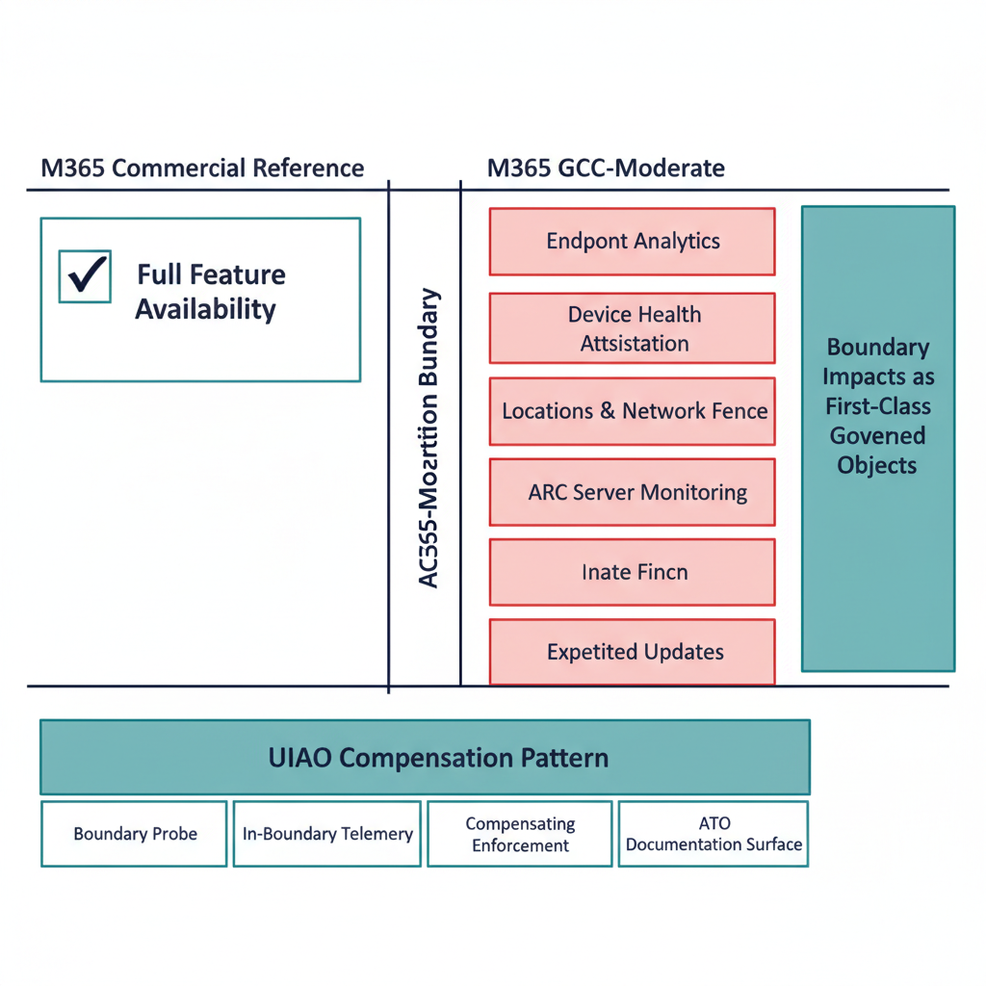
GCC-Moderate boundary engagement pattern diagram

Engagement archetype
A federal agency operating M365 in GCC-Moderate discovers — typically late in an ATO cycle or during ZT analytics rollout — that a cluster of features advertised in admin portals and referenced in the SSP do not function as documented. The pattern matches the GCC-Moderate Boundary Problem Statement: features appear available, are described in commercial documentation, and are referenced in migration plans, but silently produce no data, emit no errors, and have no documented resolution path.
The agency’s challenge is structural, not configuration: the authorization boundary itself attenuates outbound telemetry that drives many of the platform’s higher-order analytics, and Microsoft does not clearly document which features behave this way.

Starting state (typical)
- M365 GCC-Moderate tenant in production.
- SSP and migration plans reference features whose live behavior is inconsistent with documentation.
- ZT analytics, anomaly detection, and insider-risk programs partially blocked by silent telemetry gaps.
- Compliance posture nominally compliant; substrate observability structurally below commercial peers.

The Federal Modernization Program intervention pattern
The substrate addresses each impact dimension via in-boundary mechanisms (per gcc-boundary-solution-architecture.qmd):

1. Boundary probe
A programmatic test of which features actually function on each side of the boundary, producing structured capability disposition data rather than relying on portal screenshots.

2. In-boundary telemetry
Adapters operating inside GCC-Moderate emit canonical claims with explicit source_classification: derived for signals substituting for unavailable commercial features. The provenance envelope makes the substitution explicit; downstream consumers can see what is authoritative vs. derived.

3. Compensating enforcement
Agency-side enforcement adapters for controls that platform features cannot deliver in-boundary. Their evidence flows through the same canonical evidence chain.

4. ATO documentation surface
Boundary impact is captured as a first-class artifact that the SSP, POA&M, and Component Definition all reference. Specific feature gaps become named, modeled, and drift-monitored objects rather than implicit footnotes.

Substrate behaviors observed (pattern)
A real engagement would document:
- Capability disposition matrix — for each cited M365 feature in the SSP, the actual in-boundary disposition (functional / partial / silent / blocked).
- Telemetry-fidelity gap closure — what percent of unavailable signals are now substituted via in-boundary adapters with derived classification.
- Compensating-enforcement coverage — which ZT controls are agency-enforced via FMP-anchored adapters where platform features are unavailable.
- ATO package change — net SSP/POA&M edit volume to bring the package into alignment with substrate truth.
- 3PAO re-execution outcome — does the assessor’s independent rerun produce a byte-identical bundle?

Why this is different from “remediating findings”
Two distinctions matter:
- The substrate names the boundary as a first-class object. A conventional remediation cycle treats each missing feature as an isolated gap. The substrate treats the boundary itself as the governed object, with the four impact dimensions as its structured properties.
- Compensating mechanisms become canonical, not bespoke. Each compensating adapter is registered, schema-validated, drift- monitored, and OSCAL-emitted. The pattern survives staff transitions and vendor changes.

Lessons that propagate back into canon
A real engagement typically yields:
- New entries in the boundary capability disposition data (src/fmp/canon/data/gcc-moderate-telemetry-gaps.yaml).
- Refinements to the boundary impact model where new dimensions emerge (rare, but possible — would require an ADR).
- Compensating-enforcement adapter additions to modernization-registry.yaml.

Promotion to “real engagement”
Same posture as the identity case study: requires reviewed, externally releasable material; canon-change traceability for cited lessons; sponsor-side review and approval.

Related documents
- Architecture Series — Boundary Impact Model
- GCC-Moderate Problem Statement (canon)
- GCC-Moderate Solution Architecture (canon)
- B.1 GCC-Moderate Boundary Model

Cloud Boundary — Framing Pattern
Government-cloud boundary establishment

Starting state
An agency operates a mix of on-premises systems and commercial cloud services. The authorization boundary is assumed rather than modeled. Traffic hairpins through a traditional perimeter. Local breakout is desired for latency but has not been governed.

Intervention
The boundary is modeled explicitly. Local breakout is permitted only when the security-capabilities catalog is satisfied at a distributed policy enforcement point. The policy enforcement point’s location is treated as a physics and compliance decision, not a product feature.

Observed behavior (intended)
Branch traffic egresses locally only when the catalog is satisfied. Telemetry obligations to the federal monitoring program continue. The authorization package cites a modeled boundary rather than an assumed one.

Lessons
- Transport is a physics decision; control is a compliance decision.
- Bare local breakout without a governing control plane is a compliance regression.
- The governor itself is attack surface and must be protected.

Cleaned framing pattern for project use. Not a deployed reference. No internal branding or document identifiers.

Federal Modernization — Case Study

Framing pattern, not a fabricated engagement
This page is the canonical engagement pattern for an end-to-end federal-agency modernization case study. Specific agency identifiers, metrics, and timelines are intentionally absent until real engagement material is reviewed and cleared for external release.
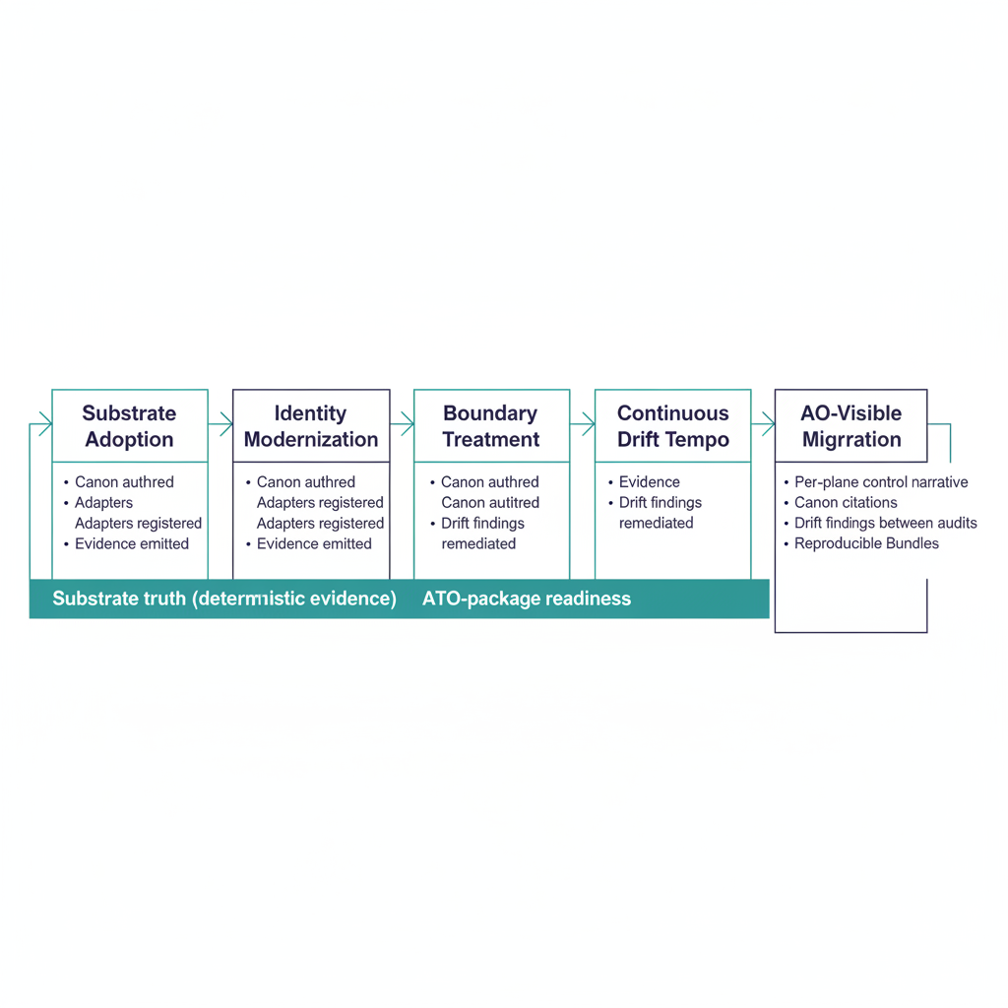
End-to-end federal modernization engagement diagram

Engagement archetype
A federal agency executes a multi-quarter modernization program spanning identity, cloud boundary, telemetry, and zero-trust controls. The program touches every concern in the Executive Governance Series: fragmented identity, uncorrelated telemetry, point-in-time evidence, boundary opacity. The Federal Modernization Program’s intervention is structural — adopting the substrate as the governance layer underneath the existing tool stack rather than replacing tools individually.
This is the engagement archetype the substrate is designed for: an agency at the scale where per-tool governance has become structurally infeasible.

Starting state (typical)
- Multi-cloud tenancy (M365 GCC-Moderate primary, named-exception workloads).
- AD environment in active migration to Entra ID.
- ZT program running per-pillar with limited cross-pillar correlation.
- ATO package authored manually against a control catalog; per-cycle re-engineering.
- Telemetry from 20+ tools, normalized partially in a SIEM.
- Compliance findings backlog with multi-year tail.

The Federal Modernization Program intervention pattern

Phase 1 — substrate adoption
Install the fmp package; run fmp substrate walk against the agency’s tree; author a substrate manifest naming the agency’s modules. Schema-validation gates land in CI for canon edits. Net effect: structural drift becomes visible.

Phase 2 — identity modernization
Apply the identity-modernization pattern (see Identity Case Study and Modernization Governance Whitepaper): canon-first attributes, modernization adapters, drift-driven cleanup, cutover, post-cutover.

Phase 3 — boundary treatment
Apply the cloud-boundary pattern (see Cloud Boundary Case Study): boundary probe, in-boundary telemetry, compensating enforcement, ATO documentation surface.

Phase 4 — continuous drift tempo
Operationalize the canonical SLA tempo (P1 immediate / P2 1hr / P3 24hr / P4 72hr). Auto-remediation handles deterministic findings; escalations land at named roles per the drift standard.

Phase 5 — ATO package migration
Migrate the ATO package from attestation-anchored to substrate- anchored. SSP, POA&M, KSI dashboards, and Component Definitions emit deterministically from canon plus telemetry. Attestations remain in the package as the human accountability wrapper but are no longer the primary verification surface.

Substrate behaviors observed (pattern)
A real engagement would document:
- Drift findings rate over time — by class and severity, across the program.
- SLA adherence — fraction of findings remediated within canonical SLA per tier.
- Canon-change ADR cadence — how often the program produces canon-change ADRs vs. operational PRs (a measure of substrate maturity).
- ATO package regeneration time — wall-clock time from “decide to regenerate” to “bundle hash matches expected”.
- 3PAO re-execution outcome — independent verifiability of evidence months after assembly.
- Net tool count change — substrate adoption typically reduces tool count by retiring parallel governance machinery.
These are the metrics a credible federal modernization case study needs.

Why this engagement is structurally different
Three properties distinguish a substrate-anchored modernization from a tool-stack modernization:
- Canon survives the modernization. Tools change, vendors change, platforms change. Canon does not — or, when it changes, it changes through a governed ADR process. The agency’s investment in canon authoring compounds.
- Evidence is regenerable. The agency does not have to keep point-in-time bundles indefinitely; they regenerate from canon plus archived inputs. Cost of long-term audit retention drops.
- Drift is the operational signal. The substrate’s findings replace the agency’s pre-existing patchwork of audit-cycle gap discovery. SOC and governance operations move to the same canonical taxonomy.

Lessons that propagate back into canon
A real engagement typically yields the most diverse lesson set of any case-study pattern:
- Canonical attribute refinements (identity).
- Boundary capability disposition updates (cloud).
- New compensating-enforcement adapters (ZT, M365 features).
- Operational-tempo tuning (canonical SLA tiers vs. agency staffing).
- ATO-package emission improvements (OSCAL fidelity).
Each lesson lands as an ADR, canon-document update, or adapter-registry change. The case study, when complete, becomes a provenance source for all five.

Promotion to “real engagement”
Same posture as the identity and cloud-boundary case studies: requires reviewed, externally releasable material; canon-change traceability for cited lessons; sponsor-side review and approval.
End-to-end engagements are the most demanding case studies to externalize because the lesson set is broad and the engagement material is sensitive. The substrate’s case study posture is honest about this — the pattern is documented now; the engagement is documented when reviewed material is available.

Related documents
- Executive Governance Series
- Identity Case Study
- Cloud Boundary Case Study
- Program Vision (canon)
- Modernization Timeline (canon)

Federal Modernization — Framing Pattern
End-to-end federal agency modernization arc

Starting state
A federal civilian agency carries decades of client-server architecture, Active Directory, on-premises SQL Server, and a traditional perimeter. Modernization has been attempted as a sequence of independent projects. Evidence is assembled retrospectively for authorization.

Intervention
The program is sequenced as identity-first, then addressing, overlay, telemetry, management automation, and governance at runtime. Governance is in place before any identity object moves. Drift detection and provenance are first-class operational signals.

Observed behavior (intended)
Mission value is delivered early. Long-tail authorization and drift risk are reduced. Evidence is a byproduct of the migration rather than a retrospective assembly. Phase gates are held on evidence quality and operational determinism, not only on schedule milestones.

Lessons
- Fund and govern the program as a sequence, not as independent projects.
- Modernization produces the operational conditions required for continuous authorization to be credible.
- Treat the roadmap as a governed delivery arc, not as a claim of full operational completion across every workstream today.

Cleaned framing pattern for project use. Not a deployed reference. No internal branding or document identifiers.

Alternative Collaboration Path — Google Workspace
Who this is for: Teams evaluating productivity suite options while preserving an authoritative identity origin and no-rip-and-replace discipline.

Purpose
This note documents a real federal example of moving email and collaboration workloads from a Microsoft suite to Google Workspace. It is not an alternative identity path. The identity plane (source of truth for attributes, organizational structure, policy scope, and access decisions) remains independent and can continue to live in Entra ID or another governed directory.
The pattern is consistent with the workbook’s principles: authoritative origin, identity as root namespace, no rip-and-replace, and governance that transcends any single vendor.

Framing
Layer | Typical Role | Can Be Separated?
Identity / governance | Authoritative origin for attributes, dynamic groups, policy scope, drift detection | Yes — remains the root
Collaboration / email | Day-to-day productivity (mail, docs, chat, meetings, AI assistants) | Yes — can be federated or provisioned from the identity plane
Access control | Conditional access, app access, Zero Trust signals | Usually stays with the identity platform
Google Workspace brings its own directory (Cloud Identity). In practice this is almost always a derived or federated surface rather than a second source of truth.

Case Summary: Department of Transportation (2025–2026)
DOT became the first cabinet-level agency to move its collaboration suite from Microsoft to Google Workspace with Gemini.
Aspect | Detail
Scale | ~50,000+ employees (DOT proper + FAA and other modes)
Contract | Five-year agreement, ceiling up to $89 million (via Carahsoft, GSA OneGov)
Tools | Gmail, Docs/Sheets/Slides, Drive, Meet, Chat; Gemini and NotebookLM
Timeline | Foundational environment and initial users in ~22–30 days; broader rollout through 2026
Security | Google Workspace and Gemini are FedRAMP High authorized; Assured Controls Plus used
Drivers | OneGov pricing (temporary ~71% discount), AI capabilities, modernization, reported cost reduction
Coexistence | Period of parallel operation with Microsoft tools during transition
Key observations from the public record:
- The move was framed as a collaboration-suite modernization, not a full identity platform replacement.
- Speed of initial deployment was high once the contract was in place.
- AI features (Gemini) were cited as a meaningful differentiator beyond pure cost.
- The agency has described a broader multi-cloud posture rather than a single-vendor commitment.

Technical Patterns (Identity Boundary)
Two common, governable approaches keep the workbook’s authoritative-origin model intact:
- Entra ID as source of truth
  - Users and groups are provisioned from Entra ID into Google Workspace / Cloud Identity.
  - SSO is configured so Google apps trust Entra (or the reverse for specific scenarios).
  - Attribute changes, dynamic group membership, and policy scope continue to originate from the identity plane.
  - Drift between intended and observed state remains detectable in the identity system.
- Federated coexistence
  - Limited set of attributes and groups are synchronized in one direction.
  - Conditional access and high-assurance signals stay with the identity platform.
  - Google Workspace is treated as a workload that consumes identity, not a second directory of record.
Both patterns allow the collaboration plane to change without forcing a rip-and-replace of the identity and governance model.

Alignment with Workbook Principles
- Authoritative origin: Identity attributes and organizational structure retain a single origin. Google Workspace holds derived or synchronized objects.
- No rip-and-replace: Coexistence and phased cutover are the observed pattern. Core identity, addressing, and policy controls are preserved.
- Identity as root namespace: Organizational structure, policy scope, and access decisions continue to derive from the identity plane.
- Drift is explicit: Synchronization or federation failures become observable drift between the authoritative source and the collaboration directory.
- Evidence-driven change: Migration waves, provenance of attribute flow, and validation of federation or provisioning remain required.

Considerations and Counter-Examples
- Dominance: Microsoft 365 remains the majority platform across federal agencies. Google Workspace has meaningful but smaller adoption (examples previously cited by Google include GSA, Department of Energy, and Air Force Research Laboratory).
- Utilization risk: The Army ran a large Google Workspace pilot and later sunsetted the accounts after low utilization, consolidating on Army 365 (Microsoft). Demand and change-management outcomes matter.
- Identity surface: Cloud Identity is not a drop-in replacement for a mature Entra ID deployment that already carries conditional access, Privileged Identity Management, application registrations, and Zero Trust signals.
- Procurement and discount window: OneGov pricing was a significant accelerator. Discount duration and subsequent pricing should be evaluated explicitly.
- Data and compliance: FedRAMP High authorization removes a major barrier, but data residency, client-side encryption options, retention/eDiscovery (Vault), and records requirements still require agency-specific validation.

When This Path May Be Worth Evaluating
- The primary pain is in the collaboration and email experience (or cost), not in the identity governance model.
- AI features embedded in the productivity suite are a material requirement.
- The organization is already comfortable with, or actively pursuing, multi-cloud or multi-vendor patterns.
- Federation or provisioning from the existing identity plane can be governed and monitored for drift.
- Change management capacity exists for a coexistence period.

When It Is Probably Not the Right Path
- The core modernization problem is directory hierarchy, attribute authority, dynamic groups, or policy scope — these remain identity-plane problems.
- High-assurance conditional access, privileged access workflows, or extensive application integrations are already deeply implemented on Entra ID and would be expensive to re-create.
- The organization lacks capacity for dual-directory governance during a transition.

Suggested Next Steps for an Agency
- Confirm whether the authoritative identity origin will remain Entra ID (or equivalent).
- Inventory applications and workflows that depend on Microsoft 365 identity, mail, or files.
- Evaluate federation vs. provisioning options and the drift-detection surface they create.
- Validate FedRAMP High configuration requirements and any Assured Controls or data-region needs.
- Model coexistence duration, training, and rollback triggers before any cutover wave.
- Treat productivity-suite choice as separable from the identity and governance modernization program.

Sources (public reporting, 2025–2026):
Department of Transportation announcements and interviews (Nextgov/FCW, MeriTalk, Google Public Sector), GSA OneGov materials, FedRAMP authorization statements for Google Workspace and Gemini, and Army sunset notice for its prior Google Workspace pilot.
This note is a pattern reference only. It does not constitute a recommendation to adopt or reject any specific vendor. Execution decisions remain with the adopting organization.

Identity Modernization — Case Study

Framing pattern, not a fabricated engagement
This page is the canonical engagement pattern for an identity- modernization case study, structured so that real engagement material can be anchored on top when it becomes externally releasable. Specific metrics, agency identifiers, and timelines are intentionally absent until real material is reviewed.

Engagement archetype
A federal agency operating Active Directory at scale (>100k identities, multi-forest topology, decade-old OU hierarchy) plans transition to Entra ID under GCC-Moderate. The program has identified the technical migration tooling but has not addressed the architectural inversion from hierarchical placement to attribute-driven access (see Modernization Governance Whitepaper).
Without a substrate, the program risks inheriting the OU-driven model in Entra ID and losing most cloud-native value.

Starting state (typical)
- AD forest topology with several thousand OUs.
- Group memberships authored manually; movers handled via ticket- driven re-permissioning.
- Identity claims consumed inconsistently across SIEM, IDP, IPAM, and ATO documentation.
- ATO package describes intended controls; substrate truth at any given moment is not reproducibly verifiable.

The Federal Modernization Program intervention pattern

Phase 1 — canon-first
Author the canonical attribute set in canon:
- Canonical attribute set (assignment_scope, organizational_role, classification_clearance).
- Computed-group rules per attribute combinations.
- Provenance envelope per identity claim.
Substrate walker passes against the new canon before any runtime change.

Phase 2 — modernization adapters
Stand up entra-id, active-directory, entra-policy-targeting, and the relevant attribute-source adapters (piv-usaccess, agency-specific HR adapter). Adapters emit canonical claims with full provenance from day one — including during the parallel-running period.

Phase 3 — drift-driven cleanup pre-cutover
Pre-cutover runs surface inherited inconsistencies (stale attributes, group rules with retired references, broken provenance chains) as canonical drift findings. Each is remediated under the canonical SLA tempo.

Phase 4 — cutover
The directory transition is a substrate event: the identity plane’s authoritative source switches from on-prem AD to Entra ID. Canon is already in place to interpret post-cutover claims.

Phase 5 — post-cutover
Drift findings continue to surface inconsistencies; auto-remediation handles deterministic fixes; the canon-change ADR process handles residual model evolution.

Substrate behaviors observed (pattern)
A real engagement would document, with metrics, behaviors such as:
- Provenance breakage rate during cutover — how many claims emitted with incomplete chains during parallel-run, attributable to which adapter, remediated within which SLA tier.
- Attribute-quality drift — how many identities passed canonical validation pre-cutover vs. post-cutover, and how the gap closed under drift-driven cleanup.
- Cross-pillar correlation health — whether the same identity resolves identically across PIV, Entra, and HR systems post- cutover.
- Attribute-computed access — what fraction of access decisions are attribute-computed vs. manually-administered post-cutover.
These metrics are the credible-claim surface for an externally releasable case study. The substrate produces them deterministically; authoring requires real engagement material.

Lessons that propagate back into canon
A real engagement typically reveals:
- Edge cases in the canonical attribute set that require canon-change ADRs.
- Adapter conformance gaps (where a vendor’s API does not cleanly map to the canonical claim shape).
- Operational tempo tuning (SLA tiers that work in theory but require agency-specific staffing).
Each lesson lands as either an ADR, a canon-document update, or an adapter-registry change. The case study, when complete, becomes a provenance source for those changes.

When this study can be promoted to “real engagement”
Per the section’s authoring posture, promotion requires:
- Engagement material reviewed and cleared for external release.
- Specific metrics anonymized or formally authorized for citation.
- Canon-change traceability — every “lesson” cited points to the ADR or canon-document update it produced.
- Sponsor-side review and approval of the narrative.
Until then, this page documents the engagement pattern a customer should expect, not a specific engagement outcome.

Related documents
- Whitepaper — Modernization Governance
- Modernization Spec — Identity
- the program decision: Zero Trust Identity

Federal Civilian AD → Entra ID + SQL Estate — Reference Deployment Pattern

Framing pattern, not a fabricated engagement
This page is the canonical engagement pattern for a federal civilian agency migrating Active Directory and its dependent SQL estate to Microsoft Entra ID + M365 GCC-Moderate, end-to-end through the Federal Modernization Program substrate. Specific metrics, agency identifiers, contractor names, and calendar dates are intentionally absent until real engagement material is reviewed and externally releasable. The narrative below is the substrate’s behavior against the archetype, not a deployed-and- attested reference.
Status badge in the family index: Framing-Pattern per the Whitepapers status conventions.

Engagement archetype
A federal civilian agency of approximately fifty thousand users operates two Active Directory forests — one for the agency proper, one inherited from a component organization absorbed in a prior reorganization — joined by a transitive trust that nobody fully documented and that nobody currently owns. The forests collectively hold roughly seventy thousand computer accounts, twelve thousand groups, several thousand orphaned service accounts whose original owners have rotated out, and a SQL Server estate of approximately ninety instances spread across regional offices, the agency headquarters data center, and three relocated workloads now running on Azure Arc-enrolled hardware. The agency is under explicit modernization pressure from OMB M-22-09 (Zero Trust), CISA BOD 25-01 (logging and visibility), and a forthcoming FedRAMP 20x continuous-monitoring expectation. It has chosen Microsoft 365 GCC-Moderate as the destination identity plane and is committed to consolidating its data estate around the Fabric + OneLake + Purview Azure SSOT stack.
The agency’s compliance posture today is recognizable. Its previous ATO package was assembled retrospectively over a twelve-month window by a system integrator who is no longer on contract. The directory’s SPN inventory exists only in spreadsheets that were last refreshed two years ago. The SQL estate’s lineage and ownership are documented in component-level binders that disagree with each other on basic attribution questions. The agency has the right tools — Entra Connect, Intune, Defender, Purview Premium — but no shared canon for what those tools should be told about the agency’s organizational structure.
This is the engagement pattern the Federal Modernization Program is built for, and the substrate’s behavior across the five phases below is what this case study illustrates. For the federal mandate alignment that makes this work necessary, see the Federal SSOT Alignment whitepaper.

Phase 1 — Discover
The first substrate action is to make the current state of the agency’s identity infrastructure honest. The AD survey adapter at src/fmp/adapters/modernization/active_directory/survey.py reads both forests in read-only mode and emits an ADSurveyReport that enumerates the eleven AD object types catalogued in src/fmp/modernization/directory-migration/ad-dependency-inventory.md: users, computers, service accounts, security groups, GPOs, DNS and DHCP records, PKI artifacts, RADIUS configurations, LDAP-dependent applications, Kerberos SPNs, and the trust relationships between the two forests. The survey is the same one that produced the substrate’s test fixtures; it is not a per-engagement script.
The service-account scan codified in Spec3-D1.1 (FMP_139) runs as part of the discovery pass. It produces a service-accounts inventory with delegation classification, AdminCount status, and a per- account risk score that flags ADCS-dependent SPNs and unconstrained Kerberos delegation as critical pre-migration findings. The agency in this archetype has roughly four hundred service accounts with at least one SPN registration; the survey flags approximately sixty of them as critical and another hundred as high-risk.
The SPN inventory artifact introduced in PR #395 captures the agency’s MSSQLSvc/* registrations with a phase: pre_migration tag, the discovery timestamp, and the organizational attribution resolved via the service- account principal (preferred) or the hosting computer (fallback). Approximately eighty of the agency’s ninety SQL instances resolve cleanly; ten emit DRIFT-IDENTITY findings because their service accounts predate any organizational attribution the agency can defend. These ten are flagged as P2 conditions that must be remediated through explicit owner reassignment before migration begins.
The discovery phase ends with a readiness bundle, HMAC- signed, ready to be consumed by the next phase. The bundle’s provenance section names the substrate canon documents it derives from and binds the bundle to the agency’s specific run.

Phase 2 — Normalize
The discovery output is not yet authoritative. The agency’s two forests carry overlapping organizational hierarchies — both have an “Operations” OU at the top level, but the Operations group in forest A is a completely different population than Operations in forest B, and the merged tenant cannot tolerate that ambiguity. The organizational registry, populated from the discovery output and refined through the agency’s organizational chart of record, becomes the source of truth for organizational position. The collision is resolved in the registry, not at the group level.
The normalization phase emits DRIFT-IDENTITY findings for principals that the registry cannot attribute. In the archetype, roughly two thousand users and several hundred service accounts fall into this bucket on the first pass. Each finding includes a suggested organizational attribution candidate derived from OU placement, manager chain, or computer-account attribution; the substrate does not auto-assign because organizational attribution is load-bearing for every downstream policy decision. The agency’s governance team resolves these findings through the change-request workflow before the next phase begins.

Phase 3 — Map
Mapping translates the X.500 / LDAP governance model encoded in AD into the attribute-driven model Entra ID requires. The eight adapter interfaces under src/fmp/modernization/directory-migration/adapters/ each carry an explicit contract for one of the AD-adjacent surfaces that must be re-governed: IPAM, PKI, RADIUS, LDAP-proxy, sync-engine, device-management, NTP, DFS, and the SQL Server workload adapter introduced in PR #397 (adapters/sql-server/sql-server-adapter-interface.md). Each adapter declares its class, mission-class, and gcc-boundary in migration-adapter-registry.yaml and is schema-validated in CI.
For this archetype, the most operationally significant adapters are PKI (the agency’s ADCS hierarchy hosts dozens of templates whose auto-enrollment must move to Intune SCEP without expiring certificates mid-cutover) and the SQL Server adapter (the ninety instances need SPN re-registration coordinated with service-account migration). The LDAP-proxy adapter covers the agency’s approximately forty LDAP-bound internal applications. RADIUS is critical because the agency’s network access requires 802.1X EAP-TLS that depends on the same ADCS hierarchy PKI governs.

Phase 4 — Migrate
The migration itself is executed as a sequence of provenance-chained events. Each adapter operation carries an immutable record of the principal that requested the change, the source of authority, the canon document version the change was made against, and the verification hash of the resulting state. The schema contract ssot-mutation: never is enforced: adapters consume and emit against the canon, never replace it. The certificate-anchored: true contract requires every operation to be signed by an identity certificate; the agency’s deployment uses the same ADCS hierarchy the PKI adapter governs for substrate operations as well as user authentication.
During migration, drift findings emerge in real time. The drift taxonomy formalized in 16_DriftDetectionStandard §2 surfaces five classes:
- DRIFT-SCHEMA — a recently-migrated computer object has an attribute encoding that does not match the canon schema version
- DRIFT-SEMANTIC — an organizational attribute value drifts into a deprecated geographic OU encoding pattern
- DRIFT-PROVENANCE — a state change appears with no recorded provenance event in the chain (this is a P1 condition — the migration is halted and the change is investigated before resuming)
- DRIFT-AUTHZ — a Conditional Access policy in Entra ID contradicts the NIST 800-63 AAL requirement encoded for that principal in the COR
- DRIFT-IDENTITY — a principal exists in the migrated tenant with no resolvable canon counterpart (orphan migration artifact)
The agency in this archetype encounters approximately three hundred drift findings across the migration window, the majority P3 and P4 (auto-remediated per §4 of the drift standard). The single P1 event in a representative cycle is a DRIFT-AUTHZ against a Finance service account whose post-migration role assignment exceeds the AAL-3 requirement the canon records; the substrate halts the migration of the dependent SQL instance until the role assignment is reduced.

Phase 5 — Validate
Post-migration, the SPN inventory is captured a second time, this time with phase: post_migration. The substrate’s drift comparison applies the four SPN-drift conditions catalogued in 16_DriftDetectionStandard §7.1:
Condition | Drift class | Severity | Detection
SPN present pre-migration, absent post-migration | DRIFT-IDENTITY | P1 | Set-difference between phase-tagged inventories
SPN host or port changed without provenance | DRIFT-PROVENANCE | P2 | Same (service_class, principal_name) key, different host or port
SPN owner changed without recorded migration event | DRIFT-AUTHZ | P1 | Same SPN, different principal, no transition record
SPN in AD but no Entra Kerberos delegation | DRIFT-IDENTITY | P2 | Cross-reference fails between AD and workload-identity federation
For this archetype, approximately three SPNs surface as P1 DRIFT-IDENTITY findings (SPNs whose re-registration step was skipped during the SQL Server adapter’s migration sequence). These become halt-and-alert conditions per the severity model in 16_DriftDetectionStandard §3; the agency’s operations team re-registers the SPNs against the migrated principals and re-runs the post-migration inventory until zero P1 findings remain.

The Azure SSOT bridge
With the identity migration complete, the agency’s data plane joins the substrate.
On the user plane, the existing Adaptive Policy Scopes target each segment’s labels, DLP rules, retention schedules, and eDiscovery custodian queries. On the data plane, Fabric Domains are created to mirror the organizational hierarchy; the agency provisions one domain per FabricDomainBoundary-flagged node, and each Fabric workspace is assigned to the domain that matches the workspace’s owning segment. The ninety SQL instances are registered into the Purview data map under collections keyed on custom metadata; the eighty-five that completed migration cleanly are mirrored into OneLake under the matching Fabric Domain workspaces. The remaining five — instances whose post-migration drift is still being remediated — are deferred until the drift cycle closes.
The Purview Information Protection telemetry constraint catalogued in B.1.1 §3 applies: every sensitivity-label trust assertion in the GCC-Moderate tenant inherits the boundary’s verification gap. The substrate’s role at this boundary is not to remediate it (it is structural) but to record the compensating controls the agency has put in place and verify them continuously.

The Evidence Bundle the assessor consumes
At any point after Phase 2 begins, the agency can produce an Evidence Bundle from the substrate’s accumulated artifacts. The bundle includes:
- The readiness bundle from each phase, HMAC-signed
- Both phase-tagged SPN inventories (pre- and post-migration) with drift comparison results
- The provenance chain of every adapter operation
- All drift findings, each with severity, drift class, and remediation evidence per the contract in 16_DriftDetectionStandard §4
- The B.1.1 three-way GCC-Moderate compliance-conflict finding (GCC-BOUNDARY-3WAY-001) with the agency’s specific compensating- controls catalogue
- The Purview collection registration state with attribution per asset
- The Fabric Domain assignment state with per-workspace attribution
This is the artifact the 3PAO consumes during the next FedRAMP cycle. It is produced as a byproduct of operations rather than assembled retrospectively in a twelve-month window. The agency’s authorizing official sees the substrate’s state at any moment, not a stale snapshot.

What survives the engagement
The deliberate point of the substrate is that the canon, the schemas, the drift findings, and the Evidence Bundle do not belong to whichever system integrator delivered the migration. They belong to the agency. The next FedRAMP cycle consumes the existing canon rather than rebuilding it. A subsequent SI engagement — for the next modernization program, the next directory consolidation, the next data-governance expansion — anchors on the substrate’s state rather than starting from zero. This is the cost-shape inversion the Federal SSOT Alignment whitepaper §6 describes: re-engagement consumes canon; it does not rediscover it.
The substrate behaviors a real engagement would document and that this framing pattern is structured to receive:
- Time-to-evidence under the substrate vs. the prior twelve-month baseline
- Drift-finding rate over the migration window, decomposed by class and severity
- SPN drift incidence per ten instances migrated
- B.1.1 compensating-controls verification cadence and false-positive rate
- Purview policy-decision count whose trust assertion is now backed by continuously-verified identity state
When real engagement material becomes externally releasable, those metrics replace the prose-level claims above. Until then this page is the canonical archetype the substrate is built against and the shape the Evidence Bundle is produced into.

Cross-references
- Federal SSOT Alignment whitepaper — federal mandate alignment over the identity layer
- B.1 GCC-Moderate Boundary Model — abstract boundary model
- B.1.1 Three-Way GCC-Moderate Compliance Conflict — TIC 3.0 × Zero Trust × FedRAMP 20x finding
- Drift Detection Standard — drift taxonomy, severity model, and §7.1 SPN drift detection
- Directory Migration README — discovery and inventory artifacts
- SQL Server Adapter Interface — DM_090 adapter contract
- Identity Modernization — Case Study — identity-plane case-study companion
- Cloud Boundary — Case Study — GCC-Moderate boundary establishment companion

SQL Server Identity Transformation — Case Study
From Windows Authentication to cloud identity — transforming a twenty-year SQL Server estate

Status
This is a cleaned overview of a multi-chapter narrative. It is written as an engineering argument, not a runbook. Treat the patterns as guidance that must be validated against the specific estate.

The destination
Windows Authentication and SQL Authentication are eliminated and replaced with cloud identity authentication for SQL Server 2022 and later. Authentication is enforced through OAuth 2.0 tokens, a managed identity for the engine process, and multi-factor authentication for every human principal.

The inheritance
SQL Server’s Windows Authentication was good engineering for its world, not negligence. The problem is that the world changed. Session-based authentication that assumes a domain controller is reachable and that a service principal name is correctly registered does not survive long-distance, heavily inspected networks or Zero Trust requirements.

The precondition most narratives skip
You cannot migrate the authentication of an estate you have not first assessed and consolidated. After twenty years across an Active Directory forest, the estate is larger and more tangled than any team’s mental model of it. Consolidation and inventory precede authentication migration.

The journey in three states

Before — the domain is the trust boundary
Every party is domain-joined. The domain controller is the authentication authority. Kerberos is the protocol. NTLM is the silent fallback when the service principal name is missing. The cloud identity plane is not in the path.
What this architecture cannot provide: Conditional Access, phishing-resistant multi-factor authentication, and cloud identity plane visibility.

During — both paths live simultaneously
Legacy clients still use Kerberos or fall back to NTLM through the domain controller. Migrated clients authenticate to the cloud identity platform and present a token. The SQL Server accepts both Windows logins and cloud-identity logins during the parallel-run window.
This hybrid state is a controlled risk. Progress is measured across estate consolidation, hybrid-management enrollment, login migration, NTLM elimination, and connection-string migration.

After — no domain controller in the authentication path
The client authenticates to the cloud identity platform with multi-factor authentication. Conditional Access evaluates identity and device. An OAuth 2.0 token is issued. The SQL Server validates the token signature against the cloud identity platform’s public key infrastructure. The token carries context — how you authenticated, which groups you belong to, whether your device is compliant — making the database application-aware.
Windows Authentication, SQL Authentication, Kerberos, NTLM, and domain-controller dependency are eliminated.

Chapter substance

Book 01 — The inheritance
Windows Authentication was good engineering for its world. Kerberos tickets, service principal names, and the assumption of domain-controller proximity worked when everything was local. The failure mode is silent NTLM fallback when the service principal name is missing or when the domain controller is unreachable.

Book 02 — Assess and consolidate first
Three forms of sprawl: orphaned instances, duplicate databases, and service accounts that no one owns. Discovery instruments must inventory what is actually running before any authentication change is attempted. Rationalization lenses decide retain, consolidate, or retire. The gate is evidence, not opinion.

Book 03 — Authentication audit
What is actually using Windows Authentication, SQL Authentication, and NTLM. The audit produces a principal-type inventory and a connection-string inventory. No migration plan is valid without this baseline.

Book 04 — Hybrid-management identity bridge
Attach the management plane so the server can receive policy and telemetry without requiring domain membership for authentication. Managed identity for the engine process is the destination for the service account.

Book 05 — Login migration
Introduce cloud-identity logins alongside Windows logins. Parallel-run is the controlled risk period. Type-U (Windows) and type-E (cloud identity) logins coexist until the connection-string migration is complete.

Book 06 — NTLM elimination at the SQL layer
NTLM is the silent fallback. Eliminating it requires first repairing service principal names, then restricting the protocol, then verifying that no application falls back. Premature restriction breaks legacy clients.

Book 07 — Access control
Dynamic groups driven by organizational attributes replace manual database-administrator provisioning. Administrative-unit delegation scopes who can manage which databases. The attribute infrastructure must precede the dynamic-group work.

Book 08 — Upstream application chain
Applications that depend on Windows Authentication or LDAP bind must be migrated or wrapped. Four classes of applications: those that can use tokens natively, those that need a proxy, those that need a code change, and those that must be retired.

Book 09 — Transformed steady state
The 2027 milestone: no domain controller in the authentication path, no NTLM, no SQL Authentication for human principals, managed identity for the engine, Conditional Access for every human connection.

Book 10 — Certificate-authority dependency
The layer the other steps depend on but rarely name. Certificate services, auto-enrollment, and the trust relationships that Kerberos and token validation both rely on. Certificate-authority failure is a silent failure that surfaces only when tickets or tokens cannot be validated.

Relationship to attribute-driven structure
Dynamic security groups whose membership rules reference organizational attributes drive SQL Server access without manual database-administrator provisioning. The attribute infrastructure must precede the dynamic-group access work.

Audience
Database engineers who execute the login migrations, infrastructure architects responsible for estate consolidation and hybrid-management sequencing, security engineers who own the Conditional Access design, and program leadership who must understand the scope of the consolidation program that precedes authentication migration.

Cleaned extraction for project use. No internal branding or document identifiers. Full multi-chapter narrative and implementation companion remain in the source repository if deeper detail is required.

SQL Server Identity Transformation

Status — Draft series
This series — ten books and an epilogue — is DRAFT v0.1. It is the explanatory companion to the SQL Server engine-authentication decision, which is PROPOSED, not yet accepted. Treat the engineering patterns here as the evidentiary foundation for that decision rather than as accepted normative governance until it is accepted and this series is reviewed against it.

Companion series — the executable layer
This narrative is the why. Its book-for-book companion, the SQL Server Identity Transformation — Implementation Companion, is the how: the runbooks, scripts, parameters, output schemas, and failure modes — each implementation book the executable counterpart to the narrative book of the same number.
The transformation inventory classifies the SQL Server authentication transformation as Partially Defined. The destination is not in doubt — the inventory names it precisely: Windows Authentication and SQL Authentication are eliminated and replaced with Microsoft Entra ID authentication for SQL Server 2022 and later, enforced through OAuth 2.0 tokens, a Microsoft Entra identity for each instance (the Arc managed identity on SQL Server 2025, an app registration on SQL Server 2022), and multi-factor authentication for every human principal. What was partially defined is the normative canon governing how that destination is reached at the engine layer. This series documents that path, fills it in narrative form, and provides the analytical foundation that the SQL Server engine-authentication decision formalizes.
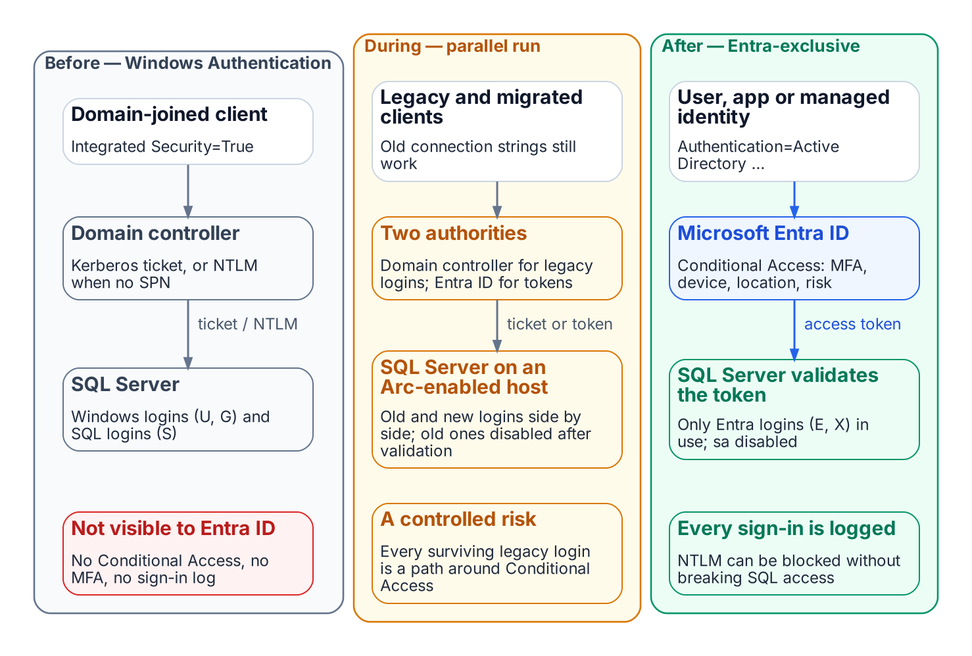
How a connection authenticates before, during and after the transformation.
The series is written in continuous narrative voice. It avoids the bullet-point shorthand of a runbook, because the transformation it describes is not a checklist — it is an engineering argument, and engineering arguments require sentences.
The reading sequence has a deliberate shape. Book 01 names the inheritance: SQL Server’s Windows Authentication was good engineering for its world, not negligence. Book 02 — new to this revision — confronts the precondition that most authentication narratives skip: you cannot migrate the authentication of an estate you have not first assessed and consolidated, and after twenty years across an Active Directory forest, the estate is larger and more tangled than any team’s mental model of it. Books 03 through 06 trace the migration itself — the authentication audit, the Arc identity bridge, the login migration, and NTLM elimination at the SQL layer. Books 07 and 08 follow the transformation outward, into access control and the upstream application chain. Book 09 describes the transformed steady-state and the 2027 milestone, and Book 10 addresses the certificate-authority dependency that the other nine books depend on but rarely name. Read Applicability first: it says where the series applies as written and what to do where it does not. Book 11 is an epilogue: once the estate is rationalized and its authentication migrated, it takes up the platform question for each retained data domain.

The dependency chain
Inventory → Rationalize → Audit survivors → Enable identity substrate → Introduce Entra principals → Move applications → Remove legacy principals → Enforce protocol retirement → Demonstrate sustained posture. The Series Overview maps each step to its book.

Reading sequence
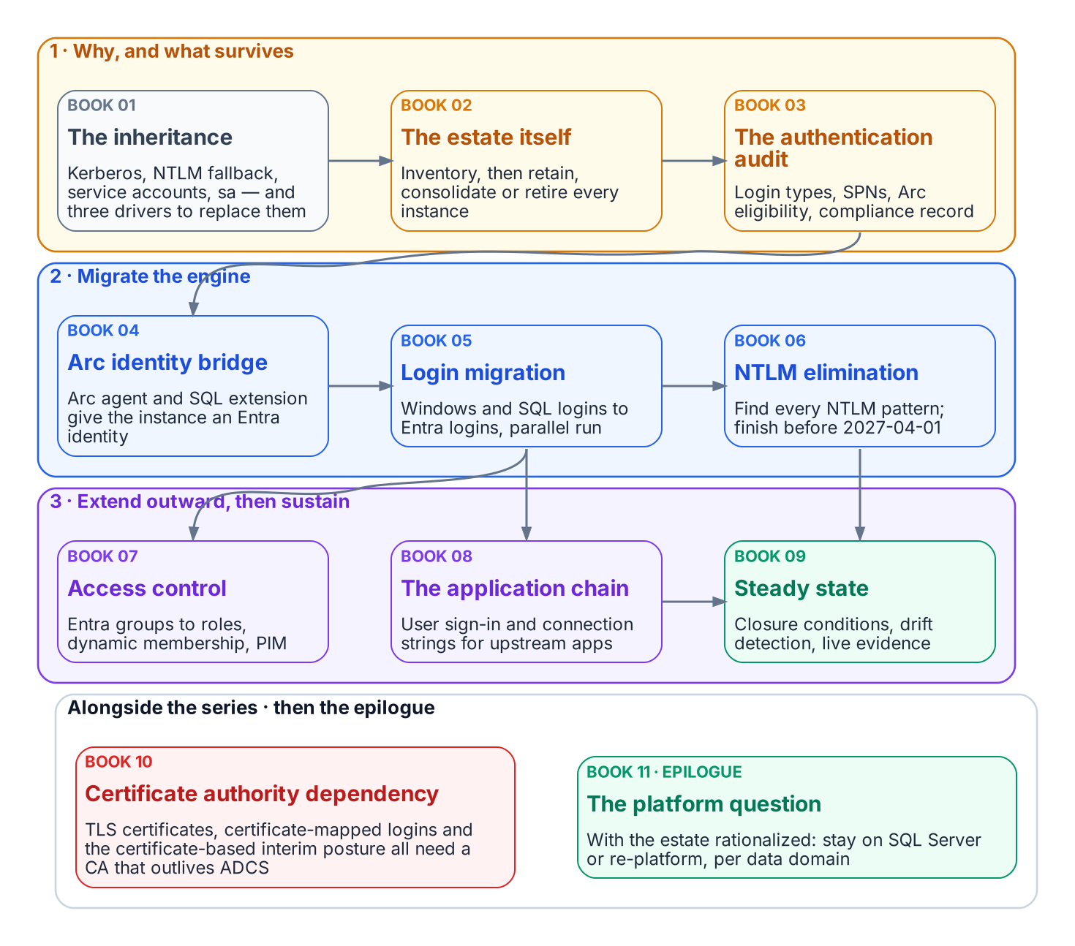
The ten books and the epilogue, in the order they depend on each other.

Related decisions
This narrative is the explanatory foundation for several governance decisions:
- The SQL Server engine-authentication decision — the engine-layer decision this series motivates (currently PROPOSED).
- The Kerberos/NTLM-elimination program — the protocol layer, with its 2027-04-01 NTLM backstop.
- The Arc non-domain-join requirement — the server / OS layer.
- The LDAP-dependent-application migration plan — the upstream application chain.
- The identity & directory transformation inventory — the program-wide catalog in which the SQL Server authentication transformation is entry #7.
- The authentication-audit script — the engine-layer discovery baseline.

Relationship to identity governance
Book 07 depends on identity governance outside SQL Server. The dynamic Entra security groups that grant SQL Server access read user attributes such as department, company, job title, and HR-sourced extension or directory extension attributes. Those attributes must come from the HR system of record through automated provisioning, and only that provisioning account may write them, before any dynamic group grants production access. Book 07 also relies on the tenant’s administrative-unit, Privileged Identity Management, and access-review configuration for delegation, just-in-time privilege, and recertification.

Audience
Database engineers who execute the login migrations, infrastructure architects responsible for estate consolidation and Arc sequencing, security engineers who own the Conditional Access design and the continuous-compliance monitoring, and program leadership who must understand the scope of the engine-authentication gap and the consolidation program that precedes it. The series assumes familiarity with SQL Server administration and Active Directory security concepts; familiarity with Entra ID is built progressively across the ten books.

Download
Every chapter renders to Microsoft Word (.docx) alongside the web view (see the DOCX button in the page header on each chapter).

SQL Server Identity Transformation — Narrative Series
From Windows Authentication to cloud identity — a reading sequence on transforming the SQL Server estate
The ten books and the epilogue, in the order they depend on each other.
Full narrative bundle: sql-server-narrative-bundle.docx — all books combined into one Word document, regenerated on every site deploy.
Series overview: Series Overview — cleaned summary with the series diagrams.

Status
The full original narrative is available as a single DOCX bundle. Individual cleaned Markdown chapters are also present. Every book and chapter carries its own diagram; the sources and render script are in docs/images/sql-server/diagrams/.

The destination
Windows Authentication and SQL Authentication are eliminated and replaced with cloud identity authentication for SQL Server 2022 and later. Authentication is enforced through OAuth 2.0 tokens, a Microsoft Entra identity for each instance (the Arc managed identity on SQL Server 2025, an app registration on SQL Server 2022), and multi-factor authentication for every human principal.

The journey in diagrams
How a connection authenticates before, during and after the transformation.
Before, every party is domain-joined and NTLM is the silent fallback when the service principal name is missing. During the parallel run, legacy and migrated clients coexist. After, Conditional Access evaluates every sign-in and the SQL Server validates the Entra token; no domain controller is in the path.

Reading sequence
Book | Title | Focus
— | Applicability | Read first: where the series applies as written, alternatives, and fallback protections
01 | The Authentication Inheritance Problem | What Windows Authentication actually is, and why it must end
02 | The Estate Itself | Assess and consolidate before you touch authentication
03 | The Authentication Audit | What is actually using Windows Authentication, SQL Authentication, and NTLM
04 | The Identity Bridge | Hybrid-management attachment and an Entra identity for the engine
05 | Login Migration | Parallel-run of Windows and cloud-identity logins
06 | NTLM Elimination | Silent fallback, service principal name repair, and protocol restriction
07 | Access Control | Dynamic groups and administrative-unit delegation
08 | The Upstream Application Chain | Applications that depend on Windows Authentication or LDAP
09 | Transformed Steady State | The destination and the milestone
10 | Certificate-Authority Dependency | The layer the other steps depend on but rarely name
11 | Epilogue — The Platform Question | Database consolidation toward SSOT, after the transformation
A | Appendix A — Requirements Mapping | Each book’s controls and evidence mapped to M-22-09, CISA ZTMM v2, SP 800-207 and SP 800-53 Rev. 5 (compliance-enabling, not a compliance claim)
B | Appendix B — Security-Approval (ATO) Kit | Boundary diagram, outbound endpoints, FedRAMP audit scope, Graph permission justification, token-folder mitigation, break-glass and licensing

Relationship to identity governance
Dynamic Entra security groups grant SQL Server access based on HR-sourced user attributes, so no database administrator has to provision access by hand. The HR-to-directory attribute feed, its write protection, and the rule testing described in Book 07 must be in place before the dynamic-group access work starts.

Original diagrams from the source bundle. Paths are relative and resolve for both HTML and DOCX.

Building the Word bundles
The combined Word document (downloads/sql-server-narrative-bundle.docx, also published as sql-server-narrative-standalone-bundle.docx) and the per-book documents (downloads/Book_01-bundle.docx to Book_11-bundle.docx) are built directly from the Markdown pages in this folder by scripts/build_bundles.py. The same script builds the site’s other section bundles. The site deploy workflow runs it on every push to main. To build locally, run this from the repository root (you need Quarto, plus rsvg-convert if any page uses an SVG):
python3 scripts/build_bundles.py # every bundle, into _site/downloads/
python3 scripts/build_bundles.py --only sql-server-narrative-bundle.docx Book_07-bundle.docx
python3 scripts/build_bundles.py --list # print each manifest, build nothing
- Reading order comes from the manifests in scripts/bundles.yml. The combined bundle lists every page explicitly: index.md, then each Book_NN.md followed by its chapters, then Book 11. When you add, remove, or rename a page, update that list. The build fails if a listed file is missing, and it warns about any Book_* page that isn’t listed. Each per-book bundle is Book_NN.md followed by its Book_NN_CPT_*.md chapters, so new chapters are picked up automatically.
- Images are resolved relative to the page that references them (normally ../../images/sql-server/). Each one is embedded where it appears, with its alt text as the caption, scaled to the page width. SVGs are converted to PNG, and files whose extension doesn’t match their content are fixed for Word. The build fails if a referenced image is missing. It prints a report of references and embedded images per bundle, plus any images in docs/images/sql-server/ that no page uses.
- Web-only pieces are dropped by scripts/bundle-filter.lua: chapter listings, the “Continue the series” and “Download” callouts, and links between pages, which become plain text. Each bundle gets a title page and a Word table of contents. If Word asks to update fields when you open it, choose Yes so it fills in the page numbers.
- Download links on the site must point at a bundle the script builds: the build fails if any downloads/*.docx link on a published page has no matching bundle.

Applicability — Where the Series Applies as Written

Platform facts as of 19 October 2026
SQL Server enabled by Azure Arc changes month to month. Every platform fact on this page was checked against Microsoft Learn on 19 October 2026. Recheck the linked pages before you rely on them.

Where the series applies as written
The engine-side steps (Books 04, 05 and 09) depend on Microsoft Entra authentication in SQL Server itself. The series applies as written where all of these hold:
Dimension | In scope | Source
Cloud | Microsoft’s commercial cloud, including GCC-Moderate tenants. SQL Server needs access to the Azure public cloud to use Entra authentication.
SQL Server version | SQL Server 2022 (app registration and Key Vault certificate) and SQL Server 2025 (Arc managed identity, recommended for 2025).
Operating system | Windows. The managed-identity setup is supported only for Arc-enabled SQL Server 2025 on Windows Server.
Topology | Standalone instances and availability groups.

Where it does not apply as written
Environment | What Microsoft documents | What still applies
GCC High and DoD (Azure Government) | SQL Server enabled by Azure Arc in Azure Government runs only in US Gov Virginia, only on Windows, and offers only onboarding, inventory, licensing and billing, failover-cluster-instance management and ESU licenses; “all other features are not currently available.” Entra authentication is not among them. Microsoft Cloud PKI is supported in GCC High but not DoD. | Books 01–03 (case, consolidation, audit), Book 06 (Kerberos repair and NTLM restriction) and the Entra-side work of Book 07: dynamic groups, PIM, access reviews and entitlement management are available in Azure Government. Books 04, 05 and 09 do not apply until the engine side is available there.
Air-gapped or disconnected networks | Entra authentication needs outbound reach to Entra ID and Microsoft Graph, with or without Arc. Microsoft’s cloud-first identity guidance says disconnected applications need to stay on premises. | Consolidation (Book 02), the audit (Book 03) and Kerberos hardening (Book 06).
Failover cluster instances (FCIs) | Entra authentication is not supported for SQL Server failover cluster instances. Arc can still onboard and manage them. | Move the databases to an availability group, or keep the FCI on Kerberos with the fallback protections below, tracked as a named exception class.
SQL Server 2019 and older | Entra authentication needs SQL Server 2022 or later. | The upgrade is a prerequisite and belongs to Book 02’s consolidation plan. Until then, Kerberos hardening only.
SQL Server on Linux | Entra authentication is documented for SQL Server 2022 on Linux. The managed-identity path and Disable SQL Authentication are Windows-only on SQL Server 2025. | Treat Linux instances as their own exception class and verify each feature on Microsoft Learn before planning.

Alternatives
Entra authentication without Azure Arc. Microsoft documents a manual setup for SQL Server 2022 and later on Windows. You register an application, upload a certificate, install adal.dll from the OLE DB driver, and set the FederatedAuthentication registry values. The host still needs outbound access to login.windows.net, login.microsoftonline.com, graph.microsoft.com, graph.windows.net and database.windows.net. It suits agencies that won’t install the Arc agent, but you take on certificate rotation and configuration drift yourself. Microsoft documents only commercial-cloud endpoints for this method, so the series makes no claim that it works in Azure Government.
Re-platforming. For a data domain whose instances fall out of scope, the platform question (Book 11) is a legitimate alternative. The identity question follows the data to any platform.

Fallback protections for out-of-scope servers
An instance that can’t reach Entra authentication still benefits from most of the series:
- Consolidate first. Retiring the instance removes the problem (Book 02).
- Turn SQL authentication off where you can. Use Windows Authentication mode (SERVERPROPERTY('IsIntegratedSecurityOnly') = 1), disable and rename sa, and give every remaining SQL login an owner and a sunset date.
- Make Kerberos work and measure it. Register SPNs so connections negotiate Kerberos instead of falling back to NTLM, and confirm with sys.dm_exec_connections.auth_scheme (Book 06).
- Retire the weakest protocols. NTLMv1 is removed in Windows Server 2025, and NTLMv2 and RC4 for Kerberos are deprecated. Use the enhanced NTLM auditing events (Windows 11 24H2, Windows Server 2019 and later) to find what still uses NTLM.
- Least privilege through AD groups. Apply the one-group, one-role discipline of Book 07 with AD groups and recurring reviews.
- Third-party MFA for Kerberos and NTLM. Some products add MFA to legacy protocols. Evaluate them as compensating controls, not as a destination.

Book_01 — The Authentication Inheritance Problem
SQL Server’s Windows Authentication was an act of good engineering, not negligence. This book makes the case for replacement without making the case that what came before was foolish — a precise account of what Windows Authentication is, why it worked, and why it must now end.
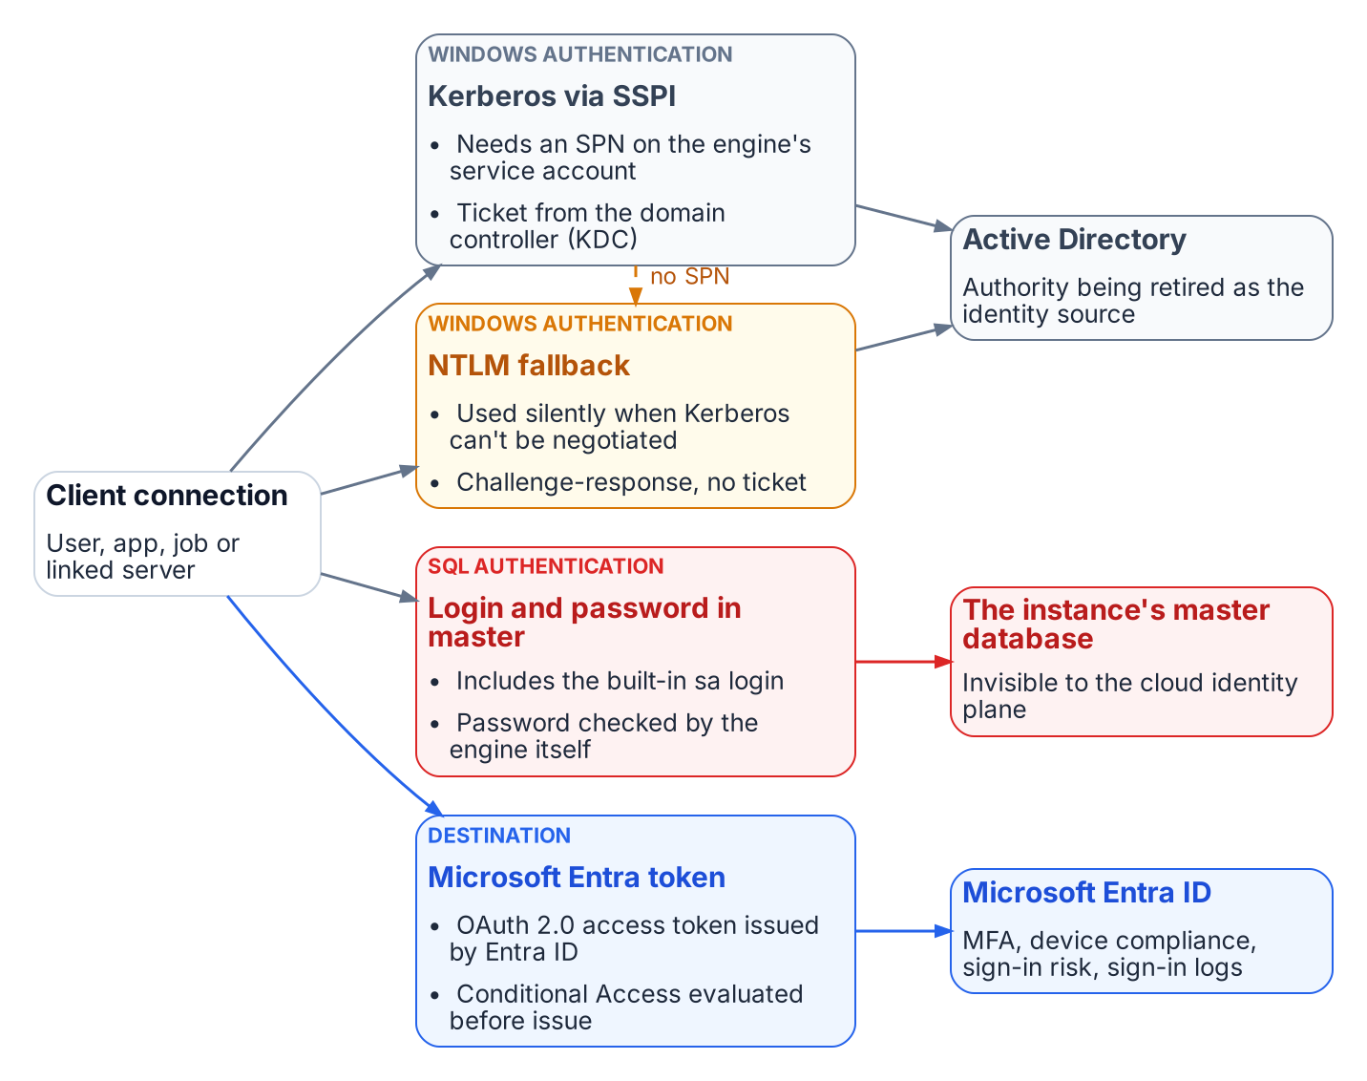
The four ways a connection authenticates to SQL Server today, and which authority each depends on.
Place in the dependency chain: Why the chain exists (before step 1).

Authoritative references
Checked 19 October 2026.
- Microsoft Entra authentication for SQL Server overview
- Microsoft Entra cloud-first identity guidance
- Retiring NTLM: frequently asked questions (Microsoft Tech Community)
- OMB M-22-09, Federal Zero Trust Strategy
- Memo 22-09 identity requirements overview

Chapter 1 — What Windows Authentication Actually Is
The inheritance, named precisely, before the case for replacing it.

In this chapter
How SQL Server delegates authentication to the Windows security subsystem through Kerberos and SSPI, why a missing SPN silently drops a connection to NTLM, what the service account and the sa account each contribute to the picture, and why this whole architecture was genuinely good engineering for the world it was designed for.

The Kerberos Foundation
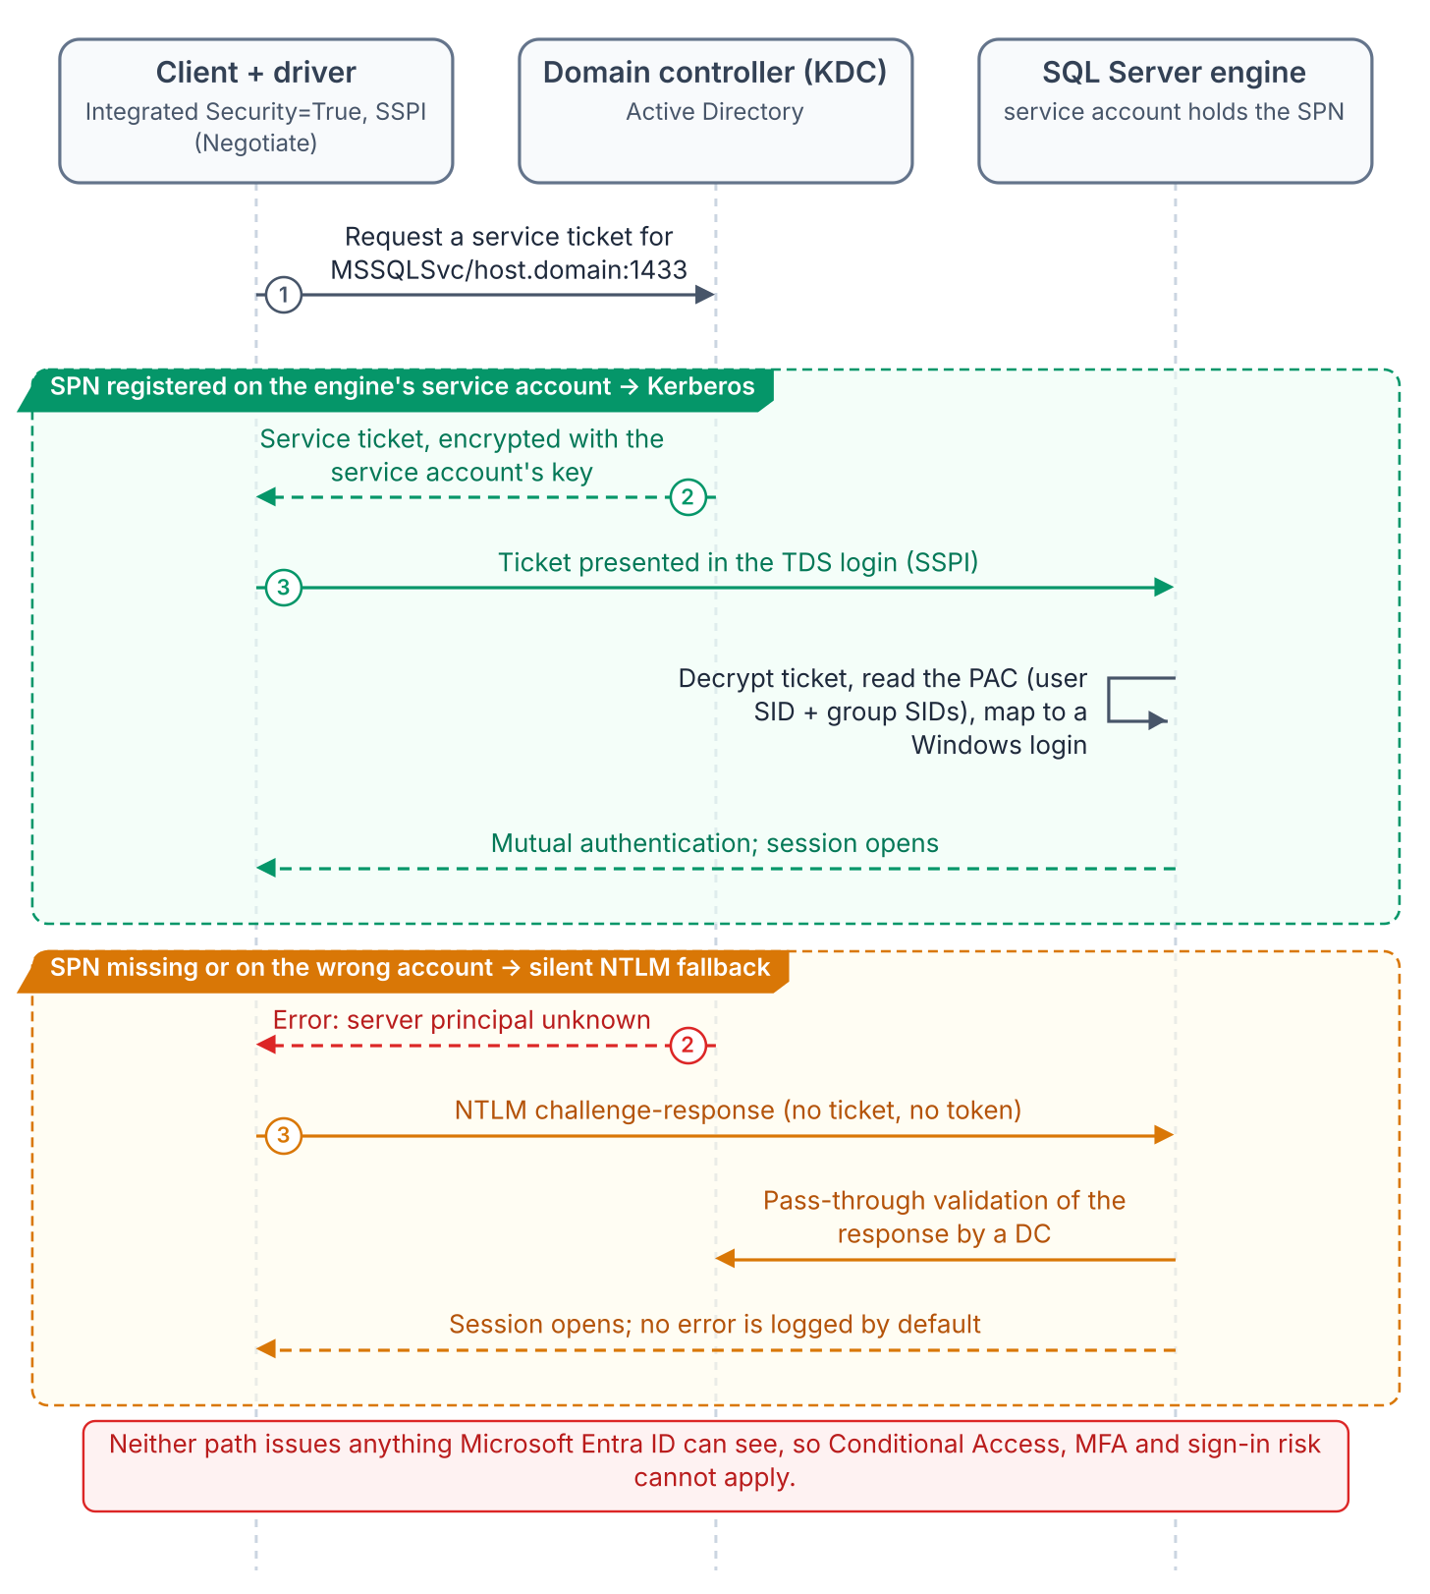
A Windows-integrated connection: SSPI negotiates Kerberos when the SPN resolves, and silently falls back to NTLM when it doesn’t.
In Windows Authentication mode, SQL Server delegates authentication entirely to the Windows security subsystem, with no password verification or token model of its own. With Integrated Security=True, the driver hands off to the Security Support Provider Interface (SSPI), which, if Kerberos is negotiable, requests a service ticket from the domain controller’s Key Distribution Center (KDC) for the instance’s Service Principal Name (SPN). The engine validates the ticket with the service account’s key and maps the principal to a login. No password crosses the network, none sits in configuration files, and authentication is mutual. This is good security architecture, and it deserves saying plainly before explaining why it must be replaced.
The SPN, MSSQLSvc/hostname.domain.com:port, is registered on the engine’s service account, binding that account’s long-term key to the service name. Without it the KDC cannot issue a ticket, and SSPI silently falls back to NTLM.
That silent fallback is the most consequential fault in the inheritance. It is invisible to applications and absent from the default error log, so environments confident they run Kerberos are running NTLM on a significant fraction of connections. Only measurement reveals the fraction; the authentication audit is the instrument, and most federal environments have not run it.

The NTLM Fallback
NTLM was Windows’ original network protocol. When Windows 2000 made Kerberos preferred, NTLM stayed as the fallback where Kerberos could not be negotiated: untrusted domains, non-domain-joined clients, unreachable KDCs. SQL Server inherited that order unchanged, and for a perimeter-defended, fully domain-joined network it was adequate.
It does not scale to zero trust, which this program’s FedRAMP Moderate boundary now requires. NTLM’s challenge-response happens entirely inside the connection negotiation and issues no token or assertion a third party can validate. Conditional Access, which lives in the Azure identity plane outside the connection path, has nothing to observe, evaluate, or deny.

The Service Account
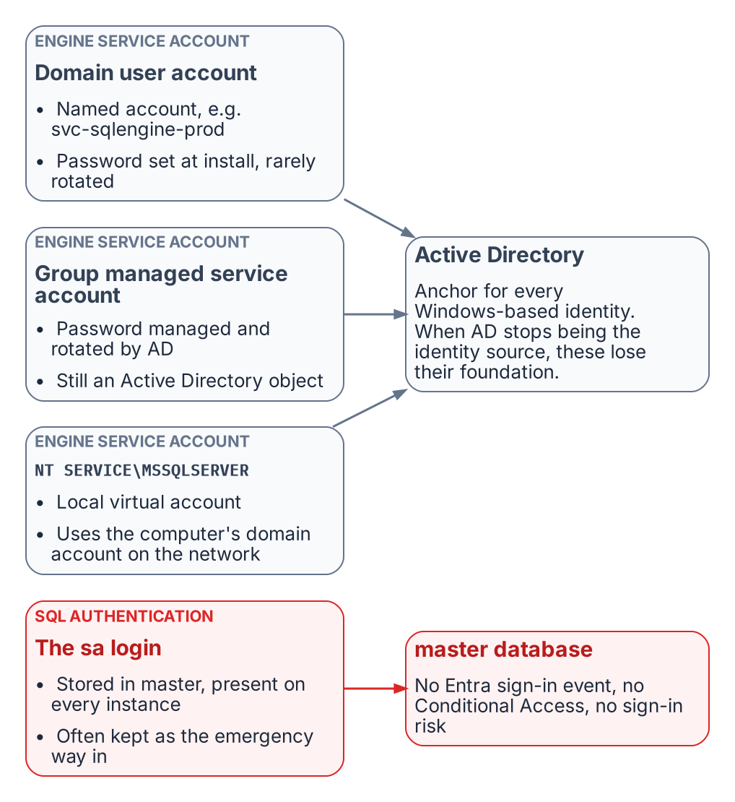
The identities the engine has historically run under, and where each one is anchored.
The engine’s service account is the identity it presents on the network: to file shares, linked servers, and monitoring sinks. Federal estates use three forms:
- a domain service account such as svc-sqlengine-prod, with a password set at installation and rarely changed;
- a group managed service account (gMSA), whose password AD rotates every 30 days and no human knows; better hygiene, but still AD-anchored;
- the NT SERVICE\MSSQLSERVER virtual account, which authenticates on the network as the domain-joined computer account.
In every case AD is the engine’s identity authority. When the program removes AD as the authoritative source, the engine needs a new identity in Microsoft Entra ID — on SQL Server 2025, the system-assigned managed identity that Arc provides for the host; on SQL Server 2022, an app registration whose certificate is kept in Azure Key Vault. That identity sits alongside the Windows account the service runs as rather than replacing it; the transition is the subject of Book 04.

The sa Account
SQL Authentication stores credentials in master instead of AD, and sa is its built-in administrator on every instance. Well-governed estates disable or rename it; many federal estates keep it active as an emergency path in case AD fails, often with its installation-time password.
SQL Authentication is invisible to the Azure identity plane: no Entra sign-in event, no Conditional Access, no Defender for Identity signal, no risk assessment. An active sa is the most dangerous entry point on the instance. Its handling is one of the decisions the SQL Server engine-authentication decision formalizes.

Why This Was Correct
Taken together, SSPI-negotiated Kerberos, SPNs, NTLM fallback, AD service accounts, and SQL Authentication as a local fallback form a coherent, defensible architecture. In a fully domain-joined world it was centrally managed, non-repudiable at the ticket level, resistant to credential theft in transit, and needed nothing beyond the domain controllers already in place. It was not a compromise. The problem is that its world (every machine domain-joined, the perimeter as the boundary, no cloud identity plane) no longer exists.
What Book 01 establishes — Chapter 1
- SQL Server Windows Authentication delegates to the Windows security subsystem: Kerberos through SSPI when an SPN is registered, silent NTLM fallback when it is not.
- The engine’s process identity and the sa account are anchored to authorities — Active Directory and master — that the program removes or that the Azure identity plane can’t see.
- None of this was a mistake; it was correct engineering for a fully domain-joined world that no longer exists.

Chapter 1 — The Shape of Twenty Years
Why the estate you must transform is not the estate anyone remembers building.

In this chapter
The three forms of sprawl that accumulate in a SQL Server estate over two decades across an Active Directory forest — instance sprawl, database sprawl, and forest entanglement — and why an authentication transformation that begins before this sprawl is assessed will migrate the authentication of servers that should not survive the transformation at all.
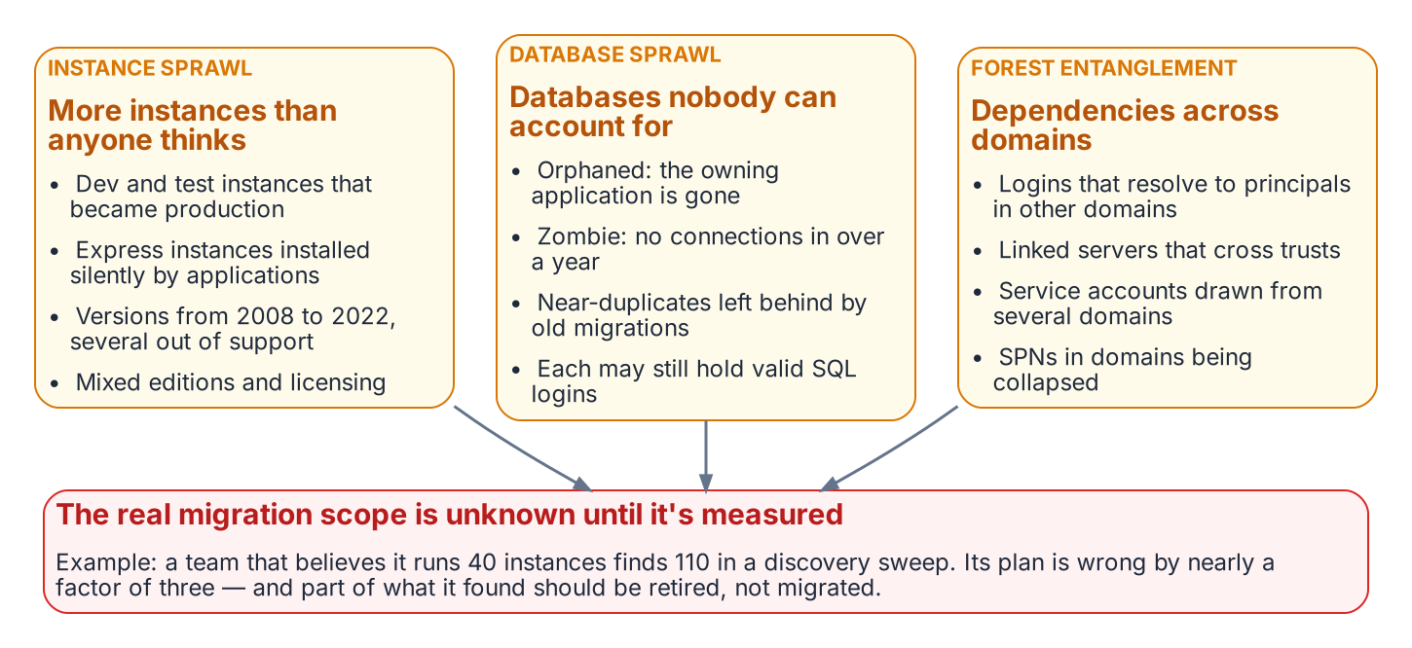
Instance sprawl, database sprawl and forest entanglement overlap, and together they set the scope of the transformation.
The previous book named the inheritance and the three drivers that require ending it. This book confronts a precondition that most authentication narratives skip entirely: you cannot migrate the authentication of an estate you have not first measured and rationalized. After twenty years across an Active Directory forest, the SQL Server estate is larger, older, and more entangled than any single team’s mental model of it — and a meaningful fraction of it should not survive the transformation in its current shape.
The order matters because effort is finite and the 2027-04-01 deadline is fixed. Migrating the logins of an instance to Entra ID, only to retire that instance three months later, is wasted work measured against a deadline that does not move. The SQL Server engine-authentication decision makes the sequencing normative: the consolidation assessment classifies every instance retain, consolidate, or retire before any login is touched.

Instance Sprawl
A SQL Server estate does not grow by design. It grows by accretion. A development instance becomes a production instance because a project shipped and nobody rebuilt it on the production tier. A test instance set up for a vendor evaluation is never decommissioned. An application installer silently provisions a SQL Server Express instance on an application server, and that instance accumulates real data for years without ever appearing on a DBA team’s inventory.
The result, in a mature federal environment, is a population of instances spanning every SQL Server version released across two decades — 2008, 2012, 2014, 2016, 2017, 2019, and 2022 — in every edition, from Express on a workstation to Enterprise on a clustered host. Several of those versions are out of support and receive no security updates. The licensing posture is equally heterogeneous: a mix of Standard and Enterprise cores, some covered by Software Assurance and some not, with no single authority that can state how many cores the estate actually consumes.
Instance sprawl is the first thing the assessment must quantify, because the count of instances — and especially the count of unknown instances — determines the true scope of the transformation. In an illustrative example, an estate that the DBA team believes contains forty instances and the discovery sweep reveals to contain a hundred and ten is not forty instances behind schedule; it is operating on a scope estimate that is wrong by a factor of nearly three.

Database Sprawl
Beneath the instances lies a second layer of accretion: the databases themselves. An instance that has run for fifteen years carries databases nobody can confidently account for. Some are orphaned — the application that created them has been decommissioned, but the database was never dropped because no one was certain it was safe to do so. Some are zombies — they have received no connection in over a year, yet they consume storage, appear in backup jobs, and lengthen every maintenance window. Some are near-duplicates, the residue of a migration that copied a database to a new name and never removed the original.
Database sprawl matters to the authentication transformation for a specific reason. Every database is a potential source of logins, and every login is a unit of migration work. A zombie database may map a long-forgotten SQL Authentication service account that still has a valid password and still appears, to a discovery script, as an active credential requiring migration. The fastest way to reduce the migration surface is not to migrate faster — it is to retire the databases and instances that should not be migrated at all.
Zombie detection is therefore not a housekeeping nicety; it is migration-scope reduction. To take an illustrative example, a database with no connections in four hundred days, no recent backups consumed for a restore, and an owning application that the application portfolio lists as retired is a database whose logins should never enter the migration pipeline.

Forest Entanglement
The third form of sprawl is the one that makes the SQL Server transformation genuinely harder than a single-domain migration: the estate is entangled with the Active Directory forest it grew up in. Instances are spread across multiple domains connected by trusts. Logins on one instance resolve to security principals in a different domain. Linked-server definitions form a web of cross-instance dependencies that crosses domain boundaries, and the service accounts running the engine processes are drawn from several domains with no consistent naming or governance.
This entanglement is precisely what the directory modernization removes the foundation for. When Active Directory ceases to be the authoritative identity source, every cross-domain login, every SPN registered in a domain that is being collapsed, and every shared service account becomes a dependency that must be resolved — not merely re-pointed. Consolidation is the moment when that resolution is cheapest, because collapsing many instances into fewer modern targets is also the moment to collapse the cross-domain identity sprawl into Entra-backed identity.
The shape of twenty years, then, is three overlapping problems: too many instances, too many databases, and too many forest-spanning dependencies between them. The chapters that follow describe how to measure each, and how to turn the measurement into the retain / consolidate / retire decision that gates everything in Books 03 through 10.
What Book 02 establishes — Chapter 1
- A twenty-year estate has three overlapping forms of sprawl: instances, databases, and forest entanglement.
- Sprawl inflates the migration surface, because much of the estate should be retired or consolidated rather than migrated.
- The authentication transformation doesn’t begin until the sprawl is assessed.

Chapter 1 — The Authentication-Audit Script: What It Measures and Why
The instrument that turns the surviving estate into a structured, drift-aware authentication record.

In this chapter
What the authentication-audit script enumerates across the surviving estate, how it reads the authentication-mode configuration and classifies every login by type, how it captures the engine service-account identity and SPN registration, the three-category Arc-eligibility classification that drives migration sequencing, and why the script’s output feeds the compliance-monitoring pipeline rather than a spreadsheet.
This audit runs only on the instances Book 02 classified as retain or consolidation-target — the rationalization decision has already removed the zombies and retirees from scope before a single line of enumeration runs.

Scope of the Enumeration
The authentication-audit script performs a structured enumeration of the SQL Server estate across all hosts in the program’s management scope. For each host it identifies every SQL Server instance — named instances and the default instance — along with the version, edition, and build number.
The host operating system version is captured because it determines the Arc capability envelope. Windows Server 2019 and 2022 support the Connected Machine agent, and therefore support Arc-based Entra authentication for the SQL Server engine (through an app registration on SQL Server 2022, the managed identity on SQL Server 2025). They do not, however, support the AADLoginForWindows OS-level Entra login extension, which requires Windows Server 2025. Windows Server 2025 supports both capabilities.
That distinction matters for migration sequencing, and the audit captures it explicitly. The domain-join status of the host is recorded alongside it: a host already migrated to a non-domain-joined state under the Arc non-domain-join requirement occupies a different starting position than a domain-joined host, and the per-instance output must reflect that.
Arc-enablement status — whether the Connected Machine agent is installed and the system-assigned Managed Identity is available — is the single most consequential classification output for migration prioritization.

Authentication Mode Configuration
For each instance the script reads the authentication-mode configuration. SQL Server supports two modes: Windows Authentication mode and Mixed Mode. In Windows Authentication mode, SQL Authentication logins are rejected at the connection level — no SQL Authentication credential is accepted regardless of whether a matching login exists in master. In Mixed Mode, both Windows Authentication and SQL Authentication are accepted. Microsoft Entra authentication, once configured, works alongside either mode; neither mode turns Windows authentication off.
The mode is stored in the Windows registry at HKLM:\SOFTWARE\Microsoft\Microsoft SQL Server\[InstanceName]\MSSQLServer\LoginMode: a value of 1 indicates Windows Authentication mode, and a value of 2 indicates Mixed Mode.
The audit reads this value directly and also cross-references it against the running instance with SERVERPROPERTY('IsIntegratedSecurityOnly'), which returns 1 in Windows Authentication mode. Discrepancies between the registry value and the running configuration can occur after a manual reconfiguration without a service restart. Any discrepancy is flagged as an anomaly requiring resolution before the migration can proceed.

Login Type Classification
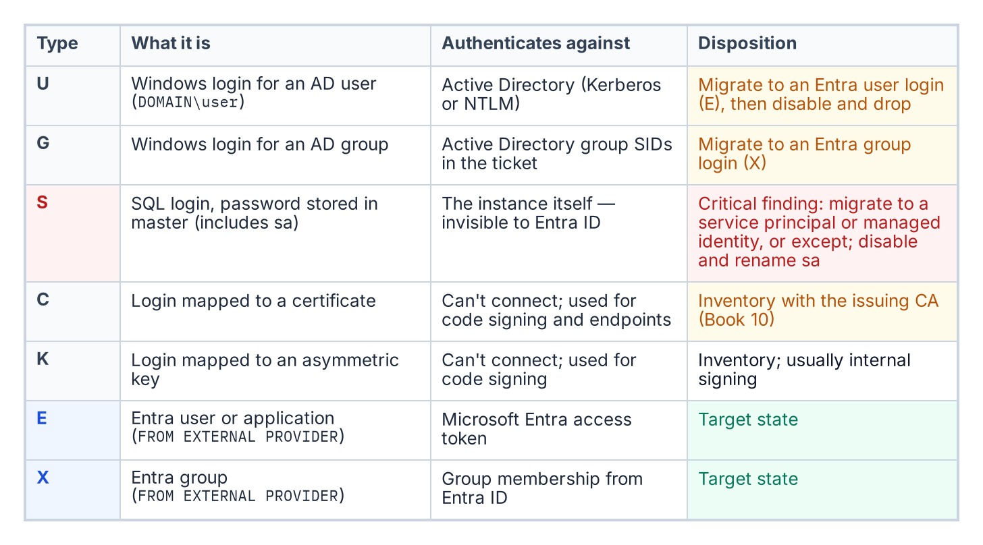
The login types the audit classifies, by sys.server_principals type, and what happens to each.
The script connects to each instance and queries the sys.server_principals system view to enumerate all logins. Each login is classified by type: Windows logins derived from individual AD user accounts (type U, mapped by SID to an AD user object); Windows logins derived from AD security groups (type G, mapped by SID to an AD group object); SQL Authentication logins with credentials stored in master (type S); certificate-mapped logins (type C); and asymmetric key-mapped logins (type K).
The count and identity of each type is reported per instance. The presence of active SQL Authentication logins — type S — is a critical finding, because these logins are invisible to the Azure identity plane.
Such logins must be either migrated to Entra ID equivalents — type E, FROM EXTERNAL PROVIDER logins created in Book 05 — or formally excepted with documented justification before the SQL Server authentication transformation can be declared closed.
The sa account’s status is separately flagged: enabled, disabled, or renamed. An enabled sa account with a non-rotated password is the highest-priority remediation finding in the audit output.

Service Account Identity and SPN Registration
The script captures the identity of the Windows service account running the SQL Server engine process — the MSSQLSERVER service or its named-instance equivalent — by querying the service configuration. This identifies whether the engine runs as a domain service account, a gMSA, the NT SERVICE\MSSQLSERVER virtual account, or another identity.
It then queries Active Directory — using the Get-ADServiceAccount and setspn equivalents — to determine whether the correct SPN is registered for the service account and the instance endpoint.
The SPN check is one of the most operationally valuable outputs of the audit. SPN misconfiguration is the primary cause of NTLM fallback, and it is not visible without deliberately querying AD for it.
An instance with a missing or incorrect SPN is generating NTLM traffic for every connection that expects Kerberos — and in most cases, the application teams generating those connections do not know it.

The Arc-Eligibility Output
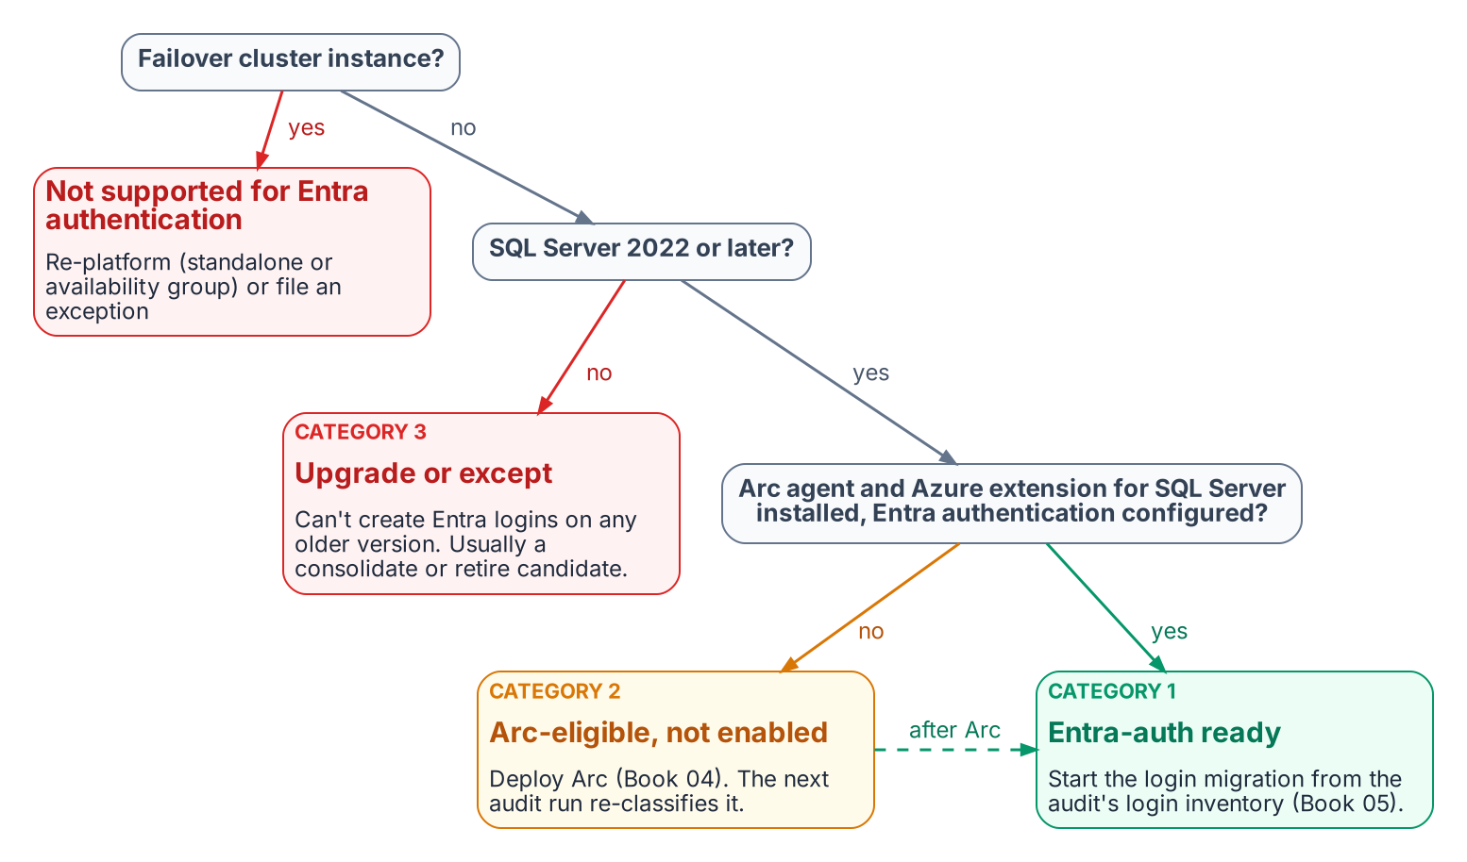
How the audit assigns each instance an Arc-eligibility category.
The most consequential output of the audit is the Arc-eligibility classification it assigns to every instance. Every instance falls into one of three categories.
Category 1 is Arc-eligible and Entra-auth-ready today: the server is already running the Connected Machine agent, the Azure extension for SQL Server has been deployed, the system-assigned managed identity is available, and the SQL Server version is 2022 or later. A Category 1 instance can have its Entra ID logins created and its login migration begun immediately — it requires no further infrastructure work before Book 05’s migration pattern can be applied.
Category 2 is Arc-eligible but not yet enabled: the host meets all the prerequisites for Arc enablement — Windows Server 2019 or later, network connectivity to the Azure Arc endpoint, SQL Server 2022 — but the Connected Machine agent has not been installed. A Category 2 instance requires Arc deployment as the prerequisite action before login migration can begin.
Category 3 is not yet Arc-eligible. Either the SQL Server version is pre-2022 — 2019, 2017, or earlier — which means the engine cannot accept FROM EXTERNAL PROVIDER logins regardless of Arc status, or the host has a configuration that prevents Arc enrollment.
A Category 3 instance requires a SQL Server version upgrade as the gate before any Entra-auth migration can occur, and that upgrade timeline must be factored into the overall program sequencing against the 2027-04-01 NTLM deadline.

The Compliance-Monitoring Telemetry Sink
The audit script’s output is not a standalone deliverable — it is the input to the compliance-monitoring pipeline. This is the architectural characteristic that distinguishes the authentication-audit script from a conventional discovery script.
The continuous-compliance monitoring system is the program-level tracking system for SQL Server authentication state at the instance level. Each time the audit runs — and it is designed to run continuously, on a schedule, against the full estate — it produces a structured per-instance compliance record that the compliance-monitoring pipeline ingests.
That pipeline computes the current authentication posture of the instance, compares it to the previous record, and flags any drift: a new SQL Authentication login that appeared since the last scan, an instance that has reverted from Windows Authentication mode back to Mixed Mode, a new linked-server definition that uses NTLM passthrough.
Drift events are not informational — they are compliance violations that trigger the program’s remediation workflow. The required output is a per-instance compliance record, not a spreadsheet delivered to a program manager.
What Book 03 establishes — Chapter 1
- The audit enumerates the surviving estate: version and OS, domain join, authentication mode, login types, and service-account and SPN posture.
- Every instance gets an Arc-eligibility category: Entra-ready (1), Arc-eligible but not enabled (2), or upgrade required (3).
- The output is a per-instance compliance record that re-runs as a drift-aware baseline, not a one-off spreadsheet.

Chapter 1 — What Arc Provides to SQL Server
Arc is not an end state — it is the bridge that gives the SQL Server engine a cloud-native identity.

In this chapter
What the Connected Machine agent and its managed identity establish; which Entra identity the instance uses on SQL Server 2022 and 2025; the two-layer distinction between SQL-engine Entra authentication and OS-level Entra login; why Arc’s managed identity beats a gMSA, a vaulted secret, or certificate-based authentication; and what Arc deliberately does not change.
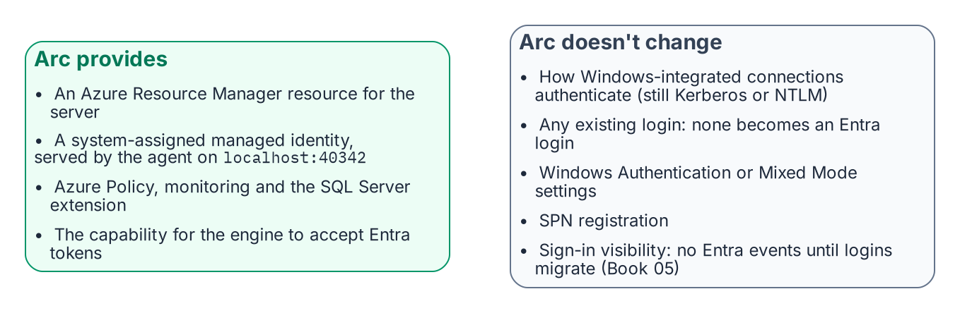
What installing Arc changes, and what it deliberately doesn’t.
Arc is usually introduced as a management capability: on-premises servers in the Azure portal, under Azure Policy and Azure Resource Manager. For this transformation it matters more because it gives the server, and through it the SQL Server engine, a cloud-native identity. Without that identity the engine cannot authenticate to Key Vault, forward logs to Azure Monitor, or accept Entra ID tokens from clients. Arc is the enablement layer for everything that follows.

The Arc Agent and the ARM Resource Identity
Installing the Azure Connected Machine agent gives the server a first-class ARM resource of type Microsoft.HybridCompute/machines, with a resource ID, subscription, and resource group. That resource makes the server visible in the portal and addressable by Azure Policy and ARM, and it is the basis for the system-assigned managed identity: an Entra ID service principal created at registration and deleted at deregistration.
The identity’s private key sits in the Arc agent’s local certificate store, is rotated automatically every 90 days, and is never seen by an administrator. A process requests a token from the agent’s local identity endpoint, the Hybrid Instance Metadata Service (HIMDS) at http://localhost:40342/metadata/identity/oauth2/token (not the Azure VM address 169.254.169.254), and the agent returns a token for any Azure resource the identity has been granted. The endpoint first issues a challenge that only members of the local Administrators or Hybrid Agent Extension Applications group can complete, so not every process on the host can obtain a token.

The Two-Layer Distinction
Arc enables two architecturally independent Entra ID capabilities for SQL Server. Confusing them is the most common sequencing error in this transformation.
Layer 1 is SQL Server engine Entra authentication, the subject of this series. With the Azure extension for SQL Server on an Arc-enabled server running SQL Server 2022 or later, the engine accepts Entra ID OAuth 2.0 access tokens for CREATE LOGIN ... FROM EXTERNAL PROVIDER logins and validates them against Entra ID. It needs the registered Arc agent, SQL Server 2022 or later, the Azure extension for SQL Server, and Entra authentication configured on the instance (Chapter 2). It does not need domain unjoin or Windows Server 2025: a domain-joined Windows Server 2019 host running SQL Server 2022 is fully capable of Layer 1 today.
Layer 2 is OS-level Entra login through the AADLoginForWindows extension, which lets administrators RDP with Entra credentials. It belongs to the server infrastructure transformation, requires domain unjoin and Windows Server 2025 with Desktop Experience, and is more disruptive: unjoin affects every AD-dependent service on the host, plus DNS, Group Policy, and certificate enrollment.
Do not block Layer 1 on domain unjoin, a Layer 2 prerequisite. Layer 1 proceeds on domain-joined servers and should finish before Layer 2 begins. Say this explicitly to every DBA and infrastructure team; incorrect sequencing assumptions are the most common cause of unnecessary delay.

The Managed Identity and the Service Account
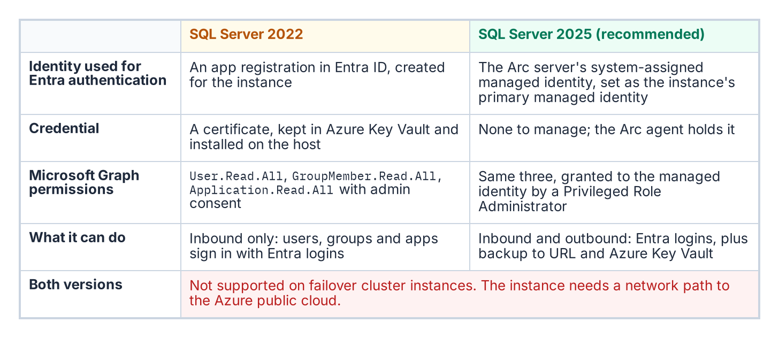
Where an Arc-enabled instance’s Entra identity comes from in SQL Server 2022 and in SQL Server 2025.
What the instance uses as its Entra identity depends on the version. On SQL Server 2025, the server’s system-assigned managed identity is set as the instance’s primary managed identity and serves both inbound Entra authentication and outbound connections to Azure services such as backup to URL and Azure Key Vault. On SQL Server 2022, the instance uses an Entra app registration whose certificate is kept in Azure Key Vault; the Arc agent retrieves that certificate with the server’s managed identity and installs it on the host. An app registration covers inbound Entra authentication only and cannot make outbound connections.
On both versions, agent-side work (retrieving certificates from Key Vault, log forwarding through the Azure Monitor agent, the extension’s own operations) authenticates with the server’s managed identity, not stored credentials.
None of this replaces the Windows account the service runs as (NT SERVICE\MSSQLSERVER, a gMSA, or a domain account), which still presents the computer or domain identity for Windows networking on a domain-joined host. What changes is the identity Entra ID and Azure see: the managed identity (2025) or the app registration (2022) instead of an AD service account. On SQL Server 2025 there is no credential to manage; on 2022 the one credential is the app registration’s Key Vault certificate, which needs a named renewal owner and, per Microsoft, a validity of at most 12 months.

Why Arc and Not the Alternatives
Every alternative either re-anchors on the directory the program is retiring or reintroduces the stored credential it exists to eliminate.
- A gMSA or domain service account works only while AD is authoritative. Book 01’s third driver removes AD as the authority for this boundary; a gMSA can stay the Windows logon account while the domain exists, but it cannot be the engine’s Entra identity.
- A service principal with a client secret, on disk or in Key Vault, reintroduces a rotatable credential and a bootstrap problem: the engine must authenticate to the vault first, so a root credential lands on the server anyway.
- Certificate-based authentication is the program’s interim posture, authorized for the pre-2022 exception long tail that cannot reach Kerberos or Entra OAuth before the 2027-04-01 block. It still needs certificate lifecycle management, hence the ADCS-to-Microsoft Cloud PKI dependency the transformation inventory still classifies as “Not Yet Defined.” It is a bridge, not a destination.
The Arc managed identity is the only option that is both cloud-native and credential-free for the operator: its certificate rotates automatically, no human sees it, and its lifecycle is bound to the ARM resource rather than to AD. SQL Server 2025 uses it directly. SQL Server 2022 still authenticates through an app registration certificate, but the Arc agent fetches it from Key Vault with the managed identity, so no root credential is placed on the server by hand.

What Arc Does Not Do
Arc’s effect is often overstated in both directions. A domain-joined client using Integrated Security=True against an Arc-enabled instance still negotiates Kerberos or NTLM exactly as described in Book 01, and Arc alone produces no Entra sign-in events for SQL Server connections. Arc converts no login to the External Provider type, disables neither Windows Authentication nor Mixed Mode, and leaves SPN registration untouched. It provides the capability without activating it; the login migration in Book 05 is what changes authentication behavior. Arc is a necessary prerequisite, not the transformation itself.
What Book 04 establishes — Chapter 1
- Arc gives the server an ARM identity and a system-assigned managed identity whose tokens come from the local endpoint (localhost:40342); the instance’s Entra identity is an app registration and Key Vault certificate on SQL Server 2022 and the managed identity on SQL Server 2025.
- Layer 1 (SQL-engine Entra authentication) is independent of Layer 2 (OS-level Entra login) and must never be blocked on it.
- Arc provides the capability but doesn’t activate it, and it doesn’t replace the Windows account the service runs as; of the alternatives, it is the only one both credential-free and independent of AD.

Chapter 1 — Three Principal Types — User, Group, Service Principal
The moment the engine stops accepting Kerberos and NTLM and starts accepting Entra-issued tokens.

In this chapter
The FROM EXTERNAL PROVIDER syntax that creates type-E logins validated by token at connect time, the three principal types those logins map to — Entra user, Entra security group, and Entra service principal — and the three-phase parallel-run pattern that creates and validates the new logins before disabling the old ones.
This is the technical heart of the series: the engine stops accepting Kerberos tickets and NTLM exchanges and starts accepting Entra ID OAuth 2.0 access tokens carrying claims about identity, group membership, device compliance, and MFA. Books 01–04 are prerequisite; Books 06–10 are consequence. The SQL Server engine-authentication decision records the canonical sequence this chapter follows.

The FROM EXTERNAL PROVIDER Syntax
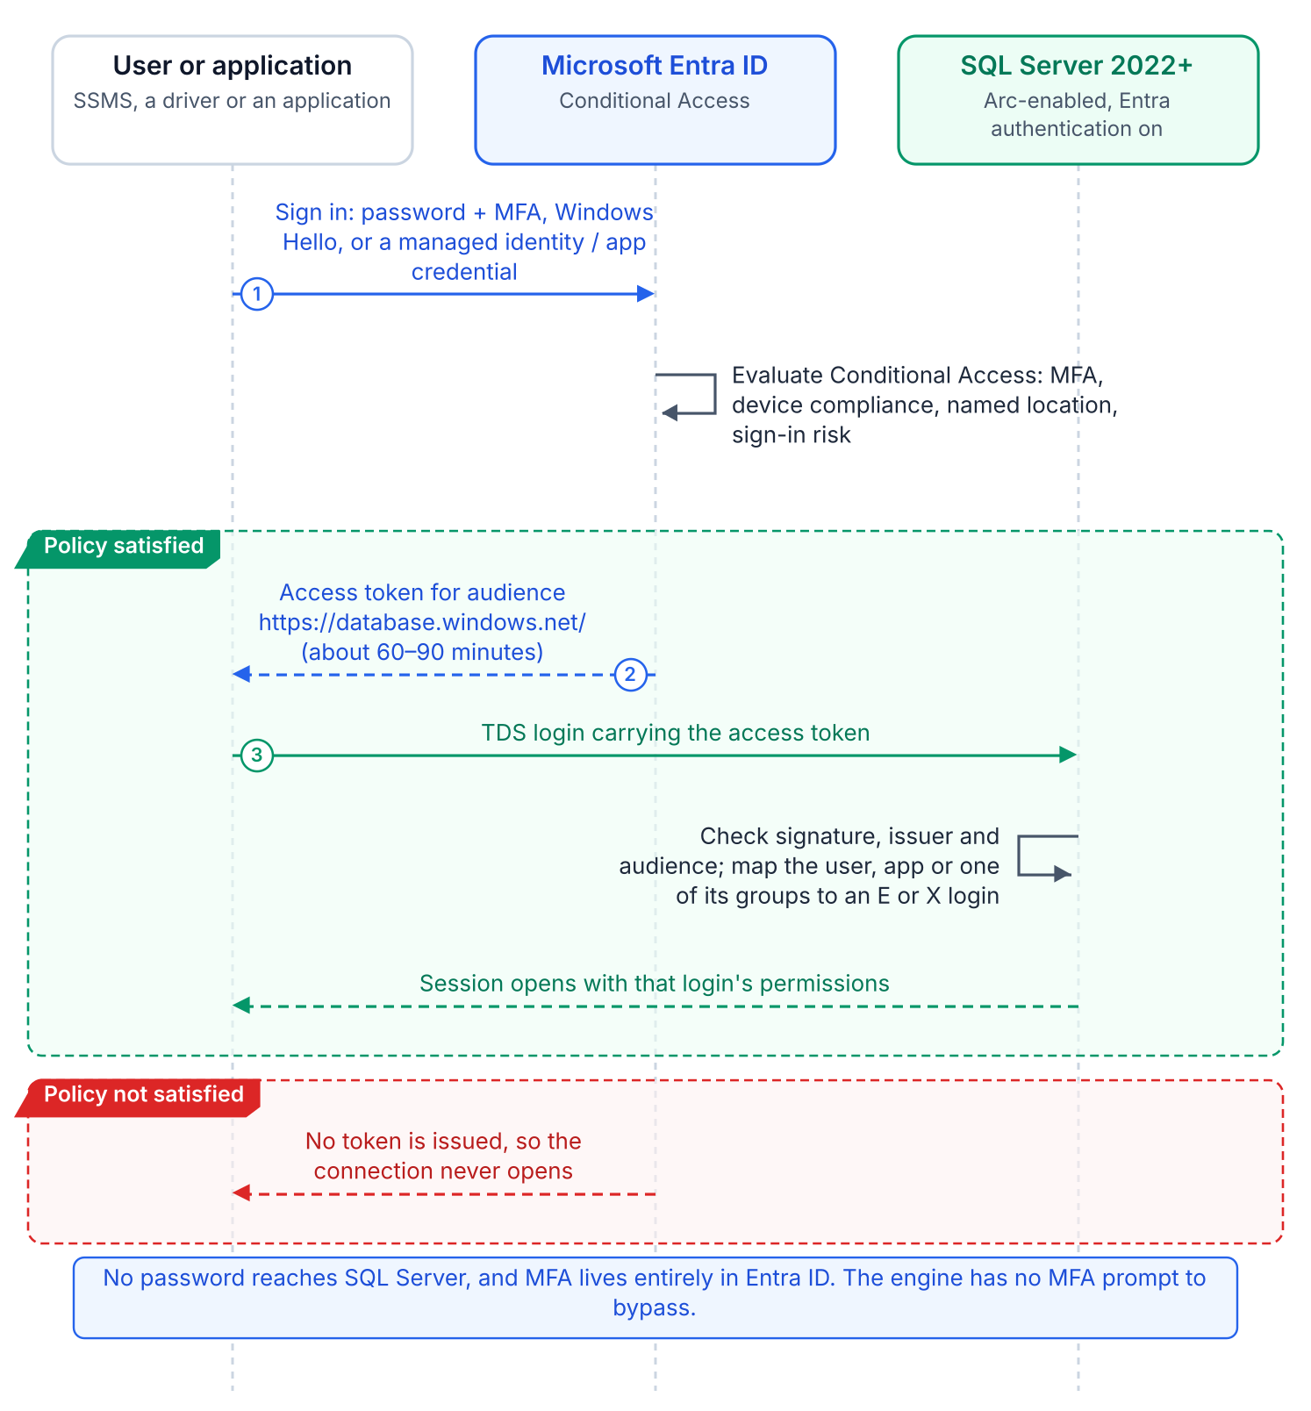
A connection with an Entra login: the client gets a token for the SQL audience and the engine validates it.
SQL Server 2022’s CREATE LOGIN [principal] FROM EXTERNAL PROVIDER maps an Entra principal (a user’s UPN, a group’s display name, or an application’s name) to a login with no Active Directory involvement. The login is stored in master as a passwordless external principal. At connection time the client presents an access token for the SQL Server resource audience; the engine validates its signature, maps the claims to the login, and, if the login is enabled, applies its permissions and database roles.
The syntax requires the Azure extension for SQL Server, which configures the instance’s Entra identity (an app registration on 2022, the managed identity on 2025) and token validation, and registration with the Arc SQL resource plane. CREATE LOGIN looks the principal up through Microsoft Graph, which is why the instance’s identity needs Graph read permissions. Verify that each principal exists before creating its login, to avoid orphaned logins that map to deleted or renamed principals.

Type 1 — Entra User Login
For human DBAs and developers, a CREATE LOGIN [DOMAIN\username] FROM WINDOWS login gets a type-E counterpart for the same person’s UPN: CREATE LOGIN [username@tenant.onmicrosoft.com] FROM EXTERNAL PROVIDER. UPNs can differ from SAM account names where UPN synchronization was never standardized, so the audit captures the UPN-to-SAMAccountName mapping for every Windows login first. The user then signs in with password plus MFA, FIDO2, or Windows Hello for Business, as Conditional Access requires.
The engine has no MFA logic. Conditional Access enforces MFA, device compliance, Named Locations, and sign-in risk before the token is issued; if they fail, no token is issued and the connection never opens. There is no SQL-level MFA prompt and no SQL-level bypass. None of these controls apply to Windows Authentication or NTLM connections.

Type 2 — Entra Group Login
A SQL Server login can be created for an Entra ID security group rather than an individual user: CREATE LOGIN [GroupDisplayName] FROM EXTERNAL PROVIDER. When a user whose Entra access token includes a claim asserting membership in the named group connects to SQL Server, the engine maps the group claim to the group login and grants the user the permissions associated with that login.
It is the familiar AD group pattern, with group claims in place of SID resolution and Kerberos PAC membership. Group logins appear in sys.server_principals as type X (EXTERNAL_GROUP), distinct from type E. When the group is a dynamic group whose rule reads HR-sourced attributes, users gain and lose SQL Server access as HR updates them, with no CREATE USER or DROP USER. Book 07 covers designing and governing those groups.

Type 3 — Entra Service Principal Login
ETL pipelines, reporting services, API backends, and monitoring agents replace their SQL Authentication account (a type-S login with a stored password) with a service principal login: CREATE LOGIN [ApplicationDisplayName] FROM EXTERNAL PROVIDER. This removes passwords from connection strings, configuration files, logs, and repositories, along with their rotation.
Preferably the application uses a managed identity and holds no credential. On an Arc-enabled server, DefaultAzureCredential in Azure.Identity finds the server’s managed identity at the agent’s local endpoint (localhost:40342), provided the process account is in the local Hybrid Agent Extension Applications group. Azure VMs, Container Instances, and App Service use their platform managed identity. Where a credential is unavoidable, use a client certificate stored in Key Vault, never a client secret or a file.

The Parallel-Run Migration Pattern
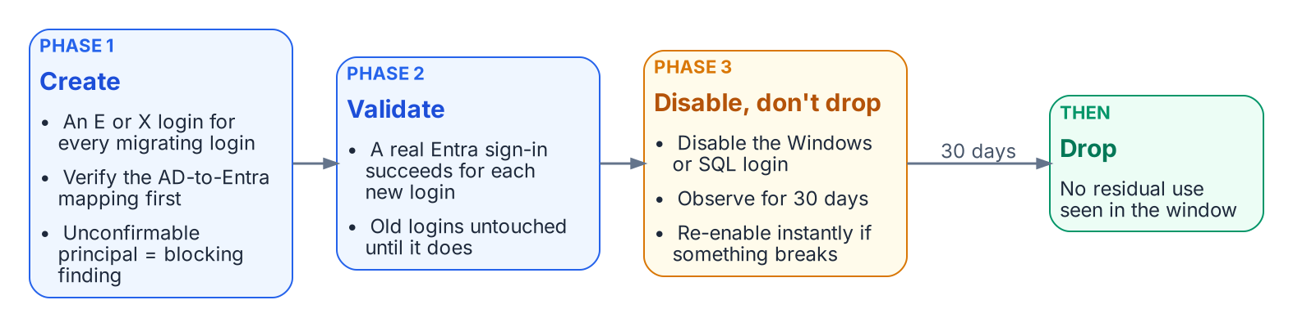
The required three-phase parallel run for production.
No Windows login is dropped until its Entra equivalent is validated. The engine-authentication decision makes this three-phase parallel run required for production:
- Create. For every migrating Windows login, user or group, create the FROM EXTERNAL PROVIDER login for the corresponding Entra principal. Verify each mapping first; a principal with no confirmed Entra equivalent is a blocking finding. This mapping, built from the authentication audit’s AD inventory and Entra’s UPN and group data, is the most labor-intensive step.
- Validate. Test each new login with the principal’s real Entra credential before any legacy login is touched.
- Disable, observe, drop. Disable (do not drop) the legacy Windows and SQL Authentication logins, monitor for 30 days to confirm nothing depends on them, then drop them.
Non-production instances may shorten the observation window with documented owner sign-off, but create→validate→disable→observe→drop is the canonical sequence. Other platforms document the same side-by-side premise: Google’s Cloud SQL for SQL Server lets Entra ID authentication be enabled without disabling existing Active Directory authentication during a phased migration. The next chapter records four further decisions around it.
What Book 05 establishes — Chapter 1
- FROM EXTERNAL PROVIDER creates passwordless logins for Entra users and applications (type E) and groups (type X), authenticated by Entra-issued tokens.
- MFA and other sign-in conditions are enforced by Conditional Access in the Entra plane, not by the engine.
- Migration is the parallel run: create, validate, disable (not drop) the legacy login, observe for 30 days, then drop.

Chapter 1 — NTLMv1, NTLMv2, and the Patterns That Generate NTLM
NTLM is a protocol, not a setting — so eliminating it means naming every connection pattern that produces it.

In this chapter
Why NTLMv1 is blocked early (Phase B, targeted 2026-Q3) while NTLMv2 has a phased 2027-04-01 deadline, and the four SQL Server connection patterns that generate NTLM: a missing or incorrect SPN, an unreachable KDC, linked-server passthrough, and non-domain-joined application hosts.
No single switch or Group Policy change removes NTLM from SQL Server connections. Eliminating it means finding every connection pattern that generates it, and there are more than most database teams expect. Beyond Book 01’s missing-SPN case there are cross-site connections, linked-server passthrough, and hosts already moved to a non-domain-joined state, each with its own root cause and fix.

NTLMv1: Blocked First, in Phase B
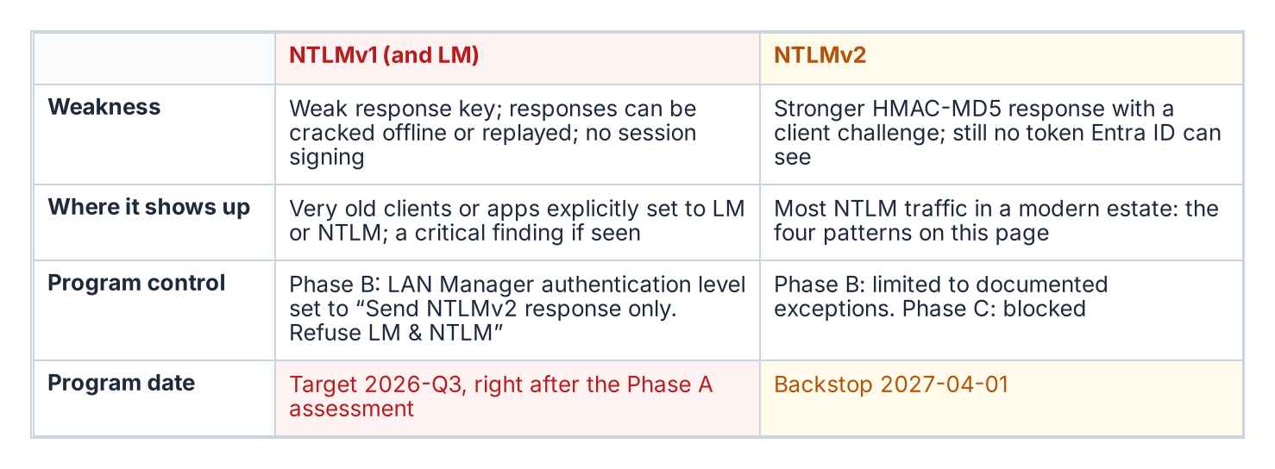
The two NTLM variants and their different timelines.
NTLMv1 uses an MD4 hash of the password as its response key. A captured response can be attacked offline or replayed to authenticate as the victim (pass-the-hash), and with no session signing, traffic can be modified in transit.
The Kerberos/NTLM-elimination program blocks NTLMv1 in its Phase B “block-where-safe” stage, by default as soon as the Phase A assessment completes (targeted 2026-Q3), by setting “Network Security: LAN Manager Authentication Level” to “Send NTLMv2 response only; refuse LM and NTLM.” The Local Security Authority then negotiates only NTLMv2. This is slightly ahead of Microsoft, whose October 2026 Windows Update flips the BlockNTLMv1SSO default from Audit to Enforce on devices without an explicit policy; the program’s Group Policy makes the block deterministic.
Windows Server 2016 and later with default settings generate no NTLMv1; it surfaces only with Windows 7-era clients or applications explicitly configured for LM or NTLM. NTLMv1 found by the authentication audit or Phase A traffic analysis is a critical finding requiring immediate remediation, not a routine migration item.

NTLMv2: The 2027-04-01 Deadline
NTLMv2 uses HMAC-MD5, adds a client challenge against replay, and supports signing; it is what most SQL Server NTLM traffic in a modern federal environment uses. Phase B restricts it to documented exception groups; Phase C disables it at the 2027-04-01 hard cutover, the program’s own backstop. That is a program decision, not a Microsoft deadline: Microsoft’s stated target is to disable NTLM by default — not remove it — in the next major release of Windows Server and client, subject to change, with re-enablement possible at least initially. SQL Server NTLMv2 connections must be migrated either to Kerberos as an interim posture — using Cloud Kerberos trust per the elimination program — or to Entra ID OAuth 2.0 authentication as the final destination, before that date.

Pattern One: Missing or Incorrect SPN
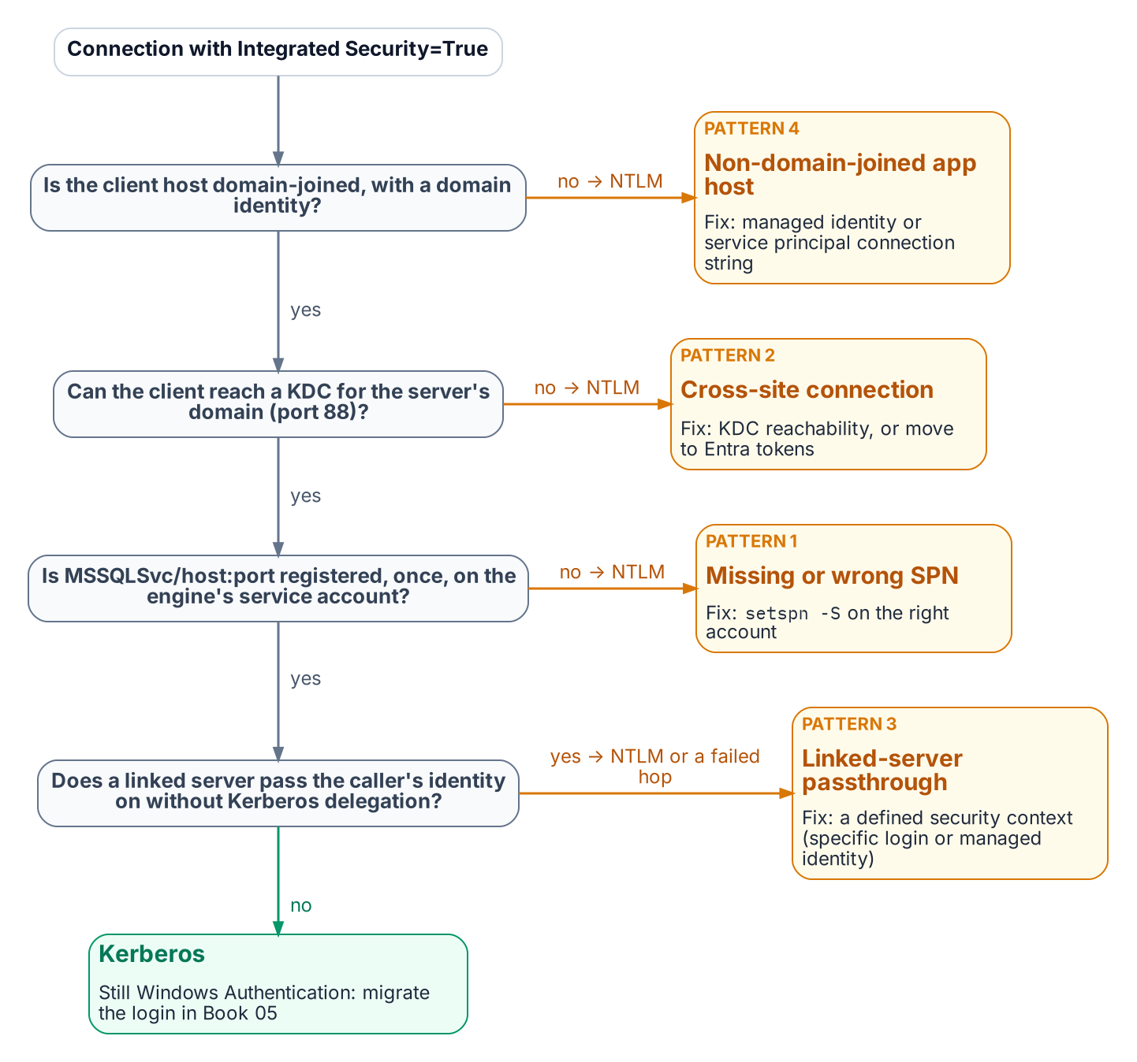
The checks Negotiate makes before it settles for NTLM, and the connection pattern behind each failure.
Established in Book 01
When no valid SPN is registered on the engine’s service account, SSPI cannot negotiate Kerberos and falls back to NTLM.
This is the most common cause of NTLM fallback. The SPN takes the form MSSQLSvc/hostname.domain.com:port (named instances also MSSQLSvc/hostname.domain.com:instancename) on the account the engine runs under. A service-account change without an SPN update leaves the SPN on the wrong account, with the same result. The fix is setspn -S MSSQLSvc/hostname.domain.com:port serviceaccount; the authentication audit captures SPN status per instance, and each gap can be fixed independently of the login migration.

Pattern Two: Cross-Site Connections
Connections that cross AD sites, domains, or forests can generate NTLM when Kerberos cannot complete. Kerberos requires the client to obtain a service ticket from a domain controller (KDC) for the domain that holds the server’s service account — any DC of that domain, not one in a particular site. Across forests it also needs a forest trust with name-suffix routing for the SPN; without a trust, neither Kerberos nor NTLM can authenticate an account from the other forest.
If the client cannot reach or locate a DC for that domain — port 88 blocked, or DNS that doesn’t resolve it — Negotiate falls back to NTLM where a trust lets the server validate the account, and the connection fails where it doesn’t. This is common in distributed federal networks.
Detect it in Phase A output by correlating source and destination sites. Cross-site NTLM usually means DC reachability or DNS from the source site, but a missing SPN or trust gap looks the same, so confirm with klist or the client’s Kerberos events before changing firewall rules. The remediation is to restore Kerberos — DC reachability on UDP and TCP port 88 and working DNS from every client site, a correct SPN, and, across forests, a trust — or to move the connection to Entra ID tokens, which need no KDC at all. Cloud Kerberos trust, which the Kerberos/NTLM-elimination program deploys for Windows Hello for Business sign-in, is not a fix for this pattern: the partial ticket Entra ID issues must still be exchanged with an on-premises domain controller, and the service ticket for the SQL Server SPN still comes from one.

Pattern Three: Linked-Server Passthrough Authentication
Linked-server definitions in SQL Server — which allow one instance to query another using OPENQUERY or four-part name syntax — frequently use Windows passthrough (self-mapping, @useself = 'TRUE') as the mechanism for the linked-server connection. In the passthrough model, the originating instance impersonates the connecting client’s Windows identity and tries to present that identity to the target SQL Server — a second hop.
NTLM cannot make that second hop: an instance that authenticated the client with NTLM holds no credential it can forward, so the connection to the target fails, typically as Login failed for user 'NT AUTHORITY\ANONYMOUS LOGON'. Passthrough needs Kerberos delegation: the client should reach the first instance with Kerberos, and the first instance’s service account must be trusted for (preferably constrained) delegation to the target’s SPN. In practice the pattern shows up as NTLM on the client’s first hop or as a failed second hop; it is not a working NTLM path to keep.
Linked-server NTLM often looks like “internal” traffic and escapes standard connection audits; find it through sys.linked_logins, sys.servers, and inter-instance traffic analysis. Each passthrough definition is migrated during the restriction phase to a defined security context: a specific mapped login, a managed identity (SQL Server 2025 on an Arc-enabled host, linking to a target with Entra authentication), or, where the caller’s own identity must reach the target, Kerberos constrained delegation.

Pattern Four: Non-Domain-Joined Application Hosts
An application on a host unjoined under the Arc non-domain-join requirement has no Kerberos TGT, so a connection string still using Windows Integrated Security falls back to NTLM with local credentials: a new NTLM source the unjoin created. The pattern grows as server unjoin progresses, which is why connection strings should move to managed identity before or alongside application-host unjoin. A host on managed identity generates no NTLM and satisfies both programs.
What Book 06 establishes — Chapter 1
- NTLM is a protocol, not a setting; no single switch removes it from SQL Server connections.
- NTLMv1 is blocked early; NTLMv2 is restricted to exception groups, then blocked at the program’s 2027-04-01 cutover.
- Four patterns generate NTLM at the SQL layer — missing SPNs, unreachable KDCs, linked-server passthrough, and non-domain-joined hosts — and each must be found before it can be fixed.

Chapter 1 — Groups, Roles, and How Membership Reaches the Engine
Group-based authorization survives the migration. Its plumbing, its timing, and its outer boundary do not.

In this chapter
How an Entra security group becomes a SQL Server login and a database role member. Why each group should grant exactly one role. Why the group model should stay flat. When a membership change actually takes effect at the engine. How the four kinds of AD group found in a SQL Server estate migrate. Why Conditional Access becomes the outer perimeter once every login is Entra-backed.
SQL Server’s access model has two halves: roles and permissions inside the engine, and the directory outside it that decides group membership. For twenty years the outside half was Active Directory: a DBA mapped DOMAIN\SQL-Reporting-Readers to a login and role, and whoever controlled that AD group controlled access.
The transformation replaces the outside half and leaves the inside nearly untouched. Roles, GRANT and DENY, ownership chains, and module signing work as before. What changes is the principal (an Entra group), the proof of membership (an Entra token, not a Kerberos ticket), and when a membership change takes effect.

How an Entra Group Becomes SQL Server Access
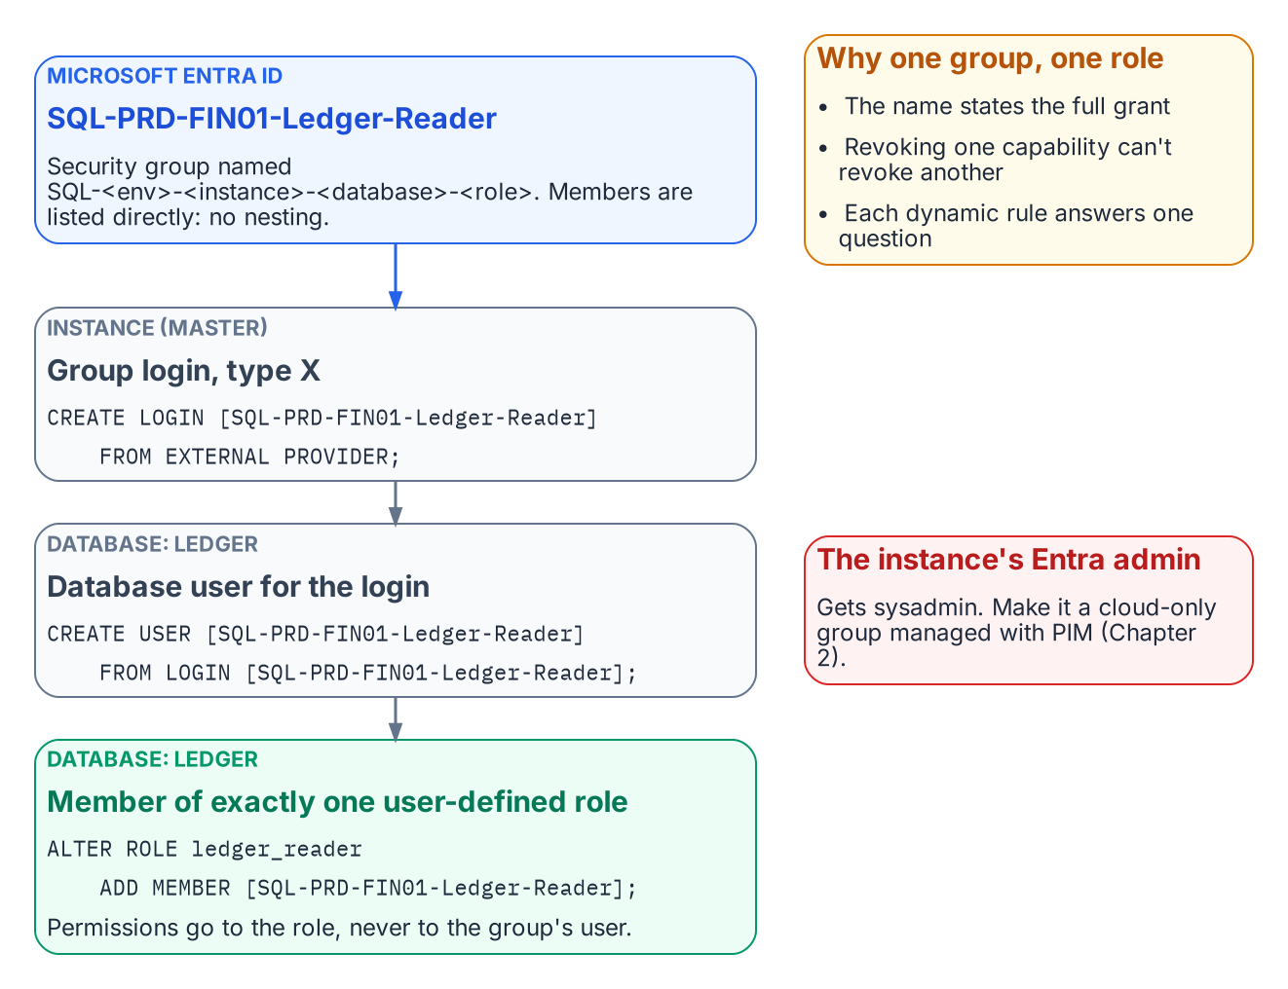
How one Entra group becomes exactly one database role.
Established in Book 05
CREATE LOGIN … FROM EXTERNAL PROVIDER creates type-E logins for Entra users and applications and type-X (EXTERNAL_GROUP) logins for groups.
A group enters SQL Server as an AD group did, as a server login created by display name, then a database user (CREATE USER … FROM LOGIN) added to a role. Book 09’s continuous audit must count type X as well as type E, because group logins are where most access should live.
The instance’s Microsoft Entra administrator receives sysadmin and, in any sizable estate, should be a group (Chapter 2). The instance’s Entra identity needs Microsoft Graph User.Read.All, GroupMember.Read.All, and Application.Read.All, granted by a Privileged Role Administrator: an identity-team step, not a DBA step.
-- Instance level: one login per Entra group
CREATE LOGIN [SQL-PRD-FIN01-Ledger-Reader] FROM EXTERNAL PROVIDER;
-- Database level: the group becomes a member of exactly one role
USE Ledger;
CREATE USER [SQL-PRD-FIN01-Ledger-Reader] FROM LOGIN [SQL-PRD-FIN01-Ledger-Reader];
ALTER ROLE ledger_reader ADD MEMBER [SQL-PRD-FIN01-Ledger-Reader];
The Implementation Companion carries the full runbook. Authorization inside the engine is not redesigned; only the principal changes.

One Group, One Role
The most consequential design decision in this book is the simplest: each Entra group grants exactly one role, on one database, in one environment. A user who reads the ledger and runs the month-end job belongs to two groups.
The rule pays off three ways. The group name fully states what it grants, so an access review can be answered without opening SQL Server Management Studio. Revoking one capability never revokes another. And dynamic membership becomes tractable: “who should read the ledger?” can be written as a rule; “whoever this legacy group happened to include” cannot.
Permissions go to user-defined database roles, never directly to group users, and db_owner and sysadmin are kept for the few who need them. Every legacy group mapped to db_owner “because the application needed it” is a finding to resolve before its replacement is created.

Flat by Design
AD estates are full of nested groups. Don’t rebuild that tree in Entra ID; the platform’s constraints point to a flat model.
- Dynamic groups can’t contain groups. A dynamic rule selects users (or devices) by attribute, never other groups.
- The memberOf operator is ending. It was the preview workaround for building a dynamic group from other groups. Microsoft has announced that its public preview ends on 3 November 2026. After that date, groups that use it stop updating and stay in their last-known state.
- Role-assignable groups can’t nest. These are the groups with the strongest protection against privilege escalation, and they accept no group members at all.
- Group claims are capped. Applications that read group membership straight from the token get at most 200 groups in a JWT, and above that receive an overage indicator instead of the list.
- Nested-group evaluation is undocumented for SQL Server. Microsoft’s SQL Server documentation doesn’t describe how nested Entra group membership is evaluated for an on-premises instance’s group logins.
Nesting builds on behavior that is unsupported, ending, or undocumented. A flat model costs a few more groups and gives up nothing: each role-mapped group lists members directly, by rule or assignment, and several populations needing one role share one rule. Where a nested chain is unavoidable, test it on the target instance version first.

When a Change Takes Effect
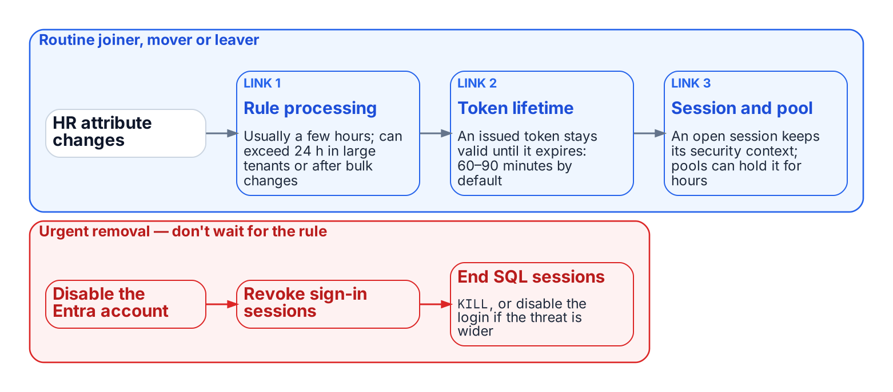
The chain between an HR change and the engine, and the urgent path that doesn’t wait for it.
Under Windows Authentication a membership change arrived with the next Kerberos ticket, usually the next logon. The Entra chain is longer:
- Rule processing. A dynamic group is recalculated when a relevant attribute changes. Microsoft documents that this usually completes within a few hours, but that it can take more than 24 hours in large tenants, after bulk changes, or with complex rules.
- Token lifetime. An access token already issued to the user stays valid until it expires. By default that’s a randomized 60 to 90 minutes.
- Session and pool lifetime. An open SQL Server session keeps the security context it was established with. A connection pool can keep that session open for hours.
That latency is acceptable for routine joiners, movers, and leavers, and often beats the ticket queue it replaces. Urgent removal doesn’t wait for a rule: disable the Entra account, revoke the user’s sign-in sessions, and end the user’s SQL Server sessions (KILL, or disabling the individual or group login if the threat is broader). Write this path into the operations runbook before the first dynamic group grants production access.

Migrating the Four AD Group Patterns
Groups in a long-lived SQL Server estate fall into four patterns:
- Organization-derived access groups, kept in step with the org chart by hand, become dynamic groups whose rules read HR-maintained attributes such as department, companyName, jobTitle, an extensionAttribute, or a directory extension property (Chapter 2).
- Explicit role-assignment groups such as PROD-SQL-SYSADMIN reflect specific people given a specific permission, so no rule should define them. They become flattened assigned groups managed by a delegated administrator or, for privileged roles, PIM (Chapter 2).
- Distribution lists for SQL Server Agent notifications become mail-only groups; the operator address is updated and no login is created.
- Mail-enabled security groups split into a mail-only group and an assigned security group, with the pairing recorded in both descriptions and the migration record.

Conditional Access as the Outer Perimeter
Once every login is Entra-backed, every connection needs a token and every token request passes Conditional Access. A non-compliant device, a sign-in outside named locations, or a high-risk sign-in is refused a token, so the connection never opens.
None of this reaches a Windows or SQL-authenticated login, so the perimeter is binary: one surviving Windows login bypasses every policy. Privileged-access workstations, bastions, segmentation, and vaulting are legitimate interim controls, but none evaluates identity, device, and risk per connection. Book 05 therefore treats each surviving legacy login as a documented, sunset-dated exception.
What Book 07 establishes — Chapter 1
- An Entra group reaches SQL Server as a type-X login and grants exactly one role, on one database, in one environment.
- The group model stays flat, and membership changes reach the engine only after rule processing, token expiry and session turnover, so urgent removal needs its own runbook.
- Each kind of AD group maps to a specific Entra replacement, and Conditional Access then sits in front of every login.

Authoritative references
- CREATE LOGIN — Microsoft Entra group logins and sys.server_principals principal types
- Set up Microsoft Entra authentication for SQL Server enabled by Azure Arc and Managed identity for SQL Server enabled by Azure Arc (Graph permissions)
- Rules for dynamic membership groups and the memberOf preview and its end date
- Role-assignable groups and group claims limits
- Dynamic group processing times and access token lifetimes

Chapter 1 — The Four-Class Pattern Applied to SQL-Consuming Applications
The application is the other half of the authentication chain — and it has its own AD dependency to remove.

In this chapter
Why SQL Server’s authentication transformation is incomplete until the upstream applications that consume it are addressed, how the LDAP-dependent-application migration plan’s four-class taxonomy categorizes those applications by modernization capability, what each class means for both the user-authentication track and the SQL-connection track, and how the application-audit script produces the per-application classification data that drives the triage.
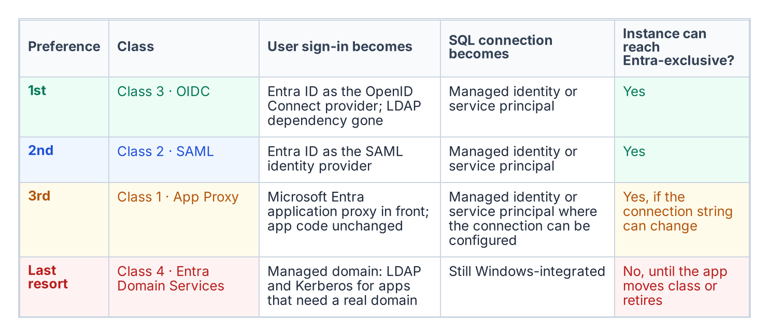
The four application classes in preference order, with what each means for user sign-in and the SQL connection.
SQL Server does not exist in isolation. In every federal environment of meaningful size, it is the data layer downstream of a middleware tier — web application servers, API backends, reporting services, ETL pipelines, and legacy integration systems. Those middleware applications carry their own authentication architecture, and in many federal environments that architecture includes LDAP binding: the application binds to Active Directory as a directory authority, queries group membership or user attributes, and treats AD as its authorization source.
The same AD dependency that must be removed from SQL Server’s authentication layer must also be removed from those upstream applications, and the removal must be coordinated. An application that has migrated its user authentication to Entra ID OIDC but still uses a SQL Authentication service account to reach SQL Server has not completed its transformation. The application chain must be addressed as a complete authentication path — user to application to database — not as independent layers.
The LDAP-dependent-application migration plan, accepted 2026-05-13, provides the four-class taxonomy for categorizing upstream applications by modernization capability, in a strict preference order: Class 3 (OIDC) preferred, then Class 2 (SAML), then Class 1 (App Proxy), then Class 4 (Entra Domain Services) as the last resort. The application-audit script (Get-LDAPBindAccountInventory.ps1) is the discovery instrument that produces the per-application classification data this chapter depends on.

Two Axes: User Sign-In and the Database Connection
The four classes describe only one axis: how users authenticate to the application. The SQL connection is a second, independent axis, and an application’s place on it is set by evidence, not by its class:
- Driver version and Entra modes. Does the application’s database driver, at the version deployed, support the Entra authentication mode it needs?
- Token acquisition and refresh. Can it be configured to use a managed identity or service principal, or must its code acquire a token and refresh it before expiry?
- Connection pooling. Does pooling keep working when connections use per-identity tokens?
- Vendor support. For commercial software, does the vendor support Entra authentication to SQL Server, and in which release?
- Client platform. Does the operating system or runtime the application runs on offer an Entra-capable driver?
These answers place each application in one of four database-axis columns: A — configuration only (connection-string change); B — code change; C — vendor-dependent; D — no Entra path today. Reading the two axes together gives the outcome for the host instance:
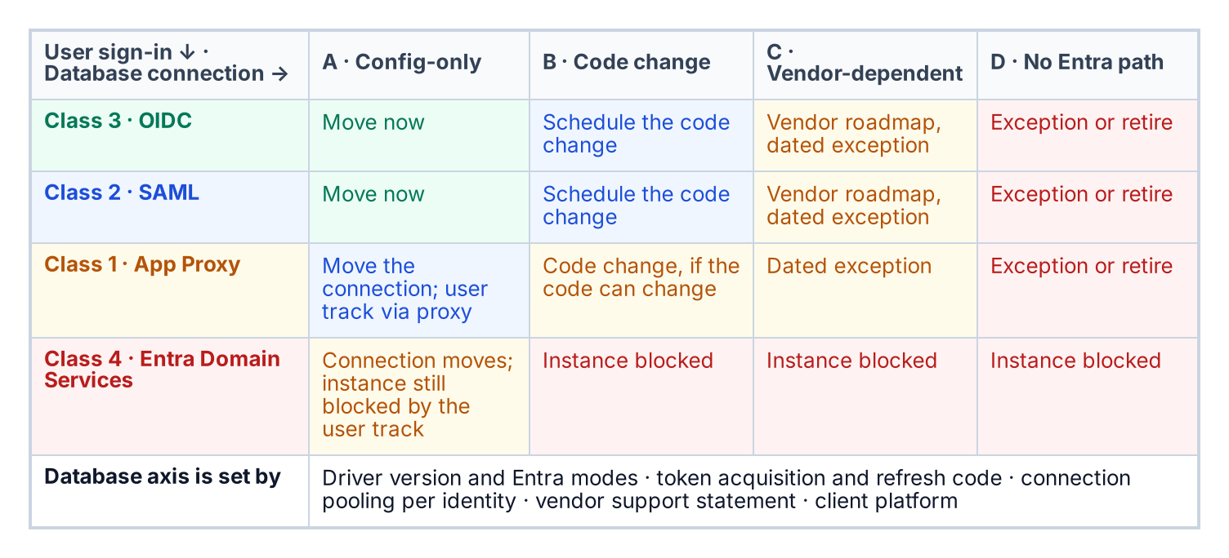
Where an application lands on both axes, and what that means for its host instance.
The application audit collects the user-axis data; the database-axis data comes from the driver inventory, the code owner and the vendor. Every cell outside A carries an owner, an effort band and a dated exception in the exception registry.

Class 1 — App Proxy: Cannot Be Modernized Directly
Class 1 applications cannot modify their authentication mechanism. They bind to LDAP for user authentication, and the dependency is architectural — embedded in unmaintainable code, supplied by a vendor with no modern auth option, or frozen by a regulatory certification that prevents code modification. For SQL Server, Class 1 applications typically connect using an AD service-account credential stored in a connection string or configuration file.
The Class 1 migration pattern has two independent tracks. The user-authentication track deploys Entra Application Proxy in front of the application: the App Proxy connector fronts the application’s user authentication behavior without modifying the application itself. The SQL-connection track migrates the application’s database credential from a SQL Authentication service account to a service principal or Managed Identity — a change made in the connection string or configuration, not in code, and independent of the user-authentication track. Both tracks must complete before the application’s contribution to the SQL Server transformation is fulfilled.

Class 2 — SAML: Federated Identity but Not OIDC
Class 2 applications support SAML federation but not OIDC. SAML 2.0 is an XML-based federation protocol that predates OIDC and is common in federal environments because many enterprise applications implemented SAML support before OIDC was standardized. For Class 2 applications, Entra ID becomes the SAML Identity Provider per the SAML identity-provider standard. The user’s authentication is modernized — they authenticate to Entra ID using their Entra credentials, Entra issues a SAML assertion, and the application validates the assertion and grants access — but the protocol is SAML, not OIDC.
The SQL-connection track for Class 2 follows the same pattern as Class 1: the connection string migrates from SQL Authentication or Windows Integrated Security to Managed Identity or service-principal authentication. The user-authentication modernization and the SQL-connection migration are separate tracks and can be sequenced independently. The LDAP-dependent-application migration plan places Class 2 second to Class 3 because SAML eliminates the LDAP dependency rather than proxying through it, yet ranks below OIDC because it does not provide the full capability set of a modern identity protocol.

Class 3 — OIDC: The Preferred Destination
Class 3 is the preferred migration destination in the LDAP-dependent-application migration plan’s ordering. An OIDC-capable application can migrate fully to Entra ID as its identity provider, eliminating the LDAP dependency entirely. The application redirects the user to the Entra ID authorization endpoint, the user authenticates with Entra credentials, Entra issues an ID token and an access token, and the application uses the claims in those tokens for identity and authorization. No LDAP bind occurs, and no AD query occurs.
The application’s SQL Server connection also uses Managed Identity or service-principal authentication, with no stored credential. The end-to-end chain for a Class 3 application reaching SQL Server is direct: the user authenticates to Entra ID via OIDC, the application uses its Managed Identity to authenticate the SQL connection, SQL Server validates the Managed Identity token through the Arc-provided token-validation infrastructure, and the connection is established. There is no AD in this path, no LDAP, no NTLM or Kerberos, and no stored credential. This is the target architecture.

Class 4 — Entra Domain Services: Last Resort
Class 4 applications cannot be modernized to any modern authentication protocol. They require actual LDAP and Kerberos from a domain controller — not a proxy, not a federation, but a real AD-compatible domain with DNS SRV records, LDAP on port 389, and Kerberos on port 88. For these applications, Entra Domain Services provides a Microsoft-managed PaaS domain that presents an AD-compatible interface — LDAP, Kerberos, NTLM — while being backed by Entra ID rather than a customer-managed domain controller. The LDAP-dependent-application migration plan places Class 4 last because it preserves the AD dependency rather than eliminating it.
For SQL Server, Class 4 carries a specific implication. An instance hosting databases for a Class 4 application cannot complete the full authentication transformation until that application is upgraded to a higher class or sunset. An instance that still accepts Windows Authentication logins because a Class 4 application cannot use Entra ID authentication is blocked from the Entra-exclusive posture that the SQL Server authentication transformation requires. Class 4 applications must be inventoried against their SQL Server dependencies, and each instance with a Class 4 upstream application must carry a documented exception with a sunset date.

The Application-Audit Script as the Classification Triage Tool
The application-audit script (Get-LDAPBindAccountInventory.ps1) is the instrument that produces the per-application classification data needed to execute the four-class triage. For each application in its enumeration scope, the script captures the LDAP bind account — the AD service account used for directory queries — and the SQL Server connection target, meaning the instance and database the application connects to.
It also captures the authentication mechanism for that SQL connection (Windows Integrated Security, SQL Authentication, or already-migrated Managed Identity or service principal) and the signals that map to each class: SAML metadata URLs, OIDC discovery-endpoint registration, or vendor documentation indicating modernization capability. The output is a per-application record with a recommended class assignment and the detection signals that support it.
That record is the input to the LDAP-dependent-application migration plan triage and to the instance-level migration planning in Book 05. The two audit scripts must be correlated to produce a complete picture: the authentication-audit script enumerates SQL Server instances, and the application-audit script enumerates the upstream applications. Only when both are joined does each SQL Server instance reveal its full authentication chain — every application that depends on it, and the class each one falls into.
What Book 08 establishes — Chapter 1
- The transformation is incomplete until each application chain — user to application to database — is addressed.
- Each application is placed on two axes: how users authenticate to it, and how it authenticates to the database.
- The application audit supplies the data for both axes, and an application stuck on Entra Domain Services keeps its host instance off the Entra-exclusive posture.

Chapter 1 — The Closure Condition for the SQL Server Authentication Transformation
Transformations do not complete — they achieve a posture, and a posture is something you keep proving.

In this chapter
The five conditions that must be simultaneously satisfied for the SQL Server authentication transformation to be closed across the estate, why the continuous audit rather than a one-time scan is the verification instrument, how the per-instance compliance record captures the satisfying state, what drift detection looks for, and how behavioral telemetry — Defender for SQL threat alerts, Entra ID sign-in logs, and host authentication logs — adds a layer on top of the structural monitoring.
A transformation that achieves a completed state and then stops monitoring is a transformation that will regress. A SQL Server instance brought to the Entra-exclusive operational posture can be reconfigured to Mixed Mode by any administrator with sufficient permission. New SQL Authentication logins can be created. New Windows logins can be created if the instance remains domain-joined. The transformed posture is not a permanent state achieved through a one-time action — it is an ongoing condition maintained by continuous monitoring, automated drift detection, and a governance process that treats regression as a compliance violation rather than an operational preference.

The Five Closure Conditions
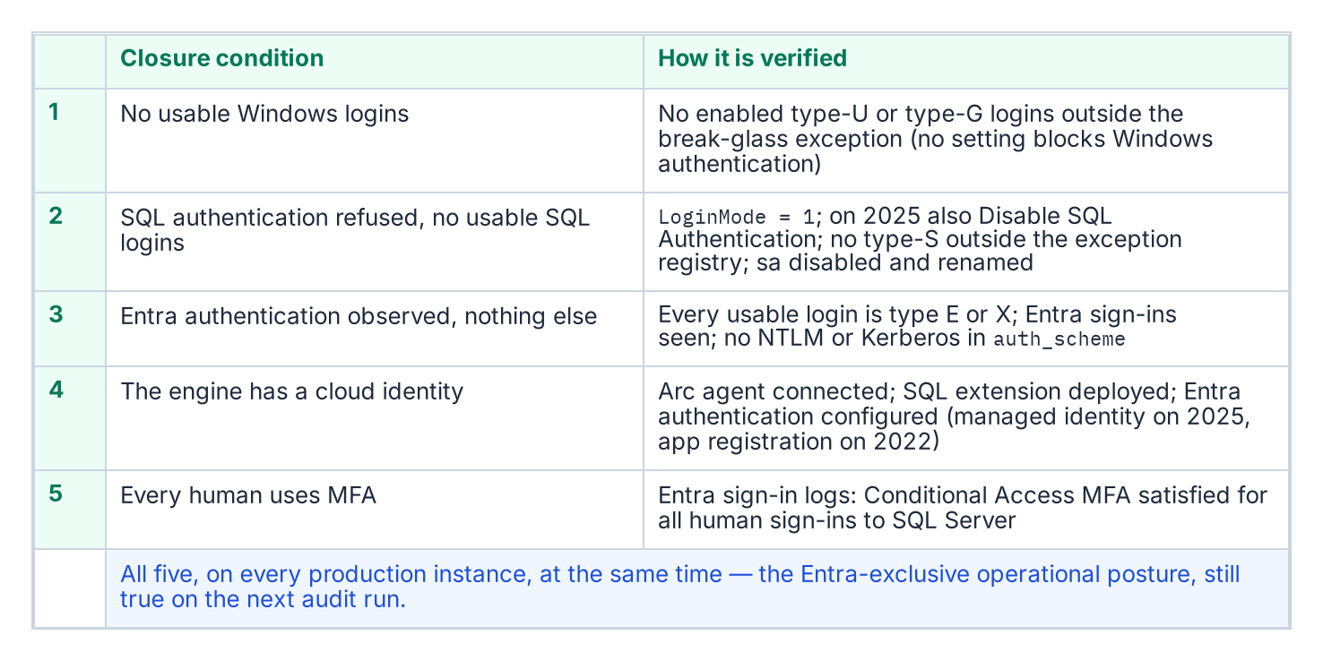
The five closure conditions, and the check that proves each one.
The transformation inventory defines the SQL Server authentication transformation as complete when five conditions are simultaneously satisfied across all production SQL Server instances in the estate. None of the five is a single engine setting, and the series calls the combined state the Entra-exclusive operational posture: an evidenced condition, not a mode. SQL Server has no setting that turns Windows authentication off. Entra authentication works alongside whichever authentication mode the instance uses, and even SQL Server 2025’s Disable SQL Authentication setting leaves the instance accepting “Microsoft Entra authentication and Windows authentication.” LoginMode = 1 (Windows Authentication mode) therefore proves only that SQL logins are refused, not that Windows logins are gone.
The first condition is that no usable Windows-backed principal remains. A query of sys.server_principals shows zero type-U and type-G logins that are enabled and hold CONNECT SQL, other than a documented break-glass group recorded in the exception registry.[^b09c01-principals]
The second condition is that SQL Authentication is eliminated. No SQL Authentication logins — type-S logins — exist on any production instance other than those carrying documented exception status, and the sa account is disabled on every instance. SQL logins are refused: SERVERPROPERTY('IsIntegratedSecurityOnly') = 1 (Windows Authentication mode, LoginMode = 1), and on SQL Server 2025 also SERVERPROPERTY('IsExternalAuthenticationOnly') = 1 once Disable SQL Authentication is on. The operational verification is that evidence plus a sys.server_principals query for type-S logins, cross-referenced against the exception registry the program maintains. The third condition is that Entra authentication is observed working and nothing else is: every usable login is type E or X, Entra sign-in logs show connections to the instance, and sys.dm_exec_connections.auth_scheme shows no NTLM or KERBEROS connections over the validation period.[^b09c01-auth-scheme]
The fourth condition is that the engine has a cloud identity. The Arc Connected Machine agent is connected, the Azure extension for SQL Server is deployed, and Microsoft Entra authentication is configured on every production instance — with the managed identity on SQL Server 2025, or an app registration on SQL Server 2022.[^b09c01-arc-servers][^b09c01-arc-sql][^b09c01-mi-2025] The fifth condition is that every human principal authenticates with MFA enforced by Conditional Access.[^b09c01-ca] This is verified through Entra ID sign-in logs and Conditional Access policy reports — every sign-in event for a SQL Server resource should show MFA satisfied and Conditional Access grant controls met.

The Continuous Audit as the Verification Instrument
The authentication-audit script in continuous monitoring mode — running on a recurring schedule against the full estate rather than as a point-in-time scan — is the primary instrument for verifying that all five closure conditions remain satisfied over time. The per-instance compliance record, updated on each audit run, is the structured evidence artifact that captures the current state of each condition for each instance. The SQL Server engine-authentication decision defines the field set that record carries.
A per-instance compliance record that shows SQL authentication refused, zero usable type-S logins, zero usable type-U and type-G logins outside the break-glass exception, zero Windows-authenticated connections over the validation period, the sa account disabled and renamed, the Arc agent enrolled, the SQL extension deployed, and Entra authentication configured is a record that satisfies all five closure conditions for that instance. When all production instances carry satisfying compliance records, the SQL Server authentication transformation is verifiably closed for the estate. The continuous audit ensures closure is not a point-in-time claim — it is an ongoing verification.

Drift Detection
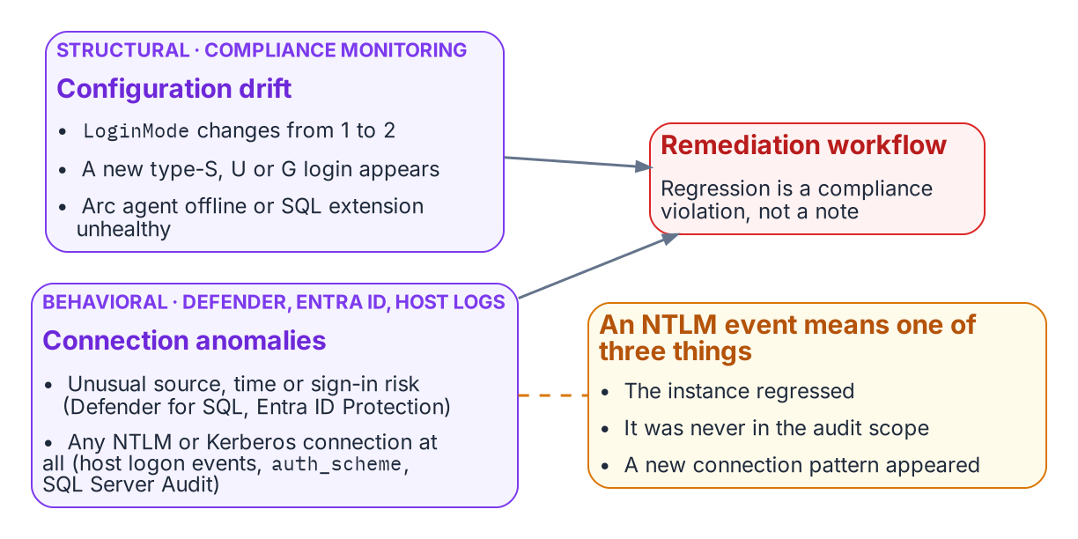
Structural drift detection and behavioral telemetry feed one remediation workflow.
Drift detection in the compliance-monitoring pipeline identifies conditions that would constitute regression before they become compliance violations. A drift event for SQL Server authentication takes one of several forms. An instance whose LoginMode value changes from 1 to 2 — Windows Authentication Only to Mixed Mode — indicates that someone has enabled Mixed Mode without authorization. A new type-S login appearing in sys.server_principals that was not present on the previous audit run indicates that a SQL Authentication login has been created.
A new type-U or type-G login appearing on an instance that was previously in the Entra-exclusive posture is the same class of regression for Windows-backed identity. And an Arc agent going offline, or the SQL extension becoming unavailable, would leave the instance’s Entra identity unmanaged: certificate renewal on SQL Server 2022 and managed-identity tokens on SQL Server 2025 both depend on the agent. Each drift event triggers the program’s remediation workflow. The SQL Server engine-authentication decision records these same events — LoginMode reverting to Mixed Mode, a new type-S/U/G login appearing, the Arc agent going offline — as compliance violations, not advisory signals.
The 2027-04-01 NTLM elimination backstop is not a migration completion date in the continuous-compliance monitoring context — it is the date by which the records for all production instances must have been in the satisfied state continuously for a sufficient validation period. Migration activity should conclude well before the 2027-04-01 block date set by the elimination program’s enforcement phase; the final months before it are the continuous-audit validation period, not the migration period.

Behavioral Telemetry: Defender for SQL, Entra ID, and Host Logs
Behavioral telemetry complements the continuous-compliance monitoring. The compliance monitoring tracks the configuration state of each instance — is the LoginMode correct, are the login types correct. The behavioral layer watches the connections themselves, and it draws on three sources with distinct jobs. Microsoft Defender for SQL servers on machines, enabled through Defender for Cloud on the Arc-enabled host, raises threat alerts — sign-ins from an unusual location or an unfamiliar principal, brute-force attempts, potential SQL injection — and runs vulnerability assessment; it is an alerting service, not an audit log of every authentication. Entra ID sign-in logs record every token issued for SQL Server, with its risk and Conditional Access result. The authentication protocol itself is recorded on the host: Windows Security log logon events (4624 and 4625) name the authentication package, the NTLM operational log records NTLM use, sys.dm_exec_connections.auth_scheme shows NTLM or KERBEROS for each live Windows connection, and SQL Server Audit records successful and failed logins.[^b09c01-sqlaudit] The Azure Monitor agent forwards those Windows logs, including SQL Server Audit written to the Security log, to a Log Analytics workspace, where the alert queries run.
In the transformed posture, the baseline is Entra-authenticated connections only. Every Entra-authenticated connection rests on a token that Entra ID issued, and each token issuance is recorded in the sign-in logs (a client can reuse a cached token across connections); an anomalous connection — from an unusual source IP, at an unusual time, with an elevated sign-in risk signal — is surfaced by Defender for SQL and by Entra ID Protection.[^b09c01-idp] Any NTLM- or Kerberos-authenticated connection to an instance, visible in auth_scheme, SQL Server Audit and the host’s logon events, should be zero in the transformed posture and raises an immediate alert from Log Analytics.
An NTLM event means one of three things: an instance has regressed to Mixed Mode, which the compliance monitoring should already have detected; an instance was not included in the original audit scope, a discovery gap; or a novel connection pattern has appeared that the migration plan did not anticipate. All three require investigation. The combination of continuous-compliance structural monitoring and behavioral monitoring from these sources is the two-layer governance instrument that maintains the transformed posture continuously after the migration is complete.
What Book 09 establishes — Chapter 1
- Closure is the Entra-exclusive operational posture: five evidenced conditions holding at once on every production instance.
- The scheduled audit is the instrument, and the per-instance compliance record is the evidence.
- Drift detection catches regression, and behavioral telemetry adds a layer over the structural checks.
[^b09c01-principals]: Microsoft Learn, sys.server_principals (Transact-SQL).
Microsoft Learn, Manage emergency access admin accounts. [^b09c01-auth-scheme]: Microsoft Learn, sys.dm_exec_connections (Transact-SQL). [^b09c01-mi-2025]: Microsoft Learn, Managed identity overview — SQL Server enabled by Azure Arc. [^b09c01-arc-sql]: Microsoft Learn, Overview — SQL Server enabled by Azure Arc. [^b09c01-arc-servers]: Microsoft Learn, Azure Arc-enabled servers overview. [^b09c01-ca]: Microsoft Learn, What is Conditional Access?. [^b09c01-sqlaudit]: Microsoft Learn, SQL Server Audit (Database Engine). [^b09c01-idp]: Microsoft Learn, What is Microsoft Entra ID Protection?.

Chapter 1 — Where SQL Server Touches ADCS
The certificate dependencies a decommission plan cannot see, named before any decommission plan exists.

In this chapter
The three distinct SQL Server capabilities that can depend on ADCS-issued certificates — TLS encryption of client connections, certificate-mapped logins used for signing and endpoints, and Certificate-Based Authentication as the authorized NTLM-replacement interim posture — why each one breaks if ADCS is decommissioned before it is migrated, and why this book documents a transformation for which no normative ADR has yet been authored.
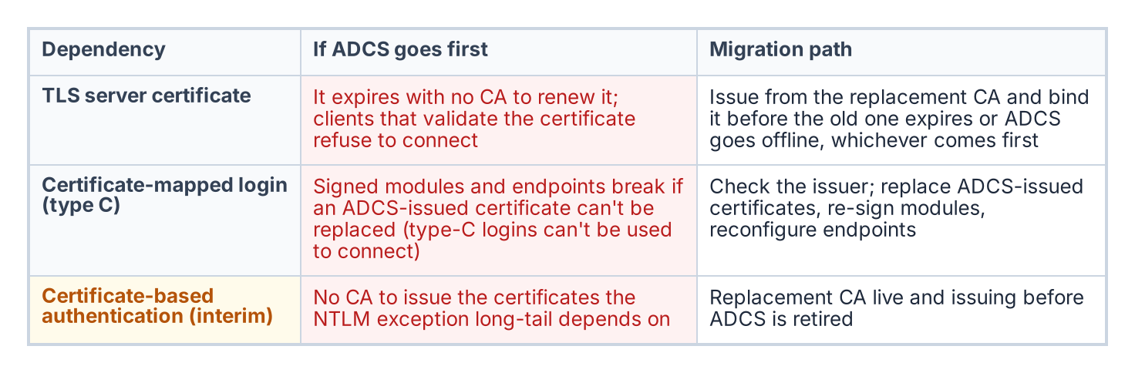
What fails if ADCS goes away before each dependency is moved, and the migration path for each.
The transformation inventory identifies the Active Directory Certificate Services to Microsoft Cloud PKI transformation as “Not Yet Defined.” As the series opening established, that label means the destination may be known but the normative canon governing how to reach it has not been authored. For most of this series, the missing record has been the substrate architecture decision; for Book 10, the gap is more fundamental still. No architecture decision record governs the certificate authority transformation at all.
There is no architecture decision equivalent to point to. The transformation is identified as necessary in the transformation inventory, the discovery instrument exists, but the normative decision about the replacement CA, the enrollment mechanism, and the sequencing of ADCS decommission has not been made. This book is therefore analytical and motivational rather than prescriptive. It documents why the certificate gap matters specifically for SQL Server, and it cites no normative ADCS-migration architecture decision because none exists.
It matters specifically because SQL Server has certificate dependencies that are not visible to most of the teams that will plan the ADCS decommission. Three distinct capabilities can depend on ADCS-issued certificates: TLS encryption of client connections, certificate-mapped SQL Server logins (used for code signing and endpoints, not to connect), and Certificate-Based Authentication as the authorized NTLM replacement for connections that cannot reach Kerberos or Entra OAuth before the deadline. Get-CertBasedAuthAudit.ps1 is the instrument for discovering them.

SQL Server TLS/SSL Certificates
The first and most commonly recognized SQL Server certificate dependency is the TLS certificate the engine presents for encryption of client connections. When SQL Server is configured to use TLS encryption — which is required under this program’s FedRAMP Moderate posture — it presents a server certificate to connecting clients as part of the TLS handshake.
In most federal environments, that certificate is issued by the organization’s ADCS infrastructure. The administrator submitted a request to the ADCS Certificate Authority, the CA issued a certificate carrying the SQL Server’s hostname as the Subject Alternative Name, and the certificate was installed in the instance’s certificate store and bound through SQL Server Configuration Manager. The certificate has an expiration date.
When ADCS is decommissioned, that certificate will not be renewed automatically — there is no CA left to issue the renewal. If the TLS certificate expires after ADCS decommission, clients configured to validate the server certificate, which is the correct security posture, will reject the connection with a certificate validation error. The encryption that FedRAMP Moderate requires becomes the thing that breaks the connection.
The certificate-audit script captures the TLS certificate for every instance in scope: the subject, the SAN, the issuing CA, and the expiration date. Any instance whose TLS certificate is ADCS-issued is a dependency the migration plan must address. The replacement certificate must come from the new CA — whether Microsoft Cloud PKI (the Intune Suite certificate service, which issues through Intune SCEP profiles to Intune-enrolled devices, so check that each SQL Server host qualifies) or an alternative — and must be installed and bound before the ADCS-issued certificate expires or before ADCS goes offline, whichever comes first.

Certificate-Mapped SQL Server Logins
The second dependency is less commonly known. SQL Server supports a login type — the type-C login — created from a certificate in master with CREATE LOGIN [name] FROM CERTIFICATE [cert_name]. It is not a way to connect: Microsoft documents that logins created from certificates or asymmetric keys “are used only for code signing” and “can’t be used to connect to SQL Server.” They carry permissions for signed modules, and certificates of the same kind secure Service Broker and database mirroring endpoints.
Certificate-mapped logins are uncommon in standard deployments, but they appear in specific scenarios: module signing that grants a stored procedure permissions its caller lacks, and Service Broker or mirroring endpoint security. Each is the kind of arrangement that survives quietly across an estate for years without anyone documenting it.
Most such certificates are created inside SQL Server rather than issued by ADCS, so the first question is the issuer. Where an ADCS-issued certificate backs a type-C login or an endpoint, replacing it means issuing a new certificate, re-signing the modules or reconfiguring the endpoints, and moving the login’s permissions, before ADCS is retired. Type-C logins are not migrated to Entra logins, because nothing connects with them. The certificate-audit script captures every certificate-mapped login and the issuing CA of its associated certificate, providing the inventory the migration needs.

CBA as the NTLM Replacement Interim Posture
The third dependency is the most consequential for the NTLM elimination timeline. The Kerberos/NTLM-elimination program designates CBA as the authorized replacement for NTLM connections that cannot be migrated to Kerberos or Entra ID OAuth 2.0 tokens within the required timeline. Here CBA means certificate-based sign-in by the user — a smart card or PIV credential — rather than a password. SQL Server itself has no client-certificate login, so for a pre-2022 instance the certificate secures the user’s sign-in to Active Directory, and the SQL Server connection that follows still authenticates with Windows authentication. It avoids NTLM only where that connection can use Kerberos.
For connections that cannot reach Entra ID auth before the 2027-04-01 NTLM backstop — Category 3 instances still pre-2022, or applications still in the deferred class — CBA is the authorized interim posture. Certificate sign-in removes the password from the user’s side, and the program accepts it as the interim posture provided the connection itself then negotiates Kerberos rather than NTLM — which still depends on the SPN and KDC fixes of Book 06. It is the bridge that keeps an un-migratable connection compliant.
The problem is that CBA certificates must be issued by a CA. If the plan is to deploy CBA as the NTLM-replacement posture for connections that cannot yet reach Entra auth, and ADCS is being decommissioned, the replacement CA must already be in place and issuing CBA certificates before ADCS goes offline. The interim posture has its own certificate dependency, and that dependency points at the same authority the program intends to remove.

The Sequencing Dependency
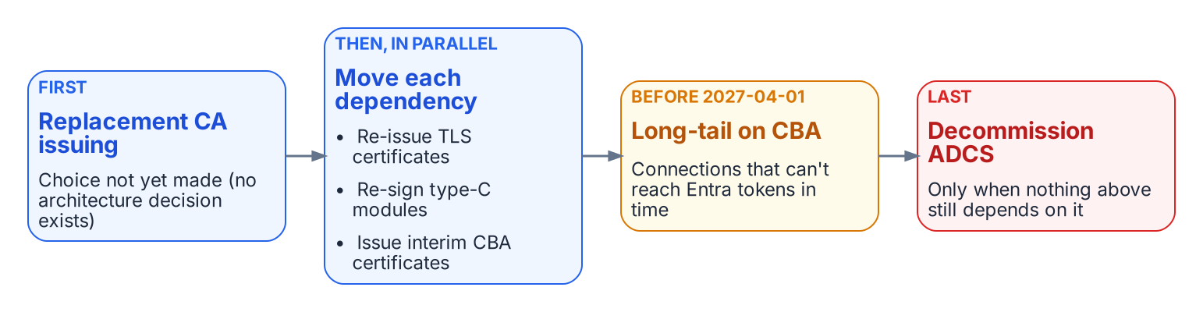
The order the ADCS migration must respect.
The three dependencies converge on a single sequencing question. TLS certificates must be re-issued before they expire; ADCS-issued certificates behind type-C logins and endpoints must be replaced and their modules re-signed; and CBA, the very mechanism the Kerberos/NTLM-elimination program relies on to cover connections that cannot meet the deadline, must have a CA issuing its certificates before ADCS is retired.
If the ADCS decommission timeline runs earlier than the replacement-CA and CBA-deployment timeline, the program loses the interim posture the Kerberos/NTLM-elimination program depends on at precisely the moment it is most needed — connections that could not migrate to Entra auth in time would have no compliant fallback. The sequencing of ADCS decommission against the 2027-04-01 NTLM deadline is therefore a critical dependency, and it is one the as-yet-unwritten ADCS-migration architecture decision must explicitly address before any decommission date is set.
What Book 10 establishes — Chapter 1
- SQL Server can depend on ADCS in three places: the TLS server certificate, certificates behind type-C logins and endpoints, and the certificate-based interim posture.
- Get-CertBasedAuthAudit.ps1 discovers all three.
- The sequencing of the ADCS decommission against the 2027-04-01 deadline is a dependency that the as-yet-unwritten ADCS-migration decision must resolve.

Chapter 2 — Why the Inheritance Must End
Three drivers, each as well-reasoned as the original design, and their dependency structure.

In this chapter
The three forces that now require replacing Windows Authentication for SQL Server — the NTLM elimination the program has committed to, with its 2027-04-01 backstop, the zero-trust requirement that puts the Azure identity plane in the authentication path, and the service-account credential problem created by the broader directory modernization — and why their dependency structure dictates the order of the entire series.
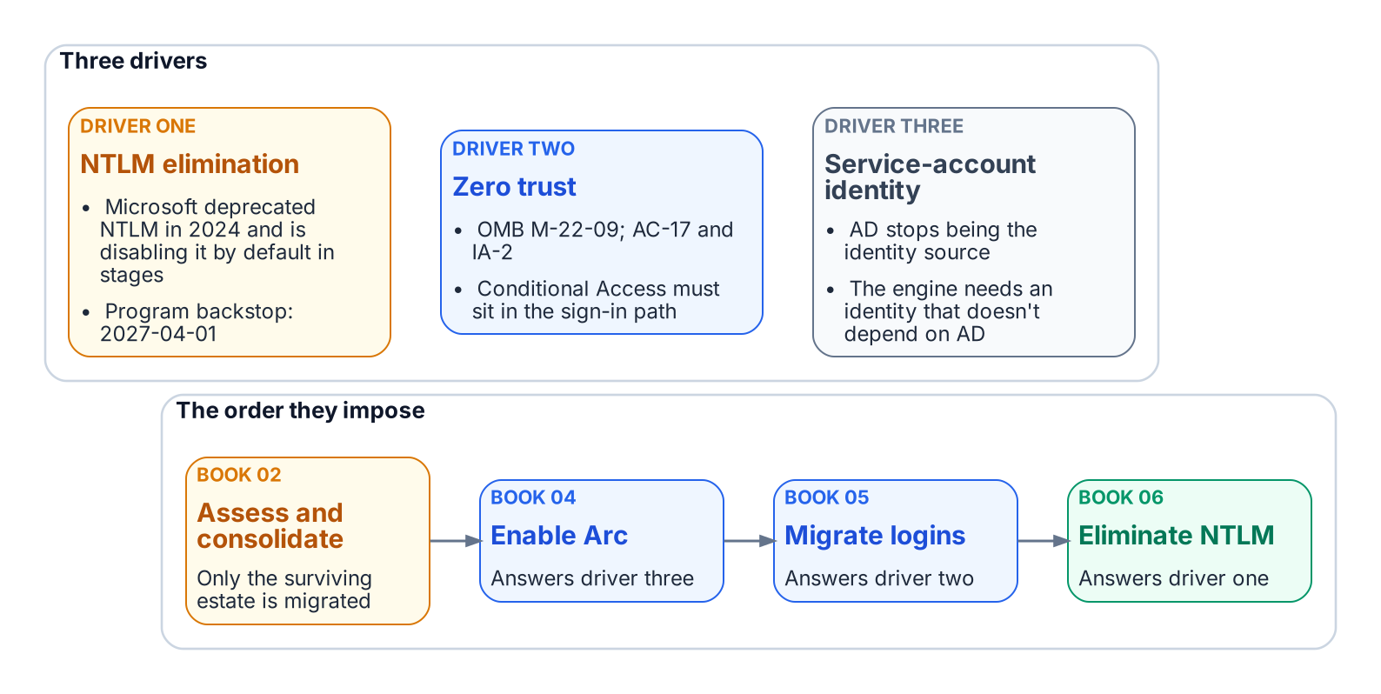
Three drivers end the inheritance, and their dependencies set the order of the series.
The reasons for replacement are as well-reasoned as the original design. NTLM elimination, Conditional Access in the authentication path for all human access, and the end of the domain-joined world are not preferences. They follow from Microsoft’s deprecation of NTLM, the transformation inventory, and OMB M-22-09 (the Federal Zero Trust Strategy), operationalized in this boundary as phishing-resistant MFA and Conditional Access (AC-17, IA-2).

Driver One — The NTLM Elimination Commitment
The first driver is a decision this program has made and recorded: the Kerberos/NTLM-elimination program, accepted 2026-05-13, commits the program to eliminating NTLM. The external driver is real but gradual: Microsoft formally deprecated NTLM in June 2024 and is disabling it by default — not removing it — across successive Windows releases, from enhanced auditing in Windows Server 2025 / Windows 11 24H2, to the BlockNTLMv1SSO enforcement default arriving via Windows Update in October 2026, to network NTLM off by default in the next major Windows Server release (~2027/2028). Microsoft has not published a fixed calendar date for that final step; the program’s 2027-04-01 backstop is its own planning anchor, set to finish ahead of it, not a vendor deadline. Both NTLM variants are eliminated, on different timelines. NTLMv1 goes first: Phase B blocks it through the LAN Manager Authentication Level policy as soon as the Phase A assessment completes (targeted 2026-Q3), so any connection still needing LM or NTLMv1 fails before the engine evaluates the login. Book 06 covers the detail.
NTLMv2 has a firm backstop: on 2027-04-01 the enforcement phase disables NTLM at the LSA layer across the estate. Any SQL Server connection still relying on it, through a missing SPN, a client that cannot negotiate Kerberos, a trust boundary, or an unjoined host, will fail inside the host’s security subsystem before the engine sees it. 2027-04-01 is not the migration’s completion date; it is the date by which consolidation, Arc deployment, login migration, and connection-string migration must already be complete.

Driver Two — The Zero-Trust Requirement
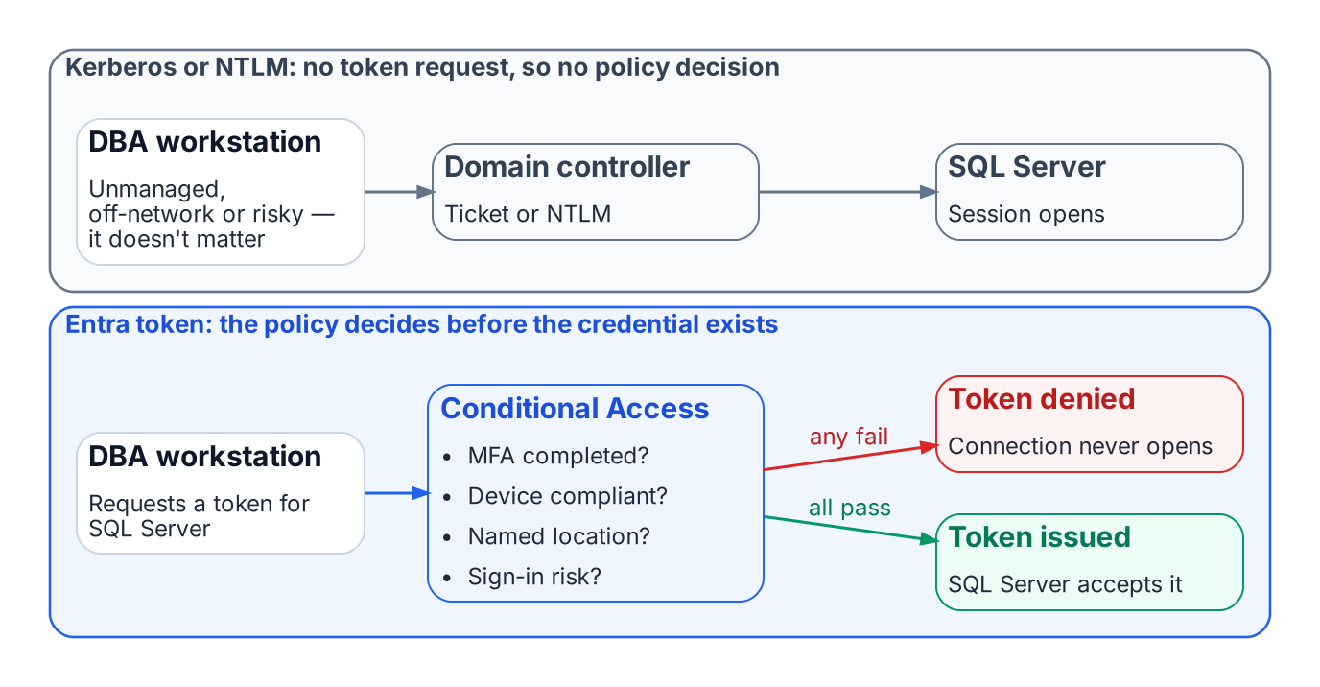
Conditional Access can evaluate an Entra token request; it never sees a Kerberos or NTLM exchange.
The M-22-09 zero-trust posture for this FedRAMP Moderate boundary cannot be implemented without the Azure identity plane in the SQL Server authentication path. Conditional Access enforces device compliance, named locations, MFA, and sign-in risk by intercepting token issuance. Kerberos and NTLM involve no token request, so a DBA on an unmanaged device, outside named locations, or with elevated risk cannot be blocked.
With Entra ID authentication, every token request is evaluated first. Missing MFA, a non-compliant device, or elevated risk (an anonymous IP, an account flagged by Entra ID Protection) means no token, or a remediation challenge, and no connection. The policy has real leverage because the token it controls is the credential SQL Server accepts.

Driver Three — The Service Account Credential Problem
The transformation inventory removes Active Directory as the authoritative identity source. The AD service accounts and gMSAs that authorize the engine on the network then lose their governance foundation, so the engine needs a new identity first.
On-premises, that identity arrives through Azure Arc: the server’s managed identity, which SQL Server 2025 uses directly, or on SQL Server 2022 an app registration certificate the Arc agent fetches from Key Vault with that identity. (Microsoft also documents an Arc-free, certificate-only app-registration setup.) Arc is therefore a prerequisite, not an enhancement. It does not change the Windows account the service runs as.
The order follows from these dependencies, preceded by Book 02’s consolidation decision: assess and consolidate, enable Arc, migrate logins, then eliminate NTLM. That order is the architecture of this series.
What Book 01 establishes — Chapter 2
- Three independent drivers end the Windows Authentication inheritance: the Kerberos/NTLM-elimination program and its 2027-04-01 backstop, the M-22-09 zero-trust posture, and the engine’s need for an identity that outlives AD.
- The zero-trust posture works only when the Entra identity plane is in the authentication path.
- The drivers’ dependencies set the order of the books: inventory and rationalize, audit, enable the identity substrate, move principals and applications, retire protocols, then demonstrate the posture.

Book_02 — The Estate Itself
You do not migrate the estate in the shape you discover it. After twenty years across an Active Directory forest, the SQL Server estate is larger and more tangled than any team’s mental model of it — and a significant fraction of it should not survive the transformation at all. This book establishes the consolidation assessment that classifies every instance retain, consolidate, or retire before any login is touched.
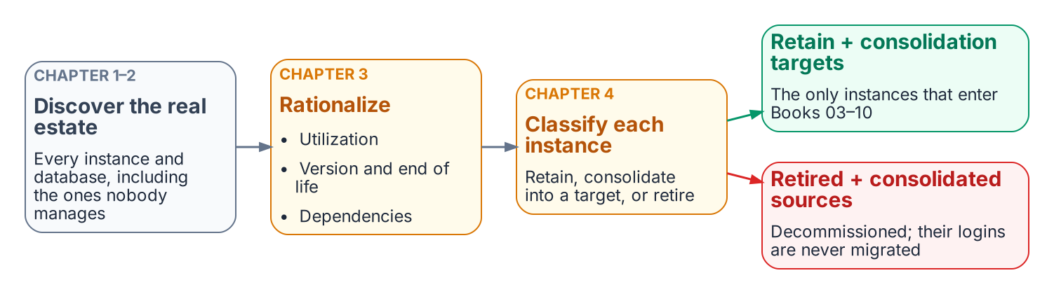
The estate is measured and reduced before any login moves.
Place in the dependency chain: Steps 1–2 — Inventory and Rationalize.

Authoritative references
Checked 19 October 2026.
- End of support options — SQL Server
- SQL Server enabled by Azure Arc — overview
- Migrate SQL Server Windows users and groups to SQL Managed Instance using T-SQL
- Microsoft Entra cloud-first identity guidance

Chapter 2 — The Estate Inventory
Finding the instances and databases that no inventory already records.

In this chapter
What a complete estate inventory must capture before consolidation can begin, the discovery instruments that find the instances no one remembers — network and Active Directory sweeps, the SPN registration trail, and Microsoft’s migration-assessment tooling — and why estate discovery is a broader exercise than the authentication audit that Book 03 describes.
A consolidation assessment begins with an inventory, and the defining characteristic of a twenty-year estate is that the inventory does not already exist in complete form. The instances a DBA team manages deliberately are known. The instances that matter most to the assessment are the ones nobody is managing — and those must be discovered, not retrieved from a list.
This is the point at which estate discovery diverges from the authentication audit of Book 03. The authentication-audit script measures the authentication posture of instances that are already known: their login types, their authentication mode, their SPN status, their Arc eligibility. Estate discovery runs earlier and casts wider. Its job is to establish the denominator — the complete set of instances and databases that exist — so that the authentication audit has something complete to measure.

What the Inventory Must Capture
An estate inventory sufficient to drive a consolidation decision captures, for every instance it can find, a consistent set of facts. The version, edition, and build number establish the support and licensing posture. The host operating system version establishes the Arc and upgrade envelope. The domain-join state and the owning domain establish the forest-entanglement picture. The service-account identity and its source domain establish the credential dependencies. And, for every database on the instance, the size, the last-access timestamp, the recovery model, and the owning application establish the utilization and zombie picture that Chapter 3 turns into a rationalization decision.
The inventory is not a point-in-time spreadsheet. Like the authentication audit it precedes, it is designed to be re-run, because instances appear and disappear across a multi-month assessment, and the consolidation plan must track a moving estate rather than a single snapshot.

Discovery Instruments
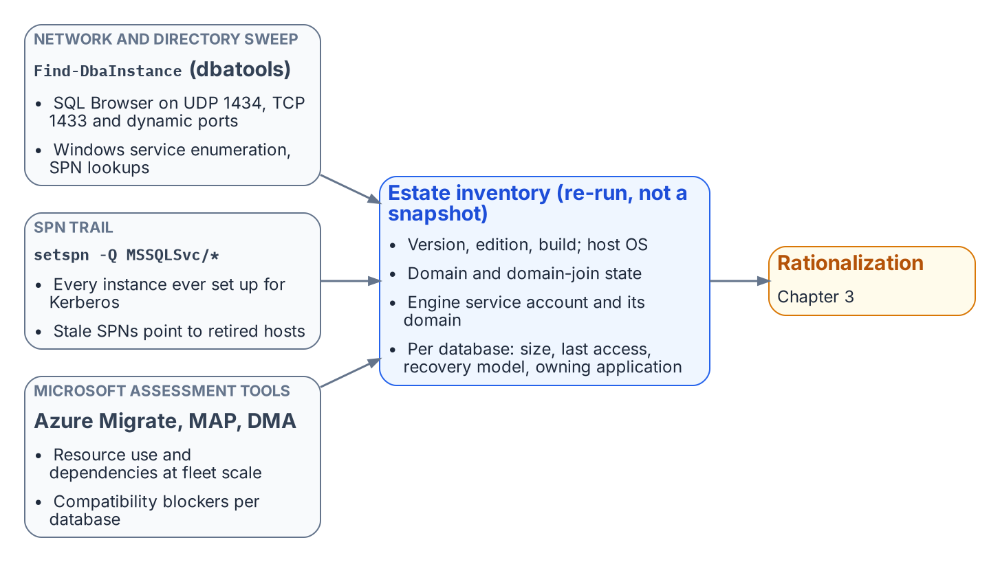
Three independent discovery instruments feed one re-runnable estate inventory.
No single instrument finds every instance, because instances hide in different ways. A complete sweep combines several, each blind to what the others surface.
A network and directory sweep finds instances by listening for them. The SQL Server Browser service responds on UDP 1434, instances listen on TCP 1433 and dynamic ports, and Active Directory itself records instances indirectly. The open-source PowerShell module dbatools provides Find-DbaInstance, which combines these signals — service-principal-name lookups, SQL Browser responses, port scans, and Windows service enumeration — into a single discovery pass across a network range or an Active Directory domain. It is the most direct way to surface instances that no inventory records.
The SPN registration trail is a second, independent signal. Because every instance that successfully negotiates Kerberos must register an MSSQLSvc service principal name, a forest-wide query for those SPNs (setspn -Q MSSQLSvc/*, or the equivalent directory query) enumerates every instance that was ever configured for Kerberos — including instances on hosts that are otherwise off the radar. The SPN trail also feeds directly into the authentication audit, because a registered SPN that points at a decommissioned host, or an instance generating Kerberos traffic with no corresponding SPN, are both findings the later books act on.
Microsoft’s migration-assessment tooling is the third instrument, and it captures what the first two cannot: workload and dependency data. Azure Migrate, with its dependency-analysis capability, and the Microsoft Assessment and Planning (MAP) Toolkit, enumerate instances and their resource consumption at fleet scale. The Data Migration Assistant (DMA) assesses individual databases for compatibility and feature blockers against a target version. These instruments are pedagogically useful here for what they reveal about the estate, independent of any decision to use Azure as a migration target — the dependency map and the version-compatibility findings are inputs to the consolidation decision regardless of where the consolidated estate ultimately lands.

Why a Canonical Estate-Discovery Spec Does Not Yet Exist
The discovery instruments named above are real and well-understood, but they are not yet bound into a canonical discovery specification the way the authentication-audit script, the application-audit script, and the certificate-audit script bind the authentication, application, and certificate audits. The SQL Server engine-authentication decision names this as an explicit gap: the estate-consolidation inventory that produces the retain / consolidate / retire classification has no discovery script of its own. Authoring that instrument — a discovery script whose output feeds the same compliance-monitoring pipeline as the authentication audit — is identified in the implementation plan as Phase 0, the prerequisite to everything the later books describe.
Until that specification exists, the consolidation assessment is conducted with the general-purpose instruments above and recorded as a deliberate program artifact rather than a canonical telemetry record. Naming the gap is itself part of the assessment’s value: an estate transformation that proceeds on an incomplete inventory will discover its missing instances at the worst possible moment, which is exactly the failure mode the discipline of this book exists to prevent.
What Book 02 establishes — Chapter 2
- Inventory comes first: the estate doesn’t already know what it has.
- Discovery combines a network and directory sweep, the MSSQLSvc SPN trail, and Microsoft’s assessment tooling, because each misses what the others find.
- No canonical discovery script exists yet; the engine-authentication decision names authoring it as Phase 0.

Chapter 2 — Reading the Audit: Classification and Triage
From a per-instance category to a defensible migration order — and the one distinction that prevents the program’s most common mistake.

In this chapter
How to interpret each of the three Arc-eligibility categories the audit assigns, how the audit output should drive triage and prioritization within each category, and the architectural distinction between SQL Server engine Entra authentication and server OS Entra login capability — the Layer 1 versus Layer 2 separation that lets engine migration proceed on a host that is still domain-joined.
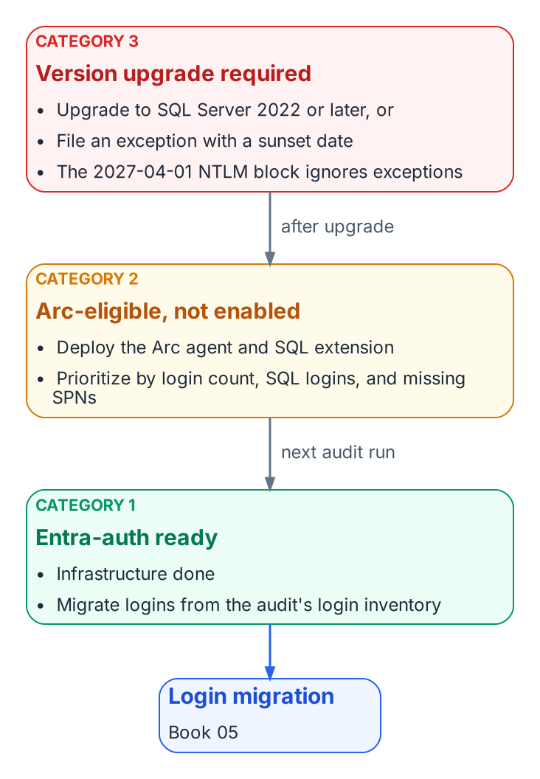
The triage action for each category, and the path from Category 3 and 2 to Category 1.

Interpreting Category 1: Entra-Auth-Ready
A Category 1 classification is the program’s best starting position. It means the infrastructure prerequisites for Entra ID authentication are already in place — the Arc agent is running, the Azure extension for SQL Server is deployed, and the engine is running on SQL Server 2022.
The Managed Identity for the server is available, and the SQL Server extension has registered the instance with the Arc data services plane. Nothing in the infrastructure stack remains to be built.
The migration work for a Category 1 instance therefore begins with the login inventory from the audit: how many Windows logins exist, what AD groups are mapped to SQL Server roles, and whether any SQL Authentication logins need to be addressed before or alongside the Windows login migration. The specific migration steps are documented in Book 05.
The point here is that the audit has done its job for a Category 1 instance when it delivers a precise login inventory. The infrastructure work is already done, and the migration can proceed without any further prerequisites.

Interpreting Category 2: Arc-Eligible but Not Enabled
A Category 2 instance requires an Arc deployment action before login migration can begin. The audit output for such an instance should be used to prioritize that deployment.
Instances with a large number of Windows logins, active SQL Authentication logins, or missing SPN registrations — and therefore NTLM-generating connections — are higher priority for Arc deployment than instances with simple, well-configured Windows Authentication.
The Arc deployment itself is not a SQL Server change. It is a server-level action that installs the Connected Machine agent and the SQL Server extension. Book 03 describes the Arc deployment sequence in detail.
Once Arc deployment is complete and the SQL Server extension confirms the Managed Identity is available, the instance re-classifies from Category 2 to Category 1 on the next audit run, and the login migration can begin.

Interpreting Category 3: Version Upgrade Required
A Category 3 instance is the most operationally complex. A pre-2022 instance cannot accept FROM EXTERNAL PROVIDER logins regardless of any other configuration change.
The CREATE LOGIN [user@tenant] FROM EXTERNAL PROVIDER syntax was introduced in SQL Server 2022 as part of the Azure extension for SQL Server integration. Earlier versions do not support the syntax at all — it produces a parse error.
A Category 3 instance therefore has two possible paths: upgrade the SQL Server engine to 2022 and then proceed through the Category 2 pathway, or document a formal exception with a sunset date for the instance.
Given the 2027-04-01 NTLM elimination deadline, a Category 3 instance that cannot be upgraded to SQL Server 2022 before that date will face NTLM failure regardless of exception status. The NTLM block is network-level, not application-level, and it does not distinguish between instances that are excepted from the transformation and instances that are not.
The version-upgrade timeline for Category 3 instances must be integrated into the SQL Server engine-authentication migration plan as an explicit dependency.

The SQL Engine vs. OS Entra Auth Distinction
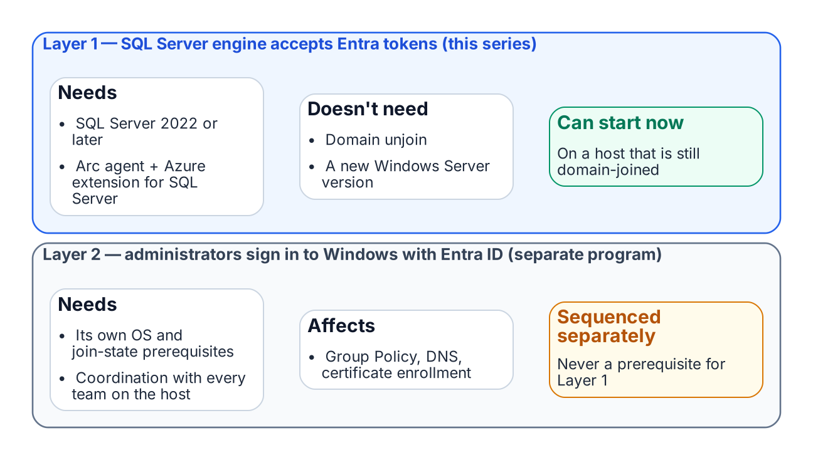
SQL engine Entra authentication and OS-level Entra sign-in are independent tracks.
One of the most important clarifications the audit output must carry — and that the teams reading it must internalize — is the architectural distinction between SQL Server engine Entra authentication and server OS Entra ID login capability. These are two separate capabilities with separate prerequisites, and confusing them is the most common misunderstanding this program will encounter.
SQL Server engine Entra authentication — Layer 1, the capability described in this series — requires the Arc Connected Machine agent, the Azure extension for SQL Server, and SQL Server 2022. It does not require the server to be domain-unjoined, and it does not require Windows Server 2025.
A domain-joined Windows Server 2019 host running SQL Server 2022 with Arc installed can have Entra ID-backed SQL Server logins today, while the server itself remains domain-joined and continues to authenticate OS-level users via Kerberos to the domain controller.
Server OS Entra ID login capability — Layer 2, the ability for administrators to RDP into the server using Entra ID credentials instead of domain credentials — is a separate transformation governed by the Arc non-domain-join requirement. It requires domain unjoin and Windows Server 2025 with Desktop Experience.
The two capabilities are related — both are part of the SQL Server authentication transformation — but they are sequenced independently, and the SQL Server engine migration can and should proceed first.
This sequencing point must be explicit in every instance of audit output that classifies a server as “not yet domain-unjoined.” The correct interpretation is not “SQL Server migration blocked” but “OS-level Entra login not yet available; SQL engine migration can proceed.”
What Book 03 establishes — Chapter 2
- Category 1 migrates now; Category 2 gets Arc and becomes Category 1; Category 3 upgrades or carries a dated exception.
- SQL-engine Entra authentication (Layer 1) needs only Arc, the SQL extension and SQL Server 2022 or later.
- Layer 1 proceeds on domain-joined hosts and never waits for OS-level Entra login (Layer 2).

Chapter 2 — Arc Deployment Sequencing for SQL Server Hosts
The ordered prerequisites that turn a domain-joined SQL Server host into an Arc-enabled, identity-ready instance.

In this chapter
The connectivity prerequisites that Arc enrollment demands inside a GCC-Moderate boundary, why the Azure extension for SQL Server is a distinct installation with its own version validation, the version-specific step that enables Microsoft Entra authentication on the instance, and the checks — a token from the Arc agent’s local endpoint and a test Entra login — that confirm the identity is genuinely available before any login migration begins.
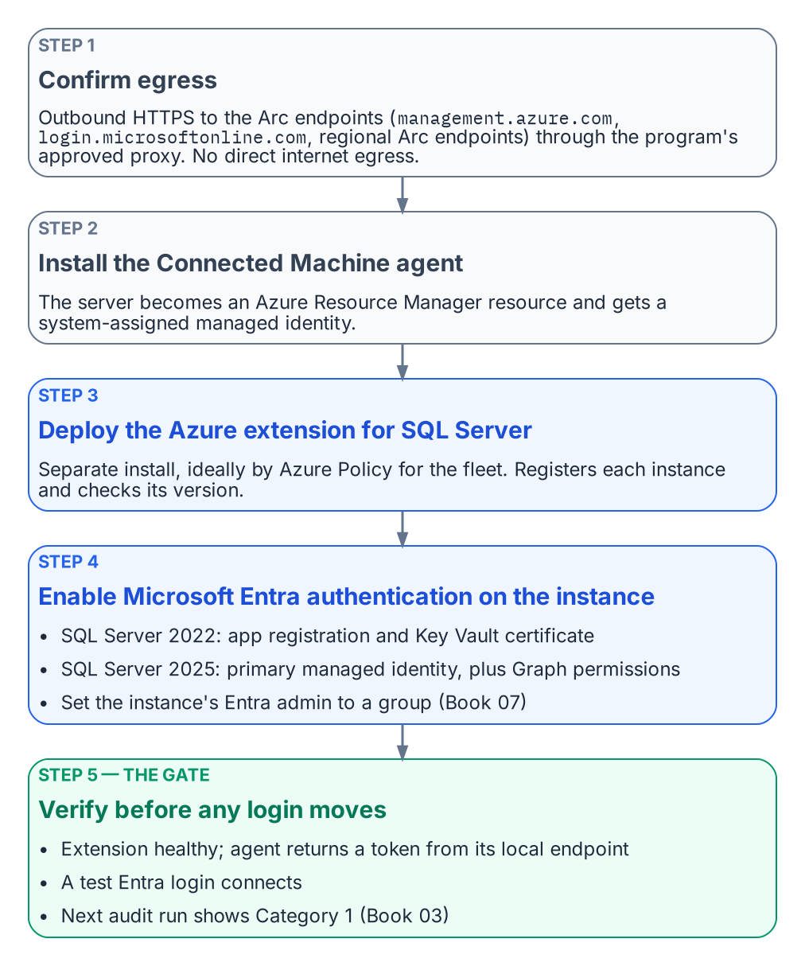
The ordered steps that make a host identity-ready.
Arc deployment is a sequence, not a single act. Each step has a prerequisite that the prior step satisfies, and skipping ahead produces failures that are easy to misdiagnose as migration problems when they are in fact enrollment problems. The order is connectivity first, then the Connected Machine agent, then the SQL Server extension, then Entra authentication on the instance, then a verification that the identity is actually present and answering.

Prerequisites for Arc Enrollment
The Connected Machine agent requires outbound HTTPS connectivity from the server to the Azure Arc endpoints — management.azure.com, login.microsoftonline.com, and the Arc-specific regional endpoints. In a GCC-Moderate boundary, this connectivity must be routed through the program’s approved network egress path.
Direct internet egress from a production SQL Server host is not acceptable under the boundary’s network posture. The Arc agent supports proxy configuration for HTTPS traffic, and the proxy address must be provided at installation time. The instance’s own Entra authentication traffic does not use the Arc agent’s proxy setting: SQL Server connects to Entra ID directly, so a host that needs a proxy also needs the machine-level WinHTTP proxy set (netsh winhttp set proxy).
Connectivity verification — confirming that the server can reach all required Arc endpoints through the approved proxy — is the first prerequisite check before Arc deployment begins. An agent that cannot reach its endpoints will fail to register its ARM resource, and without that resource there is no Managed Identity to verify later.

The Azure Extension for SQL Server
The Azure extension for SQL Server is a distinct installation from the Connected Machine agent and must be deployed after the agent is enrolled. It is installed via Azure Policy assignment — the recommended approach for fleet-wide deployment — or via the Azure portal or CLI for individual servers.
The extension performs additional validation at installation time. It verifies the SQL Server version, where 2022 or later is required for Entra auth capability; it registers the SQL Server instance with the Arc SQL resource plane; and it is the component that later applies the instance’s Entra authentication configuration.
The authentication-audit script Arc-eligibility classification — Category 1 versus Category 2 versus Category 3 — is the primary input for prioritizing Arc deployment across the estate. Category 2 instances are the immediate deployment targets, and the audit’s login inventory and NTLM risk signals within Category 2 are used to order those deployments by remediation urgency.

Enabling Microsoft Entra Authentication on the Instance
Installing the extension does not by itself switch on Entra authentication. That is a separate, version-specific step. On SQL Server 2022, the instance uses an Entra app registration: register the application, grant it the Microsoft Graph read permissions the setup tutorial lists with admin consent, create its certificate in Azure Key Vault, and give the Arc server’s managed identity read access to that certificate so the Arc agent can install it on the host. On SQL Server 2025, the recommended path is to set the Arc server’s system-assigned managed identity as the instance’s primary managed identity and grant that identity User.Read.All, GroupMember.Read.All and Application.Read.All, which only a Privileged Role Administrator can do. On both versions, set the instance’s Entra admin to a group (Book 07). Neither version supports Entra authentication on failover cluster instances, and both need a network path to the Azure public cloud.

Verification of Managed Identity Availability
After the Connected Machine agent is installed and the Azure extension for SQL Server is deployed, the program must verify that the system-assigned Managed Identity is available, and that Entra authentication works on the instance, before proceeding to the login migration. This verification is not optional — it is the gate between enrollment and migration.
The first check calls the Arc agent’s local identity endpoint (HIMDS) on the server — http://localhost:40342/metadata/identity/oauth2/token?api-version=2019-11-01&resource=https://management.azure.com/ — not the Azure VM metadata address 169.254.169.254. The endpoint first returns a challenge that only a local administrator or a member of the Hybrid Agent Extension Applications group can answer; the check confirms that the Arc agent then returns a valid access token. The second check is a test Entra login that connects to the instance. The third is the next audit run, which should classify the instance as Category 1 (Book 03).
A successful token response confirms three things at once: that the Managed Identity is enrolled in Entra ID, that the Arc agent is functioning, and that the server’s ARM resource is in a healthy state. A failed token response at this stage requires Arc troubleshooting before the SQL Server migration can proceed.
The authentication-audit script’s Arc-eligibility classification is updated on each run to reflect the current Managed Identity availability state, so the per-instance compliance record for the instance reflects this verification outcome in near-real-time.
What Book 04 establishes — Chapter 2
- Enrollment runs in a strict order: egress connectivity, the Connected Machine agent, the SQL extension, then Entra authentication on the instance.
- Verification — a token from the local endpoint, a test Entra login, and Category 1 on the next audit — is the gate for login migration.
- A failed verification is an enrollment problem, resolved before migration starts.

Chapter 2 — What the Engine-Authentication Decision Settles
The five governance positions that turn the migration pattern into enforceable canon.

In this chapter
The five decisions the engine-authentication decision records — that consolidation gates auth migration, that the parallel-run sequence is required, that SQL Authentication is eliminated and sa disabled and renamed, that pre-2022 instances are upgrade-or-except with a Certificate-Based Authentication interim posture, and that the per-instance compliance record is the closure artifact.
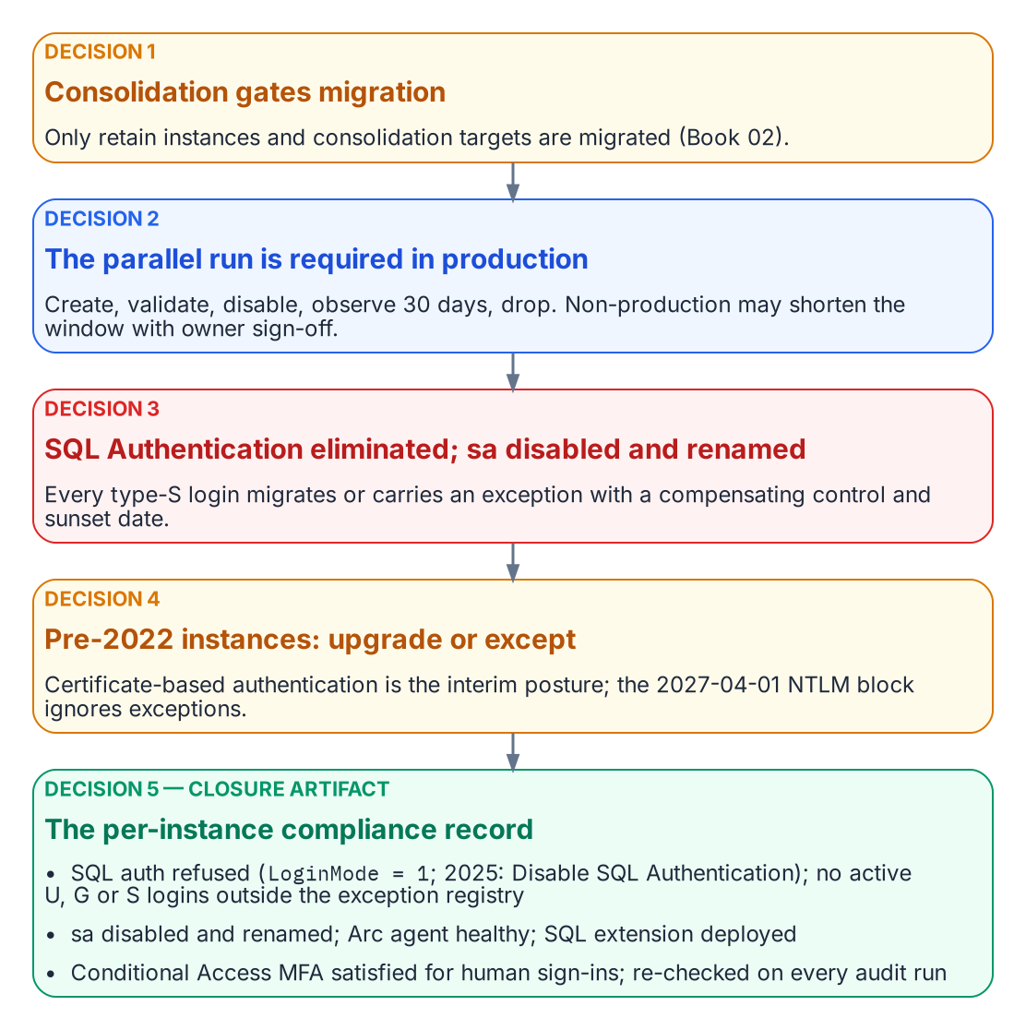
The five positions of the engine-authentication decision, in operational order, ending in the closure record.
Chapter 1’s pattern covers the engineering case, Windows logins migrated through FROM EXTERNAL PROVIDER, but leaves governance positions that need a decision, not a narrative. The SQL Server engine-authentication decision (currently proposed) is the engine-layer companion to the Kerberos/NTLM-elimination program (protocol layer) and the Arc non-domain-join requirement (server and OS layer). It answers all five positions, in operational order.

Decision 1 — Consolidation Precedes and Gates Auth Migration
Established in Book 02
Every instance is classified retain, consolidate-into-target, or retire before any migration work; Arc-eligibility Categories 1–3 are layered on top.
The decision makes that assessment the normative prerequisite for this book. Only retain instances and consolidation targets are migrated; migrating logins on instances about to be retired or collapsed is wasted effort. Consolidating into fewer SQL Server 2022 or later targets, Azure SQL Managed Instance, or Arc-enabled SQL is also the natural moment to retire cross-domain login sprawl, orphaned SPNs, and shared service accounts.

Decision 2 — The Parallel-Run Sequence Is Required
On every retain or target instance, Windows logins (type U users, type G groups) and SQL Authentication logins (type S) migrate to Entra external-provider logins through Chapter 1’s parallel run, which is required for production. The letters are the values of sys.server_principals.type, not mnemonics: S SQL login, U Windows login, G Windows group, E external (Entra) login. There is no type W — a discovery query written against one returns zero rows and reports a clean instance, which is how a typo becomes a false attestation of closure.
Non-production instances may compress the 30-day observation window only with documented owner sign-off. Disable-and-observe keeps every cutover reversible inside the window, so a wrong mapping locks no one out.

Decision 3 — SQL Authentication Eliminated; sa Disabled and Renamed
Every active type-S login on a retain or target instance migrates to a service-principal or managed-identity login, or carries a documented exception with a named compensating control and a sunset date. Open-ended retention is not an option: SQL Authentication is invisible to Conditional Access and Defender for Identity.
sa is disabled and renamed on every production instance. Any retained emergency recovery is a documented, monitored break-glass procedure, not an active sa. An enabled sa with a non-rotated password is the authentication audit’s highest-priority finding.

Decision 4 — Pre-2022 Instances Are Upgrade-or-Except
External-provider logins require SQL Server 2022 or later with the Azure extension on an Arc-enabled host, so a pre-2022 Category 3 instance cannot accept them regardless of Arc status. A Category 3 retain instance either upgrades and follows the Category 2-to-1 pathway or files a sunset-dated exception, though most Category 3 instances should be retire or consolidation candidates. An exception records the reason, the compensating control (for example, an identity-protection product that applies MFA or block policies to Kerberos and NTLM at the domain controller), the maximum duration, and acknowledgement that the 2027-04-01 NTLM block is network-level and ignores engine-layer exceptions.
Connections that cannot reach Kerberos or Entra OAuth by that date use Certificate-Based Authentication, the authorized interim posture, which makes the ADCS-to-Cloud-PKI transformation (Not Yet Defined in the transformation inventory) a hard dependency for the exception long tail.

Decision 5 — The Per-Instance Compliance Record Is the Closure Artifact
An instance is closed when its compliance record simultaneously shows SQL authentication refused (LoginMode = 1; on SQL Server 2025, Disable SQL Authentication as well), zero active type-S logins outside the exception registry, zero active type-U or type-G logins, sa disabled and renamed, the Arc Connected Machine agent enrolled and healthy, the Azure extension for SQL Server deployed with Entra authentication configured, and — for human principals — Conditional Access MFA enforcement satisfied for SQL Server resource sign-ins over a defined validation period.
“Done” becomes a queryable posture instead of a claim. Because no engine setting blocks Windows authentication, the record evidences the Entra-exclusive posture rather than reading a mode switch (Book 09). Closure is continuously verified: the authentication audit runs on a schedule, and drift (LoginMode reverting, a new type-S, U, or G login, the Arc agent going offline) is a violation that triggers remediation.
What Book 05 establishes — Chapter 2
- Consolidation gates migration, and the parallel run is required in production.
- SQL Authentication is eliminated and sa disabled and renamed; pre-2022 instances upgrade or carry a sunset-dated exception.
- The per-instance compliance record is the continuously re-verified closure artifact.

Chapter 2 — The Three Phases of NTLM Elimination for SQL Server
Discover, restrict, eliminate — the same phase structure the Kerberos/NTLM-elimination program applies program-wide, applied specifically to SQL Server workloads.

In this chapter
How the Kerberos/NTLM-elimination program’s three-phase structure applies to SQL Server: Phase A discovery using the authentication-audit script alongside Windows event-log NTLM analysis, Phase B restriction that converts NTLM connections to Kerberos and migrates the remaining patterns, and Phase C elimination at the 2027-04-01 domain-wide block — and why an instance migrated to Entra ID logins is immune to that block because it was never generating NTLM in the first place.
The Kerberos/NTLM-elimination program structures NTLM elimination into three phases — discover, restrict, eliminate — and this chapter applies that structure specifically to SQL Server workloads. The phases are sequential and the final one is a hard backstop: the domain-wide NTLM block takes effect no later than 2027-04-01, the date the elimination program sets for the program.
After that date, any SQL Server connection that requires NTLM will fail at the LSA layer — inside the host’s Windows security subsystem, where the Local Security Authority (LSA) enforces the policy. The SQL Server engine will not receive an authenticated connection; the NTLM exchange is rejected by the LSA before the engine evaluates the login. SQL Server NTLM elimination is therefore not decoupled from the broader elimination program timeline. Every NTLM-generating connection pattern must be resolved before the elimination phase, not after.

Phase A — Discovery
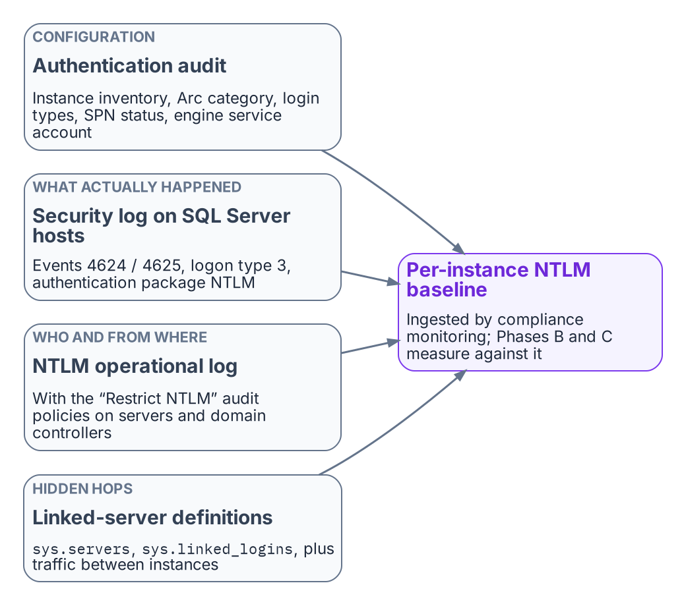
The evidence Phase A combines into the NTLM baseline.
The discovery phase is the elimination program’s first phase, and for SQL Server its primary instrument is the authentication-audit script. The Phase A output for SQL Server includes the full instance inventory with Arc-eligibility classifications, the login-type inventory, the SPN registration status for every instance, and the service-account identity for each engine process.
Network-traffic analysis supplements the script output by capturing actual NTLM authentication events in the Windows event log. The relevant events are Event IDs 4624 and 4625 — logon success and failure — with logon type 3, the network logon type, and authentication package NTLM, filtered to events where the target server is a SQL Server host.
The combination of the audit-script output and the event-log analysis produces a complete picture of NTLM-generating SQL Server connection patterns across the estate. That Phase A output is ingested by the compliance-monitoring pipeline as the baseline record from which all subsequent phases measure progress.

Phase B — Restriction
The restriction phase applies controls that reduce NTLM traffic without eliminating it entirely. The restrictions create pressure on connection patterns to migrate while preserving operational continuity. The primary Phase B control for SQL Server is NTLMv1 blocking, combined with Kerberos remediation for the missing-SPN cases.
SPN registration is corrected for all instances with missing or incorrect SPNs, converting those connections from NTLM to Kerberos. Cross-site connection patterns are fixed by restoring DC reachability (port 88 and DNS) and, across forests, a trust, or by moving the connection to Entra ID tokens; Cloud Kerberos trust, which the Kerberos/NTLM-elimination program also deploys, does not remove the need for DC reachability, because its tickets are still exchanged with on-premises domain controllers. Linked-server definitions using passthrough authentication are migrated to defined security contexts. Application connection strings on recently domain-unjoined hosts are migrated to Managed Identity or service-principal authentication.
After Phase B, the only remaining NTLM-generating SQL Server connections should be those that require the elimination program’s enforcement phase’s hard block to remove. These are typically applications that cannot be modified before the 2027-04-01 block date set in the elimination program, which become exception cases requiring formal exception documentation per the elimination program.

Phase C — Elimination
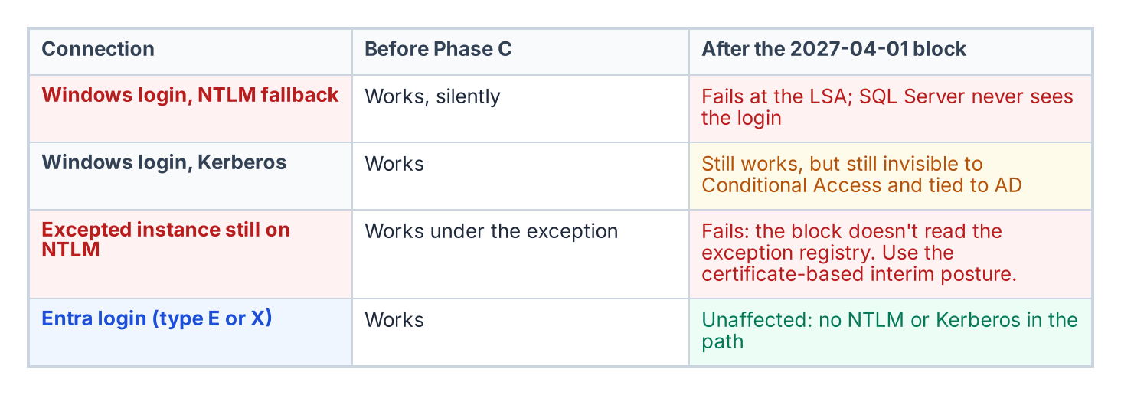
What the Phase C block does to each kind of connection.
The elimination phase disables NTLM across the estate. Group Policy pushed domain-wide restricts NTLM authentication at the LSA layer on every host, and any connection that cannot negotiate an alternative protocol fails. For SQL Server, Phase C is only safe to implement after the login migration of Book 05 has been completed for every instance in the estate.
An instance whose connections have been migrated to Entra ID OAuth 2.0 tokens generates no NTLM traffic at all. The SQL Server engine does not use NTLM or Kerberos for type-E login connections. An instance that has completed the login migration is therefore immune to Phase C — it was not generating NTLM before the block, and it is not affected by the block after.
The sequencing imperative is clear: complete the SQL Server login migration before Phase C is applied. The 2027-04-01 backstop is the Phase C application date, and the SQL Server login migration must be complete before that date for every production instance in the estate.
Unresolved: what happens to the long tail on 2027-04-01
Known fact. Microsoft’s own plan is to disable NTLM by default in the next major Windows release, subject to change; 2027-04-01 is this program’s date, not Microsoft’s (Chapter 1).
Dependency. Pre-2022 instances and deferred applications that can’t reach Kerberos or Entra tokens by then rely on the certificate-based interim posture, which needs a replacement CA issuing before ADCS is retired (Book 10).
Unresolved decision. Whether the Phase C date holds for instances whose interim posture isn’t in place, or whether they get dated exceptions with network-level isolation.
Owner and artifact. The Kerberos/NTLM-elimination program, recorded as an amendment to its enforcement-phase decision and reflected in the exception registry.
What Book 06 establishes — Chapter 2
- Discovery baselines every NTLM-generating pattern from the audit and Windows NTLM logon events.
- Restriction blocks NTLMv1, repairs SPNs and Kerberos reachability, and migrates linked-server security contexts and connection strings.
- Elimination applies the domain-wide block; instances already on Entra logins are unaffected because they don’t use NTLM.

Chapter 2 — Dynamic Membership, Delegation, and Privileged Access
A dynamic group is a policy that executes itself. It is only as trustworthy as the data it reads and the people who can change it.

In this chapter
Why the attribute a rule reads is itself an access control. Which user attributes Entra dynamic rules can use, and where those values should come from. How to write, name, test, and change rules safely within Microsoft’s processing limits. How administrative units scope DBA delegation, and where restricted management collides with governance tooling. Why privileged SQL Server access belongs in PIM for Groups rather than in a dynamic rule. How access reviews, break-glass, and monitoring close the loop. What a FedRAMP Moderate system in the commercial cloud can adopt as written, and why preview features stay out of production.
Chapter 1 turned the organization-derived groups of the old estate into dynamic groups, whose membership Entra ID recomputes from a rule such as user.department -eq "Finance" whenever attributes change. No ticket, no DBA action. This chapter covers what has to be true for that to be safe.

The Attribute Is the Access Control
Principle: the attribute writer controls access
The person or process that can write the attribute a dynamic rule reads controls access to everything that rule grants. Write access to an access-driving attribute is therefore a privileged permission, governed and reviewed like any other.
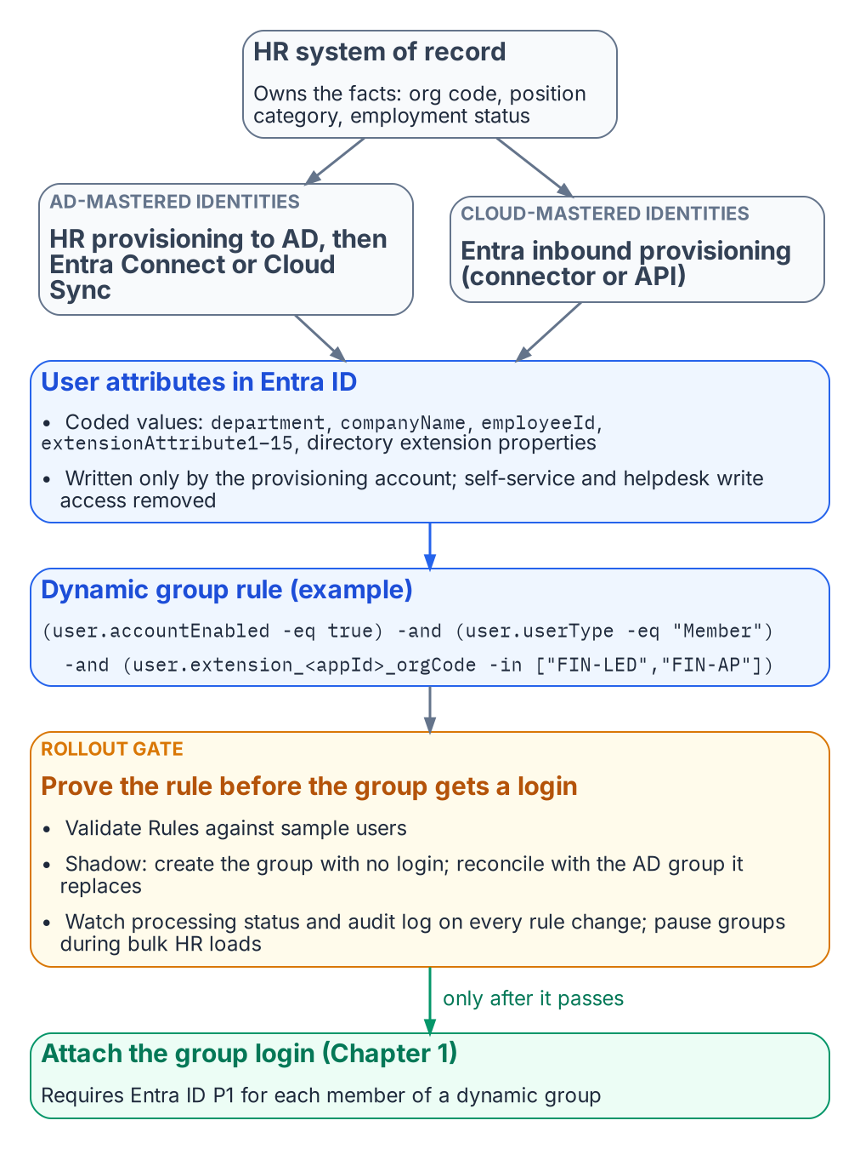
HR-sourced attributes drive dynamic membership, and no group grants access until its rule is proven.
Under assigned membership, whoever can add a member controls access; under dynamic membership, whoever can write the attribute does. Microsoft’s dynamic-group guidance says to review who can write an attribute in Entra ID and in any source directory that syncs it, especially on-premises attributes users can edit on their own objects.
The single source of truth for access-driving attributes is therefore the HR system of record, which knows when someone joins, moves, or leaves and has the governance to make those changes defensible. The path from HR to the directory is automated and one-way:
- For identities still mastered in Active Directory, HR-driven provisioning populates AD, and Microsoft Entra Connect or Cloud Sync carries the values into Entra ID.
- For cloud-mastered identities, Entra ID’s inbound provisioning writes them directly. There are built-in connectors for the major cloud HR suites, and an API-driven inbound provisioning endpoint covers any other HR system that can produce a feed.
Either way, a provisioning service account writes the attribute, and self-service and helpdesk write access to it is removed.

Choosing the Attributes
Entra dynamic rules can read a fixed set of user properties. Microsoft’s current list includes department, companyName, jobTitle, employeeId, employeeHireDate (preview), userType, accountEnabled, and location fields. It also includes the fifteen extensionAttribute1–extensionAttribute15 values, which are commonly synced from on-premises AD, and directory extension properties (user.extension_<appId>_<name>), which can be synced from AD or created through Microsoft Graph. Two cautions apply. First, not every attribute on the user object is usable. For example, employeeType doesn’t appear in the supported-properties list at the time of writing, so check that list before designing around any attribute. Second, multi-value extension properties aren’t supported in rules.
Good rule inputs are HR-owned codes that change only when the business fact changes: an organization code in a directory extension property, not a display string someone will eventually retype. Publish a small, documented set of HR-sourced access attributes (organization code, position category, employment status) and write rules only against those:
(user.accountEnabled -eq true) -and (user.userType -eq "Member")
-and (user.extension_<appId>_orgCode -in ["FIN-LED","FIN-AP"])
-and (user.extension_<appId>_positionCategory -eq "Analyst")
A rule body can’t exceed 3,072 characters, and a tenant can have at most 15,000 dynamic groups. Prefer -eq, -startsWith, and -in over -match, -contains, and chains of -or; such rules process faster and review more easily. Every access rule excludes disabled accounts and guests explicitly, as above.
Dynamic membership needs a Microsoft Entra ID P1 license for each user in one or more dynamic groups. Most federal tenants have it through Microsoft 365 or EMS; confirm the count before rollout.

Writing, Naming, and Testing Rules
Two practices keep a dynamic group from becoming an untested access grant.
The first is naming and ownership. Entra’s naming policy covers only Microsoft 365 groups, so the convention for SQL Server access groups is enforced by the provisioning automation or a review gate. A pattern such as SQL-<env>-<instance or app>-<database>-<role> carries Chapter 1’s one-group-one-role meaning. Each description records the rule’s business intent, the owning team, and the last change record; each group has at least two named owners.
The second is testing before granting. A rule should be proven before its group is attached to a SQL Server login:
- Validate. The Validate Rules feature in the Entra admin center evaluates a draft rule against up to 20 chosen users and shows which expression each one passes or fails.
- Shadow. Create the group first with no login attached. Once processing reports complete, compare its membership with the legacy AD group it replaces, and explain every difference before the login is created.
- Watch processing. For a rule change on a group that’s already live, check the group’s processing status and its audit-log entries for the additions and removals the change caused.
- Pause bulk changes. For HR reorganizations or bulk attribute loads that will touch thousands of users, Microsoft recommends pausing non-essential dynamic groups, letting processing catch up, and resuming in phases.
The rollout gate for the whole pattern follows from this. No dynamic group grants production access until the access attributes are populated and verified for a pilot cohort, and its rule has been validated, shadowed, and reconciled against the group it replaces.

Scoped Delegation with Administrative Units
Someone still has to manage the assigned groups and the dynamic groups’ owners and descriptions, and tenant-wide Groups Administrator for a DBA lead would just move the privilege concentration. Administrative units solve this: Groups Administrator assigned at AU scope manages only the groups in that AU. The scoped administrator needs P1; AU members need nothing extra. Draw one AU per DBA team, application portfolio, or data owner, so a team’s authority matches its accountability.
Restricted management administrative units go further. Only administrators scoped to the AU can modify its objects, even Global Administrators can’t, and that is attractive for protecting access groups. But it has costs that matter here:
- Groups in a restricted management AU can’t be managed by PIM, access reviews, entitlement management, or lifecycle workflows.
- Restricted management AUs accept only plain security groups.
- The setting can’t be changed after the AU is created.
Use regular AUs for groups that need governance tooling; reserve restricted management for cases where tamper-resistance outweighs reviewability. Dynamic AU membership is generally available in the commercial cloud (not Azure Government), but its rules select users or devices, not groups, so access groups are added to an AU explicitly or by automation.

Privileged Access Belongs in PIM, Not in a Rule
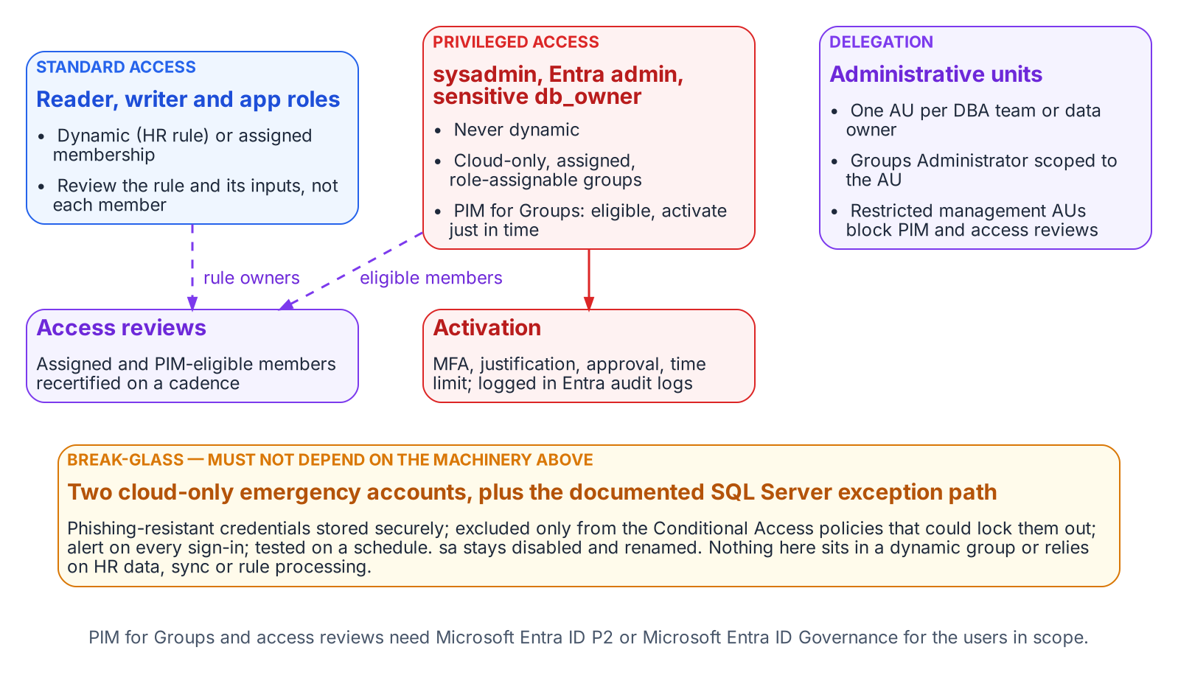
Which groups may be dynamic, which belong in PIM, how delegation is scoped, and the break-glass path that bypasses all of it.
Groups mapped to sysadmin, the instance’s Entra administrator, and db_owner on sensitive databases are never dynamic. Microsoft makes the same judgment for directory roles: role-assignable groups must have assigned membership. The SQL Server equivalent is PIM for Groups: DBAs are eligible, not standing, members, and each logged activation is time-bound and requires MFA and, where policy demands, approval and justification.
PIM for Groups can’t manage dynamic or on-premises-synced groups, so privileged groups are cloud-only and assigned by construction; making them role-assignable also blocks credential changes by lower-tier administrators. PIM for Groups and access reviews require Microsoft Entra ID P2 or Microsoft Entra ID Governance for eligible users, approvers, and reviewers.

Access Reviews
A dynamic group’s membership can’t be edited by hand, so a member-by-member review has no remediation path. Review the rule and its inputs instead: on a fixed cadence the data owner confirms the rule still expresses the intended population, and the identity team confirms its attributes are still HR-sourced and write-protected. For assigned groups and PIM eligible assignments, use Entra access reviews; a recurring review can remove access when the reviewer doesn’t respond, and its results are the AC-2 evidence an assessor will ask for.

Break-Glass
Two kinds of break-glass access are needed, and they must not depend on the machinery they exist to bypass. At the tenant level, Microsoft’s guidance for emergency-access accounts applies:
- at least two cloud-only accounts, with phishing-resistant credentials stored securely
- excluded only from the Conditional Access policies that could lock them out
- alerting on every sign-in
- tested on a regular schedule
At the SQL Server level, Book 05’s position stands. The built-in sa is disabled and renamed, and any retained emergency path is a documented exception with its own monitoring. Neither emergency path may sit in a dynamic group or rely on HR data, Entra Connect, or rule processing being healthy.

Monitoring
The access model is now spread across HR, the provisioning service, Entra ID, and the engine, so monitoring has to cover each hand-off:
- Entra audit logs record rule edits, membership additions and removals, PIM activations, and AU and role-assignment changes. A change to the rule of any SQL Server access group should raise an alert.
- Entra sign-in logs show every token issued for SQL Server and the Conditional Access result.
- SQL Server Audit records successful and failed logins, and changes to server and database role membership.
The continuous audit described in Book 09 should reconcile all three. Every type-E and type-X principal on an instance must map to a known user, application, or group. Every group must follow the naming convention and have an owner. No privileged role may have a standing member that PIM doesn’t account for.

FedRAMP Moderate in the Commercial Cloud
The series assumes Microsoft’s commercial cloud (Entra ID at login.microsoftonline.com, Azure public US regions) under an agency authorization at FedRAMP Moderate.
What the cloud authorization covers. Azure’s public cloud holds a FedRAMP High P-ATO for its US regions. The Moderate baseline (325 controls) is a subset of High (421), so a Moderate system can draw on High-authorized services; whether it inherits them is the agency’s call. The public-cloud audit-scope list includes the services this book relies on:
- Entra ID (Free, P1 and P2), Entra ID Governance, the Entra provisioning service, and Entra multifactor authentication
- Microsoft Graph
- Azure Arc-enabled servers and Azure Arc-enabled SQL Server
- Azure Monitor (Log Analytics), Microsoft Sentinel, and Key Vault
The list names services, not features; confirm dynamic groups, AUs, PIM for Groups, and access reviews against the agency’s boundary and Microsoft’s FedRAMP package (requestable through the FedRAMP Marketplace). The SQL Server hosts and Arc agent are part of the agency’s own system, and a third-party HR system has its own authorization. As Microsoft’s Entra FedRAMP guidance says, the authorization makes compliant configuration possible; the agency configures it.
Keep previews out of the production access path. Microsoft’s Data Protection Addendum says previews “may employ lesser or different privacy and security measures” and, unless noted otherwise, should not be used for regulated data; Entra’s preview terms add that SLAs don’t apply. For a Moderate system, that rules out:
- the memberOf dynamic-rule operator (a preview that ends on 3 November 2026; see Chapter 1)
- preview user properties in membership rules, such as employeeHireDate
- any PIM, access-review, or provisioning capability that the Entra admin center or Microsoft Learn still marks as preview
Check for the preview label at adoption and again at the rollout gate.
What is in scope as recommended. The generally available pieces of this design are delivered by services on the High list:
- Entra group logins and Entra authentication for SQL Server through Azure Arc. Microsoft notes that the SQL Server instance needs access to the Azure public cloud for this.
- Dynamic security groups built on supported properties and directory extension attributes
- Regular and restricted-management administrative units, including dynamic AU membership for users
- PIM for Groups and access reviews, licensed through P2 or Entra ID Governance
- Emergency access accounts and Log Analytics monitoring
Treat any feature not verifiable at feature level as unconfirmed until the agency’s ATO documentation says otherwise.
What Book 07 establishes — Chapter 2
- Whoever can write the attribute a rule reads controls access, so only HR-driven provisioning writes access attributes.
- Rules are validated, shadowed against the groups they replace and piloted; privileged groups are assigned, cloud-only and governed by PIM for Groups and access reviews.
- Only generally available features sit in the production access path, and break-glass paths depend on none of this machinery.

Authoritative references
- Rules for dynamic membership groups: supported properties, extension attributes, attribute write-permission guidance, 3,072-character limit, 15,000-group limit, P1 licensing
- Create simpler, more efficient rules, validate rules, and dynamic group processing and pausing
- Plan cloud HR provisioning and API-driven inbound provisioning
- Group naming policy (Microsoft 365 groups)
- Administrative units, restricted management administrative units, and dynamic membership for administrative units
- PIM for Groups, role-assignable groups, and ID Governance licensing
- Access reviews and emergency access accounts
- Azure services in FedRAMP audit scope (Azure public cloud: FedRAMP High P-ATO; Entra ID, Entra ID Governance, provisioning, Graph, Arc-enabled SQL Server) and Azure FedRAMP offering (Moderate and High baselines; requesting the package)
- Configure Microsoft Entra ID to meet FedRAMP High (customer configuration responsibility)
- Microsoft Entra preview program terms and the Microsoft Products and Services Data Protection Addendum (May 2026 edition, “Previews” section)
- Microsoft Entra authentication for SQL Server and managed identity for Arc-enabled SQL Server (requires Azure public cloud access)

Chapter 2 — Connection String Migration: The Last Mile
The simplest change in the entire program, and the most gate-controlled.

In this chapter
The connection-string change that ends the application-chain migration — from Integrated Security or SQL Authentication to Entra ID authentication keywords — the gate conditions that must hold before it can be executed, and how the Azure.Identity SDK’s DefaultAzureCredential chain lets a .NET application use one credential code path across production and development without modification.
The final step in the application-chain migration is the SQL Server connection-string change. It is the moment the engine sees the Entra ID identity plane in the application connection rather than a SQL Authentication credential or a Windows Integrated Security token. Technically it is the simplest step in the entire migration. Operationally it is the most gate-controlled, and the two facts together are why it is treated as a distinct step rather than folded into the work that precedes it.

The Connection String Change
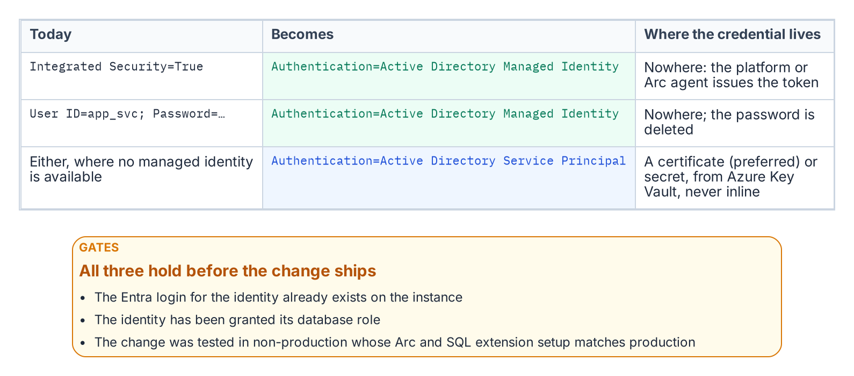
The connection-string change and the three gates in front of it.
For an application using Windows Integrated Security — Data Source=sqlserver;Initial Catalog=database;Integrated Security=True — the connection string changes to use Entra ID authentication. For an application running on an Arc-enabled server with a system-assigned Managed Identity, it becomes Data Source=sqlserver;Initial Catalog=database;Authentication=Active Directory Managed Identity. The keyword tells the driver to acquire a token from the local Managed Identity rather than negotiate a Windows credential. On an Arc-enabled server the driver reaches that identity through the Arc agent’s local endpoint (localhost:40342), the application authenticates as the server’s own identity, and its process account must be a member of the local Hybrid Agent Extension Applications group (or Administrators) to obtain the token.
For an application using a service principal with a client credential, the string uses Authentication=Active Directory Service Principal, with the client ID and credential supplied through an Azure Key Vault reference rather than inline. For SQL Authentication connections — User ID=serviceaccount;Password=storedpassword — migrating to Managed Identity or service principal eliminates the credential from the connection string entirely. In every case the stored secret is removed, which is the point: the connection no longer carries a credential the identity plane cannot see.

The Gate Conditions
The change is the simplest step technically, but it cannot be executed on demand. Three conditions must hold first. The Entra ID login must already exist on the target SQL Server instance — the FROM EXTERNAL PROVIDER login created in the work Book 05 covers — because a connection string that names an Entra identity with no corresponding login on the instance fails at connection time.
The application’s service principal or Managed Identity must have been granted the appropriate SQL Server database role, so that authentication succeeds and authorization follows. And the change must have been tested in a non-production environment whose Arc and SQL Server extension configuration matches production, because token acquisition and validation depend on that infrastructure being present and correctly configured. A connection-string change that works against a developer’s laptop but has never been exercised against a production-equivalent Arc and extension stack is not a tested change. Only when all three gates are satisfied is the production cutover safe to perform.

The Azure.Identity SDK and DefaultAzureCredential
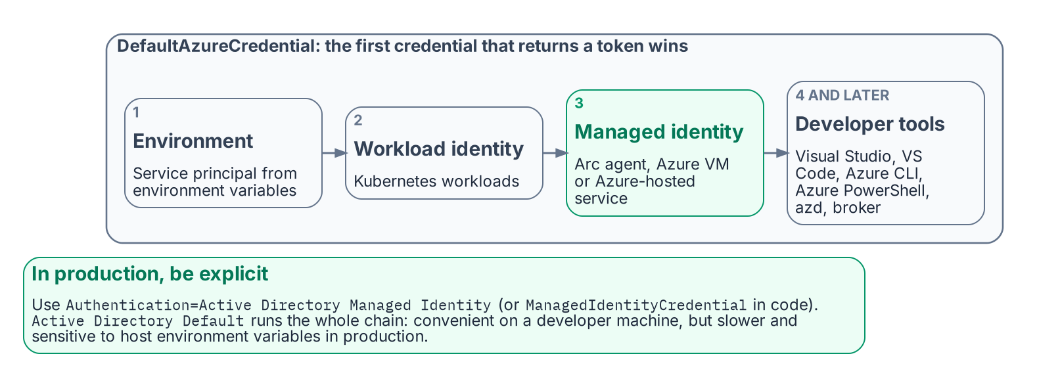
The order in which DefaultAzureCredential tries credentials, and what to use in production.
For .NET applications — a large fraction of the federal application estate — the Azure.Identity SDK provides the DefaultAzureCredential class, which implements an ordered credential chain. It tries environment-variable service-principal credentials first, then workload identity, then managed identity — reached through the Arc agent’s local endpoint (localhost:40342) on an Arc-enabled server and through the Azure Instance Metadata Service on an Azure VM — and then developer-tool credentials: Visual Studio, Visual Studio Code, Azure CLI, Azure PowerShell, Azure Developer CLI and, where installed, the broker.
The value of the chain is that a single credential code path works unchanged across environments. In production the application resolves its Managed Identity; in a developer’s local environment it resolves the developer’s Visual Studio or Azure CLI sign-in; no code differs between them. The SQL connection uses a SqlConnection with the Authentication=Active Directory Default keyword — available in Microsoft.Data.SqlClient 3.0 and later — or sets the AccessToken property from the DefaultAzureCredential token directly.
The Authentication=Active Directory Default keyword is convenient in development, because it delegates credential resolution to the DefaultAzureCredential chain automatically. In production, Microsoft recommends naming the credential explicitly — Authentication=Active Directory Managed Identity, or ManagedIdentityCredential in code — because walking the whole chain is slower and its result can change if someone sets environment variables on the host. The result is that the connection-string change is a net reduction in complexity for .NET applications: one keyword replaces an entire credential-management system. This is the workload-identity model the Managed Identity credential model establishes — the application authenticates as itself through a Managed Identity, with no human credential and no stored secret anywhere in the path.
What Book 08 establishes — Chapter 2
- The connection-string change replaces Integrated Security or SQL Authentication with an Entra authentication mode, and the stored credential disappears.
- It is gated on an existing Entra login, the right database role and a tested change in a production-equivalent environment.
- In production, name a specific mode such as Active Directory Managed Identity; Active Directory Default walks a credential chain.

Chapter 2 — The 2027 Milestone: What Done Looks Like
The evidence is not a binder you assemble — it is the live output of the monitoring you never turn off.

In this chapter
The six evidence artifact sets that close the SQL Server authentication transformation — and why each is a live output of the continuous monitoring infrastructure rather than a point-in-time document — followed by the correct reading of 2027-04-01: not a migration completion date, but the date the network block is applied, which means the migration must already be complete and the final months reserved for validation.
The evidence artifacts required to close the SQL Server authentication transformation in the transformation inventory are not a collection of documents produced at a single point in time — they are the live outputs of the continuous monitoring infrastructure described in Chapter 1. A closure claim is only as strong as the monitoring that keeps producing the evidence after the claim is made. This chapter names the artifacts, then places the program’s 2027-04-01 NTLM backstop in its proper operational context.

The Evidence Artifacts as Live Outputs
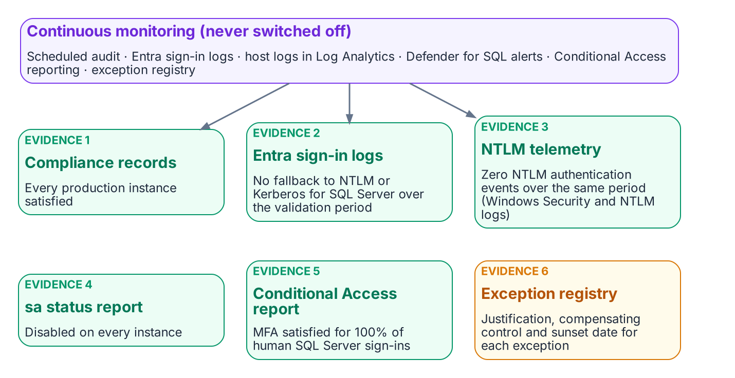
The six evidence sets are live outputs of continuous monitoring.
The closure claim for the SQL Server authentication transformation must be supported by six artifact sets, and each is a continuously regenerated output rather than a static deliverable. The first is the per-instance compliance record set: a record for every production SQL Server instance in the estate, each showing the Entra-exclusive operational posture — SQL authentication refused, zero usable SQL Authentication logins, zero active Windows-backed logins, the Arc agent enrolled and healthy, and the SQL extension deployed. The SQL Server engine-authentication decision defines the field set these records carry, and the continuous audit keeps them current rather than freezing them at the moment of the claim.
The second is the Entra ID sign-in log set, showing zero failed token requests attributable to NTLM or Kerberos fallback for SQL Server resource audience tokens over a defined validation period preceding the closure claim. The third is the NTLM telemetry — the Windows Security and NTLM operational logs from SQL Server hosts, collected in Log Analytics — showing zero NTLM authentication events over that same validation period — the behavioral confirmation that complements the structural compliance view. These two artifacts together demonstrate that the transformed posture holds not only in configuration but in observed connection behavior.
The fourth is the sa account status report, showing the sa account disabled on all instances. The fifth is the Conditional Access policy compliance report, showing MFA enforcement satisfied for one hundred percent of SQL Server resource sign-ins by human principals over the validation period. The sixth is the exception registry, showing every currently excepted instance with documented justification, a sunset date, and its own compliance tracking record. When all six artifact sets are simultaneously satisfying, and the monitoring infrastructure confirms they have been satisfying for the validation period, the SQL Server authentication transformation is closed. That is what done looks like — not a checkbox, but a demonstrated, continuously verified, evidence-backed posture.

2027-04-01: A Consequence, Not a Completion Date
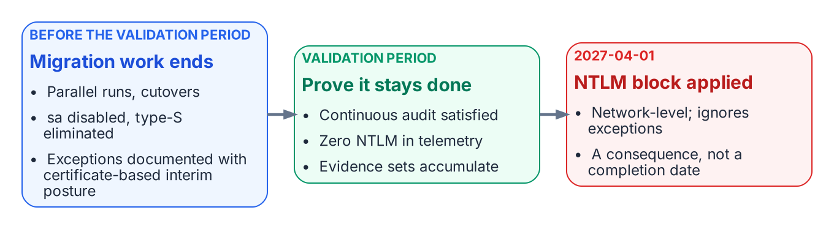
2027-04-01 is when the block lands, so migration ends well before it and the last stretch is validation.
The 2027-04-01 NTLM elimination deadline is the single most misread date in the program. It is widely treated as the date by which the migration must complete. It is not. It is the date on which the network-level NTLM block is applied. The block does not distinguish a compliant instance from an excepted one — it does not honor engine-layer exception status at all. The difference between “migration complete by 2027-04-01” and “migration must be complete before 2027-04-01, and 2027-04-01 is when the block is applied” is not a semantic distinction. It is the difference between a deadline and a consequence.
Read as a consequence, the date reorganizes the schedule. If 2027-04-01 is when connections that still depend on NTLM stop working, then the migration must have already concluded by then, with enough margin for the continuous audit to have confirmed the satisfying posture across a full validation period. Migration activity — the three-phase parallel-run, the cutover, the sa disablement, the type-S elimination — should finish well before the deadline. The final months are reserved for validation, not for migration, because a posture confirmed only on the last day before the block is a posture nobody has had time to prove.
This reading also gives the exception long-tail its proper weight. An instance that cannot reach Kerberos or Entra OAuth before the block must carry a documented exception with Certificate-Based Authentication as the authorized interim posture, and that exception’s sunset date must be reconciled against the block rather than against any softer internal milestone. The block is network-level and fixed; the program’s schedule must bend to it, not the other way around. When the migration is complete, the audit has validated the posture continuously, and the six artifact sets are live and satisfying, the 2027-04-01 block arrives as a non-event — which is exactly what done is supposed to feel like.
What Book 09 establishes — Chapter 2
- Six evidence sets close the transformation, and each is a live output of continuous monitoring.
- They must hold across a defined validation period, not be assembled once.
- 2027-04-01 is the network-block date, not the migration finish line: migration finishes earlier, so the block arrives as a non-event.

Chapter 3 — Rationalization: Utilization, Versions, and Dependencies
Turning a complete inventory into a defensible judgment about what each instance is worth.

In this chapter
The three analytical lenses that convert a raw inventory into a rationalization judgment — utilization and zombie detection, version and end-of-life posture, and dependency mapping — and why the dependency map in particular determines which instances can be consolidated and which are load-bearing in ways that are invisible until they are mapped.
An inventory establishes what exists. Rationalization establishes what each item is worth keeping. The assessment applies three lenses to every instance and every database the inventory surfaced, and the combined picture drives the retain / consolidate / retire decision that Chapter 4 formalizes.

Utilization and Zombie Detection
The first lens is utilization. An instance consumes CPU, memory, storage, and a licensing entitlement whether or not anyone is using it, and a twenty-year estate contains instances that consume all four while serving no current workload.
Utilization analysis rightsizes the survivors and identifies the candidates for retirement. For each instance, the assessment captures sustained and peak resource consumption, connection counts, and the workload profile — read-heavy reporting, transactional, batch, or idle. For each database, it captures the last-access timestamp, the recent query workload, and the backup-restore history.
A database with no connections in over a year, no restores consumed, and a retired owning application is a zombie, and zombies are the cleanest retirement candidates in the estate. Retiring them is the single most effective way to reduce the authentication migration surface, because every login they carry — including long-forgotten SQL Authentication service accounts with still-valid passwords — is removed from the migration pipeline before it ever enters it.
Utilization data also rightsizes the consolidation targets. In an illustrative example, an instance running at four percent of a sixteen-core Enterprise license is not a retain candidate at its current size; it is a consolidation source whose workload belongs on a shared modern target, freeing the license and the host.

Version and End-of-Life Posture
The second lens is version posture, and it interacts directly with the authentication transformation. The FROM EXTERNAL PROVIDER login syntax that the entire transformation depends upon requires SQL Server 2022. An instance on any earlier version — 2019, 2017, 2016, or the out-of-support 2012 and 2008 — cannot accept Entra ID logins regardless of any other change, a constraint Book 03 formalizes as the Category 3 classification.
This makes version posture a primary input to the consolidation decision rather than a secondary one. An out-of-support instance on SQL Server 2012 is simultaneously a security-update liability, a licensing question, and an instance that cannot be migrated to Entra ID authentication without an engine upgrade. For most such instances, the right answer is not “upgrade in place to 2022 and then migrate” — it is “consolidate the surviving workload onto a modern target and retire the old engine.” The version lens and the utilization lens converge on the same conclusion for the bulk of the aged estate: collapse it onto fewer modern instances rather than carrying each old engine forward.
The licensing posture rides alongside the version posture. Consolidation that reduces the instance count also reduces the core-license consumption, and an estate that can state its true core count before consolidation can quantify the licensing dividend that consolidation produces.

Dependency Mapping
The third lens is the one that most often overturns a naive consolidation plan: dependency mapping. An instance that appears idle by connection count may be the silent target of a linked-server chain, a replication topology, an SSIS package, or a cross-database query that runs once a quarter and matters enormously when it runs.
Dependency mapping traces these relationships before any instance is moved. Linked-server definitions (sys.servers, sys.linked_logins) reveal the cross-instance — and frequently cross-domain — web that forest entanglement produced. Application-to-database mapping, drawn from connection telemetry and the application portfolio, reveals which databases are load-bearing for which systems. The SQL Server Agent job inventory, the replication configuration, and the SSIS/SSRS/SSAS footprint reveal the integration surface that a consolidation must preserve. Azure Migrate’s dependency analysis and the Data Migration Assistant’s compatibility findings supplement the in-engine views with workload-level dependency and feature-blocker data.
The dependency map is also the bridge to Book 08. The upstream applications that consume SQL Server — many of them LDAP-bound — are precisely the systems whose dependencies the map records, and the application-chain migration of Book 08 acts on the same relationships the rationalization lens surfaces here. An instance cannot be classified retire if a load-bearing application still depends on it, and the dependency map is what makes that judgment defensible rather than hopeful.

The Combined Picture
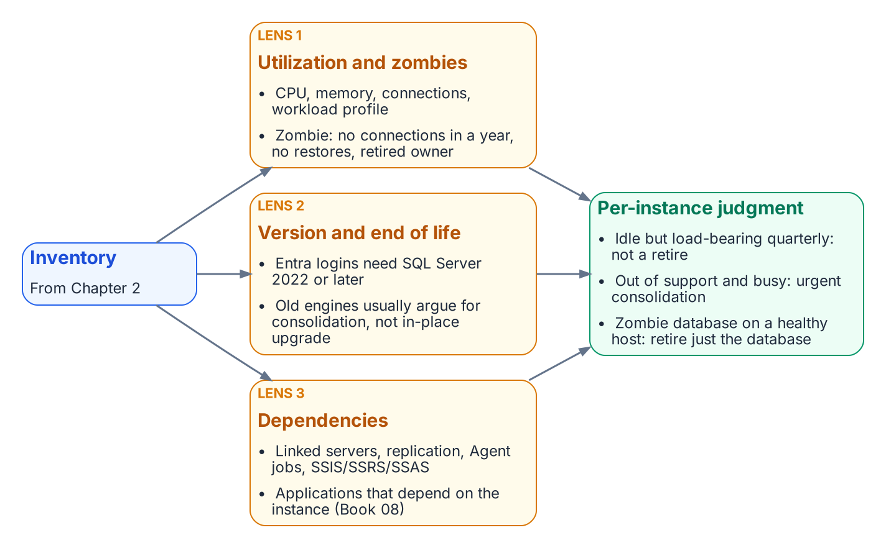
Utilization, version posture and dependencies, applied together, produce a defensible judgment per instance and per database.
No single lens produces the rationalization decision. An instance that is lightly utilized but load-bearing for a quarterly process is not a retirement candidate. An out-of-support instance with heavy utilization is an urgent consolidation target, not a leave-alone. A zombie database on an otherwise healthy instance is a local retirement that shrinks the migration surface without touching the host. The three lenses together produce, for each instance and each database, a defensible judgment — and that judgment is the input to the decision Chapter 4 records.
What Book 02 establishes — Chapter 3
- Rationalization applies three lenses — utilization, version and end-of-life posture, and dependencies — to every inventoried instance.
- Idle instances and zombie databases are retired, which shrinks the migration surface.
- The three lenses together produce the per-instance retain, consolidate or retire judgment.

Book_03 — Discovery: The Authentication Audit
Where Book 02 measured the estate to decide what survives, this book measures the authentication posture of what remains. The authentication-audit script is the instrument, the Arc-eligibility classification is its most consequential output, and the per-instance compliance record — not a spreadsheet — is its deliverable.
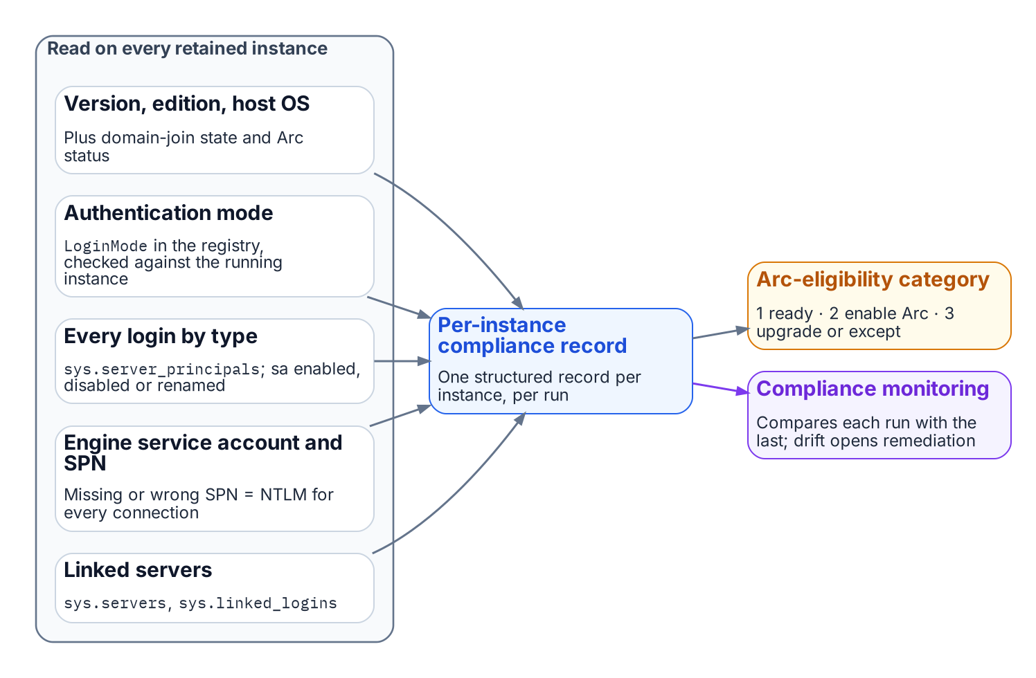
What the authentication audit reads on each instance, and where its output goes.
Place in the dependency chain: Step 3 — Audit survivors.

Authoritative references
Checked 19 October 2026.
- sys.server_principals (Transact-SQL)
- sys.dm_exec_connections (Transact-SQL)
- Change server authentication mode
- Register a Service Principal Name for Kerberos connections
- Overview of NTLM auditing enhancements in Windows 11, version 24H2, Windows Server 2019, and later versions (Microsoft Support)

Chapter 4 — The Retain, Consolidate, Retire Decision
The gate that determines which instances enter the authentication migration at all.

In this chapter
How the three rationalization lenses resolve into a single per-instance classification — retain, consolidate-into-target, or retire — the target-state options that absorb consolidated workloads, the constraints that prevent consolidation, and why this decision is the moment to collapse the forest-spanning identity sprawl into Entra-backed identity.
The assessment now resolves to a decision. Every instance the inventory surfaced and the rationalization lenses evaluated is assigned one of three classifications, and that classification governs whether the instance enters the authentication migration that Books 03 through 10 describe. The SQL Server engine-authentication decision makes the classification a normative prerequisite: engine-layer authentication migration is performed only on instances classified retain or on the consolidation targets that absorb consolidated workloads. Instances classified retire or consolidate-into-target (source) are not migrated — they are decommissioned or collapsed.

The Three Classifications
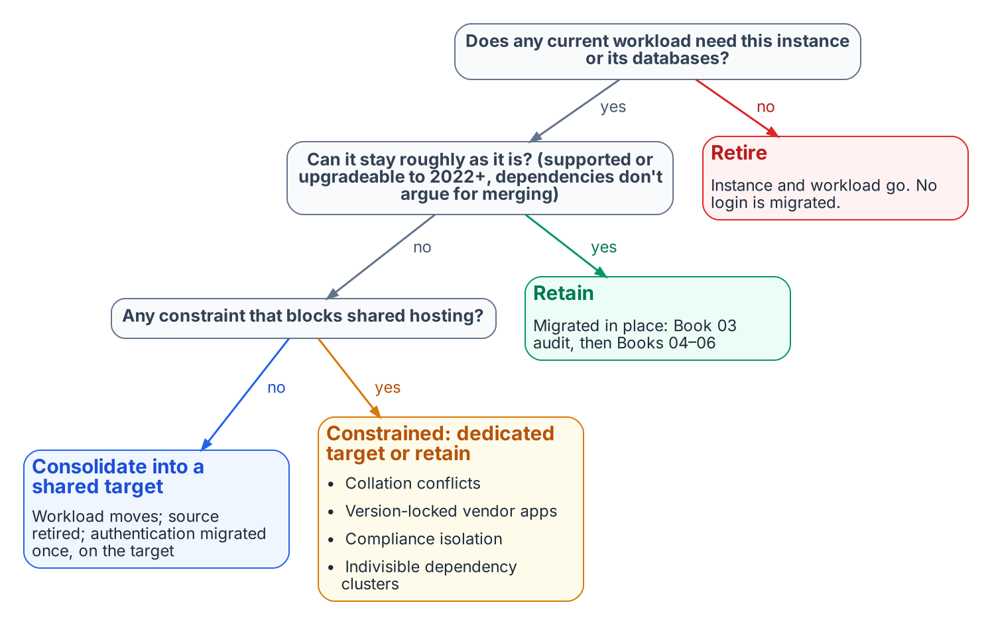
Retain, consolidate or retire: the classification that gates the authentication work.
A retain instance survives the transformation roughly in place. It carries current, load-bearing workload; it is on a supported version or has a clear in-place upgrade path to SQL Server 2022; and its dependencies do not argue for collapsing it into something larger. A retain instance proceeds directly into the Book 03 authentication audit and the Arc-eligibility classification.
A consolidate-into-target instance does not survive as an instance, but its workload does. The databases it carries are migrated onto a modern consolidation target, and the source instance is then retired. This is the classification for the large middle of an aged estate: lightly utilized instances, out-of-support engines whose workload is still needed, and instances whose only real function is to host one or two databases that belong on a shared platform. The migration work for these instances happens at the database-and-workload level; the authentication migration is performed on the target, not the source.
A retire instance does not survive at all, and neither does its workload. Zombie instances, instances whose every database is a zombie, and instances whose owning applications are decommissioned are retired outright. No login on a retire instance ever enters the migration pipeline — which is the entire point of running this assessment before the migration rather than after it.

Target-State Options
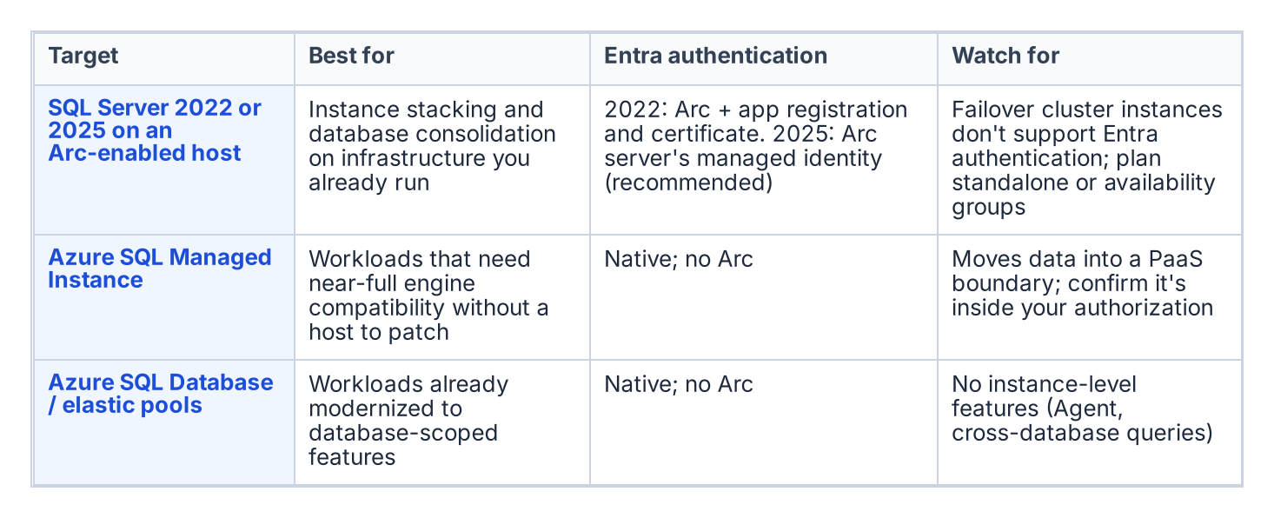
Consolidation targets, and what each one means for authentication.
A consolidation target is the platform that absorbs consolidated workloads, and the assessment chooses among a small set of options based on the workload profile and the program’s boundary posture. Collapsing many instances onto fewer modern SQL Server 2022 instances — through instance stacking or database consolidation onto a shared engine — is the most direct path and keeps the workload on infrastructure the program already operates. Azure SQL Managed Instance offers a near-full-compatibility platform-as-a-service target for workloads that can move to a managed surface, eliminating the host and much of the patching burden. Azure SQL Database and elastic pools suit workloads that have been modernized to the database-scoped feature set.
The target choice interacts with the rest of the series. A consolidation onto SQL Server 2022 on an Arc-enabled host is exactly the Category 1 starting position that Book 03 describes and Book 05 migrates. A consolidation onto Azure SQL Managed Instance changes the authentication story in detail — the Managed Instance is natively Entra-integrated — but not in principle, because the destination is still Entra ID-only authentication. The point of naming the target during the assessment is that the authentication migration is then performed once, on the target, in its final shape, rather than twice.

What Cannot Be Consolidated
Not every instance that looks like a consolidation candidate can actually be consolidated, and the assessment must record the constraints honestly. Collation conflicts between databases that must coexist on a shared instance can block stacking. Version-locked vendor applications that certify only against a specific SQL Server version cannot be moved to a newer engine without losing vendor support. Compliance-isolation requirements — a database whose data classification mandates physical or logical separation — can prevent co-residency regardless of technical compatibility. And cross-database or cross-instance dependencies that the dependency map surfaced can make two instances a single indivisible unit that must move together or not at all.
Each of these constraints converts an apparent consolidate candidate into either a constrained-consolidation case (move it, but onto a dedicated rather than shared target) or a retain case (leave it in place and migrate its authentication where it sits). Recording the constraint is what makes the consolidation plan executable rather than aspirational.

The Identity Dividend
Consolidation and the authentication transformation are mutually reinforcing, and the assessment is the moment to realize the connection. Collapsing many instances across multiple domains into fewer modern targets is also the moment to collapse the forest-spanning identity sprawl that Chapter 1 described. The cross-domain logins, the orphaned SPNs registered in domains being decommissioned, and the shared service accounts drawn from several domains do not need to be re-pointed instance by instance if the instances carrying them are being retired or consolidated. They are resolved once, at the target, into Entra-backed identity.
This is why the consolidation decision gates the authentication migration rather than running alongside it. The retain instances and the consolidation targets are the surface on which Books 03 through 10 operate; everything classified retire or consolidate-source falls away before that work begins, and the forest entanglement falls away with it. The SQL Server engine-authentication decision records this ordering as the governing constraint: assess and consolidate first, so the authentication transformation is spent only on the estate that survives.
What Book 02 establishes — Chapter 4
- Every instance is classified retain, consolidate-into-target or retire, and only retained instances and consolidation targets enter the migration.
- Targets are chosen during the assessment, so authentication is migrated once, in its final shape.
- Consolidation is the moment to collapse forest-spanning identity sprawl, which is why the assessment gates everything that follows.

Book_04 — Arc as the Identity Bridge
Without Arc, the SQL Server engine has no cloud-native identity; without that identity, there is nothing to anchor the instance’s Entra identity — the managed identity on SQL Server 2025, or the app registration certificate the Arc agent installs on SQL Server 2022 — and no mechanism to accept Entra ID-issued tokens. This book explains exactly what Arc does and does not change — and why SQL engine Entra auth (Layer 1) must not be blocked on the domain unjoin that OS-level Entra login (Layer 2) requires.
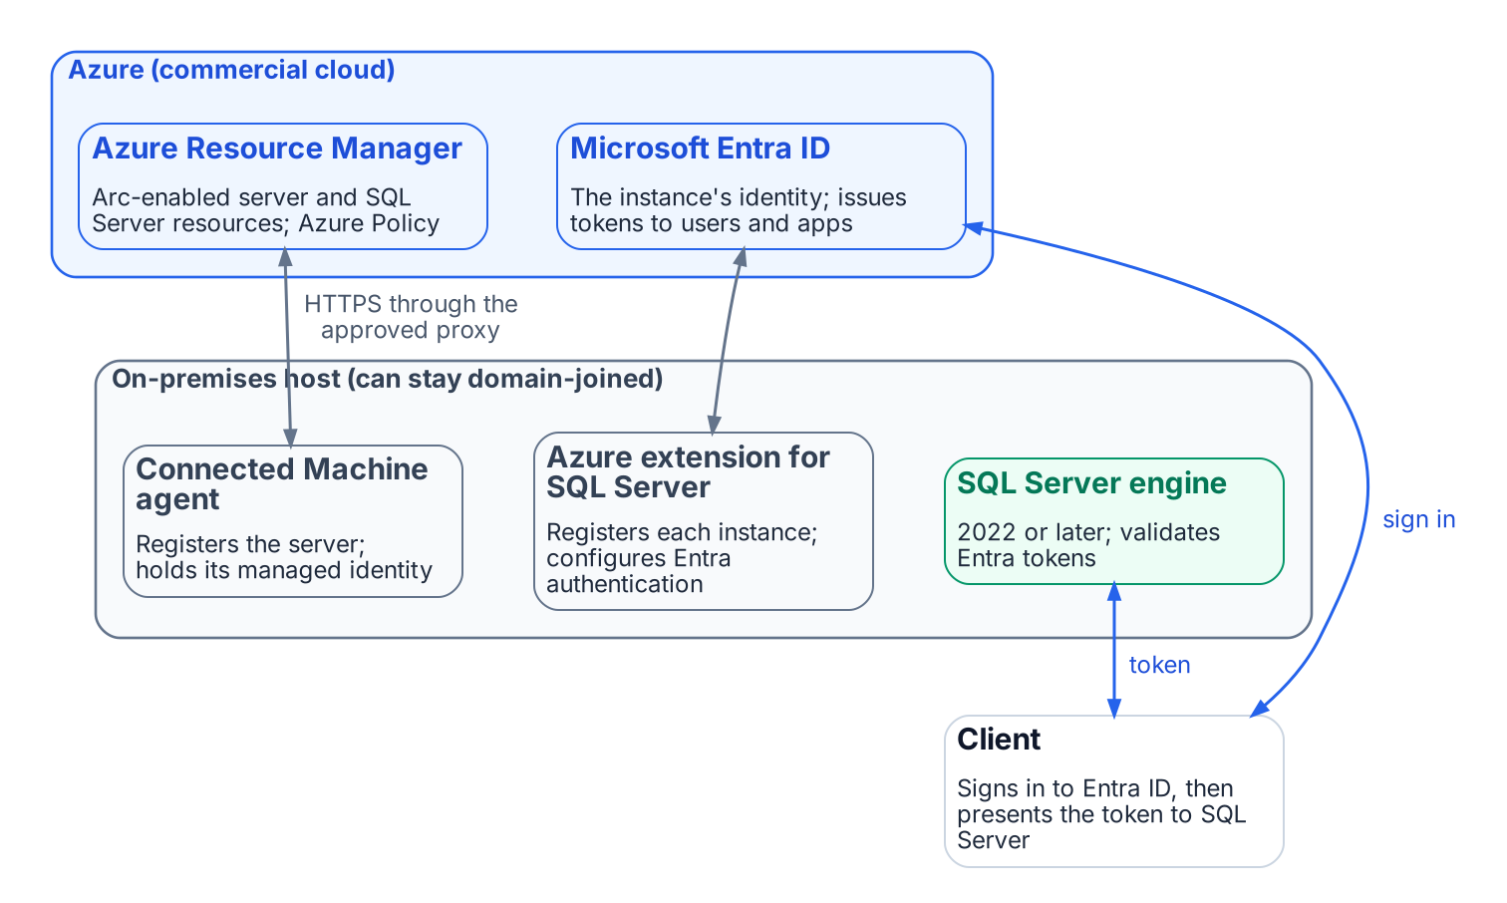
What Azure Arc connects: the on-premises host, Azure Resource Manager and Microsoft Entra ID.
Place in the dependency chain: Step 4 — Enable identity substrate.

Authoritative references
Checked 19 October 2026.
- Prerequisites — SQL Server enabled by Azure Arc
- Connected Machine agent network requirements
- Access Azure resources with managed identity on Azure Arc-enabled servers
- Set up Microsoft Entra authentication with app registration (SQL Server 2022)
- Set up managed identity and Microsoft Entra authentication (SQL Server 2025)
- Managed identity overview — SQL Server enabled by Azure Arc
- Enable Microsoft Entra authentication for SQL Server on Windows without Azure Arc

Book_05 — The Login Migration: Windows Principals to Entra Logins
Everything in Books 01 through 04 is prerequisite; everything in Books 06 through 09 is consequence. This book is the migration itself — performed only on the instances Book 02 classified retain or target, using the three-phase parallel-run pattern that the SQL Server engine-authentication decision makes normative.
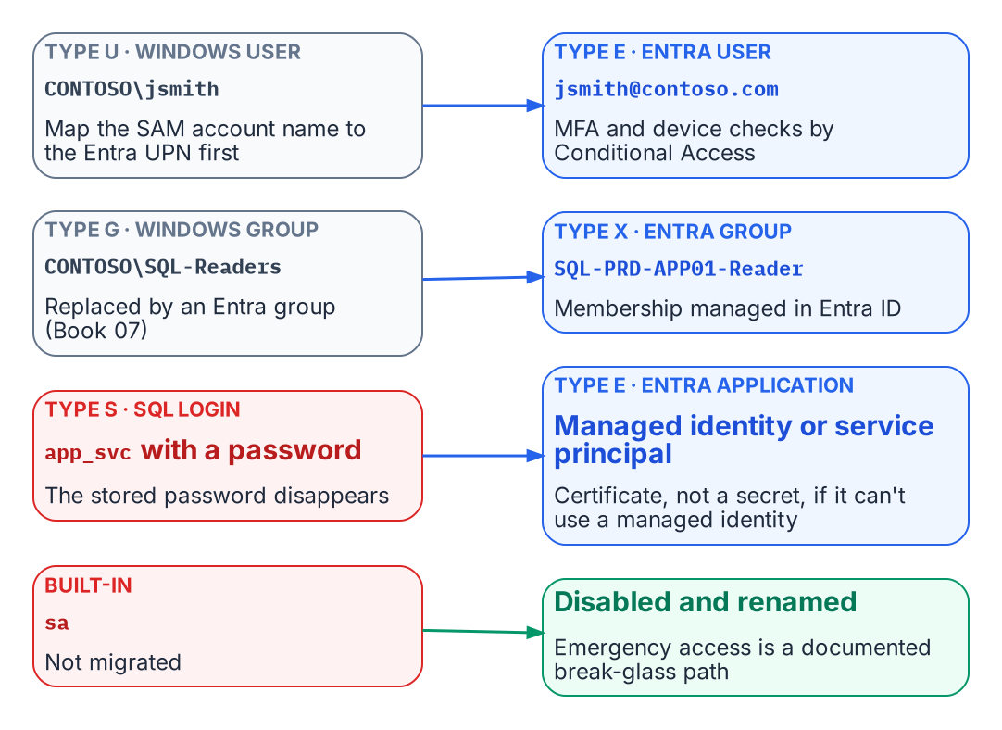
Every legacy login type maps to an Entra principal.
Place in the dependency chain: Steps 5 and 7 — Introduce Entra principals, then remove legacy principals.

Authoritative references
Checked 19 October 2026.
- CREATE LOGIN (Transact-SQL)
- sys.server_principals (Transact-SQL)
- Disable SQL Authentication — SQL Server enabled by Azure Arc
- Change server authentication mode
- What is Conditional Access?

Book_06 — Eliminating NTLM at the SQL Layer
SQL Server is one of the most common sources of NTLM traffic in a federal environment, and the reasons are more varied than most DBA teams expect. This book traces the Kerberos/NTLM-elimination program’s three phases — assess, block-where-safe, eliminate — as they apply to the SQL Server workload, against the program’s hard 2027-04-01 network-level block.
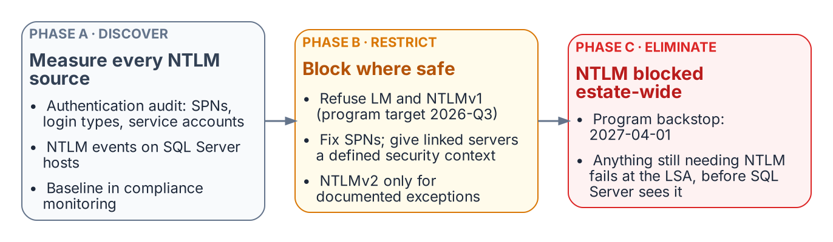
The three phases of the program’s NTLM elimination, applied to SQL Server.
Place in the dependency chain: Step 8 — Enforce protocol retirement.

Authoritative references
Checked 19 October 2026.
- Retiring NTLM: frequently asked questions (Microsoft Tech Community)
- Features removed or no longer developed in Windows Server
- Overview of NTLM auditing enhancements in Windows 11, version 24H2, Windows Server 2019, and later versions (Microsoft Support)
- Register a Service Principal Name for Kerberos connections
- sys.dm_exec_connections (Transact-SQL)
- Linked server for SQL Server with Microsoft Entra authentication
- Kerberos constrained delegation overview

Book_07 — Access Control: Groups, Roles, and Dynamic Membership
The migration moves SQL Server’s groups from Active Directory to Microsoft Entra ID, but it keeps group-based authorization. What changes is who maintains the groups and how. A group that maps to a single database role can keep itself current from HR-sourced attributes, which removes the helpdesk ticket. That only works if the attributes are trustworthy, the rules are tested, delegation is scoped, and privileged access is just-in-time. This book covers that design and the governance it needs.
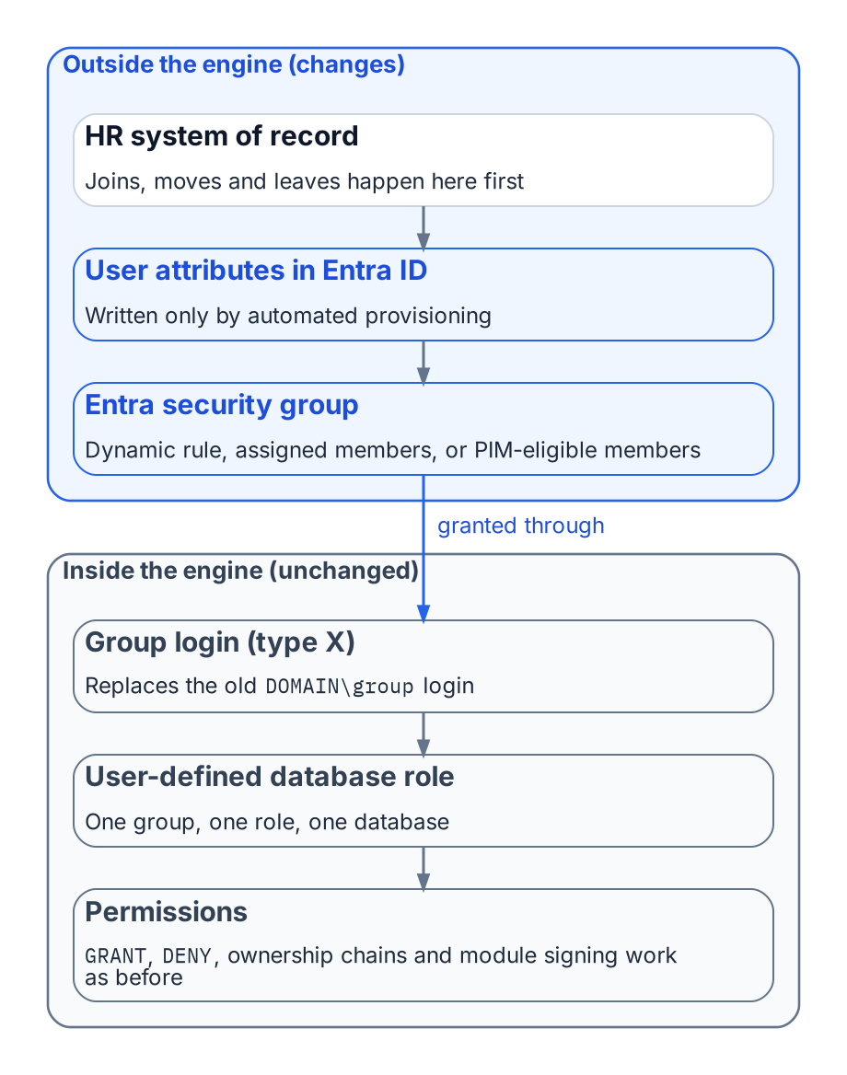
The directory half of SQL Server access moves to Entra ID; the engine half barely changes.
Place in the dependency chain: Step 5 — Introduce Entra principals (groups and authorization).

Authoritative references
Checked 19 October 2026.
- Manage rules for dynamic membership groups in Microsoft Entra ID
- Privileged Identity Management (PIM) for Groups
- What are access reviews?
- Administrative units in Microsoft Entra ID
- CREATE LOGIN (Transact-SQL)

Book_10 — Certificate Authority: From ADCS to Microsoft Cloud PKI
This book documents a “Not Yet Defined” gap from the transformation inventory. The content is analytical and motivational — it identifies the dependencies, names the gap, and describes what the as-yet-unwritten ADCS-migration architecture decision must address. Get-CertBasedAuthAudit.ps1 is the discovery instrument. Do not cite this book as normative governance for ADCS-migration decisions.
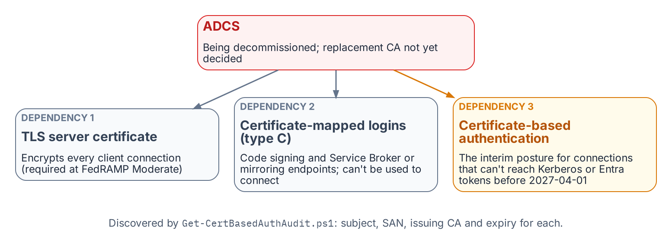
The three places SQL Server depends on ADCS-issued certificates.
Place in the dependency chain: The certificate dependency behind steps 4 and 8.

Authoritative references
Checked 19 October 2026.
- Microsoft Cloud PKI for Microsoft Intune
- Microsoft Intune Government service overview
- Encrypt connections by importing a certificate
- CREATE LOGIN (Transact-SQL)
- Microsoft Entra certificate-based authentication overview

Book_11 — Epilogue: The Platform Question

An epilogue, not an eleventh migration step
Books 01–10 are the SQL Server Identity Transformation. This epilogue starts where they end: with a rationalized estate whose authentication has moved to Microsoft Entra ID. Nothing in Books 01–10 depends on it.

The Fragmentation Cost
The authentication transformation produces a rationalized estate. The platform question asks what to do with that estate. Twenty years of accretion have produced overlapping instances, duplicated data domains, and no single authoritative source for any given subject. The goal is fewer authoritative platforms: one authoritative database per data domain.

Three Destinations
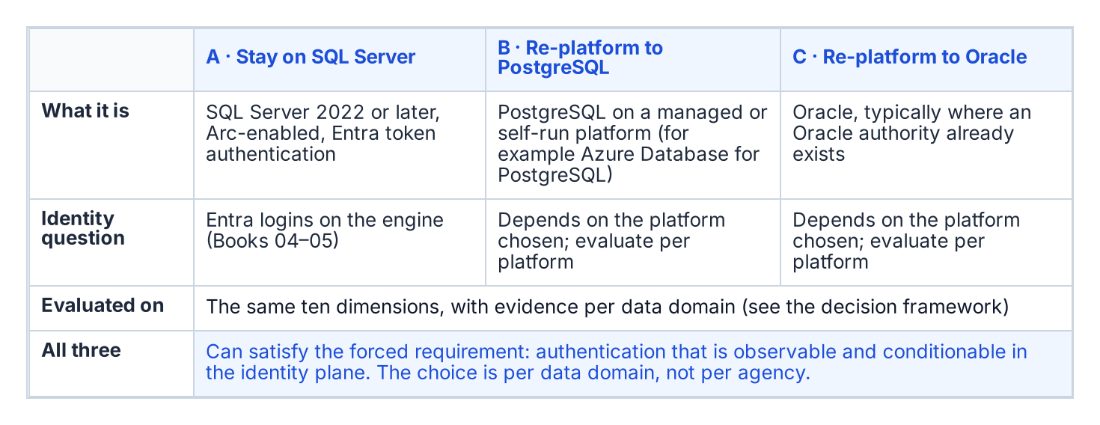
The three candidate destinations for a retained data domain.
Every retained data domain ends at one of three candidate destinations: stay on SQL Server, re-platform to PostgreSQL, or re-platform to Oracle. Each can satisfy the forced requirement — authentication that is observable and conditionable in the identity plane. This epilogue doesn’t rank them. Which one fits depends on the data domain, so the decision is made with a framework rather than a verdict.

Decision Framework
Score each candidate destination for each data domain on the same dimensions, and record the evidence behind each score:
Dimension | Evidence required per data domain
Migration effort | Schema and code inventory (procedures, functions, triggers, jobs), conversion estimate, test scope
Application compatibility | Driver and connection-string support for every consuming application; vendor support statements
Operational maturity | Monitoring, patching, backup and runbook coverage the operating team already has for the platform
HA/DR fit | Required RPO and RTO against the platform’s supported HA and DR topologies
Identity integration | How the platform authenticates to the chosen identity plane, verified in its own documentation
Licensing exposure | Current and projected license cost from the agency’s own agreements
Portability | Dependence on platform-specific features; exit path
Data-domain consolidation opportunity | Which duplicate copies of the domain the move would retire
Required skills | Staff skills today, and the training or hiring the move needs
Switching cost | Parallel-run duration, dual-running cost, contract terms
Two data domains can reach different answers, and that is normal. The goal is fewer authoritative platforms, not a single vendor.

Decision Sequence
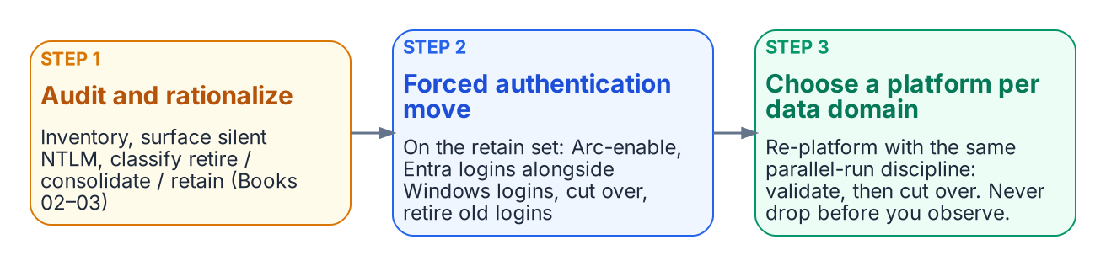
The platform decision comes after the forced authentication move.
- Audit and rationalize first (Books 02–03). Inventory every instance, surface silent NTLM fallback, and classify each instance retire, consolidate or retain.
- Do the forced authentication move on the retained set (Books 04–06): Arc-enable, stand up Entra logins alongside Windows logins, cut over, retire the old logins.
- Then make the platform choice per data domain. Re-platforming follows the same parallel-run discipline — establish the target, validate in parallel, cut over only after the validation window. Never drop before you observe.
What Book 11 establishes
- The authentication transformation produces the inventory that scopes the platform decision.
- The decision is made per data domain against a common set of dimensions and evidence, and two estates with two answers is normal.
- The goal is fewer authoritative platforms, not a single vendor.
Place in the dependency chain: Epilogue, after step 9.

Authoritative references
Checked 19 October 2026.
- Migrate SQL Server Windows users and groups to SQL Managed Instance using T-SQL
- Microsoft Entra authentication for SQL Server overview
- SQL Server enabled by Azure Arc — overview

Appendix A — Requirements Mapping

Compliance-enabling, not a compliance claim
This appendix maps the series’ controls and evidence to federal requirements so an agency can reuse them in its own system security plan. It does not claim that following the series satisfies any requirement, control or maturity stage. Control selection, tailoring, implementation statements and assessment belong to the agency and its assessors. Identifiers are from the sources’ current editions, checked 19 October 2026.

The four frameworks
- OMB M-22-09 sets the federal zero trust strategy’s identity outcomes: centrally managed enterprise identity integrated into applications, phishing-resistant MFA enforced at the application layer, and at least one device-level signal considered when authorizing access.
- CISA Zero Trust Maturity Model v2.0 describes the identity pillar through four functions — Authentication, Identity Stores, Risk Assessments and Access Management — plus the cross-cutting Visibility and Analytics, Automation and Orchestration, and Governance capabilities, each at Traditional, Initial, Advanced and Optimal stages.
- NIST SP 800-207 states seven zero trust tenets, cited below by number: (1) all data sources and computing services are resources; (2) all communication is secured regardless of network location; (3) access is granted per session; (4) access is determined by dynamic policy; (5) the enterprise monitors the integrity and security posture of all assets; (6) authentication and authorization are dynamic and strictly enforced before access; (7) the enterprise collects information on the current state of assets, infrastructure and communications.
- NIST SP 800-53 Rev. 5 supplies the control identifiers.

Mapping by book
Book | Control the book puts in place | Evidence it produces | M-22-09 | CISA ZTMM v2 identity | SP 800-207 tenet | SP 800-53 Rev. 5
02 The Estate | Inventory every instance; retire, consolidate or retain each | Instance inventory with a disposition per instance | Enterprise identity applied to every system in scope | Identity Stores (know and reduce the stores); Governance | 1 | CM-8, PM-5
03 The Audit | Classify every login and measure NTLM fallback | Per-instance login census by sys.server_principals type; auth_scheme counts | Inventory of legacy authentication to retire | Authentication (Traditional baseline); Visibility and Analytics | 5, 7 | AC-2, AU-2, AU-12, CM-8
04 The Identity Bridge | A cloud identity for the engine: Arc managed identity (2025) or app registration and certificate (2022) | Arc and extension health; Graph permission grants per machine identity; local token test | Centrally managed identity integrated with the application | Identity Stores; Authentication (non-person entities) | 6 | IA-9, IA-5, AC-6
05 Login Migration | Entra logins replace Windows and SQL logins through create → validate → disable → observe → drop | Parallel-run record; disabled-then-dropped legacy logins; sa disabled and renamed; SQL authentication refused | Enterprise identity at the application; MFA at the application layer through Conditional Access | Authentication (Advanced with phishing-resistant MFA); Access Management | 3, 6 | AC-2, AC-2(3), IA-2, IA-2(1), IA-2(2), IA-5, CM-3
06 NTLM Elimination | SPN repair so connections negotiate Kerberos; restrict NTLM | auth_scheme trend to zero NTLM; NTLM audit events | Removes a legacy, replayable method on the way to phishing-resistant authentication | Authentication | 2, 6 | IA-2(8), CM-7, SC-8
07 Access Control | One Entra group, one role, one database, one environment; dynamic membership from HR attributes; write control on the attributes; PIM for Groups; access reviews | Group-to-role map; attribute write-permission evidence; review completions; PIM activation logs | Attribute- and role-based authorization | Access Management (Initial → Advanced → Optimal JIT); Automation and Orchestration; Governance | 4 | AC-2(1), AC-3, AC-6, AC-6(7), AC-2(7), AC-16
08 The Application Chain | Each application authenticates users and connects to the database with Entra tokens, or carries a dated exception | Per-application class, owner and exception register | Enterprise identity integrated into applications | Authentication; Access Management | 3, 6 | IA-2, IA-9, AC-3, CA-3
09 Steady State | Entra-exclusive operational posture, re-evidenced on every audit run; drift alerts | Per-instance compliance record; drift events; sign-in logs | Continuous verification of the identity outcomes | Visibility and Analytics; Governance (Optimal) | 5, 7 | CA-7, AU-6, AU-12, AC-2(4), AC-6(9)
10 Certificate Authority | A replacement CA issuing before ADCS is retired; certificate inventory | Certificate inventory (subject, issuer, expiry) per instance | — | Identity (cross-cutting governance of credentials) | 2 | SC-17, SC-12, IA-5(2), SC-8
11 Epilogue | Per-data-domain platform decision | Decision record per data domain | — | Governance | 1 | PM-5, SA-9
Book 01 states the case and produces no control evidence of its own. The Applicability page decides which rows apply to an environment.

Notes on the mapping
- Mixed results are normal. An instance can meet one row and miss another; the per-instance compliance record of Book 09 is what shows which.
- MFA is a Conditional Access outcome, not an engine setting. SQL Server accepts the Entra token; whether the human behind it used phishing-resistant MFA is decided by Conditional Access policy and evidenced in Entra sign-in logs.
- IA-9 applies to the engine’s own identity. The Arc managed identity or app registration authenticates SQL Server to Microsoft Entra ID and Microsoft Graph; Appendix B — Security-Approval (ATO) Kit gives the permission justification.
- The 800-207 mapping is architectural. SQL Server acts as the enforcement point that accepts only tokens Entra ID issued under policy; the series does not implement a full policy engine.

Appendix B — Security-Approval (ATO) Kit

Supports an authorization decision; doesn’t make one
The authorization boundary, interconnection and leveraged-authorization language, and the risk decision belong to the agency’s authorizing official. This kit collects the facts an assessor will ask for. Platform facts were checked on 19 October 2026 and apply to Microsoft’s commercial cloud, including GCC-Moderate; see Applicability for GCC High and DoD.

Boundary
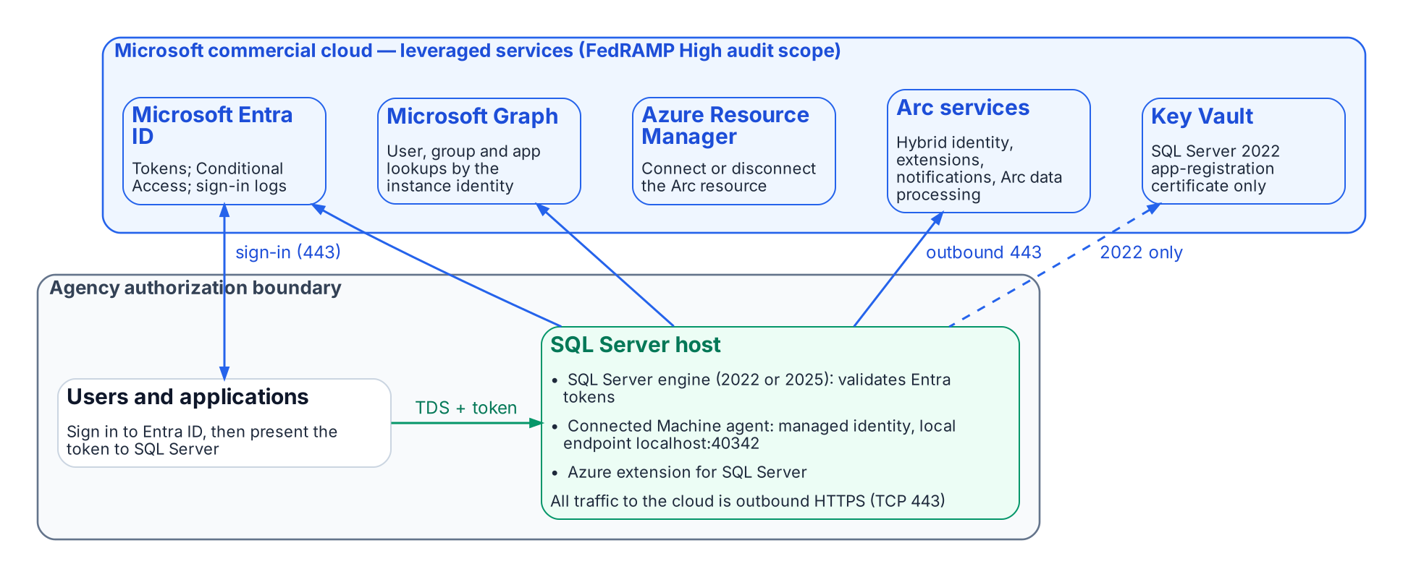
What runs inside the agency boundary and what it reaches outside it.
The SQL Server host stays inside the boundary. What changes is that it now depends on leveraged cloud services: Microsoft Entra ID for tokens, Microsoft Graph for lookups of users, groups and applications, and the Azure Arc services for the agent and the SQL extension. The Connected Machine agent communicates outbound to Azure Arc over TCP port 443. Azure Private Link can carry the Arc service traffic, but “network traffic to Microsoft Entra ID and Azure Resource Manager doesn’t traverse the Azure Arc private link scope and continues to use your default network route to the internet.”

Outbound endpoints
From Microsoft’s network requirements for the Connected Machine agent (Azure public cloud) and the prerequisites for SQL Server enabled by Azure Arc:
Endpoint | Purpose | When required
download.microsoft.com | Windows installation package | Installation only
login.microsoftonline.com | Global Microsoft Entra token endpoint (onboarding and fallback) | Always
*.login.microsoft.com | Regional Microsoft Entra token endpoints | Always
pas.windows.net | Microsoft Entra ID | Always
management.azure.com | Azure Resource Manager: create or delete the Arc server resource | Connect or disconnect only
*.his.arc.azure.com | Metadata and hybrid identity services | Always
*.guestconfiguration.azure.com | Extension management and guest configuration | Always
guestnotificationservice.azure.com, *.guestnotificationservice.azure.com | Notification service | Always
azgn*.servicebus.windows.net or *.servicebus.windows.net | Notification service | Always
*.<region>.arcdataservices.com | Arc data processing service for Arc-enabled SQL Server | If Arc-enabled SQL Server is used
<key-vault-name>.vault.azure.net, graph.microsoft.com | Microsoft Entra authentication with Arc-enabled SQL Server | If Arc-enabled SQL Server is used
Use Microsoft’s page, not this table, as the firewall source of truth: it lists optional endpoints (Windows Admin Center, SSH, ESU certificates, license validation) and changes over time.

FedRAMP audit scope of each leveraged service
Microsoft’s compliance-scope page lists each of these Azure public-cloud services as in scope for FedRAMP High (page dated 21 September 2026):
Service | Role in this design | FedRAMP High (Azure public)
Microsoft Entra ID (P1 + P2) and Microsoft Entra multifactor authentication | Tokens, Conditional Access, MFA, sign-in logs | ✅
Microsoft Entra ID Governance | PIM for Groups, access reviews (Book 07) | ✅
Microsoft Graph | Instance-identity lookups | ✅
Azure Arc-enabled servers | Connected Machine agent, managed identity | ✅
Azure Arc-enabled SQL Server | Azure extension for SQL Server | ✅
Azure Resource Manager | Arc resources | ✅
Key Vault | SQL Server 2022 certificate | ✅
Azure Monitor (incl. Log Analytics) | Telemetry (Book 09) | ✅
Microsoft Defender for Cloud | Defender for SQL (Book 09) | ✅
Microsoft Intune | Cloud PKI (Book 10) | ✅
An audit-scope listing is not the agency’s authorization. Leveraging a provider authorization still needs the agency’s own review of the package and of customer responsibilities.

Graph permissions for each machine identity
What is required. “Each system-assigned managed identity requires User.Read.All, GroupMember.Read.All, and Application.Read.All permissions to query Microsoft Graph.” They are application permissions (app roles) that “must be assigned directly to each managed identity” and “can’t be manually assigned to a Microsoft Entra security group.” Only a Privileged Role Administrator or higher can grant them. The SQL Server 2022 app-registration setup documents either Directory.Read.All or the narrower set Application.Read.All, Group.Read.All and User.Read.All; choose the narrower set.
Least-privilege justification.
- User.Read.All resolves the Entra users that CREATE LOGIN … FROM EXTERNAL PROVIDER names and that connect.
- GroupMember.Read.All resolves group membership for type-X (group) logins, which is how Book 07 grants access.
- Application.Read.All resolves service principals and managed identities that connect as applications (Book 08).
- All three are read-only. None grants write access to the directory.
Why not Directory Readers. Microsoft offers assigning the Directory Readers role to a role-assignable group as an alternative for many machines, but notes that it “grants broad read access across all directory objects, significantly exceeding the three targeted Graph API permissions,” and that it “isn’t recommended for production environments where least-privilege access is required.” Grant the three app roles to each identity with a script, and review the grants with the rest of the access reviews.

Token folder and BULK permissions
Microsoft documents that “OPENROWSET BULK operations can also read the tokens folder C:\ProgramData\AzureConnectedMachineAgent\Tokens\,” and that the ADMINISTER BULK OPERATIONS and ADMINISTER DATABASE BULK OPERATIONS permissions “should be treated as equivalent to sysadmin.” The mitigation:
- Grant either permission only to principals that already hold sysadmin, and record any exception in the exception registry.
- Include both permissions in the audit’s privileged-permission report and in SQL Server Audit, alongside sysadmin membership.
- The agent’s local identity endpoint requires the caller to be in the local Administrators group or the Hybrid Agent Extension Applications group, so manage those memberships as privileged.

Break-glass design
Failure | Design
Entra ID or Graph unreachable | Entra logins can’t authenticate. Keep one documented break-glass path: a Windows group holding sysadmin, empty by default, in the exception registry, with every membership change and every login alerting.
Every sysadmin path lost | Microsoft documents starting the instance in single-user mode; a member of the computer’s local Administrators group can then connect as sysadmin. That is why local Administrators membership on SQL hosts is itself privileged.
Tenant-side lockout | Follow Microsoft’s emergency-access account guidance for the Entra tenant.
Pressure to turn Entra authentication off | Microsoft states that once Entra authentication is enabled with a managed identity, disabling it isn’t advisable, and forcibly deleting registry entries can cause unpredictable behavior. Recover through the paths above instead.

Licensing bill of materials
List prices change and agreements differ, so this table names the license each capability needs, not its price.
Book | Capability | License | Source
02–03 | Arc inventory and the audit | SQL Server license; Arc’s client connection summary needs Software Assurance, a SQL Server subscription or pay-as-you-go
04–05 | Entra authentication on the engine | Available with “License only” — no Software Assurance or pay-as-you-go needed
04 | SQL Server 2022 certificate | Azure Key Vault (consumption)
05, 07, 09 | Conditional Access (MFA, device, location, risk) | Microsoft Entra ID P1
07 | Dynamic membership groups | Microsoft Entra ID P1 for each unique member
07 | PIM for Groups | Microsoft Entra ID P2, ID Governance or Entra Suite
07 | Access reviews | Microsoft Entra ID Governance or Entra Suite
09 | Defender for SQL servers on machines | A Microsoft Defender for Cloud plan
09 | Log Analytics | Azure Monitor (consumption) | —
10 | Microsoft Cloud PKI | Intune add-on, standalone or in the Intune Suite

Book_08 — The Application Chain: LDAP-Bound and SQL-Consuming Applications
An upstream application that has migrated its user authentication to Entra ID but still uses a SQL Authentication service account to reach the database has not completed its transformation. The application chain must be addressed as a complete authentication path, not as independent layers.
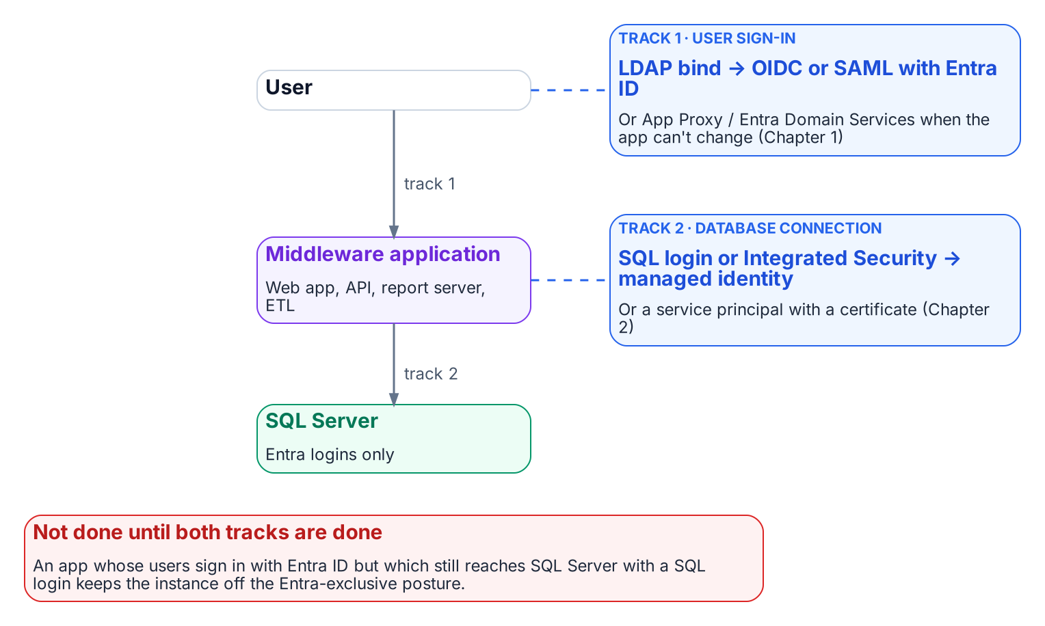
The application chain has two authentication tracks, and both must leave Active Directory.
Place in the dependency chain: Step 6 — Move applications.

Authoritative references
Checked 19 October 2026.
- Microsoft Entra authentication with Microsoft.Data.SqlClient
- Credential chains in the Azure Identity library for .NET
- Linked server for SQL Server with Microsoft Entra authentication
- Access Azure resources with managed identity on Azure Arc-enabled servers
- What is Conditional Access?

Book_09 — The Transformed Posture: Continuous Governance and the 2027 Milestone
A transformation that achieves a completed state and then stops monitoring is a transformation that will regress. The transformed posture is not a permanent state achieved by a one-time action — it is an ongoing condition maintained by continuous monitoring, automated drift detection, and a governance process that treats regression as a compliance violation.
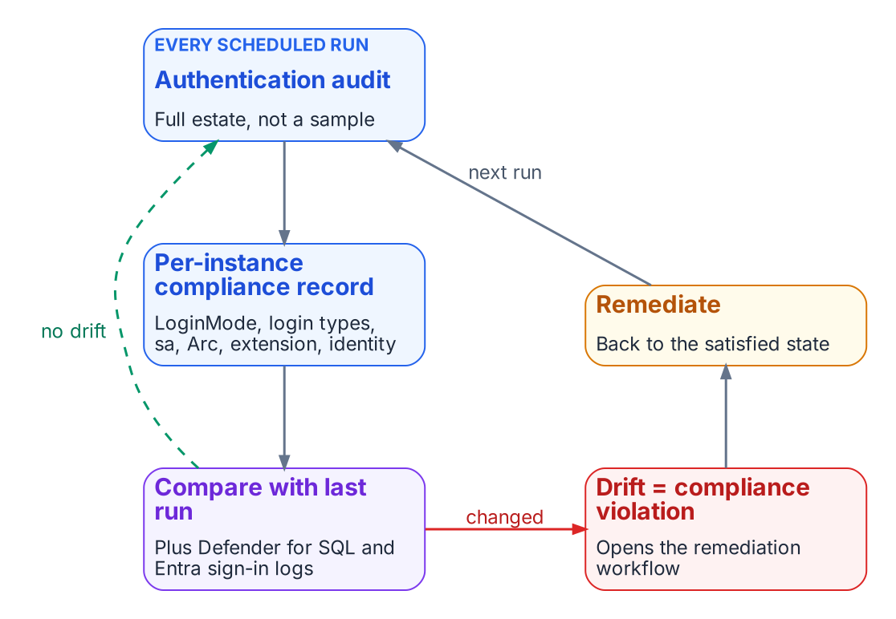
The transformed posture is a loop that never stops.
Place in the dependency chain: Step 9 — Demonstrate sustained posture.

Authoritative references
Checked 19 October 2026.
- Disable SQL Authentication — SQL Server enabled by Azure Arc
- sys.dm_exec_connections (Transact-SQL)
- Sign-in logs in Microsoft Entra ID
- Microsoft Defender for SQL servers on machines overview
- SQL Server Audit (Database Engine)
- CISA Zero Trust Maturity Model, Version 2.0

SQL Server Identity Transformation
From Windows Authentication to cloud identity — a ten-book reading sequence, with an epilogue, on transforming the SQL Server estate from twenty years of forest sprawl to cloud-only authentication
The ten books and the epilogue, in the order they depend on each other.

Status
This is a cleaned multi-chapter narrative. It is written as an engineering argument, not a runbook. Treat the patterns as guidance that must be validated against the specific estate.

The destination
Windows Authentication and SQL Authentication are eliminated and replaced with cloud identity authentication for SQL Server 2022 and later. Authentication is enforced through OAuth 2.0 tokens, a Microsoft Entra identity for each instance (the Arc managed identity on SQL Server 2025, an app registration on SQL Server 2022), and multi-factor authentication for every human principal. This series documents the path to that destination and provides the analytical foundation for the engine-layer decision.
The series is written in continuous narrative voice. It avoids the bullet-point shorthand of a runbook, because the transformation it describes is not a checklist — it is an engineering argument, and engineering arguments require sentences.

The dependency chain
Every book serves one chain. Each step depends on the ones before it:
Inventory → Rationalize → Audit survivors → Enable identity substrate → Introduce Entra principals → Move applications → Remove legacy principals → Enforce protocol retirement → Demonstrate sustained posture
Step | Stage | Where
1 | Inventory | Book 02, Chapters 1–2
2 | Rationalize | Book 02, Chapters 3–4
3 | Audit survivors | Book 03
4 | Enable identity substrate | Book 04
5 | Introduce Entra principals | Books 05 and 07
6 | Move applications | Book 08
7 | Remove legacy principals | Book 05
8 | Enforce protocol retirement | Book 06
9 | Demonstrate sustained posture | Book 09
Book 01 makes the case for the chain. Book 10 is the certificate dependency that steps 4 and 8 rely on. Book 11, the epilogue, comes after step 9.

Reading sequence shape
Book 01 names the inheritance: SQL Server’s Windows Authentication was good engineering for its world, not negligence. Book 02 confronts the precondition that most authentication narratives skip: you cannot migrate the authentication of an estate you have not first assessed and consolidated, and after twenty years across an Active Directory forest, the estate is larger and more tangled than any team’s mental model of it. Books 03 through 06 trace the migration itself — the authentication audit, the identity bridge, the login migration, and NTLM elimination at the SQL layer. Books 07 and 08 follow the transformation outward, into access control and the upstream application chain. Book 09 describes the transformed steady-state and the milestone, and Book 10 addresses the certificate-authority dependency that the other nine books depend on but rarely name.

The transformation in diagrams

Before, during and after
How a connection authenticates before, during and after the transformation.
Before, every party is domain-joined, the domain controller is the authentication authority, and NTLM is the silent fallback when the service principal name is missing; the cloud identity plane never sees the sign-in. During the parallel run, legacy and migrated clients coexist and the SQL Server accepts both kinds of login. After, the client authenticates to Microsoft Entra ID, Conditional Access evaluates the request, and the SQL Server validates the token.

Kerberos and the NTLM fallback
A Windows-integrated connection: SSPI negotiates Kerberos when the SPN resolves, and silently falls back to NTLM when it doesn’t.
The client asks the domain controller for a service ticket for the SQL Server SPN and presents it in the TDS login. When the SPN is missing, Negotiate drops to NTLM challenge-response without logging an error by default.

The parallel-run pattern
The required three-phase parallel run for production.
Create the Entra login alongside the Windows login, validate a real Entra sign-in, disable the old login and observe for 30 days, and only then drop it.

Token authentication
A connection with an Entra login: the client gets a token for the SQL audience and the engine validates it.
The client signs in to Microsoft Entra ID, Conditional Access evaluates MFA, device, location and risk, and a token for the SQL Server audience is issued. The SQL Server checks the token and maps it to an Entra login.

The decision, in one page
The platform vendor is moving the SQL Server identity floor — version end-of-support, Extended Security Updates gated behind hybrid management, and NTLM deprecation — on a timeline the agency does not set. The choices that remain (stay on SQL Server, or consolidate onto another engine) and a profile-driven recommendation matrix should be summarized for leadership in a single reference page.

Division of labor
The organizing principle of the series — what the platform vendor provides versus what only the program can solve — should be captured for every topic in a single reference page.

Reading sequence
Book | Title | Focus
— | Applicability | Read first: where the series applies as written, alternatives, and fallback protections
01 | The Authentication Inheritance Problem | What Windows Authentication actually is, and why it must end
02 | The Estate Itself | Assess and consolidate before you touch authentication
03 | The Authentication Audit | What is actually using Windows Authentication, SQL Authentication, and NTLM
04 | The Identity Bridge | Hybrid-management attachment and an Entra identity for the engine
05 | Login Migration | Parallel-run of Windows and cloud-identity logins
06 | NTLM Elimination | Silent fallback, service principal name repair, and protocol restriction
07 | Access Control | Dynamic groups and administrative-unit delegation
08 | The Upstream Application Chain | Applications that depend on Windows Authentication or LDAP
09 | Transformed Steady State | The destination and the milestone
10 | Certificate-Authority Dependency | The layer the other steps depend on but rarely name
11 | Epilogue — The Platform Question | Database consolidation toward SSOT, after the transformation
A | Appendix A — Requirements Mapping | Each book’s controls and evidence mapped to M-22-09, CISA ZTMM v2, SP 800-207 and SP 800-53 Rev. 5 (compliance-enabling, not a compliance claim)
B | Appendix B — Security-Approval (ATO) Kit | Boundary diagram, outbound endpoints, FedRAMP audit scope, Graph permission justification, token-folder mitigation, break-glass and licensing

Relationship to identity governance
Dynamic Entra security groups grant SQL Server access based on HR-sourced user attributes, so no database administrator has to provision access by hand. The HR-to-directory attribute feed, its write protection, and the rule testing described in Book 07 must be in place before the dynamic-group access work starts.

Audience
Database engineers who execute the login migrations, infrastructure architects responsible for estate consolidation and hybrid-management sequencing, security engineers who own the Conditional Access design and continuous monitoring, and program leadership who must understand the scope of the engine-layer decision and the consolidation program that precedes it. The series assumes familiarity with SQL Server administration and Active Directory security concepts; familiarity with cloud identity is built progressively across the ten books.

Cleaned extraction for project use. Original diagrams from the source bundle.

Microsoft Learn, Release notes — SQL Server enabled by Azure Arc.
Microsoft Learn, Managed identity for SQL Server enabled by Azure Arc, Limitations (“SQL Server needs access to Azure public cloud”; managed-identity setup “only supported with Azure Arc-enabled SQL Server 2025, running on Windows Server”). Checked 19 October 2026.
Microsoft Learn, Microsoft Entra authentication for SQL Server (SQL Server 2022 and later; failover cluster instances not supported). Checked 19 October 2026.
Microsoft Learn, Managed identity for SQL Server enabled by Azure Arc, Limitations (“SQL Server needs access to Azure public cloud”; managed-identity setup “only supported with Azure Arc-enabled SQL Server 2025, running on Windows Server”). Checked 19 October 2026.
Microsoft Learn, Managed identity for SQL Server enabled by Azure Arc, Limitations (“SQL Server needs access to Azure public cloud”; managed-identity setup “only supported with Azure Arc-enabled SQL Server 2025, running on Windows Server”). Checked 19 October 2026.
Microsoft Learn, Microsoft Entra authentication for SQL Server (SQL Server 2022 and later; failover cluster instances not supported). Checked 19 October 2026.
Microsoft Learn, Azure Government — SQL Server enabled by Azure Arc. Checked 19 October 2026.
Microsoft Learn, Microsoft Intune Government service overview.
Microsoft Learn, Microsoft Entra feature availability in Azure for US Government.
Microsoft Learn, Enable Microsoft Entra authentication for SQL Server on Windows without Azure Arc, Prerequisites. Checked 19 October 2026.
Microsoft Learn, Microsoft Entra cloud-first identity guidance.
Microsoft Learn, Microsoft Entra authentication for SQL Server (SQL Server 2022 and later; failover cluster instances not supported). Checked 19 October 2026.
Microsoft Learn, Microsoft Entra authentication for SQL Server (SQL Server 2022 and later; failover cluster instances not supported). Checked 19 October 2026.
Microsoft Learn, Managed identity for SQL Server enabled by Azure Arc, Limitations (“SQL Server needs access to Azure public cloud”; managed-identity setup “only supported with Azure Arc-enabled SQL Server 2025, running on Windows Server”). Checked 19 October 2026.
Microsoft Learn, Disable SQL Authentication — SQL Server enabled by Azure Arc.
Microsoft Learn, Enable Microsoft Entra authentication for SQL Server on Windows without Azure Arc, Prerequisites. Checked 19 October 2026.
Microsoft Learn, SERVERPROPERTY (Transact-SQL).
Microsoft Learn, Register a Service Principal Name for Kerberos connections.
Microsoft Learn, sys.dm_exec_connections (auth_scheme).
Microsoft Learn, Features removed or no longer developed in Windows Server.
Microsoft Support, Overview of NTLM auditing enhancements in Windows 11, version 24H2, Windows Server 2019, and later versions.
Microsoft Learn, Register a Service Principal Name for Kerberos connections.
Microsoft Learn, Change server authentication mode.
Microsoft Learn, What is Microsoft Entra ID Protection?.
Microsoft Learn, What is Conditional Access?.
Microsoft Learn, Group Managed Service Accounts overview.
Microsoft Learn, Managed identity overview — SQL Server enabled by Azure Arc.
Microsoft Learn, Set up Microsoft Entra authentication with app registration — SQL Server enabled by Azure Arc.
Microsoft Learn, Azure Arc-enabled servers overview.
Microsoft Learn, Connected Machine agent prerequisites.
Microsoft Learn, Microsoft Entra authentication for SQL Server overview.
Microsoft Learn, Managed identity overview — SQL Server enabled by Azure Arc.
Microsoft Learn, Change server authentication mode.
Microsoft Learn, sys.server_principals (Transact-SQL).
Microsoft Learn, CREATE LOGIN (Transact-SQL).
Microsoft Learn, Group Managed Service Accounts overview.
Microsoft Learn, Register a Service Principal Name for Kerberos connections.
Microsoft Learn, Overview — SQL Server enabled by Azure Arc.
Microsoft Learn, Linked server for SQL Server with Microsoft Entra authentication.
Microsoft Learn, Group Managed Service Accounts overview.
Microsoft Learn, Azure Arc-enabled servers overview.
Microsoft Learn, Access Azure resources with managed identity on Azure Arc-enabled servers.
Microsoft Learn, Overview — SQL Server enabled by Azure Arc.
Microsoft Learn, Microsoft Entra authentication for SQL Server overview.
Microsoft Learn, CREATE LOGIN (Transact-SQL).
Microsoft Learn, Sign in to an Azure Arc-enabled server using Microsoft Entra ID.
Microsoft Learn, Managed identity overview — SQL Server enabled by Azure Arc.
Microsoft Learn, Set up Microsoft Entra authentication with app registration — SQL Server enabled by Azure Arc.
Microsoft Learn, Microsoft Cloud PKI for Microsoft Intune.
Microsoft Learn, Change server authentication mode.
Microsoft Learn, CREATE LOGIN (Transact-SQL).
Microsoft Learn, Overview — SQL Server enabled by Azure Arc.
Microsoft Learn, Microsoft Entra authentication for SQL Server overview.
Microsoft Learn, Managed identity overview — SQL Server enabled by Azure Arc.
Microsoft Learn, What is Conditional Access?.
Microsoft Learn, What is Microsoft Entra ID Protection?.
Microsoft Learn, sys.server_principals (Transact-SQL).
Microsoft Learn, Manage rules for dynamic membership groups in Microsoft Entra ID.
Microsoft Learn, Access Azure resources with managed identity on Azure Arc-enabled servers.
Third-party source (Google Cloud documentation), Integration with Microsoft Entra ID — Cloud SQL for SQL Server, “Migration from Microsoft Active Directory.”
Microsoft Learn, Linked server for SQL Server with Microsoft Entra authentication.
Microsoft Learn, Features removed or no longer developed in Windows Server.
Microsoft Learn, Register a Service Principal Name for Kerberos connections.
Microsoft Tech Community, Retiring NTLM: frequently asked questions.
Microsoft Learn, Windows Hello for Business cloud Kerberos trust deployment guide.
Microsoft Learn, Kerberos constrained delegation overview.
Microsoft Learn, Managed identity overview — SQL Server enabled by Azure Arc.
Microsoft Learn, What is Conditional Access?.
Microsoft Learn, Set up managed identity and Microsoft Entra authentication for SQL Server enabled by Azure Arc.
Microsoft Learn, What are access reviews?.
Microsoft Learn, What is Microsoft Entra ID Protection?.
Microsoft Learn, Microsoft Defender for SQL servers on machines overview.
Microsoft Learn, Sign-in logs in Microsoft Entra ID.
Microsoft Learn, Change server authentication mode.
Microsoft Learn, Disable SQL Authentication — SQL Server enabled by Azure Arc (SQL Server 2025 on Windows).
Microsoft Learn, Encrypt connections by importing a certificate.
Microsoft Learn, Microsoft Cloud PKI for Microsoft Intune.
Microsoft Learn, CREATE LOGIN (Transact-SQL), Remarks.
Microsoft Learn, Register a Service Principal Name for Kerberos connections.
Microsoft Learn, What is Conditional Access?.
Office of Management and Budget, M-22-09, Moving the U.S. Government Toward Zero Trust Cybersecurity Principles.
Microsoft Learn, Features removed or no longer developed in Windows Server.
Microsoft Learn, Register a Service Principal Name for Kerberos connections.
Microsoft Learn, What is Microsoft Entra ID Protection?.
Microsoft Learn, Group Managed Service Accounts overview.
Microsoft Learn, Azure Arc-enabled servers overview.
Microsoft Learn, Managed identity overview — SQL Server enabled by Azure Arc.
Microsoft Learn, Set up Microsoft Entra authentication with app registration — SQL Server enabled by Azure Arc.
Microsoft Learn, Register a Service Principal Name for Kerberos connections.
Microsoft Learn, Overview — SQL Server enabled by Azure Arc.
Microsoft Learn, Register a Service Principal Name for Kerberos connections.
Microsoft Learn, Azure Arc-enabled servers overview.
Microsoft Learn, CREATE LOGIN (Transact-SQL).
Microsoft Learn, Microsoft Entra authentication for SQL Server overview.
Microsoft Learn, Overview — SQL Server enabled by Azure Arc.
Microsoft Learn, Azure Arc-enabled servers overview.
Microsoft Learn, Microsoft Entra authentication for SQL Server overview.
Microsoft Learn, Managed identity overview — SQL Server enabled by Azure Arc.
Microsoft Learn, Set up managed identity and Microsoft Entra authentication for SQL Server enabled by Azure Arc.
Microsoft Learn, Access Azure resources with managed identity on Azure Arc-enabled servers.
Microsoft Learn, Set up Microsoft Entra authentication with app registration — SQL Server enabled by Azure Arc.
Microsoft Learn, CREATE LOGIN (Transact-SQL).
Microsoft Learn, sys.server_principals (Transact-SQL).
Microsoft Learn, What is Conditional Access?.
Microsoft Learn, Overview — SQL Server enabled by Azure Arc.
Third-party source (vendor case study), Silverfort, Customer case study: preventing NTLM-based lateral movement with Silverfort. Cited as an example of the control category, not an endorsement.
Microsoft Learn, Change server authentication mode.
Microsoft Learn, Azure Arc-enabled servers overview.
Microsoft Learn, Disable SQL Authentication — SQL Server enabled by Azure Arc.
Microsoft Learn, Features removed or no longer developed in Windows Server.
Microsoft Learn, Register a Service Principal Name for Kerberos connections.
Microsoft Learn, Windows Hello for Business cloud Kerberos trust deployment guide.
Microsoft Learn, Linked server for SQL Server with Microsoft Entra authentication.
Microsoft Learn, What is Microsoft Entra Connect?.
Microsoft Learn, What is Conditional Access?.
Microsoft Learn, Sign-in logs in Microsoft Entra ID.
Microsoft Learn, SQL Server Audit (Database Engine).
Microsoft Learn, Access Azure resources with managed identity on Azure Arc-enabled servers.
Microsoft Learn, CREATE LOGIN (Transact-SQL).
Microsoft Learn, Sign-in logs in Microsoft Entra ID.
Microsoft Learn, What is Conditional Access?.
Microsoft Learn, CREATE LOGIN (Transact-SQL).
Microsoft Learn, Microsoft Entra authentication for SQL Server overview.
Microsoft Learn, Microsoft Entra authentication for SQL Server overview.
Microsoft Learn, Managed identity overview — SQL Server enabled by Azure Arc.
Microsoft Learn, Set up Microsoft Entra authentication with app registration — SQL Server enabled by Azure Arc.
Office of Management and Budget, M-22-09, Moving the U.S. Government Toward Zero Trust Cybersecurity Principles (January 2022).
Microsoft Learn, Memo 22-09 identity requirements overview and Meet authorization requirements of memorandum 22-09.
CISA, Zero Trust Maturity Model, Version 2.0 (April 2023).
Microsoft Learn, CISA Zero Trust Maturity Model for the identity pillar.
NIST, SP 800-207, Zero Trust Architecture, Section 2.1, Tenets of Zero Trust.
NIST, SP 800-53 Rev. 5, Security and Privacy Controls for Information Systems and Organizations.
Microsoft Learn, What is Conditional Access?
Microsoft Learn, Connected Machine agent network requirements. Checked 19 October 2026.
Microsoft Learn, Use Azure Private Link to connect servers to Azure Arc by using a private endpoint.
Microsoft Learn, Connected Machine agent network requirements. Checked 19 October 2026.
Microsoft Learn, Prerequisites — SQL Server enabled by Azure Arc.
Microsoft Learn, Azure and other Microsoft cloud services compliance scope, “Azure public services by audit scope”. Checked 19 October 2026.
Microsoft Learn, Set up managed identity and Microsoft Entra authentication for SQL Server enabled by Azure Arc, “Grant application permissions to the identity”.
Microsoft Learn, Set up Microsoft Entra authentication with app registration — SQL Server enabled by Azure Arc.
Microsoft Learn, Set up managed identity and Microsoft Entra authentication for SQL Server enabled by Azure Arc, “Grant application permissions to the identity”.
Microsoft Learn, Managed identity overview — SQL Server enabled by Azure Arc, Limitations.
Microsoft Learn, Access Azure resources with managed identity on Azure Arc-enabled servers.
Microsoft Learn, Connect to SQL Server when system administrators are locked out.
Microsoft Learn, Manage emergency access admin accounts.
Microsoft Learn, Managed identity overview — SQL Server enabled by Azure Arc, Limitations.
Microsoft Learn, Overview — SQL Server enabled by Azure Arc, feature availability by license type.
Microsoft Learn, Overview — SQL Server enabled by Azure Arc, feature availability by license type.
Microsoft Learn, Set up Microsoft Entra authentication with app registration — SQL Server enabled by Azure Arc.
Microsoft Learn, What is Conditional Access?, License requirements.
Microsoft Learn, Manage rules for dynamic membership groups in Microsoft Entra ID, License requirements.
Microsoft Learn, Microsoft Entra ID Governance licensing fundamentals.
Microsoft Learn, What are access reviews?, License requirements.
Microsoft Learn, Microsoft Defender for SQL servers on machines overview.
Microsoft Learn, Microsoft Cloud PKI for Microsoft Intune.

