Next Generation DDI
  - Governing DNS, DHCP and IPAM as the hybrid multi-cloud control plane
Table of Contents

Next Generation DDI
Governing DNS, DHCP and IPAM as the hybrid multi-cloud control plane
How DNS evolved from a name-lookup service into the application surface, the security enforcement plane and the identity substrate of the hybrid multi-cloud enterprise, and what federal agencies must do to govern it.
Michael Stratton · Updated October 2026

Why this book exists
DNS was designed to answer one question: what is the address for this name? In a hybrid multi-cloud agency it now does far more. It publishes private endpoints, selects SaaS front doors, enforces security policy, anchors certificate validation and defines the application surface that Zero Trust policy is written against. Most agencies still run it as a commodity utility spread across five independent platforms: Active Directory DNS or an on-premises DDI grid, AWS Route 53, Azure DNS, Google Cloud DNS and VMware NSX.
The result is split-brain DNS that breaks private connectivity, certificate trust and Layer 7 policy at once, and that shows up as certificate errors and access denials rather than DNS errors. This book makes the case for one authoritative DDI policy plane, and walks through what it takes to get there and run it.

The arc
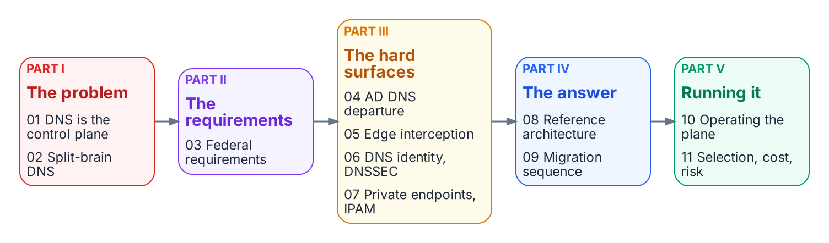
The reading path: five parts and eleven chapters.
Start with Applicability if you work in GCC High, DoD or an air-gapped environment. It sets out which statements in later chapters change at higher impact levels.

Part I · The problem
- 01 — DNS Is Now the Control Plane: problem, solution and ask; the three DNS perspectives; IPAM and DHCP as the address layer of the inventory.
- 02 — Split-Brain DNS: The Structural Problem: private-IP, security-policy and SaaS-endpoint split-brain, and what fragmented DDI costs.

Part II · The requirements
- 03 — Federal Requirements: FedRAMP Moderate, NIST SP 800-81 Rev. 3, OMB M-22-09 and the control mapping.

Part III · The hard surfaces
- 04 — The Active Directory DNS Departure: the records AD maintains, and what the Entra ID transition does not carry over.
- 05 — Edge Interception, Encrypted DNS and Rogue DHCP: where queries escape the governed resolver path.
- 06 — DNS Identity, Certificates and DNSSEC: the name layer as the first link in the trust chain.
- 07 — Cloud Private Endpoints, SDN and IPAM Consistency: Azure Private Endpoints, cloud IPAM, VMware NSX and dual-stack.

Part IV · The answer
- 08 — Reference Architecture and the Five Critical Decisions: one authoritative policy plane and the decisions that carry the operational risk.
- 09 — The Migration Sequence: six phases from AD-integrated DNS/DHCP to a unified policy plane.

Part V · Running it
- 10 — Operating the Control Plane: delegated administration, ITSM and certificate automation, and compliance evidence.
- 11 — Platform Selection, Cost and Residual Risk: how to choose, how to measure success, and what risk remains.

Reference
- Appendix A — DNS Record Types and Ecosystem Integrations: the record-type catalog, ecosystem integrations and glossary.
- Appendix B — Requirements Mapping and Sources: each federal requirement mapped to the chapters and evidence, and every source cited, primary and third-party listed separately.

The canonical sequence
Every chapter aligns to one sequence. It is the order in which the work is done, and the order in which evidence accumulates:
Inventory → Coexist → Migrate authority → Federate clouds → Decommission AD DNS and DHCP → Harden and evidence
Five configuration decisions carry most of the risk along the way. Each is owned by one chapter and checked in Chapter 10:
Decision | Settled in | Phase
1. redirect-dns targets a network-addressable agency resolver | Ch 05, Ch 08 | Migrate authority
2. The agency resolver is the first hop; other resolvers are its forwarders | Ch 05, Ch 08 | Migrate authority
3. The policy plane holds every per-cloud conditional forwarding rule | Ch 07, Ch 08 | Federate clouds
4. AD DNS is inventoried and reprovisioned before any domain controller goes | Ch 04, Ch 09 | Inventory, Decommission
5. OCSP and CRL endpoints resolve from every origin | Ch 06, Ch 08 | Federate clouds, Harden

How to read this book
Audience | Recommended path
CIO / CISO / authorizing official | 01 → 03 → 08 → 11
Enterprise or network architect | 01 → 02 → 07 → 08 → 09
Identity architect | 04 → 06 → 10
Network or security engineer | 05 → 06 → 07 → 09
Program manager | 01 → 09 → 10 → 11
GCC High, DoD or air-gapped reader | Applicability → 03 → 05 → 07 → 11

Related reading
- Client-Server to Hybrid-Cloud, Chapter 06 — DNS, DHCP and IPAM in Hybrid Cloud: the services view of the same transition, inside the wider AD modernization program.
- Next Generation DNS (full-depth whitepaper): the earlier, longer vendor-specific paper this book builds on, with the platform-by-platform DNS detail and the open vendor questions.
- Federal Compliance Series, Volume VIII — Multi-Cloud DDI: the implementation and control-closure volume for DDI automation.
- DNS Modernization operational guide: the phased operational runbook view.

Source note
This book restructures the October 2026 Next Generation DDI whitepaper (Word edition) into chapters. Platform-specific examples are illustrative; evaluate every option against the architectural requirement of a single authoritative policy plane. Footnotes cite primary sources (federal documents, IETF standards and the cloud providers’ own documentation) wherever one exists; the few third-party sources are labeled as such, and Appendix B lists both groups separately.

Applicability
Which parts of this book apply in commercial cloud, GCC-Moderate, GCC High, DoD and air-gapped environments.
This page is included in the whole book as a Word document.
The architecture in this book (one authoritative DDI policy plane, agency-controlled resolvers as the first hop, consistent forwarding and policy everywhere) applies in every environment. What changes from one environment to the next is which services are authorized, which integrations exist, and which optimizations are available. This page sets out those boundaries so that readers in higher-impact environments know which statements in later chapters need adjusting.
The book uses GCC-Moderate for the Microsoft 365 Government Community Cloud offering that Microsoft documents as “GCC”. It runs on the Worldwide (commercial) service instance and is used at FedRAMP Moderate.

Primary Scope: Commercial Cloud at FedRAMP Moderate
The book is written for agencies whose workloads run in commercial Azure, commercial AWS Regions and Google Cloud, with Microsoft 365 in GCC-Moderate, at the FedRAMP Moderate impact level. In this environment:
- Everything in Chapters 01–11 applies as written.
- A DDI management service delivered as SaaS must hold a FedRAMP Moderate authorization (or better) and an agency ATO. On-premises and in-tenant resolvers stay inside the agency’s own boundary (Chapter 03).
- Microsoft 365 informed network routing is not available. Microsoft supports it only in the Worldwide commercial cloud, not GCC-Moderate (Chapter 05).
- The AWS VPC IPAM integration with an external IPAM is available in commercial AWS Regions (Chapter 07).
- Microsoft 365 GCC-Moderate uses the Worldwide endpoint list, so the DNS risk is path consistency rather than resolving to the wrong cloud (Chapter 02).

GCC High, Azure Government and AWS GovCloud (High)
The architecture is unchanged. The differences are in authorization and integration:
- A policy plane authorized only at FedRAMP Moderate does not cover High-impact systems. Either use a service authorized at High, or keep the policy plane inside the agency’s own High boundary (on-premises or in-tenant management), and confirm with the authorizing official.
- Microsoft 365 GCC High uses its own endpoints and namespaces, many under .us domains, and every resolver must answer them correctly (Chapter 02).
- INR is not available.
- The AWS VPC IPAM–Infoblox integration is not available in the AWS GovCloud (US) Regions. Treat GovCloud like Azure and Google Cloud in Chapter 07: discovery, reconciliation and a reservation process.
- Azure Government feature availability differs from commercial Azure. Confirm Azure DNS Private Resolver, DNS security policy and DNSSEC availability in the target Azure Government regions before design.

DoD (Impact Levels 4 and 5)
Everything in the GCC High section applies, plus the DoD Cloud Computing Security Requirements Guide and component-specific requirements. This book does not map those requirements. Treat Chapter 03 and the control mapping as a starting point only, and confirm provisional authorization status at the required impact level for every cloud service in the design.

Air-Gapped and Classified Networks
The core design still applies: one authoritative policy plane, agency resolvers as the first hop, consistent forwarding, DNSSEC validation under agency control and full logging. Several things in this book do not:
- No SaaS management plane. The policy plane, resolvers and IPAM run entirely inside the enclave.
- No CISA Protective DNS forwarding and no public recursion. Internet-facing guidance in Chapters 02 and 05 does not apply; local response policy zones carry threat intelligence that is imported through approved cross-domain processes.
- DNSSEC trust anchors and any internal root are managed locally.
- Cloud-provider integrations apply only where the provider offers a corresponding isolated region, and their availability must be confirmed separately.
Mission-specific guidance governs these environments, and this book’s sources do not cover them.

Quick Reference
Topic | Commercial / GCC-Moderate | GCC High / GovCloud | DoD IL4–IL5 | Air-gapped
Single DDI policy plane | Applies | Applies | Applies | Applies
SaaS management at FedRAMP Moderate | Sufficient with agency ATO | Not sufficient alone | Not sufficient alone | Not applicable
CISA Protective DNS forwarding | Required for FCEB egress | Required for FCEB egress | Per DoD requirements | Not applicable
Microsoft 365 INR | Not in GCC-Moderate (Worldwide commercial only) | Not available | Not available | Not applicable
AWS VPC IPAM external-IPAM integration | Commercial Regions | Not in GovCloud | Not in GovCloud | Not applicable
Azure Private DNS DNSSEC signing | Not supported (public zones only) | Not supported | Not supported | Not applicable

Previous: Next Generation DDI — book home
Next: Chapter 01 — DNS Is Now the Control Plane

Chapter 01 — DNS Is Now the Control Plane
Why DNS, DHCP and IPAM can no longer be run as a commodity utility.

Problem, Solution, Ask
Problem. DNS has quietly become the application surface, the security enforcement plane, and the PKI and identity substrate of the hybrid multi-cloud enterprise. Most agencies still run it as a commodity utility across as many as five independent platforms: Active Directory DNS or an on-premises DDI grid, AWS Route 53, Azure DNS and Azure Private DNS, Google Cloud DNS, and VMware NSX. The result is split-brain DNS that breaks private connectivity, SaaS endpoint selection, certificate trust and Layer 7 Zero Trust policy at once. It surfaces as certificate errors and access denials, rarely as DNS errors.
Solution. One authoritative DDI (DNS, DHCP and IP address management) policy plane that propagates DNS, DHCP and IPAM state consistently to every resolution surface, with edge interception (for example the redirect-dns data policy in Cisco Catalyst SD-WAN) pointed at resolvers under agency control rather than around them. This is an architectural requirement, not a product. Enterprise DDI platforms, and cloud-native resolvers managed as code, can all be evaluated against it (Chapter 11). As one concrete data point, Infoblox Government Cloud, which runs in AWS GovCloud (US) and holds a FedRAMP Moderate authorization, added its Universal DDI management service to that authorized offering in July 2026.
Ask. Authorize the architecture decision to operate a single authoritative DDI policy plane. Assign an owner (typically the enterprise architecture or network operations lead) to complete the five configuration decisions in Chapter 08 within 90 days and report residual risk to the authorizing official.

For Decision Makers
DNS fragmentation across independent platforms produces split-brain DNS: the same query resolves to different answers depending on where it originates. That is no longer a lookup inconvenience. It breaks private connectivity, SaaS endpoint selection, certificate trust and FQDN-based Zero Trust policy at the same time. A single authoritative DDI policy plane is the structural fix.
- Split-brain DNS is structural, not a bug to patch. Independent per-cloud DNS systems diverge because they share no state (Chapter 02).
- DNS is now a security and PKI dependency. Certificate validation, OCSP and CRL lookups, token audiences and FQDN-based policy all fail quietly under split-brain (Chapter 06).
- Edge interception can silently bypass the policy plane. The SD-WAN redirect-dns destination determines whether response policy zones (RPZ), DNSSEC validation and logging apply at all (Chapter 05).
- Some cloud optimizations stop at the commercial boundary. Microsoft 365 informed network routing (INR) is not available in GCC-Moderate, GCC High or DoD. The DDI architecture is unaffected; that one optimization is simply unavailable (Chapter 05 and the Applicability page).
- Five configuration decisions carry the operational risk: the redirect-dns target, forwarding chain order, per-cloud conditional forwarding, Active Directory DNS inventory before decommissioning, and OCSP/CRL reachability (Chapter 08).

DNS in the Modern Hybrid Multi-Cloud Enterprise
DNS was specified in 1983 (RFC 882 and 883) and redefined in 1987 (RFC 1034 and 1035) to map hostnames to addresses in a distributed, hierarchical database. In a hybrid multi-cloud agency it now also publishes private endpoint addresses, selects public SaaS front doors, enforces security policy, supports certificate validation, identifies services for Zero Trust policy and, through wildcard namespaces, defines the application surface.

Three DNS Perspectives Under a Single Control Plane
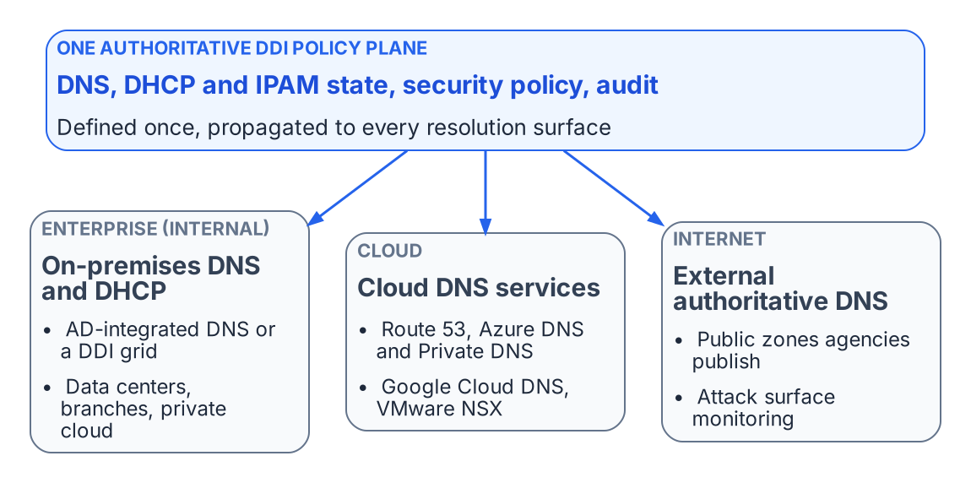
One authoritative policy plane governs the enterprise, cloud and internet DNS perspectives.
A unified DDI policy plane manages DNS from three interconnected perspectives:
- Enterprise (internal): AD-integrated DNS or an on-premises DDI grid, DNS views, high availability and anycast, and role-based administration for data centers, branches and private clouds.
- Cloud: Amazon Route 53, Azure DNS and Azure Private DNS, and Google Cloud DNS, with discovery of cloud networks and federation with cloud IPAM.
- Internet (external authoritative): the public zones the agency publishes, whether self-hosted or on a managed authoritative service, together with monitoring of the external attack surface.
The typical agency landscape spans on-premises AD DNS or a DDI grid; Route 53 public and private hosted zones with Route 53 Resolver; Azure Private DNS zones with Azure DNS Private Resolver; Google Cloud DNS private zones and DNS peering; and the VMware NSX DNS service. Each has its own console, API and failure modes. Managed separately, they create a combinatorial synchronization burden. A single new Azure private endpoint can require changes to an Azure Private DNS zone, Private Resolver forwarding rulesets, Route 53 outbound rules and on-premises conditional forwarders.

Hybrid Cloud IPAM and DHCP
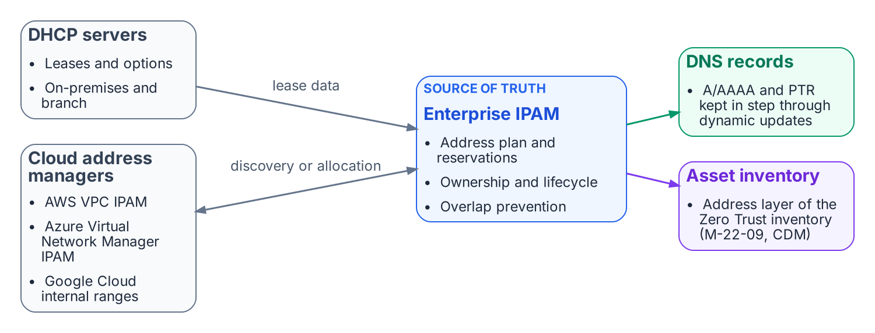
Enterprise IPAM is the address-layer source of truth for DHCP, cloud address managers, DNS records and the asset inventory.
A central IPAM is the authoritative record of the address plan, reservations and ownership across on-premises and cloud address space, and it is what prevents overlaps. DHCP lease data and dynamic DNS updates keep address and name records in step through each record’s lifecycle. Existing Microsoft DHCP servers can be discovered and brought under the same inventory during transition. This is also the address layer of the continuous asset inventory that Zero Trust architectures depend on.

What this chapter establishes
- DNS now carries private endpoint publication, SaaS front-door selection, security policy and service identity, so it has to be governed as a control plane, not run as a utility.
- Several independent DNS platforms (as many as five) with no shared state make split-brain structural.
- The answer is one authoritative DDI policy plane, with five configuration decisions carrying most of the risk.

Previous: Applicability
Next: Chapter 02 — Split-Brain DNS: The Structural Problem

Chapter 02 — Split-Brain DNS: The Structural Problem
Same name, different answers — and why process discipline cannot fix it.
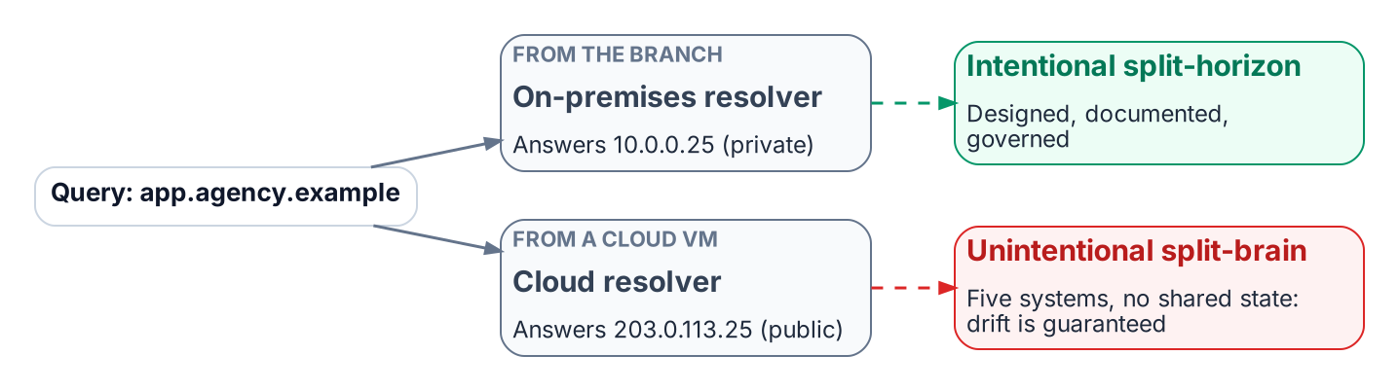
The same query returns different answers depending on where it originates.
Split-brain DNS is the condition in which a query for the same name returns different answers depending on where the query originates. Intentional split-horizon DNS (an internal private address and an external public address for the same name) is common and legitimate when it is designed, documented and governed. Unintentional split-brain is close to guaranteed when several independent DNS systems hold copies of the same names with no shared state: each copy drifts on its own schedule, and no single team can see the whole.

Private IP Split-Brain: The Cross-Cloud Case
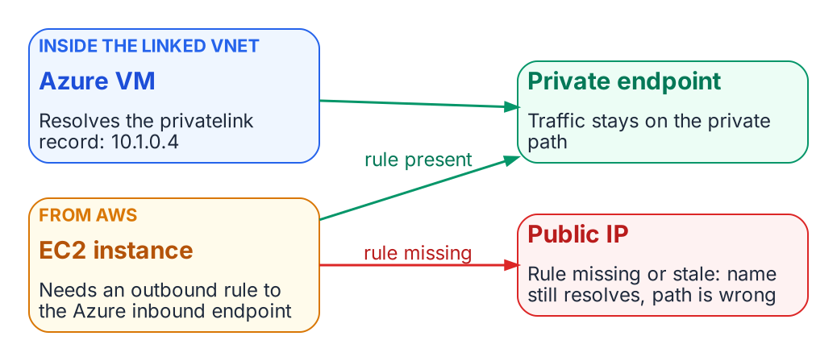
A missing or stale forwarding rule sends a cross-cloud client to the public address.
When an Azure Storage account uses a private endpoint, Azure publishes a record in the matching privatelink zone that resolves the service FQDN to an address in the virtual network (for example 10.1.0.4). Inside a VNet linked to that Private DNS zone, the query returns the private address and traffic stays private. An EC2 instance in AWS sees that answer only if a Route 53 Resolver outbound rule forwards the zone to an Azure DNS Private Resolver inbound endpoint, or to an agency resolver that does. If that rule is missing or stale, the name still resolves, but to the public address. Traffic then either leaves the private path, around the controls on it, or is refused by the service’s network rules. Because the name resolves successfully, the failure is invisible without query logging and flow analysis.

Security Policy Split-Brain
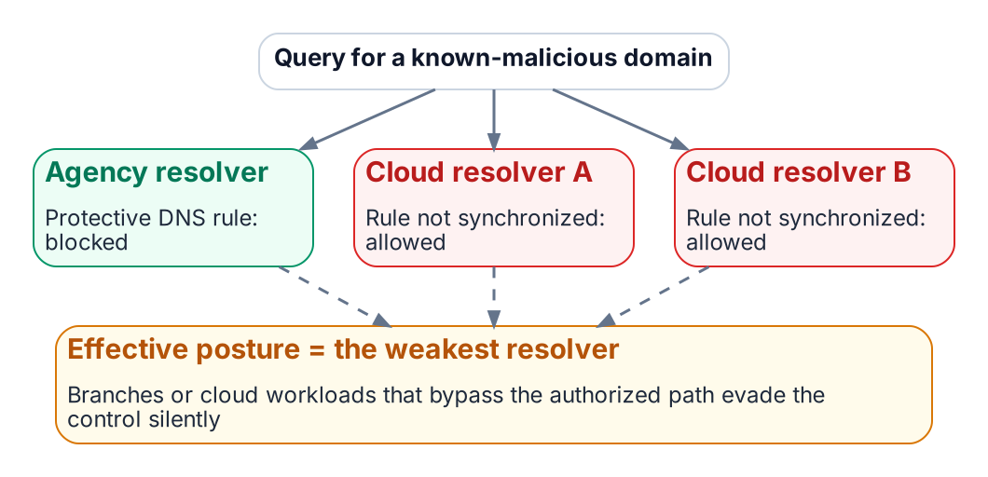
Security policy that is not synchronized is only as strong as the weakest resolver.
DNS security policy (response policy zones, DNS firewall rules, Protective DNS block lists) is enforced only at the resolver that answers the query. A domain blocked at the agency resolver may still be answered by Route 53 Resolver, Azure DNS or Google Cloud DNS if the equivalent rule there (Route 53 Resolver DNS Firewall, Azure DNS security policy, Cloud DNS response policies) was never created or has drifted. The effective posture is that of the weakest resolver a client can reach. The same gap appears in the federal requirements: OMB M-22-09 expects agency DNS traffic to use encrypted DNS and to pass through CISA-operated Protective DNS infrastructure, so branches or cloud workloads that bypass the authorized resolver path also bypass those controls without anyone noticing.
Public SaaS endpoint split-brain follows the same pattern. Microsoft 365 GCC High and DoD use their own endpoint lists and namespaces, which must resolve correctly from every resolver. GCC-Moderate uses the Worldwide endpoint list, so the risk there is not a “wrong cloud” answer but resolution-path consistency and front-door selection. A client using DNS over HTTPS to a public resolver can change the answer again.

Problems of Not Using Modern Enterprise-Grade DDI
Organizations that rely on fragmented or do-it-yourself DDI accumulate configuration drift, stale and dangling records, overlapping address space and siloed administration. Each is an operational risk and an audit finding waiting to happen. A vendor-commissioned survey reports that respondents without enterprise-grade DDI saw more frequent outages of cloud-hosted applications and slower outage response; treat such figures as directional rather than as a benchmark.
Without a unified DDI plane, agencies struggle to show the consistent policy, audit trail and asset inventory that FedRAMP continuous monitoring, NIST SP 800-81r3, CISA Protective DNS and Zero Trust reporting all ask for. For secure access service edge (SASE) and Zero Trust, DNS is the first trust decision: it chooses the destination before TLS, single sign-on or any application policy can act. Fragmented DNS undermines consistent filtering, encrypted DNS policy and threat blocking.

What this chapter establishes
- Intentional split-horizon is legitimate; unintentional split-brain is drift between systems with no shared state.
- Split-brain breaks private connectivity and security policy silently, because the name still resolves.
- The effective security posture is that of the weakest resolver a client can reach.

Previous: Chapter 01 — DNS Is Now the Control Plane
Next: Chapter 03 — Federal Requirements: NIST SP 800-81 Rev. 3, FedRAMP and Zero Trust

Chapter 03 — Federal Requirements: NIST SP 800-81 Rev. 3, FedRAMP and Zero Trust
What the federal mandates actually require of the name layer.
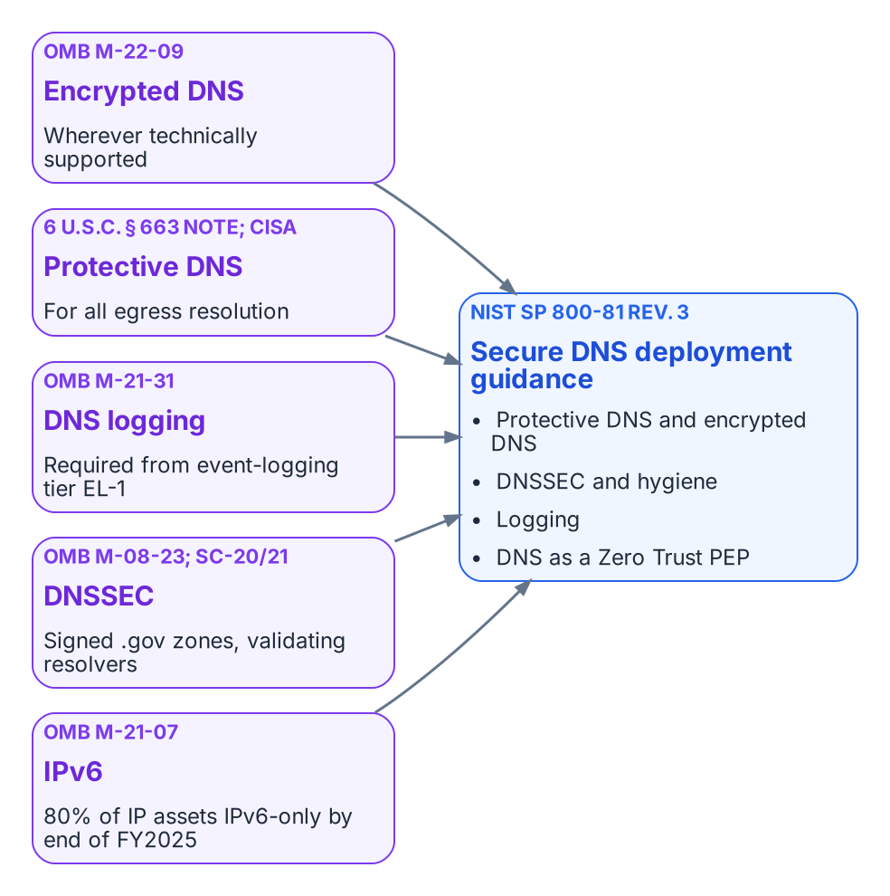
The federal drivers that land on the name layer.

What the Mandates Say
The federal requirements on DNS are specific, and it is worth quoting them rather than paraphrasing them into something stronger.
- OMB M-22-09 (Zero Trust strategy). “Agencies must resolve DNS queries using encrypted DNS wherever it is technically supported.” The memorandum also notes that agencies “are already required to have DNS requests routed through CISA-operated infrastructure.”
- CISA Encrypted DNS Implementation Guidance (May 2024). Explains how Federal Civilian Executive Branch agencies meet the M-22-09 requirement while keeping Protective DNS for egress resolution, sets out phased implementation, and names the protocols in scope: DNS over HTTPS (DoH), DNS over TLS (DoT) and DNS over QUIC (DoQ).
- OMB M-21-31 (event logging). DNS request logs are among the logs required from the first event-logging maturity tier, EL-1.
- OMB M-08-23 (August 2008). Required agencies to deploy DNSSEC on federal information systems by December 2009; SP 800-53 controls SC-20 and SC-21 carry the signing and validating-resolver requirements into every system baseline.
- OMB M-21-07 (IPv6). Sets targets for IP-enabled assets on federal networks to be IPv6-only: at least 20% by the end of FY2023, 50% by the end of FY2024 and 80% by the end of FY2025. DDI is where dual-stack and IPv6-only address and name management actually happens (Chapter 07).
None of these mandates names a product. Read together, they require resolvers the agency controls that log every query, encrypt client-to-resolver traffic wherever the client supports it, forward egress resolution through Protective DNS, and validate DNSSEC. At enterprise scale that means centralized policy and logging combined with local or edge delivery, so that roaming and branch traffic cannot slip past the controls.

NIST SP 800-81 Rev. 3: Secure DNS Deployment Guide
NIST published SP 800-81r3, Secure Domain Name System (DNS) Deployment Guide, on March 19, 2026. It supersedes SP 800-81-2 (2013), and its authors include engineers from Infoblox as well as NIST. It treats DNS as critical infrastructure and as an active security control. Its core recommendations are to use Protective DNS, encrypt DNS traffic (DoT, DoH or DoQ) wherever feasible, deploy DNSSEC, maintain DNS hygiene (no lame delegations, dangling CNAMEs or stale records), log comprehensively, and position DNS as a policy enforcement point within a Zero Trust architecture aligned with SP 800-207.
SP 800-81r3 is guidance, not a mandate in its own right. It is the practical companion to the requirements above, and to the DNS-related controls in SP 800-53 (notably SC-20, SC-21 and SC-22 for the name and address resolution architecture) that FedRAMP baselines inherit.

FedRAMP Moderate and Agency Authorization
FedRAMP authorizes cloud services, not architectures. If the policy plane is delivered as a cloud service, that service needs an authorization at the impact level of the systems it supports, and the agency still issues its own ATO for its use of it. The resolvers, appliances and agents running in agency data centers, branches and cloud tenants remain inside the agency’s own authorization boundary.
As one example, Infoblox Government Cloud, which runs in AWS GovCloud (US), has been FedRAMP Moderate authorized since December 2022 (package FR2017257053). In July 2026 the company announced that Universal DDI management, NIOS-X servers and Universal Asset Insights had been added to that authorized offering. A Moderate authorization does not cover High or DoD impact levels; agencies operating there must confirm whether a separate authorization or an agency-specific ATO is required. The Applicability page sets out these boundaries for each Microsoft and federal cloud environment.

Control Mapping for NIST SP 800-53, FedRAMP and CISA Zero Trust
The following table maps the core capabilities of a unified DDI plane to representative SP 800-53 controls. It is illustrative, not exhaustive; agencies should validate it against their own authorization boundary and continuous monitoring strategy.
Capability | Primary controls supported | Evidence / notes
Protective DNS / response policy zones | SC-7, SI-3, SI-4, AC-4 | Query logs, policy hit rates, block events; alignment with CISA Protective DNS
Encrypted DNS (DoT, DoH, DoQ) | SC-8, SC-13, SC-17 | Resolver certificate management and protocol configuration; supports M-22-09
Name and address resolution architecture | SC-22 | Redundant, role-separated internal and external resolvers
IPAM inventory and discovery | CM-8, CM-6, SI-4 | Asset inventory reports, discovery logs, address space consistency
Audit trails and role-based administration | AU-2, AU-6, AC-2, AC-3, AC-6 | Change logs, role assignments, policy modification history
DNSSEC and zone integrity | SC-20, SC-21, SI-7 | Key management, validation status, zone signing evidence

What this chapter establishes
- M-22-09, M-21-31, M-08-23, M-21-07 and CISA guidance together require agency-controlled, logging, encrypting, validating resolvers that forward egress through Protective DNS.
- SP 800-81r3 is the practical guide to meeting them; it is guidance, not a mandate.
- FedRAMP authorizes the cloud service, not the architecture, and a Moderate authorization does not cover High or DoD.

Previous: Chapter 02 — Split-Brain DNS: The Structural Problem
Next: Chapter 04 — The Active Directory DNS Departure

Chapter 04 — The Active Directory DNS Departure
What AD-integrated DNS does today, and what must be reprovisioned before it leaves.
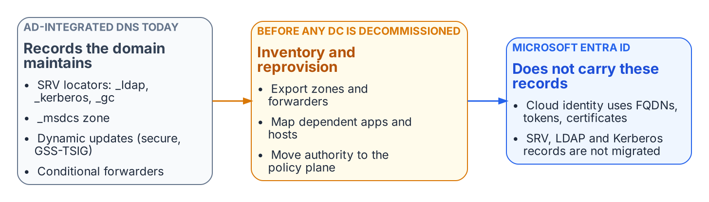
Records the domain maintains today must be inventoried and reprovisioned before any domain controller is decommissioned.
Active Directory has been the hidden DNS substrate of on-premises federal networks for twenty years. Domain controllers register SRV locator records (for LDAP, Kerberos and the global catalog) and the _msdcs zone; domain-joined hosts register their own records through secure dynamic updates; and AD-integrated zones quietly carry conditional forwarders that other systems depend on. None of this migrates when workloads move to Microsoft Entra ID. Entra ID is a cloud identity service: it consumes FQDNs, but it does not host the agency’s zones, and it does not publish the SRV records that remaining domain-joined systems need to find a domain controller.
Departing AD DNS is therefore an inventory problem before it is a migration problem. Every zone, forwarder, SRV record and dynamic-update client must be found, mapped to the systems that depend on it, and reprovisioned under the policy plane before the first domain controller is retired (Chapter 09). DDI platforms commonly provide a coexistence mode for this: they synchronize with Microsoft DNS and DHCP in both directions, preserve domain controller SRV resolution and GSS-TSIG secure updates, and let authority move zone by zone. Decoupling DNS from the identity platform also removes a dependency: an identity outage no longer takes name resolution with it, and the reverse.

Implications for Modern Microsoft SQL Server
SQL Server deployments continue to shift from Kerberos and SPN-based authentication toward Entra ID authentication, token-based access, managed identities and certificate-based patterns. The SQL Server modernization narrative covers that shift; its DNS consequences are these:
- Kerberos SPNs and the SRV records behind them remain necessary for remaining domain-joined and hybrid instances, and must be inventoried before any AD DNS decommissioning.
- Token audiences, certificate SANs and connection strings all use FQDNs. Split-brain that sends a client to the wrong endpoint produces TLS or authentication failures that look like identity or certificate problems.
- Private connectivity to Azure SQL Database, Azure SQL Managed Instance or equivalent services depends on the private DNS records being visible from every client location (Chapter 07).
- OCSP and CRL endpoints used by the authentication stack must resolve reliably from every origin (Chapter 08, Decision 5).
The net effect is that the name layer must be at least as reliable and consistent as the identity layer it now supports.

What this chapter establishes
- AD-integrated DNS carries SRV locators, the _msdcs zone, secure dynamic updates and forwarders that Entra ID does not replace.
- Leaving AD DNS is an inventory problem first: nothing is retired until its dependents are reprovisioned.
- For SQL Server and every token-based service, the name layer must be as reliable as the identity layer.

Previous: Chapter 03 — Federal Requirements: NIST SP 800-81 Rev. 3, FedRAMP and Zero Trust
Next: Chapter 05 — Edge Interception, Encrypted DNS and Rogue DHCP

Chapter 05 — Edge Interception, Encrypted DNS and Rogue DHCP
Where queries escape the governed resolver path.

SD-WAN DNS Interception
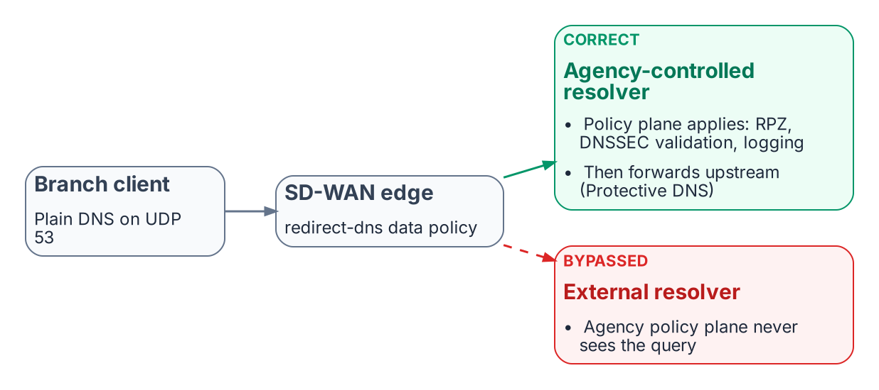
The redirect-dns destination decides whether agency policy applies at all.
SD-WAN edges can intercept DNS regardless of the resolver a client was configured with. In Cisco Catalyst SD-WAN this is the redirect-dns action of a centralized data policy: the edge router matches DNS traffic and sends it to a policy-designated resolver. Cisco documents the feature for IPv4 DNS over UDP only; DNS over TCP and DNS carried inside overlay tunnels are not redirected. The destination decides whether agency policy applies:
- Correct path: branch client → SD-WAN edge → network-addressable agency-controlled resolver → DDI policy plane (response policy zones, DNSSEC validation, logging) → per-cloud private resolvers, with internet-bound recursion forwarded through Protective DNS.
- Bypassed path: branch client → SD-WAN edge → an external resolver outside agency control → public recursion. The agency policy plane never sees those queries.
DNSSEC validation must happen on a resolver the agency controls. A forwarding resolver can validate if it requests and checks DNSSEC records, but if redirect-dns or conditional forwarding hands queries to an upstream resolver outside agency control, the agency loses control of its validation policy and trust anchors (Chapter 06).

Microsoft 365 informed network routing
Microsoft 365 informed network routing (INR) lets a supported SD-WAN share network-quality data with Microsoft so that Microsoft 365 traffic takes the best path; the Cisco integration requires Cisco IOS XE SD-WAN 20.4 / 17.4 or later. Microsoft documents INR as available only for the Worldwide commercial cloud; it is not supported in the GCC-Moderate, GCC High, DoD, Germany or China clouds. For agencies in those clouds, local internet breakout and application-aware routing remain the main Microsoft 365 optimizations. None of this changes the DDI design: INR is a routing optimization, not a DNS dependency.

Encrypted DNS and Bypass Controls
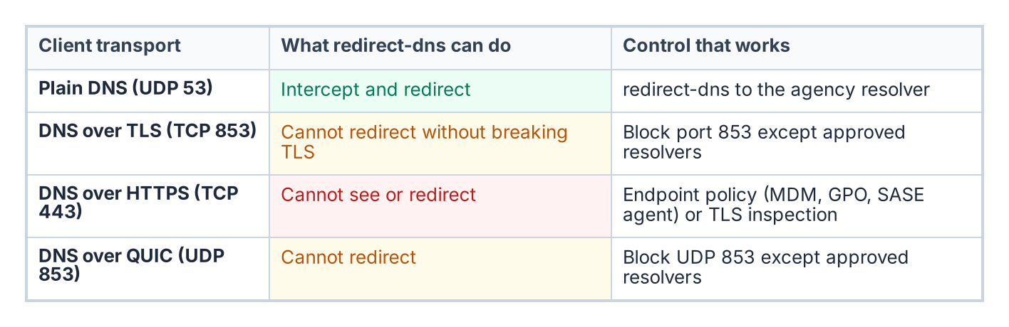
What an edge can and cannot do with each DNS transport.
Client-side encrypted DNS to a public resolver is the most common bypass. M-22-09 requires encrypted DNS wherever it is technically supported, and CISA’s implementation guidance requires that agency egress resolution still pass through Protective DNS. The goal is therefore not to prohibit encrypted DNS but to make sure it terminates at an agency-controlled or CISA Protective DNS resolver rather than an ungoverned public service. Practical controls:
- Know what the edge can reach. redirect-dns works on plain DNS only. It cannot redirect DNS over TLS (TCP 853) or DNS over QUIC (UDP 853) without breaking the session, because the client validates the resolver’s certificate; those ports can be blocked except to approved resolvers. DNS over HTTPS runs on TCP 443 alongside ordinary web traffic, so neither redirect-dns nor port blocking can isolate it.
- Control the endpoint. MDM, Group Policy or a SASE or DDI endpoint agent should point clients’ encrypted DNS at the governed resolver, and disable or restrict browser-level DoH. Windows supports configuring DoH to a named resolver.
- Block known public encrypted DNS endpoints at the network edge, with exceptions only for approved resolvers.
- Alert on resolution-path anomalies, such as connections from hosts whose queries never appear in the governed resolver logs.

DHCP Option 6 and Rogue DHCP
A rogue DHCP server that hands out a malicious resolver in option 6 can move an entire subnet onto an attacker-controlled resolver in one step, past every response policy zone and Protective DNS control. In IPv6 networks, rogue router advertisements carrying the RDNSS option (RFC 8106) can do the same and are often the larger attack surface. Unified DHCP and IPv6 governance addresses this through:
- Centralized scope and option management with change control and an audit trail.
- Rogue DHCP and router advertisement detection, through DHCP snooping and RA Guard on the access switches, lease analysis and network discovery.
- Consistent option 6 and RDNSS values across every authorized DHCP server and router.
- IPAM integration, so unauthorized leases are visible immediately.

What this chapter establishes
- The redirect-dns destination decides whether agency policy applies at all, and redirect-dns only handles IPv4 DNS over UDP.
- Encrypted DNS must terminate at an agency-controlled or Protective DNS resolver; DoH can be governed only at the endpoint.
- Rogue DHCP and rogue router advertisements can move a whole subnet to an attacker resolver in one step.

Previous: Chapter 04 — The Active Directory DNS Departure
Next: Chapter 06 — DNS Identity, Certificates and DNSSEC

Chapter 06 — DNS Identity, Certificates and DNSSEC
The name layer as the first link in the trust chain.

DNS Identity as the Foundation for Certificates, Application-Aware Networking and Tokens
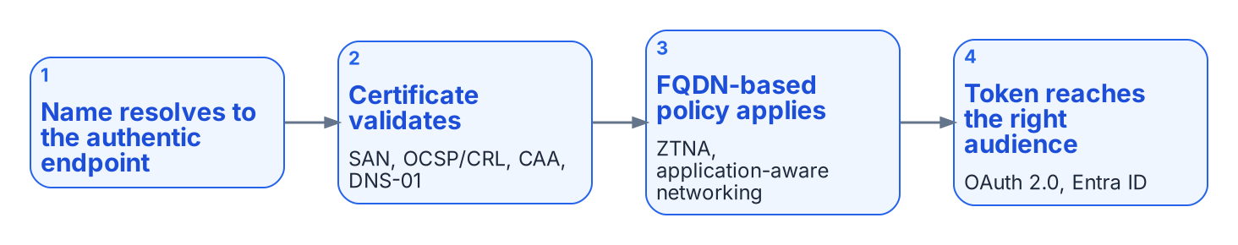
DNS identity is the first link in the trust chain.
DNS identity, meaning the authoritative mapping of names to addresses, owners and lifecycle, is a prerequisite for certificate-based security, application-aware networking and token-based controls.
- Certificate issuance. ACME DNS-01 challenges, used by public and private certificate authorities, require the ability to create and remove TXT records under controlled, auditable authority. An enterprise DDI API makes automated issuance and renewal possible without exposing web servers. CAA records limit which authorities may issue for a name.
- Certificate pinning. DNSSEC provides integrity and authenticity for DNS data, which is what makes DANE and TLSA records usable for binding certificates to names independently of the public PKI.
- Encrypted DNS. DoT, DoH and DoQ resolvers present certificates of their own, which must be issued, rotated and monitored like any other server certificate.
- Application-aware networking and zero trust network access (ZTNA). These depend on reliable FQDN-based policy (“allow this group to this application FQDN”) rather than brittle IP rules. Wildcard namespaces (*.api.agency.gov) define the application surface.
- Tokens. OAuth 2.0, JWTs and Microsoft Entra ID operate after the connection is made. DNS decides whether the client reaches the authentic endpoint that issues or validates the token, and Protective DNS helps keep tokens from being sent to malicious destinations.
DNS identity is the first link in the chain that makes certificate, application and token controls meaningful. Under split-brain, certificate validation failures, access denials and policy gaps become symptoms that are harder to diagnose than classic Kerberos failures.

DNSSEC
DNSSEC (DNS Security Extensions) adds data-origin authentication and integrity protection to DNS. It does not encrypt queries; it lets a resolver verify that the answer it received is authentic and was not modified in transit. It provides:
- Data-origin authentication: the answer came from the legitimate authoritative servers for the zone.
- Integrity protection: the data has not been altered.
- Authenticated denial of existence: proof that a name or record type does not exist.
DNSSEC uses a chain of trust from the DNS root through the top-level domains to individual zones. Zones are signed with private keys; resolvers validate the signatures with the matching public keys (DNSKEY records) and the Delegation Signer (DS) records published in the parent zone.

Why It Matters in Hybrid Multi-Cloud and Federal Environments
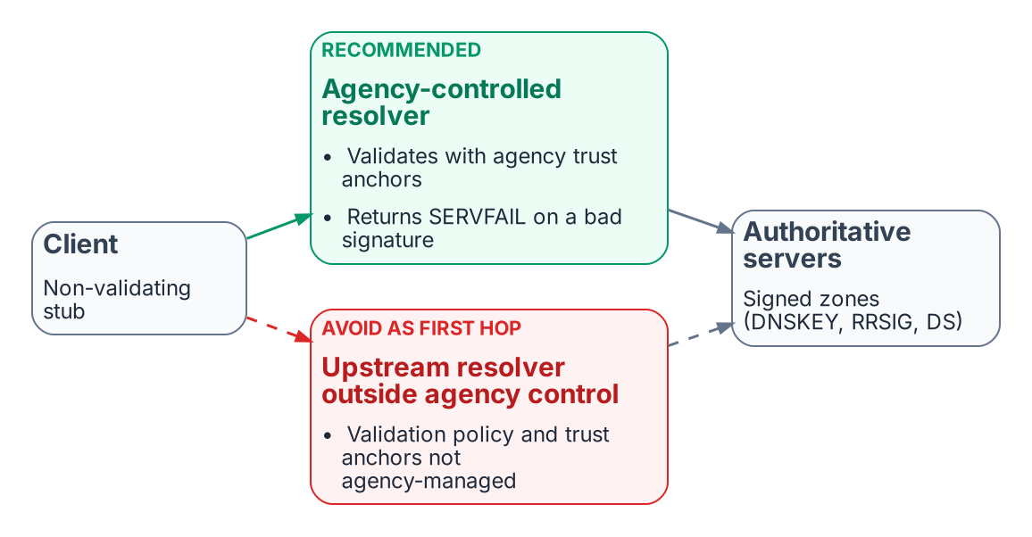
Validation belongs on a resolver the agency controls.
- DNSSEC mitigates cache poisoning and on-path tampering with DNS answers.
- It is the foundation for DANE and TLSA records.
- OMB M-08-23 required DNSSEC for federal systems, SP 800-53 controls SC-20 and SC-21 require signing and validation, and NIST SP 800-81r3 recommends deploying it.
- Validation must occur on a resolver the agency controls (Chapter 05). If redirect-dns or forwarding sends queries to an upstream resolver that validates outside agency control, the agency cannot enforce its own validation policy.

Operational Considerations
- Key management (KSK and ZSK rollover) must be automated and audited.
- Signing increases response sizes, so EDNS(0) and correct MTU and fragmentation handling are required.
- DNSSEC support differs across cloud DNS services (see below); a unified DDI plane makes consistent signing and validation policy achievable.
- DNSSEC protects integrity, not confidentiality. Encrypted DNS and Protective DNS remain complementary controls.
Inconsistent DNSSEC deployment across views (signed in one, unsigned or differently signed in another) produces validation failures that surface as application or certificate errors rather than clear DNSSEC errors. A single policy plane removes most of that class of inconsistency.

DNSSEC Across Azure, AWS and Other Cloud Providers
Signing and validation policy should be orchestrated from the central DDI plane, so that key rollover, DS publication and validation behavior do not diverge between environments. The cloud services do not offer equal support, and the gaps matter:
- Azure. Azure DNS supports DNSSEC signing for public zones only, with zone-signing key rollover handled automatically. Azure Private DNS zones cannot be signed, and the Azure-provided recursive resolver does not perform DNSSEC validation. Workloads that need validation must use a validating resolver the agency controls. Entra ID consumes FQDNs but does nothing for DNSSEC or private endpoint DNS.
- AWS. Route 53 supports DNSSEC signing for public hosted zones, not private hosted zones. Route 53 Resolver can validate DNSSEC responses when validation is enabled for a VPC.
- Everywhere. Zones that must be signed are signed by the DDI platform, or by the cloud DNS service under DDI control, with rollover automated in one place. Validation happens on resolvers the agency controls, and redirect-dns and cloud forwarding point at those resolvers.

What this chapter establishes
- DNS identity is the first link in the trust chain for certificates, FQDN-based policy and tokens.
- DNSSEC validation belongs on a resolver the agency controls.
- Cloud DNSSEC support is uneven (Azure Private DNS cannot be signed; Route 53 signs public zones only), so signing and validation policy must be set centrally.

Previous: Chapter 05 — Edge Interception, Encrypted DNS and Rogue DHCP
Next: Chapter 07 — Cloud Private Endpoints, SDN and IPAM Consistency

Chapter 07 — Cloud Private Endpoints, SDN and IPAM Consistency
Keeping names and addresses consistent across Azure, AWS, Google Cloud and VMware.

Azure DNS and Private Endpoints
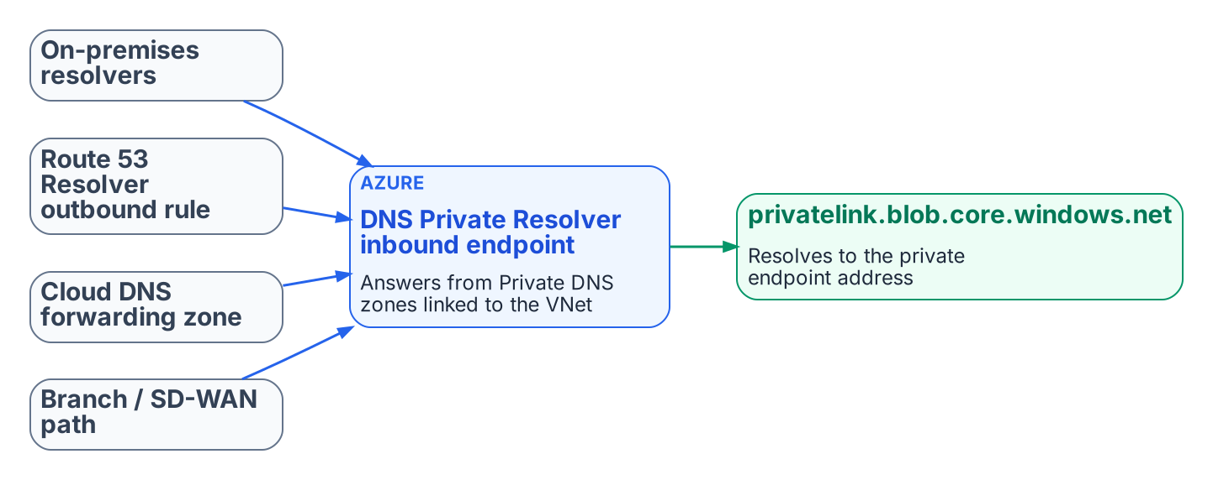
Every origin forwards the privatelink zone to one resolution point.
Azure private endpoints are the most common source of private-IP split-brain in hybrid environments. Getting them right takes deliberate DNS design rather than reliance on Azure’s default public resolution.

Core Behavior
When a private endpoint is created with DNS integration, Azure records the service’s address in a privatelink Private DNS zone (for example privatelink.blob.core.windows.net or privatelink.database.windows.net), and the public name gains a CNAME into that zone. A query resolves to the private address only if it reaches a resolver that can see the zone: the Azure-provided resolver in a VNet linked to the zone, or an Azure DNS Private Resolver inbound endpoint (or another resolver forwarding to one). Queries that fall through to public recursion get the public address instead. Private Resolver inbound and outbound endpoints each need their own dedicated subnet in the VNet.

Recommended Pattern with a Unified Control Plane
- Make the DDI policy plane the system of record for the private namespaces and their forwarding rules.
- Configure conditional forwarding so that on-premises resolvers, Route 53 Resolver outbound endpoints, Google Cloud DNS forwarding zones and branch SD-WAN paths all send the relevant privatelink zones to the Azure DNS Private Resolver inbound endpoint, or to an agency resolver that forwards there.
- Link the Private DNS zones to the VNets that must resolve the private endpoints natively.
- Validate end to end, from every major origin (on-premises, AWS, Google Cloud, branches), that the FQDN returns the private address and that traffic stays on the private path.
- Monitor for resolution-path anomalies, so that a missing or stale forwarding rule is found before it causes a silent fallback to the public path.
DDI platforms that synchronize records with Azure DNS each have documented limits on which record types, routing policies and zone records they synchronize. Review the current vendor documentation before relying on synchronization for a given zone; selective zone ownership or forwarding may be the better choice for edge cases.

SDN–IPAM Consistency Across Cloud Providers and VMware
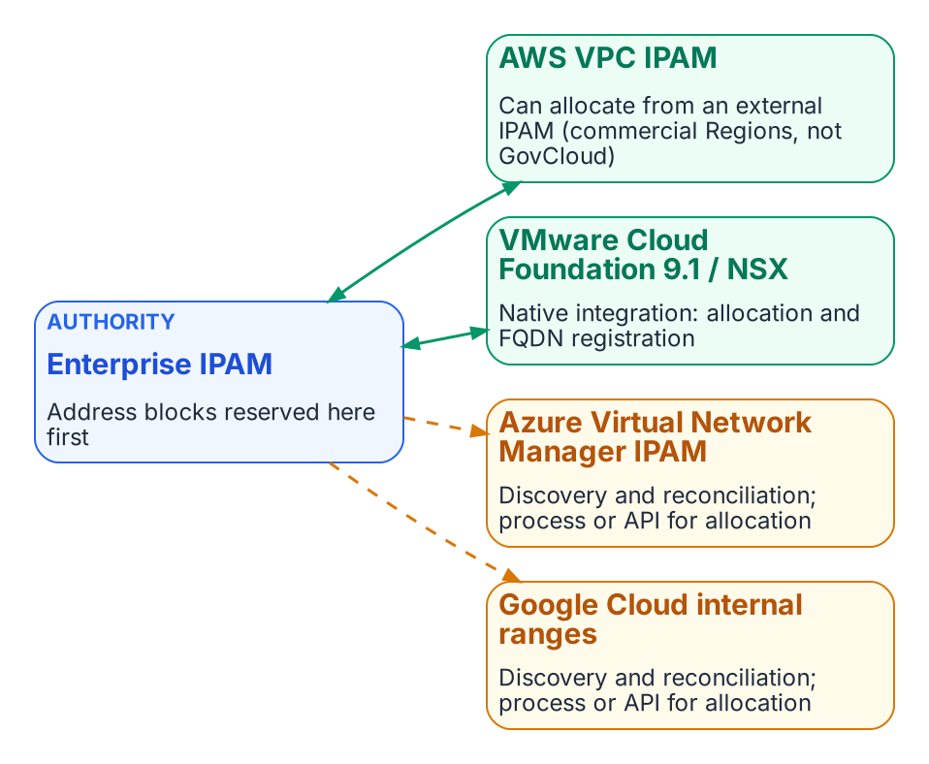
Enterprise IPAM is the authority; integration depth differs by platform.
Each cloud provider, and VMware, has its own software-defined networking constructs and native address management. Unintegrated, they allocate address space independently of the enterprise DDI plane, recreating for addresses the same divergence that split-brain DNS creates for names.

The Consistency Problem
AWS VPCs, Azure VNets, Google Cloud VPCs and VMware NSX segments each have their own address pools and allocation logic. When cloud teams create networks directly in a provider console or in VCF Automation, the resulting CIDRs can overlap with on-premises space, with other clouds or with other divisions, and the enterprise DDI system does not know until discovery runs or a conflict appears. DNS shows the same pattern: private zones and records are created inside the provider or NSX with no synchronized policy or inventory in the central policy plane.

AWS VPC IPAM Integration
Amazon VPC IPAM can use an external IPAM as its source of address space. Since November 2025 it has integrated with Infoblox Universal IPAM: cloud teams request address space through the AWS console, CLI or SDK, the external IPAM checks uniqueness and returns a conflict-free CIDR, and VPC IPAM organizes it into regional pools. The integration applies to private scopes and is not available in the AWS GovCloud (US) or China Regions, so it does not help a GovCloud estate today.

Azure and Google Cloud
Azure Virtual Network Manager has its own IPAM pools for non-overlapping CIDR assignment inside Azure, and Google Cloud has internal ranges for reserving and protecting address space in a VPC. DDI discovery and cloud federation bring these networks, subnets and their DNS zones into the central inventory, so that overlaps and policy gaps become visible. Neither offers an equivalent of the AWS external-IPAM pattern today. On Azure and Google Cloud the main controls are discovery, inventory reconciliation and DNS-side policy, and address-block governance still needs an explicit process or API integration.

VMware Cloud Foundation and NSX
VMware Cloud Foundation 9.1 added native integration between NSX and Infoblox DDI. NSX imports Infoblox network containers as external IP address blocks. When vCenter administrators or VCF Automation tenants provision networks or workloads, subnets and addresses are drawn from those blocks and FQDN records can be registered automatically. The enterprise IPAM thus stays the source of truth for both physical and NSX address space while cloud teams keep self-service. Confirm the current scope of the integration, including IPv6 support and certificate requirements, against VMware and Infoblox documentation before relying on it.

Operational Implications
- Treat the enterprise IPAM as the authoritative source for address blocks used across on-premises, cloud and VMware environments.
- Where native integration exists (AWS VPC IPAM in commercial Regions, VCF 9.1 and NSX), enable it so that cloud and VCF tenants allocate from the central authority rather than inventing CIDRs.
- Where only discovery is available (Azure, Google Cloud, and AWS GovCloud), run continuous discovery and reconciliation, and require address blocks to be reserved in the enterprise IPAM before cloud or NSX networks are created.
- Pair address consistency with DNS consistency: private zones and records created in cloud or NSX DNS services must be synchronized or conditionally forwarded, so that resolution matches the address that was allocated.
- Monitor synchronization health. Integration reduces independent authoring but adds a failure mode if the central IPAM is unreachable or sync lag allows a conflicting allocation.
SDN–IPAM consistency is the address-layer counterpart to split-brain DNS. A single authoritative DDI plane that federates with cloud and VMware networking prevents the overlaps and inventory gaps that otherwise surface only when connectivity fails or an audit finds undocumented address space.

IPv6 Lifecycle and Dual-Stack Considerations
OMB M-21-07 sets IPv6-only targets for IP-enabled assets on federal networks: 20% by the end of FY2023, 50% by the end of FY2024 and 80% by the end of FY2025. A unified DDI plane supports dual-stack and IPv6-only operation through:
- Unified IPv4 and IPv6 address planning and allocation, to prevent overlaps.
- DHCPv6, router advertisement governance and dynamic DNS with consistent lifecycle management for both protocols.
- DNS views and conditional forwarding that handle dual-stack resolution paths correctly, including AAAA records for private endpoints where the cloud service supports them.
- Hygiene and discovery that surface dual-stack assets for inventory and Zero Trust policy.
Split-brain risk rises in dual-stack environments when IPv4 and IPv6 resolution paths are managed separately; a single policy plane reduces it.

What this chapter establishes
- Every origin must forward privatelink zones to one resolution point, or private endpoints fall back silently to public addresses.
- The enterprise IPAM is the authority for address blocks; integration depth differs by platform and is absent in GovCloud.
- Address consistency and name consistency are the same problem and need the same policy plane.

Previous: Chapter 06 — DNS Identity, Certificates and DNSSEC
Next: Chapter 08 — Reference Architecture and the Five Critical Decisions

Chapter 08 — Reference Architecture and the Five Critical Decisions
One authoritative policy plane, and the decisions that carry the operational risk.

The End-to-End Resolution Flow and Five Decisions
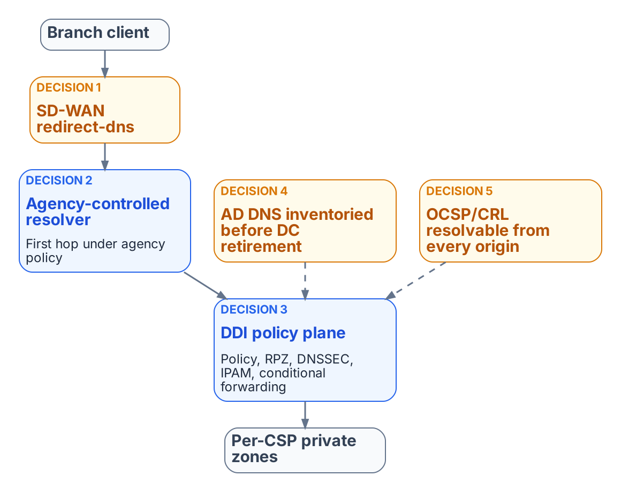
Reference architecture: a single authoritative DDI policy plane and the five decisions.
The end-to-end resolution flow runs from the SD-WAN branch edge, through a network-addressable agency-controlled resolver, into the DDI policy plane (policy, response policy zones, DNSSEC, IPAM) and on to per-cloud private zones and authoritative services. Internet-bound recursion leaves through CISA Protective DNS. Five decisions carry almost all of the operational risk:
- Decision 1 — the redirect-dns destination. It must be a network-addressable resolver under agency control (a DDI resolver or forwarding proxy at the branch or in a regional hub), never a client-side loopback stub such as an endpoint agent listening on 127.0.0.1, which the edge cannot reach.
- Decision 2 — forwarding chain order. Any additional resolver, such as a SASE provider’s DNS service, must be a forwarding target of the agency-controlled resolver, never the redirect-dns target. The agency resolver is always the first hop under agency policy control.
- Decision 3 — per-cloud conditional forwarding. The policy plane holds the authoritative forwarding rules for every private namespace (Chapter 07).
- Decision 4 — AD DNS inventory before retirement. SRV records, conditional forwarders and namespace delegations are inventoried and reprovisioned before any domain controller is decommissioned (Chapter 04).
- Decision 5 — OCSP and CRL reachability from every origin. PKI validation endpoints must resolve consistently from on-premises, every cloud and every branch (Chapter 06).

Moving from Per-Cloud Local Syncs to a Unified Control Plane
Agencies that already copy DNS records into each cloud provider should change the operating model from “author copies in every silo” to “one authoritative policy and state plane that the silos consume.”

Target Operating Model
- The DDI policy plane holds the system of record for zones, forwarding rules, IPAM data and security policy.
- Cloud DNS services (Route 53, Azure Private DNS, Google Cloud DNS and others) become synchronized targets or forwarding destinations rather than independently authored sources.
- SD-WAN redirect-dns and other edge interceptors point at network-addressable resolvers inside the governed path.
- AD DNS is inventoried and either coexists during the transition or is migrated; Entra ID does not inherit SRV, LDAP or Kerberos records.

Expected Improvements
- Far less unintentional split-brain for private endpoints and SaaS resolution.
- Faster, safer change: a new private endpoint or application namespace is published once.
- Uniform Protective DNS, logging and, where required, DNSSEC validation for the queries that matter.
- One hybrid inventory instead of islands of address and name data.
- A cleaner AD retirement path and fewer “works in one cloud but not another” incidents.

What this chapter establishes
- The governed path is SD-WAN edge, agency resolver, DDI policy plane, per-cloud private zones, with egress through Protective DNS.
- Five decisions carry almost all of the operational risk.
- Cloud DNS services become consumers of one authoritative state, not independently authored sources.

Previous: Chapter 07 — Cloud Private Endpoints, SDN and IPAM Consistency
Next: Chapter 09 — The Migration Sequence

Chapter 09 — The Migration Sequence
Six phases from AD-integrated DNS/DHCP to a unified policy plane.

Phased Migration and Cutover Sequence
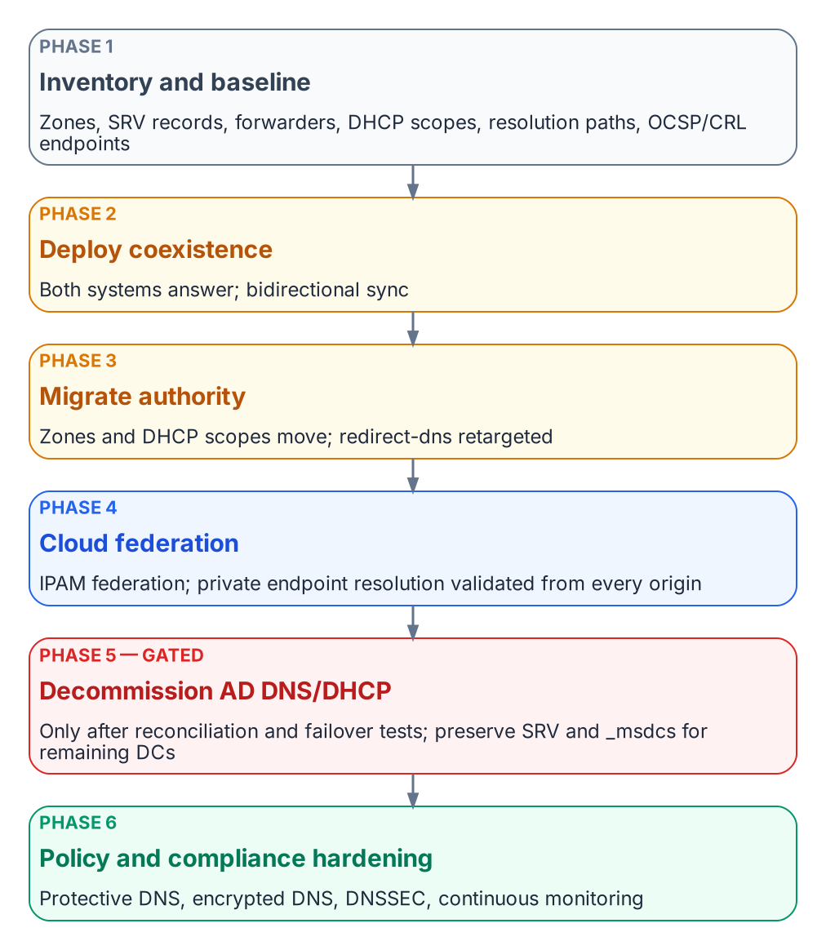
Six-phase migration sequence.
This is the book’s canonical sequence (Inventory → Coexist → Migrate authority → Federate clouds → Decommission AD DNS and DHCP → Harden and evidence), applied to the move from AD-integrated DNS and DHCP plus independent cloud DNS to a unified DDI plane while keeping services running:
- Phase 1 — Inventory and baseline. Export every AD DNS zone, SRV record, conditional forwarder and DHCP scope. Document current resolution paths, including SD-WAN redirect-dns targets, and the OCSP and CRL endpoints in use.
- Phase 2 — Deploy coexistence. Stand up the DDI platform’s resolvers and its Microsoft DNS and DHCP synchronization. Establish conditional forwarding so that both systems can answer during the transition.
- Phase 3 — Migrate authority. Move authoritative zones and DHCP scopes to the DDI platform, zone by zone. Retarget SD-WAN redirect-dns to network-addressable agency resolvers (Chapter 08, Decision 1).
- Phase 4 — Cloud federation. Enable cloud discovery and IPAM federation with AWS, Azure and Google Cloud, and VMware where it applies. Validate private endpoint resolution end to end from every origin.
- Phase 5 — Decommission AD DNS and DHCP. Only after full inventory reconciliation and successful failover testing. Preserve the SRV and _msdcs records that remaining domain controllers and domain-joined systems still need.
- Phase 6 — Policy and compliance hardening. Enable Protective DNS forwarding, encrypted DNS, DNSSEC signing and validation where required, and continuous monitoring dashboards, and assemble the evidence in Chapter 10.
Each phase should end with a rollback point and a resolution-path consistency test (Chapter 11), not with a calendar date.

What this chapter establishes
- The migration runs in six phases: inventory, coexistence, authority, cloud federation, AD DNS decommissioning, hardening.
- AD DNS and DHCP are decommissioned only after reconciliation and failover testing.
- Each phase ends with a rollback point and a consistency test, not a date.

Previous: Chapter 08 — Reference Architecture and the Five Critical Decisions
Next: Chapter 10 — Operating the Control Plane: Delegation, Automation and Evidence

Chapter 10 — Operating the Control Plane: Delegation, Automation and Evidence
Divisional autonomy, ITSM integration, certificate automation and compliance evidence.
A single policy plane only works if the divisions that own their own networks can still operate them. This chapter sets out what the plane must support for delegated administration, automation, ITSM and identity integration, certificate automation and compliance evidence. Where it names products, they illustrate the requirement; equivalent capabilities should be confirmed in current vendor documentation for any platform under evaluation.

Delegated Administration Across Divisions
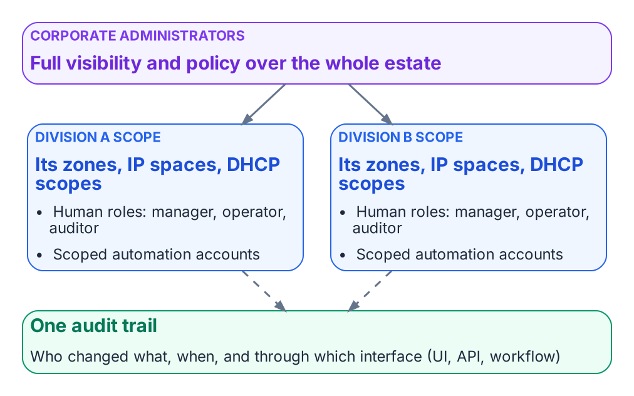
Delegated administration: divisional autonomy, corporate visibility, one audit trail.
The policy plane should let corporate administrators keep full visibility while giving divisional teams scoped autonomy:
- Corporate administrators see and manage the entire estate.
- Each divisional team is assigned a scope that limits it to the zones, IP spaces, address blocks, DHCP scopes and other objects that belong to the division, including zones synchronized from cloud DNS services. Child objects inherit their parent’s scope.
- Predefined roles cover DNS, DHCP and IPAM functions (for example manager, operator and auditor), and custom roles can combine granular create, read, update and delete permissions.
- Divisional users and automation accounts cannot see or change objects outside their scope.
- The result is fewer tickets and faster divisional change, with one authoritative policy plane and a full audit trail for corporate oversight.

Illustrative implementation
Infoblox Universal DDI implements this model as Access Views combined with role-based access control in the Infoblox Portal. Other enterprise DDI platforms provide comparable delegation models under different names.

API and Automation
Every object in the policy plane should be reachable through a documented API, so that infrastructure as code, ITSM workflows, certificate automation and CI pipelines all go through the same authority and the same audit trail:
- API coverage for IPAM, DHCP, DNS configuration and DNS data.
- Non-interactive service accounts for automation, bound by the same role and scope restrictions as human users and unable to log in to the console.
- A migration path for existing automation, so scripts written against the legacy grid keep working while authority moves (some platforms proxy legacy API calls through the new policy plane).
- Supported Terraform and Ansible integrations, so network and cloud teams can manage DDI objects in the same pipelines as the rest of their infrastructure.
Divisions can then automate their own DDI operations through scoped service accounts, while corporate teams keep policy, audit and cross-estate visibility.

ITSM Integration
Integration with the agency’s ITSM platform, commonly ServiceNow, should let change requests, catalog items and incidents drive or draw on authoritative DDI data rather than manual updates:
- Synchronizing networks, IP addresses and devices into the CMDB, and continuously reconciling live network and cloud asset data against CMDB records to find missing, stale or misclassified configuration items.
- Workflow actions to reserve and release IP addresses, register DNS records and manage DDI objects from change and catalog workflows.
- Pushing correlated security events, such as Protective DNS blocks, into incident management.
Enterprise DDI vendors publish their own ServiceNow integrations; confirm which of these functions each one covers.

Certificate Automation (ACME DNS-01)
DDI platforms generally do not provide full certificate lifecycle management. What they provide is the authoritative DNS control that automated issuance and renewal through ACME DNS-01 challenges depends on:
- ACME clients and plug-ins (cert-manager webhooks, Posh-ACME, lego and similar) call the DDI API to create and remove the TXT records that DNS-01 validation needs.
- Issuance and renewal can then be automated without exposing web servers, provided the automation account’s permissions are scoped to the names it serves.
- DNSSEC, CAA records and consistent private endpoint resolution (Chapters 06 and 07) remain prerequisites for trustworthy certificate validation after issuance.
- Certificate inventory, multi-CA orchestration and post-issuance deployment still need a dedicated certificate lifecycle platform or process that uses the DDI policy plane.

Identity Governance Integration
Identity governance platforms such as SailPoint typically reach DDI through APIs rather than packaged connectors: a custom connector or workflow calls the DDI API directly, or the identity platform opens ITSM requests that in turn call DDI workflow actions. This supports joiner, mover and leaver automation for network resources (IP allocation, DNS registration), but expect custom development. Confirm whether a supported connector exists for the platforms in use.

Monitoring, Telemetry and Compliance Evidence
The policy plane should produce the continuous telemetry and audit trail that FedRAMP, NIST and Zero Trust reporting require:
- DNS query logs (source, query name, response, policy action, timestamp) for Protective DNS, M-21-31 logging and incident response, exported to the SIEM and SOAR platforms.
- Response policy and Protective DNS hit data.
- IPAM discovery and inventory reports for CM-8 asset accounting, and continuous discovery data for CMDB reconciliation.
- Configuration change and role audit trails (who changed what, when and through which interface) for AU-2 and AU-6.
- Resolution-path consistency metrics: the percentage of queries answered by the governed resolver.
- Stale record and dangling CNAME rates for hygiene reporting.
These artifacts support the control mapping in Chapter 03, continuous monitoring, FedRAMP evidence packages and Zero Trust maturity assessments.

Sample Evidence Checklist
For a program office or an authorization package:
- Documented redirect-dns targets for every branch, all of them network-addressable agency-controlled resolvers.
- Forwarding chain order verified in the running configuration: the agency-controlled resolver is the redirect-dns target, and any additional resolvers are its forwarding targets.
- AD DNS inventory completed and reconciled before any domain controller is decommissioned.
- OCSP and CRL endpoints resolvable from on-premises, every cloud and every branch.
- Protective DNS and encrypted DNS configuration evidence aligned with M-22-09, CISA guidance and SP 800-81r3.
- IPAM inventory and discovery reports covering the hybrid address space.
- Query logs and policy audit trails retained for continuous monitoring.
- Rogue DHCP and router advertisement detection, and option 6 and RDNSS consistency controls, documented.

What this chapter establishes
- A single policy plane must still give each division scoped autonomy, with one audit trail.
- Every change, human or automated, goes through the same API, roles and scopes.
- The plane must produce the logs, inventory and change evidence that FedRAMP, M-21-31 and Zero Trust reporting require.

Previous: Chapter 09 — The Migration Sequence
Next: Chapter 11 — Platform Selection, Cost and Residual Risk

Chapter 11 — Platform Selection, Cost and Residual Risk
How to choose, what it costs to run, and what risk remains.

Cost, Staffing and Success Measures
Adopting a single authoritative DDI policy plane needs a view of cost, staffing and how success will be measured. Licensing and operating cost vary with the deployment model (SaaS management with local resolvers, or on-premises appliances) and with the number of resolvers and IP address objects under management. Staffing goes mainly to operating the policy plane, monitoring synchronization and the initial migration.
The headline success measure is resolution-path consistency: the percentage of tested names that return the same answer, or the intentionally different internal and external answers, from every governed origin. Baseline the current rate, set a target and report progress to the authorizing official. Secondary measures are address-block overlap incidents and the certificate and access errors traced to wrong DNS answers.

Selection Criteria
Selection should follow the architectural requirements, not a vendor list:
- A single authoritative policy plane for DNS, DHCP and IPAM across on-premises, every cloud and VMware.
- Authorization status at the impact level and in the cloud environment where it will be used (Applicability).
- Consistent resolution and security policy (response policy zones and Protective DNS forwarding, encrypted DNS, DNSSEC validation, logging) across every hybrid surface.
- Support for the five configuration decisions in Chapter 08, including network-addressable resolvers that SD-WAN redirect-dns can target at every branch.
- Delegated administration, APIs and ITSM integration as described in Chapter 10.
- Scale: resolver sizing and policy distribution for the agency’s full branch estate.
The table turns these criteria into a decision framework. Score each candidate on the evidence it can produce, not on its marketing.
Dimension | Evidence to request
Authorization | FedRAMP Marketplace listing for the exact offering, impact level and region; the agency ATO path
Policy-plane coverage | Demonstrated management of on-premises, each cloud in use and VMware, from one system of record
Edge and endpoint fit | Network-addressable resolvers that redirect-dns can target; encrypted DNS termination; endpoint agent behavior
Security policy | Response policy and Protective DNS forwarding, DNSSEC signing and validation, logging export to the SIEM
IPAM integration | External-IPAM allocation where the cloud supports it; discovery and reconciliation where it does not
Delegation and automation | Scoped roles, service accounts, API coverage, Terraform and ITSM integration
Scale and resilience | Resolver sizing for the branch estate; behavior when the management plane is unreachable
Migration path | Microsoft DNS and DHCP coexistence; support for existing automation during transition
Operating cost and skills | Licensing model, staffing for operation and synchronization monitoring, training needs
Options to evaluate against this framework include:
- Enterprise DDI platforms. Infoblox, BlueCat and EfficientIP are the most widely deployed. Check each one’s FedRAMP Marketplace status for the specific offering and deployment model, its sovereign-cloud support, its SD-WAN and SASE integration depth, and its multi-cloud federation. As of this writing Infoblox Government Cloud is listed at FedRAMP Moderate (Chapter 03); confirm current status for every candidate on the FedRAMP Marketplace rather than relying on vendor claims.
- Cloud-native resolvers managed as code. Route 53 Resolver, Azure DNS Private Resolver and their equivalents, managed through infrastructure as code with a CI drift gate. This path is common and reduces independent authoring, but it still needs explicit controls to prevent split-brain between clouds and to enforce consistent security policy. By itself it provides neither a single multi-cloud IPAM source of truth nor a multi-division delegation model.

Residual Risk and Limitations
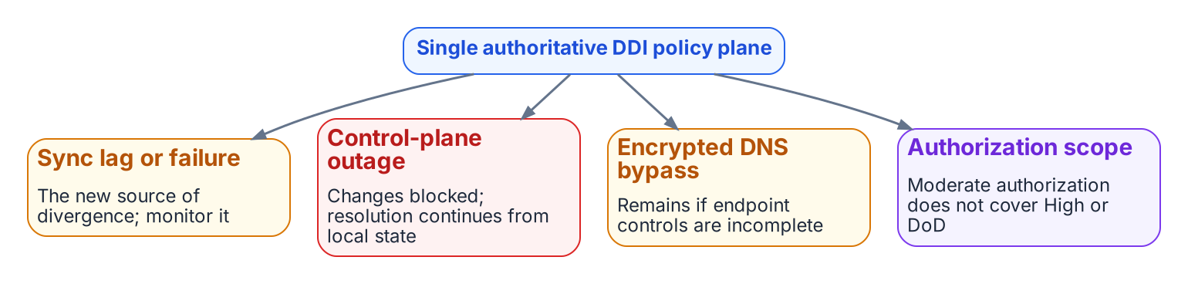
Residual risks of a unified policy plane.
The residual risks are real:
- Sync lag and sync failure between the policy plane and per-cloud DNS or IPAM services become the new source of divergence. Monitor synchronization health.
- Control-plane concentration. If the management plane is unavailable, changes cannot be made, but existing resolution should continue from local resolver state. Define the operational response and any local override procedures.
- Authorization scope. A Moderate authorization does not cover High or DoD environments (Applicability).
- Commercial-only optimizations. Microsoft 365 INR is unavailable in GCC-Moderate, GCC High and DoD; Microsoft 365 optimization there relies on local breakout and application-aware routing.
- Loopback endpoint agents. A client-side DNS agent listening on loopback cannot be a redirect-dns target; a network-addressable resolver is required.
- Encrypted DNS bypass remains possible where endpoint and network controls are incomplete.
- Open engineering questions for very large branch estates, such as resolver and forwarding-proxy sizing and source-address behavior under redirect-dns, need vendor engagement and testing.
None of these negates the architecture. They define the operational controls and vendor engagements still required.

Conclusion
DNS is no longer a name-lookup utility. It is the identity substrate, the security enforcement plane and the definition of the application surface for the hybrid multi-cloud agency. Independent DNS systems produce structural split-brain that breaks private connectivity, certificate trust and Zero Trust policy. A single authoritative DDI policy plane, authorized at the right impact level, keeps DNS, DHCP and IPAM consistent across the enterprise, cloud and internet perspectives. It puts the NIST SP 800-81r3 recommendations and the M-22-09 requirements into practice, carries the AD-to-Entra and VMware transitions, and works with SD-WAN edges that are configured correctly. The five configuration decisions in Chapter 08 remain the highest-leverage actions. Governing DNS is a strategic security and architecture task, not an operations afterthought.

What this chapter establishes
- Choose a platform against the architectural requirements and evidence, not a vendor list.
- Resolution-path consistency is the headline success measure.
- Sync, concentration, authorization-scope and bypass risks remain and need operational controls.

Previous: Chapter 10 — Operating the Control Plane: Delegation, Automation and Evidence
Next: Appendix A — DNS Record Types and Ecosystem Integrations

Appendix A — DNS Record Types and Ecosystem Integrations
This appendix is the record-type catalog and integration reference behind the chapters. It is meant to stand alone as a practitioner reference.

DNS Record Type Catalog
DNS is usually described through A and CNAME records, but IANA registers dozens of resource record types. At least fifteen are directly relevant to federal hybrid multi-cloud security, certificate governance, application-aware routing, and threat defense.

Address and Alias Records
- A (RFC 1035): Maps hostname to IPv4. The unit of inconsistency in split-brain DNS; every private endpoint ultimately resolves via an A record.
- AAAA (RFC 3596): Maps hostname to IPv6. Central to the OMB M-21-07 IPv6-only targets; dual-stack environments double the governance surface.
- CNAME (RFC 1034): Aliases one name to another. Not permitted at the zone apex. Chains create resolution delay and dangling-record risks.
- ALIAS / ANAME: Non-standard, provider-specific pseudo-records (for example Route 53 alias records and Azure DNS alias record sets) that resolve CNAME-like references at the zone apex. Behavior varies by implementation.
- PTR (RFC 1035): Reverse mapping. Critical for email deliverability, SIEM attribution, some Kerberos validation, and compliance logging. Often neglected in cloud private IP space.

Service Discovery Records
- SRV (RFC 2782): Maps service+protocol to host and port with priority/weight. Essential for Active Directory (_kerberos, _ldap, _gc and others). They do not migrate automatically when AD is retired (Chapter 04). Also used by SIP/VoIP, XMPP, and service meshes.
- NAPTR (RFC 3403): URI rewriting, primarily for ENUM/VoIP and E911 routing. Often chains to SRV records.

Certificate Governance Records
- CAA (RFC 8659): Specifies which CAs may issue certificates for the domain. Public CAs must check it before issuing. Split-brain can cause internal ACME automation to see different (or missing) CAA data.
- TLSA / DANE (RFC 6698): Pins a certificate or public key in DNS. Requires DNSSEC to be meaningful. Provides a second validation path independent of commercial CAs.
- SSHFP (RFC 4255): Publishes SSH host key fingerprints. Requires DNSSEC. Binds hostname to cryptographic identity.
- SMIMEA (RFC 8162): Associates S/MIME certificates with email addresses. Requires DNSSEC.

Email Authentication Records
- SPF (RFC 7208): TXT record listing authorized senders. A domain may publish only one SPF record, and evaluation is limited to 10 DNS lookups. Split-brain or duplicate records cause permanent errors.
- DKIM (RFC 6376): Public key for email signatures, published at selector._domainkey. Requires coordinated key rotation.
- DMARC (RFC 9989, which obsoletes RFC 7489): Policy for SPF and DKIM failures, plus reporting. CISA BOD 18-01 requires p=reject for federal second-level domains.
- BIMI: Brand logo display when DMARC is at enforcement; usually requires a mark certificate. BIMI is an industry specification, not an IETF standard.
- MTA-STS (RFC 8461): Forces TLS for inbound mail and rejects downgrade. Depends on both a TXT record and an HTTPS policy file.

Modern Service Binding Records
- HTTPS / SVCB (RFC 9460): Moves protocol negotiation (ALPN, ECH, port, IP hints) into DNS. Significant for HTTP/3/QUIC and for avoiding SNI exposure. Split-brain can leave private resolvers without ECH configuration.

DNSSEC Record Types
- DNSKEY, DS, RRSIG, NSEC/NSEC3, CDS/CDNSKEY: Form the chain of trust, signatures, authenticated denial of existence, and automated parent-child key rollover signaling. RRSIG expiration requires automated signing. DS updates must stay synchronized across parent zones.

Security Integration Matrix (Summary)
High split-brain impact record types include A/AAAA, CNAME, SRV, TLSA/DANE, SPF, HTTPS/SVCB, DNSKEY, and DS. Records that require DNSSEC for security value include TLSA, SSHFP, SMIMEA, and the DNSSEC types themselves. CAA, TLSA, and DNSSEC types have direct PKI integration. Unified DDI is the practical mechanism for applying consistent governance across this entire surface.

Ecosystem Integrations
Integration requirements for any DDI platform, with the vendor feature names left out; confirm each against current documentation.
- API: Full object-model access, consumed by Terraform, Ansible and IPAM-driven CI/CD so that address and DNS record lifecycle stay aligned with infrastructure provisioning.
- Network discovery: Active and passive discovery (SNMP, ARP tables, scanning) that populates IPAM with real device state and detects rogue DHCP servers that could distribute malicious Option-6 values.
- Security and ITSM ecosystem: Integrations with SIEM platforms (for example Splunk and Microsoft Sentinel), ServiceNow CMDB and ITSM, firewalls (for example exchanging block lists between response policy zones and firewall external dynamic lists), EDR, network access control and vulnerability scanners, so that DNS and DHCP signals to flow into SIEM, SOAR, and EDR workflows.
- Audit trail and change control: Every change is logged with actor, timestamp, and interface. Optional approval workflows for production zones or high-impact changes map to NIST SP 800-53 CM controls and federal change-management requirements.
The governance implication is that record types which appear unrelated (for example a CAA record and an SSHFP record) share the same consistency requirement. Fragmented authoritative surfaces subject each record type to independent split-brain risk. A unified DDI plane is the mechanism that applies consistent lifecycle and policy governance across the full record-type surface simultaneously.

Glossary
- Split-brain DNS: Same query returns different answers depending on origin.
- Split-horizon DNS: Intentional, governed split-brain, such as different internal and external answers for the same name.
- GCC-Moderate: This book’s name for Microsoft 365 Government Community Cloud (“GCC”), which runs on the Worldwide service instance at FedRAMP Moderate.
- Protective DNS: DNS-layer filtering that blocks known-malicious domains and supports logging and threat detection.
- RPZ: Response Policy Zone — DNS mechanism for policy-based responses (block, redirect, etc.).
- redirect-dns: Cisco Catalyst SD-WAN data policy that intercepts and redirects DNS queries.
- INR: Microsoft 365 informed network routing, telemetry-based path optimization for SD-WAN (Worldwide commercial cloud only; not GCC-Moderate, GCC High or DoD).
- DNS-01: ACME challenge type that proves domain control via DNS TXT records.
- DDI policy plane: The single authoritative policy plane for DNS, DHCP and IPAM state and policy that this book argues for. Infoblox Universal DDI is one commercial example.

Source Note
This book was developed from the Next Generation DDI whitepaper (Word edition, October 2026). Sources include NIST SP 800-81 Rev. 3 (March 19, 2026) and SP 800-207; OMB M-22-09, M-21-31, M-21-07 and M-08-23; CISA Encrypted DNS Implementation Guidance (May 2024) and BOD 18-01; Microsoft Learn, AWS and Google Cloud documentation; Cisco Catalyst SD-WAN configuration guides; the IETF RFCs cited above; and, as third-party sources, Infoblox and VMware publications and an Infoblox-commissioned ESG survey (February 2025). Product capabilities named in the book illustrate the requirements; confirm them against current vendor documentation.

Previous: Chapter 11 — Platform Selection, Cost and Residual Risk
Next: Appendix B — Requirements Mapping and Sources

Appendix B — Requirements Mapping and Sources
Each federal requirement, where the book addresses it, the evidence it calls for, and every source cited.

Requirements Mapping
The table maps each federal requirement that touches the name layer to the chapter that addresses it and the evidence an assessor can expect. It is a working aid, not a substitute for the agency’s own control implementation statements. Requirement wording is summarized; the cited documents govern.
Requirement (source) | What it asks of DNS, DHCP and IPAM | Addressed in | Evidence
Encrypted DNS (OMB M-22-09) | Resolve DNS queries using encrypted DNS wherever technically supported | Ch 03, Ch 05 | Resolver DoT, DoH and DoQ configuration; endpoint DNS policy; port 853 and public-DoH blocking rules
Protective DNS for egress (OMB M-22-09; CISA Encrypted DNS Implementation Guidance; CISA Protective DNS) | Route agency DNS egress through CISA-operated Protective DNS, including encrypted DNS | Ch 03, Ch 05, Ch 08 | Forwarding chain configuration; redirect-dns targets; resolver logs showing the governed path
DNS logging (OMB M-21-31, EL-1) | Collect and retain DNS request logs | Ch 03, Ch 10 | Query log configuration, SIEM ingestion, retention settings
DNSSEC (OMB M-08-23; SP 800-53 SC-20, SC-21) | Sign authoritative zones; validate on recursive resolvers | Ch 03, Ch 06 | Signed-zone inventory, DS publication, KSK/ZSK rollover records, resolver validation settings
Name and address resolution architecture (SP 800-53 SC-22) | Fault-tolerant, role-separated resolution services | Ch 03, Ch 08 | Architecture diagram, resolver redundancy, internal/external role separation
IPv6 (OMB M-21-07) | Move IP-enabled assets to IPv6-only (80% by end of FY2025) | Ch 07 | Dual-stack and IPv6-only address plans, DHCPv6 and RA governance, AAAA coverage
Email authentication (CISA BOD 18-01) | DMARC p=reject, SPF and DKIM for federal second-level domains | Appendix A | DMARC, SPF and DKIM records per domain; aggregate report review
Asset inventory (SP 800-53 CM-8; CISA Zero Trust Maturity Model) | Continuous, accurate inventory of networked assets | Ch 01, Ch 07, Ch 10 | IPAM discovery reports, CMDB reconciliation results
Audit and access control (SP 800-53 AU-2, AU-6, AC-2, AC-3, AC-6) | Logged, role-based administration of DNS, DHCP and IPAM | Ch 03, Ch 10 | Change logs, role and scope assignments, review records
Secure DNS deployment (NIST SP 800-81r3) | Protective DNS, encrypted DNS, DNSSEC, hygiene, logging, DNS as a Zero Trust policy enforcement point | Ch 03 – Ch 10 | The checklist in Chapter 10
Cloud service authorization (FedRAMP) | Authorization of any cloud-delivered management plane at the right impact level, plus agency ATO | Ch 03, Applicability | FedRAMP Marketplace listing, agency ATO letter, boundary diagram

Sources
Every URL below was checked as reachable on October 19, 2026. Primary sources (federal documents, standards and the cloud and platform providers’ own documentation of their services) are listed separately from third-party sources, which the chapters label as such in their footnotes.

Primary sources: federal requirements and guidance
- OMB M-22-09, Moving the U.S. Government Toward Zero Trust Cybersecurity Principles, January 26, 2022, section on encrypted DNS. https://www.whitehouse.gov/wp-content/uploads/2022/01/M-22-09.pdf
- CISA, Encrypted DNS Implementation Guidance, May 2024. https://www.cisa.gov/resources-tools/resources/encrypted-dns-implementation-guidance
- CISA, Protective Domain Name System (DNS) Resolver service. https://www.cisa.gov/resources-tools/services/protective-domain-name-system-dns-resolver
- OMB M-21-31, Improving the Federal Government’s Investigative and Remediation Capabilities Related to Cybersecurity Incidents, August 27, 2021 (DNS logs at event-logging tier EL-1). https://www.whitehouse.gov/wp-content/uploads/2021/08/M-21-31-Improving-the-Federal-Governments-Investigative-and-Remediation-Capabilities-Related-to-Cybersecurity-Incidents.pdf
- OMB M-08-23, Securing the Federal Government’s Domain Name System Infrastructure, August 22, 2008. https://georgewbush-whitehouse.archives.gov/omb/memoranda/fy2008/m08-23.pdf
- OMB M-21-07, Completing the Transition to Internet Protocol Version 6 (IPv6), November 19, 2020. https://www.whitehouse.gov/wp-content/uploads/2020/11/M-21-07.pdf
- CISA, Binding Operational Directive 18-01, Enhance Email and Web Security, October 16, 2017. https://www.cisa.gov/news-events/directives/bod-18-01-enhance-email-and-web-security
- NIST SP 800-81 Rev. 3, Secure Domain Name System (DNS) Deployment Guide, March 19, 2026. https://csrc.nist.gov/pubs/sp/800/81/r3/final
- NIST SP 800-207, Zero Trust Architecture, August 2020. https://csrc.nist.gov/pubs/sp/800/207/final
- NIST SP 800-53 Rev. 5 (update 1), Security and Privacy Controls for Information Systems and Organizations: SC-20, SC-21, SC-22 and the other controls cited. https://csrc.nist.gov/pubs/sp/800/53/r5/upd1/final
- CISA, Zero Trust Maturity Model, Version 2.0. https://www.cisa.gov/zero-trust-maturity-model
- FedRAMP Marketplace, Infoblox Government Cloud (package FR2017257053), authorized at Moderate since December 15, 2022. https://www.fedramp.gov/marketplace/products/FR2017257053/

Primary sources: IETF and IANA standards
- IETF RFC 882, Domain Names — Concepts and Facilities, November 1983; superseded by RFC 1034 and RFC 1035 (November 1987). https://www.rfc-editor.org/rfc/rfc882; https://www.rfc-editor.org/rfc/rfc1034; https://www.rfc-editor.org/rfc/rfc1035
- IETF RFC 4033, DNS Security Introduction and Requirements, March 2005, and RFC 9364, DNS Security Extensions (DNSSEC), BCP 237, February 2023. https://www.rfc-editor.org/rfc/rfc4033; https://www.rfc-editor.org/rfc/rfc9364
- IETF RFC 6891, Extension Mechanisms for DNS (EDNS(0)), April 2013. https://www.rfc-editor.org/rfc/rfc6891
- IETF RFC 7344, Automating DNSSEC Delegation Trust Maintenance (CDS and CDNSKEY), September 2014. https://www.rfc-editor.org/rfc/rfc7344
- IETF RFC 7858 (DNS over TLS), RFC 8484 (DNS over HTTPS) and RFC 9250 (DNS over QUIC). https://www.rfc-editor.org/rfc/rfc7858; https://www.rfc-editor.org/rfc/rfc8484; https://www.rfc-editor.org/rfc/rfc9250
- IETF RFC 8106, IPv6 Router Advertisement Options for DNS Configuration, March 2017. https://www.rfc-editor.org/rfc/rfc8106
- IETF RFC 8555, Automatic Certificate Management Environment (ACME), March 2019 (DNS-01 challenge). https://www.rfc-editor.org/rfc/rfc8555
- IETF RFC 6698, The DNS-Based Authentication of Named Entities (DANE) Transport Layer Security (TLS) Protocol: TLSA, August 2012. https://www.rfc-editor.org/rfc/rfc6698
- IETF RFC 8659, DNS Certification Authority Authorization (CAA) Resource Record, November 2019. https://www.rfc-editor.org/rfc/rfc8659
- IETF RFC 9989, Domain-based Message Authentication, Reporting, and Conformance (DMARC), May 2026, which obsoletes RFC 7489. https://www.rfc-editor.org/rfc/rfc9989
- IANA, Domain Name System (DNS) Parameters, Resource Record (RR) TYPEs registry. https://www.iana.org/assignments/dns-parameters/dns-parameters.xhtml

Primary sources: cloud and platform provider documentation
- Microsoft Learn, “Azure Private Endpoint DNS Integration Scenarios” and “Azure Private Endpoint private DNS zone values.” https://learn.microsoft.com/en-us/azure/private-link/private-endpoint-dns-integration; https://learn.microsoft.com/en-us/azure/private-link/private-endpoint-dns
- Microsoft Learn, “Azure DNS Private Resolver Overview” (inbound and outbound endpoints and their dedicated subnets). https://learn.microsoft.com/en-us/azure/dns/dns-private-resolver-overview
- Microsoft Learn, “Azure Private DNS: Secure DNS for Virtual Networks.” https://learn.microsoft.com/en-us/azure/dns/private-dns-overview
- Microsoft Learn, “Overview of DNS resolver policy” (Azure DNS security policy). https://learn.microsoft.com/en-us/azure/dns/dns-security-policy
- Microsoft Learn, “Overview of DNSSEC - Azure Public DNS” (Azure DNS: public zones only; Private DNS not supported; automatic ZSK rollover). https://learn.microsoft.com/en-us/azure/dns/dnssec
- Microsoft Learn, “What is IP address management (IPAM) in Azure Virtual Network Manager?” https://learn.microsoft.com/en-us/azure/virtual-network-manager/concept-ip-address-management
- Microsoft Learn, “Compare Azure Government and global Azure.” https://learn.microsoft.com/en-us/azure/azure-government/compare-azure-government-global-azure
- Microsoft Learn, “Microsoft 365 informed network routing” (WW Commercial only; Cisco IOS XE SD-WAN 20.4/17.4 or later). https://learn.microsoft.com/en-us/microsoft-365/enterprise/office-365-network-mac-perf-cpe?view=o365-worldwide
- Microsoft Learn, “Microsoft 365 URLs and IP address ranges” (the Worldwide list, which includes GCC). https://learn.microsoft.com/en-us/microsoft-365/enterprise/urls-and-ip-address-ranges?view=o365-worldwide
- Microsoft Learn, “Microsoft 365 U.S. Government GCC High endpoints.” https://learn.microsoft.com/en-us/microsoft-365/enterprise/microsoft-365-u-s-government-gcc-high-endpoints?view=o365-worldwide
- Microsoft Learn, “Office 365 GCC,” Office 365 US Government service description. https://learn.microsoft.com/en-us/office365/servicedescriptions/office-365-platform-service-description/office-365-us-government/gcc
- Microsoft Learn, “DNS and AD DS” and “Verify that SRV Domain Name System (DNS) records have been created.” https://learn.microsoft.com/en-us/windows-server/identity/ad-ds/plan/dns-and-ad-ds; https://learn.microsoft.com/en-us/troubleshoot/windows-server/networking/verify-srv-dns-records-have-been-created
- Microsoft Learn, “Secure DNS Client over HTTPS (DoH) on Windows Server 2022.” https://learn.microsoft.com/en-us/windows-server/networking/dns/doh-client-support
- AWS, Amazon Route 53 Developer Guide: “Configuring DNSSEC signing in Amazon Route 53” and “Enabling DNSSEC validation in Amazon Route 53.” https://docs.aws.amazon.com/Route53/latest/DeveloperGuide/dns-configuring-dnssec.html; https://docs.aws.amazon.com/Route53/latest/DeveloperGuide/resolver-dnssec-validation.html
- AWS, Amazon Route 53 Developer Guide, “Using DNS Firewall to filter outbound DNS traffic.” https://docs.aws.amazon.com/Route53/latest/DeveloperGuide/resolver-dns-firewall.html
- AWS, “Amazon VPC IPAM automates IP assignments from Infoblox IPAM,” November 17, 2025, and Amazon VPC IPAM User Guide, “Integrate VPC IPAM with Infoblox infrastructure” (private scopes; not in the China or AWS GovCloud (US) Regions). https://aws.amazon.com/about-aws/whats-new/2025/11/amazon-vpc-ipam-automates-ip-from-infoblox/; https://docs.aws.amazon.com/vpc/latest/ipam/integrate-infoblox-ipam.html
- Google Cloud, “Manage response policies and rules” (Cloud DNS). https://cloud.google.com/dns/docs/zones/manage-response-policies
- Google Cloud, “Internal ranges overview” (VPC). https://cloud.google.com/vpc/docs/internal-ranges
- Cisco, Cisco Catalyst SD-WAN Policies Configuration Guide, Cisco IOS XE Catalyst SD-WAN Release 17.x, “Redirect DNS in Cisco Catalyst SD-WAN Service-Side VPNs” (restrictions: IPv4 only; UDP only, not TCP; no DNS from the overlay tunnel; service-side VPN support from 17.8.1a / 20.8.1). https://www.cisco.com/c/en/us/td/docs/routers/sdwan/configuration/policies/ios-xe-17/policies-book-xe/redirect-dns.html
- Microsoft Learn, “Azure Government DoD Overview.” https://learn.microsoft.com/en-us/azure/azure-government/documentation-government-overview-dod

Third-party sources
Used only for product-specific facts that no primary source documents. They are labeled “Third-party source” in each footnote.
- Infoblox, “Infoblox Government Cloud Achieves FedRAMP Moderate Certification, Bringing Modern DDI and Asset Visibility to Federal Agencies,” press release, July 22, 2026. https://www.infoblox.com/news/news-events/press-releases/infoblox-government-cloud-achieves-fedramp-moderate-certification-bringing-modern-ddi-and-asset-visibility-to-federal-agencies/
- Enterprise Strategy Group, commissioned by Infoblox, 9 Pitfalls of Not Using Enterprise-Grade DDI, February 2025. No public URL was verified for this book; figures are reported by the sponsor and were not independently verified.
- VMware Cloud Foundation blog, “VCF 9.1 Networking: Seamless DDI Integration with Infoblox,” May 15, 2026. https://blogs.vmware.com/cloud-foundation/2026/05/15/vcf-networking-9-1-seamless-ddi-integration-with-infoblox/

Previous: Appendix A — DNS Record Types and Ecosystem Integrations
Next: Next Generation DDI — book home

Microsoft Learn, “Office 365 GCC,” Office 365 US Government service description. https://learn.microsoft.com/en-us/office365/servicedescriptions/office-365-platform-service-description/office-365-us-government/gcc
Microsoft Learn, “Microsoft 365 informed network routing” (WW Commercial only; Cisco IOS XE SD-WAN 20.4/17.4 or later). https://learn.microsoft.com/en-us/microsoft-365/enterprise/office-365-network-mac-perf-cpe?view=o365-worldwide
AWS, “Amazon VPC IPAM automates IP assignments from Infoblox IPAM,” November 17, 2025, and Amazon VPC IPAM User Guide, “Integrate VPC IPAM with Infoblox infrastructure” (private scopes; not in the China or AWS GovCloud (US) Regions). https://aws.amazon.com/about-aws/whats-new/2025/11/amazon-vpc-ipam-automates-ip-from-infoblox/; https://docs.aws.amazon.com/vpc/latest/ipam/integrate-infoblox-ipam.html
Microsoft Learn, “Microsoft 365 URLs and IP address ranges” (the Worldwide list, which includes GCC). https://learn.microsoft.com/en-us/microsoft-365/enterprise/urls-and-ip-address-ranges?view=o365-worldwide
Microsoft Learn, “Microsoft 365 U.S. Government GCC High endpoints.” https://learn.microsoft.com/en-us/microsoft-365/enterprise/microsoft-365-u-s-government-gcc-high-endpoints?view=o365-worldwide
Microsoft Learn, “Compare Azure Government and global Azure.” https://learn.microsoft.com/en-us/azure/azure-government/compare-azure-government-global-azure
Microsoft Learn, “Azure Government DoD Overview.” https://learn.microsoft.com/en-us/azure/azure-government/documentation-government-overview-dod
FedRAMP Marketplace, Infoblox Government Cloud (package FR2017257053), authorized at Moderate since December 15, 2022. https://www.fedramp.gov/marketplace/products/FR2017257053/
Third-party source (vendor). Infoblox, “Infoblox Government Cloud Achieves FedRAMP Moderate Certification, Bringing Modern DDI and Asset Visibility to Federal Agencies,” press release, July 22, 2026. https://www.infoblox.com/news/news-events/press-releases/infoblox-government-cloud-achieves-fedramp-moderate-certification-bringing-modern-ddi-and-asset-visibility-to-federal-agencies/
IETF RFC 882, Domain Names — Concepts and Facilities, November 1983; superseded by RFC 1034 and RFC 1035 (November 1987). https://www.rfc-editor.org/rfc/rfc882; https://www.rfc-editor.org/rfc/rfc1034; https://www.rfc-editor.org/rfc/rfc1035
CISA, Zero Trust Maturity Model, Version 2.0. https://www.cisa.gov/zero-trust-maturity-model
Microsoft Learn, “Azure Private Endpoint DNS Integration Scenarios” and “Azure Private Endpoint private DNS zone values.” https://learn.microsoft.com/en-us/azure/private-link/private-endpoint-dns-integration; https://learn.microsoft.com/en-us/azure/private-link/private-endpoint-dns
AWS, Amazon Route 53 Developer Guide, “Using DNS Firewall to filter outbound DNS traffic.” https://docs.aws.amazon.com/Route53/latest/DeveloperGuide/resolver-dns-firewall.html
Microsoft Learn, “Overview of DNS resolver policy” (Azure DNS security policy). https://learn.microsoft.com/en-us/azure/dns/dns-security-policy
Google Cloud, “Manage response policies and rules” (Cloud DNS). https://cloud.google.com/dns/docs/zones/manage-response-policies
OMB M-22-09, Moving the U.S. Government Toward Zero Trust Cybersecurity Principles, January 26, 2022, section on encrypted DNS. https://www.whitehouse.gov/wp-content/uploads/2022/01/M-22-09.pdf
CISA, Encrypted DNS Implementation Guidance, May 2024. https://www.cisa.gov/resources-tools/resources/encrypted-dns-implementation-guidance
Microsoft Learn, “Microsoft 365 U.S. Government GCC High endpoints.” https://learn.microsoft.com/en-us/microsoft-365/enterprise/microsoft-365-u-s-government-gcc-high-endpoints?view=o365-worldwide
Microsoft Learn, “Microsoft 365 URLs and IP address ranges” (the Worldwide list, which includes GCC). https://learn.microsoft.com/en-us/microsoft-365/enterprise/urls-and-ip-address-ranges?view=o365-worldwide
Third-party source (vendor-commissioned survey). Enterprise Strategy Group, commissioned by Infoblox, 9 Pitfalls of Not Using Enterprise-Grade DDI, February 2025. No public URL was verified for this book; figures are reported by the sponsor and were not independently verified.
OMB M-22-09, Moving the U.S. Government Toward Zero Trust Cybersecurity Principles, January 26, 2022, section on encrypted DNS. https://www.whitehouse.gov/wp-content/uploads/2022/01/M-22-09.pdf
CISA, Encrypted DNS Implementation Guidance, May 2024. https://www.cisa.gov/resources-tools/resources/encrypted-dns-implementation-guidance
OMB M-21-31, Improving the Federal Government’s Investigative and Remediation Capabilities Related to Cybersecurity Incidents, August 27, 2021 (DNS logs at event-logging tier EL-1). https://www.whitehouse.gov/wp-content/uploads/2021/08/M-21-31-Improving-the-Federal-Governments-Investigative-and-Remediation-Capabilities-Related-to-Cybersecurity-Incidents.pdf
OMB M-08-23, Securing the Federal Government’s Domain Name System Infrastructure, August 22, 2008. https://georgewbush-whitehouse.archives.gov/omb/memoranda/fy2008/m08-23.pdf
NIST SP 800-53 Rev. 5 (update 1), Security and Privacy Controls for Information Systems and Organizations: SC-20, SC-21, SC-22 and the other controls cited. https://csrc.nist.gov/pubs/sp/800/53/r5/upd1/final
OMB M-21-07, Completing the Transition to Internet Protocol Version 6 (IPv6), November 19, 2020. https://www.whitehouse.gov/wp-content/uploads/2020/11/M-21-07.pdf
CISA, Protective Domain Name System (DNS) Resolver service. https://www.cisa.gov/resources-tools/services/protective-domain-name-system-dns-resolver
NIST SP 800-81 Rev. 3, Secure Domain Name System (DNS) Deployment Guide, March 19, 2026. https://csrc.nist.gov/pubs/sp/800/81/r3/final
NIST SP 800-207, Zero Trust Architecture, August 2020. https://csrc.nist.gov/pubs/sp/800/207/final
FedRAMP Marketplace, Infoblox Government Cloud (package FR2017257053), authorized at Moderate since December 15, 2022. https://www.fedramp.gov/marketplace/products/FR2017257053/
Third-party source (vendor). Infoblox, “Infoblox Government Cloud Achieves FedRAMP Moderate Certification, Bringing Modern DDI and Asset Visibility to Federal Agencies,” press release, July 22, 2026. https://www.infoblox.com/news/news-events/press-releases/infoblox-government-cloud-achieves-fedramp-moderate-certification-bringing-modern-ddi-and-asset-visibility-to-federal-agencies/
Microsoft Learn, “DNS and AD DS” and “Verify that SRV Domain Name System (DNS) records have been created.” https://learn.microsoft.com/en-us/windows-server/identity/ad-ds/plan/dns-and-ad-ds; https://learn.microsoft.com/en-us/troubleshoot/windows-server/networking/verify-srv-dns-records-have-been-created
Cisco, Cisco Catalyst SD-WAN Policies Configuration Guide, Cisco IOS XE Catalyst SD-WAN Release 17.x, “Redirect DNS in Cisco Catalyst SD-WAN Service-Side VPNs” (restrictions: IPv4 only; UDP only, not TCP; no DNS from the overlay tunnel; service-side VPN support from 17.8.1a / 20.8.1). https://www.cisco.com/c/en/us/td/docs/routers/sdwan/configuration/policies/ios-xe-17/policies-book-xe/redirect-dns.html
Microsoft Learn, “Microsoft 365 informed network routing” (WW Commercial only; Cisco IOS XE SD-WAN 20.4/17.4 or later). https://learn.microsoft.com/en-us/microsoft-365/enterprise/office-365-network-mac-perf-cpe?view=o365-worldwide
OMB M-22-09, Moving the U.S. Government Toward Zero Trust Cybersecurity Principles, January 26, 2022, section on encrypted DNS. https://www.whitehouse.gov/wp-content/uploads/2022/01/M-22-09.pdf
CISA, Encrypted DNS Implementation Guidance, May 2024. https://www.cisa.gov/resources-tools/resources/encrypted-dns-implementation-guidance
IETF RFC 7858 (DNS over TLS), RFC 8484 (DNS over HTTPS) and RFC 9250 (DNS over QUIC). https://www.rfc-editor.org/rfc/rfc7858; https://www.rfc-editor.org/rfc/rfc8484; https://www.rfc-editor.org/rfc/rfc9250
Microsoft Learn, “Secure DNS Client over HTTPS (DoH) on Windows Server 2022.” https://learn.microsoft.com/en-us/windows-server/networking/dns/doh-client-support
IETF RFC 8106, IPv6 Router Advertisement Options for DNS Configuration, March 2017. https://www.rfc-editor.org/rfc/rfc8106
IETF RFC 8555, Automatic Certificate Management Environment (ACME), March 2019 (DNS-01 challenge). https://www.rfc-editor.org/rfc/rfc8555
IETF RFC 8659, DNS Certification Authority Authorization (CAA) Resource Record, November 2019. https://www.rfc-editor.org/rfc/rfc8659
IETF RFC 6698, The DNS-Based Authentication of Named Entities (DANE) Transport Layer Security (TLS) Protocol: TLSA, August 2012. https://www.rfc-editor.org/rfc/rfc6698
IETF RFC 4033, DNS Security Introduction and Requirements, March 2005, and RFC 9364, DNS Security Extensions (DNSSEC), BCP 237, February 2023. https://www.rfc-editor.org/rfc/rfc4033; https://www.rfc-editor.org/rfc/rfc9364
OMB M-08-23, Securing the Federal Government’s Domain Name System Infrastructure, August 22, 2008. https://georgewbush-whitehouse.archives.gov/omb/memoranda/fy2008/m08-23.pdf
NIST SP 800-81 Rev. 3, Secure Domain Name System (DNS) Deployment Guide, March 19, 2026. https://csrc.nist.gov/pubs/sp/800/81/r3/final
IETF RFC 6891, Extension Mechanisms for DNS (EDNS(0)), April 2013. https://www.rfc-editor.org/rfc/rfc6891
Microsoft Learn, “Overview of DNSSEC - Azure Public DNS” (Azure DNS: public zones only; Private DNS not supported; automatic ZSK rollover). https://learn.microsoft.com/en-us/azure/dns/dnssec
AWS, Amazon Route 53 Developer Guide: “Configuring DNSSEC signing in Amazon Route 53” and “Enabling DNSSEC validation in Amazon Route 53.” https://docs.aws.amazon.com/Route53/latest/DeveloperGuide/dns-configuring-dnssec.html; https://docs.aws.amazon.com/Route53/latest/DeveloperGuide/resolver-dnssec-validation.html
Microsoft Learn, “Azure Private Endpoint DNS Integration Scenarios” and “Azure Private Endpoint private DNS zone values.” https://learn.microsoft.com/en-us/azure/private-link/private-endpoint-dns-integration; https://learn.microsoft.com/en-us/azure/private-link/private-endpoint-dns
Microsoft Learn, “Azure DNS Private Resolver Overview” (inbound and outbound endpoints and their dedicated subnets). https://learn.microsoft.com/en-us/azure/dns/dns-private-resolver-overview
Microsoft Learn, “Azure Private DNS: Secure DNS for Virtual Networks.” https://learn.microsoft.com/en-us/azure/dns/private-dns-overview
AWS, “Amazon VPC IPAM automates IP assignments from Infoblox IPAM,” November 17, 2025, and Amazon VPC IPAM User Guide, “Integrate VPC IPAM with Infoblox infrastructure” (private scopes; not in the China or AWS GovCloud (US) Regions). https://aws.amazon.com/about-aws/whats-new/2025/11/amazon-vpc-ipam-automates-ip-from-infoblox/; https://docs.aws.amazon.com/vpc/latest/ipam/integrate-infoblox-ipam.html
Microsoft Learn, “What is IP address management (IPAM) in Azure Virtual Network Manager?” https://learn.microsoft.com/en-us/azure/virtual-network-manager/concept-ip-address-management
Google Cloud, “Internal ranges overview” (VPC). https://cloud.google.com/vpc/docs/internal-ranges
Third-party source (vendor blog). VMware Cloud Foundation blog, “VCF 9.1 Networking: Seamless DDI Integration with Infoblox,” May 15, 2026. https://blogs.vmware.com/cloud-foundation/2026/05/15/vcf-networking-9-1-seamless-ddi-integration-with-infoblox/
OMB M-21-07, Completing the Transition to Internet Protocol Version 6 (IPv6), November 19, 2020. https://www.whitehouse.gov/wp-content/uploads/2020/11/M-21-07.pdf
CISA, Protective Domain Name System (DNS) Resolver service. https://www.cisa.gov/resources-tools/services/protective-domain-name-system-dns-resolver
OMB M-21-31, Improving the Federal Government’s Investigative and Remediation Capabilities Related to Cybersecurity Incidents, August 27, 2021 (DNS logs at event-logging tier EL-1). https://www.whitehouse.gov/wp-content/uploads/2021/08/M-21-31-Improving-the-Federal-Governments-Investigative-and-Remediation-Capabilities-Related-to-Cybersecurity-Incidents.pdf
FedRAMP Marketplace, Infoblox Government Cloud (package FR2017257053), authorized at Moderate since December 15, 2022. https://www.fedramp.gov/marketplace/products/FR2017257053/
Microsoft Learn, “Microsoft 365 informed network routing” (WW Commercial only; Cisco IOS XE SD-WAN 20.4/17.4 or later). https://learn.microsoft.com/en-us/microsoft-365/enterprise/office-365-network-mac-perf-cpe?view=o365-worldwide
IANA, Domain Name System (DNS) Parameters, Resource Record (RR) TYPEs registry. https://www.iana.org/assignments/dns-parameters/dns-parameters.xhtml
IETF RFC 9989, Domain-based Message Authentication, Reporting, and Conformance (DMARC), May 2026, which obsoletes RFC 7489. https://www.rfc-editor.org/rfc/rfc9989
CISA, Binding Operational Directive 18-01, Enhance Email and Web Security, October 16, 2017. https://www.cisa.gov/news-events/directives/bod-18-01-enhance-email-and-web-security
IETF RFC 7344, Automating DNSSEC Delegation Trust Maintenance (CDS and CDNSKEY), September 2014. https://www.rfc-editor.org/rfc/rfc7344

