Modernization Canon
  - Modernization Workbook — Word edition
Table of Contents

Modernization Canon
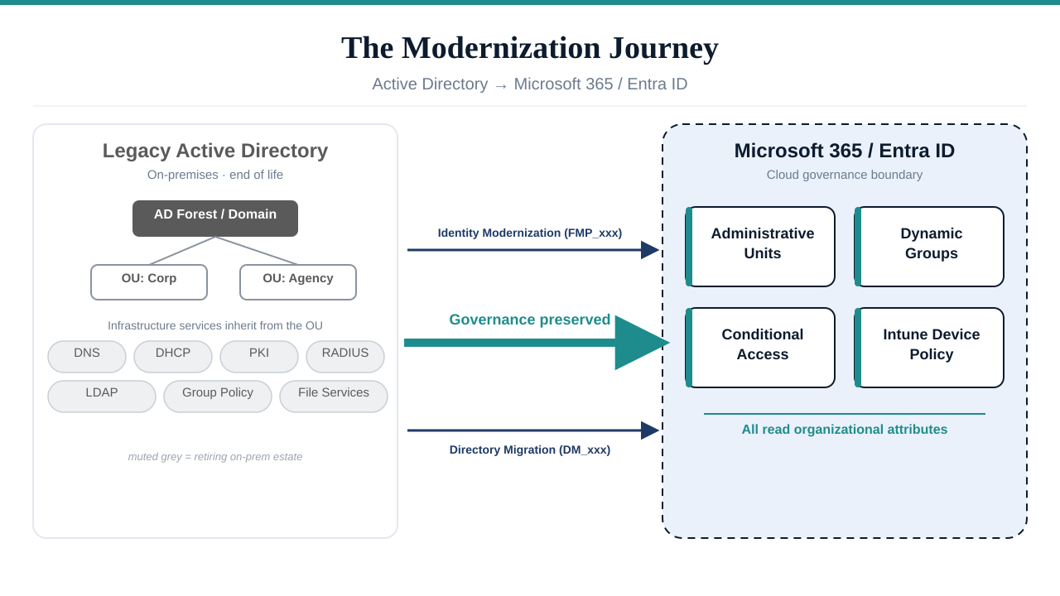
A clean 16:9 architecture illustration of the AD-to-Entra-ID modernization journey

The Problem
Federal agencies — and most enterprises — are frozen in 2003.
Active Directory was never just an identity store. It was the implicit governance model for every network service in the enterprise: DNS, DHCP, PKI, RADIUS, LDAP authentication, GPO-based device policy, file services, and cross-domain trust relationships. When an administrator created an OU, they were not just organizing users — they were defining delegation boundaries, security policy scope, group policy inheritance, and operational accountability. The OU tree was the governance model.
Microsoft is now deprecating the entire Client/Server stack. Entra ID replaces Active Directory. Intune replaces Group Policy. Conditional Access replaces network-perimeter enforcement. But Microsoft gave agencies the tools — nobody gave them the framework for what decisions to make with those tools.
The result: agencies migrate users into Entra ID’s flat directory and lose every governance relationship that the OU hierarchy encoded. Delegation boundaries vanish. Policy inheritance breaks. Group membership becomes a manual spreadsheet exercise. Security groups proliferate without governance. And the infrastructure services that depended on AD — DNS, PKI, RADIUS, LDAP — lose their governance anchor entirely.
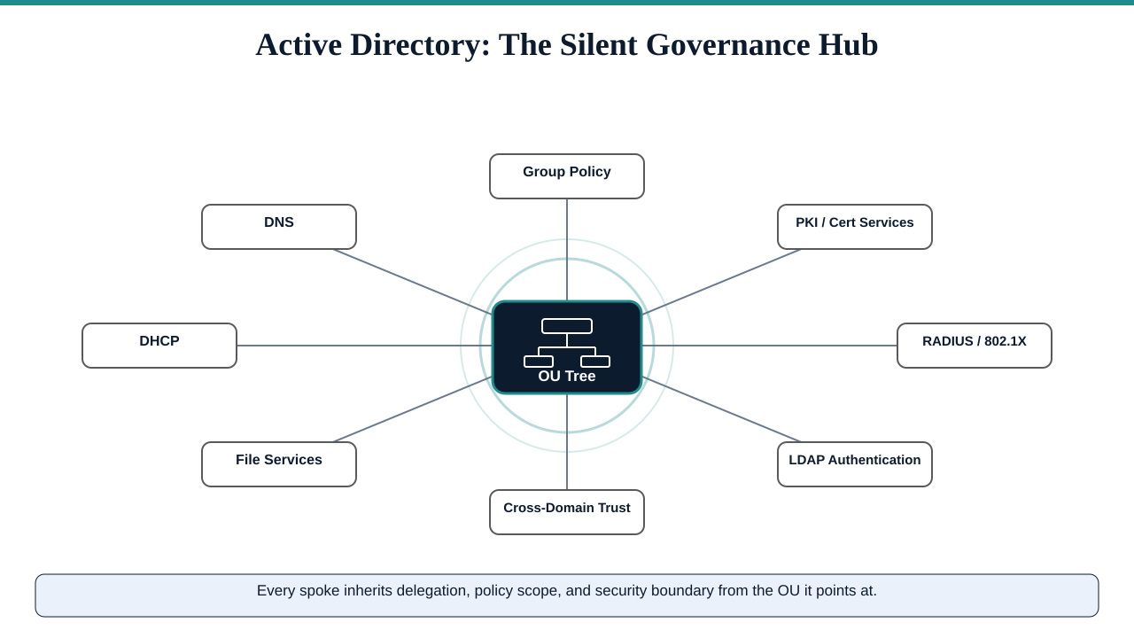
A 16:9 conceptual diagram showing Active Directory as the silent governance hub of a legacy enterprise

The Solution
The Federal Modernization Program Modernization Canon is that missing framework.
It provides the complete, deterministic, drift-resistant architecture for governing the AD-to-Entra ID transition — not just user migration, but the full governance surface that Active Directory was silently holding together. Two complementary canons cover the entire migration surface:
Domain | Namespace | Scope | Documents
Identity Modernization | FMP_xxx (formerly MOD_xxx; retired by [the program decision]) | User hierarchy, extension attributes, dynamic groups, AUs, HR-driven lifecycle, delegation, Conditional Access | 27 files (FMP_150 + the A–Z series FMP_151–FMP_176)
Directory Migration | DM_xxx | DNS, DHCP, PKI, RADIUS, LDAP, sync engines, device management, NTP, DFS | 12 files (DM_000–DM_090): 8 adapter interfaces + 4 framework docs
Both canons share a universal design principle:

Canon Rule
fmp-gos is a universal enterprise product. It is NOT government-specific. Federal compliance (FedRAMP, OSCAL, KSI) is one vertical adapter on top of the universal core. Never frame the core engine as federal-only.

Architecture: The Four-Layer Governance Stack
The architecture is a four-layer governance stack. Each layer has a defined responsibility, explicit dependency relationships, and canonical artifacts.
Layer | Responsibility | Key Artifacts
Governance Layer | Drift detection, telemetry, escalation, boundary impact, provenance, error taxonomy | FMP_163 (Drift Engine); FMP_167 (SLA Escalation Playbooks); FMP_174 (Telemetry)
Policy Layer | Validation cmdlets, enforcement test suite, decision trees, SLA tracking | FMP_159 (PowerShell Validation); FMP_161 (Decision Trees); FMP_162 (SLA Heatmap)
Structure Layer | Administrative-Unit delegation, workflow catalog, migration runbook | FMP_154 (Delegation Matrix); FMP_156 (Migration Runbook)
Identity Layer | Dynamic-group library, attribute mapping, extension attributes | FMP_150 (Executive Summary); FMP_152 (Dynamic Groups); FMP_153 (Attribute Mapping)
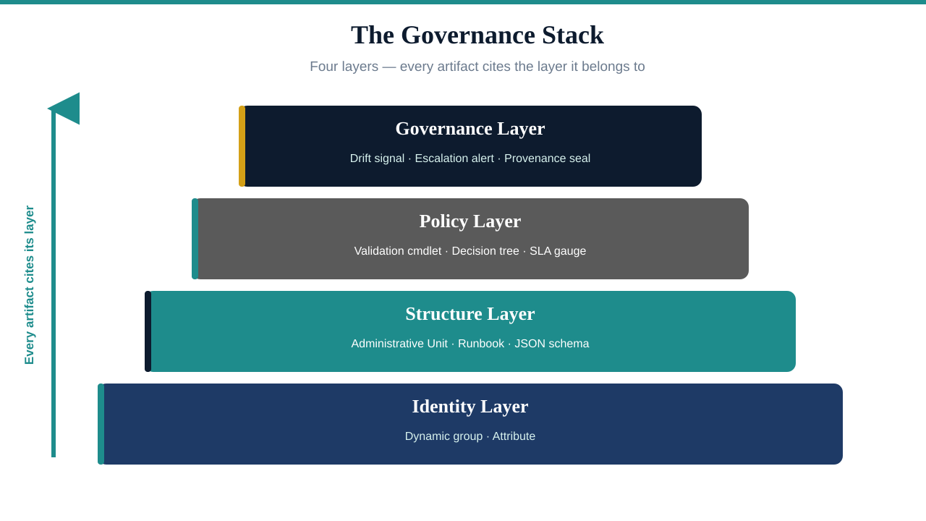
A clean 16:9 layered-stack diagram showing the four-layer governance stack

Governance Principles — 3 Universal + 3 Tier-Specific
Per [the program decision], the Federal Modernization Program ships 6 governance principles in two scopes, declared canonically in [src/fmp/canon/substrate-manifest.yaml] (FMP_200). The substrate manifest is the code SSOT for principles; the descriptions below mirror it verbatim.

3 Universal Substrate Principles
These apply at all 5 conformance tiers per [the program decision]. Every the Federal Modernization Program deployment honors all three.
- Single Source of Truth (SSOT). Canonical governance artifacts under src/fmp/canon/ define structure, policy intent, and registry authority exactly once. Downstream systems consume those artifacts via importlib.resources rather than duplicating policy logic.
- Canon-Anchored Evidence. Every artifact the substrate produces — SSP, POA&M, KSI dashboards, component definitions — cites the canon document ID and version it derives from. Reviewers trace findings back to requirements deterministically.
- Drift Is Explicit. Five-class taxonomy (DRIFT-SCHEMA, DRIFT-SEMANTIC, DRIFT-PROVENANCE, DRIFT-AUTHZ, DRIFT-IDENTITY) surfaces structural and provenance mismatch as first-class findings, not exception reports.

3 Tier-Specific Principles
These become operational only at the named the program decision tier (inclusive — apply at that tier and above):
Principle | Applies at tier | Rationale for tier scope
Two-Brain Execution — Copilot governs (canonical review, policy enforcement, validation); Execution Substrate executes (PowerShell, Graph API, tenant provisioning); governance logic and execution logic never co-mingle | Tier 3+ (Active Substrate) | At Tiers 1–2 there is no active runtime to split between governance and execution. The principle becomes operational only when the Federal Modernization Program writes agency state.
Boundary Enforcement — No governance artifact may extend beyond the M365 GCC-Moderate SaaS boundary. Out-of-scope references are non-canonical and rejected at validation | Tier 4+ (Active Services / Platform Server) | At Tiers 1–3, boundary is a documented scope; at Tier 4 it becomes an enforced runtime contract on agency-deployed the Federal Modernization Program services.
Tenant Agnosticism — All artifacts are portable across any M365 GCC-Moderate tenant. No tenant-specific identifiers, UPNs, or GUIDs. All environment values are injected at deployment time | Tier 5 (Embedded Libraries) | At Tiers 1–4, the Federal Modernization Program runs agency-side and may carry tenant-local context. At Tier 5, code shipped to third parties (PyPI, NuGet, adapter SDK) MUST be portable.

Historical names (“Seven Non-Negotiable Principles”)
Earlier framings of this canon listed seven principles. Per the program decision, four of those names were partial expressions of the universal three and have been collapsed into them:
Retired narrative name | Collapses into universal principle
Deterministic State | SSOT (single canonical state per object)
Schema Fixity | SSOT (canon defines structure once)
Provenance Traceability | Canon-Anchored Evidence (same property, different label)
Drift Resistance | Drift Is Explicit (same property; the 5-class taxonomy is the canonical drift surface)
The other three names (Boundary Enforcement, Two-Brain Execution, Tenant Agnosticism) remain canonical, now scoped to the tiers where they bind. The “seven principles” phrasing should not be cited in new material; refer to the 3 + 3 split above or to the substrate manifest directly. “Assessment Before Action” is treated as an operational discipline — a corollary of Drift Is Explicit and Canon-Anchored Evidence — not a first-class substrate principle.

Who This Is For
Audience | What They Get
Federal CISOs and CIOs | A governed framework for AD retirement that does not create compliance gaps
IT Modernization Program Managers | Step-by-step runbooks with deterministic outcomes, not “it depends” guidance
Identity Architects | Dynamic group library, AU delegation matrix
Network and Infrastructure Engineers | Adapter interfaces for every AD-dependent service
Compliance Officers | Provenance-tracked, drift-resistant artifacts that satisfy FedRAMP continuous monitoring
Enterprise Architects (non-federal) | Universal framework — federal compliance is a vertical adapter, not the core

Navigation

Canon entry points
Section | What is There
Identity Modernization | The A-Z Suite: 27 canonical artifacts (FMP_150 + FMP_151–FMP_176) governing user hierarchy, dynamic groups, delegation, migration, drift detection, and operational governance
Directory Migration | 8 adapter interfaces for every infrastructure service AD was holding together: IPAM, PKI, RADIUS, LDAP, sync engines, devices, NTP, DFS

Explainers and walk-throughs
Page | Who it’s for
Delegation Matrix | Identity admins mapping Administrative Units to operator roles
Intune-First Asset Onboarding | Procurement + endpoint teams governing net-new devices from day zero (per the program decision; for existing-fleet GPO replacement see GPO Sunset Program)
Directory Migration — Adapters | Network/infrastructure engineers wiring DNS/DHCP/PKI/RADIUS through canonical adapters
GPO-to-Cloud Governance Gaps | Architects/operators asking “what control do we lose moving Group Policy to Intune/Entra?” — the five lost capabilities

Source Files
All canonical source files are maintained in the monorepo:
- Directory Migration: src/fmp/modernization/directory-migration/

Directory Migration Adapters

The Hidden Surface
When people say “migrate off Active Directory,” they mean move users to Entra ID. But Active Directory was not just an identity store. It was the implicit governance model for every network service in the enterprise:
- DNS — AD-integrated DNS zones, SRV records for domain controllers
- DHCP — Scope-to-subnet-to-OU mappings
- PKI — Active Directory Certificate Services, auto-enrollment via GPO
- RADIUS — Network Policy Server authenticating against AD groups
- LDAP — Hundreds of applications doing LDAP binds to domain controllers
- Device Management — SCCM collections querying AD, GPO-based device policy
- Time Services — Every domain-joined machine syncing NTP from the PDC emulator
- File Services — DFS namespaces resolving through AD domain names
Migrating users to Entra ID without migrating these services is not a migration — it is a liability. The Directory Migration canon provides a governed adapter interface for each of these eight service categories.

Adapter Priority Matrix
ID | Adapter | Priority | Risk If Ignored
DM_010 | IPAM (DNS/DHCP) | HIGH | DNS resolution failure, rogue DHCP
DM_020 | PKI / Certificate Services | CRITICAL | Silent auth failure weeks post-migration
DM_030 | RADIUS / 802.1X / VPN | CRITICAL | Network access failure
DM_040 | LDAP Proxy | CRITICAL | Silent application auth failure — largest hidden surface
DM_050 | Sync Engine (Entra Connect) | HIGH | Permanent AD dependency
DM_060 | Device Management | HIGH | Non-deterministic policy application
DM_070 | NTP / Time Services | MEDIUM | Kerberos clock skew failures
DM_080 | DFS / File Services | MEDIUM | Silent UNC path failure
Three adapters are CRITICAL — they must be addressed before any AD infrastructure can be decommissioned: PKI, RADIUS, and LDAP.

IPAM (DNS / DHCP / IP Management)
Document: DM_010 | Priority: HIGH
AD-integrated DNS is the most visible dependency. Every domain-joined machine resolves domain controller locations through SRV records (_kerberos._tcp, _ldap._tcp, _gc._tcp). AD retirement requires migrating these zones to standalone DNS.
Required capabilities:
- Full zone export as canonical snapshot for drift detection baseline
- SRV record migration (_kerberos, _ldap, _gc)
- Side-by-side operation with AD-integrated DNS during hybrid window
- DHCP scope inventory and rogue DHCP detection
Registered implementations: InfoBlox NIOS (FedRAMP authorized), BlueCat Address Manager, Generic RFC-compliant IPAM

PKI / Certificate Services
Document: DM_020 | Priority: CRITICAL | Risk: Silent auth failure weeks post-migration
Active Directory Certificate Services (ADCS) is deeply embedded in federal environments. Smart card / PIV / CAC authentication depends on it. Auto-enrollment policies flow through Group Policy. The entire certificate chain is anchored in AD.
The failure mode is insidious: certificates work fine until they expire. If the replacement CA is not operational before the first expiry wave, authentication fails silently across the organization — weeks or months after the migration was declared “complete.”
Required capabilities:
- Full certificate inventory (issued, pending, revoked, expired)
- Certificate-to-identity binding (who owns each cert)
- Expiry timeline export (90/180/365-day windows)
- CA hierarchy mapping (root, issuing, subordinate chains)
- Smart card / PIV / CAC certificate inventory (federal critical)
- Auto-enrollment migration from GPO to Intune/SCEP/EST
Migration sequence:
- Inventory all issued certificates and expiry dates
- Map certificates to identity objects
- Establish replacement CA before any AD retirement begins
- Migrate auto-enrollment to Intune/SCEP/EST
- Validate certificate chain through new CA
- Retire ADCS only after all renewals confirmed through new CA
Registered implementations: ADCS (migration source), DigiCert, Entrust, Entra CBA

RADIUS / Network Policy Server
Document: DM_030 | Priority: CRITICAL | Risk: Network access failure pre-migration completion
Windows Network Policy Server (NPS) authenticates 802.1X wired/wireless, VPN, and dial-up connections against Active Directory groups. Every access point, VPN concentrator, and managed switch that uses RADIUS is an AD dependency.
If NPS goes down before the replacement RADIUS is validated, users cannot connect to the network. This is not a degraded experience — it is a total access failure.
Required capabilities:
- Inventory all NPS policies (Connection Request, Network, Health)
- Map NPS policies to AD group dependencies
- Identify all RADIUS clients (APs, VPN concentrators, switches)
- 802.1X certificate profile and EAP method inventory
- Policy translation from AD groups to Entra ID dynamic groups
- Side-by-side validation before cutover
Migration sequence:
- Inventory all RADIUS clients and NPS policies
- Map all NPS AD group dependencies to Entra ID equivalents
- Deploy replacement RADIUS (Cisco ISE / ClearPass / Entra proxy)
- Validate in parallel — both NPS and replacement serving simultaneously
- Cut over RADIUS clients to new server
- Decommission NPS only after 30-day validation window
Registered implementations: NPS (migration source), Cisco ISE, Aruba ClearPass, Entra RADIUS Proxy

LDAP Proxy
Document: DM_040 | Priority: CRITICAL | Risk: Silent application auth failure — largest hidden surface
LDAP is the largest hidden AD dependency. Applications that were deployed 10-15 years ago do LDAP binds to domain controllers for authentication. Nobody maintains an inventory of these applications because nobody had to — AD was always there.
The discovery phase for LDAP is the longest of any adapter because you cannot migrate what you cannot see, and you cannot see LDAP dependencies without passive traffic analysis.
Required capabilities:
- Network traffic analysis: identify all hosts making LDAP binds to DCs
- Service account inventory for LDAP binds
- Application-to-LDAP dependency map
- Query analysis (what attributes are being read)
- Bind type inventory (simple, SASL, certificate-based)
- Attribute mapping (AD names to Entra ID equivalents)
Migration sequence:
- Deploy passive LDAP traffic monitor on DC network segment
- Run 30-day discovery window — capture all LDAP bind sources
- Build application-to-LDAP-dependency map
- Deploy LDAP proxy (Entra Domain Services or standalone)
- Validate each application against proxy
- Cut over applications in waves — never all at once
Registered implementations: Entra Domain Services, Generic LDAP Proxy

Sync Engine (Entra Connect)
Document: DM_050 | Priority: HIGH | Risk: Permanent AD dependency if lifecycle unmanaged
The sync engine is the bridge between AD and Entra ID — and it is also the tether that keeps AD alive. As long as the sync engine runs, AD is a production dependency. The sync engine is not retired until every other adapter has been migrated.
Retirement criteria (ALL must be true):
- All users provisioned from authoritative HR source (not AD sync)
- All groups migrated to dynamic or Entra-managed
- All applications off on-prem AD authentication
- All devices managed by Intune (no AD dependency)
- All service accounts migrated to Entra service principals
- ADCS replaced; DNS migrated; RADIUS migrated; LDAP apps validated

Device Management
Document: DM_060 | Priority: HIGH
SCCM collections query AD. Group Policy Objects flow through the OU tree. Co-management workloads split responsibility between SCCM and Intune. The device adapter governs the transition from AD-dependent device policy to Intune-native management.
Key capability: Run Group Policy Analytics to identify GPO settings without Intune equivalents before migrating any workload.

NTP / Time Services
Document: DM_070 | Priority: MEDIUM
Every domain-joined machine syncs time from the PDC emulator. Kerberos allows a maximum 5-minute clock skew. If domain controllers are decommissioned without redirecting NTP, Kerberos authentication fails across the environment.
Fix: Deploy Intune policy redirecting w32tm to external NTP sources (time.windows.com) before any DC decommission.

DFS / File Services
Document: DM_080 | Priority: MEDIUM
DFS namespaces resolve through AD domain names. Domain-based DFS namespaces (\\domain\share) fail silently when the domain is retired. Migration targets: SharePoint Online, Azure Files, or standalone DFS with non-AD names.

Post-Migration Validation
After all adapters are migrated, the [Validation Checklist (DM_090)] provides a comprehensive pass/fail gate for each service category before AD infrastructure decommission is authorized.

Source
Full adapter interface specifications with vendor manifests: src/fmp/modernization/directory-migration/adapters/

Delegation Matrix

The Delegation Problem
In Active Directory, delegation was implicit. Place a user in an OU, grant an admin group permissions on that OU, and delegation was done. The OU tree was the delegation model — every branch of the hierarchy defined a scope of management authority.
Entra ID has no OUs. It has a flat directory where every user is at the same level. Without a replacement for OU-based delegation, organizations face two bad choices:
- Over-delegate: Give administrators tenant-wide permissions (Global Admin, User Admin) because there is no scope boundary. This violates least-privilege and creates audit findings.
- Under-delegate: Lock down all administration to a tiny team, creating bottlenecks where every password reset, group change, and user update requires a central IT ticket.
Administrative Units (AUs) solve this — they create virtual scope boundaries within the flat directory. The Delegation Matrix (FMP_154) names the canonical AUs and the role assignments they carry.

Three-Tier Model
Tier | Scope | Who | What They Can Do
Tier 1 | Enterprise | Security team, Compliance, Executives | Read-only visibility across all governed principals
Tier 2 | Department / Division | Department administrators | Full user lifecycle management within their AU scope
Tier 3 | Sub-team (Department + Division + Role tier) | Helpdesk / per-team admins | Password resets and basic user support within their narrow AU scope
Each tier maps to an Administrative Unit:
- Tier 1: AU-Enterprise
- Tier 2: AU-Department-IT
- Tier 3: AU-IT-CyberOps

Administrative Unit Registry

Enterprise AU (Tier 1)
AU | Restricted
AU-Enterprise | Yes
The Tier-1 enterprise AU uses the Department attribute’s non-empty check as the “is this principal governed?” predicate — populated Department implies the principal has been HR-provisioned through the provisioning pipeline.

Department AUs (Tier 2)
AU | Department | Restricted
AU-Department-IT | IT | Yes
AU-Department-HR | HR | Yes
AU-Department-Finance | Finance | Yes
AU-Department-Legal | Legal | Yes
AU-Department-Engineering | Engineering | Yes
AU-Department-Operations | Operations | Yes
AU-Department-Sales | Sales | Yes
AU-Department-Executive | Executive | Yes

Division AUs (Tier 3 — created on demand within a Department)
AU | Scope | Restricted
AU-IT-CyberOps | IT/CyberOps | Yes
AU-IT-InfraOps | IT/Infrastructure | Yes
AU-IT-AppDev | IT/AppDev | Yes
AU-Legal-GRC | Legal/GRC | Yes

Role Assignment Matrix
Role | Assigned To | Scoped To | Tier
Global Reader | IT-CyberOps-Users | AU-Enterprise | 1
Security Reader | Legal-GRC-Users | AU-Enterprise | 1
Reports Reader | Department-Executive-Users | AU-Enterprise | 1
User Administrator | Finance-Admins | AU-Department-Finance | 2
Groups Administrator | Finance-Admins | AU-Department-Finance | 2
User Administrator | HR-Admins | AU-Department-HR | 2
User Administrator | IT-Admins | AU-Department-IT | 2
Helpdesk Administrator | IT-CyberOps-Admins | AU-IT-CyberOps | 3
Password Administrator | IT-CyberOps-Admins | AU-IT-CyberOps | 3
Authentication Administrator | IT-InfraOps-Admins | AU-IT-InfraOps | 3
Notes: - The *-Admins dynamic groups derive from the corresponding *-Users groups via a separate membership rule (typically an enriched HR attribute or a manually curated list per FMP_154).

Restricted Management
Every AU in this matrix is Restricted Management. This is non-negotiable.
Restricted Management means:
- Global Administrators cannot manage AU members without explicit AU-scoped role assignment
- Only users with roles scoped to the specific AU can manage objects within it
- This prevents privilege escalation — even a Global Admin cannot bypass AU-scoped delegation
An unrestricted AU is classified as CRITICAL drift and triggers immediate remediation.

Drift Detection
Drift Type | Severity | Auto-Fix
AU Membership Drift — rule mismatch | HIGH | Yes
Role Assignment Drift — unauthorized assignment | CRITICAL | No — investigate
Unrestricted AU — missing Restricted flag | CRITICAL | Yes
Orphaned AU — no role assignments | LOW | No — flag
Missing AU — canonical entry with no tenant AU | HIGH | Yes

Source
Canonical narrative: FMP_154_Delegation_Matrix_AUs_Roles.md.

Directory Migration — AD Infrastructure Bridge
Directory migration is the flagship journey of OrgMod (Organizational Modernization). Like its sibling, Federal Compliance, OrgMod is designed to be adopted together with it or entirely on its own.

The Hidden Migration Surface
When organizations plan their “AD to Entra ID migration,” they think about users and groups. They forget about everything else Active Directory was silently holding together.
Active Directory was the implicit governance model for eleven categories of infrastructure objects. When AD goes away, every one of these services loses its governance anchor — and most of them fail silently. No errors. No alerts. Just certificates that stop renewing, RADIUS authentications that stop working, DNS records that go stale, and LDAP-dependent applications that quietly break.

The Eleven AD Dependency Object Types
# | Object Type | What AD Was Doing | What Breaks Without Governance
1 | Users | Identity lifecycle, OU placement, attribute authority | Orphaned accounts, privilege drift, compliance gaps
2 | Computers | Domain join, GPO targeting, machine certificates | Unmanaged endpoints, missing patches, security exposure
3 | Service Accounts | SPNs, Kerberos delegation, password management | Application authentication failures, silent service outages
4 | Security Groups | Access control, policy scoping, resource permissions | Permission sprawl, ungoverned access, audit failures
5 | Group Policy Objects | Device configuration, security baselines, software deployment | Configuration drift, inconsistent baselines, compliance gaps
6 | DNS / DHCP | Name resolution, IP allocation, AD-integrated zones | Name resolution failures, IP conflicts, split-brain DNS
7 | PKI / Certificate Services | Certificate issuance, auto-enrollment, CRL distribution | Silent certificate expiration, authentication failures, mTLS breaks
8 | RADIUS / NPS | 802.1X network access, VPN authentication, Wi-Fi auth | Network access failures, VPN outages, unauthorized access
9 | LDAP | Application authentication, directory queries, legacy integrations | Application login failures, directory query errors, broken integrations
10 | SPNs / App Registrations | Kerberos service principal names, application identity | Application SSO breaks, delegation failures, service identity loss
11 | Trust Relationships | Cross-domain authentication, forest trusts, selective authentication | Cross-domain access failures, authentication breaks between orgs

Eight Adapter Interfaces
Each AD-dependent service gets a dedicated adapter interface that defines the governance model for migrating that service away from Active Directory. Every adapter follows the same structure:
- Discovery — what to inventory and how to find it in AD
- Risk Assessment — what fails if this is not migrated correctly
- Target Architecture — the modern equivalent and how governance works there
- Migration Path — step-by-step governance-driven migration
- Validation — how to confirm the migration preserved governance integrity
- Rollback — what to do if the migration causes failures

CRITICAL Priority — Silent Failure Risk
These adapters address services that fail silently when AD governance is removed. No error messages, no alerts — just things that stop working.
ID | Adapter | Risk Profile
DM_020 | PKI / Certificate Services | Certificates stop auto-enrolling. mTLS connections fail weeks later when certs expire. Nobody notices until production breaks.
DM_030 | RADIUS / 802.1X / VPN | Network access control stops authenticating against AD groups. Devices fall off the network. VPN stops accepting machine certificates.
DM_040 | LDAP Proxy | Legacy applications that authenticate via LDAP bind stop working. This is the largest hidden attack surface in most enterprises — hundreds of apps nobody inventoried.

HIGH Priority — Operational Impact
ID | Adapter | Risk Profile
DM_010 | IPAM (InfoBlox / BlueCat) | IP address management loses its AD-integrated authority model. Includes vendor-specific adapter manifests for InfoBlox and BlueCat.
DM_050 | Sync Engine (Entra Connect) | The bridge between AD and Entra ID. This adapter defines the retirement criteria — when is it safe to turn off Entra Connect? Includes a 12-point Retirement Readiness Checklist.
DM_060 | Device Management | SCCM/MECM to Intune transition. GPO-to-configuration-profile translation. Co-management state machine.

MEDIUM Priority — Operational Continuity
ID | Adapter | Risk Profile
DM_070 | NTP / Time Services | Kerberos requires clock synchronization within 5 minutes. AD provided this implicitly via the PDC emulator. Entra ID does not. Clock skew causes authentication failures that look like identity problems.
DM_080 | DFS / File Services | DFS namespaces and UNC paths that reference AD domain names. User-facing file access breaks when the domain name changes. Migration requires namespace redirection and GPO-based drive mapping updates.

The Eight Core Concepts
Every adapter is grounded in the Federal Modernization Program’s eight universal core concepts:
Core Concept | Definition | Adapter Relevance
SSOT | Every claim has one authoritative origin | Each adapter defines its SSOT for governance decisions
Conversation as atomic unit | Every interaction binds identity, certificates, addressing, path, QoS, and telemetry | Adapter migrations must preserve complete conversation integrity
Identity as root namespace | Every IP, certificate, subnet, policy, and telemetry event derives from identity | All adapter governance traces back to identity authority
Deterministic addressing | Addressing is identity-derived and policy-driven | IPAM and DNS adapters enforce deterministic address assignment
Certificate-anchored overlay | mTLS anchors tunnels, services, and trust relationships | PKI adapter is the foundation — other adapters depend on it
Telemetry as control | Telemetry is a real-time control input, not passive reporting | Every adapter emits governance telemetry for drift detection
Embedded governance | Governance is executed through orchestrated workflows, not manual tickets | Adapter migrations are governed workflows, not ad-hoc projects
User experience first | The migration is invisible to end users if governance was done right | The ultimate validation: users notice nothing

The Six Migration Phases
Every adapter follows the same six-phase governance-driven migration:
Phase | What Happens | Governance Gate
1. Discover | Complete inventory of what AD encodes for this service | Inventory signed off by service owner
2. Normalize | Rationalize decades of organic growth into a clean model | Normalized model reviewed against the canonical model
3. Map | Translate AD governance constructs to modern equivalents | Mapping validated — no governance gaps, no orphaned objects
4. Migrate | Execute with continuous validation | Every step validated before proceeding — no big-bang cutover
5. Validate | Confirm governance integrity is preserved post-migration | Full drift scan, telemetry confirmation, user experience validation
6. Decommission | Formally retire legacy infrastructure after validation passes a stability window | Legacy systems offline; rollback window expired with no incidents; provenance archived for audit
Adapter migrations that add a net-new capability without retiring any legacy infrastructure may declare Phase 6 as N/A — net-new capability in their registry entry with a brief justification. See [the program decision] for the canonical phase model and the customer-side mapping pattern (DNS 11→6, PKI 6→6).

Adapter Registration Schema
Every adapter registers in the migration-adapter-registry.yaml with standardized metadata. The contract is declared in [src/fmp/schemas/migration-adapter-registry/migration-adapter-registry.schema.json] (the program decision Phase 2):
- Adapter ID and name
- Priority tier (CRITICAL / HIGH / MEDIUM)
- Migration phase (current state in the six-phase model per [the program decision]; valid values: Discover, Normalize, Map, Migrate, Validate, Decommission, or N/A — net-new capability)
- Dependencies (which other adapters must complete first)
- Validation criteria (machine-checkable success conditions)
- Canon crosswalk (links to relevant FMP_xxx canon documents; the legacy MOD_xxx namespace was retired into FMP_xxx per [the program decision])

Source Files
All Directory Migration source files are in the monorepo at src/fmp/modernization/directory-migration/. The adapter registry is at src/fmp/modernization/directory-migration/migration-adapter-registry.yaml.
Companion documents in the module:
- [src/fmp/modernization/directory-migration/eight-core-concepts.md] — the eight universal architectural concepts grounding every adapter
- [src/fmp/modernization/directory-migration/ad-dependency-inventory.md] — comprehensive inventory of the eleven AD-dependent object types and their migration risks

GPO-to-Cloud Governance Gaps

Why this page exists
Most large customers understand the benefits of moving from Group Policy to Intune/Entra — cloud scale, remote device management, modern security baselines, less on-prem infrastructure. Far fewer internalize the governance and control trade-offs until they are deep in the migration or already living with the post-migration operating model.
This page names the capabilities that are commonly lost or significantly weakened in the GPO-to-cloud shift, and describes how the migration is actually progressing in large and regulated environments. It is a framing document, not a how-to: the per-capability mechanics live in the linked canon and reference pages.
This page takes the GPO device-policy plane lens specifically. For the broader structural argument that the AD→Entra gap is structural rather than technical, see AD to Entra ID — The Structural Migration Problem; for the tool-by-tool comparison (including Group Policy Analytics), see The Federal Modernization Program vs Microsoft Native Tools. This page does not restate their claims — it focuses on what is lost in the policy plane.

The short answer: do customers know what they’re going to lose?
Partially, at best. The benefits of Intune/Entra are well advertised and well understood. The governance cost is not — it tends to surface unevenly, and usually after the targeting model has already changed underneath the organization.
The net effect is a shift from hierarchical, structure-driven governance (OU tree + GPO links + inheritance) to attribute-driven, intent-based governance (dynamic groups, assignment filters, Settings Catalog). That shift is more flexible on paper and much harder to govern consistently at scale without a strong canonical model underneath it. The organizations that feel the loss earliest and most acutely are exactly the ones trying to maintain or improve strong, deterministic, auditable governance through the transition.
The rest of this page breaks that down: first what is lost, then how the migration is actually going.

What is lost or significantly weakened
The losses cluster into five areas. None of them is a reason to stay on Active Directory — they are the governance surface that has to be re-created intentionally on the cloud side rather than assumed.
Lost / weakened capability | On-prem GPO model | Cloud (Intune/Entra) default | Where it bites
Granular, deterministic targeting + inheritance | OU hierarchy, block inheritance, enforcement, loopback | Dynamic groups, assignment filters, Settings Catalog | “Single source of truth” for why a device gets a policy is lost
Fine-grained control over legacy/complex settings | Full ADM/ADMX + GP Preferences surface | ~30–60% direct Intune equivalents (varies widely) | Functionality gaps, workarounds, extended hybrid
Visibility, troubleshooting, drift detection | gpresult, RSOP, centralized, near-immediate | Asynchronous check-in, cloud-dependent, cross-plane gaps | Drift becomes harder to see and remediate
Delegation, auditing, change management | OU-scoped GPO create/edit/link delegation | Intune RBAC, policy ownership, scope tags | Traditional GPO teams find the model less familiar/granular
Predictable, low-latency enforcement | Known refresh cycles, cached, works offline | Device check-in + connectivity dependent | Operational timing assumptions change

Granular, deterministic targeting and inheritance
Traditional GPO plus an OU structure gave powerful, predictable control rooted in organizational hierarchy — block inheritance, enforcement, loopback processing, link order. The cloud model shifts that weight onto attribute-based dynamic groups, assignment filters, and Settings Catalog policies. That is more flexible, but the determinism is no longer free: it has to be manufactured by a canonical attribute model. Without one, organizations lose the “single source of truth” feeling for why a given device or user receives a particular policy, and group membership quietly becomes a manual spreadsheet exercise.

Fine-grained control over legacy and complex settings
Microsoft’s Group Policy Analytics is the standard starting point: export GPOs as XML, import them, and read the MDM-support percentage. In practice it typically reports that only 30–60% of settings (often lower) have a direct Intune equivalent. The remainder — many Group Policy Preferences, certain custom/legacy ADM/ADMX settings, complex security configurations, and app-specific tweaks — has no one-to-one mapping. Organizations either lose the functionality, accept a workaround (Administrative Templates, Settings Catalog, PowerShell, custom profiles), or carry hybrid/co-management longer than planned.

Triage the surface before you assume the gap
The exact percentage is environment-specific. Measure it rather than guessing: Invoke-GpoMigrationTriage classifies every live GPO onto a target plane (Intune for workstation scope, Azure Arc for server scope) and sizes each setting against its most-likely Settings Catalog / Guest Configuration destination, so the genuinely unmappable surface is named explicitly instead of discovered late.

Visibility, troubleshooting, and drift detection
On-prem GPO had mature, near-immediate tooling — gpresult, RSOP, centralized reporting. Intune policy application is more asynchronous and cloud-dependent, and cross-plane visibility (how an identity change ripples into device policy, server workloads, applications, and data access) is weak natively. Drift becomes harder to detect, let alone remediate. This is precisely the gap a drift engine fills, surfacing drift as explicit DRIFT-* findings rather than silent divergence.

Delegation, auditing, and change management
On-prem delegation was well understood: who can create, edit, or link a GPO, at which OU level. The cloud equivalent — Intune roles, RBAC, policy ownership, scope tags — is a different shape, and to traditional GPO teams it can feel less granular or less auditable. The Delegation reference covers how a delegation boundary is carried forward so scope is canonical rather than reconstructed per-admin.

Predictable, low-latency policy enforcement
GPO refresh cycles were well known and worked offline/cached. Cloud policies depend more on device check-in and internet connectivity, which changes operational assumptions about when a policy is actually in force. This is rarely a blocker, but it is an assumption that has to be re-set with the operations team during cutover.

How the GPO migration is actually going
Progress is real but slow and uneven, especially for large, complex, or regulated enterprises.
- Tooling exists and is improving. Group Policy Analytics is the standard on-ramp, and the “Migrate” feature translates the supported subset into Settings Catalog policies.
- Typical outcomes. 30–60%+ of settings migrate with reasonable effort (highly environment-dependent); the rest require manual recreation, an alternative approach, or accepted reduced functionality. Many organizations land in long-term hybrid / co-management rather than a clean cloud-native end state.
- Large-enterprise reality (2025–2026). Migration is phased and multi-year for estates with hundreds or thousands of GPOs, legacy applications, intricate OU structures, and regulatory requirements. Common blockers: testing burden, policy conflicts during transition, the skills shift (GPO admins learning endpoint management), and the targeting-model change above. Practitioner feedback shows ongoing weekly/monthly migration work rather than big-bang cutovers — often with GPO rationalization and cleanup happening before migration.
- Federal / regulated environments. Slower still — compliance validation, GCC/GCC-High considerations, and the need for auditable governance throughout the transition. Many are deliberately building a governance layer on top of the Microsoft surfaces because the native capabilities feel insufficient for their risk posture.

Sourcing note
The “30–60%” figure and the “Migrate” feature behavior are properties of Microsoft’s Group Policy Analytics, not the Federal Modernization Program canon — treat the exact percentage as environment-specific and confirm it against your own analytics export. The provenance discipline here follows the substrate SSOT rule: external facts are authoritative only at their source.

Bottom line
Large customers are not uniformly aware of the full governance and control implications until they are deep in migration or already post-migration. The migration itself is progressing, but it is rarely a clean lift-and-shift — it is a multi-year transformation that changes the fundamental nature of policy governance from hierarchical/on-prem to dynamic/cloud-native. Many organizations discover that they need additional governance architecture — not just more licenses or a basic IGA tool — to avoid losing critical control and visibility.

Where to go next
- Triage the legacy GPO surface: Invoke-GpoMigrationTriage
- Whole-of-transition framing: Modernization Canon (section index)
- Structural-gap argument: AD to Entra ID — The Structural Migration Problem
- Tool-by-tool comparison: the Federal Modernization Program vs Microsoft Native Tools

Intune-First Asset Onboarding — Net-New Devices into Governance from Day Zero

Scope: net-new devices only (per the program decision)
This page is the canon for Intune-First Asset Onboarding — the doctrine for devices that have never been on the network. For replacing GPOs on the existing fleet, see the GPO Sunset Program (a different program, different stakeholders, different timeline). For the policy-authoring philosophy that governs how GPO Sunset Program authors replacement policies, see the Policy Transformation Pattern (“regenerate, not copy”). Per [the program decision], “Intune-First” by itself is reserved for this page’s net-new doctrine and should not be used to refer to the GPO replacement program.

What “Intune-First” Means
A net-new asset (laptop just unboxed, server just racked, phone just issued) is governed by Intune — or, for servers, Azure Arc into the same governance plane — from the moment it first powers on. There is no intermediate state where the device:
- joins on-prem Active Directory and waits for a future migration,
- is provisioned by SCCM and later co-managed,
- runs without an organizational assignment,
- enters production without a compliance evaluation,
- or skips the procurement-side organizational positioning step.
This is the inverse of the Directory Migration path. Migration takes a device that already exists and brings it under governance. Intune-First refuses the existence of any ungoverned device in the first place.

Why This Canon Exists
The Federal Modernization Program already had a mature canon for migrating AD-joined endpoints into Entra ID + Intune (covered by the Directory Migration adapter family). What did not exist: the operational doctrine and procurement-to-validation process for net-new assets.
The intune-native/ sub-adapter slot under device-management/ had been registered but never authored. Operationally, this meant net-new asset acquisition followed an implicit pattern with three failure modes:
- Procurement-time organizational assignment was missed. Devices ended up wherever the runtime user-derivation script placed them — not where procurement intended.
- Cross-platform inconsistency. Windows had Autopilot; macOS, iOS, Android, and Arc-managed servers each had bespoke handling.
- Co-management drift. Net-new Windows endpoints occasionally entered SCCM co-management because it was operationally convenient — each one a future migration ticket and a present compliance gap.
The Intune-First canon closes all three.

The Five Doctrine Pillars
Per the program decision and the full doctrine at src/fmp/modernization/intune-first-onboarding/doctrine.md:
# | Pillar | What it asserts
1 | No ungoverned device, ever | Every asset must be governance-enrolled before transitioning to production use. Quarantine (/UNPOSITIONED) is the safety valve, not the steady state.
2 | Procurement is the first governance step | Asset organizational assignment is determined when the PO is issued, not when the device arrives. Procurement systems integrate with the governance pipeline as a peer of HR systems for user provisioning.
3 | Zero-touch only | Manual enrollment is a controlled exception requiring written justification, compensating controls, a finite duration, and an audit entry.
4 | One management plane per asset; no co-management for new assets | Intune for endpoints; Arc + Intune Settings Catalog for servers. No greenfield SCCM, no greenfield GPO, no greenfield HAADJ.
5 | Quarantine on failure; never silently degrade | Onboarding failures produce a quarantine entry and a governance ticket — never a silently-degraded production device.

The Three Documented Exception Paths
Doctrine carve-outs for unavoidable cases. Each requires written justification, compensating control, and an audit entry:
Path | Applies to | Why it’s permissible
A — User-driven enrollment for BYOD | Personally-owned devices being enrolled to a corporate work profile or partition (iOS user-enrolled, Android work-profile, Windows registered) | Refusing to govern BYOD at all would push users to entirely-unmanaged access via personal browsers. Governed at a lower assurance level is better than ungoverned.
B — Linux endpoint with Arc fallback | Linux endpoints that cannot use Microsoft Intune’s Linux MDM surface (developer workstations requiring root, embedded Linux, air-gapped) | Microsoft’s Intune Linux MDM is GA but limited; Arc + Azure Policy Guest Configuration is the substitute governance plane.
C — Pre-Server-2025 Windows servers | Windows Server 2019 and 2022 hosts whose OS upgrade is not yet feasible | the program decision explicitly notes Server 2019/2022 cannot use AADLoginForWindows. Arc-managed-only is acceptable as an interim state.
Full text in src/fmp/modernization/intune-first-onboarding/doctrine.md §4.

The Five-Phase Onboarding Process
Every net-new asset, regardless of platform, follows the same five phases. What changes per platform is the vendor program used in Phase 2 and the enrollment vector used in Phase 4.
Phase | Owner | Trigger | Output | Gate to next phase
1. Procure | Procurement | Business request for an asset | Approved PO with organizational assignment | Assignment validated against the organizational registry
2. Pre-stage | Procurement + Vendor | PO submitted to vendor | Vendor program record (Autopilot device profile, ABM device assignment, etc.) | Vendor program record carries the organizational assignment
3. Position | Governance pipeline | Vendor confirms hardware-hash registration | Pre-staged Entra ID device object placeholder OR procurement-side mapping table entry | Mapping committed to governance repo and reviewed
4. Provision | End user (zero-touch) or IT (assisted zero-touch) | Asset arrives at recipient location | Enrolled, assigned, compliant device | Compliance policy returns Compliant; CA grants access
5. Validate | Governance pipeline | Device first compliance evaluation completes | Validation record in the governance audit log | All Phase 5 checks pass; device removed from quarantine if applicable
Full process spec in src/fmp/modernization/intune-first-onboarding/process.md. Reference latency target: PO issuance to production-governed within 14 calendar days for standard hardware, 5 calendar days for expedited orders.

Procurement is the First Governance Step
Phase 1 — Procure is where the doctrine departs most sharply from historical practice. Asset organizational assignment is captured at PO time in a structured field, not inferred downstream from whoever provisions the device.
Required intake fields, per procurement-handoff.md §2:
- recipient_upn, recipient_org_attributes (resolved from Entra ID)
- asset_class (windows-endpoint / macos-endpoint / ios-tablet / etc.)
- asset_assignment_type (personal / shared / kiosk / lab / service)
- asset_org_attributes and asset_orgnodeid (validated against the organizational registry)
- vendor, vendor_program (autopilot-direct, apple-abm, android-zerotouch, samsung-knox-me, arc-direct)
The procurement system commits a JSON procurement record to governance/procurement/orders/{PO-number}.json and writes the organizational assignment to the appropriate vendor program at Phase 2.

Per-Platform Onboarding Annexes
The five-phase process is platform-neutral. Per-platform mechanics live in dedicated annexes:
Platform | Vendor program | Assignment carrier | Trust elevation state | Annex
Windows endpoint | Windows Autopilot Device Preparation (v2) | Group Tag | Microsoft Entra Join (per the program decision) | platforms/windows-autopilot.md
Microsoft Surface (sub-pattern of Windows endpoint) | Surface direct via Microsoft CSP, or authorized reseller (CDW, Insight, Connection) | Group Tag + DFCI profile applied at ESP Device Setup | Entra Join + DFCI firmware lockdown + Pluton attestation (Pro 11 / Laptop 6+) | platforms/windows-surface.md
macOS endpoint | Apple Business Manager (ABM) or Apple School Manager (ASM) ADE | ABM device note | Supervised + ADE-enrolled | platforms/macos-abm-ade.md
iOS / iPadOS | Apple ABM/ASM ADE | ABM device note | Supervised | platforms/mobile-ios-android.md Part A
Android Enterprise | Android Zero-Touch (Google) or Knox Mobile Enrollment (Samsung) | Custom JSON managed config | Device Owner mode | platforms/mobile-ios-android.md Part B
Server (Windows 2025+ / Linux) | Azure Arc onboarding | Azure resource tag on Arc machine | WORKGROUP + Arc-onboarded; Entra-joined via AADLoginForWindows for Server 2025+ | platforms/arc-managed-servers.md

Validation, Drift Classes, and Evidence
Phase 5 validation runs a checklist of platform-neutral and platform- specific checks (validation-and-evidence.md §1). Failures quarantine the device per Pillar 5.
The doctrine introduces five new drift classes:
Drift class | What it detects
DRIFT-PROCUREMENT-MISMATCH | Organizational assignment on the device differs from the procurement-record value
DRIFT-VENDOR-PROGRAM-CARRIER | Organizational assignment in the vendor program record (Autopilot Group Tag, ABM device note, etc.) differs from the procurement record
DRIFT-ENROLLMENT-VECTOR | Device enrolled via a non-zero-touch path without an exception path grant
DRIFT-CO-MANAGEMENT-NEW | Net-new Windows endpoint landed in SCCM co-management instead of Intune-first
DRIFT-PROCUREMENT-RECORD-ABSENT | Device enrolled in Intune with no corresponding procurement record
Each detection produces an HMAC-signed evidence artifact under governance/evidence/intune-first/ and supports FedRAMP Moderate control families AC-2, AC-19, CM-2, CM-7, CM-8, IA-3, MA-2, SC-15.

Source Files
All Intune-First Asset Onboarding canon lives in the monorepo at src/fmp/modernization/intune-first-onboarding/. The doctrinal anchor is src/fmp/canon/adr/adr-071-intune-first-asset-onboarding.md.

Related
- Directory Migration — the sibling track that handles existing AD-joined fleet (where Intune-First applies to net-new acquisition, Directory Migration handles the legacy estate)
- the program decision — controlling precedent for Windows endpoint join target (Entra Join only; HAADJ deprecated)
- the program decision — controlling precedent for server identity (Arc + Entra Join, WORKGROUP state required)
- the program decision — establishes the Intune-First doctrine

