The Physics of a Single Source of Truth
  - Modernization Workbook — Word edition
Table of Contents

The Physics of a Single Source of Truth

Thesis in one paragraph
The fashionable architecture of the last decade — fragment data into many small, service-owned databases — overcorrected, and the fragmentation it created became the largest single source of governance drift. Three forces now push the pendulum back toward logical centralization: wide-area networks that are fat and application-aware, token-based (zero-trust) security that lets one logical store safely serve many trust domains, and the discipline of a single source of truth (SSOT) as the cheapest thing to reason about. This white paper argues that the era of small SQL servers as sources of truth is over — but that small databases survive, repurposed as disposable caches, read replicas, and compliance-stamped exceptions. It then confronts the one wall none of this moves: the speed of light. Network optimization (SD-WAN differentiated transport, forward error correction, clock distribution) can take you to the physical latency floor with a tight tail, but never below it — so the correct architectural move is not “make global sync fast” but “need less global sync.” the Federal Modernization Program’s own SaaS data plane (the program decision) is the worked reference example throughout.

Who this is for
- Architects and platform engineers weighing centralized vs. distributed data topologies for a multi-tenant or multi-region service.
- CISOs and zero-trust practitioners evaluating how identity-based security changes the data-isolation calculus.
- Network engineers deciding what SD-WAN path differentiation can and cannot buy a database tier.
- Governance and compliance teams mapping data-residency and blast-radius constraints onto a consolidation strategy.

Chapters
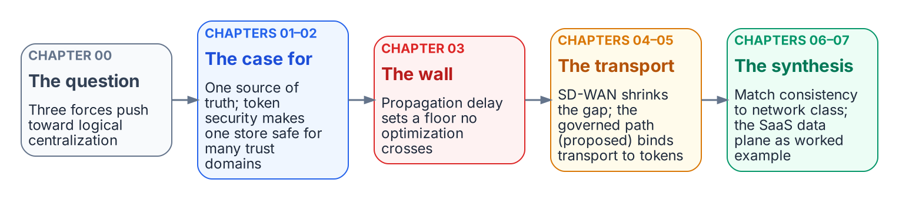
The chapters build one argument: the case for centralization, the physical wall, what transport can and cannot do, and the synthesis.
- 00 — Executive Summary — The Centralization Question
  - The pendulum, the three forces, and the wall that does not move
  - Audience: Executive stakeholders · architects · CISO
- 01 — Logical Centralization and the Single Source of Truth
  - Why fewer authoritative copies beats more, and how hardware ate the scaling objection
  - Audience: Architects · platform engineers · data owners
- 02 — Token-Based Security as the Enabler
  - How zero-trust identity removes the historical reason to fragment data
  - Audience: CISO · zero-trust practitioners · platform engineers
- 03 — The Speed-of-Light Tax
  - Propagation delay vs. everything else, and why strong consistency is a latency problem
  - Audience: Architects · network engineers · SRE
- 04 — SD-WAN and Differentiated Transport
  - Path classes, tail-latency reduction, FEC, and clock distribution for keeping large databases in sync
  - Audience: Network engineers · platform engineers · SRE
- 05 — The Governed Path — Token-Bound Transport and the Application-Aware Overlay
  - Forward-looking (Proposed, the program decision). Why an efficient edge device needs an identity-anchored fabric, and how the path becomes governed evidence
  - Audience: Network architects · zero-trust practitioners · platform engineers
- 06 — Matching Consistency Classes to Network Classes
  - The synthesis: aligning the data layer’s consistency model with the network layer’s transport tiers
  - Audience: Architects · platform engineers · network engineers
- 07 — Reference Architecture — the Federal Modernization Program SaaS Data Plane
  - How the program decision and the program decision implement centralize-the-truth / distribute-the-copies in practice
  - Audience: Architects · platform engineers · governance teams

Provenance
This white paper is an analysis document. Its FMP-specific claims trace to the canonical decision records they cite — principally the program decision (Azure SaaS architecture), the program decision (passwordless Entra Postgres auth), the program decision (GCC-Moderate boundary), and the program decision (diagram source-of-truth doctrine) under src/fmp/canon/adr/ — and, for the forward-looking Chapter 5, the Proposed the program decision (Application-Aware Networking and Token-Bound Transport) — and to the substrate operating principle of SSOT recorded in AGENTS.md and the program decision. Per the Federal Modernization Program provenance doctrine, external facts (networking physics, vendor behavior) are authoritative only where this document cites their source directly; where a claim rests on a Federal Modernization Program decision, the ADR is named inline.

A note on figures
This white paper uses no generative-AI raster figures and no inline Mermaid. Each figure is generated from a committed source in docs/images/diagrams/ssot-network-physics/ with the site’s shared diagram renderer (scripts/diagrams/render.py): SVG for the web, a 2x PNG for the Word edition.

Executive Summary — The Centralization Question

The question
For a decade the default answer to “where should the data live?” has been spread it out: every microservice owns its own database, every region gets its own store, and a single large SQL server is treated as a legacy embarrassment. That instinct is now worth re-examining. With wide-area networking that is both fast and application-aware, and with token-based security that travels identity with every request, is it more efficient to consolidate onto large, centralized database servers — to fight data drift and stay close to a single source of truth?
This white paper’s answer is a qualified yes, with one hard boundary set by physics. The qualification matters as much as the answer.

The three forces pushing toward consolidation
Force | What it removes | Consequence for data topology
Fat, application-aware WAN | The latency penalty that forced data to sit physically next to compute | You can centralize the system of record without the old performance tax — at least within a region.
Token-based (zero-trust) security | The need to fragment data behind network perimeters for isolation | One logical store can safely serve many trust domains; you no longer shard for security.
SSOT discipline | The reconciliation cost of many divergent copies | Fewer authoritative copies means less drift, fewer “which number is correct?” incidents, and a model one engineer can hold.
Each force is real, and together they justify pulling authority back toward the center. The microservices-era fragmentation created drift that the original gospel never budgeted for; consolidating the truth is a defensible, and increasingly common, correction.
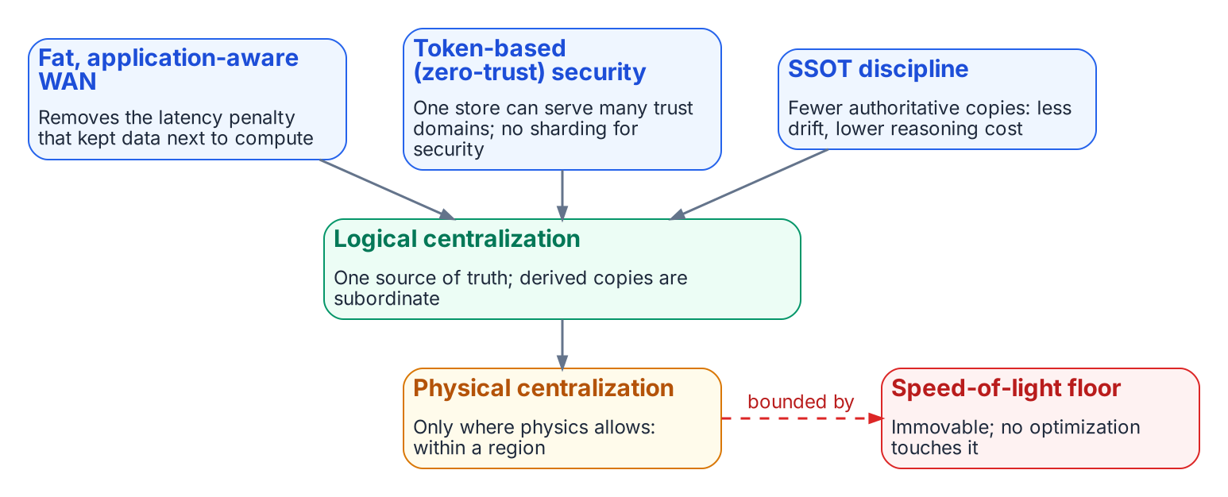
Three forces push toward logical centralization; physical centralization stops at the speed-of-light floor.

The distinction that prevents the trap
The single most important idea in this paper is the separation of two things that the word “centralize” carelessly fuses:

Logical centralization is good; physical centralization hits walls.
Centralize the truth — one authoritative source of record. Distribute the copies — read replicas, caches, edge stores — and keep them explicitly subordinate, derived, and disposable. A convenience copy must never be allowed to quietly promote itself to a source of truth. That promotion is where drift is born.
Physical centralization — one big server in one place — still runs into walls that no amount of clever networking removes:
- The speed of light. WAN got fast in bandwidth; it did not get fast in latency. Strong consistency across continents is a latency problem, and the propagation floor is fixed by distance.
- Blast radius. One central server is one outage, one bad migration, one noisy tenant away from taking everything down. Distribution is partly a failure-domain strategy, not only a performance one.
- Data residency and sovereignty. Some data legally cannot sit in one central place, regardless of how good the network is. This veto is political, not technical, so no technology removes it.

The wall, and the way around it
Chapters 3 and 4 confront the speed-of-light tax directly and ask what modern networking — specifically SD-WAN differentiated transport, which can steer latency-critical traffic onto a lean low-latency path while pushing bulk traffic onto a fat slower one — can actually do for keeping large databases in sync.
The honest finding: SD-WAN attacks the (usually large) gap between the latency you observe and the physical floor, and that gap is where most real-world sync pain lives. It cannot move the floor itself. The architecturally correct response, therefore, is not to make global synchronization fast — it is to need less of it: keep strong consistency inside a region where it is nearly free, and let everything that crosses a continent be asynchronous, eventually-consistent, or merge-friendly by design.

The Federal Modernization Program reference example
The Federal Modernization Program’s own SaaS data plane already embodies this doctrine, and the paper uses it as the worked example throughout:
- One shared, single-region PostgreSQL store is the tenant registry and system of record — logical centralization (the program decision).
- Passwordless, token-based authentication (an Entra access token used as the database password) makes that shared store safe to operate and removes the highest-value secret in the deployment (the program decision) — the enabler force made concrete.
- A control-plane “stamp” provisions dedicated, physically-isolated resources only for customers whose compliance posture requires it — the distribute-where-you-must escape hatch, kept as an exception rather than the default (the program decision).
- No global synchronous write path exists, on purpose — the Federal Modernization Program’s answer to the speed-of-light tax is to not span it synchronously in the first place.

How to read this paper
Chapter 1 makes the case for logical centralization and SSOT. Chapter 2 shows why token-based security is the keystone that makes consolidation safe on the data plane. Chapter 3 establishes the physics floor. Chapter 4 details what SD-WAN can and cannot buy a database tier. Chapter 5 — forward-looking, on the proposed the program decision transport plane — extends token-based security from data access to the network path itself, so “identity is the new boundary” holds on both planes. Chapter 6 unifies the data and network layers into a single design rule. Chapter 7 walks the Federal Modernization Program implementation end to end and names the one risk this whole bet imports.

Logical Centralization and the Single Source of Truth

The objection that no longer holds
The original case for fragmenting data into many small databases rested on two loadbearing claims: that a single server could not scale to the workload, and that independent services needed independent stores to deploy and fail independently. Both claims have weakened to the point of reversal.
Hardware ate the scaling objection. A single commodity server today carries dozens of cores, hundreds of gigabytes to multiple terabytes of RAM, and NVMe storage delivering millions of IOPS. A workload that demanded a sharded cluster a decade ago now fits comfortably on one node with headroom to spare. The overwhelming majority of organizations never outgrow a single well-provisioned database. Vertical scaling is now the correct first move, and frequently the only move ever needed.
The independence claim quietly imported a cost nobody priced. Every independent store is an independent copy of some shared truth — a customer record, a price, an entitlement — and every copy is a liability: a place to go stale, to diverge, to silently disagree. The microservices era treated those copies as free. They are not. They are paid for later, in reconciliation jobs, in eventual-consistency archaeology, and in incidents that begin with the sentence “which system has the right number?”

What a single source of truth actually buys
A single authoritative source of record is not merely tidier — it is cheaper to reason about, which is the scarcest resource in any large system.
Property | Many small stores | One logical source of truth
Cross-entity invariants | Enforced by application code and reconciliation, eventually | Enforced by the database — real foreign keys, real transactions
Joins across the data | Distributed query, fan-out, or duplicated data | A local JOIN
“Which value is correct?” | A judgment call, often an incident | Defined — there is exactly one
Drift surface | One per copy, multiplied by every replication path | Minimized to the derived copies you explicitly create
Mental model | N schemas and their interactions | One schema and its invariants
This is the heart of the Federal Modernization Program’s own operating doctrine. The substrate’s first operating principle is unambiguous: every claim has exactly one canonical source; all other representations are provenance-anchored pointers (see AGENTS.md operating principles and the program decision). Drift is not an accident to be mopped up; it is a named, first-class failure mode the architecture is built to prevent. Fewer authoritative copies is the most direct lever on that goal.
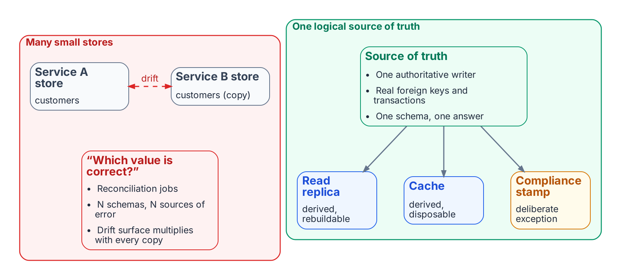
Many small authoritative stores drift; one logical source of truth keeps every other copy derived and subordinate.

Logical vs. physical: the distinction that does the work
“Centralize” hides two very different decisions, and conflating them is the single most common architectural error in this debate.

Two meanings of “centralize”
- Logical centralization — one source of truth. One place that is authoritative for a given fact; everything else derives from it. This is almost always good.
- Physical centralization — one server, one location. One machine that holds and serves all the data. This is sometimes good and often constrained by physics, blast radius, and law.
The goal is the first. The second is an implementation choice you make only as far as it is safe and cheap, and back away from the moment physics, failure domains, or data-residency law push back (Chapters 3 and 7). You can have one logical source of truth that is physically replicated across three regions for durability — that is still SSOT, because exactly one of those copies is authoritative for writes and the others are explicitly subordinate.

Small databases are not dead — they are repurposed
The provocative framing — “the era of small SQL servers is over” — is precise only when narrowed: it is the era of small SQL servers as sources of truth that is ending. Small databases are flourishing in two repurposed roles:
- As disposable accelerators. Read replicas, caches, materialized edge stores. These are derived and rebuildable — explicitly not authoritative — so they cannot drift authoritatively. You can blow one away and regenerate it from the source of truth. (How to keep them current across distance is exactly the SD-WAN question of Chapter 4.)
- As compliance-stamped exceptions. Where a customer’s regulatory posture demands hard physical isolation, a dedicated small store is provisioned for that tenant. The Federal Modernization Program implements precisely this as the control-plane “stamp” pattern (Chapter 7, the program decision) — the exception, not the default.
Meanwhile the small-database movement is expanding, not contracting: SQLite-at-the-edge patterns push SQL smaller and closer to the application than ever — but as derived, near-cache copies, which is the opposite of a distributed source of truth. The direction of travel confirms the thesis rather than refuting it: truth consolidates; convenience copies proliferate.

Where drift is actually born
The deepest reason to centralize the truth is behavioral, not technical. Drift rarely originates in the database engine. It originates when a team, finding the central store too slow or too restricted to reach, creates an unofficial local copy “just for performance” — and that copy slowly diverges into a shadow source of truth nobody blessed.
This reframes the whole problem. The way to stay near SSOT is to remove the incentive to fragment: make the central source of truth fast enough and frictionless enough to reach that no one is tempted to fork it. That is exactly what the next two forces deliver — token-based security removes the access friction (Chapter 2), and application-aware networking removes the latency friction (Chapter 4). Centralization of truth is sustained not by policy but by making the centered path the path of least resistance.

Summary
- Hardware has removed the scaling objection for the vast majority of workloads; scale up before you scale out.
- A single source of truth is cheapest where it counts most — in the cost of reasoning about the system and the absence of drift.
- Separate logical centralization (one truth — almost always right) from physical centralization (one server — sometimes constrained).
- Small databases survive as disposable caches and compliance-stamped exceptions, not as competing sources of truth.
- Drift is born from unofficial convenience copies; the cure is to make the central truth the path of least resistance — the job of Chapters 2 and 4.

Token-Based Security as the Enabler

Why this is the keystone
Chapter 1 made the case for consolidating the source of truth. But there is a reason the industry fragmented data in the first place that had nothing to do with scale: isolation by perimeter. When the only way to enforce “who may touch this data” was network segmentation, the safest way to separate two trust domains was to give them separate databases behind separate network boundaries. Security, not performance, drove a great deal of the fragmentation — and no hardware advance addresses it.
Token-based, identity-centric (zero-trust) security is what dissolves that reason. It is the keystone of the whole consolidation argument: without it, you are forced back into per-domain physical isolation for safety, and the single-source-of-truth story collapses. With it, one logical store can serve many trust domains safely, because the trust boundary travels with the request rather than living in the network.

The shift: from perimeter to identity
Dimension | Perimeter model | Token / zero-trust model
Where trust lives | In the network location of the caller | In a signed, verifiable claim the caller presents
Unit of isolation | A network segment (and often a separate datastore) | A verified identity, scoped per request
Default posture | Trust inside the perimeter | Trust nothing; verify every request
Effect on data layout | Encourages a store per trust domain | Permits one store across many trust domains
Highest-value secret | Long-lived credentials guarding the perimeter and the database | None — short-lived tokens, minted on demand
The consequence for data architecture is direct: you no longer shard for security. Two customers, two business units, two classification levels can share a logical store when every request carries a cryptographically verifiable statement of who is asking and what they are entitled to, and the store enforces scoping on that statement.
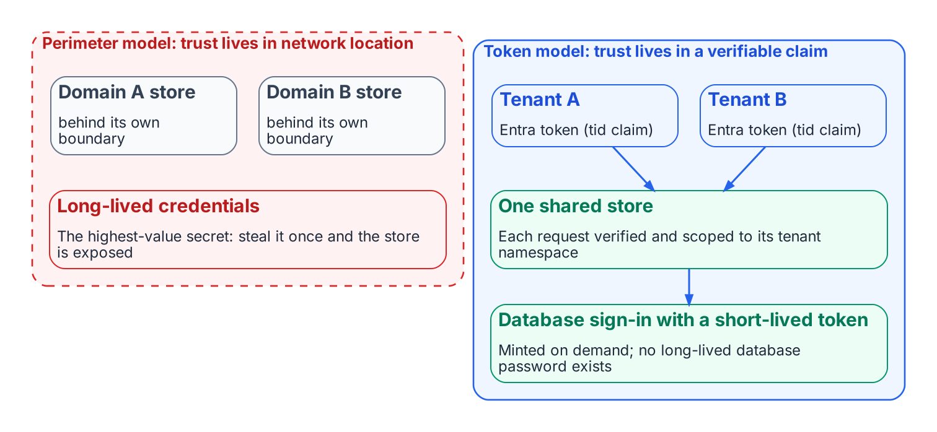
The perimeter model needs a store per trust domain; the token model lets one store serve many.

How the Federal Modernization Program makes this concrete
The Federal Modernization Program’s SaaS plane is a working instance of this principle on both sides of the connection — inbound (who is calling the service) and outbound (how the service authenticates to its own database).

Inbound: identity travels with the request
Many different customer Microsoft Entra tenants are governed by one operated The Federal Modernization Program service. Requests arrive bearing Entra access tokens minted by different tenants. The data plane verifies each token’s signature against the issuing tenant’s published keys (JWKS, RS256), reads the tenant identity from the token’s tid claim, and binds a tenant context for the life of the request (the program decision). One shared, elastically-scaled data plane serves every customer — and the isolation is enforced because the identity of the tenant is proven on every single call, not assumed from a network location.

Outbound: the database password disappears
The sharper demonstration is how the service authenticates to its own PostgreSQL store. Under the program decision, the Federal Modernization Program uses passwordless authentication: Azure Database for PostgreSQL Flexible Server accepts a short-lived Entra access token as the connection password. The service’s managed identity is bound as the database’s Entra administrator, so the application connects with no long-lived database password at all.

The highest-value secret is removed, not protected
A stored database password is the single most valuable secret in a typical deployment — steal it once and the central store is exposed. Token-based auth does not guard that secret better; it eliminates it. The connection is authorized by a token that is minted on demand, scoped to the database audience, cached only briefly, and refreshed before expiry. There is nothing durable to steal. (The Federal Modernization Program: fmp.saas.pg_auth, the program decision.)
Mechanically, a token provider acquires an access token scoped to the OSSRDBMS audience for the correct sovereign cloud, caches it, and refreshes it shortly before expiry so token acquisition stays off the hot path of every connection while a near-expired token is never presented. The same connection seam is provider-agnostic: an Entra token provider on Azure and an RDS-IAM token provider on AWS both satisfy it, so passwordless auth works identically across clouds.

Why this makes centralization safe, not merely possible
The combination of inbound token verification and outbound passwordless auth changes the risk calculus that originally justified fragmentation:
- No perimeter to breach into a shared trust zone. Every request re-proves identity; there is no “inside the firewall” where a single foothold yields ambient access to all tenants’ data.
- No long-lived database credential to exfiltrate. The classic “one leaked connection string compromises everything” failure mode is designed out.
- Per-request scoping replaces per-store isolation. A tenant’s reach is bounded by its verified identity on each call, so one store can hold many tenants without that being a security downgrade relative to many stores.
This is the precise sense in which token security earns the right to centralize. The shared source of truth is not safe despite being shared; it is safe because the security model moved from the network to the identity.
That same move — a credential minted per event rather than a durable secret or a standing session — applies one layer down, to the network path the request rides on. Chapter 5 (forward-looking, on the proposed the program decision transport plane) carries token-based security from data access onto the transport plane, so “identity is the new boundary” holds end to end rather than only at the store.

The friction it removes — and the drift that follows
Chapter 1 argued that drift is born when teams create unofficial local copies because the central store is too hard to reach. Token-based security attacks the “too restricted to reach” half of that friction directly. When access is a matter of presenting the right scoped identity — rather than being granted a network path, a firewall exception, and a shared secret — the central store becomes easier to reach than standing up a private copy. Removing access friction removes the incentive to fork, which removes the drift at its source. Security, counter-intuitively, becomes a centralization enabler rather than a fragmentation driver.

The residual constraint
Token security removes the security reason to fragment. It does not remove the legal one. Data-residency and sovereignty rules can still require that certain data physically reside in a certain place or boundary, and no identity model overrides a regulator. The Federal Modernization Program handles this not by fragmenting the default plane but by provisioning a dedicated, physically-isolated stamp for the customers who require it (Chapter 7, the program decision), and by carrying sovereign-cloud token audiences explicitly in the auth layer (the OSSRDBMS scope differs for US Government clouds; the program decision, the program decision). The default stays centralized and safe; the exception is provisioned deliberately, with its own boundary.

Summary
- Much historical data fragmentation was driven by security through perimeter, which no hardware advance addresses.
- Token-based, zero-trust security moves the trust boundary from the network into a verifiable, per-request identity, so one store can serve many trust domains.
- The Federal Modernization Program realizes this on both sides: inbound tid-claim verification per request (the program decision) and outbound passwordless Postgres auth that removes the highest-value secret entirely (the program decision).
- This makes centralization safe, not merely possible — and it removes the access friction that drives teams to create drift-prone shadow copies.
- The one reason to fragment that survives is legal residency, handled as a deliberate stamped exception rather than as the default.

The Speed-of-Light Tax

The wall that does not move
Everything in the preceding chapters pushes toward consolidation, and within a single region the case is close to unanswerable. Stretch the same store across continents to keep a globally-synchronous source of truth, and you hit a wall that no networking technology, present or future, moves: the speed of light.
This chapter establishes that floor precisely, because the rest of the paper — and any honest claim about what SD-WAN can do — depends on separating the part of latency that is negotiable from the part that is not.

Two latencies, added together
Wide-area round-trip time is the sum of two components with completely different physics:
Component | What it is | Can engineering reduce it?
Propagation delay | Time for the signal to physically travel the distance, at the speed of light in fiber | No. Fixed by distance on the chosen path.
Everything else | Queueing, congestion, jitter, packet loss → retransmits, and circuitous (non-geodesic) routing | Yes — often dramatically. This is the entire addressable surface.
The first component is a tax levied by physics. The second is the gap between the latency you observe and that physical floor — and on a congested or badly-routed path that gap is frequently 2× to 10× the floor itself. The single most important framing in this paper is:

Optimization attacks the gap, never the floor.
Every networking technique discussed in Chapter 4 — SD-WAN path selection, forward error correction, jitter smoothing, clock distribution — operates on the “everything else” component. None of them reduces propagation delay by a single microsecond. The wins are real because the gap is usually large, but the floor stays exactly where distance puts it.

The numbers
Light in optical fiber travels at roughly two-thirds of its vacuum speed — about 200,000 km/s, or ≈ 5 microseconds per kilometer, or roughly 1 millisecond per 200 km, one way. That yields hard floors that no optimization can beat:
Path (approx. great-circle) | One-way propagation floor | Round-trip floor
Within a metro (~50 km) | ~0.25 ms | ~0.5 ms
Cross-region, same continent (~1,000 km) | ~5 ms | ~10 ms
New York ↔ London (~5,600 km) | ~28 ms | ~56 ms
New York ↔ Singapore (~15,300 km) | ~77 ms | ~153 ms
These are minimums assuming a perfectly straight fiber path. Real paths are longer — internet routes commonly run 1.5× to 3× the great-circle distance — so observed propagation alone is typically well above these figures before any congestion is added. Optimization can claw back the routing excess (Chapter 4); it cannot go below the straight-line floor.
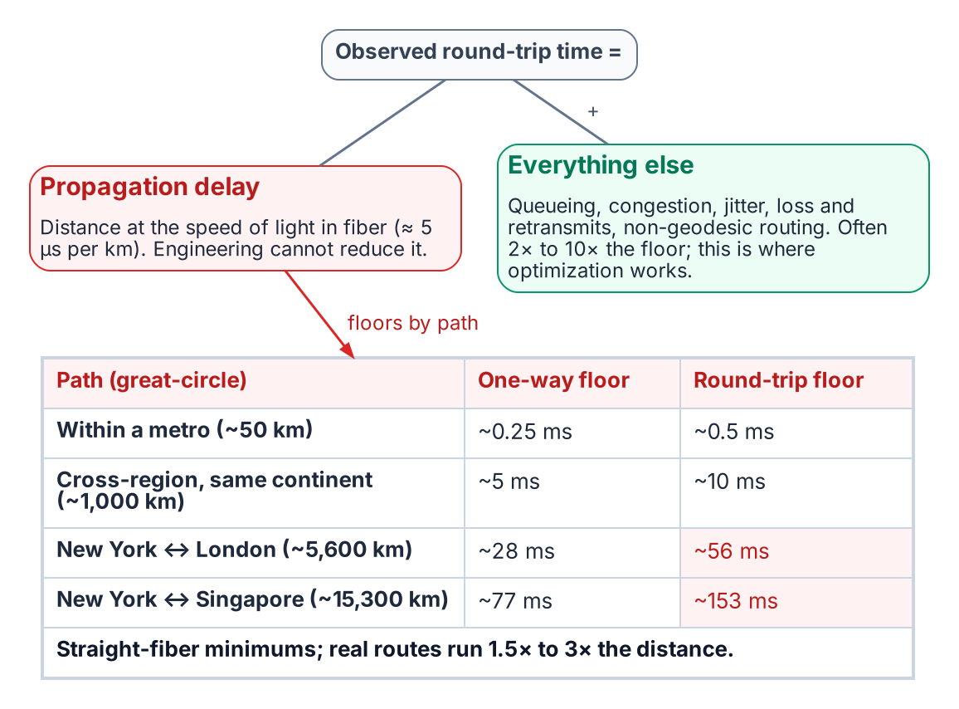
Observed latency is an immovable propagation floor plus an addressable gap; the floors for four paths.

Why strong consistency is a latency problem, not a bandwidth one
The crucial insight for database architecture is that strong consistency spends round trips, and round trips are priced in latency, not bandwidth.
WAN bandwidth has grown enormously — moving terabytes between continents is routine. But a strongly-consistent, synchronous commit does not need bandwidth; it needs agreement, and agreement requires messages to travel to other nodes and back:
- A synchronous commit that must be durable on a remote replica pays at least one round trip before it can acknowledge — every time.
- A consensus protocol (Paxos, Raft) committing through a quorum typically pays one to two round trips to the quorum members, and is gated by the slowest member it must hear from.
Across New York and London, that is a floor of ~56 ms per synchronous commit, multiplied by every dependent operation in a transaction. No amount of fat pipe changes it, because the limiting resource is the time for light to make the trip, not the volume of data in flight.

Tail latency: the part that actually hurts
There is a subtler reason distributed consistency suffers, and it sharpens what Chapter 4 must target. Because a quorum commit waits for the slowest response it needs, commit latency is governed by a tail statistic — the p99, not the average. A path can have an excellent mean and still inflict terrible commit latency if its tail is ugly, because every so often the one packet the quorum is waiting on is the one that got queued, dropped, and retransmitted.
This matters because the “everything else” component — congestion, loss, jitter — is precisely what inflates the tail, while propagation delay is constant and therefore tail-neutral. So the addressable part of WAN latency is also the part that disproportionately damages distributed databases. That is the opening Chapter 4 exploits.

What follows for architecture
Two conclusions fall directly out of the physics, and the rest of the paper builds on them:
- Keep strong consistency inside a region. At metro and intra-continental distances the propagation floor is sub-millisecond to a few milliseconds — synchronous consistency is effectively free there. This is why the Federal Modernization Program’s single-region writer (Chapter 7) is not a limitation but a deliberate exploitation of the physics.
- Across regions, stop spending round trips. The win is not a faster synchronous path — physics caps that — but an architecture that requires fewer synchronous crossings: asynchronous replication, bounded staleness, and merge-friendly data types (Chapter 6).
SD-WAN, the subject of the next chapter, lives entirely inside the gap between observed latency and the floor. Understanding that it operates there — and only there — is what lets us state precisely what it can and cannot do for keeping large databases in sync.

Summary
- WAN latency is propagation delay (fixed by distance, ~5 µs/km) plus everything else (congestion, loss, jitter, routing excess).
- Optimization addresses only the second component; the propagation floor is immovable. NY↔London is ~56 ms round-trip, minimum, forever.
- Strong consistency spends round trips, so it is a latency problem; fat bandwidth does not help it.
- Commit latency in a quorum is a tail statistic, and the tail is inflated by exactly the addressable (non-propagation) component — which is why network optimization can still help meaningfully.
- The architectural response: keep strong consistency intra-region; minimize synchronous crossings between regions.

SD-WAN and Differentiated Transport

The question, stated precisely
Software-defined WAN can select among multiple underlay paths per traffic class: it can steer latency-sensitive traffic onto a lean, low-latency, low-jitter path while pushing bulk traffic onto a fatter but slower or cheaper one. Can this help large databases stay in sync, and can it assist with the speed-of-light problem through optimization?
The answer, grounded in Chapter 3: yes, meaningfully — but only inside the gap between observed latency and the physical floor. SD-WAN never moves the floor. Because the gap is usually large and disproportionately damages distributed databases (it inflates the commit-latency tail), operating there is high-value. Overstating it as “beating the speed of light” is the error to avoid.

SD-WAN as the network mirror of consistency classes
The instinct to split traffic into a low-latency class and a bulk class is exactly right, because it maps one-to-one onto what a database actually emits:
Traffic class | Database traffic it carries | Wants | Best path
Lean / low-latency | Consensus heartbeats, leader election, synchronous-commit quorum acknowledgements, clock synchronization | Minimum RTT, minimum jitter | Shortest, least-congested path; small packets
Fat / bulk | Base snapshots, backups, re-sync after a partition, analytics replication, asynchronous log shipping | Maximum throughput, cost efficiency | High-bandwidth path; latency-tolerant
This is differentiated transport per traffic class, and it is the network layer’s reflection of a decision the data layer is already making — what must be strongly consistent versus what can be eventually consistent (Chapter 6). When the two agree, you get the best synchronization physics permits.
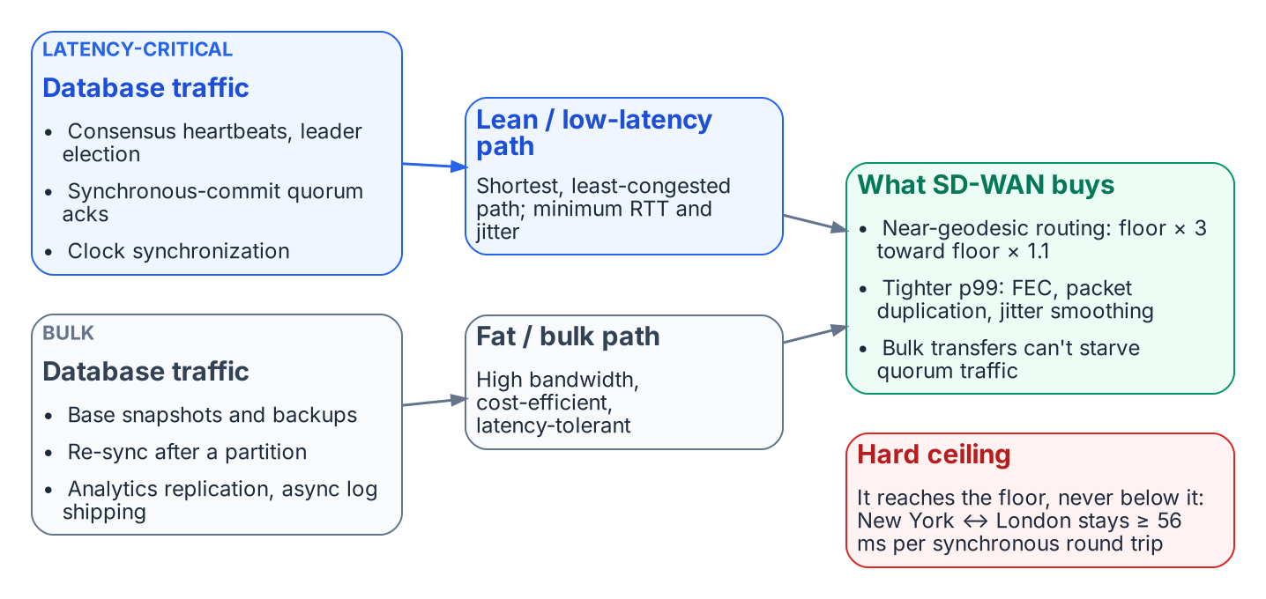
SD-WAN carries each class of database traffic on the path built for it, down to the floor but never below it.

What SD-WAN genuinely buys a database tier

1. Steering and near-geodesic routing
Internet paths routinely run 1.5×–3× the great-circle distance. SD-WAN, by choosing a better underlay (or a premium backbone) and steering the latency-critical class onto it, reclaims much of that routing excess — moving observed propagation from “floor × 3” toward “floor × 1.1.” That is a pure win against the addressable part of latency, with no consistency trade-off.

2. Crushing the tail, not just the average
This is the underrated, highest-leverage effect. Recall from Chapter 3 that a quorum commit waits for the slowest member it must hear from, so commit latency is a tail (p99) statistic — and the tail is inflated by loss, congestion, and jitter, not by propagation. SD-WAN targets the tail directly:
- Forward error correction (FEC): send redundant repair data so a lost packet is reconstructed at the receiver without waiting for a retransmit. This trades bandwidth for latency — and for a quorum gated by the unluckiest packet, eliminating retransmit waits can cut p99 commit latency far more than shaving the mean ever could.
- Packet duplication across two paths: send the latency-critical packet on two diverse paths and take whichever arrives first; the slow or lossy path no longer determines the tail.
- Jitter smoothing and sub-second path failover: move traffic off a browning-out path before TCP’s own loss detection reacts.

The leverage point
Distributed-database performance is a tail problem; SD-WAN’s loss/jitter mitigations are tail tools. The match is exact. A path can go from “floor × 3 with an ugly tail” to “floor × 1.1 with a tight tail” — a large, real improvement in how well replicas stay in sync — without anyone violating physics.

3. Protecting sync traffic from bulk traffic
A re-sync or a backup can saturate a link and inflict queueing delay on the small, latency-critical consensus packets sharing it — self-inflicted tail latency. Class separation ensures the bulk transfer cannot starve or delay the heartbeats and commit acks. The database stays in sync during exactly the heavy-transfer events that would otherwise destabilize it.

The clock angle: optimization that assists physics directly
There is a second, independent way networking helps — and it is the closest thing to genuinely assisting the speed-of-light problem rather than merely approaching the floor. It runs through time, not distance.
A low-latency, low-jitter path is also the best path to distribute a clock. Precision time protocols degrade with path asymmetry and jitter, not with raw distance, so the same lean class that carries consensus traffic also carries high-quality clock synchronization. And tight clock sync enables an architecture that replaces network round trips:

Trading network coordination for bounded clock uncertainty
Google Spanner’s TrueTime orders transactions using globally synchronized clocks (GPS and atomic references) with a small, bounded uncertainty. Instead of an extra cross-continent round trip to agree on transaction order, Spanner waits out a short “commit-wait” interval sized to its clock uncertainty. The latency bound becomes clock error, not network RTT — and clock error is kept tiny. (Source: Corbett et al., “Spanner: Google’s Globally-Distributed Database,” OSDI 2012.)
This is the deepest version of the user’s question. You cannot make light faster, but you can make the database need fewer trips through it by spending clock certainty instead of network round trips. The lean SD-WAN class is what makes the clock certain enough to do so — so SD-WAN assists the speed-of-light problem not by reducing propagation, but by enabling a design that propagates less often.

The hard ceiling, restated
For all of that, one boundary is immovable and must be stated plainly:

SD-WAN gets you to the floor with a tight tail. It never gets you below it.
A synchronous, strongly-consistent commit across continents pays at least one round trip, every time — ~56 ms for New York ↔ London, no matter how clever the network. SD-WAN removes the excess over that floor and tames the tail; the floor itself is the speed-of-light tax on strong consistency, and it is non-negotiable.
Therefore SD-WAN does not change the correct architectural conclusion from Chapter 3 — it enables it. The right move remains “need less global sync,” and SD-WAN’s contribution is to make the synchronization you do keep cheaper, more reliable, and tighter in the tail, while making asynchronous bulk replication efficient on its own dedicated path.
SD-WAN supplies the path; it does not, by itself, govern the path. Chapter 5 (forward-looking) takes the next step — making the chosen path identity-anchored and token-bound, so the network carrying the data is held to the same per-call standard as access to the data itself.

Summary
- SD-WAN’s low-latency / bulk path split is the network-layer mirror of the data layer’s strong-vs-eventual consistency split; align them.
- It buys three things: near-geodesic routing, tail-latency reduction (FEC, packet duplication, jitter smoothing — which match the database’s tail-gated commit behavior), and protection of sync traffic from bulk transfers.
- The lean path also distributes high-quality time, enabling clock-based concurrency (Spanner/TrueTime) that replaces network round trips with bounded clock-wait — the one technique that genuinely sidesteps propagation.
- It cannot move the floor: a cross-continent synchronous commit still pays at least one RTT. SD-WAN takes you to the floor with a tight tail, never below.
- Net: it enables the “need less global sync” architecture rather than overturning it.

The Governed Path — Token-Bound Transport and the Application-Aware Overlay

Forward-looking chapter — proposed direction, not yet ratified
This chapter rests on the program decision (Application-Aware Networking and Token-Bound Transport Plane), whose status is Proposed. Unlike the Accepted decisions that anchor the rest of this paper (the program decision, the program decision), the transport-plane model here is canon direction with implementing specifications — FMP_122 (Token-Based Transport Authorization), FMP_123 (Application-Aware Overlay Fabric Model), FMP_124 (Transport Plane Telemetry Contract) — still open. Read it as where the architecture is going, not where it has arrived.

The other half of “identity is the new boundary”
Chapter 2 established the keystone of consolidation: token-based security lets one logical store serve many trust domains because the trust boundary travels with the request. That argument was about the data plane — who may touch the data. This chapter applies the identical principle to the transport plane — the network path the request rides on — and shows that the two are the same idea wearing different clothes.
The Federal Modernization Program’s own doctrine names the gap precisely. Identity has become the root of trust and the addressing model, but, in the program decision’s words, “identity is the new boundary, but only halfway”: the transport that carries identity-derived claims is still session-based — “a TLS connection establishes once, then rides for minutes-to-hours carrying intent the issuer can no longer attest to” (the program decision §Context #2). The data plane re-proves identity on every call; the transport plane proves it once and coasts. That asymmetry is the subject of this chapter.

The unified thesis
“Identity is the new boundary” must hold on both planes. Chapter 2 anchored the data plane with token-bound access — a fresh, scoped credential per call. This chapter anchors the transport plane with token-bound transport — a fresh, scoped credential per path. A centralized source of truth reached over an ungoverned, session-trusted network is only half-secured: the front door is identity-checked while the hallway is not.

The efficient edge device is necessary but not sufficient
Consider a perfectly tuned edge device: identity-anchored, telemetry-emitting, policy-compliant — everything the endpoint control plane asks for (control-planes.yml, Endpoint plane). Land it on a flat, non–application-aware datacenter LAN and its efficiency is bounded by the fabric it lands on. The device is optimized in isolation while its traffic is undermined in three concrete ways.
# | What the flat LAN lacks | Canon | Consequence for the edge device
1 | Local breakout / Cloud OnRamp — app-aware path selection, local_breakout, optimal_path_selection | control-planes.yml (Network plane, cloud_onramp) | Traffic is backhauled/hairpinned through a central perimeter — the TIC3 / F5 choke-point being retired. The device’s efficiency is spent on the detour.
2 | INR — Identity-aware Routing — the convergence point where identity, telemetry, and routing unify; requires: [telemetry_plane, ipam_plane] | control-planes.yml (INR) | A flat LAN treats every flow identically. It cannot do per-user / per-app path selection or zero-trust segmentation, so the device’s identity signals have nowhere to land.
3 | Per-call authorization — trust scoped to a single intent | the program decision §Context #2 | Trust collapses into a long-lived session: authorize once, ride for hours. Hijacking the session inherits its trust — exactly the antipattern the program decision exists to retire.
The pattern is the same each time: the edge device emits high-quality identity, posture, and application context, and a flat Layer-3/4 LAN throws it all away. The substrate is left able to govern what runs and who runs it, but not how it gets there — and that blind spot surfaces as DRIFT-AUTHZ findings the substrate cannot explain, because the transport context is invisible (the program decision §Context).
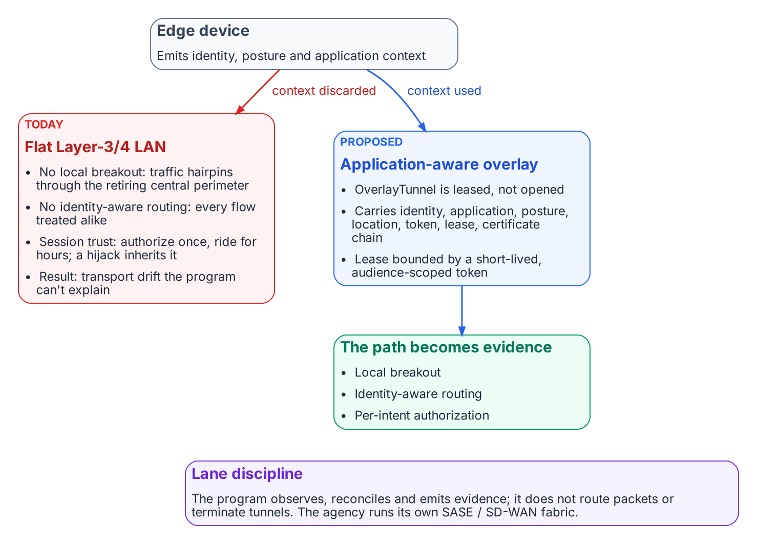
A flat LAN discards the edge device’s context; the proposed application-aware overlay turns it into a governed path.

What the device actually needs: an application-aware overlay
The requirement is not “a faster LAN.” It is an application-aware overlay fabric in which the path is a typed, identity-anchored, governed object. the program decision promotes FMP_001’s tunnel abstraction from concept to schema as the OverlayTunnel:

The OverlayTunnel (the program decision §Decision #3)
An OverlayTunnel carries {identity, application, posture, location, token, lease, certificate-chain}. Tunnels are leased, not opened — the lease is bounded by token lifetime, and the canonical record is provenance-anchored to SSOT. The authorizing token is short-lived and audience-scoped, bound to caller identity + target application + device posture + organizationally derived location (the program decision §Decision #2). A “session” — any long-lived authorization context that survives a single authorized intent — ceases to be a canonical concept.
This is precisely the data-plane move of Chapter 2, transposed onto the network. There, the database password was replaced by a freshly-minted, audience-scoped token per connection. Here, the open session is replaced by a freshly-leased, audience-scoped tunnel per path. In both cases the durable, hijackable artifact — the stored password, the long-lived session — is removed, and authorization becomes a per-event, identity-bound act.
The “SD-WAN / SDN” part is only the mechanism — vManage/vSmart/vBond and WAN edges (overlays/cisco/sd-wan.yml), SASE/ZTNA from the TIC3 retirement roadmap. The requirement is application-awareness plus token-bound transport. On that fabric the edge device’s efficiency is finally realized, and the path itself becomes governed evidence rather than an invisible Layer-3/4 detail.

A flat LAN is a drift generator, not neutral ground
The sharpest consequence for a governance substrate: a non-optimized LAN that stays flat does not merely run slower — it manufactures drift. the program decision proposes a sixth drift class, DRIFT-TRANSPORT, joining the substrate’s existing five (DRIFT-SCHEMA, DRIFT-SEMANTIC, DRIFT-PROVENANCE, DRIFT-AUTHZ, DRIFT-IDENTITY). Under it, an OverlayTunnel or flow observed without an issuing token is a finding (P2), as is path-policy variance between the canonical organizational/location binding and the observed flow (P4). The flat LAN is therefore not a neutral substrate the edge device merely fails to exploit — from the substrate’s point of view it is an active source of transport drift.
This closes the loop with Chapter 1’s deepest claim: drift is born where the governed path is the path of most resistance and an ungoverned shortcut exists. A flat, session-trusted LAN is that ungoverned shortcut, one layer down from the shadow-copy problem — the network equivalent of an unofficial local database nobody blessed.

Lane discipline: The Federal Modernization Program governs the fabric, it does not become it
One boundary must be stated as plainly here as the speed-of-light floor was in Chapter 3. The Federal Modernization Program’s stake in “land the device on an application-aware overlay” is governance, not packet-forwarding. Per the program decision’s lane discipline (§“what the Federal Modernization Program does NOT become”), transport adapters observe, reconcile, and emit evidence — they do not route packets or terminate tunnels. The decision is explicitly doctrinal, not implementation-prescriptive: it picks no token format (SPIFFE vs PASETO), no SD-WAN vendor, and does not put the Federal Modernization Program in the data plane. The agency operates whatever SASE/SD-WAN fabric it likes; the Federal Modernization Program requires only that the fabric be application-aware and token-bound, so the edge device’s identity / application / posture / location can drive routing and per-call authorization — and so the path becomes auditable evidence.
The relationship is exactly that of an identity to Conditional Access. Without the governed overlay, the efficient edge device is optimized in isolation, its traffic backhauled through a perimeter being retired, and its trust riding a long-lived session the substrate cannot see.

Summary
- “Identity is the new boundary” must hold on the transport plane as well as the data plane; today it holds “only halfway” (the program decision §Context #2).
- An efficient edge device is necessary but not sufficient — its efficiency is bounded by the fabric it lands on. A flat LAN undermines it three ways: no local breakout / Cloud OnRamp, no identity-aware routing (INR), and trust that collapses into a long-lived session.
- The requirement is an application-aware overlay where the path is a typed OverlayTunnel — leased, not opened, bounded by a short-lived, audience-scoped token (the program decision §Decision #2–3). SD-WAN/SASE is the mechanism; application-awareness + token-bound transport is the requirement.
- A flat LAN is a DRIFT-TRANSPORT generator (P2/P4), not neutral ground.
- The Federal Modernization Program governs the fabric and emits evidence; it does not route packets. The whole model is Proposed (the program decision), with FMP_122/123/124 as the open verification items.

Matching Consistency Classes to Network Classes

The single design rule
The previous chapters converge on one rule that ties the data layer and the network layer together:

Align consistency class with transport class.
The data layer’s question — what must be strongly consistent versus what can be eventually consistent — is the same question, viewed from the other side, as the network layer’s — what rides the lean low-latency path versus the fat bulk path. When those two decisions agree, you get the best synchronization physics permits. When they disagree, you pay for it.
A mismatch is expensive in both directions. Putting strong-consistency traffic on the bulk path inflicts the bulk path’s latency and tail on your commits. Putting trivial asynchronous replication on the premium low-latency path wastes the scarce resource that your consensus quorum actually needs. The architecture works when each class of data rides the class of transport built for it.

The mapping
Data need | Consistency model | Network class | Crosses regions synchronously?
Authoritative writes to the source of truth | Strong / serializable | Lean, low-latency | No — kept intra-region
Quorum durability across nearby zones | Synchronous replication | Lean, low-latency | Within a region only
Cross-region durability / disaster recovery | Asynchronous replication | Fat, bulk | No — async by design
Read-mostly access far from the writer | Bounded staleness / read replica | Fat, bulk (refresh) | No
Multi-writer collaborative data | Causal / CRDT merge | Fat, bulk | No — merges, not round trips
Analytics / reporting | Eventual | Fat, bulk | No
The pattern is stark: only the top two rows ride the lean path, and neither of them crosses a region synchronously. Everything that spans distance is asynchronous and rides the bulk path. That is the physics of Chapter 3 made into a layout.
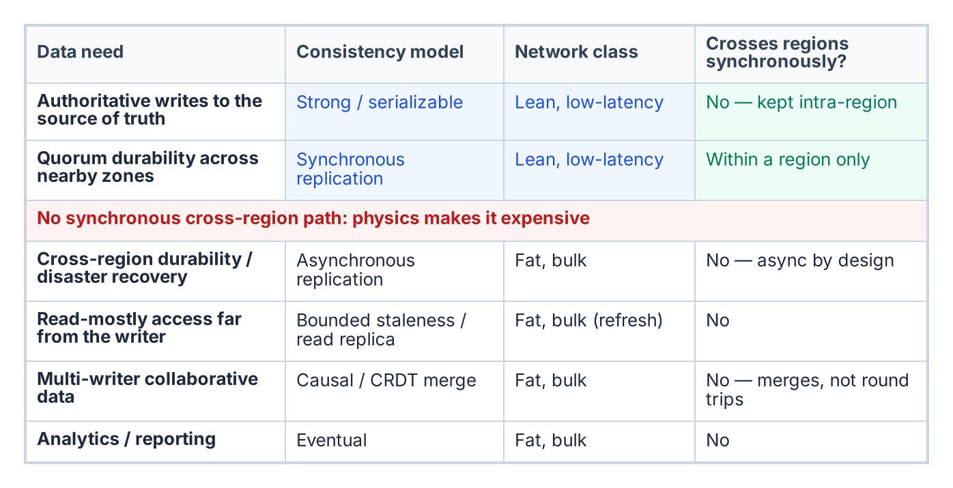
Only intra-region flows need the lean path; everything that crosses regions is asynchronous on the bulk path.

Techniques for needing less global synchronization
Chapter 3 concluded that the architectural goal across regions is to need fewer synchronous crossings. These are the concrete techniques, each of which moves a workload off the lean cross-region path it cannot afford:
- Strong within a region, asynchronous across regions. At metro and intra-continental distances the propagation floor is sub-millisecond to a few milliseconds, so synchronous consistency is effectively free. Confine the single-writer source of truth and its quorum to one region; replicate to other regions asynchronously. This is the default for the overwhelming majority of systems, and it is the Federal Modernization Program’s choice (Chapter 7).
- Bounded staleness instead of strict global serializability. Where the business tolerates reads that are a known, small interval behind, you replace a cross-region read round trip with a local read from a slightly-stale replica. The staleness bound is a contract, not an accident.
- Causal consistency. Preserve cause-and-effect ordering without paying for total global ordering — far cheaper across distance, and sufficient for a large class of application semantics.
- Conflict-free replicated data types (CRDTs). For genuinely multi-writer data, CRDTs let independent replicas accept writes locally and merge deterministically, so cross-region traffic becomes a mergeable bulk-path update rather than a coordination round trip. (Source: Shapiro et al., “Conflict-free Replicated Data Types,” 2011.) Distance stops being a per-operation latency tax.
- Witness / learner replicas placed by path. Put voting quorum members on the lean, low-latency links so quorum is decided by your fastest paths, while non-voting learner replicas on the bulk path provide cross-region durability and read scale without dragging the quorum across a continent.
- Clock-based concurrency (Spanner/TrueTime). Where strong cross-region semantics are genuinely required, spend bounded clock uncertainty instead of network round trips (Chapter 4), and carry the clock on the lean class.

A decision procedure
For any given dataset, the layout falls out of three questions answered in order:
- Does this data have one source of truth? It should (Chapter 1). Identify the single authoritative writer. Everything else is a derived copy.
- What is the weakest consistency the business actually tolerates for each reader and writer? Not the strongest you can imagine needing — the weakest that is still correct. Strong only where required; bounded-stale, causal, or eventual everywhere it suffices.
- For each flow, which transport class matches? Strong/synchronous flows take the lean path and stay intra-region. Everything that crosses a region takes the bulk path and is asynchronous or merge-based.
The output is a data-and-network layout in which the lean path carries a small volume of latency-critical, intra-region consensus and clock traffic, and the bulk path carries everything that spans distance — which is, by design, latency-tolerant.

The risk this synthesis imports
Aligning the layers this way concentrates correctness into a small number of places, and honesty requires naming the cost. When you centralize the source of truth and enforce tenant or domain isolation in code (per-request identity scoping, Chapter 2) rather than by physical separation, the blast radius moves into that code path. A bug in tenant resolution or namespace scoping is no longer a contained, single-tenant fault — it is a potential cross-tenant data exposure. This is the unavoidable trade of the whole consolidation bet: you exchange the failure-domain isolation of many physical stores for the simplicity and drift-resistance of one logical store, and in return you owe that shared correctness path disproportionate engineering rigor — small, heavily tested, and fail-closed. Chapter 7 shows where exactly that path lives in the Federal Modernization Program.
A parallel obligation applies to the network classes themselves: the lean and bulk paths are not merely selected but must be governed — token-bound and auditable — or the transport layer becomes its own drift surface. Chapter 5 (forward-looking) develops that requirement.

Summary
- One rule unifies the paper: align the data layer’s consistency class with the network layer’s transport class.
- Only authoritative writes and intra-region quorum durability ride the lean path; everything that crosses a region is asynchronous on the bulk path.
- The toolkit for “needing less global sync” is concrete: strong-local/ async-remote, bounded staleness, causal consistency, CRDTs, path-placed witnesses, and clock-based concurrency.
- A three-question decision procedure (one source of truth → weakest tolerable consistency → matching transport) produces the layout.
- The bet concentrates correctness into the shared isolation path; that path must be small, tested, and fail-closed — examined next in the Federal Modernization Program.

Reference Architecture — the Federal Modernization Program SaaS Data Plane

Why the Federal Modernization Program is the worked example
The preceding chapters argued a doctrine: centralize the truth, distribute the copies, let token security make centralization safe, and refuse to span the speed of light synchronously. The Federal Modernization Program’s multi-tenant SaaS data plane was designed to that doctrine before this paper named it. Reading the decision record back through the framework shows the abstractions landing as concrete components — and, importantly, shows where the one residual risk lives.
The authoritative sources for everything in this chapter are the program decision (Azure SaaS architecture), the program decision (passwordless Entra Postgres auth), and the program decision (the GCC-Moderate boundary) under src/fmp/canon/adr/.

The decision, in the paper’s terms
The Federal Modernization Program offers governance-as-a-service: many customer Microsoft Entra tenants are governed by one operated service. the program decision had to answer the central question of this paper — one shared store or many — and chose, deliberately:

the program decision, Decision 2–3 (paraphrased)
One shared, elastically-scaled data plane with strong per-tenant data-namespace isolation, plus a control plane that can stamp dedicated resources where a customer’s compliance posture requires it. The durable tenant registry and per-tenant state live in a single PostgreSQL Flexible Server; the data_namespace derived from each tenant’s GUID is the isolation handle.
That is logical centralization (Chapter 1) with a deliberate physical-isolation escape hatch (Chapters 1 and 2), expressed as an accepted decision.

Mapping the architecture to the doctrine
Paper concept | the Federal Modernization Program realization | Source
One logical source of truth | Single PostgreSQL Flexible Server holds the saas_tenants registry and per-tenant state | the program decision, Decision 3
Token security, inbound | Per-request tid-claim verification against the issuing tenant’s JWKS (RS256); non-onboarded / non-active tenants rejected with 403 | the program decision, Security
Token security, outbound | Passwordless auth — a short-lived Entra token used as the Postgres password; no long-lived DB secret exists | the program decision; fmp.saas.pg_auth
Distribute the copies | Evidence bundles in Blob Storage; per-tenant secrets in Key Vault — derived, subordinate stores keyed by the same namespace | the program decision, Decision 3
Compliance-stamped exception | Control-plane ProvisioningService stamps dedicated DB schema / Blob prefix / Key Vault scope for hard-isolation customers | the program decision, Decision 2
Refuse to span light synchronously | Single-region writer; no global synchronous multi-master commit path exists | the program decision (single Flexible Server)
Sovereign-cloud readiness | OSSRDBMS token audience and issuer/Graph/ARM resolution already branch per cloud (US Gov vs. commercial) | the program decision, the program decision
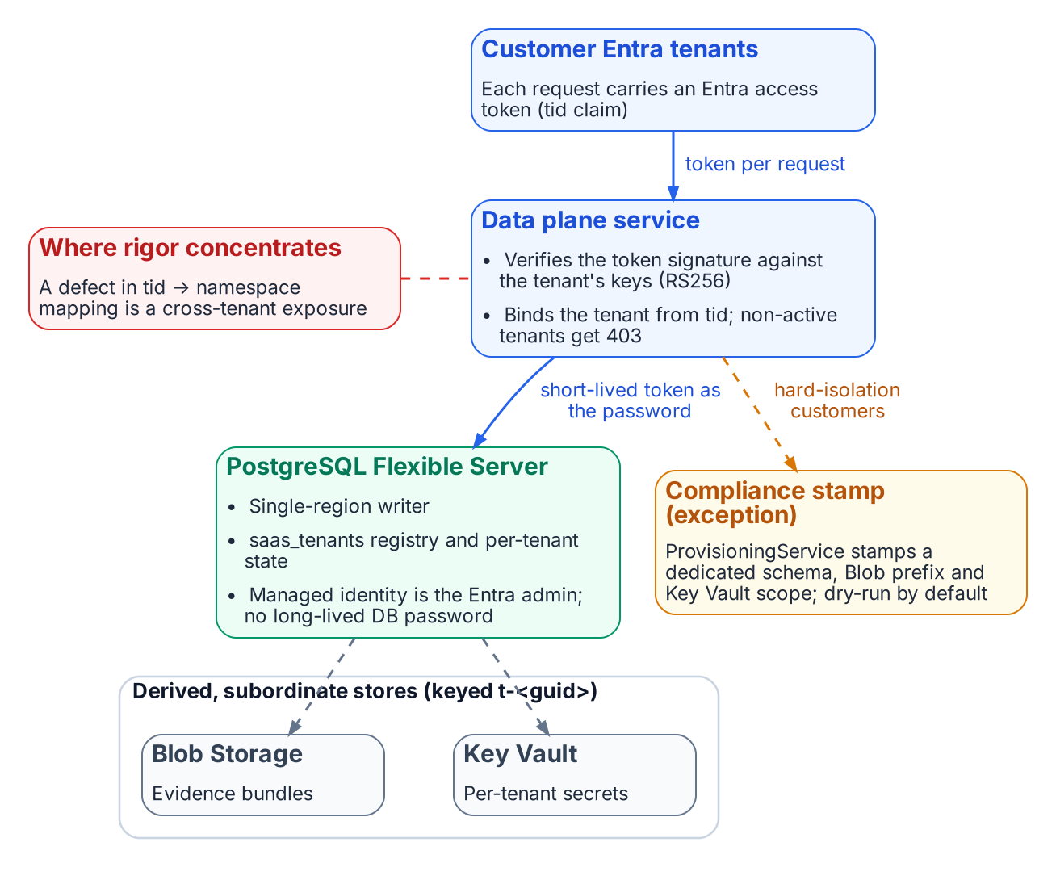
The SaaS data plane: one shared registry, token security on both sides, derived stores, and a provisioned exception.

The source of truth: one registry, one writer
The tenant registry is the system of record for who is onboarded and in what state. A tenant is identified by its Entra directory GUID and carries an explicit lifecycle state machine — PENDING → ACTIVE → SUSPENDED → ACTIVE / → DEPROVISIONED — with illegal transitions rejected at the model boundary (fmp.saas.tenant). There is exactly one authoritative copy of this truth. Every other representation — evidence in Blob, secrets in Key Vault — is keyed by the data_namespace derived deterministically from the tenant GUID (t-<guid>), so the derived stores are subordinate pointers to the registry’s truth, never independent sources of it. This is Chapter 1’s SSOT discipline as running code.
Because the writer is single-region, the strong-consistency path never crosses a continent. Per Chapter 3, that is not a limitation to be engineered away — it is the deliberate exploitation of the physics: at single-region distances, strong consistency is nearly free, so the Federal Modernization Program takes it.

Token security: the secret that does not exist
Chapter 2’s keystone is visible on both sides of every connection:
- Inbound, the trust boundary travels in the request. The data plane does not assume a caller is trustworthy because of where it connects from; it verifies the Entra token’s signature against the issuing tenant’s published keys and binds the tenant context from the tid claim, per request. One shared plane safely serves all tenants because identity is proven every time.
- Outbound, under the program decision, the application authenticates to PostgreSQL with a freshly-minted Entra access token used as the connection password — its managed identity is the database’s Entra administrator. The token provider caches and refreshes the token off the connection hot path and never presents a near-expired one. There is no long-lived database password anywhere in the deployment — the single highest-value secret is removed, not guarded. The same connection seam serves an AWS RDS-IAM token provider, so passwordless auth is cloud-portable.
This is precisely why the shared store is safe to centralize: the security model lives in identity, not in a perimeter or a stored credential.

The escape hatch: distribute only where compliance demands it
The Federal Modernization Program does not pretend physical centralization is universally acceptable. the program decision keeps the option to fragment as a deliberate, provisioned exception rather than the default:
- The control plane’s ProvisioningService can stamp dedicated resources — a dedicated DB schema, Blob prefix, and Key Vault scope — for a customer whose compliance posture cannot accept shared-plane, in-code isolation.
- Provisioning is dry-run by default (a no-op stamp executor only plans), so the control plane is safe to exercise in CI and locally; a concrete executor is injected only in production.
- The GOV tenant plan and the sovereign-cloud token audiences exist for customers under stricter boundaries, with sovereign SaaS itself listed as a future decision and explicit review trigger.
This is Chapter 1’s “small databases survive as compliance-stamped exceptions” realized exactly: the default is one shared source of truth; the dedicated small store is the exception, requested by compliance, not the architecture’s resting state.

Centralize until you measurably cannot
the program decision even encodes the discipline of Chapter 1 — scale up before you scale out — into its own expiry conditions. Among the decision’s stated review triggers is “the tenant registry outgrows a single PostgreSQL Flexible Server.” The architecture is centralized-until-evidence: it stays on one node until a measured limit forces a change, rather than pre-emptively sharding against a hypothetical. That is the correct posture this paper has argued for throughout.

Where SD-WAN would enter — and where it would not
Applying Chapters 3–4 to the Federal Modernization Program sharpens what networking does and does not buy here. Because the data plane is single-region with one writer, there is no global synchronous commit path for SD-WAN to optimize — the Federal Modernization Program has already removed the workload that would need it. Differentiated transport would matter in exactly two latency-tolerant, bulk-class places:
- Cross-region disaster-recovery replication of the Postgres registry — asynchronous by design, riding the fat bulk path; SD-WAN would improve its lag and resilience, not its correctness.
- Read-replica and evidence-bundle freshness for tenants far from the home region — bounded-staleness reads on the bulk path.
The day a sovereign-cloud stamp (a listed review trigger) requires a second region that must stay in sync, the full Chapter 4 toolkit — path classes, FEC for the commit tail, clock distribution for TrueTime-style coordination — becomes load-bearing. Until then, the Federal Modernization Program’s answer to the speed-of-light tax is the cheapest one available: do not span it synchronously in the first place.
The proposed next frontier is orthogonal to the data topology: governing the path itself. the program decision (Proposed) would promote the transport plane to a first-class governed concern — token-bound OverlayTunnels and a DRIFT-TRANSPORT class — holding the network that carries the Federal Modernization Program’s claims to the same per-call, identity-anchored standard as the data plane (Chapter 5).

The one risk, named plainly
The whole bet has a cost, and the decision record states it without flinching. Because tenant isolation on the shared plane is enforced in code — TenantResolutionMiddleware plus data_namespace scoping — rather than by physical separation, the blast radius lives in that code path. A defect in tenant resolution or namespace scoping is not a contained single-tenant fault; it is a potential cross-tenant data exposure. the program decision lists this explicitly as a negative trade-off.

Where the engineering rigor must concentrate
The database topology is not where this architecture can quietly fail — the tenant-resolution and namespace-scoping path is. That path must be small, exhaustively tested, and fail-closed (the auth layer already rejects unsigned, non-onboarded, and non-active tenants by default). The single highest-value verification for this whole design is to confirm there is no code path by which a validated tid for tenant A can address tenant B’s data_namespace. That is the concentrated correctness obligation you accept in exchange for one shared source of truth.

Summary
- the program decision chose one shared, single-region PostgreSQL source of truth with per-tenant in-code isolation, plus a stamped escape hatch — the paper’s doctrine as an accepted decision.
- Token security appears on both sides: inbound per-request tid verification, outbound passwordless Postgres auth (the program decision) that removes the highest-value secret entirely.
- Derived stores (Blob, Key Vault) are subordinate, namespace-keyed pointers to the registry’s truth — never independent sources.
- The single-region writer is a deliberate refusal to span the speed of light synchronously; SD-WAN would help only the async DR and read-replica paths until a second region is required.
- The architecture concentrates correctness into the tenant-resolution path; that path — not the database topology — is where rigor and verification must go.

